***Original Research Article***

**Mean Performance, Genetic Variability and Correlation Analysis of Parthenocarpic Cucumber(*Cucumis sativus* L.) Under Protected Cultivation**

**ABSTRACT**

The present study was conducted under naturally ventilated polyhouse conditions at Department of vegetable science, College of Agriculture, Kerala Agricultural University, Vellanikkara, Thrissur, during the period of 2023-2024. Eleven gynoecious parthenocarpic cucumber lines were evaluated, with the leading private sector variety Sania as a check, focusing on growth, parthenocarpic fruit set and yield parameters. Significant differences were observed among all the evaluated lines for all traits under study. The character association studies revealed that yield per plant had significant positive correlation with node of clustered fruit appearance, parthenocarpic fruit set percentage, parthenocarpic fruit expansion percentage and number of fruits per plant. Among the evaluated lines, CS 136 recorded the highest parthenocarpic fruit set (37.35 %) and fruit expansion percentage (31.75 %) and yield per plant (4.44 kg), outperforming the check variety Sania (2.97 kg). Phenotypic coefficient of variation (PCV) was found higher than genotypic coefficient of variation (GCV) for all the characters under study. Among the observed traits, node of first female flower emergence, node of parthenocarpic expression, parthenocarpic fruit set percentage, and parthenocarpic fruit expansion percentage showed high phenotypic and genotypic coefficient of variation, high heritability and high genetic advance, making them more reliable for effective selection in future crop improvement programmes.

*Keywords: Protected cultivation, Parthenocarpic cucumber, Correlation, Genetic variability, Heritability*

**INTRODUCTION**

Greenhouse farming allows growers to boost their yield by tenfold or more, establishing it as the optimal strategy for growing high-value vegetable crops on a commercial scale. Additionally, it helps to overcome seasonal barriers by creating a microclimatic condition that favors crop production and mitigates biotic and abiotic stresses (Murthy *et al*., 2009). Cucumber (*Cucumis sativus* L.), is a member of the Cucurbitaceae family and it is said to be indigenous to India (Vavilov & Dorofeev,1992). It is commercially grown worldwide in open fields and also under protected conditions (Kumar *et al*., 2019). Cucumber is typically a monoecious annual plant with various sex forms. However, monoecious varieties or hybrids are not suitable for protected cultivation mainly due to the pollination requirement. Therefore, for cucumber genotypes to be commercially viable in polyhouses, they must possess an intrinsic parthenocarpic gynoecious fruit formation mechanism. The dark green color, texture, burpless quality, and flavor of parthenocarpic/seedless cucumbers are highly regarded and popular worldwide. Since the parthenocarpic cucumber genotypes are gynoecious and do not require pollinators for fruit set, their yield potential is greater than that of typical seeded cucumber varieties. Furthermore, economic gains are significant because seedless fruits are more expensive than seeded fruits (Thapliyal, 2017).

Though cultivation of parthenocarpic cucumber under protected structures has been undertaken in our country since turn of the century, very little work is done in the public sector for developing varieties as well as hybrids suitable for it (Singh & Malhotra, 2012). The lack of progress in parthenocarpic cucumber breeding might be partially due to the unavailability of parthenocarpic and gynoecious lines and also due to conflicts in the information regarding the inheritance pattern of parthenocarpy (Pradeepkumar *et al*., 2018). Being a high value vegetable crop suitable to both protected and open cultivation, development of parthenocarpic gynoecious F1 hybrids in cucumber will help to boost the production and ensure more returns to farmers. Due to the fact that numerous factors interact to influence crop production, direct selection for increased yield could be deceiving (Gatti *et al*., 2005). Therefore, understanding genetic variability is crucial for the success of any crop development effort and the strategies used to exploit it. Taking these considerations into account, a study was conducted to investigate the average performance and determine the type and extent of genetic variability among eleven cucumber inbreds comparing with the leading commercial salad cucumber variety Sania (check).

**MATERIALS AND METHODS**

The present experiment was carried out at Department of vegetable science, College of Agriculture, Kerala Agricultural University, Vellanikkara, Thrissur, over two consecutive seasons (2023-2024). Eleven parthenocarpic gynoecious cucumber lines, *viz*., CS 134, CS 135, CS 136, CS 137, CS 138, CS 139, CS 140, CS 141, CS 142, CS 143, CS 144 and check variety Sania were grown inside naturally ventilated polyhouse in randomized block design with three replications at a spacing of 1.5 m x 0.5 m. Recommended cultural practices were adopted for proper growth and stand of the crop. The observations were recorded in five randomly selected plants of each genotypes and replication. To reduce errors before evaluating parthenocarpy, female flowers below the 5th node on the main stem were removed. Female flowers from the 6th to 30th nodes, which were expected to open the following day, were tagged. Phenotypic data for each female flower were collected 8 days after the isolation treatment. Parthenocarpic phenotypes, including expanded parthenocarpic fruit and initial parthenocarpic fruit, were recorded as parthenocarpic indices. The percentage of parthenocarpic fruit set (PFS) and the percentage of parthenocarpic fruit expansion (PFE) were then calculated using the following formulae (Gou *et al*., 2022).

PFS (%) = Number of parthenocarpic fruits / Number of ovaries under isolation treatment × 100

PFE (%) = Number of expanded parthenocarpic fruits / Number of ovaries under isolation treatment × 100.

Analysis of variance was done for all characters using GRAPES (Gopinath *et al.,* 2020). The techniques as stated by Burton & DeVane (1953) were used to calculate the GCV and PCV. According to the formulas given by Johnson *et al.* (1955), heritability, genetic gain, and genetic advancement were calculated, and correlation coefficients have been obtained using the technique suggested by Al-Jibouri *et al.* (1958).

**RESULTS AND DISCUSSION**

**Mean performance**

Significant differences were observed among the lines for all the characters under study. The mean values obtained from two season evaluation are depicted in Table 1 and the significant correlation between crop parameters is given in Figure 1.Traits that indicate earliness of salad cucumber, such as days to 1st emale flower anthesis, node of 1st female flower emergence, node of 1s parthenocarpic fruit expression, and days to 1st harvest, showed significant differences among the lines. Superiority in these traits is highly desirable as early fruit harvest fetches higher market prices and ensures higher cropping intensity inside the protected structure. Being at par with CS 136 (32.00), CS 141 (31.83) was found to be the earliest in female flower anthesis, while CS 141, CS 142, and CS 143 (42.83) on par with CS 135 (44.67) were the earlier to harvest. It has been noted that the female bloom emerged at the earliest node in CS 143 (4.17) and CS 136 (4.50), CS 141(4.67), CS 135 (4.83) and CS 142 (4.67) were found to be statistically on par with it, while the lower node at which parthenocarpic expression occurred was observed in CS 143 (4.17) which was statistically on par with CS 142 (4.67) and CS 144 (5.00). From correlation analysis it was evident that number of node at which first female flower emerged had a significant positive correlation with days to first female flower anthesis and node of first parthenocarpic fruit expression was positively correlated with node at which first female flower emerged. Also days to first harvest had positive association with days to first female flower anthesis and node of first female flower emergence. According to Kumar *et al.* (2008), this variation with respect to earliness in cucumber was attributed to genetic factors, whereas Ene *et al*. (2016) attributed it to the growing environment. Kaur and Sharma (2022) have also reported similar significant variabilities in these particular traits in salad cucumber.

Clustered fruit habit is an important yield-contributing factor, and among the lines evaluated, clustered fruits appeared in the lowest nodes in CS 138 (9.17), which was on par with the check variety Sania. Referring to the study by Gou *et al*. (2022), both the percentages of parthenocarpic fruit set (PFS) and parthenocarpic fruit expansion (PFE) were investigated to evaluate the parthenocarpic ability of cucumber lines. The results showed that parthenocarpic fruit set ranged from 12.48 to 37.35 percentage and CS 136 exhibited the highest parthenocarpic fruit set percentage while the lowest percentage fruit set was observed in CS 138. Seven among the evaluated lines *viz*. CS 136 (37.35), CS 141(34.60), CS 143 (30.67), CS 137 (29.31), CS 135 (26.28), CS 142 (25.77) and CS 140 (24.90) had significantly higher fruit set percentages over the check variety Sania. Similar variations in fruit set percentage among cucumber lines have been reported by Nwofia (2015) and Choudhary (2022). There is a clear indication from correlation analysis that parthenocarpic fruit expansion rate is positively correlated with parthenocrapic fruit set rate. Parthenocarpic fruit expansion ranged from 12.27 to 31.75 percentage and similar to parthenocarpic fruit set rate CS 136 showed the highest fruit expansion rate and the lowest rate of fruit expansion was noticed in CS 138. Among the lines evaluated, significantly higher fruit expansion percentage over check variety Sania was observed in CS 136, CS 137, CS 140, CS 143 and CS 135. Ranjan *et al*. (2015), Singh *et al*. (2018), and Kumar *et al*. (2019) reported that the differences in the fruit set percentage may be linked to the genetic composition of different genotypes, lower levels of abscisic acid, higher levels of auxin accumulation in gynoecious cucumber varieties, and increased accumulation of photosynthates in the leaves, along with their movement to developing fruits.

Fruit yield is directly influenced by certain yield attributed traits including number of fruits and fruit weight and these may vary depending upon genetic potential of the hybrids and climatic conditions in which they are grown (Kumar *et al*., 2015). Fruits with higher weight are preferred by the farmers in order to get more marketable yield per plant. Among the lines evaluated, highest average fruit weight was recorded in CS 134 (257.00 g) while CS 142 had the lowest average fruit weight (173.33 g). Correlation studies revealed that average fruit weight is negatively correlated with the days to first female flower anthesis and node at which first female flower emerged. Cylindrical, tender fruits are highly preferred by consumers and bring better returns to growers. Fruits of check variety Sania had maximum length (22 cm) whereas CS 140 had the minimum fruit length (12.73 cm) These results are supported by the findings of Choudhary (2022).

Number of fruits per plant was found to have significant positive association with number of fruits per cluster, parthenocarpic fruit set rate, parthenocarpic fruit expansion rate and average fruit weight. Maximum number of fruits per plant was recorded in CS 135 (17.67) which was found on par with CS 140 (15.83) and number of fruits per plant was found minimum in CS 138 (5.00). The variation in fruit count among different cucumber hybrids could be attributed to factors such as fruit set percentage, genetic characteristics, and their response to environmental conditions. In a study conducted by Kumar *et al*. (2019) it has been reported that high fruit number per vine was not related to more number of flowers, rather it was a result of high fruit set. This finding is supported by previous studies on polyhouse cucumber by Bhagwat *et al*. (2018) and Nagamani *et al*. (2019).

Correlation studies revealed the significant positive effect of node of clustered fruit appearance, parthenocarpic fruit set and fruit expansion rate and number of fruits per plant on total yield. Maximum yield was obtained in CS 136 (4.44 kg) which was significantly superior over the standard check Sania while the lowest yield was recorded in CS 134 (2.65 kg) and CS 138 (2.45 kg). All the evaluated lines except CS 138, CS 134 and CS 144 were having significantly higher yield over the check variety. Previous studies have also demonstrated significant variation in fruit yield among the tested gynoecious cucumber hybrids. This yield variation can also be attributed to the genotypic composition of each plant, which is expressed differently in specific environments (Singh *et al*. 2015 and Chaudhary *et al*., 2016). Presence of wide genetic variation with respect to yield per plant was also reported by Bhagwat *et al*. (2018), Sharma *et al*. (2019) and Kaur and Sharma (2022).

**Genetic variability, Heritability, and Genetic advance**

To design an effective breeding program, understanding the nature and extent of genetic variability is crucial. Estimates of the phenotypic coefficient of variation (PCV) and genotypic coefficient of variation (GCV) are useful for predicting the degree of variation present within genetic stocks. Table 2 provides the calculations for genetic parameters, including PCV (%), GCV (%), broad sense heritability (h2 bs), and genetic advance as percentage of mean (GAM) for various traits. The magnitude of phenotypic coefficient of variation (PCV) was greater than the corresponding genotypic coefficient of variation (GCV) for all the characters under study. The PCV values ranged from 8.78 % to 40.84 %. Highest phenotypic coefficient of variation was observed for number of fruits per plant (40.84) and traits like node at which parthenocarpic expression occurred (29.67), parthenocarpic fruit set percentage (27.05), node at which first female flower emerged (26.32), node at which clustered fruit appeared (22.74), parthenocarpic fruit expansion percentage (21.75) and yield per plant (20.70) also showed high PCV. Moderate PCV was observed for fruit length (16.16), average fruit weight (14.17) and days to first harvest (10.45), while days to first female flower anthesis (8.78) showed low PCV. These results are in agreement with the findings from previous studies. High PCV estimates were reported for number of fruits per plant by Tripathi *et al*., 2021, node of first female flower appearance by Patra *et al*., 2023 and yield per plant by Ahirwar *et al*., 2018, Tripathi *et al*., 2021 and Patra *et al*., 2023, while moderate PCV was reported for fruit length and average fruit weight by Kumar *et al*., 2008, Mehta, 2019 and Patra *et al*., 2023 and low PCV for days to first female flower anthesis and fruit diameter by Tripathi *et al*., 2021 and Patra *et al*., 2023.

Among the lines evaluated, wide range of genotypic variability was observed for the characters under investigation ranging from 8.21 to 29.41 %. Highest genetic coefficient of variation was observed for number of fruits per plant (29.41), followed by parthenocarpic fruit set percentage (26.38), node at which parthenocarpic expression occurred (24.98), node at which first female flower emerged (22.52) and parthenocarpic fruit expansion percentage (21.49). Moderate level of genetic variation was present in case of traits like node of clustered fruit appearance (18.12), fruit length (15.70), yield per plant (14.78), average fruit weight (11.90), and days to first harvest (10.02) whereas days to first female flower anthesis (8.21) exhibited low GCV. The results are consistent with the findings of previous researchers. High GCV was reported for number of fruits per plant by Tripathi *et al*., 2021 and for node of first female flower emergence by Patra *et al*., 2023. Moderate GCV was reported for yield per plant (Kumar *et al*., 2008), fruit length and fruit weight (Patra *et al*., 2023). Low GCV was reported for days to anthesis of first female flower by Ahirwar *et al*., 2018 and Mehta, 2019. Among the studied traits, node of first female flower emergence, node of parthenocarpic expression, parthenocarpic fruit set and fruit expansion percentage, and number of fruits per plant were found to have high PCV and GCV and this indicates greater genetic variability among genotypes for these characters, allowing for further improvement through selection.

The GCV alone does not fully capture the heritable variation, making the evaluation of heritability essential. The heritability ranged in extent from 51.0 to 97.7 %. Moderate broad sense heritability was observed in case of traits like node at which clustered fruit appeared (63.5), number of fruits per plant (51.8) and yield (51.0). All the remaining traits under study were found to have high heritability and among them, maximum heritability was found for PFE percentage (97.7%). Similar to the results obtained in this study, high estimates of heritability was recorded for fruit weight (Choudhary *et al*., 2016), node at which first female flower emerged (Kumar *et al*., 2008), days to first harvest (Kumar *et al*., 2008), days to first female flower anthesis (Ahirwar *et al*., 2018) and fruit length (Tripathi *et al*., 2021) and moderate estimate of heritability was recorded for number of fruits per plant (Patra *et al*., 2023) in previous studies. High heritability in the broad sense indicates that a large portion of phenotypic variance is attributed to genotypic variance. Traits with high heritability estimates are less influenced by the environment, making selection based on phenotypic performance more reliable (Bartaula *et al*., 2019).

High heritability does not necessarily mean high genetic gain and is insufficient alone for making improvements through selection based on phenotypic characters. Johnson *et al*. (1955) emphasized that heritability combined with genetic advance is more useful for estimating the real effect of selection. Therefore, genetic advance provides an advantage over heritability as a guiding factor for breeders in various selection programs. In this study genetic gain as a percentage of mean ranged from 15.82 to 53.00. High genetic advance was recorded for PFS percentage (53.00), PFE percentage (43.76), number of fruits per plant (43.62), node at which parthenocarpic expression occurred (43.32), node at which 1st female flower emerged (39.69), fruit length (31.43) and node at which clustered fruit appeared (29.74) while moderate genetic advance was exhibited for the traits like yield per plant (21.73), average fruit weight (20.59), days to 1st harvest (19.79) and days to 1st female flower anthesis (15.82). Similar to these findings, various studies have reported high genetic gain for number of fruits per plant (Tripathi *et al*., 2021), node at which first female flower emerged (Patra *et al*., 2023), fruit length (Kumar *et al*., 2008) and moderate genetic gain for days to first female flower anthesis (Kumar *et al*., 2008). High to moderate heritability, coupled with high to moderate genetic advance, indicates that the traits are controlled by additive gene action, and improvement for these traits can be achieved through phenotypic selection (Panse and Sukhatme, 1957). In contrast, moderate to low heritability combined with low genetic advance suggests that the inheritance of the traits is under the control of non-additive gene action, making selection based on phenotypic appearance ineffective. Instead, these traits can be improved through recombinant breeding. In the present study, high heritability along with high genetic advance were observed for the traits *viz*., node of first female flower emergence, node at which parthenocarpic expression occurred, parthenocarpic fruit set and fruit expansion percentage, and fruit length, and therefore, these characters could be more reliable for effective selection.

**CONCLUSION**

In the present study, among the 11 salad cucumber lines evaluated, CS 136 could be considered as the best line since it was observed to have the highest parthenocarpic fruit set and fruit expansion percentage and yield per plant. Significant positive association of traits like node of clustered fruit appearance, parthenocarpic fruit set and fruit expansion rate and number of fruits per plant with total yield is confirmed in this study. Among the observed traits, node of 1st female flower emergence, node of parthenocarpic expression, parthenocarpic fruit set and fruit expansion percentage were found to have high GCV and PCV along with high heritability and high genetic advance and therefore, these traits could be more reliable for effective selection for further crop improvement programmes in salad cucumber.

**Table 1: Mean performance of salad cucumber lines for growth,parthenocarpic fruit setand yield traits**

|  |  |  |  |  |  |  |  |  |  |  |  |  |
| --- | --- | --- | --- | --- | --- | --- | --- | --- | --- | --- | --- | --- |
| **Sl.no** | **Lines** | **Days to 1st female flower anthesis** | **Node at which 1stfemale flower emerged** | **Node at which parthenocarpic expression occured** | **Node at which clustered fruit appeared** | **PFS (%)** | **PFE (%)** | **Average fruit weight (g)** | **Fruit length (cm)** | **Days to 1st harvest** | **Number of fruits per plant** | **Yield per plant (kg)** |
| 1 | CS134 | 33.83gh | 5.33bcd | 5.33cd | 11.67de | 17.85h | 17.20g | 257.00a | 15.50g | 45.00c | 11.00cd | 2.65f |
| 2 | CS135 | 34.50fg | 4.83de | 6.00c | 14.33bc | 26.28d | 22.67d | 226.67bc | 19.83b | 44.67cd | 17.67a | 3.45d |
| 3 | CS136 | 32.00i | 4.50de | 9.00a | 15.17b | 37.35a | 31.75a | 236.50b | 18.23d | 45.83c | 15.50b | 4.44a |
| 4 | CS137 | 40.50b | 7.83a | 8.00b | 11.33e | 29.31c | 28.07b | 186.83ef | 17.50e | 51.83b | 9.50de | 3.76b |
| 5 | CS138 | 36.33e | 6.00b | 6.17c | 9.17f | 12.48i | 12.27h | 190.33ef | 16.42f | 52.67ab | 5.00g | 2.45f |
| 6 | CS139 | 37.83d | 7.33a | 9.33a | 18.83a | 23.72ef | 20.70f | 182.33f | 14.75h | 53.00ab | 6.67fg | 3.52cd |
| 7 | CS140 | 42.33a | 7.00a | 7.17b | 11.50e | 24.90de | 23.52c | 201.67de | 12.73i | 53.83a | 15.83ab | 3.42d |
| 8 | CS141 | 31.83i | 4.67de | 5.33cd | 13.00cd | 34.60b | 21.77e | 210.00cd | 16.58f | 42.83d | 11.00cd | 3.50cd |
| 9 | CS142 | 36.50e | 4.67de | 4.67de | 14.67b | 25.77d | 20.58f | 173.33f | 12.83i | 42.83d | 8.33ef | 3.39d |
| 10 | CS143 | 33.16h | 4.17e | 4.17e | 11.67de | 30.67c | 23.50c | 212.50cd | 19.17c | 42.83d | 11.83c | 3.67bc |
| 11 | CS144 | 35.50ef | 5.00bcd | 5.83cd | 14.67b | 20.83g | 20.70f | 182.67f | 15.00gh | 54.00a | 11.00cd | 3.06e |
| 12 | Sania (Check) | 39.00c | 7.50a | 9.33a | 10.33ef | 22.92f | 21.55e | 190.00ef | 22.00a | 52.33ab | 11.00cd | 2.97e |
|  | **Mean** | 36.11 | 5.83 | 6.63 | 13.03 | 25.56 | 22.02 | 204.15 | 16.71 | 48.47 | 11.19 | 3.36 |
|  | **CV (%)** | 2.48 | 12.06 | 10.98 | 9.05 | 5.85 | 1.99 | 6.93 | 2.47 | 3.07 | 13.85 | 5.18 |
|  | **CD (P=0.05)** | 1.14 | 0.89 | 0.92 | 1.50 | 1.90 | 0.56 | 17.98 | 0.53 | 1.89 | 1.97 | 0.22 |

PFS – Parthenocarpic fruit set (%); PFE – Parthenocarpic fruit expansion (%)

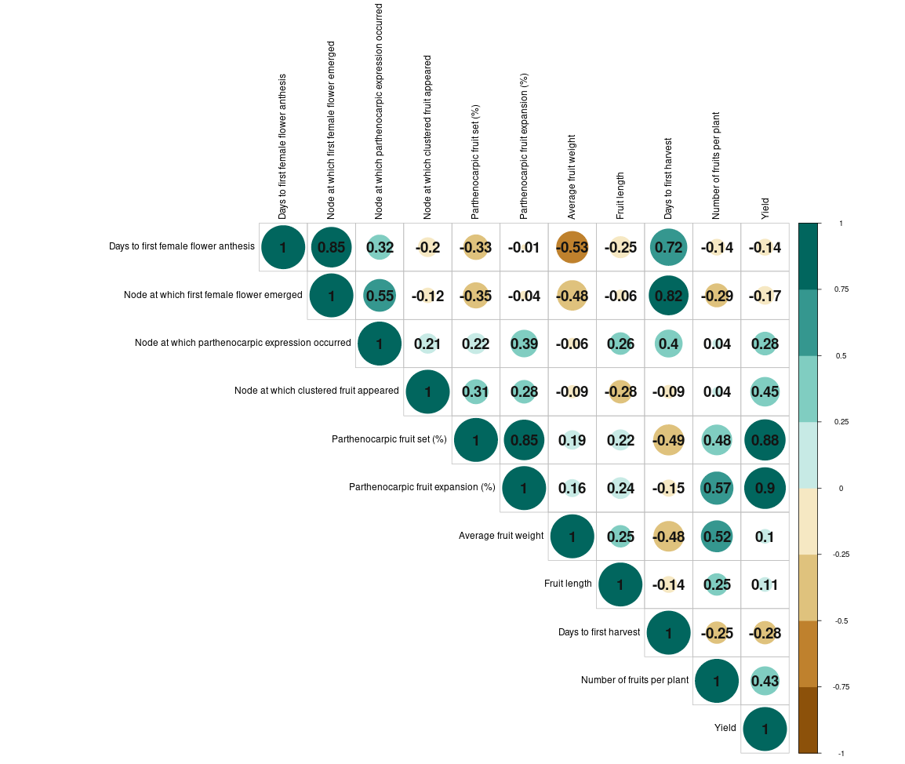

**Fig 1: Estimates of the correlation coefficient among different pairs of characters in salad cucumber**

|  |  |  |  |  |
| --- | --- | --- | --- | --- |
| **Traits** | **PCV (%)** | **GCV (%)** | **h2 bs** | **Genetic advance**  **(%) (i=5%)** |
| Days to 1st female flower anthesis | 8.78 | 8.21 | 87.4 | 15.82 |
| Node at which 1st female flower emerged | 26.32 | 22.52 | 73.2 | 39.69 |
| Node at which parthenocarpic expression occurred | 29.67 | 24.98 | 70.9 | 43.32 |
| Node at which clustered fruit appeared | 22.74 | 18.12 | 63.5 | 29.74 |
| Parthenocarpic fruit set percentage | 27.05 | 26.38 | 95.1 | 53.00 |
| Parthenocarpic fruit expansion percentage | 21.75 | 21.49 | 97.7 | 43.76 |
| Average fruit weight | 14.17 | 11.90 | 70.5 | 20.59 |
| Fruit length | 16.16 | 15.70 | 94.5 | 31.43 |
| Days to 1st harvest | 10.45 | 10.02 | 92.0 | 19.79 |
| Number of fruits per plant | 40.84 | 29.41 | 51.8 | 43.62 |
| Yield per plant | 20.70 | 14.78 | 51.0 | 21.73 |

**Table 2: Estimates of phenotypic (PCV) and genotypic (GCV) coefficients of variation, heritability and genetic advance in percent of mean for different traits in salad cucumber**

PCV: “Phenotypic Coefficient of Variation {>20 % - High (H), 10 – 20 % - Moderate (M), <10% - Low (L)}

GCV: Genotypic Coefficient of Variation {>20 % - High (H), 10 – 20 % - Moderate (M), <10% - Low (L)}

h2bs(%): Heritability in broad sense { >70 % - High (H), 50 – 70 % - Moderate (M), <50% - Low (L)}

Genetic Advance (%) of mean {>25% - High (H), 15 – 25 % - Moderate (M), <15% - Low” (L)}

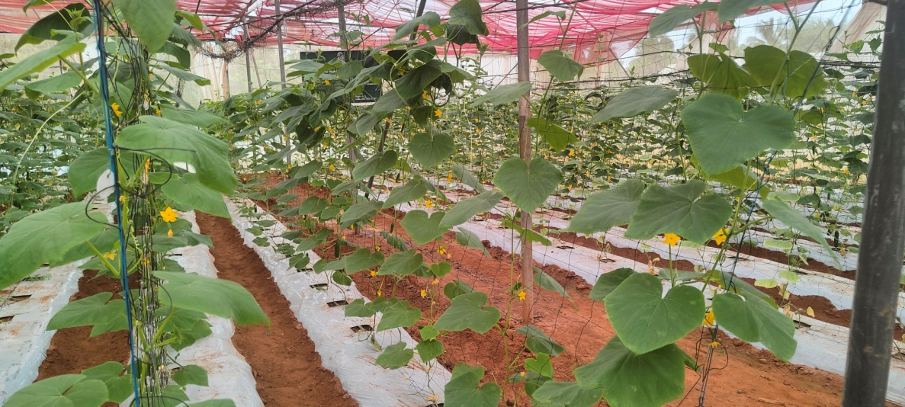

**A**

**Fig 2: A. General view of crop**

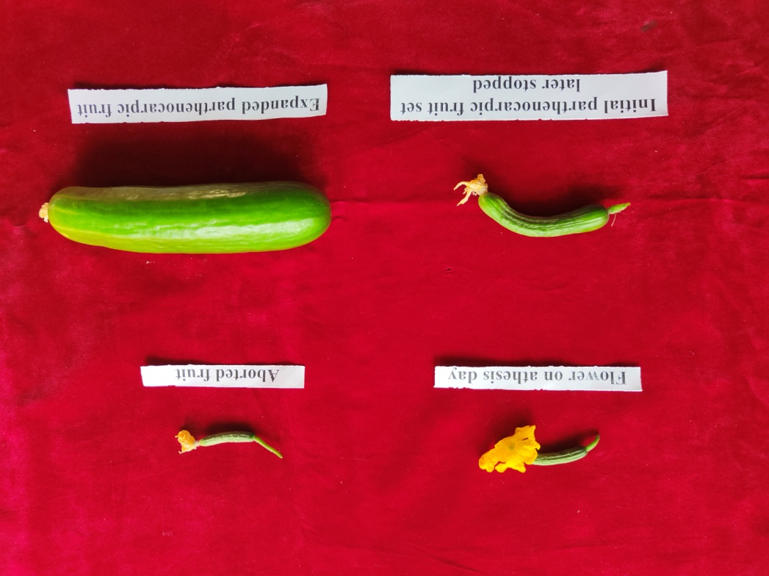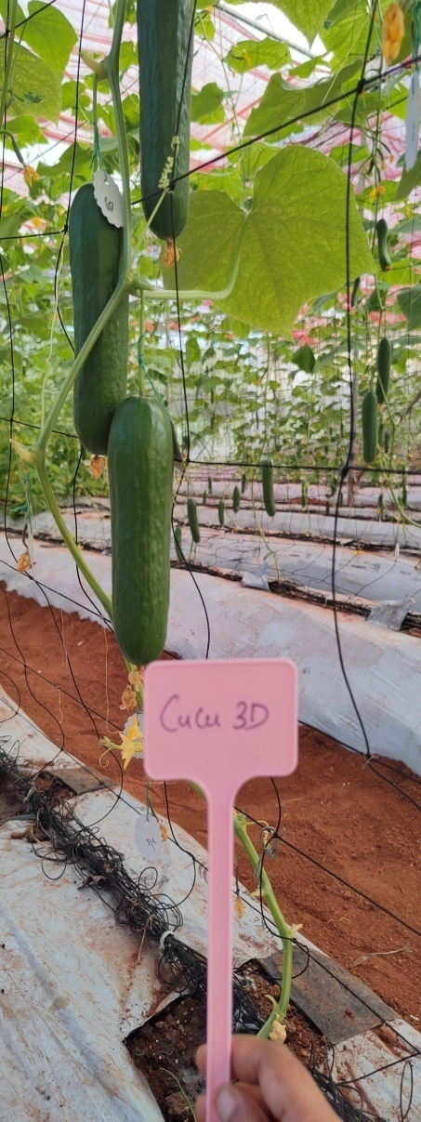

**B**

**C**

**Fig 2. B. Stages of parthenocarpy as well as non-parthenocarpy in cucumber C. High yielding line CS 136**

Disclaimer (Artificial intelligence)

Option 1:

Author(s) hereby declare that NO generative AI technologies such as Large Language Models (ChatGPT, COPILOT, etc.) and text-to-image generators have been used during the writing or editing of this manuscript.

Option 2:

Author(s) hereby declare that generative AI technologies such as Large Language Models, etc. have been used during the writing or editing of manuscripts. This explanation will include the name, version, model, and source of the generative AI technology and as well as all input prompts provided to the generative AI technology

Details of the AI usage are given below:

1.

2.

3.

**REFERENCES**

Ahirwar, C. S., & Singh, D. K. (2018). Assessment of genetic variability in cucumber (Cucumis sativus L.). International Journal of Current Microbiology and Applied Sciences, 7, 813–822.

Al-Jibouri, H. A., Muller, P. A., & Robinson, H. P. (1958). Genotypic and environmental variances and covariances in an upland crop of interspecific origin. Agronomy Journal, 30, 633–636.

Bartaula, S., Adhikari, A., Panthi, U., Karki, P., & Timalsena, K. (2019). Genetic variability, heritability and genetic advance in cucumber (*Cucumis sativus* L.). Journal of Agriculture and Natural Resources, *2*(1), 215-222.

Bhagwat, A., Srinivasa, V., Bhammanakati, S., & Shubh, A. S. (2018). Evaluation of cucumber (Cucumis sativus L.) genotypes under hill zone of Karnataka, India. International Journal of Current Microbiology and Applied Sciences, 7(9), 837–842.

Burton, G. W., & De Vane, E. W. (1953). Estimating heritability in tall fescue (Festuca arundinacea) from replicated clonal material. Agronomy Journal, 45, 478–481.

Chaudhary, V. I., Kumar, S., & Tank, R. V. (2016). Evaluation of greenhouse cucumbers for various horticultural traits under naturally ventilated polyhouse. Advances in Life Sciences, 5(8), 3320–3327.

Choudhary, S. (2022). Evaluation of parthenocarpic cucumber (*Cucumis sativus* L.) cultivars for summer cultivation under insect-proof net house in Indian hot arid region. Annals of Arid Zone, 61(1), 53–59.

Ene, C. O., Ogbonna, P. E., Agbo, C. U., & Chukwudi, U. P. (2016). Studies of phenotypic and genotypic variation in sixteen cucumber genotypes. Chilean Journal of Agricultural Research, 76, 307–313.

Gatti, I., Anido, F. L., Vanina, C., Asprelli, P., & Country, E. (2005). Heritability and expected selection response for yield traits in blanched asparagus. Genetics and Molecular Research, 4(1), 67–73.

Gopinath, P. P., Parsad, R., Joseph, B., & Adarsh, V. S. (2020). GRAPES: General R Shiny Based Analysis Platform Empowered by Statistics. https://www.kaugrapes.com/home. Version 1.0.0. DOI:10.5281/zenodo.492320

Gou, C., Zhu, P., Meng, Y., Yang, F., Xu, Y., Xia, P., Chen, J., & Li, J. (2022). Evaluation and genetic analysis of parthenocarpic germplasms in cucumber. Genes, 13(2), 225.

Johnson, H. W., Robinson, H. F., & Comstock, R. E. (1955). Estimates of genetic and environmental variability in soybean. Agronomy Journal, 47, 314–318.

Kaur, M., & Sharma, P. (2022). Performance of parthenocarpic cucumber (*Cucumis sativus* L.) genotypes for yield and quality characters under protected environment. Himachal Journal of Agricultural Research, 48(2), 220–224.

Kumar, A., Kumar, S., & Pal, A. K. (2008). Genetic variability and characters association for fruit yield and yield traits in cucumber. Indian Journal of Horticulture, 65(4), 423–428.

Kumar, P., Edelstein, M., Cardarelli, M., Ferri, E., & Colla, G. (2015). Grafting affects growth, yield, nutrient uptake, and partitioning under cadmium stress in tomato. Horticultural Science, 50, 1654–1661.

Kumar, P., Khapte, P. S., Saxena, A., & Kumar, P. (2019). Evaluation of gynoecious cucumber (*Cucumis sativus* L.) hybrids for early-summer greenhouse production in western Indian arid plains. Indian Journal of Agricultural Sciences, 89, 545–550.

Mehta, P. (2019). Genetic evaluation for fruit yield and related traits in parthenocarpic cucumber. Doctoral dissertation, CSKHPKV, Palampur.

Murthy, D. S., Prabhakar, B. S., Hebbar, S. S., Srinivas, V., & Prabhakar, M. (2009). Economic feasibility of vegetable production under polyhouse: A case study of capsicum and tomato. Journal of Horticultural Sciences, 4(2), 148–152.

Nagamani, G. V., Kumar, J. S. A., Reddy, T. B. M., Rajesh, A. M., Amarananjundeswara, H., Reddy, R. L. R., &Doddabasappa, B. (2019). Performance of different parthenocarpic cucumber (*Cucumis sativus* L.) hybrids for yield and yield attributing traits under shade net house. International Journal of Current Microbiology and Applied Sciences, 8, 978–982.

Nwofia, G. E., Amajuoyi, A. N., & Mbah, E. U. (2015). Response of three cucumber varieties (*Cucumis sativus* L.) to planting season and NPK fertilizer rates in lowland humid tropics: Sex expression, yield and inter-relationships between yield and associated traits. International Journal of Agriculture and Forestry, 5(1), 30–37.

Panse, V. G., &Sukhatme, P. V. (1957). Statistical Methods for Agricultural Workers. ICAR, New Delhi, pp. 359.

Patra, S., Singh, D. K., Singh, S. S., & Negi, M. (2023). Assessment of genetic diversity of parthenocarpic cucumber (*Cucumis sativus* L.) genotypes under polyhouse condition. The Pharma Innovation Journal, 12(7), 1532–1538.

Pradeepkumar, T., Bhardwaj, A., & Varun Roch, C (2018). Breeding parthenocarpic cucumber for protected cultivation: impact and assessment of kpch-1. Technologies and sustainability of protected cultivation for hi-valued vegetable crops, 83-97.

Ranjan, P., Gangopadhyay, K. K., Bag, M. K., Roy, A., Srivastava, R., Bhardwaj, R., & Dutta, M. (2015). Evaluation of cucumber (*Cucumis sativus* L.) germplasm for agronomic traits and disease resistance and estimation of genetic variability. Indian Journal of Agricultural Sciences, 85(2), 234–239.

Sharma, P., Dhillon, N. S., Kumar, P., & Mehta, P. (2019). Evaluation of parthenocarpic cucumber genotypes for fruit yield and its contributing traits under protected environment of N-W Himalayas. International Journal of Chemistry Studies, 3, 4–6.

Singh, H. P., & Malhotra, S. K. (2012). Current scenario and policy issues for protected cultivation of horticultural crops in India. In Proceedings of National Seminar on Protected Cultivation of Vegetables and Flowers—A Value Chain Approach, CoA, GBPUA&T, Pantnagar, India, 11–12 January, pp. 9–20.

Singh, A. K., Chandra, P., Shrivastava, R., & Kumar, R. (2015). Influence of varieties and spacing on yield and economics during off-season cucumber production under protected condition in North Indian plains. Vegetable Science, 42(2), 71–75.

Singh, S. S., Yadav, G. C., & Kathayat, K. (2018). Study of genetic variability in cucumber. Journal of Hill Agriculture, 9(1), 39–43.

Thapliyal, V. (2017). Heterosis and combining ability for yield and yield attributing traits of parthenocarpic cucumber (*Cucumis sativus* L.) under poly-net house conditions. Doctoral dissertation, Punjab Agricultural University, Ludhiana.

Tripathi, V., Singh, V. K., Bhardwaj, A., Singh, R. S., Srinivasaraghavan, A., & Kumari, A. (2021). Mean performance and genetic variability of parthenocarpicgynoecious cucumber inbreds under protected conditions of Eastern India. Journal of Current Opinion in Crop Science, 2(2), 178–183.

Vavilov, N. I., & Dorofeev, V. F. (1992). Origin and geography of cultivated plants. Cambridge University Press.