Ganoderma Farming in India: A Sustainable Pathway to Profitability and Public Health

Abstract
The COVID-19 pandemic in 2020 significantly boosted the demand for herbal and natural health products in India, creating substantial opportunities for the large-scale cultivation and commercialization of medicinal mushrooms. Among them, Ganoderma lucidum has emerged as a high-potential crop in the expanding agricultural market. Commonly known as the "mushroom of immortality" or "red reishi," Ganoderma lucidum is highly valued for its therapeutic properties and strong international demand. In response to this growing demand, the cultivation of Reishi mushroom is rapidly expanding across India, particularly in Himalayan regions such as Dehradun and Tehri Garhwal, where advanced cultivation techniques including wood log, sawdust substrate, and the billet method are predominantly employed.
Ganoderma farming presents a lucrative opportunity to enhance farmers' income, with dried fruiting bodies commanding prices between ₹4,000 and ₹5,000 per kilogram. The increasing adoption of Ganoderma lucidum farming among farmers is driven by its high market value, strong global demand, and low input costs. Government support, research initiatives, and growing consumer preference for herbal products further enhance its appeal. Several government schemes in India, such as the National Horticulture Mission and Rashtriya Krishi Vikas Yojana, provide financial assistance and technical support to promote mushroom cultivation. These initiatives aim to boost production, support farmers financially and enhance income generation opportunities. Additionally, its adaptability, sustainability, and potential for farm income diversification can play a crucial role in diversifying farmer’s income and strengthening India’s position in the global medicinal plant market.

- Introduction
Herbal medicines, which have been the foundation of healthcare since ancient times, continue to gain global attention in modern health sector reforms. Their clinical, pharmaceutical, and economic significance has promoted international trade, though practices vary across countries. Traditional plant-based medicines, widely used in India and globally, were central to healthcare before modern medicine. Even today, after the COVID-19 pandemic attack, many humans in developing countries rely on herbal remedies due to limited access to modern drugs, the perception of fewer side effects, lower costs, and concerns over the toxicity of allopathic medicines.
Since the 2016–2017 Union Budget, the Government of India has prioritized its core mission of doubling farmers' income. To achieve this, several initiatives have been undertaken, including improving irrigation efficiency, providing crop insurance, promoting organic farming, restoring soil health, and various other measures aimed at enhancing agricultural productivity and farmer’s income (Saxena et al., 2017). The recent trends in consumer behaviour have led to a growing demand for high-quality niche products, prompting the agricultural sector to implement commercially, technically, and economically viable agribusiness solutions (Shirur et al., 2016). To meet this growing demand, mushroom cultivation is regarded as one of the most promising agricultural practices.
Since ancient times, mushrooms have been valued as a unique and nutritious food. The Greeks believed mushrooms gave strength to their warriors, and the Romans revered them as the “Food of the Gods”. This traditional herbal medicine has been gradually gaining interest and acceptance, even among practitioners of modern medicine. Mushrooms have long served as a source of chemical compounds, either functioning as drugs themselves or as essential components in the synthesis of modern medicines. Mushroom cultivation depends on the efficient and sustainable utilization of agricultural residues, which are readily available nationwide.
In the era of health-conscious diets, mushrooms are gaining popularity as a future vegetable due to their rich medicinal and nutritional properties, driving a significant rise in consumer demand. Additionally, their high digestibility makes them a viable alternative to muscle protein (Pavel, 2009). In addition to being a rich source of protein, mushrooms serve as an exceptional natural provider of vitamin D, a nutrient often lacking in other food supplements (Pehrsson et al., 2003). Mushrooms are a nutrient-rich food with low caloric content, free from fat, cholesterol, and gluten, and containing minimal sodium. They are an excellent source of essential minerals such as potassium, iron, copper, zinc, and manganese, which are primarily concentrated in their fruiting bodies. Furthermore, mushrooms contain various bioactive compounds that offer multiple health benefits.
Key bioactive compounds found in mushrooms include lentinan in shiitake mushrooms, lovastatin in oyster mushrooms, lectins in white button mushrooms, ganoderic acid and β-glucans in reishi mushrooms, acidic polysaccharides in wood ear mushrooms, ergothionine in winter mushrooms, and cordycepin in Cordyceps species. These compounds possess immunomodulatory properties, supporting immune function and offering protection against cancer risk and tumor progression (VP Sharma et al., 2017).
This review article primarily focuses on the health benefits of Ganoderma, attributed to its rich phytochemical profile and nutrient composition. Additionally, it examines the growth stages and market potential of Ganoderma, driven by its expanding applications in the pharmaceutical, cosmetic, and food industries.
- Ganoderma Mushroom- An Overview
The reishi mushroom has a rich historical background, with numerous legends documenting its use for over 2,000 years. In traditional Chinese medicine, Taoist monks utilized reishi to cultivate inner calm, enhance meditation practices, and promote longevity and overall well-being. Similarly, in Japanese culture, reishi has been highly revered and is considered the most significant medicinal polypore. The genus Ganoderma was established by Karsten (1881), with Ganoderma lucidum (Curtis) P. Karst. designated as the type species (Moncalvo & Ryvarden, 1997). Ganoderma species are globally distributed (Pilotti, 2005), and their fruiting bodies typically emerge from living or, more commonly, dead tree trunks and branches. These fungi function as facultative parasites, capable of surviving as saprobes on decaying wood (Turner, 1981).
Depending on the species, Ganoderma produces two distinct types of fruiting bodies: laccate fruiting bodies, characterized by a glossy upper surface, and non-laccate fruiting bodies, which have a matte appearance (Smith & Sivasithamparam, 2000; Pilotti et al., 2004). A defining taxonomic characteristic of this genus is the presence of double-walled basidiospores with interwall pillars (Smith & Sivasithamparam, 2000; Li et al., 2013). In addition to its ecological significance, Ganoderma holds considerable economic value due to its medicinal applications and pathogenic potential (Dai et al., 2009). Traditionally, Ganoderma has been used for millennia in China, Japan, and Korea as a medicinal mushroom, valued for its purported ability to promote health and longevity (Cao et al., 2012). Additionally, Ganoderma is recognized as a functional food with therapeutic potential for the prevention and management of various immunological disorders (Tan, 2015). Ganoderma lucidum (known as Mannentake or Sachitake in Japanese, and Youngzi in Korean) is a species belonging to the class Basidiomycetes, within the family Polyporaceae or Ganodermataceae of the order Aphyllophorales (Chang & Miles, 2004).
Ganoderma lucidum has been successfully cultivated on various substrates while maintaining optimal growth conditions, including temperature, relative humidity, water content, air pH, and light intensity (Chang & Miles, 2004). This species thrives on a diverse range of dead or decaying trees, particularly deciduous species such as Quercus, Acer, Alnus, Betula, Pyrus, and Magnolia.
Currently, the most widely adopted commercial cultivation methods include wood log cultivation, short wood segment techniques, tree stump cultivation, sawdust bag cultivation, and bottle-based procedures (Wasser, 2005). The fruiting body of G. lucidum typically exhibits a fan-shaped, kidney-shaped, or semi-circular morphology. Its coloration varies from dark red and reddish-brown to reddish-black, with yellow or ochre hues becoming more pronounced towards the edges. The internal flesh of the mushroom varies in colour from yellowish-brown to dark brown. The Latin root of its name, Lucidum, meaning "bright," refers to the characteristic glossy surface of these mushrooms. Additional details on the diverse colour variations and applications of G. lucidum are presented in Table 1.
Table 1: The five traditional types of Ganoderma and their uses (Wasser, 2005)
Colour | Taste | Chinese name | Japanese name | Uses
Blue | Sour | Seishi | Aoshiba | Enhances eyesight and liver function; promotes nerve relaxation
Red | Bitter | Sekishi | Akashiba | Supports internal organ health; improves memory and vitality
Yellow | Sweet | Oushi | Kishiba | Strengthens spleen function
White | Hot | Hakushi | Shiroshiba | Enhances lung function; promotes courage and resilience
Black | Salty | Kokushi | Kuroshiba | Supports kidney health

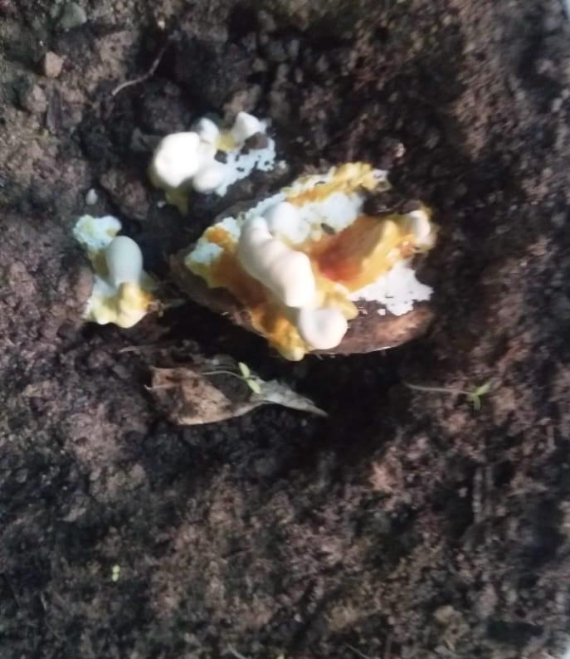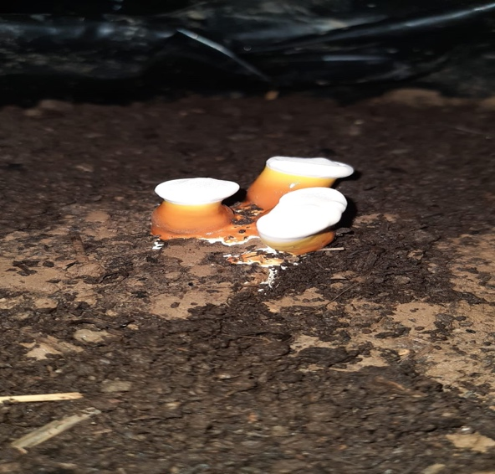
Mycelium run after inoculation at 40th day

The production of young fruiting bodies at 45th day

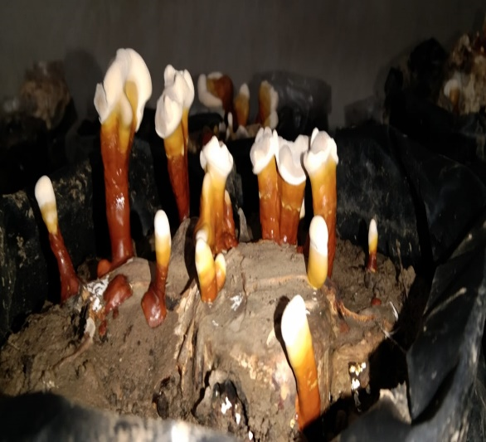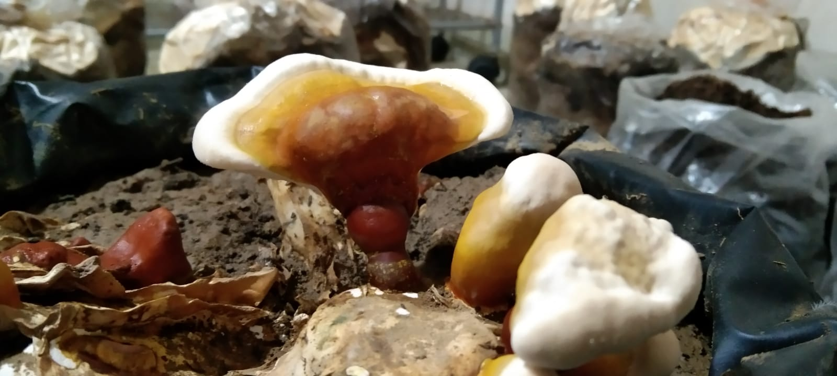
Young fruiting bodies developing into mature bodies at 55th day

The production of young fruiting bodies at 50th day

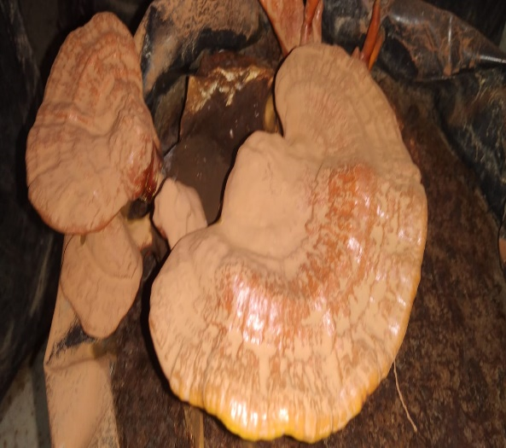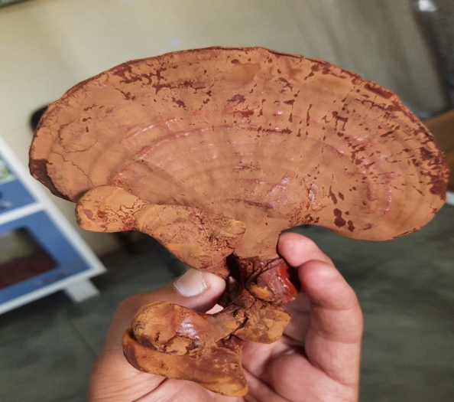
Mature Ganoderma lucidum after Harvesting at 65th day

Mature fruiting bodies were seen at 62nd day

Figure 1: Growth stages of Ganoderma lucidum
- Phytoconstituents of Ganoderma lucidum
Species of Ganoderma have been extensively researched for their medicinal significance, as they contain a diverse range of bioactive compounds with potential nutritional and therapeutic benefits (Hapuarachchi et al., 2017). Ganoderma is recognized as a functional food and is widely used for the prevention and management of immunological disorders (Wang et al., 2012). Extensive research has identified hundreds of metabolites within this genus, with G. lucidum being the most highly valued species (Dong & Han, 2015). Ganoderma is recognized as a functional food and is widely used for the prevention and management of immunological disorders (Wang et al., 2012). Extensive research has identified hundreds of metabolites within this genus, with G. lucidum being the most highly valued species (Dong & Han, 2015).
The bioactive constituents (Table 2) have been reported to exhibit a wide range of therapeutic properties, including anti-cancer, anti-inflammatory, anti-tumor, and antioxidant activities. Additionally, they possess immunomodulatory and immunodeficiency-regulating effects, along with anti-diabetic, antiviral, antibacterial, anticonvulsant, antifungal, antihypertensive, and anti-atherosclerotic properties.
Table 2: Common therapeutic effects of different Ganoderma spp.
Therapeutic effects | Major bioactive compounds | References
Anti-cancer | Triterpenoids | Yuen & Gohel 2005
 | Immunomodulatory protein LZ-8 | Boh 2013
 | Ganoderma-specific immunostimulant | Zhang et al. 2010
 | Fungal-derived protein LZP-F3 | Huang & Ning 2010
 | Polysaccharides, GLP-2B | Zhang et al. 2011
 | Ganoderma polysaccharides | Cao & Lin 2006
Anti-diabetic effects | proteoglycans | Ma et al. 2015
 | Bioactive fungal proteins (LZ-8) | Ma et al. 2015
 | Polysaccharides | Ma et al. 2015
 | Triterpenoids | Ma et al. 2015
Anti- inflammatory | Ganoderic acids T-Q | Sliva et al. 2003
 | lucideinic acids A, D2, E2, and P | Sliva et al. 2003
Anti-oxidant activity | Polysaccharides | Mehta 2014
 | Triterpenes | Mehta 2014
 | phenolic component | Kana et al. 2015
 | polysaccharide-peptide complex | Kana et al. 2015
Anti- Microbial Activity | Triterpenoids | Zhang et al. 2011
 | Polysaccharides | Zhang et al. 2011
 | Ganodermadiol | Isaka et al. 2013
 | Ganodermanondiol | Isaka et al. 2013
 | Ganolucidic acid A | Isaka et al. 2013
 | Ganodermin | Isaka et al. 2013
Cardiovascular problems | Polysaccharides | Gao et al. 2004

Moreover, these bioactive compounds have been linked to geroprotective effects, anti-androgenic activity, hepatoprotective properties, and free radical scavenging potential. They also contribute to neuroprotection, sleep regulation, cholesterol biosynthesis inhibition, glycemic control, suppression of lipid peroxidation and oxidative DNA damage, maintenance of gut microbiota balance, obesity prevention, and probiotic stimulation (Vyas et al., 2016). Additionally, Ganoderma species are recognized as a rich source of antioxidant compounds (Rawat et al., 2013), which play a pivotal role in mitigating oxidative stress by directly neutralizing intracellular free radicals (Agarwal et al., 2012). The presence of phenolic compounds has been identified as a key contributor to the antioxidant properties observed in many mushrooms (Barros et al., 2008). Specifically, flavonoids exhibit detoxification properties, anti-inflammatory effects, and therapeutic potential for various cardiovascular diseases (Le Marchand, 2002).
Several Ganoderma species exhibit potent anti-tumor properties (Jeong et al., 2008), primarily due to the presence of bioactive compounds such as triterpenes and polysaccharides. Triterpenes inhibit cancer cell proliferation and metastatic potential, while polysaccharides enhance the immune-mediated anti-cancer response by stimulating cytokine production (Smina et al., 2011). Flavonoids also play a crucial role in these therapeutic effects (Le Marchand, 2002). Extracts of G. lucidum have been shown to inhibit key signaling pathways involved in the progression of various cancer cell types (Aydemir, 2002). Furthermore, G. lucidum demonstrates potent anti-proliferative activity against human prostate cancer cells by inducing apoptosis, suppressing cell proliferation, and inhibiting metastatic potential (Stanley et al., 2005). Ganoderma species have also demonstrated therapeutic efficacy against lymphoma, leukemia, and multiple myeloma cells (Müller et al., 2006). Additionally, the methanolic extract of G. applanatum has been reported to induce apoptotic anti-tumor effects in human colon cancer cell lines (Elkhateeb et al., 2018).
Moreover, certain Ganoderma metabolites have exhibited antimicrobial activity against a range of pathogenic bacteria and fungi (Singh et al., 2014). Quereshi et al. (2010) reported that the acetone extract derived from the fruiting bodies of G. lucidum possesses antibacterial properties against Staphylococcus aureus and Pseudomonas aeruginosa.

Bioactive compounds | Molecular Formula | Molecular Structure
Triterpenoids | C₃₀H₄₈ | 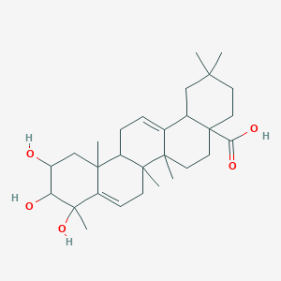
Polysaccharides | (C₆H₁₀O₅)n | 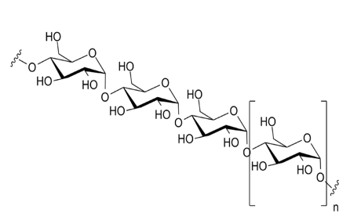
Ganoderic acids T-Q | C₃₂H₄₆O₅ | 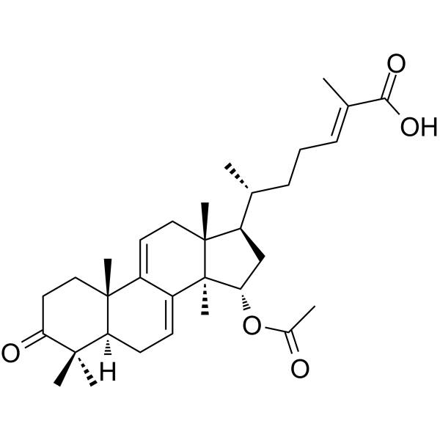
Lucideinic acids A | C₂₇H₃₈O₆ | 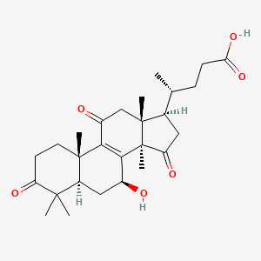
Lucideinic acids D2 | C₂₉H₃₈O₈ | 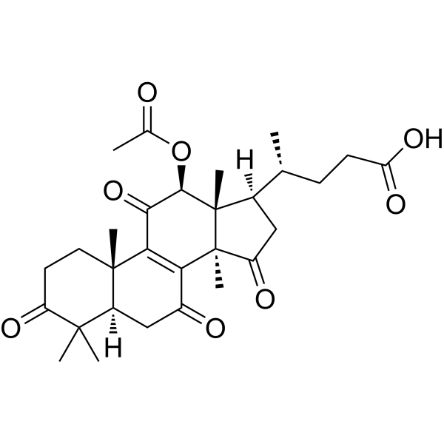
Triterpenes | C₃₀H₄₈ | 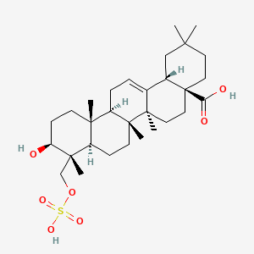
Polysaccharide-peptide complex | (C₆H₁₀O₅)n | 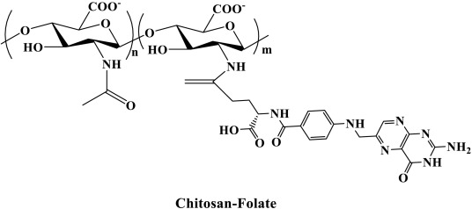
Phenolic component | C₆H₅OH | 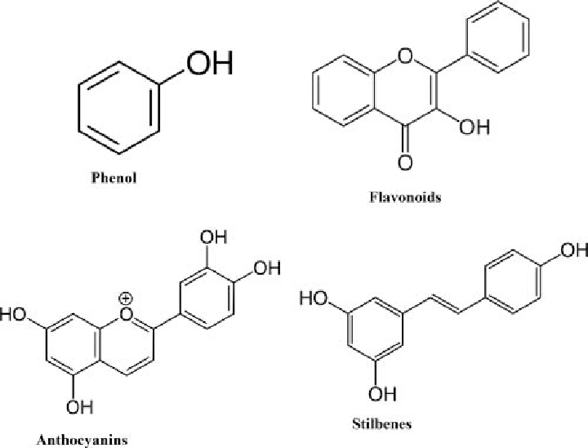
Ganoderic acid | C₃₀H₄₄O₇ | 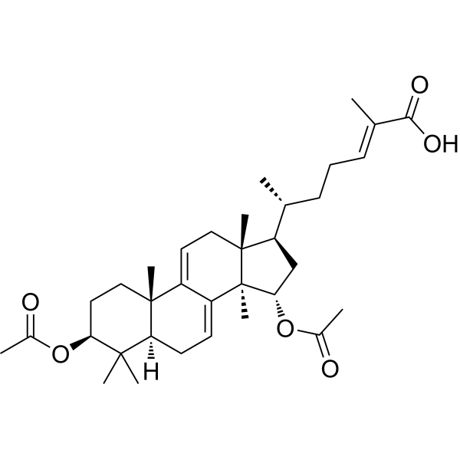
Ganolucidic acid A | C₃₀H₄₄O₆ | 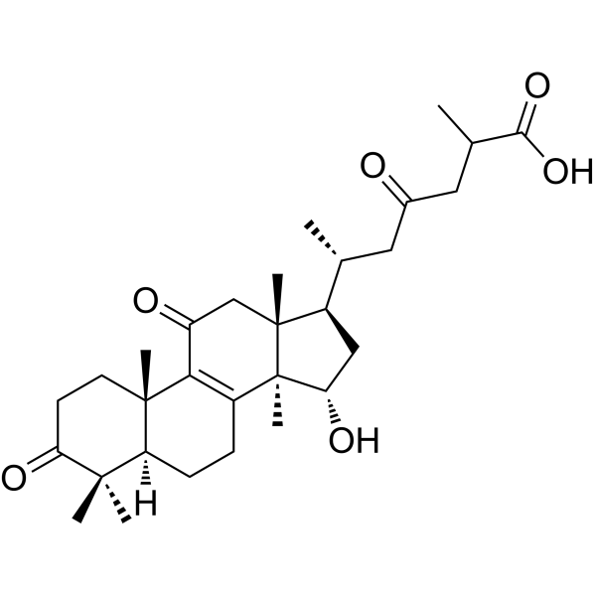
Ganodermanondiol | C₃₀H₄₈O₃ | 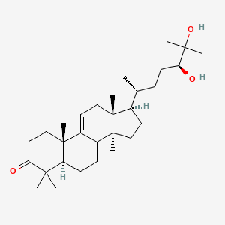
Ganodermadiol | C₃₀H₄₈O₂ | 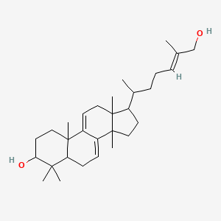
Figure 2: Structure of different chemical constituents of Ganoderma lucidum
- Medicinal importance of Ganoderma lucidum

  - Anticancer
The anticancer benefits of Ganoderma lucidum are confirmed by recent investigations, mainly through immunological regulation (Lin et al., 2004). NK cells, T-helper cells, and macrophages are activated by its polysaccharides, particularly β-D-glucans, which improve host defence (Cao & Lin, 2003). Additionally, Ganoderma lucidum stimulates cytotoxic T lymphocyte activity and dendritic cell maturation. Immune activation, induction of Phase II enzymes, suppression of angiogenesis, inhibition of uPA/uPAR production, and direct cytotoxicity are some of its anticancer actions (Lin et al., 2004).

  - Antioxidant
Ganoderma lucidum contains strong antioxidants in the form of polysaccharides, polysaccharide-peptide complexes, triterpenes, and phenolic compounds (Kana et al., 2015). Studies show that the antioxidants in Ganoderma lucidum are quickly absorbed after consumption, increasing the antioxidant activity of plasma. Its glucans induce the generation of interferon in human blood cells, prevent lipid peroxidation, and scavenge free radicals. Furthermore, Ganoderma lucidum shows notable effectiveness against breast cancer, most likely as a result of its enzymatic and antioxidant properties. It reduces oxidative stress and inhibits the activity of mitochondrial and glycolytic enzymes by modifying both enzymatic (catalase, superoxide dismutase, glutathione peroxidase) and non-enzymatic (glutathione, vitamin C, vitamin E) pathways (Sun et al., 2002).

  - Antidiabetic
Both people and animals experience hypoglycemic effects from Ganoderma lucidum's pharmacologically active substances. By decreasing hepatic PEPCK gene expression, its extracts dramatically lower phosphoenol-pyruvate carboxykinase (PEPCK) levels, which are generally increased in obese and diabetic animals (Agius, 2007). Research demonstrates that by increasing plasma insulin secretion and decreasing plasma glucose, Ganoderma lucidum regulates blood glucose levels. By decreasing hepatic glucose synthesis and increasing the activity of phosphofructokinase, glucose-6-phosphate dehydrogenase, and hepatic glucokinase, it prevents hyperglycemia (Cormack et al., 2001).

  - Antimicrobial
Several studies demonstrate Ganoderma lucidum antibacterial qualities, which successfully inhibit both Gram-positive and Gram-negative bacteria. Significant antibacterial activity is exhibited by its polysaccharides (Gao et al., 2003). Escherichia coli, Staphylococcus aureus, Bacillus cereus, Enterobacter aerogenes, and Pseudomonas aeruginosa are all susceptible to the antimicrobial actions of Ganoderma lucidum methanol extract (Alves et al., 2013). Furthermore, Ganoderma lucidum increases the effectiveness of antibiotics such ampicillin, cefazolin, oxytetracycline, and chloramphenicol. Additionally, Ganoderma lucidum toothpaste has antifungal qualities; it successfully inhibits Candida albicans, a primary cause of oral candidiasis (Dzubak et al., 2006).

  - Antiosteoporotic
Similar to the effects of 17β-estradiol, research on Ganoderma lucidum ethanol extract indicates that it may be able to prevent bone loss caused by ovariectomy by lowering serum osteocalcin levels. Osteoporosis and other ageing conditions linked to sex hormones may be treated with Ganoderma lucidum bioactive substances. It may have anti-osteoporotic effects via binding to the oestrogen receptor, causing cellular and molecular reactions, or by boosting vital minerals for healthy bones like calcium, iron, and phosphorus.

  - Anti-inflammatory
Triterpenes from Ganoderma lucidum have been investigated for their anti-inflammatory qualities in murine macrophage cell lines activated by the gram-negative bacterial cell wall component lipopolysaccharide (LPS). Through Toll-like receptor-4 signalling, these triterpenes increase the activation of transcription factors like AP-1 and NF-κB, which in turn causes the production of inflammatory genes including TNF-α, iNOS, COX-2, and IL-6. Triterpenes from G. lucidum have the potential to be anti-inflammatory and antiproliferative agents because they cause cell cycle arrest by preventing the generation of inflammatory mediators (Dudhgaonkar et al., 2009). Furthermore, the immunomodulatory polysaccharide G. lucidum β-glucan interacts with a C-type lectin called pattern recognition receptor dectin-1, which works with TLR2 to trigger innate immunological responses in antigen-presenting cells (Cai et al., 2016).

  - Anti-arthritic
Ganoderma lucidum may be used to treat autoimmune diseases such as rheumatoid arthritis because of its immunomodulatory and anti-inflammatory qualities (Lin, 2005). According to in vitro research, Ganoderma lucidum affects peripheral mononuclear cells' production of cytokines, such as TNF-α and interleukins (IL-1β, IL-2, and IL-6), which are linked to the pathophysiology of rheumatoid arthritis (Lin, 2005). Furthermore, Ganoderma lucidum decreases the synthesis of monocyte chemoattractant protein (MCP)-1, IL-1β, or LPS-induced IL-8, and rheumatoid arthritis synovial fibroblast (RASF) proliferation. The inhibition of the NF-κB transcription pathway is partially responsible for these inhibitory effects (Ho et al., 2007).

  - Cardioprotective
Significant cardiovascular benefits of Ganoderma lucidum include lowering blood pressure, triglycerides, and cholesterol. According to clinical research, hypertension patients' blood pressure returned to normal after taking G. lucidum extract for two months (Xie et al., 2016). According to studies, it also helps rats avoid atherosclerosis and lower their cholesterol (Wang et al., 2009). Endothelial cells are shielded by polysaccharide-peptide complexes, which have hypotensive, antithrombotic, and hypolipidemic properties (Yang et al., 2010). According to a double-blind trial, Ganoderma lucidum increased respiratory performance, reduced chest discomfort, and improved ECG. It contributes to cardioprotection by increasing glutathione (GSH), a cofactor for antioxidant enzymes (GPx, GST, CAT, and SOD) (Wachtel et al., 2004). Its triterpenoids have ACE-inhibitory properties, and extracts scavenge free radicals to prevent adriamycin-induced cardiotoxicity (Rajasekaran et al., 2012). According to recent research, Ganoderma lucidum decreased reperfusion contracture and cardiomyocyte necrosis in ischaemic rat hearts following a 15-day treatment (Lasukova et al., 2015).

Conclusion
The rising global awareness of health and wellness, particularly after the COVID-19 pandemic, has led to an increased demand for natural and herbal products. Among these, medicinal mushrooms, particularly Ganoderma lucidum (Red Reishi), have gained significant importance due to their wide-ranging therapeutic properties. Recognized for its anti-inflammatory, immune-boosting, anti-cancer, and antioxidant properties, Ganoderma lucidum is not just a traditional medicinal product but also a valuable resource in modern pharmaceuticals and nutraceuticals. With the growing trend of organic and herbal-based medicine, the cultivation and commercialization of Ganoderma have emerged as a highly lucrative opportunity, especially for Indian farmers. The increasing consumer shift toward alternative medicine, driven by concerns over synthetic drugs and their side effects, has further fueled the demand for Ganoderma products in both domestic and international markets. This creates a promising avenue for economic growth, particularly in rural and semi-urban areas, where medicinal mushroom farming can provide additional income and employment opportunities.
Ganoderma lucidum is a medicinally significant fungus with diverse therapeutic properties. Its anticancer effects are mediated through immune modulation, cytotoxicity, and angiogenesis suppression. It exhibits potent antioxidant activity by scavenging free radicals and regulating enzymatic pathways. The hypoglycemic properties of G. lucidum stem from its ability to enhance insulin secretion and regulate hepatic glucose metabolism. Its antimicrobial activity is broad-spectrum, targeting both bacteria and fungi, with potential synergistic effects with antibiotics.
Furthermore, G. lucidum demonstrates anti-osteoporotic effects by mimicking estrogenic activity and improving bone mineral content. It possesses strong anti-inflammatory and immunomodulatory properties, making it a promising candidate for treating autoimmune diseases like rheumatoid arthritis. Cardioprotective effects include reducing cholesterol, triglycerides, and blood pressure, protecting endothelial cells, and counteracting drug-induced cardiotoxicity.
Overall, the extensive pharmacological properties of Ganoderma lucidum highlight its potential as a natural therapeutic agent for various chronic diseases. Future clinical studies are needed to further validate its efficacy and explore its applications in modern medicine.
Moreover, the government’s support through various agricultural and research initiatives has played a crucial role in promoting medicinal mushroom cultivation. With advancements in biotechnology, improved cultivation techniques, and better processing methods, Ganoderma lucidum farming has become more accessible and profitable. The availability of training programs, financial aid, and technological interventions has further encouraged farmers to adopt this high-value crop. Additionally, the integration of Ganoderma in various industries, including pharmaceuticals, cosmetics, dietary supplements, and functional foods, has opened up diverse revenue streams. Its application in health products such as capsules, powders, teas, and skincare formulations has expanded its market reach, making it a highly sought-after commodity worldwide. Countries like China, Japan, and the United States have already capitalized on the Ganoderma industry, and India has the potential to become a leading player in this sector.
However, to maximize the benefits of Ganoderma cultivation, challenges such as market accessibility, standardization of cultivation practices, and product quality control need to be addressed. Strengthening supply chain mechanisms, enhancing awareness among farmers, and improving research collaborations will be crucial steps in ensuring long-term sustainability and profitability in Ganoderma farming.
In conclusion, Ganoderma lucidum holds immense potential as a medicinal and commercial crop, offering both health and economic benefits. With the right policies, investment in research, and farmer education, India can tap into the global market for medicinal mushrooms, contributing to both public health and economic development. By embracing the cultivation and commercialization of Ganoderma, the agricultural sector can diversify, create employment opportunities, and support a sustainable, health-focused economy.
Obstacles in the Cultivation and Management of Ganoderma lucidum
The study by Tong et al. (2020) highlights several key obstacles in the continuous cultivation of Ganoderma lucidum. One major challenge is the spread of Trichoderma and Mucor on the soil surface, which competes with Ganoderma lucidum for resources and affects its growth. Additionally, while the cultivation of G. lucidum leads to a significant increase in organic matter and total nitrogen content in the soil, this accumulation can support the growth of unwanted fungi, further complicating cultivation. These factors contribute to the difficulty in maintaining sustainable and high-yielding G. lucidum production over time. However, the study also suggests that waterlogging can help restore production by mitigating these fungal competitions offering a potential solution for improving continuous cultivation.
Conflict of interest
The authors declare no conflicts of interest relevant to this article.

Disclaimer (Artificial intelligence)
Option 1:
Author(s) hereby declare that NO generative AI technologies such as Large Language Models (ChatGPT, COPILOT, etc.) and text-to-image generators have been used during the writing or editing of this manuscript.
(yes)
Option 2:
Author(s) hereby declare that generative AI technologies such as Large Language Models, etc. have been used during the writing or editing of manuscripts. This explanation will include the name, version, model, and source of the generative AI technology and as well as all input prompts provided to the generative AI technology
Details of the AI usage are given below:
1.
2.
3.

- The Ganoderma market has grown tremendously during the last two decades in
- Asia, now offering thousands of products, notably nutraceuticals, that are eaten as
- dietary supplements. Ganoderma basidiocarp, slices, and spore powders are the
- three most popular forms in the domestic economy among buyers looking to
- improve their health or treat and prevent diseases. Based on these forms, there are
- many different types of Ganoderma products available, such as Brain Gano, Heart
- Gano, Kimshen Gano, Liver Gano, Peacock Gano, and Ruyi Gano, with a variety of
- names and labels (Karuppiah & Ji, 2020). Despite the enormous market, the industry
- faces challenges in developing a global market. The multifaceted activity of fungi in
- the genus Ganoderma paves the way for their widespread application in a variety of
- economic categories. It is a prominent Asian therapeutic agent with a wide range of
- uses. It is widely utilized in food supplements worldwide, with an increasing number
- of patents and products utilizing G. lucidum as an active ingredient. The extracted
- and puriﬁed compounds are sold globally as capsules, lotions, hair tonics, and
- syrups. The global Ganoderma mushroom market was valued at USD 3096.9
- million in 2019 and is predicted to reach USD 5059.4 million by 2027, growing at
- an 8.1% compound annual growth rate between 2021 and 2027. Demand for
- Ganoderma is also rising due to growing consumer health awareness, spending,
- and product understanding and knowledge. Additionally, consumers are becoming
- more receptive to sustainably produced foods and beverages, such as those with
- simpliﬁed labels, no additives or preservatives, and a non-GMO and easily identiﬁ-
- able ingredient list. This is a signiﬁcant factor contributing to the growth of the
- Ganoderma mushroom market. According to market trend on Ganoderma products,
- the market is segmented by type, end use, origin, and geographic area. Food and
- beverages, pharmacological, nutritional, and dietary ingredients, and beauty
- products and personal care are the market segments classiﬁed by end usages. The
- market is segmented geographically into Asia-Paciﬁc, Europe, North America, and
- Latin America. Ganoderma mushroom powder is also a popular cosmetic and
- personal care product. Powdered Ganoderma products dominated the fresh, dried,
- and sliced Ganoderma markets. In both its natural state and usage, powdered
- The Ganoderma market has grown tremendously during the last two decades in
- Asia, now offering thousands of products, notably nutraceuticals, that are eaten as
- dietary supplements. Ganoderma basidiocarp, slices, and spore powders are the
- three most popular forms in the domestic economy among buyers looking to
- improve their health or treat and prevent diseases. Based on these forms, there are
- many different types of Ganoderma products available, such as Brain Gano, Heart
- Gano, Kimshen Gano, Liver Gano, Peacock Gano, and Ruyi Gano, with a variety of
- names and labels (Karuppiah & Ji, 2020). Despite the enormous market, the industry
- faces challenges in developing a global market. The multifaceted activity of fungi in
- the genus Ganoderma paves the way for their widespread application in a variety of
- economic categories. It is a prominent Asian therapeutic agent with a wide range of
- uses. It is widely utilized in food supplements worldwide, with an increasing number
- of patents and products utilizing G. lucidum as an active ingredient. The extracted
- and puriﬁed compounds are sold globally as capsules, lotions, hair tonics, and
- syrups. The global Ganoderma mushroom market was valued at USD 3096.9
- million in 2019 and is predicted to reach USD 5059.4 million by 2027, growing at
- an 8.1% compound annual growth rate between 2021 and 2027. Demand for
- Ganoderma is also rising due to growing consumer health awareness, spending,
- and product understanding and knowledge. Additionally, consumers are becoming
- more receptive to sustainably produced foods and beverages, such as those with
- simpliﬁed labels, no additives or preservatives, and a non-GMO and easily identiﬁ-
- able ingredient list. This is a signiﬁcant factor contributing to the growth of the
- Ganoderma mushroom market. According to market trend on Ganoderma products,
- the market is segmented by type, end use, origin, and geographic area. Food and
- beverages, pharmacological, nutritional, and dietary ingredients, and beauty
- products and personal care are the market segments classiﬁed by end usages. The
- market is segmented geographically into Asia-Paciﬁc, Europe, North America, and
- Latin America. Ganoderma mushroom powder is also a popular cosmetic and
- personal care product. Powdered Ganoderma products dominated the fresh, dried,
- and sliced Ganoderma markets. In both its natural state and usage, powdered
- The Ganoderma market has grown tremendously during the last two decades in
- Asia, now offering thousands of products, notably nutraceuticals, that are eaten as
- dietary supplements. Ganoderma basidiocarp, slices, and spore powders are the
- three most popular forms in the domestic economy among buyers looking to
- improve their health or treat and prevent diseases. Based on these forms, there are
- many different types of Ganoderma products available, such as Brain Gano, Heart
- Gano, Kimshen Gano, Liver Gano, Peacock Gano, and Ruyi Gano, with a variety of
- names and labels (Karuppiah & Ji, 2020). Despite the enormous market, the industry
- faces challenges in developing a global market. The multifaceted activity of fungi in
- the genus Ganoderma paves the way for their widespread application in a variety of
- economic categories. It is a prominent Asian therapeutic agent with a wide range of
- uses. It is widely utilized in food supplements worldwide, with an increasing number
- of patents and products utilizing G. lucidum as an active ingredient. The extracted
- and puriﬁed compounds are sold globally as capsules, lotions, hair tonics, and
- syrups. The global Ganoderma mushroom market was valued at USD 3096.9
- million in 2019 and is predicted to reach USD 5059.4 million by 2027, growing at
- an 8.1% compound annual growth rate between 2021 and 2027. Demand for
- Ganoderma is also rising due to growing consumer health awareness, spending,
- and product understanding and knowledge. Additionally, consumers are becoming
- more receptive to sustainably produced foods and beverages, such as those with
- simpliﬁed labels, no additives or preservatives, and a non-GMO and easily identiﬁ-
- able ingredient list. This is a signiﬁcant factor contributing to the growth of the
- Ganoderma mushroom market. According to market trend on Ganoderma products,
- the market is segmented by type, end use, origin, and geographic area. Food and
- beverages, pharmacological, nutritional, and dietary ingredients, and beauty
- products and personal care are the market segments classiﬁed by end usages. The
- market is segmented geographically into Asia-Paciﬁc, Europe, North America, and
- Latin America. Ganoderma mushroom powder is also a popular cosmetic and
- personal care product. Powdered Ganoderma products dominated the fresh, dried,
- and sliced Ganoderma markets. In both its natural state and usage, powdered
- The Ganoderma market has grown tremendously during the last two decades in
- Asia, now offering thousands of products, notably nutraceuticals, that are eaten as
- dietary supplements. Ganoderma basidiocarp, slices, and spore powders are the
- three most popular forms in the domestic economy among buyers looking to
- improve their health or treat and prevent diseases. Based on these forms, there are
- many different types of Ganoderma products available, such as Brain Gano, Heart
- Gano, Kimshen Gano, Liver Gano, Peacock Gano, and Ruyi Gano, with a variety of
- names and labels (Karuppiah & Ji, 2020)
- The Ganoderma market has grown tremendously during the last two decades in
- Asia, now offering thousands of products, notably nutraceuticals, that are eaten as
- dietary supplements. Ganoderma basidiocarp, slices, and spore powders are the
- three most popular forms in the domestic economy among buyers looking to
- improve their health or treat and prevent diseases. Based on these forms, there are
- many different types of Ganoderma products available, such as Brain Gano, Heart
- Gano, Kimshen Gano, Liver Gano, Peacock Gano, and Ruyi Gano, with a variety of
- names and labels (Karuppiah & Ji, 2020
References
Agarwal, K., Chakarborthy, G.S. and Verma, S. (2012). In vitro antioxidant activity of different extract of Ganoderma lucidum. DHR International Journal of Pharmaceutical Sciences, (DHR-IJPS) ISSN, 2278–8328.
Agius, L. (2007). New hepatic targets for glycaemic control in diabetes, Best Practice & Research: Clinical Endocrinology & Metabolism, 21 (4): 587–605.

Alves, M., Ferreira, I. (2013). A review on antimicrobial activity of mushroom extracts and isolated compounds. Planta Medica, 78:17-18.
Aydemir G. (2002). Research on nutrition and cancer: the importance of the standardized dietary assessments. Asian Pacific Journal of Cancer Prevention, 3: 177–180.
Barros, L., Cruz, T., Baptista, P. and Estevinho, L. (2008). Wild and commercial mushrooms as source of nutrients and nutraceuticals. Food and Chemical Toxicology, 46: 2742–2747.
Boh, B. (2013). Ganoderma lucidum: A Potential for Biotechnological Production of Anti-Cancer and Immunomodulatory Drugs. Recent Patents on Anti-Cancer Drug Discovery, 8: 255–287.
Boh, B., Berovic, M., Zhang, J. and Zhi-Bin, L. (2007). Ganoderma lucidum and its pharmaceutically active compounds. Biotechnology Annual Review, 13: 265–301.
Cai, Z., Wong, C. & Dong, J. (2016). Anti-inflammatory activities of Ganoderma lucidum and an-Miao-San supplements in MRL mice for the treatment of systemic lupus erythematosus. Chinese medicine, 11 (1): 23.

Cao, L., Lin, Z. (2003). Regulatory effect of Ganoderma lucidum polysaccharides on cytotoxic T-lymphocytes induced by dendritic cells in vitr: Acta Pharmacologica Sinica., 24 (4): 321–326.
Cao, Q.Z. and Lin, Z.B. (2006). Ganoderma lucidum polysaccharides peptide inhibits the growth of vascular endothelial cell and the induction of VEGF in human lung cancer cell. Life Sciences, 78: 1457–1463.
Cao, Y., Wu, S.H. and Dai, Y.C. (2012). Species clarification of the prize medicinal Ganoderma mushroom ‘‘Lingzhi’’. Fungal Diversity, 56: 49–62.
Chang, S.T. and Miles, P.G. (2004). Mushrooms: Cultivation, Nutritional value, Medicinal effect and Environmental Impact (2 edition). Boca Raton, CRC press.
Cormack, J., Westergaard, N., Kristiansen, M. (2001). Pharmacological approaches to inhibit endogenous glucose production as a means of anti-diabetic therapy, 7 (14):1451–1474.
Dai, Y.C., Yang, Z.L., Cui, B.K. and Yu, C.J. (2009). Species diversity and utilization of medicinal mushrooms and fungi in China. International Journal of Medicinal Mushrooms, 11: 287–302.
Dong, C. and Han, Q. (2015). Ganoderma lucidum (Lingzhi, Ganoderma): Fungi, algae, and other materials. In: Liu Y, Wang Z, Zhang J. (Eds.) Dietary Chinese Herbs Chemistry. Pharmacology and Clinical Evidence Springer, London 759–765.
Dudhgaonkar, S., Thyagarajan, A. & Sliva, D. (2009). Suppression of the inflammatory response by triterpenes isolated from the mushroom Ganoderma lucidum. 9 (11): 1272–1280.
Dzubak, P., Hajduch, M. (2006). Pharmacological activities of natural triterpenoids and their therapeutic implications. National Product Reports, 23: 394 – 411.
Elkhateeb, W.A., Zaghlol, G.M., El–Garawani, I.M. and Ahmed, E.F. (2018). Ganoderma applanatum secondary metabolites induced apoptosis through different pathways: In vivo and in vitro anticancer studies. Biomedicine & Pharmacotherapy, 101: 264–277.
Gao, H., Chan, E. and Zhou, F. (2004). Immunomodulating activities of Ganoderma, a mushroom with medicinal properties. Food Reviews International, 20: 123−161.
Gao, Y., Zhou, S. (2003). Antibacterial and Antiviral Value of the Genus Ganoderma P. Karst. Species (Aphyllophoromycetideae): A Review. International Journal of Medicinal Mushrooms, 5:3 - 20.
Hapuarachchi, K.K., Cheng, C.R., Wen, T.C. and Jeewon, R. (2017). Mycosphere Essays 20: Therapeutic potential of Ganoderma species: Insights into its use as traditional medicine. Mycosphere, 8: 1653–1694.
Ho, Y., Yeung, J. & Chiu. (2007). Ganoderma lucidum polysaccharide peptide reduced the production of proinﬂammatory cytokines in activated rheumatoid synovial ﬁbroblast, Molecular and Cellular Biochemistry, 301 (1–2): 173–179.
Huang, S.Q. and Ning, Z.X. (2010). Extraction of polysaccharide from Ganoderma lucidum and its immune enhancement activity. International Journal of Biological Macromolecules, 47: 336– 341.
Isaka, M., Chinthanom, P., Kongthong, S. and Srichomthong, K. (2013). Lanostane triterpenes from cultures of the Basidiomycete Ganoderma orbiforme BCC 22324. Phytochemistry, 87: 133– 139.
Jeong, Y.T., Yang, B.K., Jeong, S.C. and Kim, S.M. (2008). Ganoderma applanatum: A Promising Mushroom for Antitumor and Immunomodulating Activity. Phytotherapy Research, 22: 614– 619.
Kana, Y., Chen, T. (2015). Antioxidant activity of polysaccharide extracted from Ganoderma lucidum using response surface methodology, International Journal of Biological Macromolecules, 72: 151–157.
Kana, Y., Chen, T., Wu, Y. and Wu, J. (2015). Antioxidant activity of polysaccharide extracted from Ganoderma lucidum using response surface methodology. International Journal of Biological Macromolecules, 72: 151–157.
Lasukova, T. & Maslov (2015). Cardioprotective activity of Ganoderma lucidum extract during total ischemia and reperfusion of isolated heart, Bulletin of Experimental Biology and medicine, 158 (6): 739–741.
Le, Marchand L. (2002). Cancer preventive effects of flavonoids– a review. Biomedical Pharmacotherapy, 56: 296–301.
Li, J., Zhang, J., Chen, H. and Chen, X. (2013). Complete Mitochondrial Genome of the Medicinal Mushroom Ganoderma lucidum. Plos one, 8: 72038.
Lin, Z. & Zhang, H. (2005). Anti-tumor and immunoregulatory activities of Ganoderma lucidum and its possible mechanisms. Acta Pharmacologica Sinica, 25:1387–1395.

Lin, Z., Zhang, H. (2004). Anti-tumor and immunoregulatory activities of Ganoderma lucidum and its possible mechanisms, Acta Pharmacologica Sinica, 25:1387–1395.
Ma, H.T. Hsieh, J.F. and Chen, S.T. (2015). Anti-diabetic effects of Ganoderma lucidum. Phytochemistry, 114: 109–113.
Mehta, S. (2014). Studies on genetic variability and bioactive molecules production by Ganoderma species. Ph.D. Thesis, Shoolini University of Biotechnology and Management Sciences Bajhol, Solan (HP), India.
Moncalvo, J.M., Ryvarden, L. (1997). A nomenclatural study of the Ganodermataceae Donk. Fungi flora, 10: 1–114.
Muller, C.I., Kumagai, T., O’Kelly, J. and Seeram, N.P. (2006). Ganoderma lucidum causes apoptosis in leukemia, lymphoma and multiple myeloma cells. Leukemia Research, 30: 841–848.
Pavel, K. (2009). Chemical composition and nutritional value of European species of wild growing mushrooms: A review. Food Chemistry, 113(1): 9-16.
Pehrsson, P.R., Haytowitz, D.B. and Holden, J.M. (2003). The USDA’s National Food and Nutrient Analysis Program: Update 2002. Journal of Food Composition and Analysis, 16:331-341.
Pilotti, C.A., Sanderson, F.R., Aitken, A.B. and Armstrong, W. (2004). Morphological variation and host range of two Ganoderma species from Papua New Guinea. Mycopathologia, 158: 251–265.
Pilotti, CA. (2005). Stem rots of oil palm caused by Ganoderma boninense: Pathogen biology and epidemiology. Mycopathologia, 159: 129–137.
Quereshi, S., Pandey, A. and Sandu, S. (2010). Evaluation of Antibacterial Activity of Different Ganoderma lucidum Extract. People’s Journal of Scientific Research, 3: 1–5.
Rajasekaran, M., Kalaimagal, C. (2012). Cardioprotective eﬀect of a medicinal mushroom, Ganoderma lucidum against adriamycin induced toxicity. International journal of pharmacology, 8 (4): 252–258.
Rawat, A., Mohsin, M., Negi, P.S. and Sah, A.N. (2013). Evaluation of polyphenolic contents and antioxidant activity of wildy collected Ganoderma lucidium from Himalayan hills of India. Asian journal of plant science and research, 3: 85–90.
Saxena, R., Naveen, P., Balaji, S.J., Ahuja, U., Kumar, U. and Joshi, D. (2017). Doubling Farmers’ Income in India by 2022-23: Sources of Growth and Approaches Agricultural Economics Research Review, 30(2): 265-277.
Sharma, V.P., Annepu, S.K., Gutam, Y., Singh, M. and Kmal, S. (2017). Status of mushroom production in India. Mushroom Research, 26 (2) : 111-120
Shirur, M., Shivalingegowda, N.S., Chandregowda, M.J. and Rana, R.K. (2016). Technological adoption and constraint analysis of mushroom entrepreneurship in Karnataka. Economic Affairs, 61(3): 427-436.
Singh, J., Gupta, V., Malviya, S. and Ahrwar, B. (2014). In-vitro Evaluation of Antimicrobial Activity of Ganoderma lucidum. International Journal of Advanced Research, 2: 460–466.
Sliva, D., Sedlak, M., Slivova, V. and Valachovicova, T. (2003). Biologic activity of spores and dried powder from Ganoderma lucidum for the inhibition of highly invasive human breast and prostate cancer cells. The Journal of Alternative and Complementary Medicine, 9: 491–497.
Smina, T.P., Mathew, J., Janardhanan, K.K. and Devasagayam, T.P. (2011). Antioxidant activity and toxicity profile of total triterpenes isolated from Ganoderma lucidum (Fr.) P. Karst occurring in South India. Environmental Toxicology and Pharmacology, 32: 438–446.
Smith, B.J. and Sivasithamparam, K. (2000). Internal transcribed spacer ribosomal DNA sequence of five species of Ganoderma from Australia. Mycological Research, 104: 943–951.
Stanley, G., Harvey, K., Slivova, V., Jiang, J. and Sliva, D. (2005). Ganoderma lucidum suppresses angiogenesis through the inhibition of secretion of VEGF and TGF-beta1 from prostate cancer cells. Biochemical and Biophysical Research Communications, 330: 46–52.
Sun, J., Chu, Y. (2002). Antioxidant and antiproliferative activities of common fruits. Journal of Agricultural and Food Chemistry, 50 (25): 7449–7454.
Tan, W.C. (2015). Ganoderma neo-japonicum Imazeki revisited: Domestication study and antioxidant properties of its basidiocarps and mycelia. Scientific Reports, 5: 12515.
Tong, X., Jiang, H., Liang, Y., Rao, Y., Li, M., and Wang, Y. (2020). Waterlogging reduces soil colonization by antagonistic fungi and restores production in Ganoderma lucidum continuous cultivation. Crop Protection, 137, 105314.
Turner, P.D. (1981). Oil Palm Diseases and Disorders. Oxford University Press, 88:110.
Vyas, D., Seikh, I.A. and Tiwari, G.K. (2016). Role of Mushroom in Maintaining Mental Health with Special Reference to Anti–Convulsant Activity. The International Journal of Indian Psychology, 4: 73–92.
Wachtel, S., Tomlinson, B. & Benzie, I. (2004). Ganoderma lucidum a Chinese medicinal mushroom: biomarker responses in a controlled human supplementation study, British journal of Nutrition, 91 (2): 263–269

Wang, G., Huang, Y., Chen, D., Lin, Y., Wachtel, S., Tomlinson, B. & Benzie, I. (2009). Ganoderma lucidum a Chinese medicinal mushroom: biomarker responses in a controlled human supplementation study. British journal of Nutrition, 91 (2): 263–269
Wang, X.C., Xi, R.J., Li, Y. and Wang, D.M. (2012). The species identity of the widely cultivated Ganoderma, ‘G. lucidum’ (Ling–zhi), in China. PLOS ONE, 7: 40857.
Wasser, S.P. (2005). Reishi or Ling Zhi (Ganoderma lucidum). Encyclopedia of Dietary Supplements. pp. 603-622.
Xie, Y., Yang, F. & Tan, W. (2016). The anti-cancer components of Ganoderma lucidum possesses cardiovascular protective eﬀect by regulating circular RNA expression, Oncoscience 3: 7–8

Yang, X., Liu, J., Ye, (2010). In vitro and in vivo protective eﬀects of proteoglycan isolated from mycelia of Ganoderma lucidum on carbon tetrachloride-induced liver injury. World journal of Gastroenterology, 12 (9):1379.
Yuen, W.M.J. and Gohel, M.D.I. (2005). Anti-cancer Effects of Ganoderma lucidum: A Review of Scientific Evidence. Nutrition and Cancer, 53: 11–17.
Zhang, J., Tang, Q., Zhou, C. and Jia, W. (2010) – GLIS, a bioactive proteoglycan fraction from Ganoderma lucidum, displays anti-tumour activity by increasing both humoral and cellular immune response. Life sciences, 87: 628–637.
Zhang, X.Q., Ip, F.C., Zhang, D.M. and Chen, L.X. (2011). Triterpenoids with neurotropic activity from Ganoderma lucidum. Natural Product research, 25: 1607–1613.

Karuppiah, S., & Ji, L. S. (2020). Ganotherapy and holistic human system is the pathway of holistic
health for immediate relief for COVID19. Open Journal of Preventive Medicine, 10,45–61.
Karuppiah, S., & Ji, L. S. (2020). Ganotherapy and holistic human system is the pathway of holistic
health for immediate relief for COVID19. Open Journal of Preventive Medicine, 10,45–61.
Karuppiah, S., & Ji, L. S. (2020). Ganotherapy and holistic human system is the pathway of holistic
health for immediate relief for COVID19. Open Journal of Preventive Medicine, 10,45–61.

