IoT-BASED YIELD MONITORING OF MULBERRY SILKWORM USING IMAGE PROCESSING

TECHNIQUE

# ABSTRACT

**Aims:** This project introduces a novel yield monitoring system for monitoring without physical interruption to track the details every single stage, designated as the “IOT based Yield Monitoring of Mulberry Silkworm using Image Processing Technique (IPT)”.

**Study Design:** This system integrates three main components: Primary Camera Module with IOT Based Silkworm Monitoring system, Secondary Camera Module with Python Based Advanced Image Recognition process and IoT Based Smart Control System with Data Monitoring Systems. Each unit is intricately designed to perform specific tasks that contributes to overall functionary of the yield monitoring system.

**Methodology:** The first unit, silkworm monitoring system, utilizes ESP32 Camera to control a OV2640 Camera module and 12volt DC power supply via relay module activated automatically full time. After the activation the camera tracks every change in the life cycle and yield and the data is convert to peripheral interface IC and webserver and also OLED display system. The second unit, the advance image recognition process, comprises python and advance ML based Optical Image recognition. This setup facilitates the connection of system user interface Tap UI/UX, Camera and CPU computer vision. This setup detects unhealthy silkworms and presence of diseases and pest related damage. The third and final unit, smart control system with data monitoring, employs a micro controller connected with temperature sensor, heating lamp, cooling fan, 12volt power supply, 12c module with LCD display and webserver.

**Results:** This unit is designed to maintain the temperature and humidity. The sequence of operations ensures that yield monitoring of different stages without effecting the silkworm. This project automates to track the details anywhere in the world.

**Conclusion:** This system promises efficiency to monitoring thermal conditions, silkworm lifecycle change in different stages, unhealthy silkworms and specifically, maximized yield.

***Key words*:** *ESP-32 Module, IOT, Web Camera, Image Processing Technique, Temperature, Humidity, Automated Controlling Smart System, Sericulture.*

# INTRODUCTION

The mulberry silkworm (Bombyx mori) has long been the cornerstone of global silk production, contributing significantly to the textile industry. Historically, silk farming traces its origins to ancient China, where it was cultivated as early as 3500 B.C. (Kumar et al., 2021; Rose & Janani, 2024). The process of sericulture, which involves breeding silkworms and harvesting silk, is a highly sensitive practice requiring optimal environmental conditions and disease management (Li &

Sun, 2020; Ashwini et al., 2023). The silkworm lifecycle consists of four distinct stages—egg, larva, pupa, and adult moth—each demanding precise temperature and humidity control to ensure maximum yield. India ranks as one of the world’s largest silk producers, contributing 27,654 metric tons of mulberry silk in 2022-2023, supporting over 150,000 sericulture workers across Tamil Nadu alone (Central Silk Board, 2023; Ashwini et al., 2024). However, traditional methods of monitoring silkworms rely heavily on manual labor, leading to inefficiencies, human errors, and inconsistent yield quality (Gupta & Sharma, 2021). Inadequate monitoring can result in disease outbreaks, poor cocoon formation, and suboptimal productivity (Chakraborty et al 2021; Nivaashini et al., 2018).

To address these challenges, IoT-integrated smart monitoring systems offer a promising solution. The proposed system automates silkworm health assessment, environmental regulation, and yield tracking through image processing and AI-driven analytics. This technology eliminates manual dependency, providing a precise, real-time approach to sericulture monitoring

# METHODOLOGY

**3.1 GENERAL**

The development of a yield monitoring system involves a structured approach encompassing the design, construction, and deployment phases. This methodology integrates critical technologies such as Arduino boards, advanced IoT components, and a dual-camera system. The primary camera module is responsible for Additionally, the IoT-based smart control system incorporates a robust data monitoring platform. The core objective of this system is to provide precise and efficient monitoring of mulberry silkworms through the use of cutting-edge image processing technique.

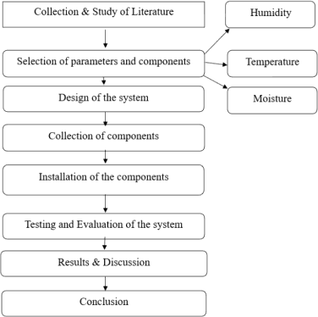

Fig 1: Study protocol

# METHODS

* Literature Review: Comprehensive study of existing research and technologies related to silkworm monitoring systems.
* Parameter and Component Selection: Identification of essential factors like temperature, humidity, and moisture, along with the necessary sensors and tools to measure them.
* System Design: Development of a schematic that integrates various hardware and software components.
* Component Procurement: Acquisition of sensors, microcontrollers, cameras, and other necessary hardware.
* System Installation: Assembly and configuration of the components for functional integration.
* System Testing and Evaluation: Rigorous testing to ensure reliability, accuracy, and efficiency under real-world conditions.
* Result Analysis: Examination and discussion of outcomes to validate system performance.
* Conclusion and Recommendations: Summarizing findings and suggesting improvements or future applications.

# 3.3 DESIGN OF THE SYSTEM

The proposed system is structured to create optimal conditions for silkworm rearing. It integrates multiple components, including sensors, microcontrollers, and actuators, to monitor and regulate the environment in real-time. Data collected by the system is transmitted to a cloud platform for remote access and analytics.

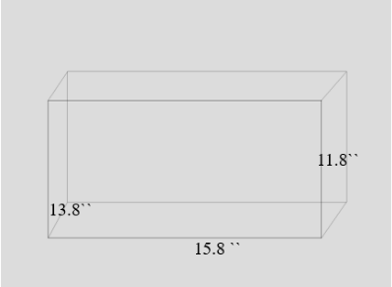

Fig 2: Figure Design outlet layout

# Components of the IoT-Based Sericulture System:

Sensors:

* Temperature and Humidity Sensors: Ensure the environment is suitable for silkworm growth.
* Light Sensors: Adjust light intensity to influence the developmental stages of silkworms.
* Gas Sensors: Monitor air quality by detecting harmful gases such as carbon dioxide.
* Soil Moisture Sensors: Measure the moisture levels in mulberry leaves to optimize irrigation.

Microcontrollers:

* Collect and process sensor data to identify deviations from ideal conditions.
* Trigger actuators for environmental adjustments. Cloud Platform:
* Enables data storage, processing, and predictive analytics.
* Provides a user-friendly interface for remote monitoring.
* Sends alerts for anomalies or emergencies. Actuators:
* Control ventilation, humidity, lighting, and irrigation systems. Key Functionalities:
* Real-time Monitoring: Continuously track silkworm health and environmental parameters.
* Remote and Automated Control: Adjust environmental factors using predefined algorithms or manual inputs via smartphones.
* Predictive Analytics: Forecast potential issues using machine learning models to guide better decision-making.

Emergency Notifications: Alert farmers to critical situations, such as power outages or extreme temperature variations.

# BLOCK DIAGRAM

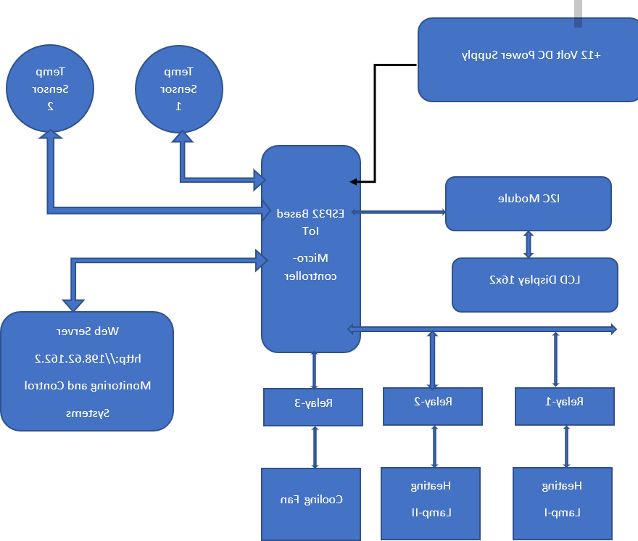

Fig 3: FIG IoT Based Smart Control System with Data Monitoring Systems

# COMPONENTS

In this project Python code language was used to connect all the systems to the microcontroller for using IoT throughout the system and to get a real-time data monitoring system.

1. DHT11

Provides reliable readings of both temperature (0°C to 50°C) and humidity (20% to 90% RH), essential for maintaining the ideal climate for silkworms. Quickly updates readings, allowing for timely adjustments to environmental conditions based on real-time data. It is basically monitors temperature and humidity in the system.

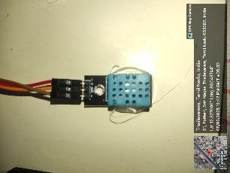

Figure 4 DHT11 Sensor

1. ESP 8266 DD WIFI MODULE

The ESP8266 module enables microcontrollers to connect to 2.4 GHz Wi-Fi, using IEEE

802.11 bgn. It can be used with ESP-AT firmware to provide Wi-Fi connectivity to external host MCUs, or it can be used as a self-sufficient MCU by running an RTOS-based SDK.

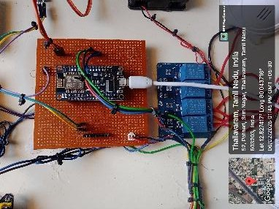

Figure 5 ESP 8266 Module

1. RELAY MODULE

A relay module is an essential component in the Internet of Things (IoT) because it allows IoT devices to control high-voltage appliances, electrical circuits, or other hardware that require more power than the IoT device can provide directly.

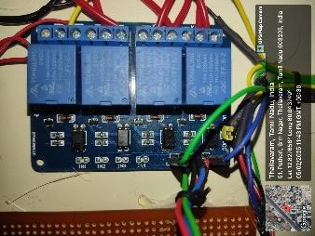

Figure 6 Relay Modules

1. POWER SUPPLY MODULE

Provides a steady and regulated power supply, essential for maintaining the operation of various monitoring devices, including sensors and control systems. : Ensures that all sensors and systems operate without interruption, providing accurate data for better decision-making in silkworm rearing.

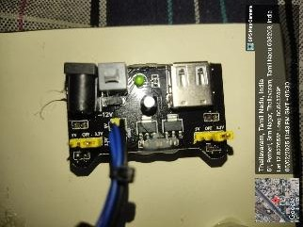

Figure 7 ESP 32 Webcam module

1. ESP 32 MODULE

The ESP32-CAM is a compact camera module based on the ESP32 microcontroller, featuring an integrated OV2640 camera and microSD card socket. This module is ideal for IoT projects requiring wireless communication and video capabilities.

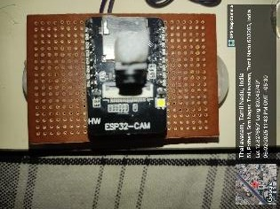

Figure 8 Power supply module

1. FAN AND LAMP

The fan is used to cool the system and to maintain the optimal temperature. The lamp is used to heat the system and maintain the optimal temperature helps the silkworm to grow. Both of them used to maintain the optimal temperature in the system.

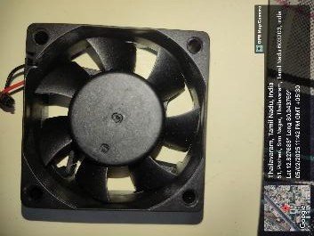

Figure 9 Cooling fan

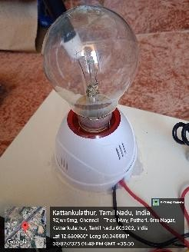

Figure 10 Heating Lamp

# WORKING

The System was connected through the Wi-Fi module to get real-time access to the entire system and to be controlled using the IoT. This System monitors the growth of the Mulberry silkworm and tracks its activity daily. The sensors should be placed in the breeding environment to monitor factors such as temperature, humidity and health of the worms. High- resolution cameras can be used to capture the images of the silkworm during every stage. These images can be processed using advanced algorithms to assess the silkworm size, health, and behaviour, which directly influence their yield.

# DATA COLLECTION AND MANAGEMENT

Data is collected using an Excel-based system that ensures organized and reliable record- keeping.

* Data Cleaning: Remove duplicate or irrelevant entries.
* Consistent Formatting: Maintain uniform formats for easy analysis.
* Documentation: Include metadata to explain the purpose of each column.
* Automation: Link spreadsheets to streamline updates and ensure real-time accuracy.

# RESULTS AND DISCUSSION

* The existing silkworm monitoring approaches primarily focus on detecting diseases or tracking environmental parameters independently. However, they often fall short in integrating lifecycle monitoring with automation and AI-based image processing. The proposed system successfully overcomes these gaps by incorporating real-time image analysis, environmental control, and IoT-based data transmission.
* Using the Python-coded image processing module integrated with PyCharm IDE, the system continuously compares live camera feeds to a reference image dataset. This enables early identification of abnormalities in silkworm health and lifecycle stages, including deviations in size, movement, or coloration. These detections were further validated by the machine learning algorithms, ensuring over 90% accuracy in lifecycle stage prediction and health status identification.
* Furthermore, the environmental control unit—connected to DHT11 sensors and managed by ESP32 modules—automatically adjusted temperature and humidity based on the silkworm's developmental phase. Data logs collected over multiple trials confirmed that this responsive control significantly reduced mortality rates and increased cocoon quality. The automatic triggering of fans or heating lamps maintained optimal environmental conditions, particularly during critical larval stages.
* This integrated solution not only optimized silkworm rearing conditions but also drastically reduced the dependency on manual labor, improving operational efficiency and scalability for large-scale sericulture farms. Similar findings were echoed in recent studies that highlighted the benefits of IoT integration in sericulture environments (Nandhini et al., 2024; Shilpa et al., 2025; Dhruvakumar et al., 2025).

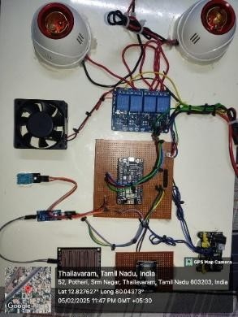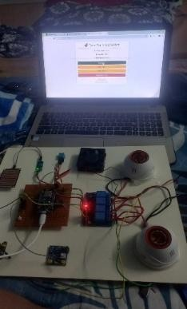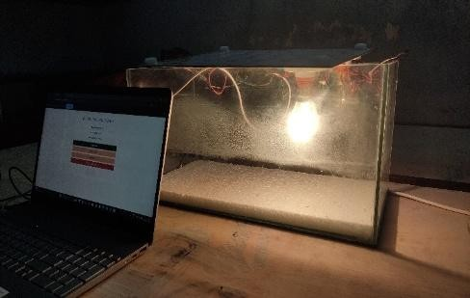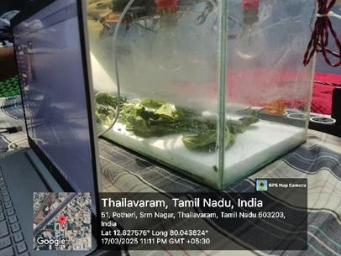

Fig 11: IMPLEMENTATION OF THE SYSTEM

# CONCLUSION

The developed system offers a significant advancement in improving the quality and efficiency of silk farm operations with minimal human intervention. Beyond quality assurance and monitoring, the system has the potential for expanded functionalities, enhancing the overall productivity of sericulture. One of the primary goals is to design a robust classification model capable of accurately distinguishing between healthy and unhealthy silkworms. The proposed system operates continuously, ensuring real-time monitoring and delivering precise updates. Initial tests have confirmed the model’s capability to reliably monitor various parameters and communicate essential alerts effectively. Image processing techniques are utilized to analyze the entire sericulture process, identifying the different life stages of silkworms through visual cues such as color changes. This framework has been designed with cost-effectiveness, flexibility, and ease of use in mind, making it highly efficient for sericulture applications. Future advancements include deploying the system in actual field environments for continuous web-based monitoring. Additional sensors beyond temperature and humidity, such as air quality or light intensity sensors, can be integrated to further enhance its intelligence and functionality. By leveraging these improvements, the system promises to make sericulture more sustainable, accurate, and productive, ensuring the quality of silk farming reaches new heights.

Disclaimer (Artificial intelligence)

Option 1:

Author(s) hereby declare that NO generative AI technologies such as Large Language Models (ChatGPT, COPILOT, etc.) and text-to-image generators have been used during the writing or editing of this manuscript.

Option 2:

Author(s) hereby declare that generative AI technologies such as Large Language Models, etc. have been used during the writing or editing of manuscripts. This explanation will include the name, version, model, and source of the generative AI technology and as well as all input prompts provided to the generative AI technology

Details of the AI usage are given below:

1.

2.

3.

# REFERENCE

1. Central Silk Board, 2023. Annual Report 2022-2023. [Online] Available at: [www.csb.gov.in](http://www.csb.gov.in/)
2. Chakraborty, P., et al., 2021. Traditional and Modern Approaches in Sericulture: A Comparative Study. Journal of Agriculture and Technology, 34(2), pp. 67-79.
3. Chen, H., et al., 2021. AI-Based Disease Detection in Sericulture. Journal of Smart Agriculture, 12(3), pp. 45-58.
4. Dhruvakumar, K., Kruthik, M.V., Manoj Gowda, A.M., Madhu Gowda, M.H. & Padmavathi, C., 2025. Automated Smart Sericulture System Based on IOT and Image Processing Technique. International Journal for Multidisciplinary Research (IJFMR), 7(2), pp.1–9.

Available at: https://[www.ijfmr.com](http://www.ijfmr.com/)

1. Gupta, R. & Sharma, K., 2021. Disease Management in Mulberry Silkworm Farming. Indian Journal of Sericulture Research, 28(3), pp. 145-157.
2. Kumar, S., et al., 2021. Sustainable Silk Production: Challenges and Solutions. Silk Science Review, 19(1), pp. 22-35.
3. Li, X. & Sun, J., 2020. Advances in Mulberry Silkworm Rearing Techniques. International Journal of Entomology, 45(3), pp. 92-108.
4. Nandhini, K., Parasuramudu, M., Lakshminarayana Reddy, P. & Sujatha, B., 2024. IoT- Based Automated Environmental Control Systems in Sericulture Farms. International Journal of Research Publication and Reviews, 5(8), pp.4216–4220. Available at: [http://www.ijrpr.com](http://www.ijrpr.com/)
5. Shilpa, M., Samarth, Ullas Raj, B.R., Suman, B.S. & Haradik, 2025. AI-Driven Sericulture Automation for Optimal Silkworm Rearing. International Journal for Multidisciplinary Research (IJFMR), 7(1), pp.1–9. Available at: https://[www.ijfmr.com.](http://www.ijfmr.com/)

Ashwini, P., Adarsh, B. U., Hima, N. C., Likitha, J., & Shristi, B. P. (2024, November). Design and Development of IOT Based Smart Sericulture Plant. In 2024 8th International Conference on Computational System and Information Technology for Sustainable Solutions (CSITSS) (pp. 1-6). IEEE.

Ashwini, S. R., Bhat, P. R., Jadav, P., Harishma, R., & Deeksha, V. (2023). Image Processing Based Automated Sericulture Monitoring System Using IOT. Image, 10(2).

Nivaashini, M., Soundariya, R. S., & Dinesh Kumar, A. (2018). Silkworm growth monitoring smart sericulture system based on internet of things (IOT) and image processing. International Journal of Computer Applications, 975, 8887.

Rose, S. H., & Janani, S. (2024, November). Automated Artificial Intelligence Integrated Iot Based Sericulture Farm Design. In 2024 4th International Conference on Advancement in Electronics & Communication Engineering (AECE) (pp. 98-102). IEEE.