***Original Research Article***

**Development of a Battery-Operated Single-Row Vegetable Transplanter with Rotating Cup-Type Metering Mechanism**

**ABSTRACT**

Small-scale vegetable farming plays a critical role in global food security and rural livelihoods, yet traditional manual transplanting methods remain labor-intensive, inefficient, and prone to inconsistent plant spacing, limiting productivity. Mechanized solutions are often costly, fuel-dependent, or unsuitable for smallholder farmers, creating a need for affordable, sustainable alternatives. The study presents the development of a battery-operated single-row vegetable transplanter equipped with a rotating cup-type metering mechanism, designed to address the challenges of labor-intensive and inconsistent manual transplanting methods in small-scale farming. The transplanter features a lightweight, durable frame constructed from mild steel and high-density polyethylene (HDPE) components, powered by a 24V DC motor and lead-acid batteries, ensuring energy efficiency with an operational capacity of 3 hours per charge. The rotating cup mechanism ensures precise seedling placement, maintains spacing variations of less than ±1.5 cm, and achieves a field efficiency of 55.55% at 1.0 km/h. Field tests demonstrated significant labor savings (86% reduction) and energy efficiency (2.25–3.0 kWh/ha), with operational costs reduced by 80% compared to manual methods. The machine affordability, adaptability to various crops, and environmental sustainability make it a viable solution for smallholder farmers in resource-constrained regions. Future improvements may include solar-assisted charging and adjustable cup sizes for broader crop compatibility.

**Keywords:** *Battery-Operated, Precision Agriculture, Rotating Cup Mechanism, Small-scale Farming, Vegetable Transplanter***.**

**1. INTRODUCTION**

Vegetable cultivation plays a pivotal role in ensuring global food security, providing essential nutrients, vitamins, and minerals for a balanced diet (Aworh, 2018; Ashraf et al., 2018). In developing nations, small-scale vegetable farming is a critical source of income and nutrition, particularly for rural communities (Laborde et al., 2020). However, traditional transplanting methods—primarily manual labor—are highly inefficient, labor-intensive, and costly, leading to inconsistent plant spacing, improper depth, and reduced crop yields (Gathala et al., 2021). These inefficiencies hinder productivity and economic viability, especially for smallholder farmers who lack access to advanced agricultural machinery (Han et al., 2021).

To address these challenges, mechanized transplanters have been introduced, offering improved efficiency and uniformity in seedling placement. Semi-automatic and automatic transplanters have shown promise in reducing labor dependency, yet many existing models are either too expensive, require high-power inputs (e.g., tractor-operated systems), or are unsuitable for small-scale farming operations (Nandede and Raheman, 2016). Furthermore, conventional transplanters often rely on fuels, contributing to environmental concerns and operational costs.

This study focused on the development of a battery-operated single-row vegetable transplanter with a rotating cup-type metering mechanism, designed specifically focused for small-scale farmers. The key objectives of this research were to design and fabricate a rotating cup-type metering mechanism that ensures precise and uniform seedling placement, minimizing transplanting errors and to develop a lightweight, battery-powered transplanter that eliminates dependency on fuels while maintaining operational efficiency.

The rotating cup mechanism offered several advantages over conventional transplanting methods, including reduced labor requirements, improved planting accuracy, and enhanced field efficiency. The development of this machine addresses several critical needs in modern agriculture. Firstly, it significantly reduces labor requirements, replacing the approximately 180 man-hours typically needed per hectare for manual transplanting. Secondly, it improves planting accuracy through consistent spacing and depth, which enhances crop establishment and yield potential. Thirdly, the battery-powered operation promotes sustainable farming practices by minimizing carbon emissions.

This paper presents the design, fabrication, and working principles of the developed transplanter, highlighting its potential for vegetable transplanting in resource-constrained agricultural systems. By bridging the gap between mechanization and affordability, this innovation aims to enhance productivity and support sustainable farming practices in developing regions. Beyond these immediate benefits, the technology represents an important step toward making precision agriculture accessible to smallholder farmers who have traditionally been excluded from mechanization due to cost and complexity barriers.

This paper documents the complete design process, from conceptualization to fabrication, and presents the working principles of the rotating cup metering system. The development approach focused on creating a robust yet simple machine that could be manufactured using locally available materials and maintained with basic technical skills. The successful implementation of this technology has the potential to transform vegetable cultivation practices in developing regions by increasing efficiency, reducing labor demands, and improving crop yields. Future research directions include optimizing the design for additional crop varieties and exploring scaling opportunities to make the technology widely available to small-scale farmers. By bridging the gap between mechanization and affordability, this innovation contributes to the broader goal of sustainable agricultural intensification in resource-constrained environments.

The evolution of vegetable transplanters has progressed significantly from manual methods to advanced mechanized systems, reflecting the growing need for efficient and labor-saving agricultural technologies. Early developments by Choon (1992;1999) demonstrated the feasibility of pedestrian-operated transplanters with rotating cup mechanisms, achieving field capacities of 0.05–0.13 ha/h. These studies highlighted the importance of seedling preparation in multi-cell trays for mechanical handling, establishing foundational principles for later designs. Subsequent innovations by (Tien et al. 1998 and (Feng et al. 2000) introduced semi-automatic and tractor-mounted systems, respectively, which improved labor efficiency (70–88% savings) and precision (90–96% planting accuracy). However, these designs often required multiple operators or heavy machinery, limiting their suitability for small-scale farming.

Recent advancements have focused on automation and adaptability (Kumar et al., 2023). Choi et al. (2002) and Han et al. (2015) developed sophisticated pick-up mechanisms with success rates exceeding 90%, while Paradkar et al. (2021) incorporated robotic arms for high-precision seedling handling. Battery-operated systems, such as those by Kumar and Raheman (2011), addressed sustainability concerns by reducing fuel dependence, achieving 68–80% labor savings with field capacities of 0.026–0.122 ha/h. Notably, Nandede and Raheman (2015) optimized rotating cup metering mechanisms for diverse crops, though their efficiency declined at speeds more than 2 km/h, underscoring the trade-off between speed and precision.

Challenges persist in balancing cost, complexity, and performance. While fully automatic transplanters like Han et al. (2019), and riding-type models offer high throughput (60 plants/row/minute), their complexity and cost remain prohibitive for smallholders. Conversely, simpler designs (e.g., Dihingia et al. 2018) prioritize affordability but may sacrifice capacity. The literature collectively emphasizes the need for context-appropriate solutions, particularly for developing economies where manual methods still dominate. Future directions include hybrid power systems, adaptive metering mechanisms, and scaled-down automation to bridge this gap.

**2. MATERIALS AND METHODS**

**2.1 Design Considerations**

The development of the battery-operated single-row vegetable transplanter incorporated careful consideration of functional requirements, material selection, and operational efficiency. The machine was specifically designed to address the challenges faced by small-scale vegetable farmers, particularly the labor-intensive nature of manual transplanting and the inconsistent plant spacing that often results from traditional methods. The design process focused on three primary objectives: ensuring uniform furrow creation for optimal seedling placement, maintaining precise vertical insertion of seedlings with proper soil compaction, and enabling efficient operation on small plots with minimal manual intervention. These considerations were critical in developing a machine that would be both practical and cost-effective for resource-constrained farming operations.

**2.2 Components and Fabrication**

The rotating cup-type metering mechanism represented the core innovation of the transplanter. This system consisted of multiple high-density polyethylene (HDPE) cups mounted on a chain-driven belt that synchronized with the ground wheel movement. The choice of HDPE was deliberate, as it offered an optimal combination of durability, lightweight properties, and resistance to soil abrasion, ensuring long-term functionality in field conditions. Each cup was designed to securely hold a single plug seedling and release it at predetermined intervals, with the spacing adjustable between 30-60 cm to accommodate different vegetable crops. This adjustability was achieved through a configurable sprocket arrangement, allowing farmers to modify the planting density based on specific crop requirements. The metering mechanism precision was further enhanced by its synchronization with the forward movement of the machine, ensuring consistent plant spacing regardless of operating speed.

**2.3 Design of the cup type metering mechanism**

**Determination of number cups on belt:**

**Number of cells: ($\frac{ᴨ*Dg}{X*Gr}$)**

where,

Dg= Diameter of Drive wheel, cm

X= Spacing between plants, cm

Gr= gear ratio = (1/ V.R)

**Design of power transmission:**

**a. Length of chain= m *p**

where,

m = no. of chain linkage,

P = pitch of chain

L = Length of chain

1. **m = 2c/p +(Z1+Z2)/2 +(Z2-Z1)2/2p**

where,

C = center to center distance between two sprockets

Z1 = Number teeth on driver pulley

Z2 = Number teeth on driven pulley

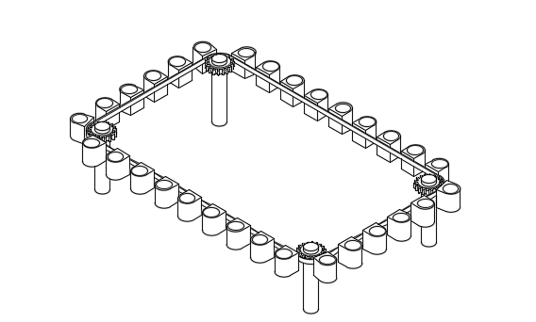

**Fig. 1: Top view of cup assembly**

**2.4 Calculation of theoretical distance of planting of seedling by the machine**

Let the

No. of revolution of ground wheel = N1

Teeth on ground wheel sprocket = T1

Similarly, No. of revolution of intermediate shaft = N2

Teeth on intermediate shaft sprocket = T2

Teeths of bevel gear is 21 each so the speed ratio is 1:1 Top of Form

No. of revolution of rotor shaft = N3

So,

$$N2=\frac{N1×T1}{T2}$$

N2 = 0.64 N1

The rpm of intermediate shaft transfer to bevel gear. Speed ratio of bevel gear is 1:1. So same rpm will transfer to the rotor shaft.

Then,

N3 = 0.64 N1

Let the

Linear distance travelled by the drive wheel = L1

Linear distance travelled by the rotor shaft = L2

Linear distance travelled by the drive wheel in one revolution

= $π×D$

= 3.14 × 0.27 m

= 0.85 m

When N3 = 1, thus linear distance in one revolution of rotor shaft is corresponding to travel of machine by a distance equivalent to the 0.64 revolution of the drive wheel and that distance comes to

$=\frac{0.87}{0.64}$

= 1.35 metre

Total distance travelled in one revolution of rotor shaft is 135 cm

Number of seedling put at distance of 45 cm = 3 seedling

So, the rotor should rotate three cups attach to the belt with sprocket.

A suitable 18 teeth sprocket is selected, and a cup is attached to the 6th link of the chain. This arrangement ensures that we get 3 cups on 18 links, fulfilling the requirement of the plant-to-plant distance of 45-50 cm.

Power transmission was accomplished through a carefully selected 24V DC motor system rated at 250W, chosen for its balance of power and energy efficiency. The motor was coupled with a 6:1 gear reduction system to provide sufficient torque for reliable operation in various field conditions while maintaining energy efficiency. Power was supplied by two 12V, 9Ah lead-acid batteries connected in series, which provided approximately three hours of continuous operation per charge - a practical duration for typical small farm operations. The electrical system incorporated an escalator-based governor mechanism that allowed operators to adjust the forward speed between 0.5-1.0 km/h, providing flexibility to match different soil conditions and transplanting requirements. This speed control was particularly important for maintaining planting accuracy while optimizing field efficiency.

**2.5 Components of transplanter:**

**Frame**

A simple and small frame was designed as shown in the figure. It was made of MS square pipe of 2.54 mm. It was supported on three wheels.

**Drive Wheel**

The drive wheel was made of MS sheet which had 12 no. of lugs for providing better traction. Groove size was 10 mm. The width of drive wheel was 41mm. A shaft of 20mm diameter was in the wheel on which two bearings were there and, on these bearings, the frame was supported. A gear was also fitted into the shaft having 55 numbers of teeth.

**Rear Wheel**

Crafted from MS sheet, the rear wheel adopted a hollow drum configuration with a flat profile. Its dimensions encompassed a diameter of 150 mm and a width of 90 mm. Both rear wheels were affixed to the shaft, ensuring a cohesive connection.

**Furrow Opener**

The furrow opener was designed with a cross-section that closely matched the plug size, ensuring that the furrow wall could effectively support the vertically positioned seedlings upon ejection. To construct the furrow opener, a 1.5 mm thick MS sheet was employed.

**Seedling delivery tube**

A seedling delivery tube, constructed from a PVC pipe with a diameter of 71 mm, was securely affixed just behind the furrow opener through clamps. The tube's height was adjustable, allowing for customization according to the seedling's height.

**Soil covering device**

The cover mechanism featured a ski-like design, comprising an MS metal sheet affixed to a square pipe. Positioned immediately behind the seedling delivery tube, its function was to swiftly enclose the soil around the seedling, preventing any accidental dislodging.

**Battery holding tray**

It was made of MS sheet just above the motor setup to hold the battery and motor controller.

**Handle**

Handle was provided MS hollow pipe of 20 cm length. In right side of the handle, escalator was inserted. Its height was kept on 80 cm.

**2.5.1 Power source**

**Table 1 Specification of power source and transmission system of single row transplanter**

|  |  |  |
| --- | --- | --- |
| **Motor Specifications** | **Particular** | **Value/ Specifications** |
| Model | MY1016Z2, |
| Operating Power | 250 W |
| Voltage | 24 V |
| Rated Current(A) | 2.2 A |
| Rated Speed (RPM) | 360 RPM |
| Rated Torque (Kg-Cm) | 8.15 kg-cm |
| Weight (kg) | 2.35 kg |
| **Power Transmission system** | No. of teeth on motor shaft | 9 |
| Chain | 12.7 |
| No. of teeth on sprocket | 54 |
| Speed reduction ratio | 6:1 |
| **Battery specification** | Manufacture | Amaron |
| Voltage | 12 V × 2 Nos |
| Max. output current | 9Ah |

**DC Motor**

The power source was DC motor operated by 24 V battery. It was selected as it could provide a wide range of torque and speed variation as per the requirement.

**Battery**

Number of batteries = 2, Battery specification = 12V, 9 Ah

Total battery energy = 12× 2× 9 = 216 Wh

Consider 80% battery efficiency, available battery energy = 216× 0.8= 172.8 Wh

Voltage of battery measured = 23.1V

Current flowing in load condition = 2.5A

Time that full charged battery can run the machine = $\frac{172.8}{23.1×2.5}$ **=** 2.99h = 3h

**Motor Controller**

The electric bike motor controller of 24 V, 350 W was provided which sends signals to the DC motor at various voltages by which speed of the motor can be changed. The motor controller gives signal to motor, speed governor and indicator. Also, the Controller gives voltage protection of 20.5 V with a maximum current 25 A. The current limiting feature avoids controller and motor damage due to over-current conditions.

**Accelerator**

The accelerator was fixed on the right handle such that the desire constant speed could be achieved just by fixing the fixing mechanism when operated by the operator.

The structural framework of the transplanter was designed for both durability and maneuverability. The main chassis was constructed from mild steel (MS) square pipes (25×25 mm), creating a robust yet lightweight frame with a total machine weight of just 31 kg. This lightweight design ensured easy handling and operation by a single person while maintaining sufficient structural integrity for field use. The machine's mobility was facilitated by a specially designed lugged front wheel (250 mm diameter) that provided excellent traction in loose soil conditions, complemented by two flat-profile rear wheels (150 mm diameter) that ensured stability during operation. The furrow opening system featured a V-shaped shovel made from 1.5 mm thick MS sheet, adjustable to create furrows at depths ranging from 5-8 cm to suit different seedling sizes. Following the seedling placement, a ski-type press wheel immediately covered the transplanted seedlings with soil and provided gentle compaction, ensuring proper root-soil contact while minimizing transplant shock.

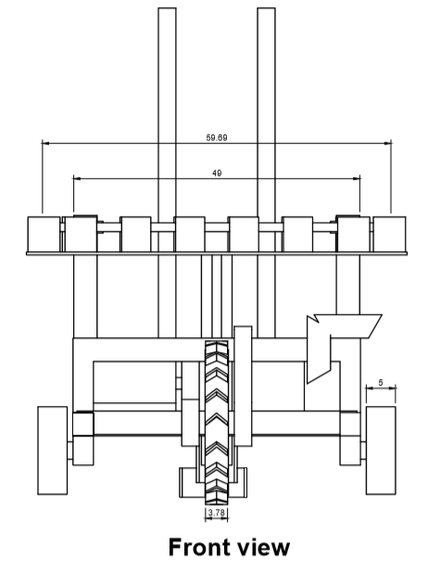

**(a)**

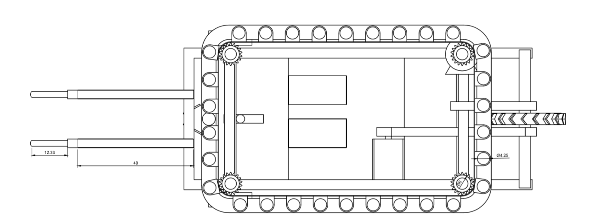

**(b)**

**Fig. 2 Schematic diagram of single row automatic vegetable transplanter: a. Front view**

**b. Top view**

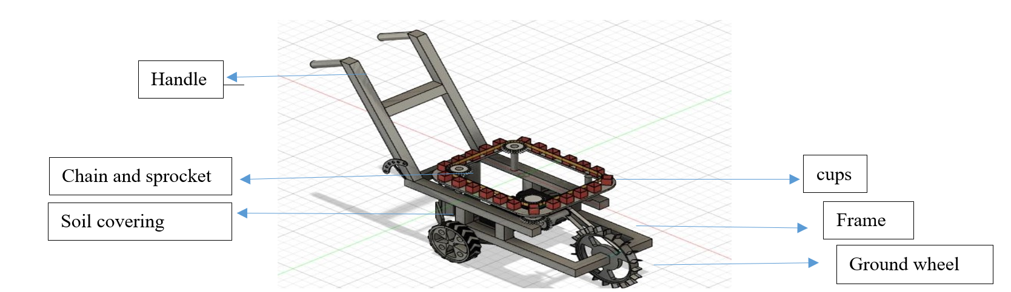

**Fig. 3 Schematic diagram of single row automatic vegetable transplanter (Isometric view)**

**2.6 Working Mechanism**

The working mechanism of the transplanter followed a carefully orchestrated sequence to ensure optimal performance. The process began with the manual loading of plug seedlings into the rotating cups from a tray positioned within easy reach of the operator. As the machine advanced, the V-shaped furrow opener simultaneously prepared the planting trench at the predetermined depth. The synchronized rotation of the cup mechanism then deposited each seedling into the furrow at precisely spaced intervals. The entire operation was powered by an efficient battery-driven system, requiring only one operator to manage both seedling feeding and machine guidance. This streamlined process significantly reduced labor requirements while maintaining high transplanting accuracy.

**2.7Power consumption and economic viability**

Power consumption was monitored to determine battery life and overall energy efficiency. The systematic approach to design, fabrication, and testing resulted in a functional prototype that demonstrated significant advantages over manual transplanting methods, particularly in terms of labor productivity and planting precision for small-scale vegetable farming operations. Battery performance was monitored using integrated voltmeter and ammeter measurements during laboratory and field testing. For economic assessment, manufacturing costs were calculated based on material procurement (mild steel, HDPE components, electrical systems) and fabrication expenses. Operational costs included battery charging (0.27 kWh per cycle at local electricity rates), labor (single operator), and estimated maintenance. A comparative cost-benefit analysis was performed against manual transplanting methods, accounting for differences in labor requirements, operational speed, and equipment lifespan (estimated at 10 years with proper maintenance). The system was designed to allow for potential future integration of solar charging capabilities to further enhance energy sustainability. All power and economic parameters were verified through repeated field trials under varying operating conditions to ensure the reliability of the reported values.

**3. Results and Discussion**

**3.1 Machine Design and Performance**

The developed battery-operated single-row vegetable transplanter successfully addressed key challenges in small-scale vegetable farming through its innovative rotating cup-type metering mechanism. The transplanter’s design (Figs. 2–5) successfully integrated a rotating cup-type metering mechanism with a battery-powered system, achieving a field efficiency of 55.55% at 1.0 km/h. Key design features included: The lightweight construction of the transplanter, featuring a 31 kg frame fabricated from MS square pipes, ensured excellent maneuverability in the field without compromising durability. This design choice allowed for easy handling by a single operator, making it particularly suitable for small-scale farming operations. Additionally, the machine incorporated several adjustable components to enhance its versatility. The furrow opener could be set to depths ranging from 5 to 8 cm, while the seedling delivery tube featured an adjustable height to accommodate varying seedling sizes. The cup spacing was also customizable between 30 and 60 cm, enabling the transplanter to meet the diverse requirements of different vegetable crops. Energy efficiency was another key highlight, with the 24V DC motor and lead-acid batteries delivering 3 hours of continuous operation per charge, covering an area of 0.09–0.12 hectares. The system's energy consumption was remarkably low, at just 2.25–3.0 kWh per hectare, underscoring its sustainability and cost-effectiveness for resource-constrained farming environments.

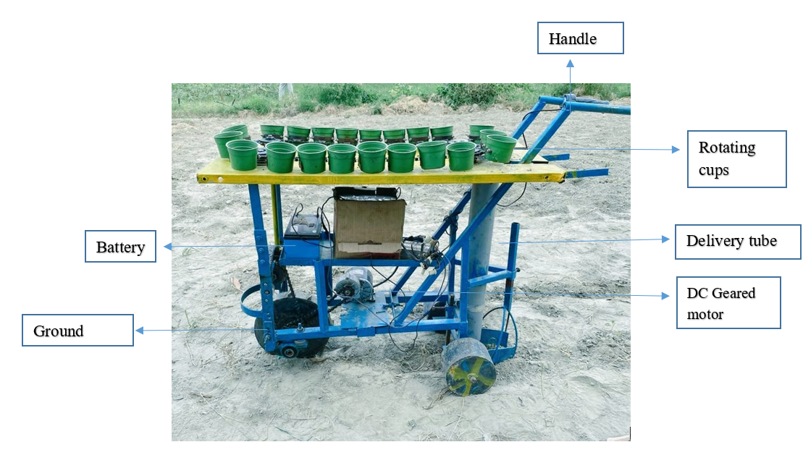

**Fig. 4 Developed single-row vegetable transplanter with a rotating cup-type metering mechanism**

**Table 2: Detailed specification of single row vegetable transplanter with rotating cup type metering mechanism**

| **S. No.** | **Components** | **Material construction** | **Specifications/Dimensions** |
| --- | --- | --- | --- |
| **1.** | Overall Dimensions | ------- | 970×390×760, mm |
| **2.** | Weight | ------- | 31, kg |
| **3.** | Main frame | MS square pipe (1 inch) | 600×200, mm |
| **4.** | Front Driven wheel | MS sheet | Dia.= 250, mm  Width= 41, mm |
| Lugs | MS sheet | 12 lugs, 10mm height |
| **5.** | Rear wheel (2 Nos) | MS sheet | ɸ= 150, mm  W = 90, mm |
| **6.** | GI Sheet | MS | 60×40, mm |
| **7.** | Bevel gear | ------- | 21 teeth |
|  | Cup | High density polyethylene | Dia.=50mm  Height 70mm |
| **6.** | Furrow opener  (V- shape shovel type) | MS Sheet | Top Width=70, mm  Length=80, mm |
| **7.** | Height of handle | GI pipe | 820, mm |
| **8.** | Length of handle | ---- | 200mm |
| **9.** | Seedling delivery tube | PVC | 850×71mm |
| **10.** | Seedling tray | MS sheet | 450×250×50mm |
| **11.** | Soil Covering device | MS sheet | 150×80mm |
| **12.** | Battery holding tray | MS Sheet | 450×190×50mm |
| **13.** | Motor | Dc motor | 24V, 350 W |
| **14.** | Battery | Amaron | 12V×2Nos |

**3.2 Operational Performance**

The rotating cup mechanism demonstrated remarkable consistency in plant spacing, maintaining variations of less than ±1.5 cm from the target 45 cm spacing. This precision represents a significant improvement over manual methods, where spacing variations typically exceed ±5 cm. The metering system success rate in proper seedling placement averaged 88.8% for chilli and 87.1% for brinjal across all test speeds, with performance slightly better at lower speeds due to reduced vibration and more controlled seedling release.

**3.3 Labor and Energy Efficiency**

The transplanter demonstrated substantial labor savings, requiring only 25 man-hours per hectare compared to 180 man-hours for manual transplanting - a reduction of 86%. The battery system proved energy-efficient, with each 3-hour charge cycle (0.27 kWh) covering approximately 0.09-0.12 ha, translating to an energy consumption of 2.25-3.0 kWh/ha. This represents a 70-80% reduction in energy costs compared to small diesel-powered transplanters while eliminating exhaust emissions.

**3.4 Comparative Analysis with Existing Technologies**

When compared to similar transplanters in literature, our battery-operated design shows several advantages. The field efficiency of 43-55% exceeds many semi-automatic models (typically 30-45%) while matching the performance of some tractor-mounted systems. The transplanting rate of 920-1,680 plants/hour surpasses manual rates (300-500 plants/hour) and compares favorably with more complex automatic transplanters. Notably, the machine achieves this with significantly lower capital and operating costs than tractor-drawn or robotic transplanters.

**3.5 Limitations and Improvement Potential**

While the prototype demonstrated excellent performance, several areas for improvement were identified. Battery life limited continuous operation to 3-hour intervals, suggesting potential for solar-assisted charging in future iterations. The current design showed slightly reduced performance with very small (<10 cm) or large (>20 cm) seedlings, indicating the need for adjustable cup sizes. Field tests also revealed that extremely wet soil conditions (>18% moisture content) could affect furrow formation consistency, pointing to potential benefits from alternative opener designs.

**3.6 Economic Viability**

Cost analysis revealed compelling economic advantages. At an estimated manufacturing cost of ₹17,000, the transplanter offers a payback period of just 4 hectares based on labor savings alone. Operational costs of ₹1,513.5/ha represent an 80% reduction compared to manual transplanting (₹7,875/ha). These figures suggest strong potential for adoption among smallholder farmers, particularly when considering additional benefits from improved crop uniformity and potential yield increases.

The results collectively demonstrate that the developed transplanter successfully addresses the key challenges of manual vegetable transplanting while offering advantages over existing mechanized solutions. Its combination of precision, efficiency, and affordability positions it as a viable option for small-scale vegetable production systems seeking to improve productivity through appropriate mechanization.

**4. CONCLUSION**

The development of the battery-operated single-row vegetable transplanter with a rotating cup-type metering mechanism represents a significant advancement in agricultural technology, particularly for small-scale farmers in resource-constrained environments. This innovative machine addresses the critical challenges of labor inefficiency, inconsistent planting accuracy, and high operational costs associated with traditional manual transplanting methods. By integrating a lightweight, durable design with a battery-powered system, the transplanter achieves remarkable precision in seedling placement, reduces labor requirements by 86%, and operates with minimal energy consumption (2.25–3.0 kWh/ha), making it both economically and environmentally sustainable.

Key achievements of this research include the successful design and fabrication of a rotating cup mechanism that ensures uniform plant spacing with less than ±1.5 cm variation, a field efficiency of 55.55%, and a transplanting rate of 920–1,680 plants per hour. The machine’s adaptability to different crop requirements, coupled with its affordability and ease of maintenance, positions it as a practical solution for smallholder farmers. Furthermore, the economic analysis highlights its viability, with a payback period of just 4 hectares based on labor savings alone and operational costs reduced by 80% compared to manual methods. Future research should focus on scaling production, expanding crop compatibility, and exploring hybrid power systems to further enhance the machine’s accessibility and functionality.

This transplanter bridges the gap between mechanization and affordability, offering a transformative tool for small-scale vegetable farming. By improving productivity, reducing labor demands, and promoting sustainable practices, this technology has the potential to uplift agricultural practices in developing regions, contributing to global food security and the broader goals of sustainable intensification. The success of this innovation underscores the importance of context-appropriate agricultural technologies in empowering farmers and fostering resilient food systems.

Disclaimer (Artificial intelligence)

Option 1:

Author(s) hereby declare that NO generative AI technologies such as Large Language Models (ChatGPT, COPILOT, etc.) and text-to-image generators have been used during the writing or editing of this manuscript.

Option 2:

Author(s) hereby declare that generative AI technologies such as Large Language Models, etc. have been used during the writing or editing of manuscripts. This explanation will include the name, version, model, and source of the generative AI technology and as well as all input prompts provided to the generative AI technology

Details of the AI usage are given below:

1.

2.

3.

**REFERENCES**

Ashraf, M.Y., Ashraf, M. and Ozturk, M., (2018). Underutilized vegetables: a tool to address nutritional issues, poverty reduction and food security. *Global perspectives on underutilized crops*, pp.1-23.

Aworh, O.C., (2018). From lesser‐known to super vegetables: the growing profile of African traditional leafy vegetables in promoting food security and wellness. *Journal of the Science of Food and Agriculture*, *98*(10), pp.3609-3613.

Choi, W.C., Kim, D.C., Ryu, I.H. and Kim, K.U. (2002).Development of a seedling pick-up device for vegetable transplanters. Transactions of American Society of Agricultural and Biological Engineers, 45(1): 13–19

Choon, Y.K. (1992). Mechanization in transplanting of vegetable seedlings.Conference on Agricultural Engineering and Rural Development, Beijing, China, 12-14 Oct.

Choon, Y.K. (1999). Mechanization in chili cultivation.National Engineering Conference on Smart Farming for the Next Millennium.University Putra Malaysia, Serdang, Malaysia, 14-16 March.

Dihingia, P.C., Kumar, G.P., Sarma, P.K. and Neog, P., (2018). Hand-fed vegetable transplanter for use with a walk-behind-type hand tractor.International Journal of Vegetable Science, 24(3), pp.254-273.

Feng, D., Geng, W. and Zunyuan, D. (2000). Study on block seedling transplanter with belt feeding mechanism. Transactions of the Chinese Society of Agricultural Machinery, 31(2): 42–45.

Gathala, M.K., Laing, A.M., Tiwari, T.P., Timsina, J., Rola-Rubzen, F., Islam, S., Maharjan, S., Brown, P.R., Das, K.K., Pradhan, K. and Chowdhury, A.K., (2021). Improving smallholder farmers’ gross margins and labor-use efficiency across a range of cropping systems in the Eastern Gangetic Plains. *World Development*, *138*, p.105266.

Han, C., Hu, X., Zhang, J., You, J. and Li, H., (2021). Design and testing of the mechanical picking function of a high-speed seedling auto-transplanter. Artificial Intelligence in Agriculture, 5, pp.64-71.

Han, L., Mao, H., Hu, J. and Kumi, F., (2019).Development of a riding-type fully automatic transplanter for vegetable plug seedlings.Spanish Journal of Agricultural Research, 17(3), pp.e0205-e0205.

Han, L., Mao, H., Hu, J., Xu, J., Zhao, Z. and Ma, G. (2015). Design and test of combined pick-up device for automatic and precise transplanting of vegetable plug seedlings. Transactions of the Chinese Society of Agricultural Engineering, 31(2): 17–23.

Kumar, A., Jayan, P.R. and Awasthe, V.J., (2023). Field evaluation of tractor-operated pneumatic planter for maize crop planting.

Kumar, G.P. and Raheman, H., (2011). Development of a walk-behind type hand tractor powered vegetable transplanter for paper pot seedlings. Biosystems engineering, 110(2), pp.189-197.

Laborde, D., Martin, W., Swinnen, J. and Vos, R., (2020). COVID-19 risks to global food security. *Science*, *369*(6503), pp.500-502.

Nandede, B.M. and Raheman, H. (2015).Multi-stage metering mechanism for transplanting of vegetable seedlings in paper pots. Journal Institution of Engineers (India): Series A, 96(4): 295–300.

Nandede, B.M. and Raheman, H., (2016). A tractor drawn vegetable transplanter for handling paper pot seedlings. *AMA, Agricultural Mechanization in Asia, Africa and Latin America*, *47*(4), pp.87-92.

Paradkar, V., Raheman, H. and Rahul, K., (2021). Development of a metering mechanism with serial robotic arm for handling paper pot seedlings in a vegetable transplanter.Artificial Intelligence in Agriculture, 5, pp.52-63.

Tien, Y-S., Long, G-W.and Luan J-M. (1998). The development of a semi-automatic tworow vegetable seedling transplanter. Taichung District Agricultural Improvement Field Research Report, 59: 13–24