**Research Articles**

**“Evaluation of decomposition rates and suitability of various crop residues for vermicompost production”**

**ABSTRACT**

**Aims:** Evaluation of decomposition rates and suitability of various crop residues for vermicompost production

**Study Design:** Randomized block design (RBD)

**Place and Duration of Study**: Centre for Organic Agriculture Research and Training Farm, Department of Agronomy, Dr. PDKV, Akola during experimental period of October 2018 to February 2019.

**Methodology**: The experiment was laid out in randomized block design with eight treatments and replicated thrice. The treatments comprised various crop residues: soybean straw, rice straw, wheat straw, sunhemp stalk, foxtail millet straw, pigeonpea stalk, cotton stalk, and a mixture of available grasses and crop residues. *Eisenia foetida* earthworm species was utilized for the study.

**Result:** The present study was formulated to evaluate decomposition rate and suitability of various crop residues for vermicompost production. To examine these parameters such as periodical changes in mean temperature, change in weight and recovery ratio, time taken for maturity, moisture content (%) at maturity and periodical changes in C: N ratio of crop residue during vermicomposting preparation are studied. The result showed that, as vermicompost preparation proceeded, the temperature was steadily decreased towards maturity in all crop residue used as substrate for vermicompost production. The maximum final weight (11.0 kg), higher percentage of vermicompost yield recovery (55.0%) was achieved in soybean straw (T1) substrate followed by sunhemp straw (T4), which has final weight (10.5 Kg) and yield recovery of vermicompost (51.2%) respectively. The highest reduction in the final volume of vermicompost was observed in rice straw (T2) (0.036 m3) being at par with soybean straw (T1) (0.039 m3), sunhemp stalk (T4) (0.043 m3) and wheat straw (T3) (0.044 m3) and minimum reduction in final volume was recorded with pigeonpea stalk (T6) (0.069 m3). Vermicompost maturity was significantly earlier in soybean straw (T1) (65 DAF) followed by foxtail millet straw (T5) (68 DAF) and traditional heap method (T8) (72 DAF). At maturity, the lowest C:N ratio (%) exhibited in vermicompost derived from soybean straw (T1) (17.24%), followed by vermicompost from sunhemp stalk (T4) (18.09%) and the traditional heap method (T8) (18.41%).

**Conclusions:** Soybean straw proved to be the most suitable substrate for producing high-quality vermicompost, followed by sunhemp and pigeonpea stalk after assessing different parameters. Among parameters especially, the C:N ratio of crop residue at maturity is low, which positively affected the composting duration and quality of vermicompost.

**Keywords: crop residue, earthworm, vermicompost, C:N ratio, Maturity and soil fertility**

**1.INTRODUCTION**

Agricultural activities generate large amounts of crop residue, which is a key source of soil nutrients. Proper utilization, stabilization, and transformation of crop residue are crucial for enhancing soil fertility and prolonging nutrient availability. (Wei and Gui, 2017). Intensive agricultural practices, coupled with optimized nutrient and water management, can enhance crop biomass production and improve the efficiency of water and nutrient utilization, thereby increasing plant-derived carbon input to the soil and lower the rate of organic matter decomposition. (Das et al., 2023). Composting technology has as a successful management strategy for recycling and turning organic waste into a valuable "compost" product that is low in harmful microbes and high in nutrients. (Sanasam*, et al*, 2017). Crop residue has a high organic matter content, making it an ideal raw material for composting. The resulting compost can be used as a soil amendment to enhance soil structure and fertility, and to supply essential nutrients to plants. Composting is the most eco-friendly option for management of stubble by which the nutrients can be returned into the soil in readily available form. (Dutta, et al, 2022). Composting crop residue is an environmentally friendly and long-term waste reduction strategy. It has the potential to improve soil health by increasing organic carbon content and nutrient availability. (Sen, et al, 2024). The total amount of crop residues generated and burned for the year 2017–18 was estimated at 516 million tonnes and 116 million tonnes respectively. It is estimated that 116.3 Tg of crop residues burning released about 176.1 Tg of CO2, 10Tg of CO, 313.9Gg of CH4,8.14Gg of N2O, 151.14Gg of NH3, 813.8 Gg of NMVOC, 453.4 Gg of PM 2.5, and 935.9 Gg of PM10. The emission estimates can be used as a substitute for creating a national inventory of air pollutants caused by burning crop residue. (Venkatramanan *et al*, 2021). According to the Ministry of New and Renewable Energy, crop residue generation is greatest in Uttar Pradesh (60 Mt) followed by Punjab (51 Mt) and Maharashtra (46 Mt). Among different crops, cereals generate 352 Mt of residues followed by fibre crops (66 Mt), oilseeds (29 Mt), pulses (13 Mt) and sugarcane (*Saccharum officinarum*) (12 Mt). Rice (34%) and wheat (22%) are the dominant cereals contributing to crop residue generation. (NAAS, 2012). Direct application of fresh organic waste to soil is inadvisable due to potential nutrient imbalances, phytotoxicity, heavy metals, pathogens, and high salt content, which can hinder plant growth. Biochemical treatments help recover nutrients, making them safe for agricultural use (Wang et al., 2016). The composition and C/N ratio of CRs, pH, moisture, temperature, and aeration may affect the process of composting (Bhuvaneshwari *et al.* 2019). The main objective of vermicomposting is to develop a sustainable agriculture system, which conserves the environment, maintains soil fertility and ensures adequate food production. The earthworms accelerate decomposition of plant litter and organic matter and improve soil fertility by releasing mineral elements in the forms that are easily uptake by plants (Curry, 1987). The passage of soil through earthworm promotes growth of bacteria and actinomycetes, the latter thrive in presence of earthworm and their content in casts is more than 6 times that original soil. Earthworm casts are rich sources of micronutrient, enzyme, antibiotics and growth earthworm (Prasad, *et al.* 2014).

To prevent issues with agricultural residue burning, slow down the rate of organic matter breaks down, and impedes growth. Utilizing agricultural waste to prepare vermicomposting is a better option and has been thought of as a means of converting residues into compost that is beneficial for plants and soil while reducing its detrimental effects on the environment.

**2. MATERIAL AND METHODS**

The present investigation pertaining to “Evaluation of decomposition rates and suitability of various crop residues for vermicompost production” was carried out during the year 2018-2019 at Centre for Organic Agriculture Research and Training (COART) Farm, Department of Agronomy, Dr. Panjabrao Deshmukh Krishi Vidyapeeth, Akola. The statistical analysis was carried out by applying randomized block design (RBD) with eight treatments and three replications. The experimental duration was approximately 5 months, due to varying decomposition rates of the residues. Composting was conducted in a tank with dimensions of 0.90 x 0.45 x 0.30 m³, utilizing dung slurry (25%) as the decomposition culture**.**

**TABLE 1: TREATMENT DETAILS**

|  |  |
| --- | --- |
| **Treatments** | **Crop residues** |
| T1 | Soybean straw |
| T2 | Rice straw |
| T3 | Wheat straw |
| T4 | Sunhemp stalk |
| T5 | Foxtail millet straw |
| T6 | Pigeon pea stalk |
| T7 | Cotton stalk |
| T8 | Traditional heap method |

The properties of vermicompost like temperature of vermicompost was recorded at 7 days interval by portable digital thermometer. The probe of the thermometer was placed 15 cm depth in the vermicompost tank for 10 minutes to stabilize the reading. Initial weight comprises of total weight of crop residues, dung and soil was recorded at the time of filling of vermicompost tank and final total weight of vermicompost was recorded after confirming complete process of vermicomposting it’s all contributing to weight of vermicompost (kg). The initial volume of vermicompost tank was 0.1215 m3 and the final volume of vermicompost was recorded at the time of maturity of vermicompost from tank. The C: N ratio was calculated from the measured values of C and N. Total Carbon (%) measured by using dichromate oxidation method [Walkley and Black,1934] and total Kjeldahl nitrogen (%) by using alkaline permanganate method. (Jackson, 1973)

C:N ratio (%) =

Total organic carbon

Total Nitrogen content

**FLOW CHART OF VERMICOMPOST**

The 0.9 x 0.45x 0.3 m³ of cement tanks were used



Dung slurry was made by thoroughly mixing of 5 kg dung in 20-liter water



Different crop residues were used



At bottom of tank 2 cm layer of soil was spread evenly



Crop residues as per the treatments were added upto 5 cm height



Dung slurry (25%) sprinkled to wet the desired layer



Likewise six layers were filled up to top level of tank

At final layer soil is mixed in slurry to plaster the layer to prevent heat and gaseous exchange



After partial decomposition (21days), the earthworms *Eisenia foetida* were released @ 100 worms per tank (0.1215 cu. m.)



Temperature was monitored at 7 days of interval



Final vermicompost is ready as per treatments

**Figure1.Plan of layout**

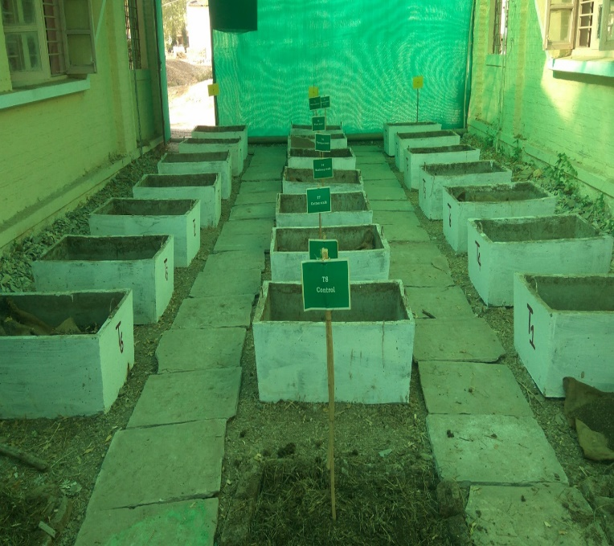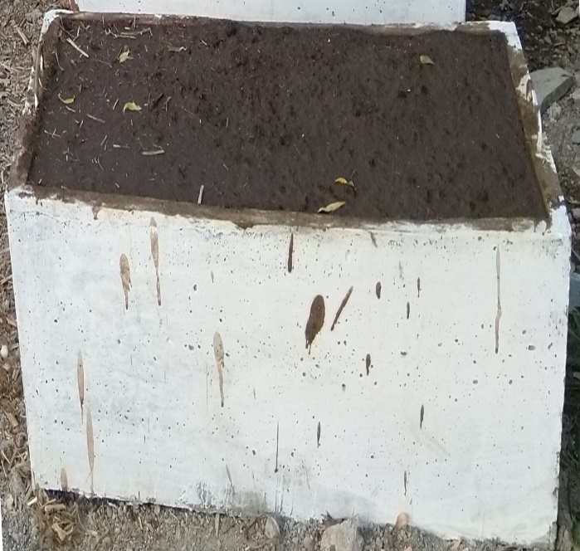

**.**

**Plate 2. Filled tank for predecompostion**

**Plate 1. General view of experiment**

**2.2: TANK FILLING AND PRE-DECOMPOSITION:**

The dung slurry was prepared by thoroughly mixing 5 kg of dung in 20 liters of water and was applied layer wise. Pre-decomposition was carried out to establish a conducive environment for earthworm inoculation. A 2 cm layer of soil was evenly spread at the bottom of the tank to retain moisture. A 5 cm layer of crop residue was subsequently added, followed by an adequate amount of dung slurry to sufficiently moisten the residue. This layering process was repeated until the tank was filled, requiring approximately six layers in total. Upon the addition of the final layer, one kg soil is added in dung slurry to plaster the layer to prevent heat and gaseous exchange. These tanks were left undisturbed for 21 days to allow for partial decomposition.

***Eisenia Foetida* SPECIES AND INOCULATION:**

After the partial decomposition turning is given to partial decomposed material, water is sprinkled to remove excess heat for the convenience of earthworms. About 100 earthworms per tank were released and throughout the composting process, sufficient moisture was maintained at percent of maximum water holding capacity of a material.

**3. RESULTS AND DISCUSSION**

The investigational data have been arranged in sequential order starting from the initial temperature of vermicompost to till the mature vermicompost prepared.

**Table 2. Periodical changes in mean temperature (0C) at 7 days interval as influenced by different crop residues**

|  |  |  |  |  |  |  |  |  |  |  |  |  |  |  |  |  |  |  |
| --- | --- | --- | --- | --- | --- | --- | --- | --- | --- | --- | --- | --- | --- | --- | --- | --- | --- | --- |
| **Treatments** | | **Temperature ( 0C )** | | | | | | | | | | | | | | | | |
|  | | **Days After Filling (DAF)** | | | | | | | | | | | | | | | | |
| **7** | **14** | **21** | **28** | **35** | **42** | **49** | **56** | **63** | **70** | **77** | **84** | **91** | **98** | **105** | **112** | **119** |
| **T1** | **Soybean straw** | 45.4 | 47.3 | 42 | 33.6 | 29.9 | 27.1 | 24.2 | 21.3 | 18 | - | - | - | - | - | - | - | - |
| **T2** | **Rice straw** | 44.2 | 45 | 39.5 | 32 | 30.1 | 26.2 | 23 | 22.2 | 17.3 | 18.1 | 19.3 | 23.1 | 22 | - | - | - | - |
| **T3** | **Wheat straw** | 44.1 | 45.8 | 41 | 34 | 30.3 | 25.8 | 24.3 | 21.5 | 17.9 | 18.2 | 18.4 | 22.5 | - | - | - | - | - |
| **T4** | **Sunhemp stalk** | 44.6 | 46 | 41.5 | 31 | 29.4 | 24.2 | 22.4 | 19.6 | 17.8 | 17.1 | 19.2 | - | - | - | - | - | - |
| **T5** | **Foxtail straw** | 44.3 | 46.9 | 40 | 33.2 | 29.9 | 25.4 | 22.6 | 19.9 | 17.3 | 17.6 | - | - | - | - | - | - | - |
| **T6** | **Pigeonpea stalk** | 44.8 | 46.4 | 41.8 | 34.1 | 30.8 | 26.1 | 24.8 | 21.8 | 18.1 | 18.3 | 18.1 | 22.8 | 23.5 | 23.9 | 24.4 | 25.3 | 25.9 |
| **T7** | **Cotton stalk** | 45 | 47 | 42.1 | 32.2 | 31.2 | 26.9 | 24.9 | 22.4 | 19.1 | 19.5 | 19.2 | 23.8 | 24.3 | 25.8 | 26.1 | 26.3 | 26.6 |
| **T8** | **Traditional heap method** | 44.6 | 46.7 | 39.9 | 30.2 | 30.6 | 26 | 25.3 | 23 | 19.9 | 20.1 | - | - | - | - | - | - | - |
| **GM** | | 36.32 | 40.60 | 38.03 | 31.97 | 30.76 | 27.37 | 25.90 | 23.85 | 20.85 | 21.73 | 23.82 | 29.85 | 32.70 | 39.24 | 40.59 | 42.08 | 43.44 |

The temperature regime, generated by self-heating resulting from microbial activity, serves as an indicator of the efficacy of the composting process. (Hassan et al., 2023). Top of FormBottom of FormThe persual data is present in table 2. show that, during predecomposition period (21 DAF) there was an increase in temperature up to 14 DAF then it started decline. At 21 DAF, maximum temperature was observed in cotton stalk (42.10C) followed by 420C in soybean straw (T1). Comparison of compost pit temperature with atmospheric temperature revealed erratic variation during the initial stages of composting (up to 15 days). After the inoculation of earthworms, the mean temperature of vermicomposting beds from 28 DAF to its maturity was in between 33.6 to 22.3 0C which was good for the earthworm activity. To support these, Singh (2022) reported the ideal temperature range for earthworms, between 25°C and 37°C, supports their growth, activity, metabolism, reproduction, and cocoon formation, as well as benefiting associated microorganisms. The gradual decrease in temperature after the introduction of earthworms was due to the crawling action of earthworms and activity of microorganisms under ex-situ mode of composting. Similar results were reported by Mayadevi (2016), Nagarvallemma et al. (2004a), Hait and Tare (2011) and Vasanthi et al. (2013).

**3.1: Change in weight (kg) and recovery ratio (%) during vermicomposting as influenced by different crop residues**

Figure number 2 illustrated that significantly maximum final weight (11.0 kg) of vermicompost was obtained with soybean straw being at par (10.5 kg) with sunhemp straw (T4) and pigeonpea stalk (T6). However, the lowest final weight (6.50 kg) was observed in rice straw (T2) vermicompost. Figure 3 depicts that the maximum percentage of vermicompost yield recovery was achieved using soybean straw (T1) vermicompost (55.0%), followed by sunhemp stalk (T4) vermicompost (51.2%) and vermicompost made using the traditional heap method (T8) (50.0%). However, using cotton stalk (T7) vermicompost resulted in the lowest yield recovery percentage (40.9%). This might be due to crop residues having different palatability, digestibility, protein and crude fiber contents and even some concentration of special plant metabolites, i.e. polyphenols and related substances and also maximum change in weight was associated with the higher mineralization of organic matter**. (**Verma et, al, 2014). Similarly, Manaig (2016) concluded that efficiency of vermicomposting is affected by bedding materials. Results were also in conformity with Suthar (2009a), Borang et al. (2016) and Viji and Neelanarayanan (2016).

**3.2: Change in volume (m3) during vermicomposting as influenced by different crop residues**

The application of this specific dosage of eco-enzyme resulted in a significant reduction in the volume of organic waste, indicating a faster composting process. Figure 4 revealed that significantly highest reduction in final volume of vermicompost was observed in rice straw (0.036 m3) being on par with soybean straw (T1) (0.039 m3), sunhemp stalk (T4) (0.043 m3) and wheat straw (T3) (0.044 m3). However, minimum reduction in final volume was recorded with pigeonpea stalk (T6) (0.069 m3) and also, it is observed that rice straw vermicompost (T2) indicated maximum reduction in volume of about 0.086 m3 (70.7%) over initial volume added in vermicompost tank of 0.122 m3 at start of filling of tank. However, pigeonpea stalk vermicompost (T6) recorded less reduction in volume of about 0.053 m3 (43.3%) over initial volume of material added in vermicompost tank and 8% more reduction were observed in rice straw compared to traditional heap method. Most of the scientists reported about loss in weight rather than loss in volume. In fact, when there is loss in weight of crop residue also affects loss in volume linearly. Maximum decrease in volume of rice straw might be due to its light weight with less density occupied in tank initially and due to the less decomposed by the earthworms while in case of soybean volume reduction may be due to its feasibility and palatability therefore more readily decomposed by earthworms. Nagavallemma *et al.* (2004b) also reported that earthworms consume various organic wastes and reduce the volume by 40–60%.

**3.3 Time taken for maturity of vermicompost as influenced by different crop residues.**

Figure 5 depicts how the time required for vermicompost maturity (DAF) varies depending on crop residues. Soybean straw (T1) vermicompost matured in 65 days, which is earlier than other crop residues, followed by foxtail millet straw (T5) vermicompost and the traditional heap method (T8), at 68 and 72 days, respectively. However, vermicompost prepared from cotton stalk, pigeonpea stalk and rice straw were matured late *i.e.*at 120 DAF, 100 DAF and 90 DAF, respectively. This might be due, lignin in plant cell is extremely resistant to microbial decomposition that reflected into maturity durations and that the bioavailability of the other cell-wall components is decreased by lignin, resulting in a lower real C:N ratio (i.e., ratio of biodegradable C to N). Similar findings are reported by Suthar (2009b)

**3.4: Moisture content (%) at maturity of vermicompost as influenced by different crop residues**

In present study moisture per cent at maturity in vermicompost prepared from different crop residues ranged between 18.6 to 29.5%. The significantly maximum moisture per cent in vermicompost was recorded in wheat straw vermicompost (T3) (29.5%) being at par with cotton stalk vermicompost (29.2%) (T7) and pigeonpea stalk (T6) vermicompost (27.6%). However, minimum moisture content (18.6%) was observed in vermicompost prepared by traditional heap method. Nagarvallemma et al. (2004c) also reported that moisture content of castings ranges between 32 and 66%.

**Table 3. Periodical changes in C: N (%) ratio during vermicomposting as influenced by different crop residues**

|  |  |  |  |  |  |  |
| --- | --- | --- | --- | --- | --- | --- |
| **Treatments** | | **C:N ratio (%)** | | | | |
| **Initial content** | **30 DAF** | **60 DAF** | **90 DAF** | **At maturity** |
| T1 | Soybean straw | 48.25 | 35.78 | 20.18 | - | 17.24 |
| T2 | Rice straw | 60.87 | 41.56 | 31.26 | 31.26 | 20.52 |
| T3 | Wheat straw | 78.25 | 50.14 | 29.77 |  | 19.44 |
| T4 | Sunhemp stalk | 51.91 | 36.02 | 22.72 | - | 18.09 |
| T5 | Foxtail millet straw | 63.27 | 33.71 | 21.83 | - | 19.29 |
| T6 | Pigeonpea stalk | 53.06 | 35.52 | 27.42 | 22.42 | 20.58 |
| T7 | Cotton stalk | 77.11 | 44.25 | 31.47 | 25.70 | 20.29 |
| T8 | Traditional heap method | 60.79 | 39.53 | 21.66 |  | 18.41 |
| GM | | 47.85 | 35.00 | 24.88 | 26.65 | 20.52 |

The observed data from table 3 revealed that C:N ratio of vermicompost decreased at all the stages of vermicomposting. Decomposition rate can be predicted from the initial C:N ratio. (Chatterjee & Acharya, 2020). At the initial stage, the C:N ratio across different treatments ranged from 78.25 to 48.25, with a significant decrease to maturity, where the C:N ratio ranged between 20.58 and 17.24. The changes in the C:N ratio from the initial to the final stage, least observed in soybean straw T1 (256.67%) and the highest in wheat straw (T3) (402.52%). The highest initial C:N ratio (78.25) was observed in wheat straw (T3), followed by cotton stalk (T7), whereas the lowest initial C:N ratio (48.25) was recorded in soybean straw (T1), likely due to its higher initial nitrogen content. Vermicompost derived from soybean straw (T1) exhibited the lowest C:N ratio (17.24) at maturity, followed by vermicompost from sunhemp stalk (18.09) and the traditional heap method (18.41).

The gaseous loss of carbon through microbial respiration and simultaneously addition of nitrogen by worms in the form of mucus and nitrogenous excretory material caused lowered the C:N ratio. Higher C:N ratio indicated slow degradation of substrate and the lower C:N ratio indicated the higher efficiency level of mineralization by the species. Similar results have also been reported by Gajbhiye and Satpute (2014).

**4. CONCLUSIONS**

Soybean straw was most feasible for production of quality vermicompost followed by sunhemp and pigeonpea stalk. Among all the crop residues, the rate of decomposition of soybean straw was faster followed by foxtail millet straw, traditional heap method and sunhemp stalk. Soybean straw exhibited the lowest C:N ratio at maturity, followed by vermicompost from sunhemp stalk and the traditional heap method.

**5. DISCLAIMER (ARTIFICIAL INTELLIGENCE)**

Author(s) hereby declare that NO generative AI technologies such as Large Language Models (ChatGPT, COPILOT, etc) and text-to-image generators have been used during writing or editing of this manuscript. **6.COMPETING INTERESTS**

Authors have declared that no competing interests exist.

**7. REFERENCES**

Bhuvaneshwari S, Hettiarachchi H, Meegoda JN (2019) Crop residue burning in India: policy

Borang, B., Y.K. Sharma, S.K. Sharma, (2016). Effect of various substrates on performance of earthworm and quality of vermicompost. Annals of Plant and Soil Research, 18(1):37-42.

Chatterjee, A. and Acharya, U. (2020). Controls of carbon and nitrogen releases during crops’ residue decomposition in the Red River Valley, USA, Archives of Agronomy and Soil Science, 66:5, 614-624.

Curry, J. P. (1987). The invertebrate fauna of grassland and its influence on productivity. Grass For. Sci., 42: 103-120.

Das, B., Wani, S.P., Benbi, D.K., Muddu, S., Bhattacharyya, T., Mandal, B., Santra, P., Chakraborty, B., Bhattacharyya, R., Basak, N. and Reddy, N.N. (2023). Soil health and its relationship with food security and human health to meet the sustainable development goals in India. Soil Security 8:1-15.

Dutta, A., Patra, A., Hazra, K.K., Nath, C.P., Kumar, N., Rakshit, A. (2022). A state of the art review in crop residue burning in India: Previous knowledge, present circumstances and future strategies. Environmental Challenges 8:1-16.

Gajbhiye, B.R. and Satpute, U. M. (2014). Quality of vermicompost as influenced by earthworm species and legume crop residues. International Research Journal of Agricultural Science and Soil Science, 4(9): 172-179.

Hait, S. and Tare, V. (2011). Optimizing vermistabilzation of waste activated sludge using vermicompost as bulking material. Waste management, 31:502-511.

Hassa, N.Y.I., Badawi, E.M., Mostafa, D.E.S., Wahed, N.A.H., Smohamed, M., Abdelhamid, A.N.M., Ashry, H., Bassiony, D., Mohamed, O.M.A., Sayed, M.S., Mohammed, R.A., Mansour, A.M.A., Hassan, M.Y. and Mohamed, M.Y. 2023. Composting: an eco-friendly solution for organic waste management to mitigate the effects of climate change. Innovare Journal of Social Sciences, 11(4): 1-7.

Jackson, M.L., (1973). Soil Chemical Analysis, Prentice Hall of India Pvt.Ltd. New Delhi. pp 1-492

Manaig, E.M. (2016). Vermicomposting efficiency and quality of vermicompost with different bedding materials and worm food sources as substrate. Research Journal of Agriculture and Forestry Sciences, 4(1): 1-13.

Mayadevi, M.R. and Sushama, P.K. (2016). Quality check- up of vermicompost by exotic (*Eisenia foetida* S.) and native ( *Perionyx excavates* P.) species of earthworms. Green farming, 7(5): 1224-1227.

NAAS 2012. “Management of Crop Residues in the Context of Conservation Agriculture”. Policy Paper No. 58, National Academy of Agricultural Sciences, New Delhi. 12 p.

Nagavalamma, K.P., Wani, S.P., Stephance, L., Padmja, W., Vineetha, C..,Rao, M.B. and Sahrawat, K.L. (2004). Vermicomposting: Recycling wastes into valuable organic fertilizer*.* Global Theme on Agri Eco Systems Report(8) Patancheru, A. P. ICRISAT.

Prasad R., D. Kumar, D. S. Rana, Y.S. Shivay and R. K. Tewatia. 2014. Textbook of plant nutrient management. Indian Society of Agronomy,New Delhi. pp: 31.

Sanasam, S.D.; Talukdar, N.C. Quality Compost Production from Municipality Biowaste in Mix with Rice Straw, Cow Dung, and Earthworm Eisenia fetida. Compos. Sci. Util. 2017, 25, 141–151.

Sen, M., Roy, A., Rani, K., Nalia, A., Das, T., Tigga, P., Rakshit, D., Atta, K., Mandal, S., Vishwanath, Das, A. (2024). Crop residue: Status, distribution, management, and agricultural sustainability. DOI: 10.1016/B978-0-443-18486-4.00017-8

Singh, A.P. (2022). An Analysis of Vermicomposting, International Journal of Food and Nutritional Sciences,11 (7):3911-3916.

Suthar S., (2007). Bioconversion of post-harvest crop residues and cattle shed manure into value added products using earthworm *Eudrilus eugeniae* (king berg). Ecology Engineering, 32(3): 206-214.

Vasanthi, K., Senthilkumari, M., Chairman, K. and Singh, R. (2013). Influence of temperature on growth and reproduction of earthworm *Eudrilus eugeniae*. International Journal Current Microbiology and Applied Science, 2(7): 202-206.

Venkatramanan V, Shah S, Rai, A.K. and Prasad, R. (2021) Nexus Between Crop Residue Burning, Bioeconomy and Sustainable Development Goals Over North-Western India. Front. Energy Res. 8:1-14.

Verma, R., Badole, W. P., Deewan, P. and Meena, V.S. (2014). Carbon and weight loss during composting of wheat straw by different methods. Annals of Biology, 30 (2):354-357.

Viji J. and P. Neelanarayanan, (2016). Vermicomposting of sunflower (*Helianthus annuus* l.) Cob (pre-digested with *Aspergillus niger*) without cow dung by utilizing conventional composting earthworms. International journal of current science research, 2(5): 650-667.

Walkley A, Black I A. (1934). An examination of the Degtjareff method for determining soil organic matter and a proposed modification of the chronic acid titration method. Soil Science, 37:29-39.

Wang, Q., Wang, Z., Awasthi, M.K., Jiang, Y., Li, R., Ren, X., Zhao, J., Shen, F., Wang, M., Zhang, Z. (2016). Evaluation of medical stone amendment for the reduction of nitrogen loss and bioavailability of heavy metals during pig manure composting. Bioresour. Technol., 220:297–304.

Wei, F. and Gui, J.W. (2017). Crop Residue Application and Stabilization in Soil: A Review. *Chinese Journal of Soil Science*, 48(2): 501-506.