***Original Research Article***

**Conspectus of Tree Wealth Conserved in the Botanic Garden of Indian Republic, Noida, India**

**ABSTRACT**

Botanic Garden of Indian Republic (BGIR) plays a crucial role in biodiversity conservation, scientific research, and public awareness by preserving plant species, supporting ecological studies and aiding in habitat restoration efforts. The Botanic Garden of Indian Republic (BGIR), Noida, established in 1997, spans 164.85 acres and is managed by the Botanical Survey of India under the Ministry of Environment, Forest & Climate Change. Situated in the floodplain of the Yamuna River. The garden is divided into eight forest zones and multiple specialized plant sections, which houses 5,011 individual trees representing 175 angiosperm tree taxa across 133 genera and 38 families. The dominant families include Fabaceae, Malvaceae, Bignoniaceae, Rutaceae and Moraceae. The study documents 141 taxa listed in the IUCN Red List of Threatened Species (version 3.1). These findings highlight the gardens’ effectiveness in providing a secure habitat for rare and endemic species, ensuring their survival and promoting conservation research.The BGIR serves as a critical centre for plant ex-situ conservation, biodiversity management and ecological research. The documentation of its rich tree diversity underscores its importance in safeguarding endangered taxa, contributing to global conservation efforts, and fostering public education on plant diversity and sustainability.

**Keywords:** *Botanical Survey; Climate Change; Environment; Forest; Plant Species*

**1. INTRODUCTION**

Botanical Gardens plays crucial role in conservation, scientific research and public participation in scientific activities by preserving biodiversity, supporting ecological studies, and aiding in habitat restoration efforts. They serve as living repositories where scientists study plant genetics, climate adaptability, and medicinal properties (Heywood, 2017). Additionally, these gardens contribute to public education and awareness about endangered species and sustainable practices (Wyse Jackson & Sutherland, 2000). Through seed banks and conservation programs, botanical gardens help in protection of rare and threatened plant species from extinction (Mounce et al., 2017). The botanical gardens can be used as common platform, where researchers can conduct comparative studies of conservation, propagation, horticulture, seed science, taxonomy, systematics, genetics, biotechnology, education, restoration ecology, public education, plant physiology, anatomy and responses to climate change and much more (Maunder et al., 2001; Donaldson, 2009; Sellmann & Bogner, 2013; Chen & Sun, 2018; Primack et al., 2021). Botanic Garden of Indian Republic (BGIR), Noida is also contributing in aforesaid studies by conserving 5011 trees.

**2. Methods and materials**

**2.1 Study Location**

Botanic Garden of Indian Republic (BGIR) was established in 1997, is situated in Noida within the National Capital Region (NCR) under the jurisdiction of the Botanical Survey of India, Ministry of Environment, Forest & Climate Change. The Botanic Garden of Indian Republic is spread over 164.85 acre which is situated at 28°33′27″ N. lat. to 28°34′00″ N. lat. and 77°19′16" E. long to 77°20′13″ E. long (Figure 1 and Figure 2). The area is located in flood plain of river Yamuna having alluvial soil, represents fairly coarse sand with very fine texture on surface soil, greyish-brownish to grey depending upon depth, deficient in nitrogen, humus and phosphoric acid. However, soil contains high percentage of soluble salts of sodium, calcium and magnesium as pH of soil is alkaline and moisture content is very low during most part of the year. Over the years, BGIR has evolved into a sanctuary which is dedicated to the conservation of endemic and threatened plant species from diverse ecological zones across the country, fulfilling a vital role in their ex-situ conservation and the requirement of agreement, International Agenda and Global Mission through Botanical Survey of India with the following objectives *i.e*. (i) Ex-situ Conservation of endemic and threatened plant species of representative ecosystems of the country, (ii) Serve as a 'Centre of Excellence' for research and training and (iii) To create public awareness through educational programmes on plant diversity and conservation. Before establishment of this garden, the land area was under cultivation of cereal crops where the natural vegetation represented by *Azadirachta indica* A.Juss., *Bombax ceiba* L., *Cassia fistula* L., *Dalbergia sissoo* Roxb., *Morus alba* L. and *Tamarix aphylla* (L.) H.Karst. Currently, despite the regions’ extreme and contrasting climatic conditions, BGIR serves as a national repository and safe haven for over 5,011 individual plants.

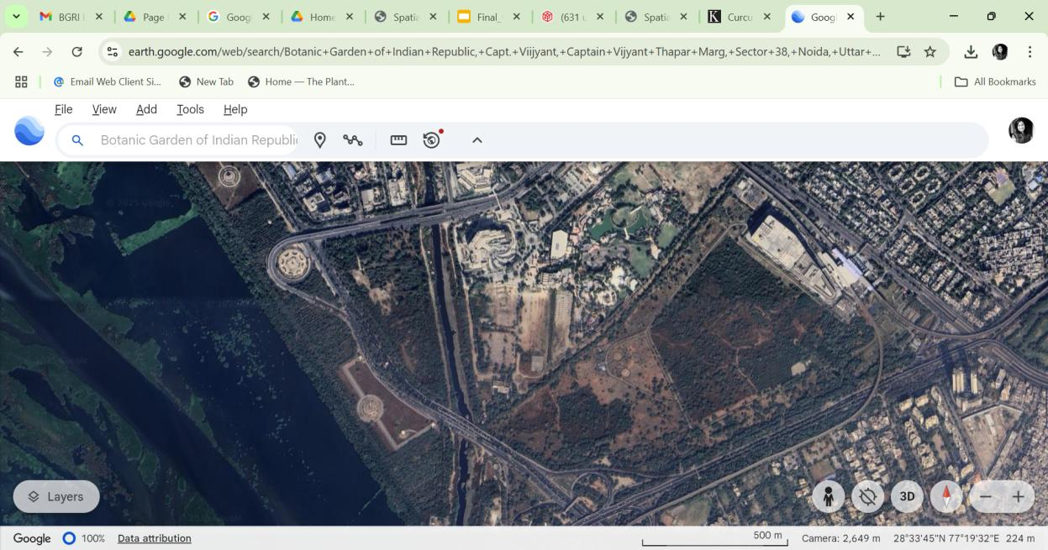

**Figure 1:** Google Earth Image of Botanic Garden of Indian Republic (BGIR), Noida (Location Map).

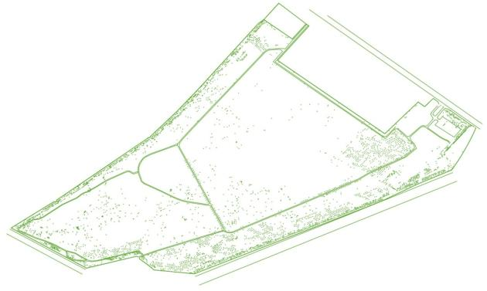

**Figure 2:** Spatial Analysis of trees of Botanic Garden of Indian Republic (BGIR), Noida

**2.2 Data Collection**

Plant samples of the tree species were collected in duplicates from different zones and from other sections in flowering and fruiting. These trees are mainly conserved in eight Forest zones established along the peripheral area adjacent to boundary wall of the Garden and adjoining area, different plant sections and central open area of the garden. The representation of these zones and sections is as follows-.

Table 1: The representation of zones and sections

|  |  |  |
| --- | --- | --- |
| **Sl. No.** | **Name of the zone and section** | **Representation of forest type** |
|  | Forest Zone 1 | Tropical wet evergreen forest |
|  | Forest Zone 2 | Tropical semi-evergreen forest |
|  | Forest Zone 3 | Tropical moist-deciduous forest |
|  | Forest Zone 4 | Dry deciduous forest |
|  | Forest Zone 5 | Thorny scrub forest |
|  | Forest Zone 6 | Tropical dry evergreen forest |
|  | Forest Zone 7 | Sub-tropical broadleaf forest |
|  | Forest Zone 8 | Sub-tropical dry forest |
|  | Economic Plant Section (EPS) | Economically important plants |
|  | Medicinal Plant Section (MPS) | Medicinal plants |
|  | Fruit Plant Section (FPS) | Fruit plants |
|  | Central Open Area | Middle area of the garden with randomly cultivated and naturally grown trees |

The specimens were critically studied for morphological details and for correct identification. Identification was confirmed by consulting standard literature and through reference against identified herbarium specimens at Botanical Survey of India, Western Regional Centre herbarium, Pune (BSI), Central National Herbarium (CAL), Southern Regional Centre herbarium (MH). Web databases such as International Plant Names Index (IPNI), Biodiversity Heritage Library, Global Biodiversity Information Facility (GBIF) and Plants of the World Online (POWO) were also consulted for correct nomenclature, author citation and additional information.

**3. Results**

The present study resulted in the documentation of 175 angiosperms tree taxa. Presently, the garden houses over 5,011 individual plants representing 175 species of angiosperm trees, encompassing 133 genera across 38 families (Figure 3). This is mainly based on the native as well as exotic tree taxa conserved in the botanical garden and few naturally occurring taxa are also included in this research.

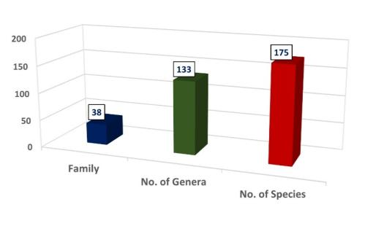

**Figure 3**: Graphical representation of number of families, genera and species conserved in the garden

Thefive dominant families of the BGIR are viz., Fabaceae (28 genera, 40 spp.), Malvaceae (12 genera, 14 spp.), Bignoniaceae (11 genera, 11 spp.), Rutaceae (6 genera, 11 spp.), Moraceae (3 genera, 9 spp.).

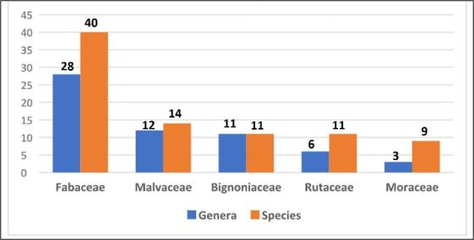

**Figure 4:** Graphical representation of five dominant families conserved in BGIR

**Table 2. Familywise number of genus and species of the trees conserved in BGIR**

|  |  |  |  |
| --- | --- | --- | --- |
| **Sl. No.** | **Family** | **No. of Genus** | **No. of Species** |
|  | Anacardiaceae | 4 | 4 |
|  | Annonaceae | 2 | 2 |
|  | Apocynaceae | 5 | 7 |
|  | Arecaceae | 4 | 5 |
|  | Bignoniaceae | 11 | 11 |
|  | Boraginaceae | 2 | 3 |
|  | Burseraceae | 1 | 1 |
|  | Capparaceae | 1 | 1 |
|  | Casuarinaceae | 1 | 1 |
|  | Celastraceae | 1 | 1 |
|  | Combretaceae | 2 | 7 |
|  | Elaeocarpaceae | 1 | 1 |
|  | Euphorbiaceae | 3 | 3 |
|  | Fabaceae | 28 | 40 |
|  | Lamiaceae | 4 | 5 |
|  | Lauraceae | 2 | 2 |
|  | Lecythidaceae | 2 | 2 |
|  | Loganiaceae | 1 | 1 |
|  | Lythraceae | 2 | 2 |
|  | Malvaceae | 12 | 14 |
|  | Meliaceae | 5 | 5 |
|  | Moraceae | 3 | 9 |
|  | Moringaceae | 1 | 2 |
|  | Myrtaceae | 5 | 7 |
|  | Oleaceae | 1 | 1 |
|  | Phyllanthaceae | 3 | 5 |
|  | Putranjivaceae | 1 | 1 |
|  | Rhamnaceae | 1 | 1 |
|  | Rosaceae | 1 | 1 |
|  | Rubiaceae | 5 | 5 |
|  | Rutaceae | 6 | 11 |
|  | Salvadoraceae | 1 | 1 |
|  | Santalaceae | 1 | 1 |
|  | Sapindaceae | 2 | 3 |
|  | Sapotaceae | 4 | 5 |
|  | Simaroubaceae | 2 | 2 |
|  | Tamaricaceae | 1 | 1 |
|  | Ulmaceae | 1 | 1 |
|  | Total | 133 | 175 |

In the present study approximately 5011 trees are conserved in different Forest Zones and Plant Sections i.e., Forest Zone 1 (418), Forest Zone 2 (724), Forest Zone 3 (414), Forest Zone 4 (265), Forest Zone 5 (246), Forest Zone 6 (347), Forest Zone 7 (569), Forest Zone 8 (690), Economic Plant Section (EPS) (478), Medicinal Plant Section (MPS) (121), Fruit Plant Section (FPS) (218) and Central Open Area (521).

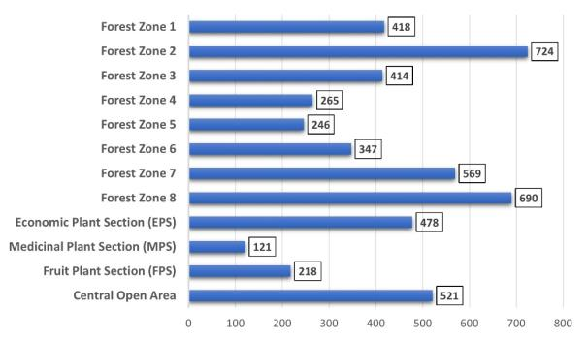

**Figure 5:** Number of trees distributed in different zones and sections of the garden.

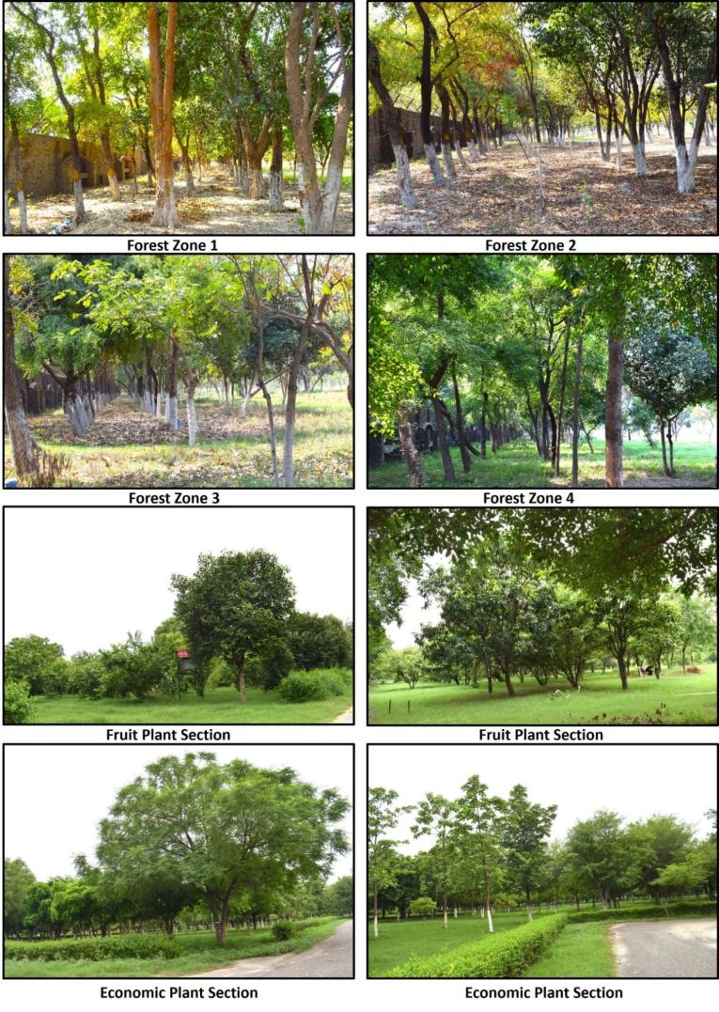

**Figure 6. Different Zones/Sections of Botanic Garden of Indian Republic (BGIR), Noida**

The garden conserves 141 taxa listed in the IUCN Red List of Threatened Species (version 3.1), including: 127 species categorized as Least Concern (LC), 3 as Near Threatened (NT), 7 as Vulnerable (VU), 2 as Endangered (EN) and 2 as Critically Endangered (CR), from remaining species 6 are Data Deficient (DD) and 28 are Not Evaluated (NE). All the taxa within BGIR are thriving and growing luxuriantly in the garden.

**Table 3:** List of tree taxa conserved in BGIR, listed in the IUCN Red List of Threatened Species with their category & criteria.

|  |  |  |  |  |
| --- | --- | --- | --- | --- |
| **Sl. No.** | **Name of the plant** | **Family** | **Number of trees in BGIR** | **IUCN Red**  **List Category**  **& Criteria** |
|  | *Commiphora wightii* (Arn.) Bhandari | Burseraceae | 3 | CR A2cd |
|  | *Hildegardia populifolia* (Roxb.) Schott & Endl. | Malvaceae | 21 | CR D |
|  | *Mangifera indica* L. | Anacardiaceae | 16 | DD |
|  | *Ehretia aspera* Willd. | Boraginaceae | 39 | DD |
|  | *Elaeodendron glaucum* (Rottb.) Pers. | Celastraceae | 10 | DD |
|  | *Millettia peguensis* Ali | Fabaceae | 5 | DD |
|  | *Parkia biglandulosa* Wight & Arn. | Fabaceae | 4 | DD |
|  | *Ailanthus excelsa* Roxb. | Simaroubaceae | 8 | DD |
|  | *Tecomella undulata* D.Don | Bignoniaceae | 5 | EN A2a |
|  | *Tectona grandis* L.f. | Lamiaceae | 24 | EN A2cd |
|  | *Buchanania lanzan*Spreng. | Anacardiaceae | 1 | LC |
|  | *Spondias pinnata* (L. f.) Kurz | Anacardiaceae | 23 | LC |
|  | *Annona squamosa* L. | Annonaceae | 8 | LC |
|  | *Monoon longifolium* (Sonn.) B. Xue & R.M.K. Saunders | Annonaceae | 78 | LC |
|  | *Alstonia scholaris* (L.) R. Br. | Apocynaceae | 3 | LC |
|  | *Holarrhena pubescens* Wall. ex G.Don | Apocynaceae | 4 | LC |
|  | *Plumeria alba* L. | Apocynaceae | 214 | LC |
|  | *Plumeria obtusa* L. | Apocynaceae | 8 | LC |
|  | *Plumeria rubra* L. | Apocynaceae | 2 | LC |
|  | *Thevetia peruviana* (Pers.) K. Schum. | Apocynaceae | 20 | LC |
|  | *Wrightia tinctoria* (Roxb.) R.Br | Apocynaceae | 13 | LC |
|  | *Bismarckia nobilis* Hildebrandt & H.Wendl. | Arecaceae | 2 | LC |
|  | *Livistona chinensis* (Jacq.) R.Br. Ex Mart. | Arecaceae | 23 | LC |
|  | *Phoenix dactylifera* L. | Arecaceae | 1 | LC |
|  | *Phoenix sylvestris* (L.) Roxb. | Arecaceae | 5 | LC |
|  | *Roystonea regia* (Kunth) O.F. Cook | Arecaceae | 69 | LC |
|  | *Dolichandrone falcata* Seem. | Bignoniaceae | 10 | LC |
|  | *Fernandoa adenophylla* (Wall. ex G.Don) Steenis | Bignoniaceae | 54 | LC |
|  | *Kigelia africana* (Lam.) Benth. | Bignoniaceae | 18 | LC |
|  | *Markhamia lutea* (Benth.) K. Schum. | Bignoniaceae | 11 | LC |
|  | *Millingtonia hortensis* L.f. | Bignoniaceae | 1 | LC |
|  | *Oroxylum indicum* (L.) Benth. ex Kurz | Bignoniaceae | 26 | LC |
|  | *Spathodea campanulata* P. Beauv. | Bignoniaceae | 15 | LC |
|  | *Stereospermum chelonoides* (L.f.) DC. | Bignoniaceae | 39 | LC |
|  | *Tecoma stans* (L.) Juss. ex Kunth | Bignoniaceae | 55 | LC |
|  | *Cordia dichotoma* G.Forst. | Boraginaceae | 17 | LC |
|  | *Ehretia acuminata* R.Br. | Boraginaceae | 1 | LC |
|  | *Crateva adansonii* DC. subsp. odora (Buch.–Ham.) Jacobs | Capparaceae | 9 | LC |
|  | *Casuarina equisetifolia* L. | Casuarinaceae | 4 | LC |
|  | *Conocarpus erectus* L. | Combretaceae | 2 | LC |
|  | *Terminalia bellirica* (Gaertn.) Roxb. | Combretaceae | 227 | LC |
|  | *Terminalia chebula* Retz. | Combretaceae | 38 | LC |
|  | *Terminalia elliptica* Roxb. | Combretaceae | 4 | LC |
|  | *Terminalia pendula* (Edgew.) Gere & Boatwr. | Combretaceae | 154 | LC |
|  | *Jatropha curcas* L. | Euphorbiaceae | 19 | LC |
|  | *Mallotus nudiflorus* (L.) Kulju & Welzen | Euphorbiaceae | 1 | LC |
|  | *Acacia auriculiformis* A.Cunn. ex Benth. | Fabaceae | 24 | LC |
|  | *Albizia lebbeck* (L.) Benth. | Fabaceae | 117 | LC |
|  | *Albizia odoratissima* (L.f.) Benth. | Fabaceae | 16 | LC |
|  | *Bauhinia purpurea* L. | Fabaceae | 28 | LC |
|  | *Bauhinia racemosa* L. | Fabaceae | 25 | LC |
|  | *Bauhinia variegata* L. | Fabaceae | 4 | LC |
|  | *Butea monosperma* (Lam.) Taub. | Fabaceae | 13 | LC |
|  | *Cassia fistula* L. | Fabaceae | 28 | LC |
|  | *Cassia javanica* L. | Fabaceae | 1 | LC |
|  | *Dalbergia lanceolaria* subsp. paniculata (Roxb.) Thoth. | Fabaceae | 15 | LC |
|  | *Dalbergia sissoo* Roxb. | Fabaceae | 134 | LC |
|  | *Delonix regia* (Bojer ex Hook.) Raf. | Fabaceae | 8 | LC |
|  | *Dichrostachys cinerea* (L.) Wight & Arn. | Fabaceae | 2 | LC |
|  | *Hardwickia binata* Roxb. | Fabaceae | 208 | LC |
|  | *Neltuma juliflora* (Sw.) Raf. | Fabaceae | 6 | LC |
|  | *Ougeinia oojeinensis* (Roxb.) Hochr. | Fabaceae | 12 | LC |
|  | *Peltophorum pterocarpum* (DC.) Backer ex K.Heyne | Fabaceae | 5 | LC |
|  | *Pithecellobium dulce* (Roxb.) Benth. | Fabaceae | 54 | LC |
|  | *Pongamia pinnata* (L.) Pierre | Fabaceae | 83 | LC |
|  | *Prosopis cineraria* (L.) Druce | Fabaceae | 5 | LC |
|  | *Senegalia catechu* (L.f.) P.J.H.Hurter & Mabb. | Fabaceae | 47 | LC |
|  | *Senegalia polyacantha* (Willd.) Seigler & Ebinger | Fabaceae | 45 | LC |
|  | *Senegalia senegal* (L.) Britton | Fabaceae | 2 | LC |
|  | *Senna siamea* (Lam.) H.S.Irwin & Barneby | Fabaceae | 55 | LC |
|  | *Tamarindus indica* L. | Fabaceae | 3 | LC |
|  | *Vachellia nilotica* (L.) P.J.H.Hurter & Mabb. | Fabaceae | 6 | LC |
|  | *Vachellia tortilis* (Forssk.) Galasso & Banfi | Fabaceae | 8 | LC |
|  | *Gmelina arborea* Roxb. | Lamiaceae | 199 | LC |
|  | *Premna serratifolia* L. | Lamiaceae | 1 | LC |
|  | *Vitex negundo* L. | Lamiaceae | 6 | LC |
|  | *Vitex trifolia* L. | Lamiaceae | 3 | LC |
|  | *Cinnamomum camphora* (L.) J. Presl | Lauraceae | 6 | LC |
|  | *Litsea glutinosa* (Lour.) C. B. Rob. | Lauraceae | 1 | LC |
|  | *Strychnos nux-vomica* L. | Loganiaceae | 9 | LC |
|  | *Lagerstroemia speciosa* (L.) Pers. Kurz | Lythraceae | 5 | LC |
|  | *Adansonia digitata* L. | Malvaceae | 1 | LC |
|  | *Bombax ceiba* L. | Malvaceae | 67 | LC |
|  | *Ceiba pentandra* (L.) Gaertn. | Malvaceae | 26 | LC |
|  | *Firmiana colorata* (Roxb.) R.Br. | Malvaceae | 1 | LC |
|  | *Grewia optiva* J.R.Drumm. ex Burret | Malvaceae | 31 | LC |
|  | *Guazuma ulmifolia* Lam. | Malvaceae | 6 | LC |
|  | *Helicteres isora* L. | Malvaceae | 1 | LC |
|  | *Kydia calycina* Roxb. | Malvaceae | 3 | LC |
|  | *Pterospermum acerifolium* (L.) Willd. | Malvaceae | 19 | LC |
|  | *Sterculia foetida* L. | Malvaceae | 9 | LC |
|  | *Sterculia urens* Roxb. | Malvaceae | 79 | LC |
|  | *Thespesia populnea* (L.) Sol. Ex Corrêa | Malvaceae | 24 | LC |
|  | *Azadirachta indica* A. Juss. | Meliaceae | 350 | LC |
|  | *Melia dubia* Cav. | Meliaceae | 18 | LC |
|  | *Soymida febrifuga* (Roxb.) A.Juss. | Meliaceae | 20 | LC |
|  | *Toona ciliata* M. Roem. | Meliaceae | 3 | LC |
|  | *Broussonetia papyrifera* (L.) L'Hér. ex Vent. | Moraceae | 1 | LC |
|  | *Ficus benghalensis* L. | Moraceae | 2 | LC |
|  | *Ficus benjamina* L. | Moraceae | 27 | LC |
|  | *Ficus carica* L. | Moraceae | 4 | LC |
|  | *Ficus palmata* subsp. virgata Browicz | Moraceae | 2 | LC |
|  | *Ficus racemosa* L. | Moraceae | 18 | LC |
|  | *Ficus religiosa* L. | Moraceae | 16 | LC |
|  | *Ficus virens* Aiton | Moraceae | 37 | LC |
|  | *Morus alba* L. | Moraceae | 23 | LC |
|  | *Moringa concanensis* Nimmo ex Dalzell & A.Gibson | Moringaceae | 10 | LC |
|  | *Corymbia torelliana*(F. Muell.) K.D.Hill & L.A.S.Johnson | Myrtaceae | 5 | LC |
|  | *Melaleuca viminalis* (Sol. ex Gaertn.) Byrnes | Myrtaceae | 22 | LC |
|  | *Psidium guajava* L. | Myrtaceae | 75 | LC |
|  | *Syzygium cumini* (L.) Skeels | Myrtaceae | 80 | LC |
|  | *Nyctanthes arbor-tristis* L. | Oleaceae | 2 | LC |
|  | *Bridelia retusa* (L.) A.Juss. | Phyllanthaceae | 38 | LC |
|  | *Bridelia verrucosa* Haines | Phyllanthaceae | 9 | LC |
|  | *Phyllanthus emblica* L. | Phyllanthaceae | 12 | LC |
|  | *Putranjiva roxburghii* Wall. | Putranjivaceae | 56 | LC |
|  | *Ziziphus mauritiana* Lam. | Rhamnaceae | 40 | LC |
|  | *Adina cordifolia* (Roxb.) Brandis | Rubiaceae | 18 | LC |
|  | *Gardenia latifolia* Aiton | Rubiaceae | 34 | LC |
|  | *Mitragyna parvifolia* (Roxb.) Korth | Rubiaceae | 70 | LC |
|  | *Bergera koenigii* L. | Rutaceae | 13 | LC |
|  | *Citrus × aurantium* L. | Rutaceae | 2 | LC |
|  | *Citrus × taitensis* Risso | Rutaceae | 2 | LC |
|  | *Citrus limon* L. | Rutaceae | 3 | LC |
|  | *Citrus maxima* (Burm.) Merr. | Rutaceae | 2 | LC |
|  | *Citrus medica* L. | Rutaceae | 6 | LC |
|  | *Glycosmis pentaphylla* (Retz.) DC. | Rutaceae | 2 | LC |
|  | *Murraya paniculata* (L.) Jack | Rutaceae | 71 | LC |
|  | *Salvadora persica*L. | Salvadoraceae | 2 | LC |
|  | *Sapindus mukorossi* Gaertn. | Sapindaceae | 23 | LC |
|  | *Schleichera oleosa* (Lour.) oken. | Sapindaceae | 4 | LC |
|  | *Madhuca neriifolia* (Moon) H.J.Lam | Sapotaceae | 26 | LC |
|  | *Manilkara hexandra* (Roxb.) Dubard | Sapotaceae | 21 | LC |
|  | *Mimusops elengi* L. | Sapotaceae | 52 | LC |
|  | *Simarouba glauca* DC. | Simaroubaceae | 3 | LC |
|  | *Tamarix aphylla* (L.) H.Karst. | Tamaricaceae | 2 | LC |
|  | *Holoptelea integrifolia* (Roxb.) Planch. | Ulmaceae | 178 | LC |
|  | *Lannea coromandelica* (Houtt.) Merr. | Anacardiaceae | 68 | Not Evaluated |
|  | *Terminalia anogeissiana* Gere & Boatwr. | Combretaceae | 1 | Not Evaluated |
|  | *Terminalia arjuna* (Roxb.) Wight & Arn. | Combretaceae | 148 | Not Evaluated |
|  | *Elaeocarpus sphaericus* (Gaertn.) Heer | Elaeocarpaceae | 1 | Not Evaluated |
|  | *Ricinus communis* L. | Euphorbiaceae | 4 | Not Evaluated |
|  | *Calliandra haematocephala* Hassk. | Fabaceae | 2 | Not Evaluated |
|  | *Colophospermum mopane* (J.Kirk ex Benth.) J.Léonard | Fabaceae | 5 | Not Evaluated |
|  | *Indopiptadenia oudhensis* (Brandis) Brenan | Fabaceae | 3 | Not Evaluated |
|  | *Leucaena leucocephala* (Lam.) de Wit | Fabaceae | 190 | Not Evaluated |
|  | *Phanera roxburghiana* (Voigt) Bandyop., Anand Kumar & Chakrab. | Fabaceae | 7 | Not Evaluated |
|  | *Senegalia rugata* (Lam.) Britton & Rose | Fabaceae | 2 | Not Evaluated |
|  | *Senna suratensis* (Burm.f.) H.S. Irwin & Barneby | Fabaceae | 4 | Not Evaluated |
|  | *Careya arborea* Roxb. | Lecythidaceae | 16 | Not Evaluated |
|  | *Planchonia andamanica* King | Lecythidaceae | 1 | Not Evaluated |
|  | *Punica granatum* L. | Lythraceae | 33 | Not Evaluated |
|  | *Moringa oleifera* Lam. | Moringaceae | 22 | Not Evaluated |
|  | *Eucalyptus globules* Labill. | Myrtaceae | 3 | Not Evaluated |
|  | *Melaleuca lanceolata* Otto | Myrtaceae | 8 | Not Evaluated |
|  | *Psidium cattleianum* Hodel. | Myrtaceae | 4 | Not Evaluated |
|  | *Phyllanthus acidus* (L.) Skeels | Phyllanthaceae | 7 | Not Evaluated |
|  | *Malus domestica* (Suckow) Borkh. | Rosaceae | 3 | Not Evaluated |
|  | *Morinda pubescens* J. E. Sm. | Rubiaceae | 2 | Not Evaluated |
|  | *Neolamarckia cadamba* (Roxb.) Bosser | Rubiaceae | 2 | Not Evaluated |
|  | *Citrus reticulata* Blanco | Rutaceae | 10 | Not Evaluated |
|  | *Limonia acidissima* L. | Rutaceae | 13 | Not Evaluated |
|  | *Sapindus emarginatus* Vahl. | Sapindaceae | 11 | Not Evaluated |
|  | *Diploknema butyracea* (Roxb.) H.J. Lam | Sapotaceae | 6 | Not Evaluated |
|  | *Madhuca longifolia* var. latifolia (J.Konig) J.F.Macbr. | Sapotaceae | 89 | Not Evaluated |
|  | *Aegle marmelos* (L.) Correa | Rutaceae | 19 | NT A2acd |
|  | *Swietenia mahagoni* (L.) Jacq. | Meliaceae | 8 | NT A2cd |
|  | *Pterocarpus marsupium* Roxb. | Fabaceae | 32 | NT C1 |
|  | *Dalbergia latifolia* Roxb. | Fabaceae | 60 | VU A1cd. |
|  | *Cleistanthus collinus* (Roxb.) Benth. ex Hook.f. | Phyllanthaceae | 7 | VU A1d |
|  | *Jacaranda mimosifolia* D.Don | Bignoniaceae | 3 | VU A2cd |
|  | *Pterocarpus dalbergioides* Roxb. ex DC. | Fabaceae | 26 | VU A2d |
|  | *Santalum album* L. | Santalaceae | 8 | VU A2de |
|  | *Saraca asoca* (Roxb.) Wilde | Fabaceae | 1 | VU B1+2c |
|  | *Pterospermum reticulatum* Wight & Arn. | Malvaceae | 13 | VU B1+2c |
|  | **Total number of plants** | | **5011** |  |

**4. Discussion**

According to Global Tree Portal (2025) out of world’s *c.* 60,000 tree species, 17,756 species (approximately 30.8 %) are globally threatened. Total 2,584 tree species are native to India of which 654 tree species are endemic and 431 are globally threatened. As per the in the IUCN Red List of Threatened Species (version 3.1), Botanic Garden of Indian Republic (BGIR), Noida conserves 141 taxa from which Critically Endangered (CR) taxa are *Commiphora wightii* (Arn.) Bhandari (Oldfield et al., 1998; CAMP Workshops on Medicinal Plants, India, 1998) and *Hildegardia populifolia* (Roxb.) Schott & Endl. The two 2 Endangered (EN) taxa are *Tecomella undulata* D.Don (Plummer, 2021) and *Tectona grandis* L.f. (Gua et al., 2022). The seven Vulnerable (VU) taxa are *Dalbergia latifolia* Roxb. (Lakhey, 2020), *Cleistanthus collinus* (Roxb.) Benth. ex Hook.f., *Jacaranda mimosifolia* D.Don (Hills, 2020), *Pterocarpus dalbergioides* Roxb. ex DC. (Barstow, 2018), *Santalum album* L. (Arunkumar et al., 2019), *Saraca asoca* (Roxb.) Wilde (CAMP, 1998) and *Pterospermum reticulatum* Wight & Arn. (WCMC, 1998). The three Near Threatened (NT) taxa are *Aegle marmelos* (L.) Correa (Plummer, 2020), *Swietenia mahagoni* (L.) Jacq. (Bahamas, 2018; Barstow, 2020) and *Pterocarpus marsupium* Roxb. (Barstow, 2017). Total 127 tree species are Least Concerned (LC), 6 species are Data Deficient (DD), 28 species are not evaluated.

**5. Conclusion**

The present study underscores the biodiversity conserved within the Botanic Garden of Indian Republic (BGIR) Noida, documenting 175 angiosperm tree taxa across 38 families, comprising both native and exotic species. With over 5,011 individual trees representing 133 genera, the garden plays an integral role in preserving a wide variety of plant species. The dominant families, including Fabaceae, Malvaceae, Bignoniaceae, Rutaceae, and Moraceae, reflect the gardens’ diverse collection of tree taxa, distributed across various forest zones and plant sections. In addition, the garden makes a significant contribution to global conservation efforts by protecting 141 taxa listed in the IUCN Red List of Threatened Species, including species that are near threatened, vulnerable, endangered or critically endangered. Through this initiative, these taxa are thriving in a safe environment, supporting the preservation of both common and endangered species. The successful management of these trees highlights the vital role of Botanic Garden of Indian Republic (BGIR) Noida in biodiversity conservation, ensuring the continued survival of plant life in the face of challenges such as habitat loss and climate change.

**Acknowledgements**

The authors are grateful to the Director, Botanical Survey of India for the facilities and encouragement. Thanks are due to DD (Forest Research Institute, Dehradun) herbarium authority for permitting specimen study and to Dr. S.K. Srivastava (former Indian Botanic Liaison Officer at the Royal Botanic Gardens, Kew) for details of specimens housed in European herbaria. On-line herbarium image courtesy/credits by authorities/Directors/Curators/respective Board of Trustees of K, LE, MICH and BM herbaria are also duly acknowledged.

**Competing Interests disclaimer**

Authors have declared that they have no known competing financial interests OR non-financial interests or personal relationships that could have appeared to influence the work reported in this paper.

**Disclaimer (Artificial intelligence)**

Author(s) hereby declare that NO generative AI technologies such as Large Language Models (ChatGPT, COPILOT, etc.) and text-to-image generators have been used during the writing or editing of this manuscript.

**References**

Arunkumar, A.N., Dhyani, A. and Joshi, G. 2019. *Santalum album*. The IUCN Red List of Threatened Species 2019: e.T31852A2807668.

Bahamas GTA Workshop 2018 and Barstow, M. 2020. *Swietenia mahagoni*. The IUCN Red List of Threatened Species 2020: e.T32519A68104916.

Barstow, M. 2017. *Pterocarpus marsupium*. The IUCN Red List of Threatened Species 2017: e.T34620A67802995.

Barstow, M. 2018. *Pterocarpus dalbergioides*. The IUCN Red List of Threatened Species 2018: e.T33261A67802958.

Chen G. and Sun W. 2018. The role of botanical gardens in scientiﬁc research, conservation, and citizen science. Plant Diversity 40: 181–188.

Conservation Assessment and Management Plan Workshops on Medicinal Plants, India (January 1997). 1998. *Saraca asoca*. The IUCN Red List of Threatened Species 1998: e.T34623A9879360.

Donaldson J.S. (2009). Botanic gardens science for conservation and global change. *Trends in Plant Science* 14: 608–613.

Gua, B., Pedersen, A. and Barstow, M. 2022. *Tectona grandis*. The IUCN Red List of Threatened Species 2022: e.T62019830A62019832.

Heywood, V. H. 2017. Botanic gardens as centres for science, education and conservation. BGjournal, 14(1): 3-6.

Hills, R. 2020*. Jacaranda mimosifolia*. The IUCN Red List of Threatened Species 2020: e.T32027A68135641.

Lakhey, P., Pathak, J. and Adhikari, B. 2020. *Dalbergia latifolia*. The IUCN Red List of Threatened Species 2020: e.T32098A67777757.

Maunder, M., Higgens, S. and Culham, A. 2001. The effectiveness of botanic garden collections in supporting plant conservation: a European case study. Biodivers. Conserv. 10: 383e401.

Mounce, R., Smith, P., & Brockington, S. 2017. Ex situ conservation of plant diversity in the world’s botanic gardens. Nature Plants, 3(10): 795-802.

Oldfield, S., Lusty, C. and MacKinven, A. 1998. The World List of Threatened Trees. World Conservation Press, Cambridge, UK.

Plummer, J. 2020. *Aegle marmelos*. The IUCN Red List of Threatened Species 2020: e.T156233789A156238207.

Plummer, J. 2021. *Tecomella undulata*. The IUCN Red List of Threatened Species 2021: e.T137731325A169300279.

Richard B. Primack, Elizabeth R. Ellwood, Amanda S. Gallinat and Abraham J. Miller-Rushing. 2021. The growing and vital role of botanical gardens in climate change research. New Phytologist 231: 917–932.

Sellmann D. and Bogner F.X. 2013. Climate change education: quantitatively assessing the impact of a botanical garden as an informal learning environment. Environmental Education Research 19: 415–429.

Ved, D., Saha, D., Ravikumar, K. and Haridasan, K. 2015. *Commiphora wightii*. The IUCN Red List of Threatened Species 2015: e.T31231A50131117. Accessed on 20 March 2025.

Ved, D., Saha, D., Ravikumar, K. and Haridasan, K. 2015. *Commiphora wightii*. The IUCN Red World Conservation Monitoring Centre. 1998. *Pterospermum reticulatum*. The IUCN Red List of Threatened Species 1998: e.T31172A9610738.

Wyse Jackson, P. and Sutherland, L. A. 2000. International Agenda for Botanic Gardens in Conservation. Botanic Gardens Conservation International (BGCI).