**Effect of abiotic inducers on Purple blotch (*Alternaria porri*) and Black Mould of Garlic (*Aspergillus niger*)**

**Abstract**

The present study aims to evaluate the efficacy of different abiotic resistance inducers in promoting disease resistance and growth in garlic. Purple blotch caused by *Alternaria porri* and black mould of garlic caused by *Aspergillus niger* is the most devastating disease infecting garlic during storage. The field experiment was conducted to study the efficacy of abiotic resistance inducers during the year 2019-2020. A variety of garlic was sprayed after 60 days of sowing with abiotic inducers *viz.* Sodium salicylate (20mM,50mM), Salicylic acid (20mM,50mM), Potassium hydroxide (200mM, 300mM) and Potassium dihydrogen phosphate (50mM,100mM) to check the growth of disease. Data was recorded in terms of disease severity (%) after 45, 60 and 75 DAT for purple blotch of garlic. The first spray of abiotic resistance inducers was applied at 45 DAS, followed by three additional foliar sprays at 15-day intervals. After harvesting, the garlic bulbs were inoculated artificially with *Aspergillus niger*. Minimum disease severity after 45, 60 and 75 DAT of 26.11, 42.78 and 61.21 per cent was recorded with Salicylic acid 20mM. After harvesting, Minimum disease incidence and index were recorded with Potassium dihydrogen phosphate (100mM) and Potassium hydroxide (300mM). A maximum yield of 2.00 kg per plot was recorded with Potassium dihydrogen phosphate (100mM), whereas a minimum yield of 0.86 kg per plot was recorded with Potassium hydroxide (200mM).

**Keywords:** Purple blotch, Black mould, Potassium dihydrogen phosphate, Salicylic acid

**Introduction**

Garlic (*Allium sativum* L.) is a popular cultivated spice crop belonging to the *Alliaceae* family. It is said to have originated in central Asia. Garlic has high nutritional as well as medicinal properties. It is also used for treating fever, headache, stomach ache, hemorrohoids, asthma and bronchitis, low as well as high blood sugar and snakebites (Sethiet al.2014). Its secondary metabolites have been shown to positively affect health and contribute to the prevention of many common human diseases, particularly through their antioxidant, anti-inflammatory, and lipid-lowering effects (FAOSTAT.2019; Gálvez and Palmero, 2021). Vernalization fulfilment, followed by a higher temperature and long photoperiod, is indispensable for garlic growth and development (Wu et al., 2015). However, the uncertainty of specific parameters, the interaction between temperature and photoperiod and the mechanism for bolting and bulbing have been key restrictions for the developmental regulation of garlic or the design of cultivation seasons and systems (Wu et al. 2016). Meanwhile, the bulbing and cloving of garlic are influenced by the length of the day and the temperature to which the dormant cloves or growing plants are exposed before bulbing begins (Bandara et al., 2000).  India ranks second in area and production and comes lowest as far as productivity is concerned (5.29 t/ha). (Bhosle S, 2024). In India, garlic occupies an area of 317 thousand ha with an annual production of 1611 thousand metric tonnes whereas in Himachal Pradesh, the area under garlic cultivation is 4.95 thousand ha with a production of 8.49 thousand metric tonnes (Anonymous, 2015). Garlic crop suffers from many fungal diseases, which cause considerable losses during the growing, harvesting, post-harvesting, processing and marketing stages, which lower the quality and export potentiality of the crop. Various fungal pathogens attack garlic bulbs during post-harvest storage, including *Aspergillus* spp., *Penicillium* spp., *Fusarium* spp., *Rhizopus* spp., *Colletrotrichum* spp., *Pseudomonas* spp., *Alternaria* spp., *Lactobacillus* spp., *Erwinia* spp., *Botrytis* spp.). Purple blotch is also a most destructive disease of *Allium* spp. (onions, garlic, shallots, leeks, scallions and chives) caused by *A. porri* and caused extensive losses (Yadav et al. 2015; Anshika and Zacharia, 2023). *A. niger* causes black mould of onion and garlic, resulting in losses of up to 80 per cent during storage (Futane et al. 2018). Management of purple blotch and black mould could be achieved by the spray and dip treatment with fungicides before and after the harvesting of garlic bulbs. However, there are health concerns due to intoxicants that are present in the fungicides. The present study has highlighted the potential risks to the environment of applying fungicides, which has led to greater restrictions on their use (Mishra et al.2014). Furthermore, the development of fungicide resistance in the fungal population is also a major problem. Consequently, these issues require the innovation of alternative control methods to successfully increase agricultural productivity and meet future food demands in a sustainable manner (Luna, 2016). Therefore, keeping in view the importance of the crop, abiotic inducers were used for the management of purple blotch and black mould of garlic (Attri et al. 2024).

**Material and methods**

**Experimental site**

The efficacy of various abiotic resistant inducers for the management of purple blotch and black mould disease of garlic was studied under the field and laboratory conditions during the year 2019-2020 crop season at the experimental farm of the College of Horticulture and Forestry at Neri, Hamirpur with the coordinate of 31o 41’47.6” N latitude and 76o 28’6.3” E longitude with an altitude of 650m above mean sea level. The experiment was conducted in Randomized Block Design (RBD) and each treatment was replicated thrice. The treated garlic was procured from the market of Hamirpur with a seed rate of ////////kg/ha. Selected cloves should be planted vertically 2 cm below the soil surface with plant-to-plant spacing of 10 cm and row-to-row spacing of 15 cm. Pot size was 1×1m2 with the spacing between rows to row and plant-to-plant was 15× 10 cm. After 60 days of sowing garlic bulbs, the first spray of abiotic resistance inducers was given in Table 1. Subsequently, three foliar sprays of inducers were given at 15 days intervals.

The harvested bulbs treated with abiotic inducers were artificially inoculated with the black mould disease. A spore suspension of *A. niger* was prepared from a seven-day-old culture by scraping the surface with a sterilized razor and filtering through a muslin cloth. The concentration was adjusted to 10^6 spores per ml using a hemocytometer. Healthy garlic bulbs were surface-sterilized in 0.1 per cent sodium hypochlorite, and then randomly pin-pricked with sterilized pins. The bulbs were immersed in 500 ml of the spore suspension for 30 minutes and air-dried for another 30 minutes. A control was dipped in sterilized distilled water. Both inoculated and control bulbs were placed in sterilized plastic trays and covered with perforated, moistened polyethene bags to retain moisture. The bulbs were examined daily for symptom expression. Data were recorded in terms of disease incidence and disease severity (%) as described in Table 2. The data on bulb weight and yield (kg/plot) was also recorded. On the basis of disease severity, the disease index was calculated using the following formula (Wheeler, 1969):

Disease index (%) =

**Isolation and identification of pathogens**

Garlic bulbs showing the typical symptoms of black mould disease were selected from the stored garlic bulbs in shops in the local market of Hamirpur, Himachal Pradesh, India and brought to the laboratory of the Department of Plant Pathology, College of Horticulture and Forestry, Dr. Y. S. Parmar University of Horticulture and Forestry, Neri, Hamirpur, Himachal Pradesh for the isolation of the pathogen. Infected garlic bulbs were first washed with running tap water to remove the soil particles, if any. The bits were surface sterilized by dipping in sodium hypochlorite (0.1%) solution for 10 to 20 seconds with the help of sterilized forceps, and then three to four washings were given in sterilized distilled water. These bits were then placed on a sterilized filter paper to remove excessive moisture and then aseptically transferred to Petri plates containing a potato dextrose agar (PDA) medium. The plates were incubated at 25°C for seven days.The Petri plates were observed periodically for fungal growth. The advanced margins of the growing fungal colonies were marked and hyphal tips were transferred to Petri plates containing potato dextrose agar medium under aseptic conditions. The pure culture was obtained by repeatedly transferring the hyphal tip. The mother culture of the pathogen was maintained again on potato dextrose agar slants. These were simultaneously stored at optimum temperature in a refrigerator and regularly sub-cultured at four-week intervals (Fig 1 and Fig 2).The culture of the isolated fungus and fungus on garlic bulbs showing black mould diseases were examined microscopically, and the shape and size of conidia were also recorded. Identification of the pathogen was carried out by studying the cultural and morphological characteristics (Barnett, 1972).

**Pathogenicity**

The spore suspension of *A. niger* was harvested from seven days old culture grown on potato dextrose agar in Petri plates. To harvest the spores, the Petri plate was flooded with 10 ml of sterilized distilled water the surface of the fungal culture was gently scraped with the help of a sterilized razor. The spore suspension was then filtered through a muslin cloth and collected in a beaker. The concentration of spore suspension was then adjusted to 106 spores per ml with the help of a haemocytometer. Healthy garlic bulbs were selected and surface sterilized with sodium hypochlorite (0.1%) solution. The garlic bulbs were then randomly pin-pricked with sterilized pins. The bulbs were then dipped in 500 ml of spore suspension (106 spores/ml) of *A. niger* for 30 min. and air dried for 30 min. Simultaneously, control was maintained by dipping the garlic bulbs in sterilized distilled water. The inoculated and un-inoculated (dipped in distilled sterilized water) bulbs were placed separately in sterilized plastic trays. The trays were covered with perforated and moistened polyethene bags to maintain moisture. A piece of sterilized moist absorbent cotton swab was placed inside the plastic tray to maintain relative humidity. The mouth of the bag was loosely tied with a rubber band. Then, the trays were kept at room temperature for seven days. The bulbs were examined daily for symptom expression.

**Statistical Analysis**

The data obtained from laboratory as well as field experiments was subjected to appropriate statistical analysis. The differences exhibited by treatments in various experiments were tested for their significance at 5 per cent using standard procedures as described by Gomez and Gomez (1984). Statistical analysis was also performed by one-way and two-way ANOVA using OPSTAT software (Sheoran et al.1998).

**Results and Discussion**

**Disease management through induced resistance**

**Effect of resistance inducers on disease severity (%) of purple blotch of garlic under field conditions**

Data presented in Table 3 states that minimum disease severity of 26.11 per cent was recorded with T3 (Salicylic acid 20mM) followed by T2 (Sodium salicylate 50mM) with 30.48 per cent which was statistically at par with T4 (Salicylic acid 50mM) with 31.50 per cent disease severity followed by T1 (Sodium Salicylate 20mM) with 37.18 per cent disease incidence as compared to 60.16 per cent disease severity taken as control. Maximum disease severity of 54.26 per cent was observed with T5 (Potassium hydroxide 200mM), which was statistically at par with T7 (Potassium dihydrogen phosphate 50mM) with 50.79 per cent disease severity 45 days after treatment (DAT). It was statistically at par with T6 (Potassium hydroxide 300mM) and T8 (Potassium dihydrogen phosphate 100mM) with 48.78 and 46.11 per cent disease severity, respectively. Similarly, 60 days after treatment (DAT) minimum disease severity of 42.78 per cent was recorded with T3 (Salicylic acid 20mM) which was statistically at par with T2 (Sodium salicylate 50mM) with 50.48 per cent compared with 80.23 per cent disease severity taken as control. Maximum disease severity of 73.16 per cent was observed with T5 (Potassium hydroxide 200mM) followed by T6 (Potassium hydroxide 300mM, T7 (Potassium dihydrogen phosphate 50mM), T8 (Potassium dihydrogen phosphate 100mM) with 66.14, 66.12 and 66.11 per cent disease severity, respectively. Subsequently, 75 days after treatment (DAT) minimum disease severity of 61.21 per cent was recorded with T3 (Salicylic acid 20mM) followed by T2 (Sodium salicylate 50mM) with 71.26 per cent compared with 100.00 per cent disease severity taken as control. Maximum disease severity of 89.82 per cent was observed with T5 (Potassium hydroxide 200mM) followed by T7 (Potassium dihydrogen phosphate 50mM), T8(Potassium dihydrogen phosphate 100mM) and T6 (Potassium hydroxide 300mM with 87.28, 86.79 and 85.42 per cent disease severity, respectively. Foliar sprays of acibenzolar-S-methyl and ß-amino-butyric acid were effective in reducing the prevalence of Phytophthora leaf blight and fruit rot of bell pepper caused by soil-borne oomycetous phyto-pathogen *Phytophthora capsici* (Sharma et al. 2016). Foliar application of potassium phosphite induced resistance in potatoes against late blight caused by Phytophthora infestans (Feldman et al. 2020). The application of abiotic inducers of resistance brings structural and biochemical changes in pathogen-challenged plants (Sood et al. 2023). El-Garhy et al 2020 reported that six sprays of Salicylic acid can be used as effective and safe alternatives to fungicides against black mould disease in tomato fruits.

There have been reports of several chemicals like Beta-amino butyric acid (BABA) and salicylic acid (SA), which include deposition of lignin, assimilation of phytoalexins, and reinforcement of cell wall polymers. Hamza et al.(2017) reported the efficacy of certain chemical inducers like potassium dihydrogen phosphate, potassium mono hydrogen phosphate, oxalic acid, salicylic acid, and sodium salicylate against *Sphaerotheca fuliginea* that causes powdery mildew of cucumber. Wilkinson et al.(2018) showed that the application of β-amino-butyric acid (BABA) to tomato seedlings triggered induced resistance, which was maintained to the fruiting stage and provided protection against the post-harvest fungal pathogen *Botrytis cinerea*. El-Tanany et al.(2018) showed that out of four chemical inducers, salicylic acid at a concentration of 10mM completely inhibited the growth of *Alternaria solani* which causes tomato early blight disease.

**Effect of resistance inducers on disease incidence and severity (%) of black mould of garlic**

All treatments effectively reduced disease incidence and disease index compared to the control (Fig 3). Seven days after inoculation (DAI), the lowest disease incidence of 12.41 per cent was observed with potassium dihydrogen phosphate (100 mM) and potassium hydroxide (300 mM), compared to 78.52 per cent in the pathogen-inoculated control. This was followed by 23.15 per cent disease incidence with potassium hydroxide (200 mM) and sodium salicylate (50 mM). Sodium salicylate (20 mM) resulted in 33.89 per cent incidence followed by 44.63 per cent with salicylic acid (50 mM) and potassium dihydrogen phosphate (50 mM). The maximum disease incidence of 55.37 per cent was recorded with salicylic acid (20 mM). A similar pattern was observed 14 days after inoculation, with minimum disease incidences of 21.50 per cent for potassium dihydrogen phosphate (100 mM) and 23.15 per cent for potassium hydroxide (300 mM) compared to 100.00 per cent in disease-inoculated control. Potassium hydroxide (200 mM) had a 23.48 per cent incidence, and sodium salicylate (50 mM) had 33.89 per cent. The highest incidence was 66.11 per cent and 55.37 per cent with salicylic acid (20 mM and 50 mM, respectively).

7th day after inoculation, the lowest disease index was observed with potassium dihydrogen phosphate (100 mM) at 3.56 per cent, sodium salicylate (50 mM) at 3.89 per cent, and potassium hydroxide (300 mM) at 4.22 per cent which were statistically at par compared to 24.33 per cent in control. This was followed by a disease index of 9.33 per cent with potassium dihydrogen phosphate (50 mM), 10.00 per cent with sodium salicylate (20 mM), and 10.66 per cent with potassium hydroxide (200 mM). The highest disease index was 17.11 per cent with salicylic acid (20 mM) and 13.89 per cent with salicylic acid (50 mM).

14th day after inoculation, the lowest disease index was recorded with potassium dihydrogen phosphate (100 mM) at 6.67 per cent, sodium salicylate (50 mM) at 7.34 per cent and potassium hydroxide (300 mM) at 8.00 per cent, which were statistically at par compared to 53.33 per cent in the control. This was followed by a disease index of 13.34 per cent with potassium dihydrogen phosphate (50 mM) and 14.00 per cent with sodium salicylate (20 mM). The highest disease index was 17.78 per cent with salicylic acid (20 mM), 17.11 per cent with salicylic acid (50 mM) and 16.11 per cent with potassium hydroxide (200 mM), which were statistically at par.

All treatments significantly increased the overall yield of harvested garlic compared to the control. The maximum yield of 2.00 kg/plot was obtained from potassium dihydrogen phosphate (100 mM) followed by 1.86 kg/plot from potassium dihydrogen phosphate (50 mM) and 1.70 kg/plot from potassium hydroxide (300 mM). These results are in accordance with other scientists who have reported that foliar spray of abiotic resistance inducers *viz*., potassium chloride, acibenzolar-S-methyl (ASM), oxalic acid, ß-aminobutyric acid (BABA) and salicylic acid (SA), were effective against Fusarium wilt of pepper (Attri et al. 2024). Khalil *et al.* (2020) reported the efficacy of chemical inducers like salicylic acid and potassium di-hydrogen phosphate against the root diseases of peas like *Pythium* sp*., Rhizoctonia solani, Fusarium* sp. under field conditions.

**Conclusion**

Salicylic acid (20mM) was the most effective treatment in reducing purple blotch severity in garlic, followed by sodium salicylate (50mM), showing notable efficacy. However, potassium hydroxide (200mM) led to the highest disease severity, marking it as the least effective treatment. For black mould, abiotic resistance inducers proved successful in decreasing both disease incidence and severity, with potassium dihydrogen phosphate (200mM) and potassium hydroxide (300mM) being particularly effective, improving yields. In contrast, treatments with salicylic acid (20mM) and potassium hydroxide (200mM) were less effective, resulting in higher disease levels and lower yields.

Disclaimer (Artificial intelligence)

Option 1:

Author(s) hereby declare that NO generative AI technologies such as Large Language Models (ChatGPT, COPILOT, etc.) and text-to-image generators have been used during the writing or editing of this manuscript.

Option 2:

Author(s) hereby declare that generative AI technologies such as Large Language Models, etc. have been used during the writing or editing of manuscripts. This explanation will include the name, version, model, and source of the generative AI technology and as well as all input prompts provided to the generative AI technology

Details of the AI usage are given below:

1.

2.

3.

**References**

Anonymous. 2015. State of Indian Agriculture, Government of India, Ministry of Agriculture and Cooperation, New Delhi.

Attri, K., Sharma, A., & Sharma, M. (2024). Protection against *Fusarium* wilt disease in bell pepper through abiotic resistance inducers. *Vegetable Science, 51*(1), 192–195.

Barnett, H. L. (1972). *Illustrated genera of imperfect fungi.* Burgess Publishing Company.

Bhosle, S. S. (2024). Review on garlic cultivation in India: Techniques, challenges, and future prospects. *Modern Phytomorphology*, 18, 133–143.

El-Garhy, H. A. S., Abdel-Rahman, F. A., Shams, A. S., Osman, G. H., & Moustafa, M. M. A. (2020). Comparative analyses of four chemicals used to control black mold disease in tomato and its effects on defense signaling pathways, productivity, and quality traits. *Plants*.9:808.

El-Tanany, M. M., Hafez, M. A., Ahmed, G. A., & El-Mageed, M. H. A. (2018). Efficiency of biotic and abiotic inducers for controlling tomato early blight disease. *Middle East Journal of Agriculture Research, 7*(2), 650–670.

Feldman, M. L., Guzzo, M. C., Machinandiarena, M. F., Rey-Burusco, M. F., Beligni, M. V., Rienzo, J. D., Castellote, M. A., Daleo, G. R., & Andreu, A. B. (2020). New insights into the molecular basis of induced resistance triggered by potassium phosphite in potato. *Physiological and Molecular Plant Pathology, 109*, 101452.

Futane, A. S., Dandnaik, B. P., Jadhav, P. P., & Salunkhe, S. S. (2018). Management of storage disease of onion by using different botanicals. *International Journal of Current Microbiology and Applied Sciences, 7*(3), 3708–3719.

Hamza, A., Mohamed, A., & Derbalah, A. (2017). Chemical inducers for resistance induction against powdery mildew of cucumber under greenhouse conditions. *Acta Phytopathologica et Entomologica Hungarica, 52*(1), 49–60.

Khalil, M. S. A., El-Mougy, N. S., El-Gamal, N. G., & Abdel-Kader, M. M. (2020). Field approaches of chemical inducers and bioagents for controlling root diseases incidence of pea (*Pisum sativum* L.) under field conditions. *Plant Pathology Journal, 19*(3), 166–175.

Luna, E. (2016). Using green vaccination to brighten the agronomic future. *Outlooks on Pest Management, 27*, 136–140.

Mishra, R. K., Jaiswal, R. K., Kumar, D., Saabale, P. R., & Singh, A. (2014). Management of major diseases and insect pests of onion and garlic: A comprehensive review. *Journal of Plant Breeding and Crop Science, 6*(11), 160–170.

Sethi, N., Kaura, S., Dilbaghi, N., Parle, M., & Pal, M. (2014). Garlic: A pungent wonder from nature. *International Research Journal of Pharmacy, 5*(7), 523–529.

Sharma, M., Sharma, A. & Attri, K. (2016). Management of Phytophthora leaf blight and fruit rot of capsicum through induction of resistance. *Indian Phytopathology* 69 (4):212-214.

Sheoran, O. P., Tonk, D. S., Kaushik, L. S., Hasija, R. C., & Pannu, R. S. (1998). Statistical software package for agricultural research workers. In D. S. Hooda & R. C. Hasija (Eds.), *Recent advances in information theory, statistics & computer applications* (pp. 139–143). Department of Mathematics Statistics, CCS HAU, Hisar.

Sood, D., Sharma, M., & Sharma, A. (2023). Induction of resistance in tomato against bacterial wilt using abiotic resistance inducers. *Journal of Plant Pathology, 105*, 481–491.

Wheeler, B. E. J. (1969). *An introduction to plant diseases.* Wiley and Sons.

Wilkinson, S., Pastor, V., Paplauskas, S., & Petriacq, P. (2018). Long-lasting β-aminobutyric acid-induced resistance protects tomato fruit against *Botrytis cinerea*. *Plant Pathology, 67*, 30–41.

Yadav, S. P., Prasad, R., Kumar, S., Shahid, M., Pandey, S., Srivastava, M., & Kumar, S. (2015). Induction of defense response in Indian mustard against *Alternaria* blight through abiotic inducers. *African Journal of Microbiology Research, 9*(1), 47–52.

FAOSTAT. FAO Statistical Division 2019. Available online: [**http://www.fao.org/faostat/en#data**](http://www.fao.org/faostat/en#data) (accessed on 17 April 2021).

Gálvez, L., & Palmero, D. (2021). Incidence and etiology of postharvest fungal diseases associated with bulb rot in garlic (Alllium sativum) in Spain. *Foods*, *10*(5), 1063.

Anshika, & Zacharia, S. (2023). Biorational Approaches for Purple Blotch Disease of Garlic (Allium sativum L.) Incited by Alternaria porri (Ellis) Cif. *International Journal of Environment and Climate Change*, *13*(10), 1612–1620. <https://doi.org/10.9734/ijecc/2023/v13i102816>

Bandara, M. S., Krieger, K., Slinkard, A. E., & Tanino, K. K. (2000). Pre-plant chilling requirements for cloving of spring-planted garlic. *Canadian Journal of Plant Science*, *80*(2), 379-384.

Wu, C., Wang, M., Dong, Y., Cheng, Z., & Meng, H. (2015). Growth, bolting and yield of garlic (Allium sativum L.) in response to clove chilling treatment. *Scientia Horticulturae*, *194*, 43-52.

Wu, C., Wang, M., Cheng, Z., & Meng, H. (2016). Response of garlic (Allium sativum L.) bolting and bulbing to temperature and photoperiod treatments. *Biology Open*, *5*(4), 507-518.

**Table1. Abiotic resistance inducers screened for the management of pathogen**

|  |  |  |
| --- | --- | --- |
| **Treatments** | **Abiotic inducers of resistance** | **Concentration (mM)** |
| T1 | Sodium salicylate | 20, 50 |
| T2 | Salicylic acid | 20, 50 |
| T3 | Potassium hydroxide | 200, 300 |
| T4 | Potassium dihydrogen phosphate | 50, 100 |
| T5 | Control | - |

**Table2. Scale for assessing disease severity of pathogen**

|  |  |
| --- | --- |
| **Disease grade** | **Extent of rotting of garlic bulb** |
| 0 | No rotting |
| 1 | Pin head to 10 mm |
| 2 | Upto 1/4th of the bulb |
| 3 | Upto1/2th of garlic bulb |
| 4 | Upto 3/4thof garlic bulb |
| 5 | More than 3/4th of garlic bulb |

**Table3. Evaluation of abiotic inducers of resistance on garlic bulbs for the management of purple blotch of garlic**

|  |  |  |  |  |  |  |
| --- | --- | --- | --- | --- | --- | --- |
| **Treatments** | **Abiotic inducers** | **Concentration**  **(mM)** | **Dose (g/l)** | **Disease severity (%)**  **45 DAT** | **Disease severity (%)**  **60 DAT** | **Disease severity (%)**  **75 DAT** |
| **T1** | Sodium salicylate  Sodium salicylate | 20 | 3.2 | 37.18  (37.55) | 56.60  (48.77) | 76.60  (61.04) |
| **T2** | 50 | 8.0 | 30.48  (33.46) | 50.48  (45.26) | 71.26  (57.57) |
| **T3** | Salicylic acid  Salicylic acid | 20 | 2.76 | 26.11  (30.68) | 42.78  (40.85) | 61.21  (51.47) |
| **T4** | 50 | 6.9 | 31.50  (34.11) | 52.48  (46.04) | 72.34  (58.26) |
| **T5** | Potassium hydroxide  Potassium hydroxide | 200 | 11.2 | 54.26  (47.43) | 73.16  (58.79) | 89.82  (71.59) |
| **T6** | 300 | 16.8 | 48.78  (44.28) | 66.14  (54.39) | 85.42  (67.53) |
| **T7** | Potassium dihydrogen phosphate  Potassium dihydrogen phosphate | 50 | 6.8 | 50.79  (45.43) | 66.12  (54.38) | 87.28  (69.14) |
| **T8** | 100 | 13.6 | 46.11  (42.75) | 66.11  (54.38) | 86.79  (68.66) |
| **T9** | Control |  |  | 60.16  (50.84) | 80.23  (63.57) | 100.00  (90.00) |
|  | C.D. |  |  | 4.5  (2.73) | 3.79  (2.22) | 3.94  (3.06) |
|  | SE(m) |  |  | 1.49  (0.90) | 1.25  (0.73) | 1.30  (1.02) |
|  | C.V. |  |  | 6.02  (3.84) | 3.58  (2.45) | 2.78  (2.65) |

*Figures in parentheses are angular transformed values*

*Values denoted by same letter do not differ significantly*

**Table 4. Evaluation of foliar sprays of abiotic inducers of resistance for the management of black mould of garlic**

|  |  |  |  |  |  |  |  |  |
| --- | --- | --- | --- | --- | --- | --- | --- | --- |
| **Treatments** | **Abiotic inducers** | **Concentration**  **(mM)** | **Dose (g/l)** | **Disease incidence (%)** | | **Disease index (%)** | | **Yield**  **(kg/plot)** |
|  | **7 DAI** | **14 DAI** | **7 DAI** | **14 DAI** |
| **T1** | Sodium salicylate  Sodium salicylate | 20 | 3.2 | 33.89  (35.58)c | 44.63  (41.90)d | 10.00  (18.42)b | 14.00  (21.93)b | 1.10e |
| **T2** | 50 | 8.0 | 23.15  (28.74)b | 33.89  (35.58)c | 3.89  (11.32)a | 7.34  (15.59)a | 1.26d |
| **T3** | Salicylic acid  Salicylic acid | 20 | 2.76 | 55.37  (48.06)e | 66.11  (54.37)g | 17.11  (24.42)d | 17.78  (24.91)c | 0.96f |
| **T4** | 50 | 6.9 | 44.63  (41.90)d | 55.37  (48.06)f | 13.89  (21.86)c | 17.11  (24.42)c | 1.16e |
| **T5** | Potassium hydroxide  Potassium hydroxide | 200 | 11.2 | 23.15  (28.74)b | 23.48  (28.96)b | 10.66  (19.03)b | 16.11  (23.65)c | 0.86f |
| **T6** | 300 | 16.8 | 12.41  (20.57)a | 23.15  (28.74)b | 4.22  (11.74)a | 8.00  (16.34)a | 1.70c |
| **T7** | Potassium dihydrogen phosphate  Potassium dihydrogen phosphate | 50 | 6.8 | 44.63  (41.90)d | 48.33  (44.02)e | 9.33  (17.75)b | 13.34  (21.38)b | 1.86b |
| **T8** | 100 | 13.6 | 12.41  (20.57)a | 21.50  (27.60)a | 3.56  (10.86)a | 6.67  (14.92)a | 2.00a |
| **T9** | Control |  |  | 78.52  (62.37)f | 100.00  (90.00)h | 24.33  (29.54)e | 53.33  (46.89)d | 0.80f |
|  | C.D.(0.05) |  |  | (1.29) | (1.59) | (1.63) | (2.36) | 0.10 |
|  | SE(m) |  |  | 0.42 | 0.50 | 0.54 | 0.78 |  |

*Figures in parentheses are angular transformed values*

*Values denoted by same letter do not differ significantly*

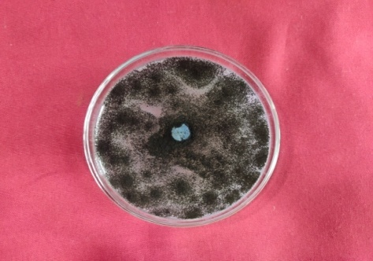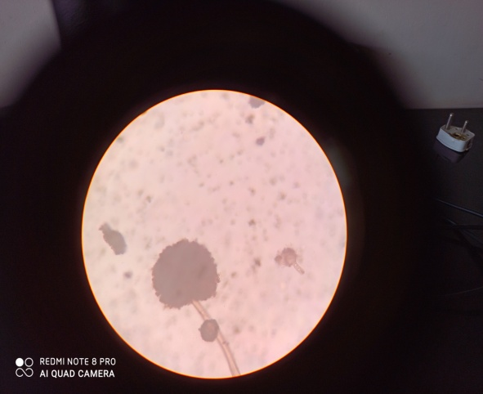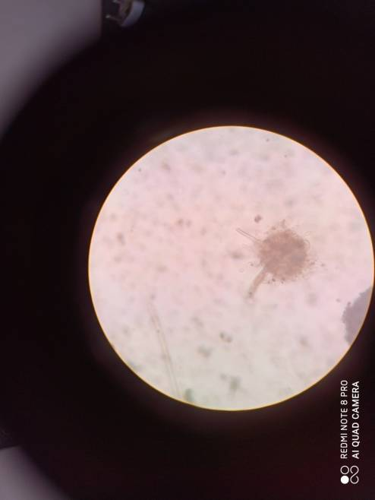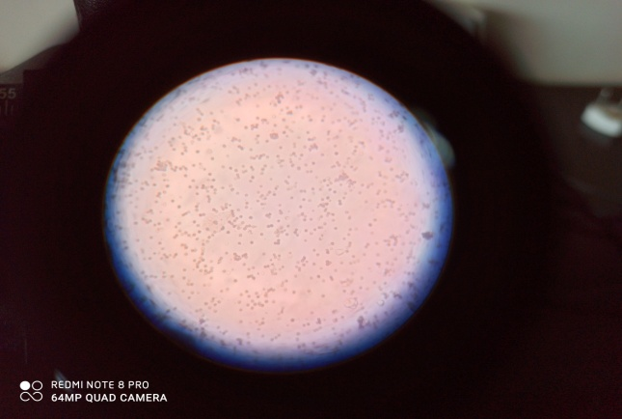

|  |  |  |  |
| --- | --- | --- | --- |
| **a) Pure culture** | **b) Conidiophore with globose vesicle and attached conidia** | **c) Vesicles after releasing conidia** | **d) Conidia** |

**Fig 1. Cultural and morphological characters of *Aspergillus niger***

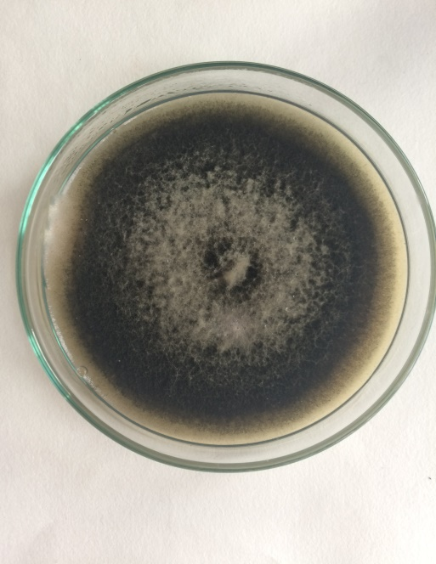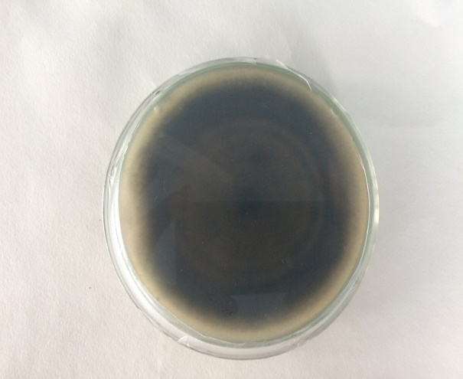

**Plate 2a. Pure Culture of *Alternaria porri***

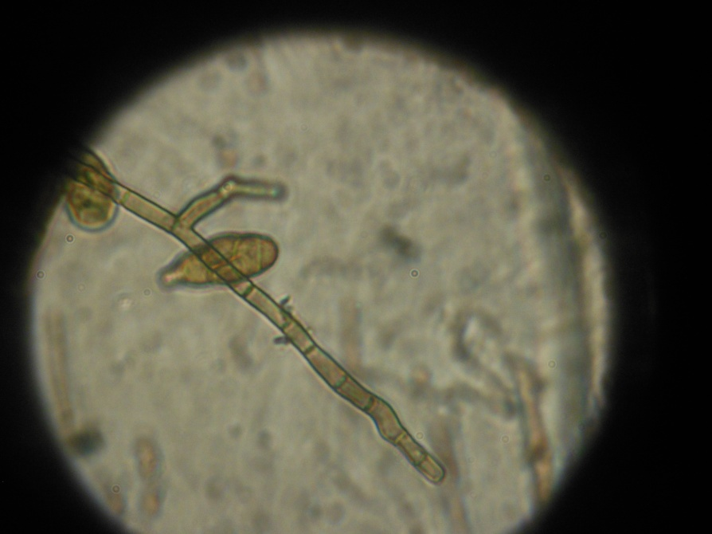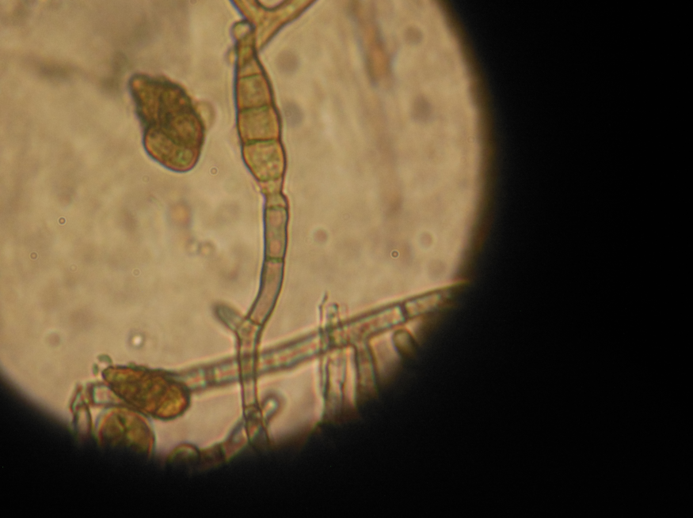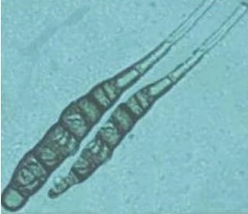

**Fig 2. Morphological characters of *Alternaria porri***

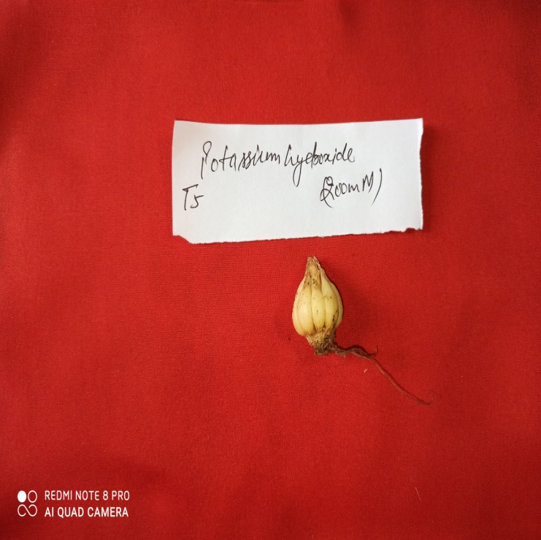 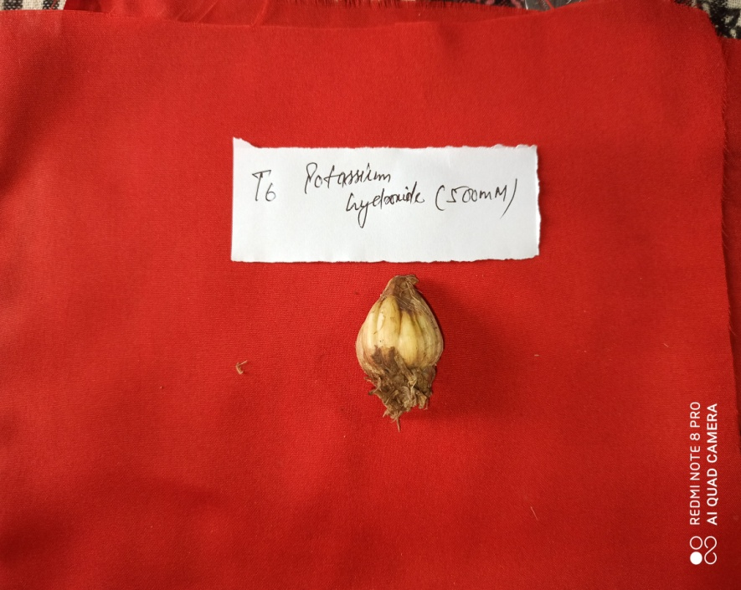 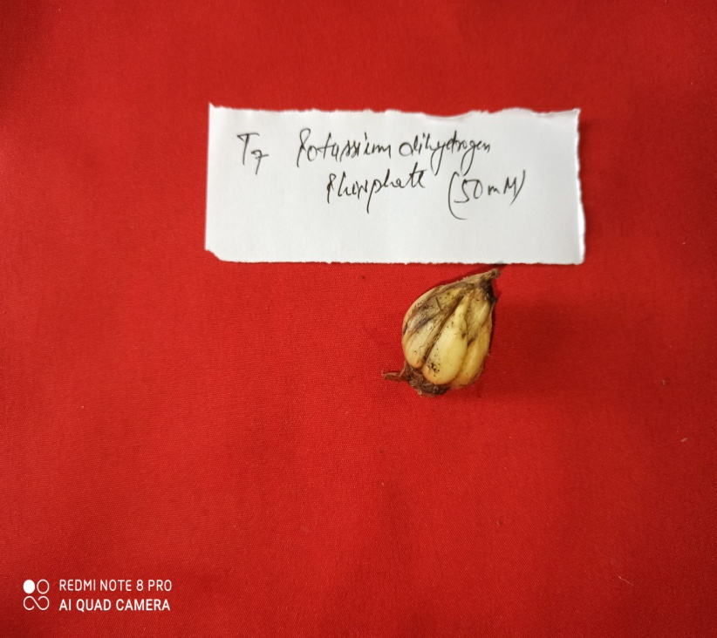

1. Bulbs treated with b. Bulbs treated with c. Bulbs treated with

Potassium hydroxide Potassium hydroxide Potassium dihydrogen phosphate

(7thDAI) (14thDAI) (7thDAI)

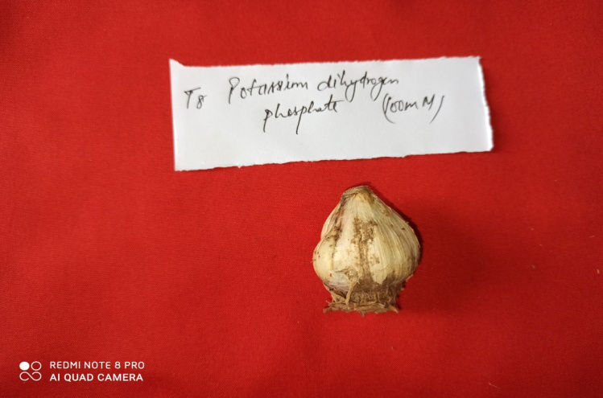 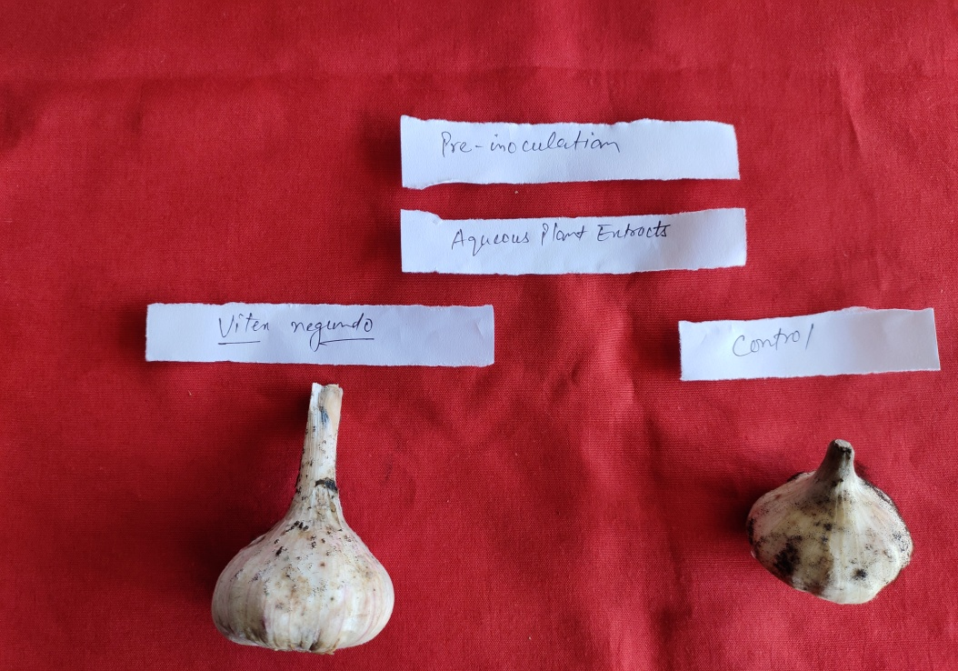

d. Bulbs treated with Potassium dihydrogen phosphate Control

(14thDAI)

**Fig 3. Effect of foliar sprays of abiotic inducers for the management of**

**black mould of garlic**