Original Research Article

# Evaluation of switch over to definitive therapy from empirical therapy in adult patients admitted with lower respiratory tract infections

**ABSTRACT**

**Background:** Lower respiratory tract infections (LRTI) are defined as infection of lower respiratory tract which includes bronchitis, bronchiolitis and pneumonia. Antibiotic treatment is one of the main approaches of modern medicine which is used to combat all types of infections. Empirical antibiotic therapy is initiated to treat patients with LRTI within 24 hours of admission. Benefits includes early treatment, reduced mortality, broad spectrum coverage, reduced hospital stay, prevent complications and time saving. Later, based on clinical condition of patients and culture reports, antibiotics are switched over to definitive therapy. Therefore, the aim of our study is to evaluate the effectiveness of empirical therapy.

**Objectives:** To evaluate the effectiveness of empirical antibiotic therapy in LRTI patients after 48 hours of treatment and to determine the percentage of patients need for switching over to definitive therapy.

**Methodology:** We conducted a prospective observational study for a period of 6 months which includes patients who were diagnosed with LRTI and admitted for atleast 5 days in Siddaganga hospital under Respiratory and General Medicine.

**Results:** A total of 115 patients were included in the study. Higher incidence of LRTI was found in males (54.78%). Majority of the patients were aged between 46-60 years (33.91%). Commonly prescribed antibiotics as empirical therapy was piperacillin + tazobactum (38.26%). Nearly, 88 (76.52%) patients were symptomatically improved with empirical antibiotic therapy. 27 (23.47%) needed switching over from empirical therapy after 48 hours of admission based on culture sensitivity report and clinical response. Most frequent reason for switching over to definitive therapy was poor clinical response (8.69%). Most frequently used definitive therapy was meropenem (37.03%).

**Conclusion:** Our study concludes that, most male patients suffered from LRTI. Empirical antibiotic therapy is effective in most of the patients (76.52%) and only 23.47% are switched over to definitive therapy. A Clinical pharmacist helps in ensuring timely and appropriate de-escalation, minimizing resistance, reducing side effects and improving patient outcome in LRTI management.

Keywords: Antibiotics, Empirical therapy, Switch over, Definitive therapy, LRTI

**ABBREVIATIONS**

LRTI : Lower Respiratory Tract Infection

H/o : History of

IP : Inpatient

URTI: Upper Respiratory Tract Infection

**1. INTRODUCTION**

Lower respiratory tract infection (LRTI) is defined as “infection of the respiratory tract and lung parenchyma presenting with acute febrile respiratory symptoms”. Respiratory tract infections are an significant cause of mortality and morbidity, particularly during winter seasons in temperate climates and rainy seasons in tropical climates (Stover et al., 2014). Diagnosis is established based on the history of (h/o) fever, elevated total leukocyte counts and respiratory symptoms including cough/ sputum production.

Among children under 5 years of age, they are the leading cause of death. Globally, approximately 85-88% of respiratory infections involve upper respiratory tract infections (URTI) while 8-10% affect lower respiratory tract infections. Most recent estimates of LRTI-related mortality in India attribute pneumonia to approximately 3,69,000 deaths, accounting for 28% of total respiratory infection-related mortality (Krishnan et al., 2015).

Lower respiratory tract infections includes acute bronchitis, bronchiolitis, pneumonia. Causes for respiratory infections are bacteria, virus.Antibiotic therapy remains a cornerstone in the treatment of LRTI.

Selection of an appropriate first-line empirical antibiotic regimen for the treatment of respiratory infection is essential for achieving optimal clinical outcome. Improper antibiotic selection may results in therapeutic failure, antibiotic resistance and adverse drug reactions (Mettler et al., 2007).

Empirical therapy is defined as “medical treatment selected initially (i.e., within 24 hours of admission) as an antibiotic regimen on the basis of standard guidelines, experience and hospital antibiogram in the absence of definitive microbiological pathogen identification and susceptibility testing” (McGregor et al., 2007).

Usually, broad-spectrum antibiotics are preferred as empirical antimicrobial therapy, because they are effective against wide range of gram positive and gram negative bacteria. Commonly used broad-spectrum antibiotics are Amoxicillin\ Clavulanic acid, Azithromycin, Piperacillin\ Tazobactam, Ceftriaxone. Narrowspectrum antibiotics are highly specific. Hence, effective against a specific organism. Also, referred as limited spectrum antibiotics. They can act on either gram-positive or gram-negative bacteria but not on both. Narrow- spectrum antibiotics are preferred only when the pathogen identification has been made. Commonly used narrow-spectrum antibiotics are Penicillin, Gentamycin, Doxycycline, Cefixime.

Empirical therapy is selected based on patient characteristics, suspected site of infection, differential diagnosis, local microbial susceptibility data, antibiotic stewardship. Choice of empirical therapy is done by considering other factors such as cost of treatment, antibiotic availability, potential drug intolerance, toxicity (Dat et al., 2021).

Switching over to definitive antibiotic therapy according to sputum culture/sensitivity or blood culture /sensitivity reports results in decreasing the cost of antibiotics, narrowing of antibiotic therapy, avoid unnecessary broad spectrum-antibiotics, reduces the development of drug resistance (Berild et al., 2005).

**Need for the study**

* Evaluating the effectiveness of empirical antibiotic therapy after 48 hours of treatment
* Determining the necessity of switching over to definitive therapy
* Identifying reasons for switching from empirical therapy
* Understanding the pattern of empirical and definitive antibiotic use

**2. MATERIALS AND METHODS**

**Study Design:** A Prospective Observational study, was carried out in the Department of General Medicine and Respiratory Medicine, SMCRI, Tumkur District, Karnataka for a period of six months (From 21st of March to 28th of September). After approval has been obtained from Institutional Ethics Committee of Sree Siddaganga Medical College and Research Institute, this study was conducted (Ref.no: SMCRI/IEC/202425/71).

Sample Size: n = (Z2(1-α) x P(1-P))/d2 where,

n = sample size

z = 1.96, associated with 95% CI d = 9%, absolute precision value

p = 23.8% = 0.238, population proportion now, substituting these values in given equation we get,

n = ((1.96)2 x 0.238(1-0.238))/ (0.08)2

= 108.858

≈ 109

The sample size was calculated by considering percentage of therapy adjusted in patients receiving inadequate empirical antibiotic treatment parameter 23.8% “1” and for margin of error 8% and 95% confidence interval, the minimum number of subjects required for the present study was 109.

A total of 115 samples was collected.

**Source of Data:** Data was collected from patient case sheets.

**Study Criteria:** The study was carried out by considering following inclusion and exclusion criteria.

|  |  |
| --- | --- |
| **Inclusion criteria:** | **Exclusion criteria:** |
| * Participants aged above 18 years. * Patients who was admitted under Respiratory and General Medicine with the diagnosis of lower respiratory tract infections. | * All patients who were discharged or referred out within 3 days after initiation of treatment. * Patients who had URTI, Tuberculosis, viral infections, recently hospitalized. * Allergic to empirical antibiotics. |

**Sampling method:** Convenient sampling method

**Materials Used:** It involves patient informed consent form, data collection form, participant information sheet, patient case sheets.

**Statistical method used:** Descriptive Statistical Method

Data was analysed using IBM SPSS 16 software. Descriptive statistics including, proportions/percentages, frequencies was calculated. Appropriate Statistical tests of significance will be applied when appropriate. A P-values < 0.05 will be considered as statistically significant.

**Study procedure:**

A study protocol was prepared by reviewing various articles and ethical consent was taken prior collecting data from study participant. Patients were enrolled based on inclusion and exclusion criteria. Data was collected from patient case sheet and assessed the effectiveness of empirical therapy. The obtained information were represented in the form of graphs and tables by using MS excel sheets, and report was submitted.

1. **RESULTS**

**3.1 Characterization of patients based on age, gender and medical history:**

A total of 115 patients were included in the study. Characteristics includes demographics such as age, gender and medical history of the patients were shown in Table 1. Majority of the patients were aged between 46-60 years (33.91%) and most of them were found to be males (54.78%) when compared to females (45.21%) shown in Figure 1.

40% of patients were not having any past medical history. Remaining, 60% of the patients had the past medical history such as Hypertension (44.34%), Diabetes Mellitus (33.91%), Cardiovascular diseases such as IHD, CCF etc (18.26%), Thyroid disease (6.08%), Chronic kidney disease (5.21%) and Seizure (0.86%). Comorbidity of patients were shown in the Figure 2.

|  |  |
| --- | --- |
| **Characteristics** | **Number of Patients (n=115)** |
| **Age in years** |  |
| 19-30 years | 06 (5.21%) |
| 31-45 years | 17 (14.78%) |
| 46-60 years | 39 (33.91%) |
| 61-75 years | 35 (30.43%) |
| >75 years | 18 (15.65%) |
| **Gender** |  |
| Male | 63 (54.78%) |
| Female | 52 (45.21%) |
| **Medical History** | **89 (77.39%)** |
| Hypertension (HTN) | 51 (44.34%) |
| Diabetes Mellitus (DM) | 39 (33.91%) |
| Cardiovascular disease | 21 (18.26%) |
| Thyroid disease | 07 (6.08%) |
| Chronic Kidney Disease (CKD) | 06 (5.21%) |
| Seizure | 01 (0.86%) |
| No Medical History | 46 (40%) |

**Table**

**1:**

**Characteristics**

**of**

**patients**

**admitted**

**to**

**general**

**medicine**

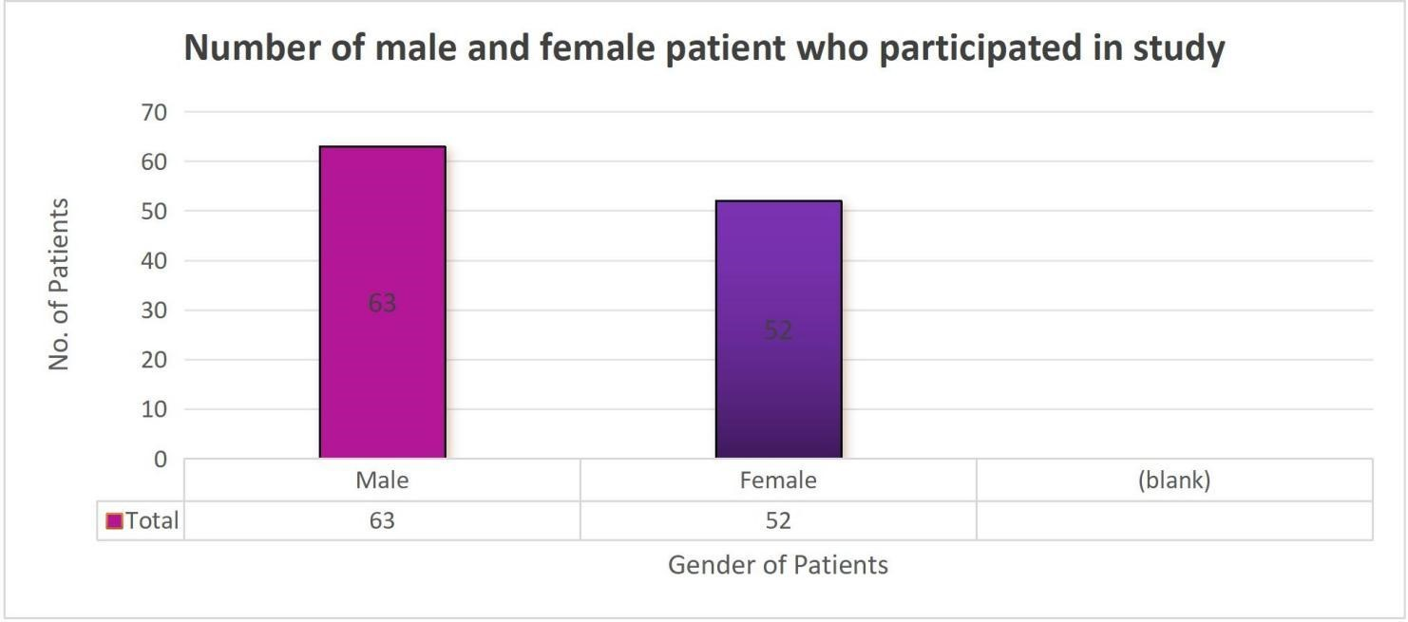

**Figure**

**1**

**Figure**

**2**

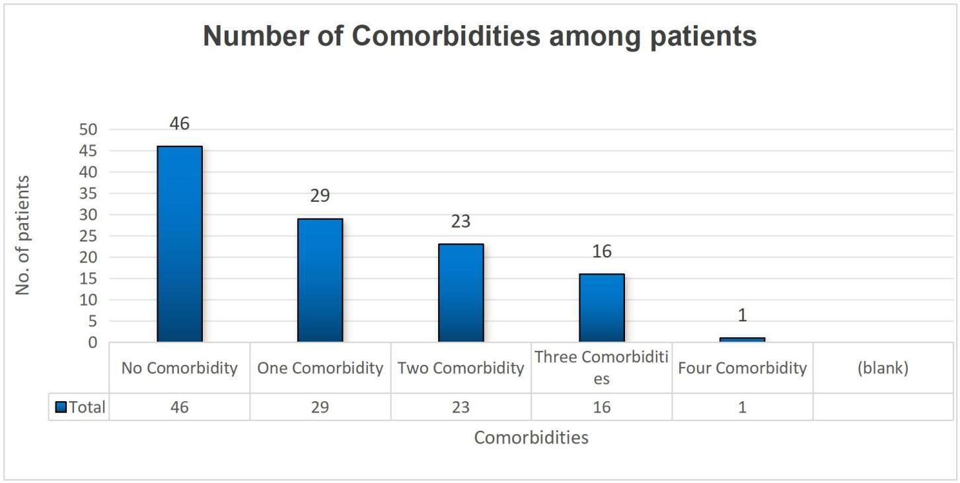

**3.2 Empirical Antibiotic Therapy used within 24 hours of admission:**

A total of 178 antibiotics were administered initially as empirical therapy in 115 patient case records based on physician experience, antibiotic availability, clinical guess and hospital antibiotic policy. Overall, 46.95% patients received atleast one antibiotic within 24 hours of admission.

Commonly prescribed antibiotics as empirical therapy were piperacillin + tazobactum (38.26%), clarithromycin (37.39%), cefoperazone + salbactum (29.56%), ceftriaxone (18.26%), doxycycline (11.3%), amoxicillin + clavulanate (6.08%), meropenem (5.21%), levofloxacin (3.47%), metronidazole (3.47%), ciprofloxacin and azithromycin (0.86%). Antibiotics which were prescribed initially had broad-spectrum of antimicrobial activity which covers both gram positive and gram negative organisms. Initial antibiotic therapy were shown in the Table 2.

Among 115 patients who received any antibiotics, 54 (46.95%) were treated with mono therapy, 54 (46.95%) received dual therapy and 7 (6.08%) received triple therapy (Figure 3).

**Initial antibiotic therapy All patients (n=115)**

Piperacillin + Tazobactum 44 (38.26%)

Clarithromycin 43 (37.39%)

Cefoperazone + Salbactum 34 (29.56%)

Ceftriaxone 21 (18.26%)

Doxycycline 13 (11.3%)

Amoxicillin + Clavulanate 07 (6.08%)

Meropenem 06 (5.21%)

Levofloxacin 04 (3.47%)

Metronidazole 04 (3.47%)

Ciprofloxacin 01 (0.86%)

Azithromycin 01 (0.86%)

**Table 2: Empirical antibiotic therapy used within 24 hours of admission**

.

**Figure**

**3**

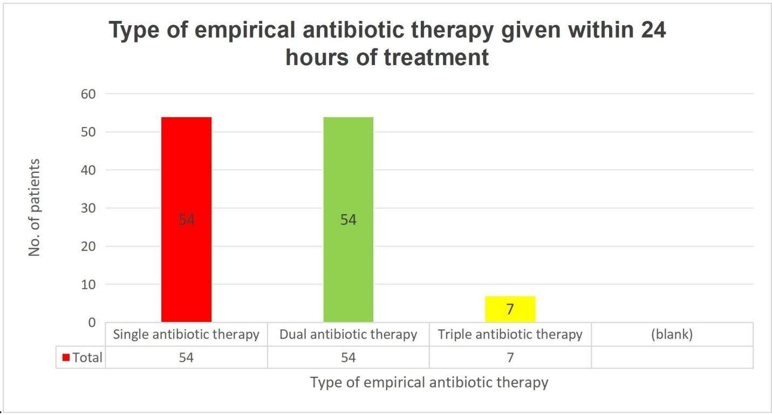

**3.3 Empirical Antibiotic Prescription:**

Among patients received atleast one antibiotic, the most commonly prescribed antibiotic classes were penicillins with beta lactamase inhibitors (44.34%), macrolides (38.26%) and 3rd generation cephalosporins with beta lactamase inhibitors (29.56%) shown in Table 3.

|  |  |
| --- | --- |
| **Empirical Antibiotic Prescription** | **All patients (n=115)** |
| Combination of penicillins and beta lactamase inhibitors | 51 (44.34%) |
| Macrolides | 44 (38.26%) |
| Combination of 3rd generation cephalosporins with beta lactamase inhibitors | 34 (29.56%) |
| 3rd generation Cephalosporins | 22 (19.13%) |
| Tetracyclines | 14 (12.17%) |
| Carbapenem | 06 (5.21%) |
| 2nd generation Fluoroquinolones | 04 (3.47%) |
| Nitroimidazole | 04 (3.47%) |
| Lincosamide | 03 (2.6%) |
| 1st generation Fluoroquinolones | 02 (1.73%) |

**Table 3: Empirical antibiotic prescription in patients receiving atleast one antibiotics**

**3.4 Bacteriological Evaluation:**

Within 48 hours of admission, a total of 47 (40.86%) bacteriological samples were taken from 115 patients (Figure 4). The most commonly isolated pathogenic bacteria were *Klebsiella pneumoniae, Streptococcus pneumoniae and Pseudomonas aeruginosa*.

**Figure**

**4**

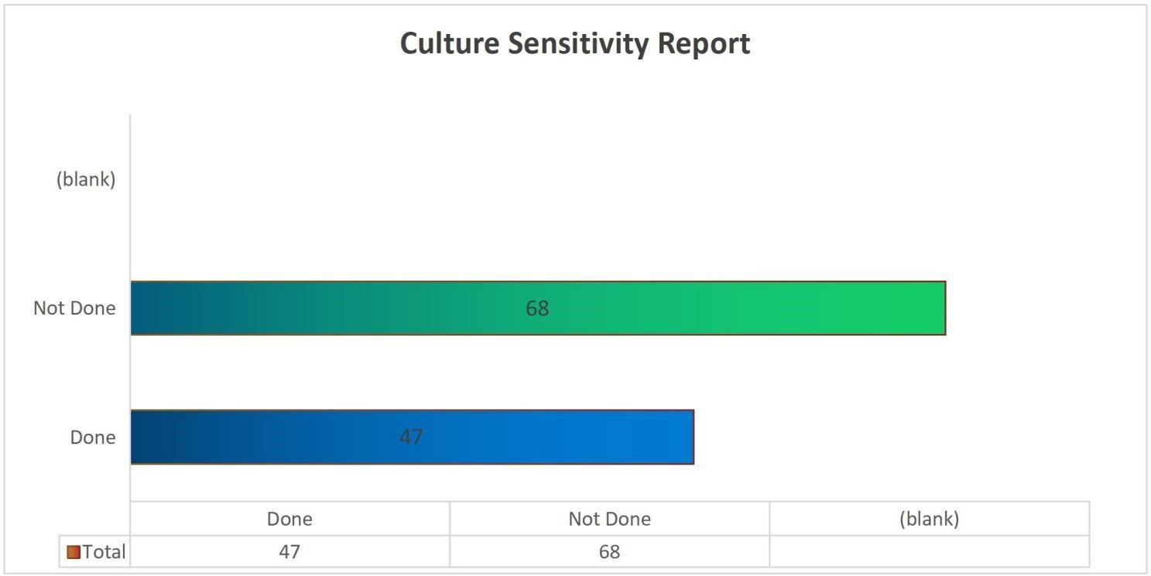

**3.5 Clinical Evaluation (Effectiveness of Empirical Therapy):**

Out of 115 patients, nearly 88 (76.52%) patients were symptomatically improved with empirical antibiotic therapy and remaining 27 (23.47%) patients were not symptomatically improved (Figure 5). This indicates that empirical antibiotic therapy administered within 24 hours of admission was effective to treat infection in most of the LRTI patients.

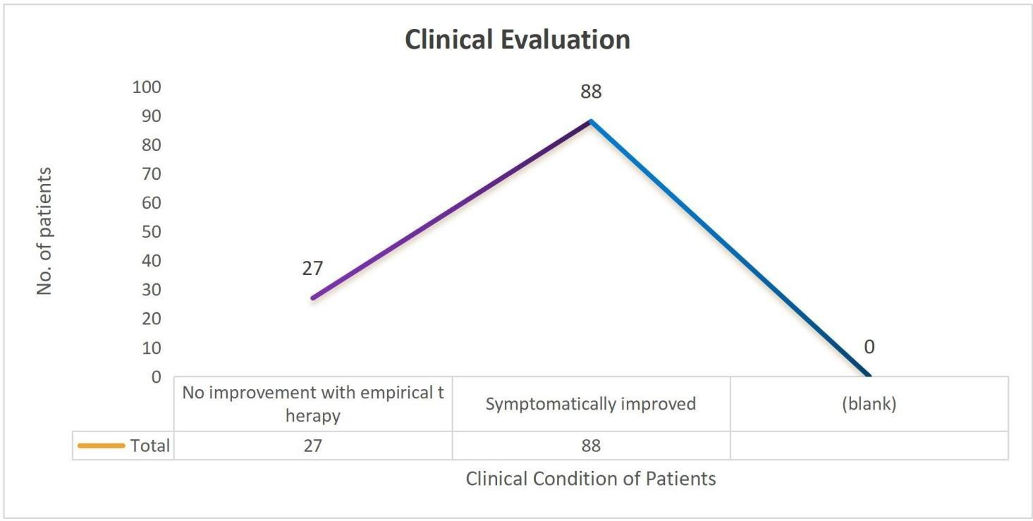

**Figure**

**5**

**3.6 Percentage of patients need for switching over to definitive therapy:**

Among 115 patients, 27 (23.47%) needed switching over from empirical therapy after 48 hours of admission based on culture sensitivity report and clinical response. Remaining, 88 (76.52%) patients were improved with empirical therapy (Figure 6).

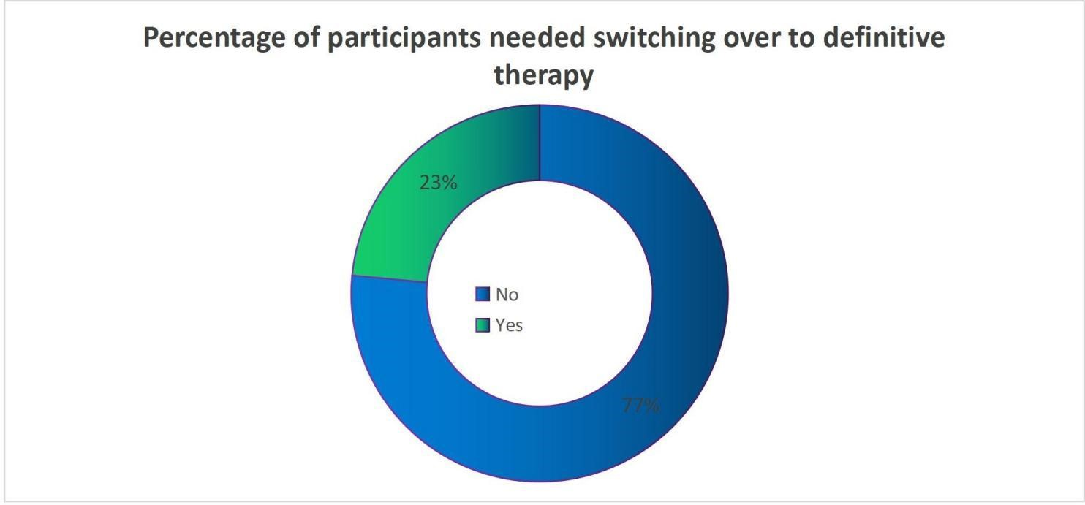

**Figure**

**6**

**3.7 Reasons for switching over to definitive therapy:**

Most frequent reasons for switching over to definitive therapy were allergic to antibiotic (2.6%), inadequate duration (4.34%), poor clinical response (8.69%), resistance during treatment (3.47%) and spectrum too broad (4.34%) shown in Figure 7.

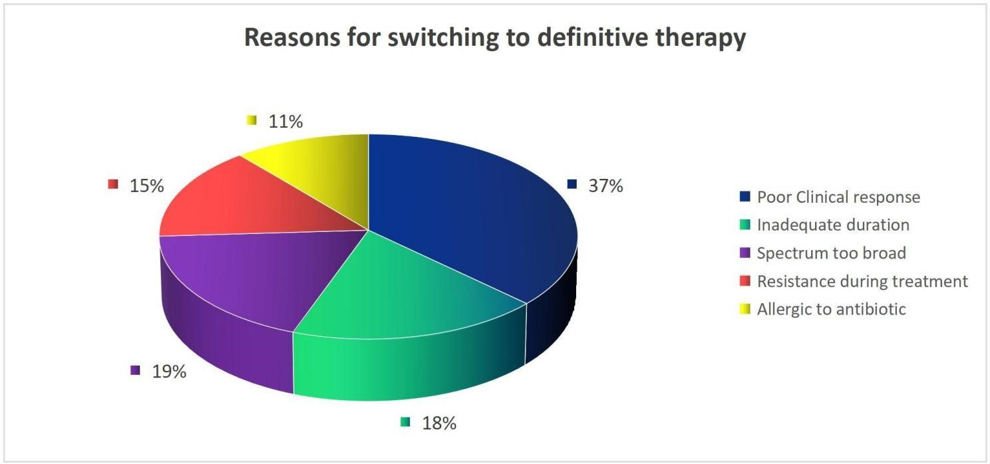

**Figure**

**7**

**3.8 Definitive antibiotic therapy used after 48 hours of admission:**

Out of 115 patients, 27 (23.47%) were switched to definitive therapy. A total of 34 antibiotics were administered after switching over to definitive therapy based on culture sensitivity report and clinical response. Overall, 55.55% patients received atleast one antibiotic after switching over.

Most frequently used definitive therapy were meropenem (37.03%), pipercillin + tazobactum (25.92%), doxycycline (25.92%) and clarithromycin (18.51%) shown in Table 4.

|  |  |
| --- | --- |
| **Definitive Antibiotic Therapy** | **All patients (n=27)** |
| Meropenem | 10 (37.03%) |
| Piperacillin + Tazobactum | 07 (25.92%) |
| Doxycycline | 07 (25.92%) |
| Clarithromycin | 05 (18.51%) |
| Cefoperazone + Salbactum | 04 (14.81%) |
| Levofloxacin | 04 (14.81%) |
| Ceftriaxone | 01 (3.7%) |
| Cefuroxime | 01 (3.7%) |
| Metronidazole | 01 (3.7%) |

**Table 4: Definitive antibiotic therapy prescribed on 3rd day of admission**

Among 115 patients who received any antibiotics, 14 (52%) were treated with mono therapy, 12 (44%) received dual therapy and 1 (4%) received triple therapy (Figure 8).

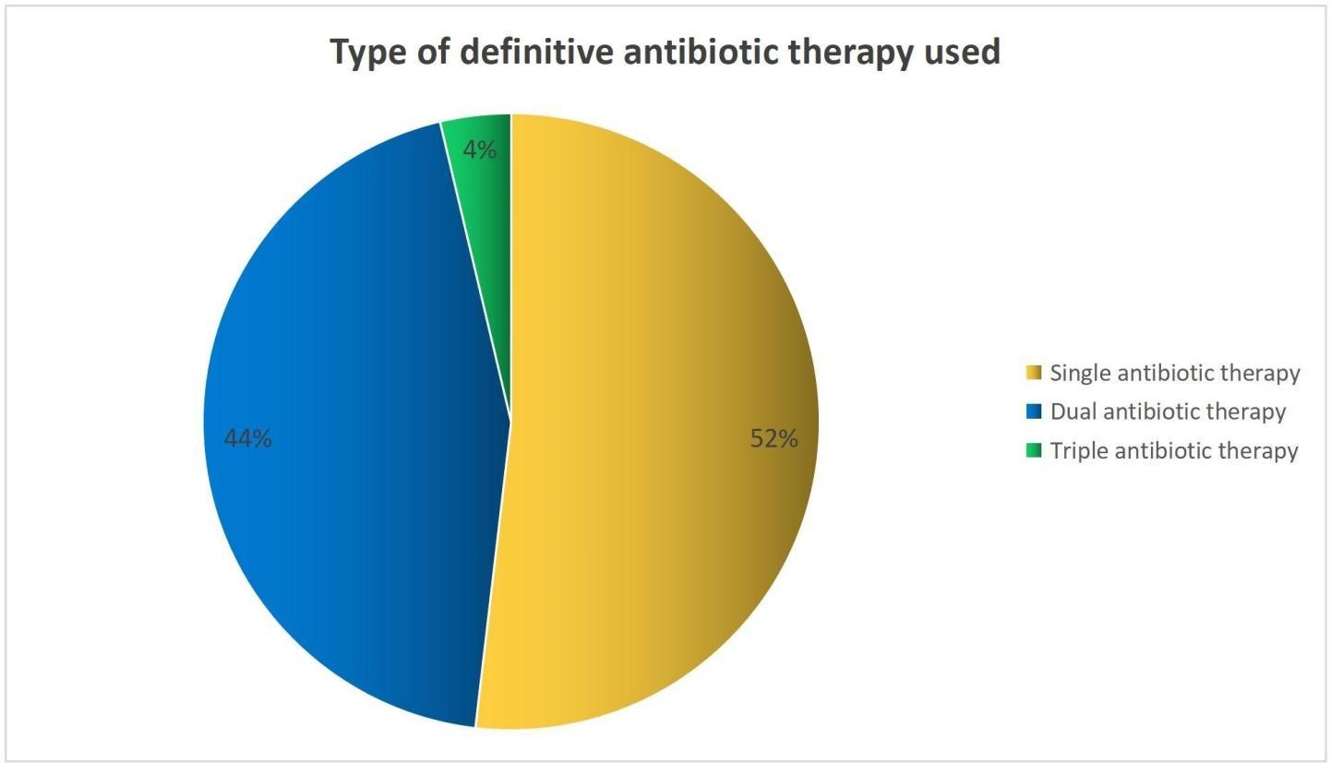

**Figure**

**8**

**3.9 Definitive Antibiotic Prescription:**

Among patients received atleast one antibiotic, the most commonly prescribed antibiotics classes were carbapenem (37.03%), penicillins with beta lactamase inhibitors (25.92%), and tetracyclines (25.92%) shown in Table 5.

|  |  |
| --- | --- |
| **Definitive Antibiotic Prescription** | **All patients (n=27)** |
| Carbapenem | 10 (37.03%) |
| Combination of penicillins and beta lactamase inhibitors | 07 (25.92%) |
| Tetracyclines | 07 (25.92%) |
| Macrolides | 05 (18.51%) |
| Combination of 3rd generation cephalosporins with beta lactamase inhibitors | 04 (14.81%) |
| 2nd generation Fluoroquinolones | 04 (14.81%) |
| 3rd generation Cephalosporins | 01 (3.7%) |
| 2nd generation Cephalosporins | 01 (3.7%) |
| Niroimidazole | 01 (3.7%) |

**Table 5: Definitive antibiotic prescription in patients receiving atleast one antibiotics**

**3.10 Empirical Antibiotic Regimens:**

|  |  |
| --- | --- |
| **Empirical Antibiotic Regimens** | **All patients (n=115)** |
| **Mono antibiotic therapy** | **54 (46.95%)** |
| 3rd generation cephalosporins | 10 (8.69%) |
| Combination of 3rd generation cephalosporins with beta lactamase inhibitors | 21 (18.20%) |
| Combination of penicillins and beta lactamase inhibitors | 18 (15.65%) |
| Macrolides | 01 (0.86%) |
| Tetracyclines | 04 (3.47%) |
| **Dual antibiotic therapy** | **54 (46.95%)** |
| 3rd generation cephalosporins and 2nd generation Fluoroquinolones | 01 (0.86%) |
| 3rd generation cephalosporins and Combination of penicillins and beta lactamase inhibitors | 01 (0.86%) |
| 3rd generation cephalosporins and Macrolides | 05 (4.34%) |
| 3rd generation cephalosporins and Tetracyclines | 02 (1.73%) |
| Carbapenem and 2nd generation Fluoroquinolones | 02 (1.73%) |
| Carbapenem and Macrolides | 02 (1.73%) |
| Combination of 3rd generation cephalosporins with beta lactamase inhibitors and 1st generation Fluoroquinolones | 01 (0.86%) |
| Combination of 3rd generation cephalosporins with beta lactamase inhibitors and Macrolides | 11 (9.56%) |
| Combination of 3rd generation cephalosporins with beta lactamase inhibitors and Tetracyclines | 01 (0.86%) |
| Combination of penicillins and beta lactamase inhibitors and 3rd generation cephalosporins | 01 (0.86%) |
| Combination of penicillins and beta lactamase inhibitors and 2nd generation Fluoroquinolones | 01 (0.86%) |
| Combination of penicillins and beta lactamase inhibitors and  Macrolides | 19 (16.52%) |
| Combination of penicillins and beta lactamase inhibitors and  Nitroimidazole | 03 (2.6%) |
| Combination of penicillins and beta lactamase inhibitors and  Tetracyclines | 01 (0.86%) |
| Macrolides and Combination of penicillins and beta lactamase inhibitors | 01 (0.86%) |
| Tetracyclines and Combination of penicillins and beta lactamase inhibitors | 01 (0.86%) |
| Carbapenem and Lincosamide | 01 (0.86%) |
| **Triple antibiotic therapy** | **07 (6.08%)** |
| Carbapenem Macrolides and Lincosamide | 01 (0.86%) |
| Combination of penicillins and beta lactamase inhibitors along with 3rd generation cephalosporins and Tetracyclines | 01 (0.86%) |
| Combination of penicillins and beta lactamase inhibitors along with  Macrolides and Lincosamide | 01 (0.86%) |
| Combination of penicillins and beta lactamase inhibitors along with  Macrolides and Tetracyclines | 03 (2.6%) |
| Tetracyclines with st generation Fluoroquinolones and Nitroimidazole | 01 (0.86%) |

**Table**

**6:**

**Empirical**

**antibiotic**

**regimens**

**within**

**24**

**hours**

**of**

**admission**

**3.11 Definitive Antibiotic Regimens:**

|  |  |  |
| --- | --- | --- |
| **Definitive Antibiotic Regimen** | **All patients (n=27)** | |
| **Mono antibiotic therapy** | **15 (55.55%)** | |
| 3rd generation cephalosporins | 01 (3.7%) |
| 2nd generation cephalosporins | 01 (3.7%) |
| Carbapenem | 04 (14.81%) |
| Combination of 3rd generation cephalosporins with beta lactamase inhibitors | 03 (11.11%) |
| Combination of penicillins and beta lactamase inhibitors | 03 (11.11%) |
| Macrolides | 01 (3.7%) |
| Tetracyclines | 01 (3.7%) |
| Nitroimidazole | 01 (3.7%) |
| **Dual antibiotic therapy** | **11 (40.74%)** |
| Carbapenem and 2nd generation Fluoroquinolones | 03 (11.11%) |
| Carbapenem and Tetracyclines | 02 (7.4%) |
| Combination of 3rd generation cephalosporins with beta lactamase inhibitors and Macrolides | 01 (3.7%) |
| Combination of penicillins and beta lactamase inhibitors and Macrolides | 02 (7.4%) |
| Combination of penicillins and beta lactamase inhibitors and  Tetracyclines | 02 (7.4%) |
| Macrolides and Tetracyclines | 01 (3.7%) |
| **Triple antibiotic therapy** | **01 (3.7%)** |
| Carbapenem and 2nd generation Fluoroquinolones and Tetracyclines | 01 (3.7%) |

**Table**

**7:**

**Definitive**

**antibiotic**

**regimens**

**on**

**3**

**rd**

**day**

**of**

**admission**

**4. DISCUSSION**

A prospective observational study was conducted over a period of 6 months among the participants above 18 years of age those who were having lower respiratory tract infection and admitted to Siddaganga hospital. Articles were collected related to study and reviewed. A detailed study protocol, informed consent sheet and data collection form were designed and submitted to Institutional Review Board (IRB) at SMCRI. Under their guidance, correction has been made.Later, protocol presentation was given to Institutional Ethics Committee and obtained ethical approval letter. Patient was enrolled according to inclusion and exclusion criteria.

The informed consent forms were obtained from the participants before initiation of the study. Once the consent was obtained, data was collected using pre-designed data collection form. Data which was collected as follows:

**i.Socio-demographic details:** such as name, age, sex, inpatient (IP) number.

**ii.Clinical Assessment:**

 After 48hours of administration of empirical antibiotic therapy, patients vitals and total counts are monitored in order to evaluate the effectiveness of empirical antibiotic therapy on patients with LRTI.

* If there is no improvement in the patient condition even after 48hours of antibiotic administration then the antibiotic is switched over to definitive therapy based on culture sensitivity report.

**iii. Outcome Measurement:**

* The primary outcome of the study was to determine the percentage of patients need for switching over to definitive therapy.

The obtained information were represented in the form of graphs and tables by using MS Excel sheets, and report was submitted.

In our study, we had a sample size of 115 patients, consisting of 63 (54.78%) males and 52 (45.21%) females. In contrast, the study conducted by Vu Quoc Dar et al. (2021) comprised a larger sample of 1747 subjects, including 988 (56.55%) males and 759 (43.44%) females.

The study included patients aged 18 years and older, with the majority being over 60 years of age.

Among them, 53 (46.08%) patients aged above 60 years were suffered with LRTI. These findings align with the results of the study by Julian Mettler et al. (2007), which also reported that most patients were over 60 years old. While in the context of past medical history and comorbid condition, there was a change when compared to cross sectional study conducted by Vu Quoc Dat et al. (2021).

Piperacillin-Tazobactum (38.26%) was the most commonly used antibiotic for empirical therapy in our study, which contrasts with the use of Amoxicillin-Clavulanate as the primary empirical antibiotic in the study conducted by Julian Mettler et al. (2007). Furthermore, our study observed the utilization of both single and dual empirical therapy regimens. This differs from the findings of cross-sectional study executed by Vu Quoc Dat et al. (2021), where single empirical therapy was more frequently employed.

Among 115 patients, 77% were not switched over to definitive therapy, indicating that most showed clinical improvemnet with empirical therapy. This finding found to be in the agreement of prospective study conducted by F. Alvarez-Lerma, where no changes in empirical therapy were observed in 237 (53.37%) patients.In contrast, the main reason for switching to definitive therapy in the remaining 23% of patients in our study was due to poor clinical response (37.03%). Comparatively, F. AlvarezLerma’s (1996) study attributed the switch to inadequate microbial coverage in 53.41% of cases.

We found that, nearly 40.86% of patients were done with bacterial culture sensitivity test which was comparable by Nikolay P Morgan et al. (2014), where microbiological cultures were collected in almost 59% of patients. Most frequently used definitive therapy in our study was Meropenem (37.03%) which is not in significant relationship with the study done by Julian Mettler et al. (2007), where Amoxicillin-Clavulanate (17.26%) was used more predominantly.

The discrepancy could be attributed to varying categorizations of symptoms, distinct research areas and utilization of different study tools.

**5. CONCLUSION**

A Prospective observational study was conducted to evaluate the effectiveness of empirical therapy and percentage of patient requires switch over. A total of 115 cases were included based on inclusion criteria. The demographic details such as age, sex and treatment details were recorded in a suitable designed patient profile form.

Overall, 46.95% patients received atleast one antibiotic within 24 hours of admission. Commonly prescribed antibiotics as empirical therapy was piperacillin + tazobactum (38.26%). Within 48 hours of admission, a total of 47 (40.86%) bacteriological samples were taken from 115 patients. Out of 115 patients, nearly 88 (76.52%) patients were symptomatically improved with empirical antibiotic therapy. This strongly suggests that initial choice of antibiotics were often appropriate for treatment of infection in patient population.The fact that only 27 (23.47%) of patients needed switching over to definitive therapy from empirical therapy after 48 hours of admission based on culture sensitivity report and clinical response indicates that the empirical therapy was successful for a substantial proportion of study participants.

Most frequent reason for switching over to definitive therapy was poor clinical response (8.69%). Most frequently used definitive therapy were meropenem (37.03%). Hence, from our study it was found that empirical therapy which was given within 24 hours of admission was effective to combat infections in most of the patients and only 23.47% of patient requires switching over to definitive therapy.

A Clinical pharmacist play a crucial role in ensuring appropriate selection of empirical antibiotics based on patient factors and local antibiograms, interpreting culture sensitivity reports to identify causative pathogen, optimisation of definitive therapy, ensuring patient adherence and understanding of prescribed regimen, documenting interventions and tracking clinical outcome.

Physician, Clinical Pharmacist and other health care professionals must collaborate for the proper selection and adjustment of antibiotics in management of patient with lower respiratory tract infections if needed.

**6. RECOMMENDATIONS/ CLARIFICATIONS/ SUGGESTIONS**

1. Assess Clinical Stability: Before switching over to definitive therapy, ensure the patient shows signs of improvement, including stable vital signs, afebrile for 24-48 hours, improved oxygenation and respiratory symptoms
2. Review Microbiological data
3. Optimise antibiotic therapy
4. Monitor for treatment failure and avoid unnecessary use of antibiotics for prolonged period
5. Economic evaluation of empirical versus definitive therapy approaches

**7. STRENGTH AND LIMITATIONS**

**Strength:**

* This study potentially reduces recall bias because it was a prospective observational study which allowed for collection of data as it occurred.
* The collection of data on both empirical and definitive therapy allowed for evaluation of switch-over practices and reasons for such changes.
* The study aimed to determine the percentage of patients needed for switch over to definitive therapy, which is a clinically relevant outcome measure for assessing the effectiveness of initial empirical therapy.

**Limitations:**

* The study was conducted at a single center, which might limit the generalizability of findings to other healthcare settings or populations.
* The use of convenient sampling might introduce selection bias, as the participants were chosen based on their availability during the study period.
* The study did not include control group receiving a different empirical strategy or no initial antibiotics, which makes it challenging to directly compare the effectiveness of observed empirical practices.

**DISCLAIMER (ARTIFICIAL INTELLIGENCE)**

Author(s) hereby declare that NO generative AI technologies such as Large Language Models (ChatGPT, Deep seek, Perplexity) were used during manuscript preparation.

**CONSENT AND ETHICAL APPROVAL**

The Institutional Ethics Committee (IEC) of Sree Siddaganga Medical College and Research Institute (SMCRI) approved the study protocol and informed consent was obtained from the study participants.

**COMPETING INTERESTS DISCLAIMER:**

Authors have declared that they have no known competing financial interests OR non-financial interests OR personal relationships that could have appeared to influence the work reported in this paper. **REFERENCES**

Stover, C. S., Litwin, C. M. (2014). Epidemiology of Upper Respiratory Infections at a Tertiary Care Center:

Prevalence, Seasonality, and Clinical Symptoms. Journal of Respiratory Medicine, 2014(1), 469393, 1-8. https://doi.org/10.1155/2014/469393

Krishnan, A., Amarchand, R., Gupta, V., Lafond, K. E., Suliankatchi, R. A., Saha, S., *et al*. (2015) Epidemiology of acute respiratory infections in children - preliminary results of a cohort in a rural north Indian community. BMC Infectious diseases, 15, 462, 1-10.

https://doi.org/10.1186/s12879-015-1188-1

Mettler, J., Simcock, M., Sendi, P., Widmer, A. F., Bingisser, R., Battegay, M., *et al*. (2007) Empirical use of antibiotics and adjustment of empirical antibiotic therapies in a university hospital: a prospective observational study. BMC Infectious Diseases, 7, 21, 1-10.

https://doi.org/10.1186/1471-2334-7-21

McGregor, J. C., Rich, S. E., Harris, A. D., Perencevich, E. N., Osih, R., Lodise, T. P., *et al*. (2007). A Systematic Review of the Methods Used to Assess the Association between Appropriate Antibiotic Therapy and Mortality in Bacteremic Patients. Clinical Infectious Diseases, 45(3), 329-337.

https://doi.org/10.1086/519283

Dat, V. Q., Dat, T. T., Hieu, V. Q., Giang, K. B., Otsu, S. (2021) Antibiotic use for empirical therapy in the critical care units in primary and secondary hospitals in Vietnam: a multicenter cross-sectional study. The Lancet Regional Health - Western Pacific, 18, 100306, 1-10.

https://doi.org/10.1016/j.lanwpc.2021.100306

Berild, D., Mohseni, M., Diep, L. M., Jensenius, M., Ringertz, S. H. (2005). Adjustment of antibiotic treatment according to the results of blood cultures leads to decreased antibiotic use and costs. Journal of Antimicrobial Chemotherapy, 57(2), 326-330.

https://doi.org/10.1093/jac/dki463

Alvarez-Lerma, F. (1996). Modification of empiric antibiotic treatment in patients with pneumonia acquired in the intensive care unit. Intensive Care Medicine, 22(5), 387-394.

https://doi.org/10.1007/BF01712153

Braykov, N. P., Morgan, D. J., Schweizer, M. L., Uslan, D. Z., Kelesidis, T., Weisenberg, S. A., *et al*. (2014). Assessment of empirical antibiotic therapy optimisation in six hospitals: an observational study. The Lancet Infectious Diseases, 14(12), 1220-1227.

https://doi.org/10.1016/S1473-3099(14)70952-1

Shiroshita, A., Yamamoto, S., Anan, K., Suzuki, H., Takeshita, M., Kataoka, Y. (2022). Association between empirical anti-pseudomonal antibiotics for recurrent Lower respiratory tract infections and Mortality: A Retrospective cohort Study. International Journal of chronic obstructive pulmonary disease, 17, 2919-2929. https://doi.org/10.2147/COPD.S386965

Drago, L., Vecchi, E. D., Nicola, L., Gismondo, M. R. (2007). In vitro evaluation of antibiotics combinations for empirical therapy of suspected methicillin resistant Staphylococcus aureus severe respiratory infections. BMC infectious disease, 7, 111, 1-7. https://doi.org/10.1186/1471-2334-7-111

Gueli, N., Martinez, A., Verrusio, W., Linguanti, A., Passador, P., Martinelli, V., *et al*. (2012). Empirical antibiotic therapy (ABT) of lower respiratory tract infections (LRTI) in the elderly: Application of artificial neural network (ANN). Preliminary results. Archives of gerontology and geriatrics, 55(2), 499-503.

https://doi.org/10.1016/j.archger.2011.09.006

Falcone, M., Corrao, S., Licata, G., Serra, P., Venditti, M. (2012). Clinical impact of broad-spectrum empirical antibiotic therapy in patients with healthcare-associated pneumonia: a multicenter interventional study. Internal and emergency medicine, 7(6), 523-531.

https://doi.org/10.1007/s11739-012-0795-8

Dambrava, P. G., Torres, A., Valles, X., Mensa, J., Marcos, M. A., Penarroja, G., *et al*. (2008). Adherence to guidelines empirical antibiotic recommendations and community-acquired pneumonia outcome. The European respiratory journal, 32(4), 892-901.

https://doi.org/10.1183/09031936.00163407

File, T. M., Jr, Garau, J., Blasi, F., Chidiac, C., Klugman, K., Lode, H., *et al*. (2004). Guidelines for empiric antimicrobial prescribing in community-acquired pneumonia. Chest, 125(5), 1888-1901. https://doi.org/10.1378/chest.125.5.1888

Mortensen, E. M., Restrepo, M. I., Anzueto, A., Pugh, J. (2005). The impact of empiric antimicrobial therapy with a beta-lactam and fluoroquinolone on mortality for patients hospitalized with severe pneumonia. Critical care, 10(1), R8, 1-8.

https://doi.org/10.1186/cc3934

Boyer, A., Goret, J., Clouzeau, B., Romen, A., Prevel, R., Lhomme, E., *et al*. (2019). Tailoring empirical antimicrobial therapy in subjects with ventilator-associated pneumonia with a 10-hour E-test approach. Respiratory Care, 64(3), 307-312.

https://doi.org/10.4187/respcare.06255

Kumar, M. P., Amrin, S., Vaishnavi, C. R., Swapna, B., Charan, P. S., & Prasad, L. (2024). Evaluation of Antibiotics Resistance Pattern in Respiratory Tract Infections and Urinary Tract Infections in Tertiary Care Hospital. International Journal of Pharmaceutical Investigation, 14(4), 1221–1225.

https://doi.org/10.5530/ijpi.14.4.134

Santella, B., Serretiello, E., De Filippis, A., Veronica, F., Iervolino, D., Dell'Annunziata, F. (2021). Lower Respiratory Tract Pathogens and Their Antimicrobial Susceptibility Pattern: A 5-Year Study. Antibiotics (Basel, Switzerland), 10(7), 851.

https://doi.org/10.3390/antibiotics10070851

Ahmed, S. K., Hussein, S., Qurbani, K., Ibrahim, R. H., Fareeq, A., Mahmood, K. A., *et al*. (2024). Antimicrobial resistance: Impacts, challenges, and future prospects. Journal of Medicine, Surgery, and Public Health, 2, 100081, 1-9.

https://doi.org/10.1016/j.glmedi.2024.100081

Canton, R., Barberan, J., Linares, M., Molero, J. M., Rodriguez-Gonzalez-Moro, J. M., Salavert, M., *et al*. (2022). Decalogue for the selection of oral antibiotics for lower respiratory tract infections. Official journal of the Spanish Society of Chemotherapy : Revista Espanola de Quimioterapia, 35(1), 16–29.

https://doi.org/10.37201/req/172.2021

Ferrara, A.M., Fietta, A.M. (2004). New Developments in Antibacterial Choice for Lower Respiratory Tract Infections in Elderly Patients. Drugs Aging, 21(3), 167-186.

https://doi.org/10.2165/00002512-200421030-00003