Original Research Article

The Effect of Roasted Coffea Arabica and Coffea Canephora Intake on The Gaster Histopatology in Mus Musculus

.

ABSTRACT

|  |
| --- |
| **Background**  Coffee is a globally consumed beverage, and substantial interest is being shown in its biological effects. It contains both irritant and protective agents.  **Objective**  This experiment aimed to evaluate the impact of roasted Coffea arabica/*C. arabica* (arabica coffee) and *Coffea canephora/C. canephora* (robusta coffee) on the histopathological alterations in the gastric tissue of Mus musculus.  **Methods**  A laboratory-based experimental design, utilizing a control group setup, was employed for this study. Thirty mice were randomly assigned to one of three groups: a control group (K) receiving standard chow and distilled water, a group administered *C. arabica* powder at a dose of 0.1 grams dissolved in 1.8 ml of distilled water per day, gavage for 7 consecutive days, and a group receiving an equivalent dose of *C. canephora* powder via the same administration protocol. Gastric tissues were processed using standard paraffin embedding techniques, followed by Hematoxylin and Eosin (HE) staining for histological examination. The histopathological assessment of gastric tissue was conducted to evaluate the extent and severity of morphological damage, utilizing the Wattimena scoring system. Statistical analysis was performed using the Kruskal-Wallis test within the IBM SPSS Statistics 25 software suite.  **Result**  The results indicated that neither roasted *C. arabica* nor roasted *C. canephora* induced significant histopathological changes in the gasters of the mice (Mus musculus). Additionally, no statistically significant differences were observed between the effects of both coffee powders on the gastric histopathology.  *Keywords: Roasted robusta coffee, Coffea canephora, roasted arabica coffee, Coffea arabica, gastric erosion, gastroprotection* |

INTRODUCTION

Coffee is one of the most widely consumed beverages globally, primarily due to its distinctive aroma and flavor profile. Coffee is commercially available worldwide and is derived from two primary plant species: Coffea arabica/*C. arabica* and Coffea canephora/*C. canephora* (commonly known as Arabica and Robusta coffee, respectively). These species are rich in biologically active compounds, including nicotinic acid, quinolinic acid, trigonelline, pyrogallic acid, tannic acid, and caffeine (Farhaty n.d.). A standard cup of coffee typically contains approximately 100 mg of caffeine; however, other sources estimate that 240 mL of brewed coffee can contain between 72–130 mg of caffeine (Afriliana 2018). The generally accepted safe upper limit for daily caffeine intake in adults is approximately 300 mg (Baehaki, Nurhamidah, and Purwaeni 2023). In addition to caffeine, coffee also provides essential minerals. For example, it contributes up to 8% of the daily recommended intake of chromium (Cr) and contains approximately 63.7 mg of magnesium (Mg) per 100 mL. Coffee is also recognized as a significant dietary source of polyphenols, including caffeic acid, chlorogenic acid, coumaric acid, ferulic acid, and sinapic acid—compounds known for their antioxidant and anti-inflammatory properties (Carlsen et al. 2010; Hečimović et al. 2011).

Polyphenols represent the most abundant group of antioxidants in the human diet, with an average daily intake estimated at around 1 gram (Hečimović et al. 2011; Hussain et al. 2016). These compounds exhibit antioxidant activity approximately ten times greater than that of vitamin C and up to one hundred times more potent than vitamin E and carotenoids. Among beverages, coffee ranks as one of the richest sources of dietary antioxidants, with *C. canephora* possessing a higher antioxidant capacity than other varieties (Pellizzon et al. 2017). Antioxidants are molecules that inhibit oxidative stress by neutralizing reactive oxygen species (ROS), including free radicals, which are generated endogenously and exacerbated by various environmental and physiological stressors. The polyphenolic compounds in coffee can scavenge ROS, thereby protecting cells from oxidative damage and mitigating inflammatory responses (Al-Snafi 2016).

Some studies suggest that coffee, particularly its caffeine content, may stimulate gastric acid secretion, leading to increased gastric acidity and potential irritation of the gastric mucosa. Caffeine, an alkaloid, is known to enhance the secretion of hydrochloric acid (HCl) in the gaster (Shofa and Ismail 2014). The gastric mucosa serves as a critical barrier, protecting the gaster lining from autodigestion by HCl and pepsin. When the integrity of the gastric mucosal barrier is compromised, HCl can diffuse into the mucosa, resulting in tissue damage. This damage promotes the conversion of pepsinogen to its active form, pepsin, and stimulates mast cell-mediated histamine release. Histamine increases capillary permeability, leading to edema and potential vascular injury (Shimoyama et al. 2013). Chronic exposure to such irritants may cause inflammation, which, over time, can result in fibrotic tissue replacement, atrophy of mucosal epithelial cells, and degradation of the mucosal lining (Selviana 2015)

Conversely,other studies propose that caffeine may exert anti-inflammatory effects by acting as a ROS inhibitor, thereby suggesting a protective role for coffee in gastrointestinal health (Hafiedz, Iskandar, and Murti 2024). Given the conflicting data regarding the impact of coffee on gastric physiology—both as a potential irritant and also a protective agent—this study aims to evaluate the effects of roasted *C. arabica* and *C. canephora* powder on the gastric morphology of mice.(Tjahjani, Biantoro, and Tjokropranoto 2019)

material and methods

This study was a laboratory-based experimental investigation designed to evaluate histopathological differences in the gastric mucosa of mice across three experimental groups. A post-test-only control group design was utilized. Sample size determination followed the Federer formula, which is commonly applied in animal experimental studies.

The study population consisted of healthy male Swiss Webster mice (*Mus musculus*), aged approximately 2 weeks, with body weights ranging from 20 to 40 grams. A total of 30 mice were randomly assigned to three groups (n = 10 per group):

1. Control group
2. Treatment Group I – Roasted *Coffea arabica* powder
3. Treatment Group II – Roasted *Coffea canephora* powder

It is known that 13 grams of coffee powder brewed in a standard cup (240 mL) contains approximately 95 mg of caffeine. A moderate human caffeine dose (300 mg) is equivalent to approximately 41 grams of coffee powder. Using the Laurance and Bacharach interspecies dose conversion table, this was translated to a mouse-equivalent dose of 0.1 grams.

* The control group received no treatment.
* Mice in Treatment Group I were administered 0.1 grams of roasted *C. arabica* powder dissolved in 1.8 mL of distilled water, given orally via gastric gavage once daily for seven consecutive days.
* Mice in Treatment Group II received 0.1 grams of roasted *C. canephora* powder using the same solvent volume and administration protocol.

The experiment was conducted at the Integrated Laboratory, Faculty of Medicine, Universitas Kristen Indonesia, from September to October 2020. All mice underwent a one-week acclimatization period to adjust to laboratory conditions prior to treatment.

At the end of the treatment period, mice were euthanized using the cervical dislocation technique, and gastric tissues were harvested. The tissues were fixed in 10% neutral buffered formalin, processed using standard paraffin embedding techniques, sectioned with a microtome, and mounted onto glass slides. The sections were stained with Hematoxylin and Eosin (H&E) and examined under a light microscope at 200× magnification.

The severity of gastric mucosal erosion was evaluated using the Wattimena scoring system, which classifies histopathological damage based on the depth of erosion:

* Score 1: No erosion observed
* Score 2: Erosion limited to the surface epithelium
* Score 3: Erosion involving the upper one-third of the gastric glands
* Score 4: Erosion extending into the middle one-third of the gastric glands
* Score 5: Erosion involving the lower one-third of the gastric glands
* Score 6: Erosion reaching the lamina muscularis mucosae

Data were analyzed using SPSS statistical software (version [insert version]), and appropriate statistical tests were applied to determine the presence of significant differences between groups, with a significance level set at p < 0.05.

results

There were no observable differences in the physical appearance of the mice across the control group, Treatment Group I, and Treatment Group II, both before and after the experimental procedures.

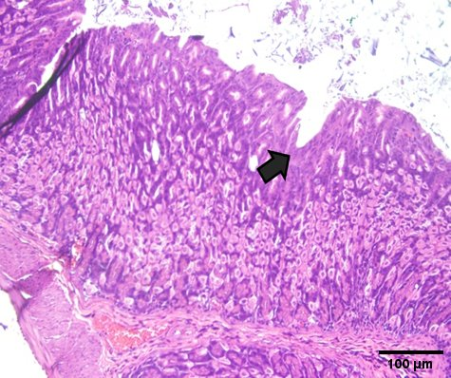In the control group, nine out of ten mice were assigned a Wattimena Score of 1, indicating normal gastric histology with intact mucosal layers and no evidence of epithelial erosion or inflammatory changes (Figure 1.A.). One mouse demonstrated a Wattimena Score of 2, characterized by mild erosion of the gastric epithelium (Figure 1.B.)

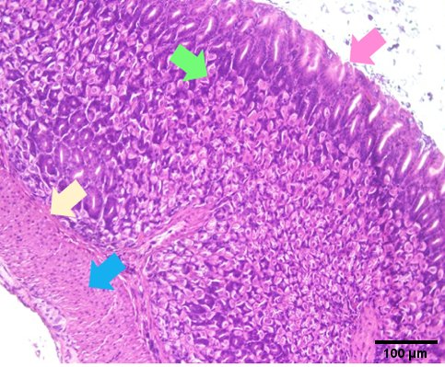 1.A. 1.B.

Figure 1. Microscopic histopathological image of mice gastric in control group

The mucosal layer (green arrow), the tunica muscularis layer (yellow arrow), and the submucosal layer (blue arrow) are visible. (1A) wattimena score 1. A single-layered columnar epithelium is present without erosion (pink arrow); (2B) wattimena score 2. Erosion is visible on the surface of the gastric epithelium (black arrow)

In Treatment Group I, which received 0.1 grams of roasted Coffea arabica, nine out of ten mice exhibited Wattimena Score 1 histology, similar to the control group (Figure 2.A). One mouse showed Wattimena Score 2, indicating superficial mucosal erosion (Figure 2.B).

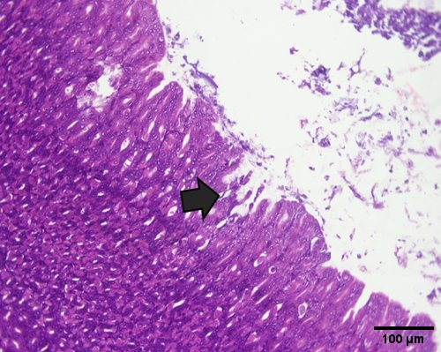

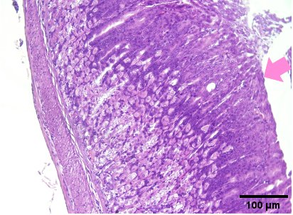

2.A. 2.B.

Figure 2. Microscopic histopathological image of mice gastric in treatment group I

(A) Wattimena Score 1. Normal mucosa, submucosa, tunica muscularis externa, and serosa layers are visible without erosion or signs of inflammation (pink arrow); (B) Wattimena Score 2. Erosion is visible on the surface of the gastric epithelium (black arrow).

In Treatment Group II, which received 0.1 grams of roasted Coffea canephora, seven out of ten mice showed Wattimena Score 1, indicating preserved gastric histology without evidence of inflammation (Figure 3.A). The remaining three mice presented with Wattimena Score 2, showing superficial epithelial erosion of the gastric mucosa (Figure 3.B.).

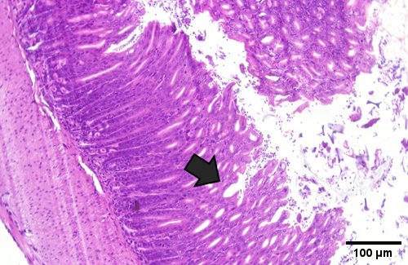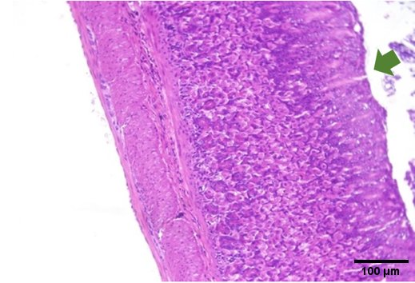

3.A. 3.B.

Figure 3. Microscopic histopathological image of mice gastric in treatment group II

(A) Wattimena score 1. Normal mucosa, submucosa, tunica muscularis externa, and serosa layers are visible without erosion or signs of inflammation (green arrow); (B) Wattimena score 2. Erosion is visible on the surface of the gastric epithelium (black arrow).

The result from 3 groups of mice are shown in the table below.

**Table 1. Results of Microscopic Observations of Histopathological Images of Mice Gastric**

|  |  |  |  |
| --- | --- | --- | --- |
| Wattimena Score | Number of Mice | | |
| **Control** | **Group I** | **Group II** |
| 1  2  3  4  5  6 | 9  1  0  0  0  0 | 9  1  0  0  0  0 | 7  3  0  0  0  0 |

Data The data obtained from histopathological evaluation were analyzed using the Kruskal-Wallis test to determine statistical differences among the three groups..

**Table 2. Kruskal-Wallis Test Results**

|  |  |
| --- | --- |
|  | Histopathology |
| Kruskal-Wallis H | 2.167 |
| df | 2 |
| **Asymp. Sig.** | **0.338** |

The Kruskal-Wallis test yielded a p-value of 0.338, which is greater than the threshold of significance (p > 0.05). Therefore, it can be concluded that there were no statistically significant differences in gastric histopathological outcomes among the control, Treatment Group I, and Treatment Group II.

**DISCUSSION**

The gastric mucosa is regulated by two main mechanisms: aggressive factors and defensive factors. The primary aggressive factors are gastric acid and pepsin, which play a critical role during conditions of hypersecretion, such as in duodenal ulcers. In contrast, the defensive factors of the gastric mucosa, collectively referred to as cytoprotection, help to maintain mucosal integrity and are influenced by several key elements: (1) Mucus (glycoproteins) and bicarbonate, which serve to protect the mucosa from the damaging effects of acid, pepsin, bile, and external irritants such as salicylates and nonsteroidal anti-inflammatory drugs (NSAIDs); (2) Mucosal resistance, including the electrical potential of the mucous membrane and the processes of wound healing. Bile and salicylates reduce the electrical potential, impairing mucosal cell proliferation, particularly in chronic ulcers; (3) Decreased mucosal blood flow, which can lead to cellular anoxia, reduced mucosal resistance, and an increased susceptibility to gastric ulceration; (4) Prostaglandins, produced by the gastric and duodenal mucosa, significantly enhance mucosal resistance by promoting the secretion of mucus and bicarbonate, maintaining the function of sodium pumps, and improving blood flow to the mucosa (Pellizzon et al. 2017).

In the control group, the histopathological examination revealed largely normal gastric tissue, with intact layers and no signs of erosion or inflammation. This suggests that the administered diet and water did not contain any irritants that could damage the gastric mucosa. The vascularization and integrity of the gastric provide protection under normal conditions. Additionally, the regeneration of gastric cells is optimal, supported by adequate nutrition and oxygen supply. Under normal circumstances, the gastric barrier also protects the stomach from the deleterious effects of hydrochloric acid (HCl) and the back diffusion of hydrogen ions (H+) (de Lira Mota et al. 2009).

In coffee, chlorogenic acid is the most dominant acid, which is around 8% in coffee beans and 4.5% in roasted coffee. The content of chlorogenic acid in roasted C. arabica is 1.9-2.5g/100g and in roasted C. canephora is 3.3-3.8g/100g. Most of the chlorogenic acid is converted into caffeic acid and quinic acid during the roasting process. Chlorogenic acid belongs to the ester family which is formed from a combination of quinic acid and several trans-cinnamic acids, generally caffeic, p-coumaric, and ferulic acids. Chlorogenic acid has several benefits, one of which is as an antioxidant.35 The antioxidant content in coffee is approximately 300mg/gram of coffee. Giving coffee at the right dose can make chlorogenic acid in coffee produce a gastroprotective effect. Interleukin-18 levels as a biomarker of inflammation and 8-isoprostane as a product of lipid peroxidation can be suppressed by antioxidant activity in coffee. Chlorogenic acid inhibits neutrophil migration and increases the number of catalase, superoxide dismutase, glutathione peroxidase, glutathione, and thiobarbituric acid (de Lira Mota et al. 2009; Shimoyama et al. 2013). In this study moderate dose coffee still has no significant harm effect on gastric mucosa.

Several mice in the study exhibited erosion of the gastric surface epithelium, a condition that can arise from a variety of etiological factors, with stress being one of the key contributors. Stress activates a cascade of physiological responses, including alterations in gastrointestinal motility and an increase in gastric acid secretion. Prolonged elevation of gastric acid, particularly hydrochloric acid (HCl), can lead to mucosal irritation, and if left unaddressed, it may progress to the erosion of the gastric epithelial lining. The excessive production of gastric acid disrupts the balance between aggressive and defensive factors in the stomach. HCl, secreted by parietal cells, is converted into pepsin, which, along with HCl, acts as an aggressive factor. Pepsin is particularly detrimental to the gastric mucosa due to its high activity at low pH (<4). This imbalance between acid secretion and protective mechanisms weakens the gastric barrier, allowing for the back diffusion of protons (H+ ions) into epithelial cells, exacerbating the damage. Additionally, stress-induced histamine release further enhances acid secretion, leading to capillary dilation, increased vascular permeability, and subsequent damage to the gastric mucosa, contributing to the development of gastric ulceration (Salsabila, Asmoro, and Tari 2025; Turnip, Indriarini, and Wijaya 2023).

Caffeine has positive effects on the body at low to moderate doses. Effects that can arise include increasing fight or flight, can stimulate the heart muscle, stimulate the smooth muscle relaxation center, and increase energy. Low to moderate doses of caffeine are 50-300mg/day. The higher the dose of caffeine in coffee, the more negative impacts it can have on health such as tremors, restlessness, decreased memory, anxiety, excessive fatigue, insomnia, increased blood pressure, increased stress, heart attacks, strokes, digestive disorders, addiction, and premature aging (Affonso et al. 2016; Baehaki et al. 2023; Tjahjani et al. 2019) In this study the mice were fed with moderate dose daily and it seems that there is still no significant result to histopathological appearance. May be if the mice had been given the higher dose the result can be more significant.

Although the results showed a trend toward increased gastric erosion in the treatment group I (robusta group), the lack of statistical significance may be attributed to the limited sample size. Increasing the number of animals could enhance statistical power and potentially reveal meaningful differences. However, this must be carefully weighed against ethical considerations regarding animal use. Any increase in sample size should be scientifically justified and balanced by efforts to reduce unnecessary animal use. Future studies might also consider alternative or adjunct models, such as in vitro systems, to minimize ethical burden while strengthening the robustness of the findings.

Conclusion

There was no statistically significant difference in the histopathological profiles of the gastric tissues between the mice treated with C. arabica and those treated with C. canephora. These results indicate that, under the conditions of this study, oral administration of roasted coffee from either C. arabica or C. canephora does not induce observable deleterious effects on the structural integrity of gastric tissue.

**Ethical Approval**

Animal Ethic committee approval has been collected and preserved by the author(s)

Disclaimer (Artificial intelligence)

Author(s) hereby declare that NO generative AI technologies such as Large Language Models (ChatGPT, COPILOT, etc.) and text-to-image generators have been used during the writing or editing of this manuscript.

References

Affonso, Regina Celis Lopes, Ana Paula Lorenzen Voytena, Simone Fanan, Heloísa Pitz, Daniela Sousa Coelho, Ana Luiza Horstmann, Aline Pereira, Virgílio Gavicho Uarrota, Maria Clara Hillmann, Lucas Andre Calbusch Varela, Rosa Maria Ribeiro-do-Valle, and Marcelo Maraschin. 2016. “Phytochemical Composition, Antioxidant Activity, and the Effect of the Aqueous Extract of Coffee ( *Coffea Arabica* L.) Bean Residual Press Cake on the Skin Wound Healing” edited by R. Szymanska. *Oxidative Medicine and Cellular Longevity* 2016(1):1923754. doi: 10.1155/2016/1923754.

Afriliana, A. 2018. “Latest Coffee Processing Technology.” *CV Budi Utama, Yogyakarta*.

Al-Snafi, Ali Esmail. 2016. “Medicinal Plants with Antioxidant and Free Radical Scavenging Effects (Part 2): Plant Based Review.” *IOSR Journal Of Pharmacy* 6(7):62–82.

Baehaki, Farhan, Yeni Nurhamidah, and Purwaeni Purwaeni. 2023. “Analysis of Caffeine Levels in Packaged Coffee in Indonesia.”

Carlsen, Monica H., Bente L. Halvorsen, Kari Holte, Siv K. Bøhn, Steinar Dragland, Laura Sampson, Carol Willey, Haruki Senoo, Yuko Umezono, Chiho Sanada, Ingrid Barikmo, Nega Berhe, Walter C. Willett, Katherine M. Phillips, David R. Jacobs, and Rune Blomhoff. 2010. “The Total Antioxidant Content of More than 3100 Foods, Beverages, Spices, Herbs and Supplements Used Worldwide.” *Nutrition Journal* 9(1):3. doi: 10.1186/1475-2891-9-3.

Farhaty, N. n.d. “Muchtaridi.(2016)Chemical Review and Pharmacological Aspects of Chlorogenic Acid Compounds in Coffee Beans: Review’.” *Jurnal Farmaka* 14(1):214–27.

Hafiedz, Adzan Fajar, Abdillah Iskandar, and Ignatia Sinta Murti. 2024. “The Relationship Between Coffee Consumption and Symptoms of Gastroesophageal Reflux Disease in Mulawarman University Students Hubungan Konsumsi Kopi Dengan Gejala Gastroesophageal Reflux Disease Pada Mahasiswa Universitas Mulawarman.” *Jurnal Medika: Karya Ilmiah Kesehatan* 9(2):1–7.

Hečimović, Ivana, Ana Belščak-Cvitanović, Dunja Horžić, and Draženka Komes. 2011. “Comparative Study of Polyphenols and Caffeine in Different Coffee Varieties Affected by the Degree of Roasting.” *Food Chemistry* 129(3):991–1000.

Hussain, Tarique, Bie Tan, Yulong Yin, Francois Blachier, Myrlene C. B. Tossou, and Najma Rahu. 2016. “Oxidative Stress and Inflammation: What Polyphenols Can Do for Us?” edited by V. Rupasinghe. *Oxidative Medicine and Cellular Longevity* 2016(1):7432797. doi: 10.1155/2016/7432797.

de Lira Mota, Kelly Samara, Guilherme Eduardo Nunes Dias, Meri Emili Ferreira Pinto, Ânderson Luiz-Ferreira, Alba Regina Monteiro Souza-Brito, Clélia Akiko Hiruma-Lima, José Maria Barbosa-Filho, and Leônia Maria Batista. 2009. “Flavonoids with Gastroprotective Activity.” *Molecules* 14(3):979–1012.

Pellizzon, Cláudia Helena, M. de Souza, L. Sérgio Gushiken, and F. P. Beserra. 2017. “Evaluation of the Gastroprotective and Antioxidant Effects of Caffeine and Caffeic Acid on Ethanol-Induced Gastric Ulcer.” *JSM Hepat* 2(1):1008.

Salsabila, Shafa Nur Alifia, Novian Wely Asmoro, and Agustina Intan Niken Tari. 2025. “Physicochemical And Organoleptic Characteristics Of Cold Brew Robusta Coffee (Coffea Canephora) From Temanggung Based On Roasting Process.” *Agritech: Jurnal Fakultas Pertanian Universitas Muhammadiyah Purwokerto* 26(2):47–54.

Selviana, Berta Yolanda. 2015. “Effect of Coffee and Stress with the Incidence of Gastritis.” *J Majority* 4(2):1–5.

Shimoyama, André T., José Roberto Santin, Isabel D. Machado, Ana Mara De Oliveira E Silva, Illana L. Pereira De Melo, Jorge Mancini-Filho, and Sandra H. P. Farsky. 2013. “Antiulcerogenic Activity of Chlorogenic Acid in Different Models of Gastric Ulcer.” *Naunyn-Schmiedeberg’s Archives of Pharmacology* 386(1):5–14. doi: 10.1007/s00210-012-0807-2.

Shofa, Oktanida Amalia, and Akhmad Ismail. 2014. “Pengaruh Pemberian Metanil Yellow Peroral Dosis Bertingkat Selama 30 Hari Terhadap Gambaran Histopatologi Gaster Mencit Balb/C.” Faculty of Medicine Diponegoro University.

Tjahjani, Susy, Yonathan Biantoro, and Rita Tjokropranoto. 2019. “Ethyl Acetate Fraction of Garcinia Mangostana L Rind Study as Antimalaria and Antioxidant in Plasmodium Berghei Inoculated Mice.” *Open Access Macedonian Journal of Medical Sciences* 7(12):1935.

Turnip, Esra Desyanti, Maria Yunita Indriarini, and Yosi Maria Wijaya. 2023. “Unhealthy Lifestyle Among Sufferers Of Gastritis On Young Adult Age.” *Jurnal Berita Ilmu Keperawatan* 16(2):232–39.