Original Research Article
Influence of Coconut Shell Aggregate Size Variation on the Durability of Concrete

ABSTRACT
Concrete is a widely used material globally. As demand grows, environmental concerns about its production have become more urgent. This study examines the effects of coconut shells as partial replacements for coarse aggregates in concrete on its durability, focusing on abrasion resistance, magnesium sulphate attack resistance, and sodium chloride attack resistance.
The study was conducted at the AAMUSTED construction laboratory within 12 months. The West Coast tall coconut species was employed in the study. Sieved crushed coconut shell aggregates of various sizes: 12.5- 9.5 mm, 19-12.5mm, 25-19mm, and 37.5-25 mm were used, constituting 10% of the total coarse aggregate.
The aggregates were mixed with a 1:2:4 mix ratio. Three coconut shell aggregate size variation concrete mixes and three samples each were cast and cured for 7,14,21, and 28 days before exposure to chemical attack.
The study found that 37.5 - 25mm coconut shell aggregate size replacement improved the concrete's resistance to abrasion by 1.7% compared to 1.32% for smaller size replacement (12.5mm – 9.5mm). The percentage reduction in Compressive strength after NaCl attack was 6.87% for 12.5mm – 9.5mm replacement and 15.70% for 37.5 – 25mm replacement. The study concludes that using coconut shell aggregate in concrete is a sustainable alternative to natural aggregates, supporting eco-friendly construction practices, especially in regions with a plentiful supply of coconut shells. This method reduces waste while improving concrete's surface durability and chemical resistance, making it ideal for specific applications. The results of the tests indicated that the durability properties of coconut shell-replaced concrete specimens were comparable to conventional concrete, and all durability properties of coconut shell-replaced concrete had a reduction in their strength properties as compared to normal concrete.
Keywords: Coconut shells (CS), Abrasion resistance, Magnesium sulphate attack, Sodium chloride attack.
1. INTRODUCTION

The demand for concrete has surged due to its ability to meet the requirements of various civil infrastructure and construction systems, along with the availability of its main components and strength characteristics (Olsson et al., 2023). Concrete ranks as the second most used material globally, after water, with an annual production of around 10 billion tons, equating to roughly one ton per person (Yerramala & Ramachandrudu, 2012). Coarse aggregate is a key element of concrete, historically available in sufficient quality and quantity for construction. However, concerns about the depletion of high-quality natural aggregates and environmental harm caused by extensive extraction have been raised (Kalyanapu et al., 2015; Wahab & Appiah-Kubi, 2024). Concrete consists of four main ingredients: water, cement, fine aggregate, and coarse aggregate. While water and cement act as binders, the aggregates provide structural strength, with variations in size and shape (de Brito & Kurda, 2021).
In Ghana, there is an increase in housing deficit to about one million, and 3.6 million additional houses will be required by 2025 to accommodate the population. The country’s housing and road sector is still experiencing significant development, which will demand a lot of natural aggregate, and millions of tons are used annually (Adinkra-Appiah et al., 2015). Also in the UK, natural aggregate use in construction grew from 110 million tonnes in 1960 to 275 million tonnes by 2006, while the U.S. produces about 2 billion tonnes of aggregates annually, expected to surpass 2.5 billion tonnes by 2020 (Reddy et al., 2014). Coarse aggregate, comprising 35% to 70% of concrete, is vital for construction, but environmental concerns from quarrying have led to site closures, prompting interest in alternative materials (Ibearugbulem & Igwilo, 2019). Transporting aggregates over long distances is expensive, so local alternatives like river stones are sometimes preferred (Steven et al., 2002). With rapid urbanisation causing shortages of traditional building materials (Arora et al., 2023), concrete technology is moving toward sustainable alternatives to reduce reliance on natural resources (Sujatha & Balakrishnan, 2021). To make concrete more affordable and environmentally friendly, researchers are exploring waste materials like wood chips, plastic, snail shells, and broken bricks as replacements for coarse aggregates (Murthy et al., 2020).
Characteristics of composite materials, mechanical strength can be improved by removing seashells as secondary reinforcement in polymer matrix and their properties are enhanced when filler is incorporated (Perumal et al., 2023).
One such alternative is coconut shells, an agricultural waste product with similar chemical properties to wood. Coconut shells are durable, non-biodegradable, and could substitute natural aggregates in concrete production, maintaining many of their properties (Chin et al., 2021; Verma & Shrivastava, 2019). Classified as lightweight aggregates, coconut shells contain cellulose, lignin, and ash, and are considered suitable for concrete mixes, especially in low-income regions near coconut plantations (Kulkarni & Kumar, 2013; Gunasekaran et al., 2014).
Arora et al. (2023) and Danso & Appiah-Agyei (2021) found that concrete made with coconut and palm kernel shells has lower compressive strength than conventional concrete, though coconut shells outperform palm kernels. Using these materials can also reduce costs by 30% and 42%, respectively (Irham et al., 2024).
In this regard, coarse aggregate (granite stones) can be replaced with bio products like coconut shells. However, works on the durability of concrete made with coarse aggregate replaced with coconut shells, such as Abrasion resistance, Sulphate attack and Sodium Chloride attack, are essential but have not yet been done. This study aims to investigate the durability of concrete made with aggregate replaced with variations in the shell sizes of coconut shells.

2. MATERIALS

The study made use of various materials, including sand, coconut shells, crushed granite stones, and cement.
2.1 Sand
The Sand was sourced from Kumasi in the Ashanti region of Ghana, and it was ensured to be free of organic matter by collecting it from 300mm below the surface.
2.2 Granite Stones
Crushed granite stones of sizes that passed through 14mm and retained on 12.5mm

2.3 Coconut shells
The coconut shells, as shown in Figures 1a and 1b, were procured from Roman Hill, Kumasi in the Ashanti Region, Ghana. These shells were from the west coast tall coconut variety, commonly found along Ghana’s coastal areas. They were air-dried for 14 days to remove moisture before being manually crushed and sieved into different size variations. Coconut shells are believed to have a good aggregate impact resistance.
Table 1 Properties of aggregates (granite stones and coconut shells)
Properties | Coarse aggregate | Coconut shell aggregate
Size ranges (maximum to minimum) | 14mm – 12.5mm | 37.5mm – 25mm, 25mm – 19mm, 19mm – 12.5mm, 12.5mm – 9.5mm.
Specific gravity | 2.83 | 1.18
Aggregate impact value | 11.23 | 6.80
Fineness modulus | 7.0 | 6.57

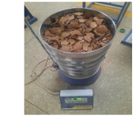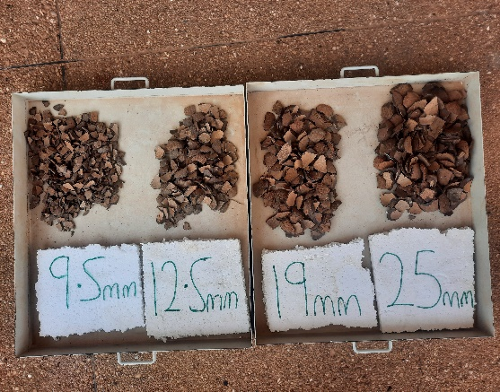
a
b

Figure 1: Crushed coconut shells in a sieve (a) and Sieved coconut shell Sizes (b)

2.4 Cement
Ordinary Portland cement, produced by CIMAF Ghana Cement Factory with a grade of 42.5r and conforming to BS EN 197-1 (2011), was also used.
2.5 Water
The water that was used for the study conformed to BS EN 1008 (2002). Potable water (tap water) from the Ghana Water Company was employed in mixing concrete.

3. METHODS

The coconut shells (CS) were manually crushed with a maul hammer into smaller sizes and sieved. The materials were batched by weight and mixed mechanically. In the mixtures, 10% of the crushed coconut shell aggregate was used to partially replace the crushed granite stones (coarse aggregate), with various CCS size ranges: 12.5 - 9.5 mm, 19 - 12.5 mm, 25 - 19 mm, and 37.5 - 25 mm, as illustrated in Fig. 1b. The specimens were then mechanically moulded and cured by sun-drying for 28 days, following the procedures specified in BS 1881-111 (1983).

3.1 Mixing
10% of crushed and sieved sizes of coconut shells, that retained on the following sieves (37.5mm - 25mm, 25mm - 19mm, 19mm - 12.5mm and 12.5mm - 9.5mm), were presoaked for 24 hours before being used in mixing. Shells were collected separately and mixed separately with pit sand and crushed granite stones. In line with (BS EN 12620, 2002), Concrete materials were batched and mixed using the mechanical mix machine accordingly. The materials were mixed until a uniform mix was obtained with a 1:2:4 mix ratio. Water-cement ratio of 0.769kg was then added and mixed thoroughly until a uniform mixture was obtained.
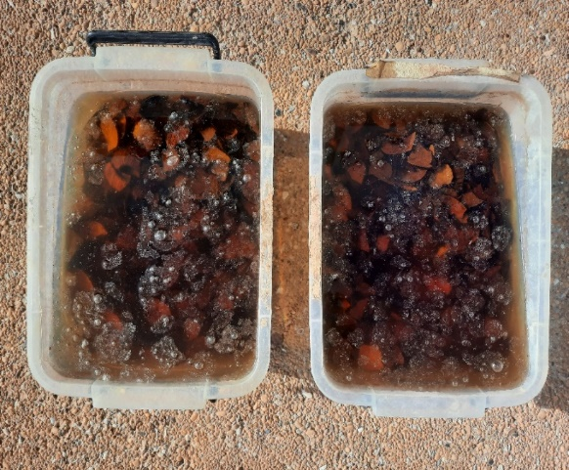
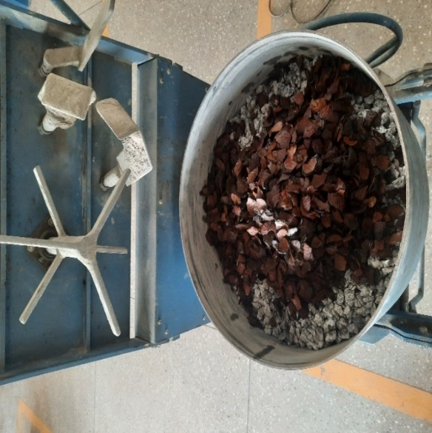
b
a

Figure 2. Pre-soaking of coconut shell (a) and coconut shell aggregate in the mixing machine (b)
3.2 Curing
Specimens were cured by total immersion in potable water from Ghana Water Company for 28 days in accordance with BS 1881-111 (1983).
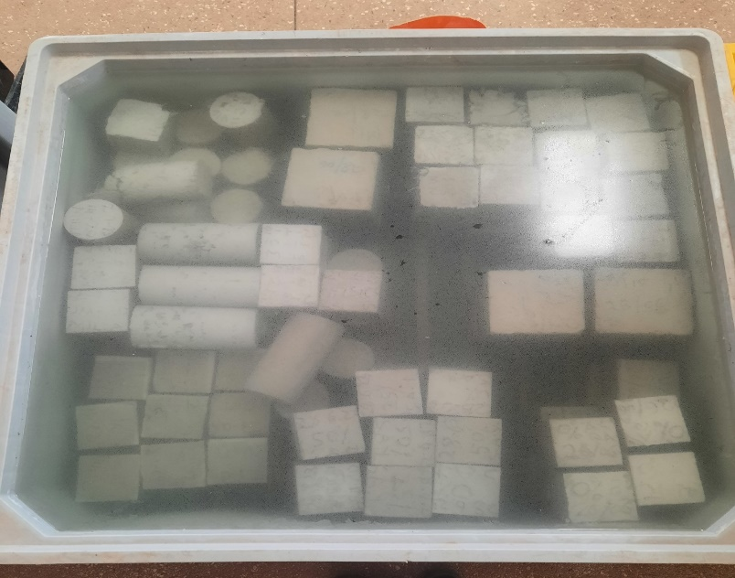
c

Figure 3. Curing of the specimen (c).

4. TESTING PROCEDURES
4.1 Abrasion resistance

Following BS EN 12390-1 (2021), specimens underwent abrasion resistance testing after 28 days of curing using the surface wire brushing method with an iron brush, as shown in Fig. 2. This test was conducted to assess the surface hardness and wear resistance of the specimens. Initially, the specimens were weighed and their masses recorded as (M1), then placed securely on a table to prevent sliding. The top surface, intended as the facing surface, received 60 strokes per second with a wire brush in both forward and backwards motions. Care was taken to ensure the brush width did not exceed the specimen's width by more than 2mm. After brushing, the specimens were reweighed and recorded as (M2). The abrasion resistance was then calculated as a percentage using the given formula.
$Ca =\frac{A }{M1-M2}$X 100 ………………..eqn. 1
Where,
Ca = Abrasion in percentage
A = Area of the brushed surface
M1 mass of concrete before brushing
M2 = mass of concrete after brushing.
b
a
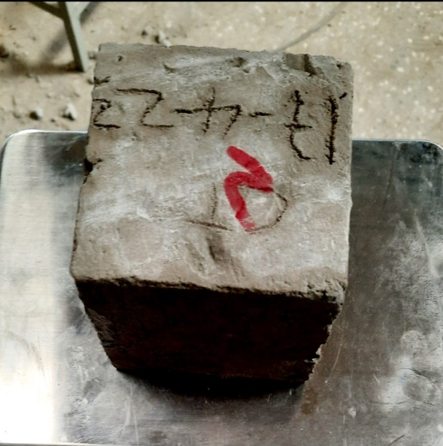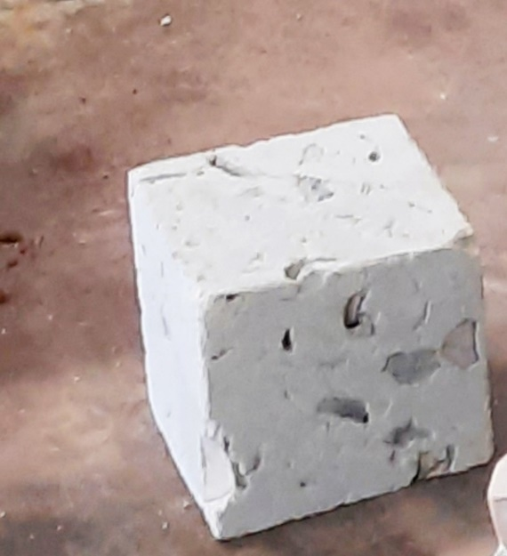

Figure 4: specimen (a) and specimen (b) before and after the abrasion resistance test.

4.2 Magnesium Sulphate (MgSO₄) attack

Magnesium Sulphate (MgSO₄) attack occurs when MgSO₄ reacts with different phases of the hydrated cement paste, leading to the degradation of the concrete matrix through spalling, softening, and mass loss. This process can result in the expansion of the concrete and a reduction in its strength and elasticity (Shehata et al., 2008). A MgSO₄ resistance test was conducted on the specimens after 28 days, following the guidelines in BS EN 206-1. After 24 hours, the specimens were moulded for each size variation of coconut shell aggregate replacement, then submerged in a MgSO₄ solution, as shown in Figure 3 with a concentration of 30% by mass, and kept at room temperature for 28 days, similar to the method used by Zhutovsky & Hooton (2017). The physical MgSO₄ attack on the concrete specimens was evaluated by measuring mass loss before and after exposure to the MgSO₄ solution. The extent of the damage was expressed as a percentage using the formula provided.
$C =\frac{B-A }{A}$X 100 ………………..eqn. 2
Where,
C = Chemical attack
B = Compressive strength before attack
A Compressive strength after magnesium sulphate attack
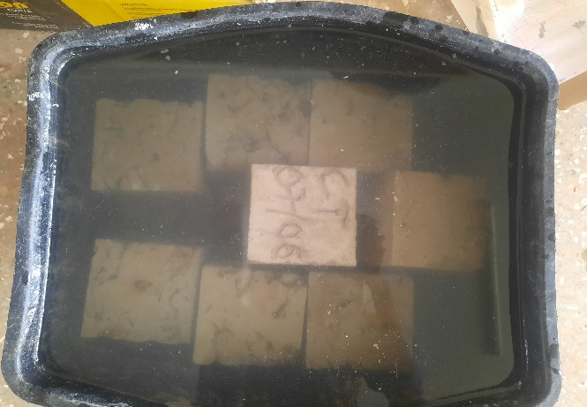
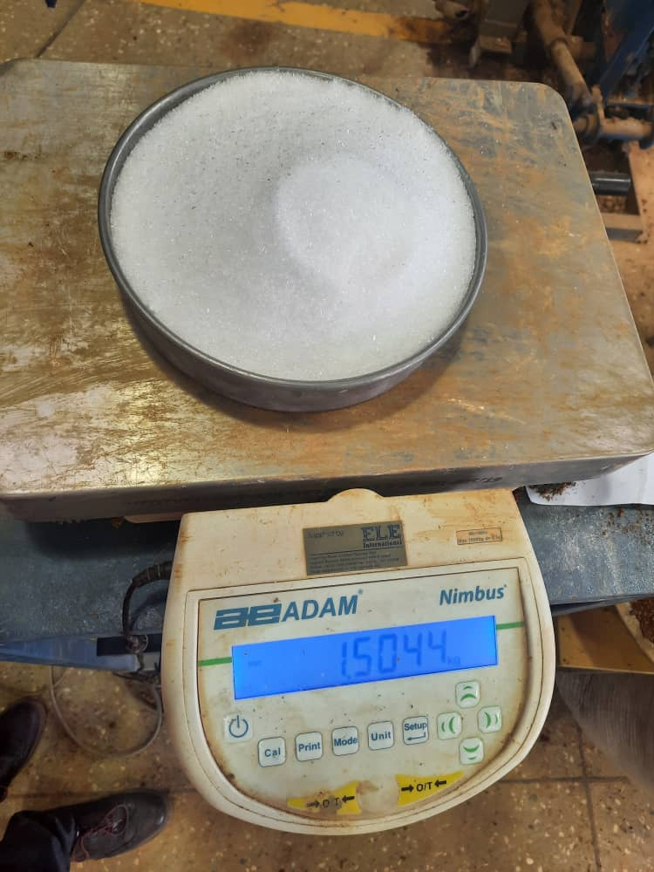
5
5
Figure 5. (a)showing 30% Magnesium Sulphate (MgSO₄), (b)specimens in the solution.

4.3 Sodium Chloride (NaCl) attack

Following the guidelines of BS EN 206-1, CCS concrete specimens were tested for sodium chloride (NaCl) exposure. After 24 hours, the specimens were demolded for each variation in crushed coconut shell aggregate replacement and cured for a maximum of 28 days. The specimens were then submerged in a 30% by mass NaCl solution, shown in Fig. 4, and maintained at room temperature for 28 days, as done by Zhutovsky & Hooton (2017). The extent of damage from a physical NaCl attack on the concrete was evaluated by measuring the mass loss before and after exposure to the NaCl solution. The degree of attack on the specimens was then calculated as a percentage using the following formula;
$C =\frac{B-A }{A}$X 100 ………………..eqn. 3
Where,
C = Chemical attack
B = Compressive strength before NaCl attack
A Compressive strength after NaCl attack
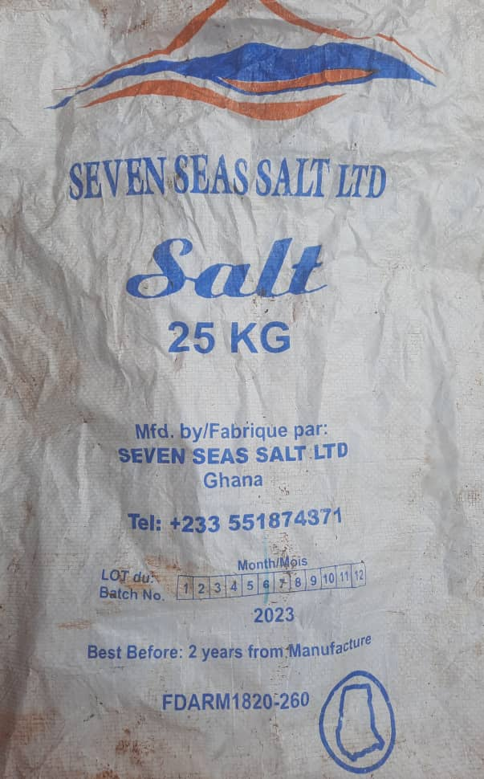
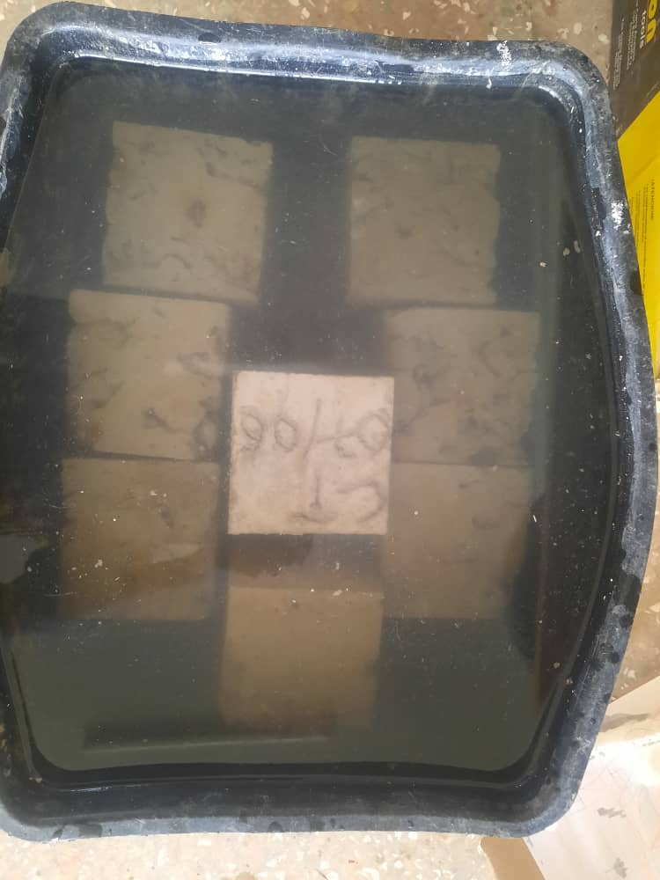
b
a

Figure 6. Sodium Chloride (NaCl) (a) and 30% (NaCl) Solution (b).

5. RESULTS AND DISCUSSIONS
5.1 Water Absorption Test
Table 2. Results of the water absorption test.
Curing days | Control | 12.5 - 9.5mm Replacement | 19 - 12.5 Replacement | 25 - 19mm Replacement | 37.5 - 25mm Replacement
28 | 3.155 | 5.542 | 4.821 | 4.718 | 4.577

The water absorption test results of specimens cured for 28 days in Table 2 demonstrate that the water absorption of CS concrete specimens decreases as the size of the crushed coconut shells increases. Specimens with smaller crushed coconut shell sizes exhibited higher water absorption rates compared to those with larger sizes. However, this difference does not significantly impact the concrete's strength. The decrease in water absorption with larger coconut shell sizes may be attributed to the greater surface area of the shells compared to the smaller sizes. These findings align with Ealias et al. (2014), who reported water absorption within the range of 6.43% to 4.6%. The study indicates that smaller shell sizes, with more surface area, absorb more water compared to larger sizes. These results also correlate with Herring et al. (2021), who observed that smaller particle sizes of coconut shells in concrete occupy more space, leading to increased surface area and higher water absorption. However, this conflicts with Kalyanapu et al. (2015), who reported a reduction in water absorption of 2.43%, possibly due to the size of coconut shells and the concrete mix design. Gunasekaran et al. (2011) discovered that coconut shells have a high water absorption capacity due to their porous structure, ranging from 20% to 24% by weight. The study suggests that this high absorption rate requires adjustments in the water-cement ratio to maintain the concrete’s workability and strength.

5.2 Abrasion Resistance Test
Figure 7 shows the results of the abrasion resistance test conducted on CCS concrete specimens. The results indicate that the abrasion resistance of CCS concrete improves with increasing strength. However, the study found that as the size variation of coconut shells in the concrete increased, the abrasion resistance increased. Among the tested sizes, the 37.5 - 25mm replacement exhibited the highest abrasion resistance, suggesting that this concrete can endure abrasive forces and resist erosion, abrasion, and surface degradation. The results also demonstrated that coconut shell concrete with higher compressive strength offered less resistance to abrasion compared to those with lower compressive strength, aligning with findings by Nadir and Sujatha (2018), who reported an average wear of less than 1.5% for all coconut shell concrete specimens. Additionally, Sujatha and Balakrishnan (2021) recorded a similar abrasion resistance value of 1.63%, which was consistent with this study. Also, the coconut shell concrete specimen had a higher abrasion resistance compared to the control specimen, with average percentage wear of M1, M2 and M3 specimens being 5.97%, 2.24% and 3.98%. Figure 7 shows the Average abrasion resistance (%)

Figure 7. Average abrasion resistance (%)

5.3 Results of Compressive Strength after Magnesium Sulphate (Mgso4) Attack
Figure 7 illustrates the effects of magnesium sulphate on the CCS concrete specimen. The results show that exposure to magnesium sulphate weakens the concrete matrix through chemical reactions, leading to deterioration, cracking, and loss of structural integrity. Additionally, it was observed that increasing the size of coconut shell aggregates in the concrete mix reduces its strength. Concrete with 9.5mm coconut shell aggregate exhibited better resistance to MgSO₄ attack, likely due to the higher quantity of smaller coconut shell particles, which mitigated the destructive impact of ettringite formation compared to larger shell sizes. These findings align with previous research by Anon (2022) and Zhutovsky and Hooton (2017), which describe magnesium sulphate as a strength-reducing agent that causes internal cracking due to ettringite crystals. The study also supports Sharan and Raijiwala's (2017) conclusion that coconut shell aggregate concrete experiences a significant reduction in strength when exposed to MgSO₄ solution. Figure 8 shows the Compressive strength before and after Magnesium Sulphate(MgSo₄ ) Attack.

Figure 8. Compressive strength before and after Magnesium Sulphate(MgSO4) Attack

5.4 Results of Sodium Chloride (NaCl) Attack
Table 3 illustrates the compressive strength of concrete specimens after sodium chloride (NaCl) attack. The findings showed that as the size of the coconut shells in the concrete mix increased, the strength of the specimens decreased after being exposed to NaCl for 28 days. This reduction in strength is likely due to the deterioration caused by chemical reactions between the concrete and NaCl solution. Concrete containing 9.5mm coconut shell aggregate demonstrated better resistance to NaCl attack, possibly because the smaller coconut shells helped minimise the destructive effects of chemical ettringite, compared to mixes with larger shell sizes. Specimens with larger coconut shells were more vulnerable, likely due to the internal voids they created. This aligns with Ealias et al. (2014), who found that the presence of sufficient chloride ions in concrete affects compressive strength, depending on the rate of NaCl penetration and the pore structures. The study also reported a 19.9% chloride ion penetration in coconut shell concrete, which weakened the compressive strength, possibly due to the larger shell size. Prakash et al. (2020) similarly noted a 7.14% strength reduction after 28 days of NaCl exposure at a 28% chloride concentration, attributing the decline to the presence of quarry dust and the size variation of the coconut shells in the mix. However, Yashida and Sujatha (2017) concluded that, chloride ion penetrability of coconut shell concrete mixes and the control mix was almost the same, and therefore disagree with the study; this could be the addition of a 3% concentration of H₂SO₄ solution for 6 months. Table 3 shows the percentage reduction in compressive strength before and after sodium chloride (NaCl) attack.

Table 3 Percentage Reduction in Compressive Strength before and after Sodium Chloride (NaCl) Attack

Sample sizes | Compressive strength after NaCl (A) | Compressive strength before NaCl (B) | C=(B-A)/(A) | D=(C*100) %
Control | 13.26 | 14.4 | 0.079 | 7.92
12.5 -9.5mm Replacement | 12.48 | 13.40 | 0.069 | 6.87
19 - 12.5mm Replacement | 12.01 | 12.8 | 0.062 | 6.17
25 - 19mm Replacement | 10.85 | 12.20 | 0.111 | 11.07
37.5 - 25mm Replacement | 9.72 | 11.53 | 0.157 | 15.70

5.5 Descriptive and one-way ANOVA analysis for compressive strength after chemical attack (MgSO₄).
Table 4 shows descriptive and one-way ANOVA analysis for compressive strength after (MgSO₄) attack.
Descriptive statistics
Treatment Name | N | Missing | Mean | Std Dev | SEM
Control | 3 | 0 | 13.933 | 0.0153 | 0.00882
9.5mm CS | 3 | 0 | 11.6 | 0.361 | 0.208
12.5mm CS | 3 | 0 | 10.767 | 0.473 | 0.273
19mm CS | 3 | 0 | 9.133 | 1.518 | 0.876
25mm CS | 3 | 0 | 8.567 | 1.721 | 0.994

Table 5. One-Way ANOVA
Source of Variation | DF | SS | MS | F | P
Between Subjects | 2 | 3.362 | 1.681
Between Treatments | 4 | 54.673 | 13.668 | 13.879 | 0.001
Residual | 8 | 7.879 | 0.985
Total | 14 | 65.914 | 4.708

Table 6 Pairwise comparisons between P-values
Comparison | Diff of Means | T | P | P<0.050
Control vs. 25mm CS | 5.367 | 6.623 | 0.002 | Yes
Control vs. 19mm CS | 4.8 | 5.924 | 0.003 | Yes
Control vs. 12.5mm CS | 3.167 | 3.908 | 0.035 | Yes
9.5mm Replace vs. 25mm CS | 3.033 | 3.744 | 0.039 | Yes
9.5mm Replace vs. 19mm CS | 2.467 | 3.044 | 0.092 | No
Control vs. 9.5mm CS | 2.333 | 2.88 | 0.098 | No
12.5mm Replace vs. 25mm CS | 2.2 | 2.715 | 0.102 | No
12.5mm Replace vs. 19mm CS | 1.633 | 2.016 | 0.218 | No
9.5mm Replace vs. 12.5mm CS | 0.833 | 1.028 | 0.556 | No
19mm Replace vs. 25mm CS | 0.567 | 0.699 | 0.504 | No

5.5 CONCLUSION

The study found that using crushed coconut shells aggregate (37.5-25 mm) in concrete enhances its resistance to abrasion. The study concluded that the size of the coconut shell aggregates affects the abrasion resistance, with 37.5 – 25mm size aggregates offering better protection as compared to 12.5 – 9.5mm aggregates. This indicates that concrete with bigger-sized coconut shells is more durable and suitable for applications where surface wear resistance is important. Additionally, the study revealed that concrete's resistance to magnesium sulfate (MgSO₄) decreases with larger coconut shell aggregates. Concrete made with smaller shells (12.5-9.5 mm) had better resistance to damage caused by MgSO₄; larger shells led to greater deterioration, likely due to the formation of harmful compounds like ettringite. This makes concrete with smaller coconut shells more durable in environments prone to sulfate exposure. Similarly, the size of coconut shell aggregates also affects the concrete's resistance to sodium chloride (NaCl). Smaller-sized shells (12.5-9.5 mm) showed better resistance to NaCl-induced degradation, while larger shells caused more strength reduction due to increased porosity, which allowed for more chemical reactions with NaCl. This makes concrete with 12.5 – 9.5mm shells more durable in salty or coastal environments. Overall, using coconut shells as a partial replacement for coarse aggregates in concrete offers a sustainable alternative by reducing waste and reliance on natural resources, making it a valuable option for promoting sustainable construction, especially in areas of abundant coconut shells.

6.0 RECOMMENDATION
This study contributes to the existing knowledge on sustainable concrete production by partial replacement of coarse aggregate (granite stones) with coconut shell size variation at 10%. The study investigated only the durability properties of concrete made with coconut shell size variations. Durability properties of concrete replaced with coconut shell size variation at 15%, 20% and 25% on a large scale are recommended for future research.

Disclaimer (Artificial intelligence)
Option 1:
Author(s) hereby declare that NO generative AI technologies such as Large Language Models (ChatGPT, COPILOT, etc.) and text-to-image generators have been used during the writing or editing of this manuscript.

REFERENCES
Adinkra-Appiah, K., Adom-Asamoah, M., & Afrifa, O. R. (2015). Reducing Environmental Degradation from Construction Activities: The Use of Recycled Aggregate for Construction in Ghana. JCE. Architect. Res. 2(8), pp. 831-841.
Arora, R., Kumar. S., Dixit. S., Tipu. R. K., Kaul. P. Chauhan. S., Raju. Y. K., Nijhawan. G., & Haindavi., P. (2023). “ Parametric Investigation of Coconut Shell as Partial Replacement of Coarse Aggregates in Sustainable Concrete”. WoC 430, 01180.
Anon (2022). What Is Hydration Of Cement? Know Heat Of Hydration & Products Of Cement Hydration Here - Civil Giant.
British Standard 812-P122-AIV 1990. Determination of aggregate impact value.
British Standard 1881-111 (1983). Testing for concrete. Methods of accelerated curing of test cubes.
British Standard EN 1008 (2002). Mixing water for concrete.
British Standard 1881-111 (1983). Testing for concrete. Methods of accelerated curing of test cubes.
British Standards EN 206- 1. Concrete - specification, performance, production and conformity, BSI, London, 2001.
British Standard EN 1008 (2002). Mixing water for concrete.
British Standard EN 1008 (2002). Mixing water for concrete.
British Standard EN 12390-1:2021: Testing hardened concrete. Shape, dimensions and other requirements for specimens and moulds.
Chin, M. Y., Rahman, M. R., Kuok, K. K. & Chiew, W. Y. (2021). Characterization and Impact of Curing Duration on the Compressive Strength of Coconut Shell Coarse Aggregate in Concrete. 16(3), 6057 – 6073.
Danso, H. & Appiah-Agyei, F. (2021). A study on the Size Variation of Palm Kernel Shells as a replacement of Coarse Aggregate for Lightweight Concrete Production. Researchgate.net/publication/352714931.
de Brito, J., & Kurda, R. (2021). The past and future of sustainable concrete: A critical review and new strategies on cement-based materials. Journal of Cleaner Production, 281, 123558.
Ealias, A. M., John, L. & Anju, P. (2014). Improvement of the strength of concrete with partial replacement of coarse aggregate with coconut shell and coir fibre. 11(3). Ver. II. PP 16-24.
Gunasekaran, K., Lakshmipathy, M., & Kumar, P., S. (2011). Study on the properties of coconut shell as an aggregate for concrete. ICI, V(12).
Herring, T. C., Thuo, J. N., & Nyomboi, T. (2021). Influence of coconut shell grades as partial replacement of coarse aggregates on concrete properties, 8(11), 13-23.
Ibearugbulem, O. M., & Igwilo, K. C. (2019). Physical and mechanical properties of river stone as coarse aggregate for concrete production. Nigerian Journal of Technology. 38(4), 856-862.
Irham, M. Z. M. A., Nurizaty, Z., Nadiah, S., Majedu, K. A., & Kado, B. (2024). “Mechanical Properties of Concrete Containing Coconut Shell as Coarse Aggregate Replacement”. 3(1), 69 – 80.
Kalyanapu, V. R., Swaroop, A. H. L., Kodanda, P. R., Bharath, C. N. (2015). “Study on strength properties of coconut shell concrete”. 6(3), pp.42-61.
Olsson, J. A., Miller, S. A. & Alexander, M. G. (2023). “Near-term pathways for decarbonising global concrete production”. Doi.org/10.1038/s41467-023-40302-0.
Prakash Chandar, S., Gunasekaran, K., Satyanarayanan, K. S., & Annadurai, R. (2020). Study on some durability properties of coconut shell concrete with quarry dust. European Journal of Environmental and Civil Engineering, 24(6), 709-723.
Perumal, S. K. P., Selvarajan, L., Manikandan. K. P., & Velmurugan. C. (2023) “Mechanical, tribological, and surface morphological studies on the effects of hybrid ilmenite and silicon dioxide fillers on glass fibre reinforced epoxy composites”. doi.org/10.1016/j.jmbbm.2023.106095.
Reddy, B.D., Jyothy, S.A. & Shaik, F. (2014). “Experimental analysis of the use of coconut shell as coarse aggregate”. IOSR J. Mech. Civil Eng., 10(6), 06-13.
Stephen, R.S., Gerry, G, C., Virmani, Y, P., Glen, E, S., Robert, G, K. (2002). Electrochemical chloride extraction: Influence on Treatment. DOT, F 1700.7 (8 - 72).
Shehata, M. H., Adhikari, G., & Radomski, S. (2008). Long-term durability of blended cement against sulfate attack. ACI Materials Journal, 105(6), 594.
Verma, S.K., & Shrivastava, S. (2019, September). Use of coconut shell as a partial substitution of coarse aggregate: experimental analysis. In AIP Conference Proceedings. (Vol. 2158, No. 1). AIP Publishing.
Gunasekaran, K., Ramasubramani, R., Annadurai, R., & Chandar, S. P. (2014). Study on reinforced lightweight coconut shell concrete beam behaviour under torsion. Materials & Design, 57, 374-382.
Kulkarni, V, P., Kumar, S. (2013). Comparative study on coconut shell aggregate with conventional concrete. (Ijeit) 2(1). 9001: 2008.
Sujatha, A., & Balakrishnan, S. D. (2023). Properties of high-strength lightweight concrete incorporating crushed shells as coarse aggregate. Materials today. 2214 – 7853.
Sharan, S. & Raijiwala, D.B., (2017). UPV characteristics and durability aspects of the coconut shell ash concrete. Technology 8(2): 400-409.
Murthy, A., A., Pukazhendhi, D., M., Vishnuvardhan, S., Saravanan, S. (2020). Performance of concrete beams reinforced with GFRP bars under monotonic loading. 27(3): 1274 – 1288.
Nadir, Y., & Sujatha, A. (2018). Durability properties of coconut shell aggregate concrete. KSCE Journal of Civil Engineering, 22, 1920-1926. Doi 10.1007/s12205-017-0063-6.
Wahab, A., & Appiah-Kubi, E. (2024). Characterization of Pulverized Palm Kernel Shells Block. (JET), 15(1).
Yerramala, A. & Ramachandrudu, C. (2012). Properties of concrete with coconut shells as aggregate replacement. IJE, 1(6).
Zhutovsky, S., & Hooton, R. D. (2017). Accelerated testing of cementitious materials for resistance to physical sulfate attack. Construction and Building Materials, 145, 98-106.

