***Review Article***

**Nanotechnology: A review on the application of Nano-materials in water purification and medicine in Zimbabwean**

**ABSTRACT**

Nanotechnology is a revolutionary field focused on manipulating matter at the atomic and molecular scale. With applications across health, agriculture, and water purification, nanotechnology offers unique properties that can address critical challenges such as health disparities and food security. A systematic literature review was conducted, analysing articles and case studies relevant to nanotechnology in Zimbabwe, incorporating both local and international perspectives. The overall goal of this study was to collate a scoping review of nanotechnology with particular focus on content related to application opportunities in Zimbabwe. Key initiatives identified include the development of smart nano-filters for water purification and the application of nanomaterials in medical treatments. These innovations demonstrate significant potential to enhance public health outcomes and improve access to clean water, particularly in underserved areas. Despite its promise, barriers such as infrastructural deficits, funding limitations, and a lack of expertise impede the widespread adoption of nanotechnology. Strategic investments and collaborative efforts are essential to overcome these challenges and fully leverage nanotechnology's benefits. Advancing nanotechnology in Zimbabwe is vital for addressing pressing health and environmental issues. By fostering a supportive ecosystem for research and development, Zimbabwe can harness nanotechnology to drive sustainable development and improve the quality of life for its citizens.

*Keywords: Nanotechnology, Zimbabwe, health, water purification, sustainable development.*

1. **NANOTECHNOLOGY OVERVIEW**

Nanotechnology has become one of the most resourceful and useful technological advancement to human beings. Nanotechnology involves the integration, manipulation and control of molecules and atoms to form systems, devices, structures, materials and components at the nanoscale range. The nanoscale used in nanotechnology ranges from 1nm to 100nm as shown on Figure 1 below. (Samer Bayda, 2019). One nanometer is one thousand millionth of a meter ( ${10}^{9}$ m). As shown on Figure 2, nanotechnologies are contributing to almost every field of science these days, and these fields include material science, medicine, engineering, physics, transportation, food safety, environmental science, information technology, energy, and so on. This review illustrates how nanotechnology is being utilized in the field of health sciences and how nanotechnology is being applied in Zimbabwe to form tangible materials.

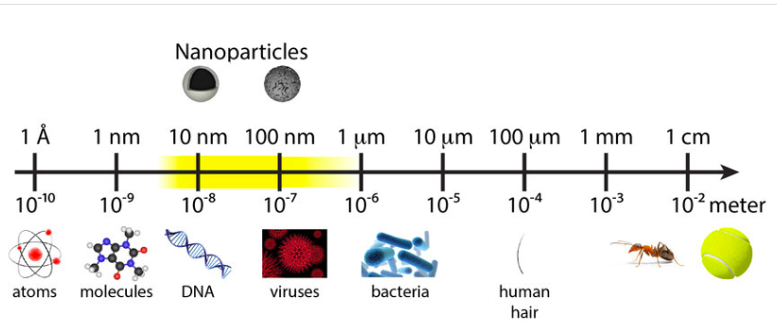

**Figure 1: Comparison of everyday objects to nanoparticles. For a nanomaterial, at least one dimension should be in the range of 1nm-100nm. (Thierry Verbiest et al, 2015)**

In the field of nanotechnology, a subdiscipline of condensed matter physics called mesoscopic physics/systems is currently being used to form nano-assemblies of nature such as nanotools, agricultural products and nanomedicine for treatment and diagnosis in the medical field (McNeil, 2005). Several medical conditions that were previously difficult to diagnose and treat are now being managed using nano-based diagnostic kits and novel nano-based treatments such Abraxane. The advances in the medical field have also allowed scientists to create nano-based sequencing formulations, screening formulations and even prophylaxis formulations. Nanotechnology has enabled drug designing and drug manufacturing of nanomedicine with efficient active pharmaceutical ingredient delivery options with advances in nano-based genomics, gene therapy and even tissue engineering. (Shiza Malik et al 2023). Figure 3 shows applications of nanotechnology in the medical industry.

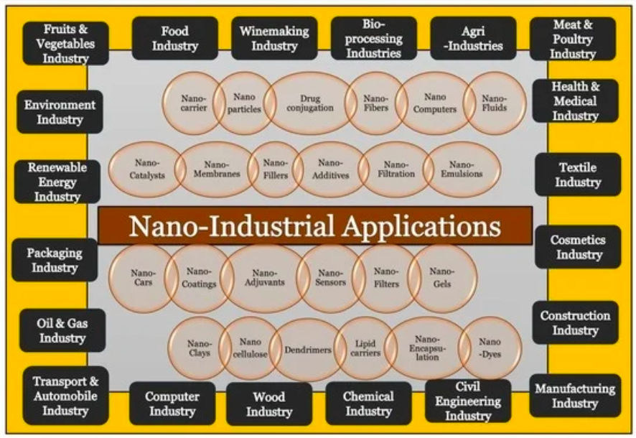

**Figure 2: Diverse applications of nanotechnology in several industries. (Shiza Malik et al 2023)**

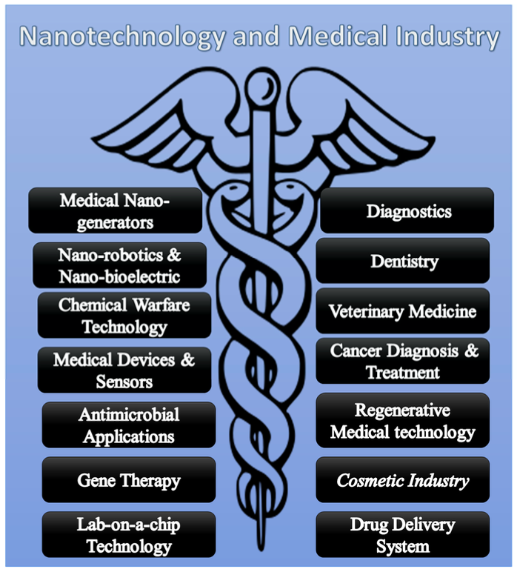

**Figure 3 shows applications of nanotechnology in the medical industry. (Shiza Malik et al 2023)**

1. **MEDICINAL NANOTECHNOLOGY**

Nanotechnologies are extensively used in treating, preventing, and diagnosing different diseases, with over 90 drugs currently approved worldwide. (Jia et al, 2023) Nanoformulations can help enhance various aspects of pharmacokinetics including processes involving absorption, distribution, metabolism, and excretion (ADME); potentially providing enhancements in safety and/or efficacy. Nanoformulations encapsulate the carried drug (e.g., liposomes, micelles, dendrimers) or conjugate it with a stable polymer (e.g.,Poly ethelyne glycole, PEG), and attach a surface guiding ligand (antibodies and small proteins). Through this mechanism, they can increase the solubility of poorly soluble compounds, improve their permeability and bioavailability, load therapeutic concentrations to a specific targeted tissue, stabilize the drug in the body, and/or increase half-life. (Haleem et al, 2023) Such benefits have shown to improve patient compliance by reducing the dose frequency and side effects for drugs with narrow therapeutic indexes. (L. Zhang et al, 2008) For example, a now FDA-approved nanoformulation of diclofenac for pain treatment showed a more rapid onset and similar magnitude in maximum concentrations (Cmax) for the lower dose nano-formulated diclofenac (35mg) compared to the standard diclofenac (50mg) formulation, while still maintaining effective analgesia. (Onoue et al 2014)

However, several challenges exist in the development and marketing of nanoformulation drugs as compared to their conventional formulations. This is also because, conventional formulations have different ADME properties when compared to nanoformulations. (See Figure 4). Traditional safety and pharmacokinetic evaluation methods for non-nanoformulated drugs, may not be able to be applied directly to the developing entities without considering the specificity of each nano-formulation. For example, PK analyses that consider only an interchange of bound versus unbound drug, i.e. the free-drug hypothesis, cannot be applied to nano-formulations without adapting their specificity. In other words, free drug concentrations are usually measured in calculating PK parameters, whereas, both forms of the free and encapsulated nano-drug are present in blood before being available to target tissue, and this requires consideration in nanoformulated drug PK analyses. (Lebreton et al., 2021) Furthermore, the costly manufacturing and regulatory requirements can stifle the clinical translation and development of large-scale production of nanoformulated drug products. (C. Zhang et al, 2020)

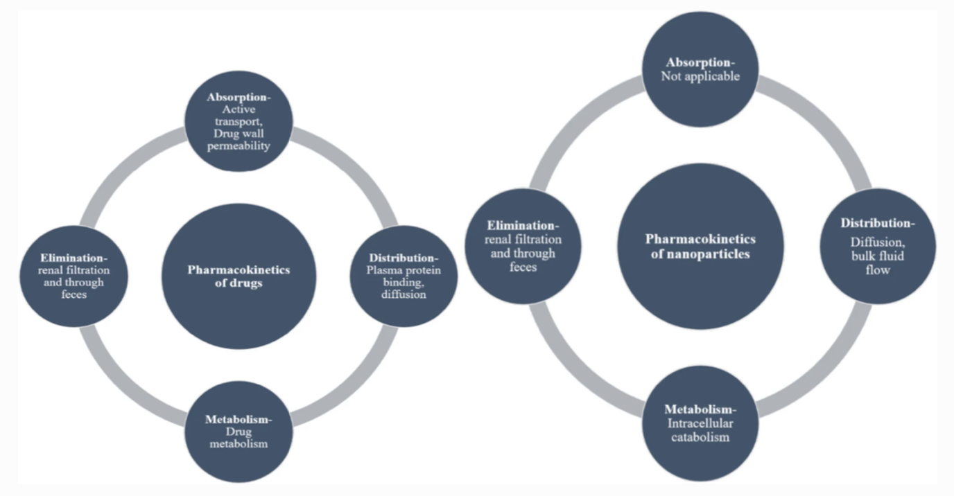

**Figure 4 – Comparison of the ADME of conventional drugs and nanoparticles. (Muthukrishnan Haripriyaa & Krishnamurthy Suthindhiran. 2023)**

That being said, there are several computational modelling and simulation approaches being developed to effectively describe, analyse, and predict different phases of nanotherapeutic development from the molecular screening phase through to therapeutic efficacy and safety establishment. (Mikayilov et al 2024) However, if the various physiological variables facing nanoparticles' journey throughout the body in accordance with diseased-based pathophysiological, are not considered or well-established, nano-specific pharmacokinetic models and eventual manufacturing challenges could potentially fail. Particularly with respect to an increasing novel therapy demand. Therefore, while these up-and-coming applications to incorporate the complex interplay between nanoparticles’ physiochemical properties and ADME processes could provide a novel breakthrough for nanotechnology application, particularly in terms of global applicability, such limitations need to be appreciated and addressed within the framework of global development and application.

1. **NANOTECHNOLOGY IN ZIMBABWE**

Nanotechnology field is expanding rapidly and there is great promise for Zimbabwe. While nanotechnology holds immense promise for Zimbabwe, its practical implementation is still nascent. The country faces significant infrastructure, funding, and expertise challenges, limiting the widespread adoption of nanotechnology across various industries. However, there are some ongoing initiatives and developments worth noting. The Zimbabwe Ministry of Science and Technology actually adopted a National Nanotechnology program (in 2011), in partnership with the Zimbabwe Academy of Sciences and Zimbabwe Research Council, to help guide local industry to take advantage of this emerging technology. (Nanotec, 2011). In Zimbabwe, efforts have also been made by the University of Buffalo, to establish a Zimbabwe International Nanotechnology Center. This centre focuses in nanotechnology research and it is a joint project between University of Zimbabwe and Chinhoyi University of Technology. (University of Buffalo, 2024). Through this center, the enthusiasm of scientists in Zimbabwe to do research and advancement in the field of nanotechnology, has grown drastically.

1. **SMART NANO FILTER**

To put this issue into context, a study was conducted in Zimbabwe by Trust Saidi and Ragna Zeiss. This study was published in 2016 and it was titled, “Investigating promises of nanotechnology for development: A case study of the travelling of smart nano water filter in Zimbabwe”. In this study, a smart nano filter was used to purify water for drinking. It was found that nanotechnology use in water purification has a potential to remove biotic and abiotic impurities which are difficult to separate when using conventional technologies that are currently available. (Trust Saidi and Ragna Zeiss, 2016). In summary, a communal drinking water filter was designed and developed using nanotechnology, for Kezi Village in the Matebeleland South province of Zimbabwe. Generally, nanotechnology is usually capital intensive, however this smart nano filter was developed in a low-cost manner and it improved the access to clean water for a whole village.

This smart nano filter uses ceramic magnetite in the nanoscale range of 1nm to 100nm. The Ceramic itself is found in abundance in most parts of Zimbabwe and as for this study conducted by Trust Saidi and Ragna Zeiss, they used ceramic from Dorowa which has huge ceramic deposits. Ceramic is widely used in Zimbabwe in pottery when making pots for cooking, storing food and storing water. The magnetite they used was derived from the iron ore which is mined and found in abundance at the Buchwa mine in the Mberengwa District, Midlands Province of Zimbabwe. In Zimbabwe, Iron ore is also found in huge deposits at other geographical landsites such as the Great dyke and mines such as Mwanesi mine. (Wikipedia, 2024). The stones, pebbles and fine sand which was used in this study was obtained from the river beds of local rivers in Kezi village. As for the media for the water filtration (ceramic-magnetite), the two naturally occurring raw materials (magnetite and ceramic) were baked and grinded into fine particles, and the pores of this media fit in the nanotechnology dimensions of 1nm to 100nm. (Trust Saidi and Ragna Zeiss, 2016). Other functionalised nanomaterials shown in Figure 5 below have also been considered for water filtration.

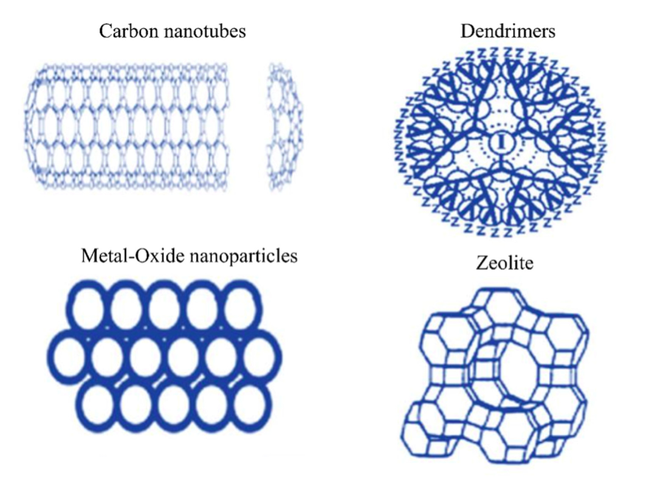

**Figure 5 – Some of the nanomaterials that are presently being considered for water filtration. (Nishu, Sudesh Kumar. 2023)**

In Zimbabwe, access to safe drinking water has always been a challenge since Zimbabwe is a lower-middle-income country. (World Bank, 2021). As a result, this has caused the nation to be prone to water-borne disease pandemics every now and then. Recently, there was a cholera pandemic in Zimbabwe which began in February 2023. And as of 23 January 2024, more than 20 000 cases had been reported and over 370 deaths were registered from all the Provinces in Zimbabwe. (World Health Organization, 2024). This application of nanotechnology to design a smart nano filter was timely to Zimbabwe as there is a high need to improve access to safe clean drinking water. However, the major drawback from this invention to the nation is that, this smart nano filter invention was patented thereafter in accordance with the Patents Act (Chapter 26:03) of the Zimbabwean law. As a result of this patent, health disparities continue to divide the nation since only the rich can continue to have access to clean drinking water whilst this technology could have helped the poor people in the country. Table 1 summarizes various types of nanomaterials, highlighting their efficiencies in pollutant removal, the specific contaminants they target, and their primary mechanisms of action. This overview underscores the potential of nanomaterials in enhancing water treatment processes.

**Table 1: Overview of Nanomaterials and Their Efficiency in Water Treatment**

|  |  |  |  |  |
| --- | --- | --- | --- | --- |
| **Nanomaterial** | **Efficiency** | **Pollutants Removed** | **Mechanism/Application** | **References** |
| Graphene and Graphene Oxide (GO) | Highly effective in adsorption | Heavy metals, organic pollutants, radionuclides | Adsorption | Biswas et al., 2024; Wu et al., 2021 |
| Carbon Nanotubes (CNTs) | Up to 99.8% | Lead, mercury | Adsorption, enhances water flow in desalination | Prasad, 2024 |
| Metal-Organic Frameworks (MOFs) | Up to 99.5% | Pharmaceutical compounds, emerging contaminants | Adsorption | Prasad, 2024; Yadav et al., 2024 |
| Nano Zero-Valent Iron (nZVI) | Effective | Arsenic, heavy metals | Adsorption | Biswas et al., 2024 |
| TiO2 Nanoparticles | High efficiency | Organic pollutants | Photocatalysis | Elhenawy et al., 2024 |
| Membrane Filtration | Enhanced filtration efficiency | Various pollutants | Membrane incorporation of nanomaterials | Yadav et al., 2024 |

1. **NANOTECHNOLOGY USE IN GREEN FABRICATION/SYNTHESIS OF METALLIC NANOPARTICLES**

All over the world, the use of green fabrication of various metallic nanoparticles is growing rapidly in the field of biomedical sciences. This is because, metallic nanoparticles have a broad spectrum of applications in the medical field as shown in Figure 6. A recent study was done by Dinesh Babu Mandikandan et al in 2021, they fabricated silver nanoparticles (AgNPs) using aqueous leaf extract from the *Ocimum americanum* (Hoary Basil) and they investigated its in vitro anticancer, antibacterial, photocatalytic reduction and antioxidant properties. (Dinesh Babu Manikandan et al, 2021). They found out that: the AgNPs exhibited photolytic dye degradation of eosin yellow under UV radiation & sunlight; the cytotoxic effects of fabricated AgNPs against A549 lung cancer cells was confirmed; fabricated AgNPs exhibited potential antibacterial effects against pathogenic Gram negative and Gram positive bacteria; and in vitro antioxidant activity was assessed and confirmed using hydrogen peroxide and reducing power assays. The AgNPs can be obtained via several methods such as sonochemical, physical, microwave assisted or chemical reduction, however biological synthesis of AgNPs is the most preferred method since it is eco-friendly, less costly and produces less toxic AgNPs.

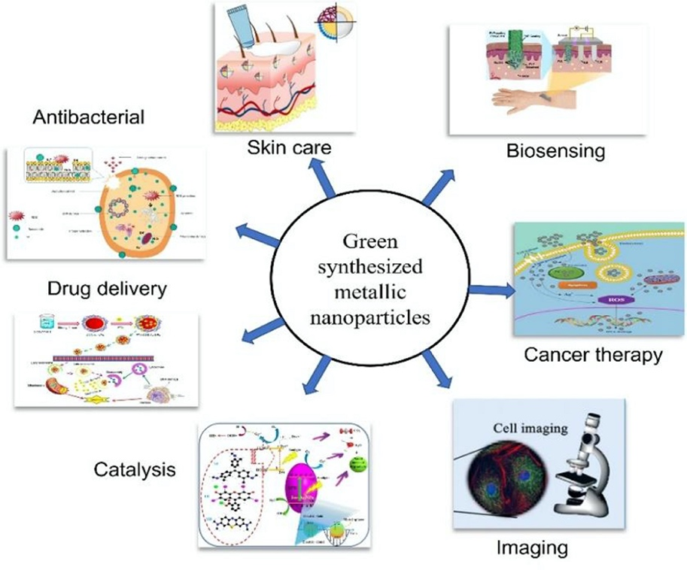

**Figure 6 – Applications of green synthesized nanoparticles in the medical field. (Shahid-ul-Islam et al, 2023).**

Several studies on green synthesis have been done and they have shown that nanoparticles can be synthesized using plants as illustrated in Figure 7. Another study on green synthesis was conducted by Siavash Iravani and Behzad Zolfaghari in 2013. In this study, they were able to synthesize silver nanoparticles (AgNPs) using a bark extract of the *Pinus eldarica* plant. Siavash Iravani and Behzad Zolfaghari took 50g of powdered Pinus eldarica bark extract and boiled it for approximately 15 minutes in 250ml of deionized water, in a 500ml volumetric flask. The mixture was cooled and filtered using a whatman filter to collect pine bark extract. (Siavash Iravani and Behzad Zolfaghari, 2013). After that, a reduction reaction was initiated in which the reactants were; aqueous bark extract (in different quantities), a pH phosphate buffer (with pH of 3, 5, 7, 9 and 11) and lastly Silver Nitrate (AgNO3) as the substrate (with concentrations of 1, 2, 4 and 6 mM). The reaction was assayed and tracked using UV absorption spectrum, of colloidal suspension of silver nanoparticles, obtained using a Shimadzu spectrophotometer. Selected samples were analysed for the size and shape of silver nanoparticles, and to investigate the process of formation of the silver nanoparticles using a Transmission Electron Microscopy (TEM) analysis.

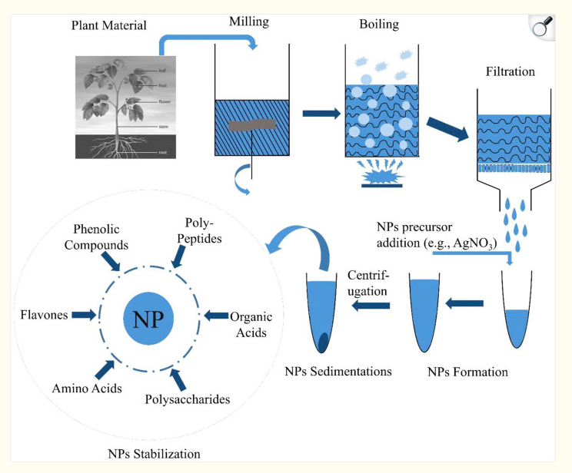

**Figure 7 – Synthesis of nanoparticles from plants. (Hitesh Chopra et al, 2022)**

In the end of the research done by Siavash Iravani and Behzad Zolfaghari at the Isfahan University of Medical Sciences, silver nanoparticles were produced from the *Pinus eldarica* bark extract. They observed that when you gradually increase the substrate AgNO3, the nanoparticle production also increased accordingly. A non-linear relationship was observed in which, as you increase the aqueous bark extract concentration, the silver nanoparticle production increased as well. When it comes to the reaction pH, Siavash Iravani and Behzad Zolfaghari recorded that; as you increase the pH of the reaction mixture, there was an increased reduction rate & increased colloidal silver nanoparticle production; and another interesting observation was that as you increase pH to alkaline, smaller silver nanoparticles were produced whilst lower acidic pH favoured the production of large sized silver nanoparticles. (Siavash Iravani and Behzad Zolfaghari, 2013). Lastly, temperature was found to influence the size and shape of silver nanoparticles synthesized using the aqueous bark extract, when temperature was increased from 25 to 150°C the size of the produced silver nanoparticles became smaller and rate of reaction became faster. In conclusion from this study, nanoparticles can be obtained from green synthesis using plants, and this is a very cost effective and environmentally friendly way of production compared to currently available chemical and physical methods such as electron irradiation, biological synthetic methods, microwave processing, laser ablation, photochemical methods, gamma irradiation and even chemical reduction methods. (Hassan Korbekandi et al, 2009)

1. **NANOTECHNOLOGY IN THE MEDICAL DEVELOPMENT OF ALBINISTIC SKIN PROTECTION IN ZIMBABWE**

In Zimbabwe, several scientists have produced medicinal nanoparticles using the green synthesis by plants. In 2015, Joey Chifamba and others carried out an albinistic skin protection development study at the University of Zimbabwe. In this study, they evaluated the safety of nanometric Titanium dioxide and nanometric Zinc oxide used in the retardation of skin actinic damage in tropical Oculocutaneous albinism. (Joey Chifamba et al, June 2015). This study and investigation was carried out *ex-vivo* through a simulated actinically damaged porcine skin. Throughout this study, Joey Chifamba and others conducted the experiment using Franz diffusion cells in line with the OECD guideline document 428, work done by Diembeck et al (1999) and in line with the EU opinion SCCNFP 0750/03. At the end of the study, they found out that both nanometric Zinc oxide and nanometric Titanium dioxide, do not penetrate damaged porcine skin or normal skin into the systemic circulation or into the body, when used in the treatments for actinically damaged albinistic patients. In Zimbabwe, nanometric Titanium dioxide is being used widely in the retardation of albinistic actinic skin damage. As a result, a second study was conducted again by Joey Chifamba and others in 2015 to evaluate the safety and dermato-pharmacokinetics of nanometric Titanium dioxide in tropical albinistic skin, using the non-invasive adhesive tape stripping technique. The results from this study concluded that nanometric Titanium dioxide in tropical oculocutaneous albinism treatments, do not pose systemic exposure risks through deep skin penetration. (Joey Chifamba et al, October 2015)

1. **NANOTECHNOLOGY IN FOOD SCIENCE**

Food security challenges have been exacerbated by the rapid growth of the world population coupled with numerous environmental concerns like climate change and land degradation. These factors have led to increased demand for food, which has tremendously impacted food production. Food spoilage and waste has led to significant losses that has also impacted food security challenges, as a result, application of nanotechnology has been a promising solution to address food security challenges. Nanotechnology has potential to be integrated across all facets of the food supply chain, for example, targeted delivery of fertilisers and pesticides in agriculture, enhanced food quality, extended shelf life during food processing, and intelligent packaging for freshness and safety in the food packaging sector (Axelos & Van, 2017). According to Vlaicu et al. (2023), nanotechnology is being used in the encapsulation and delivery of bioactive compounds such as antioxidants, minerals and vitamins that are prone to degradation during food processing. This improves their functional properties such as stability, solubility, and bioavailability, thereby allowing them to be preserved during processing and regulated release in the body.

Antioxidants are molecules play a crucial role in mitigating oxidative stress in the body by neutralising free radicals. Free radicals can be defined as highly reactive molecules generated during normal cellular activities or by exposure to environmental stressors, capable of causing cellular damage, thereby playing a role in the onset of chronic diseases (Pathak et al., 2024). The major challenge of traditional antioxidants is that they have limited bioavailability due to low absorption rates within the gastrointestinal tract, also they face difficulties in traversing cell membranes to reach targeted sites within the body, as well as their high potential for degradation before reaching their target location. Research has shown that nanotechnology has a solution to these peculiar problems associated with traditional antioxidants, as encapsulation of antioxidants within nanoparticles has enhanced stability, facilitated controlled release at target sites within the body to increase efficacy, and increased biocompatibility for enhanced interaction within the body’s system. Singh et al. (2017), highlighted that polymeric nanoparticles are being developed to encapsulate vitamins and flavonoids, which are more effective in the acidic environment of the stomach as antioxidants. Khalil et al. (2020), also highlighted the use of gallic acid loaded silica nanoparticles into food packaging materials to provide active protection against free radicals which inhibits oxidation reactions in food systems.

Nanotechnology has arisen as a promising field in food science as well as food processing, offering innovative solutions for numerous facets of the food industry. Applications include food packaging, pathogen detection, shelf-life extension, and delivery of bioactive compounds (Rashidi & Khosravi-darani, 2011; Singh et al., 2017). Nanoparticles are utilized in nanofood, nanotubes, nanocomposites, and nanosensors to enhance food solubility, nutritional value, and safety (Biswas et al., 2022). Nanotechnology enables the development of intelligent packaging systems and nano-encapsulation of bioactive food compounds (Dera & Teseme, 2020a). It also improves food quality monitoring through biosensors and nano-sensing technologies (Dera & Teseme, 2020b). Nanoparticles are used in food packaging to improve barrier properties and extend shelf life (Singh et al., 2017). As the field advances, ongoing research focuses on addressing safety concerns and developing regulatory frameworks for nano-processed food products (Rashidi & Khosravi-darani, 2011; Singh et al., 2017).

Nanotechnology also enables the development of functional foods with enhanced nutritional value and organoleptic properties (Singh et al., 2017). Nanoemulsions and polymer micelles enhance the bioavailability and efficacy of phytochemicals, with curcumin nanoemulsions showing significant anti-inflammatory properties (Huang et al., 2010). Nanoencapsulation of nutraceuticals improves their delivery and absorption (Sozer & Kokini, 2009). Nanotechnology enables the production of healthier, safer, and higher-quality functional foods with extended shelf life and enhanced sensory properties through particle size modification (Nile et al., 2020). Applications include smart nutrient delivery, bioseparation of proteins, and rapid contaminant detection (Momin et al., 2013). Nanoencapsulation is a key technique used to protect bioactive compounds, control flavor release, and enhance stability during processing and storage (Assadpour & Jafari, 2018; Suthar et al., 2020). Various nanocarriers, including lipid-based, nature-inspired, and biopolymer-based systems, have been employed to encapsulate nutraceuticals such as phenolic compounds, vitamins, and essential oils (Assadpour & Jafari, 2018). Incorporating nanoencapsulated ingredients into food products can improve their stability, bioavailability, and antimicrobial properties without negatively affecting organoleptic qualities (Nejatian et al., 2022). On the other hand, customer acceptance of food nanotechnology remains a crucial factor for successful implementation. Giles et al. (2015), suggests that consumers are more likely to accept nanotechnology in food packaging rather than in direct food applications, emphasizing the need for transparent regulation and demonstrable societal benefits.

**CONCLUSION**

In conclusion, nanotechnology is an emerging resourceful field of science that is beneficial to humans. We strongly believe that; this area of science should be funded and prioritised as it has shown a great capacity to improve everyday lives of human beings. With minimal cost-effective resources in Zimbabwe, a smart nano filter was developed and a nano albinistic skin protection was developed. Hence, the production of smart nano systems, devices and nanomaterials is possible, as evidence has shown. Nanotechnology offers promising applications in food science, particularly for developing countries. It can enhance food quality and safety assurance, and storage life through advanced packaging and sensing technologies. Nanoparticles are used as additives to improve food properties and detect pathogens In agriculture, nanotechnology enables precision farming, optimizing resource use and reducing waste (Preethi et al., 2024). Nanoencapsulation techniques improves delivery in addition to bioavailability of bioactive substances and flavors in food products. Nanosensors and smart packaging systems allow for rapid detection of food contamination and quality monitoring (Dera & Teseme, 2020b; Yu et al., 2018). While nanotechnology presents numerous opportunities for sustainable agriculture and circular economy frameworks in developing countries, concerns regarding environmental and health impacts must be addressed. Collaborative efforts among researchers, policymakers, and stakeholders are crucial for responsible and ethical integration of nanotechnology in all industries.

Disclaimer (Artificial intelligence)

Option 1:

Author(s) hereby declare that NO generative AI technologies such as Large Language Models (ChatGPT, COPILOT, etc.) and text-to-image generators have been used during the writing or editing of this manuscript.

**REFERENCES**

1. Samer Bayda, Muhammad Adeel, Tiziano Tuccinardi, Marco Cordani and Flavio Rizzolio. 2019. The History of Nanoscience and Nanotechnology: From Chemical–Physical Applications to Nanomedicine. doi: <https://doi.org/10.3390/molecules25010112>
2. Thierry Verbiest, Ann Gils, Nick Geukens. 2015. Immunomagnetic separation of bacteria by iron oxide nanoparticles. Researchgate.

<http://dx.doi.org/10.13140/RG.2.1.1065.1365>

1. Scott E. McNeil, 2005. Nanotechnology for the biologist. Journal of Leukocyte Biology, Volume 78, Issue 3, Sep 2005, Pages 585–594.

<https://doi.org/10.1189/jlb.0205074>

1. Shiza Malik, Khalid Muhammad, Yasir Waheed. 2023. Nanotechnology: A Revolution in Modern Industry. MDPI. Molecules 2023, 28(2), 661.

<https://doi.org/10.3390/molecules28020661>

1. Jia, Y., Jiang, Y., He, Y., Zhang, W., Zou, J., Magar, K. T., Boucetta, H., Teng, C., & He, W. (2023). Approved Nanomedicine against Diseases. In *Pharmaceutics* (Vol. 15, Issue 3). MDPI. <https://doi.org/10.3390/pharmaceutics15030774>
2. Haleem, A., Javaid, M., Singh, R. P., Rab, S., & Suman, R. (2023). Applications of nanotechnology in medical field: a brief review. *Global Health Journal*, *7*(2), 70–77. <https://doi.org/10.1016/J.GLOHJ.2023.02.008>
3. Zhang, L., Gu, F. X., Chan, J. M., Wang, A. Z., Langer, R. S., & Farokhzad, O. C. (2008). Nanoparticles in Medicine: Therapeutic Applications and Developments. *Clinical Pharmacology & Therapeutics*, *83*(5), 761–769. https://doi.org/https://doi.org/10.1038/sj.clpt.6100400
4. Onoue, S., Yamada, S., & Chan, H. K. (2014). Nanodrugs: Pharmacokinetics and safety. *International Journal of Nanomedicine*, *9*(1), 1025–1037. https://doi.org/10.2147/IJN.S38378
5. Lebreton, V., Legeay, S., Saulnier, P., & Lagarce, F. (2021). Specificity of pharmacokinetic modeling of nanomedicines. *Drug Discovery Today*, *26*(10), 2259–2268. https://doi.org/10.1016/j.drudis.2021.04.017
6. Zhang, C., Yan, L., Wang, X., Zhu, S., Chen, C., Gu, Z., & Zhao, Y. (2020). Progress, challenges, and future of nanomedicine. *Nano Today*, *35*, 101008. <https://doi.org/https://doi.org/10.1016/j.nantod.2020.101008>
7. Muthukrishnan Haripriyaa & Krishnamurthy Suthindhiran. 2023. Pharmacokinetics of nanoparticles: current knowledge, future directions and its implications in drug delivery. Future Journal of Pharmaceutical Sciences. Volume 9, Article number: 113.

<https://doi.org/10.1186/s43094-023-00569-y>

1. Mikayilov, E., Zeynalov, N., Taghiyev, D., & Taghiyev, S. (2024). Role of Computational Modeling in the Design and Development of Nanotechnology-based Drug Delivery Systems. In *Chemical and Biochemical Engineering Quarterly* (Vol. 38, Issue 2, pp. 97–110). Assoc. of Chemists and Chemical Engineers of Croatia. https://doi.org/10.15255/CABEQ.2024.2290
2. Zimbabwe adopts nanotechnology programme, 2011, Nanotec.or.th. Available at: <https://www.nanotec.or.th/en/zim-adopts-nanotechnology-programme/>

(Accessed: July 23, 2024).

1. University of Buffalo website, 2024, Zimbabwe International nanotechnology Center. Accessed on 24 June 2024. <https://www.buffalo.edu/integratedglobalbiomedicalsciences/projects/Zimbabwe-Intl-Nanotechnology.html>
2. Trust Saidi and Ragna Zeiss. 2016. Investigating promises of nanotechnology for development: A case study of the travelling of smart nano water filter in Zimbabwe. ScienceDirect, Elsevier. Volume 46, August 2016, Pages 40-48. <https://doi.org/10.1016/j.techsoc.2016.05.003>
3. Wikipedia. 2024. Mwanesi mine. (Accessed on 11 July 2024).

<https://en.wikipedia.org/wiki/Mwanesi_mine>

1. Nishu, Sudesh Kumar. 2023. Smart and innovative nanotechnology applications for water purification. Department of Chemistry, Vigyan Mandir, Banasthali University, India. Volume 3, 100044.

<https://doi.org/10.1016/j.hybadv.2023.100044>

1. World Bank. 2021. Poverty & Equity Brief, Africa Eastern & Southern, Zimbabwe, April 2021. (Accessed on 11 July 2024).

<https://databankfiles.worldbank.org/public/ddpext_download/poverty/987B9C90-CB9F-4D93-AE8C-750588BF00QA/AM2020/Global_POVEQ_ZWE.pdf>

1. World Health Organization (WHO). 2024. Ramping up response to curb Zimbabwe cholera outbreak. (Accessed on 11 July 2024).

<https://www.afro.who.int/countries/zimbabwe/news/ramping-response-curb-zimbabwe-cholera-outbreak>

1. Biswas, S., Johri, A., & Pal, A. (2024). *New‐Age Nano Adsorbents for Water Purification*. 1–25. <https://doi.org/10.1002/9783527838059.ch1>
2. Prasad, A. (2024). Conceptual Nanotechnology for Desalination and Water Purification. *Knowledgeable Research*, *2*(10), 118–125. <https://doi.org/10.57067/h8r95287>
3. Wu, X., Deng, X., & Zhang, Z. (2021). *Application of Nano Purification Materials in Wastewater Treatment*. *692*(3), 032015. <https://doi.org/10.1088/1755-1315/692/3/032015>
4. Yadav, P., Warkar, S. G., & Kumar, A. (2024). *Application of Nanomaterials in Water Purification*. 254–295. <https://doi.org/10.2174/9789815256772124010011>
5. Elhenawy, S., Khraisheh, M., Almomani, F., Al‐Ghouti, M. A., Selvaraj, R., & Al‐Muhtaseb, A. H. (2024). Emerging Nanomaterials for Drinking Water Purification: A New Era of Water Treatment Technology. *Nanomaterials*, *14*(21), 1707. <https://doi.org/10.3390/nano14211707>
6. Dinesh Babu Manikandan, Arun Sridhar, Rajkumar Krishnasamy Sekar, Balaji Perumalsamy, Srinivasan Veeran, Manikandan Arumugam, Parthiban Karuppaiah, and Thirumurugan Ramasam. 2021. Green fabrication, characterization of silver nanoparticles using aqueous leaf extract of Ocimum americanum (Hoary Basil) and investigation of its in vitro antibacterial, antioxidant, anticancer and photocatalytic reduction. Elsevier, Journal of Environmental Chemical Engineering. Volume 9, Issue one.

<https://doi.org/10.1016/j.jece.2020.104845>

1. Shahid-ul-Islam, Satyaranjan Bairagi and Mohammad Reza Kamali, 2023, Review on green biomass-synthesized metallic nanoparticles and composites and their photocatalytic water purification applications: Progress and perspectives. Chemical Engineering journal advances. Elsevier. Volume 14, 100460.

<https://doi.org/10.1016/j.ceja.2023.100460>

1. Siavash Iravani and Behzad Zolfaghari. 2013. Green Synthesis of Silver Nanoparticles Using *Pinus eldarica* Bark Extract. Hindawi Publishing Corporation, BioMed Research International, Volume 2013, Article ID 639725, 5 pages. <http://dx.doi.org/10.1155/2013/639725>
2. Hitesh Chopra, Shabana Bibi, Inderbir Singh, Mohammad Mehedi Hasan, Muhammad Saad Khan, Qudsia Yousafi, Atif Amin Baig, Md Mominur Rahman, Fahadul Islam, Talha Bin Emran and, Simona Cavalu. 2022. Green Metallic Nanoparticles: Biosynthesis to Applications. Frontiers in Bioengineering and Biotechnology. Volume 10, 874742.

<https://doi.org/10.3389/fbioe.2022.874742>

1. Hassan Korbekandi, Siavash Iravani and Sajjad Abbasi. 2009. Production of nanoparticles using organisms. Critical Reviews in Biotechnology, vol. 29, no. 4, pages 279–306.

<https://doi.org/10.3109/07388550903062462>

1. Joey Chifamba, Admire Dube and Charles Chiedza Maponga. June 2015. Ex-vivo penetration of nanometric ZnO and TiO2 across actinically damaged porcine skin: development of an albinistic skin protection treatment. International Journal of Pharmaceutical Sciences and Research. IJPSR, 2015; Vol. 6(6): 2339-2348.

DOI: <https://doi.org/10.13040/IJPSR.0975-8232.6(6).2339-48>

1. Diembeck. W, Beck. H, Benech-Kieffer. F, Courtellemont. P, Dupuis. J, Lovell. W, Paye. M, Spengler. J, and Steiling. W. 1999. Test Guidelines for In Vitro Assessment of Dermal Absorption and Percutaneous Penetration of Cosmetic Ingredients. Food chem. Toxicology 1999; 37 191-205.

<https://doi.org/10.1016/S0278-6915(98)00114-8>

1. Joey Chifamba, Admire Dube and Charles Chiedza Maponga. October 2015. Investigation of in-vivo penetration and distribution of nanometric TiO2 in tropical albinistic skin by sequential adhesive tape stripping. International Journal of Pharmaceutical Sciences and Research. IJPSR, 2015; Vol. 6(10): 4181-4189.

DOI: <https://doi.org/10.13040/IJPSR.0975-8232.6(10).4181-89>

Sozer, N. and J. L. Kokini. 2009. Nanotechnology and its applications in the food sector. Trends Biotechnol. 27(2):82-89.

1. Axelos, M. A. V, & Van, M. H. (2017). Nanotechnology in Agriculture and Food Science. WILEY. <https://doi.org/10.1002/9783527697724>
2. Vlaicu, P. A., Untea, A. E., Varzaru, I., Sărăcilă, M., & Oancea, A.-G. (2023). Designing Nutrition for Health—Incorporating Dietary By-Products into Poultry Feeds to Create Functional Foods with Insights into Health Benefits, Risks, Bioactive Compounds, Food Component Functionality and Safety Regulations. *Foods*, *12*. <https://api.semanticscholar.org/CorpusID:264955402>
3. Pathak, I., Niraula, M., Sharma, K. R., Thapa, P., Oli, H. B., & Kalauni, S. K. (2024). Green synthesis of silver nanoparticles from carrot. Amrit Research Journal, 5(1), 82–90. <https://doi.org/10.5958/0974-360X.2018.00509.7>
4. Singh, T., Shukla, S., Kumar, P., Wahla, V., & Bajpai, V. K. (2017). Application of Nanotechnology in Food Science : Perception and Overview. 8(August), 1–7. <https://doi.org/10.3389/fmicb.2017.01501>
5. Khalil, I., Yehye, W. A., Etxeberria, A. E., Alhadi, A. A., Dezfooli, S. M., Julkapli, N. B. M., Basirun, W. J., & Seyfoddin, A. (2020). Nanoantioxidants: Recent trends in antioxidant delivery applications. Antioxidants, 9(1). <https://doi.org/10.3390/antiox9010024>
6. Rashidi, L., & Khosravi-darani, K. (2011). The Applications of Nanotechnology in Food Industry The Applications of Nanotechnology. December 2012, 37–41. <https://doi.org/10.1080/10408391003785417>
7. Biswas, R., Alam, M., Sarkar, A., Haque, M. I., Hasan, M. M., & Hoque, M. (2022). Application of nanotechnology in food: processing, preservation, packaging and safety assessment. Heliyon, 8. <https://api.semanticscholar.org/CorpusID:253793623>
8. Dera, M. W., & Teseme, W. B. (2020a). Review on the Application of Food Nanotechnology in Food Processing. Journal of Engineering and Technology, 5, 41. <https://api.semanticscholar.org/CorpusID:218991607>
9. Dera, M. W., & Teseme, W. B. (2020b). Review on the Application of Food Nanotechnology in Food Processing. 5(2), 41–47. <https://doi.org/10.11648/j.ajetm.20200502.12>
10. Huang, Q., Yu, H., & Ru, Q. (2010). Bioavailability and Delivery of Nutraceuticals Using Nanotechnology. *Concise Reviews and Hypotheses in Food Science*, *75*(1), 50–57. <https://doi.org/10.1111/j.1750-3841.2009.01457.x>

Sozer, N., & Kokini, J. L. (2009). Nanotechnology and its applications in the food sector. Trends in Biotechnology, 27(2), 82–89. https://doi.org/https://doi.org/10.1016/j.tibtech.2008.10.010

1. Nile, S. H., Baskar, V., Selvaraj, D., Nile, A., Xiao, J., & Kai, G. (2020). Nanotechnologies in Food Science: Applications, Recent Trends, and Future Perspectives. In Nano-Micro Letters (Vol. 12, Issue 1). Springer Singapore. <https://doi.org/10.1007/s40820-020-0383-9>
2. Momin, J. K., Jayakumar, C., & Prajapati, J. B. (2013). Potential of nanotechnology in functional foods. 25(1), 10–19. <https://doi.org/10.9755/ejfa.v25i1.9368>
3. Assadpour, E., & Jafari, S. M. (2018). A systematic review on nanoencapsulation of food bioactive ingredients and nutraceuticals by various nanocarriers. 8398. <https://doi.org/10.1080/10408398.2018.1484687>
4. Suthar, T. R., Gavane, A. B., Shah, A. Y., & Devkatte, A. N. (2020). Nanotechnology , a Revolutionary Technique in the Food Industry : Systematic Review Nanotecnología , una técnica revolucionaria en la industria alimenticia : una revisión sistemática. 8(X).
5. Nejatian, M., Darabzadeh, N., Bodbodak, S., Saberian, H., Rafiee, Z., Kharazmi, M. S., & Jafari, S. M. (2022). Practical application of nanoencapsulated nutraceuticals in real food products; a systematic review. Advances in Colloid and Interface Science, 305, 102690. <https://doi.org/10.1016/j.cis.2022.102690>
6. Giles, E. L., Kuznesof, S., Clark, B., Hubbard, C., & Frewer, L. J. (2015). Consumer acceptance of and willingness to pay for food nanotechnology : a systematic review. Journal of Nanoparticle Research, 17(12), 1–26. <https://doi.org/10.1007/s11051-015-3270-4>
7. Preethi, B., Karmegam, N., Manikandan, S., Vickram, S., Subbaiya, R., Rajeshkumar, S., Gomadurai, C., & Govarthanan, M. (2024). Nanotechnology-powered innovations for agricultural and food waste valorization: A critical appraisal in the context of circular economy implementation in developing nations. Process Safety and Environmental Protection. <https://api.semanticscholar.org/CorpusID:267437647>
8. Yu, H., Park, J., Kwon, C. W., Hong, S., Park, K., & Chang, P. (2018). An Overview of Nanotechnology in Food Science : Preparative Methods , Practical Applications , and Safety. 2018. <https://doi.org/10.1155/2018/5427978>