**Review Article**

**A Review on Mechanical and Vibrational Characteristics of Natural fiber reinforced composite Materials**

ABSTRACT

In the recent acknowledgment of nature’s demand and overuse of non-degradable engineering materials, the extent of use of bio-degradable and its composites has to be raised.  The natural fiber-based composite is one such novel material that is most discussed as a probable alternative nowadays. However, the cause and reason for the use of these alternate materials are limited by their durability and production techniques or variations of ingredients. The overwhelming advantages of using these in-house materials like the specific strength, density, ease of manufacturing, and ultimately the cost which exceeds their limitations which are imposed by the wet ability of fiber for matrix materials and temperature strength degradation. Moreover, the standard method for production, cultivation, and incapability of generalization of raw materials are some of the reasons that put limits on their use in engineering applications. But overall strength-to-weight ratio, bio-degradability, and carbon emission point of view these materials will fulfill the near future engineering expectation. This review evaluatesthe overall strength of composites by considering the parameters, such as flexural modulus and strength and impact strength, the durability of the composite, applications, and the reasoning behind such behavior of materials.

*Keywords: Natural Fiber Composites, Stiffness, Damping, Tensile strength, Tensile modulus, Cellulose, alkali, microwaves, Kenaf Fiber*

1. **Introduction**

Nature is full of examples of composite materials and varieties of design. Man has also started following nature in terms of their use’s way back in the ancient era. But as the industrial revolution progressed, the overuse of artificial materials like plastics, glass fiber, and carbon fiber lost an interest in these composites. In recent decades, as nature owes, human perspective in terms of degradability and renewability, natural composite gained an interest for use as structural materials. The fiber-composite material is made of basically two subsets namely matrix and fiber as shown in Figure: 1 which transfer load to matrix.

In the case of a natural degradable composite one or both fiber and matrix are made of naturally occurring derivatives. The most interesting and suitable candidates as fibers are Coconut, Kenaf, Hemp, Sisa, Ramie, Flax, and Bamboo. These are composed of cellulose, hemicelluloses, and lignin as shown in Figure: 2, with variation in composition (Table 1). The Matrix can be chosen as per end-use as an epoxy-amine matrix, Polyvinyl chloride (PVC), or Polylactic acid (PLA). A summary of fibers and matrix materials properties is given in Table: 2 and Table: 3.

Fiber-disperse Phase

Matrix Phase

**Figure:1**- Fiber disperse – Matrix composite

The overall strength of the composite is a function of the individual strength of the fiber, matrix, manufacturing method, pre-treatment of fibers and even it changes with the addition of the Nano-particles. The Orientation of fibers and loading also play an important role to determine the overall strength of the composite. Several studies suggest that even metal structures can have alternatives from fiber composites. For rotary shafts, materials like glass-epoxy for low-torque applications like light motor vehicle shows promising behavior. But glass fiber due to its non-degradability finds some challenges as a suitable material. Metal composites are par stronger that these natural fiber composites due high temperature resistance and sustenance for mechanical work [1].

**Table:1-** Composition of various fibers [2]

|  |  |  |  |
| --- | --- | --- | --- |
| **Fiber** | **Cellulose (wt%)** | **Hemi-cellulose (wt%)** | **Lignin (wt%)** |
| Bamboo | 26.0–43.0 | 30 | 21-31 |
| Banana | 50 | 5.10 | 17 |
| Coconut | 26.6 | 17.74 | 41.18 |
| Cotton | 80.0–95 .0 | 5.0–20.0 | 0 |
| Flax | 71.0 | 18.6–20.6 | 2.2 |
| Hemp | 68.0 | 15 | 10 |
| Jute | 61.0–71.0 | 14-20 | 12-13 |
| Kenaf | 72.0 | 20.3 | 9 |
| Ramie | 68.6–76.2 | 13.0–16.0 | 0.6-0.7 |
| Sisal | 65.0 | 12.0 | 9.6 |

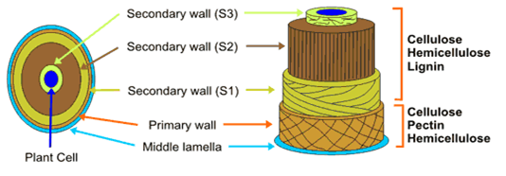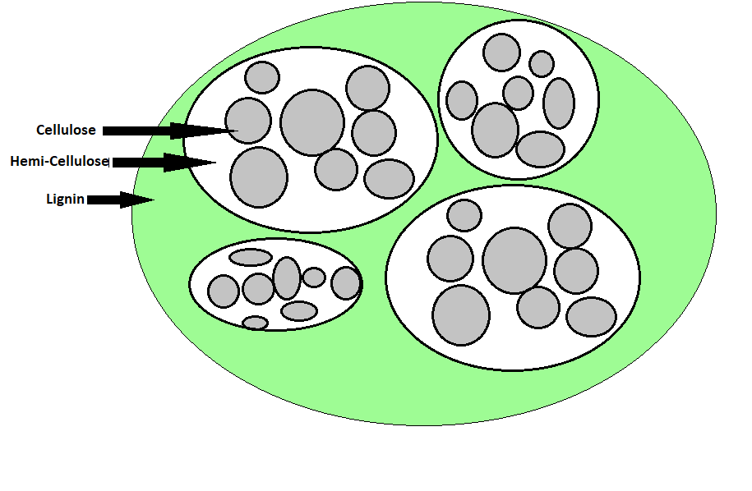

**Figure:2**- Plant Fiber sections

**Table:2-** MechanicalProperties of various Fibers [2,24-27]

|  |  |  |  |  |
| --- | --- | --- | --- | --- |
| **Fiber** | **Density(gm/cm3)** | **% Elongation** | **Tensile Strength (MPa)** | **Youngs Modulus (GPa)** |
| Banana | 1.3-1.4 | 2.0-7.0 | 54-789 | 3.4-32 |
| Coconut | 1.4–3.8 | -- | 120.0–200.0 | 19.0–26.0 |
| Cotton | 1.5–1.6 | 3.0–10.0 | 287.0–597.0 | 5.5–12.6 |
| Flax | 1.4-1.5 | 1.2-3.2 | 345-1500 | 27.6-80 |
| Hemp | 1.4-1.5 | 1.6 | 550-900 | 70.0 |
| Jute | 1.3-1.5 | 1.5-1.8 | 393-800 | 10.0-30.0 |
| Kenaf | 1.2 | 2.7-6.9 | 295 | -- |
| Ramie | 1.5 | 2.0-3.8 | 220-938 | 44-128 |
| Sisal | 1.3-1.5 | 2.0-14.0 | 400-700 | 9.0-38.0 |
| Carbon | 1.4 | 1.4-1.8 | 1500-5500 | 230-240 |
| S-glass | 2.5 | 2.8 | 4570 | 86 |

**Table:3-** Properties of various Matrix Materials [4,26-27]

|  |  |  |  |  |  |
| --- | --- | --- | --- | --- | --- |
|  | **Polymer** | **Density(gm/cm3)** | **% Elongation** | **Tensile Strength (MPa)** | **Youngs Modulus (GPa)** |
| Thermoplastic | Polyvinyl chloride (PVC) | 1.3–1.5 | 50.0–80.0 | 52.0–90.0 | 3.0–4.0 |
| Nylon 6 (PA 6) | 1.1 | 60.0 | 81.4 | 2.8 |
| Rigid thermoplastic polyurethane (RTPU, PUR-RT) | 1.1 | 5.0 | 75.0 | 4.0 |
| Low-density polyethylene (LDPE) | 0.9 | 400.0 | 10.0-11.6 | 0.2-0.3 |
| Cross-linked polyethylene (PE) | 0.9 | 350.0 | 18.0 | 0.5 |
| Thermoset | Epoxy (EP) | 1.2–1.3 | 1.3 | 600.0 | 80.0 |
| Phenol formaldehyde (PF) | 1.2 | 1.2 | 45.0 | 6.5 |
| Rigid thermoset polyurethane (RPU) | 1.2 | 90.0 | 60.0 | 2.2 |
| Polyurethane rubber | 1.2–1.3 | 300.0–580.0 | 39.0 | 2.0–10.0 |
| Biopolymers | Polylactic acid (PLA) | 1.2–1.3 | 2.1–30.7 | 5.9–72.0 | 1.1–3.6 |
| Polycaprolactone (PCL) | 1.1 | 700.0 | 16.0–23.0 | 0.4 |
| Polyhydroxybutyrate (PHB) | 1.2 | 1.56–6.0 | 24.0–40.0 | 3.5–7.7 |

1. **Recent progress in Natural fiber composites with respect to Mechanical strength**

Kenaf fibers could potentially be used as an alternative for friction material. The study reveals by Weighted Decision Matrix approach and compared with other natural fibers, the kenaf fiber found a strong candidature on the scale of Toxicity, Price, Energy, and CO2 footprint, Safe for disposal, and moderate on a scale of Strength & Stiffness **[6]**.  So it emphasizes that plant-based composite can be the alternative to traditional Asbestos which is impacting the environment and human health subjected to further improvement in mechanical properties of such alternatives.

The statistical approach for finding the mechanical properties of the vegetable sisal yarns confirms that the variation of mechanical properties of plant-based fibers are well connected to average values of Young's modulus with a linear prediction model and strength increases with decreases in Young's modulus [7] as shown in table 4. The reason behind this variation is that tested samples of sisal yarn are obtained from different geological regions with variations in climatic conditions. Also, the test conditions like grip type, variety of fibers, and measuring geometry contribute to this dispersion.

**Table 4:** Mechanical properties of sisal yarns tested under tensile quasi-static load [7].

|  |  |  |  |  |  |  |  |  |  |
| --- | --- | --- | --- | --- | --- | --- | --- | --- | --- |
| GL | Strength (MPa) | | | Strain (%) | | | Modulus (MPa) | | |
| mean | S,D | CoV(%) | mean | SD | CoV(%) | mean | SD | CoV(%) |
| 50 | 180.18 | 25.29 | 14.04 | 14.76 | 1.59 | 10.8 | 336.85 | 184.3 | 54.71 |
| 100 | 148.96 | 31.73 | 21.32 | 8.37 | 0.97 | 11.62 | 556.11 | 106.25 | 19.11 |
| 150 | 141.86 | 28.77 | 20.27 | 6.39 | 0.59 | 9.21 | 792.93 | 232.44 | 29.31 |
| 200 | 127.52 | 24.37 | 19.89 | 5.70 | 0.59 | 10.28 | 688.09 | 175.7 | 25.54 |
| 300 | 122.73 | 26.03 | 21.21 | 5.00 | 0.46 | 9.27 | 616.38 | 124.23 | 20.15 |

The load-bearing capacity of composite varies as per the orientation of fibers using the finite element method. The fiber orientation of 0° and 90° showed the best result with minimum stressed conditions for the tensile and flexural test and 45° for hardness test [8]. The impact toughness of hybrid composites was investigated and found that it is influenced by the fiber orientation [15-25]. Woven and unidirectional Kenaf and Kevlar- epoxy composites were tested under tensile test and impact test. The unidirectional sample shows the best flexural strength while others are good in impact and tensile tests.

The Tenax Reinforced Natural Rubber Composites for tensile and tear characteristics, hardness, and abrasion resistance tested and the result shows that short fiber combination gives the best compromise between tensile and tear properties and hardness shown in table-5. SamplesP1 and P3 were all filled with 6-mm-long phormium fibers; whilst P2-6, P2-10, and P2-14 were filled with 6 mm, 10 mm, and 14 mm phormium fibers, respectively. The abrasion resistance to abrasion is increasing with the amount of fibers in natural rubber. This is because, at the higher length of the fiber, the difficulty to maintain the straight alignment of fibers is more [9] against the irregular and variable surface grip in shorter fiber with effective stress transfer across the interface.

**Table 5:** Summary of the mechanical results of all rubber matrix composites [9]

|  |  |  |  |  |  |  |
| --- | --- | --- | --- | --- | --- | --- |
| **Properties** | **NR** | **P1** | **P2-6** | **P2-10** | **P2-14** | **P3** |
| Tensile strength (MPa) | 9.51 | 5.06 | 2.53 | 5.22 | 3.92 | 2.83 |
| Tensile strain (%) | 600 | 727 | 303 | 536 | 619 | 95 |
| 100% modulus (MPa) | 0.57 | 0.75 | 1.48 | 1.33 | 0.98 | - 1 |
| 200% modulus (MPa) | 0.98 | 0.78 | 1.54 | 1.24 | 1.13 | - 1 |
| 300% modulus (MPa) | 1.45 | 0.96 | 1.8 | 1.27 | 1.3 | - 1 |
| Tear strength (N/mm) | 29.2 | 27.5 | 37.2 | 26 | 24.4 | 41.2 |
| Shore A hardness | 37 | 46 | 55 | 49 | 49 | 62 |
| Abrasion loss (cc/h) | 0.5 | 0.36 | 0.35 | 0.42 | 0.45 | 0.26 |

The variation of mechanical performance of date palm and coir fibers reinforcement for polypropylene with temperature is evaluated. It is observed the heat treatment reduces strength and failure strain but not modulus. And the temperature should be limited to 2000c [10] as it drastically reduces the fiber sections. The reason behind such reduction is nothing but the reduction in the water retention over the higher temperature.

The unsatisfactory services of plant-based composite especially Natural fiber composite do not conform to the criteria to replace the traditional material as their properties deteriorate due to temperature exposure and as well hydro-phobic- hydrophilic natures at the boundary of fiber and matrix not ready adheres. In the following sub-section, the adhesion between matrix and fiber is addressed which suggests that the pre-treatment of fiber enhances the bonding capacity to matrix. Several studies reported that natural fibers that were subjected to various chemical treatments such as alkali, coupling agents, acetylation, silane, benzoylation, acrylation, isocyanates, and microwaves show improved mechanical behaviors.[19-23,30]

2.1 Alkali treatment

Literature suggests that pre-treatment of fiber with an alkaline solution, such as 10 percent NaOH for different times not only improves the locking tendency of the matrix by degrading the groups of hydroxyl present on the surface of the ﬁbre thereby expanding the surface roughness but extracts the oils, lignin, and wax that cover the cell wall's exterior surface of the fiber [11-14].

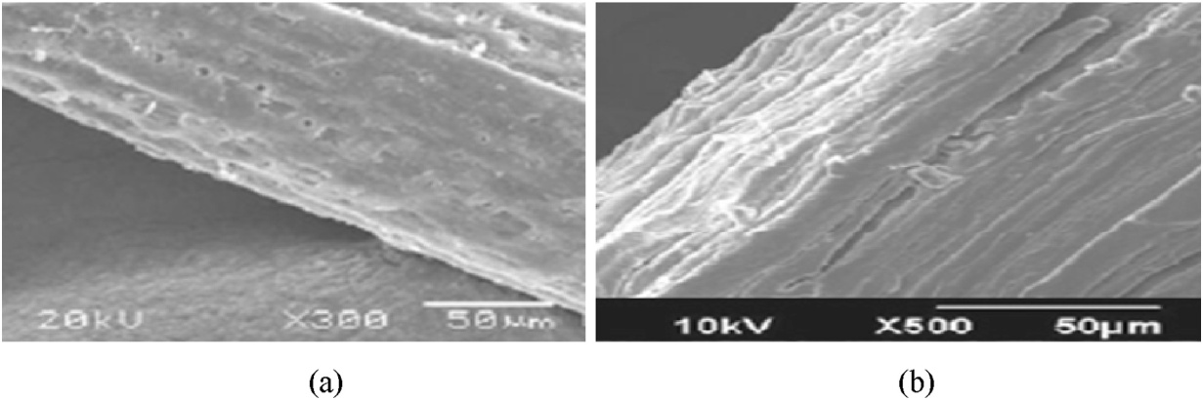

Figure: 3. SEM of Coir fiber (a) without alkali treatment (b) with alkali treatment. [11]

2.2 Microwave Treatments

Another effective treatment is treating yarns of fibers with radio or microwaves. The structure of the natural fiber is semi-cylindrical non-uniform with reducing diameter of fiber towards the end. Fiber always presents as a bundle of 4-10 fibers sticks together [20]. The pretreatments are performed to degrade the non-fibrous tissues and strong bonds between carbon and hydrogen which requires hundreds of KJ/mol of energy which in turn loosens the fiber bundles as shown in Figure 1. Microwave radiation helps in breaking these bonds by local heating by converting electromagnetic energy into mechanical and heat energy [20]. The main advantage of this treatment is that the entire materials get heated at once instead of conduction and convection means for the heat flow to spread. Microwave treatments are equally effective for changing properties, such as coloring and fiber-surface roughness.

Several experiments showed that after treating with microwaves, some properties like tenacity, elongation, and energy uptakes, as well as tensile strength, tensile modulus, etc. can be altered. The study carried out on jute yarns in unfastened and fastened states increased in the elongation by 70% after treatment for the unfastened state [22]. The reason for this is that for the un-fastened state, the resulting yarn thickness was thicker than for the yarn treated in the fastened state. The microwave treatment in water shows without any chemical treatment the tenacity of yarn can be increased but in certain conditions of states

Tensile strength and modulus of the sugar palm fiber with alkali and with microwave treatment at 70oc, 80oc, and 90oc investigated, and results are shown in Figures 4, 5, and 6 with the variation of tensile strain, strength, and modulus respectively based on the experimental data for five samples [23].

 As seen from Figure 4, tensile strain increases with temperature but this increase is nowhere comparable with samples of alkali treatment or untreated samples. Figures 5 and 6 show the tensile strength and modulus which increases with temperature as a decrease in strain at respective temperature and as compared to untreated samples the gain in strength and modulus is marginal. This experimental study reveals that after microwaves treatments surface of fibers not only improved by removing the wax but also enhanced chemical interlock with the matrix as witnessed in Figure 5.

|  |  |
| --- | --- |
| Untreated  **Tensile strain (%)** | Treated with 6% NaOH |
| 21.21 | 45.9 |
| 18.94 | 53.92 |
| 22.98 | 34.64 |
| 30.05 | 50.93 |
| 23.99 | 54.67 |

**Figure 4:** Tensile strain (%) for five samples

|  |  |  |
| --- | --- | --- |
|  | Untreated  **Tensile strength (MPa)** | Treated with 6% NaOH |
|  | 10.38 | 5.4 |
|  | 9.13 | 5.32 |
|  | 8.9 | 5.02 |
|  | 11.71 | 5.71 |
|  | 9.36 | 6 |
|  |  |  |

**Figure. 5 :** Tensile strength (MPa) for five samples

|  |  |  |
| --- | --- | --- |
|  | Untreated  **Tensile modulus (MPa)** | Treated with 6% NaOH |
|  | 105.53 | 30 |
|  | 96.32 | 30 |
|  | 90.37 | 30 |
|  | 95.84 | 30 |
|  | 88.48 | 30 |

**Figure. 6:** Tensile modulus (MPa) for five samples

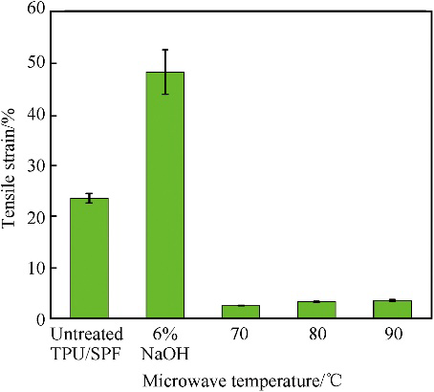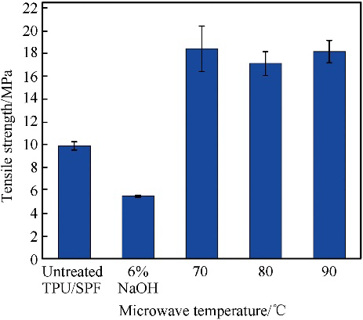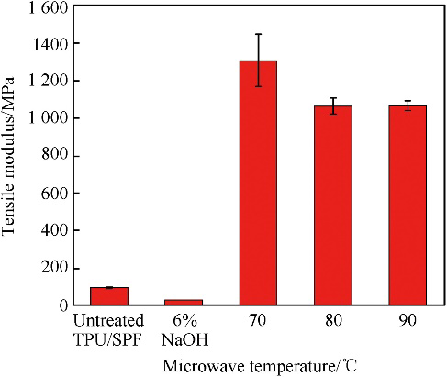

**Figure 7:** Tensile Stain, Strength and Modulus of composite of untreated and treated Samples [23]

The ability to replace the structural steel with composite is also examined [17]. The torsional strength, natural frequency, and critical speed of glass epoxy designed composite shaft investigated by have shown even better overall performance as compared to steel for light vehicle due to its low weight to strength ratios. Again, the ease of manufacturing for required strength is the added advantage of the composite thus they even can replace the conventional materials.

1. **Recent progress in Natural fiber composites with respect to vibrations**

Damping is the ability of the material to absorb vibrations by dissipating or losing an energy. These composites are made of different natural fibers and tested under flexural vibration test [25-26] as shown in the Figue:8. The time decay is measured and their vibrational characteristics like damping ratio, stiffness or product of stiffness and young modulus viz. loss modulus are analyzed.

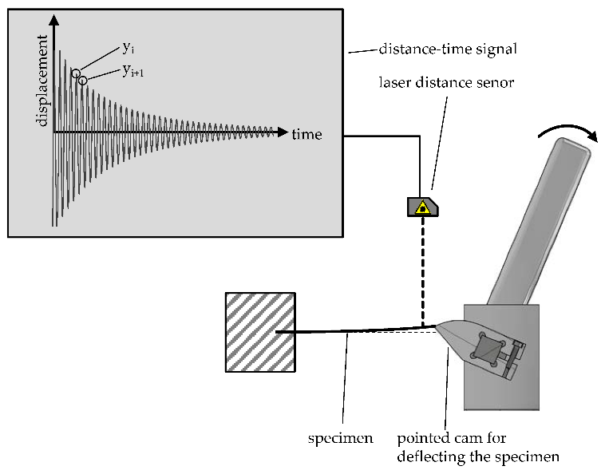

**Figue:8** : Vibration Testing Set up for Natural Fiber Composite Materials[25]

Hybridizing natural fiber composites enhances their mechanical properties, and they typically offer higher damping capacity than metals, mainly due to the viscoelasticity of the polymer matrix and frictional sliding as the dissipation mechanism. [19].

The study indicates that the best balance between stiffness and damping is achieved by maximizing the product of stiffness (E) and damping (η)[27]. By carefully selecting or treating fibers, further improvements can be made. Future development of modified plant fibers that enhance damping without sacrificing stiffness can be achieved by hybridizing the composites with nano-clay like silicas. Nanocomposites offer higher damping capacity due to their larger interfacial area. The composite made of carbon-glass and silica hybridized with cement has shown more than 30% higher performance [28] which is resulted from different lay up sequence and staking types. More the volume of matrix fraction in composite more will be frictional resistance[15,28]. These composites would be ideal for applications where both stiffness, and vibration damping are crucial. The vibration aspect of the natural fiber-based composite materials for automotive applications finds jute fibers-based composite performed better even as compared to the glass fiber in damping capacity and modal analysis [18]. Table 6 gives the comparison of jute fiber advantages for more value of the loss factor over the glass fiber-made bonnet for the first five modes of vibration. The reason behind this is the presence of lignocelluloses in jute which enhances the damping and makes it more suitable in other noise suppression applications.

**Table 6:** Modal parameters for Glass and Jute fiber bonnets [18]

|  |  |  |  |  |
| --- | --- | --- | --- | --- |
|  | Glass fiber bonnet | | Jute fiber bonnet | |
| Mode | Natural frequency [Hz] | Loss factor [%] | Natural frequency [Hz] | Loss factor [%] |
| 1 | 25.1 | 4.1 | 18.5 | 7.6 |
| 2 | 31.8 | 3.3 | 24.6 | 4.6 |
| 3 | 54.8 | 3.5 | 43.1 | 4.4 |
| 4 | 71.5 | 2.2 | 56.3 | 5.6 |
| 5 | 77.9 | 2.3 | 60.8 | 4 |

**3.1 Durability of Natural Fiber Composites**

The environmental exposure of Natural fiber composites is limited by the type of fiber and matrix. It is true that the pre-treatments can improve the life span of these materials but for limited periods only. Another way to understand the durability is peeling adhesion and three-point bending testing. Some fibers like flax are hybridized with carbon composites which exhibit 212% to 265% more strength and 27% more peeling strength when produced in laminated form [24]. Some fiber composites like cotton-blended pineapple leaf fiber and jute fiber are exposed to water to study the water absorption capacity. It reveals that these natural fibers absorb more water due to the presence of voids as predicted over time as hydroxyl in jute as seen in Figure 9

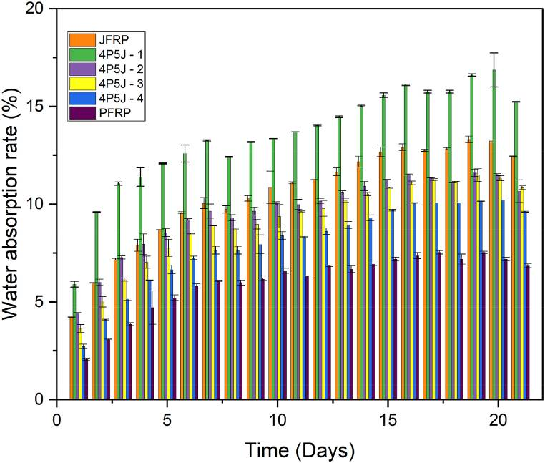

**Figure 9:** Water absorption of Natural fiber Composites over the Time for pineapple leaf fiber and jute fiber [27]

**3.2 Applications of Natural Fiber Composites**

Natural fiber composites are widely used in automotive, construction, Furniture, and Packing, for automotive applications, like brake and accelerator pedals, for a greener future and effective waste material utilization [25,29]. Fibers with anti-microbial properties such as Hemp, Flax, and PLA composite can be used in packaging industries. For the construction industry, Bamboo, rice husk, kenaf, hemp, and cereal straws play a crucial role. Bamboo can be replaced with steel reinforced which is a great eco-friendly option. Others can be used for roof insulation and aesthetic purposes [30]. Some other wood-based composite is used for noise absorption as they are found to be more porous and resist the airborne and impacted sound [31]. Some of the applications of the natural fiber composites are illustrated in Figure 10.

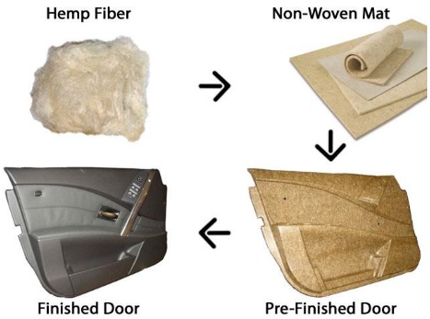

**Figure 10:** Automotive Applications of Natural fiber Composites[29-31]

**Conclusion**

The best and next alternative Natural fiber composite can be suited for various applications in mechanical The best and next alternative, Natural fiber composite can be suited for various applications in mechanical industries where mechanical properties like strength and impact are important. These properties are the functions of individual members in composite and they vary as per the treatments of the fibers and plant source. This paper reviews the various mechanical and vibrational aspects of the composites and it is found that some of the natural composite has good mechanical but poor vibrational characteristics and vice a-versa[25-27]. Such as Ramie, Flax, and Coconut fibers have good young modulus meaning they can dampen vibrations effectively but comparatively coconut fibers have less tensile strength. These characteristics can be further improved by altering the texture of the fiber with various pre-treatments like alkalis and microwaves. These treatments enhance the surface roughness of the fiber, which improves the interlocking of fiber to the matrix and improves the damping capacity creating more micro spaces to dissipate the vibrations. Another way to improve these characteristics is the reinforcement with nano-clay hybridization which affects the damping coefficient, as well as the tensile and flexural elastic modulus and strength of the hybrid composites.

The nonlinear behavior of the natural fiber composites is due to uneven the yield of plants which in turn are produced in different regions. The standard method for production, cultivation, and incapability of generalization of raw materials are some of the reasons that put limits on their use in engineering applications. But overall strength-to-weight ratio, bio-degradability, and carbon emission point of view these materials will fulfill the near future engineering expectation

**COMPETING INTERESTS DISCLAIMER:**

Authors have declared that they have no known competing financial interests OR non-financial interests OR personal relationships that could have appeared to influence the work reported in this paper.

Disclaimer (Artificial intelligence)

Author(s) hereby declare that NO generative AI technologies such as Large Language Models (ChatGPT, COPILOT, etc.) and text-to-image generators have been used during the writing or editing of this manuscript.

**References**

1. Shaw, Austin, Liang Tian, and Alan Russell. 2016. “Tensile Properties of High-Purity Ca Metal”. Current Journal of Applied Science and Technology 15 (6):1-6. https://doi.org/10.9734/BJAST/2016/26293.
2. Sathishkumar T, Navaneethakrishnan P, Shankar S, Rajasekar R, Rajini N. Characterization of natural fiber and composites – A review. Journal of Reinforced Plastics and Composites. 2013;32(19):1457-1476. doi:10.1177/0731684413495322
3. Thermoplastic vs Thermoset Plastic: Mechanical Properties Overview- An article; [https://www.fictiv.com/articles/thermoplastic-vs-thermoset-plastic-mechanical-properties overview](https://www.fictiv.com/articles/thermoplastic-vs-thermoset-plastic-mechanical-properties%20overview)
4. Rohan S. Dassanayake, Sanjit Acharya and Noureddine Abidi (November 5th 2018). Biopolymer-Based Materials from Polysaccharides: Properties, Processing, Characterization and Sorption Applications, Advanced Sorption Process Applications, Serpil Edebali, IntechOpen, DOI: 10.5772/intechopen.80898
5. Codispoti, R., Oliveira, D.V., Olivito, R.S., Lourenço, P.B. and Fangueiro, R., 2015. Mechanical performance of natural fiber-reinforced composites for the strengthening of masonry. Composites Part B: Engineering, 77, pp.74-83.
6. Abdollah, M.F.B., Shuhimi, F.F., Ismail, N., Amiruddin, H. and Umehara, N., 2015. Selection and verification of kenaf fibres as an alternative friction material using Weighted Decision Matrix method. Materials & Design, 67, pp.577-582.
7. Ahmed Belaadi, Mostefa Bourchak, Hamdi Aouici, Mechanical properties of vegetal yarn: Statistical approach,Composites Part B: Engineering,Volume 106,2016,Pages 139-153,
8. Upendra Sharan Gupta, Amit Dharkar, Mohit Dhamarikar, Arpit Choudhary, Dipanshu Wasnik, Pankaj Chouhan, Sudhir Tiwari, Rajeev Namdeo, Study on the effects of fiber orientation on the mechanical properties of natural fiber reinforced epoxy composite by finite element method,Materials Today: Proceedings,Volume 45, Part 9,2021, Pages 7885-7893,
9. Palanisamy, Sivasubramanian, Kalimuthu Mayandi, Murugesan Palaniappan, Azeez Alavudeen, Nagarajan Rajini, Felipe Vannucchi de Camargo, and Carlo Santulli. 2021. "Mechanical Properties of Phormium Tenax Reinforced Natural Rubber Composites" Fibers 9, no. 2: 11.
10. James L. Thomason, Jose L. Rudeiros-Fernández, Thermal degradation behaviour of natural fibres at thermoplastic composite processing temperatures, Polymer Degradation and Stability, Volume 188,2021,109594,
11. Yadvinder Singh, Jujhar Singh, Shubham Sharma, Thanh-Danh Lam, Duc-Nam Nguyen, Fabrication and characterization of coir/carbon-fiber reinforced epoxy based hybrid composite for helmet shells and sports-good applications: influence of fiber surface modifications on the mechanical, thermal and morphological properties, Journal of Materials Research and Technology,Volume 9, Issue 6,2020,Pages 15593-15603
12. N.H. Padmaraj, Laxmikant G. Keni, K.N. Chetan, Mayur Shetty, Mechanical Characterization of Areca husk-Coir fiber reinforced hybrid Composites, Materials Today: Proceedings,Volume 5, Issue 1, Part 1, 2018, Pages 1292-1297,
13. Potadar, O.V. and Kadam, G.S., 2018. Preparation and testing of composites using waste groundnut shells and coir fibres. Procedia Manufacturing, 20, pp.91-96.
14. Mwaikambo, L.Y. and Ansell, M.P., 2002. Chemical modification of hemp, sisal, jute, and kapok fibers by alkalization. Journal of applied polymer science, 84(12), pp.2222-2234.
15. Yahaya, R., Sapuan, S.M., Jawaid, M., Leman, Z. and Zainudin, E.S., 2016. Effect of fibre orientations on the mechanical properties of kenaf–aramid hybrid composites for spall-liner application. Defence Technology, 12(1), pp.52-58.
16. Shinde, R.M. and Sawant, S.M., 2019. Investigation on glass-epoxy composite drive shaft for light motor vehicle. International Journal of Design Engineering, 9(1), pp.22-35.
17. Furtado, S.C., Araújo, A.L., Silva, A., Alves, C. and Ribeiro, A.M.R., 2014. Natural fibre-reinforced composite parts for automotive applications. International Journal of Automotive Composites, 1(1), pp.18-38.
18. Baley, C.. “Analysis of the flax fibres tensile behaviour and analysis of the tensile stiffness increase.” Composites Part A-applied Science and Manufacturing 33 (2002): 939-948.
19. Martone A, Giordano M, Antonucci V, Zarrelli M. Enhancing damping features of advanced polymer composites by micromechanical hybridization. Compos A Appl Sci Manuf 2011;42(11):1663e72
20. Nair, G.R., 2017. Role of microwave pre-treatment in the extraction of high quality natural fibers. Journal of Textile Engineering & Fashion Technology, 2(2), p.53.
21. Kocak, Dilara, Nigar Merdan, and Oya Burcak Evren. "Research into the specifications of woven composites obtained from raffia fibers pretreated using the ecological method." Textile Research Journal 85, no. 3 (2015): 302-315.
22. Syrén, Felicia, Joel Peterson, and Nawar Kadi. 2021. "Effects of Microwave Treatment in Immersed Conditions on the Mechanical Properties of Jute Yarn" Fibers 9, no. 7: 40. <https://doi.org/10.3390/fib9070040>
23. A.A. Mohammed, D. Bachtiar, M.R.M. Rejab, J.P. Siregar, Effect of microwave treatment on tensile properties of sugar palm fibre reinforced thermoplastic polyurethane composites,Defence Technology,Volume 14, Issue 4,2018,Pages 287-290
24. Bahrami, M.; del Real, J.C.; Mehdikhani, M.; Butenegro, J.A.; Abenojar, J.; Martínez, M.Á. Hybridization Effect on Interlaminar Bond Strength, Flexural Properties, and Hardness of Carbon–Flax Fiber Thermoplastic Bio-Composites. Polymers 2023, 15, 4619. <https://doi.org/10.3390/polym15244619>
25. Kröger, H.; Mock, S.; Greb, C.; Gries, T. Damping Properties of Hybrid Composites Made from Carbon, Vectran, Aramid and Cellulose Fibers. J. Compos. Sci. 2022, 6, 13. <https://doi.org/10.3390/jcs6010013>
26. Erklig, Ahmet & Bulut, Mehmet & Yeter, Eyüp. (2014). The effect of hybridization and boundary conditions on damping and free vibration of composite plates. Science and Engineering of Composite Materials. 10.1515/secm-2014-0070.
27. Baigh TA, Nanzeeba F, Hamim HR, Habib MA. A comprehensive study on the effect of hybridization and stacking sequence in fabricating cotton-blended jute and pineapple leaf fibre biocomposites. Heliyon. 2023 Sep 7;9(9):e19792. doi: 10.1016/j.heliyon.2023.e19792. PMID: 37809613; PMCID: PMC10559121
28. Ribeiro Filho SLM, Thomas Garcia C, Durão LMP, et al. Assessment of damping and flexural behaviour of hybrid fibre-particulate composites. Journal of Composite Materials. 2024;58(10):1245-1265. doi:10.1177/00219983241237359
29. Aditya Mundhe, Balasubramanian Kandasubramanian,, Advancements in natural fiber composites: Innovative chemical surface treatments, characterizaton techniques, environmental sustainability, and wide-ranging applications, Hybrid Advances, Volume 7, 2024,100282,ISSN 2773-207X, <https://doi.org/10.1016/j.hybadv.2024.100282>.
30. Kusum Saini, Vasant A. Matsagar, Venkatesh R. Kodur, Recent advances in the use of natural fibers in civil engineering structures, Construction and Building Materials, Volume 411,2024,134364,ISSN 0950-0618, <https://doi.org/10.1016/j.conbuildmat.2023.134364>.
31. M. Fan, 22 - Future scope and intelligence of natural fibre based construction composites, Editor(s): Mizi Fan, Feng Fu,Advanced High Strength Natural Fibre Composites in Construction,Woodhead Publishing, 2017,Pages 545-556, ISBN 9780081004111, <https://doi.org/10.1016/B978-0-08-100411-1.00022-4>.