Influence of Aggregate on the Mechanical, Permeability, and Durability Properties of Porous Concrete: A Review

.

ABSTRACT

|  |
| --- |
| This study, based on a review of existing literature and experimental analysis, explores the impact of aggregates on the performance of porous concrete.It reveals that the strength and surface characteristics of natural aggregates significantly affect the mechanical properties of concrete, while recycled aggregates, although promoting resource recycling, perform poorly. A reduction in aggregate particle size is inversely proportional to an increase in concrete strength, with fine aggregates playing a pivotal role in refining the pore structure. The study also examines the trade-offs between strength and permeability, and the limitations of using recycled aggregates. By reasonably selecting the type of aggregate and optimizing the gradation, the mechanical and permeability properties of porous concrete can be significantly improved, providing an important reference for its application in practical engineering. |

*Keywords: Porous concrete, cementitious materials, performance impact*

1. INTRODUCTION

With the acceleration of urbanization, the large-scale laying of concrete and asphalt pavements has led to a significant increase in the proportion of impermeable surfaces in cities. Studies have shown that when the proportion of impermeable surfaces exceeds 75%, the volume of rainwater runoff increases dramatically, which can exceed the capacity of drainage systems and potentially trigger natural disasters such as floods. Moreover, impermeable surfaces can exacerbate the urban heat island effect and lead to issues such as pavement glare, road noise, and road damage [1]. To address these challenges, China has proposed the strategies of "Sponge City" and "Smart City" [2], aiming to improve urban ecological functions through the application of environmentally friendly building materials [3].

Porous concrete, as a new type of environmentally friendly building material, is widely used in scenarios such as roads, sidewalks, and parking lots due to its excellent permeability and lightweight characteristics [4]. Its performance is influenced by various factors, among which the properties of the aggregate (type, particle size, gradation, etc.) play a decisive role in the mechanical properties, permeability, and durability of porous concrete [5]. Aggregates can be divided into natural aggregates (such as basalt, granite, limestone, etc.) and recycled aggregates (processed from waste construction materials), the latter significantly affecting the performance of concrete while reducing resource consumption [6].The natural aggregate mining process is shown in Figure 1．Recycled treated fine aggregate is shown in Figure 2．

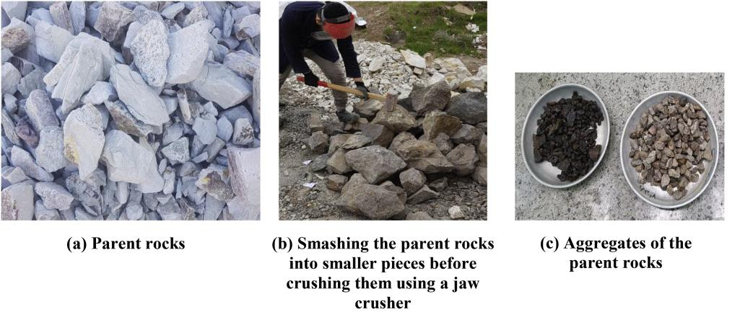

**Figure 1 Natural aggregate mining process**

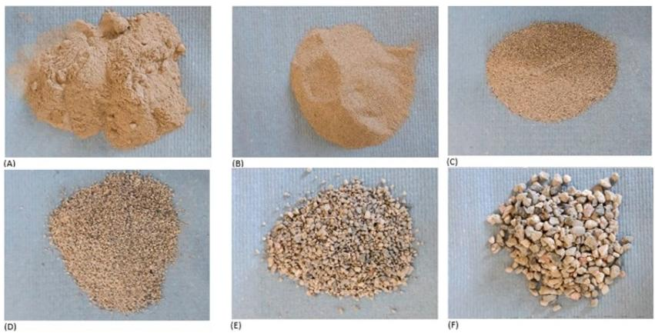

**Figure 2 Recycled treated fine aggregate**

Current research indicates that the type of aggregate has differential effects on the performance of porous concrete. For instance, basalt aggregate has a higher compressive strength and permeability compared to granite aggregate [7], while recycled aggregate, although it may reduce mechanical properties, has a slight enhancing effect on permeability [8]. Moreover, the impact of aggregate size on permeability is more significant: the size range is usually controlled between 2.36-19mm, where fine aggregates in the range of 2.36-9.5mm help improve strength, and when the size exceeds 20mm, strict control of content is necessary to avoid performance degradation [4]. Some studies suggest that the influence of aggregate size can even surpass that of aggregate type.

Although existing studies have revealed the correlation between aggregate properties and the performance of porous concrete, systematic research on different types of aggregates and their combined effects is still insufficient [15-17]. This article aims to systematically analyze the mechanism of action of aggregate type, particle size, and gradation on the performance of porous concrete, providing a theoretical basis for optimizing material design and engineering applications, and aiding in the realization of the construction goals of "sponge cities".

2. The effect of natural aggregates on the mechanical properties and permeability of porous concrete.

The properties of natural aggregates have an impact on the performance of porous concrete. Mahmood Naderi studied the effects of different types of natural aggregates on the mechanical properties and permeability of porous concrete. The results indicated that the compressive strength and surface strength of the natural aggregate rock itself are highly correlated with the compressive strength and surface strength of the concrete. There is a high negative correlation between the compressive strength and permeability of the concrete. High-strength and low-permeability natural aggregates (such as granite, andesite, silica, limestone, marble, and tuff) can be used to prepare concrete with higher compressive strength and lower permeability.The geometric shape indices of the studied aggregates are shown in Table 1．The table lists the geometric shape indices of six types of aggregates (granite, andesite, silica, limestone, marble, and tuff), including circularity, aspect ratio, and solidity. Each index provides mean, standard deviation, and coefficient of variation. The main findings are as follows:

In terms of circularity, marble has the highest circularity of 0.71, indicating its particles are closest to circular; silica has the lowest circularity of 0.632, indicating significant variation in particle shape. For aspect ratio, tuff has the highest aspect ratio of 2.29, indicating its particles are the longest; marble has the lowest aspect ratio of 1.78, indicating its particles are closest to square. Regarding solidity, marble has the highest solidity of 0.93, indicating its particles are the most compact; silica has the lowest solidity of 0.891, indicating lower particle compactness.

Aggregates with higher circularity and lower aspect ratio (e.g., marble) may enhance concrete density and strength but reduce permeability. Aggregates with higher solidity (e.g., marble) improve strength but may negatively affect permeability. Optimizing aggregate geometric properties can balance the mechanical and permeability performance of porous concrete.

**Table 1.Geometry indices of the studied aggregates.**

|  |  |  |  |  |  |  |  |  |  |
| --- | --- | --- | --- | --- | --- | --- | --- | --- | --- |
|  | Circularity | | | Aspect ratio | | | Solidity | | |
|  | Mean | SD | CoV (%) | Mean | SD | CoV (%) | Mean | SD | CoV (%) |
| Granite | 0.67 | 0.082 | 12.239 | 2.24 | 0.414 | 18.482 | 0.88 | 0.054 | 6.136 |
| Andesite | 0.691 | 0.105 | 15.195 | 1.822 | 0.37 | 20.307 | 0.908 | 0.071 | 7.819 |
| Silica | 0.632 | 0.112 | 17.722 | 2.123 | 0.565 | 26.613 | 0.891 | 0.038 | 4.266 |
| Limestone | 0.659 | 0.096 | 14.568 | 2.018 | 0.396 | 19.623 | 0.905 | 0.047 | 5.193 |
| Marble | 0.71 | 0.15 | 21.127 | 1.78 | 0.499 | 28.033 | 0.93 | 0.02 | 2.151 |
| Tuff | 0.64 | 0.126 | 19.688 | 2.29 | 0.719 | 31.397 | 0.94 | 0.046 | 4.894 |

Pumice and zeolite, as natural aggregates, have an impact on the performance of porous concrete. Pumice, which is formed from volcanic eruptions, is a fragmental material with porous, low-density, and high specific surface area characteristics. Compared to other commonly used fillers, this material can regulate the density and specific surface area of porous concrete by using low-quality volcanic pumice while maintaining the same volume, which helps to reduce the weight of the porous concrete. Hariyadi's study [9] indicates that volcanic pumice can be used as an aggregate substitute material for permeable porous concrete, enhancing its porosity without reducing the strength of the concrete. Furthermore, Ignacio Oviedo prepared permeable porous concrete using different proportions of pumice and zeolite to replace cement. Through compressive strength, flexural strength, permeability, porosity, and SEM microanalysis of the samples, it was shown that when the cement replacement amount is 10%, the performance of porous concrete prepared with pumice is superior to that prepared with zeolite. Moreover, compared to the reference group without replacement, the compressive and flexural strength of the porous concrete with 10% pumice replacement increased, and the permeability decreased but not significantly.

3. Effect of recycled aggregates on mechanical properties and permeability of porous concrete

Crushed stone and recycled expanded shale aggregates of different grain sizes are shown in Figure 3.The use of recycled aggregates can reduce the production cost of porous concrete, and at the same time, it is beneficial to the reuse of resources [7].Recycled aggregates are not as hard as natural aggregates, but they have a low density and high pore content, which can effectively reduce the weight of porous concrete.Vinícius Cominato [7] used Construction Demolition Waste (CDW) as a recycled aggregate to prepare porous concrete, and his study showed that, since the cracks in the interfacial region between the cement matrix and the recycled aggregate, the use of CDW reduced the compressive strength, tensile strength and modulus of elasticity of the porous concrete as compared to the conventional concrete. Similarly, Muhammad Aamer Rafique Bhutta [10] used waste crushed concrete as recycled aggregate for the preparation of porous concrete to study the properties of recycled aggregate porous concrete and the results showed that the total porosity of porous concrete with recycled aggregate was higher than that of porous concrete with normal aggregate and the compressive strength of recycled aggregate porous concrete was lower than that of normal aggregate porous concrete However, the permeability coefficients of the prepared recycled aggregate porous concretes were in the range of 2.4 ~ 3.7 cm/s, which can be used for permeable pavements.

Recent studies have demonstrated that treatment methods such as acid washing and mechanical abrasion can significantly improve the performance of recycled aggregates [11,18-20]. These processes help remove residual mortar and contaminants, thereby enhancing the bond between the aggregate and cement matrix. As a result, the mechanical strength and durability of porous concrete prepared with treated recycled aggregates can approach those of concrete made with natural aggregates. This study acknowledges these advancements and suggests that further optimization of treatment methods could expand the applicability of recycled aggregates in construction applications. And, Asad Elmagarhe [12] investigated the effect of recycled aggregate (RCA) on the properties of porous asphalt porous concrete, which showed that the incorporation of RCA in porous asphalt concrete decreases the concrete's pore content, permeability, stability, tensile strength, tear resistance, and acoustic absorption, but further replacement of mineral filler in the mix with fly ash helps to offset the RCA's negative effects. It has also been suggested that porous concrete prepared with recycled aggregates has higher porosity, permeability, lower density and compressive strength compared to concrete prepared from granite and gravel due to the presence of adherent mortar on the recycled concrete aggregate.

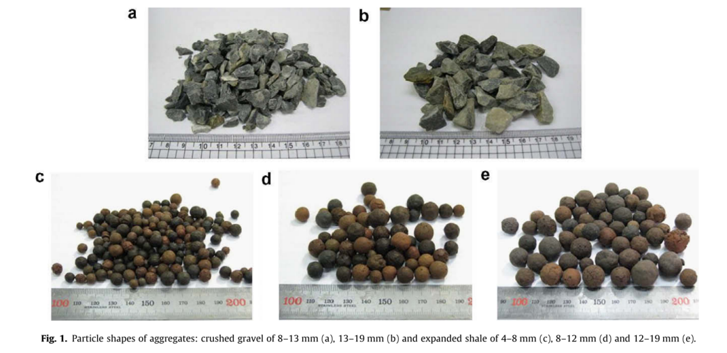

**Fig. 3 Crushed stone and recycled expanded shale aggregates with different particle sizes**

1. Effect of Aggregate Size on Mechanical Properties of Porous Concrete

Aggregate particle size has an effect on the mechanical properties of porous concrete. Ayda S. Agar-Ozbek [13] studied the effect of different particle sizes of aggregates on the properties of porous concrete, the study showed that the aggregate particle size, morphology, surface texture and angle will affect the mechanical properties of the concrete, the smaller the aggregate particle size, the rougher the surface, the closer the mechanical interlocking bond between the aggregates, and the porous concrete prepared will have higher mechanical strength. the higher the mechanical strength. The authors of this study also explained the compression damage mechanism of porous concrete, when porous concrete is subjected to pressure, cracks tend to pass through the material with minimum resistance, due to the inherent weakness of the ITZ phase and the stress concentration caused by the rigid aggregates, the cracks always start from the ITZ, but the further expansion of the cracks will be affected by the gradation of the aggregates and the distribution of the pore sizes. Cracks tend to pass through the ITZ when the aggregate is fine and more through the aggregate when the aggregate is coarse, which helps to explain why microsilica fume, which enhances the properties of the ITZ, has a slight reinforcing effect on porous concretes with finer aggregates, whereas it does not have such an effect in porous concretes prepared with coarser aggregates due to the reduction in the total amount of ITZ in the concrete. In addition, Ayda Safak Agar Ozbek [14] showed that aggregate gradation is the main determinant of total porosity, pore size distribution, and strength of the specimen, and that the mechanical properties of porous concrete were improved in experiments as the aggregate particle size decreased (from 4-8 mm to 2-4 mm), the pore size decreased, and the bonding area between the cement paste and the aggregate increased.

5. Conclusion

　　This study systematically investigates the effects of natural aggregates, recycled aggregates, and aggregate size on the performance of porous concrete. Research indicates that the compressive strength and surface strength of natural aggregates are highly correlated with the performance of porous concrete. High-strength, low-permeability natural aggregates, such as granite and basalt, can significantly enhance the mechanical properties of concrete. Special natural aggregates like pumice and zeolite, due to their porous and low-density characteristics, can increase porosity and reduce weight without compromising strength. Recycled aggregates, while beneficial for reducing costs and recycling resources, typically perform worse than natural aggregates, leading to a decrease in the compressive strength and permeability of porous concrete. However, this negative impact can be partially offset by optimizing the mix ratio, such as incorporating fly ash. The mechanical strength of porous concrete exhibits a direct relationship with the degree of mechanical interlocking between aggregates, which is inversely proportional to the aggregate particle size and directly proportional to the surface roughness. A reduction in particle size coupled with an increase in surface roughness enhances the interfacial bonding and load distribution within the concrete matrix, thereby contributing to an elevation in the overall mechanical performance. This interplay of factors underscores the significance of optimizing aggregate properties to achieve desired engineering characteristics in porous concrete applications. Fine aggregates also help reduce pore size and increase the bonding area. Aggregate gradation is a key factor in determining porosity, pore size distribution, and the strength of test specimens. In summary, the rational selection of aggregate type, optimization of size distribution, and mix design can effectively enhance the overall performance of porous concrete, providing theoretical support for its engineering applications.

**COMPETING INTERESTS DISCLAIMER:**

Authors have declared that they have no known competing financial interests OR non-financial interests OR personal relationships that could have appeared to influence the work reported in this paper.

**Disclaimer (Artificial intelligence)**

Author(s) hereby declare that NO generative AI technologies such as Large Language Models (ChatGPT, COPILOT, etc.) and text-to-image generators have been used during the writing or editing of this manuscript.

References

1. Haselbach, L.M.; Valavala, S.; Montes, F. Permeability predictions for sand-clogged Portland cement pervious concrete pavement systems. *Journal of Environmental Management* **2006**, *81*, 42-49, doi:<https://doi.org/10.1016/j.jenvman.2005.09.019>.

2. Guo, Z.; Zhang, X.; Winston, R.; Smith, J.; Yang, Y.; Tao, S.; Liu, H. A holistic analysis of Chinese sponge city cases by region: Using PLS-SEM models to understand key factors impacting LID performance. *Journal of Hydrology* **2024**, *637*, 131405, doi:<https://doi.org/10.1016/j.jhydrol.2024.131405>.

3. Xu, G.; Shen, W.; Huo, X.; Yang, Z.; Wang, J.; Zhang, W.; Ji, X. Investigation on the properties of porous concrete as road base material. *Construction and Building Materials* **2018**, *158*, 141-148, doi:<https://doi.org/10.1016/j.conbuildmat.2017.09.151>.

4. Chandrappa, A.K.; Biligiri, K.P. Pervious concrete as a sustainable pavement material – Research findings and future prospects: A state-of-the-art review. *Construction and Building Materials* **2016**, *111*, 262-274, doi:<https://doi.org/10.1016/j.conbuildmat.2016.02.054>.

5. Cai, P.; Mao, X.; Lai, X.; Wu, Q. Influence mechanism of brick-concrete ratio on the mechanical properties and water permeability of recycled aggregate pervious concrete: Macroscopic and mesoscopic insights. *Construction and Building Materials* **2025**, *467*, 140379, doi:<https://doi.org/10.1016/j.conbuildmat.2025.140379>.

6. Pan, X.; Zhang, H.; Liu, W.; Yao, J. Graphitic carbon nitride (g-C3N4) bonding stability on recycled aggregate pervious concrete (RAPC) pavement for enhanced long-term photocatalytic efficacy. *Construction and Building Materials* **2025**, *470*, 140588, doi:<https://doi.org/10.1016/j.conbuildmat.2025.140588>.

7. Cominato, V.; Benavente Canteras, F.; Andréia Gachet, L.; Cristina Cecche Lintz, R. The effect of granulometry of natural and recycled coarse aggregate on permeable concrete properties. *Materials Today: Proceedings* **2022**, *65*, 1711-1718, doi:<https://doi.org/10.1016/j.matpr.2022.04.717>.

8. Ćosić, K.; Korat, L.; Ducman, V.; Netinger, I. Influence of aggregate type and size on properties of pervious concrete. *Construction and Building Materials* **2015**, *78*, 69-76, doi:<https://doi.org/10.1016/j.conbuildmat.2014.12.073>.

9. Hariyadi; Tamai, H. Enhancing the Performance of Porous Concrete by Utilizing the Pumice Aggregate. *Procedia Engineering* **2015**, *125*, 732-738, doi:<https://doi.org/10.1016/j.proeng.2015.11.116>.

10. Aamer Rafique Bhutta, M.; Hasanah, N.; Farhayu, N.; Hussin, M.W.; Tahir, M.b.M.; Mirza, J. Properties of porous concrete from waste crushed concrete (recycled aggregate). *Construction and Building Materials* **2013**, *47*, 1243-1248, doi:<https://doi.org/10.1016/j.conbuildmat.2013.06.022>.

11. C. Sánchez-Mendieta, J.J. Galán-Díaz, I. Martinez-Lage, Relationships between density, porosity, compressive strength and permeability in porous concretes: Optimization of properties through control of the water-cement ratio and aggregate type, Journal of Building Engineering 97 (2024) 110858, doi: https://doi.org/10.1016/j.jobe.2024.110858

12. Elmagarhe, A.; Lu, Q.; Alamri, M.; Alharthai, M.; Elnihum, A. Laboratory performance evaluation of porous asphalt mixture containing recycled concrete aggregate and fly ash. *Case Studies in Construction Materials* **2024**, *20*, e02849, doi:<https://doi.org/10.1016/j.cscm.2023.e02849>.

13. Agar-Ozbek, A.S.; Weerheijm, J.; Schlangen, E.; van Breugel, K. Investigating porous concrete with improved strength: Testing at different scales. *Construction and Building Materials* **2013**, *41*, 480-490, doi:<https://doi.org/10.1016/j.conbuildmat.2012.12.040>.

14. A.S. Agar Ozbek, R.R. Pedersen, J. Weerheijm, K. van Breugel, Mesoscopic modeling of the impact behavior and fragmentation of porous concrete, Cement and Concrete Composites 102 (2019) 116-133, doi: https://doi.org/10.1016/j.cemconcomp.2019.04.020

15. Naderi, M., & Kaboudan, A. (2021). Experimental study of the effect of aggregate type on concrete strength and permeability. Journal of Building Engineering, 37, 101928.

16. Basheer, L., Basheer, P. A. M., & Long, A. E. (2005). Influence of coarse aggregate on the permeation, durability and the microstructure characteristics of ordinary Portland cement concrete. Construction and building materials, 19(9), 682-690.

17. Pereira, C. G., Castro-Gomes, J., & de Oliveira, L. P. (2009). Influence of natural coarse aggregate size, mineralogy and water content on the permeability of structural concrete. Construction and Building Materials, 23(2), 602-608.

18. Sun, D., Huang, W., Liu, K., Ma, R., Wang, A., Guan, Y., & Shen, S. (2022). Effect of the moisture content of recycled aggregate on the mechanical performance and durability of concrete. Materials, 15(18), 6299.

19. Dimitriou, G., Savva, P., & Petrou, M. F. (2018). Enhancing mechanical and durability properties of recycled aggregate concrete. Construction and Building Materials, 158, 228-235.

20. Debieb, F., Courard, L., Kenai, S., & Degeimbre, R. (2010). Mechanical and durability properties of concrete using contaminated recycled aggregates. Cement and Concrete Composites, 32(6), 421-426.