Spatial Mapping of Abandoned Mines and Land Use–Land Cover Changes in Kamtonga and Mkuki of Kenya: A Remote Sensing and GIS Approach

.

ABSTRACT

|  |
| --- |
| Following mining activities, rehabilitation is essential to restore sites to their original condition. This study employed Geographic Information System (GIS) and remote sensing techniques to analyze land use–land cover (LULC) changes in Kamtonga and Mkuki, Kenya. Specifically, satellite imagery from 2014 and 2017 was processed using supervised classification and the Normalized Difference Vegetation Index (NDVI). The results revealed significant LULC changes: vegetation cover decreased by 40%, bare rock by 75.4%, and scrubland by 15.26%, while built-up areas increased by 41.8%. Open land accounted for 92.3% of the study area. NDVI values showed a mean of 0.66 in 2014, indicating high vegetation cover, and −0.28 in 2017, reflecting a sharp decline. These findings suggest that mining activities have led to substantial alterations in LULC patterns, with an increase in built-up areas likely driven by population growth and settlement expansion. Urban encroachment has contributed to the loss of shrubs and vegetation, resulting in more open land. Furthermore, spatial overlay of abandoned mines on the LULC map revealed that they are predominantly situated in areas classified as shrubland, bare rock, and open land. These insights offer a critical foundation for policymakers and relevant institutions to design and implement effective mine rehabilitation strategies. However, further research is needed to validate the reliability of the identified indicators. |

***Keywords:*** *Remote Sensing, GIS, Land Use–Land Cover Change, NDVI, Rehabilitation, Abandoned Mines*

1. INTRODUCTION

The mining sector has been relevant on economic benefits to a country by generating fiscal revenues and export earning [1], also brings economic growth and creation of jobs. Globally, mining industry has been viewed to have potential to foster economic development by providing opportunities for decent employment and business development, minerals produced have been essential building blocks for technologies, energy and infrastructure sectors [2]. In Germany for example by the end of 1950s, the German coal mining industry produced 150 million tons of hard coal per year in 170 collieries with 600,000 employees [3], thus making mining industry a major economic pillar in the Country. Mining is defined as the extraction of valuable minerals or other geological materials from the earth, ore body, lode and reef [4]. In many parts of world, mining has been a major economic venture and in Africa small scale miners are scattered all over the continent [5]. In South Africa, mining industry has been an important component for economic development, infrastructure, and employment, however, such activities have led relevant social and environmental effects in the country that are not fully dealt with [6]. A study conducted in Kyebi town in Ghana showed that mining activities were gradually destroying agricultural lands as well as crop production, gradually resulting in food shortage for the locals [7], therefore professional guidance is vital to reduce the negative effects to the local community and environment, this is despite the fact that mining is regarded as a global activity with much economic benefit [8].

Major mining activities in Kenya revolves around gemstones and industrial minerals. The mines are categorized in to one of the three categories; large-scale, small-scale or artisanal mines.

However, poor mining technology has greatly polluted the environment in the country. Study have shown that, Taita Taveta County (TTC) is geologically located within mineral viable belt commonly referred to as the Mozambique belt [9] therefore its known to be endowed with rich mineral deposits both industrial minerals and gemstones. This has greatly made TTC to be regarded as a major mineral hub in the Country, however, most studies regarding mining operations, had mostly concentrated on the investors’ interest which aims at mineral production, this at the expense of the communities living around the mining zones. As a result, little has been published on the spatial distribution of the abandoned mine sites and its effects to the land use–land cover (LULC) in the area. The study not only identified the locations of the open pits but also found different LULC class change over the period between the year 2014 and 2017 and the general vegetation change during the period. The research findings of this study can be utilized to reduce the risk resulting from the abandoned mine sites by advocating for site rehabilitation after mining activities.

Artisanal mining has been predominant in Taita Taveta County, this group of miners mostly uses crude materials and tools for mining, at this level miners encounter numerous challenges which [10] which include;

• Insecurity in the working area.

• Lack of clean water.

• Poor health and Personal Protective Equipment.

• Lack of food.

• Lack of proper mining equipment.

• Inadequate mining skills and knowledge.

There are major companies involved in gemstone mining in the Taita Taveta County, which include; Rockland Mining Company, First Green Garnet Mining Company of Kenya, Aqua Mining Company, Baraka Mining Company, Classic Mine, Nadan Mining Company and Davis Mining Company. There are two major companies are involved in the prospecting and extraction of industrial minerals, these are Samrudha Mining Company and Nanak Mining Company, the former is engaged in iron ore mining in Kishushe areas of Taita Sub-County while Nanak deals with limestone in Mariwenyi areas of Mwatate Sub-County.

The Mining industry has for many years been dominated by men but an upsurge in mineral exploration backed by the aggressive sensitization by the local leaders has seen a number of women venture in to the sector.

Other mining related activities in the County includes Sand harvesting along designated areas and quarrying for building stones which mainly takes place Taveta in Sub-County.

Taita –Taveta County is endowed with abundant minerals. Some of the gemstones found in the area includes; Tsavorite, Red garnets (Pyrope, Almandine), Spessartine garnet, Tourmaline (Green, Black, Yellow, Bi-Color), Rhodolite, Sapphire, Ruby, Iolite, Spinel, Amethyst, Peridot, Pink Sapphire and Kyanite gemstones.

Tsavorite and Ruby are the most sought after globally, with the county being a major source of the minerals worldwide. Asia, with Hong-Kong, India and Thailand being are the major export market for the minerals [9].

Mining activities in Kamtonga and Mkuki areas have been taking place since the year 2000 and before, extensive mining in the area began around the year 2010 and by the year 2014 the population in the area increased drastically due to the intense mining operations and the high production involved.

The area majorly boasts of having a high-quality gemstone such as Tsavorite and variety of Tourmaline minerals. Kamtonga areas has Manganese minerals, which are yet to be quantified for mining purposes.

The major economic activities at Mkuki and Kamtonga areas before mining operations took over was ranching and farming, which mainly involved the rearing of beef cattle and crop farming respectively.

Mining method commonly used in the area is Open Cast mining method and to a smaller margin Underground method, in most cases they leave behind open pits which if not rehabilitated become dangerous to both human and wild animals.

Globally, it’s a requirement that after mining operations are closed, the land should be returned to its original state, a process referred to as post-mining rehabilitation. The newly enacted Mining Act, of Kenya 2016 makes it a mandatory for a miner to provide a rehabilitation plan before being granted the mining license, this clearly aimed at ensuring the land is returned to its original state after the vegetation is greatly destabilized during the mining process.

Artisanal and small-scale mining often results in serious environmental impacts, which include damage to the landscapes which is rarely rehabilitated after the mining operations are closed [11]. This affect the accessibility of some areas which were used for activities such as grazing which was the economic activity especially in the low land areas before mining activities were started. In his geological report on The Geological Evolution of the NE-Branch of the Mozambique Belt, [12] noted that parts of TTC has high and middle value gemstones. This further shows the county as important mining zone in Kenya. In their research, [11] observed some environmental effects in most mining sites where he visited. Notable was large number of abandoned pits and tunnels, which are no longer productive. This poses great danger to both human and animals besides the areas may being used as hideouts for dangerous animals and criminals.

This study investigates the persistent environmental effects of abandoned mining areas, where significant land use–land cover changes—such as deforestation, increased bare land, and the disruption of agricultural areas—remain visible long after mining has ceased. These changes have cascading ecological impacts, including elevated surface temperatures, biodiversity loss, and altered water systems. The loss of vegetation reduces natural ground cover and disrupts local evapotranspiration cycles, leading to drier conditions and microclimatic instability. Moreover, exposed soils are more prone to erosion, which can result in sediment accumulation in rivers and the mobilization of pollutants, further degrading surrounding ecosystems. Additionally, disturbed soils contribute to water contamination, threatening aquatic ecosystems and downstream water security [13,14,15,16,17,18,19]. Using geospatial techniques, we offer a detailed spatial assessment that provides a strong foundation for sustainable land-use planning and environmental monitoring. The findings may be used by relevant institutions to inform decision-making and to strengthen the enforcement of mine rehabilitation following extraction activities. Notably, this is the first study in Taita Taveta County, Kenya, to integrate geospatial methods in the analysis of abandoned mining sites, and it offers a replicable framework for similar regions globally.

2. mETHODOLOGY

**2.1 Study Area**

Taita-Taveta County lies in the south-western part Kenya’s coast. The County lies between 370 35’ 20.51’’ and 390 13’28.40’’E and 40 08’ 42.34’’ and 20 44’38 (Fig 1.). It is located approximately 200 km northwest of Mombasa and 360 km southeast of Nairobi. The bordering counties includes; Makueni, Kitui and Tana River Counties to the North; Kwale and Kilifi Counties to the east and Kajiado County to the Northwest. The county covers an area of about 17,083.9 km2 of which about 62% or 11,100 km2 is within Tsavo East and Tsavo West National park. The lowland areas of the county that do not belong to national parks are divided to ranches, estates and wild life sanctuaries. The county has approximately 25 ranches though most of them are not active. The study will be conducted in Kamtonga and Mkuki areas where most of the mining activities in Taita Taveta County takes place.

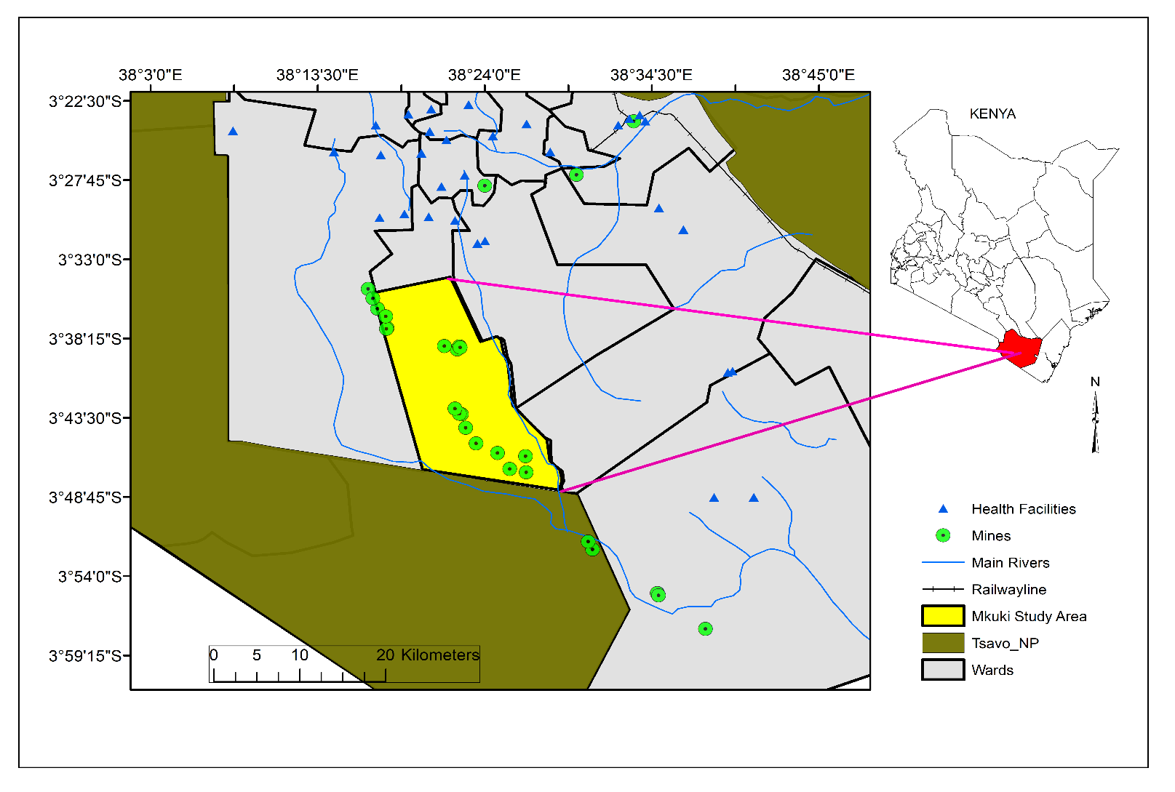

**Fig 1. Map of the Study Area**

Chawia community draws its livelihood from rearing of livestock, peasant farming and artisanal mining [11]. The area majorly boasts of having high quality gemstones such as Tsavorite (Green garnet) and Tourmaline (Green, Yellow, Black and Bi-Color).In fact the first Tsavorite gemstone was discovered in these area. In addition, Kamtonga area has Manganese minerals, which are yet to be quantified. Generally, Taita-Taveta County is endowed with abundant minerals. Its geology falls into two categories; the Mozambique belt and Tertiary Volcanic belt. The Mozambique belt covers Taita Hills, Mwatate, Kasighau and Kuranze areas among others while the Tertiary Volcanic belt covers Taveta areas

**2.2 Study Protocol:**

The research work was undertaken by utilization of GIS and Remote sensing data from the satellite images and undertaking of field survey in the study area. Methodological workflow is presented in Fig. 2.

**Data flow chart**

Landsat Images

2014 And 2017

Normalized Difference Vegetation Index (NDVI) for 2014 and 2017

Image Pre-processing-Geometric, Atmospheric and radiometric correction

Classification scheme

LULC maps for the years 2014 and 2017

Accuracy assessment

Change detection 2014-2017

**Fig 2. Methodology flow chart.**

**2.2.1 Satellite Image Data Acquisition**

Two Landsat images were used (years 2014 and 2017), they were acquired from the USGS image data portal. The acquired images had a spatial resolution of 30 meters and thought the two images were from different years, they were relatively in the same season in terms of the month they were captured, that enabled them to possess same spectral and radiometric characteristics.

Images acquired during dry season were preferred with cloud cover of less than 10%, dry season was preferred mainly because it made it easy to distinguish spectral signatures of different land use–land cover types, especially bare areas.

**Table 1. Landsat Images Acquired**

|  |  |  |  |  |  |
| --- | --- | --- | --- | --- | --- |
| **Satellite sensor** | **Path** | **Row** | **Date acquired** | **Resolution** | **Source** |
| Landsat 8 | 167 | 63 | 2014-10-26 | 30 | USGS |
| Landsat 8 | 167 | 63 | 2017-09-16 | 30 | USGS |

**2.2.2 Image Preprocessing**

The remotely sensed data were cropped to match the study area and geometrically corrected to the Universal Transverse Mercator (UTM) projection, zone 37 south. To facilitate analysis, individual Landsat image bands were stacked using QGIS 2.18.16 to create a composite band set. This allowed for various Red-Green-Blue (RGB) combinations to enhance interpretation of LULC classes.

**2.2.3 Image Classification**

Supervised classification was used for image classification by selecting training samples and classifying images based on them. The process involved three main steps: selecting training areas, generating signature files, and performing classification [20]. Training areas were selected using the image analysis toolbar, where polygons were drawn for each of the five land use–land cover (LULC) classes. These polygons were then merged into a single class. A signature file, which stores training sample data, was created using the “Create Signature File” tool. All training samples were prepared before generating the signature file. The study used the maximum likelihood classifier due to familiarity with the area and its accuracy in assigning pixels based on probability values [21]. The signature file served as input for classification. The output file was named and saved in the designated location. Results were displayed after executing the classification process.

**2.2.4 Land Use–Land Cover (LULC) and Normalized Difference Vegetation Index (NDVI) Maps for the Study Area**

LULC maps for the years 2017 and 2014 were developed. The year 2014 was regarded as the base year when mining activities in the study area became intense, while the year 2017, mining activities were at the climax.

In both years, areas covered by different LULC were computed in Hectares.

NDVI maps for the two different years were also produced. The NDVI values ranges from -1 to +1, the positive value indicated active vegetation and negative value does not.

Analysis was made using the minimum, maximum and mean of each year from the NDVI imaged produced.

**2.2.5 Accuracy Assessment**

Accuracy assessment is an important step in data analysis, it helps in detecting the quality of the work done [22]. In this case overall accuracy was calculated. Producers and user’s accuracies were also calculated and kappa, which is a value depicting whether the classification accuracy is acceptable was also worked out.

**2.1.1 Area Change Detection of Different Land Use–Land Cover (LULC) Classes**

After computation of areas covered by the land use–land cover (LULC) classes in the two different years (2014 and 2017), image differencing was undertaken in order to detect area changes in each LULC class between the years. Area change was computed and the results were either positive (in cases where the area coverage increased) or negative (in cases where the area covered reduced).

3. results and discussion

**3.1 GIS and Remote Sensing Data from the Satellite Images**

The results of the image classification for the LULC involving the years 2017 and 2014 was well documented and there after a comparison was done to access the area coverage change in each of the five land use–land cover (LULC) classes used in the classification.

**3.1.1 Land Use–Land Cover (LULC) for year 2014**

The year 2014 was considered as the base year when mining operations in the study area had started becoming intense, at that time vegetation disturbance was at minimal. LULC map for the year was developed as shown in Fig. 3.

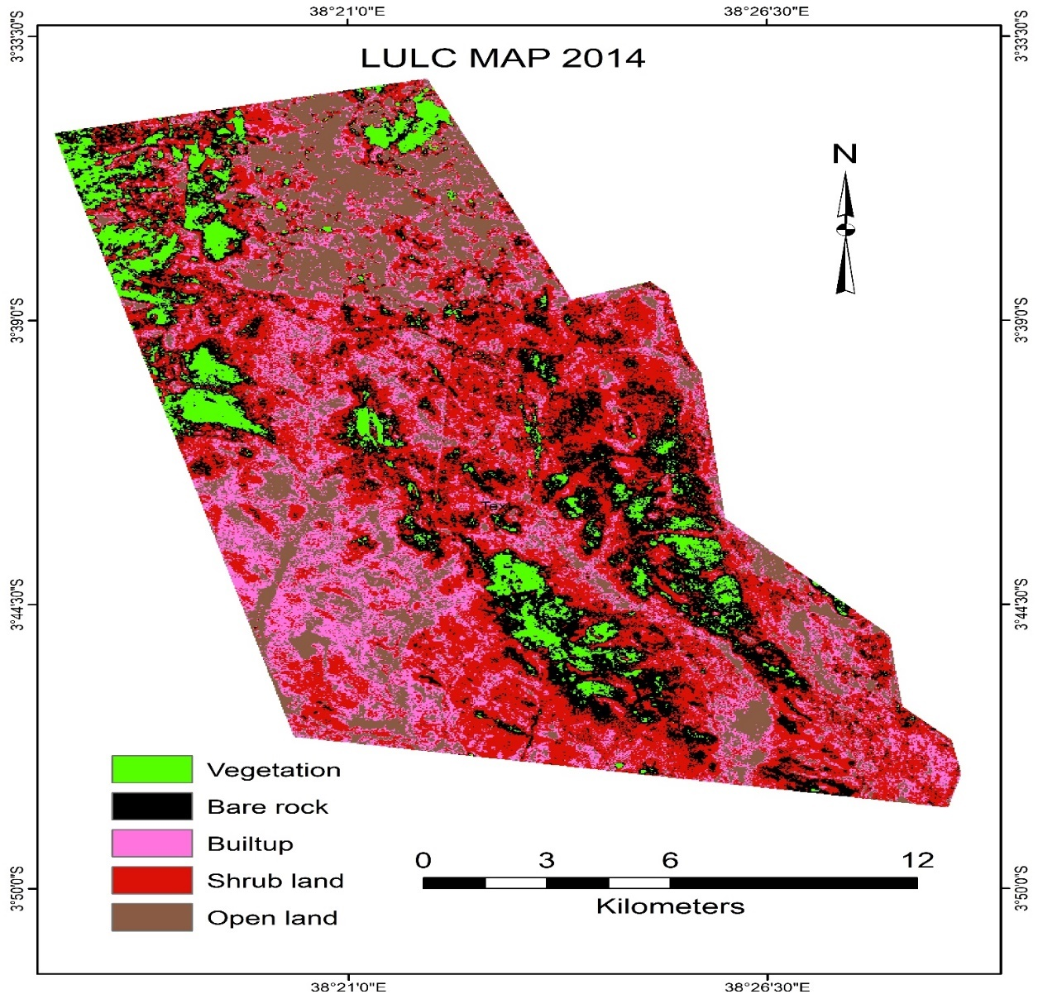

**Fig 3. Land use–land cover (LULC) map for year 2014**

Area coverage per land use–land cover class was computed and recorded in the Table 2 below.

**Table 2. Area coverage per land use–land cover (LULC) class for 2014**

|  |  |  |  |
| --- | --- | --- | --- |
| **Class** | **Value** | **Count** | **Area (ha)** |
| Vegetation | 1 | 23891 | 2,150 |
| Bare rock | 2 | 65779 | 5,920 |
| Built-up | 3 | 62151 | 5,593 |
| Shrub land | 4 | 133715 | 12,034 |
| Open land | 5 | 57804 | 5,202 |

Results from the Table 2 above shows that in the year 2014, Shrub land occupied a larger portion of the land (12,034 ha), followed by bare rock, built up and Open land in that order. Vegetation land had the least portion of 2,150 ha.

**3.1.2 Normalized Difference Vegetation Index (NDVI) for year 2014**

NDVI map for the year 2014 was developed, values were ranging from 0.36 to 0.91 (Fig. 4).

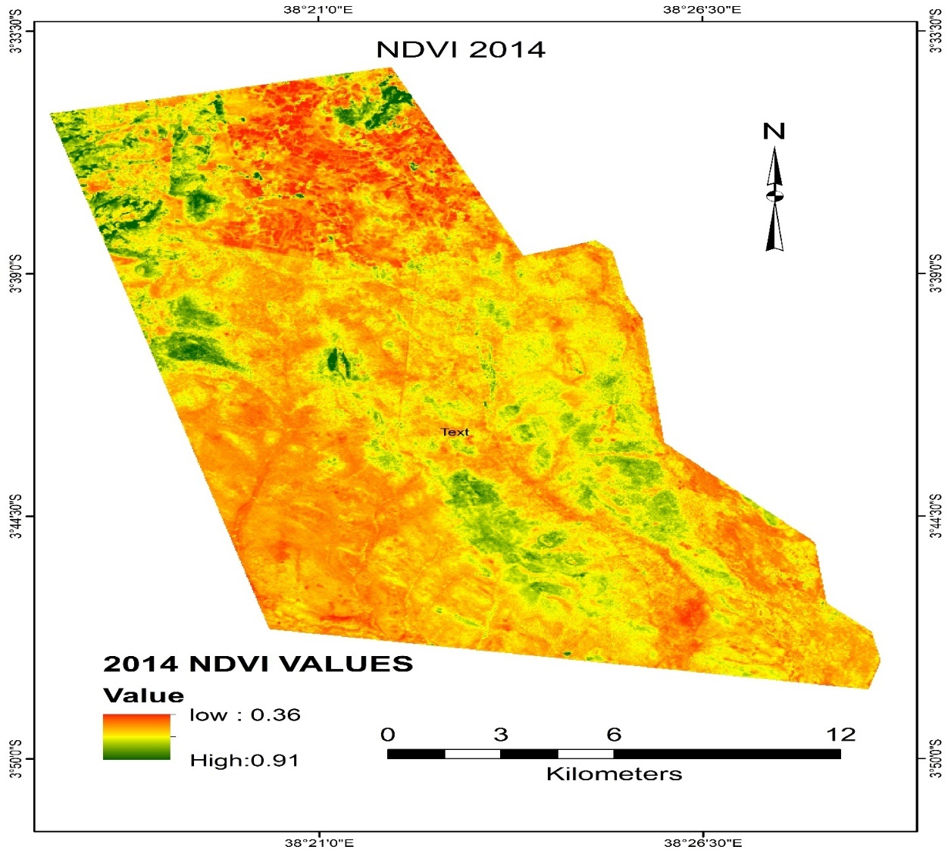

**Fig 4. Normalized Difference Vegetation Index (NDVI) map for year 2014**

**3.1.3 Land Use–Land Cover (LULC) for year 2017**

In the study, the year 2017 was considered as the year when mining activities in the study area was so much practised, LULC map for the year was developed as shown in Fig. 5.

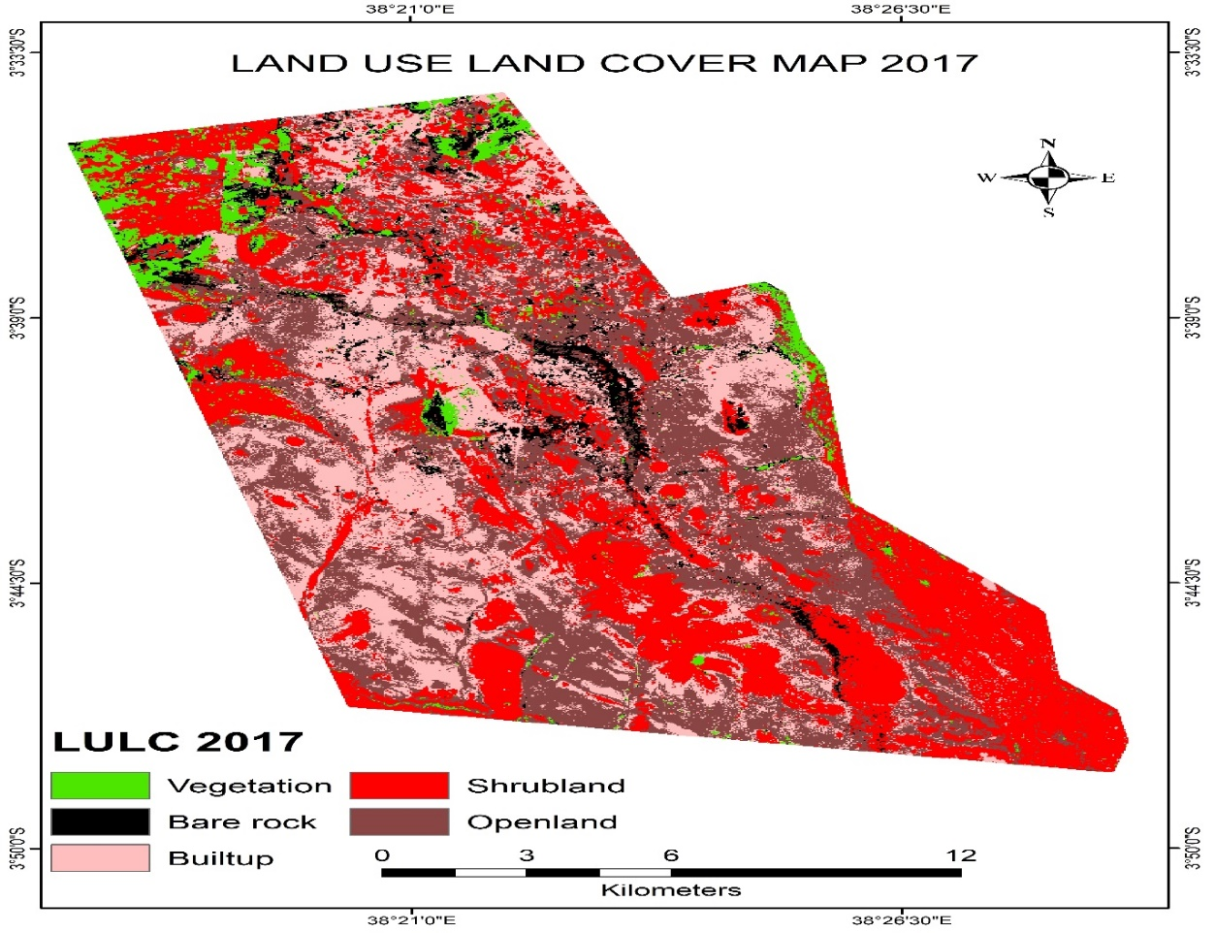

**Fig 5. Land use–land cover (LULC) map for year 2017**

The area covered by each land covered class was calculated and recorded in the Table 3 shown below.

**Table 3. Area coverage per land use–land cover (LULC) class for year 2017**

|  |  |  |  |
| --- | --- | --- | --- |
| **Class** | **Value** | **Count** | **Area (ha)** |
| Vegetation | 1 | 14579 | 1,312 |
| Bare rock | 2 | 16184 | 1,457 |
| Built-up | 3 | 88135 | 7,932 |
| Shrub land | 4 | 113306 | 10,198 |
| Open land | 5 | 111136 | 10,002 |

The results from the Table 3 above indicated that the area under Shrub land was the largest (10,198 ha), followed closely by Open land (10,002 ha). The Table 3 further indicated Vegetation land cover was the least in terms of area coverage (1,312 ha) while bare rock had area coverage of 1,457 ha and area under built up occupied 7,932 ha.

Accuracy assessment performed after the classification and the results were displayed in the Table 4.

**Table 4. Accuracy Assessment**

|  |  |  |  |  |  |  |  |
| --- | --- | --- | --- | --- | --- | --- | --- |
| **Class name** | **Vegetation** | **Bare rock** | **Built up** | **Shrub land** | **Open land** | **Total** | **Producer’s Accuracy** |
| Vegetation | 29 | 0 | 1 | 2 | 0 | 32 | 80.05% |
| Bare rocks | 0 | 16 | 0 | 0 | 2 | 18 | 76.19% |
| Built-up | 4 | 0 | 34 | 4 | 0 | 42 | 84.74% |
| Shrub land | 2 | 0 | 2 | 39 | 1 | 44 | 72.22% |
| Open land | 1 | 5 | 1 | 9 | 85 | 101 | 96.59% |
| Total | 36 | 21 | 38 | 54 | 88 | 237 |  |
| User’s Accuracy | 90.62% | 88.88% | 80.95% | 88.64% | 78.70% |  |  |
| **Overall Classification Accuracy =82%**  **Overall Kappa Statistics=0.758** | | | | | | | |

Accuracy assessment was conducted on one image, the 2017 supervised classified acquired image. The overall classification accuracy was 82% and the producer’s accuracies varied between 72.22% and 96.59% while the user’s accuracies varied between 78.70% and 90.62%.

Overall Kappa coefficient was 0.758, according to [23] it’s a moderate strength of agreement, thus the land use–land cover (LULC) classification accuracy is acceptable.

**3.1.4 NDVI for year 2017**

NDVI map for the year 2017 was developed, values were ranging from -0.91 to 0.35 (Fig. 6).

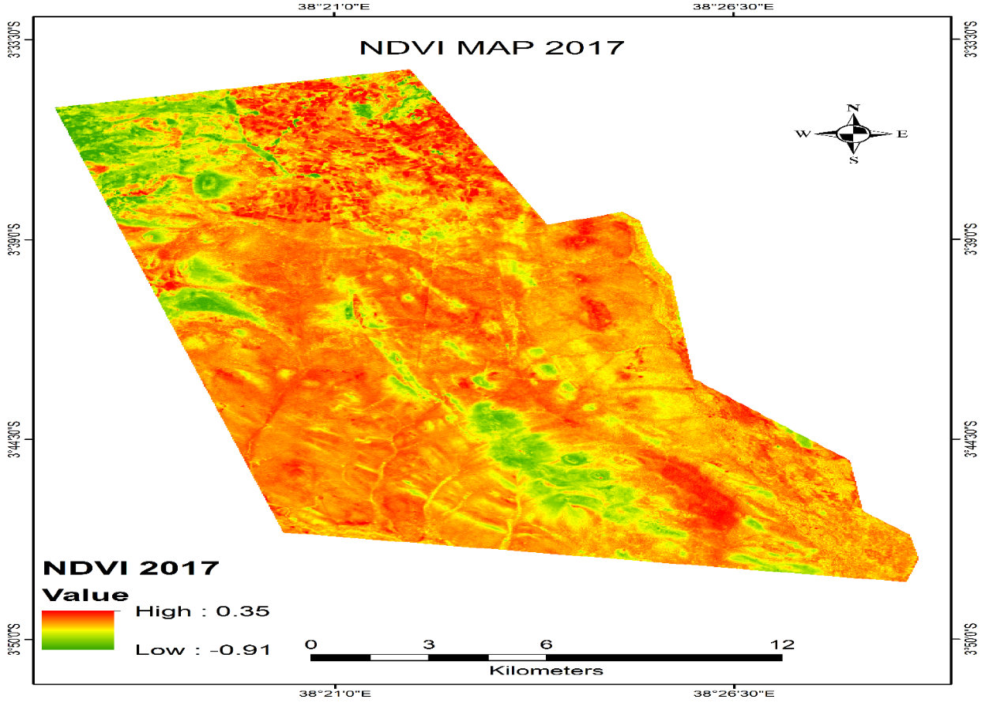

**Fig 6. Normalized Difference Vegetation Index (NDVI) map for year 2017**

**3.2 Area Change Detection for Land Use–Land Cover (LULC) between the years 2014 and 2017**

Significant changes in the land use–land cover (LULC) in the study area was detected by computing the changes in the area coverage per LULC class, the results were as shown in the Table 5 below.

**Table 5. Area change detection between the years 2014 and 2017**

|  |  |  |  |
| --- | --- | --- | --- |
| **Class** | **Area in 2014** | **Area in 2017** | **Change in Area** |
| Vegetation | 2,150 | 1,312 | -8384(40%) |
| Bare rock | 5,920 | 1,457 | -4463 (75.4%) |
| Built-up | 5,593 | 7,932 | +2339 (41.8%) |
| Shrub land | 12,034 | 10,198 | -1836 (15.26%) |
| Open land | 5,202 | 10,002 | +4800 (92.3%) |

Table 5 indicates there was a significant change in LULC in the study area, from 2014 to 2017 open land and built-up increases by a margin of 4800 and 2339 ha respectively. The increase can be associated with the increase in the economic activities in the area which was previously ranching and farming but recently mining activities have increases.

The increase in mining activities has led to an influx of people leading to an increase in settlement pattern in the area of study, as the settlement pattern increases there is need for more shelter houses and road paths. This is well shown by the increase inbuilt up areas.

The increase in population when mining operations are on a rise means there will be conversion of other LULC land space to become settlement zones (built-up), this can be the general reason for the increase in built up and open land.

The results also indicated that there was significant reduction in Vegetation land (40%), bare rock (75.4%) and Shrub land (15.26%). The reduction in vegetation area covered was also indicated by the NDVI values between the years, results were outlined as shown in the Table 6.

**Table 6. Summary of NDVI values between the years 2014 and 2017**

|  |  |  |
| --- | --- | --- |
| **Values** | **2014** | **2017** |
| Minimum | 0.36 | -0.91 |
| Maximum | 0.96 | 0.35 |
| Mean | 0.66 | -0.28 |

The Table 6 shows, the year 2014 had the highest average NDVI index of 0.66 while in the year 2017 the average mean reduced to -0.28.

This suggests that the year 2014 had a healthy vegetation cover in comparison to the year 2017 when the NDVI index declined. A healthy vegetation normally ranges from the positive values close to 1 [8]. It is known that NDVI value varies within −1 to +1. In general, values from −1 to 0 indicate non-vegetated area [24]. NDVI Therefore for the year 2014 with average mean of 0.66 depict a green vegetation cover as its closer to 1 and regarding the year 2017 when the mean average was -0.28 shows a remarkable reduction in vegetation cover in the study area.

The findings could be attributed to the influx of people in the study area, hence the creation for the settlement areas might have led to vegetation destruction. Mining activities could be a possible reason for the reduction in vegetation and the shrub land, this coincides with studied in Ghana whereby it was found that Mining activities is another significant driver to the decrease in Open and Closed Savannah lands in the area. The area is characterized by mining activities especially around BulenIga, Donfia, Mengwe and Donyoukuraa enclave [25] in those areas there is vegetation loss.

In the process of creating more settlement, shrub land areas could have been converted to open land areas thus reducing the land areas under the shrub land

**3.3 Spatial Database of the abandoned mines in the study area**

This was the first objective of the study that aimed to use remote sensing and GIS techniques in assessing abandoned mines, and determine its effects to the community**.** In achieving the objective Geographic Information System (GIS) was greatly utilized, abandoned sites were physically collected by the use of geographic positioning system (GPS) coordinates. During the field work, a data capture sheet was used to record information gathered from each abandoned mine, a part from the coordinates collected, other information captured in the data capture sheet includes; Type of the mine-Open pit/tunnel, Approximate depth of the mine, Ownership of the mine, Land status, last time the mine was active, type of minerals-industrial/gemstones, mineral mined and Accidents recorded in the –human/animals.

Captured data was later transferred to an excel sheet and then uploaded to arc map, each point was then converted to a shape file. Data captured at this point was clearly displayed under data properties in the form of attribute table, each attribute displayed information regarding each spatial feature. Overlay of the data was performed to the LULC map of the year 2017, abandoned mine map was developed as shown in Fig. 7.

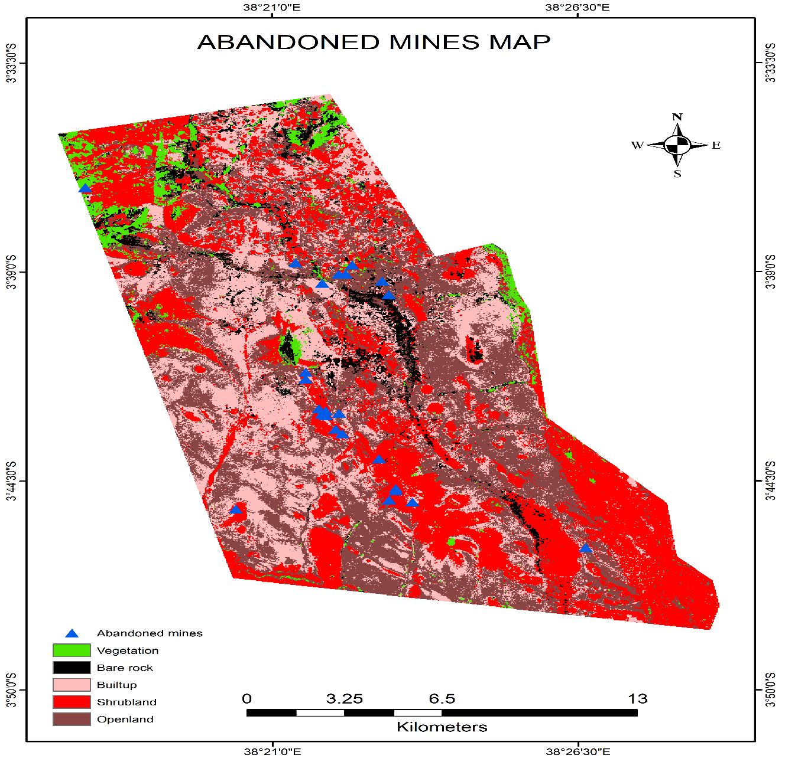

**Fig 7. Map of abandoned mine sites**

Fig. 8 depicts screen shot of the abandoned mines geospatial database. It displays data captured in a particular mine, highlighted by the light blue color.

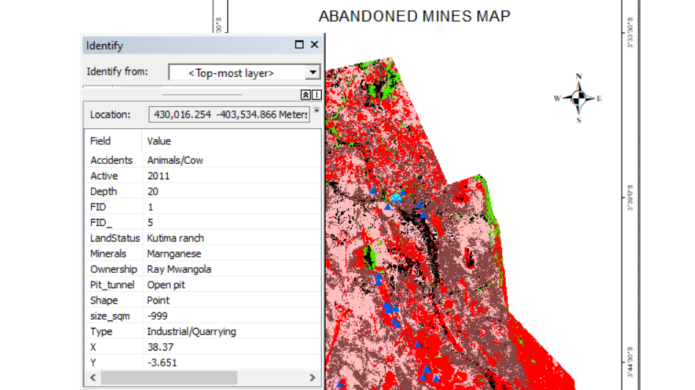

**Fig 8. Screen shot of example data captured from each abandoned mine**

The results from the map clearly shows that most of the abandoned mine sites are located in the Shrub land areas and few others in the bare rock and in Open land. This confirms the results from the classified data which showed there was reduction in Shrub land area in 2017 in comparison to the year 2014 (reduction of 15.26%) and bare rock area reduced by 75.4%, vegetation reduced by 40%, contrary to these results open land increased by 92.3% and Built-up increased by 41.8% in area coverage.

Having most abandoned mines in the Shrub land explains the reduction in the its area, possibly in favor of the open land which has increased the highest, some of the bare rock areas has been mining sites thus the reduction in area. Increase in built up areas could have contributed to reduction in bare rock as most of the constructions have been done using the construction rocks and also weathering of rocks might have caused the reduction. Increase in built up might have contributed to the reduction in vegetation area to pave way for construction, this coincides with [26], in the study they found out that expansion of built-up areas led to addition of construction land and hence deforestation was involved in conversion of forests to open land.

During the spatial data collection, the study done noted that most of the abandoned sites were open pits which were of depth between 10 and 30 meters deep and some had even collapsed thus posed a great danger to both human beings and animals (Fig 9).

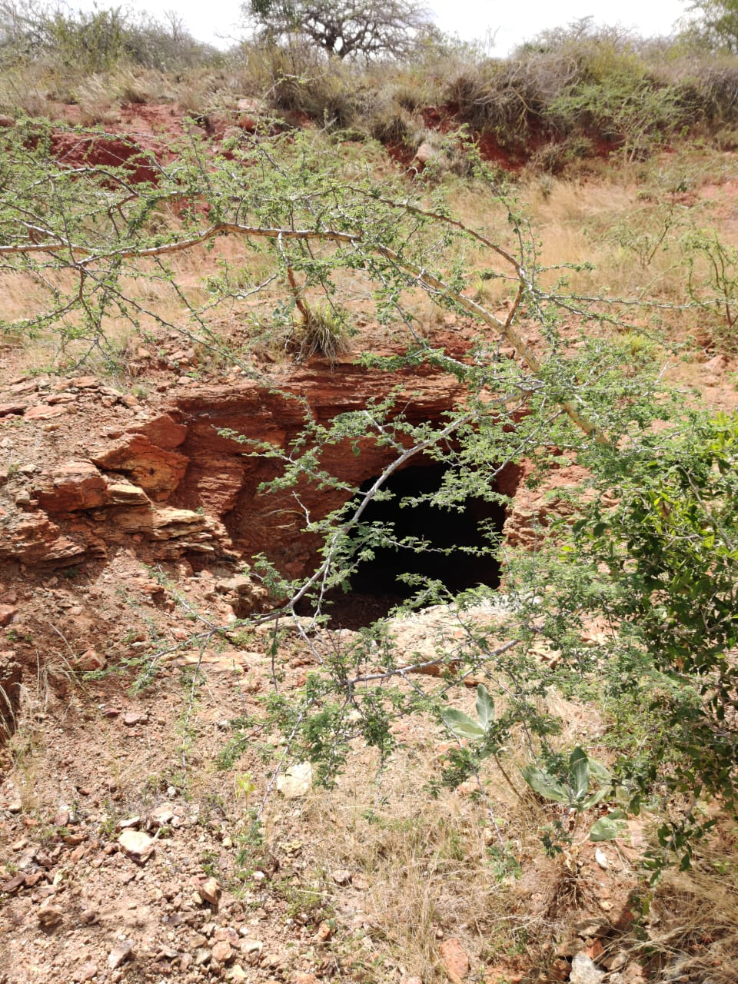

**Fig 9. Abandoned mine in the study area**

Ownership of most sites was unknown, information captured indicated that some of those sites were active many years ago when most of the current miners were not present. The study also confirmed that the study area involved more of gemstone mining than industrial minerals mining and minerals mined are mostly Green garnet and Tourmaline (variety of colors) gemstones. It was noted that some abandoned mines had already caused accidents involving both human beings and cattle. An elephant had fallen inside one mine.

4. Conclusion

The main aim of the paper is to highlight on the spatial location of the abandoned mines and how they affect the land use–land cover (LULC) in the study area over a period of time. The work was done through the use of acquired satellite data and site field visit to get GPS coordinates of the abandoned mine sites and other attributes of each site.

In analyzing satellite data, the year 2014 was used as base year when mining operations in the area were minimal and the year 2017 was the year when mining operations at Mkuki and Kamtonga were at their peak. Thus 2017 was the year which could denote measurable changes as a result of mining activities in the area.

Supervised classification was used to classify the satellite acquired images using five developed land use–land cover (LULC) classes. The classes were; Vegetation, Bare rock, Built-up, Shrub land and Open Land.

After the analysis was done for each year, difference in area coverage per class was calculated, results confirmed there was reduction in some classes and increment in some of them. Notably Vegetation cover had reduced by 40%, bare rock reduced by 75.4% and Shrub land had reduced by 15.26%. On the other hand, built- up areas had increased by 41.8% while open land had increased by 92.3%.

When NDVI values were calculated for 2014 and 2017, it was found that the mean value was 0.66 for 2014 and -0.28 for 2017. The result indicated that in 2014 there was high vegetation while in 2017 the vegetation cover had greatly reduced. This concurs with [18] who noted that, there was reduction in healthy vegetation as the mean values had reduced from 0.04 to −0.02, healthy vegetation ranges in the positive values close to 1.

The increase in mining activities in the area is a major factor contributing to the changes in different land classes, such as the increase in built-up areas which results in increase in population contributed to reduction in shrub land and Vegetation in order to get more space for both construction and settlement which in turns causes increase in open land.

The study found out that it’s very hard to get information regarding the ownership of the abandoned sites, mainly because some of them were active many years back when most of the current occupants were not living there. Most of the abandoned sited were dangerous open pits and of which from the data captured some sites had previously been the cause of accidents to the community members and grazing cows.

Data captured was over laid in a 2017 land use–land cover (LULC) map and it was noted that most abandoned sites were in the shrub land, bare rocks and in open areas.

The study found that the community was willing to be enlightened on how to conserve the environment and reduce the risks associated with the abandoned mines and mining operations as a whole.

The research work has shown there is notable negative effects emerging from the abandoned sites in the study area. Despite the many valuable minerals produced in the area there are adverse effects of abandoned sites after extracting the minerals.

The community may not have benefited from government (national and county) intervention despite numerous complaints because of lack of data on abandoned sites.

The study provides a spatial data that can guide the relevant institutions on how to mitigate effects of the abandoned mines and enforce proper mine rehabilitation after mining operations are closed this enable the quality of environment to be as it was before the operations

5. RECOMMENDATIONS

The paper makes some recommendations which aims at having conducive environment after the life of a mine come to an end leaving the community without negative effects.

1. There are a few abandoned mines whose ownership have been ascertained and should be followed up to undertake rehabilitation measures.
2. The county and national governments should sensitize the mining stakeholders on the importance of having mine rehabilitation plan before mining operations are undertaken.
3. The ministry of mining should not issue a mining license to individuals or companies without a proper and well documented rehabilitation plan.
4. The use of GIS and remote sensing should be encouraged in the field of mineral exploration as it provides ability to observe and collect data from larger area within a short time.
5. The National Environmental Management Authority needs to regularly conduct environmental assessment audits and take action on mining sites that do not comply with the regulations.
6. The local community and other stakeholders should be involved at the initial stages of mining planning.

Ethical approval (where ever applicable)

All authors hereby declare that all experiments have been examined and approved by the appropriate ethics committee and have therefore been performed in accordance with the ethical standards laid down in the 1964 Declaration of Helsinki.

Disclaimer (Artificial intelligence)

Author(s) hereby declare that NO generative AI technologies such as Large Language Models (ChatGPT, COPILOT, etc.) and text-to-image generators have been used during the writing or editing of this manuscript.

References

1. UNDP and UN Environment. (2017). Managing mining for sustainable development. (April), 116. Retrieved from http://transparency.org.au/our-work/mining-for-sustainable-development/
2. Sonesson, C., Davidson, G., & Sachs, L. (2016). Mapping Mining to the Sustainable Development Goals: A Preliminary Atlas. *Undp*, (July).
3. Kretschmann, J., Efremenkov, A. B., & Khoreshok, A. A. (2017). From Mining to Post-Mining: The Sustainable Development Strategy of the German Hard Coal Mining Industry. *IOP Conference Series: Earth and Environmental Science*, *50*(1). https://doi.org/10.1088/1755-1315/50/1/012024
4. Apollo, F., Ndinya, A., Ogada, M., & Rop, B. (2017). Feasibility and acceptability of environmental management strategies among artisan miners in Taita Taveta County, Kenya. *Journal of Sustainable Mining*, *16*(4), 189–195. https://doi.org/10.1016/j.jsm.2017.12.003
5. Festin, E. S., Tigabu, M., Chileshe, M. N., Syampungani, S., & Odén, P. C. (2019). Progresses in restoration of post-mining landscape in Africa. *Journal of Forestry Research*, *30*(2), 381–396. https://doi.org/10.1007/s11676-018-0621-x
6. Haupt, S. A. (2018). *Satellite monitoring of post-mining rehabilitation and the quantification of backfill dynamics using differential SAR interferometry by*. (March).
7. Ocansey, I. T. (2013). *Mining Impacts on Agricultural Lands and*. 1–49.
8. Osei, P. D. (2016). *ASSESSMENT OF REHABILITATED SURFACE MINE LANDS USING GEOSPATIAL TECHNOLOGY*. (October).
9. Mghanga, M. (2011). Mining in Taita Taveta County: Prospects & Problems. *Heinrich Böll Stiftung, East and Horn of Africa*.
10. Mwakumanya, M. A., Maghenda, M., & Juma, H. (2016). Socio-economic and environmental impact of mining on women in Kasigau mining zone in Taita Taveta County. *Journal of Sustainable Mining*, *15*(4), 197–204. https://doi.org/10.1016/j.jsm.2017.04.001
11. Anyona, S., & Rop, B. K. (2015). *Environmental Impacts of Artisanal and Small-scale Mining in Taita Taveta County*. 228–241.
12. Warden, A. J., & Horkel, A. D. (1984). The Geological Evolution of the NE-Branch of the Mozambique. *Mitteilungen Der Österr. Geol. Ges.*, *77*, 161–184.
13. Mangoua, M. J., Kouassi, K. A., Douagui, G. A., Savané, I., & Biémi, J. (2019). Remote Sensing and GIS Contribution for Groundwater Mapping Reservoirs in the Baya Watershed (Eastern Region of Côte d’Ivoire). Journal of Geography, *Environment and Earth Science International, 23*(3), 1–14. https://doi.org/10.9734/jgeesi/2019/v23i330169
14. R. M. Towfiqul Islam, A., M. M. Sein, Z., Ongoma, V., Saidul Islam, M., Foysal Alam, M., & Ahmed, F. (2015). Geomorphological and Land Use Mapping: A Case Study of Ishwardi Under Pabna District, Bangladesh. *Advances in Research, 4*(6), 378–387. https://doi.org/10.9734/AIR/2015/14149
15. Blanche, M.F., Dairou, A.A., Juscar, N. et al. Assessment of land cover degradation due to mining activities using remote sensing and digital photogrammetry. *Environ Syst Res 13*, 41 (2024). https://doi.org/10.1186/s40068-024-00372-5
16. Mimba, M. E., Mbafor, P. U. T., Nguemhe Fils, S. C., & Nforba, M. T. (2023). Environmental impact of artisanal and small-scale gold mining in East Cameroon, Sub-Saharan Africa: An overview. Ore and Energy Resource Geology, 15, 100031. https://doi.org/10.1016/j.oreoa.2023.100031
17. Kohio, E. N. B., Karoui, H., Sossou, S. K., & Yacouba, H. (2024). Review of pollution trends and impacts in artisanal and small-scale gold mining in Sub-Saharan Africa: Advancing towards sustainable practices through equitable redistribution of gold spin-offs. Journal of Cleaner Production. Elsevier Ltd. https://doi.org/10.1016/j.jclepro.2024.143754
18. Agbenorhevi, A. E., Amekudzi, L. K., Kèlomé, N. C., Biney, E., & Annan, E. (2024). Analyzing land use and land cover change in the Pra River Basin: A multi-tool approach for informed decision-making. Environmental Challenges, 15. https://doi.org/10.1016/j.envc.2024.100922
19. Nursamsi, I., Sonter, L. J., Luskin, M. S., & Phinn, S. (2024). Feasibility of multi-spectral and radar data fusion for mapping Artisanal Small-Scale Mining: A case study from Indonesia. International Journal of Applied Earth Observation and Geoinformation, 132. https://doi.org/10.1016/j.jag.2024.104015
20. Kumar, M. (2003). Digital Image Procession. *Proceedings of Agricultural Meteorology Program: Satellite Remote Sensing and GIS Applications in Agricultural Meteorology*, 81–102. https://doi.org/10.1073/pnas.70.2.543
21. Sunitha, A., & Suresh, B. G. (2015). Satellite Image Classification Methods and Techniques: A Review. *International Journal of Computer Applications*, *119*(8), 20–25. https://doi.org/10.1021/acs.orglett.7b02266
22. Wulder, M. A., Coops, N. C., Roy, D. P., White, J. C., & Hermosilla, T. (2018). Land cover 2.0. *International Journal of Remote Sensing*, *39*(12), 4254–4284. https://doi.org/10.1080/01431161.2018.1452075
23. Moeletsi, R. S., Tesfamichael, S. G., Studies, E., Park, A., Africa, S., & Africa, S. (2017). *ASSESSING LAND COVER CHANGES CAUSED BY GRANITE QUARRYING USING*. *XLII*(May), 8–12.
24. Sinha, N., Deb, D., & Pathak, K. (2017). Development of a mining landscape and assessment of its soil erosion potential using GIS. *Engineering Geology*, *216*, 1–12. https://doi.org/10.1016/j.enggeo.2016.10.012
25. Basommi, P. L., Guan, Q., & Cheng, D. (2015). Exploring Land use and Land cover change in the mining areas of Wa East District, Ghana using Satellite Imagery. *Open Geosciences*, *7*(1), 618–626. https://doi.org/10.1515/geo-2015-0058
26. Jazouli, A. El, Barakat, A., Khellouk, R., Rais, J., & Baghdadi, M. El. (2019). Remote sensing and GIS techniques for prediction of land use land cover change effects on soil erosion in the high basin of the Oum Er Rbia River (Morocco). *Remote Sensing Applications: Society and Environment*, *13*(May 2018), 361–374. https://doi.org/10.1016/j.rsase.2018.12.004