**The Impacts of Road Infrastructure Development on Land Use Spatial Patterns in Farka And Administrative Unit 1, Tirana, Albania**

Abstract

The development of road infrastructure in suburban areas has historically been a key element in planning policies for the management and transformation of a country not only localy but at a regional and national level as well. This is beacuse the impacts of road constructions are observed in every aspect of a country's profile: economic, social and environmental. The development of roads and road infrastructure in these spaces has a direct impact on the way people and goods move, as well as on how these areas can be integrated with major cities. It has the potential to bring many benefits, but also requires careful planning to minimize negative environmental, social and economic impacts. Regarding land use, road infrastructure often leads to the urbanization of suburban areas, increasing pressure on natural resources and causing urban sprawl into natural spaces. Consecuently, often it can be observed a significant rising in property prices that leads to the closure of green spaces. Road infrastructure construction causes habitat fragmentarization, loss of agricultural land areas, alteration of the organic composition of soils etc. In this perspective, the analysis and assessment of the impacts of infrastructure developments on land use spatial patterns using GIS technology will be addressed in this study. A set of vector data obtained by Copernicus Land Monitoring Services website were utilized for this purpose. Their time span is between years 2012-2018. Spatio-temporal changes in land use types has been identified by making use of ArcGIS analitical functionalities. The main results are then visualized through maps. They indicate slight changes in three categories of land use in the affected area: discontinous urban space, complex cultivation patterns and uncultivated agricultural land.

Key words: road infrastructure, land use patterns, Geographic Information Systems, (GIS), spatial analysis

**1. Introduction**

New road construction activities have always played a key role in planning policies, particularly in a developing country, as a way to sustain effective management of territories transformation at a local, regional or national level. This is due to the fact that infrastructural activities exert a direct impact on every aspect of a country's development: economic, social and environmental/natural. In economic terms, the road infrastructure provides positive support as it affects the growth and expansion of economic activities, especially in the service and production sectors, enables the establishment of new industrial areas and ensure the connection of remote areas to each-other. These newly created patterns of economic activities lead in turn to population growth in the affected area as a result of greater possibilities on employment offer.

However, despite these positive effects that road infrastructure brings in economic and social terms, the impact to land use may not always be in the same line. The construction activities in most of the cases are responsible for habitats alienation and fragmentation, loss of agricultural plots, destruction of organic soil composition, environmental pollution, etc. Various studies have shown that road infrastructure and land use are two different aspects but at the same time so closely related to each other. Initially, the development of transport infrastructure, especially road infrastructure, was focused and based on the residential areas and main centers of human economic activities. Whereas, nowadays it is the road infrastructure process that serves as a gravity point for the creation and development of new “to be” centers of almost all human activities[1].

Therefore, the characteristics of changing patterns in land use are crucial elements during the early stages of territory planning and management. As a result, these pattern have been always looked very carefully by policy-making authorities at all levels, especially those at local one. In order to ensure sustainable development of these territories they find it mandatory to monitor the timeline of land use and to thoroughly assess future demand in terms of infrastructure needs and potentials.

The above mentioned considerations were the impetus to address in this paper the impact on land use patterns caused by the road construction namely Outer Ring Road of Tirana. The work is done by making use of GIS technology which has been proven to be e very useful tool in creating, analyzing and visualizing spatio-temporal thematic data.

**2. Study area**

The study area includes the territories of Administrative Unit 1 and Farka Administrative Unit of Tirana Municipality, Albania (Figure 1).

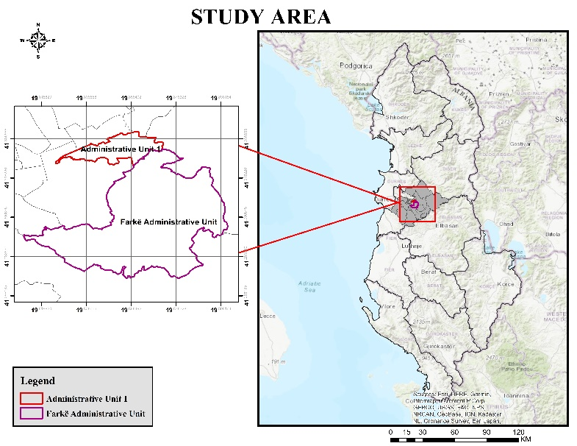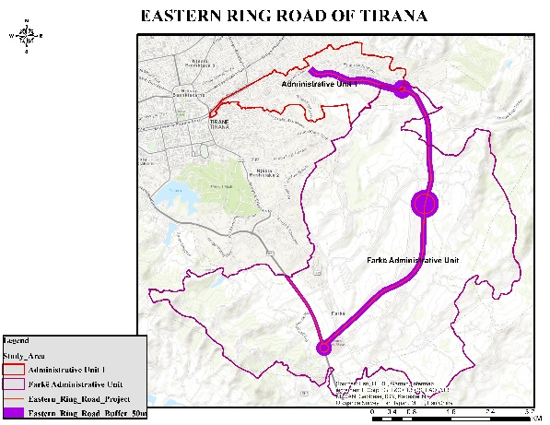

Figure 1. Map of the Study area Figure 2. Location of Outer Ring Road of Tirana

Source: World Base Map, Author’s design.

Administrative Unit 1 is an integral part of the administrative division of the Municipality of Tirana. This unit lies in the southeastern part of the city of Tirana and has an area of ​​412.7 ha, of which 100 ha is an urban area, while 312.7 ha is a rural one. The population of this Unit is mainly located on its outskirts and has increased in number over the years. Currently there reside 17.954 families with around 52,138 inhabitants as by December 2022.[2]

The territory of this unit has developed quickly after the interventions that have been made in the rehabilitation and dvelopment of road infrastructure. There are approximately 1500 private businesses within this unit, such as family businesses, shops, bars, but also large businesses such as fashion, printing offices, etc. There are 15 educational institutions of all levels and 3 public health service units.

In the last two decades the investments that are made in Administrative Unit1 consist mainly in the requalification and rehabilitation of roads, the construction of social housing for the Roma and Egyptian community in Shkoza, reconstruction of kindergartens, nurseries and schools.

Based on the New General Plan of Tirana (TR30), the former Autotractor Plant, Shkoze, is envisioned as a new epicenter of Tirana 2030, as well as an economic-industrial area. In the territory of this unit, the project of ``Outer Ring of Tirana, Lot III, Arrangements of Lana River bed and construction of parallel roads, segment from the new maternity center ``Koço Gliozheni-Outer Ring of Tirana'' has been implemented as an investment of Albanian Road Authority (ARRSH).

The Farkë Administrative Unit is another territorial part of the administrative division of Tirana Municipality. Farka is located 7km southeast of the city of Tirana, lying along the national road Tirana-Elbasan. It is bordered to the east by the Dajti Administrative Unit, to the south by Petrela and to the west by Vaqarri.It has a generally autonomous population, but is not excluded from the relocation to this area of ​​a good part of the residential population. As by December 2022 the total number of inhabitants in this unit is about 17.894, allocated in 5.250 registered families. The presence of the Farka lake, the parks around it, and the hilly relief have created an attractive panorama. This in turn has increased the interest of locals and foreign tourists to engage in leisure activities such as swimming, cycling, picnics etc.

The Tirana-Elbasan highway passes through the territory of Farka with a length of 3.5 km, contributing as such to the transformation of Farka in an important center of economic and architectural development. Along the territory of Farka passes as well the Outer Ring of Tirana, which serves as a connection point of this area with the rest of Tirana and beyond. Due to the strategic geographical position and favorable infrastructure, this area is turning into an attractive residential and economic area.

The Great Ring of Tirana has been conceived since its beginnings as a highway (category A road). The initiation of this project for the realization of the Great Ring, as a project-idea that dates back to 1996. But mainly for financing reasons among others, this project was not fully accomplished, even though it was taken as a basis during the design of the Outer Ring of Tirana.

The construction of the Outer Ring Road of Tirana was conceived as a project and further implemented under the responsibility of the Albanian Road Authority (ARRSH), strating back at 2016. The project "Requalification of the road segment Eastern Ring Road of Tirana Lot 3", is the completed road segment, which connects the area of ​​Farka with Shkoza. While the project named as "Completion of works and connecting roads in the East Ring Lot 2", also completed and open, with a length of 4.14 km, and starts from the roundabout of the shopping center "TEG" (Tirana East Gate) and ends near the Department of Helicopters in Farka11. It is exactly this road segment and its construction that constitutes the area of ​​interest for the study and its impact on the new land use patterns formed in the territories of Farkë and Administrative Unit 1.

**3. Database and methods**

**3.1 Land Use**

The database used to assess the land use change was downloaded from Copernicus Land Monitoring Services website (https://land.copernicus.eu). Two sets of digital vector data corresponding to period 2012-2018 were obtained for this purpose[3]. A total of 12 land use categories were evaluated: [Discontinuous urban fabric](https://land.copernicus.eu/content/corine-land-cover-nomenclature-guidelines/html/index-clc-112.html), Construction sites, Industrial or commercial units, Vineyards, Fruit trees and berry plantations, Olive groves, Pastures, Complex cultivation patterns, Land principally occupied by agriculture, with significant areas of natural vegetation, Broad-leaved forest, Sclerophyllous vegetation, Water bodies. These data were processed using ArcGIS Desktop 10.8 and respective maps were created (Figure 3). The land use categories, their corresponding codes and their percentages for years 2012 and 2018 are presented in the following Table 1.

|  |  |  |  |
| --- | --- | --- | --- |
| **Code** | **LU categories in study area** | **2012%** | **2018%** |
| 112 | Discontinuous urban fabric | 24.1 | 22 |
| 133 | Construction sites | 1.1 | 1.1 |
| 121 | Industrial or commercial units | 1.1 | 1.1 |
| 221 | Vineyards | 9.1 | 9.2 |
| 222 | Fruit trees and berry plantations | 1.5 | 1.5 |
| 223 | Olive groves | 13.1 | 13.1 |
| 231 | Pastures | 4.3 | 4.3 |
| 242 | Complex cultivation patterns | 17.7 | 16.7 |
| 243 | Land principally occupied by agriculture, with significant areas of natural vegetation (Non cultivated agriculture land) | 16.1 | 14.2 |
| 311 | Broad-leaved forest | 8.4 | 8.5 |
| 323 | Sclerophyllous vegetation | 0.6 | 0.7 |
| 512 | Water bodies | 2.8 | 2.7 |

Table 1. Land use categories in % in the study area; Source: CORINE 2012,2018/Author’s calculation

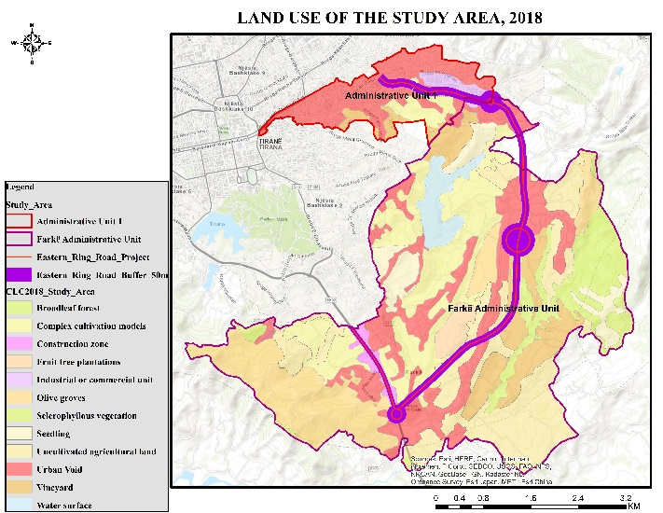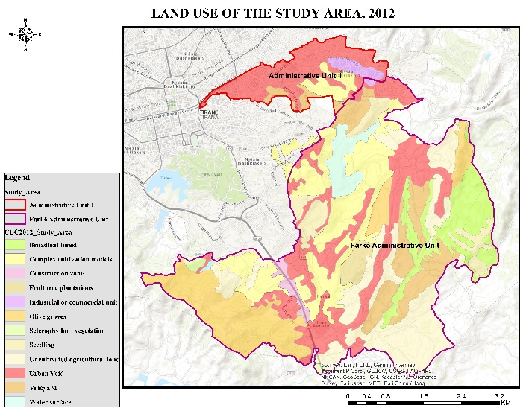Figure 3. Land use categories in 2012 and 2018

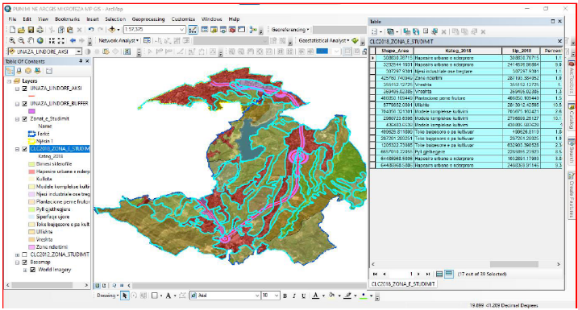Land use categories as well as land use change processes were assessed at one level distance from roads, using the following distance ranges: 0–50 m. This was done using “select by location” tool which combines attributive and locational features defined according the scope of use. The resulting features represent categories of land use that have undergone changes as a consequence of road construction and are located inside the defined distance.

Figure 4. Land use categories inside 50 m distance of Eastern Ring Road construction; Source: Authors’ calculation

**4**. **Results and Disucssion:**

**4.1 Patterns of land use changes**

To assess the level of land use changes in the time period between 2012-2018, six types of processes were distinguished: afforestation – the conversion of one of the land use categories into forest; grassing – conversion into permanent grassland; agricultural intensification – conversion into arable land, orchard, or vineyard and hop-field; the construction of water areas – conversion into water area; urbanization and other anthropogenic processes – conversion into built-up area, recreational area or other area; and stable areas – no change between the two time steps

Figure 5. Land use categories affected by the construction of Eastern Ring Road,2012-2018 Source: Author’s calculations

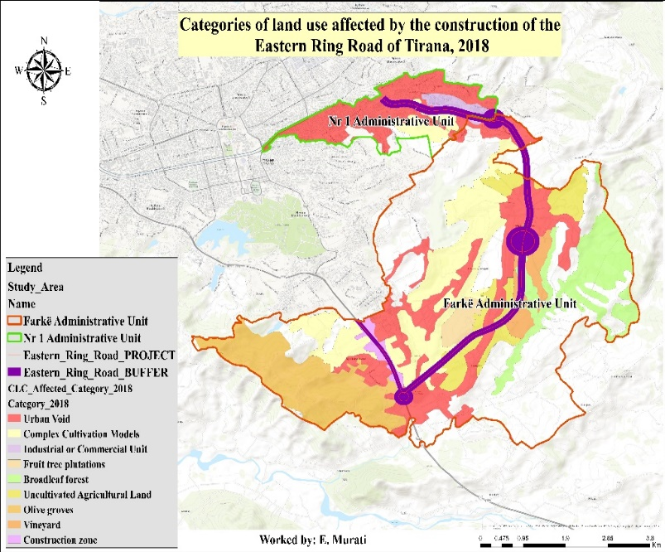

Figure 6. Spatial patterns of land use categories affected by the construction of Eastern Ring Road,2018

Looking at results according to the map and graph above, we notice that out of 12 (twelve) land use/cover categories, some of them have been affected by the construction of the Eastern Ring Road of Tirana. Among these categories, it can be seen that three of them were affected at most by the implementation of this project, namely a) discontinous urban space (2.1%); b) complex cultivation patterns (1%) c) non cultivated agricultural land (2.1%).The reasons why these categories have been affected the most firstly resides in the fact that they have a greater extent in the territory under study and secondly, because the Eastern Ring Road of Tirana is classified as ``Highway'' and `` Interurban'', and consequently a large width of the road has caused intersections within these categories. Therefore, it can be noticed that a large number of dwellings in this unit were demolished as a result of this road construction. The greatestt number of expropriations for dwellings can be found in the territory of the Unit Administrative no. 1. In addition, it is also worth noting that part of the project of the Eastern ring road of Tirana was also the rehabilitation of the bed of the Lana River, thus influencing the width of the road body which in turn createas the above mentioned affects.

Regarding the three most changed Land use categories, it can be seen from the maps that most of them are located within the territory of the Farka Administrative Unit. As above mentioned, the large extent of agricultural areas in this unit has made it known as one of the municipalities with a rural character, where the development or use of land for the cultivation of various agricultural crops has been relatively high.

The crossing and touching of these lands by the construction of the Eastern ring road of Tirana has reduced the area of ​​agricultural lands. In addition, since this road is frequented by a high number of vehicles, which cause a pollution of the air and the surrounding environment due to the fuels they discharge into the environment, we can say that the lands found along the road on both sides of it, have remained barren, hence agricultural crops are no longer cultivated.

The construction of the Eastern ring road of Tirana in the territories of the study areas has had a positive effect in terms of the socio-economic aspect. The economic side is expressed in the increase of investments and businesses that have been established on both sides of the road. While the social effect is expressed in the increase in the employment of residents, mainly young people that inhabit these areas.

Both of these units in recent years have been introduced by local authorities as important socio-economic and urban development areas, referring to the Urban Plan of the Municipality of Tirana. Administrative unit no. 1 has absorbed a high number of investments that have consisted in the rehabilitation of existing roads, the opening of new roads (mainly neighborhood roads), the construction of residential complexes, etc.

The Farka Administrative Unit has also absorbed a high number of investments, causing its territory to undergo many transformations. The reason for these developments is also the change in the Local General Plan of the Municipality of Tirana (2023), according to which in most of the territory of Farka Administrative Unit is allowed to build, even if the land or property is agricultural.

However, the last two paragraphs constitute a separate topic of study importance after a certain period of time to see how the land use has changed in the territories of these units, which every day are more and more affected by various large investments.

**4.2 The impact of on the Eastern Ring Road on socioeconomic growth of the study area**

Developments in road infrastructure are always accompanied by significant socioeconomic improvements in the areas where they occur. The enhancement of the road network enables faster and more efficient movement of people and goods, which has facilitated traffic flow in the city of Tirana and its surrounding areas.

Moreover, improvements in infrastructure have created new opportunities for the economic development of the region. These developments have stimulated the creation of new residential areas and have been accompanied by increased private and public investments, leading to new opportunities for various businesses. Likewise, investments in sectors such as construction, tourism, and trade have also increased. All these changes have boosted economic activities and resulted in the creation of new job opportunities for local residents. This infrastructure development has also contributed to improving trade and the transportation of goods, enhancing the efficiency of the supply chain, especially for businesses involved in production and distribution, by reducing transportation costs.

Additionally, infrastructure growth has led to increased demand for real estate, driving up land and housing prices in some areas of Tirana. This phenomenon has benefited property owners but has also created challenges for those looking to buy or rent properties in these areas, as prices have risen significantly.

On the other hand, infrastructure development has had significant effects on urban planning and the environment. It has led to increased traffic in some peripheral areas and has heightened air and noise pollution, requiring better management strategies.

Furthermore, construction has affected certain neighborhoods and communities, causing concerns for residents who have been forced to relocate or have experienced negative impacts due to construction activities and increased traffic.

**conclusion**

In conclusion*,* road infrastructure developments bring evident benefits in transportation, economic growth, and investment opportunities. However, they also present social and environmental challenges that require careful attention and appropriate measures for effective management in the future.

**Disclaimer (Artificial intelligence)**

Option 1:

Author(s) hereby declare that NO generative AI technologies such as Large Language Models (ChatGPT, COPILOT, etc) and text-to-image generators have been used during writing or editing of manuscripts.

Option 2:

Author(s) hereby declare that generative AI technologies such as Large Language Models, etc have been used during writing or editing of manuscripts. This explanation will include the name, version, model, and source of the generative AI technology and as well as all input prompts provided to the generative AI technology

Details of the AI usage are given below:

1.

2.

3.

**References**

1.Effects of infrastructure on Land Use and Land Cover Change (LUCC): The Case of Hangzhou International Airport, China. Online: MDPI Journal [*https://www.mdpi.com/2071-1050/10/6/2013*](https://www.mdpi.com/2071-1050/10/6/2013)

2. ResearchGate Journal: Terminology for Integrated Resources Planning and Management, Food and Agriculture Organization of the United Nations (FAO).

3. P L Hadi *et al* 2021 *IOP Conf. Ser.: Earth Environ. Sci.* 920 012003 Land use change due to road construction

4. Bashkia Tiranë: Njësitë Administrative *www.tirana.al*

5. Agjencia Kombëtare e Planifikimit të Territorit, Dokumenti i Rishikimit të PPV Tiranë shtojcat I-III-IV, 2019

6. Sentinel Hub Public Collections, CORINE Land Cover

7. Copernicus`s Land Monitoring Service, Corine Land Cover 2012 *https://land.copernicus.eu/en*

8. Autoriteti Rrugor Shqiptar- Projekti për Unazën në përputhje të plotë me ligjin, 2018

9. Ministria e Infrastrukturës dhe Energjisë *https://www.infrastruktura.gov.al/unaza-e-madhe-e-tiranes-gjiknuri-perfundon-segmenti-nga-rrethrrotullimi-teg-deri-ne-farke*

10. Autoriteti Rrugor Shqiptar: Terma Reference për objektin ``Studim Projektim Rikualifikim i Unazës Lindore për Lotet 4,5,6``, Viti i botimit 2020.

11. OPEN DATA TIRANA- *https://opendata.tirana.al*

12. Open Street Map - *https://www.openstreetmap.org*

1. P L Hadi et al 2021 IOP Conf. Ser.: Earth Environ. Sci. 920 012003
2. https://www.tirana.al/njesite-administrative
3. Reference 12 Copernicus`s Land Monitoring Service, Corine Land Cover 2012.13 Sentinel Hub Public Collections, CORINE Land Cover https://land.copernicus.eu