**Multi-Temporal Land Use and Land Cover Change Detection in Northern Nigeria's Frontline States: Geospatial Insights for Sustainable Development and Climate Adaptation**

**Abstract**

Land use and land cover (LULC) changes driven by anthropogenic activities are key contributors to local, regional, and global environmental transformations. Understanding and monitoring these changes have become essential for addressing environmental challenges. This study analyzed LULC dynamics from 1984 to 2022 in the frontline states of Northern Nigeria using remote sensing and Geographic Information Systems (GIS). Supervised classification algorithms were applied to satellite imagery, achieving an overall classification accuracy of 86.83%. The findings revealed significant trends: dense vegetation, water bodies, and bare land showed marked declines, while light vegetation and built-up areas exhibited substantial growth over the study period. The long-term annual rate of change for dense vegetation decreased from 0.77% ha⁻¹ to 6.25% ha⁻¹ (a reduction of 58% to 4.84%), and water bodies declined from 0.00% ha⁻¹ to 1.47% ha⁻¹. Conversely, light vegetation increased from 0.32% ha⁻¹ to 2.37% ha⁻¹, bare land from 7.8% ha⁻¹ to 6.12% ha⁻¹, and built-up areas from 0.93% ha⁻¹ to 3.36% ha⁻¹. A post-classification comparison using transition matrices revealed that approximately 53.36% of dense vegetation in 1984 transitioned to light vegetation by 2022. Additionally, 50.15% of bare land was converted to light vegetation, while 0.63% of light vegetation was transformed into built-up areas during the same period. These results offer reliable data on the extent and rate of LULC changes in Northern Nigeria, providing valuable insights for land management and policy formulation aimed at sustainable natural resource use. The study underscores the need for integrating these findings into regional planning and decision-making. Future research is recommended to explore the socio-economic and spatial drivers of LULC changes between 1984 and 2022 to better inform sustainable management strategies in Northern Nigeria and similar regions. The Nigerian government should develop and implement sustainable land-use plans that balance economic development with environmental conservation and also establish a robust environmental monitoring system to track land-use changes and enforce regulations.

**Keywords**: Land Use and Land Cover (LULC), Remote Sensing, Geographic Information Systems (GIS), Environmental Change, Northern Nigeria, Sustainable Resource Management

**1.0 Introduction**

Land use and land cover (LULC) changes, primarily driven by human activities, are a crucial aspect of environmental changes at local, national, regional, and global scales (Lambin *et al*., 2003; Jensen, 2005; *Foley et al*., 2011; IPCC, 2019). These changes are the result of complex interactions between climate, ecosystem processes, biogeochemical cycles, and biodiversity indicators (IGDP, 1999; Turner *et al*., 2007; Seto *et al*., 2011)

Studies on Land Use and Land Cover (LULC) have become crucial for understanding and monitoring environmental change and related processes (Turner et al., 2007). These studies provide valuable insights into the complex interactions between human activities, land use, and environmental change. Furthermore, LULC studies offer essential information for developing more sustainable natural resource management strategies (Foley et al., 2011).

Changes in LULC have significant environmental and socio-economic impacts, particularly for rural communities that rely on land-based livelihoods (Meyfroidt *et al*., 2013; Rudel *et al*., 2009). These impacts include loss of biodiversity, soil degradation, and changes in water cycles, which can have far-reaching consequences for ecosystem health and human well-being.

According to ELD (2015), Africa is the continent most vulnerable to and most affected by land degradation and desertification. Approximately 45% of Africa's land area is impacted by desertification, with around 55% of this area being at high or very high risk of further degradation.

The frontline region of Northern Nigeria comprise 11 states that are vulnerable to desertification. These states are the initial contact points for the Sahara Desert as it moves southward into Nigeria, contributing to desertification. The region's proximity to the Sahel region, sharing borders with Niger, Chad, and Cameroon, exacerbates its susceptibility to desertification.

Land degradation severely affects dryland regions like the Sahel, exacerbating poverty, food insecurity, and unsustainable land use. The Sahel faces numerous environmental challenges, including recurrent droughts, soil degradation, and vegetation loss. These issues have devastating effects on the local population, with 135 million people relying on degraded lands for their livelihood. The region struggles with food, water, and energy insecurity, making sustainable land management a critical need (UNCCD, 2020).

In response, the Great Green Wall Initiative was launched in 2007 to strengthen the ecological and socio-economic resilience of Sahel and Sahara countries. The initiative aims to help these countries recover from environmental, climatic, and development challenges (FAO, 2019).

The Sahel region's drylands have witnessed significant environmental degradation and declining biological productivity, as documented in many studies. For example, research conducted by Yacouba et al. (2016) in the Keita Valley, Republic of Niger, highlighted the detrimental impacts of land-use and land-cover changes. These findings included the degradation of vegetation, increased conflicts between farmers and herders, reduced grazing areas, expanding bare land, stream bed erosion, and declining flooded plains. A study by Umar et al. (2021) on detecting and predicting the impact of land-use changes on the streamflow regime in a Sahelian river basin in northwestern Nigeria found that land-use and land-cover (LULC) changes are the primary drivers of spatial and temporal variations in environmental flow. The study revealed that widespread deforestation has resulted from LULC changes. Specifically, the rapid decline of forest land use and the expansion of agricultural and construction land use suggest a trade-off between increased environmental flow on one hand and heightened water demand on the other.

The study by Tailor et al., (2002), examines the relationship between land use changes and climate in the Sahel region. The results show that between the 1960s and 1990s, cropland expanded from 5% to 14% of the total area, while natural forest cover declined by 28%. These changes, simulated using a land use model, are supported by empirical evidence from local studies, remote sensing, and field observations, and suggest a possible link between land use changes and the prolonged drought in the Sahel.

The study by Herrmann et al., (2020) found that population pressure in West Africa led to significant land use changes between 1975 and 2013, resulting in human-dominated land cover doubling to 1,121,000 km², agricultural land and settlements expanding to cover 23% of the total area, and land cover changes near new settlements occurring at up to three times the regional average. Population growth was the primary driver of these changes.

Several studies have investigated desertification and land degradation in Nigeria. For example, a study by Ibrahim et al., (2022) found that desertification has led to significant losses in vegetation cover and biodiversity in the Sahel region of Nigeria. Another study by Yahaya and Malik. (2021) investigated the impacts of desertification on rural livelihoods in Nigeria and found that it has led to reduced agricultural productivity, income, and food security.

The United Nations (U.N.) sustainable development goal (SDG) 15 has emphasized measures to “*protect, restore, and promote sustainable use of terrestrial ecosystems, sustainably manage forests, combat desertification, and halt and reverse land degradation and biodiversity loss*” (UN, 2021). Priority is placed on combating desertification, recovering degraded land and soil, particularly in areas affected by desertification, drought, and floods, and combating land degradation by 2030. The African Union (AU) Agenda 2063 envisions productive agriculture and healthy ecosystems in a continent resilient to climate change (AU, 2008).

Similarly, the Economic Community of West African States (ECOWAS) Regional Environmental Action Plan (EAP), adopted in 2008 and revised in 2020, seeks to “reverse trends of natural resource degradation and depletion to guarantee to the people of the sub-region, a healthy environment that consequently improves on the living conditions of the population” (ECOWAS, 2008).

In a developing like Nigeria facing accelerating desertification, depletion of vegetation cover, and widespread land degradation (Dagba *et al*., 2017; Jamala *et al*., 2013), pressures such as overgrazing, increasing land demand, population growth, and agricultural expansion are exacerbating land use and cover changes and challenges (Hula, 2014). These pressures have resulted in significant degradation and impoverishment of land conditions. To efficiently manage biological resources, comprehensive geographical and temporal data on vegetation dynamics is essential (Bino *et al*., 2008).

However, the absence of reliable evidence on the scale of desertification has cast doubt on the existence of a global degradation problem (Miehe *et al*., 2010; Hein et al., 2011), and hindered sustainable management (Fensholt *et al*., 2012; Helldén and Tottrup, 2008). There is an urgent need for accessible, verified, and accurate measurements of desertification and degradation to inform policies and management strategies (Glenn et al., 1998; Veron et al., 2006). Considering the temporal nature of land degradation, such measurements must adhere to the principles of objectivity, consistency, and repeatability (Hill et al., 2011).

Satellite Earth observation data offer one of the most reliable options for monitoring land degradation in the context of the SDGs due to their consistency and repeatability at local and large spatial scales. Information about the land cover of a country is an essential part of the planning and development process.

Remote Sensing (RS) and Geographic Information Systems (GIS) are widely recognized as effective and cost-efficient tools for mapping, characterizing, and monitoring natural resources, as well as tracking changes in the landscape over time (Miller *et al*., 1998; Welch *et al*., 2002; Parmenter *et al*., 2003; Wang and Moskovits, 2001; Manandhar et al., 2009; Zhang et al., 2017). The spatial and temporal coverage of RS data makes it an invaluable resource for understanding the processes, location, rate, trend, nature, pattern, and magnitude of Land Use and Land Cover (LULC) changes (Adeniyi and Omojola, 1999; Zhang et al., 2002).

GIS is a powerful tool for mapping and analyzing the patterns captured in RS data, allowing for a more comprehensive understanding of LULC dynamics (Hathout, 2002; Herold et al., 2003; Lambin et al., 2003; Li et al., 2005; Yuan et al., 2005; Wu et al., 2006; Jat *et al.,* 2008; Serra *et al*., 2008). The integration of RS and GIS has revolutionized the field of LULC analysis, enabling researchers and policymakers to make more informed decisions about natural resource management and environmental conservation.

Remote Sensing (RS) and Geographic Information Systems (GIS) provide critical knowledge for assessing and monitoring natural resources. This information helps planners and decision-makers identify essential resources, prioritize management and conservation efforts, and make informed decisions (Satyanarayana *et al*., 2001; Shriver *et al*., 2005; Wilkinson *et al*., 2008).

The northern region of Nigeria has undergone significant transformations in land use and land cover (LULC) over the past 38 years. However, comprehensive and accurate LULC change maps for the region are lacking. This study aims to fill this knowledge gap by assessing LULC changes in frontline states of Northern Nigeria between 1984 and 2022.

The study seeks to enhance the current understanding of the spatial pattern, trend, and rate of LULC changes in the region. The findings will provide a landscape context for the natural resource base, informing planners and decision-makers about the broader implications of natural resource management. The results will serve as a spatial baseline for land management and policy decisions, addressing themes such as urban expansion, water management, food security, climate change management, deforestation, desertification and land degradation. Additionally, accurate LULC change data is crucial for greenhouse gas reporting and climate change management (Haack et al., 2014).

The findings of this research are expected to provide valuable insights to policymakers, regional planners, researchers, educational institutions, and other stakeholders in Nigeria and beyond. These findings will aid in identifying the causes, impacts, and nature of desertification, while also serving as a basis for decisions related to future land use, afforestation, and conservation initiatives. This work will also support the efforts of government entities, non-governmental organizations, and development institutions such as the World Bank and UNEP in implementing sustainable land management strategies.

**2.0 MATERIALS AND METHOD**

**2.1 Study Area**

Northern Nigeria is situated between latitudes 9° and 14° N and longitudes 3° and 15° E (Figure 2). The term "Northern Nigeria" is a political designation referring to states entirely or partially located in the northern part of the country, including the Middle Belt region. To the north, the region is bordered by the Republics of Niger and Chad, while the eastern boundary adjoins the Republic of Cameroon. This region constitutes a significant portion of Nigeria, extending into the Sudano-Sahelian belt. Together with the adjacent northern Guinea Savannah, it forms the drylands of the country. The states in this zone include Zamfara, Yobe, Sokoto, Jigawa, Kebbi, Katsina, Kano, Borno, Gombe, Bauchi, Kwara, Plateau, Adamawa, Niger, the Federal Capital Territory (FCT), Nasarawa, Taraba, Kogi, and Benue.

The climate of Northern Nigeria is characterized by alternating wet and dry seasons driven by shifting pressure systems. The rainy season has a delayed onset and an early cessation, often accompanied by destructive storms that result in loss of life and property (Abdulkadir, 2013). Annual rainfall varies significantly, ranging from over 2,000 mm in the Guinea Savannah to less than 400 mm in the extreme northern regions. This variability contributes to desert encroachment in the 15 northernmost states (Federal Ministry of Environment of Nigeria, 2001). Arid and semi-arid areas, especially in the extreme north, are marked by low rainfall and sparse vegetation. However, central and montane regions receive higher rainfall and have denser vegetation.

Mean annual temperature in the region is 29º C, with a mean minimum temperature of 13ºC in January and a mean maximum temperature of 38ºC in April. Average daily sunlight duration is approximately 9 hours, and the mean annual rainfall is 72 mm, occurring primarily between June and October (Folaji, 2007; Usman et al., 2013). Seasonal and latitudinal variations influence diurnal and seasonal temperature ranges, with the highest maximum air temperatures typically recorded in March and April, north of latitude 9° N. Minimum temperatures occur in December and January in the same latitudinal zone.

The region's elevation ranges from 300 to 900 meters above sea level, except for the Niger-Benue Trough and the Sokoto and Chad Basins, which lie below 300 meters. Vegetation is dominated by Guinea, Sudan, and Sahel savanna types, with tree and grass density decreasing progressively northward in response to climatic conditions (Abdulkadir et al., 2013). Agriculture serves as the primary economic activity in the region.

The 11 frontline states of Northern Nigeria are the most vulnerable to desertification, being the first points of contact as the Sahara Desert encroaches southward. These states include Adamawa, Bauchi, Borno, Jigawa, Kano, Katsina, Kebbi, Sokoto, Yobe, Gombe, and Zamfara. The remaining states are considered buffer states, absorbing desertification pressures from the frontline areas. Buffer states include Benue, Kaduna, Kogi, Kwara, Nasarawa, Niger, Plateau, Taraba, and the FCT (FMEv, 2016).

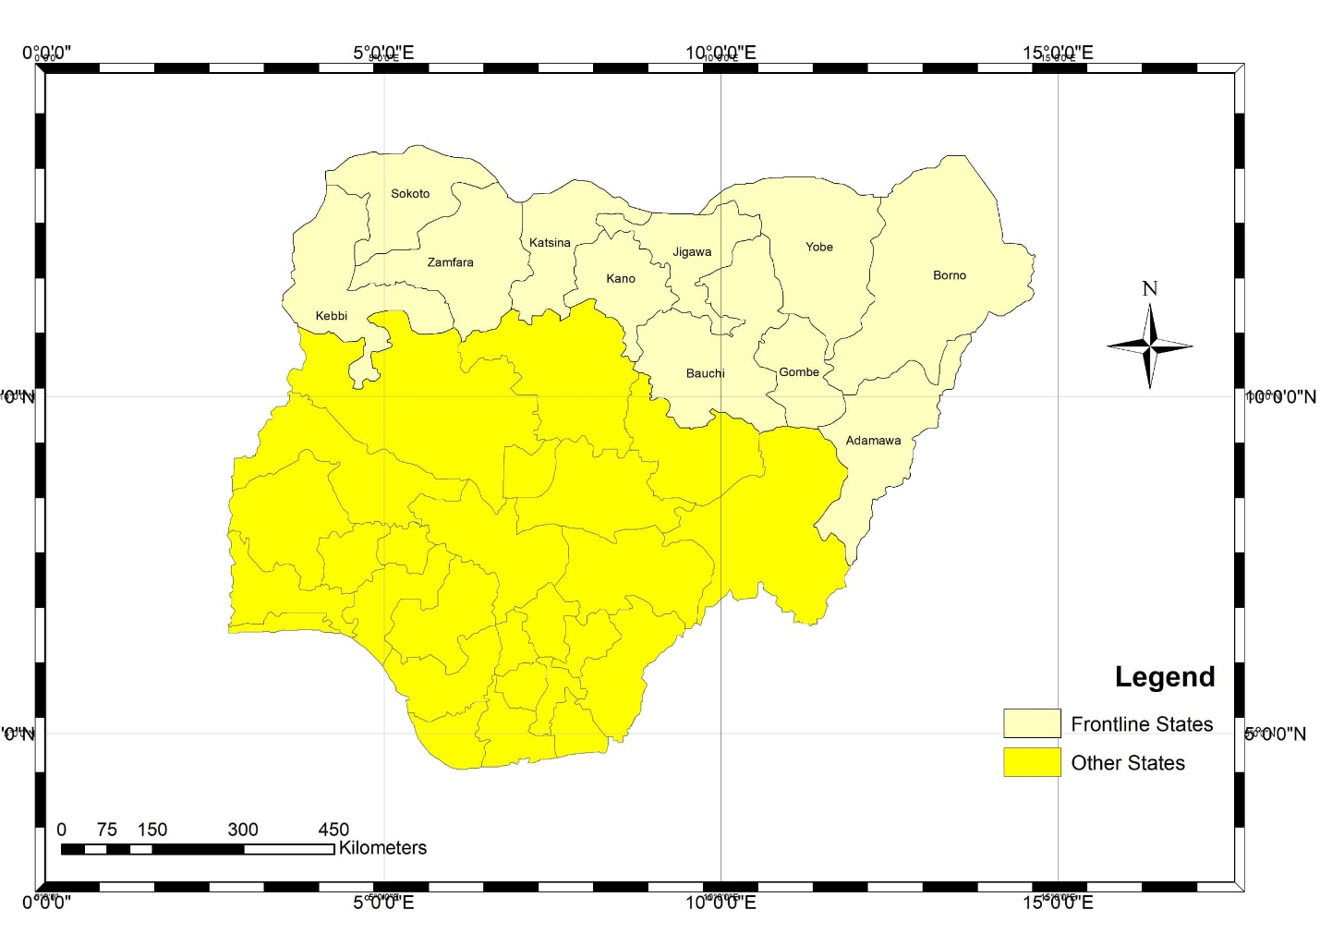

Figure 1: Map of the Frontline States of Northern Nigeria

Source: Field work

**2.2 Data Acquisition and Image Processing**

Secondary data sources for this study include satellite-derived vegetation index data from the United States Geological Survey (USGS) (<http://www.usgs.gov>), rainfall data from the Climate Hazards Group InfraRed Precipitation Station (<http://data.chcucsb.edu/products/CHIRPS2.0/-Rainfall>), and temperature data from the Climate Change Knowledge Portal (<http://www.worldbank.org>). Additional datasets include demographic data from the Nigerian Population Commission (NPC), national land cover data from the Forestry Monitoring and Evaluation Coordinating Unit (FORMECU), soil data from the FAO Soil Portal (Fischer et al., 2008), and digital elevation and global land cover data from Earth Explorer (<http://earthexplorer.usgs.gov>). Aridity data were sourced from http://doi.org/10.6064/m9.figshare.750446.v5.

For a comprehensive assessment of desertification trends across Nigeria's frontline states, Advanced Very High-Resolution Radiometer (AVHRR) vegetation index datasets spanning 1984 to 2021 were utilized, alongside Landsat imagery from 1984 to 2022. These datasets focus on the dry season months (October to May) due to minimal cloud cover during this period. Climatological datasets were employed for climate modeling, while land cover datasets supported land use and land cover (LULC) change assessment.

The least-clouded multispectral Landsat images from 1984 and 2022, acquired via the USGS Explorer Portal (USGS, February–March 2022; <http://www.usgs.gov>), were used for LULC change analysis (Table 5). Initial identification of sites within the selected states and hotspots was informed by an analysis of FORMECU land cover data in conjunction with Google Earth imagery.

Table 1: Landsat scenes, source and specifications used for the study Table 1. Characteristics of the Landsat images used for the study

|  |  |  |  |  |  |
| --- | --- | --- | --- | --- | --- |
| Data source **Year** | **Path/Row** | **Image Acquisition Date** | **Satellite** | **Sensor/Scale** | **Cloud Cover** |
| 1984 | 184-188/52  185-191/53  186/55 | 31-01-1973 | Landsat MSS | 79m MSS | 0.00% |
| 1994 | 184-188/52  185-191/53  186/55 | 25-01-2001 | Landsat 4-5 | 30m TM | 0.00% |
| 2004 | 184-188/52  185-191/53  186/55 | 15-04-1999 | Landsat 7 | 30m ETM | 0.00% |
| 2014 | 184-188/52  185-191/53  186/55 | 11-04-2012 | Landsat 8 | 30m OLI-TIRS | 0.00% |
| 2022 | 184-188/52  185-191/53  186/55 | 27-09-21 | Landsat 9 | 30m OLI-2 TIRS-2 | 0.00% |
| 2022 | - | 23/06/2015 | Sentinel | 10m, 20m, 60m MSI | 0.00% |

Field data, 2022

**2.3 Image Classification**

A supervised classification approach was implemented using ArcGIS 10.2.2 to train the spectral classes of interest. This process involved creating spectral signature classes iteratively, with the objective of aggregating a set of statistical data that characterizes the spectral signature of each information class (Florian, 2009). The Land Use and Land Cover (LULC) classification scheme is outlined in Table 2.

Table 2: LULC Classification scheme used in the study area

|  |  |  |
| --- | --- | --- |
| S/No. | LULC Class | Description |
| 1. | Bare land | Areas with no or very little vegetation cover including exposed soils, sand dunes, stock quarry, rocks, landfill sites, and areas of active excavation. |
| 2. | Built-up | Residential, commercial and services, industrial, socio-economic infrastructure and mixed urban and other urban, transportation, roads and airport |
| 3. | Dense vegetation | Protected forests, plantations, mixed forest lands, and woody vegetation. These areas are covered with intricate mixture of small trees and bushes. These categories also includes: *Eucalyptus* woodlots and/or other remnant woody plantations. |
| 4. | Light vegetation | All cultivated and uncultivated agricultural lands areas such as farmlands, crop fields including fallow lands/plots and Horticultural lands. Areas used for crop cultivation (either on a rain-fed basis or using irrigation); Land units (privately and communally owned) covered by pure stands of grass and/or herbs used for haymaking and browsing areas for livestock grazing.  Land covered with scattered or patches of various species of small trees, usually found along banks of streams, woody shrubs, thorny bushes and rugged landscapes and escarpments. Some of these land covers are utilized for communal grazing and browsing purposes. |
| 5. | Water bodies | Rivers, permanent open water, lakes, ponds, reservoirs,  Permanent and seasonal grasslands along the lake, river and streams, marshy land and swamps. |

Source: FAO, 2014; Belward and Loveland 2017.

**2.4 Multispectral analysis**

The maximum likelihood classifier (MLC) of the supervised classification algorithm, running in ArcGIS Software, was used to categorize vegetation pixels into a finite set of classes that represent land surface types based on their spectral intensity values (DNs). The likelihood density function of the normal distribution is given as follows:

( |

Where:

P($ω$/ $i$) = likelihood function,

P($i$) = the a priori information (the probability that the class i occurs in the study area)

P($ω$) = the probability that $ω$ is observed, which can be written as:

$$Ρ\left(ω\right)=\sum_{i-1}^{Μ}{P}\left(ω\right|i)P\left(i\right)$$

Where:

M = the number of classes.

P ($ω$) = normalization constant to ensure $\sum{\left(·\right)}$ = M i 1 P i | sums to 1.

Pixel x is assigned to class i by the rule:

$x ϵ i P(i\backslash ω)>P(j\left|ω\right| for all j≠i$

**2.5 Accuracy Assessment of Images**

Accuracy assessment of classified images is a critical step in Land Use and Land Cover (LULC) change analysis. A stratified random sampling method was employed to collect a total of 600 reference data points, ensuring adequate representation of all five (5) LULC classes based on the proportional area of each class. Reference data were extracted from Google Earth imagery.

The accuracy assessment was conducted exclusively on the 2022 satellite images. It was not performed on the images from 1984, 1994, 2004, and 2014 due to the lack of ground validation data, such as aerial photographs and archived Google Earth images.

The assessment utilized metrics including the Kappa coefficient, overall accuracy, and producer's and user's accuracies, which were derived from the confusion (error) matrix (Congalton and Green, 2009; Liu et al., 2007). The Kappa coefficient measures the agreement between the classified map and reference data (Lillesand and Kiefer, 2000). The error matrix was used to compute the overall accuracy for each of the five (5) LULC classes individually as well as collectively. The Kappa coefficient was calculated using the formula proposed by Jensen and Cowen (1999), as shown below.

$K=\frac{{N∑}_{i-1}^{k} C_{ii}-∑_{i-1}^{k}\left(∑_{j-i}^{k}C_{ij}\right)\left(∑_{j-i}^{k}C_{ıj}\right)}{N^{2}-∑_{i-1}^{k}\left(∑_{j-i}^{k}C_{ij}\right)\left(∑_{j-i}^{k}C_{ıj}\right)}$

Where:

$C_{ii}$ is the n umber of correctly classified samples for class $i$ $C_{ij}$ 
 is the number of reference samples of class $i$ classified as class $j$

$C_{ji}$ is the number of samples classified as class $i$ that belong to class $j$

$Ν$ is the total number of samples

$K$ is the number of classes

To enhance classification accuracy and minimize misclassifications, the initial land use and land cover (LULC) maps were integrated with visually interpreted maps. ArcGIS was used for recoding the initial LULC maps, which were then compared to reference data from archived data, topographic maps, and ground truth points to assess classification accuracy. Google Earth was utilized to supplement ground-truthing efforts.

**2.6 Change Detection Analysis**

Change detection analysis was conducted to examine the spatio-temporal patterns of land cover and land use over a 38-year period. Supervised images from 1984 and 2022 served as input data, with significant changes between different land features highlighted. The land cover classes analyzed included bare land, built-up areas, dense vegetation, light vegetation, and water bodies. Post-classification methods were employed to evaluate changes in the areas of various ground features, measured in hectares (ha), over the 38 years. The change analysis utilized mathematical formulas proposed by Zubair (2008) and Hansen et al. (2013).

**2.6.1 Land use and land cover change transition matrix**

Change detection quantifies variations in land use and land cover (LULC) within a landscape by analyzing geo-referenced, multi-temporal remote sensing images captured over the same geographical area at different acquisition dates (Ramachandra and Kumar, 2004). This study utilized the post-classification comparison (PCC) method to detect LULC changes across four independently classified maps, corresponding to different dates within the study period (Jensen, 2005). Post-classification comparison is a widely used technique for comparing maps from various sources, despite a few limitations. It offers comprehensive and detailed "from-to" change information without requiring data normalization between the two dates (Coppin et al., 2004; Jensen, 2005; Teferi et al., 2013; Aldwaik and Pontius, 2013). This method generated a cross-tabulation matrix, known as the LULC change transition matrix, computed using overlay functions in ArcGIS. Gross gains and losses were also calculated for three intervals: 1984–1994, 1994–2004, and 2004–2014, as well as for the entire period from 1984–2022. The resulting matrix displays rows (representing LULC categories at Time 1, T1) and columns (representing LULC categories at Time 2, T2), as shown in Table 3.

**2.6.2 Conversion matrix**

The conversion matrix was employed to distinguish the changes in each category and identify those that occurred at the expense of others. Its structure mirrors that of Table 3, where the categories for Time 1 (initial time) are presented in rows, and those for Time 2 (subsequent time) are presented in columns. Diagonal entries (Pjj​) indicate the areas of land use/cover that remained unchanged for class j during the period. These are used to calculate the gains and losses for each LULC class. Off-diagonal entries represent the area transitioned from category “i” to a different category “j” during the time interval (Aldwaik and Pontius, 2012). For ease of reference, the equations and notations used to compute various components are detailed below:

The proportion of the watershed Pi + that is occupied by class i in time 1, is given by:

$$Ρ_{i+}=\sum_{i=1}^{n}{Ρ_{ij}}$$

Where: n is the total number of LULC classes. Similarly, the proportion of the vegetation P+j that is occupied by class j in time 2 is stated by equation below:

$$\text{Ρ}+ j=\sum_{j=1}^{n}{Ρ_{ij.}}$$

Similarly, the gain, loss, persistence, and total change were calculated for all the classified imagery using the equations outlined below (Pontius *et al*., 2004; Braimoh, 2006).

The Gain (G*ij*) was calculated through the difference between the total value for time 2 (P+*j*) and the persistence (P*ij*), using Equation 20.

$G_{ij}$ = $Ρ_{+j}$ − $Ρ_{jj}$.

Conversely, the Loss (L*ij*) was the calculated difference between the total values for the time 1 file (P*j*+) and the persistence, using Equation 21.

$G_{ij}$ = $Ρ_{j+}$ − $Ρ_{jj}$.

Table 3: General LULC change transition matrix for comparing two maps between observation times.

|  |  |  |  |  |  |  |  |  |  |
| --- | --- | --- | --- | --- | --- | --- | --- | --- | --- |
| Time 2 | Time 1 |  | |  | |  |  |  |  |
|  | LULC 1 | LULC 2 | | LULC 3 | | LULC 4 | LULC 5 | Total time 1 | Loss |
| LULC1 | P11 | P12 | P13 | P14 | P15 | | P1+ | | P+1-P11 | |
| LULC2 | P21 | P22 | P23 | P24 | P25 | | P2+ | | P+1-P11 | |
| LULC3 | P31 | P32 | P33 | P34 | P35 | | P3+ | | P+1-P11 | |
| LULC4 | P41 | P42 | P43 | P44 | P45 | | P4+ | | P+1-P11 | |
| LULC5 | P51 | P52 | P53 | P54 | P55 | | P5+ | | P+1-P11 | |
| Total time 2 | P+1 | P +1 | P +1 | P1+ | P+1 | | 1 | |  | |
| Gain | P+1-P11 | P+1- P22 | P+1- P33 | P+1-P44 | P+1 – P55 | |  | |  | |

“P” refers to any conversion from one land use/cover (LULC) to another and the number refers to columns and rows of LULC categories

**2.7 Percentage and Annual Rate of Change**

The NDVI was used to determine quantitative changes in the areas of the various vegetation cover categories using the post-classification procedure. The area statistics for the vegetation were derived from the classification of the images for each decade (1984, 1994, 2004, and 2022).

The percentage change for vegetation was thus calculated by expressing the ratio of vegetation and total land coverage in each year as a percentage. This is represented by the following formula;

$$\% change=\frac{x}{y} ×100$$

Where:

X= Observed change for vegetation in hectares

Y= Sum of change in hectares.

According to Teferi et al. (2013), net change refers to the difference between gain and loss, and it is always considered an absolute value. The annual rate of change in LULC was calculated for three distinct periods (1991–2001, 2001–2015, and 1991–2015) following the methodologies outlined by Puyravad (2003), Teferi et al. (2013), and Batar et al. (2017). This equation serves as a benchmark for comparing LULC changes, ensuring consistency despite variations in the durations of the study periods.

Change = Corresponding value of the area of the present from the past year (ha) A2 –A1.

A2 and A1 are the areas of the LULC cover types in year 1 and year 2.

$\% Change=A2-\frac{A1}{A1}*100$

$Annual rate of Change=\frac{Change}{time} ha yr$

Long *et al*., (2007) used a slightly modified formula to calculate the average annual rate of change between two periods.

∆ = (A2 − A1)/A1 ∗ 100)/(T2 − T1)

Where:

∆ = Average annual rate of change (%),

A1 = Amount of land cover type in time 1 (T1)

A2 = Amount of land cover type in time 2 (T2).

**2.7.1 Gains and losses of LULC (Net change)**

Net change, as defined by Teferi et al. (2013), represents the difference between gains and losses in land use and land cover (LULC). The gains and losses during the study period were determined through cross-tabulation of data from 1984, 1994, 2004, 2014, and 2022.

**3.0 Result**

**3.1 Accuracy Assessment for Land Use and Land Cover Classification**

Table 4 presents the error matrix results for the 2022 classified map. The overall accuracy of the 2022 classification map was 86.83%.

The classification results showed the lowest producer’s accuracy at 84.5%, with all other categories achieving higher values. This high accuracy can be attributed to the use of high spatial resolution, advanced processing techniques, and the benefits of Sentinel data for land cover classification (Benz et al., 2017; Khatami *et al*., 2019). Additionally, the kappa coefficient was calculated at 0.815, reflecting a high level of agreement between the classified map and the reference data. This value indicates strong reliability in the classification results. As a result, the map surpassed the minimum accuracy requirements, confirming its suitability for subsequent post-classification operations and applications. Studies in the region have reported comparable classification accuracies. For instance, Ibrahim (2023) achieved 84.2% accuracy using Sentinel-2 data, while combining Sentinel-2, Sentinel-1, and SRTM data improved accuracy to 89.1% in Simi -Arid areas. Rwanga and Ndambuki (2017) reported 81.7% accuracy and a substantial kappa coefficient (K) of 0.722 in Limpopo Province. Umar et al. (2021) reported a higher overall accuracy of 91% and a kappa coefficient of 0.85, in detecting land use change impacts on streamflow in northwestern Nigeria.

Table 4:Confusion (Error) matricfor 2022 LULC Change map

|  |  |  |  |  |  |  |  |
| --- | --- | --- | --- | --- | --- | --- | --- |
| **Reference Data\Classified Data** | **Bare ground** | **Water Body** | **Light Vegetation** | **Dense Vegetation** | **Built-up** | **Row Total** | User’s accuracy (%) |
| Bare ground | 169 | 3 | 9 | 5 | 4 | 200 | **94.41** |
| Water Body | 1 | 92 | 1 | 3 | 1 | 100 | **92** |
| Light Vegetation | 4 | 1 | 87 | 3 | 2 | 100 | **84.47** |
| Dense Vegetation | 3 | 3 | 4 | 85 | 3 | 100 | **85.86** |
| Built-up | 2 | 1 | 2 | 3 | 88 | 100 | **89.80** |
| **Column Total** | 179 | 100 | 103 | 99 | 98 | 600 |  |
| Producer’s accuracy (%) | **84.5** | **92** | **87** | **85** | **88** |  |  |
|  |  |  |  |  |  |  |  |

Overall accuracy=86.83%, Kappa coefficient=0.815

**3.2 Land use and land cover change dynamics**

The analysis of Land Use and Land Cover (LULC) changes reveals significant transformations during the 38-year study period (1984–2022). The spatio-temporal distribution of LULC categories was analyzed in terms of total area and percentage for each time frame (Table 5). The results show that in 1984, dense vegetation (58%) accounted for the largest proportion of land cover, followed by light vegetation (38%), bare ground (2.7%), and water bodies (0.98%), with built-up areas having the least coverage at 0.24% (Figure 2).

By 1994, dense vegetation decreased to 53.67%, while light vegetation, bare land, and built-up areas increased to 39.29%, 5.78%, and 0.28%, respectively. Water bodies remained unchanged at 0.98% (Figure 3). In 2004, dense vegetation and light vegetation rose to 56.04% and 43.33%, respectively, while built-up areas also increased to 0.31%. In contrast, bare land and water bodies decreased slightly, as shown in Figure 4.

In 2014, dense vegetation, built-up areas, and bare land declined to 4.87%, 1.48%, and 0.11%, respectively, whereas light vegetation and water bodies increased significantly to 92.0% and 1.51%, respectively (Figure 5). By 2022, light vegetation and bare land further increased to 93.49% and 0.24%, while dense vegetation, built-up areas, and water bodies decreased to 4.84%, 0.87%, and 0.56%, respectively. Figure 9 illustrates the dominance of light vegetation across the area in 2022.

Table 6 outlines the percentage change and annual rates of LULC change over four distinct time periods. Between 1984 and 1994, bare land exhibited the highest percentage increase (3.05%), followed by light vegetation (1.24%), and built-up areas (0.04%). Conversely, dense vegetation decreased by 4.33%, while water bodies remained unchanged.

From 1994 to 2004, light vegetation recorded the highest percentage change (4.04%), followed by dense vegetation (2.38%). Built-up areas expanded marginally by 0.03%, whereas bare land and water bodies declined by 5.62% and 0.82%, respectively.

Between 2004 and 2014, light vegetation experienced substantial growth, increasing by 48.70%. Water bodies and built-up areas also expanded, growing by 1.35% and 1.17%, respectively. However, bare land and dense vegetation declined significantly, decreasing by 5.62% and 0.82%, respectively. This period marked notable expansion in light vegetation, moderate growth in water bodies and built-up areas, and contractions in bare land and dense vegetation.

During the final period (2014–2022), light vegetation and bare land increased modestly by 1.46% and 0.13%, respectively. In contrast, built-up areas, dense vegetation, and water bodies declined by 0.60%, 0.03%, and 0.95%, respectively. This period saw a slight expansion in light vegetation and bare ground, along with minor reductions in other categories.

Over the entire study period (1984–2022), light vegetation and built-up areas increased significantly by 55.45% and 3.36%, respectively. Meanwhile, dense vegetation, bare ground, and water bodies experienced declines of 53.16%, 2.48%, and 0.43%, respectively (Figures 2 and 5).

The annual rates of LULC change also varied significantly over the study period. Bare ground, dense vegetation, and water bodies experienced pronounced declines in their annual rates, dropping from 30.18% ha⁻¹ to 6.12% ha⁻¹, 0.43% ha⁻¹ to 6.25% ha⁻¹, and 16.71% ha⁻¹ to 1.47% ha⁻¹, respectively. Conversely, light vegetation and built-up areas saw steady increases in their annual rates, rising from 0.98% ha⁻¹ to 2.37% ha⁻¹ and 0.93% ha⁻¹ to 3.36% ha⁻¹, respectively. These trends underscore the complex dynamics of land cover changes over the study period.

Figure 2: LULC Classes in 1984 in the Frontline States of Northern, Nigeria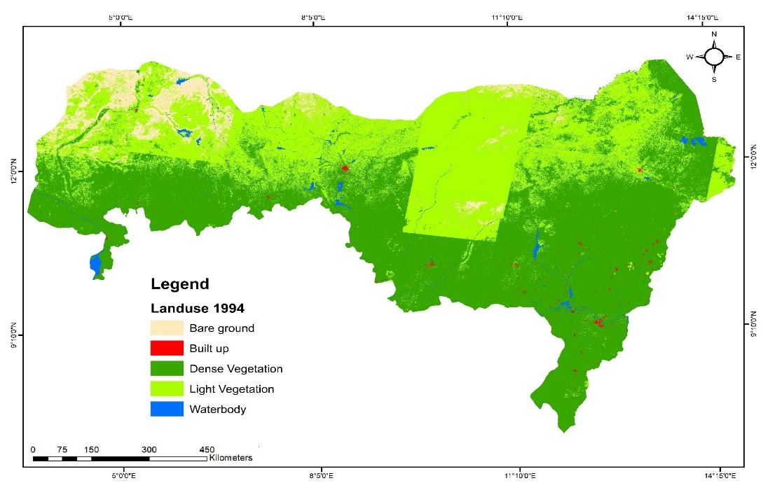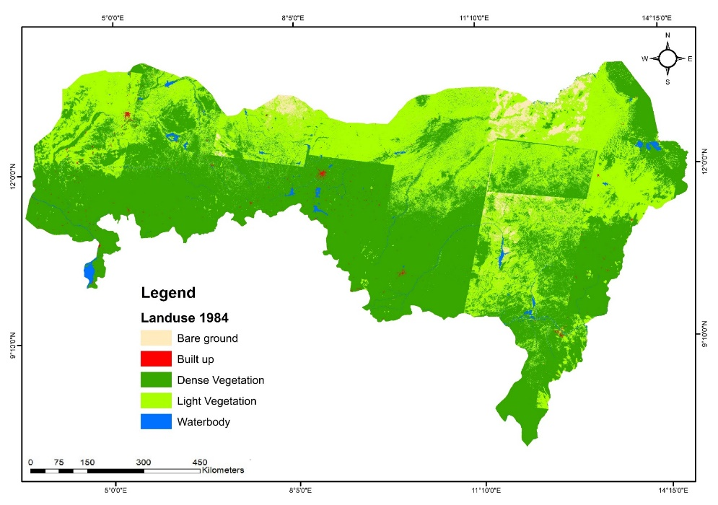 Figure 3: LULC Classes in 1994 in the Frontline States of Northern, Nigeria

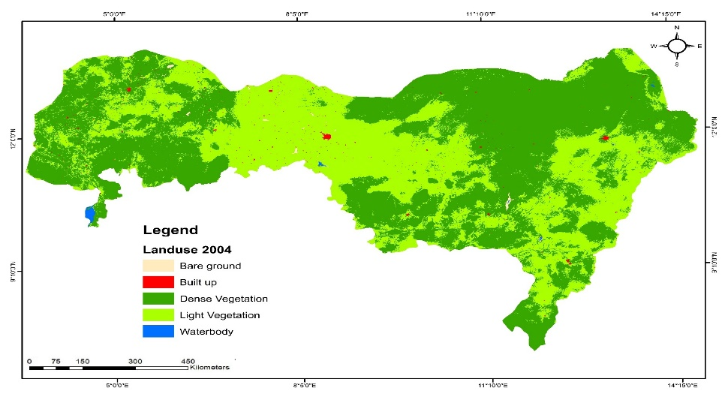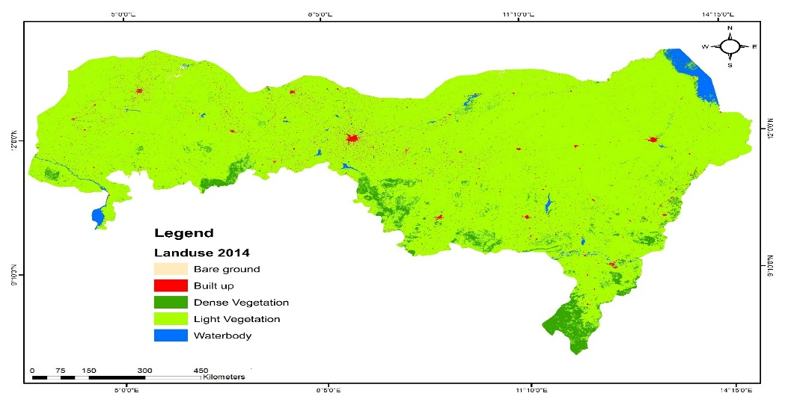

Figure 4: LULC Classes in 2004 in the Frontline States of Northern, Nigeria Figure 5: LULC Classes in 2014 in the Frontline States of Northern, Nigeria

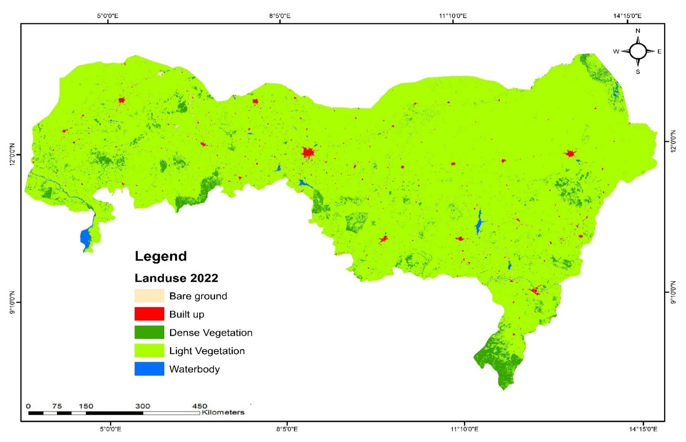

Figure 6: LULC Classes in 2022 in the Frontline Staes of Northern, Nigeria

Table 5: Area of Land use and cover classes from1984-2022 in the Frontline States of Northern Nigeria

a Percentage of each class out of the total area

|  |  |  |  |  |  |  |  |  |  |  |
| --- | --- | --- | --- | --- | --- | --- | --- | --- | --- | --- |
| **Land Cover Type** | **1984** |  | **1994** |  | **2004** |  | **2014** |  | **2022** |  |
|  | Ha | %a | Ha | %a | Ha | %a | Ha | %a | Ha | %a |
| Bare land | 1,080,316.27 | 2.7 | 2,289,165.16 | 5.78 | 63,000.17 | 0.16 | 45,005.67 | 0.11 | 95,353.83 | 0.24 |
| Built-up | 96,777.10 | 0.24 | 110,841.59.25 | 0.28 | 121,588.95 | 0.31 | 584,142.28 | 1.48 | 345,001.27 | 0.87 |
| Dense Vegetation | 22,954,682.02 | 58.0 | 21,240,222.39 | 53.67 | 22,180,775.87 | 56.04 | 1,926,399.52 | 4.87 | 1,915,475.72 | 4.84 |
| Light Vegetation | 15,057,535.33 | 38.05 | 15,549,081.08 | 39.29 | 17,149,704.69 | 43.33 | 36,424,259.23 | 92.03 | 37,001,925.3 | 93.49 |
| Waterbody | 388,146.61 | 0.98 | 388,146.56.30 | 0.98 | 62,387.46.19 | 0.16 | 597,650.63 | 1.51 | 219,701.21 | 0.56 |
| **Total** | **39,577,457.33** | **100** | **39,577,457.33** | **100** | **39,577,457.33** | **100** | **39,577,457.33** | **100** | **39,577,457.33** | **100** |

|  |  |  |  |  |  |  |  |  |  |  |
| --- | --- | --- | --- | --- | --- | --- | --- | --- | --- | --- |
|  |  | **Percentage change b** | | |  |  | **Annual rate of change %c** | | | |
|  | **1984-1994** | **1994-2004** | **2004-2014** | **2014-2022** | **1984-**  **2022** | **1984-1994** | **1994-2004** | **2004-2014** | **2014-2022** | **1984-2022** |
| Bare land | 3.05 | -5.62 | -0.05 | 0.13 | -2.49 | 7.80 | -30.18 | -3.31 | 5.74 | -6.12 |
| Built-up | 0.04 | 0.03 | 1.17 | -0.60 | 0.63 | 1.37 | 0.93 | 16.99 | -0.01 | 3.36 |
| Dense Vegetation | -4.33 | 2.38 | -51.18 | -0.03 | -53.16 | -0.77 | 0.43 | -21.68 | -0.51 | -6.25 |
| Light Vegetation | 1.24 | 4.04 | 48.70 | 1.46 | 55.45 | 0.32 | 0.98 | 7.82 | 0.01 | 2.37 |
| Waterbody | 0.00 | -0.82 | 1.35 | -0.95 | -0.43 | 0.00 | -16.71 | 25.35 | -0.01 | -1.47 |

Table 6: Percentage Change trend and Annual rate of Change in the Frontline States of Nigeria

Note: + Sign indicates increase, - Sign indicates decrease.

b percentage change in the class; c percentage of the annual rate of change in each class

**3.3** **Change Detection Analysis: Land use and land cover change (Transition Matrix)**

The Land Use and Land Cover (LULC) change matrices presented in Tables 7–11 illustrate the transitions among five LULC categories across four distinct periods: 1984–1994, 1994–2004, 2004–2014, and 2014–2022. These matrices reveal significant transformations and highlight the complex and evolving dynamics of land cover changes throughout the study period.

**1984–1994: Significant Transition of Bare Land**

Between 1984 and 1994, bare land experienced the most substantial transformation, with 82.39% (905,158.79 ha) of its area transitioning to other categories, primarily light vegetation (681,299.4 ha). Other notable changes included built-up areas (47.62%), light vegetation (41.61%), and dense vegetation (27.51%), while water bodies remained relatively stable.

During this period, the largest gains were observed in bare land (1,203,546.59 ha), followed by light vegetation (871,044 ha) and built-up areas (14,013.92 ha). Conversely, dense vegetation experienced a substantial decline (1,702,966 ha), with water bodies undergoing minimal changes (385,638.20 ha) (Figure 7).

**1994–2004: Decline of Dense Vegetation**

From 1994 to 2004, dense vegetation experienced the highest transition rate, with 95.57% (11,518,599.01 ha) of its area shifting to other categories. Similarly, notable transitions occurred in built-up areas (90.3%), light vegetation (89.71%), water bodies (16.07%), and bare land (2.75%).

Light vegetation recorded the largest gain (1,511,724 ha), followed by dense vegetation (938,370 ha) and built-up areas (149,520.4 ha). Bare land experienced significant losses (2,219,331 ha), and water bodies declined by 380,284 ha (Table 8 and Figure 8).

**2004–2014: Dramatic Shift in Dense Vegetation**

The period 2004–2014 saw a dramatic shift in dense vegetation, with 93.43% (21,400,162.05 ha) of its area transitioning to other classes, primarily bare land (83.03%), built-up areas (49.87%), and light vegetation (6.33%). Light vegetation experienced the largest gain (19,311,919.2 ha), followed by water bodies (471,343.50 ha) and built-up areas (461,693.71 ha).

Dense vegetation and bare land declined significantly, with losses of 20,227,069.6 ha and 17,886.84 ha, respectively (Table 9 and Figure 9).

**2014–2022: Dominance of Light Vegetation**

Between 2014 and 2022, bare land underwent the most significant transformation, with 71.8% (34,702.74 ha) of its total area changing to other categories. Substantial transitions were also observed in built-up areas (56.37%), dense vegetation (51.06%), water bodies (99.9%), and light vegetation (2.99%).

Light vegetation recorded the highest expansion (435,152.75 ha), followed by built-up areas (410,789.62 ha). Water bodies, however, experienced a notable decline (Table 10 and Figure 10).

**1984–2022: Long-Term Trends**

Over the entire study period (1984–2022), light vegetation and built-up areas showed substantial expansion, largely at the expense of dense vegetation, bare land, and water bodies. Light vegetation experienced the fastest growth, with a net gain of 22,129,839.44 ha, followed by built-up areas with a gain of 503,919.41 ha.

Dense vegetation recorded the greatest net loss (37,184,192.0 ha) during the study period. The largest transitions involved dense vegetation converting to light vegetation (36,415,621.8 ha), followed by light vegetation converting to dense vegetation (14,428,148.0 ha) and transitions between bare land, light vegetation, and built-up areas (Table 11).

Water bodies experienced the least change, with high persistence rates across all periods: 100% (1984–1994), 83.93% (1994–2004), and 100% in subsequent periods.

**Transition Matrices**

Tables 7–11 summarize the LULC transition matrices. The diagonal entries in each matrix represent the areas that persisted in the same LULC category, while off-diagonal entries capture the areas converted to other categories between two time points. The sum of each column represents the total area for each land cover type in Time 1, while the sum of each row indicates the total area in Time 2.

|  |  |  |  |  |  |  |  |  |  |
| --- | --- | --- | --- | --- | --- | --- | --- | --- | --- |
| **LULC** | **Bare land** | **Built up** | **Dense Vegetation** | **Light Vegetation** | **Water** | **Total 1984** | **Loss** | **Change from 1986** | **% of Change** |
| Bare ground | **193,474.87** | 209.14 | 223,643.5 | 681,299.4 | 0 | 1,098,627 | 905,152.1 | 1,203,546.59 | 116,04 |
| Built up | 1,072.19 | **60,054.94** | 24,284.59 | 29,237.58 | 0 | 114,649.3 | 54,594.36 | 14,013.92 | 14.53 |
| Dense Vegetation | 229,762.08 | 43,337.04 | **16,602,260** | 6,029,663 | 0 | 22,905,022 | 6,302,762 | -1,702,966 | -7.47 |
| Light Vegetation | 1,877,864.23 | 25,047.46 | 4,351,860 | **8,778,661** | 0 | 15,033,432 | 6,254,771 | 871,044 | 3.26 |
| Water | 0.19 | 14.63 | 8.14 | 385,615.2 | **0** | 385,638.2 | 385,638.2 | -385,638.2 | -1.29 |
| **Total 1994** | 2,302,173.55 | 128,663.2 | 21,202,056 | 15,904,476 | 0 | 39,537,368 |  |  |  |
| **Gain** | 2,108,698.69 | 68,608.28 | 4,599,796 | 7,125,815 | 0 |  |  |  |  |

Table 7: Land Use Land Cover Change Matrix between 1984 and 1994

**Note:** The bold numbers indicate the unchanged LULC proportions from 1984 to 1994

**Note:** + Sign indicates increase, - Sign indicates decrease.

|  |  |  |  |  |  |  |  |  |  |
| --- | --- | --- | --- | --- | --- | --- | --- | --- | --- |
|  | **Bare ground** | **Built up** | **Dense Vegetation** | **Light Vegetation** | **Water** | **Total 1994** | **Loss** | **Change from 1994** | **% of Change** |
| Bare ground | **24,724.49** | 6,175.83 | 1,228,509.96 | 1,042,763.27 | 0 | 2,302,173.55 | 2,277,449.06 | -2,219,331 | -97.25 |
| Built up | 0.5161 | **45,904.25** | 20,826.22 | 61,917.61 | 0 | 128,648.59 | 82,744.35 | 149,520.4 | 9.70 |
| Dense Vegetation | 3,165.59 | 35,313.51 | **12,052,525.91** | 9,127,408.81 | 3,692.89 | 21,222,106.70 | 9,169,580.80 | 938,370.0 | 4.43 |
| Light Vegetation | 1,848.59 | 52,365.82 | 8,724,351.81 | **6,760,304.31** | 42.50 | 15,538,913.03 | 8,778,608.73 | 1,511,724 | 10.29 |
| Water | 53,103.66 | 138,409.56 | 134,262.78 | 58,242.91 | **1,596.34** | 385,615.24 | 384,018.91 | -380,284 | -83.93 |
| Total 2004 | 82,842.85 | 278,168.98 | 22,160,476.67 | 17,050,636.91 | 5,331.73 | 39,577,457.13 |  |  |  |
| Gain | 58,118.36 | 232,264.73 | 10,107,950.76 | 10,290,332.60 | 3,735.39 |  |  |  |  |

Table 8: Land Use Land Cover Change Matrix between 1994 and 2004

**Note:** The bold numbers indicate the unchanged LULC proportions from 1994 to 2004

**Note:** + Sign indicates increase, - Sign indicates decrease.

Table 9: Land Use Land Cover Change Matrix between 2004 and 2014

|  |  |  |  |  |  |  |  |  |  |
| --- | --- | --- | --- | --- | --- | --- | --- | --- | --- |
| **LULC** | **Bare ground** | **Built up** | **Dense Vegetation** | **Light Vegetation** | **Water** | **Total 2004** | **Loss** | **Change from 2004** | **% of Change** |
| Bare ground | **10,665.91** | 68.02 | 243.54 | 6,565.07 | 45,296.02 | 62,838.57 | 52,172.67 | -17,886.84 | -28.56 |
| Built up | 73.01 | **60,848.01** | 1,115.36 | 58,990.65 | 363.16 | 121,390.2 | 60,542.18 | 461,693.71 | 380.42 |
| Dense Vegetation | 28,829.97 | 178,176.2 | **1,457,366** | 20,268,230 | 242,122.64 | 22,174,725 | 20,717,359 | -20,227,069.6 | -91.32 |
| Light Vegetation | 5,381.23 | 343,983.0 | 488,904.1 | **16,046,085** | 245,492.64 | 17,129,846 | 1,083,761 | 19,311,919.2 | 112.39 |
| Water | 1.62 | 8.68 | 26.38 | 61,894.28 | **0** | 61,930.96 | 61,930.96 | 471,343.50 | 857.97 |
| **Total 2014** | 44,951.74 | 583,083.9 | 1,947,656 | 36,441,765 | 533,274.46 | **39,550,731** |  |  |  |
| Gain | 34,285.83 | 522,235.9 | 490,289.4 | 20,395,680 | 533,274.46 |  |  |  |  |

**Note:** The bold numbers indicate the unchanged LULC proportions from 2004 to 2014

**Note:** + Sign indicates increase, - Sign indicates decrease.

|  |  |  |  |  |  |  |  |  |  |
| --- | --- | --- | --- | --- | --- | --- | --- | --- | --- |
| **LULC** | **Bare ground** | **Built up** | **Dense Vegetation** | **Light Vegetation** | **Water** | **Total 2014** | **Loss** | **Change from 2014** | **% of Change** |
| Bare ground | **10,249.30** | 9.44 | 30.46 | 29,062.02 | 5,600.51 | 44,951.74 | 34,702.43 | 50,145.67 | 111.87 |
| Built up | 585.08 | **266,049.1** | 1,409.54 | 341,276.7 | 504.10 | 609,824.6 | 343,775.5 | 410,789.62 | -40.94 |
| Dense Vegetation | 521.82 | 1,140.78 | **953,107.5** | 990,320 | 2,508.04 | 1,947,598.0 | 994,490.6 | 174,865.97 | -0.57 |
| Light Vegetation | 72,299.36 | 104,151.9 | 863,032.2 | **35,292,576** | 47,741.52 | 36,379,801 | 1,087,225 | 435,152.75 | 1.59 |
| Water | 11,441.84 | 117,164.7 | 304,884.4 | 161,719 | **71.68** | 595,281.6 | 595,210 | -538,855.79 | -63 |
| **Total 2022** | 95,097.41 | 488,516.0 | 2,122,464.4 | 36,814,953 | 56,425.85 | 39,577,457.0 |  |  |  |
| Gain | 84,848.10 | 754,565.1 | 1,169,357 | 1,522,378 | 56,354.17 |  |  |  |  |

Table 10: Land Use Land Cover Change Matrix between 2014 and 2022

**Note:** The bold numbers indicate the unchanged LULC proportions from 2014 to 2022

**Note:** + Sign indicates increase, - Sign indicates decrease.

|  |  |  |  |  |  |  |  |  |  |
| --- | --- | --- | --- | --- | --- | --- | --- | --- | --- |
| **LULC** | **Bare ground** | **Built up** | **Dense Vegetation** | **Light Vegetation** | **Water** | **Total 1984** | **Loss** | **Change from 1984** | **% of Change** |
| Bare ground | **239,114.57** | 6,462.44 | 1,452,427 | 1,759,689.8 | 50,896.54 | 3,508,590.84 | 3,269,476.0 | -983,525.30 | -91.17 |
| Built up | 1,730.79 | **432,856.3** | 47,635.71 | 491,422.59 | 867.26 | 974,512.65 | 541,656.3 | 503,919.41 | 256.0 |
| Dense Vegetation | 262,279.47 | 257,967.5 | **31,065,260.0** | 36,415,621.8 | 248,323.57 | 68,249,451.93 | 37,184,192.0 | -20,816,799.5 | -91.66 |
| Light Vegetation | 1,957,393.41 | 525,548.2 | 14,428,148.0 | **66,877,625.3** | 293,276.66 | 84,081,991.47 | 17,204,366.0 | 22,129,839.44 | 145.74 |
| Water | 64,547.31 | 255,597.6 | 439,181.7 | 667,471.40 | **1,668.01** | 1,428,466.06 | 1,426,798.0 | -833,434.02 | -43.40 |
| **Total 2022** | 2,525,065.54 | 1,478,432 | 47,432,652.0 | 106,211,831 | 595,032.04 |  |  |  |  |
| Gain | 2,285,950.97 | 1,045,576 | 16,367,393.0 | 39,334,205.6 | 593,364.03 |  |  |  |  |

Table 11: Land Use Land Cover Change Matrix between 1984 and 2022

**Note:** The bold numbers indicate the unchanged LULC proportions from 2014 to 2022

**Note:** + Sign indicates increase, - Sign indicates decrease.

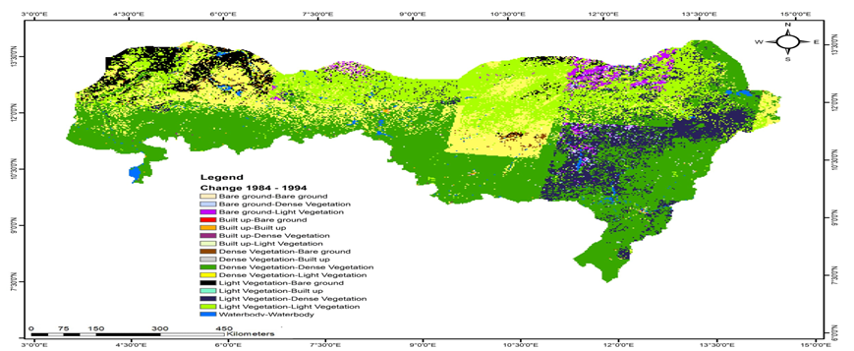

Figure 7: Change Detection Analysis of LULC between 1984 and 1994 in the Study Area

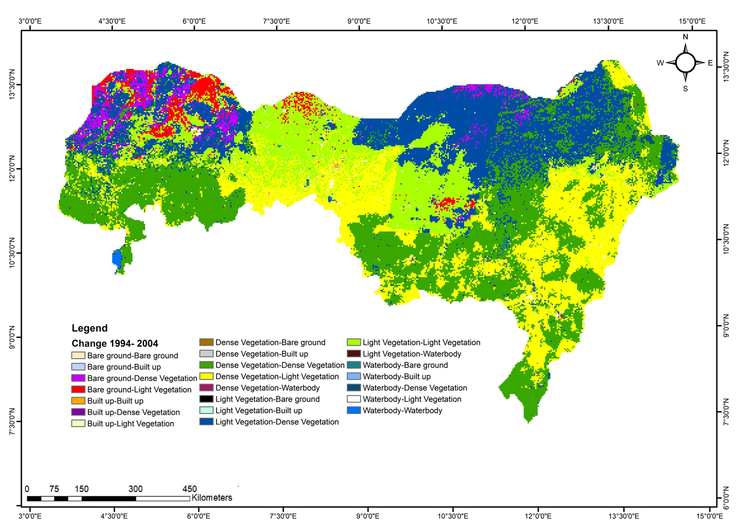

Figure 8: Change Detection Analysis of LULC between 1994 and 2004 in the Study Area

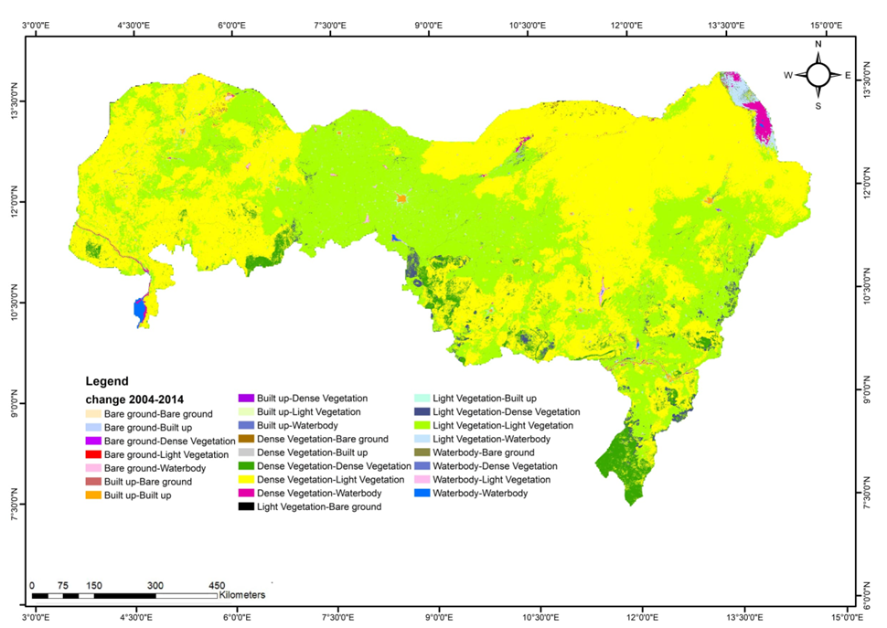

Figure 9: Change Detection Analysis of LULC between 2004 and 2014 in the Study Area

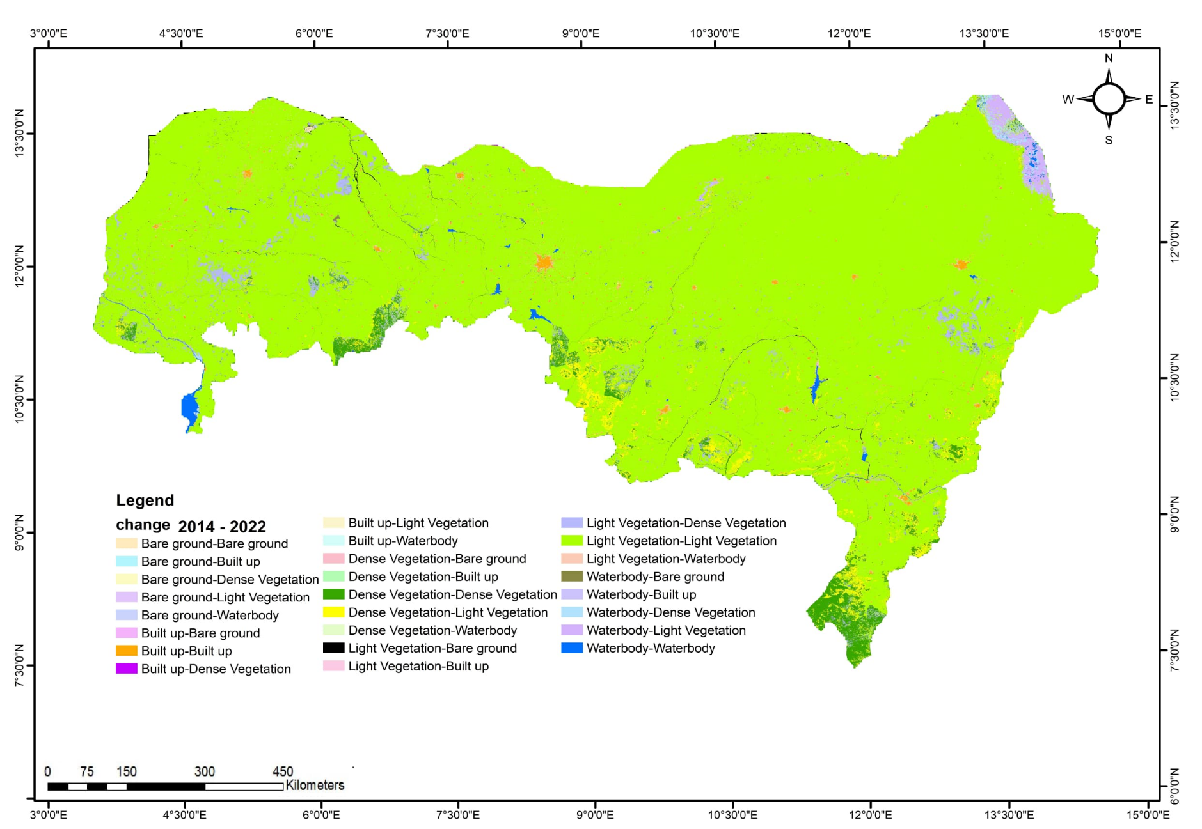

Figure 10: Change Detection Analysis of LULC between 2014 and 2022 in the Study Area

**5. Discussion**

The observed significant variation in the proportions of each LULC (Land Use and Land Cover) class over the different study periods reflects substantial changes in the frontline states of Nigeria. These changes are primarily driven by socio-economic activities in the region, with agriculture, including crop production and livestock farming, being the dominant activity. The communities in these areas exhibit high dependence on agriculture, consistent with findings by FAO (2014), Olagunju (2015), Gadzama (2017), and Yahaya and Malik (2021). This heavy reliance has placed immense pressure on vegetative resources due to overexploitation and unsustainable land management practices, culminating in land degradation and desertification.

This issue is exacerbated by the role of the frontline states as major agricultural hubs supplying critical food products like beans, soybeans, tomatoes, melon, pepper, onion, rice, and beef to the rest of the country (James et al., 2018). The resultant pressure explains the drastic decline in dense vegetation throughout the study period, with the exception of the 1994–2004 period, which saw a temporary gain due to the Forestry II project (1987–1996). This project, succeeding the Forestry I afforestation program, included shelterbelt establishment and farm forestry components in response to deforestation and desert encroachment in the region (JIGAP, 2015; Medugu et al., 2009; World Bank, 1998). According to Ibrahim (2015), the Forestry II program was the most successful afforestation project in Northern Nigeria.

Light vegetation exhibited an overall increasing trend, contrasting with the consistent decline in dense vegetation over the study period. The period 2004–2014 showed the most significant changes, with dense vegetation being converted into cultivated areas, built-up zones, and degraded land due to deforestation (Abdi et al., 2013; Hussaini, 2014). A notable decrease in bare ground and water bodies, alongside the increase in built-up areas, indicates substantial development and land use alteration. These findings align with earlier studies of LULC dynamics, such as those by Ogunjobi et al. (2018) in Sokoto and Elijah et al. (2017) in Yobe State. Similar trends have been reported by Koko et al. (2021) in Kano, Koko et al. (2020) in Zaria, and Ahmed et al. (2020) across Nigeria, attributing the decrease in barren land and the rise in built-up areas to rapid urbanization.

The findings of Musa and Shaib (2010) highlight the rapid desertification process in northern Yobe State, driven by overgrazing and unsustainable rainfed agriculture. The Karasuwa area, in particular, experiences vegetation degradation due to overgrazing during wet seasons, exposing the soil to wind erosion. Expansion of shifting cultivation areas further exacerbates this destruction. Similarly, the inability to enforce grazing control systems and increasing demand for firewood for a growing population contribute to vegetation loss (Musa, 2012; Goffner et al., 2019). Livestock from neighboring Sahel countries also intensifies pressure on local pastures, particularly around Lake Chad wetlands (Murakami, 2020). This study's findings align with Mahamat et al. (2021), who reported a significant decline in Lake Chad's open water area from 16,157.34 km² (64.6%) in 1973 to 1,831.44 km² (11.33%) by the 1980s. The drastic reduction is attributed to extreme drought, climate change, global warming, and unsustainable water use practices.

A consistent decline in water bodies observed during the study period underscores the challenges posed by increasing agricultural land demand in the region. This decline is associated with riverbank cultivation, deforestation, and overexploitation of natural resources, as corroborated by UNEP (2004), Idowu and Wakatsuki (2008), and Abdullahi et al. (2014). A decline in water bodies was also observed in the study by Al-Akad (2019). Global studies also reveal similar trends of wetland reduction due to urban, agricultural, and industrial expansion (Asselen et al., 2013).

Dense vegetation experienced the highest transition, with 45.52% converted to other LULC classes, while light vegetation gained 79.54% from other classes. These dynamic and nonlinear LULC transitions highlight the interplay of natural and anthropogenic factors driving land cover changes. Afforestation and land restoration programs, population growth, and urban development significantly influenced the observed trends, as documented by Garba et al. (2016) and Danjuma et al. (2014).

The rapid expansion of light vegetation reflects increasing pressure on marginal lands due to population growth and declining productivity of existing agricultural lands. The consistent increase in built-up areas and reduction in bare ground underscore urbanization and infrastructure development in the region, aligning with previous research on land use dynamics in Nigeria (Koko et al., 2020; Ogunjobi et al., 2018; Garba et al., 2018).

The initiative, which was effectively launched in Nigeria in 2013, focuses on combating land degradation, drought, desertification, and other challenges exacerbated by climate change. Its implementation strives to improve the livelihoods of affected communities, reduce poverty, and enhance the resilience of people facing the impacts of climate change. The Great Green Wall for the Sahara and Sahel Initiative (GGWSSI) spans from Djibouti to Senegal, involving eleven countries: Djibouti, Eritrea, Ethiopia, Sudan, Chad, Niger, Nigeria, Mali, Burkina Faso, Senegal, and Mauritania.

By 2030, the GGWSSI aims to restore 100 million hectares of degraded land, sequester 250 million tons of carbon, and create 10 million green jobs. If realized, this ambition will transform Africa's drylands from being a threat to livelihoods into a source of sustainable development. It has the potential to significantly improve the lives of millions of people living in poverty and grappling with the adverse effects of the climate crisis. Furthermore, it could help break the cycles of migration and conflict that are prevalent in the Sahel region, among other transformative impacts.

At the national level, member states have established dedicated National GGW Agencies or focal points to oversee and coordinate the implementation of GGW priority actions.

In Nigeria, the National Agency for the Great Green Wall (NAGGW) leads the implementation process. Its scope of operations includes the northern frontline states most affected by climate impacts: Adamawa, Borno, Bauchi, Gombe, Jigawa, Kano, Katsina, Zamfara, Sokoto, Kebbi, and Yobe (UNCCD, 2020).

**Conclusion**

This study has comprehensively identified the dominant dynamic changes and internal conversions among land use and land cover (LULC) types over the study period, highlighting dense vegetation as the most affected category. The findings reveal a significant negative correlation between climatic factors—such as temperature and rainfall variability—and vegetation cover, underlining their critical role in accelerating desertification processes in the study area.

The observed patterns of dense vegetation loss, coupled with the increase in light vegetation, cultivated lands, and built-up areas, demonstrate the compounded impact of anthropogenic pressures and climatic stressors. The increasing demand for agricultural land, urbanization, and overexploitation of natural resources are key drivers of these changes, exacerbating environmental degradation and threatening the sustainability of the region's ecosystems.

These results underscore the urgent need for effective land management policies and climate adaptation strategies. Interventions such as sustainable agricultural practices, afforestation programs, and stricter enforcement of resource use regulations are vital to mitigating the adverse effects of land degradation and promoting ecosystem restoration. Future research should focus on integrating socio-economic factors with LULC analysis to develop holistic approaches to sustainable development in semi-arid regions.

By addressing both natural and human-induced factors, this study provides valuable insights into the dynamic interplay of climatic variability and human activities in shaping land use changes. The findings contribute to the growing body of knowledge essential for policy formulation aimed at combating desertification and fostering resilience in vulnerable regions.

**Recommendation**

The findings of this study underscore the urgent need for comprehensive and coordinated measures to combat desertification and land degradation in Nigeria’s frontline states. To address these challenges effectively, the following recommendations are proposed:

1. **Enhanced Monitoring and Research**:
   * Research institutions should conduct regular assessments using advanced technologies such as remote sensing, Geographic Information Systems (GIS), and machine learning techniques to monitor land use and cover changes. These technologies will facilitate the identification of local and regional causes of desertification and provide data-driven insights into land use dynamics.
   * Detailed investigations into the socio-economic, climatic, and ecological drivers of land use/cover change are essential. Understanding these underlying causes will enable the development of targeted and sustainable interventions tailored to the unique needs of each region.
2. **Community Engagement and Capacity Building**:
   * State governments, in collaboration with non-governmental organizations (NGOs), should implement community-driven afforestation and reforestation programs. Such initiatives should include education campaigns to raise awareness of sustainable land management practices and the benefits of conservation.
   * Poverty alleviation programs must be integrated into environmental strategies to reduce the dependency of local communities on unsustainable land-use practices. Diversifying livelihoods through skill development, microfinance programs, and alternative income sources can mitigate pressure on natural resources.
3. **Sustainable Land Management Practices**:
   * The establishment of woodlots, shelterbelts, and grazing reserves is critical for reducing land degradation and combating soil erosion. These measures can provide sustainable resources for communities while protecting ecosystems.
   * Governments should promote the adoption of drought-resistant crop varieties and the use of organic fertilizers to enhance agricultural productivity without depleting soil health. Agricultural extension services can play a pivotal role in training farmers on sustainable practices.
   * Access to clean water resources must be prioritized by installing solar-powered boreholes and constructing earth dams. These infrastructure projects will not only support agriculture and livestock but also enhance community resilience to droughts and water scarcity.
4. **Policy Integration and Regional Collaboration**:
   * Policies addressing desertification should be integrated into national and regional development plans. A coordinated effort involving multiple stakeholders, including government agencies, NGOs, and local communities, is necessary to maximize the impact of interventions.
   * Collaboration with neighboring Sahel countries is essential to manage cross-border livestock movement and share best practices for sustainable rangeland management.
5. **Climate Adaptation Strategies**:
   * Governments and stakeholders should develop and implement climate adaptation programs that address the vulnerabilities identified in this study. These should include early warning systems for droughts and extreme weather, as well as incentives for adopting climate-smart agricultural practices.

**Disclaimer (Artificial intelligence)**

Option 1:

Author(s) hereby declare that NO generative AI technologies such as Large Language Models (ChatGPT, COPILOT, etc.) and text-to-image generators have been used during the writing or editing of this manuscript.

**Reference**

1. Abdi, O. A., Glover, E.K. and Luukkanen, O. 2013. Causes and Impacts of Land Degradation and Desertification: Case study of the Sudan. *International Journal of Agriculture and Forestry* 3(2): 40-51.
2. Abdulkadir, A., Usman, M.T., Shaba, A.H. and Saidu, S. 2015. Appraisal of the eco-climatic characteristics of Northern Nigeria. *African Journal of Environmental science and technology* 7(8): 748-757.
3. Abdullahi, S. A., Muhammad, M. M., Adeogun, B. K., Mohammed, I.U. 2014. Assessment of Water Availability in the Sokoto Rima River Basin. *Resources and Environment* 4(5): 220-233.
4. Abdulrashid, L. 2017. Farmers’ Perceptions of Drivers of Desertification and Their Impact on Food Security in Northern Katsina State. *International Journal of Innovative Environmental Studies Research*, 5(2):17-27.
5. Ackah, I. 2020. Factors Contributing to The Shrinkage of Lake Chad and Suggestions in Which It Can Be Restored. Retrieved from [https://www.researchgate.net/publication/344286312. (25 June, 2022](https://www.researchgate.net/publication/344286312.%20(25%20June,%202022)).
6. Adeniyi, P.O., and Omojola, A., 1999 “Landuse/Landcover Change Evaluation in SokotoRima Basin of North-Western Nigeria on Archival Remote Sensing and GIS Techniques,” Journal of African Association of Remote Sensing of the Environment (AARSE), 1, pp. 142-146.
7. Ahmed, H.A., Singh, S.K., Kumar, M., Maina, M.S., Dzwairo, R. and Lal, D. 2020. Impact of urbanization and land cover change on urban climate: Case study of Nigeria. *Urban Clim*. 32: 100600.
8. Al-Akad, S., Akensous, Y., Hakdaoui, M., Al-Nahmi, F., Mahyoub, S., Khanbari, K., and Swadi, H. 2019. Mapping of Land-Cover Change Analysis in Ma’rib at Yemen Using Remote Sensing and GIS Techniques. Int. Arch. Photogramm. Remote Sens. Spatial Inf. Sci., XLII-4/W12, 1–10, https://doi.org/10.5194/isprs-archives-XLII-4-W12-1-2019, 2019.
9. Aldwaik, S.Z. and Pontius, R.G. 2012. Intensity analysis to unify measurements of size and stationarity of land changes by interval, category, and transition. *Land Urban Plan* 106:103–114.
10. Asselen, S.V., Verburg, P.H., Vermaat, J.E., and Janse, J.H. 2013, “Drivers of Wetland Conversion: A Global Meta-Analysis,” *PLoS ONE* 8(11): e81292.
11. Bino, G., Levin, N., Darawshi, S., Hal, N. Van Der, Solomon, A.R., Kark, S., Levin, N. and Darawshi, S. 2008. Accurate prediction of bird species richness patterns in an urban environment using Landsat ‐ derived NDVI and spectral unmixing 1161. doi:10.1080/01431160701772534.
12. Danjuma, M.N., Bindawa, A.A., Maiwada, B., Shittu, U. and Adamu, I. 2014. 'Challenges and Prospects of Tree Seedlings Production in Katsina State of Nigeria'. IOSR Journal of Humanities and Social Science 19(4):74-80.
13. Elijah, E., Ikusemoran, Nyanganji, M., K.J. and Mshelia, H.U. 2017. Detecting and Monitoring Desertification Indicators in Yobe State, Nigeria. *Journal of Environmental Issues and Agriculture in Developing Countries* 9(1):16-33.
14. FAO (2014). FAO Statistical Yearbook 2014. Africa Food and Agriculture. Accra.
15. FAO (2014). FAO Statistical Yearbook 2014. Africa Food and Agriculture. Accra.
16. Fensholt, R. and Proud, S.R. 2012. Evaluation of Earth Observation based global long term vegetation trends - Comparing GIMMS and MODIS global NDVI time series. *Remote Sens*. *Environ.* 119:131–147.
17. FMEv. 2016. (online). [https://weircentreforafrica.com/.../desertification-in-nigeria-updatefederal-ministry-of-Environment (6 August, 2020).](https://weircentreforafrica.com/.../desertification-in-nigeria-updatefederal-ministry-of-Environment%20(6%20August,%202020).%20)
18. Folaji, M.B. (2007). Combating Environmental Degradation in Nigeria: A Case Study of Desertification in Kano State. A College paper submitted to the Armed Forces Command and Staff College Jaji Food and Agriculture Organisation (FAO) (2006).
19. Foley, J. A., Ramankutty, N., Brauman, K. A., Cassidy, E. S., Gerber, J. S., ... & West, P. C. (2011). Solutions for a cultivated planet. *Nature*, 478(7369), 337-342. doi: 10.1038/nature10452
20. Gadzama, N.M. 2017. ‘Attenuation of the Effects of Desertification through Sustainable Development of Great Green Wall in the Sahel of Africa’, World Journal of Science, Technology and Sustainable Development 14(4):279–289.
21. Gadzama, N.M., and Ayuba, H.K. 2016. On major environmental problem of desertification in Northern Nigeria with sustainable efforts to managing it. *World J. Sci. Technol. Sustain. Dev*. 2016, 13, 18–30.
22. Gao, H., Bohn, T. J., Podest, E., McDonald, K.C., and Lettenmaier, D.P. (2011). On the Causes of Shrinkage of Lake Chad. *Environ. Res. Lett.* 6 (3): 1-7).
23. Garba T.1, Ilelah, K.G. Muktari A. K., Gana B. A and Sani, M. J. 2016. Effects of World Bank Afforestation Projects for Combating Desertification on Land use Land Cover Changes. *International Journal of Science and Research* 5(5): 1284-1291
24. Glenn, E., Stafford Smith, M. and Squires, V. 1998. On Our Failure to Control Desertification: Implications For Global Change Issues, and A Research Agenda For the Future. *Environ. Sci. Policy* 1:71–78.
25. Goffner, D., Sinare, H. and Gordon, L. J. (2019) ‘The Great Green Wall for the Sahara and the Sahel Initiative as an opportunity to enhance resilience in Sahelian landscapes and livelihoods’, *Regional Environmental Change*. Regional Environmental Change, 19(5): 1417–1428.
26. Hathout, S., 2002, “The use of GIS for monitoring and predicting urban growth in East and West St Paul, Winnipeg, Manitoba, Canada,” J. Environ. Manage. 66, pp. 229–238.
27. Hein, L.; de Ridder, N.; Hiernaux, P.; Leemans, R. and de Wit, A. 2011. Schaepman, M. Desertification in the Sahel: Towards better accounting for ecosystem dynamics in the interpretation of remote sensing images. *J. Arid Environ*. 75:1164–1172.
28. Helldén, U. and Tottrup, C. 2008. Regional Desertification: A global synthesis. *Glob. Planet. Change*. 64:169–176.
29. Herold, M., Goldstein, N. C., and Clarke, K. C., 2003, “The spatiotemporal form of urban growth: measurement, analysis and modeling,” Remote Sens. Environ., 86, pp. 286–302.
30. Hill, J., Stellmes, M., Udelhoven, T. and Röder, A. 2011. Sommer, S. Mediterranean desertification and land degradation: Mapping related land use change syndromes based on satellite observations. *Glob. Planet. Chang*. 2008, 64, 146–157.
31. Hussaini, M.U. 2014. The Impact of Economic Activities on Deforestation in Bauchi State. (A Theoretical Perspective). *IOSR Journal of Humanities and Social Science* 19(3):14-18.
32. Ibrahim, E.S., Ahmed, B., Arodudu, O., Shamaki, S., Jibril, A.B., Dang, B.A., Mahmoud, M.I., Shaba, H.A. (2022). Desertification in the Sahel Region: A Product of Climate Change or Human Activities? A case of Desert Encroachment Monitoring in North-Eastern Nigeria Using Remote Sensing Techniques. Geographies 2(2):204-226.
33. Ibrahim, K.M., Muhammad, S.I. 2015. A Review Of Afforestation Efforts In Nigeria. *International Journal of Advanced Research in Engineering and Applied Sciences* 4(3):24-37.
34. Ifatimehin, O.O. and Ufuah, M.E. (2006). “An Analysis of Urban Expansion and Lost of  
    Vegetation Cover in Lokoja Using GIS Techniques”, Zaria Geographer: Journal of  
    Environmental Studies and Human Development, Volume 17(1): 28-36
35. IGDP (International Geosphere-Biosphere Programme). (1999). Land-use and land-cover change (LUCC): Implementation strategy. IGBP Report No. 48.
36. Intergovernmental Panel on Climate Change (IPCC). (2019). Climate Change and Land: an IPCC special report on climate change, desertification, land degradation, sustainable land management, food security, and greenhouse gas fluxes in terrestrial ecosystems. *Cambridge University Press.*
37. James, G.K., Jega, I.M., Halilu, A.S. Olojo, O.O. Oyewunmi, A.S. Shar, J.T., Onuoha, H., Victor, S., Mustapha, S., Shehu, I., Waziri, A.N., Mahmood, M.M., Salman, K.S. and Isah, A. 2018. Assessment of Environmental Sensitivity to Desertification in Katsina State, Nigeria*. Environment and Ecology Research*, 6(6): 545-555
38. Jat, M. K., Garg, P. K., and Khare, D., 2008, “Monitoring and modeling of urban sprawl using remote sensing and GIS techniques,” Int. J. App. Earth. Obs., 10, pp. 26-43.
39. Jensen, J., 2005. Introductory Digital Image Processing, A Remote Sensing Perspective. 3rd Edition, Prentice Hall Upper saddle River, 526pp.
40. Jigawa State Afforestation Programme- JIGAP. 2015. Second Forestry Project. Unpublished Project Brief by the JIGAP Head Office Mallam Madori. Jigawa State. 130pp.
41. Koko, A., Yue,W., Abubakar, G.A., Hamed, R. and Alabsi, A.A.N. 2020. Monitoring and Predicting Spatio-Temporal Land Use/Land Cover Changes in Zaria City, Nigeria, through an Integrated Cellular Automata and Markov Chain Model (CA-Markov). *Sustainability* 212:10452.
42. Koko, A.F., Wu, Y., Abubakar, G.A., Alabsi, A.A.N., Hamed, R. and Bello, M. 2021. Thirty Years of Land Use/Land Cover Changes and Their Impact on Urban Climate: A Study of Kano Metropolis, Nigeria. *Land* 10:1106.
43. Lambin, E. F., Geist, H. J., & Lepers, E. (2003). Dynamics of land-use and land-cover change in tropical regions. *Annual Review of Environment and Resources*, 28, 205-241.
44. Li, F., Wang, R.S., Paulussen, J. and Liu, X.S., 2005, “Comprehensive concept planning of urban greening based on ecological principles: a case study in Beijing, China,” Landscape Urban Plan., 72, pp. 325–336
45. Mahamat, A., Al-Hurban, A. and Saied, N. (2021) Change Detection of Lake Chad Water Surface Area Using Remote Sensing and Satellite Imagery. Journal of Geographic Information System, 13, 561-577. doi: 10.4236/jgis.2021.135031
46. Manandhar, R., Odeh, I.O.A., and Ancev, T., 2009, “Improving the Accuracy of Land Use and Land Cover Classification of Landsat Data using Post-classification Enhancement,” Remote Sensing, 1(3), pp. 330-344.
47. Medugu, N.I. 2009. Nigeria and the advancing Desert. Environmental Synergy World Press.com.157pp.
48. Meyfroidt, P., Lambin, E. F., Erb, K. H., & Hertel, T. W. (2013). Globalization of land use: Distant drivers of land change and geographic displacement of land use. *Current Opinion in Environmental Sustainability*, 5(5):438-444.
49. Miehe, S.; Kluge, J.; von Wehrden, H.; and Retzer, V. 2010. Long-term degradation of Sahelian rangeland detected by 27 years of field study in Senegal. *J. Appl. Ecol*. 47:692–700.
50. Miller, A. B., Bryant, E. S., and Birnie, R. W., 1998, “An Analysis of Land Cover Changes in the Northern Forest of New England Using Multi-temporal LANDSAT MSS Data,” Int. J. Remote Sens., 19 (2), pp. 215-265.
51. Murakami, F.L.R.H. 2020. Forced Migration, Conflict, and Climate Change in the Lake Chad Region: Perspectives on International Dynamics and the Anthropological Response to Enhancing Migrant Resilience and Community Cohesion. Master of Professional Studies. Presented to the Faculty of the Graduate School of Cornell University. 44p. Retried at <https://ecommons.cornell.edu/handle/1813/72666>
52. Musa, H.D. and Shaib, B. 2010. Integrated Remote Sensing Approach to Desertification Monitoring In The Crop-Rangeland Area of Yobe State, Nigeria. *Journal of Sustainable Development in Africa* 12 (5):236-250
53. Musa, J. 2012. An Assessment of the Effects of Desertification in Yobe State, Nigeria. *Con. J. Envtal Stds.* 2012:72-87.
54. Musa, J. 2012. An Assessment of the Effects of Desertification in Yobe State, Nigeria. *Confluence Journal of environmental Studies* (CJES), Kogi State, Nigeria. Pp. 72-87.
55. Nwilo, P.C., Olayinka, D.N., Okolie, C.J., Emmanuel, E.I., Orji, M.J. and Daramola, O.E., 2020. Impacts of Land cover changes on Desertification in Northern Nigeria and Implications on the Lake Chad Basin. *Journal of Arid Environments* 181:104-190
56. Ogunjobi, K.O. Adamu, Y., Akinsanola, A.A., Orimoloye, I.R., 2018. Spatiotemporal Analysis of Land Use Dynamics and Its Potential Indications on Land Surface Temperature in Sokoto Metropolis, *Nigeria. R. Soc. Open Sci*. 5:180661.
57. Olagunju, T.E. 2015. Drought and Desertification and The Nigerian Environment: A review. *Journal of Ecology and the Natural Environment* 7 (7):196 -209.
58. Olagunju, T.E. 2015. Forest Transition: Towards Modulating Climate Change. *Nat. Sci.* 13(5): 86-91
59. Olalekan, E.I., Abimbola, L.M., Saheed, M. and Damilola, O.A. 2014. Wetland Resources of Nigeria: Case Study of the Hadejia-Nguru Wetlands. *Poult Fish Wildl* Sci 2(2):123-129.
60. Oloukoi, J., Adagbasa, E.G. and Langyit, D.G., 2018. Desertification risk analysis and assessment in northern Nigeria. *Rem. Sens. Appl. Soc. Environ*. 4 (12):
61. Omale E.J., 2012. An Appraisal of the Strategies for Mitigating Desertification in Jibia and Kaita Local Government Areas of Katsina State. An Unpublished Research Thesis Submitted to Department of Geography, Ahmadu Bello University Zaria.
62. Parmenter, A. P., Hansen, A., Kennedy, R., Cohen, W., Langner, U., Lawrence, R., et al. 2003, “Land use and land cover change in the Greater Yellowstone Ecosystem: 1975–95,” Ecol. App., 13, pp. 687−703.
63. Rwanga, S. and Ndambuki, J. (2017). Accuracy Assessment of Land Use/Land Cover Classification Using Remote Sensing and GIS. International Journal of Geosciences, 8, 611-622. doi: 10.4236/ijg.2017.84033.
64. Rudel, T. K., Defries, R., Asner, G. P., & Laurance, W. F. (2009). Changing drivers of deforestation and new opportunities for conservation. *Conservation Biology*, 23(6):1396-1405.
65. Satyanarayana, B., Thierry, D., Seen, L., Raman, A.V. and Muthusankar, G., 2001, “Remote sensing in mangrove research—relationship between vegetation indices and endocentric parameters: a case for Coringa, east coast of India,” Proc. the Asian Conference on Remote Sensing, Singapore, 5–9 November, 2001, pp. 567–572.
66. Saulawa, B.G., Atlhopheng, J., Darkoh, M.B.K., and Mosetlbi, B. 2018. Impact of Desertification on Livelihoods in Katsina State, Nigeria. *Journal of Agriculture and Life Sciences 5(1):34-52.*
67. Serra, P., Pons, X., and Saurı´, D. 2008, “Land-cover and land-use change in a Mediterranean landscape: a spatial analysis of driving forces integrating biophysical and human factors,” Appl. Geogr., 28, pp. 189–209.
68. Seto, K. C., Fragkias, M., Güneralp, B., & Reilly, M. K. (2011). A meta-analysis of global urban land expansion. PLoS ONE, 6(8), e23777.
69. Shriver, G., Maniero, T., Schwarzkopf, K., Lambert, D., Dieffenbach, F., Owen, D., et al. 2005), “Appalachian Trail Vital Signs, National Park Service, Northeast Region, Boston, Massachusetts,” November 2005.
70. Turner, B. L., Lambin, E. F., & Reenberg, A. (2007). The emergence of land change science for global environmental change and sustainability. Proceedings of the National Academy of Sciences, 104(52), 20666-20671.
71. UNEP, 2004. Fortnam, M.P. and Oguntola, J.A. (eds), Lake Chad Basin, GIWA Regional assessment, University of Kalmar, Kalmar, Sweden. 129pp.
72. Usman, U., Yelwa, S. A., Gulumbe, S.U. and Danbaba, A. 2013. An Assessment of the Changing Climate in Northern Nigeria Using Cokriging. *American Journal of Applied Mathematics and Statistics* 1(5): 90-98.
73. Veron, S.; Paruelo, J.; Oesterheld, M. Assessing Desertification. *J. Arid Environ*. 66:751–763.
74. Wang, Y., and Moskovits, D. K., 2001, “Tracking fragmentation of natural communities and changes in land cover: Applications of Landsat data for conservation in an urban landscape (Chicago Wilderness),” Conserv. Biology, 15(4), pp. 835−843.
75. Welch, R., Madden, M., and Jordan, T., 2002, “Photogrammetric and GIS techniques for the development of vegetation database of mountainous areas: Great Smoky Mountains National Park,” J. Photogramm. Remote. Sens., 55, pp. 53−68.
76. Wilkinson, D. W., Parker, R. C., and Evans, D. L., 2008, “Change detection techniques for use in a statewide forest inventory program,” Photogramm. Eng. Remote Sens, 74(7), pp. 893−901.
77. Wu Qiong, Li, Hong-qing, Wang, Ru-song, Paulussen, Juergen, He, Yong,Wang, Min, Wang, Bi-hui, and Wang, Zhen, 2006 “Monitoring and predicting land use change in Beijing using remote sensing and GI,”. Landsc. urban Plan., 78, pp. 322-333.
78. Yahaya, O.Y. and Malik, N.A. (2021). Factors influencing households’ vulnerability in Rural Communities of Northern Katsina, Nigeria. *Ghana Journal of Geography*, 13(3):1-21
79. Yuan Fei, Sawaya, Kali, E., Loeffelholz and Bauer, Marvin, E. 2005, “Land cover classification and change analysis of the Twin Cities (Minnesota) Metropolitan Area by multitemporal Landsat remote sensing,” Remote Sens. Environ., 98, pp.317-32.
80. Zhang, B. P., Yao, Y. H., Cheng, W. M., Zhou, C. H., Lu, Z., and Chen, X. D., 2002, “Human-induced changes to biodiversity and alpine pastureland in the Bayanbulak Region of the East Tianshan Mountains,” Mou, 22, pp. 1–7.
81. Zhang, B., Zhang, Q., Feng, C., Feng, Q., and Zhang, S., 2017, “Understanding land use and land cover dynamics from 1976 to 2014 in Yellow River Delta,” Land, 6 (1), p. 20
82. Zubair, A.O. 2008. Monitoring the growth of settlements in Ilorin, Nigeria (a GIS and remote sensing approach), *Int. Arch. P*
83. , A. O. (2008). Monitoring the growth of settlements in Ilorin, Nigeria (a GIS and remote sensing approach). *International Archives of the Photogrammetry, Remote Sensing and Spatial Information Sciences*, 37(B6b): 225-232.
84. African Union Commission. *Second Continental Report on the Implementation of the Agenda 2063*; African Union Commission: Addis Ababa, Ethiopia, 2022; ISBN 978-1-77634-908-1.
85. ECOWAS. ECOWAS Environmental Policy; Abuja, Nigeria. 2008. Available online: [**https://www.carrotsandsticks.net/policies/305-1-ecowas-environmental-policy/**](https://www.carrotsandsticks.net/policies/305-1-ecowas-environmental-policy/) (accessed on 3 October 2024)
86. United Nations Convention to Combat Desertification (UNCCD). (2020). The Great Green Wall Initiative. Retrieved from https://catalogue.unccd.int/1551_GGW_Report_ENG_Final_040920.pdf
87. Taylor, C. M., Lambin, E. F., Stephenne, N., Harding, R. J., & Essery, R. L. H. (2002). The influence of land use change on climate in the Sahel. Journal of Hydrometeorology, 3(5), 3615–3629.
88. Umar, D. A., Ramli, M. F., Tukur, A. I., Jamil, N. R., & Zaudi, M. A. (2021). Detection and prediction of land use change impact on the streamflow regime in Sahelian river basin, northwestern Nigeria. H2Open Journal, 4(1), 92–113.
89. Yacouba, B., Wang, Z. and Boubacar, Y. (2016) Land-Use and Land-Cover Change in the Sahel Area of Keita Valley, Republic of Niger. Journal of Environmental Protection, 7, 554-565.
90. Herrmann, S. M., Brandt, M., Rasmussen, K., & Fensholt, R. (2020). Accelerating land cover change in West Africa over four decades as population pressure increased. Communications Earth & Environment , 1:53
91. Umar, D. A., Ramli, M. F., Tukur, A. I., Jamil, N. R., & Zaudi, M. A. (2021). Detection and prediction of land use change impact on the streamflow regime in Sahelian river basin, northwestern Nigeria. H2Open Journal, 4(1), 92-113.