Powering the Future: A Global Analysis of Well-to-Wheel Efficiency in Electric Vehicles

*Abstract*—Over the past few decades global warming and its effects on the environment has gained a lot of attention. Many studies have determined that keeping the increase in global temperature below 1.5 degrees Celsius is key to avoid irreversible damage to the environment. This is particularly challenging for the auto industry as it relies on fossil fuel combustion as a source of energy to enable transportation. With this goal of keeping rise in global temperatures down, several automotive OEMs have adopted modern technologies like hybrid electric vehicles, plug in hybrid electric vehicles, fuel cell batteries and battery electric vehicles to combat climate change. Among most these technologies, the common theme is to move away from using any direct fossil fuel combustion and rely on electricity from the grid to power propulsion. Although this is beneficial for reducing the number of direct emissions from automotive sector, it can increase the emissions from energy sector because the grid needs to produce more energy to charge these vehicles. However, this additional demand can be met via electricity production from renewable sources or non-renewable sources. Therefore, to get an accurate analysis of the impact of these alternative technologies, it becomes critical to analyze the efficiency, energy consumption and CO2 emissions from the source of energy to the stage where the energy is converted to useful work.

This study focuses on the estimation of a well to wheels efficiency of electric vehicles across the globe. Well to wheels efficiency considers the efficiency of all stages of energy consumption that form a part of the lifecycle of the electric vehicles. In addition to computing the well to wheels efficiency, this study also analyses the variation in wells-to-wheels efficiency in various parts of the world. Understanding this regional dependency is vital (and unique to this study) as each region relies on a different composition of sources to generate electricity which results in large variation of well to wheels efficiency across the globe. Computation of well to wheels efficiency is crucial to get a comprehensive estimate of energy consumption and losses at each stage in the lifecycle of electric vehicle’s operation and this can aid in identifying key stages where efficiency can be improved to make the most impact.

Keywords—Electric vehicles (EV), Hybrid electric vehicles (HEVs), efficiency, well-to-wheels efficiency (WTW), global warming, sustainable transport, intelligent transport.

# Introduction

Global warming is one of the key challenges faced by mankind today. Several studies show that keeping the global rise in temperatures under 1.5°C, is critical to avoid any irreversible damage to the environment [1]. Although contributions to global warming by different sectors vary, industrial sector, agriculture and transportation sectors are few of the primary contributors to global warming. Transportation alone contributes about 19.2% of the greenhouse gases emitted into the atmosphere [2]. To reduce these emissions, several automotive OEMs have stepped up to develop technologies that are environmentally friendly or made significant progress towards improving the efficiency of existing technologies to reduce total amount of greenhouse gas emissions. One example of the latter is the development of hybrid electric vehicles. Today, hybrid electric vehicles have almost twice the efficiency of comparable class of internal combustion vehicles [3], [43]. While enabling significant reduction in greenhouse gas emissions, hybrid electric vehicles also paved the way for the development of plug in hybrid electric vehicles and battery electric vehicles, all of which, along with hybrid electric vehicles are in production today. Plug in hybrids and electric vehicles take the reduction in greenhouse gases one step above hybrid electric vehicles. While enabling the use of greener sources of energy (such as renewables) in the form of electricity, plug in hybrids and electric vehicles also improve upon the efficiency of energy conversion from electricity to vehicle propulsion by almost a factor of two over hybrid electric vehicles [4].

Owing to these advantages, several automotive OEMs have invested significantly in the development and manufacture of electric vehicles. Traditional automotive OEMs like Ford, GM, Stellantis etc. already have a significant portfolio of electric vehicles, while few other automotive OEMs focus on selling electric vehicles exclusively (for e.g. Tesla and Rivian). Although electric vehicles are usually more expensive than an equivalent hybrid vehicle, plug in hybrid or internal combustion vehicle, it has been proven that over the lifetime of the usage of electric vehicles, the costs incurred would be lower compared to internal combustion vehicles. This is especially surprising considering that the cost of 33.7 kWh of electricity, equivalent to one gallon of gas, would be approximately $5.00 to $5.71 based on a national average electricity rate of around 16 cents per kWh. However, the lower cost of operating electric vehicle can be explained as the electric vehicle is much more efficient at converting the input source of energy (electricity) into useful work as compared to internal combustion vehicle. Typical electric vehicles convert about 85-90% of input energy input useful [5], [42] work while internal combustion engines convert only about 30% of input energy into useful work [6]. Thus the efficiency of energy conversion is about three times higher in electric vehicles and thus using an electricity of 11.2 kWh of electricity (which costs about $1.90) will yield the same amount of useful work as using 1 gallon of gasoline (which costs about 3.00$ on average). This difference in the cost of operation far outweighs the initial high cost of acquisition of electric vehicles. Additionally, electric vehicles also have lower maintenance costs owing to the use of less number of moving parts as compared to internal combustion vehicles and the use of regenerative braking which reduces brake pad wear.

Although most electric vehicle owners use grid power to charge the vehicle, there are significant benefits to be seen when using renewable energy sources to charge the electric vehicle. Recent studies have shown that renewable sources of energy are now significantly less expensive to capture as compared to tradition nonrenewable sources of power [7]. This renewable source of power can either be withdrawn from the grid which is powered by a renewable energy mix or direct production of renewable energy by electric vehicle owners using roof top mounted solar or household wind turbines. The latter implementation of in house renewable energy capture also has an advantage of using the car battery as a sink to absorb the variations in rate of energy production from renewables. The huge battery present in electric vehicles can act as additional storage when the energy production is at a surplus and can power the home when the energy production is less than what’s required by household utilities [8].

Electric vehicles are not the only means of transportation that are currently enabling a cleaner future. There are several technologies like mild hybrids [6] and plug in hybrids [9] that preceded electric vehicles and are being used in significant numbers today. The past few years also saw the development of several new technologies such as electric vertical takeoff and landing aircrafts [10] [11] [12], that have a potential to make personal point to point transport possible without the need for a runway to land and the problems associated with it such as airport crowding [13]. However, electric vehicles are more mature than these new technologies while operating on a cleaner fuel as compared to older technologies, thereby placing them at the forefront of the fight against climate change.

# Prior Literature

There is plenty of research material on efficiency of electric vehicles and other alternative technologies like hybrids and plug in hybrids. Although, the amount of literature on a more comprehensive well to wheels efficiency is scarce. The computation of well to wheels efficiency of electric vehicles is important because it considers the energy losses at each stage of the life cycle and thus has the potential to expose stages of the lifecycle which are less efficient. It is a common misconception that electric vehicles are extremely efficient as the conversion efficiency from battery power to the actual mechanical power that moves the vehicle is very high. Although this is true, it misses out on a key context that the overall efficiency of the vehicle starts at the source of the power which in the case of the electric vehicle is electricity. When the cost of producing electricity is considered, it becomes obvious that there are many stages where energy is lost to inefficiencies and thus the overall efficiency of electric vehicle is not as high as the conversion efficiency of the electric motors.

Chinthoju et al. [9] [6] are studies that precede this literature and they demonstrate the method of computing well to wheels efficiency of mild hybrid electric vehicles and plug in hybrid electric vehicles. The methods used in these studies list key energy consuming stages such as manufacturing of the vehicle, sourcing of the fuel and operation of the vehicle while also not ignoring stages such as maintenance and end of life processing. The approach that will be presented in the current study will also be similar but with more focus inefficiencies at the source. Electricity in different parts of the world is sourced from different sources of energy and even the composition that makes up the energy sources vary widely across regions. The preceding studies do not take this into consideration and only use an average figure (pertaining to electricity generation in the US), however the next few sections will demonstrate a detailed analysis which enables computing the well to wheel efficiency for different parts of the world (given the source composition).

Rodrigues et al [14] demonstrates the computation of well to wheels efficiency of electric vehicle and compares it to traditional internal combustion vehicles including different analysis for gasoline powered vs diesel powered vehicles. This study splits the well to wheel efficiency computation into well to tank (WTT) and tank to wheels (TTW) efficiencies and combines to arrive at a net well to wheels efficiency figure. Although this is a popular method to compute well to wheels efficiency, in most studies, the energy consumption due to maintenance and end of life activities for these vehicles are ignored. This study concludes that the well to wheels efficiency of battery electric vehicles depends heavily on the source of energy being used to charge the vehicle, which will analyzed in more depth in the current study. It concludes that battery electric vehicles charged by electricity from renewable energy sources have the highest well to wheels efficiency.

Li et al. [15], compares the well to wheel efficiency of electric vehicles with that of fuel cell electric vehicles. Fuel cell vehicles are another promising alternative to traditional internal combustion vehicles, where the fuel is decomposed produce electricity which can be used to power the vehicle. This study proves that fuel cell electric vehicles are more efficient than battery electric vehicles. However, fuel cell vehicles are not yet mature enough to be a feasible means of transportation, owing to the difficulty in storing hydrogen. Hydrogen has a very low density to be stored in gaseous form and storing it in liquid form requires very low temperatures which make the infrastructure setup to fill up hydrogen very expensive [16].

Liu et al. [17], demonstrate the well to wheel efficiency of electric medium and heavy duty trucks. Although the current study only focuses on passenger vehicles, the importance of electrifying commercial transportation cannot be understated as they account for about 20% of the total emissions due to transportation [18]. This is because commercial transportation have high utilization rates and higher power requirements although they are low in number as compared to passenger cars. This study shows that plug-in battery electric vehicles have a higher efficiency than conventional trucks while also reducing on emission of greenhouse gases such as nitrogen oxides and volatile organic compounds.

Saini et al. [19], demonstrate the computation of well to wheels efficiency of electric vehicles in Indian market. As will be shown later, the well to wheel efficiency of electric (or even plug in hybrid electric vehicles) depends heavily on the source of electricity generation. A strong renewable mix in the electricity supply would mean a higher well to wheel efficiency. This is owing to the fact that renewable energy does not have the burden of high recurring costs to procure the energy source or fuel. Instead a high initial investment and a low maintenance cost is all that is need to capture and convert the energy into electricity.

# Methodology:

The computation of well to wheels efficiency involves computing the total energy supplied to the wheels and dividing that by the total energy expenditure and the energy content of the sources. The total energy expenditure involves computing the energy consumed or lost during the following stages

1. Energy consumed to generate the electricity
2. Energy consumed to transport the electricity
3. Energy lost in conversion to mechanical energy
4. Energy consumed in manufacturing of the vehicle
5. Energy consumed in maintenance of the vehicle

## Energy consumed to generate the electricity

It is critical to get an accurate estimation of this stage of energy consumption/losses to arrive at a reasonably accurate estimate of well to wheels efficiency. This computation is challenging because the energy production has a different composition in different parts of the world. Therefore the methodology followed in this study focuses predominantly on the cost of energy production using different sources and then computes a cost of energy for the overall mix based on the energy generation statistics for different regions.

In the US, the top contributors for electricity generation are natural gas, coal, nuclear, wind and hydropower (as shown in the table below).

Table 1: U.S. utility-scale electricity generation by source, amount, and share of total in 2023 (Data source: U.S. Energy Information Administration, Electric Power Monthly, February 2024; preliminary data) [20]

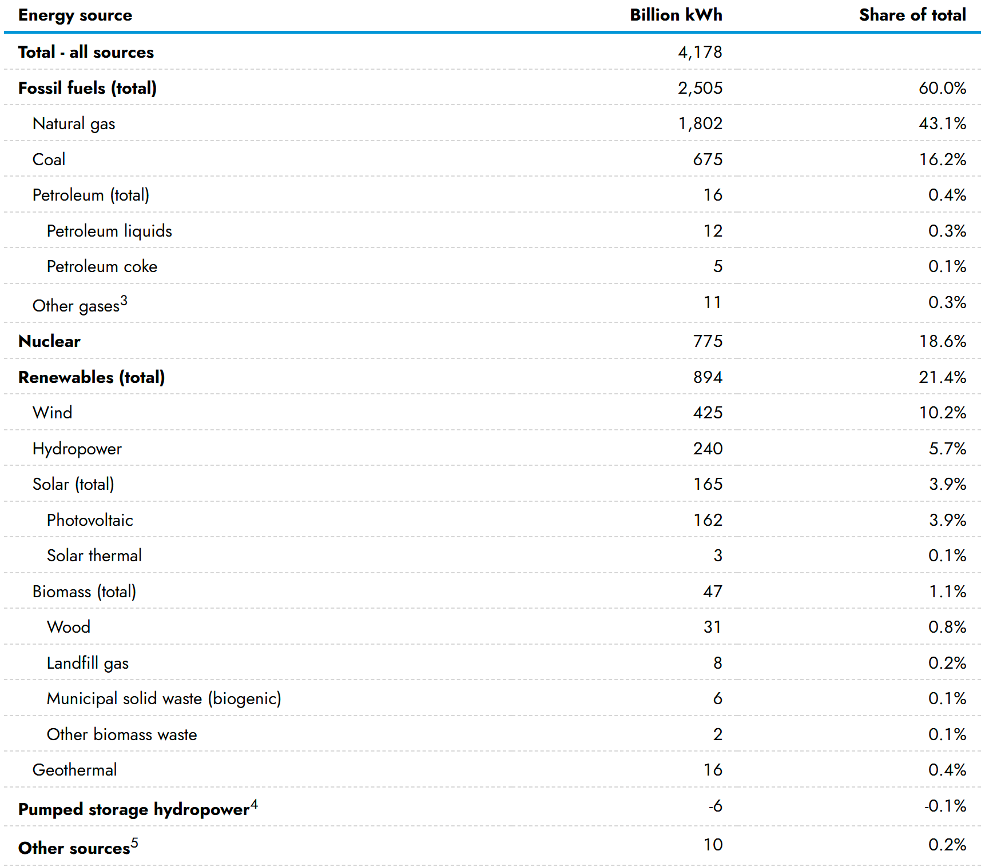

While in Europe, the energy generation sources are Nuclear (22.9%), wind (17.6%), Natural gas (16.8%), Coal (12.3%), Hydropower (11.8%) and Solar (9.1%), as is shown in the figure below.

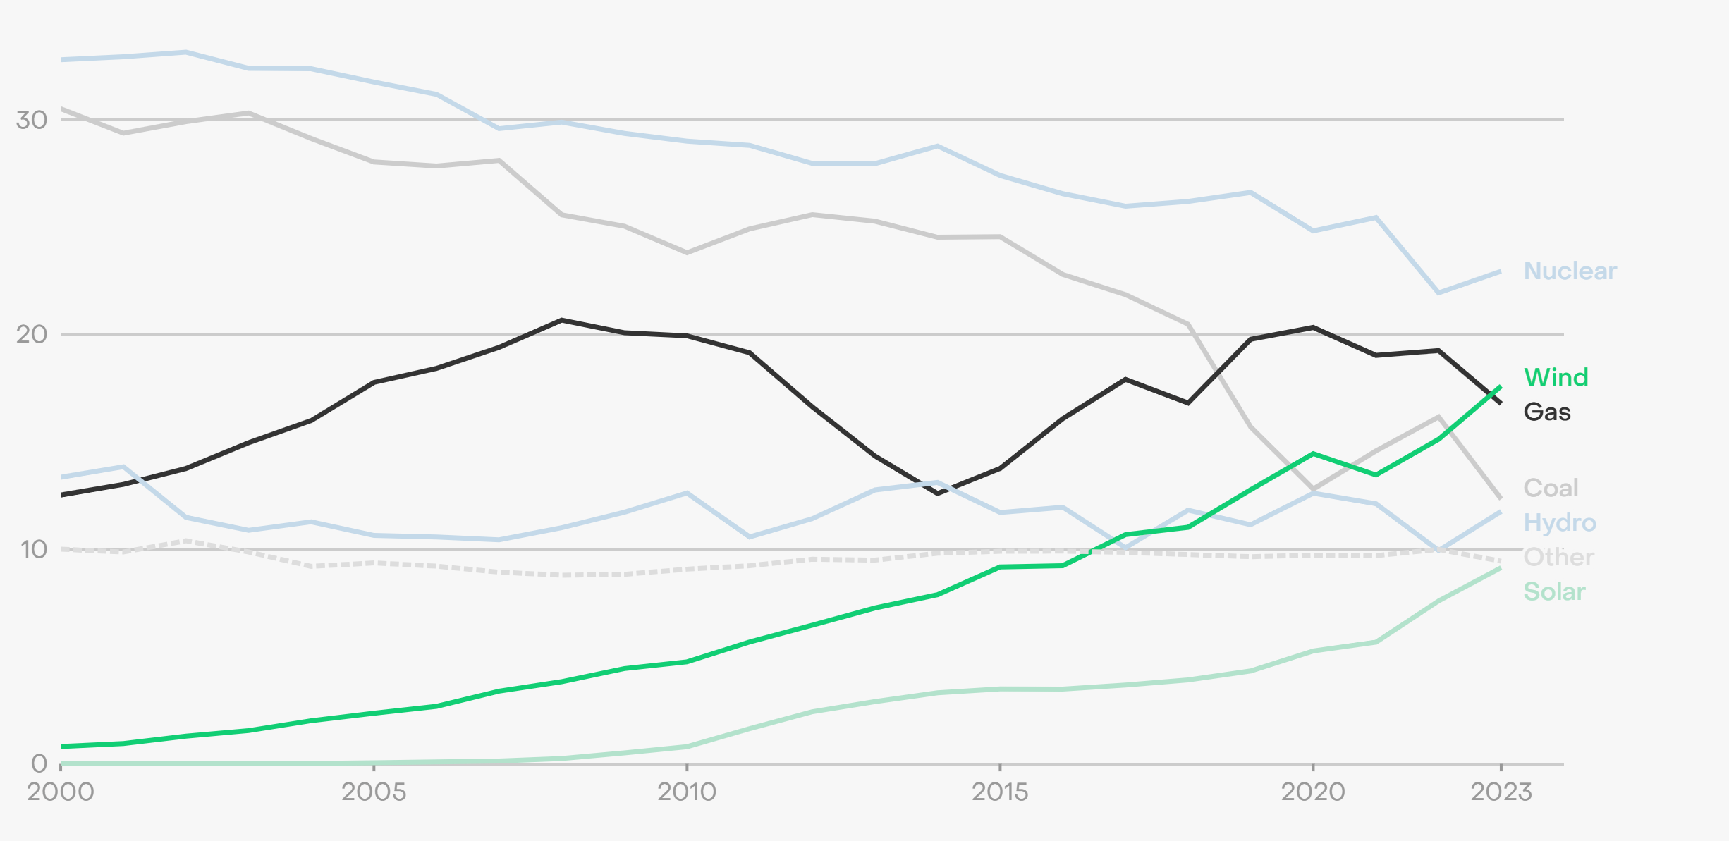

Figure 1: Share of EU electricity generation, by source (%) [21]

In Australia, Coal contributed 46%, natural gas contributed 17% and rest is generated by renewables including solar (16%), wind (12%) and hydro (6%) in 2023 [38].

While in India, Coal power accounted for 74.3% of electricity generation, hydropower contributed 7.6%, natural gas contributed 2.6%, nuclear contributed 2.5% and solar contributed 5.8% in 2023 [39].

China produced most of its electricity in 2023 from Coal power which contributed to 60.5% of electricity generated, while hydropower contributed 13.2% ,gas contributed 3% and nuclear contributed 4.6%

Using these statistics, computing the energy consumption requirement for the following sources would give us a better understanding of total energy consumed in the electricity generation process.

1. Natural Gas
2. Coal
3. Nuclear
4. Renewables

Renewables includes sources such as solar, wind and hydropower. These sources are classified as renewables because these sources of energy are constantly replenished and do not run out on human timescales.

### Natural Gas

Natural gas power plants make up a majority of the electricity produced in the US. The efficiency of natural gas power plants is in between 48-55% [22], [23], [24].

$$\begin{aligned}η=\frac{output energy}{input energy} \\ input energy=\frac{output energy}{η}\#\left(1\right)\end{aligned}$$

This means that to generate 1kWh of energy, the input energy is about 2kWh (considering an average efficiency of 50% and using the relationship in (1)). This 2kWh of energy input also includes the energy required to mine the fuel , transport it and the energy content of the fuel itself.

### Coal

Coal is another key source of fuel used to generate electricity. Coal is inherently very energy dense and is abundant in lot of countries, making it an affordable source of energy. However, since the process of generating energy involves burning the fuel, the emissions from combustion of coal can contribute to greenhouse gas effect.

The efficiency of traditional coal power plants is in between 42% to 46% [25][26]. This efficiency is higher in modern plants which use advanced technologies such as super critical carbon dioxide cycles that can increase the efficiency to 51% [27]. There are also a few plants that implement a carbon capture technology that in turn reduce the efficiency of the power plant by 10% due to the energy spent in capture and compression processes [28]. Thus, considering an average efficiency of 45%, the energy input to generate 1kWh of energy is about 2.22kWh from $\left(1\right)$.

### Nuclear:

Nuclear power plants operate in a similar fashion to coal and natural gas power plants. Nuclear fuel is broken down via fission which generates heat and this heat is used to power a steam cycle similar to coal and natural gas power plants and thus electricity is generated. Although the methodology is similar, there are vast differences in the environmental impacts. Since fission does not involve combustion, there are no biproducts that are released into the atmosphere and thereby nuclear plants do not contribute to greenhouse effect. However, handling the nuclear fuel and disposal of nuclear waste (biproduct of nuclear power plants) is a unique challenge that only nuclear power plants face.

There are several nuclear power plant designs each with a different efficiency of power conversion. For instance, Boiling Water Reactors (BWR) have an efficiency of 32%, which can be increased to 33% with advanced designs. Pressurized Water Reactors (PWR) can improve from 33% to 36.5% with enhancements like gas burners and reheating. Small Modular Reactors (SMR) show potential for higher efficiencies, reaching up to 45% when combined with technologies like Combined Cycle Gas Turbines (CCGT)[29].

Considering an average efficiency of 35%, the input energy required to generate 1kWh of energy is about 2.85kWh from $\left(1\right)$.

### Renewables

The electricity generation from electricity is different from fossil fuels or nuclear power generation in that it does not involve a recurring cost for procuring the fuel. Thus the input energy is basically free and any energy consumption happens in the form of maintenance which is miniscule for the purposes of this study. Hence, the energy consumed in the generation phase of renewables is assumed to be negligible. Note that the energy consumed for maintenance of renewables is ignored here because the maintenance energy is relatively low as compared to the overall energy produced in this stage. When it comes to maintenance of the vehicle itself, the energy required is not negligible and thus is considered in later part of this study. Similarly, there is a cost incurred to transport the electricity to the grid in the form of transmission losses. Since this is a component that’s common to all the forms of energy generation.

Now that we have the input energy estimate for all the form of electricity generation, we can now compute the overall energy input required to generate one kWh of electricity. To compute this quantity for a generic mix of electricity generation sources we can assume the following composition

Table 2: Electricity generation sources

|  |  |  |
| --- | --- | --- |
| Energy source | Percentage composition | Input energy to generate 1kWh of energy |
| Natural gas | $$n$$ | 2 kWh |
| Coal | $$c$$ | 2.22 kWh |
| Nuclear | $$ϕ$$ | 2.85 kWh |
| Renewables | $$r$$ | ~0 kWh |

Using the percentage composition and the energy required to generate 1kWh of energy from the table above, the energy required to generate $E_{output}$ of energy from the assumed composition ( $E_{total})$ is as follows

$$\begin{aligned}E_{total}=\left(2η+2.22c+2.85ϕ+0r \right)E_{output}\end{aligned}$$

$$\begin{aligned}⟹E_{total}=(2η+2.22c+2.85ϕ)E_{output} \#\left(2\right)\end{aligned}$$

The next stage of energy transfer involves transporting the generated electricity to consumers.

## Energy consumed to transport the electricity

Transporting the electricity is an inevitable expenditure since energy is generated at concentrated locations which can be in most cases far away from energy consumers. The distribution of generated energy is managed by the electric grid which also plays the role of balancing the loads and frequency of electricity supply that goes out to the consumers. According to the U.S. Energy Information Administration (EIA), the annual electricity transmission and distribution (T&D) losses averaged about 5% of the electricity distributed and transmitted in the US between 2018 to 2022 [30]. Thus, for every 1kWh of energy distributed, the input energy must be 1.05kWh. Therefore, the following relationship holds between the input and output energy for this stage.

$$\begin{aligned}E_{transport}=1.05 E_{output}\#\left(3\right)\end{aligned}$$

## Energy lost in conversion to mechanical energy

Modern electric cars have an extremely high efficiency of energy conversion. This is also one of the main advantages of electric cars over traditional internal combustion engines. Electric cars use electric motor to convert electricity into mechanical power which has an efficiency of about 85% [31]. This is significantly higher than internal combustion engines which have an average efficiency of conversion of about 30% [32]. Thus, the following equation can be used to relate the energy input and output for this stage of energy conversion.

$$\begin{aligned}E_{propulsion}=\frac{E_{output}}{0.85}=1.17×E_{output}\#\left(4\right)\end{aligned}$$

## Energy consumed in manufacturing of the vehicle

Manufacturing of electric vehicles is an energy intensive process and consumes more energy than comparable internal combustion of hybrid electric vehicle due to the presence of a massive battery pack. The process of manufacturing a battery pack involves mining of the required rare earth metals such as Lithium and Cobalt and then refining them and packing them into battery cells which are then assembled to make a battery pack. Each of these process involve high energy consumption as compared to an internal combustion vehicle that has an engine instead of a battery pack and only requires metal forming of widely abundant metals such as steel and assembly to build an engine [33]. And unlike battery packs that loose capacity over time, engines can also last longer if regular maintenance procedures such as oil changes are performed. Thus, internal combustion vehicles have the upper hand when it comes to energy consumption for manufacturing the vehicle.

Table 3: Energy consumption and CO2 emissions for different processes that form a part of vehicle manufacturing [34]

|  |  |  |
| --- | --- | --- |
| Manufacturing Process | Energy (MJ) | CO2 (kg) |
| Material transformation | 19,340 | 1,065 |
| Machining | 982 | 56 |
| Vehicle Painting | 4,167 | 268 |
| HVAC & lighting | 3,335 | 225 |
| Heating | 3,110 | 195 |
| Material handling | 690 | 46 |
| Welding | 920 | 62 |
| Compressed air | 1,380 | 93 |
|  |  |  |
| Total | 33,924 | 2,013 |

The above table shows the total energy consumed in the processes involving the manufacturing of an internal combustion vehicle (33,924MJ). For an electric vehicle however, the energy cost of manufacturing battery and motors must be added to this figure. Burnham et al. computes the energy cost of manufacturing an electric vehicle as 12,657MJ [35]. This brings the total cost of manufacturing an electric vehicle to 46,581MJ. In kWh, this translates to 12,940kWh.

## Energy consumed in maintenance of the vehicle

Maintenance is another key area where electric vehicles have an advantage over traditional internal combustion engine vehicle or even hybrid electric vehicles. Since electric vehicle do not require regular oil changes, the energy expended in such activities is eliminated. Additionally, electric vehicle relies on regenerative braking for reducing the speed of the vehicle instead of relying hydraulic brakes that wear down over time. Thus, electric vehicles require less brake pad replacements over their lifetime as compared to internal combustion engine vehicles.

However, battery packs in electric vehicles gradually loose capacity over charging cycles. The only remedy for this loss of electric range is to replace the entire battery pack which can be an additional burden that few electric vehicle owners need to face. According to EV news issue [36], only 2.5% of EVs have their battery replaced over 20,000EVs examined. Thus, we can assume an energy consumption of 2.5% of energy required to manufacture a battery and include this in the computation of energy consumed for maintenance.

$$\begin{aligned}E_{maintenance}=2.5\%×12,657MJ=316MJ=87.7kWh \#\left(5\right)\end{aligned}$$

Thus, we can see that even considering the battery pack replacements for EVs, the cost maintenance is lower compared to traditional vehicles.

# Results

To compute the overall energy consumed during the lifetime of operating an electric vehicle, we can assume a lifetime average mileage of 200,000 miles. As observed in the $E_{propulsion}$ computation, most EVs are highly efficient at energy conversion from electrical to mechanical over internal combustion engine vehicle. This is also evident in the fact that most EVs have an average real world energy consumption of 4.76miles/kWh [37]. Thus, for a lifetime mileage of 200,000 miles, an EV consumes.

$$\begin{aligned}E_{charge}=\frac{200,000miles}{\frac{4.76miles}{kWh}}=42,017kWh\#\left(6\right)\end{aligned}$$

This $E_{charge}$ is the energy input to the electric vehicle. To compute the overall energy consumed to generate $E_{charge}$ amount of electricity at the power outlet, we can use the efficiency computations performed earlier to backpropagate the input energy required until the source of energy.

The first step of this is to find the energy required to produce $E_{charge}$ of output at the start of electricity transmission.

$$\begin{aligned}E_{transport}=E_{charge}× 1.05 \#\left(7\right)\end{aligned}$$

In the next step, we include the efficiency of electricity generation

$$E_{total}=E_{transport}×(2η+2.22c+2.85ϕ)$$

$$=1.05×\left(2η+2.22c+2.85ϕ\right)E_{charge}$$

$$\begin{aligned}=44,117\left(2η+2.22c+2.85ϕ\right)kWh\#\left(8\right)\end{aligned}$$

This $E_{total}$ represents the total energy consumed in generating the electricity required to charge an electric vehicle over its lifetime.

To compute the total energy consumed in the operation of the electric vehicle over its lifetime, the energy consumption of manufacturing and maintenance can be added to $E_{total}$. This results in,

$$E_{consumption}=E_{input}+E_{manufacturing}+E_{maintenance}$$

$$\begin{aligned}=44,117\left(2η+2.22c+2.85ϕ\right)kWh+ \\ 12,940kWh+87kWh \#\left(9\right)\end{aligned}$$

$$\begin{aligned}E_{consumption}= 44,117\left(2η+2.22c+2.85ϕ\right)+ \\ 13,028 kWh \#\left(10\right)\end{aligned}$$

Shifting the focus to energy output, the EV has an average mileage of 200,000 miles over its lifetime, during which it consumes $E_{charge}$ amount of electricity. Thus $E_{charge}$ is the energy input to the electric vehicle and the corresponding energy output can be computed by assuming an 85% efficiency of conversion.

$$E_{wheels}=E_{charge}×0.85$$

$$\begin{aligned}=42,017kWh×0.85=35,714kWh\#\left(11\right)\end{aligned}$$

Finally, the overall well to wheels efficiency can be computed as

$$η_{well-to-wheels}=\frac{E_{wheels}}{E_{consumption}}$$

$$\begin{aligned}=\frac{35,714kWh}{44,117\left(2η+2.22c+2.85ϕ\right)+13,028 kWh}\#\left(12\right)\end{aligned}$$

Using the above equation, the well to wheels efficiency of an electric vehicle can be easily computed for any composition of energy sources.

The below table uses this relationship and the statistics presented earlier regarding the energy source composition for different regions of the world to compute the well to wheels efficiency of operating electric vehicles in different parts of the world.

Table 4: Well to wheel efficiency of electric vehicles in various parts of the world

|  |  |  |  |  |
| --- | --- | --- | --- | --- |
| Regions | Natural gas | Coal | Nuclear | $$η_{well-to-wheels}$$ |
| US | 43.1% | 16.2% | 18.6% | 39.54% |
| Europe | 16.8% | 12.3% | 22.9% | 51.99% |
| Australia | 17% | 46% | 0% | 48.88% |
| India | 2.6% | 74.3% | 2.5% | 39.14% |
| China | 3% | 60.5% | 4.6% | 44.24% |

# Conclusion

In this study, a detailed computation of well to wheel efficiency of electric vehicles is presented in a generic form that can accept different energy source mix for electricity. The results in Table 4, validate what is already known that a higher renewable energy mix can lead to better well to wheels efficiency. This is also clearly evident in the fact that Europe, which has the highest renewable energy based power generation, realizes the best well to wheels efficiency of ~52%. This can be inferred from the fact that the recurring cost for the capture of energy for renewable energy is negligible while in the case of non-renewables like nuclear or fossil fuels, the amount of energy expended to procure the fuel is very high. By avoid this energy cost entirely, the total input energy or the energy consumption is reduced massively when electricity is sourced from renewable energy.

These results also highlight that electric vehicles are more efficient than comparable internal combustion engine vehicles, hybrid electric vehicles and plug in hybrid electric vehicles. And this is independent of region of operation. Even in the case of complete nonrenewable energy mix, this would be the case because the efficiency of converting heat from combustion of fuel is higher in concentrated power generation plants as compared to internal combustion engines. This is because power plants can deploy advanced technologies like waste heat recovery and they also operate at a higher temperature and compression ratio [7] as compared to internal combustion engine operation, making them highly efficient. While localized conversion of heat to mechanical energy in an internal combustion engine (which has to satisfy added restrictions like a weight limit, cost limits etc.) is not capable of achieving such high efficiencies. This is also demonstrated in the computations presented in the earlier works preceding this study, where the well to wheels efficiency of hybrids and plug in hybrids is shown to be under 27%. Thus electric vehicles have at least a 44% higher well to wheels efficiency than their traditional counterparts.

To conclude, this study along with the preceding studies [6]&[9] present a comprehensive analysis of well to wheels efficiency for battery electric vehicles, mild hybrids and plug in hybrids. These results will be used in future studies to generate case studies that explain the advantages of using one vehicle architecture over the other while considering the lifetime costs and environmental impact of owning any of these vehicles.

Disclaimer (Artificial intelligence)

Option 1:

NO AI USE

Author(s) hereby declare that NO generative AI technologies such as Large Language Models (ChatGPT, COPILOT, etc.) and text-to-image generators have been used during the writing or editing of this manuscript.

##### References

1. Masson-Delmotte, Valérie, et al. "Global warming of 1.5 C." An IPCC Special Report on the impacts of global warming of 1 (2019): 93-174.
2. Abraham, Sarin, et al. "Impact on climate change due to transportation sector–research prospective." Procedia engineering 38 (2012): 3869-3879.
3. Yuhan Huang et al. "Fuel consumption and emissions performance under real driving: Comparison between hybrid and conventional vehicles.." The Science of the total environment, 659 (2019): 275-282 . <https://doi.org/10.1016/j.scitotenv.2018.12.349>.
4. František Synák et al. "Assessing the Energy Efficiency of an Electric Car." Communications, 23 (2020). <https://doi.org/10.26552/com.c.2021.1.a1-a13>.
5. Sweeting, W., Hutchinson, A., & Savage, S. (2011). Factors affecting electric vehicle energy consumption. International Journal of Sustainable Engineering, 4, 192 - 201. https://doi.org/10.1080/19397038.2011.592956
6. Chinthoju, Prajwal Kumar, and Raksha Sreenath Vashishta. 2025. “well-to-wheels Efficiency and Energy Consumption Analysis for Mild Hybrid Electric Vehicles”. Journal of Engineering Research and Reports 27 (2):216-27. <https://doi.org/10.9734/jerr/2025/v27i21406>.
7. Beijia Huang et al. "Life cycle cost analysis of solar energy via environmental externality monetization.." The Science of the total environment (2022): 158910 . https://doi.org/10.1016/j.scitotenv.2022.158910.
8. Sanjay Khan et al. "Building integrated photovoltaics powered electric vehicle charging with energy storage for residential building: Design, simulation, and assessment." Journal of Energy Storage (2023). https://doi.org/10.1016/j.est.2023.107050.
9. Chinthoju, Prajwal Kumar, Raksha Sreenath Vashishta, and Ravi Jagirdar. "Well-to-Wheels Efficiency Analysis for Plug-in Hybrid Electricvehicles." Journal of Engineering Research and Reports 27.3 (2025): 328-340.
10. Chinthoju, Prajwal Kumar. Optimal design of eVTOLs for urban mobility using analytical target cascading (ATC). Diss. University of Illinois at Urbana-Champaign, 2022.
11. Chinthoju, Prajwal, et al. "Optimal Design of eVTOLs for Urban Mobility using Analytical Target Cascading (ATC)." AIAA SCITECH 2024 Forum. 2024.
12. Chinthoju, Prajwal Kumar. "Cost Per Flight Analysis Of Tilt-Wing Evtols For Urban Mobility." International Journal of Applied Engineering and Technology 6.4 (2025): 110-120.
13. Jagirdar, Ravi, Prajwal Kumar Chinthoju, and Raksha Sreenath Vashishta. "MATHEMATICAL MODELING FOR AI-POWERED CURBSIDE MANAGEMENT AT AIRPORTS." Journal of Public Transportation 4.1 (2025): 60-73.
14. João Pedro Da Silva Rodrigues et al. "Comparison of Well-to-Wheel energy efficiency between combustion vehicles and electric vehicles.." 2022 International Conference on Electrical, Computer and Energy Technologies (ICECET) (2022): 1-4. https://doi.org/10.1109/ICECET55527.2022.9872658.
15. Mengyu Li et al. "A comparative assessment of battery and fuel cell electric vehicles using a well-to-wheel analysis." Energy, 94 (2016): 693-704. https://doi.org/10.1016/J.ENERGY.2015.11.023.
16. Q. Hassan et al. "Hydrogen Fuel Cell Vehicles: Opportunities and Challenges." Sustainability (2023). https://doi.org/10.3390/su151511501.
17. Xinyu Liu et al. "Well-to-Wheels Analysis of Zero-Emission Plug-In Battery Electric Vehicle Technology for Medium- and Heavy-Duty Trucks.." Environmental science & technology (2020). https://doi.org/10.1021/acs.est.0c02931.
18. David C. Quiros et al. "Greenhouse gas emissions from heavy-duty natural gas, hybrid, and conventional diesel on-road trucks during freight transport." Atmospheric Environment, 168 (2017): 36-45. https://doi.org/10.1016/J.ATMOSENV.2017.08.066.
19. Harshit Saini et al. "Well-to-wheel performance of internal combustion engine vehicles and electric vehicles – study for future Indian market." Energy Sources, Part A: Recovery, Utilization, and Environmental Effects, 45 (2023): 2089 - 2111. https://doi.org/10.1080/15567036.2023.2182844.
20. US Energy Information Administration: Electric Power Monthly, Feb 2024 issue, <https://www.eia.gov/electricity/monthly/>
21. European Electricity Review 2024, Ember, <https://ember-energy.org/latest-insights/european-electricity-review-2024/>
22. Y. Xiang et al. "Study on the configuration of bottom cycle in natural gas combined cycle power plants integrated with oxy-fuel combustion." Applied Energy, 212 (2018): 465-477. https://doi.org/10.1016/J.APENERGY.2017.12.049.
23. J. Amann et al. "Natural gas combined cycle power plant modified into an O2/CO2 cycle for CO2 capture." Energy Conversion and Management, 50 (2009): 510-521. https://doi.org/10.1016/J.ENCONMAN.2008.11.012.
24. Ting Lei et al. "A novel post-combustion CO2 capture process for natural gas combined cycle power plant based on waste energy utilization and absorption heat transformer." Energy (2025). https://doi.org/10.1016/j.energy.2025.134491.
25. Hao Zhang et al. "Efficiency improvement for coal-fired power plants by H2/O2 combustion: Performance analysis and economic evaluation." Journal of Energy Storage (2024). https://doi.org/10.1016/j.est.2024.111615.
26. C. Fu et al. "Thermal efficiency of coal-fired power plants: From theoretical to practical assessments." Energy Conversion and Management, 105 (2015): 530-544. https://doi.org/10.1016/J.ENCONMAN.2015.08.019.
27. ZhaoFu Wang et al. "The roadmap towards the efficiency limit for supercritical carbon dioxide coal fired power plant." Energy Conversion and Management (2022). https://doi.org/10.1016/j.enconman.2022.116166.
28. K. Goto et al. "A review of efficiency penalty in a coal-fired power plant with post-combustion CO2 capture." Applied Energy, 111 (2013): 710-720. https://doi.org/10.1016/J.APENERGY.2013.05.020.
29. M. Abedin et al. "Efficiency analysis of nuclear power plants: A comprehensive review." World Journal of Advanced Research and Reviews (2023). https://doi.org/10.30574/wjarr.2023.19.2.1553.
30. U.S. Energy Information Administration (EIA), Monthly Energy Review (April 2024), Tables 7.1, 7.2a, 7.3a, 7.6, and A6; and EIA, Form EIA-923, "Power Plant Operations Report."
31. Sweeting, W., Hutchinson, A., & Savage, S. (2011). Factors affecting electric vehicle energy consumption. International Journal of Sustainable Engineering, 4, 192 - 201. https://doi.org/10.1080/19397038.2011.592956.
32. František Synák et al. "Assessing the Energy Efficiency of an Electric Car." Communications, 23 (2020). https://doi.org/10.26552/com.c.2021.1.a1-a13.
33. Zhichao Liu et al. "Life Cycle Assessment–based Comparative Evaluation of Originally Manufactured and Remanufactured Diesel Engines." Journal of Industrial Ecology, 18 (2014). https://doi.org/10.1111/jiec.12137.
34. Sullivan, John Lorenzo, Andrew Burnham, and Michael Wang. Energy-consumption and carbon-emission analysis of vehicle and component manufacturing. No. ANL/ESD/10-6. Argonne National Lab.(ANL), Argonne, IL (United States), 2010.
35. Burnham, A., Wang, M., and Wu, Y., 2006, Development and Applications of GREET 2.7 – The Transportation Vehicle-Cycle Model, ANL/ESD/06-5, Center for Transportation Research, Argonne National Laboratory, Argonne, IL
36. Only 2.5% Of EV’s Have Battery Replaced, EV news, July 2024 <https://www.evchargingcablestore.com/ev-news/only-2-5-of-evs-have-battery-replaced>
37. Martin Weiss et al. "Energy Consumption of Electric Vehicles in Europe." Sustainability (2024). https://doi.org/10.3390/su16177529.
38. Australian Government - Energy Generation Statistics, Department of Climate change, Energy, the Environment and Water. <https://www.energy.gov.au/energy-data/australian-energy-statistics/electricity-generation>
39. Yearly electricity data, Ember, <https://ember-energy.org/countries-and-regions/india/>
40. Yearly electricity data, Ember, <https://ember-energy.org/countries-and-regions/china/>
41. M. Campisi et al. "The power of a critical heat engine." Nature Communications, 7 (2016). <https://doi.org/10.1038/ncomms11895>.
42. Karmaker, A.K.; Hossain, M.A.; Manoj Kumar, N.; Jagadeesan, V.; Jayakumar, A.; Ray, B. Analysis of Using Biogas Resources for Electric Vehicle Charging in Bangladesh: A Techno-Economic-Environmental Perspective. Sustainability 2020, 12, 2579
43. Vashishta, Raksha Sreenath, Prajwal Chinthoju, and Ravi Jagirdar. 2025. “Next Generation Fleet Fuel Fraud Prevention: Application of CAR PAY Framework”. Asian Journal of Advanced Research and Reports 19 (4):229-42. <https://doi.org/10.9734/ajarr/2025/v19i4978>