EFFECTIVENESS OF WATER ALTERNATING GAS INJECTION (WAG) FOR OIL RECOVERY IN THE NIGER DELTA

.

ABSTRACT

|  |
| --- |
| Many reservoirs on discovery have weak primary drive mechanisms an thus, are augmented with either water injection or gas injection for pressure maintenance to improve recovery. Unfortunately, using either water or gas injection has proven not to be sufficient to reduce the residual oil saturation, thus leaving behind substantial volume of unrecoverable hydrocarbons. Hence, one of the options that has been engineered to optimally reduce the residual oil saturation is the water-alternating gas injection which has been proven due to its capacity to increase both oil displacement and sweep efficiency. This research investigates the effectiveness of Water-Alternating-Gas injection in comparison with Waterflooding or Gas injection standalone methods for optimal oil recovery using a field in the Niger Delta as a case study. The Eclipse Simulator was used to simulate the Field oil efficiency (FOE), Field oil production total (FOPT) and the field water cut (FWCT) for WAG injection and compared with that of Waterflooding and Gas injection. From the results, WAG injection had an FOE (recovery factor of 34%), FOPT of 76.46 MMSTB and a FWCT of 26% while waterflooding alone has an FOE of 26.65%, FOPT of 57.62MMSTB and a FWCT of 47.58% respectively. The FOE , FOPT and FWCT of gas injected were estimated to be 21.35%, 47.89MMSTB, and 9.2% respectively. From the results, it could be inferred that WAG injection technique proved to be the most effective recovery technique in maximizing oil recovery, based on its recovery performance, having the highest recovery factor and a minimal water cut, compared to waterflooding and gas injection as standalone technique. |

*Keywords: Enhanced oil recovery, Water-Alternating-Gas Injection (WAG), waterflooding, gas injection, residual oil saturation, recovery efficiency*

1. INTRODUCTION

Within the Niger Delta province are three main lithostratigraphic units that make up the thick sedimentary succession namely; Benin formation, Agbada formation and Akata formation, with majority of the hydrocarbon found in the Agbada formation’s sandstone reservoir (Oluwajana et al, 2017, Etimita and Beka, 2019). As global energy demand continues to increase, optimizing oil production becomes crucial. Crude oil production can be achieved through different levels of recovery: primary, secondary and tertiary recovery respectively.

Primary recovery basically uses the natural energy of the reservoir to produce the trapped hydrocarbon from the subsurface (Hussein, 2023). However, due to insufficiency of this natural drive in most reservoirs, the drive is aided by supplemental energy sources to sustain production through the use of artificial lift methods like gas-lifting and pumps (Speight and El-Gendy, 2018). However, to prevent drastic drop in production and particularly, to sustain production during the plateau phase for a relatively longer time, pressure maintenance is carried out which involves primarily gas or water injection (Farahbod, 2024). The injection of water or gas for pressure maintenance is what is termed secondary recovery. It is a technique that supplements the natural reservoir energy by injection of fluids (water or gas) through injection wells using different patterns, primarily for pressure maintenance. When the volumetric rate of production is equal to the volumetric rate of fluid replacement in the reservoir, pressure maintenance is achieved in oil production, keeping the average reservoir pressure constant (Archer and Wall, 1986).

The requirement for tertiary oil recovery techniques arises from the fact that the mobility of crude oil has decreased in such a way that both standard artificial lift techniques and pressure maintenance methods have failed to achieve reasonable recovery and thus, so much crude oil is left underground and the reservoir energy is fast depleted. Tertiary recovery, also known as enhanced oil recovery (EOR), entails injecting fluids into the reservoir while applying methods for improvement other than only providing external energy to sweep and enhance crude oil recovery (Lake et al, 2014).

A typical tertiary oil recovery technology known as the Water-Alternating Gas (WAG) Injection process is used to increase the displacement efficiency through mobility control and prevention of viscous fingering of the leftover oil that cannot be recovered during the primary and secondary recovery procedures (Afzali et al, 2018). Gas fingering during gas injection could lead to unfavourable mobility ratio that reduces the sweep efficiency (Afzali et al, 2018;Holm, 1972; Moffitt and Zorn, 1992; Watts et al 1982). Gas fingering and gas breakthrough could be exacerbated by reservoir heterogeneities, resulting from fractures and high permeable layers (Birarda et al 1990; Cuesta and Merritt, 1982). WAG is an enhanced oil recovery (EOR) technique that increases oil recovery effectiveness by combining gas injection with water flooding (Kumar and Mandal, 2017). The method was developed to improve the oil displacement of gas injection and the sweep efficiency in waterflooding procedures (Abdullah and Hasan, 2021). To improve recovery and control gas mobility, WAG optimization is one of the best schemes to deploy (Chen et al, 2010). It is estimated that 80% of the United States of America (USA) WAG injection field projects are productive, and the WAG injection method is currently a recognized technology in total oil recovery enhancement by the re-injection of produced gas in water injection wells in an oil field (Shokufe et al, 2018).

Different types of WAG techniques have been studies over the years to improve the reduction of the residual oil saturation. Typical example is the study by Kulkarni and Rao (2004), where they carried out an experimental investigation through core flooding to compare gas injection and WAG and observed that WAG is superior to gas injection in reducing the residual oil saturation. Srivastava and Laxminarayan (2012) conducted an experimental investigation on GS-5C Sand of Gandhar Field to assess the applicability of WAG injection in mature light oil field's and observed incremental oil production through the WAG process with an improved displacement efficiency of 23.73 percent over the single cycle injection processes. WAG injection technique combines the improved macroscopic sweep efficiency of water flooding with the increased microscopic displacement of gas injection, thus resulting to a stabilized displacement and controlled increased mobility by alternately injecting gas and water slugs (Srivastava and Mahli, 2012). In this study, the Water-Alternating-Gas Injection (WAG) recovery method is used to determine the recovery performance of a selected oil field in the Niger Delta in comparison to waterflooding and gas injection recovery methods.

2. methodology

The field of study is an oil field located in the Niger Delta. The field is owned by a marginal operator but acquired from one of the major International oil companies (IOC) operating in Niger Delta. The reservoir used for this study was originally discovered as a depletion drive reservoir being the predominant drive mechanism at discovery. However, as at the time of acquisition from the major operator, pressure has declined below the bubble point pressure.The remaining reserves of the field was estimated to be about 35.7MMstb. To capture the initial scenario of the reservoir, the reservoir was modelled first for natural depletion and thereafter, optimization was done using waterflooding, gas injection and finally, water alternating gas injections.

Table 1 shows some of the input data used for the simulation. That data used for the simulation includes reservoir, well, PVT,fluid data respectively. The petrophysical properties of the rock (porosity, permeability and net-to-gross(NTG) were modeled using Petrel software and included in the grid file ‘PETREL PETRO.GRDECL” which were used as inputs for the reservoir simulation. The PVT data was modeled using PVTsim while well performance was modeled using Prosper software and imported as data file into Eclipse software. ECLIPSE Compositional Simulator was used to model the reservoir performance under natural depletion, waterflooding, gas injection, and water alternating gas injection (WAG) respectively. The predicted dominant drive mechanism of the oil field is the depletion drive and the reservoir pressure was found to be initially above the bubble point pressure. Depletion drive reservoirs have low ultimate recovery and are known to experience rapid decline in reservoir pressure and increase in the gas-oil ratio (Ahmed and Meehan, 2012). Having the pressure of this reservoir declined below the bubble point results in rapid reservoir pressure drop and increasing GOR and thus reduction in hydrocarbon production; the justification for investigating the application of waterflooding, gas injection or water-alternating gas injection as alternatives to natural depletion investigation.

A total of 10 wells were used for investigating the reservoir pressure maintenance; six (6) producer wells namely N2, N3, A4, E2, E3 & E4 and 4 injector wells (INJ1, INJ2, INJ3 & INJ4). FLOVIZ tool in Eclipse was used to model waterflooding and gas injection and also adjust the perforations of the wells to ensure that they produce from the oil-bearing zones only.

3. results and discussion

To compare optimization performance from each scenario investigated, the field oil efficiency (FOE) which represents the ultimate recovery for each method, the field oil production rate (FOPR), field oil production total (FOPT) and the field wate-rcut was determined for all three recovery methods. Figure 1 shows the 3D simulation models for the different recovery methods with the producers and injectors. Figures 1a is the 3D model for the natural depletion, 1b is the 3D model for waterflooding, 1c is the 3D model for gas injection and 1d is for the water-alternating gas injection model respectively.

**Table 1: Summary of Input data used for the simulation**

|  |  |  |
| --- | --- | --- |
| **S/N** | **Field Data** | |
| 1 | Original Oil in Place (OOIP) (STB) | 35,665,294 |
| 2 | API (degrees) | 39 |
| 3 | Recovery Factor (%) | 14.305 |
| 4 | Oil Formation Volume Factor (Bo) (Rbbl/stb) | 1.6629 |
| 5 | Initial Formation Volume factor (Boi) (Rbbl/stb) | 1.6024 |
| 6 | Oil Viscosity (cp) | 0.3942 |
| 7 | Water Viscosity (cp) | 0.27 |
| 8 | Rock Compressibility (1/Psi) | 5.00 x 10-5 |
| 9 | Water Compressibility (1/Psi) | 5.00 x 10-5 |
| 10 | Oil Saturation (%) | 0.85 |
| 11 | Initial Water Saturation (%) | 0.39 |
| 12 | Saturation Pressure (Psi) | 300 |
| 13 | Oil Density (Ib/ft3) | 829.7675 |
| 14 | Gas Density (Ib/ft3) | 1.0449 |
| 15 | Water Density (Ib/ft3) | 1020 |

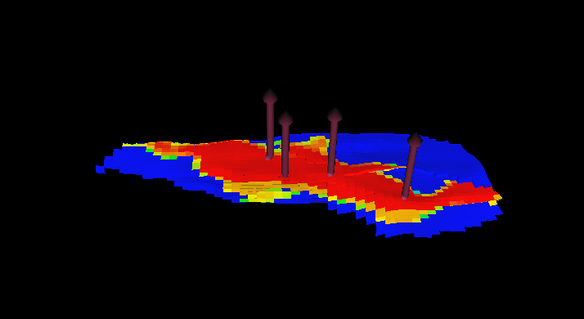 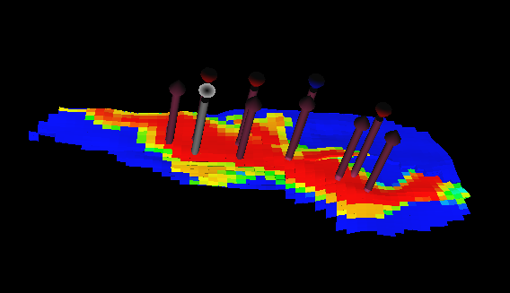

1. (b)

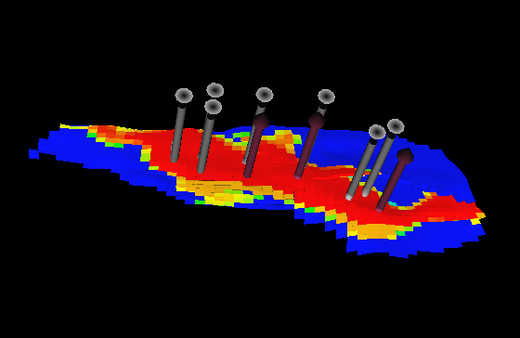 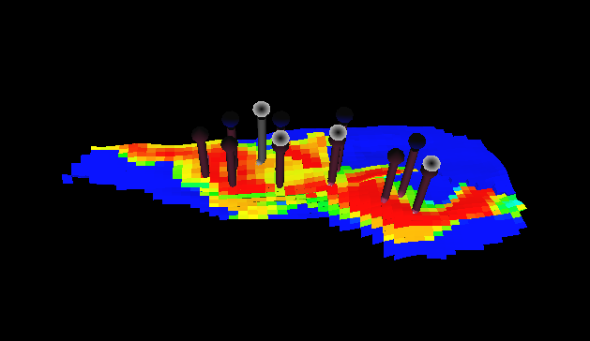

(c) (d)

Figure 1: 3D Model of different scenarious investigated. 1(a) is the is the 3D model for the natural depletion, 1(b) 3D model for waterflooding, 1(c) 3D model for gas injection and 1(d) is for the water-alternating gas injection model respectively.

Production from each of the scenario were plotted and the field oil efficiency, field oil production total and field water-cut were monitored over time for each case. Figure 2 is the result of field oil efficiency (FOE) over time. As can be seen, WAG has the highest recovery factor, 34%, followed by waterflooding and then gas injection that has 26.65% and 21.35% after 5.5 years of production. The outstanding performance of the WAG method over waterflooding and gas injection is made more obvious in Figure 3 that compares the the field oil production rate (FOPR) for each method. As can be seen in Figure 3, all methods attain a plateau rate of about 46,000stb/day after 2.16 months of production. However, decline sets in for gas injection method after 2.02 years of production, and the production rate dropped from 46,000stb/day to barely 10000 stb/day after 5.5 years of production. For the water injection, decline phase sets in after 2.18 years and production rate dropped to about 17000 stb/day while WAG has a longest plateau with 3.78 years and field production rate declined to about 30,000 stb/day after 5.5 years of production as shown in Figure 3. The cumulative field oil production (FOPT) is shown in Figure 4. WAG still proved superiority over the other methods with a cumulative production 76.46MMstb compared to waterflooding that has 59.62MMstb and the least was seen from gas injection with 47.89MM stb after 5.5 years of production as shown in Figure 4. The water cut observed from each method was also compared as shown in Figure 5. As expected, the field water cut is highest with waterflooding with a value of 47.58%, followed by WAG and the least water cut was observed in gas injection as shown in Figure 5. These results are similar to results from a study by Inaloo et al, (2014). A summary of the performance of each method is shown in Table 2.

.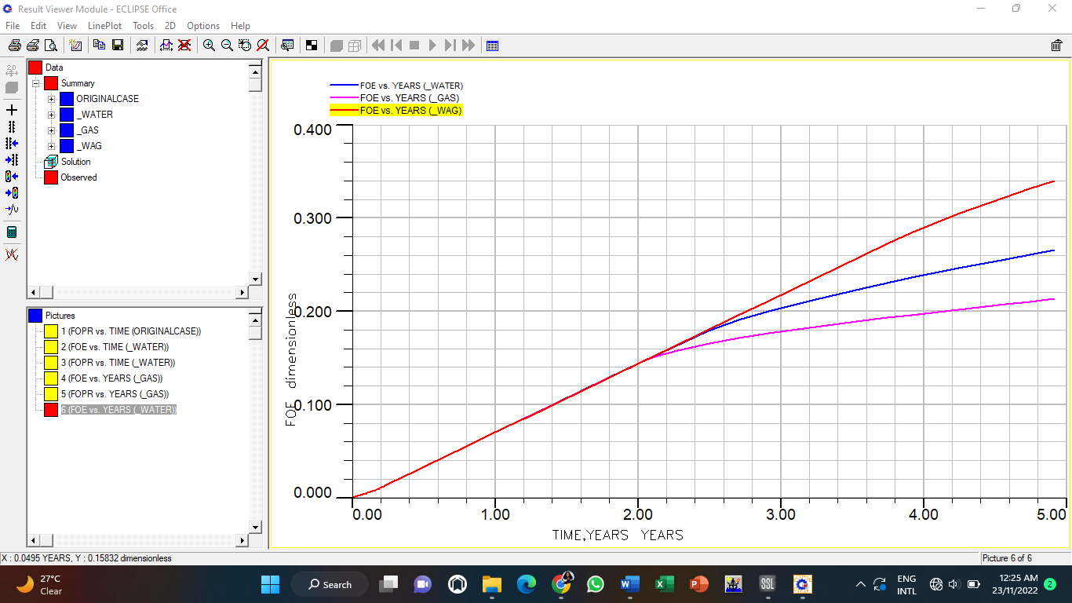

Fig.2: Plot of FOE vs TIME (yrs) – Waterflooding, Gas and WAG Injection

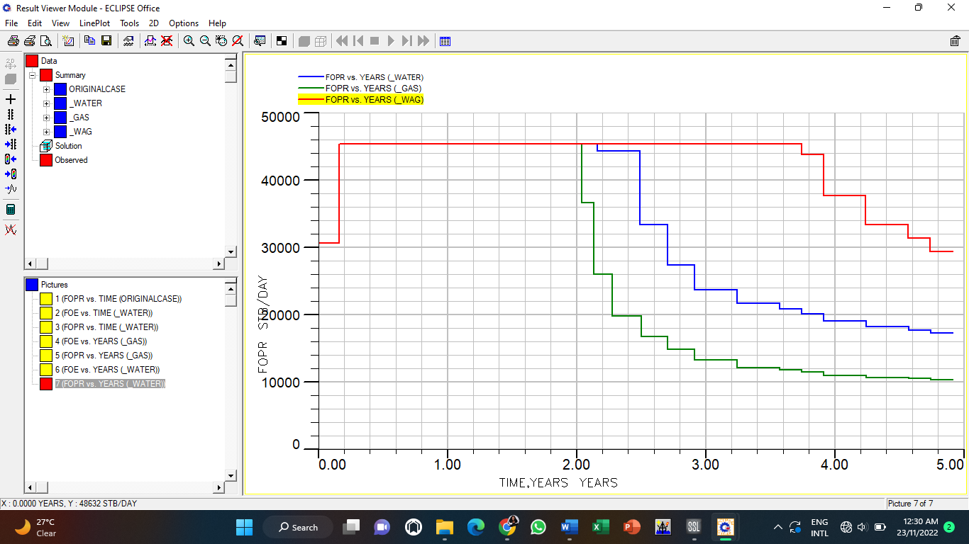

Fig.3: Plot of FOPR vs TIME (yrs) – Waterflooding, Gas and WAG Injection

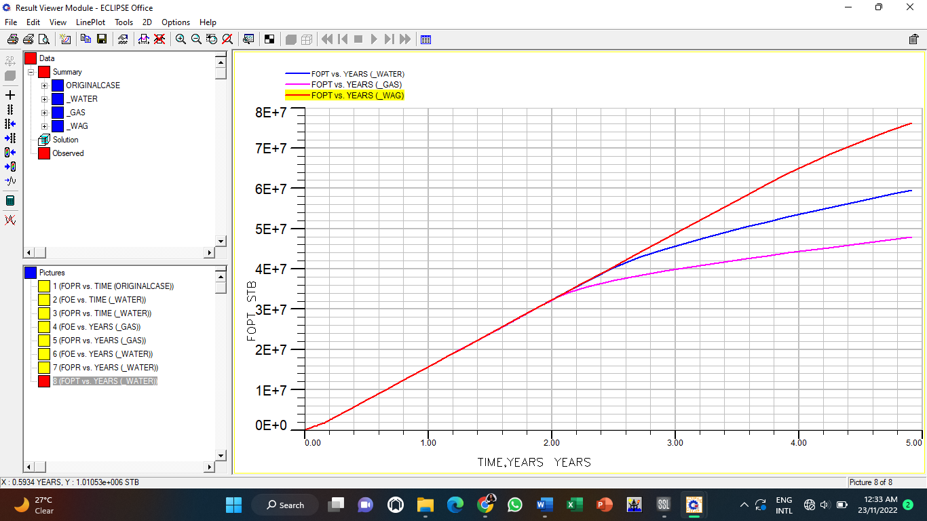

Fig.4: Plot of FOPT vs TIME (yrs) – Waterflooding, Gas and WAG Injection

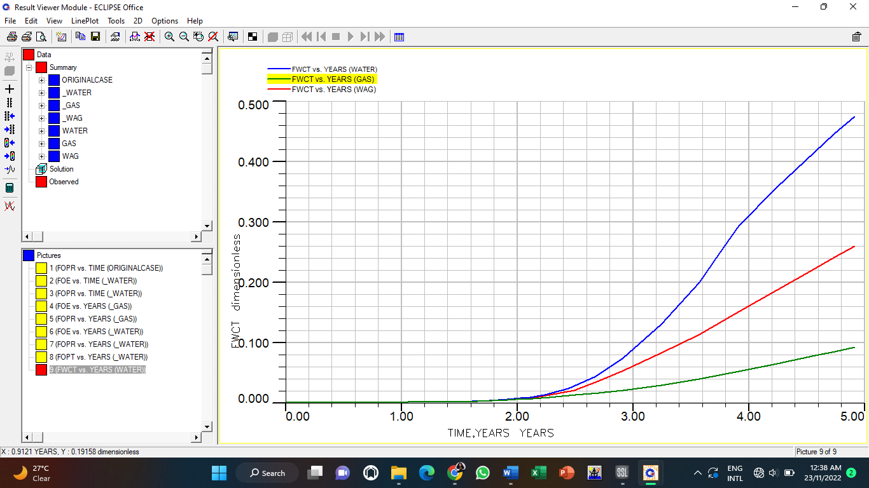

Fig.5: Plot of FWCT vs TIME (yrs) – Waterflooding, Gas and WAG Injections

**Table 2: FOE Results for Waterflooding, Gas and WAG Injection**

|  |  |  |  |
| --- | --- | --- | --- |
| Parameter | Waterflooding | Gas Injection | WAG |
| FOE (Recovery Factor, %) | 0.2665 | 0.2135 | 0.34 |
| FOPR (Plateau) (yrs) | 2.2 | 2.0 | 3.7 |
| FOPT (MMSTB) | 59.62 | 47.89 | 76.46 |
| FWCT (%) | 0.4758 | 0.092 | 0.2611 |

4. Conclusion

The use of WAG particularly at early stages of oil production is gaining ground particularly in reservoirs whose primary drive mechanism is the depletion drive for pressure maintenance. However, WAG could be applied only when at discovery the reservoir is saturated or the emergence of secondary gas cap during depletion of an undersaturated reservoir. For undersaturated reservoirs, only waterflooding is recommended for pressure maintenance until the development of secondary gas cap where either waterflooding or gas injection as standalone methods could be deployed. The use of WAG in this study considers a saturated reservoir whose initial conditions are below the bubble point pressure, thus the suitability of the comparison of the three methods to investigate their performance under the same conditions. From the simulation, it could be seen that in all the scenarios investigated, WAG outperformed both the waterflooding and gas injection as standalone techniques in optimally producing the reservoir of interest. Thus, key conclusions drawn from this investigation are:

1. WAG injection had a maximum field oil efficiency (FOE) of 34%, a field oil production total (FOPT) of 76.46 MMSTB, a plateau time of 3.7years and a field water cut (FWCT) of 26.11%.
2. Waterflooding had a FOE of 26.65%, a FOPT of 59.62 MMSTB, a plateau time of 2.2years and FWCT of 47.58%. Whereas gas injection had an FOE of 21.35%, a FOPT of 47.89 MMSTB, a plateau time of 2 years, and FWCT of 9.2%.
3. The recovery efficency using WAG is highest, followed by water floowding and the least is from gas injection
4. Field water cut is highest using the waterflooding method, followed by WAG and the least is in gas injection
5. From comparative analysis of the three recovery methods, WAG injection outperformed both waterflooding and gas injection with the highest FOE and minimal water cut after 5.5 years of production. Therefore, in comparison to waterflooding and gas injection methods, WAG technique has thus far demonstrated to be the most effective recovery method for optimal oil recovery for the selected oil field in the Niger Delta.

AcknowledgEments

The authors wish to thank the Management of the Institute of Petroleum and Energy Studies in providing the software for this research work.

Competing interests

The author wish to declare that there is no known competing interest that may arise from this research. It is an original work from the authors and does not need any special permission to publish the outcome of their research

Authors’ Contributions

Miss Deborah Yeezor was a project student of Dr Amieibibama Joseph. The topic and supervision was wholly provided by Dr Joseph while the research and simulation was carried out by miss Deborah

**DISCLAIMER (ARTIFICIAL INTELLIGENCE)**

Author(s) hereby declare that NO generative AI technologies such as Large Language Models (ChatGPT, COPILOT, etc.) and text-to-image generators have been used during the writing or editing of this manuscript.

References

1. Oluwajana, O. A., Ehinola, O. A., Okeugo, C. G. & Adegoke, O. (2017). Modeling hydrocarbon generation potentials of Eocene source rocks in the Agbada Formation, Northern Delta Depobelt, Niger Delta Basin, Nigeria. Journal of Petroleum Exploration and Production Technology, 7(2):379-388. <https://doi.org/10.1007/s13202-016-0286-y>
2. Etimita, O. O. & Beka, F. T. (2019). Structural to stratigraphic framework of “Banghan” field, onshore Niger Delta, southern Nigeria. Geology, Ecology, and Landscapes, 4(3), 216–221. <https://doi.org/10.1080/24749508.2019.1616154>
3. Hussein, A. (2023). Chapter 1 - Oil and Gas Production Operations and Production Fluids, Essentials of Flow Assurance Solids in Oil and Gas Operations, Gulf Professional Publishing,1-52, <https://doi.org/10.1016/B978-0-323-99118-6.00012-5.>
4. Speight, J.G. & El-Gendy, N. S. (2018): Chapter 4 - Microbial Enhanced Oil Recovery, Introduction to Petroleum Biotechnology, Gulf Professional Publishing, p. 103-130, <https://doi.org/10.1016/B978-0-12-805151-1.00004-7.>
5. Farahbod F. (2024). Simulation study of water and gas injection process into the Azadegan reservoir for enhanced oil recovery. Engineering Reports. 6(2):e12709. doi: [10.1002/eng2.12709](https://doi.org/10.1002/eng2.12709)
6. Archer, J.S. and Wall, C.G. (1986) Petroleum Engineering Principles and Practice. Graham and Trotman.
7. Lake, L., Johns, R. T. Rossen, W.R. & Pope, G. A. (2014). Defining Enhanced Oil Recovery", Fundamentals of Enhanced Oil Recovery, Society of Petroleum Engineers DOI: <https://doi.org/10.2118/9781613993286>
8. Afzali, S., Rezaei, N & Zendehboudi, S. (2018). A comprehensive review on Enhanced Oil Recovery by Water Alternating Gas (WAG) injection, Fuel, 227: 218-246, <https://doi.org/10.1016/j.fuel.2018.04.015.>
9. Holm L.(1972). Propane-gas-water miscible floods in watered-out areas of the adena field, Colorado. J Petrol Technol 24(10). 1264–170.
10. Moffitt P., & Zornes D. (1992). Postmortem analysis: lick creek meakin sand unit immiscible CO2 waterflood project. SPE Annual technical conference and exhibition. Society of Petroleum Engineer.

1. Watts, R. J., Conner, W. D., Wasson. J. A. & Yost, A. B. (1982). CO2 injection for tertiary oil recovery, Granny's Creek Field, Clay County, West Virginia. SPE enhanced oil recovery symposium. Society of Petroleum Engineers
2. Birarda, G. S., Dilger, C.,& McIntosh I. (1990). Re-evaluation of the miscible WAG flood in the Caroline Field, Alberta. SPE Reservoir Eng 5(04):453–8.

1. Cuesta J, & Merritt G.(1982). Caroline wag project, injectivity and interference test-a field example. J Canad Petrol Technol. Canadian Inst Mining Metallurgy Petroleum 101 6th Ave Sw, Ste 320, Calgary Ab Tzp 3p4, Canada; 1982:33
2. Kumar, S. and Mandal, A. (2017). A comprehensive review on chemically enhanced water alternating gas/CO2 (CEWAG) injection for enhanced oil recovery, Journal of Petroleum Science and Engineering, 157: 696-715. <https://doi.org/10.1016/j.petrol.2017.07.066.>

1. Abdullah, N., Hasan, N. (2021). The implementation of Water Alternating (WAG) injection to obtain optimum recovery in Cornea Field, Australia. J Petrol Explor Prod Technol 11, 1475–1485. <https://doi.org/10.1007/s13202-021-01103-7>

1. Chen S, Li H, Yang D & Tontiwachwuthikul P. (2010). Optimal parametric design for water alternating-gas (WAG) process in a CO2-miscible flooding reservoir. J Can Pet.Techno,49(10):75–82.
2. Shokufe, A.; Nima, R.; & Sohrab, Z. (2018). A Comprehensive Review on Enhanced Oil Recovery by Water Alternating Gas Injection. Journal of Fuel, 227, 218 – 246.
3. Kulkarni M & Rao D. (2004): Experimental investigation of various methods of tertiary gas injection. SPE annual technical conference and exhibition. Society of Petroleum Engineers; 2004.
4. Srivastava J.P. & Laxminarayan, M. (2012). Water Alternating Gas Injection, a Novel EOR Technique for Mature Light Oil Fields: A Laboratory Investigation for GS-5C Sand of Gandhar Field. 9 th Biennial International Conference & Exposition on Petroleum Geophysics. Ahmedabad, 109
5. Srivastava J.P & Mahli L. (2012). Water alternating gas (WAG) injection a novel EOR technique for mature light oil fields a laboratory investigation for GS-5C sand of Gandhar field. In: Biennial international conference and exposition in petroleum geophysics
6. Ahmed, T. & Meehan, D. N (2012). Chapter 4 - Performance of Oil Reservoirs, Advanced Reservoir Management and Engineering (Second Edition), Gulf Professional Publishing, 433-483, <https://doi.org/10.1016/B978-0-12-385548-0.00004-X>
7. Inaloo, M.B., Jafari, F. & Helalizadeh, A. (2014). Comparison of water flooding, gas injection and WAG injection scenarios performance in a five spot pattern. World Applied Sciences Journal. 31: 96-103. 10.5829/idosi.wasj.2014.31.01.1881.