*Data-Driven Insights Machine Learning Approaches for Netflix Content Analysis and Visualization*

*Abstract*— This paper looks at Netflix's strategic application of machine learning and data analytics to improve user involvement, maximize content strategy, and keep its leadership in the cutthroat streaming market. This research reveals important patterns in Netflix's content library including the geographical distribution of content creation, content classification by rating, and changing watching habits over time by use of exploratory data analysis (EDA) and sophisticated visualization tools like Python and Tableau. According to the study, Netflix's content and user data is mostly produced by the United States (36.6%) and India (24.1%), followed by other nations including Japan, France, and Canada albeit in lesser but noteworthy proportions. Moreover, a high inclination for adult audience material is clear: 43.0% of TV series rated "TV-MA" and 33.7% of movies categorized under the same grade. Using clustering and regression among other machine learning methods, content success is predicted and audience preferences are analyzed, therefore illuminating the impact of particular genres and directors on audience trends. Content additions show a spike in output between 2014 and 2020, with the United States keeping leadership as nations like South Korea and India become more well-known via a time-series study. Correct data integrity guarantees by data preprocessing—including null value analysis—allows correct insights. With genres like "Stand-Up Comedy" and "Dramas, International Movies" rising as top categories, the report also emphasizes Netflix's dependence on prominent filmmakers and genre-specific content initiatives. This work shows how data-driven decision-making impacts Netflix's content acquisition and recommendation system by combining visualizing with machine learning. Future studies should investigate geographical variances, sentiment analysis, and predictive modeling to better grasp audience involvement techniques and streaming industry dynamics.

Keywords—Netflix, exploratory data analysis, Tableau, Python.

# **Introduction**

Having over 230 million members as of 2024, Netflix has evolved from its 1997 origins as a DVD rental company to become of the most powerful streaming platforms worldwide. The company's quick climb results from its ability to adapt to evolving consumer trends and new technology. Netflix's data-driven approach has helped it to be so successful. By using enormous datasets, the platform maximises its content collecting, helps corporate development, and provides tailored user experiences. Data is not only an output but an integral part of Netflix's business model, allowing the company to monitor user behaviour and comprehend worldwide trends in content. To keep ahead in the very competitive streaming business, companies like Netflix rely on data analytics and machine intelligence.Regarding streaming platforms, one cannot stress the need of data analysis enough. Different international audiences, always shifting viewer interests, and the continuous need to produce or acquire engaging material define the dynamic environment in which streaming services live. Data analysis helps platforms to predict user behaviour, identify trends in data, and make intelligent decisions. For instance, services may learn which genres are most popular in certain places and modify their material depending on watching statistics. Machine learning greatly enhances these abilities by allowing predictive analytics and automated insight extraction. Through data-driven strategies such content recommendation systems and finding high-potential original ideas, platforms may today offer value to consumers and stakeholders. Netflix distinguishes itself in data's revolutionary capacity with its innovative customised content recommendations.

Finding useful insights and patterns in Netflix's massive data environment is the goal of this research study. Examining Netflix's content catalogue, user preferences, and streaming behaviours in depth using exploratory data analysis (EDA) and machine learning approaches is the goal of this study. Using these methods, the study hopes to unearth previously unseen trends and provide light on how data influences Netflix's strategic decisions. In addition, the importance of visualising data for making a strong and intuitive presentation of results is highlighted in this study. Data visualisations serve to both elucidate intricate datasets and provide insights to a wide range of users, including scholars and experts in the field.

This study will apply machine learning techniques including clustering to group related material, classification to examine audience behaviour, and regression models to forecast content performance. Key patterns, such the growth of certain genres, the distribution of viewer preferences by geography, and the development of Netflix's content collection, will be brought to light through the integration of these methods with visualisation tools. By showing how data analysis and machine learning may revolutionise streaming platform operations, this article aims to close the gap between raw data and actionable information. The research adds to our understanding of a market leader and offers insights that are applicable throughout the streaming industry by focussing on Netflix.

# Literature Review

## Overview of existing studies on Netflix data analysis.

Thanks to Netflix's explosive climb to the top of the streaming market, both academics and companies are rather eager to explore the data-driven projects of the corporation. Several studies have looked at how Netflix uses data to keep ahead in a market always shifting, enhance user experiences, and optimise content choices. Emphasising personalisation, content strategy, and predictive analytics, this review compiles significant findings from past Netflix data analysis studies and highlights areas this study aims to cover.Considered vital to Netflix's success, Netflix's recommendation system has been the subject of several research.

The innovative essay on the Netflix recommendation engine by Gomez-Uribe and Hunt (2015) details the collaborative filtering, content-based filtering, and machine learning models working together to deliver millions of viewers tailored choices. These systems look at data like ratings and viewing patterns in order to provide suggestions and projections about user tastes. Further study based on hybrid approaches and real-time data has expanded upon this to improve accuracy and user delight. Because of how effective Netflix's recommendation algorithms are, streaming providers like Disney+ and Amazon Prime Video have embraced them as standard [1].

Apart from its suggestions technique, researchers have worked extensively on Netflix's content strategy, particularly with regard to its decision-making process on original programs. Data analysis is essential for identifying trends and gaps in the content collecting so that one may make wise decisions about next productions. Before sanctioning a project, Netflix uses advanced analytics to ascertain if it will appeal to its target market, claims Smith and Telang (2020). One instance of how Netflix employs data research to produce material appealing to a broad variety of viewers is the global popularity of Stranger Things and Money Heist. Studies have also revealed that the company employs social media sentiment analysis and evaluation to monitor public reception of their content and determine future course of action [2].

Another area of much interest in the published studies is the application of machine learning in predictive analytics. Research on Netflix's usage of prediction algorithms to evaluate factors like content performance, membership increase, and viewing frequency is abound. Data scientists and industry experts have collaborated to illustrate how to use neural networks and regression models to estimate consumer turnover rates, therefore enabling Netflix to effectively use retention strategies. By use of clustering techniques, users' viewing habits may be further segmented, thereby illuminating demographic and regional preferences [3].

## Role of machine learning in entertainment analytics.

What has really distinguished machine learning (ML) from its forebears in the entertainment industry is its capacity to examine and evaluate vast datasets with the goal of delivering individualised experiences, enhancing content strategies, and anticipating audience behaviour. Streaming firms such Disney+, Hulu, and Netflix have used ML techniques to keep ahead of the competition and increase user interaction and operational efficiency. This paper explores the important part machine learning plays in entertainment analytics using cases from content recommendation, audience segmentation, predictive modelling, and content generation [6].

Among the most often used applications of machine learning in the entertainment sector are recommendation systems. These systems look at users' activity including ratings, searches, and viewing history to provide suggestions for items they are more likely to appreciate. The recommendation engine, which displays the outstanding use of machine learning, is one of the most noticeable characteristics of Netflix that has helped to explain its appeal. Gomez-Uribe and Hunt (2015) explained the recommendation system Netflix uses—which combines collaborative filtering, content-based filtering, and matrix factorisation techniques—to offer exact and always shifting choices [4]. Other platforms have also begun using similar approaches, which emphasises the need of ML-driven recommendations for enhancing user experience and retention [7].

Audience segmentation depends also on machine learning. Using clustering techniques like k-means and hierarchical clustering, streaming services may categorise customers based on their demographics, viewing patterns, and other user-provided data. By means of segmentation, platforms provide greater understanding of their audience, hence enabling customising of user interfaces and marketing strategies. Analysing user preferences depending on geography helps Netflix to produce and promote locally appropriate content as Dark in Germany or Sacred Games in India. Studies show that these focused strategies may significantly raise audience satisfaction and propel platform growth by using machine learning insights [8].

Predictive modeling—which allows platforms to forecast how people will engage with content and how effectively it will function—is one significant application of machine learning in entertainment analytics. Common tasks for regression models, neural networks, and decision trees are predicting subscriber attrition, lifetime value, and the success potential of new content. Netflix use predictive analytics to evaluate the likelihood of a program or film being well-received using elements including genre, talent, production costs, and past data on such material. Such projections are crucial for allocating resources and creating strategies to optimise the return on investment (ROI) from content production projects [9]

Machine learning supports content creation and production decisions as well. Sentiment analysis, a subset of natural language processing (NLP), helps one examine social media assessments, comments, and arguments regarding current content. Measuring audience sentiment helps platforms to enhance their content strategy and discover fresh story or genre possibilities. Moreover, the extensive application of algorithms for script analysis and casting recommendations helps to enable data-driven decision-making in content development by automating some creative process stages [10].

Though the breakthrough results from applying machine learning in entertainment analytics have been generated, there are still challenges to overcome. Key obstacles include problems with data privacy, algorithmic bias, and the interpretability of complex models. The sector is now looking at ways to mix machine learning with advanced visualisation technologies to increase the accessibility and actionability of insights for stakeholders even further [11].

## Gaps in previous research

Though a lot of research on data analysis and how machine learning affects streaming companies like Netflix exists, many unresolved issues still require attention. The main reasons of these gaps are scalability of models in capturing the always changing character of user behaviour and content trends, accessibility of datasets, and integration of advanced visualisation techniques with machine learning. It is important to close these gaps so that one may better understand how streaming platforms use data to drive operations and strategy [12]..

One of the main challenges to earlier research is Netflix's limited supply of private datasets. Netflix's proprietary data—which the private company maintains under wraps—includes specifics on user behaviour, content information, and performance measures. Sometimes academic study makes use of publicly available or fictional datasets that might not fairly reflect Netflix's actual corporate operations. Studies on recommendation systems, for example, often rely on secondary datasets like MovieLens, which although valuable cannot match the volume and richness of actual data gathered by Netflix. This limitation prevents researchers from completely exploring the possibilities of machine learning algorithms in an environment of real streaming platforms [13].

# Methodology

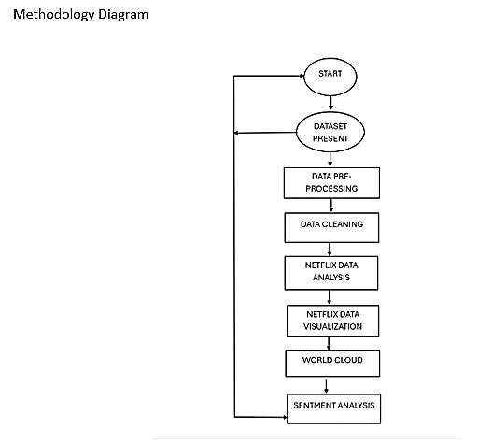

Figure : Methodology

The methodology diagram provides a thorough approach to data analysis and visualisation, with special focus on a dataset related with Netflix. The initiation phase is what starts the process at the "START" point, its beginning. The "DATASET PRESENT" node then shows whether the method has looked for availability of the dataset. The process looping back to ensure the suitable acquisition or preparation of the dataset should if one is not available shows the iterative character of the approach.

" DATA PRE-PROCESSING" comes first, after the dataset is available. In order to prepare the raw dataset for further investigation, we handle missing values, duplicate entries, and pointless data at this point. Standardising and formatting the dataset will help to ready it for further operations. Following pre-processing, the method proceeds in the " DATA CLEANING" stage, which addresses dataset variances. Ultimately, this repairs errors, manages outliers, and assures data accuracy, therefore producing a more polished and reliable dataset.

" NETFLIX DATA ANALYSIS" comes next once the data has been polished. At this point, we apply many statistical and analytical techniques to extract relevant information from the data. Finding trends, connections, and patterns in the data might help one to reach certain objectives or respond to specific research questions. Based on this stage, the next phases of the method are founded.

The second stage, "NETFLIX DATA VISUALISATION," turns the examined data into graphic forms like graphs, charts, and infographics. Visualisation helps one grasp and communicate otherwise challenging-to-understand material by simplifying and displaying it. This section of the process provides visual summaries of the dataset's properties and trends, therefore enhancing the interpretive value of the research [5].

Once the visualisation is finished, the procedure proceeds to "WORD CLOUD," a stage meant to identify and show the most regularly occurring keywords or terms in the dataset. This approach is perfect for study of text-based data as it highlights the most significant themes or words. A visual depiction of literature, the word cloud enables one to rapidly grasp the most crucial elements of the content.

Not least among other things is "sentiment analysis." By now we ought to be able to categorise the attitude of the dataset as neutral, negative, or positive. Subjective data is assessed in sentiment analysis by means of ML models and natural language processing (NLP) methods. This is a crucial initial step if you wish to know how others see Netflix or anything related.The method makes multiple feedback loops to guarantee that everything is flawless at every level. To address any issues or anomalies discovered in a past stage, the operation might revert to pre-processing or cleaning. The repetitive character of the analysis guarantees its dependability and strength.

# RESULTS AND DISCUSSION

## Total Content Produced in each Country

The pie chart shows each country's proportion of overall material generated in relation to the whole dataset. At 36.6% of the total weight, the United States is clearly the biggest contributor. Particularly on platforms like Netflix, the U.S. is heavily involved in the global production of entertainment, and this dominance reflects that. At 24.1%, India is the second biggest contributor; its vibrant film and entertainment industry is well-known for its broad spectrum of genres appealing to fans all over. Among further notable manufacturers are Japan (8.0%), France (4.4%), Spain (3.9%), and Canada (10.5%).

With over 5% of internationally distributed Netflix Originals and Exclusives in 2019, South Korea has become a major actor in Netflix's production scene [21]. This emphasizes how progressively important non-English speaking markets are to Netflix's worldwide approach.

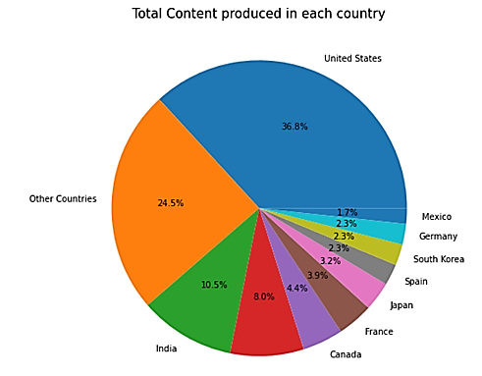

Figure : Pie chart showing Total Content Produced in each Country

Contributions from German, South Korea, and Mexico all fall less than 3%. These nations' entertainment industries range in maturity from just beginning to flourish. The "Other Countries" category—which aggregates donations from nations not ranked in the top 10—accounts for 10.5% overall.

This study highlights differences in content creation among nations as well as the concentration of output in a small number of major countries. Strategic decisions for a streaming platform like content procurement, regional targeting, and development into new markets depend on knowing such distribution.

Although the visualisation combines everything rather than separating material by genre, language, or publishing year, it is instructive. Future studies including these details might help to provide a more thorough picture of manufacturing trends. Although the "Other Countries" section keeps things straightforward, it does so at the price of underlining the possible influence of smaller markets in more specialist environments.

## Total Movie and TV Distribution Rate

Two pie charts show the ranked films and TV shows' distribution. Given that 33.7% of all films fall under "TV-MA," many of them seem to be geared towards an older audience. With 23.3%, "TV-14" has the second highest rating and denotes that many films fit consumers 14 years of age and above. Among other noteworthy ratings indicating varying degrees of parental counsel and appropriateness are "R" (13.1%), "TV-PG" (8.8%), and "PG-13" (7.1%). Smaller classifications like "G" (2.1%) and "NR" (4.7%) exclude unrated or general audience films, so there might not be many of them.

Content rating analysis of Netflix shows a clear focus on mature consumers [18]. For example, according to a survey, TV-MA is the most common classification; TV-14 comes second and R/TV-PG comes third. TV-MA makes 36% of the programming per another study; TV-14 at 25% [17]. This distribution highlights Netflix's deliberate emphasis on mostly serving adults

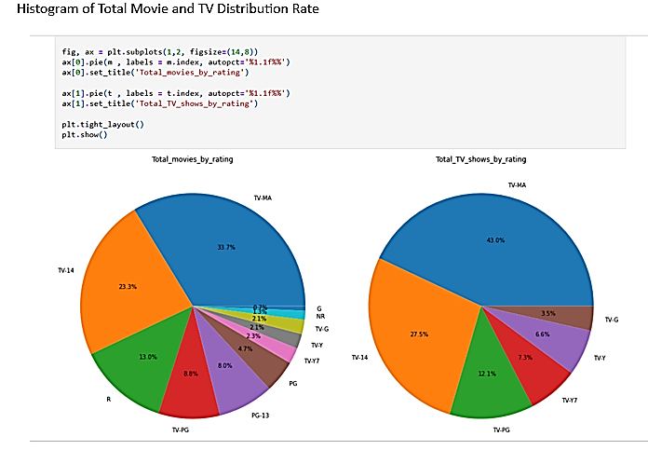

Figure : Pie charts showing Total Movie and TV Distribution Rate

Given the largest proportion of 43.0% going to "TV-MA" in the TV show category, adult material is clearly highly valued in the TV industry. Comprising 27.5%, the "TV-14" category consists of a sizable share of programs aimed at teenage audiences. Other ratings like "TV-PG" (12.1%) and "R" (7.3%), have smaller shares than wide audience ratings like "TV-G" (6.6%). This distribution clearly shows a concentrate on material fit for older and teenage viewers across both films and TV shows in keeping with audience demand trends.

## Total Movie and TV Show by Duration

Broken down by nation, a line graph displaying the overall number of films and TV shows ("show_id") added year shows the trends in movie and TV show durations throughout several nations from 2008 to 2020. The United States seems to be the top contributor, stressing its supremacy in worldwide entertainment creation and its capacity to fast grow content. Starting around 2014 and reaching a peak between 2018 and 2020, the country shows a rise in output. Other countries, such South Korea, India, and the UK, exhibit constant gains in content addition, notably following 2014, which is a reflection of their rising prominence in the worldwide entertainment sector and the range of their products. Conversely, smaller contributions from countries like France, Germany, and Australia suggest that industrial activities concentrate more on certain markets or niches.

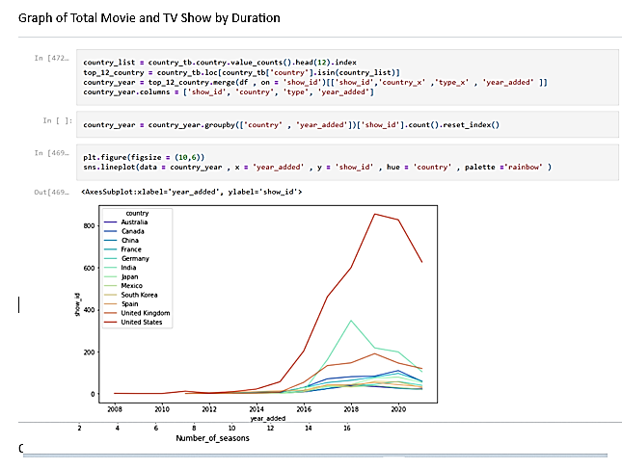

Figure : This graph shows Total Movie and TV Show by Duration

Since 2014, most countries have seen a definite growing trend in streaming services like Netflix, which have expanded their content libraries to draw people all across the globe. Many outside factors, particularly the worldwide disturbance of production plans and release pipelines brought on by the COVID-19 epidemic, helped to explain the sharp decline in content additions following 2020. These inclinations show even further how streaming services have enabled nations like South Korea and India to become globally known by means of the sharing of cultural narrative and original material appealing to people all around. Thanks to its dominant infrastructure and significant entertainment industry investment, the United States is able to maintain a high degree of content development. The consistent increase in American content production serves to show this.

## Null Value Analysis

The first step in the document—an essential preprocessing step for any data analysis—is addressing missing data. Heatmaps were produced to show the findings after missing or null values in the dataset were found using Python. Heatmaps are a useful tool to have at hand for fast evaluating data completeness and spotting trouble areas. Subsequently, null values were eliminated from the dataset to ensure the correctness of the next investigations. This level emphasises the requirement of accurate data if one wants dependable and relevant insights.

## DataVisualization

This work finds trends and patterns using Python and Tableau visualising Netflix's content library. Among these is a histogram displaying the site's whole movie and TV series distribution. This facilitates the comparison of their ratios and identification of the most often used one. We also consider their percentage distribution to help us to better grasp the relative relevance of films and TV programs. Combining Python's analytical freedom with Tableau's interactive visual tools helps one to grasp this study. Furthermore, by visualising the production output across time and spotting periods of development or decline, histograms help to investigate yearly trends in television series and films. Python and Tableau used together provide a visually pleasing and whole representation of these trends. This offers important understanding of Netflix's content's development and approach.

## Analysis of Directors

The dataset analysis highlights the top 30 directors who have helped Netflix create TV shows and films. Using Python and Tableau, we identified and highlighted these creators, therefore illuminating the platform's reliance on powerful figures in the industry. This study is absolutely essential to understand the motivating factors behind Netflix's choice and discover trends in the work of eminent directors.

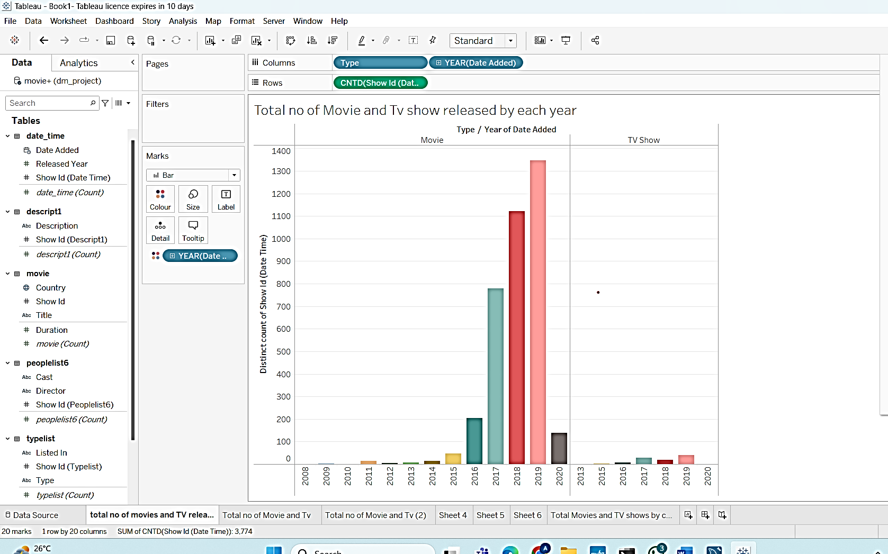

Figure : Top 30 Director along with Movies and TV shows on Netflix Python and Tableau

## Top Movies by Ratings or Metrics

The report references an analysis of Netflix's best films using factors such ratings, viewership, or user comments. Python and Tableau were used to showcase these flicks, therefore stressing the most important Netflix content. Data visualisations like as histograms or bar charts most often offer this information, therefore exposing the elements influencing platform viewing..

## Genre Distribution

Additionally looked at were the 10 most often used forms of cinema and television. Python and Tableau were used to examine and show the genre information. By noting popular genres, this study provides information on audience tastes and content strategy. It can highlight, for instance, if Netflix's main interests are action, drama, comedy, or more specialist genres like anime or documentaries.

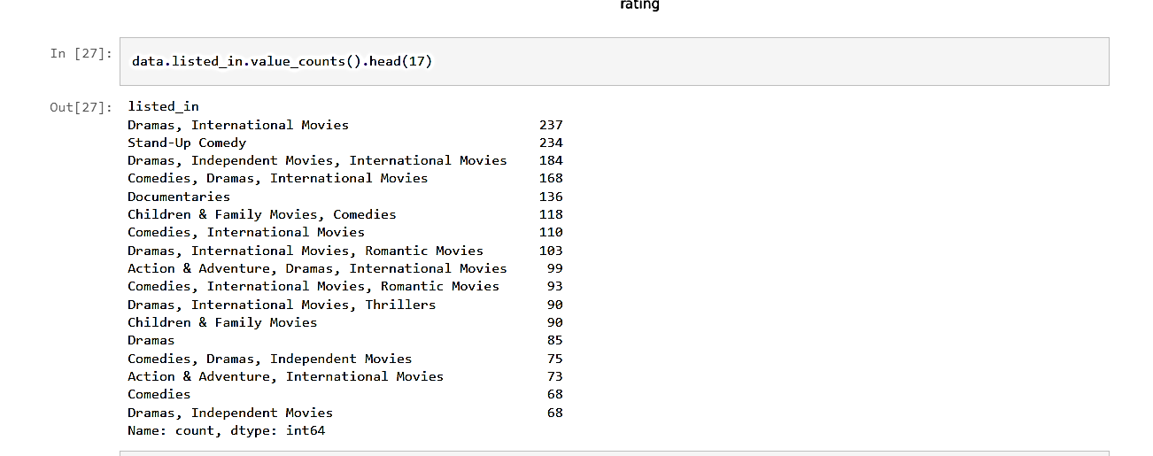

Figure : Top 10 genre of Movies and Tv shows

The presented results provide data visualisations illustrating the outcomes of popular genre research. The first graphic shows a Python bar chart created with the Seaborn module. Based on frequency of appearance in the dataset, it highlights the most regularly occurring genres. On the x-axis the frequency is displayed; on the y-axis each genre combination is displayed. "Stand-Up Comedy" and "Dramas, International Movies" are the most often occurring genres. Popular combos include "Comedies, Dramas, International Movies" and "Dramas, Independent Movies, International Movies." This infographic highlights the variety of material types rather effectively and raises awareness of the regularity with which specific genre combinations come up.

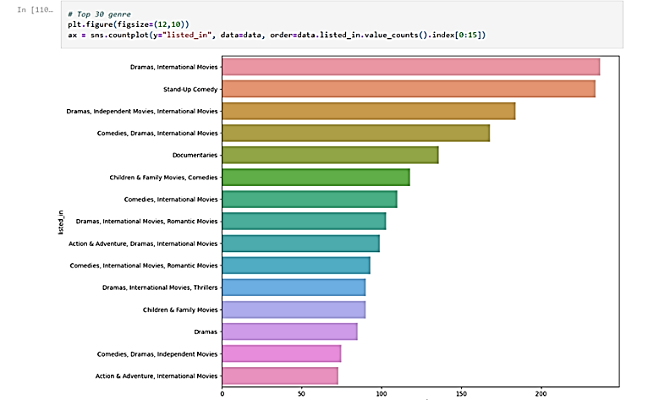

Figure : Top 10 genre of Movies and Tv shows on Python

Here is a Tableau dashboard example including a horizontal bar chart displaying the 10 most often occurring genres in the dataset. The y-axis displays the several genre combinations; the x-axis indicates the overall count of distinct show IDs. Those genres—stand-up comedy, comedies, dramas, international movies, and dramas, international movies—are ranked in that sequence of frequency. The graphic highlights how some genres predominate using number labels stressing their frequency. The dashboard's design assures readability and makes trend by genre easily visible.

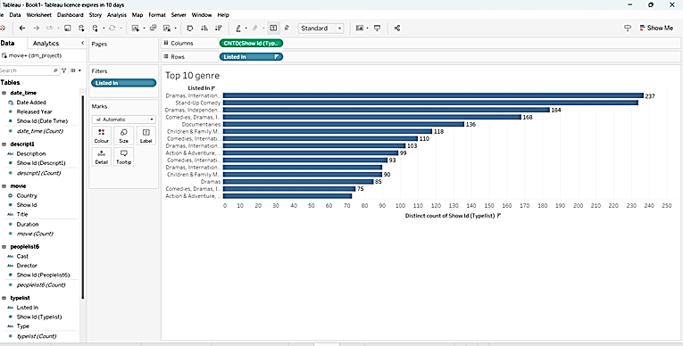

Figure : Top 10 genre of Movies and Tv shows on Tableau

Emphasising how some combinations appeal better to the audience, these visualisations reveal aspects of genre preferences and trends. While the Tableau dashboard concentrates the attention to the top 10, guaranteeing a more succinct presentation, the Seaborn chart investigates a larger range of genres (top 15). These visualisations taken together provide complementary viewpoints that help to clarify material trends for strategic decision-making in media analysis or entertainment.

## Top Highest Movie Using Python and tableau

Data analysis from movie productions was done using Python and Tableau. The first image, a Python code fragment utilising the value_counts() function, shows the top countries in terms of yearly movie output. With 1,323 films, the US tops the rankings; followed by India with 708, the UK with 152, Canada with 78, and Spain with 72. The figures also include other countries with meagre contributions to the global total of films.

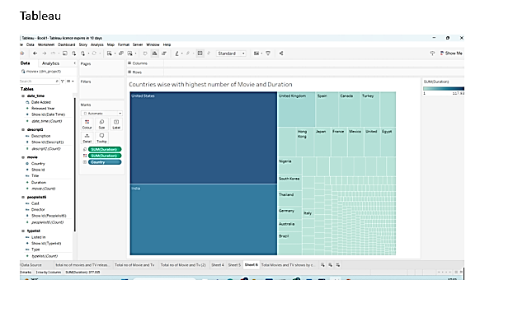

Figure : Top Highest Movie Using tableau

The figure above shows the national distribution of film output and runtime using a Tableau visualisation—more especially, a treemap. Looking at the treemap makes it abundantly evident that the two largest participants in the cinema industry are US and India. Reduced presence of other countries reflects their reduced contributions; this includes Spain, Canada, and the UK. The graphic deftly combines movie count and duration metrics, therefore offering insights into the depth and range of cinematic output produced globally.

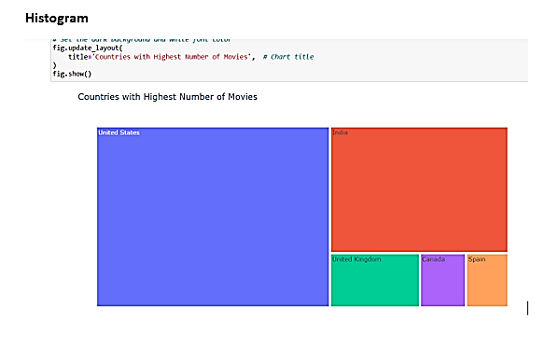

Figure : Top Highest Movie Using Python

The treemap view above shows the nations with the most movie counts. The treemap divides the nations into proportionate blocks, where the block's size reflects the nation's relative movie production. With the United States occupying the biggest block, it is clear that it dominates the movie business; India follows. Though their contributions are less, other nations including Spain, Canada, and the United Kingdom are also shown. The graphic highlights the worldwide distribution of movie output among the top nations via clearly and aesthetically appealing means.

# Conclusion

According to the study's findings, data analysis and machine learning were very vital in building Netflix's success with international streaming. This paper shows how advanced data visualisation tools, machine learning, and exploratory data analysis (EDA) could help us grasp Netflix's content library, audience preferences, and operational goals using modern methodologies. According to the findings, Netflix is mostly sponsored by the US and India; some genres and directors are starting to have greater impact on the library of the service; and adult and teen-oriented content is very important. The paper also emphasises the need of clean data and suitable visualisation in order to transform raw data into relevant insights that can direct decision-making all across the streaming company.

Among other things, this study may be expanded in further studies by include audience participation measures, linguistic diversity, and genre-specific patterns. Examining UGC, review sentiment analysis, and social media interactions helps one to get a more whole picture of what viewers enjoy. Through the improvement of machine learning models, one may obtain better content performance forecasts, user attrition rates, and new market possibilities. Examining how streaming patterns differ by area and comparing streaming patterns across platforms helps one to have a better awareness of the competitive scene of the streaming business. These advances will clarify Netflix's operations and offer helpful guidance for other platforms striving to stay up with the always shifting digital entertainment scene.

**COMPETING INTERESTS DISCLAIMER:**

Authors have declared that they have no known competing financial interests OR non-financial interests OR personal relationships that could have appeared to influence the work reported in this paper.

**Disclaimer (Artificial intelligence)**

Details of the AI usage are given below:

1. The authors of this work have completely generated all text content, data analysis, and interpretations provided here without any help from AI-based tools or automated writing technology.

2. Ensuring originality and academic integrity, the study, images, results, and conclusions are based just on the writers' experience, critical analysis, and hand reading of pertinent material.

##### References

1. Au-Yong-Oliveira, M., Marinheiro, M., & Costa Tavares, J. A. (2020). The power of digitalization: The Netflix story. In Trends and Innovations in Information Systems and Technologies: Volume 3 8 (pp. 590-599). Springer International Publishing.
2. Regin, R. (2024). Comprehensive Exploratory Data Analysis of the Netflix Dataset: Uncovering Viewer Preferences and Content Trends. Central Asian Journal of Mathematical Theory and Computer Sciences, 5(4), 388-400.
3. Maddodi, S. (2019). NETFLIX bigdata analytics-the emergence of data driven recommendation. Srivatsa Maddodi, & Krishna Prasad, K.(2019). Netflix Bigdata Analytics-The Emergence of Data Driven Recommendation. International Journal of Case Studies in Business, IT, and Education (IJCSBE), 3(2), 41-51.
4. Jadhav, A. R., Jadhav, R. D., Jadhav, A., & Singh, C. (2023, October). Netflix Data Analysis Using EDA. In International Conference on Internet of Things and Connected Technologies (pp. 309-317). Singapore: Springer Nature Singapore.
5. Thesni, F., Raj, G., & Poulose, A. (2024, March). Visualizing the Global Streaming Landscape: An In-Depth Analysis of Netflix Content Distribution Using Tableau Data Visualization Tool. In 2024 5th International Conference on Innovative Trends in Information Technology (ICITIIT) (pp. 1-6). IEEE.
6. Zhou, M., Chen, G. H., Ferreira, P., & Smith, M. D. (2021). Consumer behavior in the online classroom: Using video analytics and machine learning to understand the consumption of video courseware. Journal of Marketing Research, 58(6), 1079-1100.
7. Mishra, S., & Tyagi, A. K. (2022). The role of machine learning techniques in internet of things-based cloud applications. Artificial intelligence-based internet of things systems, 105-135.
8. Revathy, G., Alghamdi, S. A., Alahmari, S. M., Yonbawi, S. R., Kumar, A., & Haq, M. A. (2022). Sentiment analysis using machine learning: Progress in the machine intelligence for data science. Sustainable Energy Technologies and Assessments, 53, 102557.
9. Selvan, M. A. (2024). Transforming Consumer Behavior Analysis with Cutting-Edge Machine Learning.
10. Balaji, T. K., Annavarapu, C. S. R., & Bablani, A. (2021). Machine learning algorithms for social media analysis: A survey. Computer Science Review, 40, 100395.
11. Rasheed, S. (2021). A review of the role of machine learning techniques towards brain–computer interface applications. Machine Learning and Knowledge Extraction, 3(4), 835-862.
12. Herhausen, D., Miočević, D., Morgan, R. E., & Kleijnen, M. H. (2020). The digital marketing capabilities gap. Industrial Marketing Management, 90, 276-290.
13. Raes, A., Detienne, L., Windey, I., & Depaepe, F. (2020). A systematic literature review on synchronous hybrid learning: gaps identified. Learning environments research, 23, 269-290.
14. Robinson, K. A., Saldanha, I. J., & Mckoy, N. A. (2011). Development of a framework to identify research gaps from systematic reviews. Journal of clinical epidemiology, 64(12), 1325-1330.
15. Wayne, M. L. (2022). Netflix audience data, streaming industry discourse, and the emerging realities of ‘popular’television. Media, Culture & Society, 44(2), 193-209.
16. Jeon, H., Seo, W., Park, E., & Choi, S. (2020). Hybrid machine learning approach for popularity prediction of newly released contents of online video streaming services. Technological Forecasting and Social Change, 161, 120303.
17. Afilipoaie, A., Iordache, C., & Raats, T. (2021). The ‘Netflix Original’and what it means for the production of European television content. Critical Studies in Television, 16(3), 304-325.
18. Aguiar, L., & Waldfogel, J. (2018). Netflix: global hegemon or facilitator of frictionless digital trade?. Journal of Cultural Economics, 42, 419-445.
19. Lobato, R. (2019). Netflix nations: The geography of digital distribution. New York University Press.
20. Tahir, T., Maqbool, K. Q., Zafar, S., Hasan, M. Z., Hussain, M. Z., & Yaqub, M. A. (2024). A Global Analysis of Netflix Content Production Unveiling Dominant Countries and Industry Trends. Dialogue Social Science Review (DSSR), 2(3 (October)), 519-534.
21. Nam, J., Ro, D., & Jung, Y. (2023). Netflix's presence: Investigating content producers' understanding of Netflix in the Korean media industry. Telecommunications Policy, 47(4), 102525.
22. Ali, A., Irfan, A., Raza, A., & Memon, Z. (2024, January). Banking in the Digital Age: Predicting Eligible Customers through Machine Learning and AWS. In 2024 IEEE 1st Karachi Section Humanitarian Technology Conference (KHI-HTC) (pp. 1-6). IEEE. https://doi.org/10.1109/KHI-HTC60760.2024.10482026
23. Shazia, A., Dahri, F. H., Ali, A., Adnan, M., Laghari, A. A., & Nawaz, T. (2024). Automated Early Diabetic Retinopathy Detection Using a Deep Hybrid Model. IECE Transactions on Emerging Topics in Artificial Intelligence, 1(1), 71-83. http://doi.org/10.62762/TETAI.2024.305743