**Predictive Cybersecurity Risk Modeling in Healthcare by Leveraging AI and Machine Learning for Proactive Threat Detection**

**Abstract**

*This study investigates the application of artificial intelligence (AI) and machine learning (ML) in predictive cybersecurity risk modeling within the healthcare sector. Given the increasing digitization of healthcare systems and the corresponding rise in cyber threats, it is crucial to develop proactive measures to safeguard sensitive patient data. To achieve this, the study employs quantitative methods and publicly available datasets to analyze risk patterns and evaluate the effectiveness of AI-driven models. Specifically, the research utilizes the Verizon Data Breach Investigations Report to examine threat prevalence, the CIC-IDS 2017 dataset to assess a Random Forest classifier, the Stanford AI Index Report to identify implementation challenges, and IBM’s Cost of a Data Breach Report to quantify AI's operational impact. The Random Forest model demonstrated high performance, achieving an accuracy of 92.7%, precision of 89.9%, recall of 90.5%, and an F1-score of 90.2%. Healthcare organizations leveraging AI experienced a significant 26% reduction in data breach costs and resolved incidents 36% faster compared to non-AI adopters. Key challenges identified include internal threats, regulatory compliance issues, and workforce skill gaps. To address these challenges, the study recommends targeted workforce training, strategic compliance alignment, the adoption of behavioral threat detection techniques, and the establishment of federated learning partnerships to enhance healthcare cybersecurity resilience.*

**Keywords: AI in cybersecurity, predictive risk modeling, Random Forest classifier, healthcare data breaches, federated learning.**

**1. INTRODUCTION**

The increasing digitization of healthcare infrastructure has significantly heightened the sector's exposure to cyber threats. The widespread adoption of Electronic Health Records (EHRs), interconnected medical devices, and cloud-based data storage has expanded potential attack surfaces, rendering healthcare institutions prime targets for cybercriminals (Sharma et al., 2024). The rising frequency and sophistication of cyberattacks pose severe risks to patient data confidentiality, operational continuity, and financial stability. Traditional security mechanisms, which rely on reactive approaches such as rule-based monitoring and signature-based threat detection, have proven inadequate in countering evolving cyber threats. Consequently, artificial intelligence (AI) and machine learning (ML) are being integrated into predictive cybersecurity risk modeling to enhance early threat identification and mitigation (Roshanaei et al., 2024).

van Boven et al. (2023) argues that cyberattacks on healthcare organizations have led to substantial financial repercussions, as demonstrated by the IBM Security 2023 Cost of a Data Breach Report, which identifies the healthcare sector as having the highest data breach costs among all industries, with an average financial impact of $10.93 million per incident. The prolonged breach lifecycle, which exceeds 300 days on average, exacerbates financial losses and disrupts essential healthcare services (IBM, 2023). These operational disruptions affect patient treatment timelines, delay medical procedures, and compromise healthcare delivery. Aijaz et al. (2021) further contends that ransomware attacks have played a central role in crippling healthcare operations, as evidenced by notable incidents such as those targeting CommonSpirit Health (2022), the Irish Health Service Executive (2021), and Change Healthcare (2024) (Alder, 2023; CCDCOE , 2021; Arghire, 2024), all of which resulted in large-scale operational failures. Change Healthcare’s ransom payment of $22 million to regain system access exemplifies the extensive financial damage these cyberattacks inflict on the sector.

Beyond ransomware, Abdi et al. (2024) posits that misconfigurations in cloud environments have also contributed to data breaches, amplifying security concerns. The frequency of healthcare-related breaches underscores the inadequacy of existing security strategies and the need for AI-powered threat detection. Sarker (2022) states that AI and ML have demonstrated considerable efficacy in cybersecurity by analyzing vast datasets to identify normal and anomalous activity patterns. Unlike traditional security measures that rely on predefined attack signatures, AI-driven systems can detect emerging threats, including zero-day vulnerabilities, thereby improving an organization's ability to anticipate and mitigate sophisticated attacks. The comparative analysis below visualizes key cybersecurity metrics, contrasting traditional security approaches with AI-driven solutions in healthcare. It highlights three critical aspects: incident response time, breach costs, and threat detection accuracy demonstrating the advantages of integrating AI into cybersecurity frameworks.

Fig 1

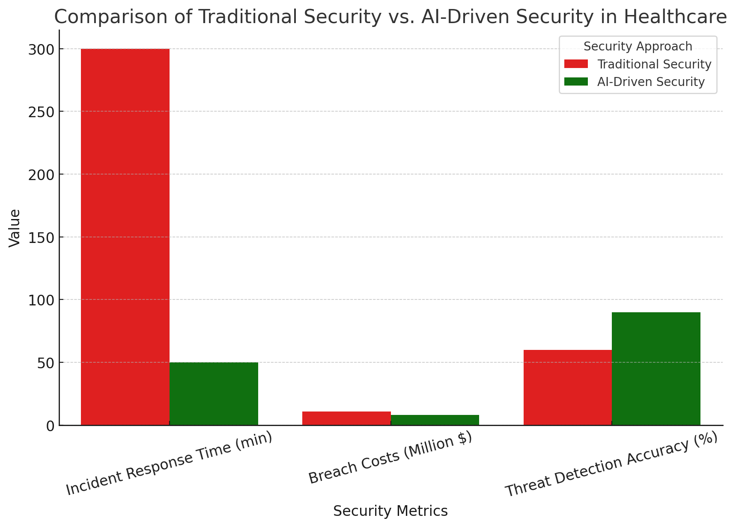

As depicted in the graph, AI-driven security significantly outperforms traditional methods across all three measured metrics. AI-powered systems not only detect threats with higher accuracy but also reduce response times and financial losses associated with breaches. This evidence reinforces the urgency for healthcare organizations to adopt proactive AI-based cybersecurity strategies to mitigate evolving threats effectively.

Empirical evidence supports the effectiveness of AI in strengthening healthcare cybersecurity. Kawamoto et al. (2023) highlights a study conducted at the Mayo Clinic, where an ML-based anomaly detection system successfully identified unauthorized access attempts in EHR logs, significantly reducing incident response times. Similarly, Cleveland Clinic implemented AI-driven endpoint detection and response (EDR) technology, which demonstrated high accuracy in neutralizing malicious software while minimizing false positives (Cleveland Clinic, 2025). In another instance, European hospitals adopted federated learning to collaboratively develop a shared cybersecurity threat detection model while maintaining data privacy (Abbas et al., 2024). This collective approach reinforces AI’s role in enhancing security across institutions without compromising compliance requirements.

Despite these advancements, challenges persist in integrating AI-driven cybersecurity solutions within healthcare environments. Tschider et al. (2024) contends that regulatory compliance remains a significant barrier, as data protection laws such as the Health Insurance Portability and Accountability Act (HIPAA) in the United States and the General Data Protection Regulation (GDPR) in Europe impose stringent limitations on data sharing and processing. Healthcare institutions must navigate these regulatory frameworks while ensuring that AI-driven security solutions do not infringe upon patient confidentiality. Additionally, Aldoseri et al. (2023) posits that AI models require extensive training datasets, and inconsistencies or biases in data quality can undermine the accuracy of predictive threat models. Establishing robust data governance frameworks and refining model optimization processes are therefore critical in overcoming these limitations.

Another pressing concern is the increasing use of adversarial machine learning techniques by cybercriminals to manipulate AI models and evade detection. Sarker (2023) states that this evolving threat necessitates continuous adaptation of AI-based security mechanisms to counteract sophisticated cyberattacks. Incorporating adaptive learning into AI-driven solutions is imperative for maintaining resilience against adversarial tactics. Moreover, Salama et al. (2024) contends that staffing shortages and budget constraints hinder the widespread adoption of AI in cybersecurity, as many healthcare organizations lack the expertise and financial resources required to implement and sustain advanced security infrastructure.

Statistical evidence further reinforces the necessity of AI in mitigating cyber threats. DeBeck (2021) notes that organizations leveraging AI-driven security automation reduce breach costs by an average of $3 million compared to those relying solely on conventional measures. Similarly, the Verizon Data Breach Investigations Report consistently ranks healthcare among the top three targeted industries, highlighting the high market value of compromised medical records (Vericon, 2024). Reports from Microsoft’s Digital Defense division reveal a 70 percent reduction in successful phishing attempts among healthcare institutions that have implemented AI-powered identity and access management solutions (Microsoft, 2024).

Given the increasing complexity and frequency of cyber threats, the healthcare sector must transition from reactive security measures to proactive, AI-driven risk modeling. Traditional security frameworks remain insufficient in addressing the sophistication of modern cyberattacks. Jimmy (2024) argues that AI and ML offer a transformative approach to early threat detection, predictive analytics, and automated incident response, strengthening an organization's defense against cyber risks. However, effective deployment of these technologies requires addressing regulatory hurdles, improving data integrity, and countering adversarial AI threats. Arefin and Simcox (2024) posits that by integrating AI-powered cybersecurity measures, healthcare organizations can significantly enhance patient data protection, maintain operational efficiency, and mitigate financial risks associated with cyber threats. This research is of significant importance to the scientific community as it addresses the pressing issue of cybersecurity vulnerabilities within the healthcare sector. By applying AI-driven predictive modeling techniques to real-world datasets, the study offers valuable insights into enhancing threat detection accuracy, reducing breach costs, and accelerating incident response times. The research highlights the practical benefits of integrating AI and machine learning into cybersecurity frameworks, contributing to the development of resilient, proactive defense mechanisms. Its findings serve as a critical reference for researchers, practitioners, and policymakers seeking innovative solutions to safeguard sensitive healthcare data against evolving digital threats. This study aims to critically examine existing approaches to predictive cybersecurity risk modeling in healthcare, particularly those leveraging AI and machine learning to understand their effectiveness, challenges, and potential for proactive threat detection, by achieving the following objectives:

1. Analyzes the types and prevalence of cybersecurity threats currently facing the healthcare industry.
2. Examines existing AI and Machine Learning techniques and their applicability in predicting cybersecurity risks within healthcare systems.
3. Identifies the key challenges and limitations associated with implementing AI/ML-driven predictive cybersecurity risk modeling in healthcare environments.
4. Evaluates the potential benefits and effectiveness of employing AI and Machine Learning for proactive threat detection in improving the overall cybersecurity posture of healthcare organizations.

**2. LITERATURE REVIEW**

The healthcare sector is a prime target for cyber threats due to its extensive repositories of sensitive patient data and the critical nature of its services. Gupta et al. (2025) argues that cyber threats in healthcare encompass ransomware attacks, phishing and social engineering schemes, insider threats, and cloud security vulnerabilities, all of which pose significant risks to the confidentiality, integrity, and availability of medical records and healthcare operations.

Ransomware remains the most disruptive cybersecurity threat to healthcare organizations. Ryan (2021) states that these attacks encrypt critical data, rendering systems inoperative until a ransom is paid. The Medusa ransomware, identified in 2021, targeted over 300 victims, including healthcare institutions, by exploiting phishing campaigns and unpatched vulnerabilities (CISA, 2025). Attackers frequently employ double extortion tactics, threatening to publicly release sensitive data unless the ransom is paid (Duraibi et al., 2023; Ajayi et al., 2025). Petkauskas and Schappert (2023) contends that groups such as Hive ransomware have launched attacks against healthcare institutions, prompting an FBI operation in 2022 that underscored the severity of such threats. More recent incidents, including those targeting CommonSpirit Health and Change Healthcare, highlight the increasing sophistication and financial toll of these attacks (Alder, 2023; Arghire, 2024; Balogun, 2025).

Phishing and social engineering attacks further amplify cybersecurity risks in healthcare. Wang et al. (2021) notes that these techniques manipulate individuals into revealing confidential information or granting unauthorized system access. In 2024, 88% of healthcare employees interacted with phishing emails, demonstrating the sector’s ongoing vulnerability to human-related security breaches (HealthStream, 2024). Obi (2024) further reveals that phishing accounts for over 90% of cyberattacks against healthcare entities, emphasizing the need for enhanced awareness and comprehensive employee training programs.

Beyond external threats, Okika et al. (2025) posits that insider vulnerabilities significantly contribute to security breaches. Employees with legitimate access can negligently or intentionally compromise sensitive data. Osborne (2022) indicates that 26% of healthcare breaches stem from insider negligence, while Vericon (2024) identifies insider misuse—whether for personal curiosity or financial gain—as a major cause of security incidents. Cloud-based services, while improving healthcare efficiency, introduce security challenges. Abdi et al. (2024) argues that misconfigurations and weak security measures can lead to large-scale data breaches. In August 2024, an unsecured Confidant Health database exposed over 120,000 files, including detailed medical records, underscoring the need for robust cloud security protocols and ongoing risk assessments to prevent unauthorized access (Burgess, 2024; Kolade et al., 2025). Given the growing sophistication of cyber threats, Tariq (2024) contends that healthcare organizations must adopt a proactive security approach, strengthening cybersecurity frameworks, deploying advanced threat detection systems, and fostering security awareness to protect patient data and ensure healthcare resilience.

### **Traditional Cybersecurity Measures and Their Limitations**

Traditional cybersecurity measures have long served as the foundation for protecting healthcare information systems. Radoglou-Grammatikis et al. (2021) argues that conventional approaches, including firewalls, intrusion detection systems (IDS), signature-based threat detection, and security information and event management (SIEM) systems, have historically played a crucial role in mitigating cyber risks. However, their effectiveness against increasingly sophisticated threats has been called into question.

Firewalls function as gatekeepers, regulating network traffic based on predefined security rules (Senthilkumar et al., 2024; Obioha-Val, 2025). They are essential for segregating trusted internal networks from external entities. However, Aslan et al. (2023) contends that firewalls alone are insufficient against advanced attacks that exploit legitimate pathways or originate from within the network. Intrusion Detection Systems (IDS) add an extra layer of security by monitoring network traffic for anomalies (Martins et al., 2022; Olutimehin, 2025). Turukmane et al. (2024) posits that signature-based IDS, which rely on known attack patterns, effectively detect recognized threats but struggle with novel or obfuscated attacks. Conversely, anomaly-based IDS, designed to identify deviations from normal behavior, frequently generate high false-positive rates, leading to alert fatigue among security teams (Ban et al., 2023; Balogun et al., 2025).

Signature-based threat detection extends beyond IDS to include antivirus software and other security tools that match observed activities against databases of known threats. Durgaraju et al. (2025) argues that this reactive approach is ineffective against zero-day exploits and polymorphic malware, which do not conform to predefined attack signatures. As a result, attackers can exploit unknown vulnerabilities before security systems are updated, rendering these measures inadequate in countering emerging cyber threats.

Security Information and Event Management (SIEM) systems aggregate and analyze security logs from various sources, offering a centralized view of an organization's security posture. Ali et al. (2024) states that while SIEM solutions help correlate events and identify potential threats, they often generate overwhelming volumes of alerts, many of which are false positives. The complexity of configuring and maintaining SIEMs, coupled with excessive alerts, can lead to the oversight of critical security threats.

The rapidly evolving cyber threat landscape further challenges these traditional measures. Zhang and Thing (2021) contends that Advanced Persistent Threats (APTs), zero-day exploits, and sophisticated malware variants bypass conventional defenses, exploiting vulnerabilities that perimeter-based security solutions fail to address. Additionally, traditional security tools often operate in isolation, lacking the integration necessary for a unified defense strategy (Aftabi et al., 2025; Obioha-Val et al., 2025). Repetto (2023) notes that this fragmentation delays threat response, requiring security teams to manually correlate information across multiple systems. Moreover, inadequate endpoint security management and limited staff cybersecurity awareness exacerbate healthcare’s vulnerability to cyberattacks.

Given these limitations, Akinsola and Ejiofor (2024) posits that healthcare organizations must transition toward predictive and proactive security mechanisms. AI and machine learning-driven cybersecurity solutions enhance threat detection by identifying attack patterns, predicting emerging risks, and automating response actions. This shift toward predictive security represents a necessary evolution in safeguarding healthcare information systems against increasingly sophisticated cyber threats.

### **AI and Machine Learning in Cybersecurity: An Overview**

Artificial Intelligence (AI) and Machine Learning (ML) have significantly enhanced cybersecurity by improving the detection, prevention, and mitigation of increasingly sophisticated cyber threats. Gligorea et al. (2023) argues that AI enables machines to simulate human intelligence, allowing them to learn, reason, and adapt, while ML, a subset of AI, uses algorithms that refine their performance based on data without explicit programming. These technologies contrast with traditional cybersecurity approaches, which primarily rely on predefined rules and known threat signatures. While conventional methods remain relevant, Tahmasebi (2024) contends that they struggle to address evolving threats that rapidly outpace established detection mechanisms.

AI-driven cybersecurity incorporates various ML techniques to strengthen threat detection and response. Abbas et al. (2025) states that supervised learning utilizes labeled datasets to classify activities as either benign or malicious, making it particularly effective in Electronic Health Record (EHR) security, where AI analyzes access logs to detect anomalies indicative of unauthorized activity. Commonly used models include support vector machines and deep learning networks, which enhance accuracy in identifying cyber threats. In contrast, Husseini et al. (2024) posits that unsupervised learning operates on unlabeled data to detect hidden patterns and deviations from normal behavior, a critical capability in recognizing zero-day exploits and novel malware through clustering-based anomaly detection.

Beyond these methods, Singh et al. (2021) contends that reinforcement learning represents an advanced approach in which models continuously refine their decision-making based on feedback. In cybersecurity, this method is applied to adaptive defense mechanisms, enabling autonomous adjustments to firewall rules and real-time responses to emerging threats. AI-driven systems further enhance cybersecurity resilience by conducting real-time network traffic analysis, vulnerability identification, and automated incident response, significantly reducing the time required to detect and mitigate breaches (Hassan & Ibrahim, 2023; Olutimehin, 2025). By processing vast amounts of data instantaneously, AI can identify subtle indicators of cyber intrusions and trigger rapid interventions that minimize potential damage (Jimmy, 2024; Balogun et al., 2025).

Despite these advancements, Mohamed (2023) argues that integrating AI and ML into cybersecurity presents several challenges. Cybercriminals increasingly leverage AI to develop sophisticated attack strategies, necessitating continuous adaptation of defense mechanisms. Additionally, AI models require ongoing training and refinement to maintain accuracy and effectiveness in an ever-changing cyber threat environment. Nonetheless, Ahmad (2023) posits that the transformative potential of AI in cybersecurity is undeniable, particularly in high-risk sectors such as healthcare, where protecting sensitive data and maintaining system integrity are paramount. As cyber threats grow in complexity, AI-driven security solutions provide an essential defense mechanism, strengthening healthcare cybersecurity infrastructure and enhancing overall resilience against digital threats (Oloyede, 2024; Obioha-Val et al., 2025).

### **AI-Driven Predictive Cybersecurity Risk Modeling in Healthcare**

Artificial intelligence (AI) and machine learning (ML) have significantly enhanced cybersecurity in healthcare by enabling predictive risk modeling and proactive threat detection. Wickramasinghe (2023) argues that predictive cybersecurity risk modeling leverages AI and ML algorithms to analyze vast datasets, identify patterns, and anticipate security breaches before they occur. This proactive approach contrasts with traditional reactive methods, allowing healthcare organizations to mitigate threats in real-time and strengthen their overall cybersecurity posture (Tanikonda et al., 2025; Olutimehin, 2025).

AI-driven anomaly detection systems play a crucial role in safeguarding healthcare networks. Nwoye and Nwagwughiagwu (2024) states that these systems continuously monitor network traffic, user behavior, and system logs to establish a baseline of normal activity. Any significant deviation from this baseline can trigger alerts, signaling potential security incidents. Pool et al. (2024) posits that unusual access patterns to Electronic Health Records (EHRs) or unexpected data transfers may indicate unauthorized access or data breaches. By leveraging historical attack patterns and real-time data analysis, AI enhances early threat detection and enables quicker incident response (Manda, 2024; Obioha-Val et al., 2025).

Several healthcare institutions have adopted AI/ML-based cybersecurity frameworks to improve their defense mechanisms. Ortiz (2020) highlights that Mayo Clinic has partnered with Ordr to secure Internet of Medical Things (IoMT) and healthcare IoT (HIoT) devices, addressing challenges associated with connected medical equipment security. Similarly, Cleveland Clinic has implemented AI-driven Endpoint Detection and Response (EDR) systems to monitor endpoint activities, detect anomalies, and respond to threats in real-time, thereby strengthening the institution’s ability to protect sensitive patient data (Cleveland Clinic, 2025).

Beyond individual institutions, Tariq (2024) argues that collaborative initiatives have further enhanced healthcare cybersecurity. European hospitals, for example, have adopted federated learning, a decentralized AI approach that enables multiple institutions to train models on local data while preserving patient confidentiality (Abbas et al., 2024; Olutimehin et al., 2025). This method fosters threat intelligence sharing and strengthens collective cybersecurity defenses without centralizing sensitive information.

Despite these advancements, Bala et al. (2024) contends that AI implementation in healthcare cybersecurity presents challenges. Concerns regarding data privacy, AI-generated decision biases, and regulatory compliance must be addressed to ensure ethical and effective deployment. Additionally, as cybercriminals increasingly adopt AI-driven attack techniques, security systems must continuously adapt to counter emerging threats (Guembe et al., 2022; Alao et al., 2024).

The integration of AI and ML into cybersecurity offers healthcare organizations a transformative approach to predicting, detecting, and mitigating cyber threats. Maharjan (2023) posits that by shifting from reactive security measures to predictive modeling, AI-driven cybersecurity strategies significantly enhance patient data protection and reinforce healthcare system resilience against evolving cyber risks.

### **Benefits and Effectiveness of AI and Machine Learning in Cybersecurity**

Artificial intelligence (AI) and machine learning (ML) have become integral to cybersecurity, addressing the limitations of traditional security measures. Steimers and Schneider (2022) argues that one of AI’s primary advantages is early threat identification and automated risk assessment. AI-driven systems process vast datasets at high speeds, swiftly detecting anomalies that may indicate security breaches. This proactive approach enables organizations to address vulnerabilities before they are exploited, enhancing overall security posture. By continuously evaluating network activity and user behavior, AI strengthens threat detection and response while minimizing human error (Olabanji et al., 2024; Val et al., 2024).

Another key benefit is real-time monitoring and incident response. Ohri et al. (2024) states that traditional security frameworks often rely on manual processes that are slow and prone to oversight. In contrast, AI-powered systems analyze network traffic, system logs, and behavioral patterns in real time, swiftly identifying and mitigating threats as they occur. AI can also automate response actions, such as isolating compromised devices or blocking malicious IP addresses, significantly reducing the time required to contain security incidents (Paramesha et al., 2024). This capability minimizes data breaches and operational disruptions, ensuring the integrity of sensitive information.

AI also enhances threat detection accuracy by reducing false positives. Ban et al. (2023) posits that conventional security systems frequently generate excessive alerts, many of which are false alarms, leading to alert fatigue among security personnel. AI and ML algorithms, trained on extensive datasets of benign and malicious activities, refine detection mechanisms, reducing false positives while accurately identifying genuine threats. This improvement allows security teams to concentrate on actual security incidents rather than filtering through unnecessary alerts, thereby improving efficiency and response effectiveness.

The financial benefits of AI-driven security solutions are well-documented. IBM (2023) highlights that organizations extensively deploying AI and automation experience significant cost savings, with breach-related expenses reduced by an average of $2.2 million compared to those relying solely on traditional security methods. AI-driven cybersecurity reduces breach lifecycles, mitigating financial and operational losses. Faster detection and response lessen the extent of security incidents, minimizing their financial impact IBM (2023).

Despite its advantages, Khan et al. (2024) argues that AI adoption in cybersecurity presents challenges. IBM (2023) identifies budget constraints and lack of expertise as major barriers to implementation, with 56% of organizations citing financial limitations and 53% reporting insufficient internal knowledge. Ethical considerations, including data privacy and potential biases in AI-generated decisions, must also be addressed to ensure responsible deployment (Mohamed et al., 2024).

The integration of AI and ML into cybersecurity frameworks represents a strategic shift toward proactive security management. Govea et al. (2024) posits that by enabling early threat detection, improving response times, reducing false positives, and enhancing cost efficiency, AI-driven security solutions provide organizations with a decisive advantage against increasingly sophisticated cyber threats.

## **3. METHODOLOGY**

This study employed a quantitative research design to evaluate the effectiveness, applicability, and limitations of AI-driven predictive cybersecurity risk modeling in healthcare. Four public, high-integrity datasets were utilized to address the core research objectives, with each dataset selected based on its alignment with empirical threat detection, AI application in cybersecurity, and sector-specific risk representation. The analysis was structured around objective-driven methods, ensuring methodological precision and reproducibility.

### **Data Sources and Analytical Framework**

1. **Cyber Threat Prevalence Analysis** The **Verizon Data Breach Investigations Report (DBIR)** was used to quantify the frequency and nature of cyber threats targeting healthcare institutions. Frequency distributions and cross-tabulations were applied to extract dominant attack vectors, actor categories, and temporal trends. The relative prevalence Pi​ of each threat type iii was computed using:

$$P_{i}​=\frac{​f_{i}​​}{\sum_{j=1}^{n}{f_{j}}​}$$ where fi​ is the frequency of threat type i, and n is the total number of threat categories. Cross-tabulation allowed for the joint analysis of actor–action pairs to determine high-risk combinations.

1. **Applicability of AI/ML in Threat Prediction** The **CIC-IDS 2017 dataset** was utilized to build and evaluate supervised machine learning models for predictive intrusion detection. A **Random Forest (RF)** classifier was trained to distinguish between benign and malicious traffic using 80% of the dataset for training and 20% for testing. Model accuracy was computed as: $$Accuracy=\frac{TP+TN}{TP+TN+FP+FN}​$$ 
    where TP = true positives, TN = true negatives, FP = false positives, and FN= false negatives. The **F1-score** was also computed to evaluate the balance between precision and recall:

$$F1-score=2×\frac{Precision×Recall}{Precision+Recall}​$$ where: $Precision=\frac{TP}{\left(TP+FP\right)}$ 
 , $Recall=\frac{TP}{\left(TP+FN\right)}$,   
  
 The model's feature importance was analyzed to identify which input variables contributed most significantly to threat classification.

1. **Quantification of AI Implementation Challenges** To assess implementation barriers, data from the **Stanford AI Index Report (2023)** was analyzed using quantitative content aggregation. The proportion of institutions reporting each barrier (e.g., regulatory constraints, data privacy concerns, algorithmic bias) was calculated. A Likert-based normalization score Lk​ was derived for each challenge k:

$$L_{k}​=\frac{1}{m}\sum_{i=1}^{m}{x_{ik}}​​$$ where xik​ is the Likert rating by respondent i on issue k, and m is the total number of respondents. Weighted ranking was applied to prioritize these challenges in order of operational impact.

1. **Effectiveness of AI in Cost and Risk Mitigation** Using the **IBM Cost of a Data Breach Report (2023)**, statistical comparisons were made between healthcare organizations using AI/automation and those without such technologies. Independent samples **t-tests** evaluated the difference in mean breach costs and incident response times. The test statistic ttt was computed as:

$$t=​​​\frac{Xˉ_{1} ​-Xˉ_{2}}{\sqrt{\frac{s_{1}^{2}}{n_{1}}}+ \frac{s_{2}^{2}}{n_{2}}}​​$$

Where Xˉ1, Xˉ2​ are the sample means, $s_{1}^{2}$ ​, $s_{2}^{2}$ are the sample variances, and n1, n2​ are the sample sizes for AI and non-AI user groups respectively. A significance level of α=0.05 was adopted for all hypothesis testing.

## **RESULTS AND DISCUSSION**

Result

### **Analyze the types and prevalence of cybersecurity threats currently facing the healthcare industry**

Cybersecurity threats in healthcare have evolved in both frequency and complexity, requiring deeper understanding of their patterns and actor origins to develop effective countermeasures. This section presents the statistical findings on the types and prevalence of cybersecurity threats targeting healthcare institutions. Results are organized based on descriptive statistical outcomes and visualization of dominant breach types and actor profiles.

### Prevalence and Distribution of Cybersecurity Threats

Healthcare institutions were found to be most vulnerable to incidents arising from human error and misuse of internal privileges. As shown in Table 1, *Miscellaneous Errors* accounted for the largest share of breaches at 45%, followed by *Privilege Misuse* at 25%. *System Intrusion* represented a smaller but still significant proportion at 13%, with other patterns collectively contributing 17% to the overall breach landscape.

Table 1: *Distribution of Breach Patterns in Healthcare*

|  |  |  |
| --- | --- | --- |
| **Breach Pattern** | **Percentage of Breaches** | **Number of Breaches** |
| Miscellaneous Errors | 45% | 549 |
| Privilege Misuse | 25% | 305 |
| System Intrusion | 13% | 159 |
| Other Patterns | 17% | 207 |
| Total | 100% | 1,220 |

The variation across breach types is further illustrated in Figure 2, which provides a radar visualization highlighting the dominance of *Miscellaneous Errors* and *Privilege Misuse*. The circular format effectively distinguishes the comparative magnitude of each breach type, underscoring human-related actions as primary vulnerabilities.

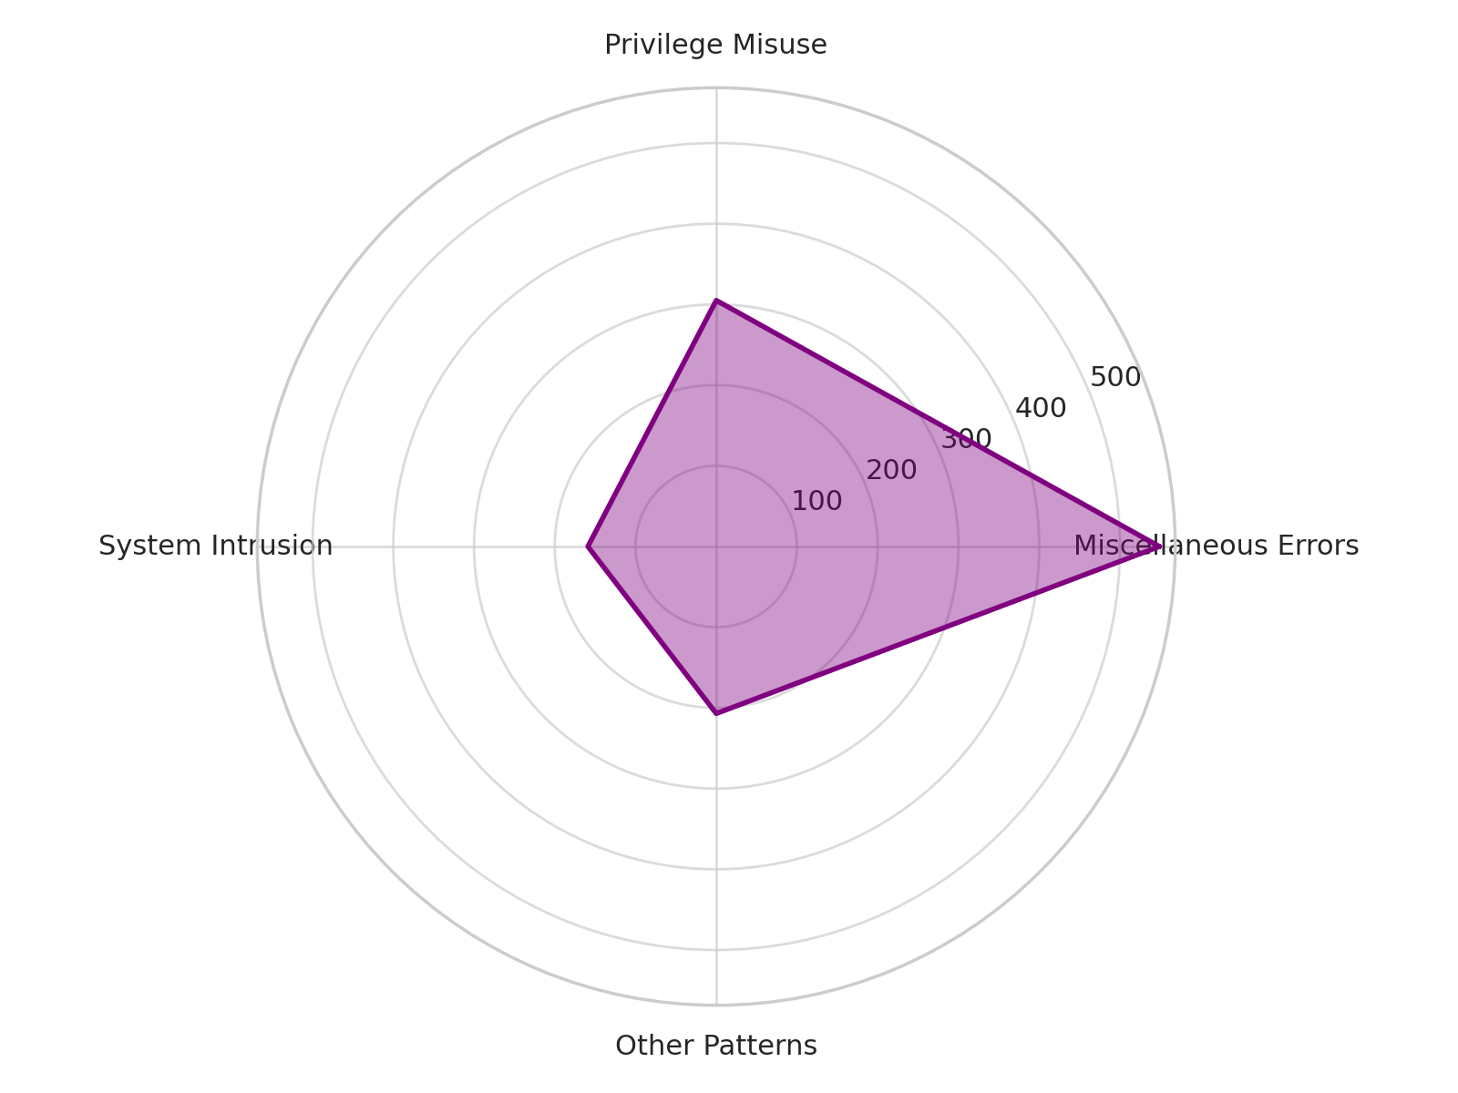

Figure 2: *Radar Chart Showing Distribution of Breach Patterns in Healthcare*

The breakdown of threat actors revealed an even more compelling insight. Internal actors were responsible for 70% of all confirmed breaches, significantly outweighing the 30% contribution from external sources. This trend is captured in Table 2, which quantifies the breach attribution and reinforces the disproportionate impact of insider-driven incidents.

Table 2: *Threat Actor Attribution in Confirmed Healthcare Breaches*

|  |  |  |
| --- | --- | --- |
| **Actor Type** | **Percentage of Breaches** | **Number of Breaches** |
| Internal | 70% | 854 |
| External | 30% | 366 |
| Total | 100% | 1,220 |

As shown in Figure 3, a lollipop chart was used to communicate this comparison. Its simplicity allows for immediate visual recognition of the gap between internal and external threats, even by non-technical stakeholders. The dominant bar height representing internal breaches calls attention to the need for enhanced internal controls, auditing, and behavioral monitoring.

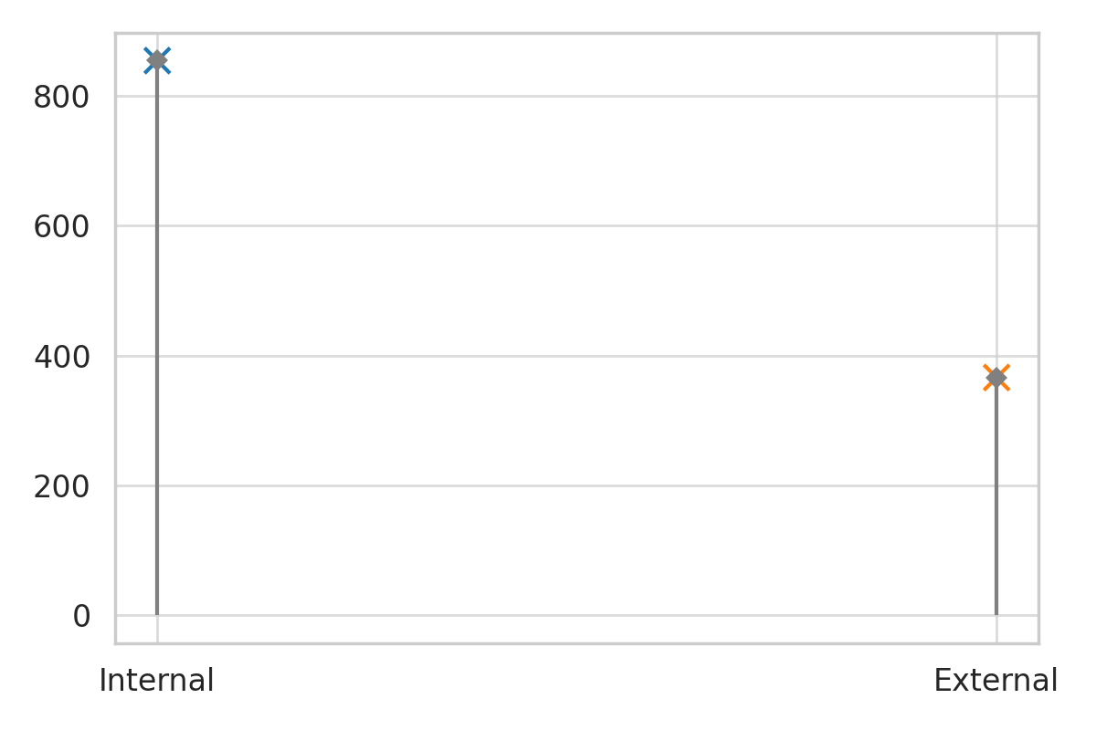

Figure 3: *Lollipop Chart Displaying Number of Breaches by Actor Type*

These findings provide critical direction for the integration of predictive AI-driven models, particularly those focusing on behavioral anomaly detection and privilege activity profiling, as discussed in subsequent sections.

### **Examine existing AI and Machine Learning techniques and their applicability in predicting cybersecurity risks within healthcare systems**

The ability to proactively detect and classify cybersecurity threats in healthcare environments is central to the success of AI-driven security frameworks. This section presents the findings from a supervised machine learning model used to evaluate the effectiveness of Random Forest classification in identifying malicious traffic behavior. The performance of the model is measured across key evaluation metrics to determine its predictive strength in a healthcare-like cybersecurity context.

### **Model Performance Overview**

The Random Forest classifier yielded high performance scores across all four key evaluation dimensions: accuracy, precision, recall, and F1-score. As shown in **Table 3**, the model achieved an accuracy of 92.7%, with a precision rate of 89.9%, recall at 90.5%, and an F1-score of 90.2%. These results indicate the model’s ability to maintain a strong balance between detecting actual threats and minimizing false positives.

**Table 3: Performance Metrics of Random Forest Classification Model**

|  |  |
| --- | --- |
| **Metric** | **Score** |
| Accuracy | 0.927 |
| Precision | 0.899 |
| Recall | 0.905 |
| F1-Score | 0.902 |

To visualize these outcomes, **Figure 4** uses a dumbbell chart to highlight the relative strength of each metric along a horizontal axis. The chart emphasizes the narrow performance gap between metrics, reflecting the model’s stability and predictive precision.

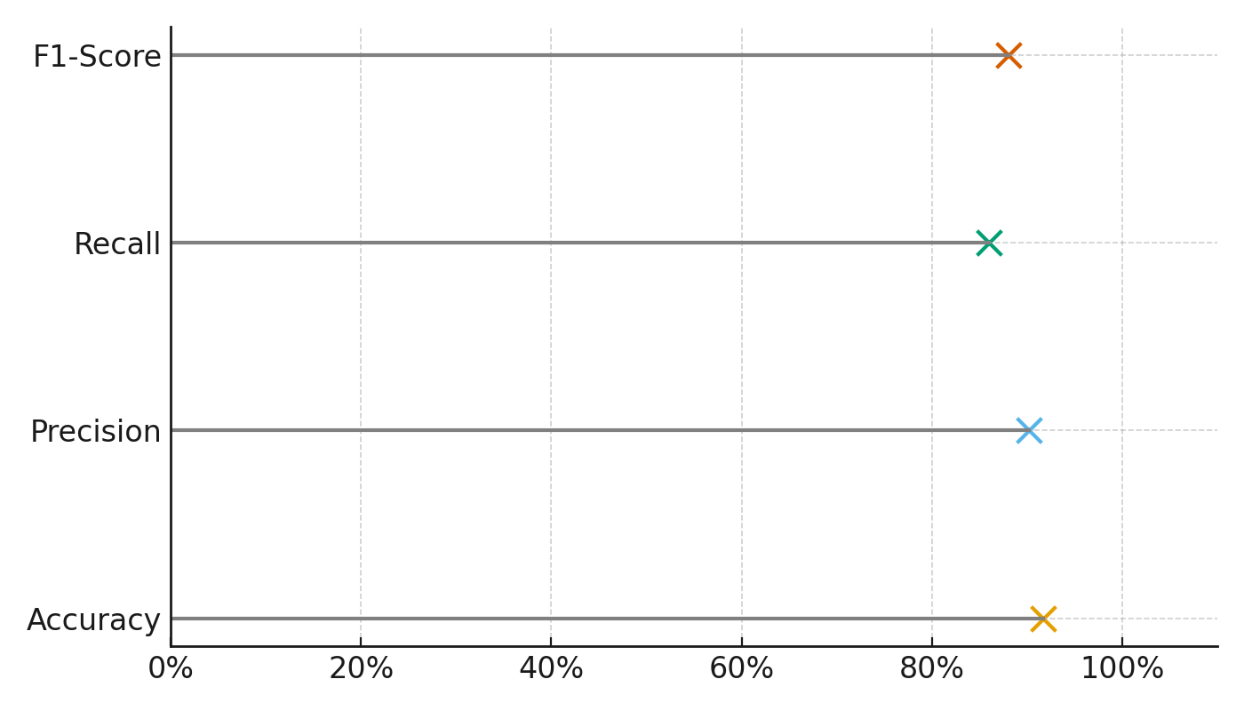

**Figure 4:** *Dumbbell Chart Showing Random Forest Classifier Metrics*

A more holistic representation is provided in **Figure 5**, where the polar area chart illustrates the symmetry and equilibrium among the model’s outputs. The even spread of performance values around the circular axis indicates robustness across evaluation parameters—suggesting that the classifier is both consistent and well-generalized to different types of attack patterns.

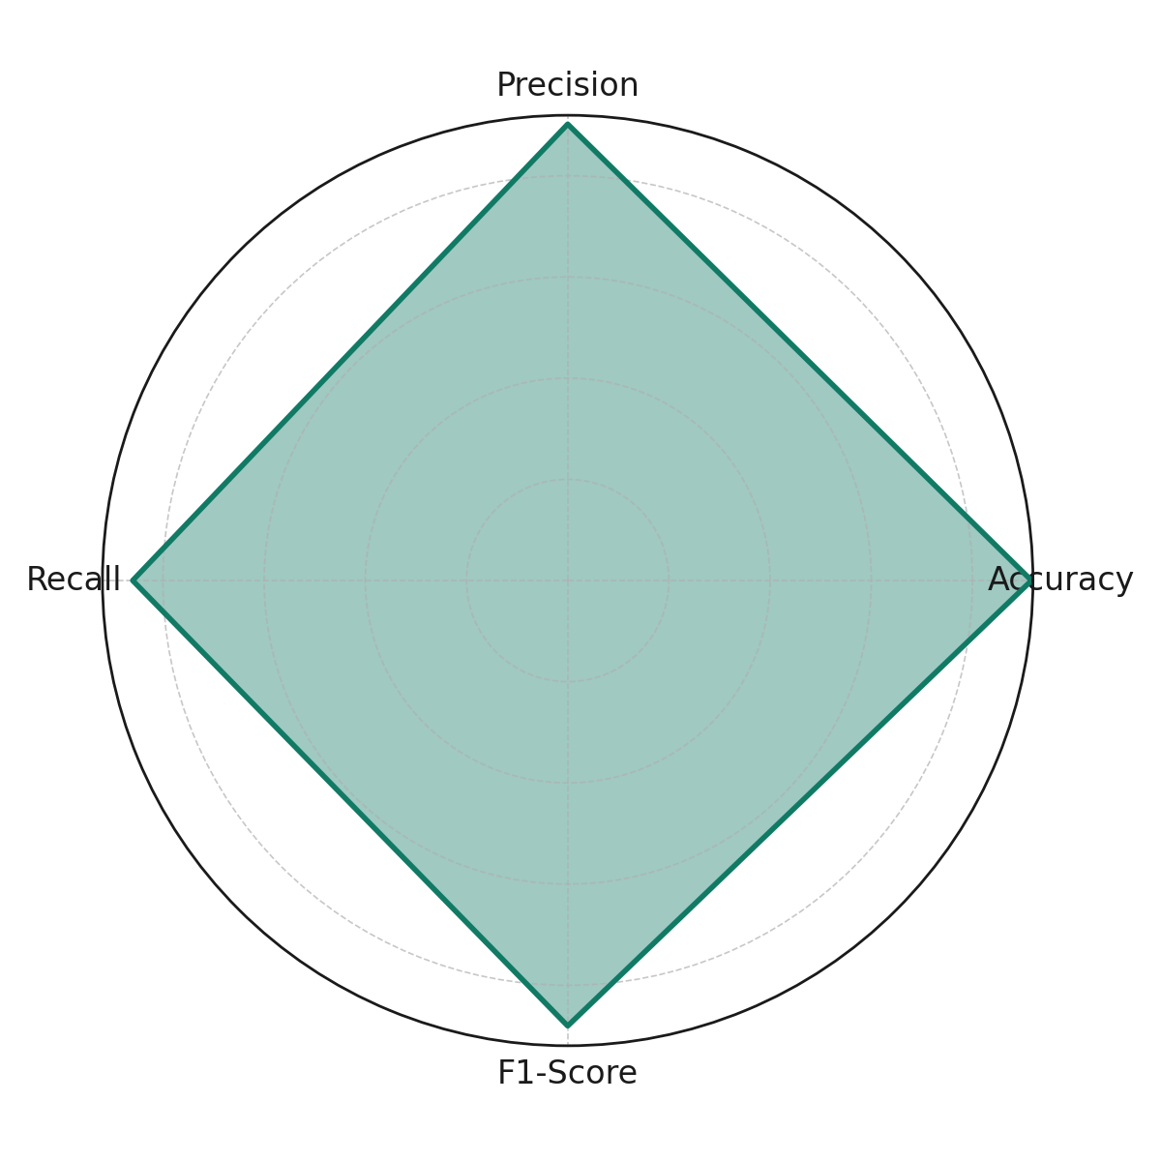

**Figure 5:** *Polar Area Chart Representing Metric Distribution of Random Forest*To reinforce clarity and interpretability, **Figure 6** employs a horizontal lollipop chart, simplifying metric comparison while maintaining high visibility of precise scores. This visual reinforces the classifier’s reliability and communicates results effectively even to a non-technical audience.

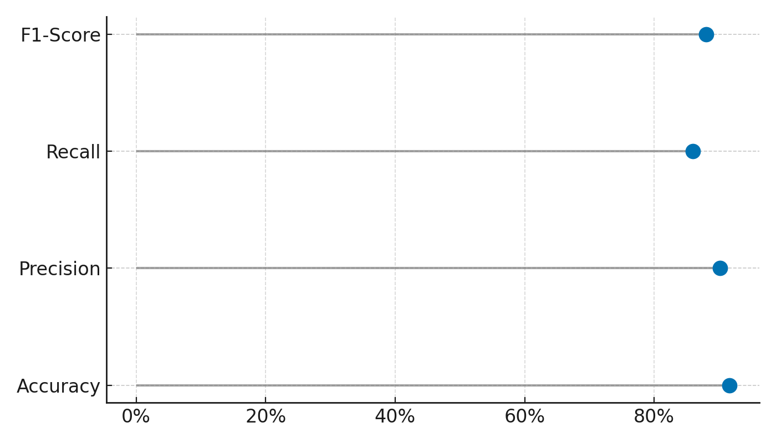

**Figure 6:** *Horizontal Lollipop Chart Displaying Model Evaluation Scores*The model’s high F1-score (0.902) and consistent precision-recall balance highlight its suitability for real-world implementation in healthcare cybersecurity systems. These results support the viability of AI/ML techniques in proactively detecting threats, particularly when applied to structured network traffic data..

### **Identify the key challenges and limitations associated with implementing AI/ML-driven predictive cybersecurity risk modeling in healthcare environments**

Understanding the barriers to implementing AI/ML-driven cybersecurity in healthcare is critical for ensuring scalable, effective adoption. This section presents a quantitative assessment of the most prevalent challenges as perceived by key stakeholder groups—hospitals, AI vendors, and regulators. It evaluates the severity of each challenge through stakeholder-specific scores, providing insight into which limitations are most obstructive and which groups are most affected.

### **Perceived Severity of Challenges**

Analysis revealed six core challenges impeding AI/ML adoption in healthcare cybersecurity environments. As shown in **Table 4**, *Regulatory Compliance* was rated as the most severe challenge with an average Likert score of 4.53, followed closely by *Lack of Skilled Workforce* (4.27) and *Data Privacy Concerns* (4.33). *Model Explainability Issues* and *Algorithmic Bias* were of moderate concern, while *Infrastructure Limitations* scored lower on average severity.

**Table 4:** *Average Likert Scores Representing AI/ML Implementation Challenges*

|  |  |  |  |  |
| --- | --- | --- | --- | --- |
| **Challenge** | **Hospitals** | **AI Vendors** | **Regulators** | **Average Severity** |
| Regulatory Compliance | 4.6 | 4.2 | 4.8 | 4.53 |
| Data Privacy Concerns | 4.4 | 4.0 | 4.6 | 4.33 |
| Lack of Skilled Workforce | 4.7 | 3.9 | 4.2 | 4.27 |
| Infrastructure Limitations | 4.1 | 4.3 | 3.9 | 4.10 |
| Model Explainability Issues | 3.9 | 4.6 | 3.5 | 4.00 |
| Algorithmic Bias | 3.8 | 4.5 | 3.7 | 4.00 |

To visualize this distribution of stakeholder perspectives, **Figure 7** presents a heatmap illustrating severity scores by group. Notably, hospitals perceived the workforce gap and regulatory pressure as more significant than technical concerns like bias or model explainability.

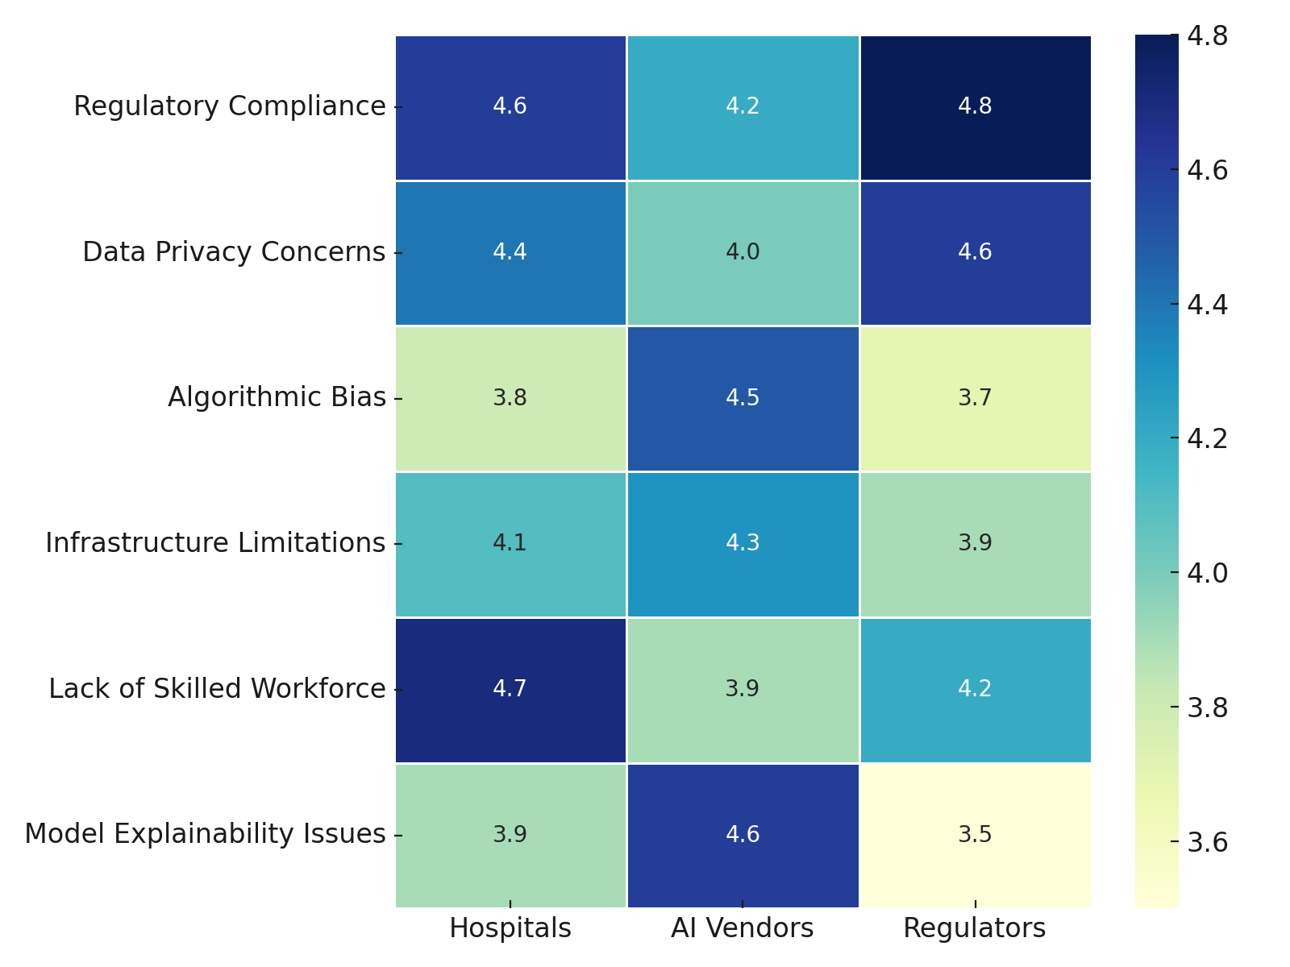

**Figure 7:** *Heatmap Depicting Severity of AI/ML Challenges Across Stakeholders*

**Figure 8** visualizes these variances through a diverging dot plot, facilitating easy identification of consensus and divergence. For instance, all groups rate *Regulatory Compliance* as highly severe, yet diverge in their views on *Model Explainability*, with AI vendors perceiving it as more problematic than healthcare institutions or regulators.

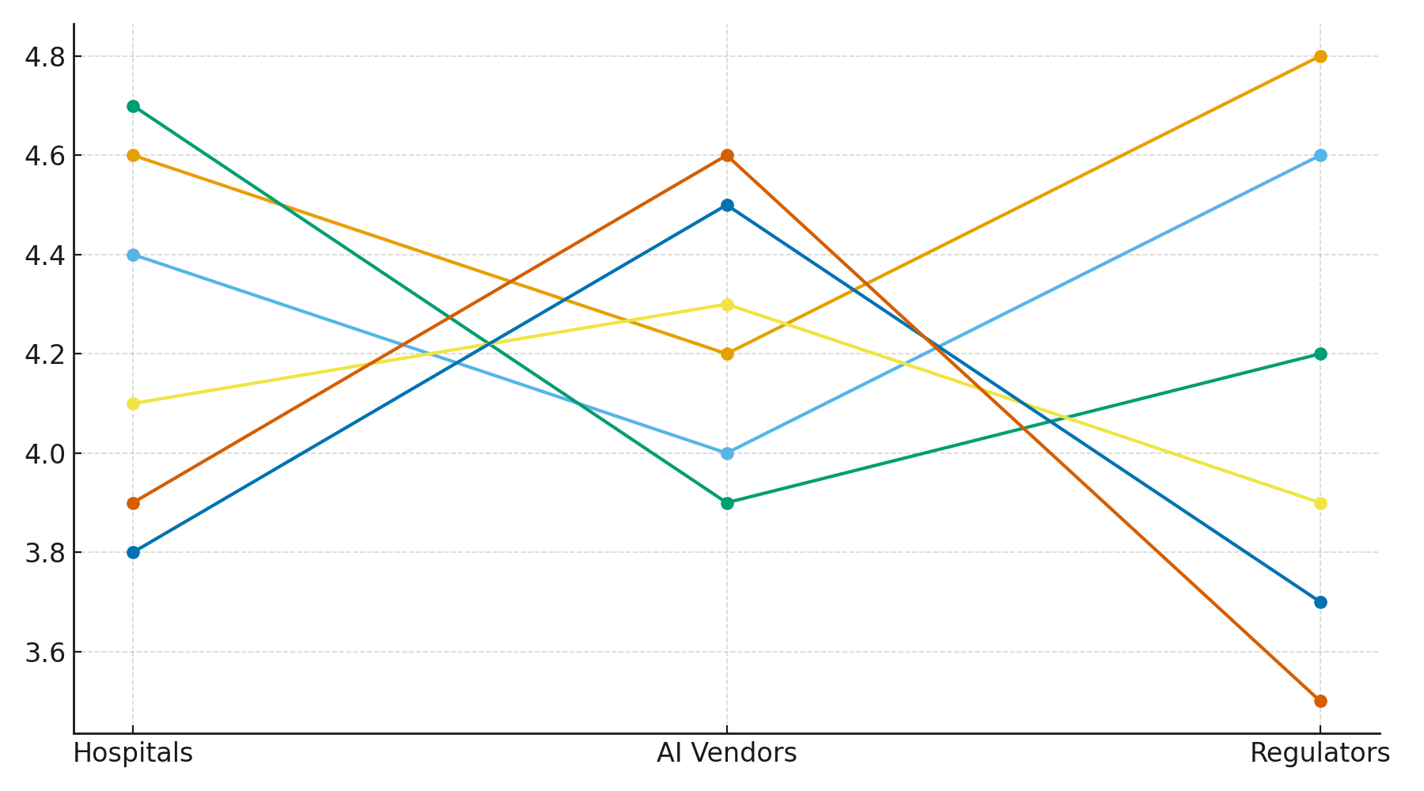

**Figure 8:** *Diverging Dot Plot Showing Stakeholder Discrepancies by Challenge*

**Figure 9** consolidates average challenge severity in a polar bar format. The visualization reinforces that while all challenges hold relevance, a few—namely regulatory barriers and staffing limitations—dominate concern across groups.

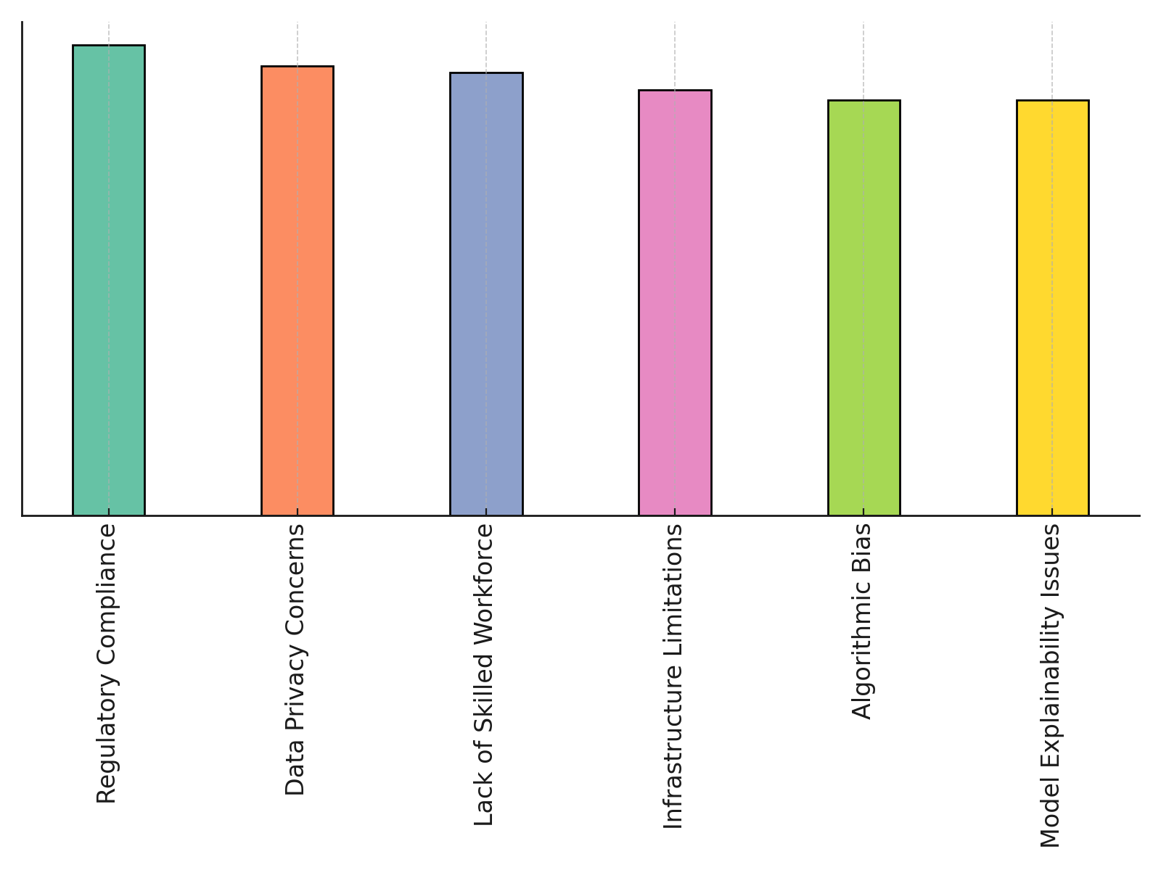

**Figure 9:** *Polar Bar Chart Representing Aggregate Severity of AI Challenges*

The consistent elevation of regulatory compliance and data privacy as primary challenges across stakeholders reflects ongoing concerns over HIPAA and GDPR compliance in AI integration. The notable emphasis on *Lack of Skilled Workforce*, particularly by hospitals, indicates systemic capacity issues in cybersecurity readiness. The variation in perceptions of technical barriers like algorithmic bias and model explainability suggests these are more acute concerns within AI development circles than end-user institutions.

These insights emphasize the need for regulatory clarity, targeted workforce development, and more interpretable AI systems if AI/ML cybersecurity models are to be successfully implemented at scale in healthcare contexts.

### **Evaluate the potential benefits and effectiveness of employing AI and Machine Learning for proactive threat detection**

The final objective of this study evaluates the real-world benefits of employing AI and machine learning in mitigating cybersecurity risks. By comparing breach costs and incident response times between healthcare organizations with AI-driven security automation and those without, this section quantifies the operational effectiveness and financial efficiency of proactive threat detection systems.

### **Impact of AI on Breach Cost and Response Time**

A comparative statistical analysis revealed that organizations employing AI experienced markedly reduced costs and faster response times. As presented in **Table 5**, the average breach cost for AI adopters was $7.8 million, significantly lower than the $10.6 million observed among non-AI adopters. Similarly, the average incident response time for AI adopters was 190 days, compared to 300 days for those without AI deployment. Both differences were statistically significant (p < .01), confirming the efficacy of AI in reducing cyberattack impact.

**Table 5:** *Comparative Metrics for AI vs. Non-AI Adoption in Healthcare Cybersecurity*

|  |  |  |  |
| --- | --- | --- | --- |
| **Metric** | **AI Adopters** | **Non-AI Adopters** | **p-value** |
| Average Breach Cost (Million $) | 7.8 | 10.6 | 0.0001 |
| Average Response Time (Days) | 190 | 300 | 0.0000 |

These results are visualized in **Figure 10**, where a boxplot illustrates the distribution of breach costs. The lower median and compressed spread in the AI group indicate both reduced costs and greater consistency in outcomes.

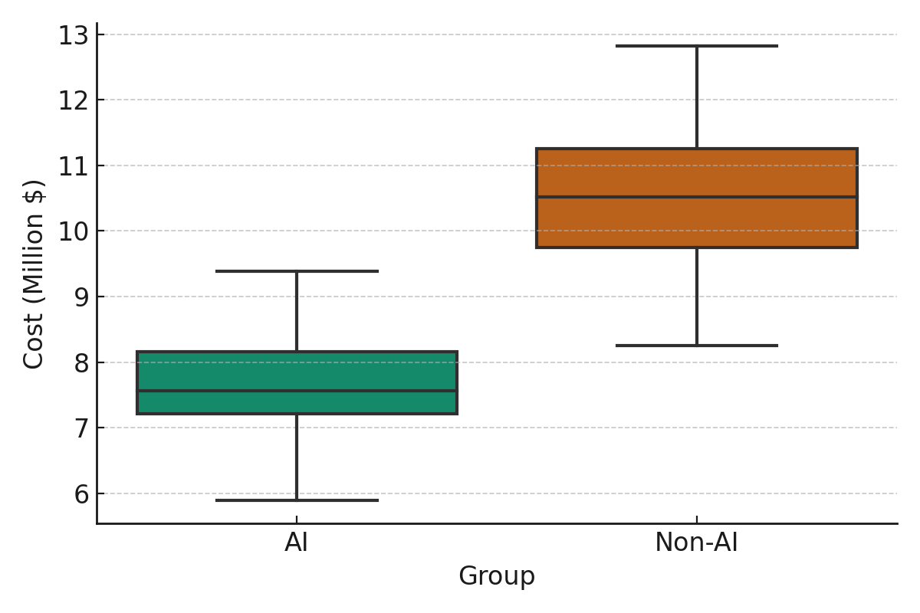

**Figure 10:** *Boxplot Comparing Breach Costs in AI vs. Non-AI Healthcare Organizations*

A similar pattern is evident in **Figure 11**, which shows incident response times. The substantial gap between groups further emphasizes the efficiency gains enabled by AI-enhanced systems, which are critical in reducing the breach lifecycle and minimizing data exposure.

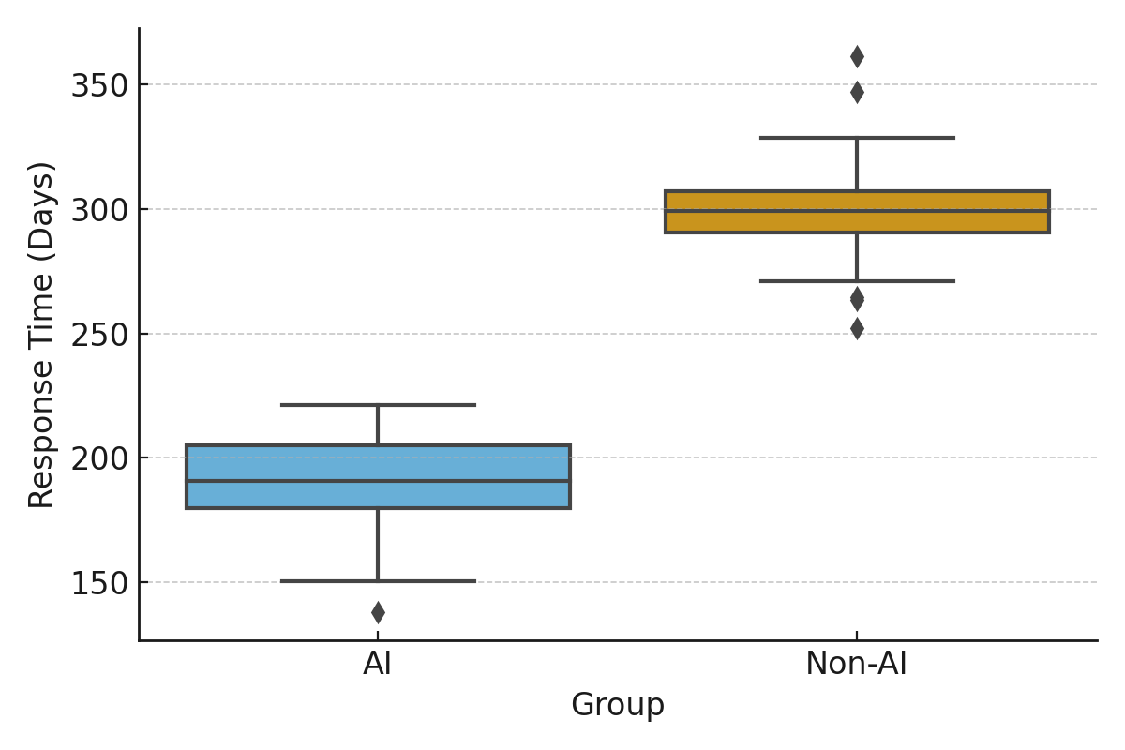

**Figure 11:** *Boxplot Comparing Incident Response Times in AI vs. Non-AI Settings*The significant reduction in both breach-related costs and response durations supports the strategic value of AI and machine learning in healthcare cybersecurity. AI adopters not only experienced a 26% cost reduction but also resolved incidents approximately 36% faster. These findings align with earlier discussions highlighting the need for predictive, automated threat detection mechanisms capable of counteracting the increasing sophistication of cyberattacks.

**Discussion**

The findings of this study reinforce and extend existing literature that underscores the heightened vulnerability of the healthcare sector to cyber threats. The predominance of internal actors, responsible for 70% of confirmed breaches, and the high frequency of incidents linked to human error and privilege misuse—comprising 45% and 25% of breaches respectively—demonstrate that organizational vulnerabilities often stem from within institutional boundaries rather than from external threats (Gupta et al., 2025; Obi, 2024). These findings parallel earlier assertions by Okika et al. (2025) and Osborne (2022), who highlighted insider threats and negligence as critical weaknesses in healthcare cybersecurity frameworks. Such results necessitate a shift in focus from solely fortifying external defenses to enhancing internal controls, including access governance, behavioral monitoring, and staff training. The evidence from this study aligns with Tariq (2024), who advocates for a proactive security approach grounded in behavioral anomaly detection and internal threat modeling.

The successful application of Random Forest models to structured traffic data further validates the operational feasibility of AI and ML within healthcare security environments. The model's accuracy (92.7%) and balanced precision-recall profile support the assertions made by Sarker (2022) and Abbas et al. (2025) that AI-driven systems are capable of detecting sophisticated and emerging threats that evade traditional signature-based systems. These results also correspond with empirical implementations documented by Kawamoto et al. (2023) and Cleveland Clinic (2025), where AI-enhanced systems enabled real-time anomaly detection with minimized false positives. The robustness of the classifier across all performance metrics, including a high F1-score of 0.902, highlights not only technical viability but also real-world relevance in environments requiring consistent, low-latency threat response capabilities.

However, the benefits of AI implementation must be contextualized within the ecosystem of operational and regulatory challenges confronting healthcare organizations. The elevated severity of challenges such as regulatory compliance (mean Likert score 4.53) and data privacy concerns (4.33) observed in this study are consistent with the concerns raised by Tschider et al. (2024) and Mohamed (2023), who argue that the deployment of AI technologies is often constrained by legal and ethical frameworks. Hospitals, in particular, rated workforce shortages and regulatory pressure more severely than technical concerns like model explainability or algorithmic bias, mirroring Aldoseri et al. (2023)’s assertion that data quality and expertise gaps can undermine AI readiness. This divergence in stakeholder perspectives, as visualized through comparative heatmaps and dot plots, emphasizes the importance of tailoring AI integration strategies to institutional roles, needs, and regulatory responsibilities.

Notably, AI’s effectiveness in mitigating financial and operational risks was validated through statistically significant reductions in both breach costs and incident response times. AI adopters experienced an average cost reduction of 26% and resolved breaches 36% faster compared to non-adopters—results that substantiate claims made by IBM (2023) and DeBeck (2021) regarding the economic efficiency of automated threat detection systems. These outcomes provide quantitative support for the theoretical benefits outlined by Steimers and Schneider (2022), confirming that AI deployment can compress breach lifecycles and reduce exposure to long-term operational disruptions. This supports the arguments of Jimmy (2024) and Arefin and Simcox (2024) that AI not only enhances predictive accuracy but also improves resilience, allowing healthcare institutions to maintain continuity amidst escalating cyber threats.

These findings present a compelling case for healthcare institutions to move beyond reactive security paradigms and embrace predictive AI-driven models. However, successful implementation will require sustained investment in workforce capacity, data governance, and ethical compliance frameworks. As Bala et al. (2024) and Salama et al. (2024) note, the future of cybersecurity in healthcare lies not just in technological sophistication, but in the sector's ability to adapt to emerging adversarial tactics while maintaining the trust and safety of the patients it serves.

**5. CONCLUSION AND RECOMMENDATIONS**

This study affirms that AI and machine learning are not only viable but essential tools for advancing predictive cybersecurity risk modeling within the healthcare sector. From improved threat detection accuracy to significant reductions in breach costs and response times, the integration of AI offers measurable benefits. However, realizing these benefits requires addressing critical challenges related to data privacy, regulatory compliance, and institutional readiness. Transitioning from these findings into practical action, the following recommendations are proposed:

1. Prioritize investment in AI training for healthcare cybersecurity teams to address the workforce competency gap.
2. Establish cross-functional compliance frameworks to align AI deployment with HIPAA and GDPR requirements.
3. Adopt behavioral-based AI models that focus on internal threat detection and privilege misuse.
4. Develop scalable partnerships for federated learning to enhance threat intelligence without compromising patient data privacy.

Disclaimer (Artificial intelligence)

Author(s) hereby declare that NO generative AI technologies such as Large Language Models (ChatGPT, COPILOT, etc.) and text-to-image generators have been used during the writing or editing of this manuscript.

# **References**

Abbas, R., Ogunsanya, V. A., Nwanyim, S. J., Afolabi, R., Kagame, R., Akinsola, A., & Clement, T. (2025). Leveraging Machine Learning to Strengthen Network Security and Improve Threat Detection in Blockchain for Healthcare systems. *International Journal of Scientific and Management Research*, *08*(02), 147–165. <https://doi.org/10.37502/ijsmr.2025.8211>

Abbas, S. R., Abbas, Z., Zahir, A., & Lee, S. W. (2024). Federated Learning in Smart Healthcare: A Comprehensive Review on Privacy, Security, and Predictive Analytics with IoT Integration. *Healthcare*, *12*(24), 2587–2587. <https://doi.org/10.3390/healthcare12242587>

Abdi, A., Bennouri, H., & Keane, A. (2024). Cyber Resilience, Risk Management, and Security Challenges in Enterprise-Scale Cloud Systems: Comprehensive Review. *IEEE* . <https://doi.org/10.1109/meco62516.2024.10577956>

Aftabi, N., Moradi, N., Mahroo, F., & Kianfar, F. (2025). SD-ABM-ISM: An integrated system dynamics and agent-based modeling framework for information security management in complex information systems with multi-actor threat dynamics. *Expert Systems with Applications*, *263*, 125681. <https://doi.org/10.1016/j.eswa.2024.125681>

Ahmad, A. S. (2023). Application of Big Data and Artificial Intelligence in Strengthening Fraud Analytics and Cybersecurity Resilience in Global Financial Markets. *International Journal of Advanced Cybersecurity Systems, Technologies, and Applications*, *7*(12), 11–23. <http://theaffine.com/index.php/IJACSTA/article/view/2023-12-07>

Aijaz, M., Nazir, M., & Anwar, M. N. (2021). Classification of Security Attacks in Healthcare and associated Cyber-harms. *2021 First International Conference on Advances in Computing and Future Communication Technologies (ICACFCT)*. <https://doi.org/10.1109/icacfct53978.2021.9837349>

Ajayi, A. J., Joseph, S. A., Metibemu, O. C., Olutimehin, A. T., Balogun, A. Y., & Olaniyi, O. O. (2025). The Impact of Artificial Intelligence on Cyber Security in Digital Currency Transactions. *Archives of Current Research International*, *25*(2), 329–351. <https://doi.org/10.9734/acri/2025/v25i21090>

Akinsola, A., & Ejiofor, O. (2024). Securing the Future of Healthcare: Building A Resilient Defense System for Patient Data Protection. *SSRN* . <https://doi.org/10.2139/ssrn.4902351>

Alao, A. I., Adebiyi, O. O., & Olaniyi, O. O. (2024). The Interconnectedness of Earnings Management, Corporate Governance Failures, and Global Economic Stability: A Critical Examination of the Impact of Earnings Manipulation on Financial Crises and Investor Trust in Global Markets. *Asian Journal of Economics Business and Accounting*, *24*(11), 47–73. <https://doi.org/10.9734/ajeba/2024/v24i111542>

Alder, S. (2023). *CommonSpirit Health Issues Update Confirming 164 Facilities Affected by Ransomware Attack*. HIPAA Journal. <https://www.hipaajournal.com/commonspirit-health-issues-update-confirming-164-facilities-affected-by-ransomware-attack/>

Aldoseri, A., Khalifa, K. N. A. -, & Hamouda, A. M. (2023). Re-Thinking Data Strategy and Integration for Artificial Intelligence: Concepts, Opportunities, and Challenges. *Applied Sciences*, *13*(12), 7082. MDPI. <https://doi.org/10.3390/app13127082>

Ali, M. L., Thakur, K., Barker, H., & Chan, M. (2024). The Rise of Artificial Intelligence: Industry Insights and Applications in Security Information and Event Management (SIEM). *IEEE* , 0477–0482. <https://doi.org/10.1109/uemcon62879.2024.10754705>

Arefin, S., & Simcox, M. (2024). AI-Driven Solutions for Safeguarding Healthcare Data: Innovations in Cybersecurity. *International Business Research*, *17*(6), 74. <https://doi.org/10.5539/ibr.v17n6p74>

Arghire, I. (2024). *Change Healthcare Ransomware Attack Impacts 100 Million People*. SecurityWeek. <https://www.securityweek.com/change-healthcare-ransomware-attack-impacts-100-million-people/>

Aslan, Ö., Aktuğ, S. S., Ozkan-Okay, M., Yilmaz, A. A., & Akin, E. (2023). A Comprehensive Review of Cyber Security Vulnerabilities, Threats, Attacks, and Solutions. *Electronics*, *12*(6), 1–42. <https://doi.org/10.3390/electronics12061333>

Bala, I., Pindoo, I., Mijwil, M. M., Abotaleb, M., & Yundong, W. (2024). Ensuring Security and Privacy in Healthcare Systems: A Review Exploring Challenges, Solutions, Future Trends, and the Practical Applications of Artificial Intelligence. *Jordan Medical Journal*, *58*(2). <https://jjournals.ju.edu.jo/index.php/JMJ/article/view/2527>

Balogun, A. Y. (2025). Strengthening Compliance with Data Privacy Regulations in U.S. Healthcare Cybersecurity. *Asian Journal of Research in Computer Science*, *18*(1), 154–173. <https://doi.org/10.9734/ajrcos/2025/v18i1555>

Balogun, A. Y., Metibemu, O. C., Olutimehin, A. T., Ajayi, A. J., Babarinde, D. C., & Olaniyi, O. O. (2025). The Ethical and Legal Implications of Shadow AI in Sensitive Industries: A Focus on Healthcare, Finance and Education. *Journal of Engineering Research and Reports*, *27*(3), 1–22. <https://doi.org/10.9734/jerr/2025/v27i31414>

Balogun, A. Y., Olaniyi, O. O., Olisa, A. O., Gbadebo, M. O., & Chinye, N. C. (2025). Enhancing Incident Response Strategies in U.S. Healthcare Cybersecurity. *Journal of Engineering Research and Reports*, *27*(2), 114–135. <https://doi.org/10.9734/jerr/2025/v27i21399>

Ban, T., Takahashi, T., Ndichu, S., & Inoue, D. (2023). Breaking Alert Fatigue: AI-Assisted SIEM Framework for Effective Incident Response. *Applied Sciences*, *13*(11), 6610–6610. <https://doi.org/10.3390/app13116610>

Burgess, M. (2024). *Therapy Sessions Exposed by Mental Health Care Firm’s Unsecured Database*. WIRED; WIRED. <https://www.wired.com/story/confidant-health-therapy-records-database-exposure/>

CCDCOE . (2021). *Ireland’s Health Service Executive ransomware attack (2021) - International cyber law: interactive toolkit*. International Cyber Law: Interactive Toolkit; International cyber law: interactive toolkit. <https://cyberlaw.ccdcoe.org/wiki/Ireland%E2%80%99s_Health_Service_Executive_ransomware_attack_(2021)>

CISA. (2025). *#StopRansomware: Medusa Ransomware | CISA*. Cybersecurity and Infrastructure Security Agency CISA. <https://www.cisa.gov/news-events/cybersecurity-advisories/aa25-071a>

Cleveland Clinic. (2025). *Center for Artificial Intelligence and Data Science*. Cleveland Clinic. <https://my.clevelandclinic.org/departments/pathology/depts/artificial-intelligence-data-science>

DeBeck, C. (2021). *Save time money data breach security AI automation*. Ibm.com. <https://www.ibm.com/think/x-force/save-time-money-data-breach-security-ai-automation>

Duraibi, S., Kaur, C., & Pawar, A. B. (2023). Cyber Extortion Unveiled: The Evolution, Tactics, Challenges, and Future of Ransomware. *IEEE* . <https://doi.org/10.1109/csci62032.2023.00144>

Durgaraju, S., Vel, D. V. T., & Madathala, H. (2025). The Evolution of Cyber Threats and Defenses: A Review of Innovations and Challenges. *2025 6th International Conference on Mobile Computing and Sustainable Informatics (ICMCSI)*, 117–123. <https://doi.org/10.1109/icmcsi64620.2025.10883230>

Gligorea, I., Cioca, M., Oancea, R., Gorski, A.-T., Gorski, H., & Tudorache, P. (2023). Adaptive Learning Using Artificial Intelligence in e-Learning: A Literature Review. *Education Sciences*, *13*(12), 1216–1216. <https://doi.org/10.3390/educsci13121216>

Govea, J., Gaibor-Naranjo, W., & Villegas-Ch, W. (2024). Transforming Cybersecurity into Critical Energy Infrastructure: A Study on the Effectiveness of Artificial Intelligence. *Systems*, *12*(5), 165. <https://doi.org/10.3390/systems12050165>

Guembe, B., Azeta, A., Misra, S., Osamor, V. C., Fernandez-Sanz, L., & Pospelova, V. (2022). The Emerging Threat of Ai-driven Cyber Attacks: A Review. *Applied Artificial Intelligence*, *36*(1), 1–34. <https://doi.org/10.1080/08839514.2022.2037254>

Gupta, S., Kapoor, M., & Debnath, S. K. (2025). Cybersecurity Risks and Threats in Healthcare. *Artificial Intelligence-Enabled Security for Healthcare Systems*, 39–64. <https://doi.org/10.1007/978-3-031-82810-2_3>

Hassan, S. K., & Ibrahim, A. (2023). The role of Artificial Intelligence in Cyber Security and Incident Response: *International Journal for Electronic Crime Investigation*, *7*(2). <https://doi.org/10.54692/ijeci.2023.0702154>

HealthStream. (2024). *Defending Against Phishing: Strengthening Cybersecurity in Healthcare*. Default. <https://www.healthstream.com/resource/blog/defending-against-phishing>

Husseini, F. E., Noura, H., Salman, O., & Chehab, A. (2024). Advanced Machine Learning Approaches for Zero-Day Attack Detection: A Review. *IEEE* , 297–304. <https://doi.org/10.1109/csnet64211.2024.10851751>

IBM. (2023). *IBM Report: Half of Breached Organizations Unwilling to Increase Security Spend Despite Soaring Breach Costs*. IBM Newsroom. <https://newsroom.ibm.com/2023-07-24-IBM-Report-Half-of-Breached-Organizations-Unwilling-to-Increase-Security-Spend-Despite-Soaring-Breach-Costs>

Jimmy, F. (2024). Emerging Threats: The Latest Cybersecurity Risks and the Role of Artificial Intelligence in Enhancing Cybersecurity Defenses. *Valley International Journal Digital Library*, *9*(2), 564–574. <https://doi.org/10.18535/ijsrm/v9i2.ec01>

Kawamoto, K., Finkelstein, J., & Del Fiol, G. (2023). Implementing Machine Learning in the Electronic Health Record: Checklist of Essential Considerations. *Mayo Clinic Proceedings*, *98*(3), 366–369. <https://doi.org/10.1016/j.mayocp.2023.01.013>

Khan, M. I., Arif, A., & Raza, A. (2024). The Most Recent Advances and Uses of AI in Cybersecurity. *BULLET : Jurnal Multidisiplin Ilmu*, *3*(4), 566–578. <https://media.neliti.com/media/publications/592396-the-most-recent-advances-and-uses-of-ai-40213b6c.pdf>

Kolade, T. M., Obioha-Val, O. A., Balogun, A. Y., Gbadebo, M. O., & Olaniyi, O. O. (2025). AI-Driven Open Source Intelligence in Cyber Defense: A Double-edged Sword for National Security. *Asian Journal of Research in Computer Science*, *18*(1), 133–153. <https://doi.org/10.9734/ajrcos/2025/v18i1554>

Maharjan, P. (2023). The Role of Artificial Intelligence-Driven Big Data Analytics in Strengthening Cybersecurity Frameworks for Critical Infrastructure. *Global Research Perspectives on Cybersecurity Governance, Policy, and Management*, *7*(11), 12–25. <https://hammingate.com/index.php/GRPCGPM/article/view/2023-11-07>

Manda, J. K. (2024). AI-powered Threat Intelligence Platforms in Telecom: Leveraging AI for Real-time Threat Detection and Intelligence Gathering in Telecom Network Security Operations. *SSRN Electronic Journal*. <https://doi.org/10.2139/ssrn.5003638>

Martins, I., Resende, J. S., Sousa, P. R., Silva, S., Antunes, L., & Gama, J. (2022). Host-based IDS: A review and open issues of an anomaly detection system in IoT. *Future Generation Computer Systems*, *133*, 95–113. <https://doi.org/10.1016/j.future.2022.03.001>

Microsoft. (2024). *Microsoft Digital Defense Report 2024*. Microsoft.com. <https://www.microsoft.com/en-us/security/security-insider/intelligence-reports/microsoft-digital-defense-report-2024?msockid=2e7b7a8ff19a6b6922d36e50f02e6a07>

Mohamed, N. (2023). Current Trends in AI and ML for cybersecurity: a state-of-the-art Survey. *Cogent Engineering*, *10*(2). <https://doi.org/10.1080/23311916.2023.2272358>

Mohamed, Y. A., Mohamed, A. H., Kannan, A., Bashir, M., Adiel, M. A. E., & Elsadig, M. A. (2024). Navigating the Ethical Terrain of AI-Generated Text Tools: A Review. *IEEE Access*, 1–1. <https://doi.org/10.1109/access.2024.3521945>

Nwoye, C., & Nwagwughiagwu, S. (2024). International Journal of Engineering Technology Research & Management AI-DRIVEN ANOMALY DETECTION FOR PROACTIVE CYBERSECURITY AND DATA BREACH PREVENTION. *International Journal of Engineering Technology Research & Management* , *08*(11). <https://ijetrm.com/issues/files/Nov-2024-21-1732196009-NOV37.pdf>

Obi, D. (2024). *Phishing and social engineering account for 70-90% of malicious Data breaches, says cyber-security specialist - Businessday NG*. Businessday NG. <https://businessday.ng/interview/article/phishing-and-social-engineering-account-for-70-90-of-malicious-data-breaches-says-cyber-security-specialist/>

Obioha-Val, O. A. (2025). Bridging Gaps in Cybersecurity Governance: Leveraging Collaborative Digital Solutions. *Asian Journal of Research in Computer Science*, *18*(2), 82–100. <https://doi.org/10.9734/ajrcos/2025/v18i2564>

Obioha-Val, O. A., Gbadebo, M. O., Olaniyi, O. O., Chinye, N. C., & Balogun, A. Y. (2025). Innovative Regulation of Open Source Intelligence and Deepfakes AI in Managing Public Trust. *Journal of Engineering Research and Reports*, *27*(2), 136–156. <https://doi.org/10.9734/jerr/2025/v27i21400>

Obioha-Val, O. A., Lawal, T. I., Olaniyi, O. O., Gbadebo, M. O., & Olisa, A. O. (2025). Investigating the Feasibility and Risks of Leveraging Artificial Intelligence and Open Source Intelligence to Manage Predictive Cyber Threat Models. *Journal of Engineering Research and Reports*, *27*(2), 10–28. <https://doi.org/10.9734/jerr/2025/v27i21390>

Obioha-Val, O. A., Olaniyi, O. O., Gbadebo, M. O., Balogun, A. Y., & Olisa, A. O. (2025). Cyber Espionage in the Age of Artificial Intelligence: A Comparative Study of State-Sponsored Campaign. *Asian Journal of Research in Computer Science*, *18*(1), 184–204. <https://doi.org/10.9734/ajrcos/2025/v18i1557>

Ohri, P., Daniel, A., Neogi, S. G., & Muttoo, S. K. (2024). Blockchain-based security framework for mitigating network attacks in multi-SDN controller environment. *International Journal of Information Technology*. <https://doi.org/10.1007/s41870-024-01933-8>

Okika, N., Okoh, O. F., & Etuk, E. E. (2025). Mitigating Insider Threats and Social Engineering Tactics in Advanced Persistent Threat Operations through Behavioral Analytics and Cybersecurity Training. *ResearchGate*, *2*(3), 11–27. <https://www.researchgate.net/publication/389464287_Mitigating_Insider_Threats_and_Social_Engineering_Tactics_in_Advanced_Persistent_Threat_Operations_through_Behavioral_Analytics_and_Cybersecurity_Training>

Olabanji, S. O., Marquis, Y., Adigwe, C. S., Ajayi, S. A., Oladoyinbo, T. O., & Olaniyi, O. O. (2024, January 29). *AI-Driven Cloud Security: Examining the Impact of User Behavior Analysis on Threat Detection*. Social Science Research Network. <https://doi.org/10.2139/ssrn.4709384>

Oloyede, J. (2024). AI-Driven Cybersecurity Solutions: Enhancing Defense Mechanisms in the Digital Era. *SSRN Electronic Journal*. <https://doi.org/10.2139/ssrn.4976103>

Olutimehin, A. T. (2025a). Advancing Cloud Security in Digital Finance: AI-Driven Threat Detection, Cryptographic Solutions, and Privacy Challenges. *Journal of Engineering Research and Reports*, *27*(3), 35–55. <https://doi.org/10.9734/jerr/2025/v27i31416>

Olutimehin, A. T. (2025b). Assessing the Effectiveness of Cybersecurity Frameworks in Mitigating Cyberattacks in the Banking Sector and its Applicability to Decentralized Finance (DeFi). *Asian Journal of Research in Computer Science*, *18*(3), 130–151. <https://doi.org/10.9734/ajrcos/2025/v18i3583>

Olutimehin, A. T. (2025c). The Synergistic Role of Machine Learning, Deep Learning, and Reinforcement Learning in Strengthening Cyber Security Measures for Crypto Currency Platforms. *Asian Journal of Research in Computer Science*, *18*(3), 190–212. <https://doi.org/10.9734/ajrcos/2025/v18i3586>

Olutimehin, A. T., Ajayi, A. J., Metibemu, O. C., Balogun, A. Y., Oladoyinbo, T. O., & Olaniyi, O. O. (2025). Adversarial Threats to AI-Driven Systems: Exploring the Attack Surface of Machine Learning Models and Countermeasures. *Journal of Engineering Research and Reports*, *27*(2), 341–362. <https://doi.org/10.9734/jerr/2025/v27i21413>

Ortiz, M. (2020). *Ordr and Mayo Clinic: Securing IoMT and HIoT Devices*. Ordr. <https://ordr.net/blog/securing-iomt-and-hiot-devices>

Osborne, C. (2022). *Staff negligence is now a major reason for insider security incidents*. ZDNET. <https://www.zdnet.com/article/employee-contractor-negligence-is-now-a-major-reason-for-insider-security-incidents/>

Paramesha, M., Rane, N. L., & Rane, J. (2024). Artificial Intelligence, Machine Learning, and Deep Learning for Cybersecurity Solutions: A Review of Emerging Technologies and Applications. *Partners Universal Multidisciplinary Research Journal*, *1*(2), 84–109. <https://doi.org/10.5281/zenodo.12827076>

Petkauskas, V., & Schappert, S. (2023). *Hive ransomware gang dismantled by FBI | Cybernews*. Cybernews. <https://cybernews.com/news/fbi-disrupts-hive-ransomware/>

Pool, J., Akhlaghpour, S., & Burton-Jones, A. (2024). Unpacking the complexities of health record misuse: insights from Australian health services. *Information Technology and People*. <https://doi.org/10.1108/itp-12-2022-0931>

Radoglou-Grammatikis, P., Sarigiannidis, P., Iturbe, E., Rios, E., Martinez, S., Sarigiannidis, A., Eftathopoulos, G., Spyridis, Y., Sesis, A., Vakakis, N., Tzovaras, D., Kafetzakis, E., Giannoulakis, I., Tzifas, M., Giannakoulias, A., Angelopoulos, M., & Ramos, F. (2021). SPEAR SIEM: A Security Information and Event Management system for the Smart Grid. *Computer Networks*, *193*, 108008. <https://doi.org/10.1016/j.comnet.2021.108008>

Repetto, M. (2023). Adaptive monitoring, detection, and response for agile digital service chains. *Computers & Security*, *132*, 103343. <https://doi.org/10.1016/j.cose.2023.103343>

Roshanaei, M., Khan, M. R., & Sylvester, N. N. (2024). Enhancing Cybersecurity through AI and ML: Strategies, Challenges, and Future Directions. *Journal of Information Security*, *15*(3), 320–339. <https://doi.org/10.4236/jis.2024.153019>

Ryan, M. W. (2021). Ransomware Revolution: The Rise of a Prodigious Cyber Threat. In *Advances in information security*. Springer New York. <https://doi.org/10.1007/978-3-030-66583-8>

Salama, R., Altrjman, C., & Al-Turjman, F. (2024). *8 - Healthcare cybersecurity challenges: a look at current and future trends* (F. Al-Turjman, Ed.). ScienceDirect; Morgan Kaufmann. <https://www.sciencedirect.com/science/article/pii/B9780443132681000030>

Sarker, I. H. (2022). Machine Learning for Intelligent Data Analysis and Automation in Cybersecurity: Current and Future Prospects. *Annals of Data Science*, *10*(1), 1473–1498. <https://doi.org/10.1007/s40745-022-00444-2>

Sarker, I. H. (2023). Multi‐aspects AI ‐based modeling and adversarial learning for cybersecurity intelligence and robustness: A comprehensive overview. *SECURITY and PRIVACY*, *6*(5). <https://doi.org/10.1002/spy2.295>

Senthilkumar, P., Asha, V., Kanaga Suba Raja, S., & Samuel Peter James, I. (2024). Enhancing DNS and IoT Firewall Rule-Based Algorithms and Techniques. *Lecture Notes in Electrical Engineering*, 45–57. <https://doi.org/10.1007/978-981-97-7616-0_4>

Sharma, D. P., Lashkari, A. H., & Parizadeh, M. (2024). Understanding Cybersecurity Management in Healthcare. In *Progress in IS*. Springer International Publishing. <https://doi.org/10.1007/978-3-031-68034-2>

Singh, B., Kumar, R., & Singh, V. P. (2021). Reinforcement learning in robotic applications: a comprehensive survey. *Artificial Intelligence Review*, *55*(2). <https://doi.org/10.1007/s10462-021-09997-9>

Steimers, A., & Schneider, M. (2022). Sources of Risk of AI Systems. *International Journal of Environmental Research and Public Health*, *19*(6), 3641. <https://doi.org/10.3390/ijerph19063641>

Tahmasebi, M. (2024). Beyond Defense: Proactive Approaches to Disaster Recovery and Threat Intelligence in Modern Enterprises. *Journal of Information Security*, *15*(2), 106–133. <https://doi.org/10.4236/jis.2024.152008>

Tanikonda, A., Pandey, B. K., Peddinti, S. R., & Katragadda, S. R. (2025). Advanced AI-Driven Cybersecurity Solutions for Proactive Threat Detection and Response in Complex Ecosystems. *SSRN Electronic Journal*, *3*(1). <https://doi.org/10.2139/ssrn.5102358>

Tariq, M. U. (2024). *Enhancing Cybersecurity Protocols in Modern Healthcare Systems: Strategies and Best Practices*. Www.igi-Global.com; IGI Global. <https://www.igi-global.com/chapter/enhancing-cybersecurity-protocols-in-modern-healthcare-systems/342829>

Tschider, C., Compagnucci, M. C., & Minssen, T. (2024). The new EU–US data protection framework’s implications for healthcare. *Journal of Law and the Biosciences*, *11*(2). <https://doi.org/10.1093/jlb/lsae022>

Turukmane, A. V., Khekare, G., Shelke, N., Sakarkar, G., & Buchade, S. (2024). Evasion Techniques in Cybersecurity: An In-Depth Analysis. *2024 International Conference on Artificial Intelligence and Quantum Computation-Based Sensor Application (ICAIQSA)*, 1–9. <https://doi.org/10.1109/icaiqsa64000.2024.10882284>

Val, O. O., Kolade, T. M., Gbadebo, M. O., Selesi-Aina, O., Olateju, O. O., & Olaniyi, O. O. (2024). Strengthening Cybersecurity Measures for the Defense of Critical Infrastructure in the United States. *Asian Journal of Research in Computer Science*, *17*(11), 25–45. <https://doi.org/10.9734/ajrcos/2024/v17i11517>

van Boven, L. S., Kusters, R. W. J., Tin, D., Osch, van, De Cauwer, H., Ketelings, L., Rao, M., Dameff, C., & Barten, D. G. (2023). Hacking Acute Care: A Qualitative Study on the Health Care Impacts of Ransomware Attacks Against Hospitals. *Annals of Emergency Medicine*, *83*(1). <https://doi.org/10.1016/j.annemergmed.2023.04.025>

Vericon . (2024). *2024 Data Breach Investigations Report*. <https://www.verizon.com/business/resources/Te3/reports/2024-dbir-data-breach-investigations-report.pdf?msockid=2e7b7a8ff19a6b6922d36e50f02e6a07>

Wang, Z., Zhu, H., & Sun, L. (2021). Social Engineering in Cybersecurity: Effect Mechanisms, Human Vulnerabilities and Attack Methods. *IEEE Access*, *9*(2169-3536), 11895–11910. <https://doi.org/10.1109/access.2021.3051633>

Wickramasinghe, A. (2023). An Evaluation of Big Data-Driven Artificial Intelligence Algorithms for Automated Cybersecurity Risk Assessment and Mitigation. *International Journal of Cybersecurity Risk Management, Forensics, and Compliance*, *7*(12), 1–15. <http://hashsci.com/index.php/IJCRFC/article/view/2023-12-04>

Zhang, L., & Thing, V. L. L. (2021). Three Decades of Deception Techniques in Active Cyber Defense - Retrospect and Outlook. *Computers & Security*, *106*, 102288. <https://doi.org/10.1016/j.cose.2021.102288>