**EXAMINING THE APPLICATION OF COATING METHODOLOGIES AND SURFACE ANALYSIS POST- MACHINING LOW CARBON STEEL**

# Abstract

This study explored the corrosion behaviour of low carbon steel under various coating methods and engineered machining techniques. The study successfully created coatings with strong adhesion and minimal porosity using electroplating, painting, and blackening methods. To evaluate the corrosion resistance of these coatings, the research conducted tests using hydrochloric acid (HCL), sodium chloride solution (NaCl) and freshwater (H2O), as well as mechanical scratch tests to assess the coatings' interaction with the steel substrate. The experiment used low carbon steel specimens and analyzed their corrosion behaviour over a five-week period. The results showed that the all coatings exhibited superior corrosion resistance in freshwater (H2O), while blackening and electroplating performed better in hydrochloric acid (HCL) and sodium chloride solution (NaCl). Notably, paint coatings showed significant surface removal, while electroplating and blackening coatings displayed strong bonding and no visible removal. The study concluded that electroplating and blackening are more suitable for low carbon steel applications requiring mechanical strength due to their ability to withstand scratches without compromising surface integrity. The findings highlight the varying effectiveness of different coating methods in protecting low carbon steel from corrosion in different environments.

**Keywords:** Electroplating, Blackening, Machining, Surface Treatment, Corrosion Resistance, Hydrochloric Acid,

**INTRODUCTION**

Low carbon steel, prized for its adaptability and cost-effectiveness, plays a vital role in diverse industries, from automotive to construction [1-2]. Nevertheless, its natural limitations, including susceptibility to corrosion, which poses a significant risk to process safety in the chemical industry and contaminate drinking water systems, posing health risks to humans and wildlife. A significant limitation of low carbon steel is its susceptibility to corrosion in various real-world environments, which can shorten its service life [3]. In offshore pipeline applications, corrosion can lead to metal degradation and potentially catastrophic as come to the point of living to pipeline failures, compromising the structural integrity of facilities [4]. Also easily wear of low carbon steels, necessitate for innovative solutions to enhance its surface properties [5]. As one of the most widely used materials in various industries, low carbon steel is valued for its ease of welding, machining, and ductility [6]. Characterized by a carbon content of less than 0.2% by weight, low carbon steel's properties are highly dependent on its microstructure.

Surface treatments are essential for metal surfaces, especially low carbon steels, to attain desired properties reducing most of low carbon steels limitations to industrial applications. Surface treatment methods are surface coating, blackening, electrolyte, hardening, painting etc., are some of the most widely used techniques. The surface treatments involve applying a thin layer of functional material to a surface, known as the substrate, to enhance its properties. These processes can significantly improve surface hardness, resistance to wear and corrosion, and alter surface characteristics such as wettability and hydrophobicity. Various coating techniques and materials used as a coating are available, catering to different applications, with the primary goal of protecting surfaces from mechanical or chemical damage [7-8]

While various non-ferrous metals have been used to coat ferrous surfaces, zinc is the most common choice due to its affordability and electrochemical properties [9]. However, aluminium alloy coatings have gained significant attention [10]. It's important to note that bonding dissimilar metals and alloys is challenging due to their differing physical, mechanical, and chemical properties [11-12]. Nevertheless, aluminium-zinc coatings can be applied to steel using various metallic coating methods [13].

This thesis aims to examining the application of coating methodologies and conducting surface analysis techniques to enhance the performance of low carbon steel, transforming it into a high-performance material by investigating the impact of environmental factors such as an exposure to corrosive media on the performance and stability of coatings on machined low carbon steel surface and to determine the kinetics of corrosion of the coated low carbon steel so that predictions of service life can be made and contributions can be made towards the utmost control of corrosion processes. To analyzed the adhesion strength and durability of coatings on machined low carbon steel by conducting mechanical tests, such as scratch tests to understand the coating-substrate interaction and predict the coating's performance under different loading conditions. Though these three coatings have been done by industries but a critical analysis has been done to establish the superiorities among these coatings. The findings of this study will provide valuable guidance to industries, enabling them to choose optimal coating techniques that improve the properties and prolong the lifespan of low carbon steel components, ultimately leading to enhanced performance and reduced maintenance costs.

Through rigorous experimentation and analysis, this research seeks to provide valuable insights and practical recommendations for material scientists, engineers, and industries involved in material science and engineering.

**2. Materials and Methods**

The low carbon steel plate was selected for the examination, with the steel having the composition: 0.02% (P), 0.37% (Mn), 0.46% (S),0.039% (Ni), 0.21% (C) and the remainder is Fe, due to their excellent machinability and surface finishing capabilities. The samples were cut to precise dimensions: 80 mm x 45 mm x 10 mm for the plate. Following cutting, the samples underwent polishing and thorough cleaning to remove any solid dirt, grease, or contamination, ensuring optimal surface preparation for the finishing operations.

**2.1 Experimental Procedure**

Three distinct coating categories were prepared for the application: electroplating, painting, and blackening/bluing, the electroplating process commenced with the thorough cleaning of the sample using acetone to remove any grease or oil residues. The electrolyte solution was prepared by mixing 400 ml of water with 250 ml of white vinegar in a container, maintaining a 2:1 water-to-vinegar ratio. An electroplating setup was configured by connecting two zinc plates to separate wires: the red wire linked to the zinc electrode (cathode) and the black wire connected to the other zinc plate. These wires were then attached to a DC power source via a charger. The setup was left undisturbed for 2 hours, with occasional stirring, allowing the electrodes to gradually lose mass and release zinc ions into the electrolyte solution. This process facilitated the electroplating process, creating an electrolyte solution suitable for plating the sample. The sample to be plated was designated as the cathode in the electrolytic cell, while a zinc anode served as the anode. The zinc electrodes were connected to the positive terminal of the power supply, and the sample to be zinc-coated was connected to the negative terminal. Upon activating the power supply, the onset of fizzling indicated that the electroplating process had commenced, signalling the deposition of zinc onto the sample. Prior to the blackening process, the sample was meticulously cleaned with acetone to remove any residual grease or oil. This setup enabled the controlled application of heat and blackening agent to achieve a uniform black oxide coating on the sample. To obtain the desired blackening finish, the metal sample was carefully submerged in oil, which served as a cooling medium, after being heated to a temperature range of 400-600°C. The sample was then allowed to remain in the oil for 3-5 minutes, during which it underwent rapid cooling. This cleaning step was crucial in achieving a visually appealing and well-finished blackened surface, ultimately resulting in the successful attainment of the blackening finish. Prior to the spray-painting process, the sample was thoroughly cleaned with acetone to remove any residual grease or oil. This setup enabled the application of a uniform paint coating to the sample, ensuring a strong bond between the paint and the substrate. A surface primer was then applied to enhance paint adhesion, increase durability, and prolong the lifespan of the paint. Prior to application, the paint was rigorously agitated to ensure uniform mixing. The paint was then applied in multiple thin, uniform coats, allowing sufficient drying time between each coat to prevent sagging and ensure a smooth, even finish. Following the drying process, the sample underwent a rigorous visual inspection to detect any surface imperfections, including scratches or marks.

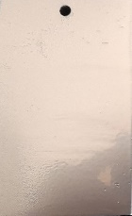

a) Plating b) Paint c) Blackening

Figure 1: Sample surfaces after coating

**2.2 Methods for mechanical testing**

To evaluate the adhesion strength and durability of coatings on machined low carbon steel, mechanical tests such as scratch tests are conducted to examine the coating-substrate interaction. This helps predict the coating's performance under various loading conditions. Standardized test methods, like ASTM D3359, are used to assess the adhesion of coating films to metallic substrates

[15]. This involves applying and removing pressure-sensitive tape over cuts made in the film to measure the coating's adhesion strength. Test Method D3359 is specifically designed for use with metal substrates. Equipment needed was cutting tool, steel rule, a pressure sensitive tape, magnifying glass.

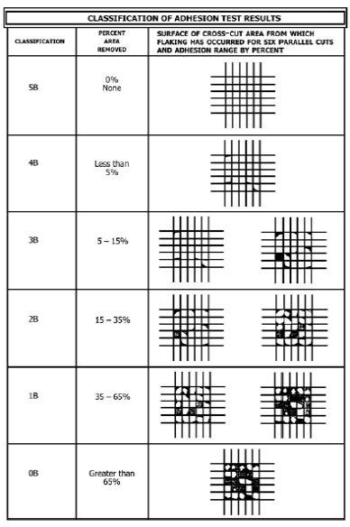***Table 1: Classification of adhesion test results***

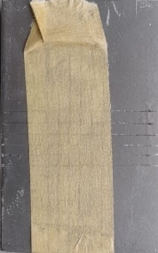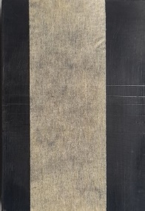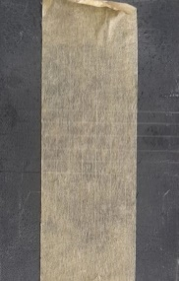

***Figure 2: Sample with lattice pattern drawn with sensitive tape***

**Alterations after the scratch test**

After conducting the scratch test on the sample, a closer examination using a magnifying glass revealed flaking on the surface of the cross-cut area, specifically along the six parallel cuts. This flaking resulted in a removal of 15-35% of the painted surface area, which corresponds to a classification of 2B according to the test standards. The sample was then spray-painted to further assess the damage.After performing a scratch test on the electroplating sample and applying tape, a detailed examination with a magnifying glass revealed no flaking or removal of the surface area along the six parallel cuts on the cross-cut surface. This indicated excellent adhesion, resulting in a classification of 5B, the highest rating, as per the defined criteria, signifying no visible damage or removal of the electroplated surface. Finally, after conducting a scratch test on the blackening sample and applying tape, a close examination with a magnifying glass surprisingly showed flaking along the six parallel cuts on the cross-cut surface, but with no visible removal of the surface area. Despite the flaking, the sample still achieved a classification of 5B, indicating excellent adhesion and no significant damage to the blackened surface, according to the defined criteria.

2.3 Methods for corrosion testing

The corrosion test was designed to assess the behavior of materials in specific environments, determine their suitability, identify effective corrosion control methods. For this study, various environments including hydrochloric acid (HCl), sodium chloride (NaCl), and fresh water were utilized. Rectangular low carbon steel specimens, which were machined and coated, were exposed to these environments to evaluate their corrosive effects. Monitoring took place on a weekly basis to track corrosion rates and assess the impact on the low carbon steel. The results from this experiment provide valuable insights into corrosion dynamics and its implications for low carbon steel materials.

The machined and coated low carbon steel specimen has a rectangular shape, with dimensions:

Length (L): 8.0 cm, Width (B): 4.5 cm, Thickness (H): 1.0 cm

To calculate the total surface area, we need to find the area of the flat surfaces and the edge surfaces.

Area of flat surfaces = 2 × (L × B) = 2 × (8.0 cm × 4.5 cm) = 72 cm²

Area of edge surfaces = 2 × (L × H) + 2 × (B × H)

2 × (8.0 cm × 1.0 cm) + 2 × (4.5 cm × 1.0 cm) = 25 cm²

Total Surface Area = Area of flat surfaces + Area of edge surfaces

Therefore 72 cm² + 25 cm² = 97 cm²

The total surface area of the rectangular low carbon steel specimen is 97 cm².

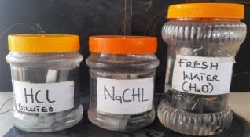



Figure 3: Samples in a different medium environment for monitoring

The experimental medium was a Hydrochloric Acid (HCl) solution, prepared by diluting 37% pure acid with water at a ratio of 3.7:1. This resulted in a mixture of 100ml of acid with 370ml of water, yielding a total of 470ml of 10% HCl solution. To also prepare the test media for the NaCl solution, begin by measuring out 470ml of water using a graduated cylinder or measuring cup. Weigh out 200g of sodium chloride using a scale. Transfer the measured water to a clean container and gradually add the sodium chloride (HCl) while continuously stirring the mixture.

**Measurement of Weight Loss**

To assess weight loss, the samples were weighed using a precision balance before and after exposure to different environments on a weekly basis. The weight change for each week was determined by calculating the difference between the initial weight and the weight measured after immersion, providing a quantitative measure of corrosion-induced weight loss over time.

**Determination of Corrosion Rate**

Calculating the corrosion rate involves a multi-step process. First, the weight change of the sample is determined before and after exposure to a corrosive environment. Then, this weight change is divided by the exposed surface area and the duration of exposure. Finally, conversion factors are applied to express the corrosion rate in the desired units, typically millimetres per year (mm/yr). This process can be represented mathematically by the following equation:

Corrosion Rate (CR) = (k × Weight Loss (∆w)) / (Exposed Area (A) × Exposure Time (T) × Density (ρ))

Where:

CR = Corrosion rate (mm/yr)

∆w = Weight loss (g or mg)

A = Exposed surface area (97 cm²)

ρ = Density of low carbon steel (7.86 g/cm³)

T = Exposure time (hours)

k = Conversion constant (8.76 × 10⁴)

This equation provides a quantitative measure of the corrosion rate, allowing for a comprehensive understanding of the material's corrosion behaviour.

***Table 2: Weight Loss of Sample in Water (H20) for Electroplating***

|  |  |  |  |  |
| --- | --- | --- | --- | --- |
| Weeks | Initial  Weight(g) | Final Weight(g) | Weight Loss(g) | Corrosion  Rate (mm/yr) |
| 1 | 300 | 299.72 | 0.28 | 0.1915 |
| 2 | 299.72 | 299.55 | 0.17 | 0.0581 |
| 3 | 299.55 | 299.42 | 0.13 | 0.0296 |
| 4 | 299.42 | 299.33 | 0.09 | 0.0154 |
| 5 | 299.33 | 299.30 | 0.03 | 0.0041 |

According to Table 2, the most significant weight loss occurred in Week 1, with a loss of 0.28g and a corresponding corrosion rate of 0.1915mm/yr. In contrast, Week 5 showed the least weight loss, with only 0.03g and a corrosion rate of 0.0041mm/yr. On average, the weight loss for coated electroplated low carbon steel exposed to fresh water was 0.14g, with an average corrosion rate of 0.0597mm/yr.

***Table 3: Weight Loss of Sample in Water (H20) for Painting***

|  |  |  |  |  |
| --- | --- | --- | --- | --- |
| Weeks | Initial Weigh(g) | Final Weight(g) | Weight Loss(g) | Corrosion Rate(mm/yr) |
| 1 | 300 | 299.66 | 0.34 | 0.2325 |
| 2 | 299.66 | 299.39 | 0.27 | 0.0923 |
| 3 | 299.39 | 299.21 | 0.18 | 0.0410 |
| 4 | 299.21 | 299.07 | 0.14 | 0.0239 |
| 5 | 299.07 | 298.96 | 0.11 | 0.0150 |

According to Table 3, Week 1 experienced the most substantial weight loss, with a loss of 0.34g and a corresponding corrosion rate of 0.2325mm/yr. Conversely, Week 5 showed the minimal weight loss, with only 0.11g and a corrosion rate of 0.0150mm/yr. On average, the weight loss for coated low carbon steel with spray paint, when exposed to fresh water, was 0.208g, with an average corrosion rate of 0.08094mm/yr.

***Table 4: Weight Loss of Sample in Water (H20) for Blackening***

|  |  |  |  |  |
| --- | --- | --- | --- | --- |
| Weeks | Initial Weight(g) | Final Weight(g) | Weight Loss(g) | Corrosion Rate(mm/yr) |
| 1 | 300 | 299.74 | 0.26 | 0.1778 |
| 2 | 299.74 | 299.55 | 0.19 | 0.0649 |
| 3 | 299.55 | 299.41 | 0.14 | 0.0319 |
| 4 | 299.41 | 299.21 | 0.12 | 0.0205 |
| 5 | 299.29 | 299.13 | 0.08 | 0.0109 |

Table 4 shows that Week 1 had the greatest weight loss, with a loss of 0.26g and a corresponding corrosion rate of 0.1778mm/yr. In contrast, Week 5 had the smallest weight loss, with only 0.08g and a corrosion rate of 0.0109mm/yr. On average, the weight loss for coated low carbon steel with a blackening coating, when exposed to fresh water, was 0.158g, with an average corrosion rate of 0.0612mm/yr.

***Figure 4: Corrosion rate against exposure time under water***

Evaluating the weight loss and corrosion rates of materials after fresh water immersion reveals their durability in such conditions. The study found that Electroplating, Painting, and Blackening had average weight losses of 0.14g, 0.208g, and 0.16g, respectively, which correlate with their corrosion rates of 0.0597, 0.0809, and 0.0612 mm/yr. The results show that Painting corroded faster in fresh water, with the highest corrosion rate of 0.0809 mm/yr, indicating it offers less protection against corrosion compared to Electroplating and Blackening. Therefore, for applications requiring corrosion resistance in fresh water, Electroplating or Blackening may be preferred over Painting due to their lower corrosion rates, suggesting better durability and protection.

***Table 5: Weight Loss ouf Sample in HCL for Electroplating***

|  |  |  |  |  |
| --- | --- | --- | --- | --- |
| Weeks | Initial Weight(g) | Final Weight(g) | Weight Loss(g) | Corrosion Rate(mm/yr) |
| 1 | 300 | 298.20 | 1.80 | 0.1224 |
| 2 | 298.20 | 296.60 | 1.60 | 0.5471 |
| 3 | 296.60 | 296.50 | 1.10 | 0.0251 |
| 4 | 296.50 | 294.80 | 0.70 | 0.1197 |
| 5 | 294.80 | 294.40 | 0.40 | 0.0547 |

According to Table 5, the greatest weight loss occurred in Week 1, with a loss of 1.80g and a corresponding corrosion rate of 0.1224mm/yr. In contrast, Week 5 showed the smallest weight loss, with only 0.40g and a corrosion rate of 0.0547mm/yr. On average, the coated low carbon steel with electroplating in HCL exhibited a weight loss of 0.12g, with an average corrosion rate of 0.1738mm/yr. Note that the average weight loss and corrosion rate values seem inconsistent with the weekly values, suggesting a possible error in the text.

***Table 6: Weight Loss of Sample in HCL for Painting***

|  |  |  |  |  |
| --- | --- | --- | --- | --- |
| Weeks | Initial Weight(g) | Final Weight(g) | Weight Loss(g) | Corrosion Rate (mm/yr) |
| 1 | 300 | 298.58 | 1.42 | 0.9575 |
| 2 | 298.58 | 297.02 | 1.56 | 0.5335 |
| 3 | 297.02 | 295.62 | 1.40 | 0.3192 |
| 4 | 295.62 | 294.34 | 1.28 | 0.2189 |
| 5 | 294.34 | 293.59 | 0.75 | 0.1026 |

According to Table 6, Week 2 experienced the most significant weight loss, with a loss of 1.56g and a corresponding corrosion rate of 0.335mm/yr. In contrast, Week 5 showed the least weight loss, with only 0.75g and a corrosion rate of 0.1026mm/yr. On average, the coated low carbon steel with painting in HCL exhibited a weight loss of 1.283g, with an average corrosion rate of 0.42634mm/yr. This indicates that the painting coating in HCL environment had a relatively high corrosion rate compared to other coatings.

***Table 7: Weight Loss of Sample in HCL for Blackening***

|  |  |  |  |  |
| --- | --- | --- | --- | --- |
| Weeks | Initial Weight(g) | Final Weight(g) | Weight Loss(g) | Corrosion Rate (mm/yr) |
| 1 | 300 | 298.66 | 1.34 | 0.9164 |
| 2 | 298.66 | 296.94 | 1.72 | 0.5881 |
| 3 | 296.94 | 295.38 | 1.56 | 0.3556 |
| 4 | 295.38 | 294.26 | 1.12 | 0.1915 |
| 5 | 294.26 | 293.08 | 1.18 | 0.1614 |

According to Table 7, the greatest weight loss occurred in Week 2, with a loss of 1.72g and a corresponding corrosion rate of 0.5881mm/yr. In contrast, Week 4 showed the smallest weight loss, with 1.12g and a corrosion rate of 0.1915mm/yr. On average, the coated low carbon steel with blackening in HCL exhibited a weight loss of 1.384g, with an average corrosion rate of 0.4426mm/yr. This indicates that the blackening coating in HCL environment had a relatively high corrosion rate, with significant weight loss occurring in the second week.

***Figure 5: Corrosion Rate against Exposure Time under HCL***

The study on the reduction in weight loss and corrosion rates after submersion in hydrochloric acid provided valuable insights into the materials' durability in such conditions. The results showed that the average weight reductions for Electroplating, Painting, and Blackening were 1.12g, 1.282g, and 1.384g, respectively, which correspond to corrosion rates of 0.1738, 0.42634 and 0.4426 mm/yr. However, the statement that Electroplating exhibited a higher rate of corrosion appears to be incorrect based on the provided data. Instead, Painting and Blackening showed higher corrosion rates than Electroplating, suggesting that they are more susceptible to corrosion in hydrochloric acid.

***Table 8: Weight Loss of Sample in NaCl for Electroplating***

|  |  |  |  |  |
| --- | --- | --- | --- | --- |
| Weeks | Initial Weight(g) | Final Weight(g) | Weight Loss(g) | Corrosion Rate(mm/yr) |
| 1 | 300 | 298.78 | 1.22 | 0.8344 |
| 2 | 298.78 | 297.69 | 1.09 | 0.3727 |
| 3 | 297.69 | 297.04 | 0.65 | 0.1482 |
| 4 | 297.04 | 296.77 | 0.27 | 0.0462 |
| 5 | 296.77 | 296.59 | 0.18 | 0.0246 |

According to Table 8, the greatest weight loss occurred in Week 1, with a loss of 1.22g and a corresponding corrosion rate of 0.8344mm/yr. In contrast, Week 2 showed the smallest weight loss, with 1.09g and a corrosion rate of 0.3727mm/yr. However, the average weight loss and corrosion rate for coated low carbon steel with electroplating in NaCl were significantly lower, at 0.682g and 0.28522mm/yr, respectively. This suggests that the corrosion rate decreased over time, with the average rate being much lower than the initial rate in Week 1.

***Table 9: Weight Loss of Sample in NaCl for Painting***

|  |  |  |  |  |
| --- | --- | --- | --- | --- |
| Weeks | Initial Weight(g) | Final Weight(g) | Weight Loss(g) | Corrosion Rate(mm/yr) |
| 1 | 300 | 298.75 | 1.25 | 0.8549 |
| 2 | 298.75 | 297.64 | 1.11 | 0.3796 |
| 3 | 297.64 | 296.78 | 0.86 | 0.1938 |
| 4 | 296.78 | 296.53 | 0.25 | 0.0427 |
| 5 | 296.53 | 296.41 | 0.12 | 0.0164 |

According to Table 9, Week 1 experienced the most significant weight loss, with a loss of 1.25g and a corresponding corrosion rate of 0.8549mm/yr. In contrast, Week 5 showed the minimal weight loss, with only 0.12g and a corrosion rate of 0.0164mm/yr. On average, the coated low carbon steel with painting in NaCl exhibited a weight loss of 0.718g, with an average corrosion rate of 0.297mm/yr. This indicates a substantial decrease in corrosion rate over time, with the average rate being much lower than the initial rate in Week 1.

***Table 10: Weight Loss of Sample in NaCl for Painting***

|  |  |  |  |  |
| --- | --- | --- | --- | --- |
| Weeks | Initial Weight(g) | Final Weight(g) | Weight Loss(g) | Corrosion Rate (mm/yr) |
| 1 | 300 | 298.77 | 1.23 | 0.8412 |
| 2 | 298.77 | 298.66 | 1.11 | 0.3796 |
| 3 | 298.66 | 296.88 | 0.78 | 0.1778 |
| 4 | 296.88 | 296.53 | 0.35 | 0.0598 |
| 5 | 296.53 | 296.28 | 0.25 | 0.0342 |

According to Table 10, the greatest weight loss occurred in Week 1, with a loss of 1.23g and a corresponding corrosion rate of 0.8412mm/yr. In contrast, Week 5 showed the smallest weight loss, with 0.25g and a corrosion rate of 0.0342mm/yr. On average, the coated low carbon steel with blackening in NaCl exhibited a weight loss of 0.744g, with an average corrosion rate of 0.2986mm/yr. This suggests that the corrosion rate decreased significantly over time, with the average rate being much lower than the initial rate in Week 1.

***Figure 6: Corrosion rate against exposure time under NaCl***

Analyzing the weight loss and corresponding corrosion rates after exposure to NaCl provides valuable insights into the materials' durability in such conditions. The results show that the average weight reductions for Electroplating, Painting, and Blackening were 0.682g, 0.718g, and 0.744g, respectively, which correlate directly with their corrosion rates of 0.28522, 0.297, and 0.2985 mm/year. Notably, Painting and Blackening exhibited the highest corrosion rates in the NaCl environment, indicating that they are more susceptible to corrosion than Electroplating. This suggests that Electroplating may be a more effective coating method for withstanding NaCl exposure.

**Surface Morphology Analysis, Results and Discussion**

To analyzed and compare the extent of corrosion under diverse conditions, a morphology test was conducted at Ashesi University's Mechanical Engineering Laboratory. The morphology of corrosion through advanced techniques such as SEM can provide crucial insights into the performance and durability of protective coatings on steel substrates. To explore the extent and nature of corrosion on coated low carbon steel, samples were immersed in various media as per test protocols. Following immersion, a section of each sample was carefully analyzed using a Leica DMi1 Scanning Electron Microscope (SEM). The SEM analysis conducted on the low carbon steel surface after a 5-week exposure period revealed the formation of corrosion product layers. The SEM images displayed in the figures provided detailed insights into the characteristics of the corrosion products found on selected areas of the samples. The samples employed in the examination were presumed to be coated samples submerged in various media. The conducted analyses were juxtaposed with the corrosion patterns that were evident within the coated samples subsequent to a 5-week immersion period. Post-immersion, the experiment manifested physical indications of corrosion on the samples, showcasing diverse types of corrosion formations.

**Comparing coated samples in fresh water**

The findings, as illustrated in the figure 7-9, offered detailed insights into the characteristics of the corrosion products across various regions of the samples under investigation. Upon thorough visual observations and the SEM scrutiny, it was evident that the low carbon steel samples exhibited a noteworthy resistance to corrosion formation beneath the bonded coatings. When comparing the corrosion resistance of coated samples in fresh water, the painted and electroplating samples initially showed significant effectiveness, but eventually exhibited surface changes. The blackening sample also demonstrated excellent durability with minimal surface alterations. In contrast, Electroplating performed moderately well, but its protective layer quickly discoloured, turning brown. Whiles electroplating and painting offered some protection, it was more effective and durable than the blackening in maintaining the surface integrity over time.

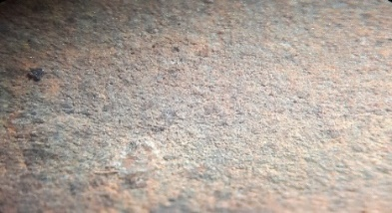

***Figure 7: selected (Painted) areas of the samples after immersion in fresh water***

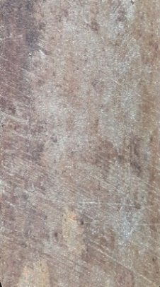

***Figure 8: selected (Electroplated) areas of the samples after immersion in fresh water***

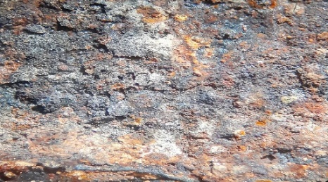

corrosion particles

***Figure 9: selected (Blackened) areas of the samples after immersion in fresh water***

**Comparing coated samples in HCL**

The SEM images displayed in figure 10-12 provided detailed insights into the characteristics of the corrosion products found on selected areas of the samples. Through visual observations and SEM analysis, it was observed that varying degrees of corrosion had developed on the low carbon steel samples beneath different bonded coatings. The presence of pit corrosion across the substrate suggested a disruption in the continuous layer of corrosion products that had initially covered the surface. When the coated samples were subjected to diluted hydrochloric acid (HCL), their responses varied significantly. The coatings displayed differing levels of vulnerability to the corrosive environment, with the electroplating method initially demonstrating a degree of resilience in the first week of exposure. However, as the exposure period extended to 5 weeks, all coatings ultimately failed to provide adequate protection against the acid. Notably, the blackening process exhibited superior protective properties compared to painting and electroplating when faced with HCL-induced corrosion, indicating its enhanced performance in resisting the corrosive effects of the acid solution.

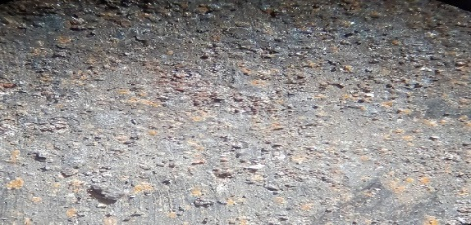

corrosionparticles

flakes

pits

Figure 10: selected (Painted) area after immersion in HCL.

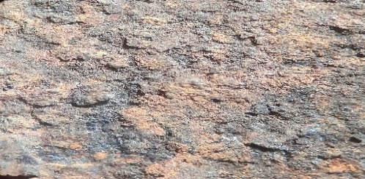

pits

flakes

Figure 11: selected (Electroplated) area after immersion in HCL.

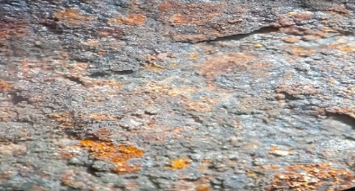

Embedded

particles

flakes

Figure 12: selected (Blackened) area after immersion in HCL.

**Comparing coated samples in NaCl**

The analysis conducted on the corrosion product layers formed on low carbon steel surfaces exposed to sodium chloride (NaCl) after 5 weeks revealed interesting findings in figure 13-15. Through SEM imaging, it was observed that erosion corrosion occurred on the samples with bonded coatings. This indicated a disruption of the continuous corrosion product layer over the substrate surface when exposed to a NaCl solution. Among the different coating methods, electroplating stood out for its exceptional corrosion resistance and durability. It outperformed the other two methods, that is blackened and painted coatings. While the electroplating method showcased the highest level of protection, the painted coating exhibited signs of surface degradation over time, suggesting limitations in its protective abilities. The blackened coating, although providing reasonable protection, showed rapid discoloration, turning brown. Each of the three coating methods

offered some degree of corrosion protection, albeit with varying effectiveness and longevity. Electroplating demonstrated the highest effectiveness in preserving the surface integrity in the NaCl solution, followed by the blackened and painted coatings, which still provided valuable protection despite their shortcomings.

The analysis provided an insight into the performance of different coating methods in resisting corrosion under NaCl exposure.

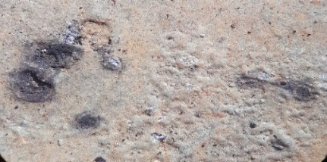

corrosion

particles

corrosion

particles

pits

Figure 13: selected (Painted)) area after immersion in NaCl

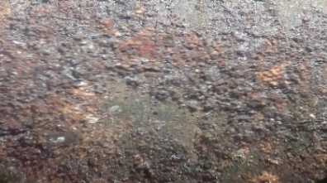

erosion

corrosion

flakes

***Figure 14*** ***selected (Electroplated) area after immersion in NaCl***

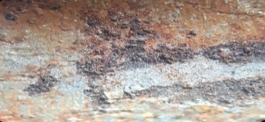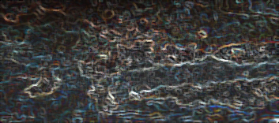

embedded

particles

***Figure 15: selected (Blackened) areas of the samples after immersion in NaCl***

**Comparing coated samples after scratch test**

After conducting a scratch test on coated samples, the results showed that spray painting had a significant area removal of 15-35%, categorizing it as 2B. In contrast, electroplating and blackening had no visible surface removal, earning a 5B classification, indicating strong bonding. The scratch test revealed that electroplating and blackening exhibited excellent surface integrity, whereas spray painting showed initial good bonding but was prone to surface removal under scratching. For low carbon steel applications requiring mechanical strength, electroplating or blackening are preferred options as they can withstand scratches without compromising surface integrity.

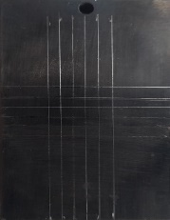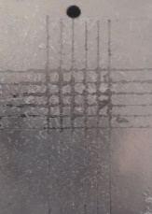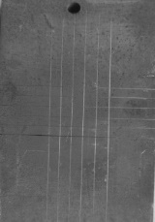

intact pattern

damage

pattern

intact pattern

(a) plating (b) painting (c) blackening

***Figure 16: Ssurface after removing sensitive tape***

***Table 11: Coated sample after the scratch test***

|  |  |  |
| --- | --- | --- |
| Samples | Classification | Percentage area removed (%) |
| Painting | 2B | 15-35 |
| Electroplating | 5B | 0 |
| Blackening | 5B | 0 |

**Conclusion**

In conclusion, the study's findings highlight the significant impact of environmental conditions, especially acidity, on corrosion rates. This underscores the importance of considering the specific environment when working with corrosion-prone materials, to minimize the risks of rapid degradation. By understanding the interplay between materials and their environments, effective strategies can be developed to combat corrosion, thereby extending the lifespan of the materials and mitigating potential damage. The scratch test is a crucial method for evaluating the mechanical properties of coated samples, as it reveals the strength of the bond between the coating and the surface. This assessment is vital for determining the coating's effectiveness and durability under various stresses and environmental conditions. By analyzing the adhesion strength and resilience of the coating through scratch testing, researchers and manufacturers can gain valuable insights into its real-world performance and ability to withstand wear, abrasion, and external impacts. The test results provide essential data for optimizing the coating process, enhancing quality, and improving longevity. A comprehensive analysis of the bonding mechanisms and failure modes observed during the scratch test enables informed decisions to enhance coating design, composition, and application methods for improved mechanical performance and reliability.

Disclaimer (Artificial intelligence)

Option 1:

Author(s) hereby declare that NO generative AI technologies such as Large Language Models (ChatGPT, COPILOT, etc.) and text-to-image generators have been used during the writing or editing of this manuscript.

Option 2:

Author(s) hereby declare that generative AI technologies such as Large Language Models, etc. have been used during the writing or editing of manuscripts. This explanation will include the name, version, model, and source of the generative AI technology and as well as all input prompts provided to the generative AI technology

Details of the AI usage are given below:

1.

2.

3.

**References**

[1] C Tassin, F Laroudie, M Pons, L Lelait - *Surface and Coatings Technology*, 1996 - Elsevier

[2] G Zangari - *Coatings*, 2015 - mdpi.com

[3] W. D. Callister, *"Material Science and Engineering and Introduction"*, John Willy and sons Inc. 4th Edition, *pp. 550-554*, 1997.

[4] C Raub - *Metal Plating and Patinatio*n, 1993 - Elsevier…, 1840

[5] DeMasi-Marcin, J.T.; Gupta, D.K. *Protective coatings in the gas turbine engine. Surf. Coat. Technol*. 1994, 68,1–9.

[6]. MS Joni, A Fattah-Alhosseini - *Journal of Alloys and Compounds*, 2016 – Elsevier

[7]. Lambourne, R., *Paint and surface coatings: Theory and Practice,* Chichester: Ellis Horwood; New York: Halsted Press, (1987), *p. 535*

[8] Mary E McKnight, James F Seiler, Tinh Nguyen, Walter J Rossiters ­– *Journal of Protective Coatings and Lining 12*,82-82,1995

[9] Berradja, A. (2019). *Electrochemical Techniques for Corrosion and Tribocorrosion Monitoring:Fundamentals of Electrolytic Corrosion. Corrosion Inhibitors*. doi:10.5772/intechopen.85392

[10] Dehghanghadikolaei, A.; Mohammadian, B.; Namdari, N.; Fotovvati, B. *Abrasive Machining Techniques for Biomedical Device Applications*. J. Mater. Sci. 2018, 5, 1–11

[11] Liu, Y.; Sparer, J.; Woskie, S.R.; Cullen, M.R.; Chung, J.S.; Holm, C.T.; Redlich, C.A. *Qualitative assessment of isocyanate skin exposure in auto body shops:* A pilot study. Am. J. Ind. Med. 2000, 37, 265–274.

[12] E. A. Noor, A. H. Al-Moubaraki, *“Corrosion Behaviour of Low carbon steel in Hydrochloric Acid”, International Journal on Electrochemistry and science*, Vol.3, pp.806-818, 2008.

[13] NACE, “ASTM G31-12a: *Standard Practice for Laboratory Immersion Corrosion Testing of Metals”, 2012.*

[14] GF Kennell, RW Evitts, KL Heppner - *Corrosion Science*, 2008 - Elsevier

[15] Ravi Vayeda, Jyhwen Wang –*International Journal of adhesion and adhesives 27(6),*480-492,2007

[16] Machado AR, da Silva LR, Pimenov DY, de Souza FC, Kuntoğlu M, de Paiva RL. *Comprehensive review of advanced methods for improving the parameters of machining steels*. Journal of Manufacturing Processes. 2024 Sep 15; 125:111-42.

[17] Berradja, A. (2019). *Electrochemical Techniques for Corrosion and Tribocorrosion Monitoring: Fundamentals of Electrolytic Corrosion*. Corrosion Inhibitors. doi:10.5772/intechopen.85392.

[18]C Raub - *Metal Plating and Patination*, 1993 - Elsevier… , 1840

[19]C Tassin, F Laroudie, M Pons, L Lelait - *Surface and Coatings Technology, 1996* - Elsevier

[20] Charng, T., & Lansing, F. (1982). Review of corrosion causes and corrosion control in a technical facility. Jet Propulsion Lab., Pasadena, CA (USA).

[21] D.E. J Talbot and J.D.R. Talbot, *“Corrosion science and technology’’*, CRC Press, 2nd ed., 2007

[22] Dehghanghadikolaei, A.; Mohammadian, B.; Namdari, N.; Fotovvati, B. *Abrasive Machining Techniques for Biomedical Device Applications*. J. Mater. Sci. 2018, 5, 1–11

[23] E. A. Noor, A. H. Al-Moubaraki, *“Corrosion Behaviour of Low carbon steel in Hydrochloric Acid”*, International Journal on Electrochemistry and science, Vol.3, pp.806-818, 2008.

[24] Gómez, O.; Perales, E.; Chorro, E.; Burgos, F.J.; Viqueira, V.; Vilaseca, M.; Pujol, J. *Visual and instrumental assessments of color differences in automotive coatings*. *Color Res.* Appl. 2016, 41, 384–391. [CrossRef]

[25] H.H. Lawson (Eds.), *Atmospheric Corrosion ASTM STP 1239*, ASTM Philadelphia, 1995, pp. 137-151.

[26]26Heppner, K.L., Evitts, R.W., Postlethwaite, 2004. *Effect of the crevice gap on the initiation of crevice corrosion in passive metals, J. Corrosion, 60*(8), 718-728.

[27] Hoar, T. P. & Agar, J. N. (1947). *Factors in throwing power illustrated by potential-current diagrams*. Discuss. Faraday Soc. 6-28.

[28] ISO, “ISO 11130: *Corrosion of metals and alloys-Alternate immersion test in salt solution”*, 2010

[29] Kabanov, B*.,* Burstein, R. and Frumkin A. (1947). *Pitting corrosion of metals – corrosion Discuss*, Faraday Soc. NI. *254*,12-26.

[30] Kennell G.F., Evitts R.W., Heppner K.L., 2008. *A critical crevice solution and IR drop crevice corrosion model, J. Corrosion Science, 50*, 1716-1725.

[31] Klaassen, C.D.; Watkins, J.B. Casarett and Doull’s Toxicology: *The Basic Science of Poisons*; McGraw-Hill: New York, NY, USA, 1996; Volume 5.

[32] Kolotyrkin, J. M. (1963). *Pitting corrosion of metals*. Corrosion, 19(8). <https://doi.org/10.5006/0010-9312-19.8.261>

[33] Lambourne, R., *Paint and surface coatings: Theory and Practice*, Chichester: Ellis Horwood; New York: Halsted Press, (1987), p. 535

[34] LH Wagner, ROCK ISLAND ARSENAL IL - (No Title), 1964 - apps.dtic.mil.

[28] M Vakili-Azghandi, A Fattah-alhosseini… - Journal of Materials …, 2016 - Springer

[35] M. Morcillo, E. Almeida, B. Rosales, J. Uruchurtu, M. Marrocos, *Corrosión Protección de Metales en las Atmósferas de Iberoamérica (MICAT*), CYTED, Madrid, 1998.