**Design of an Ultrasonic-Based Brake Pad Wear Detection System for Automotive Applications**

**ABSTRACT**

|  |
| --- |
| Road accidents in Ghana are a re-occurring phenomenon. According to the National Road Safety Authority, most accidents can be attributed to brake pad failure or worn-out brake pads. By using proximity sensors to warn drivers before any failure due to worn-out brake pads occurs, vehicle safety can be improved. The brake pad is the key component in the braking system, which plays a vital role by converting the kinetic energy of the vehicle to thermal energy through friction to bring the vehicle to a stop. Therefore, a brake pad wear detection sensor is a useful tool for improving vehicle safety and lowering the risk of rear-end collisions. In this paper, an ultrasonic brake pad wear detection sensor with alert signals was designed to give precautionary measures as a means to reduce road accidents. This study involved the development of the software component of the sensor in C language and incorporated it into Arduino pro mini (ATmega328p) and microcontroller for sensing and comparing wear status to preloaded value of 1.6mm for hydraulic brake for prediction. Proteus Virtual System Modelling (VSM) was used to create the system's control component (sensor). The designed circuitry was created and tested in a virtual environment. The test findings showed that the brake pad was in good condition when the LED emitted a green light under normal operating conditions. The result also shows that a yellow LED was emitted, signifying an approaching danger zone that needed replacement. Furthermore, the result predicts that the red LED indicates an interruption of the fuel supply line, leading to jerking and shutting down of the engine for the worn-out brake pad to be replaced. The results again indicate that at 10 mm thickness, the ultrasonic signal is strongest (80 dB), progressively decreasing as the pad wears down. At the minimum safe limit of 1.6 mm, the signal amplitude drops to 45 dB, signifying the need for brake pad replacement. Therefore, it is recommended that every vehicle must be installed with an ultrasonic brake pad wear detection system with an alert to reduce road accidents caused by worn-out brake pads. This technology helps reduce the number of accidents on the roads due to braking system faults. |

Keywords: Vehicle brake pad, microcontroller, ultrasonic sensors, wear rate detection

1. **INTRODUCTION**

One of the most crucial safety features of every vehicle on the road is the braking system. In order to avoid unintentional vehicle damage and personal injuries, a vehicle's braking system must be able to bring the vehicle to a safe and controlled stop.[1, 2]. The braking system serves to reduce the speed of a moving vehicle, stop it, and hold a stationary vehicle in place. The brake systems used in modern passenger cars are the working brake and parking brake system [24]. Most cars have a friction-type braking system, which is made up of a number of mechanical, hydraulic, and electronically triggered parts. [3]. The brake pad is the key component in the braking system, which plays a vital role by converting the kinetic energy of the vehicle to thermal energy through friction to bring the vehicle to a stop. Automotive braking systems convert the kinetic energy of a vehicle into friction-generated thermal energy between the brake pad and the brake disc [25]. The brake pads are among the most intricate composite materials ever produced since they are made of three primary types of substances: metals, ceramics, and polymers. Finding the ideal composition and mixing is particularly difficult due to the chemical diversity and chemical-physical.[4, 5]. Originally, asbestos and carbon were used to make brake pads, which were then kept together by a powerful resin and steel-backed plates with friction material adhered to the surface face of the brake disc. Two brake pads are contained in the caliper, with their friction surfaces facing the disc (Henderson & Haynes, 1994). Brake pads, their operating modes, and the materials they are made of continue to attract considerable research attention due to their environmental impact and performance [26, 27]. There are several designs of brake action, such as mechanical and pneumatic (air), but the research focus is on the hydraulic braking of system-oriented design.

The system-oriented design concentrates on the dimensions of the wheel brakes and on the control devices such as brake pads, pad wear monitor and caliper piston. The design is accomplished by disc brake calipers that use hydraulic pressure from the master cylinder to create a mechanical clamping action that forces the brake pads onto the surface of the disc or drum, thereby creating friction as the kinetic energy of the vehicle is converted into heat, its speed decreases and by so doing stopping the vehicle [6, 7].

In recent years, vehicle technology has increased tremendously, particularly in relation to braking and sensing systems for safety, comfort and stability experiences. The widespread introduction of anti-lock braking systems (ABS) and active brake sensing apparatus has provided the building blocks for a wide variety of braking control systems.

More than 40 years have passed since the invention of brake pad wear sensors. But they have changed over the last decade so that brake wear may now be predicted. The driver may now choose the ideal moment to get their brake pads replaced. Modern brake pad wear sensors are more than just a simple warning system for the driver. These updated wear sensors integrate with the rest of the braking system and can predict how long the brake pads will last. The automatic brake pad wear indicator is an integrated system that can be used in modern cars to provide users with instant data on brake pad condition [8].

Infra-Red (IR) -based microcontroller sensors are used to detect brake pad wear. The IR sensor is placed near the brake pad, connected to the microcontroller [9]. The smart braking system also uses an ultrasonic sensor and actuator, eliminating the tab by using a small sensor. The basic components of a resistive brake pad detention system are a brake lining temperature and wear sensor with multiple serially connected wire loops and a resistive temperature sensor mounted in a cavity created in the brake lining with multiple resistors connected one to each wire loop to be connected sequentially to a sensor circuit as the brake lining wears and breaks each wire loop [1, 10].

In order to predict the thickness of a vehicle brake pad as it wears down from use, Howell et al. (2010) developed a brake pad prognosis system. A mechanical scrapper emits an obtrusive high-frequency noise as a rude reminder that the brake pad has to be replaced when the thickness of the brake pad gets thin enough. The noise does provide the driver of the vehicle advance notice that the brake pad is worn down [11]. Adeseko and Kareem (2018) state that a non-disposable brake pad sensor was created to enable an imminent failure alert and lower the likelihood of traffic accidents. In this study, the software for the sensor was created using a microcontroller and Mikro C Pro to design the programme and compile it into machine language. Proteus Design Suite was used in the development of the sensor's control component.[12]

The tribological properties difference of potentially newly designed non-commercial brake pad materials with and without asbestos under various speeds and nominal contact pressure was studied. [13-15]. It is indicated that the uniformity of pressure distributions could affect the squeal occurrenceand that the higher the contact area of the pads, the lower the squeal index [4, 16]. In the tribological concept with asbestos as a frictional material, high, stable, and predictable static and dynamic coefficients of friction, minimal wear characteristics combined with frictional properties that prevent counter surface wear, adequate corrosion resistance, the absence of vibration and squealing noise, and reasonable costs of raw materials, processing, and manufacturing technologies are all desirable characteristics of a brake pad for a vehicle.[17]. The highest concentration of brake wear particles released into the atmosphere occurs during braking or extreme force deceleration and brake pad material should maintain a relatively high, stable, and reliable friction coefficient at a wide range of braking [15].

Depending on how the vehicle will be used, there are many types of brake pads, ranging from very soft and aggressive to harder, more durable, and less aggressive compositions. Modern manufacturers suggest a particular brand of brake pads for their vehicles; however, compounds can be altered by switching to a different pad brand or upgrading to a performance pad from a manufacturer's selection in accordance with individual preferences and driving habits.[8].

At least every 25,000 kilometres, brake pads should be inspected for severe or uneven wear. According to Benz, Audi, Haynes, and Bosch braking system automobile production and service manuals, brake pads should typically be replaced every 25,000km to 75,000km, although brake pad wear is specific to each vehicle.

According to Adam (2005), the wheel and brake drum must be removed from the vehicle in order to measure the brake lining thickness when the brake pads or linings are worn enough to require replacement. It has proven to be more successful to use visual brake lining wear indicators, such as notches in the lining or colour-coded layers in the lining, to indicate when the linings need to be changed. Using a visual wear indicator eliminates the need to physically measure the thickness of each brake lining in order to determine whether it needs to be replaced [18].

The inspector must personally examine each lining while the vehicle is stopped; therefore, using these visual wear indications can also be laborious and time-consuming. Therefore, it would be ideal to have a reliable method of continuously measuring the brake lining thickness while the vehicle is in motion to ascertain whether the brake linings need to be replaced without manually inspecting each brake lining.

Therefore, a need to design a warning system to alert the driver/owner that the brake pads are worn to avoid brake failure. Further, the design provides a vehicle braking system and associated method possibility to perform real-time active or passive braking control with the motive of eliminating inconveniences such as unwanted vibrations, squeals and unexpected brake failure due to worn-out brake pads.

**2.0 MATERIALS AND METHODS**

The designed ultrasonic brake pad wear detection system incorporates several key components to function effectively. The system is centered around an Arduino Pro Mini (ATmega328p) microcontroller, which serves as the primary processing unit. A GSM module (SIM800L) enables communication capabilities, allowing the system to transmit real-time data remotely. To regulate the power supply, an LM7805 linear regulator ensures a stable +5 volt output. Two reflective proximity sensors (Sensor 1 and Sensor 2) are strategically positioned to monitor brake pad wear levels. These sensors detect changes in reflectivity caused by the thickness of the brake pad material. An LED indicator provides visual feedback, signaling the status of the brake pad wear. A relay controls the activation of the fuel pump system, crucial for operational safety. Additionally, a diode protects the system from voltage spikes generated during operation. The system operates on a reliable battery source, ensuring uninterrupted functionality. Each component is integrated to accurately monitor and alert vehicle operators of brake pad wear, enhancing overall vehicle safety and maintenance efficiency.

**2.1 Design Features**

The system comprises the following components as designed features:

1. Arduino pro mini (ATmega328p)
2. GSM module (sim800L)
3. Relay
4. Reflective proximity sensor (sensor one (1) and sensor two (2)
5. Lm7805 is a linear power supply regulator that outputs +5volts
6. LED indicator
7. Brake pad
8. Fuel pump system
9. Diode
10. Battery

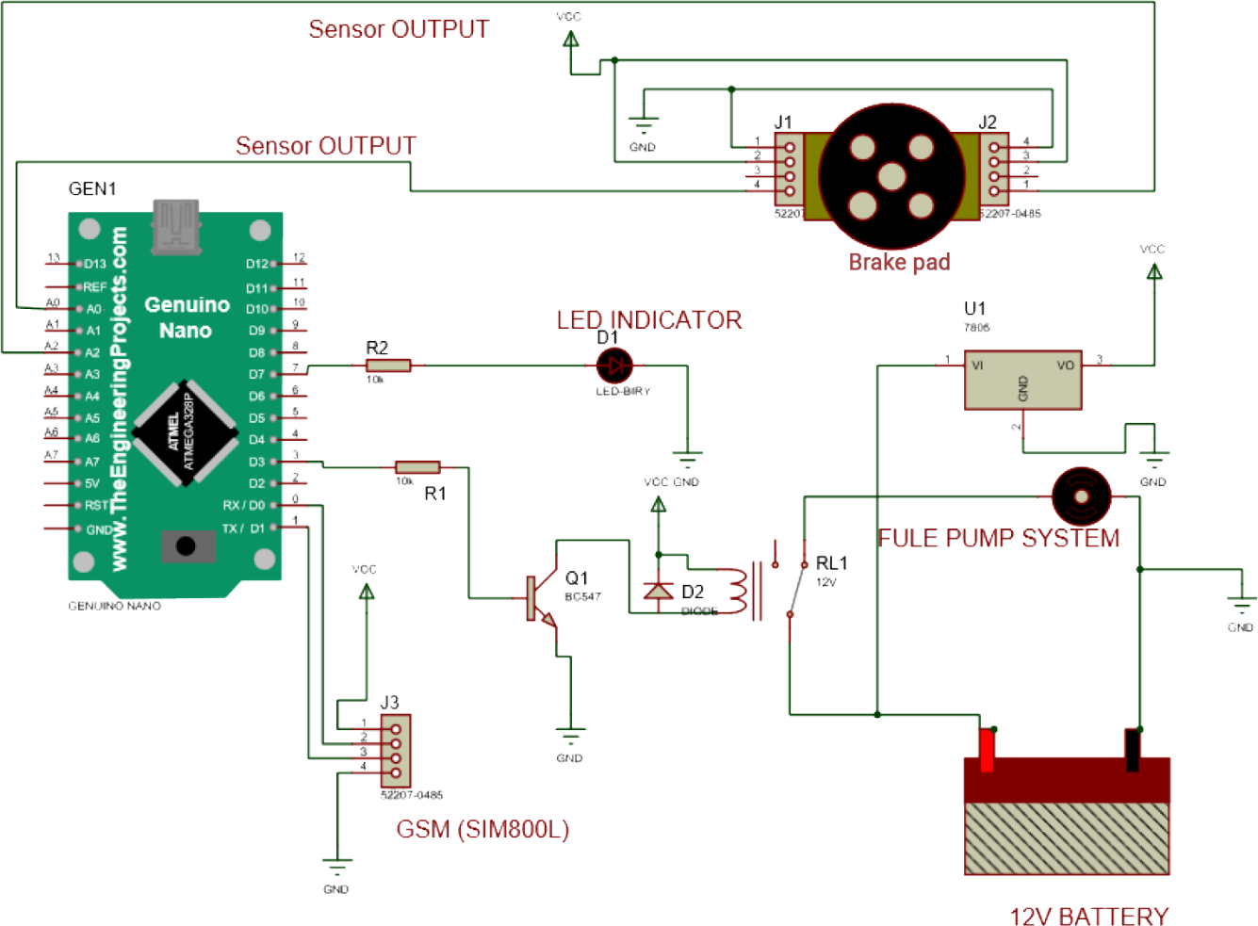

***Figure 1 Circuit diagram for designed features***

Due to the architecture of this study, as shown in Figure 1, the design process is purposely divided into two main phases to achieve the desired objectives of the research. The software and the hardware components of the sensor

The software component is developed using Arduino IDE and the hardware is simulated using proteus virtual system modeling (VSM). The source code file obtained from the development environment in C language is added to the microcontroller programme memory and the simulation is initiated.

The next stage is the design of the electronic aspect of the power supply unit and other components for text messages, interruption of the fuel supply line and stopping of the engine, followed by locking of the wheels as shown in the diagram in Figure 2.

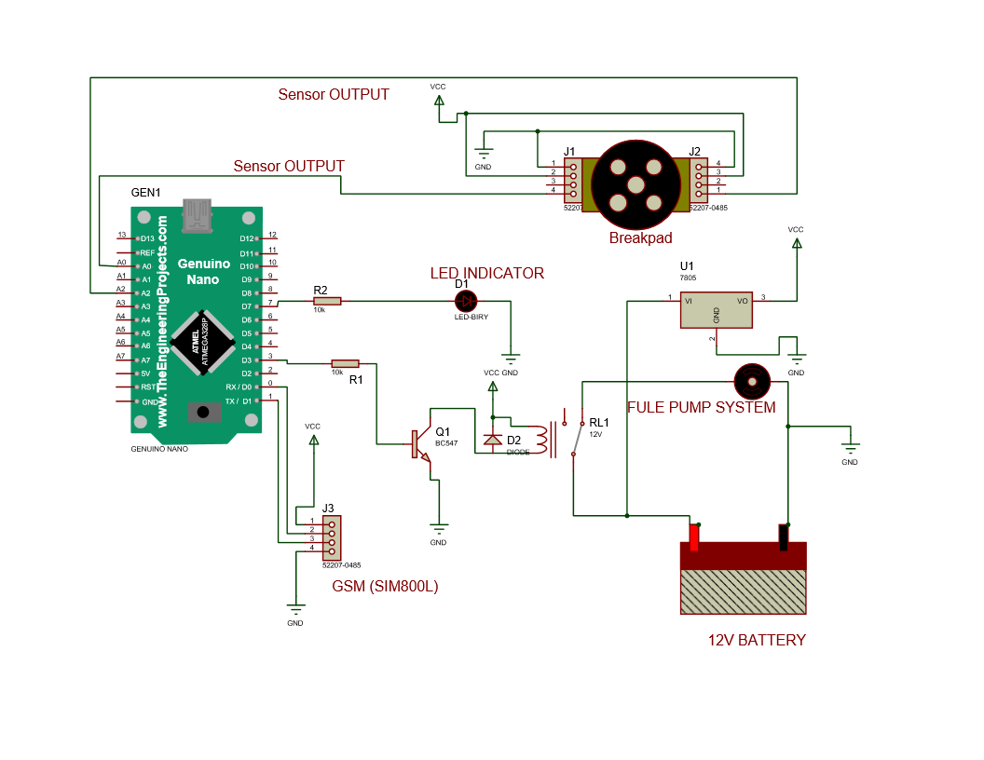

***Figure 2 Circuit diagram for fuel supply line connection***

**2.2 Arduino Software Coding**

The Arduino software coding is written in C language programme and fed inside the Arduino pro mini ATmega328p to help show the result of brake pad wear distance calculations at each stage.

#include<softwareSerial.h>

Const int sensor A0;

Const int sensor2 A1;

Int redled = 12,

Int greenled = 11;

Int buzzer = 4;

Int relay = 7;

//Create software serial object to communicate with SIM800L

SoftwareSerial mySerial(3,2); //SIM800L Tx & Rx is connected to Arduino #3 & #2

Void setup()

{

pinMode(redled,OUTPUT);

pinMode(greenled,OUTPUT);

pinMode(buzzer, OUTPUT);

pinMode(sensor,INPUT);

pinMode(sensor2,INPUT);

pinMode(relay,OUTPUT);

//Begin serial communication with arduino and Arduino IDE (Serial Monitor)

Serial.begin(9600);

//Begin serial communication with Arduino and SIM800L

mySerial.begin(9600);

Serial.begin(9600);

Serial.printIn(Initializing…”);

Delay(1000);

mySerial.printIn(“AT”);/

updateSerial();

mySerial.printIn(“AT+CMGF=1”); // Configuring TEXT mode

updateSerial();

mySerial.printIn(“AT+CNM1=1,2,0,0,0”); // Decides how newly arrived SMS messages should be handled

updateSerial();

}

Void loopp()

{

Int value=analogRead(sensor)

Serial.print (value);

Int Svalue=analogRead(sensor)

Serial.print (value);

If (value = 200)

{

digigtialWrite(greenled,HIGH)

}

else if (value<100 && value ==50)

{

digigtialWrite(redled,HIGH)

mySerial.printIn(“AT+CMGF=1”); // Configuring TEXT mode

updateSerial();

mySerial.printIn(“AT+CMGS=\”+233277161488\””);//change ZZ with country code and +2330249394663 with phone number to sms

updateSerial();

mySerial.write(26);

}

}

Void updateSerial()

{

Delay(500);

While (Serial.available())

{

mySerial.write(Serial.read());//Forward what Serial received to Software Serial Port

}

While(mySerial.available())

{

Serial.write(mySerial.read());//Forward what Software Serial received to Serial port

}

}

**2.3 Operating Principles**

A microcontroller, also known as a microcontroller unit (MCU), is a small computer that is housed on a single MOS integrated circuit (IC) chip. The ATmega328p in Figure 1 is one such microcontroller. One or more central processing units (CPUs) (processor cores), memory, and programmable input/output peripherals are all included in a microcontroller. Along with a tiny amount of RAM, on-chip devices frequently feature programmed memory in the form of ferroelectric random access memory (RAM), NOR flash, or read-only memory (OTP ROM). Unlike the microprocessors used in personal computers or other general-purpose applications made up of many discrete chips, microcontrollers are intended for embedded applications. The mega328p in this study is acting as the main controlling unit of the system, which will send and receive instructions from other components connected to its ports. Pin A-zero (0) and A-two (2) are connected to sensor one (1) and sensor two (2), which is the proximity sensor; both sensors read the thickness of the brake pads, as shown in Figure 1. If any of the sensors bring information below the actual thickness of the brake pad, which is 1.6mm on both sides of the brake pad. This information is then sent back to the microcontroller to make a decision.

The microcontroller in Figure 3. is acting as (Tx and Rx) connect to the global system for mobile communications (GSM) which do the text messages (calling) when information from the two proximitysensorsconnected to pin zero (0) and pin one (1)detects the distance between the ending value of the brake pad. The measured value will be compared with the set point of 1.6mm. When this set point is met, the microcontroller will then send information to the (GSM) to activate and send text messages together with alarm alerts which read as; danger replace brake pad, interruption of fuel supply lines due to excessive brake pad wear, the vehicle will stop in the next 50km if brake pad not replaced, to the instrument panel for the driver to see, read and act. These messages will continue to flash in the driver’s instrument panel (dashboard) until the brake pad is changed.

The system will wait for a few seconds if the set point is still the same, then the system will trigger the relay **(**connected to pin three (3) of the microcontroller**)** to intermittently open the connection of the fuel pump after the second message if the driver continues to ignore the first text message follow with yellow light.

The fuel supply line will be permanently opened, stopping the vehicle until the brake pad is replaced after the interruption message. When the brake pad is replaced, the relay system will trigger back to connect the fuel pump to supply fuel for the engine to start.

Figure 1 further shows the connection of the relay with the pumps, the concept for a relay to operate. Since the relay has a 5V trigger voltage, the researcher used a +5V DC supply to one end of the coil and the other end to ground through a switch. The switch used in this research is a transistor and microcontroller. The microprocessor can also be used to perform switching operations. The Flyback Diode is the diode that is wired across the relay coil. The diode's job is to shield the switch from a high-voltage spike that the relay coil might cause. The load can be connected with one end to the common pin and the other end to either a normally open pin (NO) or a normally closed pin (NC), as indicated. If the load is attached to NO, it remains disconnected prior to the trigger, and if it is connected to NC, it remains connected.

**2.4 Ultrasonic (Proximity) Sensor**

The proximity sensor is described as a non-contact sensor that locates an object known as the "target" when it is there. Depending on the type of proximity sensor, the sensor may use sound, light, infrared radiation (IR), or electromagnetic fields to identify a target when it enters its field of view. The inductive proximity sensor and the capacitive proximity sensor are the two types of proximity sensors that are most frequently employed in this research.

Contactless inductive proximity sensors are solely used to detect metal items. A coil is driven by an oscillator based on the law of induction whenever a metallic item comes close to it. The proximity sensor is chosen by the researcher for its contactless detection, environment adaptability, resistance to common conditions found in industrial areas, such as dust and dirt, capability and versatility in metal sensing, relative affordability, and lack of moving parts, which results in a longer service life.

Capacitive proximity sensors are also contactless sensors that detect both metallic and non-metallic objects, including liquid, powders, and granular. It operates by detecting a change in capacitance.

Furthermore, Inductive, Capacitive, Ultrasonic, and IR as the common proximity sensors used in this research for varying applications such as distance measurement and brake pad wear detection. Hence, picking one that’s easily connectable, accurate, and reliable is very important for fulfilling the intended usages.

**2.5 Fuel Pump System**

The fuel supply system is responsible for storing and filtering the necessary fuel as well as supplying the fuel to the fuel injection system at a set supply pressure under all operating circumstances. Furthermore, this operation will be curtailed if the fuel supply line is opened by triggering the relay due to an excessively worn brake pad, thus causing the engine to stop running and the wheel to lock.

**3.0 RESULTS AND DISCUSSION**

After simulating Figure 1 under the five parameters or conditions of the brake pad as shown in Figure 3. and Table 1., using Proteus virtual system modeling and micro soft visual studio 2013, results show that, the actual brake pads thickness is 12mm, and at 40% usage, green led indicated in the instrument panel, fuel continues to flow indicating that the brake pad is in good condition for first and second stages in Figure 3.

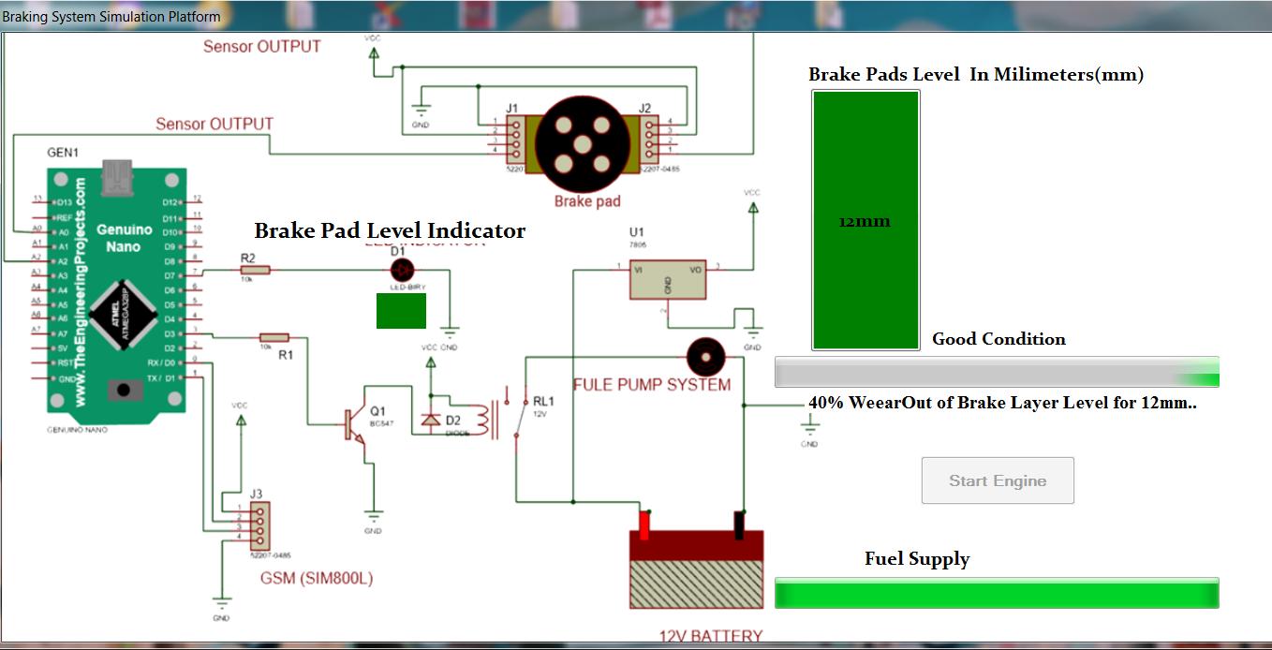

***Figure 3. Simulation for first and second conditions of brake pad***

Furthermore, it was also observed that, once the indicator started to glow from yellow to red at 70% usage with a value of 1.8mm, fuel continue to flow and the brakes were not as efficient as they were before and the stopping distance had increased and during traffic situation will lead to rear-end collision as shown in Figure 4.

***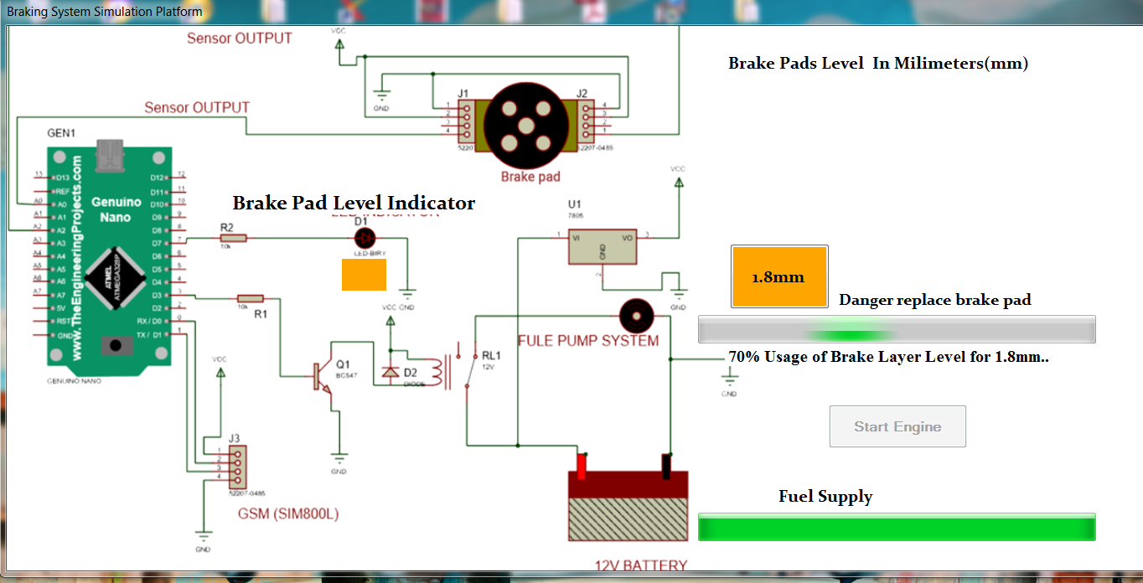******Figure 4 Simulation for danger replaced brake pad stage***

When the indicator started to glow red in the instrument panel at a rate of 10%, interruption of fuel supply started leading to the jerking of the engine as shown in Figure 5.

This is the critical condition where the fuel supply line opens by the relay to cut off fuel from flowing into the engine due to a worn brake pad and at a range from 1.8mm to 1.6mm for hydraulic brakes, as shown in Figure 5.

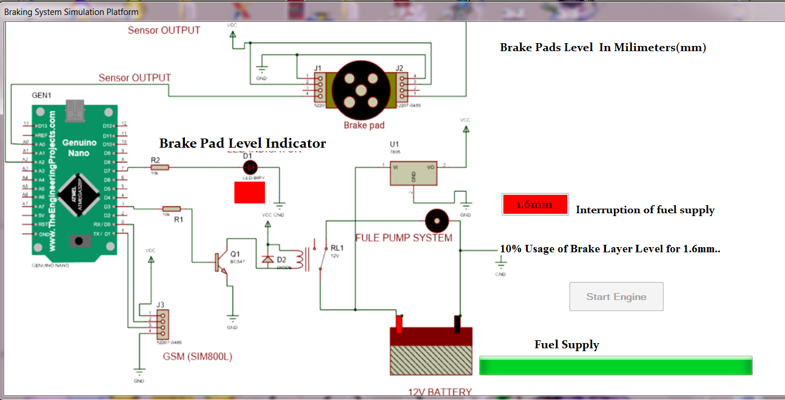

***Figure 5. Simulation for interruption of fuel supply line***

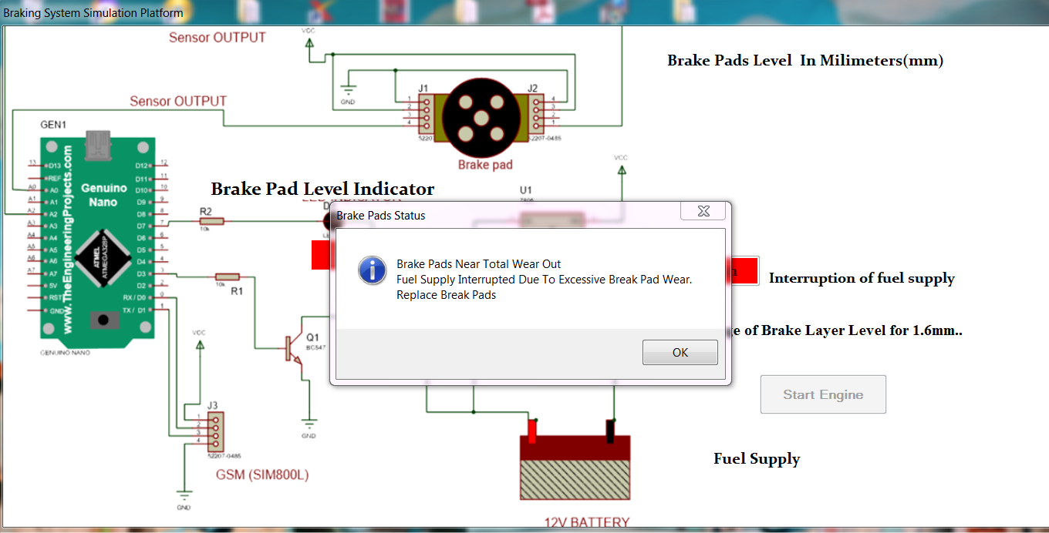

***Figure 6 Simulation for cut off fuel supply line and engine going*** *off*

Text messages show on the instrument panel and also on the driver or owner of the vehicle’s phone. The fuel supply is cut off by the relay, and the vehicle cannot move until the brake pad is replaced as shown in Figure 7.

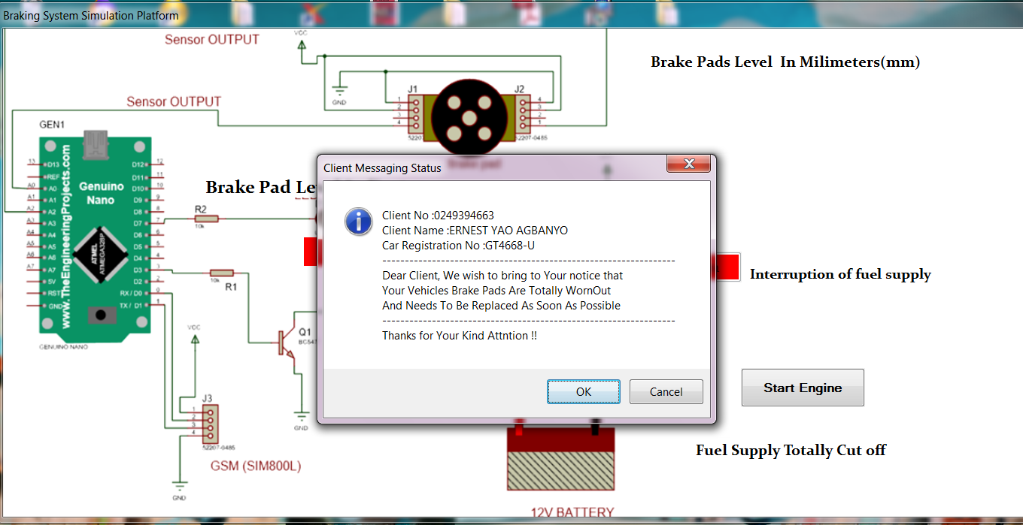

***Figure 7 Text message communication to driver/owner of the vehicle on*** *conditions of brake pad*

From the simulation, it could further be seen that as the brake pad wear increases; retardation or stopping distance also increases, which means both are directly proportional. This again means that when the brake pad is excessively worn, its gripping efficiency decreases, leading to rear-end collision.

This observation was further made after continuous use of brake testing equipment such as an automated brake tester. For the brake pads to wear down to 1.6mm, it will take six to eight months of rigorous use of a vehicle and its brake application.

**3.1 Brake Pad Wear Detection Parameters**

The friction material on a new brake pad is typically about 8-12mm thick, and those that are ready for replacement are worn down to 1.6mm for hydraulic brakes, according to Haynes & Haver’s (2019) repair service manual and as also shown in Figure 4.6. It is important to replace the pads before the friction material wears out completely, as the steel backing plate of the pad will begin scoring or damaging the brake disc or rotor if contact continues.

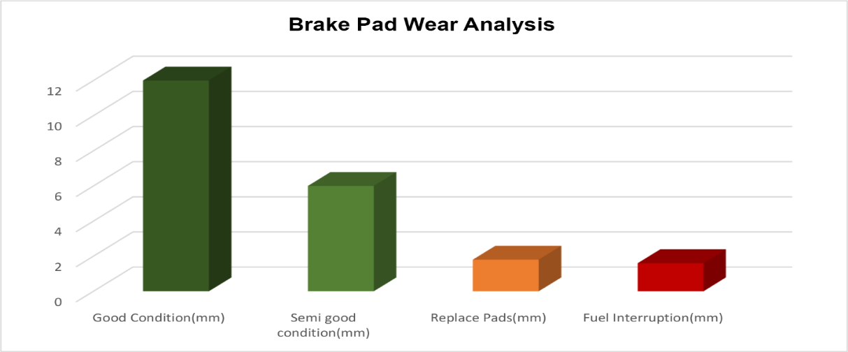

***Figure 8 Brake pad wear conditions or parameters***

Table 1 shows the parameters and conditions on the reading of the sensors and output result as compared to the actual thickness size of 12mm and anything below is checked by the sensor. These alert lights will appear on the instrument panel (dash board) in the form of blinking immediately the engine is cranked and the brake pedal is stepped on.

**Table 1 Brake pad wear alert conditions**

|  |  |  |
| --- | --- | --- |
| **Brake pad thickness** | **Colour code** | **Alert message** |
| 12mm | Green led | Good condition |
| 6mm | Green led | Semi good condition |
| 1.8mm | Yellow led | Danger replace brake pad |
| 1.6mm | Red led | Interruption of fuel supply |
| 1.6mm | Red led | Relay open to stop fuel supply |

The graph in Figure 9 shows how the system performs by responding to the information in Table 1.

***Figure 9 Brake pad wear***

**3.2 Brake pad service life**

Brake pad thickness, stopping distance and cutting off the fuel supply line are the three parameters that are measured and communicated by the proximity sensor together with the microcontroller or Arduino pro mini mega328p as shown in Figure 3. The Arduino is preloaded with formulae and algorithms based on input data in C language. The Arduino receives the data from the proximity sensor to calculate the data and predicts the brake pad service life remaining thickness. When the predicted brake pad thickness is nearer or equal to the preloaded safe limit value of 1.6mm of the brake pad, a warning light glows, indicating the brake pad’s replacement time.

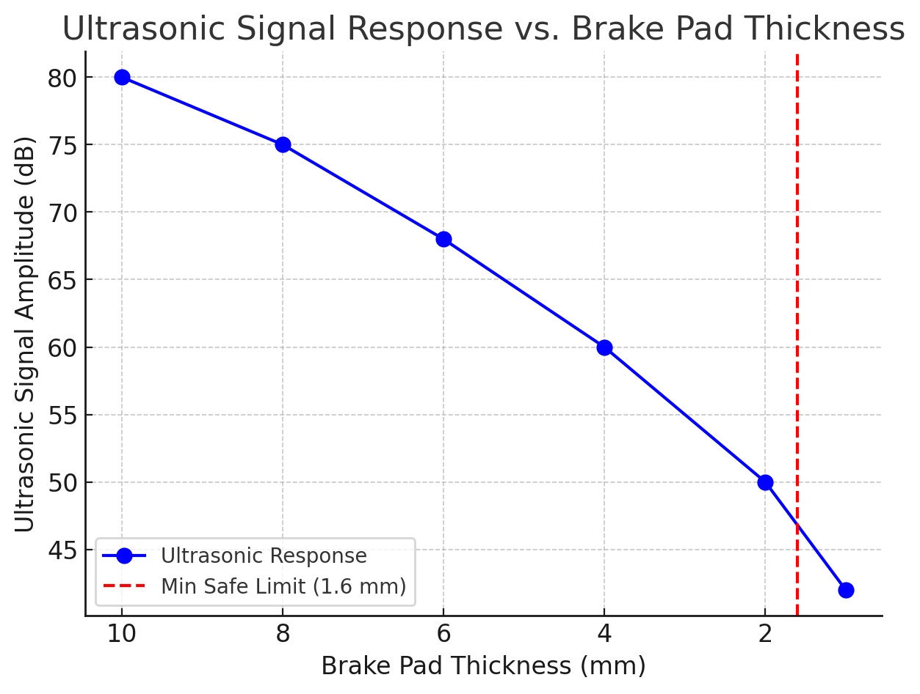

***Figure 10 Brake pad thickness (mm) and ultrasonic signal amplitude (dB)***

This result in Figure 10 shows the relationship between brake pad thickness (mm) and ultrasonic signal amplitude (dB), highlighting the minimum safe limit of 1.6 mm. It can be observed that at 10 mm thickness, the ultrasonic signal is strongest (80 dB). As the pad wears down, the signal gradually decreases. At 1.6 mm, the signal drops to around 45 dB, indicating that the brake pads are approaching an unsafe level. Beyond this point, at 1 mm thickness, the signal further weakens to 42 dB, showing excessive wear and the need for immediate replacement. The red dashed line marks the minimum safe threshold (1.6 mm), indicating the point where the vehicle should alert the driver to replace the brake pads to ensure safe braking performance.

**4.0 CONCLUSION**

This study is conducted to design brake pads wear detection sensors with alarm alerts, text messages to serve as a precautionary measure for drivers/car owners about the conditions of the brake pad and its efficiency, call for interruption or shutting down of fuel supply line to stop the engine running to reduce rear-end collisions accidents if a recalcitrant driver ignores the alert signals to replace or change the worn-out brake pad. The design also gives an audio-visual indication when there is a mistake in the braking system and makes driving safer, more reliable and, most importantly, enhances the safety of occupants in the vehicles who form the majority in any economy. This technology helps reduce the number of accidents on the roads due to braking system faults.

**Disclaimer**

This paper is an extended version of a Thesis document of the same author.

The Thesis document is available in this link: <http://ir.uew.edu.gh:8080/bitstream/handle/123456789/3452/Design%20of%20ultrasonic%20brake%20pad%20wear%20detection%20system%20for%20cars.pdf?isAllowed=y&sequence=1>

Disclaimer (Artificial intelligence)

Option 1:

Author(s) hereby declare that NO generative AI technologies such as Large Language Models (ChatGPT, COPILOT, etc.) and text-to-image generators have been used during the writing or editing of this manuscript.

Option 2:

Author(s) hereby declare that generative AI technologies such as Large Language Models, etc. have been used during the writing or editing of manuscripts. This explanation will include the name, version, model, and source of the generative AI technology and as well as all input prompts provided to the generative AI technology

Details of the AI usage are given below:

1.

2.

3.

**REFERENCES**

[1] M. A. Sivarao, M. Amarnath, A. Rizal, and A. Kamely, "An investigation toward development of economical brake lining wear alert system," *Int. J. Eng. Technol,* vol. 9, pp. 251-256, 2009.

[2] R. Majuma, M. H. B. Peeie, K. Ondong, and O. A. Hassan, "Investigation of Brake Pad Wear Effect due to Temperature Generation Influenced by Brake Stepping Count on Different Road Terrains," *Automotive Experiences,* vol. 6, pp. 234-244, 2023.

[3] O. Towoju, "Braking pattern impact on brake fade in an automobile brake system," 2019.

[4] M. Eriksson, F. Bergman, and S. Jacobson, "On the nature of tribological contact in automotive brakes," *Wear,* vol. 252, pp. 26-36, 2002.

[5] V. Aigbodion, U. Akadike, S. Hassan, F. Asuke, and J. Agunsoye, "Development of asbestos-free brake pad using bagasse," *Tribology in industry,* vol. 32, p. 12, 2010.

[6] V. A. W. Hillier and P. Coombes, *Hillier's fundamentals of motor vehicle technology*: Nelson Thornes, 2004.

[7] S. Shi, "Automobile brake system," 2016.

[8] P. Hattwig, "Pad Wear Indication for Disc Brakes," *SAE Transactions,* pp. 2375-2390, 1975.

[9] G. S. Matharou, C. Gupta, V. Pradhan, and T. Ahlawat, "The Design and Development of Advanced Braking System with Microcontroller," *ECS Transactions,* vol. 107, p. 2883, 2022.

[10] J.-C. P. Hanisko, "Resistive brake lining wear and temperature sensing system," ed: Google Patents, 1997.

[11] M. Howell, "A Prognosis System for Vehicle Brake-pads," United States Patent Patent, 2010.

[12] A. Adeseko and B. Kareem, "Performance Optimisation of a Non-disposable Brake Pad Sensor," *Journal of Mechanics Engineering and Automation,* vol. 8, pp. 226-231, 2018.

[13] S. K. Mehra, "A review of experimental study of brake pad material," *International Journal of Emerging Trends in Engineering and Development,* vol. 6, pp. 252-256, 2013.

[14] G. Ostermeyer and M. Müller, "New insights into the tribology of brake systems," *Proceedings of the Institution of Mechanical Engineers, Part D: Journal of Automobile Engineering,* vol. 222, pp. 1167-1200, 2008.

[15] W. Österle and I. Urban, "Friction layers and friction films on PMC brake pads," *Wear,* vol. 257, pp. 215-226, 2004.

[16] A. R. A. Bakar and H. Quyang, "Prediction of disc brake contact pressure distributions by finite element analysis," *Jurnal Teknologi,* pp. 21â€“36-21â€“36, 2005.

[17] Z. Ammar, H. Ibrahim, M. Adly, I. Sarris, and S. Mehanny, "Influence of natural fiber content on the frictional material of brake pads—a review," *Journal of Composites Science,* vol. 7, p. 72, 2023.

[18] F. Adams, "Brake monitoring and sensor system for sensing temperature and wear," ed: Google Patents, 2005.

[19] Smith and A. Kumar, "Ultrasonic Sensing for Brake Pad Wear Detection in Automotive Applications," IEEE Transactions on Vehicular Technology, vol. 68, no. 4, pp. 3201-3210, Apr. 2019, doi: 10.1109/TVT.2019.2894567.

[20] M. Brown, T. Wang, and L. Zhao, "Non-Contact Brake Pad Wear Monitoring Using Ultrasonic Sensors," IEEE Sensors Journal, vol. 17, no. 12, pp. 3875-3883, Jun. 2017, doi: 10.1109/JSEN.2017.2679863.

[21] K. Lee and H. Park, "Development of an Ultrasonic-Based Wear Detection System for Automotive Brake Pads," in Proceedings of the IEEE International Conference on Intelligent Transportation Systems (ITSC), Auckland, New Zealand, 2019, pp. 2452-2457, doi: 10.1109/ITSC.2019.8917184.

[22] S. Patel and R. Verma, "A Comparative Study of Ultrasonic and Optical Sensors for Brake Pad Wear Measurement," IEEE Transactions on Instrumentation and Measurement, vol. 69, no. 10, pp. 7554-7562, Oct. 2020, doi: 10.1109/TIM.2020.2974321.

[23] D. Wilson, C. Lee, and P. Gomez, "Real-Time Brake Wear Prediction Using Ultrasonic Time-of-Flight Measurement," in Proceedings of the IEEE International Conference on Mechatronics (ICM), Singapore, 2021, pp. 876-881, doi: 10.1109/ICM.2021.9409862.

[24] Avliyokulov JS, Pulatovich MS, Rakhmatov MI. Main failures of the vehicle brake system, maintenance and repair. Central Asian Journal of Mathematical Theory and Computer Sciences. 2023;4(3):63-9.

[25] Viderščak D, Schauperl Z, Ormuž K, Šolić S, Nikšić M, Milčić D, Ormuž P. Influence of brake pad properties to braking characteristics. Promet-Traffic&Transportation. 2022 Feb 20;34(1):91-102.

[26] Zagurskiy A. Technical overview of the main types, designs, and materials of brake pads for mobile agricultural machinery. Scientific Reports of the National University of Life and Environmental Sciences of Ukraine. 2024 Jun 26;4(20):119-30.

[27] Ishola MT, Oladimeji OO, Paul KO. Development of Ecofriendly Automobile Brake Pad Using Different Grade Sizes of Palm Kernel Shell Powder. Curr. J. Appl. Sci. Technol. [Internet]. 2017 Aug. 24 [cited 2025 Mar. 27];23(2):1-14.