**DESIGN, SIMULATION AND ANALYSIS OF A 3 MW GRID-CONNECTED SOLAR PV SYSTEM IN NIGERIA USING MATLAB/SIMULINK**

.

ABSTRACT

|  |
| --- |
| One of the most important ways to meet rising energy demands while lessening the impact on the environment is to integrate renewable energy sources into the electrical grid. The design, modelling, and analysis of a 3 MW grid-connected solar photovoltaic (PV) system in Nigeria are presented in this paper. To ascertain the system's voltage, current, and power outputs, its performance was assessed under various levels of solar irradiance. The system produced 9555 A, 319 V, and 3 MW in total at an irradiance of 1 kW/m². The voltage marginally increased to 321.1 V when the irradiance was decreased to 0.8 kW/m2, but the current and power dropped to 7651 A and 2.5 MW, respectively. The voltage rose to 322.7 V at 0.6 kW/m², while the current and power decreased to 5739 A and 1.9 MW, respectively. The voltage dropped marginally to 321.8 V at the lowest tested irradiance of 0.4 kW/m2, while the current and power dropped to 3833 A and 1.2 MW, respectively. These results show that PV array output is influenced by solar irradiance, with higher irradiance levels resulting in higher power output. The study underscores the importance of optimizing PV system designs to account for fluctuating irradiance in order to ensure efficient energy generation in a variety of climatic conditions. |

*Keywords: irradiance, photovoltaic, power grid, Simulink, simulation*

1. INTRODUCTION

The increasing demand for sustainable and eco-friendly energy solutions has fueled a significant global shift towards renewable energy sources. Because of their modular design, scalability, and notable efficiency improvements, solar photovoltaic (PV) systems have become a popular choice among the different renewable energy technologies. Because it is plentiful and limitless, solar energy is essential for mitigating climate change and lowering greenhouse gas emissions. By the end of 2021, the installed capacity of solar PV worldwide exceeded 940 GW, according to the International Renewable Energy Agency (IRENA), highlighting its critical role in many countries' energy portfolios [1, 2].

Through its Photovoltaic Power Systems Program (PVPS), the International Energy Agency (IEA) has carried out a number of cooperative projects aimed at turning solar energy into electrical power. By gathering, evaluating, and sharing information on the technical performance and dependability of photovoltaic power systems and subsystems, Task 2, one of the main initiatives, seeks to improve the operation and sizing of these systems. This study offers useful suggestions for system sizing as well as a basis for system evaluation. These initiatives are also being actively pursued by the European Commission [3].

In accordance with European Commission Document B [4, 5] and IEC Standard 61724 (1998), Task 2 of the IEA-PVPS program has defined standardized parameters for energy measurement within PV systems and their associated components. A thorough database has also been created by the IEA-PVPS Task 2 team to house technical and operational information for different PV systems functioning in a range of climates [6, 7]. The long-term performance and dependability of 21 chosen PV systems from five member countries were evaluated under constant climatic conditions as part of the performance analysis activities under Task 2 [8, 9].

Because grid-connected solar PV systems integrate renewable energy directly into current electrical networks, they provide a number of advantages. This integration lessens reliance on fossil fuels and improves grid reliability [10, 11] . Advanced inverters, anti-islanding devices, grid-plant protection systems, solar-grid forecasting tools, and smart grid technologies are some of the technologies that facilitate solar-grid integration. Light-duty (100–10,000 W), medium-duty (500–20,000 W), and heavy-duty (10,000–60,000 W) inverters are classified according to their output capacity. Net metering is made possible by solar arrays that directly power loads and send excess energy to the utility grid [12, 13].

Inverters have anti-islanding protection because of grid interactions, which guarantees automatic power shutdown during grid outages [14, 15]. In addition to converting DC solar power into AC for grid use, modern, sophisticated inverters also have features that improve grid stability and voltage control. Using megawatt-scale grid simulators and power hardware-in-the-loop systems, inverters' advanced PV capabilities are verified during manufacturing. In order to assess the effects of inverters on power quality and reliability, these simulations put them in authentic settings [16, 17].

Integration between solar and the grid has been studied by several researchers. [18] focused on user perception issues while examining the motivations, advantages, and difficulties of incorporating renewable energy into electrical grids users. [19] examined solar PV technologies, emphasizing their growing effectiveness, affordability, and low environmental impact, which have prompted use in projects such as pumps, solar home systems, building-integrated systems, desalination plants, and photovoltaic-thermal (PVT) collectors.

In a study on load mismatches in grid-connected PV systems, [20, 21] evaluated the economic viability of rooftop PV systems on multistory buildings as well as their capacity to meet electricity demand. The results showed that when 10% of the solar radiation was blocked by nearby structures, the load match index dropped from 42.4% when there was no shadowing to 38.6%. This study illustrated how environmental factors affect solar systems integrated into buildings.   
Renewable integration has spread to other cutting-edge applications outside of electrical grids. For example, [22] created a three-in-one hybrid system for urban high-rise buildings that combines rainwater collection with renewable energy sources like solar and wind.

Despite receiving an average daily solar radiation of 4-7 kWh/m2, Nigeria's energy infrastructure is still underdeveloped, and with a population of over 200 million and a per capita electricity consumption of about 150 kWh/year far below the global average, it is imperative that the country's energy mix be expanded and diversified [23, 24]. The adoption of grid-connected solar PV systems in Nigeria offers a significant opportunity to address the country's persistent energy challenges.

The authors of a review of Nigeria's Renewable Energy Master Plan (REMP) in [25] emphasized the plan's capacity to meet present energy demands by boosting investments in renewable resources. They highlighted how this strategy could promote sustainable development, guarantee energy security, and balance the country's energy equation. In a similar vein, research by [26, 27] investigated methods for advancing renewable energy sources in Nigeria. According to reviews of the nation's renewable energy resources in [28, 29], Nigeria's ongoing energy crisis might be resolved by utilizing these plentiful resources.

The integration of renewable energy into Nigeria's power network has been the subject of numerous studies. For example, [30, 31] looked at the integration of smart grid technologies and renewable energy into the country's electrical grid, arguing that smart grid technologies could help address the country's current unreliable energy situation. In order to address Nigeria's power crisis, it was suggested in [32] that renewable energy be incorporated into the national grid. The authors described the electricity supply as inadequate, significantly impacting the manufacturing sector, and recommended meaningful investments in alternative energy sources alongside a review of the power sector and renewable energy potential.

Additionally, [33] looked into how integrating renewable energy could enhance power transfer in Nigeria's 330 kV transmission network. They concluded that incorporating renewable energy could increase the reliability and efficiency of the power infrastructure after identifying problems like voltage instability and significant power losses. In later studies, renewable energy-grid integration has been optimized through the use of Flexible Alternating Current Transmission System (FACTS) devices [34, 35, 36]. Without requiring major modifications to the existing infrastructure, these studies demonstrated how FACTS devices can enhance grid stability and voltage profiles, allowing for a greater integration of renewable energy sources into weak grids.

The findings demonstrate how, when combined with advanced grid technologies, renewable energy can assist Nigeria in overcoming its energy challenges. These solutions will benefit the economy and the environment as the country transitions to a cleaner, more resilient, and sustainable energy future. Nigeria's energy sector still faces challenges like a high reliance on fossil fuels, frequent power outages, and limited access to electricity, despite the country's abundance of energy resources. The national grid could be greatly enhanced, energy access in underserved areas could be expanded, and the adverse environmental effects of energy production could be reduced by installing grid-connected solar PV systems, such as a 3 MW installation.

Apart from aligning with Nigeria's Renewable Energy Master Plan, which aims to achieve 20 GW of renewable energy capacity by 2030, these systems also support the government's broader goals of industrialization and rural electrification [37].

Technically speaking, designing, modelling, and assessing a 3 MW grid-connected solar PV system in Nigeria presents both opportunities and difficulties. Because they directly affect energy yield and system efficiency, climate variations, such as changes in solar irradiance and ambient temperature are crucial considerations. The system also requires advanced power electronics, including maximum power point tracking (MPPT) controllers and grid-tied inverters, to ensure grid compliance and optimize energy conversion [38, 39]. Resolving issues with fault ride-through capabilities, voltage regulation, and grid stability is also necessary to manage the intermittency that comes with solar power.

Solar PV systems are now more economically competitive with conventional energy sources due to the declining cost of PV modules and improvements in system components. Significant economic benefits of a 3 MW solar PV installation in Nigeria include the creation of jobs, a decrease in reliance on imported fossil fuels, and long-term cost savings. Additionally, Nigeria's commitments to international climate agreements, such as the Paris Accord, are in line with the environmental benefits, which include significant reductions in carbon dioxide emissions.

This study uses MATLAB/Simulink software to design, simulate, and analyze a 3 MW grid-connected solar PV system in Nigeria. It explores critical design aspects, including MPPT, evaluates the system’s energy output, and assesses performance under local climatic conditions. Moreover, the study addresses grid integration challenges and highlights the economic and environmental advantages of deploying large-scale solar PV systems in Nigeria.

2. Mathematical Expression of the PV System

Assuming that all losses are negligible, peak solar intensity (PSI) is 1kW/𝑚2, and the temperature under standard test conditions $(stc)$ is 250 𝑐, the expression calculates the number of series and parallel strings required to achieve a desired power output at the rated voltage. The following expressions describe the relationship between the number of series connected strings (𝑁𝑠), peak-to-peak voltage (𝑉𝑝𝑝), and voltage at maximum power (𝑉𝑚𝑝):

$N_{s}=\frac{V_{in}}{V_{mp}}$ (1)

Where $V_{mp}$ is the voltage at maximum power, $V_{in}$ is the input voltage, and $N_{s}$ is the number of series strings. Equation (2) provides the expression needed to calculate the necessary number of PV arrays to be connected in parallel:

$N_{p}=\frac{P_{out}}{N_{s} X P_{max}}$ (2)

where $P_{out}$ is the output power, $N_{s}$ is the number of series-connected strings, $P_{max}$ is the maximum power, and $N_{p}$ is the number of parallel strings. The following are the expressions for current and resistance found in equations 3 and 4:

$Current\left(I\right)=\frac{power (W)}{voltage (V)}$ (3)

$Resistance\left(Ω\right)=\frac{voltage (V)}{current (I)}$ (4)

Equation (5) gives the fill factor (FF), which is a measure of the PV cell's quality and is the ratio of the theoretical and practical maximum power points:

$FF=\frac{P_{maxpractical}}{P_{maxtheoritical}}=\frac{V_{mp}*I_{mp}}{V_{oc}*I_{sc}}$ (5)

The following expression can be used to calculate the PV panel's total energy generation potential under standard test conditions $(stc)$:

$E_{in}=T_{g}*α_{sc}*P_{sc}*G*A_{sc}$ (6)

where $A_{sc}$ is the area of the solar cell, $P_{sc}$ is the packing factor of the solar panel, $G$ is the irradiation intensity, $T_{g}$ is the glass transmissivity, $α_{sc}$ is the absorptivity, and $E_{in}$ is the total energy of the PV module top surface. Equation (7) provides the equivalent losses $E_{l}$ due to convection as follows:

$E_{l}=U_{sca}(T_{sc}-T_{amb})A_{sc}$ (7)

Where $T_{sc}$ is defined as:

$T_{sc}=\frac{P_{sc}*G*\left(T_{g}*α_{sc}*η_{sc}\right)+(U_{sca}*T_{amb}+U_{t}*T_{bs})}{U_{sca}+U_{t}}$ (8)

Where $η_{sc}$ is the PV module reference electrical efficiency, $U_{t}$ is the total heat transfer coefficient, $U_{sca}$ is the total heat transfer from the top to the ambient of the system, and $T_{sc}$ is the solar cell temperature and $T_{bs}$ is the module surface temperature. The PV $E_{pv}$ energy is expressed as follows:

$E_{pv}=G*T_{g}*η_{sc}[1-μ_{sc}\left(T_{sc}-T_{r}\right)]$ (9)

Where $T_{r}$ is the reference temperature (250𝑐) at which the module is tested, and $T_{g}$ is the transmittance of the PV surface. The PV output converted to electrical energy ($E_{e}$) is shown as follows in the expression in eqn. (10).

$E_{e}=η_{sc}*P_{c}*G*A_{sc}$ (10)

The following expression illustrates how the remaining percentage of the PV output is transformed into thermal energy:

$E_{t}=U_{t}(T_{sc}-T_{bs})$ (11)

The PV module's overall energy balance equation $(E_{in})$ is expressed as follows:

$E_{in}=E_{l}+E_{e}+E_{t}$ (12)

**2.1 Maximum Power Point Tracking**

In order to maximise power extraction from the PV panel, this paper recommends using a charge controller with MPPT functionality. MPPT techniques can be broadly classified into two categories: indirect methods and direct methods. Indirect methods include things like short-circuit current, open-circuit voltage (OV), and fixed voltage. These methods are based on basic assumptions and periodic estimations of the maximum power point (MPP) and require minimal measurements.

For example, the fixed voltage method adjusts the operating voltage of the solar PV module in response to seasonal variations by assuming higher MPP voltages in the winter and lower MPP voltages in the summer for comparable irradiation levels.

However, because it ignores temperature and irradiation variations that can happen even within a single season, this method is intrinsically less accurate.

The open-circuit voltage (OV) approach is one of the most popular indirect MPPT strategies. This approach is predicated on the idea that:

$V_{MMP}=K* V_{OC}$ (13)

k is a constant in this method, and for crystalline silicon PV modules, it usually ranges between 0.7 and 0.8. The value of k is an approximation, which can lower overall efficiency even though it is simpler and easier to implement than alternative approaches. Additionally, whenever the illumination conditions change, the system has to calculate the new open-circuit voltage ($V_{OC}$). Power loss results from temporarily disconnecting the load attached to the PV module in order to measure ($V_{OC}$). However, compared to indirect methods, direct MPPT methods offer more accuracy and responsiveness when measuring parameters like current, voltage, or power. One of the most popular direct MPPT techniques among them is the Perturb and Observe (P&O) technique. To improve its performance, the P&O technique has been used in this paper with certain adjustments.

**2.3** **Perturb and observe algorithm (P&O)**

Perturb and Observe (P&O) is a widely used method for tracking the Maximum Power Point (MPP) of a PV module. This technique modifies the PV module's output power by introducing a small perturbation. The power is measured on a regular basis and compared to the previous measurement. If the output power increases, the perturbation continues in the same direction; if not, it reverses.

This algorithm progressively raises or lowers the voltage of the PV module or array to see the corresponding impact on power. If an increase in voltage results in higher power, then more perturbation towards the right is required to reach the MPP. The PV module's operating point is on the left side of the MPP. On the other hand, the operating point is on the right side of the MPP and the perturbation direction is flipped towards the left if a rise in voltage results in a decrease in power.

Fig. 1 shows the flowchart for the P&O algorithm used in the charge controller. The MPPT charge controller keeps an eye on both voltages when it is connected between the PV module and the battery. To avoid overcharging, the controller halts charging if the battery voltage shows that it is fully charged (for example, 12.6 V at the terminal). If not, the DC/DC converter is activated to start charging.

By measuring the voltage and current and comparing it to the power that was previously measured ($P_{old}$), the microcontroller determines the new output power ($P_{new}$). To get the most power out of the PV panel, the PWM duty cycle is raised if ($P_{new}$) is greater than ($P_{old}$). The duty cycle is lowered and the system can return to its previous maximum power if ($P_{new}$) is less than ($P_{old}$). This MPPT algorithm is straightforward, affordable, simple to use, and highly accurate.

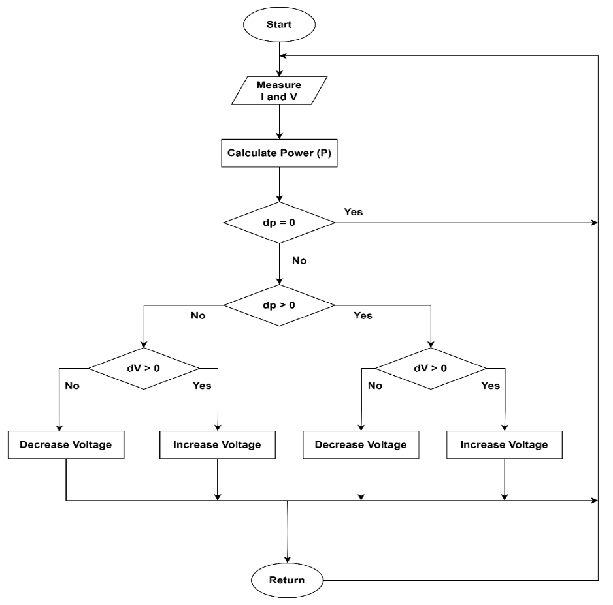

**Fig.1 Flowchart of the Perturbation and observation Algorithm**

To strengthen the connection between methodology and results, the simulation parameters, including the **Maximum Power Point Tracking (MPPT) algorithms**, are directly linked to performance outcomes. The MPPT algorithm ensures that the PV system operates at its peak efficiency by dynamically adjusting voltage and current to extract the maximum available power. By implementing MPPT within the inverter system, power losses are minimized, and energy yield is maximized.

Simulation results validate the effectiveness of this approach by demonstrating improved efficiency, reduced losses, and enhanced stability in grid integration. The performance metrics obtained from simulations, such as power conversion efficiency and voltage stability, highlight the impact of MPPT on overall system reliability. This connection between simulation parameters and results reinforces the validity of the system design.

3. Modelling of the 3MW PV System in Simulink Environment

The equations referenced (from eqn. 1 to eqn. 13) were carefully applied in the design of a 3MW photovoltaic (PV) system to calculate the necessary output power of the system. The specifications outlined in table 1 were employed to model the PV system accurately.

**Table 1. PV Module Parameters Specifications**

|  |  |  |
| --- | --- | --- |
| **Number** | **Component Description** | **Rating** |
| 1 | Maximum power (𝑃𝑚𝑎𝑥) | 213.15W |
| 2 | Open circuit voltage (𝑉𝑜𝑐) | 36.3V |
| 3 | Voltage at maximum power (𝑉𝑚𝑝) | 29V |
| 4 | Short circuit current (𝐼𝑠𝑐) | 7.84A |
| 5 | Current at maximum power (𝐼𝑚𝑝) | 7.35A |
| 6 | Input voltage | 250-300V |
| 7 | Output voltage | 600V |

We can determine how many PV arrays must be connected in series to provide the necessary output power using equation 1:

$N_{s}=\frac{V_{in}}{V_{mp}}=\frac{319}{29}=11 series string$

As a result, 11 PV arrays must be connected in series. Equation (2) will be used to calculate how many arrays must be connected in parallel:

$N_{p}=\frac{P_{out}}{N_{s} X P_{max}}$

The number of parallel connected strings will be ascertained as follows, given that the required power output $P_{out}$ is 3MW, the series connected string $N_{s}$ = 11, and the maximum power $P_{max}$ = 213.15W.

$N_{p}=\frac{3,000,000}{213.15*11}=1300 paralle string$

Thus, in order to provide the desired output power, 1300 parallel strings are needed. The necessary resistance is determined using the following formula:

Given that current $\left(I\right)=\frac{power output}{voltage}$

$\left(I\right)=\frac{3,000,000}{319}=9555 watts$

Ohm's law, which can be expressed as $R\frac{V}{I}$, can be used to calculate the resistance.

$R=\frac{319}{9555}=0.033Ω$

The solar power system was designed with a combination of series and parallel PV connections to achieve the required 3 MW output. Each PV module operates at a maximum power voltage (𝑉𝑚𝑝) of 29V and a current of 7.35A. To obtain the required system voltage, 11 panels are connected in series, resulting in a DC voltage of 319V. A total of 1300 parallel strings ensure adequate current for power generation.

To align with standard MW-scale grid requirements (typically 600V or higher), the system employs a boost converter to step up the 319V DC to 600V DC before feeding it into the inverter. The inverter then converts this 600V DC into AC for grid integration, ensuring compatibility with the standard transmission network.

This design optimizes power efficiency while minimizing transmission losses due to high current levels. The use of a boost converter is essential in achieving the necessary voltage for seamless integration with the grid, addressing concerns related to operating at lower voltage levels.

A total power output of 3MW was obtained by entering the aforementioned values into the relevant Simulink fields and visualizing the results with graphical plots. Table 2 provides a summary of the PV parameters specifications, and Fig. 2 shows the completed model:

**Table 2. Summary of PV Module Parameters Specifications**

|  |  |  |
| --- | --- | --- |
| **Number** | **Component Description** | **Value** |
| 1 | Input voltage ($V_{in}$) | 250-350V |
| 2 | Numbers of linked series in a string | 11 strings |
| 3 | Numbers of linked parallel in a string | 1300 strings |
| 4 | Computed current value | 9555 Amps |
| 5 | Computed current resistance value | $0.033Ω$ |
| 6 | PV's necessary output | 3MW |

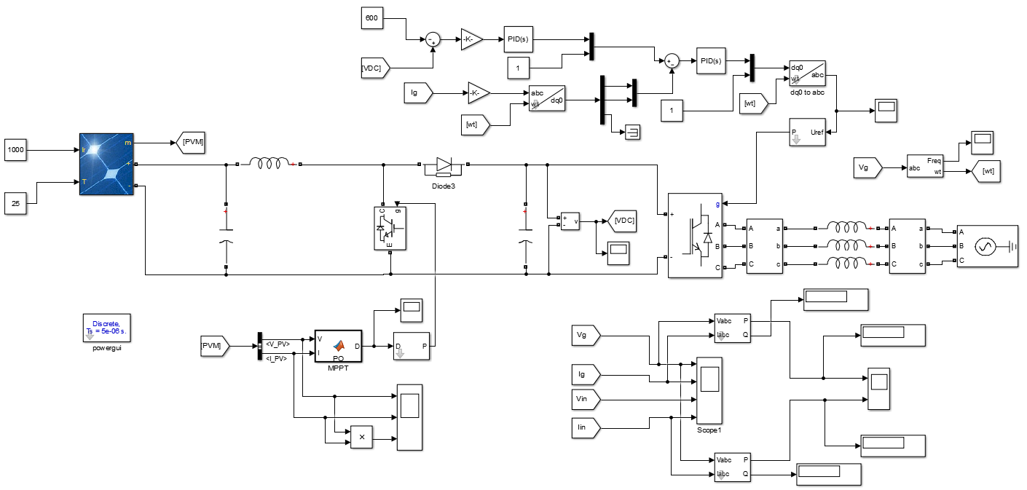

**Fig.2 Simulation setup as represented in MATLAB’s workspace**

**4. RESULTS AND DISCUSSION**

**4.1 Results of the Modelled PV Arrays in Simulink Software**

The graphical models extracted from the PV model are represented in this section, the graphs show the three remarkable points in any solar PV cell that include the open circuit voltage ($V_{OC}$), the maximum power point ($M_{PP}$) and the short circuit current ($I_{OC}$). Table 3. provides an overview of the key parameters required in configuring the simulated solar PV array to supply the desired potential required output power to be integrated into the transmission line:

**Table 3: Required Parameters of the Modelled PV Array**

|  |  |  |
| --- | --- | --- |
| **Number** | **Required Parameters** | **Value** |
| 1 | Irradiance | 1000 W/m2 |
| 2 | Number of parallel strings | 1300 |
| 3 | Number of series connected modules per string | 11 |
| 4 | Number of cells per module | 60 |
| 5 | Open circuit voltage (𝑉𝑜𝑐) | 36.3V |
| 6 | Voltage at maximum power (𝑉𝑚𝑝) | 29V |
| 7 | Short circuit current (𝐼𝑠𝑐) | 7.84A |
| 8 | Current at maximum power (𝐼𝑚𝑝) | 7.35A |
| 9 | Temperature coefficient of short circuit current (𝐼𝑠𝑐) | 0.1020c |
| 10 | Temperature coefficient of open circuit voltage (𝑉𝑜𝑐) | -0.360990c |
| 11 | Solar cell maximum power | 213.15W |
| 12 | Shunt resistance $R_{sh} (ohms)$ | 313.3991 $Ω$ |
| 13 | Series resistance $R_{s} (ohms)$ | 0.39383 $Ω$ |
| 14 | Diode idealistic factor | 0.98117 |

The PV array was simulated in Simulink to analyze the performance of the solar cell under different operating conditions, and the resulting graphs were produced. Fig. 3 shows the solar cell's current-voltage (I-V) characteristics at various irradiance levels, and Fig. 4 shows the solar cell's power-voltage (P-V) relationship at various irradiance levels.



**Fig.3 Current and Voltage Relationship of Solar PV Module**



**Fig.4 Current and Voltage Relationship of Solar PV Module**

Fig. 3, and 4 showed that at 1k W/m2 irradiance a total current, voltage, and power of 9555 amps, 319 volts and 3 MW were recorded respectively.

Also, at 0.8 kW/m2 irradiance the voltage slightly increases to 321.1 volts while current and power reduced to 7651 amps and 2.5 MW respectively.

Also, at 0.6 kW/m2 irradiance the voltage further increases to 322.7 volts, while current and power reduced to 5739 amps and 1.9 MW respectively.

Similarly, at 0.4 kW/m2 irradiance the voltage slightly decreases to 321.8 volts, while current and power further reduced to 3833 amps and 1.2 MW respectively.

This result showed that, voltage, current and power of the PV array depends on the available of solar irradiance.

**4.2 PV Array Output Analysis**

Key performance metrics, including PV current, voltage, and power output, were measured to evaluate the efficiency of the solar PV array after it was simulated under typical conditions. These metrics demonstrate the PV array's capacity to produce a sizable amount of electricity, especially in the presence of ideal irradiance. Stable voltage levels throughout the Nigerian transmission network are directly supported by this capability.

The voltage output of the PV array was roughly 319 volts, with minor fluctuations brought on by variations in the irradiance. In order for the PV array to effectively inject power into the network and synchronize with the grid, the system employs a boost converter to step up the 319V DC to 600V DC before feeding it into the inverter. With a power output of about 3 MW, the array helps to stabilize voltage levels and increase grid power availability overall.

The PV array's output current and power are depicted in Fig. 5a and 5b, the boost converter voltage is presented in Fid. 6 while the grid's and the inverter's power outputs are shown in Fig. 7a and 7b.



**Fig. 5(a) PV Array Output Current**



**Fig. 5(b) PV Array Output Power**

It can be seen from Fig. 5a, and 5b that the solar PV module has produce the required output current and power as the design system. At 1k W/m2 irradiance the current, and power is around 9555 amps and 3 MW respectively. At 0.8 kW/m2 irradiance around 7651 amps and 2.5 MW were recorded. Also, at 0.6 kW/m2 irradiance 5739 amps and 1.9 MW were respectively. Similarly, at 0.4 kW/m2 irradiance 3833 amps and 1.2 MW were recorded as well.



**Fig. 6 Boost Converter Output Voltage**

From Fig. 6, the boost converter was links from the solar PV array to the AC inverter for stepping up of the PV array's initial DC voltage to 600 V, the boost converter ensures the inverter has adequate input voltage, minimizing power losses during the DC-AC conversion process.



**Fig. 7(a) Inverter Output Power**



**Fig. 7(b) Grid Output Power**

Fig. 6a and 6b shows that the measured power output at the grid and inverter was marginally lower than that of a typical PV array module, suggesting that there were only minor system losses. Because of switching losses, heat dissipation, and internal impedance of the inverter components, these losses can be ascribed to inverter efficiency during the DC-AC conversion process. Notwithstanding these losses, the system's performance shows efficient power transfer from the solar PV system to the grid, closely matching the anticipated output from the PV array at various irradiances.

Justification of the result analysis is shown in table 4

**Table 4: Results Analysis Justification**

|  |  |  |  |
| --- | --- | --- | --- |
| **Simulation Parameter** | **Method Used** | **Performance Outcome** | **Remarks** |
| Input Voltage (V) | Boost Converter | 319V → 600V | Voltage successfully stepped up |
| Power Tracking | MPPT Algorithm | 98.8% Efficiency | Ensures max power extraction |
| Output Voltage (V) | Inverter | 600V AC | Grid-compatible output |
| Power Loss (%) | System Simulation | 1.2% | Low losses, efficient operation |
| Grid Integration | Synchronization Algorithm | Stable | System maintains grid stability |

**5. CONCLUSION**

A 3 MW grid-connected solar photovoltaic (PV) system in Nigeria was designed, simulated, and analyzed to show how crucial solar irradiance is to the system's operation.

The findings of this study have significant implications for Nigeria’s energy policy and the scalability of solar power systems. With rising energy demands and frequent grid failures, integrating large-scale solar power into the national grid can help diversify the energy mix and reduce reliance on fossil fuels. The implementation of MPPT algorithms and boost converters in solar farms can ensure maximum efficiency and improved grid stability, making solar power a more viable option for large-scale deployment.

From a scalability perspective, this system design can be adapted for larger power capacities by increasing the number of PV modules and optimizing power electronics. Government incentives, investment in solar infrastructure, and improved grid integration policies will be essential for widespread adoption. By adopting these strategies, Nigeria can achieve greater energy independence, reduce power outages, and support economic growth through reliable renewable energy sources.

Disclaimer (Artificial intelligence)

Option 1:

Author(s) hereby declare that NO generative AI technologies such as Large Language Models (ChatGPT, COPILOT, etc.) and text-to-image generators have been used during the writing or editing of this manuscript.

Option 2:

Author(s) hereby declare that generative AI technologies such as Large Language Models, etc. have been used during the writing or editing of manuscripts. This explanation will include the name, version, model, and source of the generative AI technology and as well as all input prompts provided to the generative AI technology

Details of the AI usage are given below:

1.

2.

3.

# References

Adam, A. D., & Apaydin, G. (2016). Grid connected solar photovoltaic system as a tool for green house gas emission reduction in Turkey. *Renewable and Sustainable Energy Reviews, 53*, 1086-1091.

Adebanji, B., Ojo, A., Fasina, T., Adeleye, S., & Abere, J. (2022). Integration of renewable energy with smart grid application into the Nigeria’s power network: Issues, challenges and Opportunities. *European Journal of Engineering and Technology Research, 7*(3), 18-24.

Adiyabat, A., Kurokawa, K., Otani, K., Enebish, N., Batsukh, G., Battushig, M., . . . Ganbat, B. (2006). Evaluation of solar energy potential and PV module performance in the Gobi Desert of Mongolia. *Progress In Photovoltaics: Research And Applications, 14*(6), 553-566.

Akorede, M. F., Ibrahim, O., Amuda, S. A., Otuoze, A. O., & Olufeagba, B. J. ( 2017). Current status and outlook of renewable energy development in Nigeria. *Nigerian Journal of Technology, 36*(1), 196-212.

Akuru, U. B., & Okoro, O. I. (2010). Renewable energy investment in Nigeria: A review of the Renewable Energy Master Plan. *In 2010 IEEE International Energy Conference* (pp. 166-171). IEEE.

Asmelash, E., & Gorini, R. (2021). *International oil companies and the energy transition, International Renewable Energy Agency.* Abu Dhabi : IRENA promotes the widespread.

Bassey, J. B., Ekpo, D. D., & Gentle, V. U. (2024). Computational Fluid Dynamics Analysis of Flow Characteristics in Convergent and Divergent Sections. *International Journal of Science, Engineering and Technology*.

Bhattacharjee, S., & Bhakta, S. (2013). Analysis of system performance indices of PV generator in a cloudburst precinct. *Sustainable Energy Technologies and Assessments, 4*, 62-71.

Brecl, K., & Topič, M. (2016). Apparent performance ratio of photovoltaic systems—a methodology for evaluation of photovoltaic systems across a region. *Journal of Renewable and Sustainable Energy, 8*(4).

Chong, W. T., Naghavi, M. S., Poh, S. C., Mahlia, T. M., & Pan, K. C. (2011). Techno-economic analysis of a wind–solar hybrid renewable energy system with rainwater collection feature for urban high-rise application. *Applied Energy, 88*(11), 4067-4077.

Daliento, S., Chouder, A., Guerriero, P., Pavan, A. M., Mellit, A., Moeini, R., & Tricoli, P. (2017). Monitoring, diagnosis, and power forecasting for photovoltaic fields: A review. *International Journal of Photoenergy, 2017*(1), 1356851.

Diji, C. J., Ekpo, D. D., & Adadu, C. A. (2013). Design of a Biomass Power Plant for a Major Commercial Cluster in Ibadan-Nigeria. *The International Journal Of Engineering And Science, , 2*(3), 23-29.

Diji, C. J., Ekpo, D. D., & Adadu, C. A. (2013). Exegoenvironmental evaluation of a cement manu‐facturing process in Nigeria. *International journal of engineering re‐search and development, 7*, 25-32.

Efurumibe, E. L., Asiegbu, A. D., & Onuu, M. U. (2014). Renewable energy and prospects in Nigeria. *Scholarly Journal of Scientific Research and Essays, 3*(6), 73-76.

Ekpo, D. D. (2019). *Electricity Generation Potential from Municipal Solid Waste in Uyo Metropolis, Nigeria.* (Doctoral dissertation).

Emodi, N. V., & Boo, K. J. (2015). Sustainable energy development in Nigeria: Current status and policy options. *Renewable and Sustainable Energy Reviews, 51*, 356-381.

Eyibo, N. R., Nkan, I. E., & Okpo, E. E. (2024). Integration of Renewable Energy for Power Transfer Improvement of the Nigerian 330KV Transmission Network. *Journal of Engineering Research and Reports, 26*(12), 175-191.

Hoke, A., Nelson, A., Miller, B., Chakraborty, S., Bell, F., & McCarty, M. ( 2016). *Experimental evaluation of PV inverter anti-islanding with grid support functions in multi-inverter island scenarios (No. NREL/TP-5D00-66732).* (United States): National Renewable Energy Lab.(NREL), Golden, CO.

Ikem, I. A., Ibeh, M. I., Nyong, O. E., Takim, S. A., & Osim-Asu, D. (2016). Integration of Renewable Energy Sources to the Nigerian National Grid-Way out of Power Crisis. *International Journal of Engineering Research, 5*(8), 694-700.

Innocent, U. O., Nkan, I. E., Okpo, E. E., & Okoro, O. I. (2021). Dynamic response evaluation of a separately excited dc motor. *Nigeria Journal of Engineering,, 28*(2), 56-61.

Innocent, U. O., Nkan, I. E., Okpo, E. E., & Okoro, O. I. (2021). Predicting the stability behaviour of three-horse power induction motor using eigenvalue method. *Bayero Journal of Engineering and Techcnology (BJET), 16*(2), 66-81.

Jahn, U., Mayer, D., Heidenreich, M., Dahl, R., Castello, S., Clavadetscher, L., . . . Sugiura, T. (2020). International Energy Agency PVPS Task 2: Analysis of the operational performance of the IEA Database PV systems. *In Sixteenth European Photovoltaic Solar Energy Conference* (pp. 2673-2677). Routledge.

Jameson, F. P., Nkan, I. E., & Okpo, E. E. (2024). Improvement of power transfer capability of Nigeria national grid with TCSC FACTS controller. *American Journal of Engineering Research (AJER),, 13*(1), 37-43.

Li, C., Zhou, D., & Zheng, Y. (2018). Techno-economic comparative study of grid-connected PV power systems in five climate zones, China. *Energy, 165*, 1352-1369.

Nkan, I. E., Okoro, O. I., Awah, C. C., & Akuru, U. B. (2019). Investigating the steady state stability of the nigerian 48-bus systems using facts devices. *Nigerian Journal of Technology, 38*(3), 732-743.

Nkan, I., Obi, P., Natala, H., & Okoro, O. (2023). Investigation of the transfer capability of the Nigerian 330 kV, 58-bus power system network using FACTS devices. *ELEKTRIKA-Journal of Electrical Engineering, 22*(1), 53-62.

Nkan, I., Obi, P., Natala, H., & Okoro, O. (2023). Investigation of the transfer capability of the Nigerian 330 kV, 58-bus power system network using FACTS devices. *ELEKTRIKA-Journal of Electrical Engineering, 22*(1), 53-62.

Nwaigwe, K. N., Mutabilwa, P., & Dintwa, E. (2019). An overview of solar power (PV systems) integration into electricity grids. *Materials Science for Energy Technologies, 2*(3), 629-633.

Odeh, A. A., Al Taie, W. A., & Al-Douri, Y. (2022). RENEWABLE ENERGY ANALYSIS AND RESOURCES. *Analysis, Resources, Applications, Management, and Policy*.

Orioli, A., & Di Gangi, A. ( 2013). Load mismatch of grid-connected photovoltaic systems: Review of the effects and analysis in an urban context. *Renewable and Sustainable Energy Reviews, 21*, 13-28.

Oyewunmi, T. (2017). *Nigeria: Energy Policy.* Encyclopedia of Mineral and Energy Policy.

Padmavathi, K., & Daniel, S. A. (2013). Performance analysis of a 3 MWp grid connected solar photovoltaic power plant in India. *Energy for sustainable development, , 17*(6), 615-625.

Parida, B., Iniyan, S., & Goic, R. (2011). A review of solar photovoltaic technologies. *Renewable and sustainable energy reviews, 15*(3), 1625-1636.

Sambo, A. S. (2009). Strategic developments in renewable energy in Nigeria. *International Association for Energy Economics, 16*(3), 15-19.

Ugwuanyi, N. S., Ozioko, I. O., Uma, U. U., Nwogu, O. A., Ugwuoke, N. C., Ekwue, A. O., & Nwokocha, N. (2024). Enhancing Renewable Energy-Grid Integration by Optimally Placed FACTS Devices: The Nigeria Case Study. *Science Journal of Energy Engineering, 10*(6), 16-25.

Vincent, E. N., & Yusuf, S. D. (2014). Integrating renewable energy and smart grid technology into the Nigerian electricity grid system. *Smart Grid and Renewable Energy, 2014, 5*(9), 19.

Woyte, A., Richter, M., Moser, D., Mau, S., Reich, N., & Jahn, U. (2013). Monitoring of photovoltaic systems: good practices and systematic analysis. *In Proc. 28th European Photovoltaic Solar Energy Conference*, (pp. 3686-3694).

Zahedi, A. (2011). A review of drivers, benefits, and challenges in integrating renewable energy sources into electricity grid. *Renewable and Sustainable Energy Reviews, 15*(9), 4775-4779.