1

2

3

4

5

6

7

8

9

10

11

12

13

14 .

* **Development and Evaluation of Wearable Smart Gloves for Real-Time Sign Language Translation**

# 15 ABSTRACT

**Aims:** To design and execute a two-way sign language translator aimed at enhancing communication between hearing and deaf-Dumb individuals. The device seeks to address accessibility challenges by accurately translating sign language into audio for hearing people.

**Study Design:** A technological research and development study focused on gesture recognition and audio generation.

**Place and Duration of Study**: Conducted at [The Higher Institute of Engineering and Technology in New Damietta.] over [January 2025 to December 2025].

**Methodology:** The translator uses a hand motion detection technology to interpret sign language and generates corresponding text outputs. For reverse translation, the device converts textual input into audio using a pre-designed audio database, including both hearing and deaf-Dumb individuals, to validate usability and accuracy. Performance was assessed based on parameters like recognition accuracy and ease of use.

**Results:** User testing demonstrated high device accuracy, Participants rated the device as user-friendly and effective in facilitating communication. The findings underline the potential of the system in bridging communication gaps in everyday interactions for deaf-Dumb individuals.

**Challenges**: One of the challenges encountered during the development of this device was effectively communicating its functionality to the target users and ensuring their adaptation to its use.

**Conclusions:** This two-way sign language translator presents a promising solution to improve accessibility and communication for deaf-Dumb individuals. It combines innovative gesture recognition with intuitive audio generation to address a significant societal need.Looking forward, our vision is to see this innovation adopted broadly, not only by individuals with disabilities but also by the general population, fostering a more inclusive society.

17

|  |  |  |
| --- | --- | --- |
| Keywords | Gloves | speech disabilities |
| Hearing disabilities | Artificial Intelligence |

18

19

20

21

22

23

24

26

27

28

29

30

31

32

33

# 1. INTRODUCTION

1. As illustrated in Figure 1, the everyday lives of people with impairments, including deaf-Dumb
2. people, have significantly improved as a result of technological advancements. One of the most
3. important components of human contact is communication, and its absence can lead to
4. loneliness and social rejection. Communication barriers between deaf-Dumb people and the
5. hearing community frequently result in miscommunications and restricted access
6. to services and information [1]. Sign languages have been utilized by humans for
7. communication and message delivery, especially by deaf societies. Facial emotions,
8. hand shapes, and hand orientation and movement can all be used to communicate a speaker's
9. ideas through sign language. utilized concurrently. Nonetheless, very few regular people are
10. familiar with sign language. As a result, it could be difficult for people who regularly communicate
11. using sign language to have conversations or just to share their opinions with others Thus,
12. solutions have been created to help deaf communities hear or communicate with others as a
13. result of the quick development of technology. Deafness and other communication impairments
14. can be helped by a variety of over-the-counter hearing aids, such as behind-the-ear, in-the-ear,
15. and canal aids. Although hearing aids are Although these devices are helpful, employing
16. one could make the user uneasy or make background noise audible. Scientists have therefore
17. been developing a
18. variety of methods to translate motions in sign language. Wearable technology and vision- based
19. systems are the two primary methods. Vision-based systems use image processing techniques
20. such as feature extraction to identify hand and finger
21. movements. This describes a number of additional studies on the application of a visionbased
22. system for translating sign language.
23. To eliminate cables, the wearable will be connected to a microcontroller, and the
24. The smart glove will translate sign language into spoken or written speech using a number of
25. techniques. Mobile phones with Bluetooth capabilities are used in this study to show translated
26. audio and text [2].
27. The American Sign Language alphabet was used in this paper, as indicated in Figure 2. The
28. major goal of this endeavor is to create a wearable device that will facilitate communication
29. between deaf groups and the general public while taking user comfort into account. The following
30. is a description of how the paper is structured, hardware component section II, Hardware circuit
31. design in section III, Results and Discussion section IV, The conclusion provided in V[3].

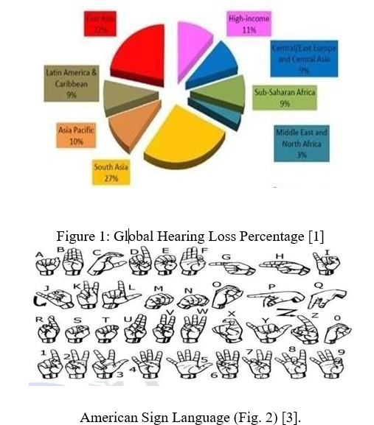

# Smart Gloves

1. The smart gloves are just regular gloves that have sensors built into them. Flex sensors and
2. gyroscopes make up the majority of these sensors. A microcontroller that receives input from the
3. sensors, processes the information, and outputs the results as text controls these sensors.
4. The gloves have one gyroscopes and five flex sensors. Figure 3 [4] illustrates how these

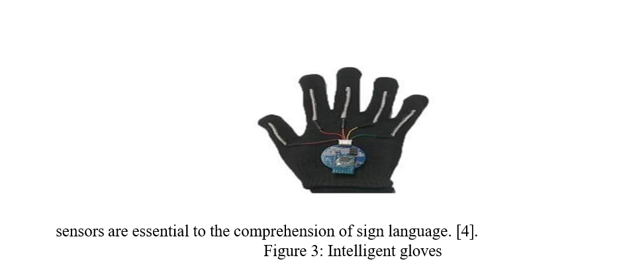

1. A - Suggested Framework
2. Figure 4 shows that every component is linked to an Arduino Uno. The HC-05 Bluetooth connects the Arduino Uno to the mobile phone. Hand gesture-sensing data from
3. accelerometers and flex sensors is transmitted to an Arduino Uno, which processes and compares the data. The generated data is then communicated to a mobile device via HC05 Bluetooth, where the output is shown. There are two sections to the suggested system:-
4. 1 - The transmitter section
5. Devices like the Arduino Nano, HC-05 Bluetooth Module, accelerometers, and Flex sensors are included in this section.
6. 2-Section of the Receiver
7. This section's gadget is a mobile phone.[3]

1. Block Diagram
2.  Accelerometer sensors measure linear hand motions in the X-axis and produce
3. various X values that correspond to the X-axis movement
4.  Following the use of five accelerometers to detect the gesture, all sensor data are then
5. handled by the MCU node.

.

# Components of hardware

1. Five flex sensors, one for each finger, were used in the construction of a smart glove that
2. translated ASL characters into spoken and written characters for a mobile phone application.
3. The accelerometer in the back of the hand indicated whether the hand was positioned vertically
4. or horizontally, an Arduino nano was used to write the code, and an HC-05 Bluetooth was used
5. to link the glove to the phone [6].
6. **A - The Arduino nanocontroller**
7. Based on the ATmega328P,
8. the Arduino Nano (Fig. 5(a))
9. is a comprehensive, compact, and breadboard-friendly board. It has six digital I/O pins,
10. fourteen 16MHz CLK speed and analog input pins. It serves as the SSG-Sys's brain in this
11. paper, processing sensor input and providing text-based outputs.
12. **b) Flex sensor**
13. In essence, a flex sensor (Fig. 5(b)) is a variable resistor, and when the sensor is bent, its
14. terminal resistance rises. Five 2.2-inch flex sensors were affixed to the glove's fingertips for this
15. study. The fingers bend in response to a gesture, and
16. the Arduino Nano receives a particular value from each sensor.
17. **c) Bluetooth module HC-05**
18. The user can view the data on the mobile app that is transformed on the Arduino board with the
19. help of the HC-05 Bluetooth module (Fig. 5(c)). It is quite
20. simple to combine with microcontrollers since the Serial Port Protocol (SPP) is how it operates.
21. **d) 10k Ohm resistor**
22. One part of the circuit that limits the flow of electrical current is the 10k ohm resistor (Fig.
23. 5(d)). It is a crucial element frequently utilized in circuits and electronic projects.
24. **e) A speedometer called the MPU-6050**
25. The accelerometer sensor (Fig. 5(e)) is utilized to monitor the hand's movement and direction.
26. The three-axis accelerometer found in each MPU-6050 is accountable for the X, Y, and Z axes'
27. linear acceleration measurements. To detect the bending motion, it is placed on the wrist.
28. **f) A breadboard**
29. plastic board with many tiny holes used to build and test circuits is called a breadboard
30. (Fig. 5(f)). It can be used to supply a variety of devices. with strength.
31. **g) Wire jumpers**
32. To connect components on the breadboard, a jump wire (Fig. 5(g)) is a single electrical wire or a
33. collection of them in a cable. and the header pins of the Arduino.
34. **h) USB cord**
35. The smart glove cannot function without a USB cable (Fig. 5(h)), which powers the Arduino
36. Nano by connecting to a laptop.
37. **i) The glove**
38. The right-hand glove (Fig. 5(i)) utilized in this research is black, composed of cotton, and flexible
39. enough to allow the user to wiggle his fingers. 5 organically when making motions
40. **j) Android smartphones**
41. mobile phone using the Android operating system, the Android mobile (Fig. 5(j)) has
42. more sophisticated computing power and greater capacity for communication than a
43. A group of electronic components

    AI-generated content may be incorrect.standard phone [7].
44. Fig. 5: SSG-Sys hardware components a breadboard, an Arduino nano, a flex sensor, an HC-05
45. Bluetooth module, a resistor, an accelerometer, jumper wires, a USB cable, an Android
46. smartphone, and a glove.[7]

# Components of software

1. The suggested SSG-Sys software components are described in depth in the section that follows.
2. *A) Software for Fritzing*
3. *Users can create electronic circuits with this open-source program. It helps them move from*
4. *testing prototypes to building more environmentally friendly circuits. "0.9.8" is the version*
5. *utilized in this work. Using Fritzing software, the circuit design of the suggested SSG-Sys is*
6. *displayed in Fig. 6.*
7. A.Proteus software
8. B.A program called Proteus is used to simulate different projects before they are
9. implemented in hardware. It has sensors, additional electronic parts, and other non- Additional
10. elements that can be added to the Proteus's library area by downloading and adding
11. particular libraries. The Proteus software version "8.10" is used in this work. The
12. Proteus software simulation of the suggested SSG-Sys is displayed in Fig. 7.
13. C.The Arduino IDE
14. It is the application that opens, writes, modifies, and uploads the Arduino board's source
15. code. Although it was developed using Java, the application makes use of Sketch, a
16. programming language that is comparable to C and C++. The Arduino IDE version
17. "2.1.0" is used in this study. The Arduino IDE's sample code for the suggested SSG-Sys
18. is seen in Fig. 8.
19. D.The second inventor
20. It is an open-source online application that lets people make apps that work on Android
21. handsets. Users must first add buttons, graphics, and other interface components to their
22. programs (Fig. 7(a) illustrates this). Second, they must use plain language instruction blocks that
23. fit together like jigsaw pieces to add logic and procedures (Fig. 7(b)). [7].

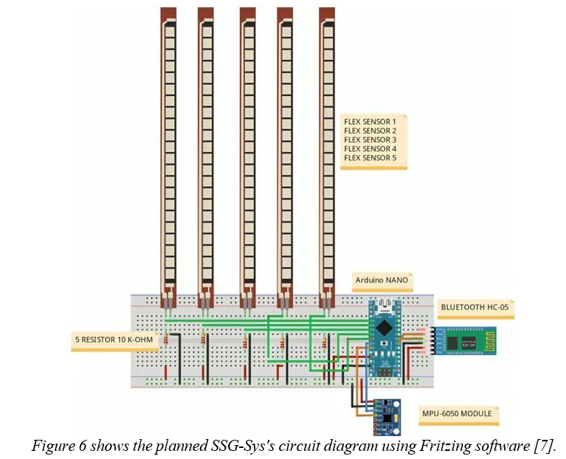

# VOCAL GESTURES

1. The selected vocabulary includes gestures and positions that correspond to 24 ASL(American Sign Language) letters,
2. syllables, or phrases. This illustrates the sensorized glove's ability to recognize both static and
3. dynamic motions and shows a possible use case that could improve the naturalness of human
4. interactions by instantly translating ASL into voice or text. The 13 dynamic gestures and 11
5. static stances are shown in Fig. 10. Naturally, ASL highlights the need to recognize hand motion
6. and posture.I and J or A and Sorry are two examples of vocabulary entry pairings that share the
7. same stance but have distinct dynamics. There are minor variations in hand positions,
8. orientations, or motion instructions among other sets, such Eat, Home, and Thank You. Certain
9. gestures, like "please" or "yes," are recurring motions that may or may not be repeated. The
10. majority of the letters are in still, motionless attitudes. Thus, the selected language collectively
11. tests the system's capacity to integrate motion and position data for multi-class gesture
12. recognition [8].

1. In order to identify a variety of stances and dynamic actions, a vocabulary consisting of 24 ASL
2. letters and words was chosen (Fig. 10). This results in a useful corpus for assessing how well
3. the embedded glove system combines accelerometer-based motion information with strain-
4. based pose information [8].

# System Overview

1. An overview of the suggested wearable sensor glove for the sign language translation system is
2. shown in Figure 11. Three components make up the system: output, data processing, and input
3. sensors. The smart glove's input sensors include five (5) units of
4. 4.5inch flexible sensors on the back of each finger and a GY-61 accelerometer sensor on the
5. back of the hand. An Arduino Nano microcontroller is connected to each sensor in order to
6. process data. The ATmega328 single chip 8-bit microcontroller, a 5V operating voltage, and a
7. processor clock with a speed of 16 MHz are all used in the tiny and compact Arduino Nano board.
8. Its eight analogue pins are sufficient to connect to the input sensors needed for this task. The
9. microcontroller processes and digitizes the data from the input sensors. It then recognizes the
10. gestures and converts them into words, which are then sent to an Android-based smartphone
11. application over an HC-05 Bluetooth module. The words will appear on the smartphone
12. application if the Arduino Nano sends them there successfully, and the speaker on the
13. smartphone will play the appropriate voices for the words [9].

1. **Performance and accuracy**
2. The letters being recognized determine how effectively this system works and how accurate it is.
3. Because they are so similar to one another, letters like "M," "N," and "T" might be inconvenient.
4. On the other hand, statistically, this only occurs around 5% of the time. "C," "O," and "E" have
5. issues that are comparable to those of those three letters.
6. In this instance, the issue is not just that they are extremely similar, but also that the joints are
7. positioned in the midst of the range, which means that the fingers are neither flexed nor
8. extended, and there is most likely a presence of oscillations from muscular twitching. Even
9. though the minimal distance classifier or the provided criteria largely outperform this, it still
10. occurs perhaps 80% to 85% of the time. Generally speaking, the other letters are separated
11. from one another with great care, and the addition of the minimal distance classifier minimizes
12. decision-making errors [10].

# Flowchart of The Project

1. The project's flowchart was created at the planning stage to make sure everything would go
2. according to plan. Figure (12,13) displays the project's flowchart. After the research is finished,
3. the project will begin with software development. GUIs and code are also a part of the software
4. development process. C++ will be the coding language utilized for this
5. project because Arduino will be used [17]. After software development is finished, the code must
6. be tested and run to find any coding or graphical user interface (GUI) flaws. Any errors must be
7. corrected before proceeding to the next stage. The following stage is hardware development. As
8. part of hardware development, the Flex and Arduino sensors are assembled [6,9]. These two
9. pieces of equipment will help collect vibration data from the tool. The hardware and software
10. components need to be connected. After thesoftware and hardware have been integrated, the
11. system will be tested once more to find any potential issues. Any errors must be fixed prior to the
12. experiment [11].

# Results and Discussion

1. Initial sensor calibration revealed that three of the sensors recorded a nearly constant increase in
2. voltage when fingers were stretched straight for five seconds, a similar but relatively higher voltage
3. when fingers were closed and fully bent for five seconds, and a similar pattern of voltage rising
4. when fingers were moved from straight to fully bent in all three sensors. Additionally, their
5. beginning and ending voltages were consistent with the ones that came before them, confirming
6. the reliability and consistency of the outcome (Figure 14). While several images of the glove's
7. operational video are shown in Figure 6, certain graphs acquired during data acquisition for
8. specific alphabets are displayed in Figure 15.
9. Due to variations in skin tone and the inability to differentiate between hands and faces, the
10. machine vision-based method may yield inconsistent results. Additionally, the user must cover
11. their arms with clothing that has full sleeves. Furthermore, this approach may be negatively
12. impacted by lighting effects. SignSpeak, on the other hand, offers a cameraindependent solution
13. that is just as accurate in bright and dim lighting. identical to this, a boosted classifier tree approach
14. for hand shape detection may produce unreliable results when hand photos have very basic and
15. identical backgrounds for both training and test databases, but the SignSpeak approach is not
16. image-based.While SignSpeak is a standalone glove that doesn't require a Kinect, gesture
17. recognition using Kinect necessitates the configuration of a Kinect with sensors to gather both
18. RGB and depth data for gesture translation. We first calculated the Euclidean distance of each
19. set from the average of 23 training sets to assess the reproducibility of experimental
20. measurements of SignSpeak. 85% was the result of calculating the percentage of these
21. discrepancies. Later, by repairing one of the flex sensors that were positioned at the wrist bent,
22. the accuracy was increased. Accuracy for an unskilled user was found to be approximately 92%
23. after additional training sets were obtained [13].

# 

# CONCLUSION

1. The GloSign glove, which converts sign language motions to letters and words, is proposed in this
2. paper. Using the recognized letters and words, the system can also construct sentences. This
3. glove decodes sign language gestures using a flex sensor and an IMU. The IBM Watson IoT
4. platform receives these sensor data. The KNN machine learning technique is used to differentiate
5. between movements that are similar or challenging. Sentences are then formed by combining the
6. letters that were detected from the gestures.To address the errors in letter detection at the word
7. and sentence levels, these sentences are subjected to an additional error correction layer known
8. as the gesture fix method. Lastly, the system's output is translated to speech for convenience and
9. shown on the screen. More research is required to increase the system's speed and accuracy so
10. that it can help with more proficient sign language gesture verification [14].

# References

1. A. Siddiqui, A. Noor, M.I. Saleem, " Efficient Learning for Hearing-Impaired: Two Way Sign Language Translator Using AI", Pakistan Journal of Engineering Technology and Science (PJETS), Vol.12, NO.1,2024.
2. A.J. Abougarair , W.A. Arebi ," Smart glove for sign language translation", International Robotics & Automation Journal, Vol.8, NO.3,2022.
3. P. Mishra, M. Hamza, S. Singh, D. Drivedi , R. Singh, "Sign Language Translator Glove", JOURNAL OF EMERGING TECHNOLOGIES AND INNOVATIVE

RESEARCH (JETIR) , Vol.10, NO.4, 2023.

1. K.Y. Reddy, D. Moses," SMART GLOVES TO UNDERSTAND SIGN LANGUAGE", INTERNATIONAL JOURNALOFCREATIVERESEARCH THOUGHTS (IJCRT), Vol.9 ,NO.12, 2021.
2. P. Mishra, M. Hamza, S. Singh, D. Drivedi , R. Singh, "Sign Language Translator Glove", JOURNAL OF EMERGING TECHNOLOGIES AND INNOVATIVE

RESEARCH (JETIR) , Vol.10, NO.4, 2023.

1. A.Z. Shukor,M.F. Miskon,M.H. Jamaluddin,F.B. Ali@Ibrahim,M.F. Ali@Ibrahim,M.B. Bahar," ANewData Glove Approach for Malaysian Sign Language Detection", Procedia Computer Science,Vol.8,2015.
2. S.A. Shaban, D.L. Elsheweikh, "An Intelligent Android System for Automatic Sign Language Recognition and Learning", Journal of Advances in Information Technology, Vol. 15, No. 8, 2024.
3. J.DelPreto, J. Hughes, M. D’Aria, M. de Fazio, D. Rus, "

AwearableSmartGloveandItsApplicationofPose

andGestureDetectiontoSignLanguageClassification", IEEE ROBOTICS AND AUTOMATION LETTERS. PREPRINT VERSION. ACCEPTED JUNE, 2022.

1. R. Ambar, S. Salim, M.H. Abd Wahab, M.M. Abdul Jamil, T.C. Phing, " Development of a Wearable Sensor Glove for Real-Time Sign Language Translation", Annals of Emerging Technologies in Computing (AETiC), Vol. 7, No. 5, 2023.
2. V. Martin, " Design and Implementation of a System for Automatic Sign Language Translation", Faculty of Electrical Engineering and Information Technologies SS Cyril and Methodius University, Karpos 2 BB, MK-1000 Skopje, R. Macedonia.
3. A.I. Mohd Thaim, N. Sazali, K. Kadirgama,A.S. Jamaludin,F.M. Turan, N. Ab. Razak," Smart Glove for Sign Language Translation", Journal of Advanced Research in Applied Mechanics,VOL.112,NO.1,2023.
4. S.C. Bodda, P. Gupta, G. Joshi, A. Chaturvedi," ANEWARCHITECTUREFORHAND-WORNSIGN

LANGUAGETOSPEECHTRANSLATOR.", arXiv:2009.03988v1 [cs.HC] 8 Sep 2020.

1. J. Bukhari,M. Rehman, S.I. Malik,A. M. Kamboh, A. Salman," American Sign Language Translation through Sensory Glove; SignSpeak", International Journal of u- and e- Service, Science and Technology, Vol.8, No.1 ,2015.
2. S.M. Biju,O. Al-Khatib,H.Z. Sheikh, F. Oroumchian, " Glove based wearable devices for sign language-GloSign", IAES International Journal of Artificial Intelligence (IJ- AI), Vol. 12, No. 4, December