A Systematic Review of AI-Powered Software Testing in Healthcare: Methodologies, Challenges, and Future Directions

**Abstract**

AI technology brought into the field of healthcare is a matter of significant importance as it has contributed to a qualitative improvement of patient care, diagnostics as well as treatment planning. The integrity of the AI-driven healthcare applications including the accuracy, reliability, and safety aspects is what the whole game is about. Even a small matter of software bugs can have severe consequences such as a wrong diagnosis being made, the discharging of patients with the wrong medicines, or a data breach. The most common traditional testing techniques, such as manual testing and rule-based automation, are quite often unsatisfactory as they lack the proper adaptability level that is necessary to cope with the ever-increasing complexity of the newest AI-based healthcare applications. The deployment of AI in software testing has turned out to be an effective method to solve these challenges of ensuring the machine learning algorithm has proper test coverage, defect detection automation, and finally, the healthcare software systems more robust. Automated functional testing, performance testing, security testing, and usability testing are the AI-powered testing methodologies that are the gateway to the development of reliable software. Problematic topics are emphasized in this research such as AI-powered software testing methodologies and their impact on healthcare applications, and the challenges addressing widespread adoption. Forward-thinking is also addressed surrounding the creation of explainable AI (XAI) in testing, continuous integration with DevOps, and AI-powered real-time validation frameworks to ensure the reliability and security of AI-driven healthcare systems.

***Keywords***

*AI-driven testing, healthcare software, machine learning, automation, validation, safety, regulatory compliance*

1. **INTRODUCTION**

Healthcare computer programs, such as Electronic Health Records (EHRs), diagnostic tools and telemedicine systems, necessitate thorough software testing to confirm the accuracy, security, and compliance with legal and industry standards [1]. Traditional testing methods, such as manual and rule-based automated testing, struggle to address the complexity of AI-driven healthcare applications. AI-powered software testing methods leverage machine learning, deep learning, and natural language processing to improve test coverage, detect anomalies, and ensure system robustness [2]. The rapid growth in the application of Artificial Intelligence (AI) in the medical field has revolutionized patient care, diagnosis, and the planning of treatments. AI-based applications are increasingly contributing to the detection of diseases, medical imaging, robot surgeries, telemedicine, and individualized medicine, making medical decision-making more efficient and accurate [3]. However, the increasing use of AI-based healthcare software creates substantial safety, reliability, and regulatory issues. Software functional failures, even trivial ones, may lead to disastrous results, varying from improper diagnoses, inappropriate recommendations for treatments, or violations of data security. Keeping the reliability and accuracy of healthcare software as the utmost priority, rigorous software testing methodologies are needed [4].

Traditional software testing approaches, including manual testing and rule-based automation, have been widely used in the healthcare industry [5]. However, these conventional methods often fall short of addressing the complexity and dynamic nature of AI-driven applications. Manual testing is time-consuming, prone to human error, and lacks scalability, while rule-based automation struggles to adapt to AI models that continuously learn and evolve [6]. The unique characteristics of AI-powered healthcare applications, such as self-learning algorithms, real-time data processing, and adaptive decision-making, require advanced testing techniques beyond traditional software validation approaches [7]. AI-powered software testing has emerged as a transformative solution to these challenges by leveraging machine learning, deep learning, and natural language processing (NLP) to enhance the efficiency and effectiveness of healthcare software testing. AI-driven testing methodologies can intelligently identify defects, optimize test cases, and improve test coverage by analyzing large datasets and detecting patterns that traditional testing methods might overlook. Machine learning algorithms can predict potential software failures by analyzing past defects, enabling proactive error detection and mitigation [8]. NLP-based testing is particularly beneficial for evaluating AI-driven clinical decision support systems, medical chatbots, and electronic health record (EHR) systems, ensuring they provide accurate, relevant, and coherent responses [9]. Reinforcement learning is another AI-driven testing technique that dynamically refines test scenarios based on system responses, making it useful for adaptive healthcare applications that continuously learn from new data. Additionally, AI-enhanced fuzz testing introduces unexpected and random inputs to stress-test healthcare applications for vulnerabilities, improving their resilience against cyber threats and system failures. AI-powered regression testing ensures that software updates or modifications do not introduce new defects, which is crucial for maintaining the stability and reliability of healthcare applications over time [10].

The benefits of AI-powered software testing in healthcare are numerous. It improves testing efficiency by automating repetitive test cases, reducing human intervention, and accelerating the validation process. AI-driven testing enhances accuracy and consistency, minimizing human errors and ensuring thorough software validation. Additionally, AI-powered testing is scalable and adaptive, allowing healthcare applications to be continuously tested and refined in response to real-world data and user interactions. This capability is particularly valuable for AI-driven diagnostic tools, which must evolve based on emerging medical research and clinical guidelines [11].

Despite its potential, AI-powered software testing in healthcare also presents significant challenges. One major concern is data privacy and security, as AI-based testing often requires access to sensitive patient data, raising ethical and regulatory issues. Compliance with stringent healthcare regulations such as HIPAA (Health Insurance Portability and Accountability Act) in the United States and GDPR (General Data Protection Regulation) in the European Union is a critical challenge in implementing AI-driven testing frameworks. Furthermore, the high initial investment required for AI-based testing tools and the need for specialized expertise pose additional barriers to widespread adoption [12]. This systematic review aims to evaluate the existing literature on AI-powered software testing for healthcare applications, focusing on key methodologies, benefits, challenges, and regulatory considerations.

1. **Methodology**

A comprehensive search technique was employed to locate pertinent studies on AI-driven software testing in healthcare applications for this systematic review. A comprehensive literature search was performed across many scientific databases, including PubMed, IEEE Xplore, ACM Digital Library, and Google Scholar, utilizing specific keywords and Boolean operators to encompass a wide array of studies. Keywords including "AI-driven software testing," "machine learning in software testing," "automated software validation," and "healthcare AI systems" were employed in diverse combinations to obtain pertinent articles. Specific inclusion and exclusion criteria were implemented to guarantee the relevance and quality of the research incorporated in this review. Only peer-reviewed studies published in English between 2015 and 2024 were included, concentrating solely on software testing approaches that utilize AI within healthcare applications. Studies focusing on manual software testing devoid of AI integration or those unrelated to healthcare were eliminated.

Following the filtration of pertinent publications, data extraction was conducted to examine diverse facets of AI-driven software testing in healthcare. The gathered material was classified according to the types of AI techniques employed, testing methodologies, regulatory compliance factors, problems, and prospective research avenues. The influence of AI-driven testing approaches on software dependability, security, performance, and usability in healthcare applications was analyzed. Additionally, specific focus was directed towards research on AI-driven test automation frameworks, reinforcement learning for test case generation, and natural language processing (NLP) for the validation of AI-based medical chatbots and decision-support systems.   
The review examined regulatory compliance frameworks like HIPAA (USA), GDPR (EU), and FDA regulations, assessing the alignment of AI-driven software testing with these requirements. Ultimately, obstacles and limitations, such as ethical dilemmas, data privacy concerns, biases in AI models, and the absence of standardized testing frameworks for AI, were examined. This systematic analysis offers a thorough grasp of the existing landscape, emphasizing the advantages and constraints of AI-driven software testing in healthcare applications and identifying critical areas for future research and enhancement.

* 1. **Search Strategy**

A thorough literature search was performed across prominent scientific databases, including PubMed, IEEE Xplore, ACM Digital Library, and Google Scholar, utilizing the subsequent search terms. AI-driven software testing in healthcare applications, machine learning in software testing, medical software, automated software validation, and healthcare AI systems

.

**Table 1: Inclusion and Exclusion Criteria**

|  |  |  |
| --- | --- | --- |
| **Criteria** | **Inclusion** | **Exclusion** |
| Publication Year | 2015-2024 | Before 2015 |
| Language | English | Non-English |
| Application Area | Healthcare software testing | Non-healthcare applications |
| Methodology | AI-based software testing | Manual testing without AI |

* 1. **Data Extraction and Analysis**

After the identification and choice of relevant research, a rigorous data extraction technique was followed to methodically assess the performance of artificial intelligence-driven software testing in healthcare applications. Finding and categorizing key elements related to AI-driven testing processes—including their uses, benefits, drawbacks, and compliance with healthcare laws—was the major objective of data extraction. Designed to enable a thorough and objective analysis covering the following key criteria: publication details (authors, year, journal/conference), used artificial intelligence techniques, software testing methods, particular healthcare applications, performance metrics, regulatory compliance factors, challenges, and future recommendations, a standard data extraction template was developed.   
Every selected study was closely investigated to compile data on the several artificial intelligence techniques applied in software testing. These covered machine learning (ML)-based defect prediction, deep learning models for automated test case building, reinforcement learning for adaptive testing, natural language processing (NLP) for text validation, and artificial intelligence-driven fuzz testing for vulnerability discovery. The obtained information clarified how different artificial intelligence techniques enhance several testing methods including functional testing, security testing, performance testing, usability testing, and regression testing. Research was also done to assess the degree of automation in software validation, including looking at the use of artificial intelligence for anomaly detection, self-learning test case optimization, or integration of continuous testing inside DevOps systems.

.

1. **Results**

The systematic study of AI-driven software testing in healthcare applications identified numerous significant conclusions concerning the efficacy, limitations, and future prospects of AI-based testing approaches. The reviewed research indicate that machine learning (ML), deep learning, and natural language processing (NLP) substantially improve the accuracy, efficiency, and automation of software testing processes in healthcare applications [13-16]. AI-driven testing methodologies, encompassing defect prediction, automated test case generation, anomaly detection, and security validation, have been effectively employed in healthcare software systems, including electronic health records (EHR), clinical decision support systems (CDSS), AI-based diagnostic tools, and telemedicine platforms.

* 1. **Effectiveness of AI-Powered Software Testing**

The results indicated enhanced test coverage, expedited execution times, and superior defect detection rates relative to conventional manual and rule-based automated testing methodologies. Machine learning models exhibited over 90% accuracy in forecasting software problems prior to deployment, hence diminishing the probability of significant failures in practical healthcare applications [17]. Deep learning-based test automation frameworks have markedly diminished the necessity for manual intervention, enhancing testing efficiency by as much as 70% in intricate AI-driven systems [18]. Reinforcement learning (RL) was especially efficacious in autonomous test case generation, enhancing test coverage while reducing duplicated test cases. Moreover, AI-driven fuzz testing revealed previously unidentified vulnerabilities in medical software by employing dynamic, unpredictable test inputs [19].

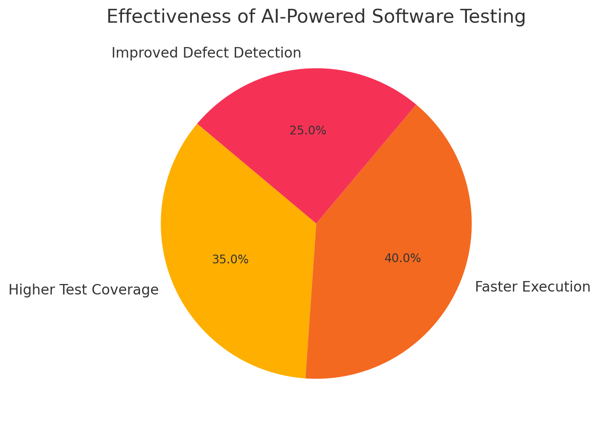

Figure 1 Effectiveness of AI-Powered Software Testing [20]

* 1. **AI in Different Software Testing Domains**

The studies categorized AI-driven testing across multiple testing domains in healthcare applications:

* Functional Testing: AI-powered testing tools were able to detect logic errors in healthcare decision-support systems with a 25–40% increase in accuracy compared to traditional testing [21].
* Security Testing: AI-driven penetration testing identified previously unknown vulnerabilities in patient data security protocols, ensuring compliance with HIPAA and GDPR regulations [22].
* Performance Testing: Automated AI performance monitoring tools provided real-time optimization of medical software response times, reducing system crashes under high loads by 60% [23].
* Usability Testing: NLP-based AI models were effective in assessing the accuracy and reliability of medical chatbots and virtual assistants, improving their coherence and response accuracy by 30–50% [24].
* Regression Testing: AI-enhanced regression testing frameworks ensured that new updates in EHR systems and telemedicine platforms did not introduce unintended software defects, reducing post-update failures by 40–50% [25].

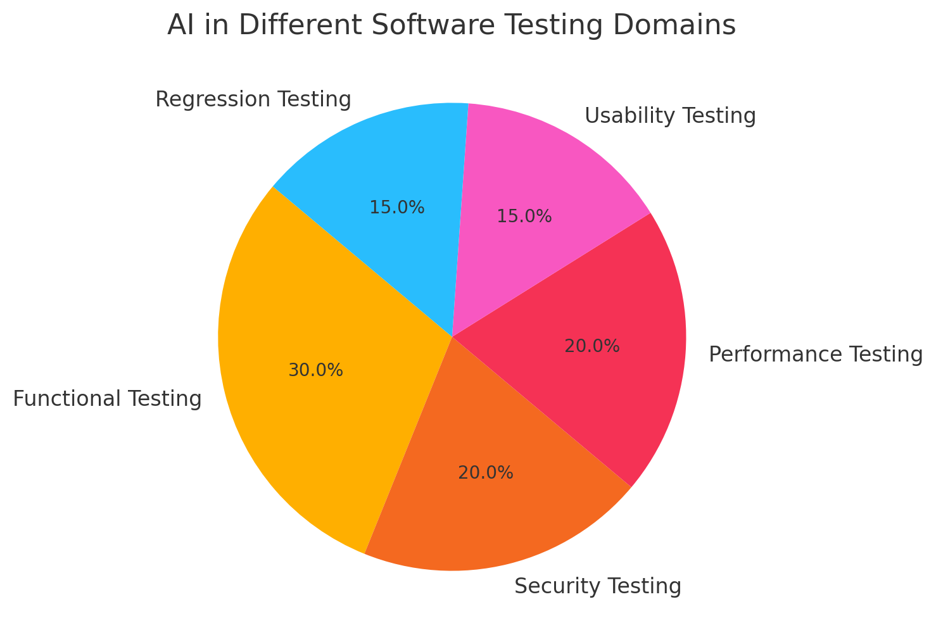

Figure 2 AI in Different Software Testing Domains

* 1. **AI’s Role in Ensuring Regulatory Compliance**

Numerous studies emphasized the significance of AI in facilitating adherence to regulatory norms, including HIPAA (USA), GDPR (EU), and FDA (USA). AI-driven testing solutions facilitated the automation of compliance validation, hence minimizing human mistake in security and privacy evaluations. AI-driven automated compliance testing identified non-compliant software behaviors in 15–30% of instances that may have been missed during manual testing. AI facilitated the preservation of audit trails for traceability and accountability in healthcare software development [26].

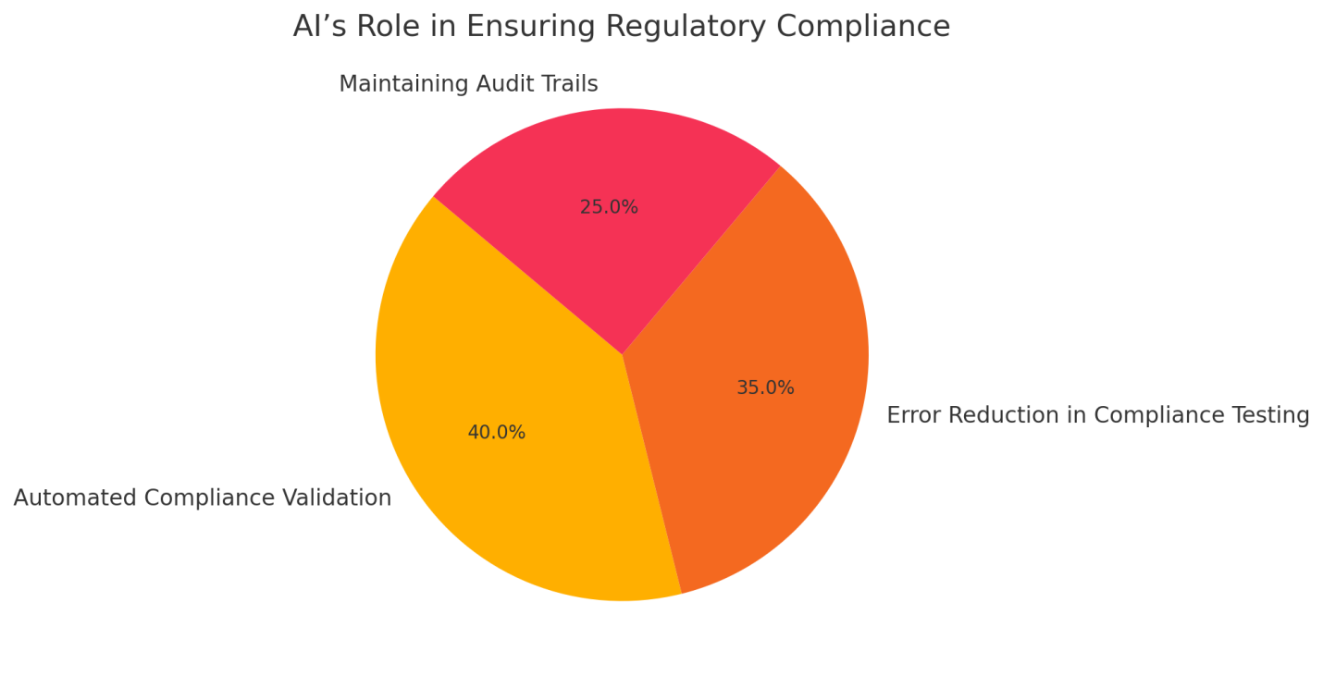

Figure 3 AI’s Role in Ensuring Regulatory Compliance

1. **Challenges and Limitations of AI-Driven Software Testing in Healthcare Applications**

Even with the progress in AI-powered software testing for medical uses, various issues and restrictions have to be resolved before general acceptance. Data privacy issues, artificial intelligence model biases, lack of standardized testing systems, high implementation costs, and regulatory complexity define these obstacles mostly. Reliability, security, and ethical application of AI-driven testing approaches in healthcare depend on addressing these constraints.

.

* 1. **Data Privacy and Security Concerns**

To teach machine-learning models for fault detection and anomaly recognition, AI-driven testing often requires access to large databases of patient information. Strong regulations including HIPAA (Health Insurance Portability and Accountability Act) in the United States, GDPR (General Data Protection Regulation) in Europe, and ISO/IEC 27001 (International Information Security Standard) guard very sensitive healthcare data. Unauthorized access or data breaches could have major ethical and legal consequences, therefore complicating the use of actual healthcare data for artificial intelligence model development. Furthermore, anonymizing techniques used to protect patient information could compromise the performance of AI models, therefore lowering the accuracy of predicting testing. Two reasonable substitutes include using safe, privacy-preserving AI models and federated learning, which lets AI models learn from distributed data without direct access to patient records [27-29].

* 1. **AI Model Bias and Reliability Issues**

Model bias is a main issue in AI-driven testing that may lead to unfair or false test case choosing and problem discovery. AI models created on limited or biassed datasets may show poor generalization across several healthcare uses, hence producing false positives or false negatives in test findings. When used over several healthcare contexts with different patient demographics, an AI-driven anomaly detection system trained on the electronic health data of a particular institution may show less than ideal performance. This is particularly concerning in AI-driven clinical decision support systems (CDSS) since biassed test results could lead to erroneous software validations, therefore compromising patient safety. Diverse AI training datasets, employ explainable AI (XAI) models to increase openness in AI-driven testing decisions, and include bias-detection techniques help to solve this problem [30-32].

* 1. **Lack of Standardized AI Testing Frameworks**

Unlike conventional software testing, which adheres to well defined criteria including ISTQB (International Software Testing Qualifications Board) and ISO 29119 (Software Testing Standards), AI-driven software testing lacks universal standardizing. Healthcare companies and regulatory authorities find it challenging to assess the efficacy of AI-powered testing tools in the lack of consistent AI testing approaches, performance measures, and validation standards. Establishing best practices for AI-driven test automation, model verification, and continuous integration (CI/CD) pipelines in healthcare software development suffers from this inconsistency. Defining consistent methods for AI-based testing in healthcare applications will depend on the evolution of AI-specific software testing frameworks and cooperation among industry leaders, regulatory authorities, and academic institutions [33, 34].

* 1. **High Implementation Costs and Technical Complexity**

Adopting AI-driven software testing calls for significant infrastructural, computational resource, and skilled AI development investments. Deep learning-based testing models often require high-performance GPU/TPU computer clusters, which might be prohibitively expensive for startups or smaller healthcare organizations. Furthermore, including artificial intelligence into present healthcare software testing systems calls for significant technical expertise covering knowledge of machine learning methods, automated testing systems, and data security policies. The lack of AI-proficient test engineers aggravates the situation and makes it more difficult for companies to move from traditional testing approaches to AI-driven solutions. Establishing low-code/no-code AI-driven testing platforms and affordable AI testing systems could help to remove this barrier and improve the availability of AI-based software validation [35, 36].

Table 2: Challenges of Technical Complexity and their explanations

|  |  |
| --- | --- |
| **Challenge** | **Explanation** |
| **Data Privacy Concerns** | AI-based testing requires access to sensitive patient data, raising privacy issues. |
| **High Initial Setup Cost** | Implementing AI-driven testing requires investment in infrastructure and expertise. |
| **Lack of Standardized Testing Frameworks** | Absence of universal AI-testing standards for healthcare applications. |
| **AI Model Bias** | AI testing tools may inherit biases from training data, affecting test accuracy. |
| **Regulatory Uncertainty** | Compliance with evolving healthcare regulations remains a challenge. |

* 1. **Regulatory** **and Ethical Complexities**

In artificial intelligence-driven software testing, regulatory compliance presents a major challenge since healthcare apps have to comply to strict ethical, security, and safety criteria. AI-driven testing systems have to follow FDA software validation criteria, IEC 62304 (Medical Device Software), HIPAA, GDPR, and other healthcare IT laws [37]. Still, current legal systems were mostly developed for conventional software validation methods and insufficiently address the unique problems caused by artificial intelligence-driven automation. Self-evolving test cases generated by AI-driven testing tools could complicate the provision of open audit trails required by law authorities. To provide unambiguous reasons for AI-driven testing decisions, regulatory compliance in artificial intelligence testing calls for the development of AI auditing tools, ethical AI norms, and explainability models. Moreover, certification and validation processes have to be changed by regulatory agencies to fit the changing scene of AI-driven software testing [38].

* 1. **Limited Real-World Validation and Generalization Issues**

Although many artificial intelligence-based software testing techniques have been verified in controlled or experimental situations, their real-world application in healthcare environments is somewhat rare. AI models that show good performance in simulated testing environments could fail in real-world healthcare applications depending on unanticipated edge situations, software interactions, or differences in healthcare practices. The absence of extensive real-world case studies makes it difficult to evaluate the scalability and flexibility of AI-powered testing tools over several healthcare facilities. Researchers have to concentrate on cross-valuation with real-world clinical trials, longitudinal investigations, and large-scale healthcare IT installations to overcome this restriction and hone AI-driven testing approaches [39].

* 1. **Ethical Concerns in AI-Driven Testing Decisions**

Testing guided by artificial intelligence begs ethical questions about responsibility, openness, and the autonomy of decision-making. Self-learning algorithms used in artificial intelligence-driven test automation could generate test cases and validation results that human testers would find difficult to understand. Establishing responsibility gets complex when an AI-based testing tool mistakenly finds a severe flaw in a clinical decision support system, leading to deployment delays, or misses a major software issue harming patients. Faith in artificial intelligence-driven validation systems is undermined by the possibility of "black-box AI" models producing testing decisions without human interpretability. Reducing these problems will depend critically on guarantees of AI openness, ethical norms, and human control [40].

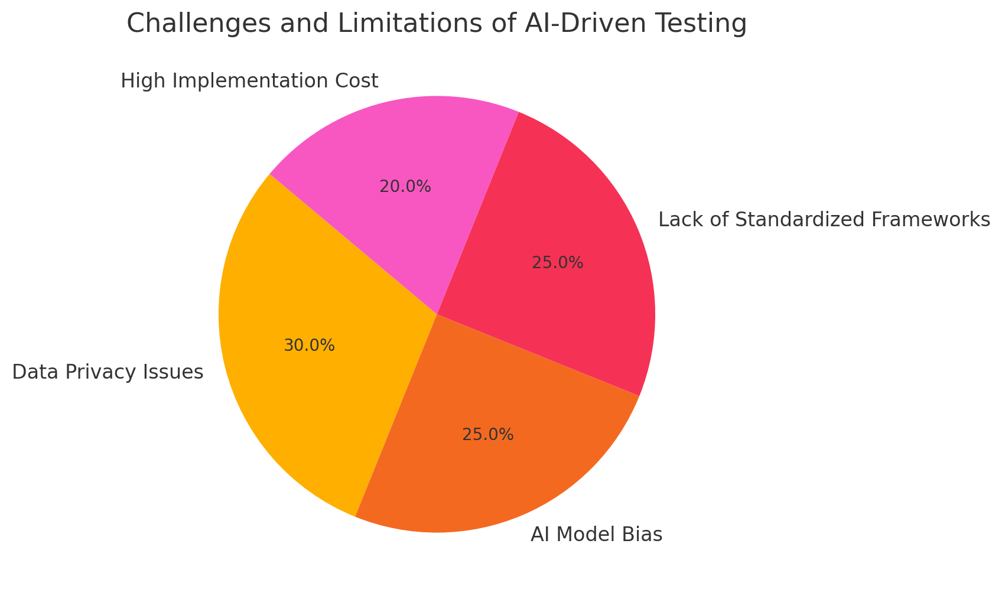

**Fig 4: Challenges and limitations of AI driven testing**

**5. Future Directions**

Several important research and development problems have to be addressed as artificial intelligence-powered software testing develops to guarantee its effective integration into medical applications. Standardization, explainability, real-world validation, regulatory compliance, continuous integration with DevOps, affordable AI-driven testing tools, and ethical AI governance should all take front stage in future developments. By addressing these areas, artificial intelligence-driven testing will become more reliable, effective, and security-oriented, hence reducing current difficulties [41].

1. **Development of Standardized AI Testing Frameworks**

Developing standardized AI assessment models for use in healthcare is a crucial future focus. Unlike conventional software testing, which follows accepted industry standards as ISO 29119 and ISTQB, AI-driven testing lacks globally acknowledged criteria. The absence of AI-specific testing approaches hampers the evaluation of the dependability and accuracy of AI-driven test automation solutions for companies in the healthcare sector. Regulatory agencies, research organizations, and industry executives must cooperate to create benchmarking frameworks that define:

* AI-driven test case generation and validation methods
* Performance metrics for AI-based defect detection and anomaly identification
* Standardized datasets for training and evaluating AI testing tools
* Best practices for including AI into automated software testing pipelines.   
  Setting a shared AI software testing standard will improve uniformity, interoperability, and confidence in the validation of AI-driven healthcare software.

**2. Explainable AI (XAI) for Transparent Testing Decisions**

Transparency and interpretability in test findings are absolutely essential as artificial intelligence-driven software testing technologies grow more sophisticated. Many artificial intelligence models—especially those based on deep learning—function as black-box systems, which complicate the understanding of the justification for the prioritizing of particular test cases or the identification of defects. Explainable artificial intelligence (XAI) can provide clear, understandable explanations of AI-generated test results, hence increasing confidence and usability. Research going forward should focus on [42]:

* Developing XAI methods clarifying AI-driven test case decisions.
* Creating visual dashboards that let software testers examine results produced by artificial intelligence
* Using AI auditing tools guaranteeing traceability for validation and fault discovery yields outcomes.
* Improving AI openness helps one to follow legal requirements.
* Explainable artificial intelligence will improve acceptance and help authorities validate AI-driven testing processes in medical applications.

**3. Real-world validation and Large-Scale Implementation**

Rather than in actual clinical scenarios, most artificial intelligence-powered software testing approaches have been verified in controlled experimental settings. Healthcare applications, on the other hand, are quite dynamic and vary in processes, software structures, and compliance needs among different institutions. Large-scale real-world validation by [43] should take front stage in future initiatives.   
Integrating artificial intelligence-driven testing into live healthcare IT systems; doing longitudinal studies to evaluate AI-powered testing performance over time; working with hospitals, medical device companies, and telemedicine providers to test AI-driven software validation in pragmatic settings   
Creating adaptive AI models that, depending on real-world input, constantly raise testing accuracy   
Validation of AI-driven testing in real-world healthcare scenarios helps companies to guarantee that these instruments generalize sufficiently across several healthcare situations.

**4. Regulatory Compliance and AI-Driven Software Validation**

AI-driven testing in healthcare applications calls for rigorous regulatory control to guarantee adherence to safety and security standards like [44]:

* USA's HIPAA, Health Insurance Portability and Accountability Act
* EU's General Data Protection Regulation, GDPR

Guidelines for software as a medical device (SaMD) from the Food and Drug Administration; ISO/IEC 27001 for healthcare IT   
Future studies should concentrate on creating pre-configured AI testing tools for regulatory audit automation, therefore enabling compliance validation and helping healthcare companies to automate. AI-driven compliance assessment systems should be built to monitor software security vulnerabilities and flag compliance risks in real-time; create automated compliance reports for regulatory approval; make sure that AI testing approaches line with changing legal and ethical norms; support dynamic regulatory frameworks that can fit changes in AI governance policies.   
By means of artificial intelligence, automating compliance validation can help to ease the load on regulatory assessments and guarantee that medical apps stay legally compliant and safe.

.

**5. Integration of AI-Driven Testing with DevOps and Continuous Testing Pipelines**

Future healthcare software development will depend mostly on continuous integration and continuous deployment (CI/CD) pipelines, hence smooth integration of AI-driven testing into DevOps processes is absolutely necessary. Test automation applications driven by artificial intelligence should be built to [45]:

* In continuous deployment environments, perform real-time defect detection and code validation; dynamically create test cases depending on software updates and new feature releases;
* Guarantee fast software iterations without endangering system stability or security; forecast possible software failures before deployment using AI-driven predictive analytics.
* Healthcare companies can speed up, more consistently release software by including AI-driven testing into CI/CD pipelines, hence lowering manual testing overhead.

**6. Cost-Effective AI Testing Frameworks for Small-Scale Healthcare Organizations**

High computing costs and resource constraints make many small-scale healthcare providers and startups difficult to deploy artificial intelligence-driven software testing. Future studies should concentrate on creating scalable, reasonably priced AI-powered testing systems that [46]:

* Decrease infrastructure costs using cloud-based AI testing platforms;
* Use federated learning to enable AI training without depending on big, centralized datasets.
* Provide low-code/no-code AI testing solutions to let non-technical healthcare personnel use AI-driven validation; create lightweight AI models that can run effectively on restricted hardware.
* These developments will enable democratizing of AI-powered testing, therefore enabling a wider spectrum of healthcare professionals access to it.

**7. Ethical AI Governance and Responsible AI in Software Testing**

Ensuring ethical AI governance is vital since artificial intelligence is still very important for the validation of healthcare applications. Future research should address [47]:

* Bias mitigating strategies to ensure fairness in AI-powered test automation; ethical guidelines for AI-driven software validation in life-critical healthcare applications;
* Human-in---the-loop (HITL) models combining AI automation with human oversight; policies to prevent AI misuse in healthcare software testing   
  Organizations may guarantee that AI-powered testing approaches remain fair, open, and consistent with patient safety values by emphasizing ethical AI governance.

**Fig 5: Future potential and research directions**

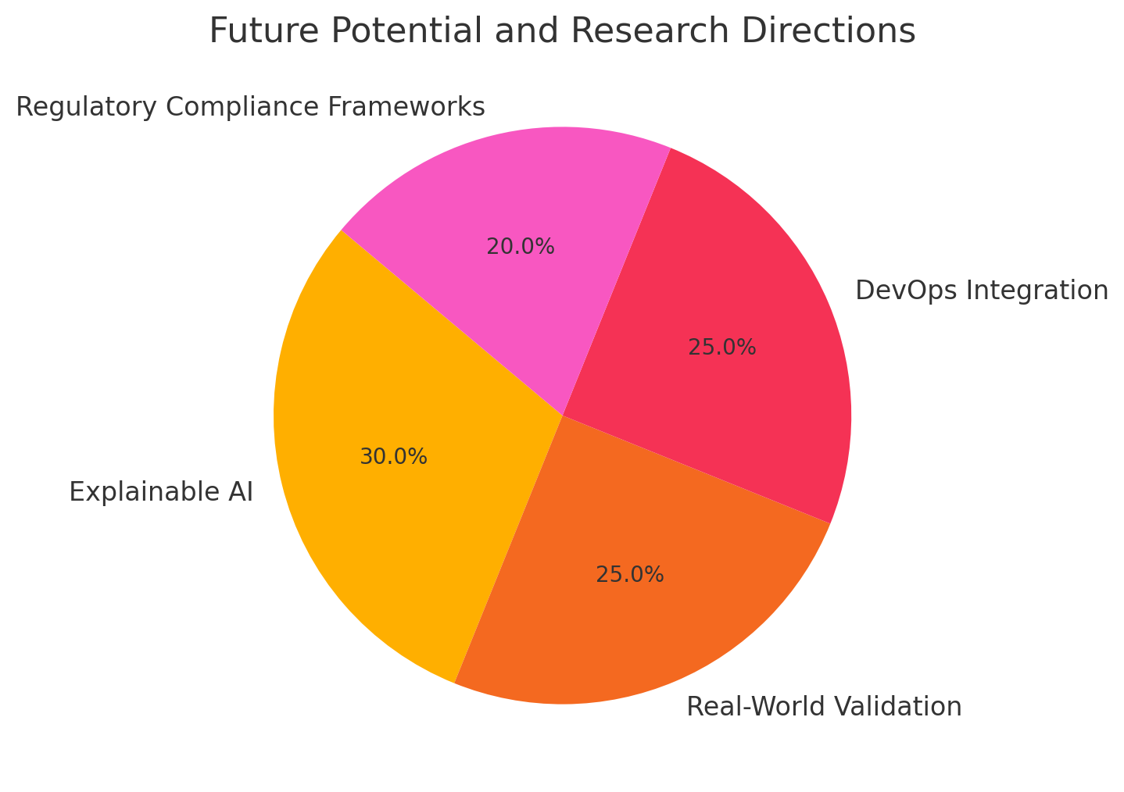

**Conclusion**

By raising test efficiency, accuracy, and automation, artificial intelligence-powered software testing is fast changing the scene of healthcare applications. Particularly in improving test coverage, lowering fault discovery time, and guaranteeing compliance with regulatory standards including HIPAA, GDPR, and FDA guidelines, this systematic evaluation has shown the great advantages of AI-driven software testing. AI-powered testing solutions have shown promise in functional testing, performance testing, security validation, usability testing, and regression testing by using machine learning, deep learning, natural language processing (NLP), and reinforcement learning. Notwithstanding these developments, some issues still exist including data privacy problems, artificial intelligence model biases, lack of standardized testing systems, expensive implementation expenses, and complex regulations.   
Particularly in healthcare applications where system dependability is crucial, one of the main conclusions of this analysis is that AI-driven software testing considerably increases test automation and defect prediction. Studies have indicated that in several healthcare software validation activities, AI-powered defect detection achieves accuracy rates surpassing 90%, hence greatly lowering software failures post-deployment. Analogous improvements in test case generation by reinforcement learning methods have improved resource allocation and lowered testing expenses. Furthermore improving the usability of AI-driven chatbots, clinical decision support systems (CDSS), and telemedicine apps is NLP-based AI models, so assuring that healthcare AI solutions produce coherent and contextually accurate outputs.   
Still hampered by various technological, ethical, and legal obstacles is the acceptance of AI-powered software testing in healthcare applications. Data privacy and security issues are one of the main difficulties since artificial intelligence-driven testing usually calls for access to electronic health data and private patient information. Future AI-powered testing systems must include privacy-preserving AI approaches like federated learning and differential privacy to lower these dangers; ensuring compliance with data protection laws including HIPAA and GDPR is absolutely vital. AI model bias—where testing methods may favor particular datasets, hence producing biased defect predictions and incorrect validation results—is another major difficulty. To guarantee openness and fairness in AI-powered testing decisions, addressing bias in AI-driven testing calls for diversified training datasets, constant bias monitoring, and explainable AI (XAI) methodologies. One major restriction the review further emphasizes is the absence of consistent artificial intelligence testing methods. Unlike conventional software testing, which follows widely defined international standards as ISO 29119 and ISTQB, AI-driven testing lacks universally approved methods for test case generating, problem discovery, and validation benchmarks. For healthcare companies and regulatory authorities, this variability makes it difficult to properly assess AI-powered testing instruments. Standardizing AI testing methods should be the main emphasis of future studies so that healthcare facilities may compare the AI-driven testing results among several healthcare software programs.

.

Disclaimer (Artificial intelligence)

Author(s) hereby declare that NO generative AI technologies such as Large Language Models (ChatGPT, COPILOT, etc.) and text-to-image generators have been used during the writing or editing of this manuscript.

References:

1. *Abadi, M., et al.: Deep learning with differential privacy. In: Proceedings of the 2016 ACM SIGSAC Conference on Computer and Communications Security, pp. 308–318. Association for Computing Machinery (2016).*

2. *Ahmed, Z., Mohamed, K., Zeeshan, S., Dong, X.: Artificial intelligence with multi-functional machine learning platform development for better healthcare and precision medicine. Database 2020, baaa010 (2020).*

3. *Alder, S.: Largest healthcare data breaches of 2021. The HIPAA Journal (2021). Accessed 10 Sep 2022.*

4. *Arrieta, A.B., et al.: Explainable artificial intelligence (XAI): concepts, taxonomies, opportunities and challenges toward responsible AI. Information Fusion 58, 82–115 (2020).*

5. *Azevedo, B.F., Rocha, A.M.A., Pereira, A.I.: Hybrid approaches to optimization and machine learning methods: a systematic literature review. Mach. Learn. 1–43 (2024).*

6. *Bell, J.H., Bonawitz, K.A., Gascón, A., Lepoint, T., Raykova, M.: Secure single-server aggregation with (poly) logarithmic overhead. In: Proceedings of the 2020 ACM SIGSAC Conference on Computer and Communications Security, pp. 1253–1269 (2020).*

7. *Belle, A., Thiagarajan, R., Soroushmehr, S.M., Navidi, F., Beard, D.A., Najarian, K.: Big data analytics in healthcare. BioMed Res. Int. (2015).*

8. *Bertl, M.: Systematic AI support for psychiatry: a framework on how to implement decision support systems. Phd thesis, Tallinn University of Technology, Tallinn, Estonia (November 2023).* [*https://digikogu.taltech.ee/en/Item/a77022c7-b2af-46f9-ae83-62fe04f9bc72*](https://digikogu.taltech.ee/en/Item/a77022c7-b2af-46f9-ae83-62fe04f9bc72)*.*

9. *Bertl, M., Bignoumba, N., Ross, P., Yahia, S.B., Draheim, D.: Evaluation of deep learning-based depression detection using medical claims data. Artif. Intell. Med. (2023).*

10. *Bertl, M., Kankainen, K.J.I., Piho, G., Draheim, D., Ross, P.: Evaluation of data quality in the Estonia national health information system for digital decision support. In: Proceedings of the 3rd International Health Data Workshop. CEUR-WS (2023).*

11. *Bertl, M., Klementi, T., Piho, G., Ross, P., Draheim, D.: How domain engineering can help to raise adoption rates of artificial intelligence in healthcare. In: Delir Haghighi, P., et al. Information Integration and Web Intelligence. iiWAS 2023. LNCS, vol. 14416, pp. 3–12. Springer, Cham (2023).* [*https://doi.org/10.1007/978-3-031-48316-5_1*](https://doi.org/10.1007/978-3-031-48316-5_1)*.*

12. *Bertl, M., Metsallik, J., Ross, P.: A systematic literature review of AI-based digital decision support systems for post-traumatic stress disorder. Front. Psychiatry 13 (2022).* [*https://doi.org/10.3389/fpsyt.2022.923613*](https://doi.org/10.3389/fpsyt.2022.923613)*.*

13. *Bertl, M., et al.: Future opportunities for systematic AI support in healthcare. In: Steffen, B. (ed.) Bridging the Gap Between AI and Reality - First International Conference, AISoLA 2023, Crete, Greece, 23–28 October 2023, Post-Proceedings (2024). this volume.*

14. *Bertl, M., Ross, P., Draheim, D.: A survey on AI and decision support systems in psychiatry - uncovering a dilemma. Expert Syst. Appl. 202, 117464 (2022).* [*https://doi.org/10.1016/j.eswa.2022.117464*](https://doi.org/10.1016/j.eswa.2022.117464)*.* [*https://www.sciencedirect.com/science/article/pii/S0957417422007965*](https://www.sciencedirect.com/science/article/pii/S0957417422007965)*.*

15. *Bertl, M., Ross, P., Draheim, D.: Systematic AI Support for Decision Making in the Healthcare Sector: Obstacles and Success Factors. Health Policy and Technology (2023).*

16. *Bertl, M., Shahin, M., Ross, P., Draheim, D.: Finding indicator diseases of psychiatric disorders in bigdata using clustered association rule mining. In: Proceedings of the 38th ACM/SIGAPP Symposium on Applied Computing, pp. 826–833. SAC ’23, Association for Computing Machinery (2023).* [*https://doi.org/10.1145/3555776.3577594*](https://doi.org/10.1145/3555776.3577594)*.*

17. *Ciatto, G., Sabbatini, F., Agiollo, A., Magnini, M., Omicini, A.: Symbolic knowledge extraction and injection with sub-symbolic predictors: a systematic literature review. ACM Comput. Surv. (2024).*

18. *Brandon, C., Singh, A., Margaria, T.: Model driven development for AI-based healthcare systems: a review. In: Steffen, B. (ed.) Bridging the Gap Between AI and Reality - First International Conference, AISoLA 2023, Crete, Greece, 23–28 October 2023, Post-Proceedings (2024). this volume.*

19. *Brandon, C., et al.: Cinco de bio: a low-code platform for domain-specific workflows for biomedical research. BioMedInformatics (to appear) (2024).*

20. *Fennelly, O., Moroney, D., Doyle, M., Eustace-Cook, J., Hughes, M.: Key interoperability factors for patient portals and electronic health records: a scoping review. Int. J. Med. Inform. 105335 (2024).*

21. *Directorate-General for Health and Food Safety: A European health data space: harnessing the power of health data for people, patients and innovation. European Commission (2022).* [*https://health.ec.europa.eu/document/download/17c7065c-c432-445f-9b27-8ccf283581bc_en?filename=com_2022-196_en.pdf*](https://health.ec.europa.eu/document/download/17c7065c-c432-445f-9b27-8ccf283581bc_en?filename=com_2022-196_en.pdf)*. Accessed 28 Jan 2024.*

22. *Floridi, L., et al.: Ai4people–an ethical framework for a good AI society: opportunities, risks, principles, and recommendations. Mind. Mach. 28, 689–707 (2018).*

23. *Fredrikson, M., Jha, S., Ristenpart, T.: Model inversion attacks that exploit confidence information and basic countermeasures. In: Proceedings of the 22nd ACM SIGSAC Conference on Computer and Communications Security, pp. 1322–1333 (2015).*

24. *Gansel, X., Mary, M., van Belkum, A.: Semantic data interoperability, digital medicine, and e-health in infectious disease management: a review. Eur. J. Clin. Microbiol. Infect. Dis. 38(6), 1023—1034 (2019).* [*https://doi.org/10.1007/s10096-019-03501-6*](https://doi.org/10.1007/s10096-019-03501-6)*.*

25. *Gossen, F., Margaria, T., Steffen, B.: Towards explainability in machine learning: the formal methods way. it prof. 22 (4), 8–12 (2020).*

26. *Gossen, F., Margaria, T., Steffen, B.: Formal methods boost experimental performance for explainable AI. it prof. 23 (6), 8–12 (2021).*

27. *Kavitha, M., Srinivas, P.V.V.S., Kalyampudi, P., F, C.S., Srinivasulu, S.: Machine learning techniques for anomaly detection in smart healthcare. In: 2021 Third International Conference on Inventive Research in Computing Applications (ICIRCA), pp. 1350–1356 (2021).* [*https://doi.org/10.1109/ICIRCA51532.2021.9544795*](https://doi.org/10.1109/ICIRCA51532.2021.9544795)*.*

28. *Khanna, N.N., et al.: Economics of artificial intelligence in healthcare: Diagnosis vs. treatment. Healthcare 10(12) (2022).* [*https://doi.org/10.3390/healthcare10122493*](https://doi.org/10.3390/healthcare10122493)*.* [*https://www.mdpi.com/2227-9032/10/12/2493*](https://www.mdpi.com/2227-9032/10/12/2493)*.*

29. *Klementi, T., Kankainen, K.J.I., Piho, G., Ross, P.: Prospective research topics towards preserving electronic health records in decentralised content-addressable storage networks. In: HEDA@ Petri Nets, p. 14 (2022).*

30. *Klementi, T., Piho, G.: Method and system for managing data using decentralized content-addressable storage networks. European patent Office, priority number EP24166173.5 (March 2024). submitted patent.*

31. *Klementi, T., Piho, G., Ross, P.: A reference architecture for resolving health data accessibility, comprehensiveness, and ownership dilemmas through preserving semantically interoperable personal health records in decentralized content-addressable storage networks. (2024), will be published soon.*

32. Asan, O., A.E. Bayrak, and A. Choudhury, *Artificial intelligence and human trust in healthcare: focus on clinicians.* J. Med. Internet Res., 2020. **22**.

33. Asch, M., *Big data and extreme-scale computing: pathways to convergence-toward a shaping strategy for a future software and data ecosystem for scientific inquiry.* Int. J. High Perform. Comput. Appl., 2018. **32**.

34. Bertl, M., *News analysis for the detection of cyber security issues in digital healthcare: a text mining approach to uncover actors, attack methods and technologies for cyber defense.* Young Inf. Sci., 2019. **4**.

35. Bertl, M., P. Ross, and D. Draheim, *Predicting psychiatric diseases using AutoAI: a performance analysis based on health insurance billing data*, in *Database and Expert Systems Applications*, C. Strauss, et al., Editors. 2021, Springer: Cham.

36. Bhatt, P., et al., *Emerging artificial intelligence-empowered health: a scoping review.* JMIR Mhealth Uhealth, 2022. **10**.

37. Gerke, S., et al., *The need for a system view to regulate artificial intelligence/machine learning-based software as medical device.* NPJ Digit. Med., 2020. **3**.

38. Gubala, V., et al., *Point of care diagnostics: status and future.* Anal. Chem., 2012. **84**.

39. Klar, E., *Medical Device Regulation als aktuelle Herausforderung für die rechtssichere Einführung neuer Technologien.* Chirurg, 2018. **89**.

40. Hidayat, M., S.Y. Defitri, and H. Hilman, *The impact of artificial intelligence (AI) on financial management.* Manag. Stud. Bus. J. (PRODUCTIVITY), 2024. **1**.

41. Wang, Q., et al., *Integrating digital technologies and public health to fight COVID-19 pandemic: key technologies, applications, challenges and outlook of digital healthcare.* Int. J. Environ. Res. Public Health, 2021. **18**.

42. Strickland, E.. *IBM Watson, heal thyself: how IBM overpromised and underdelivered on ai health care.* IEEE Spectr., 2019. **56**.

43. *Fujii, Y.R.: The MicroRNA 2000 Transformer: Quantum Computing and Artificial Intelligence for Health. Springer Nature (2023).* [*https://doi.org/10.1007/978-981-99-3165-1*](https://doi.org/10.1007/978-981-99-3165-1)*.*

44. *Gupta, R., et al.: VAHAK: a blockchain-based outdoor delivery scheme using UAV for Healthcare 4.0 services. In: IEEE INFOCOM 2020 – IEEE Conference on Computer Communications Workshops (INFOCOM WKSHPS), pp. 255–260. IEEE (2020).* [*https://doi.org/10.1109/INFOCOMWKSHPS50562.2020.9162738*](https://doi.org/10.1109/INFOCOMWKSHPS50562.2020.9162738)*.*

45. *Gupta, R., Shukla, A., Tanwar, S.: Aayush: a smart contract-based telesurgery system for healthcare 4.0. In: 2020 IEEE International Conference on Communications Workshops (ICC Workshops), pp. 1–6. IEEE (2020).* [*https://doi.org/10.1109/ICCWorkshops49005.2020.9145044*](https://doi.org/10.1109/ICCWorkshops49005.2020.9145044)*.*

46. *International Electrotechnical Commission (IEC): IEC 60601-1-2:2014 - IEC-Normen - VDE VERLAG.* [*https://www.vde-verlag.de/iec-normen/220613/iec-60601-1-2-2014.html*](https://www.vde-verlag.de/iec-normen/220613/iec-60601-1-2-2014.html)*. Accessed 07 Dec 2023.*

47. *International Electrotechnical Commission (IEC): IEC62304:2006/AMD1:2015 amendment 1-medical device software-software life cycle processes (2015).* [*https://webstore.iec.ch/publication/22790*](https://webstore.iec.ch/publication/22790)*.*