Short Research Article

Carbon-Neutral Synergy: Integrated Optimization of Energy-Water-Pollution Nexus in China's Construction Sector

.

ABSTRACT

|  |
| --- |
| To face the challenges of the low-carbon transition required for energy management in the construction industry, the research investigated the coordinated control and optimization of energy, pollutants, and water within the sector, identifying key measures such as optimized building design, renewable energy integration, and advanced water management. The findings demonstrate the potential for improving resource efficiency through advanced technologies and provide targeted policy recommendations for the regulatory framework, as well as technical recommendations for innovative building materials and energy systems. |

*Keywords: dual-carbon target; construction industry; energy; pollutants; water;*

1. INTRODUCTION

As global climate change and environmental problems become increasingly serious, countries have put forward targets to reduce carbon emissions. As one of the world's largest carbon emitters, China has put forward the goal of "dual carbon", namely, "carbon peak" and "carbon neutral".In addition, scenario simulation studies of natural gas consumption point out that China's carbon dioxide emissions will peak in 2030 and achieve "net zero" carbon emissions in 2057 and 2059 respectively.(Fan J, Wang J, Liu M, Sun W, Lan Z,2022).So as an important field of energy consumption and carbon emission in China, the coordinated control and optimization of energy, pollutants and water of the construction industry is of great significance for the realization of the dual-carbon goal.

The foreign theoretical research on the collaborative control and optimization of energy, pollutants and water in the construction industry comes from the sustainable development thought proposed during the energy crisis in the 1970s(United Nations Environment Programme (UNEP),2022). Since then, the coordinated control of energy, pollutants and water in the construction industry has been highly concerned and paid attention to by the international economic circle, and has become the focus of many scholars, and has achieved many research results. For example, research by the International Energy Agency (IEA) shows that the construction industry accounts for an important proportion of global energy consumption, and reducing energy consumption and carbon emissions from the construction industry is critical to achieving the Global Sustainable Development Goals(International Energy Agency (IEA) ,n.d.)). For another example, the EU's Zero Energy Building Directive and the US's Energy Star program are both designed to reduce building energy consumption and carbon emissions by adopting advanced energy-saving technologies and materials(European Commission,2023).

In practical research, some scholars may not fully consider the actual situation of the construction industry in terms of the coordinated control of energy, pollutants and water. YuShan in 2023, for example, in the Beijing pollution reduction carbon reduction collaborative control scenario simulation and effect assessment article points out: Beijing in energy, construction, industry and transportation of atmospheric pollutants and CO2 potential, emphasizes the optimization of motor vehicle structure, rural areas coal clean energy transformation and new building green level in emission reduction, this view is conducive to the overall research, but the collaborative control of water practical application is not put forward.

At present, there are still some problems in the coordinated control of energy, pollutants and water in China's construction industry. First of all, the energy consumption of the construction industry is relatively high, and the energy utilization efficiency needs to be improved(Editorial board of China Annual Development Report on Building Energy Conservation,2021). Secondly, the construction industry emits more pollutants, which will have a serious impact on the environment(Environmental Protection Department,2023). In addition, the utilization of water resources in the construction industry is also wasted, and the water resources utilization efficiency is low for(Ministry of Water Resources,2023).

Therefore, this study aims to study the coordinated control and optimization of energy, pollutants and water in China's construction industry, put forward corresponding improvement measures and policy suggestions, so as to contribute to the realization of China's two-carbon target. Its purpose and significance are: on the one hand, through the coordinated control and optimization of energy, pollutants and water in the construction industry, it can improve the energy utilization efficiency of the construction industry, reduce pollutant emission, and achieve sustainable development. On the other hand, the results of this study can provide a reference for policy makers and relevant departments, and promote the construction industry towards a more environmental protection and sustainable direction.

2. experimental methodology

The analysis method of each factor is used in the paper, and the each method is combined. Finally, we should consider the various factors together and look for their optimization. And use appropriate indicators and charts to represent the percentage of CO 2 emissions and their composition. Then, for the water recovery aspect, it is represented in the flowchart. Finally, the typical engineering for practice verification.

metric Tce:The full name is ton of standard coal equivalent. In short, it is a standardized unit of measurement used to gauge energy consumption, equivalent to the calorific value of 1 ton of standard coal. Standard coal is defined as containing 7,000 kcal of energy per kilogram, which facilitates a common benchmark for countries when comparing and studying overall energy consumption.

**2.1 Interactive relationship between dual-carbon goals and industry transformation**

**2.1.1 Policy constraints and low-carbon development requirements**

The dual-carbon target requires the construction industry to play an important role in achieving carbon peak and carbon neutrality. These include such as reducing carbon emissions in the construction industry, improving energy efficiency, and optimizing building design and material selection(Guan, R., & Li, X,2022). Specifically, the construction industry needs to take the following steps. One is the use of low-carbon building materials and design, by using low-carbon materials and optimizing building design, to reduce carbon emissions from the building industry. For example, using renewable energy sources, green building materials, and energy-efficient designs can reduce building energy consumption and carbon emissions. The second is to improve energy efficiency. The construction industry needs to adopt efficient energy systems and equipment to improve energy efficiency. This includes the use of efficient heating, cooling and lighting systems, as well as the adoption of energy-efficient building designs and materials(Wei, G,2022).Promoting the use of renewable energy: The construction industry can reduce carbon emissions by using solar energy, wind energy and other renewable energy sources to reduce its dependence on fossil fuels.

Under the dual-carbon target, the construction industry faces a series of challenges and opportunities. Challenges include the need to invest large amounts of capital and resources to achieve a low-carbon transformation of the construction industry, the need to change the existing architectural design and material choices, and the need to change the construction industry's production mode. Opportunities include promoting technological innovation and sustainable development of the construction industry, improving the market competitiveness of the construction industry, and improving the environmental awareness and responsibility of the construction industry.

**2.2.2 Current situation analysis of carbon emission in the construction industry**

The carbon emissions of the construction industry mainly come from the production of building materials, building construction and building operation(Wu, Z., Huang, H., Chen, X., Li, J., He, Q., et al,2022). Its carbon emissions mainly come from the following aspects:

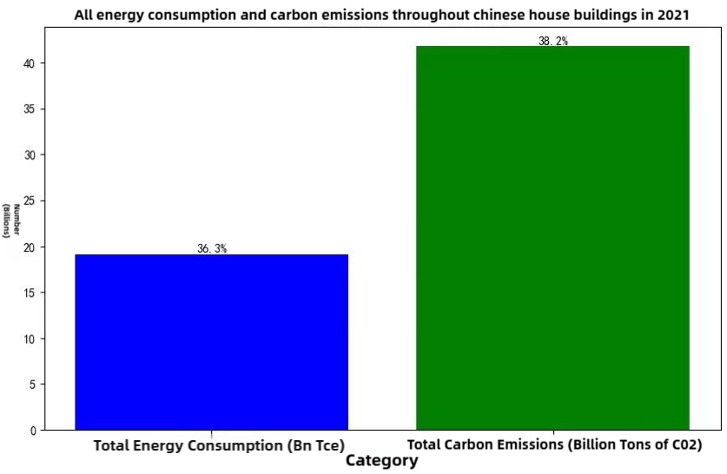

**Figure 1 Energy consumption and carbon emissions of China's housing construction in 2021**

Production of building materials: The production process of building materials produces a large amount of carbon emissions, especially the production of building materials such as cement, steel and glass.

Construction: During the construction process, the use of construction machinery and the treatment of construction waste will produce a large amount of carbon emissions.

Building operation: The use of heating, cooling, lighting and electrical equipment generates significant carbon emissions during building operations.

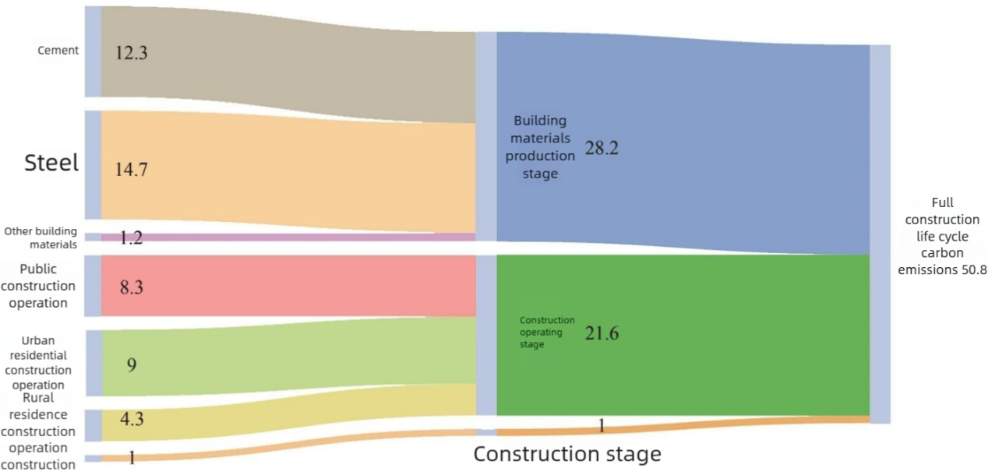

**Figure 2: Composition of carbon emissions in the construction industry**

**2.2 Energy-pollution-water collaborative control path**

**2.2.1 Energy system optimization: energy saving and efficiency improvement**

The construction industry needs to take a series of measures to reduce energy consumption, including the adoption of efficient energy systems and equipment, optimizing building design and material selection, and improving energy efficiency. For example, the use of highly efficient heating, cooling and lighting systems, as well as the use of energy-efficient building designs and materials, can reduce the energy consumption of buildings(Xu, Z., Zhou, C., Wu, J., Liu, K., & Guan, X,2023). In addition, promoting the use of renewable energy sources, such as solar and wind energy, is also an important way to reduce energy consumption.

**2.2.2 Collaborative treatment of pollutants: emission control**

The construction industry needs to take steps to reduce pollutant emissions, including optimizing building design and material selection, adoption of environmentally friendly building materials and construction methods, and improving energy efficiency during building operation. For example, the use of environmentally friendly building materials and construction methods can reduce pollutant emissions during the construction process. In addition, the use of efficient energy systems and equipment, as well as optimizing energy efficiency during building operation, can also reduce pollutant emissions during building operation.

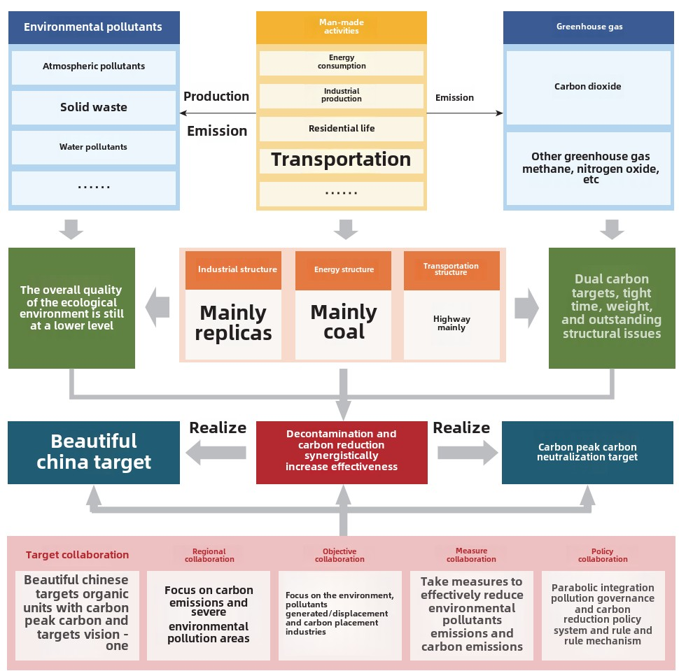

**Figure 3 The basic connotation of synergy in pollution reduction and carbon reduction**

**2.2.3 Water recycling: water-saving and reclaimed water system**

The construction industry needs to take steps to improve the efficiency of water use, including optimizing architectural design and material selection, adoption of water-saving equipment and systems, and improving the efficiency of water management

For example, in 2022, Zhang Tianyuan proposed the relationship between clean water, reclaimed water and sewage in the Optimization Model of Clean Water and Relaimed Water in Beijing, and adopted water-saving equipment and systems to reduce water consumption in the process of building operation. In addition, optimizing architectural design and material selection, as well as improving the efficiency of water management, can also reduce water consumption in the construction industry(Qin, G,2022).

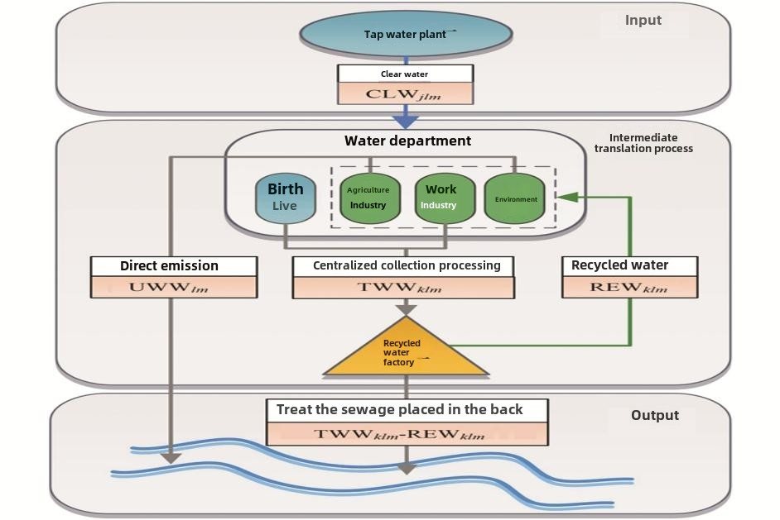

**Fig 4- Water recycling procedure**

3. results and discussion

**3.1 Near-zero energy consumption buildings (Tianyou, zero house): energy saving and its coordinated control application**

"Tianyou Zero House" is the first nearly zero energy consumption building in China built according to the national standard "nearly zero energy consumption building technical standard". The project, designed by Tianyou Design Group, is located in Daxing District, Beijing, with a project scale of 400 square meters. Through a combination of passive design and active technology, the building achieves a significant reduction in energy consumption. Its characteristics include:

Energy efficiency improvement: The project uses high-performance insulation materials and passive design to reduce energy demand(Tenio Design Group,2020). This design allows the building to avoid external heating in winter and no external cooling in summer.

Renewable energy utilization: Buildings use solar photovoltaic panels and natural ventilation systems to reduce dependence on traditional energy sources.

**3.2 Ecological Park (Flower Expo Park): Renewable energy and reclaimed water reuse efficiency**

The 10th China Flower Expo Park in Shanghai is the first demonstration park with dual-carbon standards. The main venue of the Flower Expo Park is close to Dongping National Forest Park, and the design team took advantage of the "three-dimensional information management system" to "more than 70,000 trees". These trees will offset the 153,000 tons of carbon emissions generated in the construction process in 20 years(Zhao Xiaoyu, Shan Yiming,2023)). The project features include:

Carbon neutral forest construction: through the self-built carbon neutral forest and the purchase of national voluntary emission reduction scene, to achieve the extended carbon neutral and carbon neutral in the park.

Carbon sequestration by vegetation: using vegetation to reduce the carbon emissions generated by materials and improve the microclimate of the park.

Comprehensive utilization of water resources: to realize the efficient utilization and recycling results of water resources.

Green space integration: The project combines the natural landscape with the traditional courtyards to create a low-carbon lifestyle.

**3.3 Scientific research demonstration building: multi-factor coupling effect**

Based on the operation and maintenance data for many years, the contribution rate of ground source heat pump system and solar air conditioning system is 80% and 20% respectively; the contribution rate of ground source heat pump and solar heat collection system in winter is 70% and 30% respectively. The lighting system of the demonstration building adopts a variety of high-efficiency and energy-saving lamps to realize the of illumination and intelligent opening lighting based on individual needs(The Science and Technology Daily,2021)). Its features include:

Energy-saving technology integration: the project adopts passive technology and active technology to achieve efficient energy utilization.

Data-driven assessment: assessing the energy efficiency performance of buildings through actual data.

Low-carbon operation: The project has achieved significant energy consumption and carbon emission reduction during the operation phase.

These cases demonstrate the concrete practice of achieving dual-carbon goals in the construction industry, covering from the park planning to the design and operation of single buildings, and achieving energy conservation, emission reduction and sustainable development through technological innovation and green design. These practices provide valuable experience and reference for the future of the construction industry.

This study deeply discusses the current situation, challenges and opportunities of the collaborative control and optimization of energy, pollutants and water in China's construction industry under the two-carbon target. Through case analysis and research methods, the study yielded the following results:

Through case analysis, we find that the construction industry has achieved remarkable results in realizing the coordinated control of energy, pollutants and water. For example, the construction industry can significantly reduce energy consumption by adopting efficient energy systems and equipment, such as solar photovoltaic panels, energy-efficient Windows, and smart lighting systems. At the same time, by optimizing architectural design and material selection, such as the use of environmentally friendly building materials and construction methods, the construction industry can effectively reduce pollutant emissions. In addition, the construction industry can improve the efficiency of water resources utilization by adopting rainwater collection systems and wastewater treatment facilities. These collaborative control measures can help to achieve the sustainable development of the construction industry.

By adopting advanced energy-saving technologies and materials, such as near-zero energy consumption building technology and passive house technology, the construction industry can realize the coordinated control and optimization of energy, pollutants and water. At the same time, the building industry, such as using energy-efficient Windows and insulation materials, and optimizing the building layout, can improve energy efficiency and reduce pollutant emissions. In addition, by improving the efficiency of water resources management, such as adopting water-saving equipment and systems, and optimizing water resources utilization, the construction industry can realize the efficient utilization and recycling of water resources. These optimization research measures can help to achieve the sustainable development of the construction industry.

4. Conclusion

Based on the research results, China should further improve the energy and carbon emission standard system of the construction industry, and establish a mandatory carbon quota system covering the whole process of design, construction, operation and maintenance. It is suggested to refer to the EU Building Energy Efficiency Directive (EPBD 2023), set the operating carbon emission ceiling of new public buildings at 18 kgCO ₂ / m² / year, residential buildings should not exceed 12 kgCO ₂ / m² / year, and supporting digital supervision platform to realize real-time carbon data collection. In terms of policy incentives, substantial support can be given to projects with ultra-low energy consumption technologies (such as 20% reduction) and VAT refund (rebate rate of 50%). At the same time, the quota allocation for the issuance of green bonds is inclined to prefabricated building projects. In addition, suggested to integrate the current green building evaluation standards, build covering carbon sink landscape (such as three-dimensional green carbon absorption 5 kg CO ₂ / m²), building materials cycle rate (75%) innovation index of &quot;double carbon building certification&quot; system, and certification rating and developers credit rating, pre-sale capital regulatory proportion, form market-driven green transformation mechanism. Through the verification of demonstration projects such as Shanghai Chongming Flower Expo Park, the policy combination can reduce the carbon emissions of the whole life cycle of buildings by 28% by 2025, and create an average annual new market space of 120 billion yuan for the green building materials industry.

Competing interests

“Authors have declared that no competing interests exist.”.

Disclaimer (Artificial intelligence)

Author(s) hereby declare that NO generative AI technologies such as Large Language Models (ChatGPT, COPILOT, etc.) and text-to-image generators have been used during the writing or editing of this manuscript.

References

1. Fan J, Wang J, Liu M, Sun W, Lan Z. Scenario simulations of China's natural gas consumption under the dual-carbon target. Energy. 2022 Aug 1;252:124106.
2. United Nations Environment Programme (UNEP). (2022). Global building construction industry status report 2022. Nairobi, Kenya: United Nations Environment Programme.(https://wedocs.unep.org/handle/20.500.11822/41133)
3. International Energy Agency (IEA) (n.d.). International Energy Agency website. Retrieved March 29, 2025, from (https://www.iea.org)
4. European Commission. (2023). Defining zero-emission buildings (https://op.europa.eu/en/publication-detail/-/publication/14912690-9163-11ed-b508-01aa75ed71a1/language-en)
5. Editorial board of China Annual Development Report on Building Energy Conservation. (2021). China Building Energy Conservation Annual Development Report 2021. Beijing: China State Engineering and Construction Press.（https://www.sohu.com/a/717523259_121675999）
6. Environmental Protection Department. (2023). China Ecological Environment Status Bulletin 2023(Excerpt). Beijing: The Ministry of Environmental Protection.(https://kns.cnki.net/kcms2/article/abstract?v=B-gnKLjyiTyE-LEAuhIv_skHbXloU5lLSIQor-2EMuGuCyELiCnCc_-QUoUTPObPomfvwQ6RojXX9NVQVbNxnHFVP9kSnxKyJsNHW5T-7VkC8RwT4e8itjsj0l_wRzVP-U6eaGWobFtt3TEWE9l0jg_Um45UE2snLBpL4t887XY=&uniplatform=NZKPT)
7. Ministry of Water Resources. (2023). China Water Resources Bulletin (2023). Beijing: The Ministry of Water Resources.(https://kns.cnki.net/kcms2/article/abstract?v=B-gnKLjyiTzWFkjIiK8MGsSOoGzEk_eJJHNI-9BaBv7Ntthq8C7BYjXvUjOqECemgpRUw-VM7P0gyrlyRIAblIpdC-qAVD5eSoI7jg1N3CGysE80BowulwCwauQgjWApzAWtMc2yW2t2wZKE1PLj5_eQBNxCUAhsNEFJzwbfWEc=&uniplatform=NZKPT)
8. Guan, R., & Li, X. (2022). Carbon neutralization and digital series report (III): Analysis of the current situation and development direction of China’s construction industry under the double-carbon target. Internet Industry Research Institute of Tsinghua University.(https://www.iii.tsinghua.edu.cn/info/1121/3209.htm)
9. Wei, G. (2022). Research on the high-quality development countermeasures of green buildings in China under the background of double-carbon target.(http://xueshu.qikan.com.cn/preview/1/169/1747360)
10. Wu, Z., Huang, H., Chen, X., Li, J., He, Q., et al. (2023). Research on the low-carbon transformation countermeasures of the construction industry under the goal of "double-carbon".2023, Vol. 25 ›› Issue (5) : 202-209. DOI: 10.15302/J-SSCAE-2023.05.020.(https://www.engineering.org.cn/sscae/CN/10.15302/J-SSCAE-2023.05.020)
11. Xu, Z., Zhou, C., Wu, J., Liu, K., & Guan, X. (2023). Distributed supply and demand collaborative optimization of building energy system based on edge cloud collaboration,2023,(3): 517–534(https://dds.sciengine.com/cfs/files/pdfs/1674-7267/A810C892AD26427896C203774BBA667E-mark.pdf)...
12. Qin, G. (2021). Water saving and water resources utilization in construction engineering construction management. China Water Transport, 22 (8), 219–221.(http://www.chinaqking.com/yc/2021/3184123.html)
13. Tenio Design Group. (2020).Tenio design | Tenio zero house —— domestic first nearly zero energy consumption building design practice.(http://tenio.com/news1/520.html)
14. Zhao Xiaoyu, Shan Yiming. (2023). Analysis of the landscape design method under the background of "carbon neutrality" —— Take the 10th Chongming China Flower Expo Park in Shanghai as an example [J]. Engineering Technology Research, 2023,5 (18): 81-83. DOI:10.12417/2705-0998.23.18.027. (http://www.2winpub.com//static/uploads/journalArticle/gcjsyj0518027.pdf)
15. The Science and Technology Daily.(2021). This demonstration building leads the building energy conservation to near zero energy consumption. (https://digitalpaper.stdaily.com/http_www.kjrb.com/kjrb/html/2021-06/24/content_470381.htm?div=-1)