**Impact of parameters on gas turbine performance using energy analysis**

**Abstract-** Gas turbine power plant performance was investigated using parametric analysis. Thermodynamic relationships were used to develop models that simulated the gas turbine performance under varying operating conditions. The gas turbine located at the Transcorp Power, Ughelli, Nigeria, was used for simulation employing MATLAB R2017b codes. The model demonstrated that the gas turbine performance is significantly influenced by operational parameters, for example, relative humidity (RH), compression ratio (CR), ambient temperature (AT) and turbine inlet temperature. The results showed that for every 0.7% increase in AT, compressor power consumption increased by 2.5%, and for every 25% increase in RH, compressor power requirement and heat supply increased by 55%. The efficiency analysis reveals that as RH increases from 40% to 50%, cycle efficiency decreases by 0.022%. Net power output increases as RH increases. Specific fuel consumption (SFC) increased as AT and compression ratio increased; a 2.25% increase in AT resulted in a 0.25% increase in SFC. A 1.85% increase in AT resulted in a 0.23% decrease in net power and a 0.68% decrease in net power output. According to the findings, increasing the CR and the temperature of the turbine inlet improves overall efficiency while decreasing AT. The thermal efficiency decreased with an increase in AT, whereas it increased as turbine inlet temperature increased. The CR, AT, and turbine inlet temperature are all major factors in the overall performance of a gas turbine. As a result, controlling the thermodynamic parameters is economically feasible for cycle performance and advantageous for gas turbine operations.

***Keywords:*** *Efficiency; ambient temperature; gas turbine; energy analysis; power plant; relative humidity*

**1. Introduction**

Gas turbines are utilized to generate electricity all over the world. In hot and dry conditions, the engine output power of a gas turbine is significantly decreased due to a decrease in gas turbine air mass flow caused by high input air AT (Njoku et al., 2018; Fernandez et al., 2021; Salihu, 2022; Chukwuneke et al., 2022). Nigeria, for example, does not have a predictable climate or weather. The climate in the north is different from the climate in the south. As a result, precooling techniques used in southern Nigeria may not be suitable for northern Nigeria (Okafor, 2017; Mishra & Agarwal, 2018; Okafor, 2020; Achebe et al., 2020). These gas turbine plants run on fossil fuels, particularly natural gas, which is limited in supply. These fossil fuel sources will be depleted in no time under static conditions of increasing demand and production (Chukwuneke et al., 2014; Ahmed & Esmail, 2017; Arabi et al., 2019; Ang et al., 2022; Ikpeseni et al., 2024). Another source of concern is the continued rise in natural gas prices due to increased demand, which raises the cost of operation per kWh of energy generated. Gas turbines are commonly utilized to generate electricity, power aeroplanes, and operate refineries and petrochemical plants, among other things (Direk & Mert, 2018; Jayachandran et al., 2019; Chukwuneke et al., 2021; Kumar et al., 2025).

A primary goal for any operation is to guarantee that the gas turbines function at maximum efficiency. Because the majority cost of operating a gas turbine is the cost of the fuel used to power the turbine plant, anything that increases productivity and profits is welcome in the current economic climate. The gas turbine plant's net power output is also linked to efficiency improvements; a high load factor is desired for the plant's economic operation and to produce electricity at a lower cost (Baakeem et al., 2017; Hossin et al., 2017; Ukwamba, 2018; Awogbemi et al., 2024). A gas turbine's performance is heavily affected by the weather (Chukwuneke et al., 2014). The AT has a significant impact on the performance of a gas turbine, particularly in terms of output and energy efficiency (Ujam et al., 2014; Saif & Tariq, 2017; Allakulyyev et al., 2022). The ambient air density decreases as the ambient temperature and humidity rise (Akroot & Saif, 2019; Anand & Murugavelh, 2020). When the ambient air temperature or humidity is high, inlet air cooling has been discovered to be effective for varying loads (Ahmed & Esmail, 2017).

According to the thermal performance analysis, the performance of gas turbine power plants is significantly affected by AT and CR (Mishra &Agarwal, 2018; Alomar et al., 2024). It is common knowledge that performance may be assessed using efficiency, SFC, and power output. Its performance is affected by several variables, including the CR of the compressor, the temperature of the combustion inlet, and the temperature of the turbine's inlet (Ibrahim et al., 2019; Khosravi & Aydin, 2020; Aygun, 2024). Simple gas turbine cycle calculations using realistic parameters show that raising the turbine inlet temperature does not increase cycle efficiency but rather increases the work done (Baten & Haque, 2019). The impact of relative humidity on gas turbine plants deals with air cooling issues and improves compressor efficiency (Lui et al., 2018; Alaa et al., 2024). The compressor pressure ratio (PR) determines the overall efficiency of the gas turbine cycle. It's important to remember that, unlike a reciprocating engine, the combustion, compression, and expansion processes in a gas turbine don't all happen in the same place. This study aims to evaluate how different parameters affect the performance of a gas turbine power plant in terms of exhaust energy, network output, specific power output, total power, and efficiency. And also, to evaluate the AT, RH, turbine inlet temperature, and other conditions of the inlet air by thermodynamically modeling the gas turbine performance.

**2. Thermodynamics of Gas Turbine Model**

In this study, the operating conditions of the Transcorp power plant, Ughelli, Nigeria, with a turbine output power of 25MW, were selected. The plant has the following specifications: turbine inlet temperature, compressor stage, gas turbine inlets pressure, exhaust gas temperature, gas turbine efficiency, cooling oil inlet temperature, and alternator speed of 1200 oC, 1.4mPa, 520 oC, 34%, 17, 59 oC and 7280rpm, respectively.

A gas power plant has four parts: compressor, turbine, combustion chamber (CC), and generator. A one-stage gas turbine is schematically depicted in Figure 1. The circuit is continuously supplied with fresh air from the atmosphere, and while the fuel in the working fluid burns, energy is also added by the working fluid itself. The turbine, which generates work and eventually releases the combustion byproducts into the atmosphere, expands the combustion products.

The compressor and turbine efficiencies are assumed to be denoted by $η_{c}$ and $η_{t}$, respectively. The temperature-entropy graphic in Figure 1b shows full and dotted lines, respectively, to represent the ideal and real processes. The thermodynamics cycle on which this gas turbine operates is the Brayton (Joule) cycle, which can be analyzed using Figure 1b.

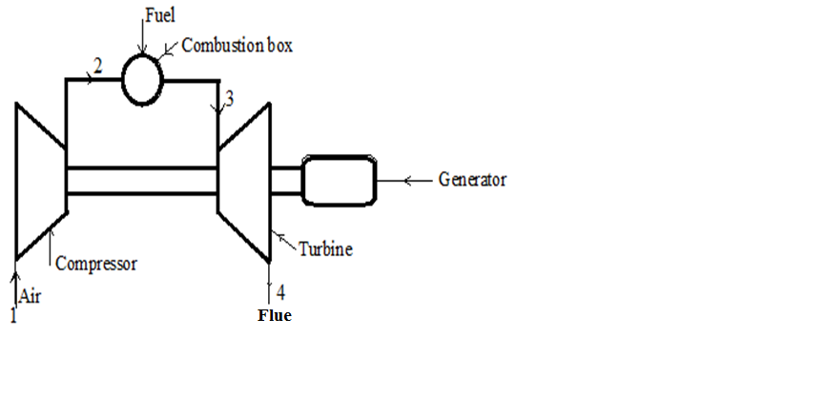

b

a

**Figure 1: (a) Gas Turbine Unit (b) Temperature-entropy graph for Gas Turbine**

The compressor CR ($r_{p})$;

$r_{p}=\frac{P_{2}}{P_{1}}$ (1)

$P_{1}$ stands for the air pressure entering the compressor, and $P_{2}$ for the air pressure leaving it.

Using the concept of isentropic efficiency and neglecting velocity across the inlet and outlet of the compressor.

For compression process 1–2;

$T_{2}=T_{1}{\left(\frac{P_{2}}{P_{1}}\right)}^{\frac{γ_{a}-1}{γ_{a}}}=T_{1}{\left(r_{p}\right)}^{\frac{γ_{a}-1}{γ_{a}}}$ (2)

Where $γ_{a} is specific heat capacities of air=1.4.$

The compressor isentropic efficiency ranges from 85 to 90% and is denoted as;

$η_{c}=\frac{T_{2^{'}}-T_{1}}{T_{2}-T_{1}}$ (3)

The temperatures of the inlet air ($T_{1}$), outlet air ($T_{2}$), and isentropic outlet ($T_{2^{'}}$), and $η_{c}$ is the compression isentropic efficiency.

The temperatures of the compressor's inlet air (T 1), outlet air (T 2), and isentropic outlet (T (2') are all given in degrees Celsius.

For a given pressure ratio;

$T_{2}-T_{1}=\frac{1}{η_{c}}\left(T_{2^{'}}-T_{1}\right)$ = $\frac{T_{1}}{η_{c}}\left(\frac{T_{2^{'}}}{T_{1}}-1\right)$ (4)

The pressure ratio and inlet compressor temperature can be used to calculate the compressed air temperature as follows;

$T_{2}=T_{1}\left\{1+\frac{{\left(r_{p}\right)}^{\frac{γ_{a}-1}{γ_{a}}}-1}{η_{c}}\right\}$ (5)

Where $T_{1}$ is the ambient temperature, $T_{2}$ is the actual compressor outlet temperature.

The power consumed by the compressor can be expressed as;

${\dot{W}}_{c}={\dot{m}}_{a}C_{pa}\left(T_{2}-T_{1}\right)$ (6)

At full load, the compressor work rate, in relation to the PR and the temperature of the inlet compressor, $W_{c}$ can be stated as:

${\dot{W}}_{c}=\left\{\frac{{\dot{m}}_{a}C_{pa}×T_{1}\left[{\left(r_{p}\right)}^{\frac{γ_{a}-1}{γ_{a}}}-1\right]}{η_{c}}\right\}$ (7)

Where $C_{pa}$ is the air-specific heat, which is considered to depend on temperature.

In terms of the specific humidity and ambient temperature, the actual power consumed by the compressor can be estimated as;

${\dot{W}}_{c}=\left\{{\dot{m}}_{a}\left(1+ω\right)[C_{pa}\left(T_{2}-T_{1}\right)+ω\left(h_{2}-h_{1}\right)]\right\}$ (8)

Equation (8) can be expressed in relation to the PR and the temperature of the inlet compressor;

${\dot{W}}_{c}=\left\{{\dot{m}}_{a}\left(1+ω\right)[\frac{C_{pa}T_{1}}{η_{c}}\left({\left(r_{p}\right)}^{\frac{γ_{a}-1}{γ_{a}}}-1\right)+ω\left(h_{2}-h_{1}\right)]\right\}$ (9)

The combustion chamber receives the compressed air, where a quantity of fuel is introduced and ignited to release a large quantum of energy, resulting in a high-temperature gaseous mixture. The stoichiometric ratio is approximately 15:1, but the actual fuel ratio is in the 100:1 range (Eastop and McConkey, 2004; Rahman et al., 2011). The mass of fuel needed to attain a specific combustion chamber exit temperature is established by the mass and energy balance applied over the control volume of the combustion chamber.

Mass and energy balance gives;

${\dot{m}}_{g}={\dot{m}}_{a}+{\dot{m}}_{f}$ (10)

Therefore;

$\left\{\left({\dot{m}}_{a}C_{pa}T_{2}\right)+\left[\left({\dot{m}}_{f}×LHV\right)+\left({\dot{m}}_{f}C_{pf}T_{f}\right)\right]\right\}=\left[({\dot{m}}_{a}+{\dot{m}}_{f})C_{pg}T_{3}\right]$ (11)

Rearranging Equation (11) yields;

$\left[\left({\dot{m}}_{a}C_{pa}T_{2}\right)+{\dot{m}}_{f}(LHV+C_{pf}T_{f})\right]=\left[({\dot{m}}_{a}+{\dot{m}}_{f})C_{pg}T_{3}\right]$ (12)

Where ${\dot{m}}_{f}$ stand for mass flow rate of the fuel, ${\dot{m}}_{a}$ stand for mass flow rate of the air, LHV stand for low heating value, $T_{3}$ stand for temperature at the inlet of the turbine, $T_{f}$ stand for temperature of the fuel, $C_{pf}$ stand for fuel-specific heat, and $C_{pg}$ stand for the specific heat capacity of the combustion product.

The fuel-air ratio (f) is given by equation (13);

$f=\frac{{\dot{m}}_{f}}{{\dot{m}}_{a}}=\left[\frac{\left(C_{pg}×T_{3}\right)-(C_{pa}×T_{2})}{LHV-(C_{pg}×T_{3})}\right]$ (13)

The heat transfer or heat supplied due to combustion in the combustion chamber by application of the steady flow energy equation is given as;

${\dot{Q}}_{s}=\left[{\dot{m}}_{g}C_{pg}(T_{3}-T_{2})\right]$ (14)

The specific value of the heat transfer is derived by rearranging Equation (14) and expressing it in relation to the PR and the compressor inlet temperature;

$Q_{s}=\left\{C_{pg}\left[T_{3}-T_{1}\left(1+\frac{{\left(r_{p}\right)}^{\frac{γ_{a}-1}{γ_{a}}}-1}{η_{c}}\right)\right]\right\}$ (15)

Thus, utilizing thermodynamics' first law in the combustor yields the energy balance in terms of specific humidity as;

${\dot{Q}}_{s}=\left\{\left[{\dot{m}}_{a}\left(1+ω\right)+{\dot{m}}_{f}\right]\left[C_{pg}\left(T_{3}-T_{2}\right)+ω(h_{3}-h_{2})\right]\right\}$ (16)

Since, ${\dot{Q}}_{s}={\dot{m}}_{f}LHV$;

Therefore;

${\dot{m}}_{f}LHV=\left\{\left[{\dot{m}}_{a}\left(1+ω\right)+{\dot{m}}_{f}\right]\left[C_{pg}\left(T_{3}-T_{2}\right)+ω(h_{3}-h_{2})\right]\right\}$ (17)

Where h3 is the enthalpy of water vapour at the turbine inlet, h2 is the enthalpy of water vapour at the compressor outlet.

Equation (18) can be applied to calculate gas turbine efficiency (Ibrahim *et al.,* 2019);

$η_{T}=\frac{{\dot{W}}_{n}}{{\dot{Q}}_{s}}$ (18)

Therefore;

$η_{T}=\frac{{\dot{W}}_{n}}{{\dot{m}}_{f}LHV}$ (19)

Equation (20) is used to calculate the network of the gas turbine;

${\dot{W}}_{n}={\dot{W}}_{T}-{\dot{W}}_{c}$ (20)

By application of the steady flow energy equation, the ideal work transfer is given as;

${\dot{W}}_{T}={\dot{m}}_{g}C_{pg}(T_{3}-T_{4})$ (21)

Where $η_{T}$ is the gas turbine efficiency, $W_{n}$ and $W_{T}$ are the gas turbine net and shaft work, respectively.

Isentropic efficiency of the turbine could be written as;

$η_{T}=\frac{Actual work}{Isentropic work}=\frac{T_{3}-T_{4}}{T_{3}-T_{4^{'}}}$ (22)

Therefore, $T_{4^{'}}$ can be defined as;

$T_{4^{'}}=\frac{T_{3}}{{\left(r_{T}\right)}^{\frac{1-γ_{g}}{γ_{g}}}}$ (23)

Therefore, a gas turbine's isentropic efficiency can be stated as a function of the turbine PR, turbine inlet temperature, and outlet temperature of the turbine:

$η_{T}=\frac{1-\left(\frac{T_{4}}{T_{3}}\right)}{1-{\left(r_{T}\right)}^{\frac{1-γ_{g}}{γ_{g}}}}$ (24)

$r_{T}$ stand for PR of the turbine $={P_{3}}/{P_{4}}$, while $γ_{g}$ stand for the specific heat capacity of the products of combustion.

From equation (24), the actual turbine outlet temperature is stated as;

$T_{4}=\left\{T_{3}\left[1-η_{T}\left(1-{\left(r_{T}\right)}^{\frac{1-γ_{g}}{γ_{g}}}\right)\right]\right\}$ (25)

By substituting Equation (25) for Equation (21), the turbine shaft work rate is expressed in relation to the turbine inlet temperature and PR as;

${\dot{W}}_{T}=\left[{\dot{m}}_{g}C_{pg}T_{3}η_{T}\left(1-{\left(r_{T}\right)}^{\frac{1-γ_{g}}{γ_{g}}}\right)\right]$ (26)

The gas turbine network rate is expressed in relation to the PR, inlet temperature of compressor, and inlet temperature of the turbine as Equation (26) minus Equation (7);

${\dot{W}}_{n}=\left\{{\dot{m}}_{g}C_{pg}T_{3}η_{T}\left(1-{\left(r_{T}\right)}^{\frac{1-γ_{g}}{γ_{g}}}\right)\right\}-\left\{\frac{{\dot{m}}_{a}C_{pa}T_{1}\left[{\left(r_{p}\right)}^{\frac{γ_{a}-1}{γ_{a}}}-1\right]}{η_{c}}\right\}$ (27)

The turbine power output (P) is expressed as a function of the PR, inlet temperature of the compressor, and inlet temperature of the turbine;

$P=m_{g}\left\{C_{pg}T_{3}η_{T}\left(1-{\left(r_{T}\right)}^{\frac{1-γ_{g}}{γ_{g}}}\right)-\frac{C_{pa}T_{1}\left[{\left(r_{p}\right)}^{\frac{γ_{a}-1}{γ_{a}}}-1\right]}{η_{c}}\right\}$ (28)

Also, using the isentropic relation between state ‘3’ and state ‘4’, substituting Equation (23) into Equation (22) gives;

$T_{3}-T_{4}= η_{T}T_{3} \left(1-{\left(r_{T}\right)}^{\frac{γ_{g}-1}{γ_{g}}}\right)$ (29)

Considering the effect of ambient conditions, the power developed by the turbine can then be evaluated using Equation (30);

$W_{T}=\left[m_{a}\left(1+ω\right)+m_{f}\right][C_{pg}\left(T_{i}-T_{4}\right)+ω\left(h_{3}-h_{4}\right)]$ (30)

Where $h_{4}$ is the enthalpy of water vapour at the turbine outlet.

Substituting Equation (29) into Equation (30), the total power developed in terms of inlet temperature and specific humidity is given by;

$W_{T}=\left\{\left[m_{a}\left(1+ω\right)+m_{f}\right][C_{pg}\left(η_{T}T_{3} \left(1-{\left(r_{T}\right)}^{\frac{γ_{g}-1}{γ_{g}}}\right)\right)+ω\left(h_{3}-h_{4}\right)]\right\}$ (31)

The net power developed by the gas turbine in terms of inlet temperature and specific humidity is given as Equation (32);

$P=\left[\left(m_{a}\left(1+ω\right)+m_{f}\right)C_{pg}\left(T_{3}-T_{4}\right)+ω\left(h_{3}-h_{4}\right)\right]-\left[\left(m_{a}\left(1+ω\right)C_{pa}\left(T_{2}-T_{1}\right)\right)+ω\left(h_{2}-h_{1}\right)\right]$ (32)

Equation (33) is used to calculate specific fuel consumption (SFC);

$SFC=\frac{3600×f}{W_{n}}$ (33)

Therefore, the energy contained in exhaust gases wasted in the atmosphere can be expressed as:

$G=\left[m_{a}\left(1+ω\right)+m_{f}\right][C_{pg}\left(T_{4}-T_{1}\right)-ω\left(h_{4}-h_{1}\right)]$ (34)

**3. Results and Discussion**

The simulation findings of the impact of operating parameters on the performance of a gas turbine, including RH, AT, turbine inlet temperature, compression ratio, and PR, are presented. The impacts of operating conditions on power output, compressor power consumption, work ratio, specific fuel consumption, exhaust energy, heat supply, and efficiency are calculated using an energy-balanced computational model and the MATLAB R2017b software. This paper looked at the impact of operational atmospheric conditions on the performance of gas turbines and is purposefully taken into account to highlight how sensitive gas turbine performance is to environmental factors.

The link between compression ratio and cycle thermal efficiency for various ambient and turbine inlet temperatures is depicted in Figure 2.

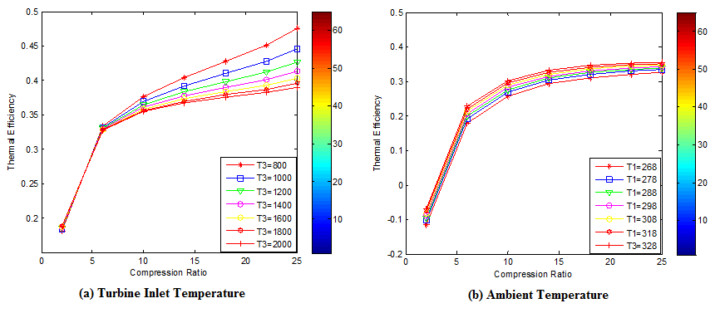**Figure 2: Variation of CR, Turbine Inlet Temperature, and AT on Thermal Efficiency**

Figure 2(a) depicts the relationship between cycle thermal efficiency and CR for turbine inlet temperatures ranging from 800 to 2000 oC. The thermal efficiency rose to 45.5 % at a higher inlet temperature of a turbine of about 2000 K with a CR of 25. That is, until a CR of 5, the thermal efficiency and inlet temperature of the turbine increase as the CR rises. At the lower CR, the variance in overall efficiency is negligible, but at the greater CR, it is critical for thermal efficiency. As the turbine inlet temperature rises, so does the efficiency, exhibiting an effective relationship that determines the specific limit. The inlet temperature of the turbine is vital for achieving a higher CR. The overall efficiency at high CR rises from 45.5 to 60.2 % when the turbine inlet temperature rises from 1200 to 2000 K. Figure 2(b) demonstrates that raising the CR and lowering the AT both result in an increase in overall efficiency. However, increasing the air-fuel ratio has a lower impact on thermal efficiency than increasing the compression ratio, which has a higher impact.



**Figure 3: Impact of Relative Humidity and Ambient Temperature on Plant Efficiency**

Figure 3 shows how AT and RH affect plant efficiency. Figure 3 depicts how plant efficiency decreases rapidly as AT increases at constant RH and increases as RH falls. This increase in efficiency as a result of lower RH and AT is due to lower compressor power consumption at lower RH and AT, as well as a reduction in heat quality supplied. A change in RH from 40 to 50% results in a 0.022% drop in cycle efficiency at an AT of 20 oC. This cycle efficiency is highest (40.5%) when RH and AT are low. Figure 3 clearly shows that the efficiency decreases from 40.5% to 40.28% as the RH rises from 40% to 70%. Figure 3 shows how AT affects gas turbine plant efficiency due to changes in RH and compressor work; a lower AT of 10oC and lower RH of 40% leads to lower compressor work of about 2.6 x 104 kW, which results in a higher gas turbine output power.

The impact of AT and RH on compressor power is depicted in Figure 4. Specifically, this refers to the amount of work necessary to operate the air compressor in relation to the surrounding temperature and relative humidity. Figure 4 demonstrates that as AT increases at constant RH, the compressor power consumption rises and that as RH rises at constant AT, the compression power soars.



**Figure 4: Effect of RH and AT on Compressor Power**

This increase is due to the high moisture content in the air stream at high RH, as well as the fact that it takes more power to compress a gas at a high temperature than at a low temperature for the same PR of 14. At a temperature of 20 oC., for example, a 25% increase in RH results in a 55% increase in compression power. As a result, the compressor turbine performs best when the RH and AT are relatively low. As a result, the best performance is obtained at relatively low RH and AT. Figure 4 shows that an average of 60% more power is consumed when the RH rises from 40% to 70%.

Figure 5 depicts the variation of compressor work with compressor PR for various AT values.



**Figure 5: Variation of AT and CR on Compressor Performance**

Figure 5 depicts the impact of CR on compressor work, which increases from 10 to 450 kW as the CR increases from 12 to 30 and AT increases from 268 to 328 K. It should be noted that increasing the PR from 12 to 30 increases the compressor work for a given value of atmospheric temperature and low PR. It was also discovered that as the AT and CR increased, the compressor work increased.

Figure 6 shows how compression ratio, AT, and turbine inlet temperature affect SFC.

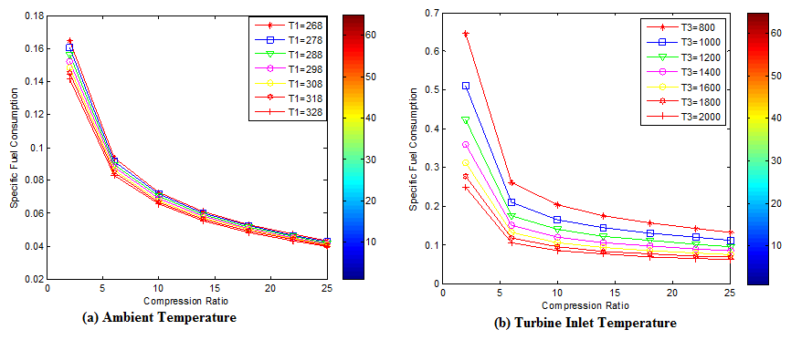

**Figure 6: Effects of CR, AT, and Turbine Inlet Temperature on SFC**

Figure 6(a) shows how CR and AT affect how much SFC is used. It has been found that the SFC increases from 0.14 to 0.168 as the AT rises from 268 to 328 K. As the temperature rises, the air density drops, which causes the air mass flow rate to drop. The fuel mass flow rate rises as a result of the constant air-fuel ratio. The SFC rises as the AT rises as a result of flue gas losses. The SFC of a gas turbine power plant falls as the CR rises.

Figure 6(b) illustrates the relationship between the CR (rp) and the turbine inlet temperature (T3) on specific fuel usage. SFC is seen to decrease linearly with the increasing CR up to approximately rp = 6 and to also decrease with rising turbine inlet temperature outside of this value. As was previously said, increasing the CR raises air temperature when it first enters the combustion chamber while lowering the amount of heat delivered in the combustion chamber for a certain turbine input temperature. This always leads to a decrease in the usage of that SFC. With a CR of rp = 6 and higher, SFC significantly rises at lower turbine inlet temperatures (800 K). The peaks of the curves, however, flatten off as the temperature of the turbine inlet rises, leading to a smaller range of least SFC. The results of the current investigation and those of other studies (Rahman et al., 2010) show a degree of agreement that is satisfactory. As the inlet temperature of the turbine rises from 800 to 2000 K, the SFC drops from 0.65 to 0.25 kg/kWh.

The temperature of the turbine inlet and the CR are what determine a gas turbine's production of electricity. The compressor PR controls the temperature of the air that leaves the compressor and enters the combustion chamber. As the CR rises, the output temperature rises as well. As a result, there is less of a temperature difference between the combustion chamber and the compressed air. Less fuel is needed (reducing the air-fuel ratio) to reach the specified inlet temperature of the turbine for a fixed gas flow to the gas turbine because the air leaving the compressors gets hotter as the CR rises. As the CR rises, so does the amount of work needed in the compressor and the gas turbine capacity to produce electricity.

The variation of heat supplied with compression ratio and turbine inlet temperature is shown in Figure 7.



**Figure 7: Impact of Heat Supply on the CR and Turbine Inlet Temperatures**

Figure 7 depicts the variation of heat supplied from 200 to 1500 kJ/kg with turbine inlet temperatures from 800 to 2000 K. It has been discovered that the amount of heat supplied increases from 200 to 1500 kJ/kg with turbine inlet temperatures from 800 to 2000 K but decreases with compression ratio from 2 to 25. The CR increases the temperature of the air entering the combustion chamber, requiring less heat to ignite combustion within. The amount of heat delivered consequently decreases as the compression ratio is raised for a given turbine inlet temperature.



**Figure 8: Influence of CR and Turbine Inlet Temperature Variations on Network Output**

Equation 3.57 demonstrates how the CR and turbine inlet temperature affect a gas turbine network output. As the CR rises, so does the amount of work that must be done in the gas turbine compressor. High PR results in an increase in compressor and turbine work output, but their disparity reduces the gas turbine network output. To increase plant network output, it is advisable to select a lower compressor pressure ratio. The correlation between network production, CR, and turbine inlet temperature is shown in Figure 8. As the CR rises, the network output rises as well. The network output rises from 450 to 1200 kJ/kg as the turbine input temperature rises from 800 to 2000 K.

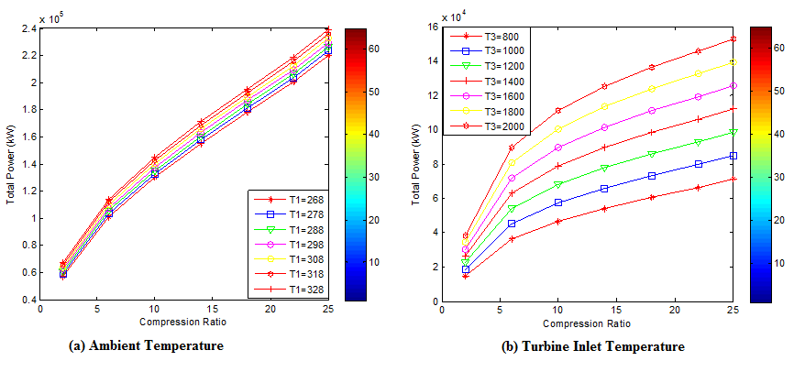

**Figure 9: Effects of CR, AT, and Turbine Inlet Temperature on Total Power**

Figure 9(a) depicts how the AT and compression ratio affects total power. It was discovered that as the compression ratio increased, the total power increased as the ambient temperature increased. Figure 9(b) depicts the variation in maximum power output as a function of compression ratio at various turbine inlet temperatures. The power output increases linearly with the turbine inlet temperature at lower CR. The output power of the peaks of the curves varies with the temperature of the turbine inlet, with higher temperatures producing higher peaks. A comparison of the current study findings with those of previous studies by Rahman et al., 2011 makes known a sufficient level of conformity.

**4. Conclusion**

The performance of a gas turbine plant is impacted by all operating variables, according to the simulation results from parameter modeling. Environmental factors, including relative humidity and ambient temperature, were carefully considered when analyzing the gas turbine. According to the model, a gas turbine power plant's performance is significantly influenced by operating factors such as the turbine inlet temperature, AT, RH, and CR. On net power output, total power, thermal efficiency, AT and CR variations have a bigger impact than changes in RH ratio. CR, AT, RH, and turbine inlet temperature all had a significant impact on the thermal efficiency of the gas turbine power plant. It is crucial to consider how thermal efficiency changes when CR, turbine inlet temperature, RH, and AT rise. The thermal efficiency and power production rise in direct proportion to the AT, RH, and CR. When the CR is high, the turbine inlet temperature is low, and when the AT is high, the overall thermal efficiency peaks. The precise fuel consumption and work ratio increase with AT and RH. When the CR is high, the turbine inlet temperature is low, and the AT is high, the efficiency, power, and SFC are at their highest. Thermal efficiency and power output rise linearly with increasing AT and turbine inlet temperatures at decreasing CR. The amount of heat generated rises as AT and turbine input temperatures rise but declines as CR rises. SFC rises with a rise in RH and AT but declines with a rise in CR and turbine inlet temperature. A gas turbine engine's performance is significantly impacted by the temperature of the turbine inlet. For the sake of minimizing losses in the gas turbine system, it should be kept as high as feasible. By increasing the turbine work and inlet temperature, the output power and thermal efficiency of the turbine are increased.

**Disclaimer (Artificial intelligence)**

Author(s) hereby declare that NO generative AI technologies such as Large Language Models (ChatGPT, COPILOT, etc.) and text-to-image generators have been used during the writing or editing of this manuscript.

**References**

Achebe, C. H., Ogunedo, B. M. O., Chukwuneke, J. L., & Anosike, N. B. (2020). Analysis of diesel engine injector nozzle spray characteristics fueled with residual fuel oil. *Heliyon*, *6*(8), e04637. https://doi.org/10.1016/j.heliyon.2020.e04637

Ahmed A.R., Esmail A.M. (2017). Boosting Gas Turbine Combined Cycles in Hot Regions using Inlet Air cooling including solar Energy. Energy procedia, 142:1509-1515.

Akroot A. and Saif E. (2019). Comparative energy analysis on a combined power plant of gas turbine and stirling engine. Int. J. Adv. Res. Eng. Technol. & Sci., 6(4): 1-9.

Alaa A.S., Oleg V.K., Farkad A.L., Mohammed A.Q., & Ahmad Y.S. (2024). Influence of surrounding air temperature and humidity upon the performance of a gas turbine power plant. *Journal of Advanced Research in Fluid Mechanics and Thermal Sciences*, *112*(1), 22–37.

Allakulyyev Sh, Altyyev B., Saryyev M., Hojalyyev A., Danatarova M. (2022). Scientific-technical analysis of the ambient temperature effect on the power of gas turbine installation in the conditions of Turkmenistan. IOP Conf. Series: Earth and Environ Sci., 1045: 012164.

Alomar, O. R., Ali, B. M., Ali, O. M., & Mustafa, A. N. (2024). Impacts of environmental conditions on thermal, emissions and economic performance of gas turbine using different types of fuels: An experimental investigation. *Results in Engineering*, *24*, 103402.

Anand B., Murugavelh S. (2020). Performance analysis of a novel augmented desalination and cooling system using modified vapor compression refrigeration integrated with humidification-dehumidification desalination. J. Cleaner Prod., 255: 120224.

Ang, T.-Z., Salem, M., Kamarol, M., Das, H. S., Nazari, M. A., & Prabaharan, N. (2022). A comprehensive study of renewable energy sources: Classifications, challenges and suggestions. *Energy Strategy Reviews*, *43*, 100939.

Arabi S.M., Ghadamian H., Aminy M., Ozgoli H. A., Ahmadi B., Khodsiani M. (2019). The energy analysis of F5 gas turbines inlet air-cooling systems by the off-design method. Measurement and Control:1-10.

Awogbemi, O., Von Kallon, D.V. and Kumar, K.S. (2024). Contributions of artificial intelligence and digitization in achieving clean and affordable energy. Intelligent Systems with Applications, 200389.

Aygun, H. (2024). Effects of air to fuel ratio on parameters of combustor used for gas turbine engines: Applications of turbojet, turbofan, turboprop and turboshaft. *Energy*, *305*, 132346.

Baakeem S.S., Orfi J., AlaqelS., Al- Ansary H. (2017). Impact of ambient conditions of Arab Gulf countries on the performance of gas turbines using energy and exergy analysis. Entropy, 19, 32:1-18.

Baten T., Haque A. (2019). Performance Analysis of Biomass fuel driven EFMGT Cycle. Int. J. Inno.Technol. & Explo. Eng. 9(2): 2421-2425.

Chukwuneke J.L., Achebe C.H., Okolie P.C., Okwudibe H.A. (2014). Experimental Investigation on Effect of Head and Bucket Splitter Angle on the Power Output of a Pelton Turbine. International Journal of Energy Engineering, 4(4): 81 – 87.

Chukwuneke J.L., Achebe C.H., Nwosu M.C., Sinebe J.E. (2014). Analysis and Simulation on Effect of Head and Bucket Splitter Angle on the Power Output of a Pelton Turbine. International Journal of Engineering and Applied Sciences, 5(3): 1 – 8.

Chukwuneke, J. L., Orugba, H. O., Olisakwe, H. C., & Chikelu, P. O. (2021). Pyrolysis of pig-hair in a fixed bed reactor: Physico-chemical parameters of bio-oil. *South African Journal of Chemical Engineering*, *38*, 115–120. https://doi.org/10.1016/j.sajce.2021.09.003

Chukwuneke, J. L., Sinebe, J. E., Orugba, H. O., Olisakwe, H. C., & Ajike, C. (2022). Production and physico-chemical characteristics of pyrolyzed bio-oil derived from cow hooves. *Arab Journal of Basic and Applied Sciences*, *29*(1), 363–371. https://doi.org/10.1080/25765299.2022.2129633

Direk M., Mert M .S. (2018). Comparative and Exergetic study of a Gas turbine system with Inlet air cooling. Technical Gazette 25, Suppl. 2: 306-311.

Eastop T. D., McConkey A. (2004). Applied Thermodynamics for Engineering Technologists” Tata McGraw Hill pp 260-265.

Fernandez D.A., Foliaco B., Padilla R.V., Bula A., Gonzalez-Quiroga A. (2021). High ambient temperature effects on the performance of a gas turbine-based cogeneration system with supplementary fire in a tropical climate. *Case Studies in Thermal Engineering*. 1(26):101206.

Hossin O., Aly K., Mohammed A. (2017). Performance of regenerative gas turbine power plant. Energy and Power Engineering, 9(2): 136 – 146.

Ibrahim T.K., Mohammed M.K., Al-Doori W.H.A., Al-sammarraie A.T., Basrawi F. (2019). Study of the performance of the gas turbine power plants from the simple to complex cycle: A Technical review. Journal of Advanced Research in fluid mechanics and Thermal Sciences, 57(2): 228-250.

Ikpeseni, S.C., Sada, S.O., Efetobor, U.J., Orugba, H.O., Ekpu, M., Owamah, H.I., Chukwuneke, J.L., Oyebisi, S., & Onochie, U.P. (2024). Optimization of bio-oil production parameters from the pyrolysis of elephant grass (Pennisetum purpureum) using response surface methodology. *Clean Energy*, *8*(5), 241–251. https://doi.org/10.1093/ce/zkae064

Jayachandran A.V.T., Gangisetty G., Tkachenko A., Rybakov V. (2019). Parametric study and efficiency optimization of the solar coupled hybrid micro gas turbine power plant for high altitude flight. J. Phy.: Conf. Series, 1276(1): 012048.

Khosravi N., Aydin D. (2020). Energetic and exergetic analysis of a novel geothermal driven multi-generation system using n-pentance as working fluid. Int. J. Exergy, 33(3): 263 – 283.

Kumar, K.S., Razak, A., Ramis, M.K., Irshad, S.M., Islam, S. and Wodajo, A.W. (2025). Statistical and machine learning analysis of diesel engines fueled with Moringa oleifera biodiesel doped with 1-hexanol and Zr2O3 nanoparticles. *Scientific Reports*, *15*(1), 7269.

Lui W., Zhang X., Zhao N., Shu C., Zhang S., Ma Z., Han J. (2018). Performance analysis of organic Ranknie Cycle power generation system for inter cooled cycle gas turbine. Advances in mechanical Engineering, 10(8): 1-12.

Mishra R.S. and Agarwal. S. (2018). Performance Parametric analysis of retrofitted gas turbine Cycle using STIG and Evaporative cooling techniques. Int. J. Res. Eng. &Inno., 2(5) : 469-483.

Njoku I.H., Oko C.O.C., Ofodu J.C. (2018). Performance evaluation of a combined cycle power plant integrated with organic Rankine cycle and absorption refrigeration system. Coget Energy, 5(1): 1451426.

Okafor V.C. (2017). Thermodynamic analysis of compressor inlet air precooling Techniques of a Gas Turbine Plant Operational in Nigeria Energy Utility sector. Int. J Eng. Sci. Technol. 2:1 – 14.

Okafor V. (2020). Thermodynamic analysis of compressor inlet air precooling techniques of a gas turbine plant operational in Nigeria energy utility sector. Int. J. Energy Sci. technol., 4(2): 13 – 24.

Rahman M.M., Ibrahim T.K., Abdalla A.N. (2011). Thermodynamic performance analysis of gas turbine power-plant. Int. J. Phy. Sci., 6(14):3539-3550.

Rahman M.M., Ibrahim T.K., Taib M.Y., Noov M.M., Kadirgama K., Bakar R.A. (2010). Thermal analysis of open-cycle regenerator gas turbine power plant. WASET, 68:94-99.

Saif M. and Tariq M. (2017). Performance Analysis of gas turbine at varying ambient temperature. Int. J. Mech. Eng. & Technol., 8(1): 270-280.

Salihu, A. (2022). Efficiency enhancement of gas turbine power output by cooling inlet air. *International Journal of Current Science Research and Review*, *05*(02). https://doi.org/10.47191/ijcsrr/v5-i2-23

Ujam J.A., Chukwuneke J.L., Achebe C.H., Ikwu G.O.R. (2014). Modeling the Effect of Head and Bucket Splitter Angle on the Power Output of a Pelton Turbine. International Journal of Engineering and Applied Sciences, 5(3): 26 – 36.

Ukwamba S.I., Orhorhoro E.K., Omonoji A.A. (2018). Performance Evaluation of A simple gas turbine power plant using vapour Absorption chiller. IOSR Journal of Mechanical and Civil Engineering, 15 (2): 13-18.