DESIGN AND SIMULATION OF DOUBLE ROTOR DUAL-STAGE HYBRID VERTICAL AXIS WIND TURBINE FOR POWER GENERATION

ABSTRACT
The release of carbon emissions and other pollutants resulting from the combustion of fossil fuels constitutes a significant environmental challenge. Throughout the years, numerous initiatives have been undertaken to mitigate or diminish these emissions, notably through the adoption of renewable energy sources as viable alternatives. Wind energy is classified as a renewable energy source that is harnessed through wind turbines to transform wind energy into mechanical and electrical energy. Wind turbines exhibit a diverse array of types, designs, and dimensions. Nevertheless, such designs and their corresponding types encounter various challenges, which include, but are not limited to, inadequate starting capabilities, suboptimal efficiency, and a propensity for unidirectional wind acceptance (specifically about horizontal axis wind turbines). In response to these challenges, this paper delineates the design and simulation of a dual-rotor, two-stage hybrid vertical axis wind turbine (DRDSH VAWT) intended for small-scale power generation. The DRDSH turbine is comprised of a 3-blade modified Savonius Bach-type rotor in conjunction with a 3-blade two-stage Darrieus turbine. Computational fluid dynamics (CFD) simulation models are employed to analyze and evaluate the performance of the turbine. The findings of the study indicated that the power coefficient (CP) of the DRDSH VAWT experienced a 71.4% increase at a tip speed ratio (TSR) of 0.563 in comparison to a 3-bladed dual rotor conventional vertical axis wind turbine (DRC VAWT). Additionally, the moment coefficient (cm) of the DRDSH VAWT exhibited a 55.2% increase at a TSR of 0.560 relative to the DRC VAWT. The DRDSH VAWT also generated 35.8% more power than the DRC VAWT, demonstrating a direct correlation between wind speed and power output. Furthermore, this indicates that the CP of the DRDSH VAWT improved by 63.7% with increasing wind speed when compared to the DRC VAWT. CFD analysis revealed that the turbine is optimally suited for lower TSRs. During the initiation phase, a practical and efficient switching mechanism was integrated to facilitate the assistance of the Bach-type rotor to the DRDSH VAWT, thereby enhancing the efficiency of the turbine.

Keyword: Power Coefficient, Tip Speed Ratio, Double Rotor Dual-Stage Hybrid, Double-Rotor Dual-Stage Conventional, Vertical Axis Wind Turbine,
1. INTRODUCTION
Energy is a vital resource that supports economic life. Efficient use and development of community energy resources are essential for the well-being of its people. With the continued growth of globalization, the growing demand for energy and countries' dependence on energy indicate that energy will become one of the major global challenges. Therefore, alternative renewable energy sources are needed (Ogunleye & Ayeni, 2012)(Gozgor et al., 2020).
While energy cannot solve the social and economic problems faced by developing economies such as Nigeria, the lack of affordable and reliable energy services is considered a major problem for the country's development (Nkoro et al., 2019).
Nigeria has abundant resources of various types, both renewable and non-renewable. This makes Nigeria's economic structure, consumption patterns, available technologies, transportation, urban and rural structures, and lifestyles different from those of developed countries but similar to those of less developed countries (LDCs). Despite the abundance of resources in the energy sector, underdevelopment and mismanagement have resulted in a gap between supply and demand (Gershon & Emekalam, 2021).
In today's world, electricity is the most widely used and desirable form of energy. A notable observable trend is that the increase in the country's population has increased electricity demand (Obada et al., 2024).
Nigeria is resource-rich, but its current power generation capacity is less than 3,000 MW, and it could be higher. Only 48% of Nigeria's 174 million people have access to electricity, which is relatively low compared to other African countries (Obada et al., 2024).
Renewable energy technologies offer a possible solution to Nigeria’s long-standing energy problems, as renewable resources are sustainable and suitable for installation in publicly owned micro-grids (Gershon & Emekalam, 2021).
The world's conventional energy resources are finite. As we continue to use fossil fuels at the current demand, natural oil will be depleted in 35 years, natural gas in 37 years, and coal in 107 years; therefore, fossil fuels will be depleted in about 100 years](Tasneem et al., 2020). Since fossil fuels are one of the significant factors in the destruction of the environment, coupled with the limited reserves of oil and natural gas, the world is looking for a sustainable alternative energy source to meet global energy needs (Durkacz et al., 2021).
Since the beginning of life, society has relied on the use of sunlight, either directly through solar radiation or indirect forms such as wind and hydropower (Al-ghriybah et al., 2019). Increased greenhouse gas emissions due to burning natural fuels have led to negative consequences such as climate change (Safarov & Mamedov, 2021). This, in turn, makes it essential to increase the proportion of clean energy used by humanity. After the 1970s, due to the depletion of traditional fuel resources, energy from renewable resources such as solar radiation, geothermal, biomass, rainwater, sunlight, tides, hydropower, and wind power began to dominate the energy sector (Li et al., 2023). As demand increases, more energy supply is needed due to the barriers to using traditional resources (such as outdoor air quality and other environmental pollution) and high (Al-ghriybah et al., 2019).
The current energy Predicament and the environmental damage caused by traditional thermal power plants are the main driving forces for the development of efficient systems to harvest various renewable energy sources (Antar et al., 2019). Since renewable energy sources are low-cost and have little harm to the environment, such projects have been implemented, with significant investments and support for promising development and research (Safarov & Mamedov, 2021). Wind energy has proven to be a cheaper alternative among these resources. Therefore, a lot of research has been invested in improving wind power generation technology (Mohammed et al., 2020).
A machine that changes the kinetic energy of wind to a more beneficial form of electrical energy is a wind turbine. Extensive research has been conducted to improve wind turbine power generation technology (Irawan et al., 2023). Wind turbines are been categorized into two types based on their rotation axis: horizontal axis wind turbines (HAWT) and also vertical axis wind turbines (VAWT). The iconic HAWT is widely used in onshore and offshore wind farms because of its higher efficiency under laminar conditions. However, the main disadvantage is that the turbine must yaw to oppose the wind direction.
On the other hand, VAWT has attracted the attention of researchers due to its unique omnidirectional characteristics (Wang et al., 2020). These advantages, such as its compact configuration, safety, ease of installation, and low pole effect, make the vertical axis wind turbine (VAWT) an attractive wind energy extraction system. However, unlike the horizontal axis wind turbine (HAWT), the angle of attack of the vertical axis wind turbine rotor varies with the azimuth angle. In addition, the aerodynamic performance of VAWTs is also affected, resulting in low self-starting capability and power generation efficiency (Rajpar et al., 2021). Vertical hybrid turbines usually comprise Darrieus and Savonius rotors, where the Savonius rotor is inside the Darrieus turbine (Irawan et al., 2023). The Savonius wind turbine is a simple type vertical axis device in the form of a semi-cylindrical component attached to opposite sides of the vertical shaft (for a two-blade arrangement). It operates on drag, so its rotation speed cannot exceed the wind speed (Didane et al., 2024).
The Darrieux rotor is a lifting turbine. The rotor comprises two or more airfoil blades fixed on a vertical axis. The wind hits the airfoil of the blades and creates lift, which is a tangential force acting on the shaft, which then rotates. This turbine is not self-starting as it has less torque at low speeds but is more efficient than the Savonius turbine (Puspitasari, 2019). Both the Savonius and Darrieux configurations have their advantages and disadvantages. Savonius rotors provide higher starting torque values, while Darius rotors provide lower starting torque values. From an efficiency perspective, the Darius rotor is superior to the Savonius rotor (Vadhyar et al., 2024)(Pan et al., 2024). Hybrid wind turbines are mainly designed and manufactured based on the combination of aerodynamic properties of the Darius and Savonius turbines (Hosseini & Goudarzi, 2018). The study found that rotors with endplates have better aerodynamic performance than rotors without endplates. In addition, the efficiency increases with the aspect ratio; the two-stage rotor performs better than the single-stage rotor (Methal et al., 2022). There are many types of wind turbines, but this study focuses on the design and simulation of a two-stage, dual-rotor hybrid vertical-axis wind turbine for small-scale power generation.
1.2 Double Darius Hybrid Vertical Axis Wind Turbine
In contrast, fixed-blade type Darius turbines have starting problems, especially in the low wind speed range. In addition, wind turbines with curved airfoil designs have better self-starting capabilities than symmetrical airfoils and higher Cp values ​​than Savonius turbines. In existing Darius-Savonius hybrid vertical axis wind turbines, the Savonius turbine is installed on the inner side due to its self-starting capability. In contrast, the Darius turbine is installed on the outer side due to its better Cp. Previous studies have shown that hybrid vertical axis wind turbines improve the self-starting speed; however, the overall efficiency is still lower than that of conventional wind turbines. While addressing the shortcomings of existing designs, an engineering solution is sought to design a double Darius hybrid vertical axis wind turbine (Homzah et al., 2021). This study combines the advantages of lift-type and drag-type vertical axis wind turbines to investigate a hybrid vertical axis wind turbine. The Savonis turbine in the existing Darius-Savonis hybrid vertical axis wind turbine is replaced by a Darius turbine based on a cambered airfoil. The improved hybrid vertical axis wind turbine consists of an outer, more giant Darius vertical axis wind turbine (symmetrical airfoil) and an inner smaller Darius turbine (cambered airfoil). The theoretical design and working principle of the improved hybrid vertical axis wind turbine are shown in Figure 1. The design parameters of the inner Darius turbine, such as chord length, number of blades, rotor height, rotor diameter, and pitch angle, are optimized using experimental design. The DOE technical parameters are studied using computational fluid dynamics (CFD) simulation. This study aims to improve the performance parameters of the vertical axis wind turbine by optimizing the design of the proposed hybrid vertical axis wind turbine (Shahzad et al., 2022).

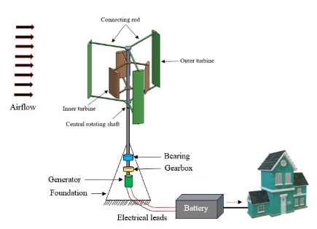
Figure 1: Double-Darrieus vertical axis wind turbine (hybrid)(Shahzad et al., 2022).
Thèse efforts have been made to improve the wind energy capture capability by increasing the capture area, doubling the generator speed, and increasing the number of windward blades. The structural design and experimental setup have shown that the multi-stage counter-rotating technology is effective in VAWT. The performance of the MSCR structure has been evaluated using some parameters, such as the electromotive force of the generator and the output power at certain wind speeds. A systematic evaluation of these parameters has led to some results for the two-stage MSCR technology in VAWT systems, which can almost quadruple the power output compared to a single-stage VAWT. Another advantage of the MSCR technology is that the energy product can extract more energy from the VAWT system with each additional stage (Junaidin, 2020).
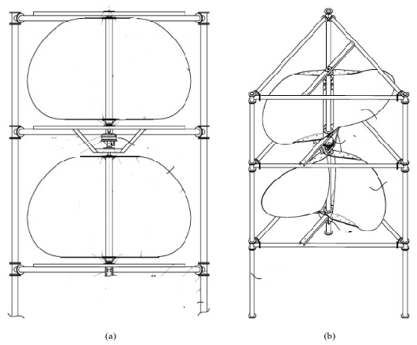
Figure 2: (a) schematic diagram of a two-stage contra-rotating VAWT (b) visualization of a two-stage contra-rotating VAWT (Junaidin, 2020)
1.3 Floating Darrieus-type wind turbine with three-stage rotor
The Darrieus F-VAWT with a three-stage rotor is shown in Figure 4. The rotor will have a straight blade configuration, which is more aerodynamic and self-adjusting at all wind speeds compared to other VAWT configurations. The concept allows for higher altitudes to benefit from stronger winds. The three wind turbine rotors rotate independently around a fixed axis, unlike conventional VAWTs, where the rotors and the shaft rotate simultaneously, resulting in increased inertia and torque applied to the shaft and causing turbine self-starting problems. In addition, by reducing the number of bearings, the axial and radial forces applied to the shaft and the associated manufacturing costs are minimized due to the simple geometrical specifications compared to a rotating shaft, and our solution does not require as much tolerance interval accuracy (Dabachi et al., 2020).

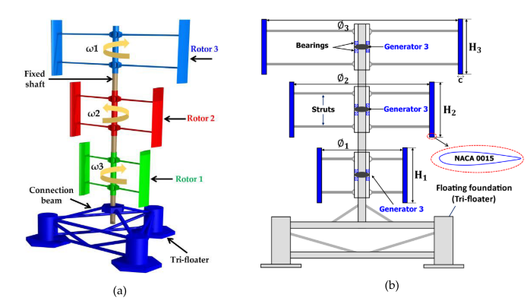
Figure 3: (a) Designed a 3D floating Darrieus-type wind turbine with three-stage rotors. (b) Detailed Schematic diagram of (a) (Dabachi et al., 2020).
The study by Saad et al., (2021) showed that the maximum power coefficient for a two-stage rotor is 0.253, 0.261 value for the four-stage rotor, and 0.223 for the single-stage rotor type. However, the multi-stage rotor with twisted blades significantly reduces the oscillations of the torque and thrust coefficients throughout the cycle. This reduces mechanical vibrations and noise emissions under operating conditions. In addition, the static torque coefficient was found to have positive values ​​and stable fluctuations at all rotation angles. This enhances the self-starting capability of the multi-stage rotor with twisted blades, making it suitable for areas with intermittent and very low wind speeds—the multi-stage Savonius rotor type with twisted blades has distinct advantages over existing vertical-axis wind turbines.
1.4 Power coefficient
According to the Betz limit, the power coefficient C_{pmax} can only reach a value of 16/27. Theoretically, this is the only maximum possible rotor power coefficient. The theoretical power coefficient of a horizontal wind turbine (called the Betz theory) reaches its maximum value at C_{P} = 0.593, while actual turbines are always below this value.
The power coefficient C_{p} represents the efficiency of a wind turbine and can be calculated using formula (1) (Mohammed et al., 2020).
$C_{p}=\frac{P_{t}}{0.5ρAU^{3}}$ (1).
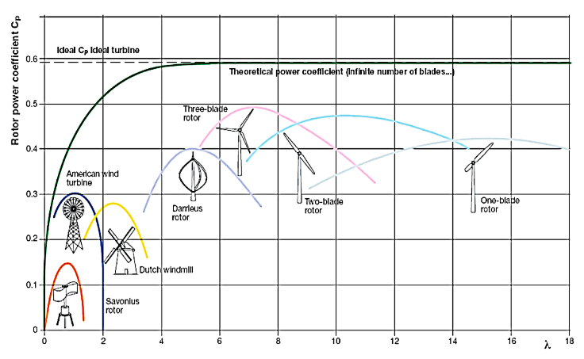
Figure 4: Rotors Power Coefficient and Tip Speed Ratio(Tata et al., 2024).
The coefficient of power can be introduced to measure the efficiency of turbines. $C_{P}=\frac{P_{Turbine}}{P_{wind}}$ (2)
${ P}_{Turbine}$ is the amount of power, and${ P}_{wind}$ is the wind power available (Gozgor et al., 2020).
1.5 Torque and Torque Coefficient
The rotational force of a wind turbine relies on its rated power and rotor speed. $C_{t}= \frac{T}{0.5ρAV^{2}R}$ (3)
The swept area in the path of the wind is denoted as \( S \), where \( R \) represents the rotor radius and \( V \) indicates the free stream velocity (Baharudin et al., 2020).
1.6 The coefficient of moment
The expression can be characterized through the following parameters: $C_{m}=\frac{M}{\frac{1}{2}QAD}$ (4)
For VAWTs, the swept area \ (A \) defined as \ (A = D \times H \), where \ ( D \) is diameter while \( H \) is the height. The dynamic pressure \ (Q \) is given by \ (Q = \frac{1}{2} \rho V^2 \), where \ (V \) is the wind velocity. (Gozgor et al., 2020).
1.7 Tip Speed Ratio (TSR)
The relationship between rotor speed and rotation is defined by the Tip Speed Ratio (TSR or Lambda ⅄) [14]
$λ= \frac{Tip speed of blade}{ wind speed}= \frac{Rω}{V}$ (5)
ω (rotational speed), R (rotor radius) (Tata et al., 2024).
2.0 Methodology
2.1 Solid Works Design: The analytical design parameters of the turbine were used to design the Double Rotor Dual-Stage Hybrid Vertical Axis Wind Turbines (DRDSH VAWT) and its components using Google Sketch-up 2019 solid tool and Solid Works 2021 solid model tools to bring out the schematic (Isometric Design) and orthographic designs with chosen and calculated dimensions. The rotor blade was first designed using NACA 0018 data downloaded and exported to Solid Works 2021 solid software tools; the rotor shaft, radial arm, and barrel rotor were designed after using the same software tools. Then, the assembly shaft was inserted into the stand using a move-and-push tool. Also, radial arms were coupled to the shaft, and the blade was inserted in the hole proved in the radial arm. Also, the batch rotor was placed between the upper radial arm of stage one and the (bottom) lower radial arm of stage two. Then, the diagram was coloured and rendered in the IRender, which was a Google Sketch-up 2019 solid tool that brings out the visual design of the Double Rotor Dual-Stage Hybrid Vertical Axis Wind Turbines (DRDSH VAWT) for 3D design and meshing. A similar procedure was taken on the Conventional (H-Darrieus) VAWT design for comparative analysis.
2.2 Double Rotor Dual-Stage Hybrid Vertical Axis Wind Turbine part
The assembly consisted of numerous parts, which were categorized into the following groups:
- Darrieus Blades: spanning a length of 0.45m in each stage
- Radial arm: The radial arm (0.225m in radius) is connected to the Darrius blade and main shaft.
- Shafts: The shaft (1 m length) was connected to the bottom and top of the Bach rotor and Darrieus systems.
- The Bach turbines (0.30 x 0.40 m in height and diameter) are connected by end plates, one at the top of the first stage and another at the bottom of the second stage.
- Each stage of the turbines has two disks with centre holes for the shafts, designed to enhance efficiency and prevent vortex shedding.
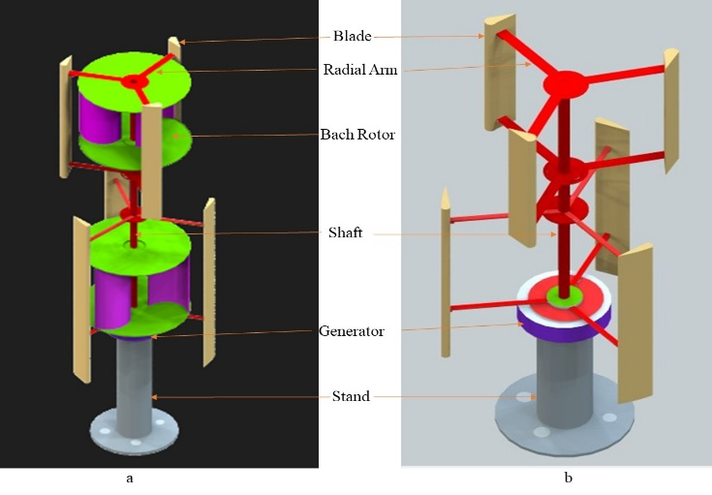
Figure 5: (a) Solid design of DRDSH VAWT) (b) solid design for Conventional DRDSH VAWT
2.3. Computational Fluid Dynamics (CFD) Simulation
The static and movable parts of a twin-rotor two-stage hybrid vertical axis wind turbine for small power generation were simulated using the ANSYS Fluent software tool 2021 model by importing the mesh model of Gambit. ANSYS Fluent is one of the most respected CFD codes. The mesh structure of each case was imported into ANSYS Fluent 2019 R3 to set up the geometry for the analysis. The basis of this code is the Unsteady Reynolds Averaged Navier-Stokes (URANS) equations, which define the pressure-velocity relationship in fluid flow as shown in the equations.
According to Salem [24], the governing equations used in numerical modelling, namely conservation of mass (continuity) and conservation of momentum (Navier-Stokes equations), are as follows:
$\frac{∂ρ}{∂t}+∇.\left(ρ\overline{v}\right)=0$ (6)
The Reynolds-Average Navier Stokes Equation (RANS) is written as: $\frac{∂}{∂t}\left(\overline{ρ}{\overline{v}}_{i}\right)+\frac{∂}{∂x_{j}}\left(\overline{ρ}{\overline{v}}_{j}{\overline{v}}_{i}\right)=\frac{∂ρ}{∂x_{i}}+\frac{∂}{∂x_{j}}({\overline{τ}}_{ij}-{\overline{R}}_{ij})$ (7)
The transport turbulence model in consideration is the Transient Shear Stress Transport (SST) model. Equations (8) and (9) represent the two governing equations derived from the Reynolds-Averaged Navier-Stokes (RANS) framework.$\frac{∂ρk}{∂t}+\frac{∂(ρv_{i}k)}{∂x_{i}}=\tilde{P_{k}}-β*ρkω+\frac{∂}{∂x_{i}}\left[(μ+σ_{k}μ_{t})\frac{∂}{∂x_{i}}\right]$
$\frac{∂ρk}{∂t}+\frac{∂(ρv_{i}k)}{∂x_{i}}=\tilde{P_{k}}-β*ρkω+\frac{∂}{∂x_{i}}\left[(μ+σ_{k}μ_{t})\frac{∂}{∂x_{i}}\right]$ (8)
$\frac{∂(ρω)}{∂t}+\frac{∂(ρv_{i}ω)}{∂x_{i}}=α\frac{1}{v_{1}}\tilde{P_{k}}-βρω^{2}+\frac{∂}{∂x_{i}}\left[\left(μ+σ_{k}μ_{t}\right)\frac{∂ω}{∂x_{i}}\right]+2(1-F_{1})ρσω^{2}\frac{1}{ω}\frac{∂k}{∂x_{i}}\frac{∂ω}{∂x_{i}}$ (9)
Where:
$$v_{1}=\frac{a_{1}}{max⁡(a_{1}ω,SF_{1})}; S\sqrt{2S_{ij}S_{ij}}$$
$$P_{k}=μ_{t}\frac{∂v_{i}}{∂x_{j}}\left(\frac{∂v_{i}}{∂x_{j}}+\frac{∂v_{i}}{∂x_{j}}\right)$$
$$\tilde{p_{k}}=min⁡(P_{k},10β*ρkω)$$
In this context, \( vj \), \( vi \), and \( vi \) represent the average and pulsating values of velocity within the axial coordinate system. Additionally, \( \tilde{p}\) denotes the average pressure, \( \mu \) is the kinematic viscosity, \(\rho\) indicates the fluid's density, and \( t \) refers to time, as cited in references (Hosseini & Goudarzi, 2018) and (Tata et al., 2024).
Renolds-Average Navier stoke (RANS) and transition SST methods were employed in running simulation processes using equations (6), (7), (8), and (9), respectively.
The SIMPLE algorithm was coupled with Trans. SST turbulent model to compute the flow physics. The SIMPLE algorithm was chosen due to its high accuracy in handling incompressible flows—the Trans. The SST model effectively calculated solutions for separated flows, particularly on rotors. Figure 6 illustrates the computational domain, which consists of two main zones: the rotating zone, which includes the rotors, and the wind flow zone, which encompasses the remainder of the computational area.
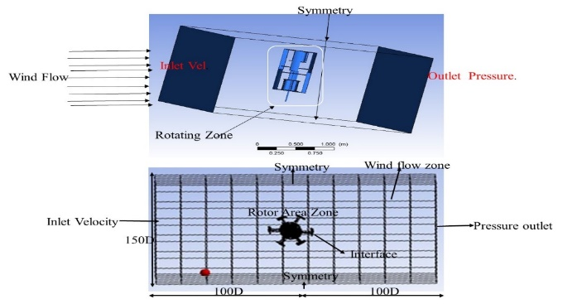
Figure 6:3D Setup overview for CDF analysis
Table 1: Setup Parameters for the CDF analysis

Parameter | Value | Unit
Flow density | 1.205 | Kg/m³
Inlet Vel. | 1-10 | m/s
Turbulence intensity ratio | 0.8 | -
Turbulence Viscosity ratio | 5 | -
Flow temperature | 25 | ºc
Algorithms | SIMPLE | ⁻
Viscosity model | Transition SST
Equation order ( kinetic energy, momentum, specific dissipation rate, transient formulation, and intermittency) | Second order | - ⁻
Wall conditions | No slip
Time discretization | 1° of rotation per time step | - ^{S}
Pressure | PRESTO
Volume | Compressive
Rotational speed | 10 | Rpm
Solution initialization Method | Hybrid

3.1 Results and Discussion
Bach blades, the curved sections of the blades, are viewed as the least favourable elements. Figure 7 shows the grid structure of the DRDSH VAWT, which combines the cell structures of the DRDSC VAWT and Bach rotors. Figure 8 show the Static pressure and Pressure Volume rendering contours of DRDSH VAWT. Figures 9 and 10 show Wall Shear and velocity Volume rendering velocity magnitude contours for the DRDSH VAWT at every 25 degrees of rotation, respectively. Similarly, Figure 11 illustrates the contours of the velocity streamline of DRDSH VAWT.
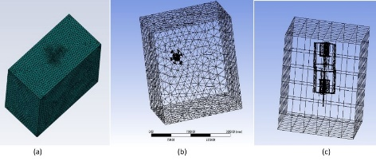
Figure 7: Computational fluid domain of DRDSH VAWT (a) Isometric view and (b) top wireframe view (c) isometric wireframe view
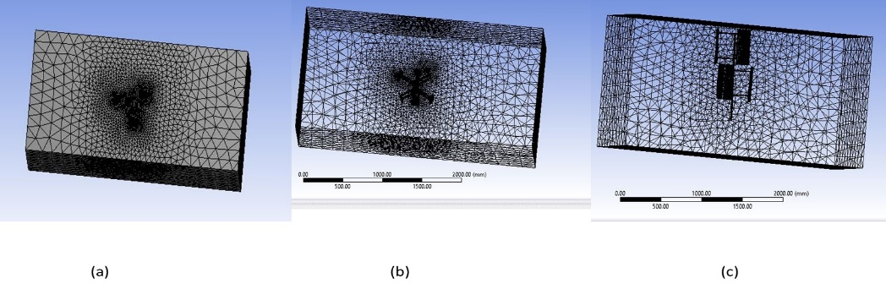
Figure 8: The Computational fluid domain for DRDSC VAWT (a) Isometric (b) top wireframe (c) isometric wireframe views
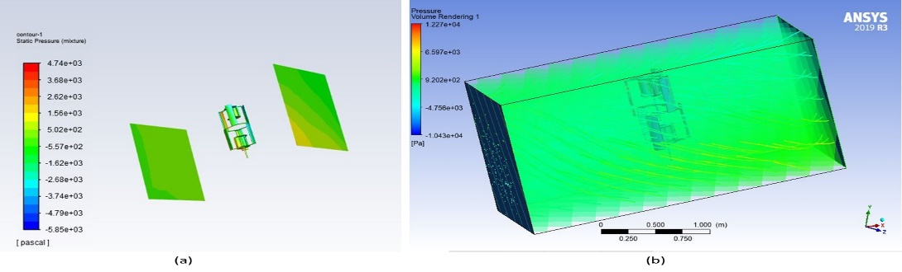
Figure 9: The contours of DRDSH VAWT (a) Static pressure (b) Pressure Volume rendering
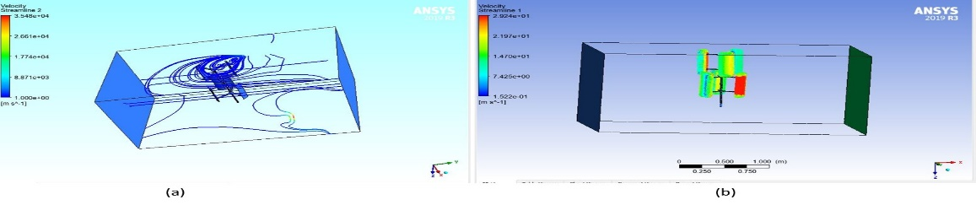
Figure 10: The contours of DRDSC VAWT (a) Pressure Contour (b) Velocity magnitude
Figures 10 to 12 show the velocity and pressure profiles for the DRDSH VAWT and DRDSC VAWT, respectively. The highest speed is observed in the hybrid turbine close to the blade tips. Also, a wake region can be observed behind the turbine, similar to the other cases. However, in this particular case, the wake region is smaller due to the momentum generated by the DRDSH VAWT on the low-speed region behind the Bach turbine. By inspecting the profiles, it can be inferred that the Bach turbine uses the vortices generated within the DRDSH VAWT from the previous standalone DRDSCVAWT simulation. The interaction between the two turbines improves the performance of the hybrid turbine at lower tip speed ratios (TSRs), where turbulent effects are less significant. However, it has estableshed that the high drag of the Bach rotor decreases the efficiency of the DRDSH VAWT at higher rotational speeds.
3.2. Performance Analysis of DRDSH VAWT.
2.1 Power Coefficient (Cp) vs. Tip Speed ​​Ratio (λ)
Figure 11 compares the power coefficient values ​​of the DRDSH VAWT and the DRDSC VAWT. The DRDSH VAWT achieves a maximum Cp value of 0.240 at a tip speed ratio (λ) 0.563. Meanwhile, the DRDSC VAWT placed at the exact location and subjected to the same simulation procedure achieves a maximum Cp value of 0.140 at a tip speed ratio (λ) of 0.321. This indicates that the DRDSH VAWT has an increase of 71.4% over the DRDSC VAWT. The improvement in's power coefficient of the DRDSH VAWT is attributed to the Bach rotor, which enables it to operate in all directions of wind. The diagonal flow effect improves wind turbine performance by reducing the minimum cut-in speed, allowing efficient energy capture in low wind conditions. However, adding radial arms creates drag, disrupts the airflow, and reduces efficiency. It is essential to balance the advantages of the diagonal flow effect and the disadvantages of the radial arms to optimize performance (Gozgor et al., 2020).
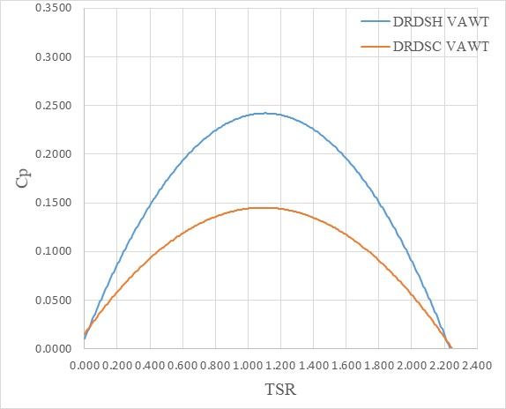
Figure 11: Relationship between coefficient of power values for the DRDSH VAWT and DRDSC VAWT
3.2.2 Coefficient of Moment (Cm) Against Tip Speed Ratio (λ)
Figure 12 illustrates the trend of numerically simulated data for two vertical axis wind turbine (VAWTs) types: the DRDSH and DRDSC. The DRDSH VAWT achieves a maximum coefficient of moment (Cm) value of 0.450 at a tip speed ratio (λ) of 0.560. In comparison, the DRDSC VAWT, tested under the same conditions and in the same position, recorded a maximum Cm of 0.290 at a tip speed ratio (λ) of 0.450. This indicates a 55.2% increase in Cm for the DRDSH VAWT compared to the DRDSC VAWT.
The higher Cm value of the DRDSH VAWT at a TSR of 0.560 demonstrates its improved performance at lower TSRs, which boosts reliability for urban deployment. Its compact size enables it to generate electricity efficiently at low wind speeds, making it ideal for offshore developments or remote locations where turbine startup is challenging. This makes the DRDSH VAWT a practical and efficient choice for such conditions. Furthermore, when combined with the advantages of VAWTs, such as low repair costs and insensitivity to wind direction, this turbine is particularly beneficial when the operating environment is less than ideal or access is limited (Ebrahimpour et al., 2019).
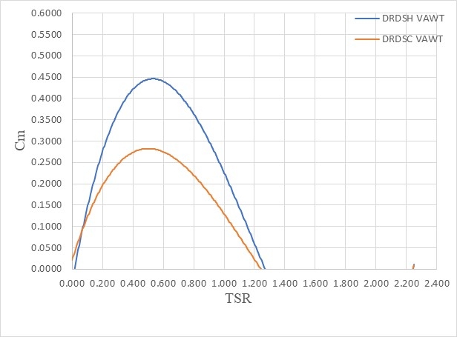
Figure 12: Relationship between coefficient of Moment values for the DRDSH VAWT and DRDSC VAWT
Table 2 highlights each turbine's key results and features, showing that the DRDSH VAWT design outperforms the DRDSC VAWT design.
Table 2: Maximum simulated result for DRDSH VAWT and DRDSC VAWT
Parameter | DRDSH VAST | DRDSC VAST | Increment (%)
Cp  TSR | 0.240  0.563 | 0.140  0.321 | 71.4
Cm  TSR | 0.450  0.560 | 0.290  0.450 | 55.2
Turbine power (w)  Wind Speed (m/s) | 9.10  8 | 6.70  7 | 35.8
Cp  Wind Speed (m/s) | 0.221  5 | 0.135  5 | 63.7

4. Conclusion
An innovative design for a wind turbine, designated as DRDSH, has been constructed and subjected to analysis utilizing computational fluid dynamics methodologies. The DRDSH vertical axis wind turbine (VAWT) integrates a Bach rotor and an H-Darrieus turbine within each operational stage. The findings are as follows:
The DRDSH VAWT exhibits a notable enhancement of 71.4% in the power coefficient (Cp) relative to the tip speed ratio (TSR) when contrasted with a double-rotor dual-stage conventional vertical axis wind turbine (DRDSC VAWT). Correspondingly, the DRDSH VAWT demonstrates a 55.2% improvement in the moment coefficient (Cm) in relation to TSR when compared to the DRDSC VAWT. Moreover, the data underscores a direct correlation between wind velocity and power output, with the DRDSH VAWT revealing a 35.8% superior power output in comparison to the DRDSC VAWT. Additionally, it indicates that the DRDSH VAWT achieves a 63.7% increase in Cp concerning wind speed relative to the DRDSC VAWT.
The computational fluid dynamics analyses indicate that the turbine operates most effectively at lower TSRs. During the initiation phase, a practical and efficient switching mechanism is employed, facilitating the Bach-type rotor's contribution to the DRDSH VAWT, thereby further augmenting the turbine's operational efficiency.
Conflicts of Interest: The authors declare no conflict of interest.

Disclaimer (Artificial intelligence)
Option 1:
Author(s) hereby declare that NO generative AI technologies such as Large Language Models (ChatGPT, COPILOT, etc.) and text-to-image generators have been used during the writing or editing of this manuscript.
Option 2:
Author(s) hereby declare that generative AI technologies such as Large Language Models, etc. have been used during the writing or editing of manuscripts. This explanation will include the name, version, model, and source of the generative AI technology and as well as all input prompts provided to the generative AI technology
Details of the AI usage are given below:
1.
2.
3.

References
Al-ghriybah, M., Zulkafli, M. F., Didane, D. H., & Mohd, S. (2019). Review of the Recent Power Augmentation Techniques for the Savonius Wind Turbines. Journal of Advanced Research in Fluid Mechanics and Thermal Sciences, 60(1), 71–84.
Antar, E., El Cheikh, A., & Elkhoury, M. (2019). A dynamic rotor vertical-axiswind turbine with a blade transitioning capability. Energies, 12(8), 1–21. https://doi.org/10.3390/en12081446
Baharudin, M., Didane, D., Mohideen Batcha, M. F., Abdullah, K., Mohammed, A. N., & Mohd Ali, M. F. (2020). CFD Simulation Study of Multistage Vertical Axis Wind Turbine (VAWT). Advances in Mechanical, Manufacturing and Aerospace Engineering, Series 1, December, 47–60.
Dabachi, M. A., Rahmouni, A., Rusu, E., & Bouksour, O. (2020). Aerodynamic simulations for floating darrieus-type wind turbines with three-stage rotors. Inventions, 5(2), 1–18. https://doi.org/10.3390/inventions5020018
Dewi Puspitasari, K. S. (2019). Effect of Savonius blade height on the performance of a hybrid Darrieus-Savonius wind turbine. Journal of Mechanical Engineering and Sciences, 13(4), 5832–5847.
Didane, D. H., Behery, M. R., Al-ghriybah, M., & Manshoor, B. (2024). Recent Progress in Design and Performance Analysis of Verti- cal-Axis Wind Turbines ( VAWTs ) - A comprehensive Review. April, 1–31. https://doi.org/10.20944/preprints202404.1310.v1
Durkacz, J., Islam, S., Chan, R., Fong, E., Gillies, H., Karnik, A., & Mullan, T. (2021). CFD modelling and prototype testing of a Vertical Axis Wind Turbines in planetary cluster formation. Energy Reports, 7, 119–126. https://doi.org/10.1016/j.egyr.2021.06.019
Ebrahimpour, M., Shafaghat, R., Alamian, R., & Shadloo, M. S. (2019). Numerical investigation of the Savonius vertical axis wind turbine and evaluation of the effect of the overlap parameter in both horizontal and vertical directions on its performance. Symmetry, 11(6), 1–16. https://doi.org/10.3390/sym11060821
Gershon, O., & Emekalam, P. (2021). Determinants of Renewable Energy Consumption in Nigeria: A Toda Yamamoto Approach. IOP Conference Series: Earth and Environmental Science, 665(1). https://doi.org/10.1088/1755-1315/665/1/012005
Gozgor, G., Kumar, M., Demir, E., & Padhan, H. (2020). The impact of economic globalization on renewable energy in the OECD countries. Energy Policy, 139(111365), 1–13. https://doi.org/10.1016/j.enpol.2020.111365
Homzah, O. F., Widagdo, T., Mardiana, Asrofi, I., & Pratama, D. A. (2021). Prototype of Small Savonius Wind Turbine. Proceedings of the 4th Forum in Research, Science, and Technology (FIRST-T1-T2-2020), 7, 208–213. https://doi.org/10.2991/ahe.k.210205.037
Hosseini, A., & Goudarzi, N. (2018). CFD and control analysis of a smart hybrid vertical axis wind turbine. American Society of Mechanical Engineers, Power Division (Publication) POWER, 1(January 2019). https://doi.org/10.1115/POWER2018-7488
Irawan, E. N., Sitompul, S., Yamashita, K.-I., & Fujita, G. (2023). The Effect of Rotor Radius Ratio on The Performance of Hybrid Vertical Axis Wind Turbine Savonius-Darrieus NREL S809. Journal of Energy and Power Technology, 05(01), 1–12. https://doi.org/10.21926/jept.2301001
Junaidin, B. (2020). Design Of Helical-Blade Rotor Of Vertical Axis Wind Turbine (VAWT). Conference SENATIK STT Adisutjipto Yogyakarta, 6, 145–150. https://doi.org/10.28989/senatik.v6i0.439
Li, Y., Yang, S., Feng, F., & Tagawa, K. (2023). A review on numerical simulation based on CFD technology of aerodynamic characteristics of straight-bladed vertical axis wind turbines. Energy Reports, 9(2023), 4360–4379. https://doi.org/10.1016/j.egyr.2023.03.082
Methal, Z., Aat, S., Hj, D., Mra, R., & Mr, S. (2022). Improvement of Hybrid Vertical Axis Wind Turbine Performance for Low Wind Speed Condition. PERINTIS EJournal, 12(1), 42–55.
Mohammed, G., Buhari, M., Kangiwa, U. M., & Danyaro, J. (2020). Design, Fabrication and Performance Evaluation of Hybrid Vertical Axis Wind Turbine. International Journal for Modern Trends in Science and Technology, 6(6), 80–86. https://doi.org/10.46501/ijmtst060618
Nkoro, E., Ikue-John, N. N., & I. Joshua, G. (2019). Energy consumption and economic growth in Nigeria. Bussecon Review of Social Sciences (2687-2285), 1(2), 01–09. https://doi.org/10.36096/brss.v1i2.138
Obada, D. O., Muhammad, M., Tajiri, S. B., Kekung, M. O., Abolade, S. A., Akinpelu, S. B., & Akande, A. (2024). A review of renewable energy resources in Nigeria for climate change mitigation. Case Studies in Chemical and Environmental Engineering, 9(February), 100669. https://doi.org/10.1016/j.cscee.2024.100669
Ogunleye, E. O., & Ayeni, R. K. (2012). Energy demand in Nigeria: A disaggregate analysis. International Research Journal of Finance and Economics, 86(July), 52–62.
Pan, J., Ferreira, C., & Zuijlen, A. Van. (2024). Performance analysis of an idealized Darrieus – Savonius combined vertical axis wind turbine. Wiley, 1(2024), 1–16. https://doi.org/10.1002/we.2904
Rajpar, A. H., Ali, I., Eladwi, A. E., & Bashir, M. B. A. (2021). Recent development in the design of wind deflectors for vertical axis wind turbine: A review. Energies, 14(16). https://doi.org/10.3390/en14165140
Saad, A. S., Elwardany, A., El-Sharkawy, I. I., Ookawara, S., & Ahmed, M. (2021). Performance evaluation of a novel vertical axis wind turbine using twisted blades in multi-stage Savonius rotors. Energy Conversion and Management, 235(February), 114013. https://doi.org/10.1016/j.enconman.2021.114013
Safarov, A. B., & Mamedov, R. A. O. (2021). Study Of Effective Omni-directional Vertical Axis Wind Turbine For Low Speed Regions. IIUM Engineering Journal, 22(2), 149–160. https://doi.org/10.31436/iiumej.v22i2.1565
Shahzad, A., Defence, A., Academy, F., Akram, F., Irtiza, S., & Shah, A. (2022). Design optimization of Double-Darrieus hybrid vertical axis wind turbine Design optimization of Double-Darrieus hybrid vertical axis wind turbine. Ocean Engineering ·, 02(06), 1–20. https://doi.org/10.1016/j.oceaneng.2022.111171
Tasneem, Z., Al, A., Das, S. K., Saha, D. K., Islam, R., Ali, F., Badal, F. R., Moyeen, S. I., & Alam, F. (2020). Developments in the Built Environment An analytical review on the evaluation of wind resource and wind turbine for urban application : Prospect and challenges. Developments in the Built Environment Journal, 4(100033), 1–15. https://doi.org/10.1016/j.dibe.2020.100033
Tata, M., Bekhti, A., Maizi, M., Cherifi, N. O., Tamoum, A., Hamane, D., Boudis, A., Debbache, M., & Guerri, O. (2024). Aerodynamic Performance Investigations of Savonius Twin-rotor Wind Turbines. Journal of Applied Fluid Mechanics, 17(2), 442–460. https://doi.org/10.47176/jafm.17.02.2044
Vadhyar, A., Sridhar, S., Reshma, T., & Radhakrishnan, J. (2024). A critical assessment of the factors associated with the implementation of rooftop VAWTs: A review. Energy Conversion and Management: X, 22(March), 100563. https://doi.org/10.1016/j.ecmx.2024.100563
Wang, X. H., Wong, K. H., Chong, W. T., Ng, J. H., Xiang, X. B., & Wang, C. T. (2020). Experimental investigation of a diffuser-integrated vertical axis wind turbine. IOP Conference Series: Earth and Environmental Science, 463(1). https://doi.org/10.1088/1755-1315/463/1/012153
Slootweg JG, Kling WL. The impact of large scale wind power generation on power system oscillations. Electric power systems research. 2003 Oct 1;67(1):9-20.
https://www.sciencedirect.com/science/article/abs/pii/S0378779603000890
Definitions, Acronyms, Abbreviations
Nomenclature
DRDSH | Double-Rotor Dual-Stage Hybrid
VAWT | Vertical Axis Wind Turbine
DRDSC | Double-Rotor Dual-Stage Conventional
HAWT | Horizontal Axis Wind Turbine
A_{s} | Swept area (m²)
N | Number of blades
C | Chord length (m)
Cp | Coefficient of power
Cm | Coefficient of moment
D | The diameter of the rotor in meter
H | Turbine height (m)
NACA | National Advisory Committee for Aeronautics
P_{turbine} | Turbine power (w)
P_{wind} | Wind turbine power in watt
NIMET | Nigeria Meteorological Agency
CFD | Computational fluid dynamics
R | Rotor radius (m)
V | Wind velocity (wind speed) (m/s)
Q | Dynamic pressure (pa)
M | Moment (Nm)
Greek symbols
$$ρ$$ | Air density kgm⁻³
$$λ$$ | Tip speed ratio (TSR)
$$σ_{r}$$ | Wind turbine solidity
$$ω$$ | Angular Velocity (rads⁻¹)
$$α$$ | Aspect ratio
$$β$$ | Angle of attack
θ | azimuth angle

