**Marketing Constraints of Pearl Millet in Gujarat, India**

**Abstract:**

The present study was conducted in Banaskantha, Anand, and Kheda districts of Gujarat to identify the constraints faced by various stakeholders in the marketing of pearl millet. A total of 100 farmers were selected from 14 villages of seven selected talukas of Banaskantha, Anand, and Kheda districts and hundred market intermediaries (Resellers) from nearby markets that included commission agents, wholesalers, retailers, traders, exporters, were taken for the collection of primary data and analysed using Henry Garrett’s ranking technique. On the basis of the review, a list of 31 constraints were prepared, and data was collected on each one. The study found that among farmers, the major problem faced in the marketing of pearl millet was a lack of credit and, delay in cash payment for commission agents. Traders had the problem of small volume and inconsistent supply. Among wholesalers and retailers, competition was the major problem in the marketing of pearl millet. Exporters had high transportation costs as the major problem in the marketing of pearl millet. The study included suggestions that improve efficiency and profitability for all stakeholders involved

**Key words:** Constraints, Stakeholders, Marketing, Garrett ranking technique

**Introduction**

Millets, a diverse group of small-seeded grains, have gained global recognition for their nutritional value, resilience, and ability to support sustainable agriculture. Popular varieties include pearl millet (bajra), finger millet (ragi), foxtail millet, and proso millet. Unlike conventional cereals, millets require minimal irrigation, are resistant to pests, and can thrive in harsh environmental conditions, making them ideal for regions facing water scarcity and unpredictable weather patterns (FAO, 2023). Due to their high fiber content, complex carbohydrates, and rich mineral profile, they are increasingly being recommended as an alternative to refined grains, particularly for individuals seeking gluten-free and nutrient-dense diets.

Recognizing the growing importance of millets, the United Nations declared 2023 as the International Year of Millets (IYM) to encourage global adoption of these nutrient-rich grains (UN, 2023). Governments worldwide, including India’s National Food Security Mission (NFSM) and Poshan Abhiyaan, have been actively promoting millet consumption as a means to combat malnutrition, enhance food diversity, and ensure long-term agricultural sustainability (Ministry of Agriculture, 2023).

Globally, pearl millet ranks as the sixth most significant cereal crop after rice (Oryza *sativa*), wheat (Triticum *aestivum*), maize (Zea *mays*), barley (Hordeum *vulgare*), and sorghum (Sorghum *bicolor*), serving as a staple for over 90 million people (Srivastava *et al*., 2020a). It is extensively cultivated on approximately 30 million hectares, primarily in the semi-arid tropical regions of Asia and Africa, where it not only serves as a primary food source but also plays a critical role in animal feed and fodder production, accounting for nearly 50 per cent of global millet output. Unlike other cereals, pearl millet requires minimal agricultural inputs while delivering higher economic returns, making it an attractive option for resource poor farmers in regions facing declining soil fertility and erratic rainfall patterns (Nambiar *et al*., 2011).To unlock pearl millet’s full potential, it is essential to identify the barriers in marketing, assess how these challenges impact the overall market, and find sustainable solutions that improve efficiency and profitability for all stakeholders. In this view the study was taken up.

**Objective**

To identify the constraints faced by various stakeholders involved in the marketing of Pearl millet

**Research Methodology**

The present study was conducted in Banaskantha, Anand, and Kheda districts of Gujarat. Henry Garrett’s ranking technique was used for analysis. Multistage purposive sampling was used for the selection of farmers involved in the marketing of pearl millet in Gujarat. At first, the top three districts (Banaskantha, Anand, Kheda) were selected based on the average area under cultivation of pearl millet from 2018-19 to 2020-21. In the second stage of the research, a list was compiled detailing the taluka-wise area under pearl millet cultivation for the past two years from each selected district—Anand, Kheda, and Banaskantha. The average area under cultivation over the last two years was calculated to assist in the selection of talukas for further study. Then, three talukas from Banaskantha and two talukas from Anand and kheda districts were selected considering area under Pearl millet cultivation. Thus, for the selection of respondents from Banaskantha district, three talukas named Tharadh, Vaav, Dhanera were selected, while from Anand district Borsad, Petlad taluka and from Kheda districts Nadiyad, Kapadvanj talukas were selected. In the third stage, two villages from each taluka were selected randomly. A total of fourteen villages of which six from Banaskantha district, four from Anand district, and four from Kheda district were selected. Inthe fourth stage, the gram sevak and sarpanch of each selected village were contacted for the selection of pearl millet cultivating farmers. Convenience sampling was adopted as an appropriate sampling procedure for the selection of market intermediaries (Resellers) such as traders, retailers, commission agents, wholesalers, and exporters with at least seven respondents from each category from selected talukas.

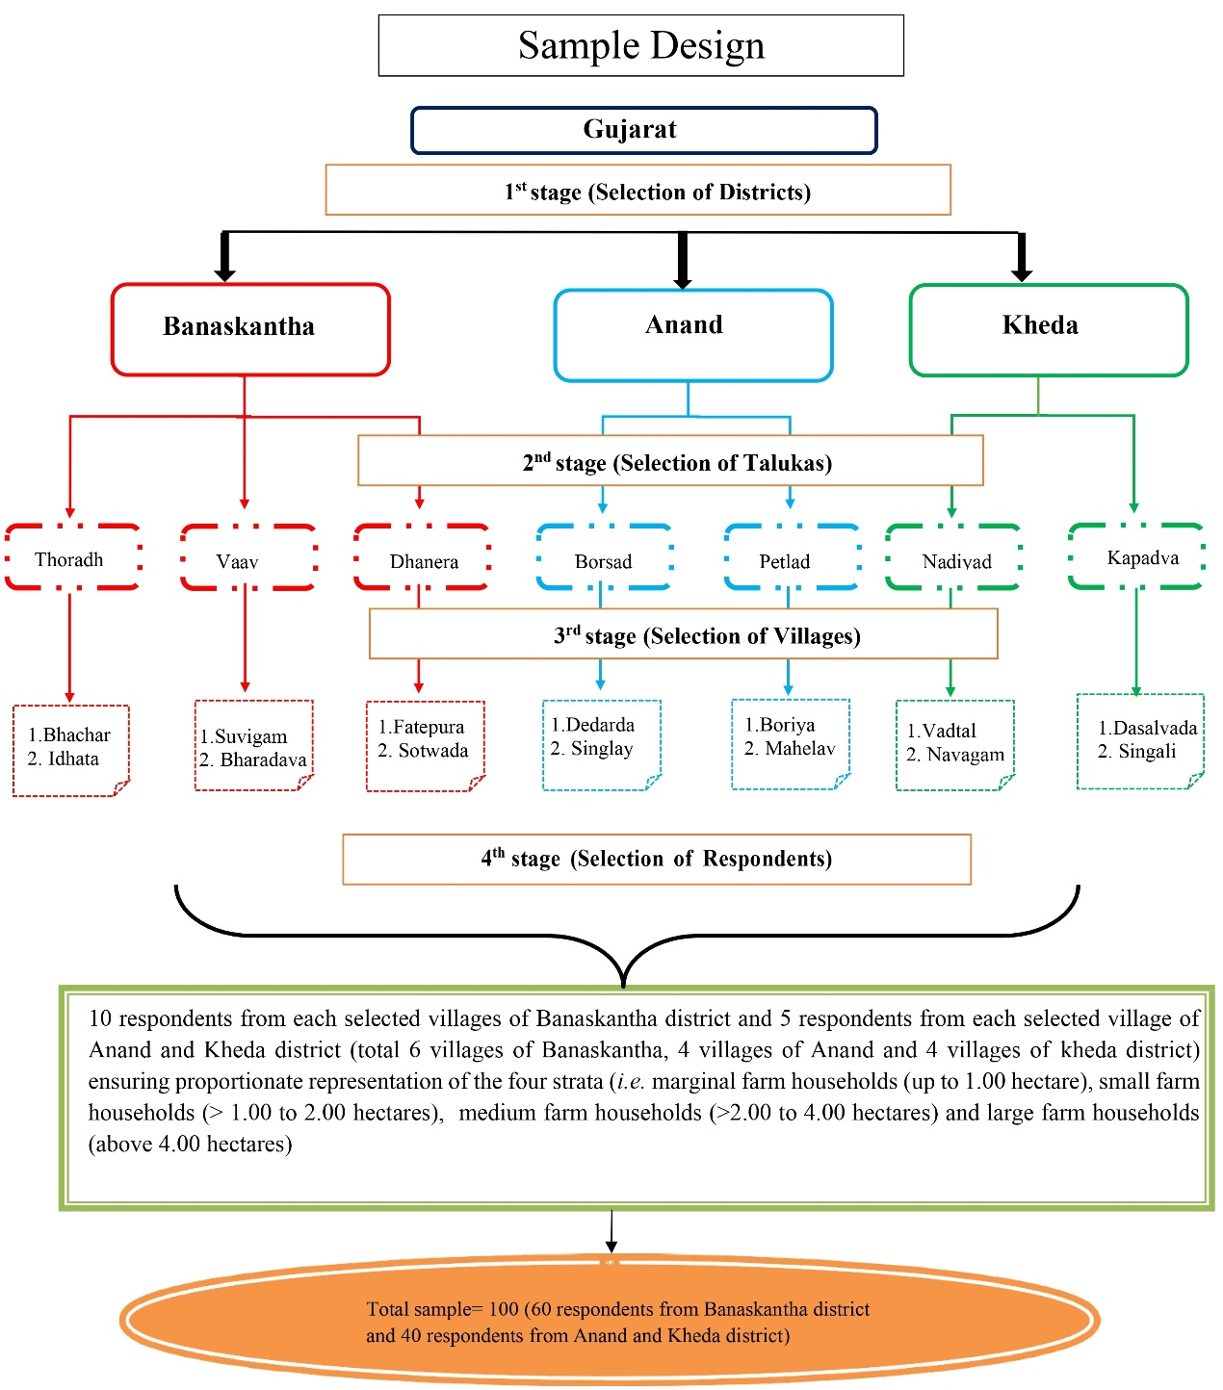

**Fig. 1**. Study protocol

**Henry Garrett’s Ranking Technique**

This technique was used to evaluate the problems faced by farmers in marketing of Pearl millet. The list of problems will be based on available literature and pilot study. As per this method, farmers will be asked to assign rank for the mentioned problems. Thus, the assigned ranks by the individual farmers were converted into percent position value by using the following formula

**Percent Position = $\frac{100(Rij-0.5)}{Nj}$**

Where,

Rij = Rank given for ith variable by jth farmer.

Nj = number of variables ranked by jth farmer.

The per cent position was converted into scores by referring the Garrett’s ranking table given by Garret and Woodworth in 1969. Mean scores were calculated by dividing the total score by the number of farmers taken under study. Overall ranking was obtained by assigning ranks in the descending order of the mean score.

**Result and Discussion:**

**PROBLEMS IN THE MARKETING OF PEARL MILLET**

1. **Problems faced by farmers**

Problems faced by farmers in marketing of pearl millet is presented in Table 1. The major constraint faced by pearl millet farmers is the lack of credit facilities with mean garrett score of 75.20, which compelled them to take loans from village-level traders. Consequently, they are obligated to sell their produce to these traders at prices determined by the traders themselves. Due to their indebtedness, farmers rarely considered exploring alternative markets for better prices. Lack of extension services, ranked second with a mean garrett score of 72.50, highlights that farmers do not have access to extension workers that could enlighten them about value addition of millets, the minimum support price, and government arranged marketing facilities. Lack of storage facilities is ranked third with a mean garrett score of 70.80. Most farmers do not store their produce because of immediate credit needs and the unavailability of nearby godown structures. As a result, they sell their produce to village traders who handle storage. Farmers often lack a deep understanding of how shifts in demand and supply can influence long-term value creation. High transportation costs are ranked fourth with a mean garrett score of 68.40. Farmers face higher expenses for diesel and drivers when transporting produce to distant markets. Additionally, they need sufficient produce to make, hiring a tractor cost-effective. Hiring a tractor incurs extra costs for those with smaller harvests, which is a significant burden for marginal and small farmers. As a result, they often sell their produce to village level traders. High labour costs are ranked fifth with a mean Garrett score of 65.20 as the wages paid to hired labourers are high placing significant burden for marginal and small farmers. Lack of market information is ranked sixth with a mean garrett score of 68.40.

Various studies have explored the challenges in pearl millet marketing, highlighting issues similar to those found in this research. Nagaraj *et al.* (2012) found that market instability, reliance on middlemen, and weak bargaining power made farmers struggle to secure credit and being compelled to sell at trader-determined prices. Kumari *et al.* (2018) emphasized storage limitations, high transportation expenses, and unfair market practices that relate to the lack of storage facilities, rising fuel costs, and restricted market access observed in this study. Their suggestion to expand village level storage and provide subsidized transport reflects the needs identified here. Kumari *et al.* (2021) and Patil (2021) noted that high labour costs and inefficient resource use add to farmers financial burdens like the challenges small scale farmers face in affording labour and transportation. Strengthening market intelligence, improving storage infrastructure, and offering financial support could help address these ongoing issues.

**Table 1: Problems faced by farmers in marketing of pearl millet**

|  |  |  |
| --- | --- | --- |
| **Particular** | **Mean Garrett Score** | **Rank** |
| Lack of credit | 75.20 | I |
| Lack of extension services | 72.50 | II |
| Lack of storage godowns | 70.80 | III |
| High cost of transportation | 68.40 | IV |
| High labour cost | 65.20 | V |
| Lack of market information | 63.50 | VI |

*Source:* Field Survey

1. **Problems faced by commission agents**

Problems faced by commission agents in the marketing of pearl millet are presented in Table 2. Delay in cash payment is a major problem for commission agents with a mean garrett score value of 70.45. They operate as intermediaries between farmers and traders often conducting transactions on credit and trust that exposes them to significant payment risks from traders. Small volume and inconsistent supply are ranked second with a mean garrett score of 61.85 as they rely on procuring pearl millet from multiple farmers to accumulate sufficient quantities for bulk sales to traders. High operational costs are ranked third with a mean garrett score of 54.87 as commission agents incur expenses on activities such as loading, unloading, ledger maintenance, and labour. Lack of infrastructure facilities are ranked fourth with a mean garrett score of 44.90 due to the unavailability of storage facilities, unloading yards, parking lots, restrooms, and essential equipment such as moisture meters. Quality issues are ranked fifth with a mean garrett score of 30.0 as the produce procured from various farmers often varies significantly in color and texture. Similar challenges are found by Nagaraj *et al.* (2012) and Kumari et al. (2018) on constraints in marketing of millets. Nagaraj *et al.* (2012) noted that unstructured markets and reliance on middlemen reduce bargaining power contributing to delayed payments and price instability for commission agents. Similarly Kumari *et al.* (2018) found that limited market information and restricted credit access create financial risks for intermediaries as the challenges commission agents face in credit-based transactions with traders. Suggestions included strengthening financial support, improving price forecasting, and enhancing storage facilities could help address these issues

**Table 2: Problems faced by commission agents in marketing of pearl millet**

|  |  |  |
| --- | --- | --- |
| **Particular** | **Mean Garrett Score** | **Rank** |
| Delay in cash payment | 70.45 | I |
| Small volume and inconsistent supply | 61.85 | II |
| High operational costs | 54.87 | III |
| Lack of Infrastructure | 44.90 | IV |
| Quality issues | 30.0 | V |

*Source:* Field Survey

1. **Problems faced by traders**

Problems faced by traders in the marketing of pearl millet are presented in Table 3. High transportation costs are a major problem for traders with a mean garrett score of 68.72 due to the increase in diesel prices and wages. Shortage of capital is ranked second with a mean garrett score of 60.43 as they face issues of delayed payments from wholesalers and retailers. Weighing loss is ranked third with a mean garrett score of 56.41 as traders experience a weight change when the produce is weighed at the point of disposal often due to adjustments in the weighing balance. Shortage of market demand is ranked fourth with mean garrett score of 40.37 as it forces traders to bear additional storage charges due to unsold produce. Small volume and inconsistent supply is ranked fifth with a mean Garrett score of 38.58 as village traders often face difficulties in fulfilling orders due to insufficient quantities of pearl millet as they struggle to procure the required produce from other Source:s. Palanichamy *et al. (*2024) also identified key challenges faced by millet stakeholders in Tamil Nadu, which closely align with the difficulties observed in this study. Their research highlights that traders and market intermediaries struggle with rising transportation costs and fluctuations in supply and demand, similar to the constraints faced by pearl millet traders due to increasing diesel prices. Additionally, financial difficulties caused by delayed payments and high storage costs are noted in their study, reflecting the capital shortages reported in this research. To address these issues, they suggested improving market linkages, enhancing transportation infrastructure, and providing financial support to traders, which could also be beneficial for pearl millet marketing.

**Table 3: Problems faced by traders in marketing of pearl millet**

|  |  |  |
| --- | --- | --- |
| **Particular** | **Mean Garrett Score** | **Rank** |
| High transportation costs | 68.72 | I |
| Shortage of capital | 60.43 | II |
| weighing loss | 56.41 | III |
| Shortage of market demand | 40.37 | IV |
| Small volume and inconsistent supply | 38.58 | V |

*Source:* Field Survey

1. **Problems faced by wholesalers**

Problems faced by wholesalers in the marketing of pearl millet are presented in Table 4. Competition from other wholesalers is a major problem faced by pearl millet wholesalers with a mean garrett score of 54.15 as they can drive down prices and profit margins and it is also difficult to maintain customer loyalty. Quality degradation is ranked second with a mean garrett score of 50.57 as pearl millet purchased during the kharif season initially remains in good condition but deteriorates easily over time such as a noticeable change in colour. Storage issues are ranked third with a mean garrett score of 50.21 due to a lack of proper infrastructure. Transportation and logistics issues are ranked fourth with a mean garrett score of 49.63 due to limited transport options and inefficient logistics. Access to capital is ranked fifth with a mean garrett score of 44.42 as wholesalers often face delayed payments from traders, retailers, and consumers, which impacts their cash flow and ability to maintain operations. Wholesalers in pearl millet marketing face competition, quality issues, and storage challenges, similar to the findings of Lokesh *et al.* (2022) on weak supply chains and Nagaraj *et al.* (2012) on logistical bottlenecks. Suggestions included improving storage, digitizing supply chains, and providing financial support can help wholesalers operate more efficiently and sustain profits

**Table 4: Problems faced by wholesalers in marketing of pearl millet**

|  |  |  |
| --- | --- | --- |
| **Particular** | **Mean Garrett Score** | **Rank** |
| Competition in market | 54.15 | I |
| Quality degradation | 50.57 | II |
| Storage issues | 50.21 | III |
| Transportation and logistics issue | 49.63 | IV |
| Access to capital | 44.42 | V |

*Source:* Field Survey

1. **Problems faced by retailers**

Problems faced by retailers in the marketing of pearl millet are presented in Table 5. Competition is a major problem with a mean garrett score of 62.15 as most retailers highlighted the pressure from online marketing and delivery platforms, which force them to offer competitive prices to retain customers. Demand fluctuations are ranked second with a mean garrett score of 58.85 as the seasonal nature of pearl millet demand, particularly during the winter season, makes it challenging for retailers to maintain consistent inventory levels. Change in consumer preferences is ranked third with a mean garrett score of 53.45 as the demand for pearl millet (bajra) is increasingly being replaced by alternative crops like quinoa driven by shifting health trends (Jain *et al*, 2022). Despite farmers' knowledge of pearl millet, poor processing facilities limit product variety, making it harder for retailers to attract consumers hence limited value addition and processing is ranked fourth with mean garrett score of 51.60. Maintaining quality is ranked fifth with a mean garrett score of 49.30 as it is challenging to preserve the shelf life of pearl millet ensuring proper storage to prevent pest infestations and decay. Palanichamy *et al.* (2024) found that millet retailers in Tamil Nadu face supply-demand imbalances and changing consumer preferences, similar to pearl millet sales fluctuations. They also highlighted poor processing facilities affecting product quality. Price competition and low consumer awareness add to the challenges, suggesting better supply chains and infrastructure improvements.

**Table 5: Problems faced by retailers in marketing of pearl millet**

|  |  |  |
| --- | --- | --- |
| **Particular** | **Mean Garrett Score** | **Rank** |
| Competition | 62.15 | I |
| Demand fluctuations | 58.85 | II |
| Changing consumer preferences | 53.45 | III |
| Limited Value Addition and Processing | 51.60 | IV |
| Quality standards | 49.30 | V |

*Source:* Field Survey

1. **Problems faced by exporter**

Problems faced by exporters in the marketing of pearl millet are presented in Table 6. High transportation cost is the major problem with a mean garrett score of 78.5 as transportation from production regions to export destinations is substantial especially due to high fuel prices. Lack of export infrastructure is ranked second with a mean garrett score of 72.3 due to inadequate facilities for essential processes such as cleaning and grading. Stringent quality standards are ranked third with a mean garrett score of 69.8 as these standards often include strict regulations on product quality, packaging, labelling, and certification, which can increase costs and time for compliance. Issues related to export financing are ranked fourth with a mean garrett score of 65.2 primarily due to the complex procedures, numerous document requirements for banking transactions, currency conversion, delays in receiving the bill of lading and letter of credit. Although millets are gaining popularity worldwide for their health benefits, Indian pearl millet still lacks strong recognition in global markets. Exporters struggle to expand due to minimal promotion, weak branding, heavy dependence on few markets and limited government initiatives, making it harder to boost demand and exports, hence limited international market awareness is ranked fifth with mean garrett score of 61.4. Exporters of pearl millet struggle with high transport costs, inadequate infrastructure, and strict quality standards similar to the findings of Lokesh *et al.* (2022) of weak supply chains and Nagaraj *et al.* (2012) of logistical issues. Suggestions included improving export facilities, easing financing, and boosting global promotion can enhance market expansion.

**Table 6: Problems faced by exporters in marketing of pearl millet**

|  |  |  |
| --- | --- | --- |
| **Particular** | **Mean Garrett Score** | **Rank** |
| High transportation costs | 78.5 | I |
| Lack of primary and secondary processing system | 72.3 | II |
| Stringent quality standards | 69.8 | III |
| Issues related to export financing | 65.2 | IV |
| Limited international market awareness | 61.4 | V |

*Source:* Field Survey

**Conclusion & Suggestions**

Among farmers the major problem faced in marketing of pearl millet were lack of credit, delay in cash payment for commission, traders had problem of small volume and inconsistent supply. Among wholesalers and retailers competition was the major problem in marketing of pearl millet. Exporters had high transportation costs as the major problem in marketing of pearl millet. To overcome the marketing problems of pearl millet across the marketing channels, a comprehensive and integrated approach is essential. Farmers should be provided with easy access to institutional credit and regular extension services to educate them on minimum support prices, value addition, and government-supported marketing avenues. Establishing storage facilities and offering transport subsidies can reduce their dependency on village traders. For intermediaries like commission agents and traders, ensuring timely digital payments, reducing operational costs through shared infrastructure, and improving procurement planning can mitigate financial and supply-related issues. Investment in calibrated weighing systems and better logistics will also reduce losses. Wholesalers and retailers can benefit from improved storage and quality control measures, promotion of millet-based products, and digital supply chain integration to address issues of competition, demand fluctuation, and consumer preferences. Exporters need upgraded export infrastructure, simplified financing processes, and support for global promotion and branding of Indian pearl millet to expand market reach. Strengthening market intelligence, infrastructure, and policy support across all levels can holistically improve the marketing ecosystem for pearl millet.

**Disclaimer (Artificial intelligence)**

Option 1:

Author(s) hereby declare that NO generative AI technologies such as Large Language Models (ChatGPT, COPILOT, etc.) and text-to-image generators have been used during the writing or editing of this manuscript.

NO AI Was not used

Option 2:

Author(s) hereby declare that generative AI technologies such as Large Language Models, etc. have been used during the writing or editing of manuscripts. This explanation will include the name, version, model, and source of the generative AI technology and as well as all input prompts provided to the generative AI technology

Details of the AI usage are given below:

1.

2.

3.

**References:**

Food and Agriculture Organization (FAO). (2023). FAOSTAT statistical database. <http://www.fao.org/faostat/en/>

Garrett, H.E.,& Woodworth, R.S.(1969). Statistics in psychology and education, Vakils,Feffer and Simons Pvt.Ltd.Bombay,329.

Kumari, P., Singh, G., Saran, D., & Thanuja, P. (2018). Constraints face by the farmers in the marketing of Pearl millet in Jhunjhunu district of Rajasthan. *Journal of Pharmacognosy and Phytochemistry*, *7*(4), 1720-1721.

Kumari, S., Rahaman, S. M., Nayak, S., Vijay, K. V., & Swami, S. (2021). Opportunity of pearl millet (Bajra) production: A case study in Bihar. *The pharma Innovation Journal*, 10(10), 272-276.

Lokesh, K., Dudhagara, C. R., Mahera, A. B., & Kumar, S. (2022). Millets: The future smart food. *The Pharma Innovation Journal*, *11*(4), 75-84.

Ministry of Agriculture. (2023). National Food Security Mission: Millets. Department of Agriculture, Cooperation & Farmers Welfare, Government of India. <https://nfsm.gov.in/nfsm/Millets.aspx>

Nagaraj, N., Basavaraj, G., & Parthasarathy Rao, P. (2012). Future outlook and options for target crops: The sorghum and pearl millet economy of India. *Economic and Political Weekly, 47*(52), 63–68.

Nambiar, V. S., Dhaduk, J. J., Sareen, N., Shahu, T., & Desai, R. (2011). Potential functional implications of pearl millet (Pennisetum glaucum) in health and disease. *Journal of Applied Pharmaceutical Science*, (Issue), 62-67.

Palanichamy N, V., Kalpana, M., Janani, L. M., & Aruna Prabha, S. (2024). An Economic Analysis of Marketing Efficiency of Maize in Tamil Nadu, India*. Journal of Basic and Applied Research International*, 30(2), 36-42.

Palanichamy N, V., Kumar K, D., Kalpana, M., & Kumar M, S. (2024a). A Study on Price Spread Analysis and Marketing Efficiency of Ragi in Krishnagiri and Dharmapuri Districts of Tamil Nadu, India. *Asian Research Journal of Agriculture*, 17(2), 249-258.

Patil, V. B., Makadia, J. J., & Patel, R. H. (2021). Marketing channels, marketing cost, market margin, and price spread in small millets in Dang and Valsad district of South Gujarat. *International Journal of Agriculture Sciences, 13*(5), 10756–10759.

Srivastava, R. K., Yadav, O. P., & Gupta, S. K. (2020a). Pearl millet: A climate-resilient nutri-cereal for mitigating hidden hunger and providing nutritional security. *Frontiers in Plant Science*, 11, 126. <https://doi.org/10.3389/fpls.2020.00126>

United Nations (UN). (2023). International Year of Millets 2023. Retrieved from <https://www.un.org/en/observances/international-year-of-millets>