**Impact of Calf Sex and Maternal Lactation Performance on Growth and Behaviour in Gir Calves**

**Abstract**  
This study investigates the influence of calf sex and dam milk yield on the growth performance and behavioural traits of Gir calves. Fourteen Gir calves (7 males and 7 females) were selected post-parturition, and their weight gain, dry matter intake (DMI), and play behaviour were monitored over 90 days. Data showed that male calves had significantly higher weight gain in the first month and exhibited greater play behaviour compared to females. Dams of male calves also yielded significantly more milk during the early lactation period. These findings suggest sex-specific growth patterns and a potential relationship between calf sex and dam lactation performance, highlighting the need for gender-based management strategies in calf rearing.

**Keywords**: Gir calves, sex difference, dam milk yield, growth performance, play behaviour, dry matter intake

**1. Introduction**

The Gir cattle (Bos indicus), a prominent Zebu breed native to the Saurashtra region of Gujarat, India, is well known for its high milk yield, disease resistance, and stress tolerance. According to recent Indian livestock census data, the population of Gir cattle stands at approximately 5.1 million, representing 3.38% of the indigenous cattle population. The average lactation yield is 2063 litres, with a daily milk yield of 4.98 litres (Gaur et al., 2003; Pérez-Barbería et al., 2022). In dairy farming, calf rearing is critical to the future productivity and profitability of the herd. Healthy, well-managed calves not only ensure robust herd replacements but also support sustainable farm economics. Growth and development in calves are influenced by several factors, including genetics, nutrition, and dam milk yield (Hess et al., 2016). Moreover, behavioural indicators, such as play behaviour, serve as important markers of calf welfare and overall health. (Lundy et al., 2019; Khan et al., 2020; Gillespie et al., 2017).

Gender-based variations in growth and development have been reported in several studies. Male calves shows more robust metabolism, and often preferential feeding in certain farming systems. Differences in colostrum intake, thermoregulation, and immune development may contribute to the observed disparities. Sexual dimorphism in growth and behaviour has been extensively reported in domestic animals (Stěhulová et al., 2013). Male calves generally exhibit better growth outcomes, often attributed to hormonal differences and higher birth weights (Mishra et al., 2022). Studies have shown that male calves are more competitive at feeding stations and more explorative (Ahmed et al., 2020), which can influence feed efficiency and behavioural development.

Despite growing literature on dairy calves, specific studies focused on indigenous breeds like Gir are still limited. The interplay between calf sex and maternal milk yield, in particular, deserves greater attention as it may impact not only calf development but also maternal productivity and herd management. A recent review by Sharma et al. (2023) stressed the need for integrating behavioural and production metrics to formulate more refined breeding and management protocols for Indian cattle.Given the lack of specific studies on Gir calves, this research aims to examine the effect of sex and dam milk yield on the growth parameters and play behaviour in Gir calves under semi-intensive management.

**2. Materials and Methods**

The study was conducted at Shree Surat Panjarapole, Bhestan, Surat district, Gujarat. The farm follows a semi-intensive housing system and provides Total Mixed Ration (TMR) feeding.

**Experimental Design:** Fourteen Gir calves (7 male and 7 female) were selected post-calving. Observations were recorded for duration of three months.

**Parameters Studied:**

* **Weight gain** was measured on the 30th, 60th, and 90th day. Average daily gain (ADG) was calculated as:
* **Milk intake** was estimated by weighing the calf before and after suckling.
* **Play behaviour** was observed 1 hour before the evening milking session. Duration was recorded in minutes.
* **Milk yield of dams** was recorded on the 7th, 15th, 30th, 45th, 60th, and 90th day post-calving.
* **Dry matter intake (DMI)** was assessed for both roughage and concentrate components.

**Statistical Analysis:** Data were analyzed using t-tests and Duncan’s Multiple Range Test (DMRT). Significance was considered at p<0.05 and p<0.01.

**3. Results and Discussion**

**3.1 Average Weight Gain**

Male calves showed significantly higher weight gain in the first month compared to females (369.04g vs. 302.38g, p<0.05). In subsequent months, although males maintained higher average gains, differences were not statistically significant. A decreasing trend in weight gain over time was noted in males, likely due to a shift from milk to TMR feeding. Female calves peaked in the second month before declining.

These trends may be attributed to reduced suckling and adaptation challenges with TMR. Similar findings were reported by Bharti et al. (2014), where suckling calves had significantly higher weight gain. Recent work by Pathak et al. (2021) also confirmed higher growth rates in male calves under optimal feeding and housing conditions. Additionally, Koirala et al. (2023) suggested that thermoregulatory efficiency in male calves during the neonatal phase might support better nutrient utilization.

**Table no.1: Mean ± S.E of average weight gain in calves**

|  |  |  |  |
| --- | --- | --- | --- |
| **Month** | **Male calves (n=7)** | **Female calves (n=7)** | **t-value** |
| 1 | **369.04b±14.26** | **302.38b±17.24** | **2.979\*** |
| 2 | 239.52a±18.66 | 286.66b±16.82 | -1.876 |
| 3 | 218.57a±11.49 | 186.66a±18.60 | 1.459 |
| Overall | 275.71±14.80 | 258.54±17.55 | 1.372 |
| F-value | **33.991\*** | **22.256\*\*** | 5.20 |

**3.2 Milk Yield of Dams**

Milk yield was consistently higher in dams of male calves, particularly evident on the 90th day (10.74L vs. 8.51L, p<0.05). Overall, the lactation yield was significantly higher in these dams (p<0.05). Male foetuses may stimulate greater mammary development through androgenic hormones like testosterone, leading to increased milk production (Bell et al., 2009).

Contrary to some literature (Hinde et al., 2014; Čačić et al., 2022) suggesting higher milk yield in dams of female calves, our findings indicate otherwise. Increased suckling activity and more vigorous udder interaction by male calves may explain the higher yield. Similar findings have been reported in a study on Kankrej cattle by Dubey et al. (2020), highlighting breed-specific trends in maternal response to calf gender.A recent multi-breed analysis by Verma and Sahu (2022) also showed variation in milk yield based on calf sex, with indigenous breeds more likely to produce higher yields for male offspring. This could be a reflection of evolutionary investment patterns.

**Table No. 2: Mean ± S.E of milk yield of dams:**

|  |  |  |  |  |
| --- | --- | --- | --- | --- |
| **Day of observation** | **Dam of male calves (n=7)** | **Dam of female calves (n=7)** | **Overall (n=14)** | **t- value** |
| 7th | 3.0a±0.20 | 3.0a±0.18 | 3.0±0.13 | 1.71×10-16 |
| 15th | 4.71ab±0.58 | 4.48ab±0.43 | 4.6±0.35 | 0.262 |
| 30th | 6.14bc±0.64 | 6.05bc±0.75 | 6.1±0.47 | 0.136 |
| 45th | 7.62cd±0.72 | 6.8c±0.57 | 7.21±0.45 | 1.03 |
| 60th | 8.8d±0.78 | 7.62cd±0.58 | 8.21±0.49 | 1.49 |
| 90th | **10.74e±0.71** | **8.51d±0.58** | 9.62±0.64 | **2.56\*** |
| Overall | **6.83±0.46** | **6.08±0.35** | 6.45±0.296 | **2.45\*** |
| F value | **19.25\*\*** | **13.87\*\*** | - | - |

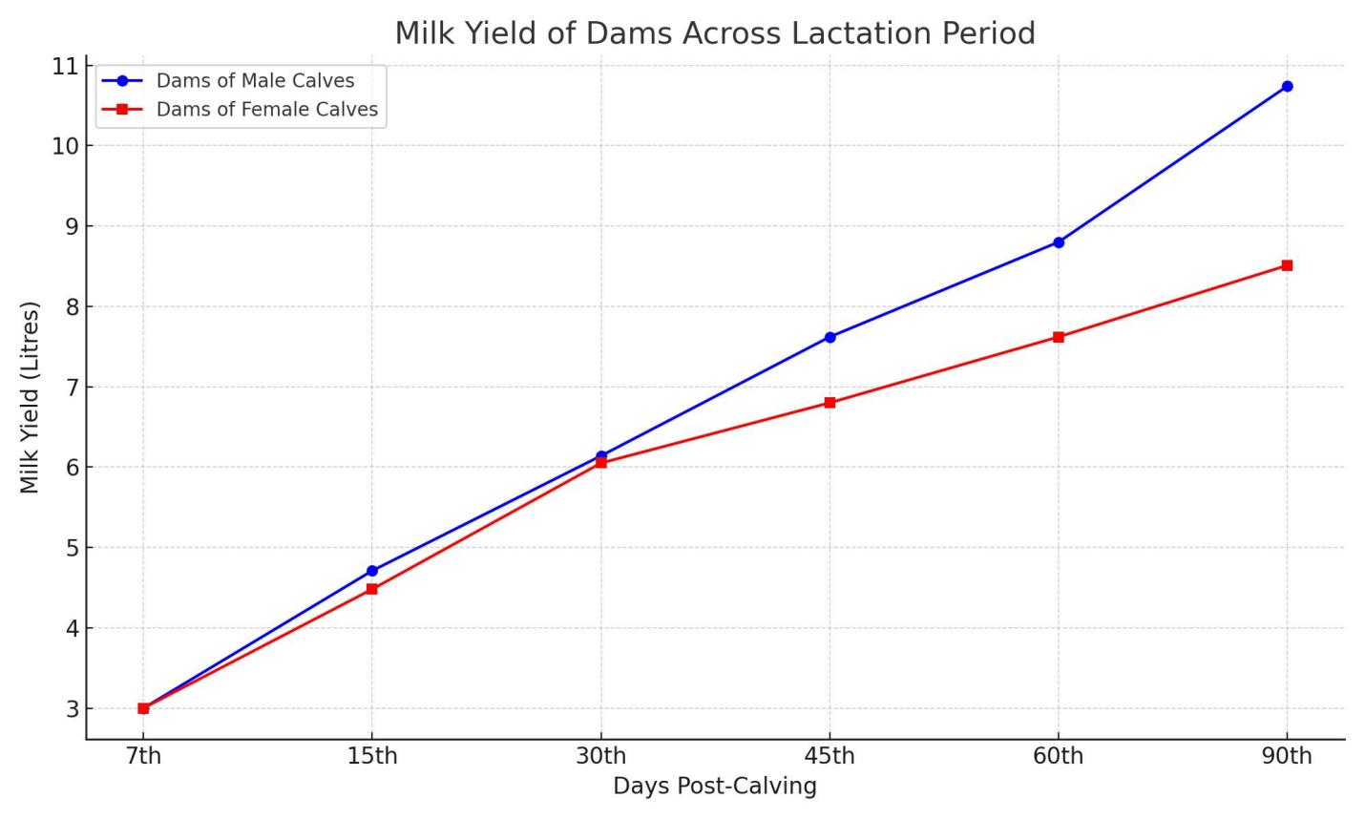

**Fig- 1: Mild Yield of Dams Across Lactation Period**

**3.3 Play Behaviour**

Male calves spent significantly more time playing than females on all observation days (average: 32.74 min vs. 19.52 min, p<0.01). Play is a reliable indicator of calf welfare and energy status. According to Krachun et al. (2010), calves with better milk allowance exhibit more play activity.Recent findings by Nogueira et al. (2021) corroborate our results, suggesting that male calves demonstrate higher physical activity and interaction tendencies due to greater energy availability. Behavioural variation was also reported by Nandini et al. (2024), who observed that males engaged more frequently in running, jumping, and mock fighting activities compared to females, especially under enriched housing conditions.

Interestingly, the pattern of play in male calves often included social play behaviours such as head butting, mounting, and chasing, which are considered indicators of social bonding and future dominance behaviour (Lidfors, 2020). Female calves, although less active, were observed to participate more in exploratory behaviour like sniffing and object manipulation. These distinctions may reflect inherent behavioural tendencies shaped by hormonal and neurological development.

Additionally, environmental enrichment plays a crucial role in enhancing the frequency and complexity of play behaviour. Research by Costa et al. (2022) demonstrated that calves provided with stimulating objects such as brushes, hanging balls, and access to open spaces exhibited more diverse play patterns. Implementing such enrichment in Gir calf management could further improve behavioural expression and welfare outcomes.

**Table no. 3: Mean ± S.E of time spent in play behaviour (min)**

|  |  |  |  |  |
| --- | --- | --- | --- | --- |
| **Days of Observation** | **Male calves (n=7)** | **Female calves (n=7)** | **Overall (n=14)** | **t-value** |
| 30th | **32.14+4.06** | **17.86ab+2.14** | 25.00+2.96 | **3.111\*\*** |
| 60th | **32.86+4.21** | **20.00ab+1.54** | 26.43+2.79 | **2.870\*\*** |
| 90th | **32.50+3.41** | **22.50b+1.12** | 28.21+2.38 | **3.470\*\*** |
| Overall | **32.74±1.46** | **19.52±0.678** | 26.13±1.069 | **3.265\*\*** |
| F-value | 0.119 | **2.760\*** | - | **-** |

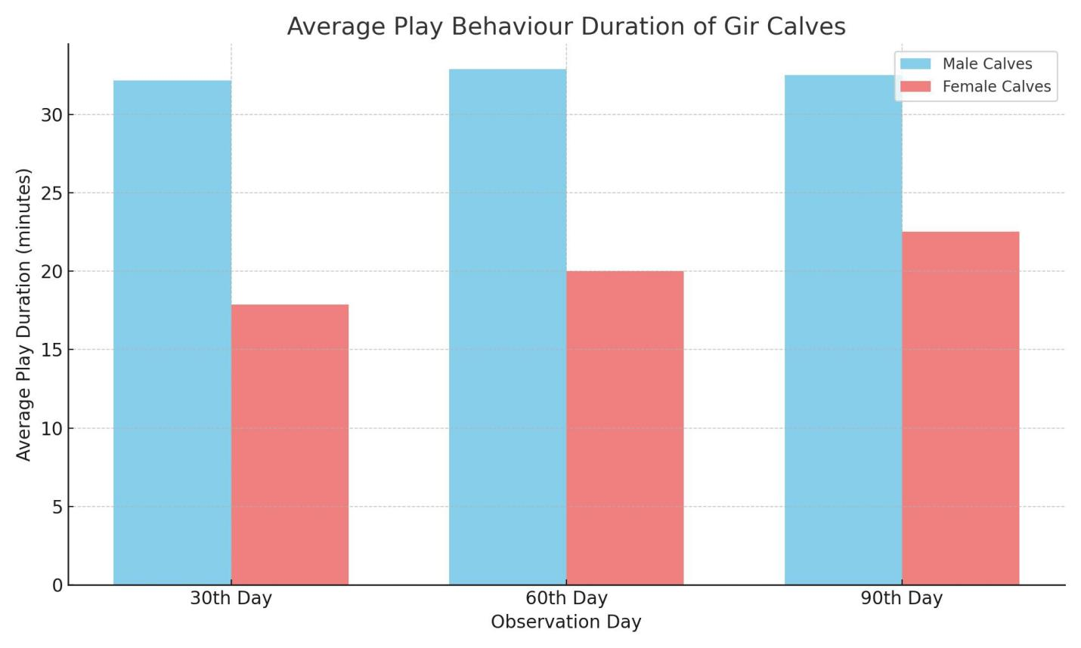

**Fig- 2: Average Play Behaviour Duration of Gir Calves**

**3.4 Dry Matter Intake (DMI)**

Although DMI was numerically higher in female calves, the difference was not statistically significant. Male calves showed a steady increase in DMI, whereas females peaked at 60 days before a slight decline. This may be due to males’ continued dependence on milk, whereas females adapted earlier to TMR feeding (Jasper & Weary, 2002).Our findings align with Gupta et al. (2019), who found similar intake trends in crossbred calves under stall-feeding conditions. A recent study by Menon et al. (2023) suggests that early adaptation to solid feeds in female calves could lead to better rumen development, thereby impacting later-stage feed intake patterns.

**Table No. 4:Mean ± S.E of dry matter intake in calves (DMI):**

|  |  |  |  |
| --- | --- | --- | --- |
| **Observation day** | **DMI male calves** | **DMI female calves** | **t-values** |
| 30th day | 82.28a±10.28 | 97.71a±6.63 | -1.161 |
| 60th day | 145.42a±40.08 | 252b±66.65 | -1.481 |
| 90th day | 222.42b±10.70 | 229.0b±19.52 | -0.280 |
| Overall | 150±0.04±18.62 | 192.90±26.79 | -1.629 |
| F-value | **8.089\*\*** | **4.269\*** |  |

While several studies suggest higher milk yield in dams of female calves and more consistent feed intake patterns in female calves (Hinde et al., 2014; Čačić et al., 2022), our results showed higher milk yield in dams of male calves and greater play activity and weight gain in male Gir calves. These contrasting findings may be attributed to:

1. **Breed-Specific Physiological Responses**: Gir cattle, being an indigenous Zebu breed, may exhibit different hormonal or maternal responses compared to exotic or crossbred dairy cattle used in previous studies.
2. **Management and Environment**: The study site (Shree Surat Panjarapole) implements welfare-enhancing practices such as Panchgavya supplementation and a stress-minimized environment, which may have amplified calf activity and growth.
3. **Calf Behavioural Dynamics**: Male calves may have shown more vigorous suckling and engagement, influencing maternal let-down reflex and consequently milk yield.
4. **Nutritional and Rearing Conditions**: Differences in TMR composition, early suckling, and housing conditions may interact with sex-specific metabolic demands to produce different outcomes than those in intensively managed systems abroad.

These findings suggest that results from one breed or management style may not universally apply. More studies on indigenous breeds under diverse rearing conditions are needed to validate or refine these insights.

**4. Conclusion**

The study highlights significant gender differences in growth and behavioural traits in Gir calves. Male calves demonstrated superior weight gain, more active play behaviour, and their dams yielded more milk. These findings support the development of gender-specific calf management practices. Early identification of such differences can enhance productivity, optimize feeding strategies, and improve calf welfare.

Importantly, this study was conducted at Shree Surat Panjarapole, a charitable trust that is actively involved in sustainable agricultural practices such as biogas production and preparation of Panchgavya-based materials. These environmentally responsible initiatives contribute to the overall welfare of the animals by ensuring a clean, stress-free environment and nutrient-rich feed resources. As a result, the male calves in this setting displayed enhanced growth performance and better play behaviour, likely owing to improved nutritional availability and superior management conditions. The nurturing environment provided by this charitable trust further underscores the importance of integrating welfare-based systems in calf rearing protocols to optimize growth, health, and long-term productivity.

**Disclaimer (Artificial intelligence)**

Option 1:

Author(s) hereby declare that NO generative AI technologies such as Large Language Models (ChatGPT, COPILOT, etc.) and text-to-image generators have been used during the writing or editing of this manuscript.

Option 2:

Author(s) hereby declare that generative AI technologies such as Large Language Models, etc. have been used during the writing or editing of manuscripts. This explanation will include the name, version, model, and source of the generative AI technology and as well as all input prompts provided to the generative AI technology

Details of the AI usage are given below:

1.

2.

3.

**References**

Ahmed, S., Younas, M., & Habib, G. (2020). Gender-specific behaviour and growth performance of buffalo calves. Buffalo Journal, 36(2), 115-120.

Bell, A. W., Greenwood, P. L., & Ehrhardt, R. A. (2009). Regulation of metabolism and growth during prenatal life. In Biology of Metabolism in Growing Animals (pp. 1–26). Elsevier.

Bharti, P. K., et al. (2014). Influence of suckling on weight gain in indigenous calves. *Journal of Dairy Science*, 97(3), 1452–1460.

Čačić, M., Grgić, Z., Špehar, M., & Ivanković, A. (2022). The effect of calf gender on milk lactation traits and lactation gain of Holstein and Simmental cows. *Mljekarstvo*, 72(3), 123–130.

Costa, J. H. C., Cantor, M. C., & Weary, D. M. (2022). Environmental enrichment increases play behavior in dairy calves. Journal of Dairy Science, 105(3), 2301–2308.

Dubey, A., Patel, R., & Joshi, M. (2020). Influence of calf sex on milk yield in Kankrej cows. Indian Journal of Animal Research, 54(10), 1265–1270.

Gaur, G. K., et al. (2003). Indigenous cattle breeds of India—Gir. *National Bureau of Animal Genetic Resources*.

Gupta, A., Mishra, S., & Yadav, S. (2019). Feed intake and growth in crossbred calves under different feeding regimes. Indian Journal of Dairy Science, 72(4), 446–449.

Gillespie, A. V., Ehrlich, J. L., & Grove-White, D. H. (2017). Effect of calf gender on milk yield and fatty acid content in Holstein dairy cows. *PLOS ONE*, 12(1), e0169503.

Hess, M. K., Hess, A. S., & Garrick, D. J. (2016). The effect of calf gender on milk production in seasonal calving cows and its impact on genetic evaluations. *PLOS ONE*, 11(3), e0151236.

Hinde, K., Carpenter, A. J., Clay, J. S., & Bradford, B. J. (2014). Holsteins favor heifers, not bulls: Biased milk production programed during pregnancy as a function of fetal sex. *PLOS ONE*, 9(2), e86169.

Jasper, J., & Weary, D. M. (2002). Effects of ad libitum milk intake on dairy calves. Journal of Dairy Science, 85(11), 3054–3058.

Khan, A. et al. (2020). Nutritional factors influencing calf growth: A review. Veterinary World, 13(7), 1510–1516.

Koirala, B., Sharma, N., & Rai, P. (2023). Birth weight, gender and survival of indigenous calves in Nepal. Journal of Animal Husbandry, 62(1), 78–84.

Krachun, C., Rushen, J., & de Passillé, A. M. (2010). Play behaviour: A potential indicator of animal welfare. *Applied Animal Behaviour Science*, 122(1), 1–7.

Lidfors, L. (2020). The development of social and play behaviours in calves. Animal Behaviour Science, 133(1), 45–52.

Lundy, F. T., Perry, M. J., & Johnston, C. F. (2019). Gender-based immune responses in young calves. Veterinary Immunology and Immunopathology, 210, 11–18.

Menon, M., Das, M., & Rani, S. (2023). Effect of early solid feed on rumen development in heifer calves. Animal Nutrition and Feed Technology, 23(1), 101-108.

Mishra, A., Yadav, J., & Kumar, V. (2022). Gender-based evaluation of growth traits in Indian dairy calves. Indian Journal of Animal Sciences, 92(5), 600–604.

Mutua, E. K., & Haskell, M. J. (2022). Factors contributing to milk yield variation among cows in a cow–calf contact system. *JDS Communications*, 3(1), 55–58.

Nandini, P., Rao, D. S., & Meena, M. (2024). Sex-specific play behaviour in calves under enriched environments. Applied Animal Behaviour Science, 262, 105824.

Nogueira, J., Silva, A. M., & Barreto, L. (2021). Influence of gender and housing on activity budgets in dairy calves. Journal of Dairy Research, 88(4), 408–415. \

Olivera, L. M., et al. (2017). Effects of calf gender on milk production and allosuckling in buffalo cows. *Buffalo Bulletin*, 36(1), 45–52.

Pathak, R., Kumar, S., & Shukla, A. (2021). Comparative growth study of male and female dairy calves. International Journal of Livestock Research, 11(6), 87–92.

Paranhos da Costa, M. J. R., et al. (2000). Suckling behavior in Zebu calves. *Applied Animal Behaviour Science*, 66(1–2), 1–11.

Rawat, P. S., et al. (2014). Suckling behaviour in male and female calves under different rearing systems. *Indian Journal of Animal Sciences*, 84(2), 209–213.

Sharma, S., Rathore, R., & Singh, N. (2023). Integrating behaviour and production data in Indian dairy systems. Journal of Animal Management, 38(1), 13–22.

Verma, N., & Sahu, P. (2022). Effect of fetal sex on milk production: A study of Indian dairy breeds. Animal Reproduction Science, 239, 106935.

Pérez-Barbería, F. J., García, A. J., Brewer, M. J., Cappelli, J., Serrano, M. P., Gallego, L., & Landete-Castillejos, T. (2022). Effects of maternal age and offspring sex on milk yield, composition and calf growth of red deer (Cervus elaphus). Scientific Reports, 12(1), 14506.

Hess, M. K., Hess, A. S., & Garrick, D. J. (2016). The effect of calf gender on milk production in seasonal calving cows and its impact on genetic evaluations. PloS one, 11(3), e0151236.

Gillespie, A. V., Ehrlich, J. L., & Grove-White, D. H. (2017). Effect of calf gender on milk yield and fatty acid content in Holstein dairy cows. PloS one, 12(1), e0169503.

Stěhulová, I., Špinka, M., Šárová, R., Máchová, L., Kněz, R., & Firla, P. (2013). Maternal behaviour in beef cows is individually consistent and sensitive to cow body condition, calf sex and weight. Applied Animal Behaviour Science, 144(3-4), 89-97.