**Soil sampling: Bridging farmer’s knowledge, perception and adoption for sustainable agriculture in Punjab, India**

**ABSTRACT**

Crop yield, nutrient management, and long-term farm sustainability are all impacted by soil health, which is essential to sustainable agriculture. Nevertheless, many farmers continue to rely on traditional knowledge rather than modern soil testing, resulting in uneven fertilization, declining soil fertility, and environmental issues. Due to a lack of accessible testing facilities, low awareness, and cost constraints, soil sampling is not commonly used in rural regions despite its advantages. In this study, 120 farmers from a rural farming community in Punjab were questioned to gauge their awareness, expertise, and readiness to use soil sampling. Farmers were first evaluated for their knowledge and practices as part of a before-and-after educational intervention strategy. After watching an educational video about appropriate sampling methods and managing soil health, they were given an after-video questionnaire to gauge their level of understanding and readiness to do soil sampling. The findings revealed that although 95% of farmers knew about soil sampling, just 31.7% knew well about the soil sampling methods. Following the video, 80% of respondents indicated interest in implementing soil sampling, compared to 38.3% who had done so before the intervention. 98.3% of respondents thought the video was helpful, indicating very high effectiveness. Financial limitations and a shortage of testing facilities, however, continue to be problems. In order to close the knowledge gap and advance scientific soil health management, this study emphasizes the value of educational initiatives. Adoption of soil sampling can be accelerated and sustainable agricultural practices ensured in rural communities by fortifying support networks with government-backed initiatives, mobile soil labs, and financial incentives.

***Keywords:*** *Soil sampling; Farmer awareness; Sustainable agriculture; Nutrient management*

**1. INTRODUCTION**

With an estimated 33% of the world's soils already damaged as a result of erosion, nutrient depletion, and unsustainable farming practices, soil degradation has emerged as a critical global concern (FAO, 2021). Nearly 58% of the population depends on agriculture for their livelihoods, and it accounts for 18.3% of the nation's Gross Value Added (GVA) (Ministry of Agriculture & Farmers Welfare, 2023). Agriculture is the foundation of the Indian economy. With reports showing that over 120 million hectares of land in India experience a reduction in soil fertility as a result of inadequate nutrient management and excessive use of chemical fertilizers, soil degradation is still a major problem (ICAR, 2022). Although Punjab, dubbed the "Granary of India," makes a substantial contribution to the country's food supply, excessive monoculture practices are causing its soil fertility to decline, with approximately 75% of its soil showing shortages in micronutrients and nitrogen (PAU, 2023). To evaluate soil fertility and make well-informed decisions about fertilization and soil management, soil sampling is an essential tool (Singh *et al.,* 2020). Despite its importance, a lot of farmers show little knowledge, erroneous opinions, or resistance to using soil sample techniques. Promoting scientifically informed agricultural methods requires an understanding of farmers' perceptions, knowledge, and adoption patterns (Verma & Gupta, 2018).

The purpose of this study is to evaluate how Punjab farmers' awareness and acceptance of soil sampling are affected by focused educational interventions. To assess behavioural changes and knowledge improvement, a systematic three-phase technique was used. A before video assessment survey was used in the first phase to gather baseline data to determine farmers' preexisting knowledge and attitudes about soil sampling. A video demonstration outlining the steps, advantages, and real-world uses of soil sampling was used as an educational tool in the second phase. To gauge knowledge acquisition, perceptual changes, and possible adoption of soil sampling techniques, an after-video assessment was carried out in the last stage.

This study sheds light on how well educational tactics work to close the knowledge gap and promote the use of soil sampling by comparing responses from before and after the intervention. By emphasizing the impact of awareness campaigns on farmers' decision-making, the findings add to the larger conversation on sustainable agriculture methods. This study emphasizes the necessity of ongoing knowledge-sharing initiatives to improve soil health management and advance sustainable agriculture in Punjab.

**2. METHODOLOGY**

**2.1 Study area and sample selection**

The research was carried out in the Punjab agricultural villages of Khant (Fatehgarh sahib), Kajouli (Rupnagar), Manpur (Fatehgarh sahib), Kotli (Rupnagar), Bari Rauni (Rupnagar), and Chhoti Rauni (Rupnagar) (Fig 1) (Table 1). The chosen village is representative of a typical farming community whose sustainable crop production is largely dependent on the condition of the soil. Farmers' decisions about soil management techniques and soil fertility are impacted by the region's seasonal variations. To ensure an appropriate representation of various agricultural experiences, landholding sizes, and degrees of knowledge about soil sample methods, a random sampling procedure was used.

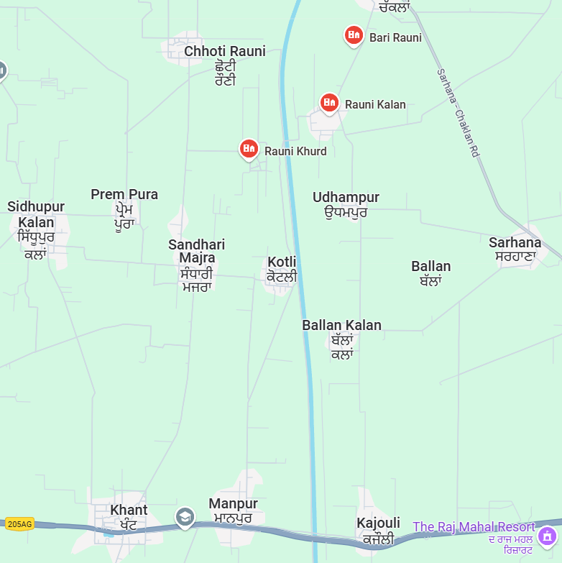 **Fig 1. Cartographic representation of the experimental villages**

**Table 1. List of villages covered in the research (Punjab)**

|  |  |  |  |  |
| --- | --- | --- | --- | --- |
| **Village** | **Tehsil** | **District** | **Pin code** | **Total geographical area of the village (hectares)** |
| Khant | Khamanon | Fatehgarh sahib | 140101 | 252 |
| Kajouli | Morinda | Rupnagar | 140101 | 184 |
| Manpur | Khamanon | Fatehgarh sahib | 140101 | 149 |
| Kotli | Morinda | Rupnagar | 140102 | 53 |
| Bari Rauni | Chamkaur sahib | Rupnagar | 140108 | 135 |
| Chhoti rauni | Chamkaur sahib | Rupnagar | 140108 | 73 |

**2.2 Data collection method**

A survey with a structured questionnaire was used to gather the primary data. Numerous facets of soil sampling adoption, knowledge, and its influence on farming practices were included in the questionnaire. To measure awareness levels before and after delivering educational content on soil sampling, the survey was split into two sections before and after watching the video.

Farmers were questioned about their prior experiences with soil sampling, their current understanding of the practice, and its significance for crop productivity before watching the video. Included were inquiries on the difficulties they have while implementing soil sample procedures, such as ignorance, equipment shortages, and budgetary limitations.

Farmers watched a brief instructional video that described the correct way to sample soil, its advantages, and the best ways to increase farm output. Topics including sampling depth, necessary equipment, sampling frequency, and typical errors to avoid were all covered in the video.

Farmers were asked the same questions again after watching the video to gauge their level of understanding improvement, and they were asked to rate their knowledge on a scale of 1 to 10, indicating how much they learned from the video. They were also asked if they would be willing to use soil sampling on their farms in the future.

**3. RESULTS AND DISCUSSION**

**3.1 Farmers' soil sampling awareness and knowledge**

In order to gauge farmers' awareness and understanding of soil sample procedures, the study evaluated 120 farmers. According to the findings, 95% farmers of the total knew about soil sampling, whereas only 5% farmers did not (Fig 2) (Table 2).

**Table 2. Soil sampling questionnaire before watching educational content**

|  |  |  |  |
| --- | --- | --- | --- |
| **Questions before video** | **Yes** | **No** | **Partially** |
| Have you ever heard about soil sampling? | 114 | 6 | 0 |
| Do you think soil testing is important for improving crop productivity? | 99 | 1 | 20 |
| Have you ever conducted soil sampling on your farm? | 38 | 75 | 7 |
| Do you know how to collect a soil sample correctly? | 46 | 54 | 20 |
| Do you think soil sampling can reduce input costs and improve yields? | 78 | 4 | 38 |
| Are you aware of government schemes or organizations that offer soil testing services? | 3 | 39 | 78 |

**Fig 2. The proportion of farmers aware of soil sampling in the surveyed village.**

But when we looked more closely, we found that only 31.7% farmers knew everything there was to know about soil sample methods, 5.8% farmers knew a little, and a significant 62.5% farmers did not know anything at all (Fig 3). This discrepancy implies that although there is a high level of broad awareness, the farming community lacks technical know-how and in-depth comprehension.

**Fig 3. Farmers in rural areas who have previously conducted soil sampling as part of their agricultural practices.**

Before any educational interventions, 16.7% farmers stated that they intended to do soil sampling in the future, 38.3% farmers had done so in the past, and 45% farmers had not (Fig 4). These numbers demonstrate a moderate amount of previous soil sampling engagement, suggesting room for growth through focused educational initiatives.

**Fig 4. Farmer’s prior knowledge of soil sampling.**

**3.2 Effect of educational videos on the adoption of soil sampling**

**Table 3. Soil sampling questionnaire after watching educational content**

|  |  |  |  |
| --- | --- | --- | --- |
| **Questions after video** | **Yes** | **No** | **Partially** |
| Did the video help you understand the importance of soil sampling? | 118 | 3 | 0 |
| Do you understand how to take a soil sample correctly? | 112 | 0 | 8 |
| Do you understand the conditions under which soil sampling is done? | 108 | 2 | 10 |
| Do you understand the common mistakes during soil sampling? | 102 | 4 | 14 |
| After watching the video, are you interested in adopting soil sampling techniques on your farm? | 96 | 4 | 20 |

To improve the farmers' comprehension of soil sample methods and their advantages, an instructional video was shown to them. According to post-intervention evaluations, 98.3% farmers thought the video was helpful, compared to just 1.7% farmers, who did not (Fig 5) (Table 3). This overwhelmingly positive response demonstrates how effective visual learning resources are in simplifying complicated agricultural processes (Patel *et al.,* 2021). ​

**Fig 5. Farmer’s knowledge enhancement after watching the soil sampling educational video**

Additionally, after the video intervention, 16.7% farmers thought about implementing soil sampling techniques in the future, 3.3% farmers were hesitant to do so, and 80% farmers indicated a clear desire to do so (Fig 6). This change suggests that farmers' attitudes and intentions can be effectively influenced by educational interventions, as it shows a notable increase in willingness to conduct soil sampling.

**Fig 6. Farmer’s interest in adopting soil sampling practices.**

**3.3 Obstacles to soil sampling practice adoption**

A number of obstacles to the broad use of soil sampling were found, notwithstanding the beneficial effects of the educational intervention (Reimer *et al.,* 2012). Farmers identified a lack of professional assistance, financial limitations, and restricted access to soil testing facilities as major obstacles (Ranjan *et al.,* 2019). These results are in line with previous research that highlights the necessity of resources and supportive infrastructure to encourage the adoption of soil health management techniques (Sharma *et al.,* 2019).

**4. CONCLUSION**

In conclusion, even though a sizable portion of farmers are aware of soil sampling, there is a noticeable lack of thorough knowledge and real-world implementation of these methods. The application of educational interventions has been successful in increasing farmers' knowledge and cultivating a favourable attitude toward implementing soil sampling techniques, especially when done through visual aids like instructional videos. However, obstacles like restricted access to soil testing facilities, budgetary limitations, and a lack of professional assistance still prevent widespread use. It is crucial to remove these obstacles by establishing easily available soil testing services, offering financial incentives, and providing ongoing educational support. By taking a comprehensive strategy that incorporates policy assistance, infrastructure development, and education, we can enable farmers to make well-informed decisions that will enhance soil health management and sustain agricultural productivity.

**DISCLAIMER (ARTIFICIAL INTELLIGENCE)**

Author(s) hereby declare that No generative AI technologies and text-to-image generators have been used during writing or editing of this manuscript.

**REFERENCE**

Food and Agriculture Organization of the United Nations. (2021). *Status of the world's soil resources*. FAO.

Indian Council of Agricultural Research (ICAR). (2022). *Status of soil health and fertility management in India* (ICAR Annual Report). Retrieved from <https://icar.org.in>

Ministry of Agriculture & Farmers Welfare. (2023). *Agricultural statistics at a glance*. Government of India. Retrieved from <https://agricoop.nic.in>

Patel, S., Sharma, A., & Verma, K. (2021). Effectiveness of video-based learning in promoting soil sampling practices among farmers. *International Journal of Agricultural Extension, 9*(2), 102-115.

Punjab Agricultural University (PAU). (2023). *Soil fertility status in Punjab*.

Ranjan, P., Church, S. P., Floress, K., & Prokopy, L. S. (2019). Synthesizing conservation motivations and barriers: What have we learned from qualitative studies of farmers' behaviors in the United States? *Society & Natural Resources, 32*(11), 1171-1199. <https://doi.org/10.1080/08941920.2019.1648710>

Reimer, A. P., Weinkauf, D. K., & Prokopy, L. S. (2012). The influence of perceptions of practice characteristics: An examination of agricultural best management practice adoption in two Indiana watersheds. *Journal of Rural Studies, 28*(1), 118-128. <https://doi.org/10.1016/j.jrurstud.2011.10.002>

Sharma, P., Yadav, R., & Gupta, N. (2019). Challenges in soil testing adoption: A case study from rural India. *Indian Journal of Soil Science, 67*(1), 29-42.

Singh, V., Kumar, S., & Chauhan, A. (2020). The role of soil testing in improving fertilizer use efficiency and crop productivity. *Advances in Agronomy, 110*, 55-72. <https://doi.org/10.1016/bs.agron.2020.01.003>

Verma, S., & Gupta, D. (2018). Factors influencing farmers' reluctance toward soil testing and nutrient management. *International Journal of Agricultural Extension, 12*(4), 55-69.