**Investigating the Synergistic Effects of Biofertilizers, Micronutrients and Biostimulants on Fruit Quality of Strawberry *Cv.* Nabila**

**ABSTRACT**

Strawberry (Fragaria × ananassa) is a high-value fruit crop with substantial economic and nutritional benefits. This study assesses how nutrient and biostimulant management influences the quality of strawberry cv. 'Nabila' grown in the Nilgiris of TamilNadu. A factorial experiment was carried out to evaluate the effect of combinations of biofertilizers, micronutrients, and biostimulants on fruit quality parameters of strawberry. The findings revealed that treatments including Arbuscular Micorhizal Fungi (AMF) and potassium-solubilizing bacteria (KSB), as well as a micronutrient mix (0.6%) with humic acid (1%) and seaweed extract (1%), greatly increased fruit production and quality. This combination resulted in higher total soluble solids, total phenols, and titratable acidity. An **integrated nutrient management strategy,** incorporating **AMF and KSB** in combination with **micronutrients and biostimulants such as humic acid and seaweed extract,** presents a promising approach to improving both the **quality and post-harvest attributes of strawberries.** Additionally, the adoption of such a **bio-enhanced fertilization approach** promotes **soil health, reduces reliance on synthetic inputs, and aligns with environmentally sustainable agricultural practices.**

**Keywords:** Strawberry, biostimulant, micronutrient, biofertilizer, Fruit quality

**INTRODUCTION**

Strawberry (Fragaria × ananassa Duch.) is a widely popular and delicious fruit belonging to the Rosaceae family. The edible portion of this aggregate fruit consists of a fleshy thalamus containing multiple achenes. Optimal growth conditions for strawberries include daytime temperatures of 22–23°C and nighttime temperatures of 7–13°C. The plant thrives best in sandy loam soil with a pH range of 5.5–6.5 (Chandrakar *et al.,* 2019). Due to their exceptional flavor and high nutritional value, strawberries are in great demand in both fresh markets and the processing industry. Fresh, ripe strawberries contain moderate levels of vitamin A (60 IU) and vitamin C (30–120 mg per 100 g of the edible portion) (Jain *et al.,* 2017). In India, strawberry cultivation covers approximately 1000 hectares, yielding around 5000 metric tons annually (Anonymous, 2016). Initially, cultivation was restricted to temperate regions like Himachal Pradesh and Jammu & Kashmir, but advancements in varietal development and agro-techniques have enabled expansion into non-traditional regions across the country (Sharma and Sharma, 2004). Currently, strawberries are cultivated on 600 hectares, producing around 4300 metric tons, catering to both domestic and export markets (Anonymous, 2018).

Micronutrients play a crucial role in plant growth, acting as catalysts in various physiological and biochemical processes. Their deficiency often limits fruit crop productivity. Zinc sulfate and boric acid applications have been shown to increase fruit yield, while molybdenum improves fruit quality. Higher concentrations of zinc sulfate can enhance fruit shelf life at ambient temperatures, whereas excessive boric acid can be toxic, negatively affecting growth, yield, and quality. Traditionally, micronutrients were considered non-essential, as soils naturally supplied these trace elements. However, intensive farming practices, soil pH increases, and salinity buildup have led to reduced nutrient availability (Ahmad *et al.,* 2010). Copper and zinc deficiencies can result in stunted growth and chlorosis, respectively (Zewail *et al.,* 2020). Research has demonstrated that foliar application of micronutrients significantly improves plant growth, yield, and fruit quality by enhancing nutrient efficiency and reducing losses (Sangeeta *et a*l., 2019). In particular, iron and zinc applications have been found to boost both the quantity and quality of fruit crops (Shanker *et al.,* 2019).

The foliar application of biostimulants, such as humic acid (HA) and seaweed extract (SWE), is an effective long-term strategy for improving crop productivity while maintaining fruit quality. Humic acid is a major source of organic carbon, formed through the chemical and biological decomposition of plant and animal matter driven by microbial activity. It enhances plant development by regulating the carbon and nitrogen cycles in the soil and contributes significantly to soil structure improvement (Canellas *et al.,* 2015).

Seaweed extract (SWE) is rich in complex polysaccharides, fatty acids, phytohormones, vitamins, and essential minerals such as phosphorus (P), potassium (K), calcium (Ca), magnesium (Mg), copper (Cu), iron (Fe), manganese (Mn), and zinc (Zn) (Bhattacharyya *et al*., 2015). Both humic acid and seaweed extract significantly enhance crop growth and fruit quality, making them widely used in horticulture, particularly for fruit crops. These biostimulants can be applied to both leaves (foliar application) and soil (root application).

Biofertilizers are natural products containing live microorganisms that improve plant growth without negatively affecting soil health or the environment (Kumar *et al.,* 2015). These beneficial microbes can exist freely in the soil or establish symbiotic relationships with plants, thereby enhancing nitrogen and phosphorus availability. Studies indicate that biofertilizers can boost crop yields by 15–30% (Singh et al., 2015). Research suggests that combining biofertilizers (such as Arbuscular Mycorrhizal Fungi (AMF) and Potassium Solubilizing Bacteria (KSB)) with micronutrients and biostimulants can significantly improve strawberry growth, productivity, and quality across diverse agro-climatic conditions (Kumar *et al.,* 2019).

**MATERIALS AND METHODS**

**Experimental Site and Planting Material**

The study was conducted at a strawberry farm in Masakal, Nilgiris, Tamil Nadu. The farm is situated at an elevation of 1000–2600 meters above MSL, experiencing temperatures between 10–25°C in summer and 0–20°C in winter, with rainfall from both the Southwest and Northeast monsoons. Runner plants of Strawberry cv. Nabila was procured from Kotagiri, Nilgiris, from an experimental location.

The site was cleaned and levelled by removing stones and rubbish, and raised beds (45 cm high and 60 cm wide) were prepared. A drip irrigation system was set up at 30 cm intervals, delivering water at a rate of 3 L/h. The experiment used a Factorial Completely Randomised Design (FCRD) with three replications. 4 weeks old seedling of Nabila were planted in nursery beds at a spacing of 30 x 30 cm. NPK was applied at recommended dose of with 100:100:80 kg/ha basal dose and top dressing was given at 30 days interval.

Total soluble solids (TSS) were measured using a hand refractometer to determine biochemical parameters. The research also assessed ascorbic acid (AA), total sugars (TS), and titratable acidity (TA) using AOAC procedures. The Folin-Ciocalteu reagent procedure (Bray and Thrope, 1954) was used to calculate total phenol. The data was checked for variance, and the least significant differences were arranged to compare significant effects at the 5% level (Snedecor and Cochran, 1967).

**Nutrient Solution Preparation:**

* Humic Acid (2%): 35 ml HA dissolved in 965 ml water.
* Seaweed Extract (2%): 66 ml SWE in 934 ml water.
* Micronutrient Solution (0.3%): 0.75 g each of boron, zinc, iron, and copper in 1 L water.
* Micronutrient Solution (0.6%): 1.5 g each of boron, zinc, iron, and copper in 1 L water.

**Table 1. Treatment combinations of biofertilizers, micronutrient blends, and biostimulants used in the study**

|  |  |  |
| --- | --- | --- |
| **S. No.** | **Treatment** | **Combination** |
| 1 | A1B1C1 | No Biofertlizer, Micronutrient blend (0.4%), No Biostimulant |
| 2 | A1B1C2 | No Biofertilizer, Micronutrient blend (0.4%), Humic acid (2%) |
| 3 | A1B1C3 | No Biofertlizer, Micronutrient blend (0.4%), Seaweed extract (2%) |
| 4 | A1B1C4 | No Biofertlizer, Micronutrient blend (0.4%), Humic acid (1%) + Seaweed extract (1%) |
| 5 | A1B2C1 | No Biofertlizer, Micronutrient blend (0.6%), No Biostimulant |
| 6 | A1B2C2 | No Biofertlizer, Micronutrient blend (0.6%), Humic acid (2%) |
| 7 | A1B2C3 | No Biofertlizer, Micronutrient blend (0.6%), Seaweed extract (2%) |
| 8 | A1B2C4 | No Biofertlizer, Micronutrient blend (0.6%), Humic acid (1%) + Seaweed extract (1%) |
| 9 | A2B1C1 | AMF+KSB, Micronutrient blend (0.4%), No Biostimulant |
| 10 | A2B1C2 | AMF+KSB, Micronutrient blend (0.4%), Humic acid (2%) |
| 11 | A2B1C3 | AMF+KSB, Micronutrient blend (0.4%), Seaweed extract (2%) |
| 12 | A2B1C4 | AMF+KSB, Micronutrient blend (0.4%), Humic acid (1%) + Seaweed extract (1%) |
| 13 | A2B2C1 | AMF+KSB, Micronutrient blend (0.6%), No Biostimulant |
| 14 | A2B2C2 | AMF+KSB, Micronutrient blend (0.6%), Humic acid (2%) |
| 15 | A2B2C3 | AMF+KSB, Micronutrient blend (0.6%), Seaweed extract (2%) |
| 16 | A2B2C4 | AMF+KSB, Micronutrient blend (0.6%), Humic acid (1%) + Seaweed extract (1%) |

**RESULTS AND DISCUSSION**

**Ascorbic Acid (AA)**

The effect of biofertilizers, micronutrients, and biostimulants on the ascorbic acid concentration of the fruit was not statistically significant at the 5% level, as shown in Table 2. This suggests that intrinsic plant metabolism, environmental conditions, and genetic factors may have a more substantial influence on ascorbic acid accumulation in strawberries than the combined application of these inputs. Overall, treatments with micronutrient concentration (B₂ 0.6%) and biostimulant treatment (C₄) – humic acid + seaweed extract resulted in slightly higher ascorbic acid levels (Fig. 1). This may be attributed to the role of micronutrients in enhancing enzymatic activity associated with antioxidant synthesis, leading to improved ascorbic acid retention. In contrast, treatments without biostimulants exhibited lower ascorbic acid levels (Fig. 1), indicating that while individual components may contribute, their combined effect does not significantly influence ascorbic acid production.

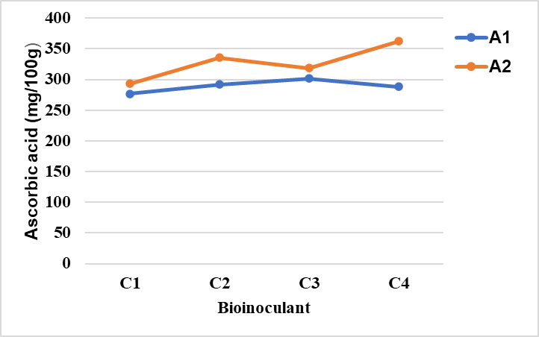

**Fig. 1. Interaction effect of Factor A (Biofertilizer) and Factor C(Biostimulant) on Ascorbic Acid content**

A1- No Biofertilizer, A2- AMF+KSB

C1 - No Bioinoculants, C2- Humic acid (2%), C3- Seaweed extract (2%), C4- Humic acid (1%) + Seaweed extract (1%)

**Total Soluble Solids (TSS)**

The three-factor interaction had a significant effect on TSS levels. The highest TSS (10.87 °Brix) was observed in A₂B₁C₄ (AMF + KSB, micronutrient mix 0.4%, humic acid 1%, and seaweed extract 1%), followed by A₂B₂C₄. In contrast, the lowest TSS (7.63 °Brix) was recorded in A₁B₂C₁ (no AMF + KSB, micronutrient mix 0.6%, no biostimulant). These results suggest that the combined effect of biofertilizers and biostimulants enhanced sugar metabolism, leading to higher TSS levels, as shown in Fig. 2a and 2b. This aligns with previous studies indicating that biofertilizers improve nutrient uptake and carbohydrate accumulation, thereby increasing TSS content in crops like strawberries (Shanker *et al*., 2019). The improvement in TSS levels may be attributed to enhanced photosynthetic efficiency and better sugar translocation from leaves to developing fruits, facilitated by biostimulants and micronutrients.

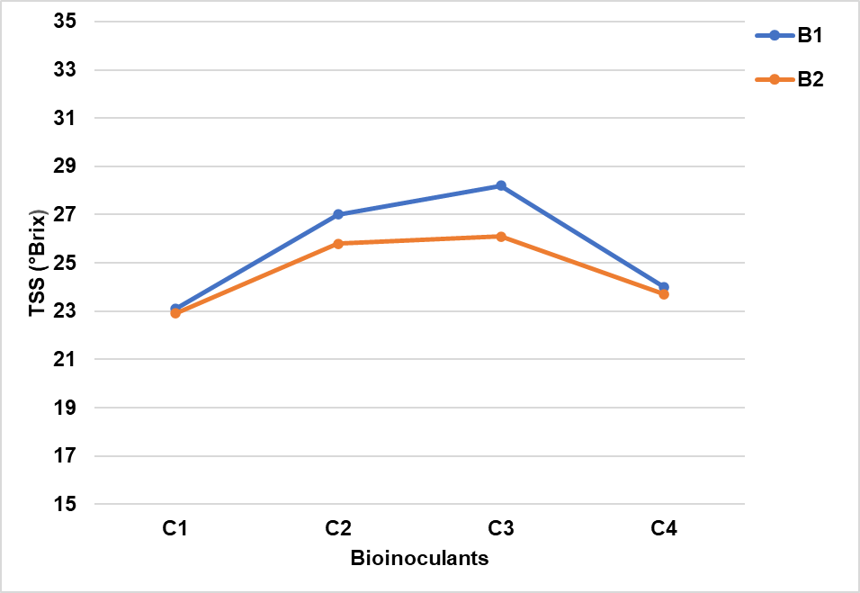 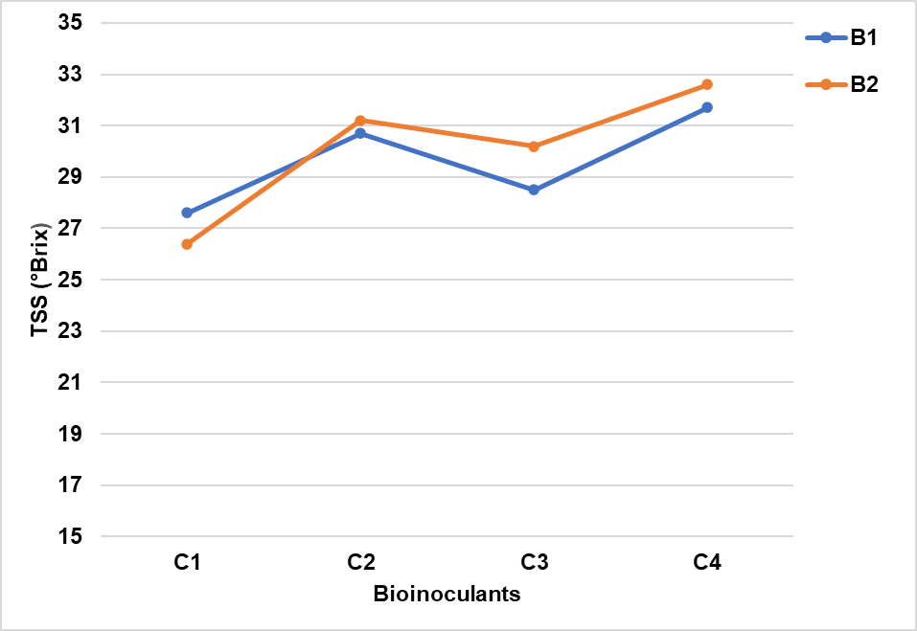

A1- No Biofertilizer, A2- AMF+KSB, B1-Micronutreint 04%, B2- Micronutreint 0.6%

C1 - No Bioinoculants, C2- Humic acid (2%), C3- Seaweed extract (2%), C4- Humic acid (1%) + Seaweed extract (1%)

**Fig. 2b. Interaction effect of factor A2 x (B x C) on TSS**

**Fig. 2a. Interaction effect of factor A1 x (B x C) on TSS**

**Total Phenols (TP)**

A significant interaction effect was observed on total phenolic content, as presented in Table 2. The highest concentration of total phenols was recorded in the treatment combination A₂B₂C₄ (AMF + KSB, micronutrient blend 0.6%, humic acid 1% + seaweed extract 1%), measuring 352.12 mg per 100g, followed by A₂B₂C₃ (AMF + KSB, micronutrient blend 0.6%, seaweed extract 2%) at 322.72 mg per 100g. This indicates that the combination of AMF and KSB, along with a higher micronutrient concentration (0.6%) and seaweed extract application, significantly boosted phenolic compound synthesis (Fig. 3a and 3b). These findings are consistent with Zewail *et al.* (2020), who reported that foliar applications of micronutrients and biofertilizers enhance phenolic content by stimulating enzymatic activity involved in the production of secondary metabolites. The increased phenolic content may also contribute to improved antioxidant properties, thereby enhancing the shelf life and nutritional quality of the fruits. Among the treatment combinations, the lowest phenol content (99.60 mg per 100g) was found in A₂B₁C₃ (AMF + KSB, micronutrient blend 0.4%, seaweed extract 2%), despite incorporating all three components.

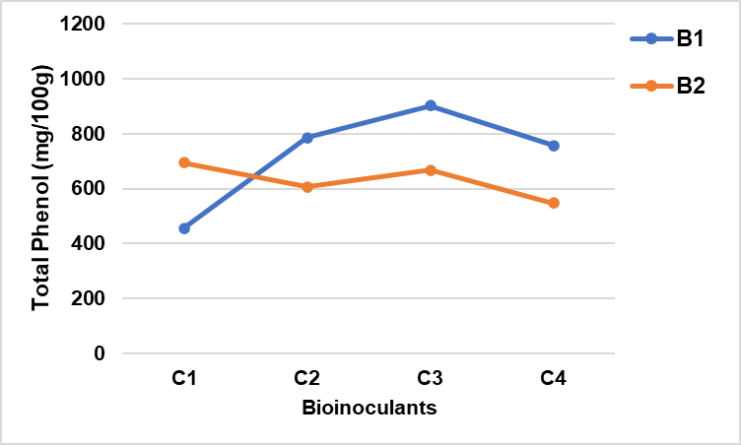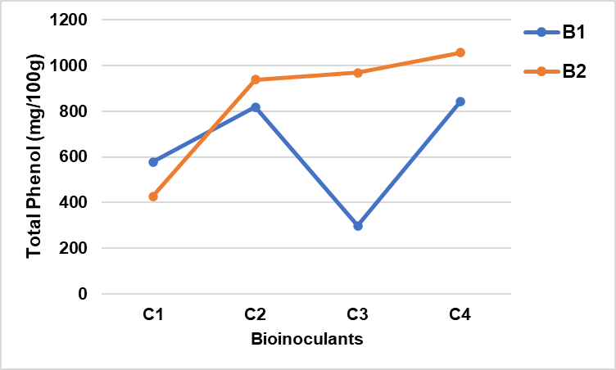

A1- No Biofertilizer, A2- AMF+KS, B1-Micronutreint 04%, B2- Micronutreint 0.6%

C1 - No Bioinoculants, C2- Humic acid (2%), C3- Seaweed extract (2%), C4- Humic acid (1%) + Seaweed extract (1%)

**Fig. 3b. Interaction effect of factor A2 x (B x C) on TP**

**Fig. 3a. Interaction effect of factor A1 x (B x C) on TP**

**Titratable Acidity (TA)**

Titratable acidity is a key factor influencing both the flavor and shelf life of fruits. Significant variations in acidity levels were observed among the different treatments (Table 2). The highest acidity level (0.867%) was recorded in A₂B₂C₄ (AMF + KSB, micronutrient blend 0.6%, humic acid 1% + seaweed extract 1%), followed by A₁B₂C₁ (No AMF + KSB, micronutrient blend 0.6%, no biostimulant) at 0.860%. The lowest acidity (0.593%) was observed in A₁B₁C₁ (No AMF + KSB, micronutrient blend 0.4%, no biostimulant) as shown in Fig. 4a and 4b. These findings highlight the critical role of nutrient availability and biostimulants in maintaining organic acid levels, which are essential for enhancing fruit flavor and extending post-harvest shelf life. Similar results were reported by Ahmad *et al.* (2010), who found that micronutrient application improves pH balance and acid metabolism in fruit crops. The presence of organic acids contributes to the characteristic tartness of strawberries, which can be regulated through optimal nutrient balance and the stress tolerance effects provided by biostimulants and seaweed extracts.

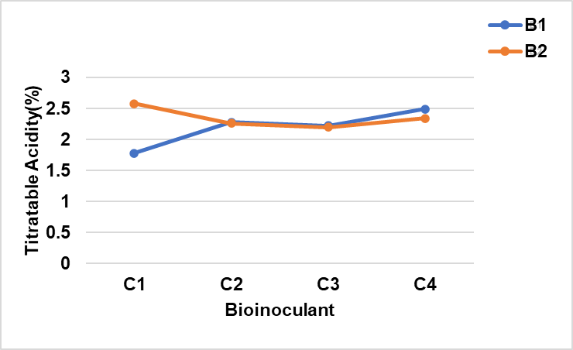 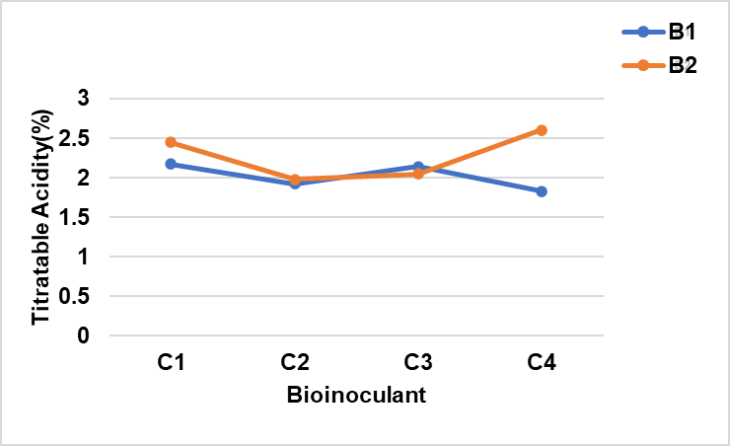

A1- No Biofertilizer, A2- AMF+KSB, B1-Micronutreint 04%, B2- Micronutreint 0.6%

C1 - No Bioinoculants, C2- Humic acid (2%), C3- Seaweed extract (2%), C4- Humic acid (1%) + Seaweed extract (1%)

**Fig. 4b. Interaction effect of factor A2 x (B x C) on TA**

**Fig. 4a. Interaction effect of factor A1 x (B x C) on TA**

**Total sugars (TS)**

The three-way interaction for total sugar content was not statistically significant, suggesting that the combined effects of biofertilizers, micronutrients, and biostimulants did not have a substantial impact on sugar accumulation (Table 2). However, the two-way interaction between biofertilizers and biostimulants was significant, with higher sugar content observed in treatments involving AMF + KSB across all levels of biostimulants (Fig. 6). Treatments incorporating a micronutrient blend (0.6%) along with biostimulants such as humic acid and seaweed extract showed slightly higher sugar levels (Fig. 5). These results indicate that while individual components may contribute to sugar synthesis, their combined effects remain limited. Sugar accumulation is largely influenced by photosynthesis, genetic regulation, and ripening processes. The minor variations in total sugar levels observed in some treatments could be attributed to enhanced enzymatic activities that regulate carbohydrate metabolism, leading to increased sugar content.

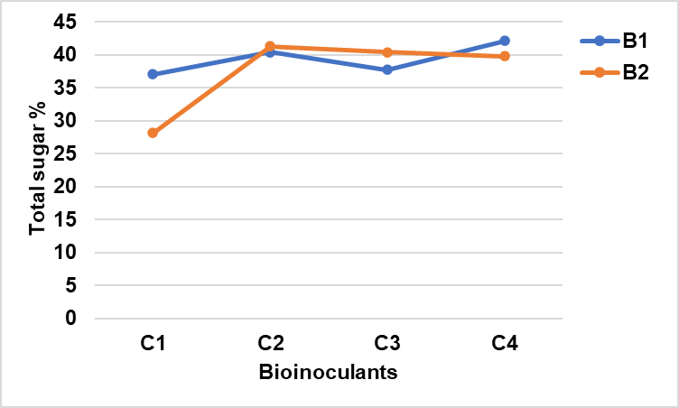 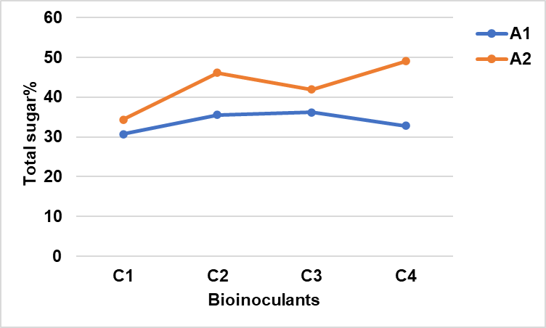

A1- No Biofertilizer, A2- AMF+KSB, B1-Micronutreint 04%, B2- Micronutreint 0.6%

C1 - No Bioinoculants, C2- Humic acid (2%), C3- Seaweed extract (2%), C4- Humic acid (1%) + Seaweed extract (1%)

**Fig. 6. Interaction effect of Factor A (Biofertilizer) and Factor C (Biostimulant) on TS**

**Fig. 5. Combined influence of Factor B (Micronutreint) and Factor C (Biostimulant) on TS**

**Table 2. Evaluation of fruit quality parameters of strawberry for the various treatment combinations**

|  |  |  |  |  |  |
| --- | --- | --- | --- | --- | --- |
| Treatment | Ascorbic Acid (mg/100g) | TSS (°Brix) | Phenol (mg/100g) | Titratable Acidity (%) | Total Sugar (%) |
| Factor A (Biofertilizers) | | | | | |
| A1 | 48.27 b | 9.81a | 225.63b | 0.76a | 7.09a |
| A2 | 54.59a | 8.50b | 246.89a | 0.71b | 5.77b |
| SE(d) | 0.709 | 0.066 | 1.21 | 0.005 | 0.13 |
| CD @5% | 1.44 | 0.134 | 2.464 | 0.01 | 0.265 |
| Factor B (Micronutrients) | | | | | |
| B1 | 52.28a | 9.37a | 246.02a | 0.70b | 6.68a |
| B2 | 50.45b | 8.94b | 226.51b | 0.76a | 6.18b |
| SE(d) | 0.709 | 0.066 | 1.21 | 0.008 | 0.13 |
| CD @5% | 1.443 | 0.134 | 2.462 | 0.016 | 0.265 |
| Factor C (Biostimulants) | | | | | |
| C1 | 47.98c | 9.55a | 179.73d | 0.74b | 6.80a |
| C2 | 52.29ab | 9.41ab | 262.32b | 0.70c | 6.72a |
| C3 | 51.69b | 9.33b | 236.24c | 0.71c | 6.50a |
| C4 | 54.22a | 8.33c | 266.75a | 0.77a | 5.69b |
| SE(d) | 0.98 | 0.093 | 1.711 | 0.011 | 0.184 |
| CD @5% | 1.998 | 0.189 | 3.485 | 0.023 | 0.374 |
| Interaction A x B (Biofertilizers x Micronutrients) | | | | | |
| SE(d) | NS | 0.093 | 1.711 | 0.011 | NS |
| CD @5% | NS | 0.189 | 3.485 | 0.023 | NS |
| Interaction B x C (Micronutrients x Biostimulants) | | | | | |
| SE(d) | NS | 0.131 | 2.419 | 0.016 | 0.26 |
| CD @5% | NS | 0.267 | 4.928 | 0.032 | 0.529 |
| Interaction C x A (Biostimulants x Biofertilizers) | | | | | |
| SE(d) | 1.417 | 0.131 | 2.419 | 0.016 | 0.26 |
| CD @5% | 2.887 | 0.267 | 4.928 | 0.032 | 0.529 |
| Interaction A x B x C (Biofertilizers x Micronutrients x Biostimulants) | | | | | |
| SE(d) | NS | 0.186 | 3.422 | 0.022 | NS |
| CD @5% | NS | 0.378 | 6.97 | 0.045 | NS |

*NS – Not Significant at 0.05 level*

*Treatment combinations with same letters are non - significantly different*

*LSD (Least Significant Difference) is performed only for those effect which are significant*

**Conclusion**

This study found that the combined effect of biofertilizers (AMF + KSB), micronutrients, and biostimulant had a substantial influence on several quality metrics in the strawberry *Cv* 'Nabila.' While the combined treatments enhanced TSS, total phenolic content, and titratable acidity, there was no significant effect on ascorbic acid or total sugar content. The results further revealed that while administering AMF + KSB, a higher dosage of micronutrient mix @ 0.6%, and biostimulant combination of humic acid and seaweed extract might improve the quality of strawberry fruit and its post-harvest properties. This encourages the use of biofertilizers and biostimulant for sustainable nutrient management to improve quality of strawberries grown in Tamil Nadu. Furthermore, the findings indicate that future research into enzyme activity, nutrient mobility, and stress responses might bring new insights into improving strawberry quality through integrated nutrient management techniques.

Disclaimer (Artificial intelligence)

Option 1:

Author(s) hereby declare that NO generative AI technologies such as Large Language Models (ChatGPT, COPILOT, etc.) and text-to-image generators have been used during the writing or editing of this manuscript.

**REFERENCE**

Ahmad, I., Khan, M. A., Qasim, M., Ahmad, R., & Randhawa, A. M. (2010). Growth, yield, and quality of *Rosa hybrid L.* as influenced by various micronutrients. *Pakistan Journal of Agricultural Sciences, 47(1), 5–12.*

AOAC (1980) Official Method of Analysis. Association of Official Analytical Chemist, AOAC, Benjaminn Franklin Station, Washinton DC.

Anonymous. 2018. Area and Production of Horticulture Crops - All India: 2017-18 (3rd Advance Est.). Indian Horticulture Database 2018, NHB, MoA, GoI, Gurgaon, Haryana, pp. 1.

Battacharyya, D., Babgohari, M.Z., Rathor, P. and Prithiviraj, B. (2015). Seaweed extracts as biostimulants in horticulture. SciHortic. 196: 39-48.

Bray, H. G., & Thorpe, W. V. (1954). Analysis of phenolic compounds of interest in metabolism. *Methods of Biochemical Analysis, 1*, 27–52.

Canellas, L.P., Olivares, F.L., Aguiar, N.O., Jones, D.L., Nebbioso, A., Mazzei, P. and Piccolo, A. (2015). Humic and fulvic acids as biostimulants in horticulture. Sci Hortic., 196: 15-27.

Chandrakar, S., Singh, P., Panigrahi, H. K., & Kumar, P. A. (2019). Response of foliar application of micro-nutrients on number of flowers, fruits and yield per plant of strawberry (Fragaria x ananassa Duch.) cv. Nabila under net tunnel condition. *The Journal of Pharmaceutical Innovation*, *8*(4), 531-3.

Jain, N., Mani, A., Kumari, S., Kasera, S., & Bahadur, V. (2017). Influence of INM on yield, quality, shelf life, and economics of strawberry (*Fragaria × ananassa Duch.*) cv. Sweet Charlie. *Journal of Pharmacognosy and Phytochemistry, 6(5), 1178–1181.*

Kumar N, Singh HK and Mishra PK. 2015. Impact of organic manure and bio-fertilizers on growth and quality parameters of strawberry Cv. Chandler. Indian Journal of Science and Technology, 8(15): 1-6.

Kumar, S., Sharma, S., & Mishra, S. (2019). Effect of biofertilizers and micronutrients on growth and yield of strawberry (*Fragaria × ananassa*). *International Journal of Current Microbiology and Applied Sciences, 8*(3), 1524-1533.

Sangeeta, P., Choudhary, D. R., Meena, R. S., & Rathore, D. K. (2019). Effect of micronutrient application on yield and fruit quality of strawberry (*Fragaria × ananassa Duch.*). *International Journal of Chemical Studies, 7(5), 3158–3162.*

Shanker, K., Misra, S., Topwal, M. and Singh, V.K. (2019). A research review on use of micronutrient in fruit crops. International Journal of Current Microbiology and Applied Sciences, 8(8): 3014-3025.

Sharma, V.P. and Sharma, R.R. 2004. The Strawberry, ICAR, New Delhi, India. pp. 106-109.

Singh KA, Beer K, Pal AK. 2015. Effect of vermicompost and bio-fertilizers on strawberry growth, flowering and yield. Annals of Plant and Soil Research, 17(2): 196-99.

Snedecor, G.W. and Cochran, W.G. (1967) Statistical methods (6thEdn.)Oxford and IBH Publ. Co., New Delhi, India 593.

Ventakalakshmi H, Nagavalli P, Singh D, Chaurasia J, Manoj A. Effect of Nutrient Management on Growth, Yield, and Quality of Strawberry in Open Field Condition, and Study of Packaging Materials and Shelf Life of Strawberry after Harvesting. Int. J. Plant Soil Sci. [Internet]. 2023 Jul. 28 [cited 2025 Mar. 31];35(18):1125

Zewail, R. M. Y., El-Gmal, I. S., Khaitov, B., & El-Desouky, H. S. (2020). Micronutrients through foliar application enhance growth, yield, and quality of sugar beet (*Beta vulgaris L.*). *Journal of Plant Nutrition, 43(15), 2275–2285.*