Energy-Efficient Sugarcane Stem Cutting: A Model-Based Approach Using Impact Type Pendulum Testing Machine

.

ABSTRACT

|  |
| --- |
| This research aimed to study the effect of cutting blade angles (bevel, shear, and approach angle) on the specific cutting energy (SCE) and the cutting index (CI) of sugarcane stalks. The optimizations of cutting blade angles were carried for obtaining minimum SCE and CI using Response Surface Method (RSM) with Box-Behnken Design (BBD). Based on the available literature, three levels of bevel, shear, and approach angle were selected. A pendulum-type impact testing machine (PTITM) was utilized to study the effect of cutting blade angles on SCE and CI. The research findings revealed that the bevel, shear, and approach angle significantly impact the SCE and CI at the 1% significance level. The blade angles, *viz.,* bevel, shear, and approach angle, with their optimal levels, were found to be15°, 20.08°, and 22.74°, respectively at peripheral velocity of cutting blade 2.78 m/s, resulting in a minimum SCE and CI of 11.34 kJm-2 and 2.15, respectively. This performance was validated by setting the optimum cutting blade angles in the pendulum testing machine. Based on performance validation, it was found that the SCE of 10.50 kJm-2 against predicted 11.34 kJm-2, and the CI of 1.5 against predicted 2.15. These results suggest that the validated outcomes closely align with the predicted values, endorsing the recommendation of the above-optimum blade angles for designing cutting blades for sugarcane harvesters and stubble shavers. |

***Keywords:*** *Specific cutting energy, Cutting blade angles, Cut quality, Pendulum Testing Machine*

1. INTRODUCTION

Sugarcane, scientifically known as *Saccharum officinarum*, is a highly valuable and long-established cash crop that is cultivated for commercial purposes in the tropical and subtropical regions of India (Powar *et. al.,* 2022). Sugarcane serves as the principal raw material in the production of sugar, jaggery, khandsari, and beverages. This resilient crop plays a pivotal role as the primary raw material in the production of various essential commodities, including sugar, jaggery, khandsari, and beverages (Vinayaka *et. al.,* 2017). India is the second-highest sugarcane-producing nation, following Brazil (Powar *et. al.,* 2020). Globally, sugarcane cultivation spans across 16 million hectares. In India, sugarcane is grown on approximately 5 million hectares, contributing to a production of 25–26 million metric tons. The combined sugarcane production of Brazil and India in the global market exceeds fifty percent (Powar *et. al.,* 2022).

Sugarcane stems typically attain a height of 3-4 meters (10-13 feet) and a diameter of 5 cm (Kamble and Kharate, 2019). Harvesting of sugarcane is typically carried out 10 to 12 months after cultivation, either manually or with the assistance of a sugarcane harvester. In manual harvesting, sugarcane stubbles are typically cut above the ground at a height ranging from 5 to 18 cm (Choudhary *et. al.,* 2017). Masute *et. al.,* (2014) investigated that the highest sugar content is found in the lower stem of the sugarcane. Mechanical harvesting of sugarcane is done at a lower height compared to manual harvesting. This discrepancy in cutting height can be attributed by following reasons. In manual harvesting, workers cut the sugarcane 6 inches above ground level to prevent the knife from striking the soil and stones. Another reason is that the abundance of sugarcane trash in the field makes it challenging for laborers to cut the sugarcane close to the ground (Powar *et. al.,* 2022). For mechanical harvesting, the base cutter is positioned as close to the ground as possible to obtain a lower cutting height (Gopi *et. al.,* 2018). In mechanical harvesting, the loss of sugarcane is reduced compared to manual harvesting. Therefore, mechanical harvesting is preferable over manual harvesting of sugarcane. The design of cutting blades for sugarcane harvesting and sugarcane stubble shaver considered important performance parameters, such as specific cutting energy (SCE) and the cutting index (CI) (Qiu *et. al.,* 2021; Wang *et. al.,* 2022). The cutting energy required for sugarcane stalk is influenced by blade angles such as the bevel, shear and approach angles. Improper combinations of these three angles during the cutting of sugarcane might cause sugarcane to divide along the axial direction(Jyoti *et. al.,* 2021). The cutting index during sugarcane harvesting is crucial. If the sugarcane stalk is damaged, it can lead to sugar loss, a decline in juice quality, susceptibility to fungus, and an impaired ability for the stem to regenerate. Sugarcane cut quality is influenced by external as well as internal factors. External factors encompass motion and structural parameters of the blade, while internal factors involve the mechanical properties of the sugarcane stalk and the propagation of stress waves during the sugarcane stalk cutting. Enhancements in sugarcane cut quality can be achieved through the interplay of these internal and external factors (Qiu *et. al.,* 2021). As a result, it is critical to determine the SCE required for sugarcane stalks and the quality of the cut. The pendulum impact testing machine (PTITM) is employed to quantify the energy needed for cutting sugarcane stalks and assess the quality of the resulting cut. Its operation is based on the principle of the law of conservation of energy (Rooha Blessy *et. al.,* 2019). This apparatus converts potential energy of pendulum arm into kinetic energy Prasanthkumar and Saravanakumar (2017).

The researcher focused on the cutting of sugarcane stalks were Sureshkumar and Jesudas (2015) utilized a pendulum-type impact test rig to quantify cutting energy (CE) required for cutting sugarcane stalks of CO-86032 variety at varying blade oblique and tilt angles. According to their findings, the combination of a 20˚ tilt angle and a 30˚ oblique angle yielded the lowest SCE. Additionally, the study revealed that the minimum cutting energy was achieved within oblique angles ranging from 15˚ to 25˚. However, this study did not address the impact of blade angles in cutting index (CI). Taghinezhad *et. al.,* (2012) investigated the impact of cane orientation on SCE. Their findings indicated that at cane orientations of 0°, 45°, and 90° the SCE for internodes were 4.368, 6.978, and 10.021 kN/m respectively, while for nodes cut at 0°, 90°, the corresponding values were 6.458 and 15.812 kN/m, respectively. Razavi *et. al.,* (2010) investigated the effect of knife velocity, knife angle, moisture content (MC) of sugarcane, cutting position of sugarcane (at node or internodes), and crop maturity on SCE. Their findings reported a minimum SCE of 0.21 J g-1 cm-1 at a knife velocity of 1.34 m/s, a moisture content of 48%, and at lower maturity of sugarcane. Interestingly, they reported that cutting position (node and internode) and knife angle did not exhibit a significant effect on SCE. Scharf (2016) optimized the base cutting parameters of cutting blades to achieve the minimum cutting energy for sugarcane. They reported that the optimal base cutter settings included a rotational speed of disc having 400 rpm, 11° clearance angle, 1.34 m/s feed rate for sugarcane stool, and 100 mm sugarcane stool diameter. The minimum energy requirement at these specified levels was recorded at 39.2 kJmm-2. The previous studies did not investigate the combined effect of bevel, shear, and approach angles on the SCE and CI. As a result, research was organized to evaluate the effects of different cutting blade angles on SCE and CI. Furthermore, the research aimed to optimize cutting blade angles to obtain the lowest SCE and CI.

2. material and methods

The details of crop specification, pendulum impact testing machine (PTITM), cutting angles, experimental design, and performance testing procedures are discussed in the following sub-section.

**2.1 Crop specifications**

Sugarcane stems of the CO-86032 variety were collected from local farmers at the maturity stage (12 months of age). The selected portion for the study was a lower-matured stem cut at the internode position. Upon experimenting, the average diameter of the stalks was measured to be 30 to 40 mm. The moisture content (MC) of the sugarcane stem at the time of the experiment was determined to be 79% (db.).

**2.2 Operational Parameters**

The operational parameters of a blade, such as bevel, shear, and approach angle, are impacting on specific cutting energy (SCE) and cutting index (CI). Proper adjustments and optimization of these angles will ensure the least amount of cutting energy (CE) and quality of the cut.

**2.2.1 Bevel angle (α)**

It is the angle between the bevel edges of a blade (Fig. 1). It determines the blade's sharpness as well as how easily the blade can penetrate sugarcane stalks during the measurement of cutting energy (Jyoti *et. al.,* 2021). The selected levels of the bevel angles for the experiment were 15°, 20°, and 25°.

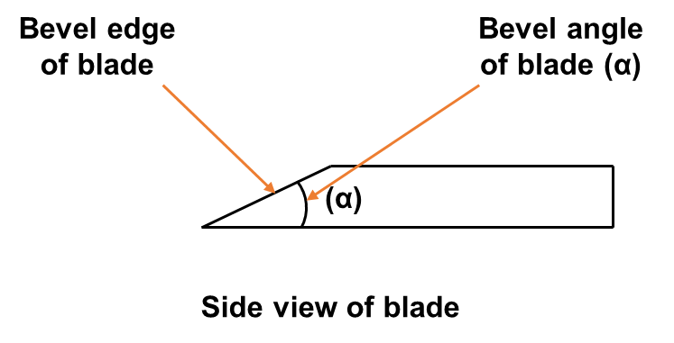

**Fig 1. Bevel angle**

**2.2.2 Shear angle (β)**

The shear angle refers to the angle between the sugarcane stalk's cutting plane and the horizontal plane (Fig. 2). This angle changes according to the height of the plant (Jyoti *et. al.,* 2021). The selected levels of the shear angles for the experiment were 15°, 20°, and 25°.

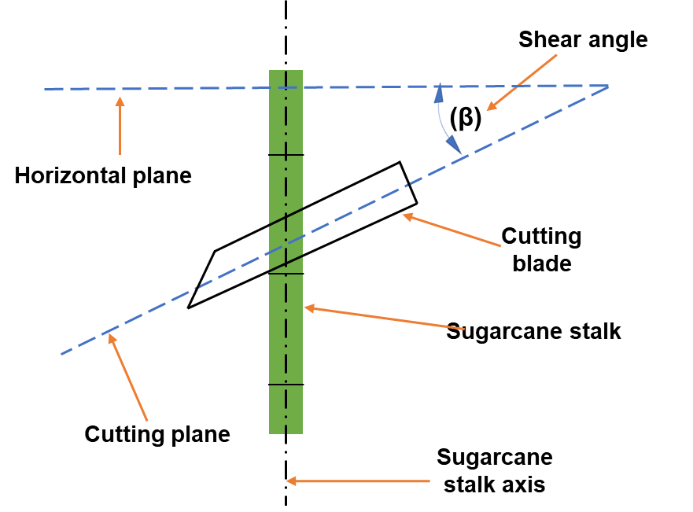

**Fig. 2 Shear angle**

**2.2.3 Approach angle (γ)**

The approach angle (γ) is the angle formed between the center line of the blade and the normal or perpendicular to the direction in which the cutting blade is moving (Fig. 3) (Jyoti *et. al.,* 2021). The selected levels of the approach angles for the experiment were 20°, 30°, and 40°.

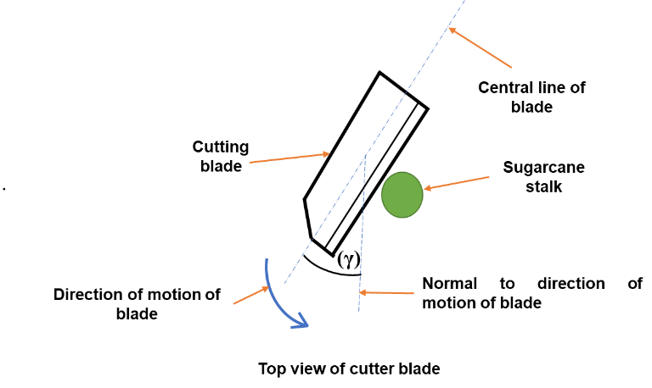

**Fig. 3 Approach angle**

**2.2.4 Cross-sectional area of sugarcane**

Sugarcane stalks is in a tapered elliptical cylinder shape and an elliptical cross-sectional profile of sugarcane stalks was obtained after cutting (Igathinathane *et. al.,* 2006). The elliptical cross-sectional area of the sugarcane stalks was measured by measuring the stalk's cross-sectional width (d1 - Major axis diameter) and the cross-sectional thickness (d2 - Minor axis diameter). The elliptical cross-sectional area of sugarcane stalks was determined using Eq. (1) (Taghinezhad *et. al.,* 2013).

d1d2  (1)

where,

Acs = cross-sectional area of sugarcane obtained after cutting (mm2);

d1 = major-axis diameter of the elliptical cross-section of the sugarcane (mm);

d2 = minor-axis diameter of the elliptical cross-section of the sugarcane (mm).

**2.3 Performance parameters**

**2.3.1 Specific cutting energy (SCE)**

The SCE was calculated to nullify the effect of the sugarcane stalk diameter on cutting energy (CE). It represented the ratio between the cutting energy needed to cut the sugarcane stalk and the exposed cross-sectional area of the sugarcane stalk after the cutting (Jyoti *et. al.,* 2021). The specific shearing energy was estimated using the Eq. (2) (Taghijarah *et. al.,* 2011).

$E_{sc}= \frac{E_{s}}{A}$ (2)

where,

$E_{s}$ = shearing energy, (MJ);

$E_{sc}$ = specific shearing energy, (MJ/mm2);

A = cross-sectional area after the shearing, (mm2).

**2.3.2 Cutting index (CI)**

The quality of the cut of the sugarcane stalk is an important factor in the sugarcane stubble shaving process because this process generates new sugarcane from old sugarcane stubbles. If the sugarcane stalk is cut at the improper combination of shear angle, approach angle, and blade thickness, then splitting of the sugarcane stalk along the axial direction occurs, and that will cause losses. For the assessment of damage caused during cutting of sugarcane stalk, an 8 - point damage rating scale (1 - Stem with clean cut and no surface damage, 8 - shattered stem) have planned to used, which is an adoption of the damage classification in sugarcane cutting process proposed by Kroes (1997) and shown in Fig. A1 (Appendix A).

**2.3.3 Determination of cutting energy**

At the equilibrium position, the pendulum arm's potential energy is zero. The mathematical relation prescribed by (Prasanthkumar and Saravanakumar, 2020; Jyoti *et. al.,* 2021; Powar *et. al.,* 2024) was used for this study. When pendulum arm raised to an angle (θ1) (Fig. 4), potential energy stored in the arm was given by Eq. (3),

Ep = MgL = MgR (1 − $\cos{θ_{1}}$) (3)

where,

Ep = Potential energy of pendulum arm when the arm is raised to θ1 (J);

M = Mass of the pendulum arm (kg);

g = Acceleration due to gravity (m/s2);

L = Total length of the pendulum arm (m);

R = Distance from the center of rotation to the center of gravity of the pendulum arm. (m);

$θ_{1}$ = Pendulum arm's initial angle from its equilibrium position (degrees).

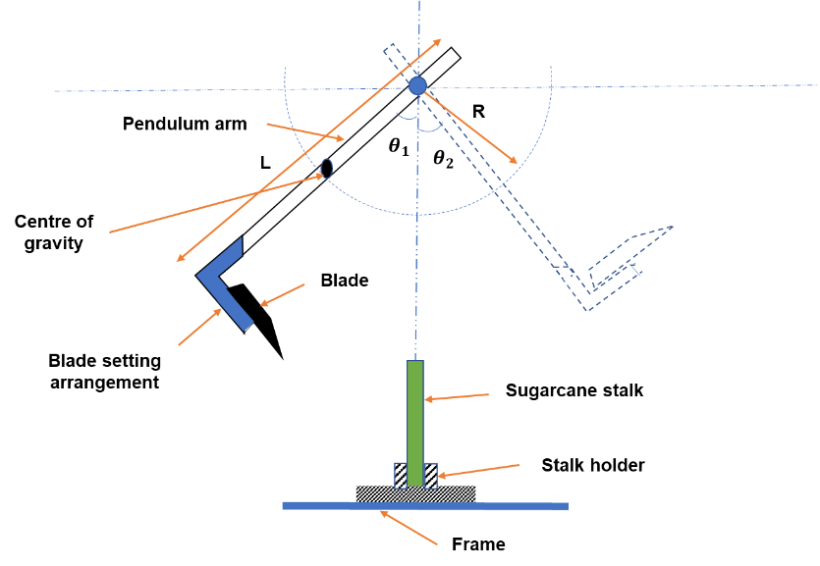

(a)

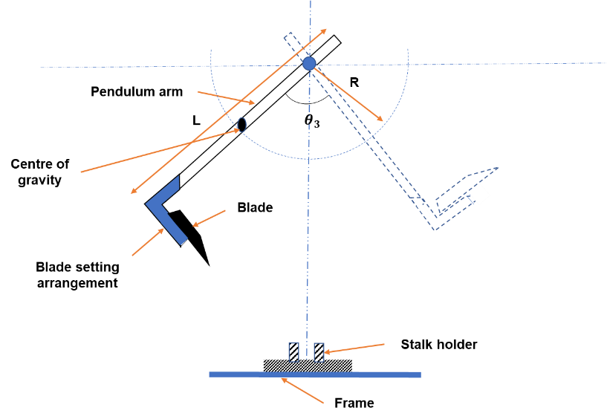

(b)

**Fig. 4 Determination of cutting energy required for sugarcane stalk using pendulum-type impact testing machine (a. cutting angle of pendulum arm with sugarcane stalk, b. cutting angle of pendulum arm without sugarcane stalk)**

The energy lost in friction and air resistance by the pendulum arm when it moved through an angle $(θ_{3})$ from the equilibrium position in the absence of any sugarcane stalk was shown in Fig.4 (b) and calculated by (Eq. 4) (Prasanthkumar and Saravanakumar, 2020; Jyoti *et. al.,* 2021),

Ef = MgR [cos $θ_{3}$– cos $θ_{1}$] (4)

where,

Ef = Potential energy lost in friction and air resistance by the pendulum arm in the absence of any sugarcane stalk (J);

M = Mass of the pendulum arm (kg);

g = Acceleration due to gravity (m/s2);

R = Distance from the center of rotation to the center of gravity of the pendulum arm (m);

The air resistance of pendulum arm was determined using mathematical expression of Eq. (5)

Eo = MgR (1 − cos $θ_{2}$) (5)

The sugarcane stalk is placed in a pipe vice, and the cutting blade is attached to the pendulum arm. Then the pendulum arm is allowed to fall in and moves at an angle of θ2 (Fig. 4 (a)) on the upswing after cutting the sugarcane stalk. The energy required for cutting sugarcane stalk (Ec) was calculated by deducting the initial potential energy of the pendulum arm (Ep) with potential energy lost due to friction (Ef) and air resistance (Eo) (Prasanthkumar and Saravanakumar, 2020; Jyoti *et. al.,* 2021). This is expressed in Eq. (6) to Eq. (7).

Ec = Ep − (Ef + Eo) (6)

Ec = MgR (cos $θ_{2}$– cos $θ_{1}$) (7)

where,

$θ_{2}$ = Final angle obtained after the cutting of the sugarcane stalk by the pendulum arm (degrees).

The rotational velocity of the cutting blade was obtained by equating potential energy with rotational kinetic energy of the pendulum arm, given in Eq. (8) (Prasanthkumar and Saravanakumar 2020; Jyoti *et. al.,* 2021),

${\text{Ω}}^{2}=$ 2MgR (1 − cos $θ_{1}$) / I (8)

where,

h = Distance from center of gravity to center of pendulum arm (m);

$\text{Ω}$ = Angular velocity of the pendulum arm (rad s-1).

The peripheral velocity (Vc) of the cutting blade was calculated by multiplying rotational velocity of blade with length of the pendulum arm is given in Eq. (9) (Prasanthkumar and Saravanakumar, 2020; Jyoti *et. al.,* 2021),

$V_{c}= ΩL= \sqrt{\text{[}2MgR (1 - cosθ_{1}) / I\text{]}} L$ (9)

**2.4 Experimental setup**

A pendulum-type impact testing machine (PTITM) was utilized to determine the SCE required for cutting sugarcane stalks. In this machine, the potential energy is transferred to kinetic energy (Prasanthkumar and Saravanakumar, 2017). The PTITM consisted of the following components main frame, swinging arm (with a blade platform attached at the bottom), sugarcane stalk holder (pipe vice), and angular displacement indicator (Appendix A, Fig. A4). The swinging arm of the PTITM is oscillated in the vertical plane. On one side of the swinging arm at the bottom end and just above the blade mounting platform, provisions were made to add additional dead weights (Appendix A, Fig. A4). The additional weights were added on the pendulum arm to increase the potential energy. When the pendulum arm is in its initial extreme upswing position, it possesses higher potential energy. After releasing the pendulum arm from an initial extreme upswing position, it loses its potential energy as it oscillates down, and potential energy is transformed into kinetic energy (Yiljep and Mohammed, 2005). Due to the oscillation of the pendulum arm, there was a continuous exchange of energy. When the pendulum arm reaches the equilibrium line, it possesses maximum kinetic energy, but the potential energy stored in it is zero (Visvanathan *et. al*., 1996; Yiljep and Mohammed, 2005). The sugarcane stalk was positioned at the point having maximum kinetic energy in the stalk holder before cutting the sugarcane stalk (Yiljep and Mohammed, 2005). A 2.5-inch pipe vice was utilized as a sugarcane stalk holder (Appendix A, Fig. A4). The height of the stalk holder was adjusted by using the screw jack. This height adjustment of the stalk holder was provided to match the different blade positions for selected levels of shear angle and approach angle. The swing arm's angular displacement was measured using a 250-mm circular dial gauge. For this dial gauge, the scale was graduated in degrees and had one degree of least count. The needle was attached to the dial gauge to indicate the angular displacement of the swing arm. The tapered wooden blocks (Appendix A, Fig. A3) were used for adjusting selected levels of shear angles (15°, 20°, and 25°), and the cutter blade was placed on the inclined surface of the wooden blocks. For adjusting approach angles, holes were drilled at an angular position on the mounting platform of the pendulum arm, and selected levels of approach angles (20°, 30°, and 40°) were used. The setting arrangement of blade according to combination of bevel, shear and approach angle is shown (Appendix A, Fig. A2).

**2.5 Experimental procedure**

During the experiment, the pendulum arm was adjusted in the extreme upswing position, which denotes the angle on the dial gauge as ‘θ1’ (Fig. 4 (a)). After releasing the pendulum arm from the extreme upswing position, it cuts the sugarcane stalk and makes the angle ‘θ2’ (Fig. 4 (a)) on the dial gauge. Then, based on various combinations of cutting blade angles, the readings were taken and noted in an Excel sheet for bevel angle (15°, 20°, and 25°), shear angle (15°, 20°, and 25°), and approach angle (20°, 30°, and 40°). Further calculations were performed as per the discussion provided in the above section.

**2.6 Experimental design**

The optimization and analysis of the experiment were conducted with the 'Design Expert 10' statistical software. For this purpose, the statistical tool 'Box Behnken Design (BBD)' was utilized in association with the Response Surface Method (RSM). This BBD was based on three elements, three levels, and five replications at the center point of a balanced incomplete block design (Powar *et. al.,* 2019). The study selected the three independent variables bevel, shear, and approach angles designed as X1, X2, and X3, respectively. These independent variables were transformed into coded variables (x1, x2, and x3) to optimize two dependent variables minimum SCE and minimum CI using Equation (10). The coded variables -1 (L1), 0 (L2), and 1 (L3) were used to represent low, intermediate, and high values, respectively. The selected levels of the BBD with their coded variables are shown in Table 1.

$x_{i}=\frac{X_{i}-X_{o}}{∆X}$ i = 1, 2, 3 (10)

**Table 1 BBD experiment to investigate the effect of operational parameters of the cutting blade on both SCE and CI.**

|  |  |  |  |  |
| --- | --- | --- | --- | --- |
| **Sr. No.** | **Variable** | **L1 (-1)** | **L2 (0)** | **L3 (1)** |
| 1 | Bevel angle (X1), degree | 15 | 20 | 25 |
| 2 | Shear angle (X2), degree | 15 | 20 | 25 |
| 3 | Approach angle (X3), degree | 20 | 30 | 40 |

Equations (11) and (12) are nonlinear second-order regression models, developed these equations to optimize SCE and CI that predict SCE and CI based on the coded values of the independent cutting energy parameters (Powar *et. al.,* 2019; Powar *et. al.,* 2022).

$SCE=b_{0}+\sum_{i=0}^{3}{b_{i}x_{i}}+\sum_{i=1}^{3}{b_{ii}{x_{ii}}^{2}}+\sum_{i=1}^{2}{\sum_{j=i+1}^{3}{b_{ij }x_{i}x_{j}}}$ (11)

$CI=b_{0}+\sum_{i=0}^{3}{b_{i}x_{i}}+\sum_{i=1}^{3}{b_{ii}{x_{ii}}^{2}}+\sum_{i=1}^{2}{\sum_{j=i+1}^{3}{b_{ij }x_{i}x_{j}}}$ (12)

The F-value was used to assess the correctness of the lack of fit (Flof) of the obtained non-linear equations. Equation (13) has been used to calculate the value of Flof. (Powar *et. al.,* 2022).

$F_{lof}=\frac{\sum_{i=1}^{N}{{(Y_{ai}-Y_{ci})}^{2}}-\sum_{i=1}^{n_{c}}{{(Y_{ai}-Y_{av})}^{2}}}{N-no. of coefficients in regression equation-N_{c}+1}$ (13)

The experimentally obtained responses were compared to the expected values using errors and correlation coefficients. The model was verified with the Root Mean Square Error (RMSE), Mean Absolute Error (MAE), cross-validated correlation coefficient (q2), and correlation coefficient (r2). The Mean Absolute Error (MAE) examines the closeness of predicted values to experimental values, with the relevant values indicating the average amount of error. The Mean Square Error (MSE), MAE, and q2 values were calculated using equations 14, 15, 16, and 17, respectively (Powar *et. al.,* 2022; Powar *et. al.,* 2024) .

$RMSE= \sqrt{\frac{\sum{{(y_{i}^{p}-y_{i}^{m})}^{2}}}{N}}$ (14)

$MSE= \frac{\sum{{(y_{i}^{p}-y_{i}^{m})}^{2}}}{N}$ (15)

$MAE= \frac{|{\left(y_{i}^{p}-y_{i}^{m}\right)}^{2}|}{N}$ (16)

$q^{2}= 1-\frac{{\sum_{i=1}^{n}{\left(y_{i}^{p}-y_{i}^{m}\right)}}^{2}}{\sum{{(y_{i}^{m}-y_{i}^{-m})}^{2}}}$ (17)

The blade angles were manipulated at the three levels according to the BBD, and 17 experiments were conducted as shown in Table 2. These experiments were carried out randomly. Also, five more experiments were carried out at the central points of the coded variable to find the error sum of squares and the lack of fit of the regression equation established for the responses and independent variables (Powar *et. al.,* 2019; Powar *et. al.,* 2024)

**Table 2 Experimental setup designed to examine the impact of cutting angles of the blade on the SCE and CI of sugarcane stems.**

|  |  |  |  |  |  |
| --- | --- | --- | --- | --- | --- |
| **Sr. No** | **Bevel Angle, Degree** | **Shear Angle, Degree** | **Approach Angle, Degree** | **Specific Cutting Energy, kJ m-2** | **Cutting Index** |
| 1 | 20 | 15 | 40 | 25.31 | 6 |
| 2 | 20 | 15 | 20 | 24.96 | 4.5 |
| 3 | 15 | 25 | 30 | 12.63 | 4 |
| 4 | 20 | 20 | 30 | 15.13 | 4 |
| 5 | 15 | 20 | 40 | 13.69 | 5 |
| 6 | 20 | 20 | 30 | 15.42 | 3.5 |
| 7 | 25 | 20 | 20 | 26.12 | 5 |
| 8 | 25 | 25 | 30 | 20.93 | 6 |
| 9 | 20 | 20 | 30 | 14.87 | 3.5 |
| 10 | 15 | 15 | 30 | 11.34 | 4 |
| 11 | 25 | 20 | 40 | 28.90 | 5 |
| 12 | 20 | 20 | 30 | 15.43 | 3.5 |
| 13 | 25 | 15 | 30 | 28.64 | 5 |
| 14 | 15 | 20 | 20 | 13.35 | 2 |
| 15 | 20 | 20 | 30 | 13.93 | 3.5 |
| 16 | 20 | 25 | 20 | 16.63 | 5 |
| 17 | 20 | 25 | 40 | 21.20 | 6 |

**3. RESULTS AND DISCUSSION**

The effect of cutting angles of blade on the requirement of Specific Cutting Energy (SCE) and Cutting Index (CI) was studied and discussed in following subheadings. Additionally, the optimization of cutting angles carried for obtaining minimum cutting energy (CE) and cutting index**.**

**3.1 Effect of Operating Parameters on Specific Cutting Energy**

Fig. 5 (Figs. 5a, 5b, and 5c) shows the impact of cutting angles on the SCE requirement. The effect of shear and bevel angles at the fixed level of approach angle (30°) on SCE is displayed in Fig. 5a. According to Fig. 5a, as the bevel angle increases from 15° to 25°, the required SCE to cut the sugarcane stem increases linearly from 11.87 kJm-2 to 30 kJm-2. Similar to this, it was seen that as shear angles increased from 15° to 20°, the SCE required to cut the sugarcane stem decreased slightly from a value of 11.87 kJm-2 to 9.29 kJm-2. However, as shear angles increase from 20° to 25°, the SCE increases linearly from 9.29 to 11.43 kJm-2. The minimum SCE of 9.29 kJ m-2 is seen at a bevel angle of 15° and a shear angle of 20°.

Figure 5b, illustrates the impact of the approach angle and bevel angle on SCE at a shear angle kept constant at 20°. It found that as the approach angle increased from 20° to 30°, the SCE decreased from 13.25 kJm-2 to 9.25 kJm-2. Further increasing the approach angle from 30° to 40°, it was seen that the SCE increased from 9.25 kJm-2 to 14 kJm-2. Also, as Fig. 5b shows, there was a direct relationship between the bevel angle and SCE. As the bevel angle increased from 15 to 25°, the SCE increased from 13.25 kJm-2 to 25 kJm-2. The minimum SCE of 9.25 kJm-2 was observed at an approach angle of 30° and a bevel angle of 15°.

Fig. 5c presents the effect of an approach and shear angle on the SCE at a fixed level of bevel angle of 20°. Fig. 5c indicated that as the approach angle increased from 20 to 27°, the SCE essential for cutting sugarcane stem decreased slightly from 17.41 kJm-2 to 14.62 kJm-2. Further as approach angle increased from 27 to 40°, the SCE increased from 14.62 kJm-2 to 24.20 kJm-2. Similarly, with increasing shear angle from 15° to 23°, the SCE needed to cut the sugarcane stem decreased from 24.02 kJm-2 to 17.10 kJm-2, and with an increase in shear angle from 23° to 25°, the SCE increased linearly from 17.10 kJm-2 to 17.5 kJm-2 was observed. The lowest SCE was seen at a shear angle of 23° and an approach angle of 27°. Jyoti *et. al.,* (2021) have also reported similar results for cassava stem.

The bevel angle of a blade has an inverse relationship with its sharpness. Based on this characteristic, the blade with a greater bevel angle needed more SCE to cut the sugarcane stalk. Therefore, the SCE essential for sugarcane stalks increases with an increasing bevel angle, and similarly, the CI also increases. According to Jyoti *et. al.,* (2021), when cutting is done at or above critical speed, the blade with a minimal thickness has no significant effect on the cutting energy requirement. The cutting energy at the entrance point of the stem is affected when the thickness of the blade increases. As the approach angle increases, the steepness of the blade also increases. At increased blade steepness, the cutting blade starts to slide along the stem, which causes SCE to increase. When the blade was at a lower approach angle, it couldn't penetrate the thick outer layer of the sugarcane stem, and a rapid increase in SCE was observed after an approach angle of 30°. This is because impact-cutting energy decreases, and this occurs as the cutting blade moves from the cortex to the pith of the cassava stalk (Jyoti *et. al.,* 2021). The frictional force of the sugarcane stem was reduced at a cutter blade shear angle of 15° to 20.74° because a straight cut was avoided, and that caused the SCE required to cut the sugarcane stem to be lowered. At a shear angle of 25°, the cutter blade's edge was not in the plane of least resistance, and due to that, impact energy was increased (Jyoti *et. al.,* 2021). A precise stem severance occurred at a shear angle of 20.74° and facilitated an oblique incision of the sugarcane stem.

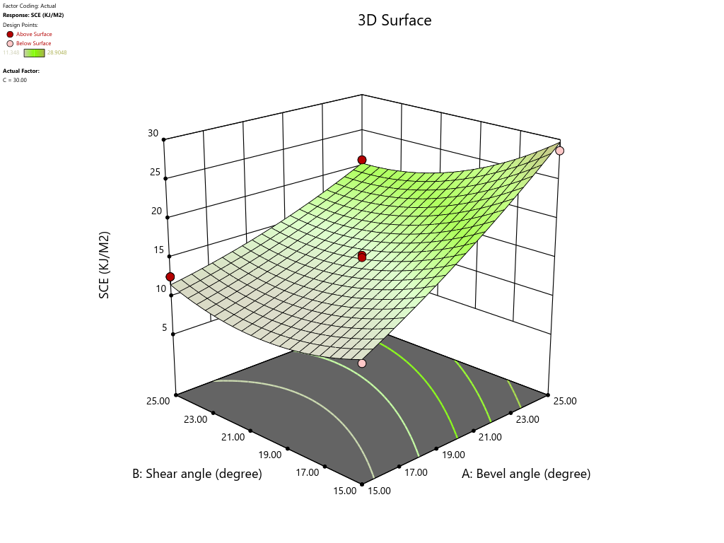

**a.**

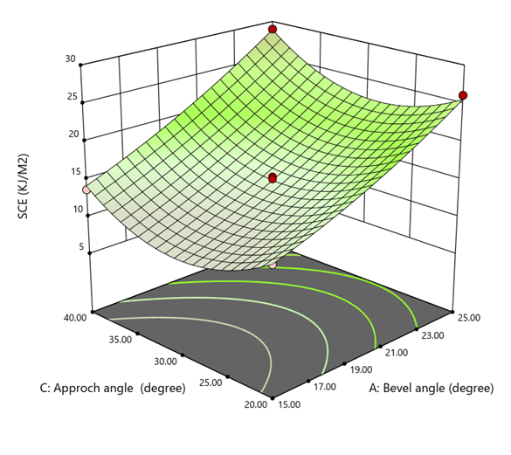

**b.**

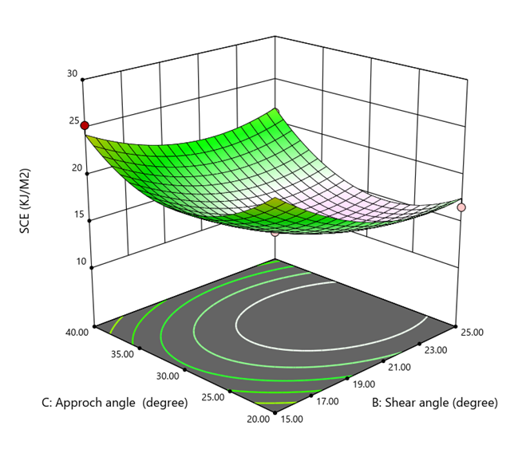

**c.**

**Fig 5. Effect of a.** **shear and bevel angles, b.** **approach and bevel angles & c. shear and approach angles on SCE of Sugarcane stem**

**Table 3 ANOVA for study effect of bevel, shear and approach angle on SCE.**

|  |  |  |  |  |  |  |
| --- | --- | --- | --- | --- | --- | --- |
| **Source** | **Sum of Squares** | **df** | **Mean Square** | **F-value** | **p-value** |  |
| **Model** | 565.47 | 9 | 62.83 | 61.20 | < 0.0001 | significant |
| X1 | 358.88 | 1 | 358.88 | 349.54 | < 0.0001 |  |
| X2 | 44.49 | 1 | 44.49 | 43.33 | 0.0003 |  |
| X3 | 8.06 | 1 | 8.06 | 7.85 | 0.0265 |  |
| X1X2 | 20.22 | 1 | 20.22 | 19.69 | 0.0030 |  |
| X1X3 | 1.49 | 1 | 1.49 | 1.45 | 0.2680 |  |
| X2X3 | 4.46 | 1 | 4.46 | 4.34 | 0.0756 |  |
| X1² | 3.88 | 1 | 3.88 | 3.78 | 0.0930 |  |
| X2² | 25.68 | 1 | 25.68 | 25.01 | 0.0016 |  |
| X3² | 89.09 | 1 | 89.09 | 86.78 | < 0.0001 |  |
| **Residual** | 7.19 | 7 | 1.03 |  |  |  |
| Lack of Fit | 5.65 | 3 | 1.88 | 4.89 | 0.0797 | not significant |
| Pure Error | 1.54 | 4 | 0.3850 |  |  |  |
| **Cor Total** | 572.65 | 16 |  |  |  |  |

* *significant at 1% level of significance, ** significant at 5% level of significance, ns not significant*

The results of the ANOVA in Table 3 indicate that the quadratic model accurately represents the experimental data (p <0.0001), with a significant model F value of 61.20. Based on the F values presented in Table 3, the linear factors, such as bevel angle (p<0.0001), shear angle (p<0.0001), and approach angle (p<0.0265), significantly affect the SCE at the 1% and 5% significance levels, respectively. The result of the analysis shows that the interaction between "bevel angle" and "shear angle" has a significant effect on the SCE at a significance level of 1% (p<0.0030). Additionally, the interaction between "shear angle" and "approach angle" has a significant effect on the SCE at a significance level of 10% (p<0.0745). The SCE was statistically significantly impacted at the 1% significance level by the quadratic component of the model, viz., shear angle (p<0.0016) and approach angle (p<0.0001). Also, the SCE was statistically significantly impacted at a 10% significance level by the quadratic coefficient of the bevel angle (p<0.0930). For this model, the predicted R2 (0.84) was also consistent with the adjusted R2 (0.97). The signal-to-noise ratio determines an acceptable degree of accuracy, and a signal-to-noise ratio greater than 4 is considered more desirable (Powar *et. al.,* 2021). The satisfactory signal indicates a ratio of 23.30. For navigating the design space this model is applicable. The regression equation (18) in a modified version of the SCE, incorporating bevel, shear, and approach angle as independent variables, was successfully fitted into a polynomial equation (18) with a coefficient of determination (R2) of 0.99, as shown below.

SCE = 74.87 + 1.23X1- 3.25X2-3.32X3-0.089 X1X2+ 0.012 X1X3 +0.021 X2X3 +0.038 X1² + 0.098 X2² + 0.045 X3² (18)

**3.2 Cutting Index**

The effect of independent parameters, viz., bevel, shear, and approach angles, was studied on the cutting index (CI). Fig. 6a represents the effect of shear and approach angle on the CI at a fixed level of bevel angle of 20°. According to Fig. 6a, it was seen that the CI decreased from 4.27 to 3.48 as the shear angle from 15 to 22° increased, and further, as the shear angle increased, an increase in the CI was observed. Similarly, Fig. 6a also showed that with an increase in approach angle from 15 to 30°, the CI linearly decreased from 4.27 to 3.64. An approach angle of 30° and a shear angle of 20° obtained the minimum CI.

Fig. 6b presents the effect of the approach and the bevel angle at the fixed level of the shear angle of 20°. From Fig. 6b, it was noted that the CI increased from 2 to 4.9 as the approach angle from 20 to 40° and the bevel angle from 15 to 25° was increased. The bevel angle of 15° and approach angle of 20 to 25° showed the minimum CI.

Fig. 6c presents the effect of shear and bevel angle on the CI at a fixed level of approach angle (30°). From Fig. 6c it was seen that a slight decrease in CI was observed from 3.92 to 2.89 as a shear angle from 15 to 20° increased, afterwards, CI increased from 1.5 to 3.9 as an increase in the approach angle from 20 to 25°. Similarly, a slight increase in CI from 3.92 to 4.94 was observed as the bevel angle increased from 15 to 25°. The minimum CI was found at a shear angle of 20° and a bevel angle of 15°.

Higher bevel angles have been observed to reduce blade sharpness and lead to an increase in CI. When the impact force of the pendulum arm exceeds the stem's resistance capacity during a straight cut, the stem ultimately fails under bending. Consequently, the CI was higher at a lower shear angle (15°), and at a shear angle of 20°, the minimum CI was found. Further increasing the shear angle causes the cutting blade to slide along the stem and damage the stem. Firmly holding the sugarcane stem in a vice improves its resistance capacity and aids in achieving the ideal stem cut. Also, this observation was supported by Jyoti *et. al.,* (2021). As the approach angle rises, the steepness of the blade also increases. Because of the increased steepness of the blade, that blade begins to slide along the stem, which leads to obtaining a higher CI. Conversely, at a lower approach angle, the thick outer core of the sugarcane stem prevents the cutting blade from penetrating the stem. The sudden rise in SCE of sugarcane stem after an approach angle of 30 degrees is because the impact-cutting energy decreases as the cutting blade progresses from the outer layer (cortex) to the inner part (pith) (Jyoti *et. al.,* 2021).

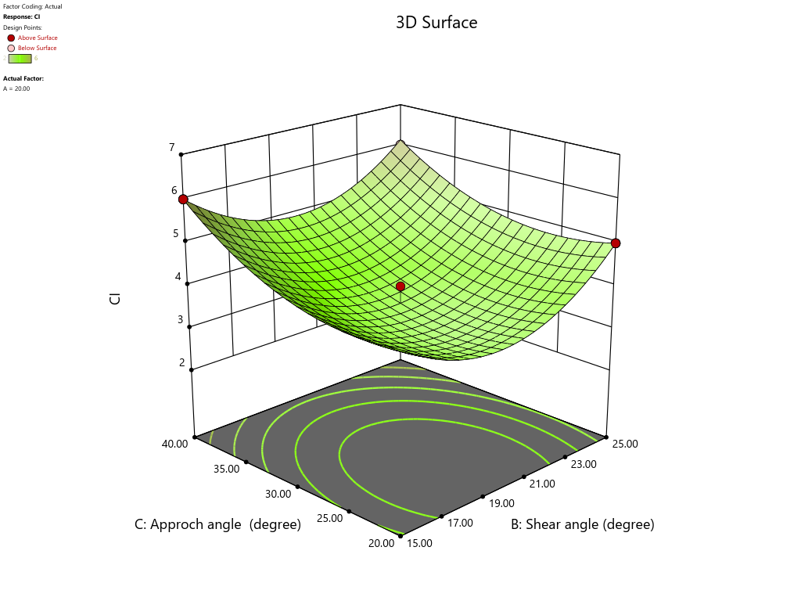

**a.**

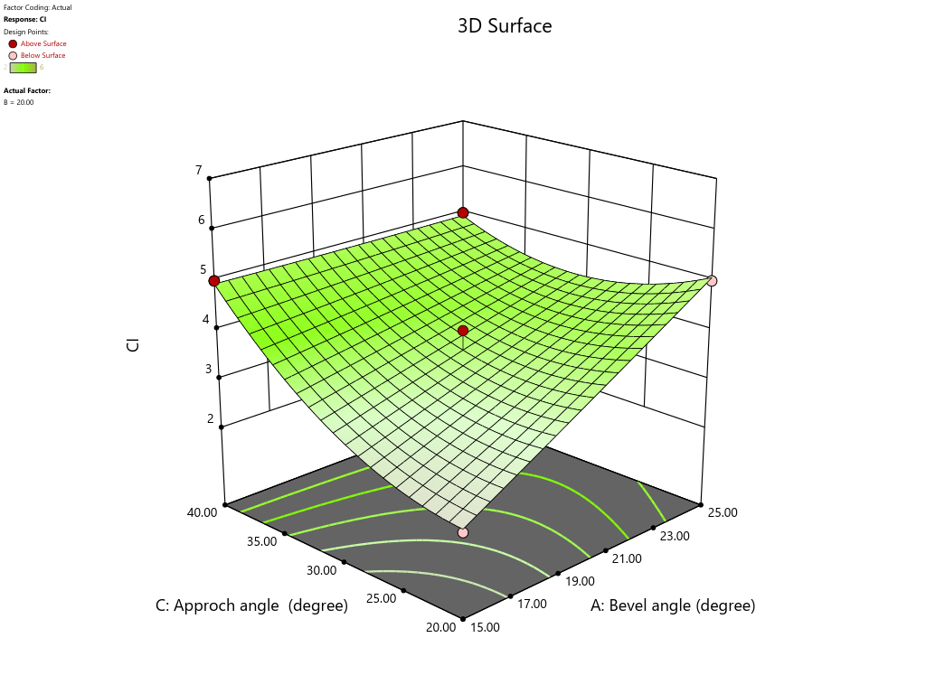

**b.**

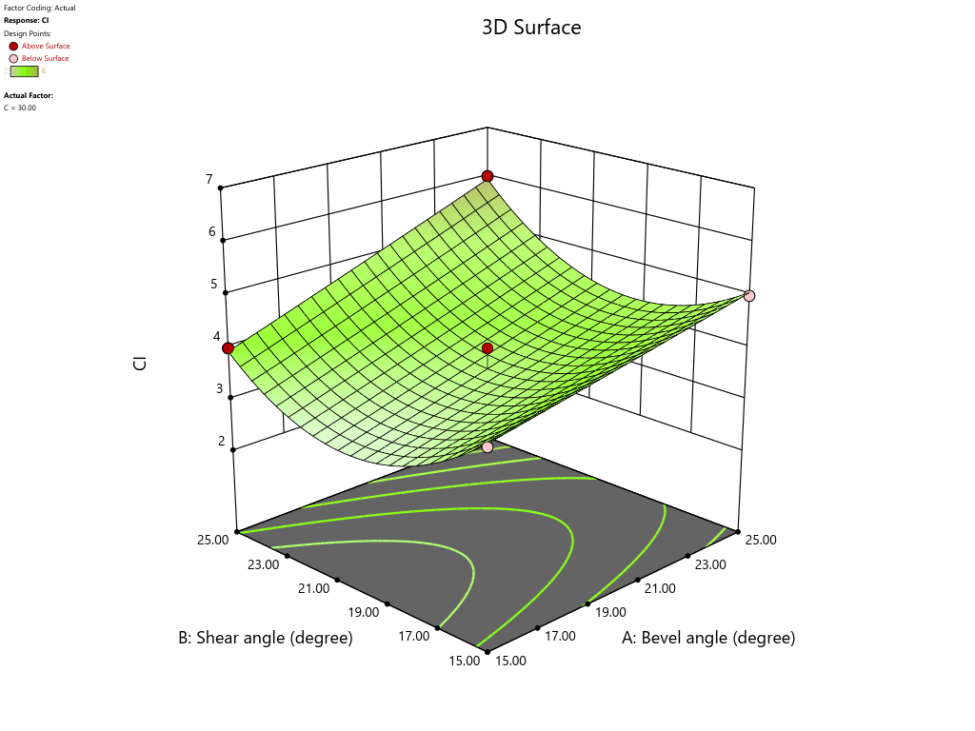

**c.**

**Fig. 6 Effect of a. approach and shear , b.** **approach and bevel & c. shear and bevel on CI of sugarcane stem**

**Table 4 ANOVA for study effect of bevel, shear and approach angle on CI.**

|  |  |  |  |  |  |  |
| --- | --- | --- | --- | --- | --- | --- |
| **Source** | **Sum of Squares** | **df** | **Mean Square** | **F-value** | **p-value** |  |
| **Model** | 18.68 | 9 | 2.08 | 55.34 | < 0.0001* | significant |
| X1 | 4.50 | 1 | 4.50 | 120.00 | < 0.0001* |  |
| X2 | 0.2812 | 1 | 0.2812 | 7.50 | 0.0290** |  |
| X3 | 3.78 | 1 | 3.78 | 100.83 | < 0.0001* |  |
| X1X2 | 0.2500 | 1 | 0.2500 | 6.67 | 0.0364** |  |
| X1X3 | 2.25 | 1 | 2.25 | 60.00 | 0.0001* |  |
| X2X3 | 0.0625 | 1 | 0.0625 | 1.67 | 0.2377ns |  |
| X1² | 0.0007 | 1 | 0.0007 | 0.0175 | 0.8984 ns |  |
| X2² | 5.45 | 1 | 5.45 | 145.28 | < 0.0001* |  |
| X3² | 1.71 | 1 | 1.71 | 45.63 | 0.0003* |  |
| **Residual** | 0.2625 | 7 | 0.0375 |  |  |  |
| Lack of Fit | 0.0625 | 3 | 0.0208 | 0.4167 | 0.7510 | not significant |
| Pure Error | 0.2000 | 4 | 0.0500 |  |  |  |
| **Cor Total** | 18.94 | 16 |  |  |  |  |

*\* significant at 1% level of significance, ** significant at 5% level of significance, ns not singnifcant*

The impact of the blade's cutting angles on the sugarcane stem's CI is illustrated in Table 4. The model displayed in the ANOVA exhibited a high F value of 55.34, indicating that a quadratic model can accurately represent the experimental data (p<0.0001). From Table 2, the F values show that the linear coefficients of bevel angle (p<0.0001) and approach angle (p<0.0001) have a significant impact on CI at a 1% significance level. Similarly, the shear angle (p<0.0001) also significantly affects CI at a 5% significance level. Moreover, the interaction between the bevel angle and shear angle (p<0.0364) has statistically significant effects on CI at a 5% significance level. Also, the interaction between the bevel angle and approach angle (p<0.0001) has a significant effect on the CI at a 1% significance level. However, the combined effect of shear and approach angles on CI is not statistically significant, even when tested at a 10% significance level. The quadratic coefficients of shear angle (p<0.0001) and approach angle (p<0.0003) have a significant impact at a 1% significance level on the CI. However, the quadratic coefficients of bevel angle (p<0.8984) do not have a significant impact, even at a 10% level of significance. The forecasted coefficient of determination (R2) for this model, 0.93, was also consistent with the adjusted R2 value of 0.96. The signal-to-noise ratio determines the measure of precision, and a ratio is considered desirable if it is higher than 4 (Powar *et. al.,* 2021). The satisfactory signal indicates a ratio of 18.97. This model is applicable for navigating the design space. The relationship between the CI and different independent variables, such as bevel, shear, and approach angle, was modelled using a polynomial equation (Eq. 19). The coefficient of determination (R2) for this model was 0.9861.

CI = 15.42+ 0.38X1-1.90X2 +0.036X3 +0.010X1X2- 0.015X1X3-0.0025X2X3+0.00050X1² + 0.0455X2² + 0.0063X3² (19)

**3.3 Optimization of The Independent Parameters**

The cutting blade's independent parameters, namely the bevel, shear, and approach angles, were optimized to minimize SCE and CI. The software generated optimal conditions for these parameters: the bevel angle at 15°, the shear angle at 20°, and the approach angle at 23°, which predicted the minimum SCE of 11.34 kJm-2 and a CI of 2.15. Fig. 7a, 7b and 7c graphically represent the optimization process for the independent parameters. The values in the flagged areas of these figures were grouped, resulting in optimized parameters: bevel angle 15°, shear angle 20°, and approach angle 22.74° ≈ 23°, which yielded a predicted minimum SCE and CI of 11.34 kJm-2 and 2.15, respectively. The results of the numerical (Fig. 8) and graphical optimization methods are found to be closely related. The performance validation was performed by setting the above-optimized parameters into PTITM. After validation, the SCE was obtained to be 10.50 kJm-2, which was slightly lower than the predicted 11.34 kJm-2. Similarly, the CI was found to be 1.5, which was slightly lower and better than the predicted value of 2.15.

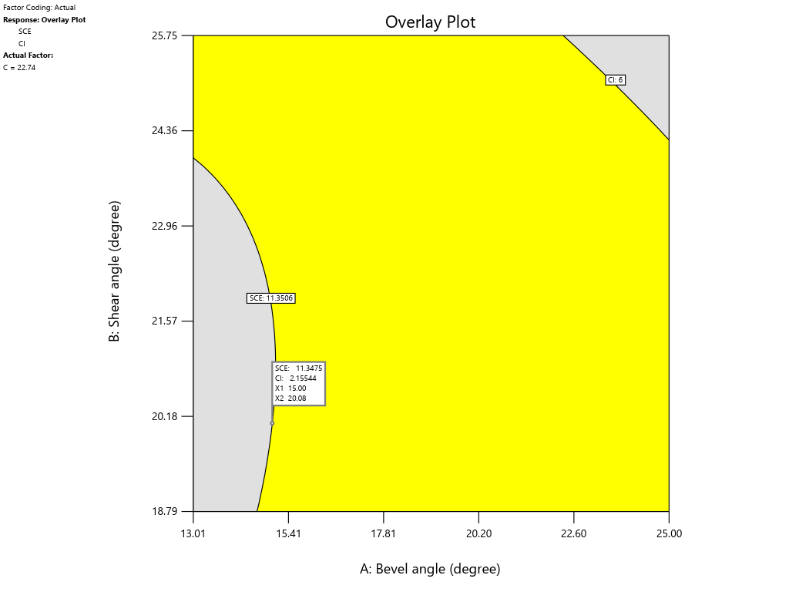

**a.**

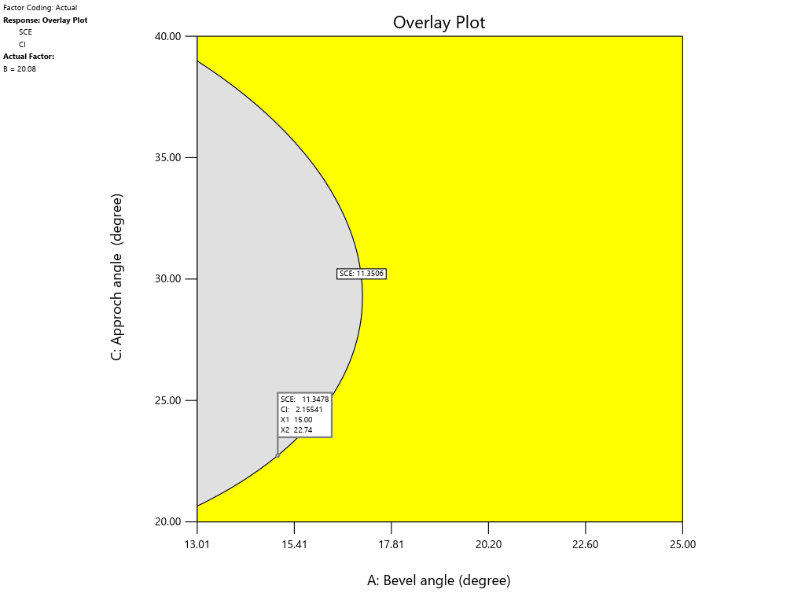

**b.**

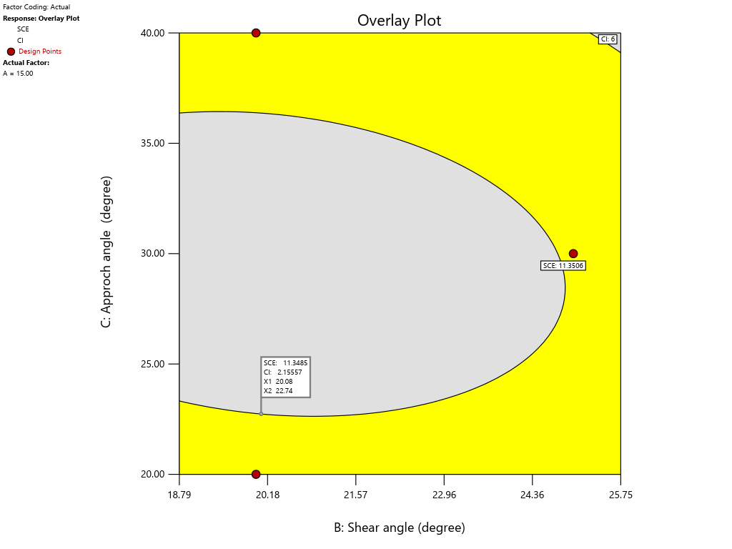

**c.**

**Fig. 7 Graphical optimization of blade angles of cutting blade. Superimposed contours for SCE and CI at a) varying bevel and shear angle, b) varying bevel and approach angle & c) varying shear and approach angle.**

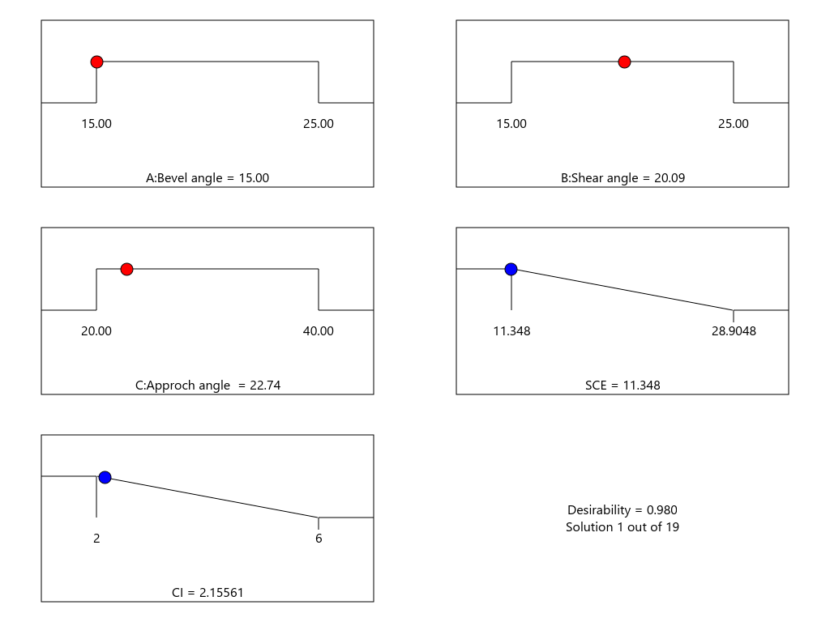

**Fig. 8 Numerical optimization of cutting blade angles for minimum SCE and CI**

**4. CONCLUSION**

A pendulum-type impact testing machine (PTITM) was utilized to investigate the effect of the cutting angles of the blade on the specific cutting energy (SCE) and the cutting index (CI). These blade angles are important for designing cutting blades for sugarcane harvesters and stubble-shaving machines. The study discovered that, at a 1% significance level, the bevel, shear, and approach angle significantly impacted the SCE and CI. Also, the study obtained the optimal blade angles as a 15° bevel angle, a 20.08° shear angle, and a 22.74° approach angle, and using this blade configuration yields a minimal SCE of 11.34 kJm-2 and a CI of 2.15. These optimal cutting blade angles were set in the PTITM for performance validation. The observed SCE was 10.50 kJm-2 (compared to the predicted 11.34 kJm-2), and the observed CI was 1.5 (compared to the predicted 2.15). These findings indicate that the validated outcomes are more closely correlated with the anticipated results. By incorporating the cutting angles mentioned in the blade design, the SCE can be reduced, and the damage to sugarcane stubble can be mitigated. This will ultimately promote consistent and robust tillering in ratoon sugarcane.

**Disclaimer (Artificial intelligence)**

Author(s) hereby declare that NO generative AI technologies such as Large Language Models (ChatGPT, COPILOT, etc.) and text-to-image generators have been used during the writing or editing of this manuscript.

References

1. Choudhary, R. L., Wakchaure, G. C., Minhas, P. S., & Singh, A. K. (2017). Response of ratoon sugarcane to stubble shaving, off-barring, root pruning and band placement of basal fertilisers with a multi-purpose drill machine. *Sugar Tech*, *19*(1), 33–40. <https://doi.org/10.1007/s12355-016-0438-x>.
2. Gopi, K., Srinivas, J., Manikyam, N., Harsha Nag, R., Maheshwar, D., Anjaneyulu, B., & kumar, Ch. S. (2018). Performance evaluation of mechanical and manual harvesting of sugarcane. *International Journal of Current Microbiology and Applied Sciences*, *7*(2), 3779–3788. <https://doi.org/10.20546/ijcmas.2018.702.447>.
3. Igathinathane, C., Womac, A. R., Sokhansanj, S. and Pordesimo, L.O. (2006). Mass and moisture distribution in aboveground components of standing corn plants. Transactions of the ASAE 49:97-106
4. Jyoti, B., Karthirvel, K., Durairaj, C. D., & Kumar, T. S. (2021). *Specific cutting energy characteristics of cassava stem with varying blade parameters using impact type pendulum test rig*. *52*(4), 15–23.
5. Kamble, S. A., & Kharate, M. S. (2019). Estimation of dry matter of sugarcane (Saccharum Officinarum Linn.) crop by ecological method in loamy soil at Aurangabad. *Research India Publications*, *Volume 14*(2), 211–216.
6. Kroes, S. and H. Harris. 1996. Splitting of the stool during an impact cut of sugarcane stalks. Madrid, Spain: EurAgEng.
7. Powar, R. V., S. A. Mehetre, P. R. Patil, R. V. Patil, V. A. Wagavekar, S. G. Turkewadkar, and S. B. Patil. 2020. Study on Energy Use Efficiency for Sugarcane Crop Production Using the Data Envelopment Analysis (DEA) Technique. *Journal of Biosystems Engineering* 45: 291–309. <https://doi.org/10.1007/s42853-020-00070-x>.
8. Powar, R. V., Aware, V. V., Deogirikar, A. A., & Patil, S. B. 2021. “Development and Performance Evaluation of Finger Millet (Eleusine coracana) Cleaning System.” *Proceedings of the International Symposium of ICAR on Coastal Agriculture*, 1071–1083.
9. Powar, R. V., S. A. Mehetre, T. R. Powar, and S. B. Patil. 2022. End-Use Applications of Sugarcane Trash: A Comprehensive Review. *Sugar Tech* 24: 699–714. <https://doi.org/10.1007/s12355-022-01107-5>.
10. Powar, R. V., V. V. Aware, and P. U. Shahare. 2019. Optimizing operational parameters of finger millet threshing drum using RSM. *Journal of Food Science and Technology* 56: 3481–3491. <https://doi.org/10.1007/s13197-019-03836-0>.
11. Powar, Ranjit, Vijay Aware, and Prashant Shahare. 2019. Modeling and optimization of finger millet pearling process by using RSM. *Journal of Food Science and Technology* 56: 3272–3281. <https://doi.org/10.1007/s13197-019-03792-9>.
12. Powar, Ranjit, Vijay Aware, Prasad Chavan, and Amit K. Jaiswal. 2022. Effect of operating parameters on performance of finger millet pearling machine. *Journal of Food Process Engineering*. <https://doi.org/10.1111/jfpe.14146>.
13. Powar, R. V., Belanekar, N. N., Chamakale, S. V., Gadade, N. S., Kolekar, V. N., Shete, V. N., & Patil, S. B. (2024). Modeling and Optimization of Specific Cutting Energy Required for Cutting Napier Grass Using RSM. *Journal of The Institution of Engineers (India): Series A*. <https://doi.org/10.1007/s40030-024-00780-x>
14. Prasanthkumar, K., & Saravanakumar, M. (2017). Development and calibration of pendulum type test rig. *International Journal of Current Microbiology and Applied Sciences*, *6*(8), 1498–1503. <https://doi.org/10.20546/ijcmas.2017.609.182>.
15. Qiu, M., Meng, Y., Li, Y., & Shen, X. (2021). Sugarcane stem cut quality investigated by finite element simulation and experiment. *Biosystems Engineering*, *206*, 135–149. <https://doi.org/10.1016/j.biosystemseng.2021.03.013>.
16. Razavi, J., Kardany, M., & Masoumi, A. (2010). Effects of some cutting blades and plant factors on specific cutting energy of sugarcane stalk. *Section III: Equipment Engineering for Plant Production Conference*, June 13-17, 2010, 1–9.
17. Rooha Blessy, D., Spandana, A., Gopaladas, V., Ravindrabharathi, P., & Kumar, Er. Ch. S. (2019). Development and evaluation of pendulum type impact shear test apparatus. *International Journal of Current Microbiology and Applied Sciences*, *8*(06), 1436–1441. <https://doi.org/10.20546/ijcmas.2019.806.174>.
18. Scharf, Patrick. 2016. Optimization of base cutting parameters in laboratory setting to minimize energy requirements for sugarcane harvesting. Washington State University. Unpublished thesis.
19. Sureshkumar, P. K., & Jesudas, M. D. (2015). Physico-mechanical properties of sugar cane stalks related to mechanical harvesting. *Journal of Tropical Agriculture.*53(1), 48–55.
20. Taghijarah, H., Ahmadi, H., Ghahderijani, M., & Tavakoli, M. (2011). Shearing characteristics of sugar cane (Saccharum officinarum L.) stalks as a function of the rate of the applied force. *Australian Journal of Crop Science. 5*(6), 630–634.
21. Taghinezhad, J., Alimardani, R., & Jafari, A. (2012). Effect of sugarcane stalks’ cutting orientation on required energy for biomass products. *Internatıonal Journal of Naturaland Engineering Sciences.* 6(3), 47–53. <https://www.researchgate.net/publication/291330676>.
22. Taghinezhad, J., Alimardani, R., & Jafari, A. (2013). Effect of moisture content and dimensional size on the shearing chararacteristics of sugarcane stalks. *International Journal of Agricultural Technology. 9*(2), 281–294.
23. Vinayak, Beerge, R., & Shirwal, S. (2017). Performance evaluation of tractor operated sugarcane stubble shaver. *International Journal of Agricultural Science and Research*, *7*(4), 233–240. <https://doi.org/10.24247/ijasraug201728>.
24. Visvanathan, R., Sreenarayanan, V. V., & Swaminathan, K. R. (1996). Effect of knife angle and velocity on the energy required to cut cassava tubers. *Journal of Agricultural Engineering Research*, *64*(2), 99–102. <https://doi.org/10.1006/jaer.1996.0050>.
25. Wang, Wei, Shilin Wang, Jinqi Zhang, Xiaolan Lv, and Zhongyi Yi. 2022. Experiment and Research on Cutting Mechanical Properties of Little Cabbage. *Applied Sciences* 12: 2060. <https://doi.org/10.3390/app12042060>.
26. Yiljep, Y. D., & Mohammed, U. S. (2005). Effect of knife velocity on cutting energy and efficiency during impact cutting of sorghum stalk. *Agricultural Engineering International: the CIGRE Journal. VII*, 1–10.

APPENDIX

Appendix A

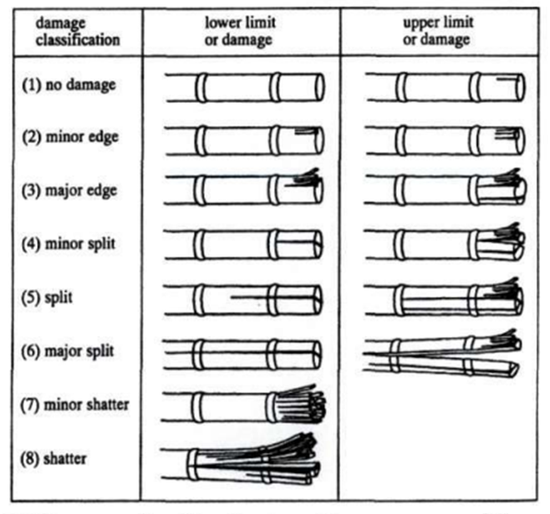

Fig A1. Damage classification in cutting process (Kroes, 1997)

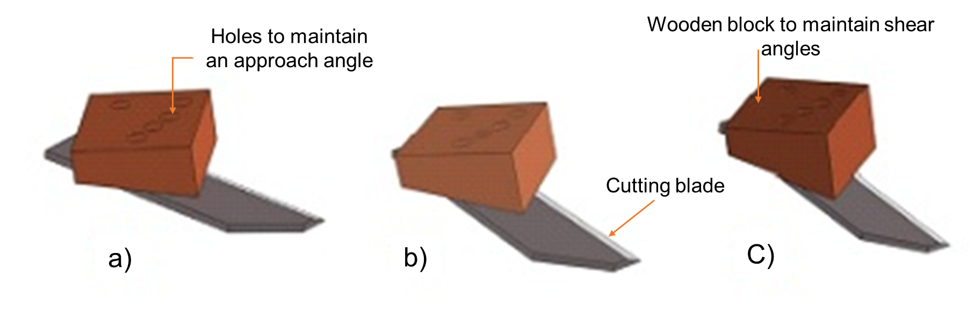

Fig. A2 Arrangement of the shear and approach angles (a) Wooden block for arranging shear angle of 20 $°$ (b) Wooden block for arranging shear angle of 30 $°$ (c) Wooden block for arranging shear angle of 40 $°$

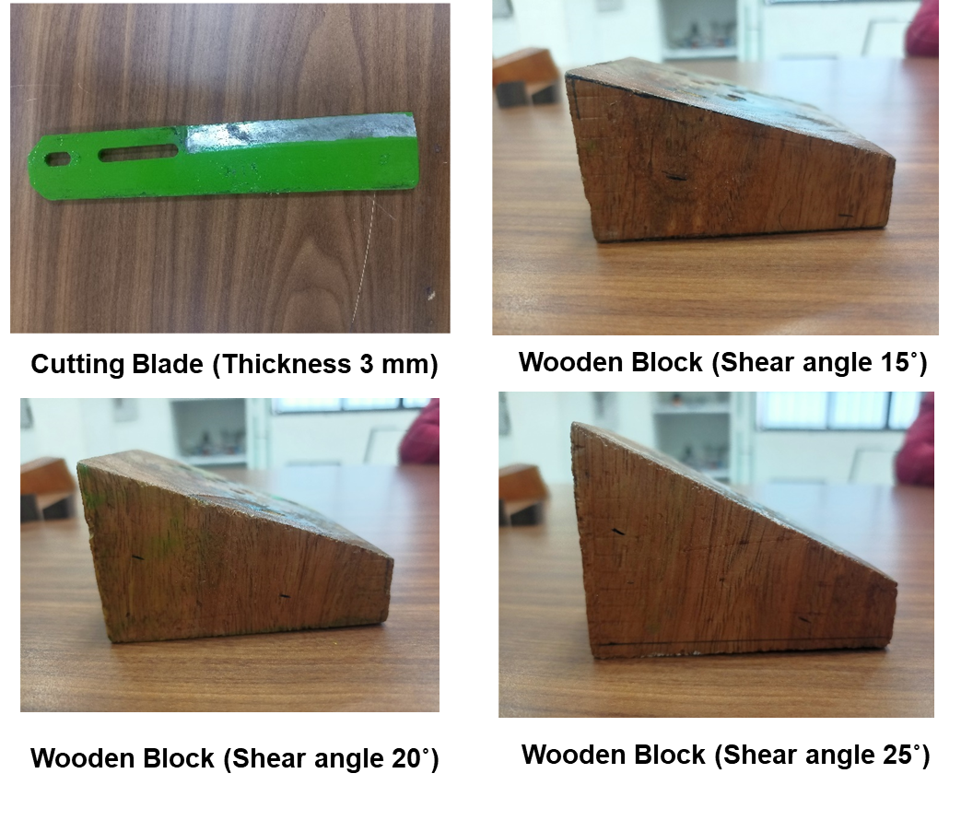

Fig. A3 cutting blades and wooden blocks used for the study

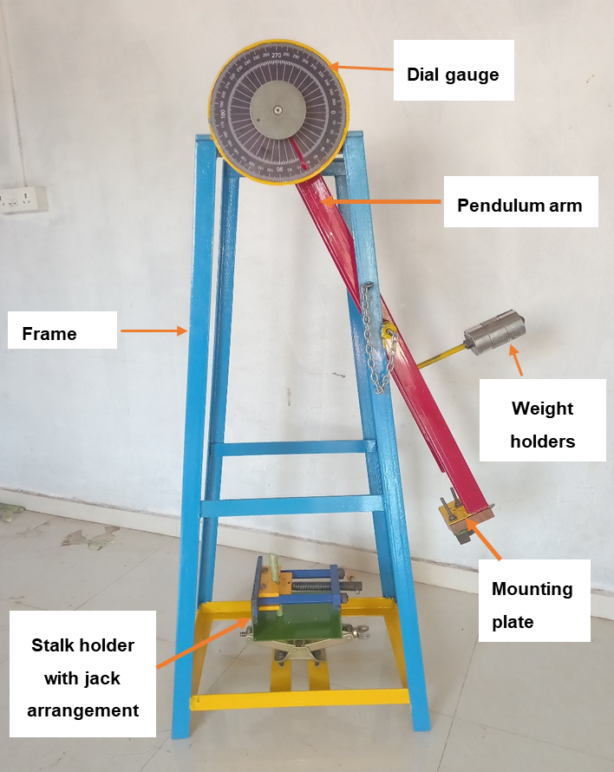

**Fig. A4 Pendulum type impact testing machine**