**Disease situation of sesame** (*sesamum indicum* l.) **in major sesame growing regions of northern karnataka, India**

**-----------------------------------------------------------------------------------------------------------------**

**Abstract**

The survey was conducted in major sesame-growing districts of North Karnataka such as Vijayapura, Belgaum, Bagalkote, Gadag and Dharwad to record the incidence of different foliar diseases such as *Cercospora* leafspot, *Alternaria* leaf blight, Powdery mildew and *Phyllody* for two the year 2023-24 and 2024-25 of *Kharif* season. The average pe rcent disease incidence of different districts surveyed during *Kharif* 2023 and 2024. The maximum average severity of *Cercospora* leaf spot was recorded in Vijaypur district (25.3%) and Belgaum (25.3%) district, whereas the lowest per cent disease severity was noticed in Bagalkote district (21.3%). The maximum average disease severity of *Alternaria* blight was noticed in the Vijaypur district (28.2%) and the lowest average disease severity was recorded in the Gadag district (21.8%). The highest severity of Powdery mildew disease was recorded in the Gadag district (25.7%) and the lowest disease severity was noticed in Dharwad district (21.8%). The maximum average per cent disease incidence of Phyllody was noticed in the Belgaum district (26.9%) and the average lowest disease incidence was recorded in the Gadag district (19.4%). Appropriate control methods of the above diseases should be identified and recommended to sesame growers to prevent crop yield loss and increase productivity.

**Keywords:** Sesame (*Sesamum indicum* L.), *Cercospora* leafspot, *Alternaria* leaf blight, Powdery mildew and *Phyllody*

1. **Introduction**

Sesame (*Sesamum indicum* L.) is one of the important oilseeds belonging to family Pedaliaceae which is having the longest history of cultivation in India (Anon., 2017). This crop is mentioned as tila in Atharva Veda, Asthadviaji, Manusmriti and Puranas, indicating its presence since the pre-Christian era in India. Asia has maximum area and production in the world where the crop is cultivated in tropical and subtropical areas. The origin of this crop is believed to be Africa (Anon., 2017). Sesame is known as the "Queen of oilseeds" because seeds have high-quality poly-unsaturated stable fatty acids that offer resistance to rancidity. Its’ seeds are a rich source of edible oil (48-55 %) and protein (20-28 %) consisting of methionine, tryptophan, vitamin (niacin) and minerals (Bashir, 2017). Seeds also contain sesamin and sesamolin. Sesamolin on hydrolysis yields sesamol which has pronounced antioxidative activity and there by longer shelf life and hence sesame is called "seeds of immortality" (Bashir, 2017). Seeds of sesame are used in food industries like baking, candy making, etc. Sesame oil contains about 47 per cent oleic and 39 per cent linoleic acid (Bashir, 2017). Because of the presence of antioxidant sesamol, fried foods from sesame oil have more shelf life. The oil is used in the manufacture of perfumes, soaps, pharmaceuticals, insecticides and paints. Sesame meal has having high protein content of about 20 to 28 percent which is used for feed for livestock and poultry (Bashir, 2017).

Sesame is the sixth most important oil seed crop in the world with an area of 7.4 million ha and a total production of 3.9 million tonnes and an average yield of 535 kg/ha (Anon., 2017). It is extensively cultivated in India, China, Myanmar, Sudan, Nigeria, Mexico, and to a small extent in Ethiopia, Uganda, Venezuela and Türkiye (Anon., 2017). In India, it is cultivated over an area of 16.66 lakh (use international unit)l ha with an annual production of 7.47 lakh (use international unit) tonnes with a productivity of 448 kg/ha, whereas, in Karnataka sesame is mainly grown under rainfed situations over an area of 0.35 lakh (use international unit) ha with annual production of 0.22 lakh (use international unit) tonnes with an average productivity of 629 kg/ha (Anon., 2017).

The acreage and production of sesame are declining in the traditional sesame growing areas due to several yield-limiting factors like biotic and abiotic stresses. Among the biotic factors, the diseases constitute a major constraint in decreasing the yield level of sesame crops. Sesame is known to be a vulnerable crop for many diseases like *Alternaria* leaf spot (*Alternaria sesame*) bacterial blight (*X.campestris pv.sesami*), stem and root rot (*Macrophomina phaseolina*), powdery mildew (*Erysiphe cichoracearum*), *Cercospora* leaf spot (*Cercospora sesame*) and phytoplasma. To know about the disease incidence survey was carried out in major sesame-growing districts of Karnataka. The survey is mainly based on topography and geography of soil, soil characterization like colour, texture and irrigation situation. Out of all these constraints, disease prevalence is the most important. To critically investigate the disease prevalence, this survey work was carried out in parts of North Karnataka.

1. **Materials and Methods**
   1. **Survey to assess the severity of major diseases of sesame in parts of North Karnataka**

A roving survey was undertaken to know the severity or incidence of major foliar diseases of sesame during 2023 and 2024 in different districts of North Karnataka region *viz.,* Vijaypur, Belgaum, Bagalkote, Gadag and Dharwad. The survey was carried out during the 45 to 90-day-old crop stage. In each district 2-3 districts were selected and in each district, a minimum of two villages, in each village, two sesame plots were selected, where from each plot a 5 m2 subplot was chosen and ten plants were selected and from each plant, five leaves were selected to assess the severity or incidence of disease *viz*. *Cercospora* leaf spot, *Alternaria* leaf blight, powdery mildew (*Erysiphe cichoracearum*) and *Phyllody* (*Plyllodium*). Fields were selected randomly in a village and each field, plants were selected at random and the incidence or severity of the diseases was recorded. Observations on different diseases of sesame such as *Cercospora* leaf spot *Alternaria* blight, powdery mildew and phyllody were recorded by using the standard disease rating scale as described below. The disease severity of *Alternaria* leaf blight was recorded by following the disease assessment key (0-9 scale) developed by Mayee and Datar (1986) which is described below.

**Table 1**: Disease rating scale for *Cercospora* and *Alternaria* leaf spot

|  |  |  |
| --- | --- | --- |
| Rating scale | Disease severity (%) | Disease reaction |
| 0 | Healthy | Immune |
| 1 | < 1% of leaf area covered with spots | Resistant |
| 3 | 1-10% of leaf area covered with spots | Moderately resistant |
| 5 | 11-25% of leaf area covered with spots | Moderately susceptible |
| 7 | 25-50% of leaf area covered with spots | Susceptible |
| 9 | >50% of leaf area covered with spots | Highly susceptible |

Observations on Powdery mildew were done by using a 0-9 disease rating scale (Mayee and Datar, 1986) as described below.

**Table 2:** Disease rating scale for powdery mildew (*Erysiphe cichoracearum*)

|  |  |
| --- | --- |
| Grade | Description |
| 0 | No symptoms on the leaf |
| 1 | A small powdery speck on the leaves covering 1% or less area |
| 3 | Powdery lesion small, scattered covering 1-10% of the leaf area |
| 5 | Powdery patches are big and scattered covering 11-25% of the leaf area |
| 7 | Powdery patches big, coalescing covering 26-50% of the leaf area |
| 9 | Powdery growth covering 51% or more of leaf area, leaves turn yellow sunarım. dry up |

Observation on phyllody was recorded by using a standard 0- 4 grade (Vanishree *et al*., 2013) disease rating scale as described below.

**Table 3**: Disease rating scale for phyllody

|  |  |  |
| --- | --- | --- |
| Rating scale | Percent disease incidence | Disease severity |
| 0 | 0 | Immune(I) |
| 1 | 1-10 | Resistance |
| 2 | 10.1-25 | Moderately resistant |
| 3 | 25.1 to 50 | Moderately susceptible |
| 4 | >50 | Susceptible |

The per cent disease index is calculated by using the formula given by Wheeler (1969).

Per cent disease index =Sum of numerical ratings

Total no. of leaves scored ×Maximum scale × 100

The per cent disease incidence of phyllody of sesame is calculated by using the formula.

Per cent disease incidence =Number of plants infected

The total number of plants examined× 100

1. **Results and Discussion**

The roving survey was conducted in the major Sesame growing districts such as Belagavi, Dharwad, Bagalkote, Gadag and Vijayapura during *Kharif* season 2023-2024 and 2024-2025 to assess the severity of foliar diseases such as *Cercospora* leafspot, *Alternaria* leafspot, Powdery mildew and phyllody of sesame. In each district, various districts along with villages were surveyed and the results obtained are presented in Figs. 1 and 2 (Tables 1 and 2).

* 1. **Survey conducted in sesame growing regions of North Karnataka during 2023-2024 for *Kharif* season**

**Vijaypura:** In Vijaypura district, the survey was conducted in Bagewadi, Jumnal and Nandihalli cross. Among these, the highest disease severity of *Cercospora* leaf spot was recorded in Bagewadi (28.2%) and the lowest disease severity was noticed in Nandihal cross village (22.1%). The highest severity of *Alternaria* blight was noticed in Nandihal Cross village (27.1%), whereas the lowest was recorded in Jumnal village (23.1%). The highest per cent severity of powdery mildew was noticed in Jumnal village (31.2) and the lowest disease severity was recorded in Nandihal cross (23.1%). The highest per cent disease incidence of sesame phyllody was observed in Nandihal cross village (28.1 %) and the lowest was noticed in Jumnal Bagewadi taluk (23.1%) (Table 4, Figure 1).

**Gadag district:** In Gadag district, the survey was conducted in four villages such as Shyagoti, Laxmishwar, Hombal and Kalkeri. Among these, the highest disease severity of *Cercospora* leaf spot was recorded in Kalkeri village (30.1%) and the lowest disease severity was noticed in Laxmishwar village (23.1%). The highest severity of *Alternaria* blight was noticed in Laxmishwar village (28.3%), whereas the lowest was recorded in Shyagoti village (23.8%). The highest per cent severity of powdery mildew was noticed in Laxmishwar village (31.1) and the lowest disease severity was recorded in Kalkeri (23.1%). The highest per cent disease incidence of sesame phyllody was observed in Hombal village (30.1 %) and the lowest was noticed in Shyagoti (18.5%) (Table 4, Figure 1).

**Belgaum District:** In Belgaum district, the survey was conducted in four villages such as Bailhongal, and Inchal. Muthwad and Sankeshwar record different diseases such as *Cercospora* leaf spot, *Alternaria* blight, Powdery mildew and Phyllody diseases. Among these, the highest severity of *Cercospora* leaf spot was recorded in Sankeshwar (30.6%) and the lowest disease severity was noticed in Inchal village (18.3%). The highest severity of *Alternaria* blight was noticed in Muthwad (31.1%), whereas the lowest was recorded in Sankeshwar (24.9%). The highest per cent severity of powdery mildew was noticed in Sankeshwar (32.1%) and the lowest disease severity was recorded in Bailhongal (21.3%). The highest per cent disease incidence of sesame phyllody was observed in Inchal village (30.1 %) and the lowest was noticed in Sankeshwar (22.7%). (Table 4, Figure 1).

**Bagalkote district:** In Bagalkote district, the survey was conducted in two villages such as Annadinni and Anagwadi, to record different diseases such as Cercospora leaf spot, *Alternaria* blight, Powdery mildew and Phyllody diseases. Among these, the disease severity of *Cercospora* leafspot ranged from 11.4% to 23.6, whereas *Alternaria* blight ranged from 18.3% to 26.1%, Powdery mildew ranged from 15.5% to 18.9% and *Phyllody* ranged from 20.1% to 25.2% (Table 4, Figure1).

**Dharwad district:** In Dharwad district, the survey was conducted in four villages such as Narendra, Amargol, Garag and Koratti to record different diseases such as *Cercospora* leaf spot, *Alternaria* blight, Powdery mildew and *Phyllody* diseases. Among these, the highest severity of *Cercospora* leaf spot was recorded in Narendra (27.3%) and the lowest disease severity was noticed in Amargol village (21.8%). The highest severity of *Alternaria* blight was noticed in Koratti (23.9%), whereas the lowest was recorded in Garag (15.9%). The highest per cent severity of powdery mildew was noticed in Koratti (28.2) and the lowest disease severity was recorded in Garag (11.4%). The highest per cent disease incidence of sesame P*hyllody* was observed in Koratti village (31.6 %) and the lowest was noticed in Narendra (15.3%) (Table 4, Figure 1).

**Table 4**: Survey for sesame diseases in major sesame growing areas of North Karnataka during 2023-24

|  |  |  |  |  |  |  |
| --- | --- | --- | --- | --- | --- | --- |
| Sl no | District | District | *Cercospora* leaf spot  (Per cent disease index) | *Alternaria* leaf spot  (Per cent disease index) | Powdery mildew  (Per cent disease index) | Phyllody  (Per cent disease incidence) |
| 1 | Vijapur | Jumnal | 22.6 | 25.2 | 30.1 | 22.1 |
|  |  | Bagewadi | 28.2 | 25.2 | 29.1 | 21.8 |
|  |  | Nanadihal cross | 22.1 | 23.1 | 23.1 | 28.1 |
|  | *Mean* |  | *24.3* | *24.5* | *27.4* | *24.0* |
| 2 | Gadag | Shyagoti | 29.1 | 21.8 | 28.2 | 15.4 |
|  |  | Laxshmishwar | 23.1 | 28.1 | 31.1 | 18.5 |
|  |  | Hombal | 21.8 | 28.2 | 25.2 | 30.1 |
|  |  | Kalkeri | 30.1 | 22.1 | 23.1 | 28.1 |
|  | *Mean* |  | *26.0* | *25.0* | *26.9* | *23.0* |
| 3 | Belgaum | Bailhongal | 22.5 | 25.2 | 21.3 | 22.3 |
|  |  | Inchal | 21.8 | 28.2 | 25.2 | 30.1 |
|  |  | Muthwad | 28.1 | 31.1 | 22.6 | 25.2 |
|  |  | Sankeshwar | 31.6 | 24.9 | 32.1 | 21.7 |
|  | *Mean* |  | *26.0* | *27.3* | *25.3* | *24.8* |
| 4 | Bagalkot | Annadinni | 23.6 | 26.2 | 18.9 | 25.4 |
|  |  | Anagwadi | 11.4 | 18.3 | 15.5 | 18.4 |
|  | *Mean* |  | *17.5* | *22.2* | *17.2* | *21.9* |
| 5 | Dharwad | Narendra | 27.3 | 21.3 | 19.4 | 15.3 |
|  |  | Amargol | 26.2 | 18.9 | 23.6 | 26.2 |
|  |  | Garag | 18.3 | 15.5 | 11.4 | 18.3 |
|  |  | Koratti | 18.6 | 23.9 | 28.2 | 31.6 |
|  | *Mean* |  | *22.6* | *19.9* | *20.6* | *22.9* |

**Figure 1:** Survey for major diseases of sesame in North Karnataka during 2023-2024 *Kharif season*

* 1. **Survey conducted in sesame growing regions of North Karnataka during 2024-2025 for *Kharif* season**

**Vijaypura:** In Vijaypura district, the survey was conducted in Bagewadi, Jumnal and Nandihalli cross. Among these, the highest disease severity of *Cercospora* leaf spot was recorded in Jumnal village (32.6 %) and the lowest disease severity was noticed in Bagewadi (18.2%). The highest severity of *Alternaria* blight was noticed in Bagewadi (35.2%), whereas the lowest was recorded in Jumnal village (27.2%). The highest per cent severity of powdery mildew was noticed in Jumnal village (20.1%) and the lowest disease severity was recorded in Nandihal cross (13.1%). The highest per cent disease incidence of sesame *Phyllody* was observed in Jumnal village (32.1 %) and the lowest was noticed in Bagewadi village (11.8%) (Table 5, Figure 2).

**Gadag district:** In Gadag district, the survey was conducted in four villages such as Shyagoti, Laxmishwar, Hombal and Kalkeri villages. Among these, the highest disease severity of *Cercospora* leaf spot was recorded in Shyagoti village (26.1%) and the lowest disease severity was noticed in Hombal village (11.8 %). The highest severity of *Alternaria* blight was noticed in Laxmishwar village (26.1%), whereas the lowest was recorded in Kalkeri village (12.1%). The highest per cent severity of powdery mildew was noticed in Kalkeri village (33.1) and the lowest disease severity was recorded in Hombal (15.2%). The highest per cent disease incidence of sesame phyllody was observed in Shyagoti village (19.4%) and the lowest was noticed in Hombal (10.1%) (Table 5, Figure 2).

**Belgaum District:** In Belgaum district, the survey was conducted in two villages such as Bailhongal, and Inchal. Muthwad and Sankeshwar record different diseases such as *Cercospora* leaf spot, *Alternaria* blight, Powdery mildew and Phyllody diseases. Among these, the highest severity of *Cercospora* leaf spot was recorded in Bailhongal (27.5%) and the lowest disease severity was noticed in Muthwad village (25.1%). The highest severity of *Alternaria* blight was noticed in Sankeshwar (34.9%), whereas the lowest was recorded in Inchal (18.2%). The highest percent severity of powdery mildew was noticed in Sankeshwar (32.1%) and the lowest disease severity was recorded in Bailhongal (11.3%). The highest percent disease incidence of sesame *Phyllody* was observed in Muthwad village (35.2 %) and the lowest was noticed in Inchal (20.1%) (Table 5, Figure 2).

**Bagalkote district:** In Bagalkote district, the survey was conducted in four villages such as Annadinni and Anagwadi, Inchal to record different diseases such as *Cercospora* leaf spot, *Alternaria* blight, Powdery mildew and phyllody diseases. Among these, the disease severity of *Cercospora* leaf spot ranged from 21.4% to 28.6%, whereas *Alternaria* blight ranged from 16.2% to 28.3%, Powdery mildew ranged from 27.5% to 28.9% and phyllody ranged from 20.4% to 25.4% (Table. 5, Figure 2).

**Dharwad district:** In Dharwad district, the survey was conducted in four villages such as Narendra, Amargol, Garag and Koratti to record different diseases such as *Cercospora* leaf spot, Alternaria blight, Powdery mildew and *Phyllody* diseases. Among these, the highest severity of Cercospora leaf spot was recorded in Amargol (31.2%) and the lowest disease severity was noticed in Koratti village (11.6%). The highest severity of *Alternaria* blight was noticed in Amargol (28.9%), whereas the lowest was recorded in Koratti (13.9%). The highest percent severity of powdery mildew was noticed in Koratti (28.3) and the lowest disease severity was recorded in Garag (11.4%). The highest percent disease incidence of sesame *Phyllody* was observed in Koratti village (31.6 %) and the lowest was noticed in Narendra (15.3%) (Table 5, Figure 2).

**Table 5:** Survey for sesame diseases in major sesame growing areas of North Karnataka during 2024-25

|  |  |  |  |  |  |  |
| --- | --- | --- | --- | --- | --- | --- |
| Sl no | District | Village/Taluk | *Cercospora* leaf spot  (Per cent disease index) | *Alternaria* blight (Per cent disease index) | Powdery mildew  (Per cent disease index) | *Phyllody* (Per cent disease incidence) |
| 1. | Vijaypur | Jumnal | 32.6 | 27.2 | 20.1 | 32.1 |
|  |  | Bagewadi | 18.2 | 35.2 | 19.1 | 11.8 |
|  |  | Nanadihal cross | 28.1 | 33.1 | 13.1 | 21.1 |
|  | *Mean* |  | *26.3* | *31.8* | *17.4* | *21.7* |
| 2. | Gadag | Shyagoti | 26.1 | 11.8 | 27.2 | 19.4 |
|  |  | Laxshmishwar | 23.1 | 26.1 | 23.1 | 15.5 |
|  |  | Hombal | 11.8 | 23.2 | 15.2 | 10.1 |
|  |  | Kalkeri | 20.1 | 12.1 | 33.1 | 18.1 |
|  | *Mean* |  | *20.3* | *18.3* | *24.7* | *15.8* |
| 3. | Belgaum | Bailhongal | 27.5 | 23.2 | 11.3 | 32.3 |
|  |  | Inchal | 26.8 | 18.2 | 29.2 | 20.1 |
|  |  | Muthwad | 25.1 | 21.1 | 12.6 | 35.2 |
|  |  | Sankeshwar | 19.6 | 34.9 | 32.1 | 28.7 |
|  | *Mean* |  | *24.8* | *24.4* | *21.3* | *29.1* |
| 4. | Bagalkot | Annadinni | 28.6 | 16.2 | 28.9 | 20.4 |
|  |  | Anagwadi | 21.4 | 28.3 | 27.5 | 25.4 |
|  | *Mean* |  | *25.0* | *22.3* | *28.2* | *22.9* |
| 5. | Dharwad | Narendra | 29.3 | 26.3 | 16.4 | 19.3 |
|  |  | Amargol | 31.2 | 28.9 | 33.6 | 36.2 |
|  |  | Garag | 28.3 | 25.5 | 21.4 | 28.3 |
|  |  | Koratti | 11.6 | 13.9 | 18.2 | 11.6 |
|  | *Mean* |  | *25.1* | *23.7* | *22.4* | *23.9* |

**Figure 2**: Survey for major diseases of sesame in North Karnataka during 2024-2025 *Kharif season*

* 1. **The average per cent disease incidence of different districts surveyed for different diseases during *Kharif* 2023 and 2024**

The survey was conducted in major sesame-growing districts of North Karnataka such as Vijayapura, Belgaum, Bagalkote, Gadag and Dharwad to record the incidence of different foliar diseases such as *Cercospora* leafspot, *Alternaria* leaf blight, Powdery mildew and *Phyllody* for two the year 2023-24 and 2024-25 for the *Kharif* season. The average percent disease incidence of different districts surveyed during the *Kharif* season of 2023 and 2024 was calculated and presented in Table 6, Figure 3 and Plate 1. The maximum average severity of *Cercospora* leaf spot was recorded in Vijaypur (25.3%) and Belgaum (25.3%) District, whereas the lowest percent disease severity was noticed in Bagalkote district (21.3%). The maximum average disease severity of *Alternaria* blight was noticed in Vijaypur district (28.2%) and the lowest average disease severity was recorded in Gadag district (21.8%). The highest severity of Powdery mildew disease was reported in Gadag district (25.7%) and the lowest disease severity was noticed in Dharwad district (21.8%). The maximum average percent disease incidence of *Phyllody* was noticed in Belgaum district (26.9%) and the average lowest disease incidence was recorded in Gadag district (19.4%). The survey results revealed that the age of the plant could influence the extent and intensity of damage by *A. sesami*. The disease severity was less in young and vigorous plants, whereas in old, senescing plants the disease severity was more. Similarly, Kolte (1985) reported that the amount of damage to sesame plants by *A. sesami* was dependent on the growth stage of the host. The data on the survey revealed that the *Alternaria* leaf blight severity varied from locality to locality, due to varied agro-climatological situations, cropping patterns, varieties grown and cultural practices.

It was also evident from the survey that, there was no considerable difference in respect of the disease incidence recorded on different local varieties of sesame. However, varieties with late maturing type recorded high phyllody incidence. Similar observations were also recorded by Gopal *et al*. (2003). A high incidence of *Phyllody* was recorded in late-maturing varieties, while early-maturity types exhibited the least incidence of *Phyllody*.

The infected plants showed different symptoms like phyllody, cracking of capsule, Ovivivipary, twisting of the stem, early drying of plant and ratoon crop also showed *Phyllody*. Invariably leafhoppers were found feeding on the sesame in most of the field surveyed and aphids in some fields. Similar observations were recorded by Salehi and Izadpanah (1992) and Akhtar *et al*. (2009). Sridhar and Patil (2013) conducted a survey on sesame phyllody in Northern Karnataka, finding that the *Phyllody* incidence was highest in Raichur district (52.3%), followed by Kalaburgi district (50.5%), and Gadag district (50.55%) (39.5%). The lowest incidence was noticed in Dharwad district (3.46%). Similarly, Min *et al.* (2019) reported that the disease incidence ranged from 5.00 percent to 30.00 percent. The varied incidence of disease can be attributed to climatic conditions (Murugesan *et al.,* 1973), cultivars grown (Gopal *et al*., 2003; Selvanarayanan and Selvamuthukumaran, 2000), insect-vector composition (Sundaraju and Jayaraju, 1977), *etc*. such variations in incidence has been observed in different parts of sesame growing areas.

**Table 6:** Survey conducted for sesame diseases in sesame growing areas of North Karnataka during 2023 and 2024

|  |  |  |  |  |  |  |  |  |  |  |  |  |  |  |
| --- | --- | --- | --- | --- | --- | --- | --- | --- | --- | --- | --- | --- | --- | --- |
|  | District | Village/Taluk | Cercospora leaf spot  (Per cent disease index) | | | Alternaria blight  (Per cent disease index) | | | Powdery mildew  (Per cent disease index) | | | Phyllody  (Per cent disease incidence) | | |
| 2023 | 2024 | Mean | 2023 | 2024 | Mean | 2023 | 2024 | Mean | 2023 | 2024 | Mean |
| 1 | Vijapur | Jumnal | 22.6 | 32.6 | 27.6 | 25.2 | 27.2 | 26.2 | 30.1 | 20.1 | 25.10 | 22.10 | 32.1 | 27.1 |
|  |  | Bagewadi | 28.2 | 18.2 | 23.2 | 25.2 | 35.2 | 30.2 | 29.1 | 19.1 | 24.10 | 21.8 | 11.8 | 16.8 |
|  |  | Nanadihal cross | 22.1 | 28.1 | 25.1 | 23.1 | 33.1 | 28.1 | 23.1 | 13.1 | 18.10 | 28.1 | 21.1 | 24.6 |
|  | *Mean* |  | *24.3* | *26.3* | *25.3* | *24.5* | *31.8* | *28.2* | *27.4* | *17.4* | *22.43* | *24.0* | *21.7* | *22.8* |
| 2 | Gadag | Shyagoti | 29.1 | 26.1 | 27.6 | 21.8 | 11.8 | 16.8 | 28.2 | 27.2 | 27.7 | 15.4 | 19.4 | 17.4 |
|  |  | Laxshmishwar | 23.1 | 23.1 | 23.1 | 28.1 | 26.1 | 27.1 | 31.1 | 23.1 | 27.1 | 18.5 | 15.5 | 17.0 |
|  |  | Hombal | 21.8 | 11.8 | 16.8 | 28.2 | 23.2 | 25.7 | 25.2 | 15.2 | 20.2 | 30.1 | 10.1 | 20.1 |
|  |  | Kalkeri | 30.1 | 20.1 | 25.1 | 22.1 | 12.1 | 17.1 | 23.1 | 33.1 | 28.1 | 28.1 | 18.1 | 23.1 |
|  | *Mean* |  | *26.0* | *20.2* | *23.1* | *25.0* | *18.3* | *21.7* | *26.9* | *24.6* | *25.7* | *23.0* | *15.8* | *19.4* |
| 3 | Belgaum | Bailhongal | 22.5 | 27.5 | 25 | 25.2 | 23.2 | 24.2 | 21.3 | 11.3 | 16.3 | 22.3 | 32.3 | 27.3 |
|  |  | Inchal | 21.8 | 26.8 | 24.3 | 28.2 | 18.2 | 23.2 | 25.2 | 29.2 | 27.2 | 30.1 | 20.1 | 25.1 |
|  |  | Muthwad | 28.1 | 25.1 | 26.6 | 31.1 | 21.1 | 26.1 | 22.6 | 12.6 | 17.6 | 25.2 | 35.2 | 30.2 |
|  |  | Sankeshwar | 31.6 | 19.6 | 25.6 | 24.9 | 34.9 | 29.9 | 32.1 | 32.1 | 32.1 | 21.7 | 28.7 | 25.2 |
|  | *Mean* |  | *26.0* | *24.7* | *25.3* | *27.3* | *24.4* | *25.9* | *25.3* | *21.3* | *23.3* | *24.8* | *29.1* | *26.9* |
| 4 | Bagalkot | Annadinni | 23.6 | 28.6 | 26.1 | 26.2 | 16.2 | 21.2 | 18.9 | 28.9 | 23.9 | 25.4 | 20.4 | 22.9 |
|  |  | Anagwadi | 11.4 | 21.4 | 16.4 | 18.3 | 28.3 | 23.3 | 15.5 | 27.5 | 21.5 | 18.4 | 25.4 | 21.9 |
|  | *Mean* |  | *17.5* | *25.0* | *21.2* | *22.2* | *22.3* | *22.3* | *17.2* | *28.2* | *22.7* | *21.9* | *22.9* | *22.4* |
| 5 | Dharwad | Narendra | 27.3 | 29.3 | 28.3 | 21.3 | 26.3 | 23.8 | 19.4 | 16.4 | 17.9 | 15.3 | 19.3 | 17.3 |
|  |  | Amargol | 26.2 | 31.2 | 28.7 | 18.9 | 28.9 | 23.9 | 23.6 | 33.6 | 28.6 | 26.2 | 36.2 | 31.2 |
|  |  | Garag | 18.3 | 28.3 | 23.3 | 15.5 | 25.5 | 20.5 | 11.4 | 21.4 | 16.4 | 18.3 | 28.3 | 23.3 |
|  |  | Koratti | 18.6 | 11.6 | 15.1 | 23.9 | 13.9 | 18.9 | 28.2 | 18.2 | 23.2 | 31.6 | 11.6 | 21.6 |
|  | *Mean* |  | *22.6* | *25.1* | *23.8* | *19.9* | *23.7* | *21.8* | *20.6* | *22.4* | *21.5* | *22.8* | *23.9* | *23.3* |

**Figure 3**: The average percent sesame disease incidence of different districts surveyed during the Kharif season of 2023 and 2024

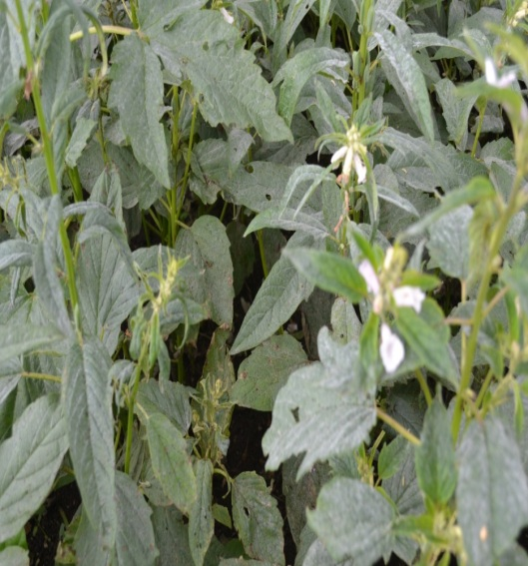 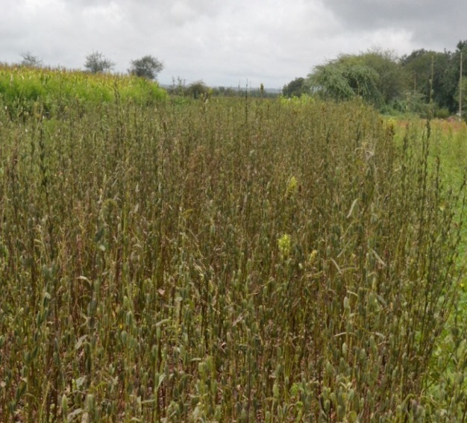

**Dharwad Bagalkote**

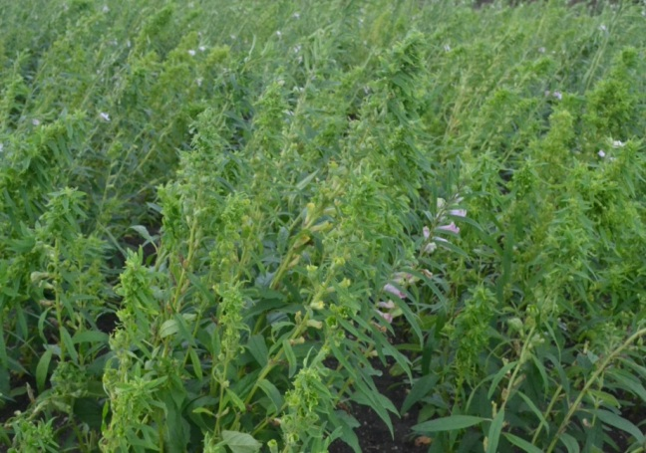 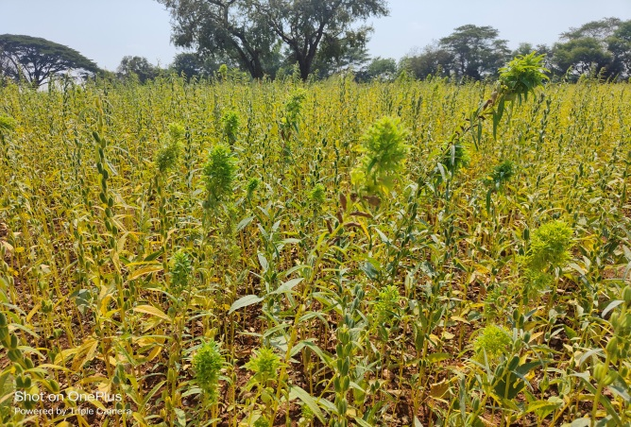

**Gadag Vijaypur**

**Plate 1: Field view of major fields infested with foliar diseases of sesame**

**Conclusion**

A survey for major foliar diseases of sesame in North Karnataka observed that the Maximum average severity of *Cercospora* leaf spot was recorded in Vijaypur (25.3%) and Belgaum (25.3%) district, whereas the lowest percent disease severity was noticed in Bagalkote district (21.3%). The maximum average disease severity of *Alternaria* blight was noticed in Vijaypur district (28.2%) and the lowest average disease severity was recorded in Gadag district (21.8%). The highest severity of Powdery mildew disease was reported in Gadag district (25.7%) and the lowest disease severity was noticed in Dharwad district (21.8%). The maximum average percent disease incidence of Phyllody was noticed in Belgaum district (26.9%) and the average lowest disease incidence was recorded in Gadag district (19.4%) respectively. The study indicated that those diseases that occurred at all sesame crop growth stages are the major diseases. From this study, we recommended that the periodization of different diseases and appropriate control methods should be identified and recommended to prevent sesame yield loss and increase productivity. Field disease assessment and inspection disease control must be from emergence to capsule formation and maturity. Farmers and investors should be given continuous training on how to assess, identify and control sesame diseases.

**Disclaimer (Artificial intelligence)**

Option 1:

Author(s) hereby declare that NO generative AI technologies such as Large Language Models (ChatGPT, COPILOT, etc.) and text-to-image generators have been used during the writing or editing of this manuscript.

Option 2:

Author(s) hereby declare that generative AI technologies such as Large Language Models, etc. have been used during the writing or editing of manuscripts. This explanation will include the name, version, model, and source of the generative AI technology and as well as all input prompts provided to the generative AI technology

Details of the AI usage are given below:

1.

2.

3.

**References**

Akhtar, K., Sarwar, G., Dickson, M., Ahmad, M., Ahsanul Haq, M., Hameed and Javeed Iqbal, M., 2009, Sesame phyllody disease: Its symptomatology, etiology and transmission in Pakistan. *Turk. J. Agric*., 33: 477- 486.

Anonymous, 2017, Status paper on oilseeds, Department of Agriculture and Cooperation, Ministry of Agriculture, Govt. of India, New Delhi.

Bashir M R, 2017, Impact of global climate change on charcoal rot of sesame caused by *Macrophomina phaseolina*. *Journal of Hort*iculture, 4(1): 100-106.

Deepthi M, Kumar RS, Ravi P, Sampath O,2024, Soil Quality Assessment of Sesame-Growing Soils with Different Productivity in the Northern Telangana Zone, India. *Arch. Curr. Res*. Int. [Internet].;24(3):65-78.

Gopal K, Jagadeswar R, Prasad babu G, 2003, Evaluation of sesame (*Sesamum indicum*) genotypes for their reactions to powdery mildew and phyllody diseases. *Pl Dis Res.*; 20(2):126-130.

Islam F, Gill RA, Ali B, Farooq MA, Xu L, Najeeb U, Zhou W. Sesame. In Breeding Oilseed Crops for Sustainable Production 2016 Jan 1 (pp. 135-147). Academic Press.

Kolte SJ, 1985,Disease of annual edible oilseed crops. Vol II: Rapeseed, mustard, safflower and sesame diseases. Boca Raton, Florida: CRC Press Inc; p. 135.

Mayee CD, Datar VV, 1986, Phytopathometry, Technical Bulletin-I (Special Bulletin-3).Marathwada Agricultural Univ., Parabhani. p. 950.

Min YY, Toyota K, 2019, Occurrence of different kinds of diseases in sesame cultivation in Myanmar and their impact on sesame yield. *J Exp Agric Int.*;38:1-9.

Murugesan S, Rap'mmshnan C, Kandaswamy TK, Murugesan M. 1973,Forecasting phyllody disease of sesamum. *Madras Agric J.*;60(7):492-495.

Selvanarayanan V, Selvamuthukumaran T, 2000, Field resistance of sesame cultivars against phyllody disease transmitted by *Orosius albicinctus* Distant. Sesame and Safflower News Lett.;15:71-74.

Sridhar D, Patil MS, 2013, Survey for Sesamum phyllody disease in Northern Karnataka. *Karnataka J Agric Sci*.; 26(2):320-321.

Sundraraju D, Jayaraj S,1977, The biology and the host range of *Orosius albicinctus* dist. (Hemoptera, Cicadellidae), The vector of sesame phyllody disease. *Madras Agric J.* 64(7):442-446.

Vanishree LR, Banakar CN, Goudappagoudar R, 2013,Inheritance of phyllody resistance in sesame (*Sesamum* *indicum* L.). *Bioinf Lett.*;10 (1b):177-179.