Agricultural valorisation of organic wastes from market of Korhogo city in Côte d’Ivoire

Abstract
The present study aims to assess the fertilization potential of organic wastes from the municipal markets of Korhogo City in Côte d’Ivoire (Market of Sinistré). Wastes collection and characterization have been done prior to thermophilic aerobic composting which has been conducted by using Berkley method with two compost piles prepared for the experiment. The first one consisted with only dried organic waste, while a layer of 0.5 m³ of dried organic wastes on the pile base and a layer of fresh organic waste on the top, have been used for the second one. The obtained compost was analysed in laboratory using Mehlich 3 method, along with an infrared spectrometer, to determine its nutrients composition. Finally, the effect on plant growth and productivity of resulting compost was evaluated through the cultivation of cucumbers (Poinsett variety). The results showed a daily collection of organic waste from the studied market with an average of 56.57 kg. The resulting compost sample, after analyse, showed average NPK (Nitrogen, Phosphorus, Potassium) concentrations of 7, 4, and 32 g/kg, respectively, with low levels of trace metals (less than 0.007 g/kg). Used as fertilizer in cucumber cultivation, the compost induced rapid plant growth within four weeks, with an average height ranging from 70 and 98 cm, for 50 g and 75 g doses per plant. In addition, first mature cucumbers were harvested (55th day) in plots treated with composts, while cucumbers were still developing in untreated plots. At the end of harvesting period (two weeks), the highest yield was observed in the plot amended with wet components compost (6.18 kg of cucumbers), followed by the plot with dry components compost (4.2 kg) and the plot treated with NPK mineral fertilizer (3.15 kg).

Keywords: Korhogo, organic waste, municipal markets, compost, agriculture

- Introduction
Municipal waste management remains a significant problematic challenge in Africa. Large quantities of household wastes are not collected, which are accumulated in streets and public spaces, and cause serious environmental and public health consequences. These wastes constitute a major source of pollution with consequence of the proliferation of disease vectors such as rats and flies. Moreover, their uncontrolled accumulation can induce soil and water resources contamination (Zhang et., 2024).
A significant fraction of these waste is produced by municipal markets, with approximately 230 million tons of food waste annually produced (FAO, 2018). This situation is exacerbated by inadequate waste management practices, as related by the World Health Organization (WHO, 2018). In a view of this situation, improving food waste management appear to be a necessity. This requires a collection systems improvement and the development of a circular economy to valorise these residual materials.
In Korhogo, a northern city in Côte d’Ivoire like most of African cities or developing countries, the rapid growth of the population has led to a significantly increase of municipal solid waste (Kebaili et al., 2022, Waqas et al., 2023, Ayilara et al., 2020). However, waste management remains largely to be inefficient, limiting valorisation opportunities and amplifying environmental and health risks. In this context, a special attention should be paid to the agricultural valorisation of these organic wastes which could provide a sustainable solution. This approach would improve waste management on one hand and in the other hand contribute to food security by using compost (a great alternative to artificial fertilisers (Gowrisankar et al., 2023) as an agricultural fertilizer.
The main objective of this study is to assess the fertilization potential in agriculture of food waste from municipal markets Korhogo. Three specific objectives have been defined: (i) characterize the organic wastes from the studied municipal market, (ii) evaluate the fertilizing potential of the compost issued from these wastes, and (iii) analyse the impact of its application on crop growth cycles and yields.

2- Material and methods
2.1 Material
The biological material used for composting consisted of various organic waste collected (Figure 1) from Sinistré market of Korhogo. Trays were essentially used as collecting containers. The Poinsett variety of cucumber (Cucumis sativus) was selected for the study (Figure 2).

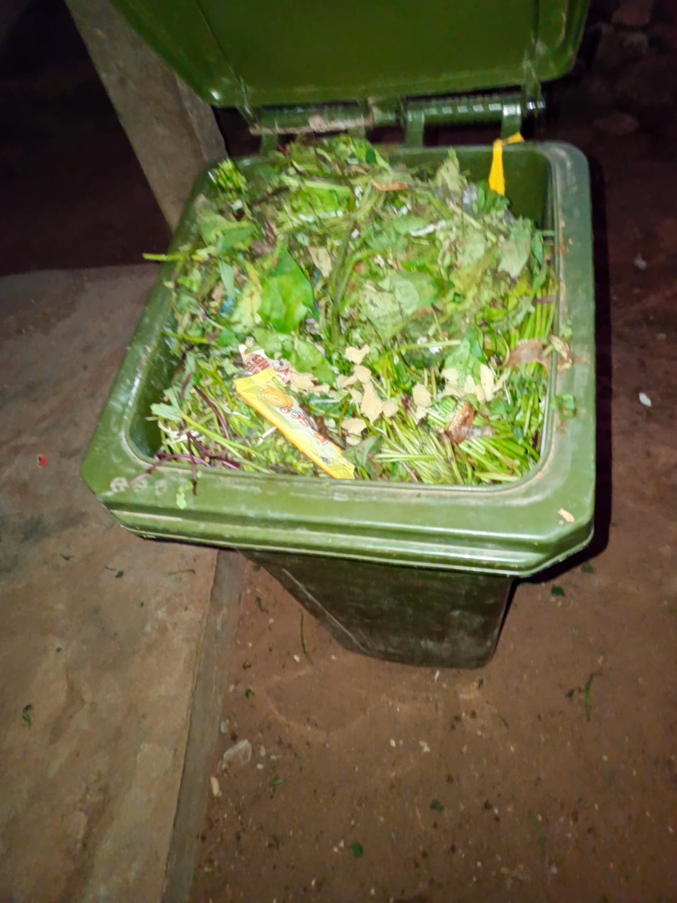
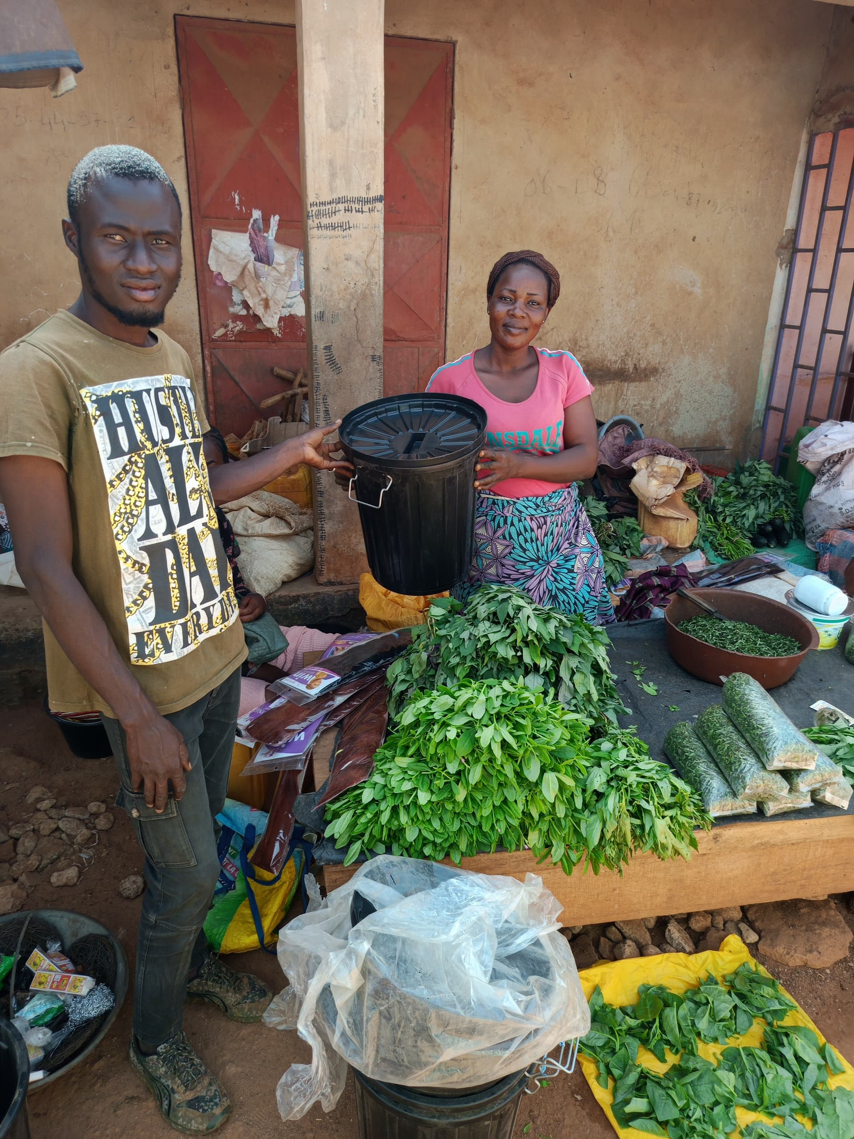

Figure 1: Organics market waste collection

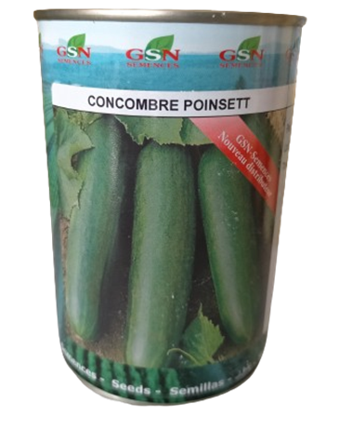

Figure 2: Variety of cucumber used for the experimentations

2.2 Method
2.2.1 Characterization of Organic Waste from Municipal Markets

Organic waste was collected daily over a three-week period from the market in the Sinistré neighbourhood. Waste was gathered using trays with capacities of 30 and 120 litres. The 30-litre bins were used to collect residual organic waste from individual vendors’ sales activities. The contents of these bins were then transferred to 120-litre containers. After collecting organic waste, drying process was done on plastic sheets about 18 days with aiming to reduce moisture and fat content, and partially pathogenic microorganisms elimination. To evaluate the lost mass due to evaporation and partial degradation of organic matter, the weight was measured before and after drying process. 1 kg sample of the dried wastes was brought to laboratory for analysis using the Melhich 3 method associated with an infrared spectrometer to determine its chemical composition (carbon, nitrogen, phosphorus, and potassium content etc…)

2.2.2 Assessment of the fertilizing potential of compost from municipal market organic wastes

Thermophilic aerobic composting was conducted using the Berkley method a rapid composting method like the method of Zakarya (2021). Two compost piles were prepared for the study:
Pile 1: only composed by dried organic wastes.
Pile 2: the base layer of 0.5 m³ is constituted by dried organic waste, with fresh organic wastes on the top.

The volume of the piles was around 0.90 m³, arranged in a pyramidal shape. Piles were periodically returned to ensure proper aeration. 1 kg was also sampled from each pile, after composting process, and taken to laboratory for analysis using the Melhich 3 method associated with an infrared spectrometer, in order to evaluate fertilizing potentialities (essential nutrients and organic matter content).

2.2.3 Assessment of the Impact of Compost Use on Crop Growth and Yield

The fertilizing effect of the produced compost was tested on experimental plots dedicated to cucumber cultivation. The experimental design included four treatments:
Plot 1 (Control): No compost or fertilizer applied.
Plot 2: compost with exclusively from dried organic wastes.
Plot 3: Compost with a mixture of dried and fresh organic wastes.
Plot 4: with Chemical NPK fertilizer applied at a rate of 100 kg/ha (after 3 weeks from cucumber seed germination).

The control plot (Plot 1) has a single row of 10 planting holes. Plots 2 and 3 have four rows, corresponding of 25 g, 50 g, 75 g, to 100 g per hole as compost dose. Plot 4 received a standard dose of 4 g NPK per hole.
The height of plants of each plot (over a four-week period) and the weight of harvested fruits (during two weeks) were measured in order to determine total yield per plot, and compare the impacts of the several treatments.

3. Results and Discussion

3.1 Physico-Chemical Characteristics of Collected Organic Waste
Table 1 presents the average daily amount (ranged from 30 to 75 kg per day, with an average of 56.57 kg/day) of organic wastes collected from the market of Sinistré, with a total of 1,244.43 kg of organic waste was collected over the three weeks. The drying process brought the weight to 396.5 kg, which represents 31.86% of fresh collected wastes. The wastes are composed of by-products from agriculture like onion peels, peanut shells, potato and cabbage. They are also leaves, orange pulp, eggplant scraps, chilli peppers, carrots, tomatoes etc...
Table 1: Quantity of organic waste collected
Total quantity of collected Fresh waste in 22 days (Kg) | Average quantity of collected Fresh waste per day (Kg) | Standard deviation | Total dry waste obtained (Kg)
1244.43 | 56.57 | 13.85 | 396
Table 2 shows physico-chemical characteristics of the dried organic wastes. The analyses revealed a significant content of nutrients essential for plant growth in 1 kg of dried organic waste sampled. Nutrients include Nitrogen (N), Phosphorus (P), and Potassium (K) with respectively values of 0.683% (6.83 g/kg), 0.311% (3.11 g/kg) and 3.218% (32.18 g/kg). They are also Calcium (Ca), Magnesium (Mg), Sulphur (S) with respectively values of 1.7365% (17.37 g/kg), 0.1323% (1.32 g/kg) and 0.2891% (2.89 g/kg). Trace elements such us (Manganese (Mn), Iron (Fe), Copper (Cu), Zinc (Zn) and Molybdenum (Mo) have been found with values less than 0.01 g/kg. Titanium (Ti), as well as Arsenic (As) and lead (Pb) have been found at levels below 0.005 g/kg. These values are considered to be non-hazardous for plants and humans. The sample also presents a significant content of carbon (71.5 g/kg) with 10.472 of C/N value.

Table 2 - Physico-Chemical Composition of Dried Organic Waste
Parameters | Dry waste (%) (1% = 10g/kg)
C | 7,155
N | 0,683
Mg | 0,1323
Al | 0,57935
P | 0,31115
S | 0,2891
K | 3,2181
Ca | 1,7365
Ti | 0,0091
Mn | 0,01395
Fe | 0,50065
Co | 0,0004
Ni | 0,00065
Cu | 0,00275
Zn | 0,00615
As | 0,0001
Mo | 0,0006
Pb | 0,0004
The drying process induced a reduction of the volume of collected municipal markets organic wastes after 18 days of drying, from 244.43 kg to only 396.5 kg (±32%). This is attributed to the loss of water and fat due to the solar exposition as well as the partial degradation of organic matter. Concentrations of macronutrients (essential minerals for plant growth) as showed by physico-chemical analyses, are superior to 1 g/kg. Content of carbon is high also (71 g/kg). These results highlight the fertilizing potential of organic wastes for the production of high-quality compost, as shown in the work of Jodar (2017). The study related that the initial composition has an influence on the quality of compost produced from urban solid wastes. At the end of composting process, volumes were reduced to 26% to 28% of the initial mass of each pile. This results are consistent with the volume reduction in the composting process reported by Hashim et al. (2022), which is due to the decomposition of organic matter through microbial activity.

3.2 Assessment of the Fertilizing Potential of Compost from Organic Waste in Municipal Markets
For each 1 kg of compost analysed, a notable presence of mineral nutrients essential for plant growth was observed. Wet components compost has approximate values of 6 g/kg, 3 g/kg and 37.4 g/kg, respectively for Nitrogen, Phosphorus and Potassium. Calcium, Magnesium and Sulphur have contents, respectively, of 23.2 g/kg, 3.9 g/kg and 3.9 g/kg. Wet components compost has slightly higher values compared to the compost with dry components, as shown in Figure 3. According to Carbon content, the C/N ratio of dry components compost (11.96) was slight higher than compost with wet components (11.25).

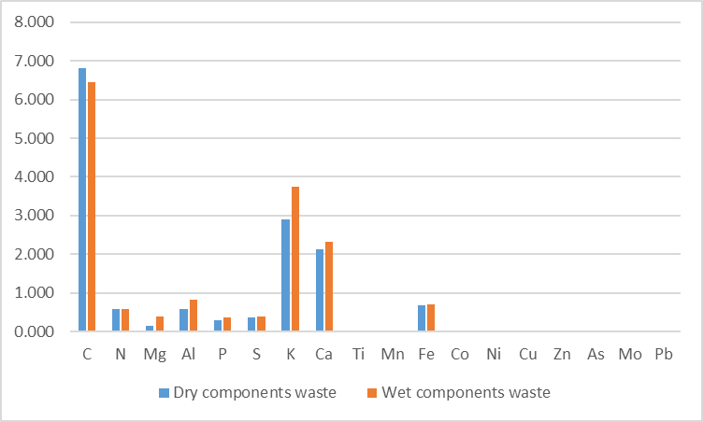

Figure 3: Physico-chemical characteristics of composts with dry and wet components
Wet components compost physico-chemical analyses showed slightly higher concentrations of macronutrients and micronutrients. This is due to the composting method, which involves mix of dry with fresh organic wastes, enhancing the substrate chemical diversity. C/N ratios of the composts are around 11, which are similar to values reported by Liegui et al. (2024), ranging from 10.5 to 13.8. This indicates that composts in the present study are near the complete mineralisation, as C/N ratio is a widely used indicator in assessing of compost mineralisation and maturity of organic matter (Ehouman et al., 2023, Elono et ., 2022 ).

3.3 Assessment of the Impact of Compost Use on Crop Growth Cycle and Yield
The parameters of vegetative cycle evaluated in the present study include germination and plant growth. The germination rate on the control plot (without compost) was 60%. The average germination rate for dry components compost was 75 % compared 65 % for wet components compost. Concerning plots amended with dry components compost, the germination rates were, respectively, 80% for 25 g and 50 g, 90% for 75 g and 50% for 100 g, as fertilization doses. Plots amended with wet components compost (applied as basal manure) have germination rates, respectively, of 90% for 25 g, 60% for 50 g and 75 g, and 50% for 100 g applied as basal manure. Figure 4 illustrates the germination rates for each plot amended with dry and wet components compost.

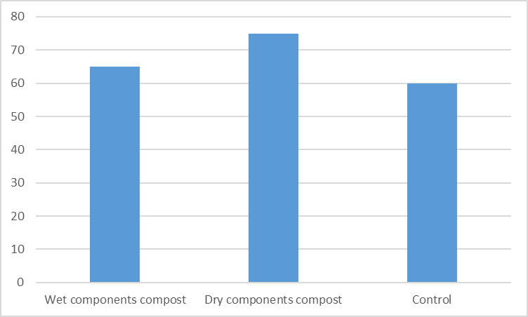
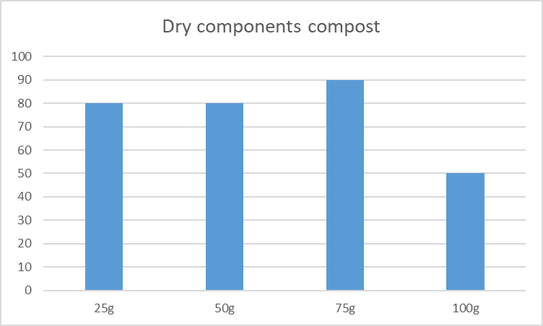
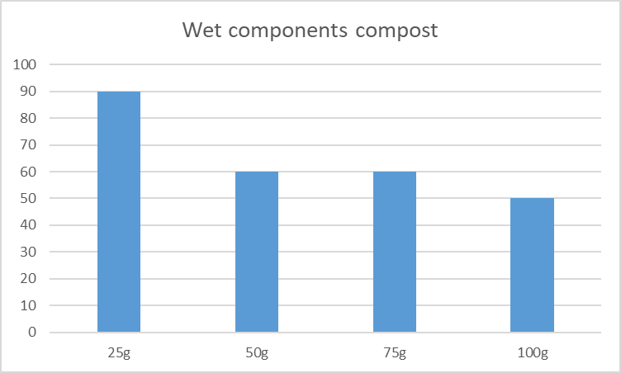
Figure 4: Germination rate
These results show that the use of compost improved the germination rate. Indeed, the incorporation of composts improved germination rates, with 75% for dry components compost and 65% for wet components compost, while the rate for the control reached 60%. These results are similar to those of Chennaoui et al. (2016), where germination rates were observed up to 85% and 67%, respectively for wheat and tomatoes, against 70% and 58% for controls. In terms of cost-effectiveness, particularly advantageous have been proved by the use of low doses of compost, such as 25 g of wet components compost. These results are similar to Tchanate et al. (2023) and Gambo et al. (2024) results, where small amounts of compost have been used for various crops as lettuce, wheat, cabbage, corn, and potatoes. However, it is important to note that germination rates could vary according to the compost dose and crop type (Liegui et al., 2024). In addition, compost should be considered as non-toxic when the germination rate exceeds 50% (Chennaoui et al., 2016). In the present study, the use of 100 g of compost could be considered to be to toxic as the germination rates were under 50 % for both dry and wet components composts.

Plant Growth
Figures 5 and 6 show the height of plants measured over a four-week period after germination. On the control plot (without compost), plants showed an average growth ranging from 1.7 cm in week 1 to 26.31 cm by week 4. However, significantly higher growth, starting from week 3 to reach a maximum average height of 84.43 cm at the end of week 4, has been observed on the plot amended with dry components compost (plants treated with 75 g per plot) (Figure 5). Contrarily, higher growth from week 3 to a maximum average height of 98 cm by the end of week 4, has been observed on the plot amended with wet components compost, on the plants line treated with 25 g per plot (Figure 6).

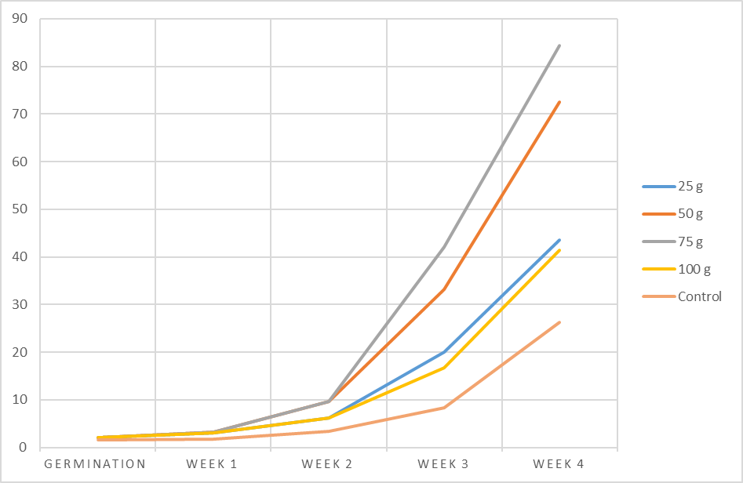
Figure 5: Plants growth with dry components compost

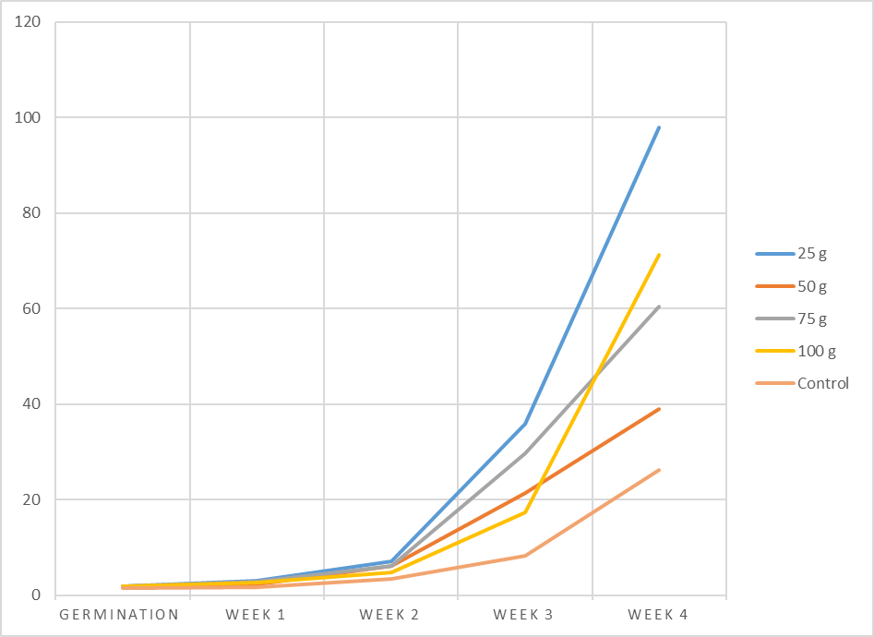
Figure 6: Plants growth with wet components compost
The influence of the use of composts, regarding cucumber plants growth, shows that wet components compost gives most higher plants number, while the control treatment gave the smallest values. The rapid growth observed with 50 g and 75 g of dry components compost and 25 g of wet components compost can be due to improvement of the substrate quality. The increase of soil organic matter induces an enhancement of nutrient availability and retention through the Cation Exchange Capacity (CEC), which has a value of 14.35 in the present works. Organic matter also contributes to soil aggregation, which improves soil structure and nutrient availability. The average number of flowers, approximately 13, remained relatively consistent, which corroborates the results of Longanza et al. (2015), where similar results have been observed, based on different treatments (control, compost, NPK) and time.

Yield
Figure 8 shows the quantities of cucumbers harvested from each plot during the two-week period. The first ripe cucumbers were harvested from plots 2 and 3 (amended with composts) around day 55, while cucumbers on plots 1 (control) and 4 (amended with NPK) were still in development. Cucumbers from plot 3 (25 g wet components compost) were distinguished by their great size and elongated shape, and were similar to those from plot 4. Contrarily, cucumbers of plot 1 were smaller with a rounded shape and a pointed end (Figure 7). Plot 2 (75 g of dry components compost) produced 1.6 kg of cucumbers, plot 3 (50 g of wet components compost) produced 1.65 kg, similar to plot 4 (amended with NPK), while plot 3 (50 g of wet components compost) gave the highest cucumber yield at 2.75 kg. These results are illustrated in, which. Results highlighted the fertilizing potential of compost obtained from market organic wastes and its positive impact on cucumber production. The first fruits were harvested from plots amended by compost, with a yield of 2.75 kg (30.6 t/ha) for wet components compost, superior to the yield of NPK-amended plots (1.65 kg, or 18.3 t/ha) and the control (1.5 kg, or 16.7 t/ha). These yields of control and NPK-amended are in the typical production range for tropical regions (5–20 t/ha) without chemical fertilizers (Tuo et al., 2023).
The heterogeneous nutrient composition of the compost which are released gradually over the crop cycle, specially phosphorus, potassium, and other mineral content, could be responsible of this performance. These observations are similar to the findings of Serémé and Phal (2007), Kusakana et al. (2022), and Tahraoui (2013), where household compost had significantly improved crop yields compared to controls.
Variation in fruit shape and size may be explained by the insufficient available nutrient, especially nitrogen that could explain the pointed apex of some fruits and the pale green colouration of leaves. Overall, the quality of compost and application doses directly influence crop yields, as documented by Naïma et al. (2023).

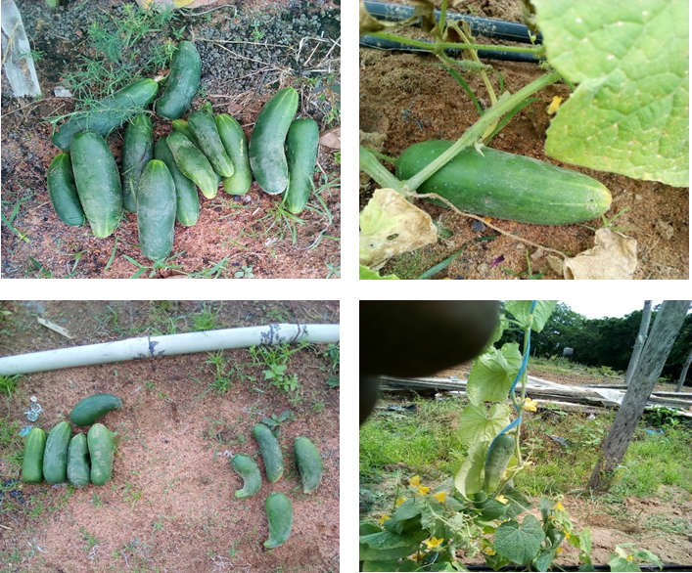

Figure 7: Shape of yields with composts and control

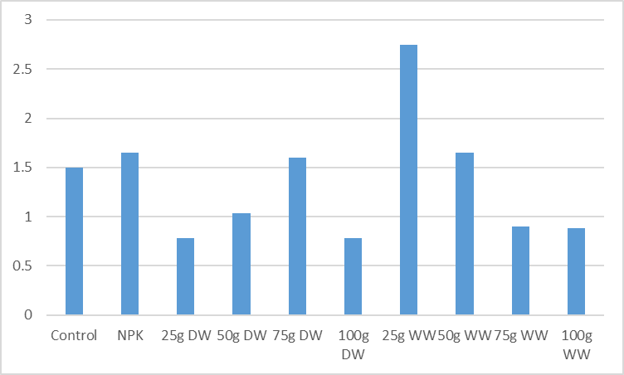

Figure 8: Plots yields with composts and control

Conclusion
The present study which aim was to demonstrate the fertilizing potential of organic wastes from municipal markets in Korhogo city, confirmed that compost from these wastes are valuable sources of nutrients that meet vegetable crops needs. This is significantly relevant in local soils context with low mineral content, as shown by low yields from the non-amended control plot (1.5 kg). The use of NPK chemical fertilizers at a dose of 4 g per plot (100 kg/ha) has not only achieved a yield of 18.3 t/ha, but also highlighted the promising potential of composting with highest yield. This approach of using organic wastes from municipal markets, not only reduces the environmental impact of pollutants, but also offers a cost-effective alternative for farmers, who despite of using chemical fertilizers, often need supplement with organic amendments to improve yields. The application of a low dose of wet components compost (25 g per plot, or 625 kg/ha) achieved a significant yield of about 30.6 t/ha while reducing production costs. This is very important in a context where many vegetable farmers look for sufficient profitability to support their families.
Future researches should be done to sufficiently explore further strategies in order to enhance the quality of compost produced from these wastes, providing valuable insights for sustainable agriculture. It is also recommended to evaluate the effectiveness of compost on crops other than cucumbers to better understand and optimize its potential. Other valorisation experimentations should be studied such as energy production through biogas produced from those waste that could be a double beneficial way of valorisation

Disclaimer (Artificial intelligence)
Option 1:
Author(s) hereby declare that NO generative AI technologies such as Large Language Models (ChatGPT, COPILOT, etc.) and text-to-image generators have been used during the writing or editing of this manuscript.

REFERENCES
- Chennaoui, M., Salama, Y., Makan, A., & Mountadar, M. (2016). Agricultural recovery of compost produced from in-tank composting of municipal waste. European Scientific Journal, 12(35), 247.
DOI: 10.19044/esj.2016.v12n35p247
- Liégui, G. S., Cognet, S., Djumyom, G. V. W., Atabong, P. A., Fankem Noutadié, J. P., Chamedjeu, R. R., & Temegne, C. N. (2024). An effective organic waste recycling through vermicomposting technology for sustainable agriculture in tropics. International Journal of Recycling of Organic Waste in Agriculture, 10(3).
https://doi.org/10.30486/ijrowa.2021.1894997.1080
- Kolani N’Djoibini Tchanaté, Gnon Baba, Nitale M’Balikine Krou, Koffi Agbegnigan. Degbe (2023). Effects of Different Doses of Compost on the Productivity of Corn (Zea mays L.) in the towns of LomÉ and Kara in Togo. Journal of Food Security., 11(2), 64-71.
DOI: 10.12691/jfs-11-2-4
- Ehouman, A., Kouakou, A., Konan, G., Abi, K., N’Dri, A. and Yao, B. (2023). Study of the Physico-Chemical Characteristics of Methacompost from a Poultry Company in Ivory Coast: Test for Growing Big Sun Chilli". Journal of Agricultural Chemistry and Environment, 12 (4): 335-350.
doi: 10.4236/jacen.2023.124024
- Longanza, B L., Kidinda, K. L., Tamina, T D., Tombo, J. A., Ikatolo, T M. (2015). Agricultural waste recovery as an alternative to waste management in cities in sub-Saharan Africa: Characterization of urban waste in Lubumbashi and assessment of its effects on food crop growth. Africa SCIENCE, 11(2) : 76–84.
https://www.researchgate.net/publication/359929910_Valorisation_agricole_des_dechets_comme_alternative_a_leur_gestion_dans_les_villes_d%27Afrique_subsaharienne_caracterisation_des_dechets_urbains_a_Lubumbashi_et_evaluation_de_leurs_effets_sur_la_croissa
- Yahoussa Gambo, Siddo Seyni, Maigari Malam Assaneb, Mani Mamman (2024). Optimizing Compost Supply Methods for Enhanced Crop Yields in the Zinder Region of Niger. Asian Journal of Agricultural Extension, Economics & SociologyVolume 42 (9): 192-200
DOI: 10.9734/ajaees/2024/v42i92554
- Naïma , T. D., Nacéra, C., Amina, F., & Serge, C. (2023). Composting-methanization of solid urban bio-waste from the municipality of Chlef (Algeria). Revue Nature Et Technologie, 15(02) :17–30.
https://journals.univ-chlef.dz/index.php/natec/article/view/152
- Hashim S, Waqas M, Rudra RP, Khan AA, Mirani AA, Sultan T, Ehsan F, Abid M, Saifullah M. (2022) On-Farm Composting of Agricultural Waste Materials for Sustainable Agriculture in Pakistan. Scientifica (Cairo). 8:5831832.
doi: 10.1155/2022/5831832
- Xavier N’kenda Kusakana, Roger Vumilia Kizungu and Jean de Dieu Mayulu Minengu (2022). Comparative effects of composts and chicken droppings on the production of tomato (Solanum lycopersicum L.) grown in the soil of Kinshasa. International Journal of Science and Research Archive, 07(01): 484–493
DOI: https://doi.org/10.30574/ijsra.2022.7.1.0220
- I A Zakarya, T N T Izhar and N M Noordin, N Ibrahim and S A Kamaruddin (2021). Rapid composting of food waste and yard waste with effective microorganisms (EM). IOP Conf. Series: Earth and Environmental Science 920: 012028
doi:10.1088/1755-1315/920/1/012028
- Sereme, A., Phal, M. (2007). Agricultural recovery of household waste in the Sudano-Sahelian zone: The case of the town of Bobo-Dioulasso. Sciences medicales, CAMES-Series A, 5: 64–71.
http://greenstone.lecames.org/collect/revu/index/assoc/HASH8e59.dir/A-005-00-064-071.pdf
- Jodar, J. R., Ramos, N., Carreira, J. A., Pacheco, R. and Fernández-Hernández, A. "Quality assessment of compost prepared with municipal solid waste" Open Engineering, vol. 7, no. 1, 2017, pp. 221-227. https://doi.org/10.1515/eng-2017-0028
- Tahraoui, D. N. (2013). Composting of solid urban waste from the commune of Chlef, Algeria (Doctoral thesis). University of Limoges in co-tutelage with the University of Blida, Department of Science and Technology, Algeria.
https://cdn.unilim.fr/files/theses-doctorat/2013LIMO4038.pdf
- Kebaili, F. K., Baziz-Berkani, A., Aouissi, H. A., Mihai, F.-C., Houda, M., Ababsa, M., Azab, M., Petrisor, A.-I., & Fürst, C. (2022). Characterization and Planning of Household Waste Management: A Case Study from the MENA Region. Sustainability, 14(9), 5461. https://doi.org/10.3390/su14095461
- Tuo Seydou , Koné Dapah Sara Fatim, Guinagui N’Doua Bertrand, Sanogo Souleymane, Bamba Barakissa, Yéo Gnénakan, Nomel Meless Patrice, Anoman Omyon Jean Anselme, Koné Daouda (2023). Assessment of the Agronomic Performance of Seven Okra (Abelmoschus esculentus (L.), Moench) Cultivars in Southern Côte d’Ivoire. World Journal of Agricultural Research, 11(4) : 87-97.
DOI: 10.12691/wjar-11-4-1
- Zhechen Zhang, Zhonghao Chen, Jiawen Zhang, Yunfei Liu, Lin Chen, Mingyu Yang, Ahmed I. Osman, Mohamed Farghali, Engui Liu, Dalia Hassan, Ikko Ihara, Kun Lu, David W. Rooney, Pow-Seng Yap (2024). Municipal solid waste management challenges in developing regions: A comprehensive review and future perspectives for Asia and Africa. Science of The Total Environment, 930: 172794
https://doi.org/10.1016/j.scitotenv.2024.172794
- Food and Agriculture Organization of the United Nations (2018). The State of Food Security and Nutrition in the World 2018.
https://openknowledge.fao.org/server/api/core/bitstreams/f5019ab4-0f6a-47e8-85b9-15473c012d6a/content
- Ayilara, M. S., Olanrewaju, O. S., Babalola, O. O., & Odeyemi, O. (2020). Waste Management through Composting: Challenges and Potentials. Sustainability, 12(11): 4456.
https://doi.org/10.3390/su12114456
- World health Organization (2018). World health statistics 2018: monitoring health for the SDGs, sustainable development goals.
https://www.who.int/publications/i/item/9789241565585
- Elono, A., Meli, A. Tsila, H. (2022) Environmental Impacts of Farm Waste Treatment Methods and Perspectives of Valorization by Composting: The Case of the Farm “Société de Provenderies du Cameroun (SPC)” of Foumbot. Journal of Geoscience and Environment Protection, 10 (6): 220-233.
doi: 10.4236/gep.2022.106014.
- Waqas, M., Hashim, S., Humphries, U. W., Ahmad, S., Noor, R., Shoaib, M., Naseem, A., Hlaing, P. T., & Lin, H. A. (2023). Composting Processes for Agricultural Waste Management: A Comprehensive Review. Processes, 11(3), 731. https://doi.org/10.3390/pr11030731
- Gowrisankar R, Sumithramma N, Mulimani V, Pradhan SK, Gundreddy R. Blatticomposting: A Sustainable Approach for Organic Waste Management. Int. J.Environ. Clim. Change. [Internet]. (2023). 13(9): 754-62. https://journalijecc.com/index.php/IJECC/article/view/2296

