**Deciphering traits Association and Regression analysis in Rice (*Oryza sativa* L.) under Saline soils**

**Abstract**

Salt stress adversely affects plant growth and development. Various strategies have been employed to enhance the production and productivity of plants to salt stress. Expression of complex traits like yield is the result of interaction of several yield contributing features, correlation analysis and regression were conducted in an experiment involving 86 rice genotypes to determine relationship of seed yield and its component traits. The experiment was conducted during *Rabi,* (November – April 2020-2021) at Agricultural Research Station Kampasagar, Telangana, India. The genotypes were transplanted in the naturally formed salinity screening block to analyze the tolerance under salinity situations. The 10 characters observed are as shown as follows: Mortality percentage, days to 50 per cent flowering, plant height, panicle length, number of productive tillers, the number of grains per panicle, unfilled grains per panicle, spikelet sterility, 1000 grain weight and seed yield per plant were recorded. Correlation analysis revealed that number of productive tillers, panicle length and total number of grains per panicle had positive significant association with seed yield per plant, selection for these traits will improve seed yield. Analysis using linear regression revealed that, in general, the seed yield showed the linear and quadratic relationships with other traits, and number of productive tillers, panicle length and 1000 grain weight showed the robust relationship. Among all the yield contributing traits, the number of productive tillers and panicle length had the highest contribution to the seed yield. It is crucial to give priority to traits that exhibit significant positive correlations and traits showing highest contribution to the seed yield during selection process. This approach will yield rewarding results in the development of high-yielding cultivars suitable for salinity conditions.

**Keywords:** Rice, Correlation, Regression, Salinity, Seed yield.

1. **Introduction**

Rice (*Oryza sativa* L.) is one of the most important grains for global nutrition and the primary source of energy for people in Asia, Africa, and Latin America (Fukagawa and Ziska 2019). Worldwide, more than 3% of the agriculture area (162 million ha) was used for rice culture and produced 539.2 million tons (FAOSTAT 2024). After China, India is the world's largest producer of rice, with an area of 43.78 mha, a production of 118.43 mt, and a productivity of roughly 2705 kg ha-1 (Anonymous, 2021). To provide food security and combat poverty, rice output must rise. One of the most useful and widely used strategies to overcome the yield barrier is hybrid rice technology, which increases yield percentage by roughly 15–20 percent (Ma and Yuan, 2015).

Climate change and abiotic stresses are causing shifts in agricultural landscapes. Salinity is the major abiotic stress after drought in rice-growing areas of the world and nearly 6.73 million hectares of land in India are saline-affected soils (Krishnamurthy et al. 2014). The area under salinization is increasing due to low precipitation, high surface evaporation, weathering of native rocks, irrigation with saline water, and poor cultural practices (shrivastava and kumar 2015; Singh et al., 2021). Though irrigated lands are further expected to suffer from secondary inland salinization, the situation is likely to be aggravated by an increase in sea level due to climate change (Tack et al., 2015). It has been estimated that more than 50% of the arable land will be affected by salinity by the end of 2050 (Jamil et al. 2011).

Rice is sensitive to salt, particularly during its early growth stages, with the seedling stage being more vulnerable than the tillering stage (Selvamani et al., 2023). In general, salt affects the growth of crop plants by limiting the absorption of water through the roots affecting the metabolic processes of the plant. It has an immediate effect on cell growth and enlargement, as a high concentration of salt results in toxicity. Ion toxicity is the primary cause while osmotic stress and oxidative damage are secondary causes of salt damage [43,44]. The saline stress has adverse affects on rice crop during the entire crop duration resulting in low seed germination rate, retarding the seedling growth, seedling mortality, low biomass accumulation, reduction in the main root length and several lateral roots, reduction in tillering ability, a lesser number of spikelets per panicle, greater spikelet sterility percentage, reduced panicle weight thereby causing a significant reduction in grain yield. Understanding the relationships among its components, yield, and grain nutrition are of predominant importance for utilizing these relationships to obtain desired modification and is suggested for a further recombinant breeding program.

Correlation and regression analysis were the common techniques used to elucidate the relationship between two quantitative variables. How strong the relationship between two quantitative characters could be analyzed using correlation, while regression analysis gave the information about the direction and causal-effect relationship in the equation form (Gyawali et al., 2018; Rukmini Devi et al., 2017; Iqbal et al., 2020). The common issues in the correlation relationship of seed yield and contributing characters were mortality percentage, days to 50% flowering, plant height, number of productive tillers, panicle length, total number of grains per panicle, unfilled grains per panicle, sterility percentage and 1000-grains weight. This study aimed to understand the correlation and regression relationship between the seed yield with yield contributing traits. The other traits would be used as a predictor in the regression analysis. Furthermore, this study could give the information on the yield traits contribution to the seed yield.

1. **Material and Methods**

**2.1 Plant materials**

The plant materials used in the study consisted of 80 genotypes and 6 checks of rice, including advanced breeding lines, released varieties, and elite lines generated through various breeding procedures, collected from various sources and maintained at the Agricultural Research Station in Kampasagar, Telangana (Table 1).

**2.2 Experimental layout**

The 80 genotypes along with four tolerant checks (FL 478, CSR 23, CSR 36, RNR 11718), one susceptible check (Pusa-44), and one local yield check (KPS 2874) were sown in Randomized Complete Block Design with three replicationsin the *Rabi,* (November – April 2020-2021). The spacing of 25 cm between rows and 15 cm between plants was followed.

**2.3 Methodology**

A naturally existing plot subjected to stress from inland salinity was used as the field environment for screening the experimental materials. An electrical conductivity (E.C.) of 4.68 dSm-1, pH of 9.30, and Exchangeable Sodium Percentage (ESP) of 88.0 were among the soil properties of the field. The Standard Evaluation Score (SES) was calculated in accordance with the IRRI Standard Evaluation System, 2013 standards during the reproductive stage (Table 2). Consistency was maintained by carefully implementing essential plant protection measures and suggested agricultural techniques for ensuring the crop's regular development in the main field.

**2.4 Data observations**

For each trait, data from each plant and the means of the five plants were observed and recorded. The 10 characters observed are as shown as follows: Mortality percentage (MT), days to 50 per cent flowering (DFF), plant height (PH), panicle length (PL), the number of productive tillers (NPT), the number of grains per panicle (TNGP), the number of unfilled grains per panicle (UFG), spikelet sterility (ST), 1000 grain weight (TGW) and seed yield per plant (SY) were recorded.

**2.5 Data analysis**

Data were collected from five randomly taken from three each genotype and replication. The observation was done manually to all traits. The averages of the collected data were used for statistical analysis. Data were analyzed for the correlation among all traits observed using Pearson’s correlation. Furthermore, in the regression analysis, seed yield (SY) was used as dependent variable and the other traits were used as predictors (independent variable), those each in a separate analysis. In the regression analysis, was used the average of replications data and the average of genotypes data. All statistical analysis was done using statistical software Minitab 16 and Microsoft Excel 2013.

1. **Results and Discussion**

**3.1 Correlation analysis**

The phenotypic correlation coefficients of different characters in genotypes grown under salinity condition were researched to discover the nature of the association (Table 1; Figure. 2). The results showed that seed yield per plant had a significant positive correlation with a number of productive tillers/m2 (0.5996**), panicle length (0.3189**), and total number of grains per panicle (0.3909**) but significantly and negatively correlated with mortality percent (-0.5888**), days to 50% flowering (-0.2615*), number of un-filled grains per panicle (-0.4517**), and sterility percentage (-0.5917**). Similar results were supported by Snehi et al.(2022) for number of filled grains panicle-1, number of productive tillers plant-1 and panicle length, Bhargava et al. (2021) for panicle length and productive tillers, Devi et al. (2017) Devi et al. (2022) and Krishnaveni et al. (2013).

The trait mortality percentage showed positive significant correlation with days to 50% flowering (0.2824**), number of un-filled grains per panicle (0.5021**), and sterility percentage (0.6217**) but negative significant association with number of productive tillers/m2 (-0.5677**) and total number of grains per panicle (-0.2578**). Touhiduzzaman *et al*. (2016) reported similar findings for mortality percentage with seed yield per plant. So, to increase yield genotypes with low mortality percentage should be selected which results in the production of more productive tillers with a greater number of grains per panicle which in turn increases the yield.

Days to 50% flowering shows positive significant correlation with mortality percentage (0.2824**) and negative significant with seed yield/plant (-0.2615*). With respect to days to 50% flowering it would be desirable to select plant with early flowering. Hence these findings reveal that early flowering types may have more chance of increase in plant growth improving the source and sink relationship, which paves way for more number of grains and seed yield. These results were in accordance with the findings of Banumathy *et al*. (2018), Aarthi *et al*. (2019), Sumithra *et al*. (2019) and Ghazy *et al*. (2020).

A positive non-significant relationship of plant height (cm) was observed with mortality percentage (0.0841), total number of grains per panicle (0.1448), number of un-filled grains per panicle (0.1730), and sterility percentage (0.0421) but negative non-significant relationship was observed with panicle length (- 0.0303), number of productive tillers/m2 (-0.0992), 1000 grain weight (-0.1045), and with seed yield per plant (-0.2084). In case of plant height selection of dwarf lines would increase the yield through the production of more productive tillers with a greater panicle length and thus accommodating a desirable 1000 grain weight and directly increasing the seed yield per plant. These results were in accordance with the findings of Tripathi *et al.* (2018), Manohara *et al*. (2019), Shrivatsav *et al.* (2020), Ghazy *et al.* (2020) and Kiruthikadevi *et al.* (2020).

Number of productive tillers/m2 showed a positive significant relationship with panicle length (0.2151*), total number of grains per panicle (0.4066**), and seed yield per plant yield (0.5996**) and a positive association with 1000 grain weight (g) (0.0891), and a negative significant relationship with mortality percentage (-0.5677**), number of un-filled grains per panicle (-0.5057**), and sterility percentage (-0.6686**). As the production of productive tillers increases, it increases the total number of grains with a greater panicle length and thus results in increase of seed yield per plant and its indirect effect is in the reduction of sterility percentage (%) and mortality percentage. Similar reports were reported by Banumathy *et al*. (2018), Sumithra *et al*. (2019), Shrivatsav *et al*. (2020), Ghazy *et al.* (2020) and Kiruthikadevi *et al*. (2020).

Panicle length shows positive significant relationship with number of productive tillers/m2 (0.2151*) and total number of grains per panicle (0.3266**). Selection of greater panicle length would increase the yield through the production of more productive tillers with a greater number of grains per panicle. These results are in agreement with the findings of Kiruthikadevi *et al*. (2020), Muthuvijayaragavan and Murugan (2020), and Ul Islam *et al*. (2017).

Total number of grains per panicle showed a positive significant relationship with number productive tillers/m2 (0.4066**), panicle length (0.3266**), but negative significant relationship with traits mortality percentage (-0.2578**), and sterility percentage (-0.3217**). As the total number of grains per panicle increases, via increasing number of productive tillers with a greater panicle length and thus results in increase of seed yield per plant and its direct effect is in the reduction of sterility percentage (%) and mortality percentage. Similar results were reported by Touhiduzzaman *et al.* (2016), Gautam *et al.* (2018), Ul Islam *et al.* (2017), Narayanan *et al.* (2019), and Sumithra *et al.* (2019).

Number of un-filled grains per panicle shows a positive significant relationship with mortality percentage (0.5021**), and sterility percentage (0.8246**), and a negative significant relationship with number of productive tillers/m2 (-0.5057**), 1000 grain weight (-0.2168*), and seed yield per plant (-0.4517**). Sterility percentage shows a negative significant relationship with number of productive tillers/m2 (-0.6686**), total number of grains per panicle (-0.3217**) and a negative non-significant relationship with 1000 grain weight (-0.0622). Reduction in number of un-filled grains per panicle character will lead to reduce sterility percentage. Reduction in 1000 grain weight is due to the reduction in the size of the grain because of the prevailing salt stress conditions. Similar results of this trait were reported by Karim *et al.* (2014), Shrivatsav *et al*. (2020), and Hasan-Ud-Daula and Sarker (2020).

1000 grain weight showed a positive non-significant relationship with seed yield per plant with a value of (0.1851). Usually high input, irrigation and soil fertility management conditions will increase 1000 grain weight. Similar results of this trait being positive non-significant correlated with grain yield (kg/ha) was reported by Shrivatsav *et al*. (2020) and Hasan-Ud-Daula and Sarker (2020).

The prime economic trait, grain yield per plant correlated significantly and positively with number of productive tillers, panicle length and total number of grains per panicle. Therefore, the selection of such characters will indirectly enhance the grain yield. The associations between yield and other traits including the number of effective tillers per hill, plant height, spikelet sterility percentage, number of filled spikelets per panicle, were also revealed by Faysal et al. (2022). These traits would be efficient for enhancing the yield, and the yield of rice in future breeding programs would be increased. Overall, among the genotypes, grain yield per plant showed a highly significant and positive correlation with its component traits (number of productive tillers, panicle length, number of grains per panicle and 1000 grain weight), while it exhibited a strong negative correlation with sterility percentage. Therefore, a separated but simultaneous selection for enhancement of these traits could be executed.

**3.2 Regression analysis**

There was a considerable association between the independent variables (multicollinearity), which prevented the implementation of multiple regression analysis based on the results of correlation analysis. The models goodness of fit would be reduced by multicollinearity (Zhang et al. 2018). It was a linear regression that was employed. Two different kinds of relationships between SY and yield-contributing characteristics were found by the regression analysis. There were two types of relationships: one was linear, and the other was quadratic. The most important equation at the highest level was used to determine whether the equation was linear or quadratic (Table 2; Figure 1). Quadratic relationships were more common than linear ones when the replication data averages were employed

The linear equation showed at the relationship between SY vs MT, DFF, PH, PL, NPT, TNGP, UFG, ST and TGW. The robust linear relationship found at the SY vs PL, DFF, MT, ST and TGW characterized by the distribution of points that were close to the regression line. Besides, they had a high R2 value.

The quadratic relationship was found in the regression between SY vs NPT, SY vs PL, SY vs DFF and SY vs TGW. Based on the statistical analysis, these PL, NPT and TGW traits had a broad variation. The positive and significant regression means that the dependent variable would increase along with the increase of the independent variable by a particular equation. As the dependent variable, the SY increased by the increase of NPT, PL and TGW in a linear and quadratic fashion. Panicle length and 1000 grain weight showed the greatest contribution to the seed yield per plant (Figure 1). Based on multiple regression analysis, found that the greatest contribution to the number of grains per panicle were the 1000 grain weight (Bai et al. 2016).

R2 is typically used for assessing the strength of the regression equation. The R2 a value showed the proportion of the dependent variable's variability that the model could account for (Sellam and Poovammal 2016). The dependent variable's degree of variation caused by the independent or predictor variable was indicated by the coefficient of determination, or R2 (Schneider et al. 2010).

The regression between SY and PH in this study had the lowest R2 of 4.3%, whereas the regression between SY and NPT had the highest R2 of 35.9%. Remarkably, this outcome validated the findings of Bagheri et al. (2011) and Bai et al. (2016). According to Mohapatra (2013), redesigning the new plant type (NPT) of rice can boost its production potential, and a key factor in this redesign was the quantity of productive tillers with dwarf character.

It was intriguing to investigate the architecture of rice yield as a crucial determinant of yield. The parameters that contributed to rice production varied widely between genotypes and had a strong positive connection. The quantity and distribution of data points had an impact on the regression equation model. Regression examination of the average replication data revealed that, generally speaking, the regression between SY and other traits, SY vs NPT, TGW and PL showed the largest linear and quadratic relationships. The PL contributed the most to the SY out of all the traits that contributed to seed yield.

Stepwise regression analysis following step down procedure gave the equation: SY = 19.81 - 0.0776 MT - 0.1708 DFF - 0.0641 PH + 0.0166 NPT + 0.260 PL + 0.1785 TNGP- 0.304 UFG - 0.0960 ST + 0.1166 TGW. This indicated that number of productive tillers, panicle length, total number of grains per panicle and 1000 grain weight jointly accounted for 60.86% variation in seed yield in this population.

**4. Conclusion**

From the above results based on correlation and regression analysis different genetic parameters used in this investigation, it appears that selection of medium plant height, more number of productive tillers with greater panicle length and higher 1000 grain weight would be more effective for improving grain yield in this population of rice under salinity situations. It is possible to apply the selection of grain yield under saline conditions but it needs to be postponed to later generations. Additionally, the role of number of productive tillers and greater panicle length had maximum positive effect on grain yield that could be used for selection. This study assists breeders to select desirable and suitable genotypes for salinity conditions.

1. **References**
2. Aarthi M, Vennila S, Palaniraja, K. Studies on genetic diversity of rice (*Oryza sativa* L.) under natural saline condition. The Pharma Innovation Journal*.* 2019; 8(7): 524-527.
3. Selvamani S, Senthil A, Ravichandran V, Djanaguiraman M, Anitha K, Shanmugam PM, Boopathi NM. Mitigation of salinity Stress by application of Plant Growth Promoting Substances in Rice. International Journal of Environment and Climate Change. 2023; 13(10): 2175-2185.
4. Bhargava K, Shivani D, Pushpavalli SNCVL, Sundaram RM, Beulah P, Senguttuvel P. Genetic variability, correlation and path coefficient analysis in segregating population of rice. Electronic Journal of Plant Breeding. 2021; 12(2): 549–555.
5. Banumathy S, Veni K, Anandhababu R, Arunachalam P, Raveendran M, Vanniarajan C. Character association and stress indices for yield components in saltol introgressed backcross inbred lines of rice (*Oryza sativa* L.). Indian Journal of Agricultural Research. 2018; 52(1): 28–33.
6. Bai X, Zhao H, Huang Y, Xia W, Han Z, Zhang B, Guo Z, Yang L, Dong H, Xue W et al. Genome-wide association analysis reveals different genetic control in panicle architecture between indica and japonica rice. The Plant Genome. 2016; 9(2): 1-10.
7. Bagheri N, Babaelan-Jelodar N, Pasha A. Path coefficient analysis for yield and yield components in diverse rice (*Oryza sativa* L.) genotypes. Biharean Biology. 2011; 5(1): 32-35.
8. Devi KR, Chandra BS, Lingaiah N, Hari Y, Venkanna V. Analysis of variability, correlation and path coefficient studies for yield and quality traits in rice (*Oryza sativa* L.). Agricultural Science Digest - A Research Journal. 2017; 37(1): 1–9.
9. Devi KR, Hari Y, Chandra BS, Prasad KR. Genetic association, variability and path studies for yield components and quality traits of high yielding rice (*Oryza sativa* L.) genotypes. International Journal of Bio-resource and Stress Management. 2022; 13(1): 81-92.
10. Fukagawa NK, Ziska LH. Rice: Importance for Global Nutrition. J Nutr Sci Vitaminol (Tokyo). 2019; 65(Supplement):S2-S3. doi: 10.3177/jnsv.65.S2. PMID: 31619630.
11. Food and Agriculture Organization of the United Nations (2024) FAOSTAT statistical database. [Rome]:FAO.
12. Gyawali S, Poudel A, Poudel S. Genetic variability and association analysis in different rice genotypes in mid-hill of western Nepal. Acta Scientific Agriculture. 2018; 9(9), 69–76.
13. Ghazy MI, Salem KFM, Sallam A. Utilization of genetic diversity and marker-trait to improve drought tolerance in rice (*Oryza sativa* L.). Molecular Biology Reports. 2020; 48(1): 157–170.
14. Gautam D, Kandel BP, Adhikari BB. Performance of rice genotypes in western mid hill of Nepal. Journal of Plant Breeding and Genetics. 2018; 6(3): 111–116.
15. Hasan-Ud-Daula H, Sarker U. Variability, heritability, character association, and path coefficient analysis in advanced breeding lines of rice (*Oryza sativa* L.). Genetika. 2020; 52(2): 711-726.
16. Jamil A, Riaz S, Ashraf M, Foolad MR. Gene expression profiling of plants under salt stress. Critical Reviews in Plant Sciences. 2011; 30(5): 435-458.
17. Faysal ASM, Ali L, Azam MG, Sarker U, Ercisli S, Golokhvast KS, Marc RA. Genetic variability, character association, and path coefficient analysis in transplant Aman rice genotypes. Plants. 2022; 11(21): 2952.
18. Krishnamurthy SL, Sharma SK, Gautam RK, Kumar V. Path and association analysis and stress indices for salinity tolerance traits in promising rice (*Oryza* *sativa* L.) genotypes. Cereal Research Communications. 2014; 42(3): 474–483.
19. Krishnaveni B, Vijayalakshmi B, Ramana JV. Variability and association studies for yield components and quality parameter for rice genotypes. Journal of Rice Research. 2013; 6(2): 16–23.
20. Kiruthikadevi U, Banumathy S, Arunachalam P, Renuka R, Thirumurugan T. Correlation, path analysis and stress indices studies of saltol introgressed lines of rice for salinity tolerance. Electronic Journal of Plant Breeding. 2020; 11(1): 230–237.
21. Ma GH, Yuan LP. Hybrid rice achievements, development and prospect in China. Journal of Integrative Agriculture. 2015; 14(2): 197–205.
22. Manohara KK, Bhosle SP, Singh NP. Phenotypic diversity of rice landraces collected from Goa state for salinity and agro-morphological traits. Agricultural Research. 2019; 8(1): 1-8.
23. Muthuvijayaragavan R, Murugan E. Association analysis of F2 generation in rice (*Oryza sativa* L.) under salinity condition. Electronic Journal of Plant Breeding. 2020; 11(1): 283-289.
24. Mohapatra PK. 2013. A physiological approach to design rice panicle architecture in the quest for high grains yield. International Dialogue on Perception and Prospects of Designer Rice. Hyderabad Directorate of Rice Research - Society for Advancement of Rice Research, India.
25. Narayanan N, Biju S, Joseph J. Evaluation of rice hybrids in saline soils of Pokkali. Journal of Tropical Agriculture. 2019; 57(2): 191–196.
26. RukminiDevi K, Venkanna V, Satish Chandra B, Hari Y. Gene action and combining ability for yield and quality traits in rice (*Oryza sativa* L.) using diallel analysis. International Journal of Current Microbiology and Applied Sciences*.* 2018; 7(1): 2319-7706.
27. Srivastava KK, Kumar R. Stress, oxidative injury and disease. Indian Journal of Clinical Biochemistry. 2015; 30(1): 3-10.
28. Singh RK, Kota S, Flowers TJ. Salt tolerance in rice: seedling and reproductive stage QTL mapping come of age. Theoretical and Applied Genetics. 2021; 134: 3495-3533.
29. Sellam V, Poovammal E. Prediction of crop yield using regression analysis. Indian Journal of Science Technology. 2016; 9(38): 1-5.
30. Sumithra V, Palaniraja K, Vennila S. Assessment of trait association and path effects of rice (*Oryza sativa* L.) under saline condition. Journalof Pharmacognosy and Phytochemistry. 2019; 2: 410–412.
31. Karim D, Siddique MNA, Sarkar U, Hasnat Z, Sultana J. Phenotypic and genotypic correlation co-efficient of quantitative characters and character association of aromatic rice. Journal of Bioscience and Agriculture Research. 2014; 1(1): 34–46.
32. Shrivastav SP, Verma OP, Singh V, Lal K. Interrelationships among yield and its contributing traits in rice (*Oryza sativa* L.) under sodic soil. Electronic Journal of Plant Breeding. 2020; 11(4): 1044–1052.
33. Snehi S, Pandey P, Rathi SR, Singh PK, Upadhyay S. Trait association and path analysis studies for yield traits in recombinant inbred lines derived from Cross KP×A-69-1 in rice (*Oryza sativa* L.). International Journal of Bio-resource and Stress Management. 2022; 13(1): 22–28.
34. Touhiduzzaman SR, Asif M, Mehraj H, Uddin AJ. Correlation and genetic distance on sixteen rice varieties grown under SRI. Advances in Plants and Agriculture Research. 2016; 3 (3): 95-99.
35. Tripathi N, Verma OP, Singh PK, Rajpoot P. Studies on correlation and path coefficient analysis for yield and its components in rice (*Oryza sativa* L.) under salt affected soil. Journal of Pharmacognosy and Phytochemistry. 2018; 7(3): 1626-1629.
36. Ul-Islam MM, Saha PS, Chakrobarty T, Saha NK, Islam MS, Salam M. Genetic diversity of aromatic rice in Bangladesh. Research in Agriculture, Livestock and Fisheries. 2017; 4(1): 1-6.
37. Tack J, Singh RK, Nalley LL, Viraktamath BC, Krishnamurthy SL, Lyman N, Jagadish KS. High vapor pressure deficit drives salt‐stress‐induced rice yield losses in India. Global change biology. 2015; 21(4): 1668-1678.
38. Iqbal MM, Naz T, Zafar MI, Imtiaz M, Farooq O, Rehman A, Ali S, Rizwan M, Hussain S, Javed W, Murtaza G. Green remediation of saline–sodic Pb-factored soil by growing salt-tolerant rice cultivar along with soil applied inorganic amendments. Paddy and Water Environment. 2020; 18: 637-649.
39. Singh, Tripti, P.K. Singh, R.K. Yadav, Prateek Saxena, and Saloni Singh. 2024. “Assessment of Genetic Variability, Character Association of Yield Related Traits and Genetic Divergence Study in Rice (Oryza Sativa L.)”. International Journal of Plant & Soil Science 36 (9):545-55. <https://doi.org/10.9734/ijpss/2024/v36i95003>.
40. Patel, D. P., V. P. Patel, V. B. Patel, R. K. Patel, K. G. Modha, Harshita Patel, Ashita Patel, M. R. Prajapati, Saryu Trivedi, and G. M. Patel. 2024. “Trait Association Studies to Determine Selection Indices in F5 Segregating Populations of Rice (Oryza Sativa L.)”. Journal of Advances in Biology & Biotechnology 27 (10):1093-1103. <https://doi.org/10.9734/jabb/2024/v27i101530>.

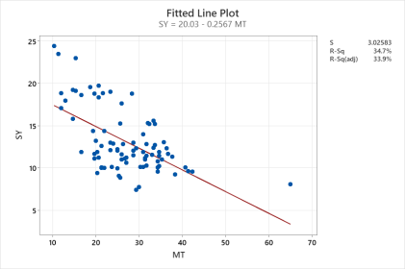 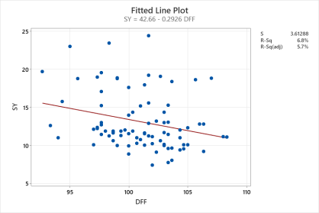 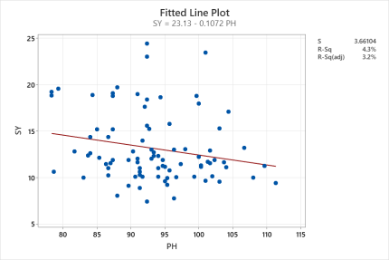 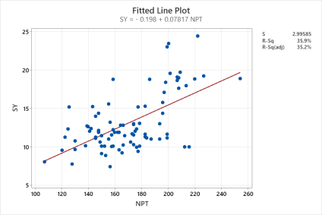 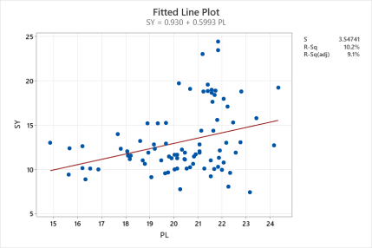 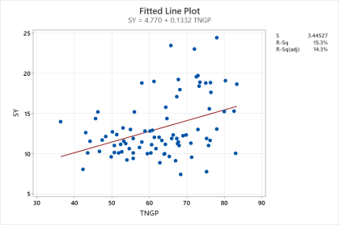 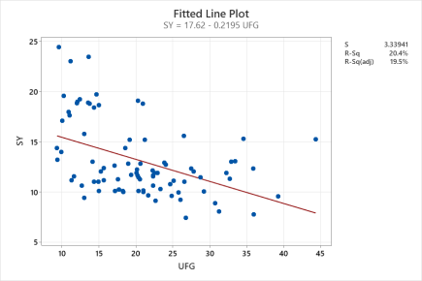 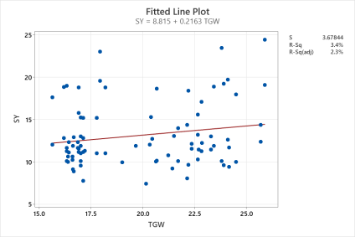 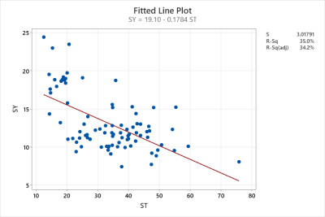

Figure1:-The fitted line plot and regression between SY vs other traits

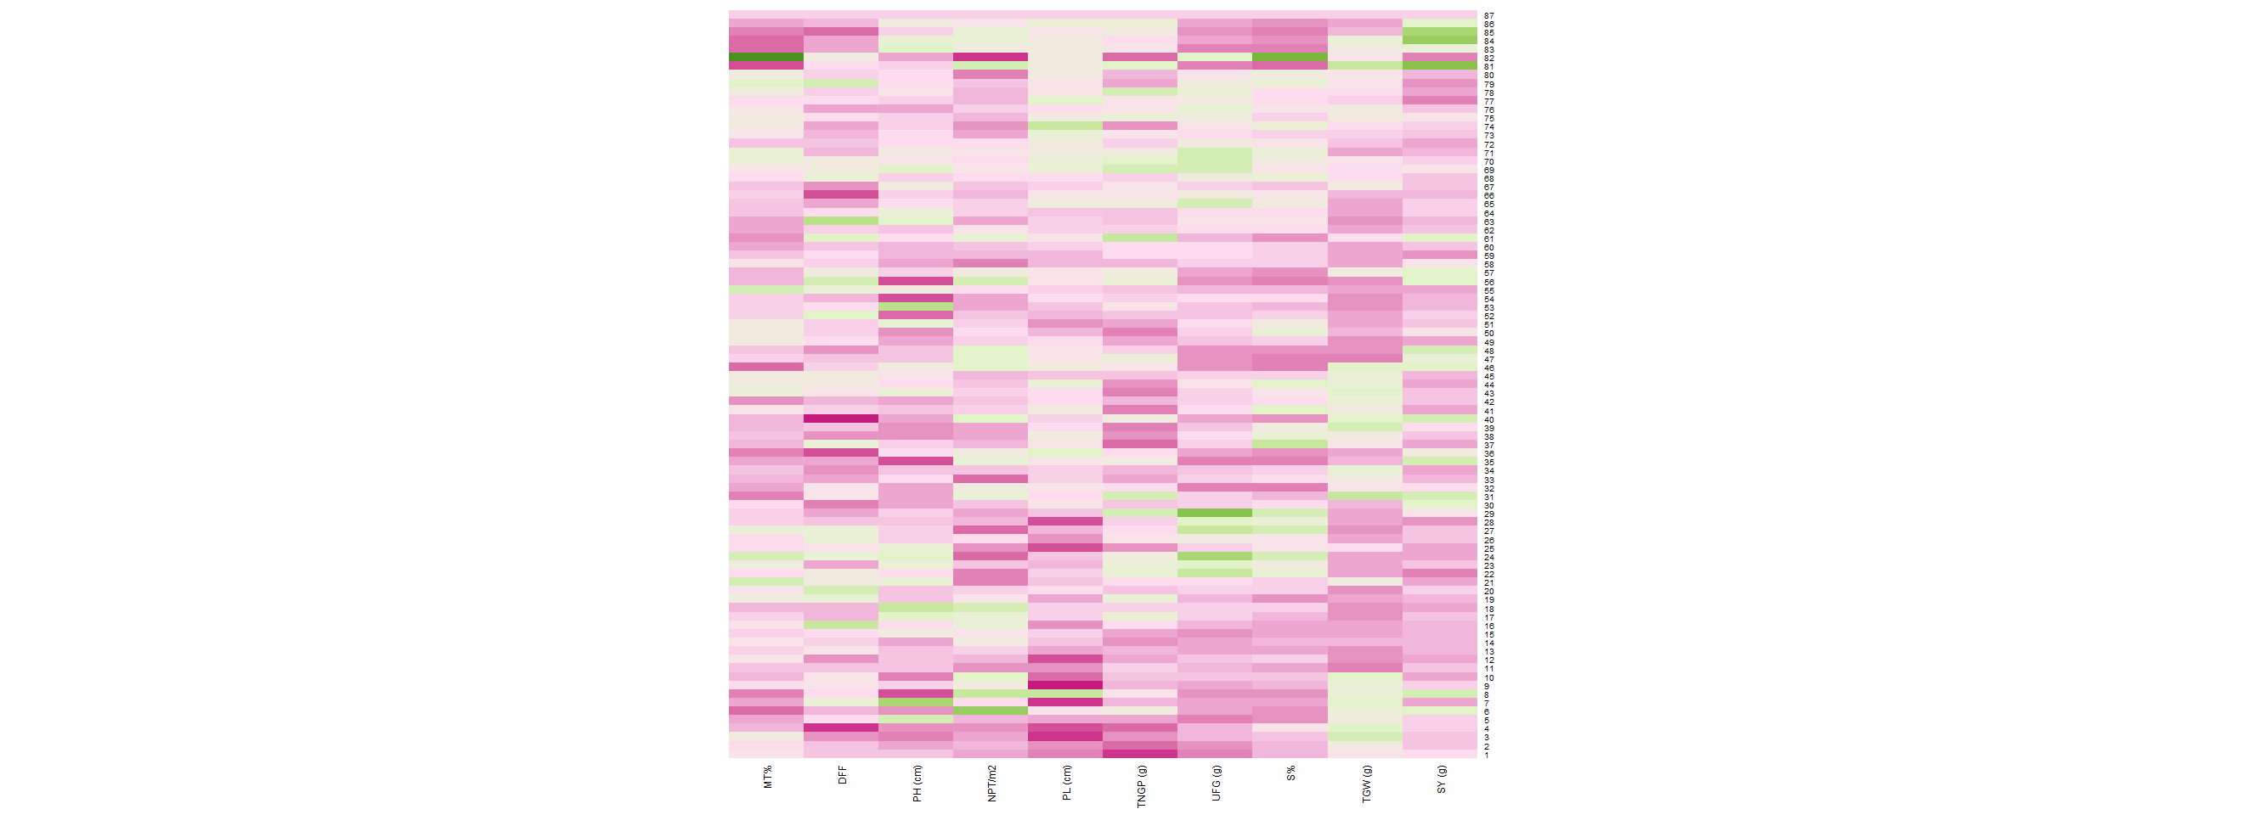

Figure2:- Shaded correlation matrix among all the genotypes with all the traits

Table1. List of rice genotypes and checks utilized in the experiment

|  |  |
| --- | --- |
| **Sources** | **Germplasm lines** |
| Germplasm collection | IR78222-20-7-148-2-B-B-B-B, IRRI 104, URAIBOOL IRGC 52785, Oryzica 1, CT118911-2-2-7-M, Kinandang patong, OM4900, IR6, Zanton:IRGC 31248-1, SUPA, M 202, MINGHU 163, ZHENSHAN 97B, IRRI 147, SANHUANGZHAN-NO2, IR10M 300, Manaw thukha, BR 28, Fedearroz 50, NSIC RC 240, GSRIR2-9-RI-Su3-Y2, IR13F 167, IR69726-116-1-1, IR77186-122-2-2-3, IRRI 154, IRBB 66, IR64-21, IR77298, N22 IRGC 19379-1, IR 93340, IR 93354, Khao Hlan on, IR 84984-83-15-481-B, IR10F 360, DJ123, TEQING, UPLR17:IRTP9897-C1, Jamir. |
| Varieties | MTU1010, Nanhi, Jasmine 85, Sambha mahsuri+sub1, Swarna, SADRI, TN1, Sahel 177. |
| Advanced breeding lines | KPS 13576, KPS 13577, KPS 13580, KPS 13584, KPS 10667, KPS 10672, KPS 13582, KPS 10628, KPS 10640, KPS 10656, KPS 10676, KPS 10683, KPS 10633, KPS 10658 KPS 10631, KPS 10642, KPS 10651, KPS 10654, KPS 10657, KPS 10661, KPS 10669, KPS 10316, KPS 10319, KPS 10321, KPS 10329, KPS 13575, KPS 13578, KPS 13579, KPS 13581, KPS 13583, KPS 13585, KPS 13586, KPS 13587, KPS 13588. |
| Checks | CSR 23 (Alkalinity and salinity tolerant check)  CSR 36 (Alkalinity tolerant check)  RNR 11718 (Local alkalinity and salinity check)  FL 478 (Salinity tolerant check)  KPS 2874 (Local yield check)  PUSA 44 (Susceptible check) |

Table2. Scoring of damage for salt injury in field conditions in rice standard evaluation system scale (IRRI-SES 2013)

|  |  |  |
| --- | --- | --- |
| **Score** | **Growth Scale** | **Salinity-induced reaction** |
| **1** | Normal growth, no leaf symptoms | Highly tolerant |
| **3** | Nearly normal growth, but leaf tips of few leaves whitish and rolled. | Tolerant |
| **5** | Growth severely retarded, most leaves rolled, only a few are elongating | Moderately tolerant |
| **7** | Complete cessation of growth, most leaves dry, some plants drying | Susceptible |
| **9** | Almost all plants dead or drying | Highly susceptible |

Table3:-. Estimates of phenotypic correlation coefficients for yield and yield attributing traits in 80 rice genotypes along with checks evaluated under saline field conditions

|  |  |  |  |  |  |  |  |  |  |  |
| --- | --- | --- | --- | --- | --- | --- | --- | --- | --- | --- |
|  | M % | DFF | PH (cm) | NPT/m2 | PL (cm) | TNGP | UFG | ST% | TGW (g) | SY (g) |
| M % | 1.0000 | 0.2824** | 0.0841 | -0.5677** | -0.1101 | -0.2578* | 0.5021** | 0.6217** | -0.1841 | -0.5888** |
| DFF |  | 1.0000 | 0.1485 | -0.0230 | -0.0866 | 0.0203 | 0.1023 | 0.1148 | -0.0842 | -0.2615* |
| PH (cm) |  |  | 1.0000 | -0.0992 | -0.0303 | 0.1448 | 0.1730 | 0.0421 | -0.1045 | -0.2084 |
| NPT/m2 |  |  |  | 1.000 | 0.2151* | 0.4066** | -0.5057** | -0.6686** | 0.0891 | 0.5996** |
| PL (cm) |  |  |  |  | 1.0000 | 0.3266** | 0.0924 | -0.0074 | 0.0556 | 0.3189** |
| TNGP |  |  |  |  |  | 1.0000 | 0.2112 | -0.3217** | -0.2064 | 0.3909** |
| UFG |  |  |  |  |  |  | 1.0000 | 0.8246** | -0.2168* | -0.4517** |
| ST% |  |  |  |  |  |  |  | 1.0000 | -0.0622 | -0.5917 ** |
| TGW (g) |  |  |  |  |  |  |  |  | 1.0000 | 0.1851 |
| SY (g) |  |  |  |  |  |  |  |  |  | 1.0000 |

* Significant at 5 per cent level; ** Significant at 1 per cent level

M % -Mortality percentage DFF- Days to 50 % flowering PH (cm) - Plant height PL (cm) - Panicle length NPT- Number of Productive tillers/m2 NGP - Total number of grains/panicle UFG - Number of un-filled grains/panicle S % - Sterility percentage TW (g) – 1000 grain weight SY (g) - Seed yield/plant

Table4:- Linear and quadratic regression equation of SY vs other traits

|  |  |  |
| --- | --- | --- |
| Trait | Linear equation | Quadratic equation |
| MT | SY = 20.03 - 0.2567 MT | SY = 25.52 - 0.6538 MT - 0.006519 MT^2 |
| DFF | SY = 42.66 - 0.2926 DFF | SY = 340.7 - 6.220 DFF + 0.02944 DFF^2 |
| PH | SY = 23.13 - 0.1072 PH | SY = 55.09 - 0.793 PH - 0.003653 PH^2 |
| NPT | SY = - 0.198 + 0.07817 NPT | SY = 18.27 - 0.1395 NPT + 0.000624 NPT^2 |
| PL | SY = 0.930 + 0.5993 PL | SY = 18.08 - 1.168 PL + 0.04499 PL^2 |
| TNGP | SY = 4.770 + 0.1332 TNGP | SY = 20.85 - 0.4025 TNGP + 0.004324 TNGP^2 |
| UFG | SY = 17.62 - 0.2195 UFG | SY = 25.85 - 1.030 UFG - 0.01753 UFG^2 |
| ST | SY = 19.10 - 0.1784 ST | SY = 24.80 - 0.5381 ST- 0.004982 ST^2 |
| TGW | SY = 8.815 + 0.2163 TGW | SY = 55.55 - 4.501 TGW + 0.1161 TGW^2 |
| Regression equation | | |
| SY = 1981-0.0776MT-0.1708DFF-0.0641PH+0.0166NPT+0.260PL+0.1785TNGP-0.304UFG-0.0960ST+0.1166TGW | | |