***Original Research Article***

***Integrated Bioinformatics Analysis of Key Genes Involved in***

***Progression of Papillary and Follicular Thyroid Cancer***

***Abstract***

**Background:** Thyroid cancer, the most common endocrine neoplasia, has seen a rapid increase in global incidence, with the USA reporting over 62,000 new cases in 2015, making it the fifth most common cancer among women. Differentiated thyroid cancer accounts for more than 95% of cases and arises from thyroid follicular epithelial cells, primarily manifesting as papillary thyroid cancer (PTC) and follicular thyroid cancer (FTC). Despite significant advancements in understanding the molecular mechanisms underlying these cancers, the identification of relevant genes for a comprehensive view of tumorigenesis remains essential. **Methods:** In this study, we conducted an integrated analysis utilizing bioinformatics approaches, including gene set enrichment analysis, gene ontology (GO) analysis, KEGG pathway analysis, and survival analysis, genetic mutations, to identify key genes associated with the development of thyroid cancer. **Results:** Our candidate genes were validated using data from The Cancer Genome Atlas (TCGA) and The Human Protein Atlas. Our results identified ALB, FN1, MYC, and IL6 as significant prognostic markers in both papillary and follicular thyroid cancer, underscoring their potential as important biomarkers for improved diagnosis and therapeutic strategies. **Conclusion:** ALB, FN1, MYC, and IL6 may serve as key genes for both papillary and follicular thyroid cancer. Additional molecular biology experiments are necessary to validate the functions of these identified genes.

**KEYWORDS**: network pharmacology, bioinformatic analysis, thyroid carcinoma., TCGA

**INTRODUCTION**

Thyroid cancer is the most common endocrine neoplasia, with its overall occurrence swiftly rising globally [1]. In the USA, thyroid cancer is the fifth most common cancer among women, with over 62,000 new cases diagnosed in both men and women in 2015 [2, 3]. Differentiated thyroid cancer is the most prevalent type, making up over 95% of cases [4], and it arises from thyroid follicular epithelial cells. This category includes well-differentiated thyroid cancers such as papillary thyroid cancer (PTC), follicular thyroid cancer (FTC), and Hurthle cell thyroid cancer [2, 5]. Papillary thyroid cancer is the predominant subtype of differentiated thyroid cancer, accounting for about 80% of cases and having the best overall prognosis [6]. In contrast, follicular thyroid cancer is the second most common histological type. Although it is often overshadowed by papillary thyroid cancer, it demonstrates unique biological behavior and has less favorable outcomes [5]. Metastasis typically affects cervical lymph nodes, with the lungs being less frequently involved [2]. In recent decades, there has been a significant rise in the global incidence of differentiated thyroid cancer [3], accompanied by substantial advances in understanding the molecular mechanisms of follicular [7] and papillary thyroid cancer [8, 9]. BRAF mutations are evidenced to occur in a small percentage of follicular and papillary thyroid carcinoma, with most of these cases being suspicious or positive on fine-needle aspiration [10].

Cancer has often been perceived as a genetic or hereditary disease [11, 12], and identifying disease-related genes through experimental methods can be both costly and time-consuming [9]. However, more relevant genes need to be identified to give a complete understanding of the tumorigenesis of thyroid cancer. The extensive use of gene chips has generated a wealth of high-throughput functional genomics data in public databases. Additionally, advancements in computational tools now offer a valuable alternative for discovering novel genes [9, 13]. Advancements in bioinformatics have transformed the traditional one-disease/one-target/one-drug paradigm in drug design and discovery into a multitarget approach that combines polypharmacology and network biology. As a result, network pharmacology has become a valuable method for exploring the pharmacological effects of multitarget compounds across different disorders [11, 14]. In this study, we conducted an integrated analysis to identify key genes associated with the development of thyroid cancer, mainly papillary and follicular thyroid cancer. The bioinformatics analyses included gene set enrichment analysis of the key targets (hub genes), gene ontology (GO) analysis, KEGG pathway analysis, survival analysis to identify key candidate genes involved in thyroid cancer, and validated our candidate genes in TCGA and The Human Protein Atlas database. Our findings indicated that ALB, FN1, MYC, and IL6 have significant prognostic value in both papillary and follicular thyroid cancer.

***2. MATERIALS AND METHODS***

*2.1 Ethical compliance*

The clinical information and sequence data were obtained in accordance with the guidelines of the GeneCards database and the TCGA databanks. Therefore, there was no requirement for ethics committee approval or consent procedures.

*2.2 Network pharmacology and bioinformatics analysis*

*2.2.1 Identification of potential targets of Thyroid Cancer targets*

The targets/expressed genes related to papillary and follicular thyroid cancer were searched in the GeneCards database (<https://www.genecards.org/>) [11, 15], using papillary thyroid cancer, follicular thyroid cancer, and thyroid cancer as the keywords, respectively. To create a collection of the related genes, the obtained information on papillary thyroid cancer and follicular thyroid cancer was compared with the obtained genes through the search with thyroid cancer and were screened separately using the Venny *tool (*[*https://bioinfogp.cnb.csic.es/tools/venny_old/venny.php*](https://bioinfogp.cnb.csic.es/tools/venny_old/venny.php)*)[16].*

*2.2.2 Protein-protein interaction (PPI) network of the obtained common genes*

The common targets identified were uploaded and analyzed using the STRING online database (https://cn.stringdb.org/) to create the protein–protein interaction (PPI) network. The STRING database is designed to predict protein interactions, encompassing both direct and indirect relationships, with each interaction being evaluated and scored. A higher score indicates greater confidence in the interaction. Once the interactions among the genes/proteins were established, the exported files from STRING were imported into Cytoscape 3.9.1 software (<https://cytoscape.org/>) for visualization and topological network analysis using the Network Analyzer tool [17]. Cytoscape is a widely recognized open-source bioinformatics software that operates on a network-based framework, where each node represents a protein, gene, or drug molecule, and the edges represent interactions among these biomolecules [11]. The CytoHubba plugin of Cytoscape was used to select the key top 20 target hub genes based on the degree score method of both papillary thyroid cancer and follicular thyroid cancer targets.

*2.2.3 Gene set enrichment analysis of the intersected targets*

ShinyGO 0.77 (<http://bioinformatics.sdstate.edu/go/>) is an online tool for gene enrichment analysis [18]. It was utilized to identify the Kyoto Encyclopedia of Genes and Genomes (KEGG) pathways and Gene Ontology (GO) terms, which encompass cellular components (CC), molecular functions (MF), and biological processes (BP) related to the common targets. The results were visualized using the built-in graphing tool on the same platform. Key signaling pathways associated with the targeted proteins were then selected and imported into Cytoscape software to create a visualization of the “target–pathway network” interactions.

2.2.4Validation in TCGA and The Human Protein Atlas

For validation, the candidate genes were evaluated at both the RNA and protein levels using the TCGA data portal and The Human Protein Atlas database, respectively. Thyroid cancer samples were categorized into two groups based on gene expression: high expression (with Transcripts per million [TPM] values above the median) and low/median expression (with TPM values below the median). The GEPIA website was utilized to compare the relative RNA expression levels between thyroid cancer and normal thyroid tissues. The genetic alterations of the identified key targets that were found to be significantly expressed via the GEPIA website were further assessed using cBioPortal (<https://www.cbioportal.org/>) [19, 20]. The selected key target genes were used as queries in the TCGA study of thyroid cancer, specifically, the dataset titled “Thyroid Carcinoma TCGA PanCancer data” [21], “Thyroid Carcinoma (TCGA, Firehose Legacy)”, “Papillary thyroid carcinoma (TCGA, GDC)”, and “Papillary thyroid carcinoma (TCGA, Cell 2014)”[22]. This dataset with a combined study (2027 samples) was chosen because it comprehensively analyzed thyroid cancers using various methods, including genomic DNA copy number arrays, microRNA sequencing, exome sequencing, DNA methylation, messenger RNA arrays, and reverse-phase protein arrays. Additionally, the study integrated data across multiple platforms to provide a thorough understanding of gene expression subtypes associated with the primary types of thyroid cancer. The Human Protein Atlas (TCGA) database was used to analyze protein distribution in the tissues [11, 23].

**3. RESULTS**

*3.1 Protein-protein interaction (PPI) network potential common targets of thyroid cancer*

A total of 4200 common targets between the thyroid cancer and papillary thyroid cancer, and 3532 common targets between the thyroid cancer and follicular thyroid cancer were identified using the Venny tool. These intersecting targets are considered the potential targets of thyroid cancer (shown in **Figure 1a** and **b**). We then used the CytoHubba plugin of Cytoscape to identify 20 densely connected regions based on degree score, revealing two dense clusters for both intersections of papillary thyroid cancer and follicular thyroid cancer-related genes. Cluster 1 consisted of 20 nodes/genes and 190 edge/ connections (GAPDH, MYC, HIF1A, CTNNB1, ESR1, TNF, ACTB, AKT1, IL6, ALB, BCL2, PTEN, SRC, IL1B, FN1, JUN, TP53, EGFR, STAT3, INS). Cluster 2 involved 20 nodes and 190 edges (BCL2, IFNG, EGFR, STAT3, AKT1, JUN, INS, FN1, SRC, ALB, ESR1, GAPDH, TNF, TP53, ACTB, IL6, CTNNB1, IL1B, MYC, CD4) (shown in **Figure 2a** and **b**). The density of our protein-protein network was validated by the high degree of nodes, indicating common competitive interactions related to thyroid cancer.

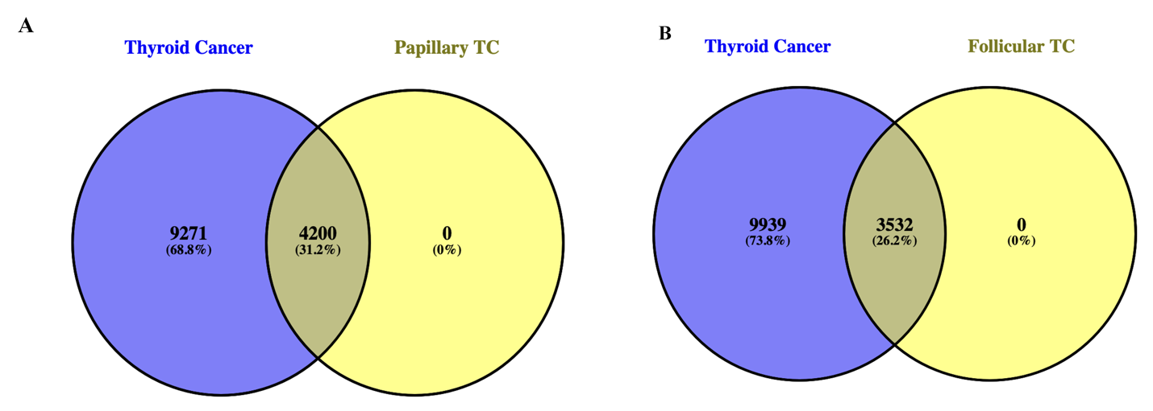

**Figure 1.**The Venn diagram showing the intersection of papillary, follicular, and thyroid cancer-related common targets.

**(A)**

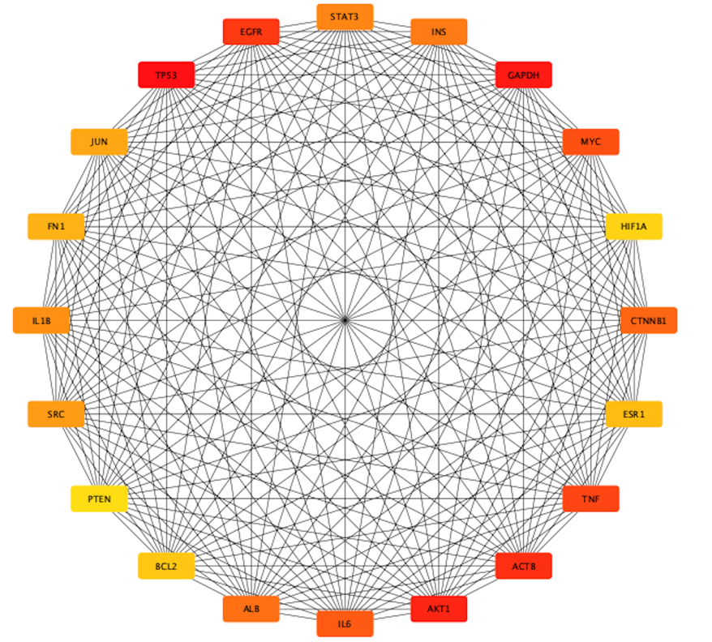

**(B)**

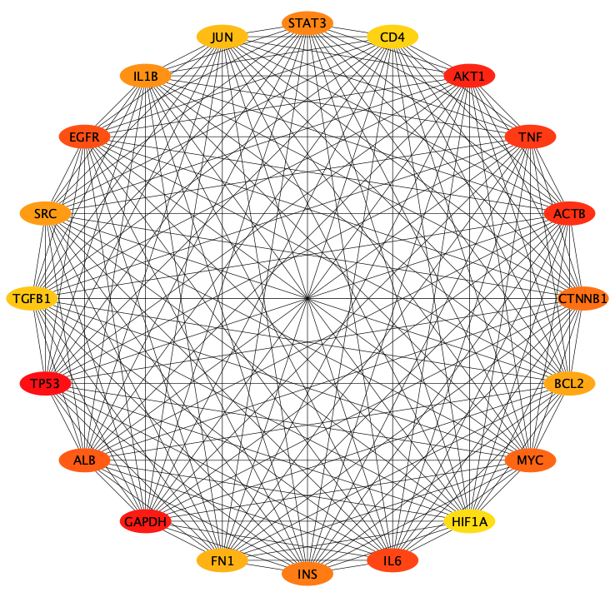

**Figure 2**. The key targets of the interaction network as identified by degree scores of the CytoHubba plugin. **A**. papillary thyroid cancer **B.** follicular thyroid cancer

*3.2 Gene set enrichment analysis of the key targets (hub genes)*

A total of 18 genes out of the 20 were common in both the thyroid cancer-related targets, however, two different genes were found in both papillary thyroid cancer-related targets (i.e., HIF1A and PTEN), and follicular thyroid cancer-related targets (i.e., IFNG and CD4). GO term and KEGG pathway enrichment analysis of the total 22 key targets/ hub genes (SRC, JUN, STAT3, CTNNB1, FN1, PTEN, TNF, ESR1, HIF1A, INS, EGFR, ACTB, IL1B, IL6, CD4, ALB, IFNG, MYC, AKT1, BCL2, GAPDH, TP53) obtained after combining the top two degree scores of papillary thyroid cancer andfollicular thyroid cancer were carried out using the ShinyGo webserver. The GO biological process results of the common targets enriched included; “positive regulation of cell population proliferation”, “positive regulation of gene expression”, “regulation of apoptotic process”, “regulation of programmed cell death”, “regulation of cell population proliferation” and so on. Similarly, the molecular function (MF) results for the common targets revealed associations with “nitric-oxide synthase regulator activity,” “disordered domain specific binding,” “RNA polymerase II-specific DNA-binding transcription factor binding,” DNA-binding transcription factor binding, transcription factor binding.” and so on. The Gene Ontology cellular components (GO CC) results indicated that the common targets are enriched in “Postsynaptic specialization intracellular component”, “euchromatin”, “transcription repressor complex”, “RNA polymerase II transcription regulator complex”, and “endoplasmic reticulum lumen,” among others. The visualization of the top 10 Gene Ontology (GO) analyses, based on an FDR cutoff of 0.05, is presented in Figure **3A–C**. The KEGG pathway enrichment analysis of the 22 hub genes revealed several enriched signaling pathways, including “HIF-1 signaling pathway”, “thyroid hormone signaling pathway”, “fluid shear stress and atherosclerosis”, “yersinia infection”, “proteoglycans in cancer”, “hepatitis B”, “kaposi sarcoma-associated herpesvirus infection”, “human cytomegalovirus infection”, “salmonella infection”, and “pathways in cancer”. The top 10 KEGG pathways were selected and visualized with an FDR cutoff of 0.05, as illustrated in **Figure 3D**.

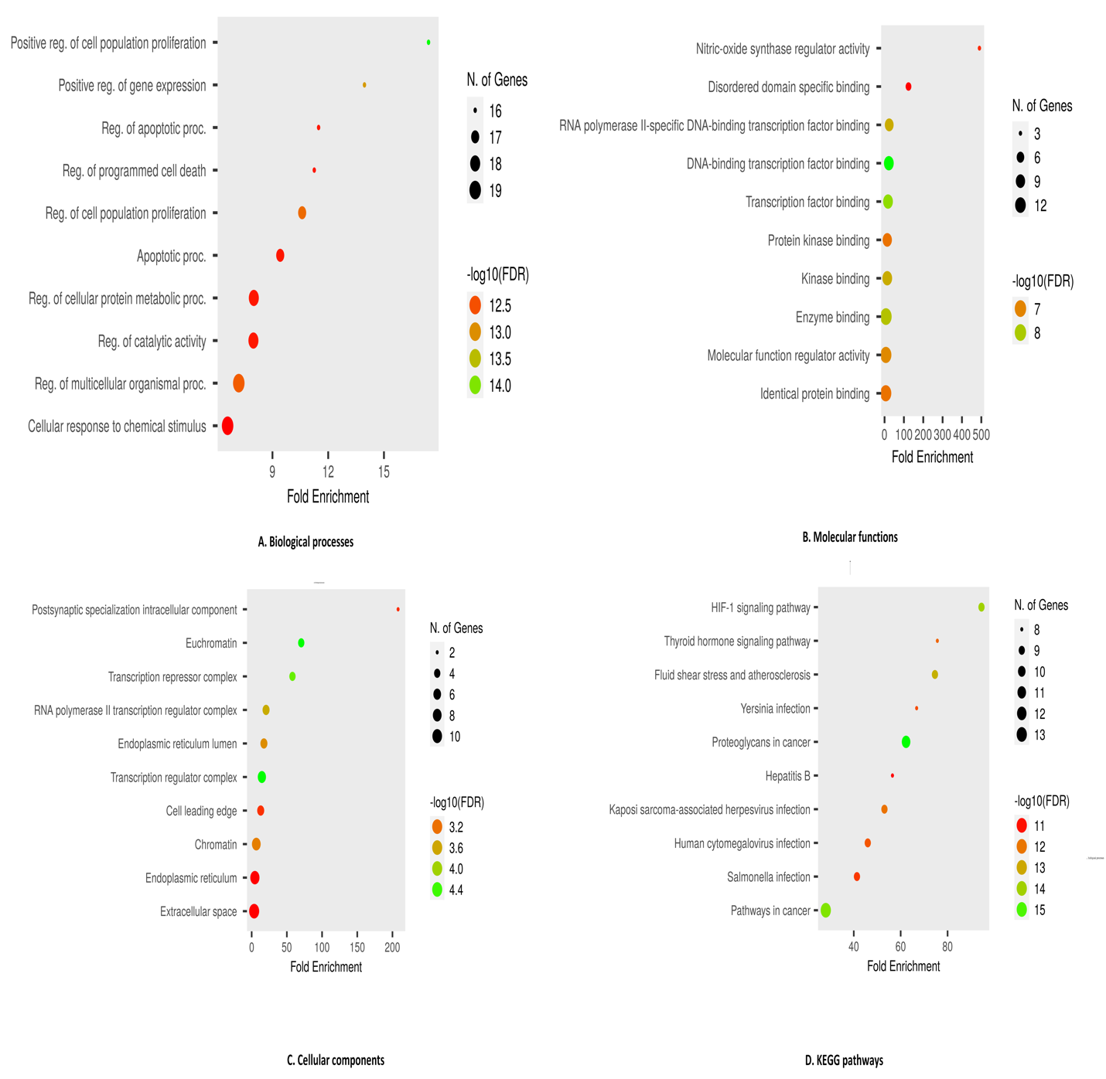

**Figure 3.** The top 10 enrichment results for Gene Ontology (GO) terms and Kyoto Encyclopedia of Genes and Genomes (KEGG) pathways for the key targets: (A) biological processes, (B) molecular functions, (C) cellular components, and (D) KEGG pathways. The size of the balls in the plots represents the number of genes associated with each pathway, with corresponding legends shown on the right.

*3.3 Construction of the key target-pathway network*

The key targets-pathway network was constructed to visualize the interactions between key target proteins and the thyroid cancer-related pathways. Using the results from the KEGG enrichment analysis, a diagram was created that links key targets and pathways. This network illustrates the complex relationships among the 22 common targets, and 10 core molecular pathways, as shown in **Figure 4**. The network comprises 93 edges and 32 nodes, including 22 nodes for composite target proteins, and 10 pathway nodes. The key targets, represented by red rectangle, interact with one or more thyroid cancer targets, which are enriched across various molecular pathways. The pathways most enriched with common targets included “pathways in cancer”, “HIF-1 signaling pathway”, and “Thyroid hormone signaling pathway”, with 13, 9, and 8 targets, respectively. The top 10 molecular pathways enriched with common targets are detailed in **Table 1**. Notably, multiple target proteins are present within a single pathway, and the same target proteins appear in multiple pathways*.*

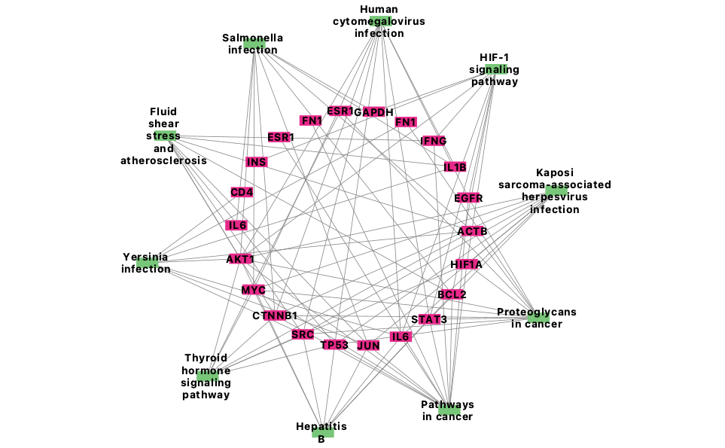

**Figure 4**. key targets -pathway network interaction the red rectangle represents the key targets, whereas the green rectangular shape represents the enriched pathways. The connecting lines represent the relationships among the key targets, and enriched pathways.

**Table 1.** The top 10 KEGG pathways enriched by the key targets.

|  |  |  |  |  |  |  |
| --- | --- | --- | --- | --- | --- | --- |
| **Pathway ID** | **Pathway terms** | **Genes** | **P-value** | **Adjusted P-value** | **Fold Enrichment** | **Number of genes** |
| hsa04066 | HIF-1 signaling pathway | EGFR; AKT1; GAPDH; HIF1A; IFNG; IL6; INS; BCL2; STAT3 | 1.42 X 10-15 | 6.56 X 10-14 | 94.463 | 9 |
| hsa04919 | Thyroid hormone signaling pathway | CTNNB1; AKT1; ESR1; HIF1A; MYC; ACTB; SRC; TP53 | 4.23 X 10-13 | 6.02 X 10-12 | 75.640 | 8 |
| hsa05418 | Fluid shear stress and atherosclerosis | CTNNB1; AKT1; IFNG; IL1B; JUN; BCL2; ACTB; SRC; TP53 | 1.14 X 10-16 | 7.03 X 10-15 | 74.612 | 9 |
| hsa05135 | Yersinia infection | AKT1; FN1; IL1B; IL6; JUN; ACTB; SRC; CD4 | 1.17 X 10-14 | 4.34 X 10-13 | 66.806 | 8 |
| hsa05205 | Proteoglycans in cancer | CTNNB1: EGFR; AKT1; ESR1; FN1; HIF1A; MYC; ACTB; SRC; STAT3; TP53 | 5.74 X 10-19 | 1.06 X 10-16 | 62.299 | 11 |
| hsa05161 | Hepatitis B | AKT1; IL6; JUN; MYC: BCL2; SRC; STAT3; TP53 | 5.45 X 10-14 | 1.12 X 10-12 | 56.496 | 8 |
| hsa05167 | Kaposi sarcoma-associated herpesvirus infection | CTNNB1; AKT1; HIF1A; IL6; JUN; MYC; SRC; STAT3; TP53 | 2.68 X 10-13 | 4.52 X 10-12 | 53.074 | 9 |
| hsa05163 | Human cytomegalovirus infection | CTNNB1; EGFR; AKT1; IL1B; IL6; MYC; SRC; STAT3; TP53 | 1.53 X10-14 | 4.71 X 10-13 | 45.966 | 9 |
| hsa05132 | Salmonella infection | CTNNB1; AKT1; GAPDH; IL1B; IL6; JUN; MYC; BCL2; ACTB | 4.23 X 10-14 | 4.23 X 10-14 | 41.351 | 9 |
| hsa05200 | Pathways in cancer | CTNNB1; EGFR; AKT1; ESR1; FN1; HIF1A; IFNG; IL6; JUN; MYC; BCL2; STAT3; TP53 | 1.92 X 10-17 | 1.78 X 10-15 | 28.062 | 13 |

*3.5 Expression level of key targets in TCGA and the Human Protein Atlas*

Out of the 22 key targets validated in the TCGA dataset, the RNA expression levels of 4 key targets genes including ALB, FN1, MYC, and IL6 were found to be significantly expressed (**Figure 5**). The results also supported that ALB, MYC, and IL6 expressions were substantially lower in thyroid cancer tissues compared to the normal tissues, whereas FN1 was significantly higher in thyroid cancer tissues compared to the normal tissues. After pinpointing the key targets, data from the TCGA study were utilized to examine the frequency and types of genetic mutations present in thyroid cancer patients. The results were visualized using OncoPrint, illustrated in **Figure 6**. To confirm these findings, The Human Protein Atlas database was also used to evaluate the expression of these key targets in both normal and thyroid carcinoma tissues to validate their effects externally. All four key targets were found to be highly expressed in cancerous tissues, indicating a significant impact (**Figure 7**).

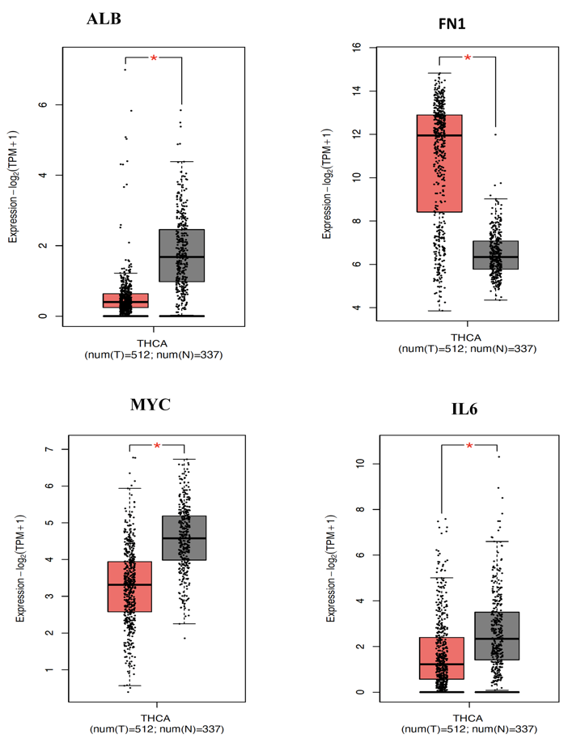

**Figure 5.** Expression level of key genes thyroid cancer cells and normal cells using the TCGA and GTEX data in the GEPIA server. (The symbol (*) denotes p < 0.05, and T and N denote thyroid and normal patients respectively).

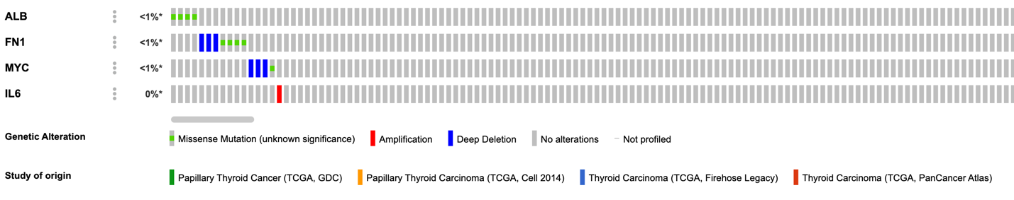

**Figure 6.** OncoPrint analysis displaying the frequency and types of genetic mutations of the key targets in the TCGA thyroid cancer study. Each bar corresponds to an individual patient’s data, with the color of the bar indicating the specific type of genetic alteration present. The legend at the bottom of the plot details the various genetic modifications represented by the different colors.

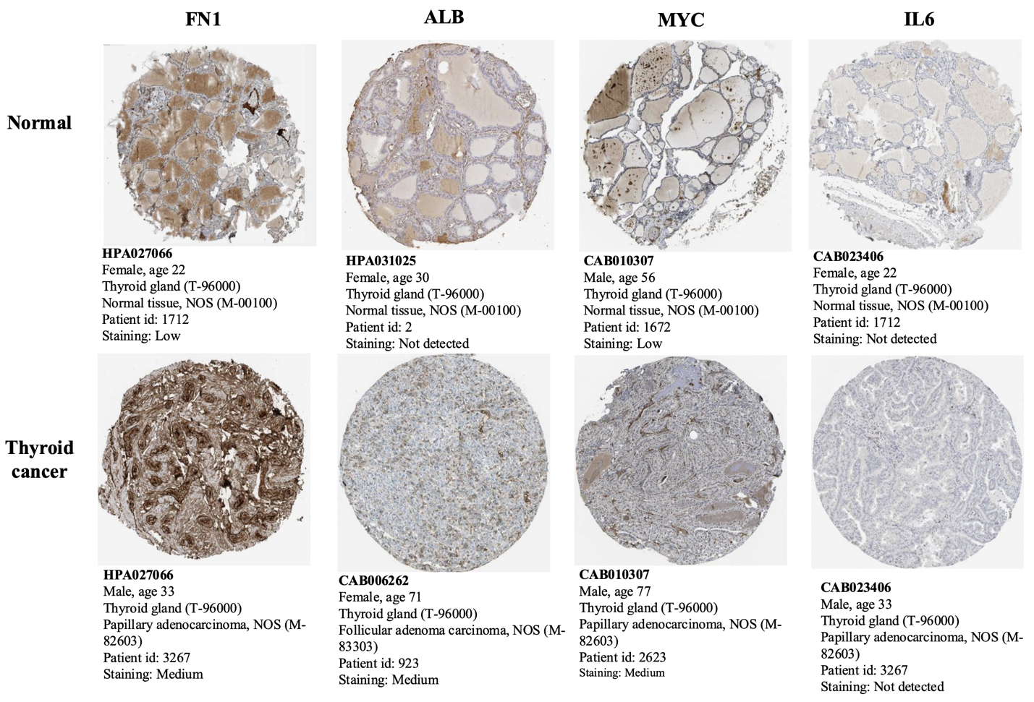

**Figure 7.** Expression level of key genes in the human protein Atlas dataset

**4. DISCUSSION**

Thyroid diseases encompass a variety of manifestations, from thyroid atrophy leading to hypothyroidism to neoplastic proliferations. The pathogenesis of these conditions involves complex interactions between genetic and environmental factors, including infections, iodine deficiency, and stress [24]. Notably, oxidative stress has been particularly linked to thyroid dysfunction, as demonstrated in both experimental models and human diseases [25]. Currently, the mechanisms behind thyroid cancer remain a vibrant field of clinical research. The connection between thyroid cancer and stem cells has garnered growing interest [26]. Investigating thyroid cancer stem cells offers fresh insights into the prevention and treatment of the disease [27, 28]. In this study, we conducted various bioinformatics analyses to identify key genes associated with the development of thyroid cancer. Initially, we identified a total of 4200 and 3532 common targets of papillary thyroid cancer and follicular thyroid cancer by comparing them with thyroid cancer-related genes. We then performed a protein-protein interaction network analysis to examine the relationships between the commonly expressed genes, followed by a clustering analysis. We then used the CytoHubba plugin to identify 20 densely connected regions based on degree score, revealing two dense clusters for both intersections of papillary thyroid cancer and follicular thyroid cancer-related genes. A total 22 key targets/ hub genes (SRC, JUN, STAT3, CTNNB1, FN1, PTEN, TNF, ESR1, HIF1A, INS, EGFR, ACTB, IL1B, IL6, CD4, ALB, IFNG, MYC, AKT1, BCL2, GAPDH, TP53) were identified after combining the top two-degree scores of papillary thyroid cancer andfollicular thyroid cancer. These key targets were used to determine the top 10 enrichment for GO terms and KEGG pathways. Next, we conducted an expression level of the key targets in TCGA and the Human Protein Atlas to evaluate their prognostic significance. Interestingly, we found a total of four genes which are ALB, FN1, MYC, and IL6 were found to be significantly expressed. Additionally, we validated these genes at both the RNA and protein expression levels, as well as types of genetic mutations, and our findings align with those of previous studies [29, 30]

***ALB:*** Thyroid dysfunction is a prevalent disorder with non-specific symptoms, making accurate diagnosis crucial for patients. Albumin (ALB) plays a key role in transporting thyroid hormones to their sites of action, facilitating the rapid delivery of these hormones to tissues [31, 32]. Zhang et at. [33] experimented the connection between serum ALB levels and total triiodothyronine (TT3) in adults. The analysis included a total of 7,933 participants, revealing an independent positive relationship between ALB and total TT3 with a coefficient of 0.006 (0.003, 0.009). In women, a significant negative correlation was observed between ALB and TT3, while in men, a significant positive correlation was observed. Furthermore, the study indicated an independent association between ALB and TT3 levels was significant among Non-Hispanic Whites but not among Non-Hispanic Blacks. Notably, the authors identified a U-shaped relationship between ALB and serum TT3 in the overall participant group (with an inflection point for ALB at 41 g/L) and in females after adjusting for covariates (with an inflection point for ALB at 46 g/L). Also in another study [34], a highly statistically substantial decrease in ALB (P value < 0.001) in a group containing 20 hypothyroid patients ((3.8 ± 0.3) when compared with a group of 20 hyperthyroid patients (4.2 ± 0.5) and group 20 patients with normal thyroid function (control group) (4.5 ± 0.3). In line with the findings of this study, both hyperthyroidism and hypothyroidism were linked to a decreased risk of developing colorectal cancer (CRC). These findings could serve as a valuable reference for future screening of adults with thyroid dysfunction.

***MYC:*** The prominent oncogene MYC (Myelocytomatosis Viral Oncogene Homolog) was initially recognized as the cellular counterpart of the viral oncogene myc [29]. Further studies revealed that human cancers often exhibit c-Myc amplification, highlighting the gene’s significance in cancer development [35]. Also, immunostaining analysis indicated that N-myc downstream-regulated gene 2 (NDRG2) expression is decreased in thyroid carcinomas compared to adjacent normal tissue. While NDRG2 mRNA levels were significantly lower in thyroid carcinoma tissues, there was little difference in adenoma tissues. However, NDRG2 expression showed no significant correlation with gender, age, different histotypes of thyroid cancers, or distant metastases [29]. This result is in accordance with our findings in this study. A recent study proposed targeting MYC for the therapeutic treatment of anaplastic thyroid cancer (ATC) [36]. The study observed that JQ1 effectively inhibited the growth of four ATC cell lines by reducing MYC and increasing p21 and p27, which delayed cell cycle progression. In addition, it also blocked cell invasion by suppressing epithelial-mesenchymal transition signals. These results were supported by xenograft studies, showing that JQ1 reduced tumor size and growth by targeting specific signaling pathways. These findings indicate that targeting the MYC protein may offer a promising treatment approach for human anaplastic thyroid cancer, where effective treatment options are currently scarce.

**IL6:** The inflammatory factor interleukin (IL)-6 is crucial for the immune response and inflammation, and it also contributes to tumor development [37]. A study revealed a strong association between IL-6 and thyroid disease, however, the mechanism by which IL-6 operates in thyroid cancer remains unclear [38]. To examine the impact of IL-6 on the proliferation of thyroid cancer stem cells, Zheng et al. [39], utilized HTh74 and HTh74R cell lines, and MTT assay to evaluate the proliferation of these cells following IL-6 treatment. The study showed that IL-6 stimulated the growth of HTh74 and HTh74R thyroid cancer stem cells and improved sphere formation. Conversely, blocking IL-6 reduced the proliferation of these cancer stem cells. IL-6 also enhanced colony formation in HTh74 and HTh74R cells and increased the levels of stem cell genes OCT4 and ABCG2. Additionally, IL-6 treatment significantly lowered the expression of the epithelial marker E-cadherin while increasing the levels of vimentin and Snail, which are associated with epithelial-mesenchymal transition (EMT). In addition, the expression of IL-6 has been shown to be significantly elevated in both autoimmune thyroid disease and thyroid cancer [30].

**FN1:** Geng et al. [40], conducted a thorough analysis of the relationship between FN1 expression and the prognosis of patients with thyroid cancer, as well as its association with tumor-infiltrating immune cells. The authors observed that FN1 expression was strongly associated with progression-free survival and showed moderate to strong correlations with the infiltration levels of M2 macrophages and resting memory CD4+ T cells, as well as with CD276 expression. In addition, the authors proposed that promoter hypermethylation may explain the changes in FN1 expression, as analysis of 20 CpG sites in 507 thyroid cancer cases from the TCGA database revealed a negative correlation with FN1 expression. Furthermore, silencing FN1 expression inhibited clonogenicity, motility, invasiveness, and CD276 expression in vitro. The findings indicate that FN1 expression levels are associated with prognosis and immune infiltration in thyroid cancer, suggesting that FN1 could serve as an immunity-related biomarker and a potential therapeutic target in thyroid cancer [40].Another study [41], examined the expression levels of epithelial-to-mesenchymal transition (EMT) markers in various papillary thyroid carcinomas (PTCs) and their association with tumor genotypes and clinicopathological features. The authors investigated the role of fibronectin-1 (FN1) by assessing the effects of FN1 silencing in two human thyroid cancer cell lines. Most EMT markers were significantly overexpressed in a cohort of 36 PTCs. Notably, FN1 mRNA levels were higher in tumor tissue compared to non-tumor tissue (117.3, p < 0.001), and were also elevated in aggressive tumors and those with the BRAFV600E mutation. These findings were corroborated at the protein level in a validation group of 50 PTCs and six lymph node (LN) metastases. Silencing FN1 in TPC-1 and BCPAP thyroid cancer cells significantly diminished proliferation, adhesion, migration, and invasion in both cell lines. The study further endorsed data suggesting that FN1 overexpression is a key factor influencing the aggressiveness of thyroid cancer.

**5. CONCLUSION**

Currently, the mechanisms underlying thyroid cancer continue to be a dynamic area of clinical research. Studying thyroid cancer stem cells provides new perspectives on prevention and treatment strategies for the disease. In conclusion, this study performed an integrated analysis to identify key target and hub genes linked to the progression of thyroid cancer. We identified a group of genes with prognostic significance that can help evaluate patient outcomes. Notably, ALB, FN1, MYC, and IL6 demonstrated significant prognostic value. These data suggest that network pharmacology-based studies could effectively identify molecular targets of for treating thyroid cancer. Further research is needed to investigate the biological functions and mechanisms through which these genes affect malignant cell behavior in cancer. Additionally, the expression patterns of these genes could serve as promising therapeutic targets for thyroid cancer, mainly papillary and follicular thyroid cancer.

**CONFLICT OF INTEREST STATEMENT**

The authors declare no conflicts of interest.

**DISCLAIMER (ARTIFICIAL INTELLIGENCE)**

Author(s) hereby declare that NO generative AI technologies such as Large Language Models (ChatGPT, COPILOT, etc.) and text-to-image generators have been used during the writing or editing of this manuscript.

**REFERENCE**

1. Lassoued, S., et al., *A comparative study of the oxidative profile in Graves’ disease, Hashimoto’s thyroiditis, and papillary thyroid cancer.* Biological trace element research, 2010. **138**: p. 107-115.

2. Cabanillas, M.E., D.G. McFadden, and C. Durante, *Thyroid cancer.* The Lancet, 2016. **388**(10061): p. 2783-2795.

3. Davies, L. and H.G. Welch, *Current thyroid cancer trends in the United States.* JAMA otolaryngology–head & neck surgery, 2014. **140**(4): p. 317-322.

4. Ries, L.A., et al., *SEER cancer statistics review, 1975-2003.* 2006.

5. Grani, G., et al., *Follicular thyroid cancer and Hürthle cell carcinoma: challenges in diagnosis, treatment, and clinical management.* The Lancet Diabetes & Endocrinology, 2018. **6**(6): p. 500-514.

6. Reyes, I., et al., *Gene expression profiling identifies potential molecular markers of papillary thyroid carcinoma.* Cancer Biomarkers, 2019. **24**(1): p. 71-83.

7. Aschebrook-Kilfoy, B., et al., *Follicular thyroid cancer incidence patterns in the United States, 1980–2009.* Thyroid, 2013. **23**(8): p. 1015-1021.

8. Tufano, R.P., et al., *BRAF mutation in papillary thyroid cancer and its value in tailoring initial treatment: a systematic review and meta-analysis.* Medicine, 2012. **91**(5): p. 274-286.

9. Liang, W. and F. Sun, *Identification of key genes of papillary thyroid cancer using integrated bioinformatics analysis.* Journal of endocrinological investigation, 2018. **41**: p. 1237-1245.

10. Proietti, A., et al., *BRAF status of follicular variant of papillary thyroid carcinoma and its relationship to its clinical and cytological features.* Thyroid, 2010. **20**(11): p. 1263-1270.

11. Swallah, M.S., et al., *Elucidating the protective mechanism of ganoderic acid DM on breast cancer based on network pharmacology and in vitro experimental validation.* Biotechnology and Applied Biochemistry, 2024.

12. Swallah, M.S., et al., *Potentialities of Ganoderma lucidum extracts as functional ingredients in food formulation.* Food Research International, 2023. **172**: p. 113161.

13. Bashir, M.A., et al., *Dual inhibitory potential of ganoderic acid A on GLUT1/3: computational and in vitro insights into targeting glucose metabolism in human lung cancer.* RSC advances, 2024. **14**(39): p. 28569-28584.

14. Chandran, U., et al., *Network pharmacology.* Innovative approaches in drug discovery, 2017: p. 127.

15. Shi, P., et al., *An integrated pharmacokinetic study of an acanthopanax senticosus extract preparation by combination of virtual screening, systems pharmacology, and multi-component pharmacokinetics in rats.* Frontiers in Pharmacology, 2020. **11**: p. 1295.

16. Oliveros, J.C., *VENNY. An interactive tool for comparing lists with Venn Diagrams. 2007*. 2015.

17. Fan, S., et al., *Bioinformatics‐based and molecular docking study on the mechanism of action of Galla chinensis in the treatment of diabetic foot ulcers.* Biotechnology and Applied Biochemistry, 2023. **70**(1): p. 387-402.

18. Ge, S.X., D. Jung, and R. Yao, *ShinyGO: a graphical gene-set enrichment tool for animals and plants.* Bioinformatics, 2020. **36**(8): p. 2628-2629.

19. Gao, J., et al., *Integrative analysis of complex cancer genomics and clinical profiles using the cBioPortal.* Science signaling, 2013. **6**(269): p. pl1-pl1.

20. Cerami, E., et al., *The cBio cancer genomics portal: an open platform for exploring multidimensional cancer genomics data.* Cancer discovery, 2012. **2**(5): p. 401-404.

21. Weinstein, J.N., et al., *The cancer genome atlas pan-cancer analysis project.* Nature genetics, 2013. **45**(10): p. 1113-1120.

22. Agrawal, N., et al., *Integrated genomic characterization of papillary thyroid carcinoma.* Cell, 2014. **159**(3): p. 676-690.

23. Tang, Z., et al., *GEPIA: a web server for cancer and normal gene expression profiling and interactive analyses.* Nucleic acids research, 2017. **45**(W1): p. W98-W102.

24. Ademoğlu, E., et al., *Determination of oxidative stress in thyroid tissue and plasma of patients with Graves' disease.* European journal of internal medicine, 2006. **17**(8): p. 545-550.

25. Bednarek, J., H. Wysocki, and J. Sowiński, *Peripheral parameters of oxidative stress in patients with infiltrative Graves’ ophthalmopathy treated with corticosteroids.* Immunology letters, 2004. **93**(2-3): p. 227-232.

26. Nagayama, Y., M. Shimamura, and N. Mitsutake, *Cancer stem cells in the thyroid.* Frontiers in endocrinology, 2016. **7**: p. 20.

27. Vicari, L., et al., *Cancer stem cells as a potential therapeutic target in thyroid carcinoma.* Oncology Letters, 2016. **12**(4): p. 2254-2260.

28. Peng, W., et al., *1, 25 dihydroxyvitamin D3 inhibits the proliferation of thyroid cancer stem-like cells via cell cycle arrest.* Endocrine research, 2016. **41**(2): p. 71-80.

29. Zhao, H., et al., *Reduced expression of N-Myc downstream-regulated gene 2 in human thyroid cancer.* BMC cancer, 2008. **8**: p. 1-9.

30. Ruggeri, R.M., et al., *Co-expression of interleukin-6 (IL-6) and interleukin-6 receptor (IL-6R) in thyroid nodules is associated with co-expression of CD30 ligand/CD30 receptor.* Journal of endocrinological investigation, 2002. **25**: p. 959-966.

31. Garmendia Madariaga, A., et al., *The incidence and prevalence of thyroid dysfunction in Europe: a meta-analysis.* The Journal of Clinical Endocrinology & Metabolism, 2014. **99**(3): p. 923-931.

32. Fröhlich, E. and R. Wahl, *Thyroid autoimmunity: role of anti-thyroid antibodies in thyroid and extra-thyroidal diseases.* Frontiers in immunology, 2017. **8**: p. 521.

33. Zhang, Y., R. Xie, and J. Ou, *AU‐shaped association between serum albumin with total triiodothyronine in adults.* Journal of Clinical Laboratory Analysis, 2022. **36**(6): p. e24473.

34. Hassan, R.H.M., et al., *Colorectal Cancer in Patients with Thyroid Dysfunction.* Al-Azhar International Medical Journal, 2023. **4**(9): p. 21.

35. Shachaf, C.M., et al., *MYC inactivation uncovers pluripotent differentiation and tumour dormancy in hepatocellular cancer.* Nature, 2004. **431**(7012): p. 1112-1117.

36. Enomoto, K., et al., *Targeting MYC as a therapeutic intervention for anaplastic thyroid cancer.* The Journal of Clinical Endocrinology & Metabolism, 2017. **102**(7): p. 2268-2280.

37. Provatopoulou, X., et al., *Interleukins as markers of inflammation in malignant and benign thyroid disease.* Inflammation Research, 2014. **63**: p. 667-674.

38. Murai, H., et al., *Elevated serum interleukin-6 and decreased thyroid hormone levels in postoperative patients and effects of IL-6 on thyroid cell function in vitro.* Thyroid, 1996. **6**(6): p. 601-606.

39. Zheng, R., et al., *Effect of IL-6 on proliferation of human thyroid anaplastic cancer stem cells.* International Journal of Clinical and Experimental Pathology, 2019. **12**(11): p. 3992.

40. Geng, Q.-S., et al., *Over-expression and prognostic significance of FN1, correlating with immune infiltrates in thyroid cancer.* Frontiers in Medicine, 2022. **8**: p. 812278.

41. Sponziello, M., et al., *Fibronectin-1 expression is increased in aggressive thyroid cancer and favors the migration and invasion of cancer cells.* Molecular and cellular endocrinology, 2016. **431**: p. 123-132.