**Development and Evaluation of Polymeric Film Forming Solution of Ciclopirox olamine for Topical Fungal Therapy**

**ABSTRACT**

|  |
| --- |
| **Aim:** Formulation and assessment of polymeric film forming solution (PFFS) loaded with Ciclopirox olamine (CPO) for managing topical fungal infections.  **Methods:** PFFS was prepared using a common solvent method with a range of polymers, such as Eudragit RL 100, Eudragit RS 100, PVP K30, PVP K90, HPC, HPMC K15, HPMC K4M, and PEG 400 in ethanol. The formulated PFFS was evaluated for Physicochemical properties, *in vitro* drug release, *ex vivo* permeation studies, stability studies, and antifungal assay.  **Results:** The formulations have exhibited drying time of less than one minute. Most of them demonstrated uniform film formation, with an acceptable viscosity and pH within permissible limits, and with minimal outward stickiness. PFFS TR2 with CPO, Eudragit RL 100, and PEG 400 showed an *in vitro* drug release rateof 83.17% over 12 hours with controlled release kinetics. *Ex vivo* studies revealed a cumulative permeation of 1341.04 µg/cm² over 24 hours with a flux of 68.31 µg/cm²/hr, characterized by anomalous diffusion (non-Fickian transport), Moreover, the TR2 formulation achieved significant antifungal efficacy, with a zone of inhibition measuring 20±0.9 mm. Complementary characterization via FT-IR (Fourier Transform Infrared Spectroscopy) and DSC (Differential Scanning Calorimetry) confirmed the absence of drug-excipient interactions.  **Conclusion:** The above study concludes that PFFS using Eudragit RL 100, Menthol: camphor, and PEG 400 showed enhanced antifungal activity and controlled release, suggesting it as a promising method for topical fungal treatment. |

*Keywords: Polymeric Film Forming Solution, Ciclopirox Olamine, Anti-Fungal agent, Eudragit RL 100*

1. INTRODUCTION

Fungal infection happens often in many different situations in nature. People get these infections when a harmful fungus enters their body in numbers that the immune system cannot fight back 1. Fungal infections traditionally have been separated into two different types: systemic and surface-level. Their sub-type examples are Tinea pedis (caused by Trichophyton (T.) rubrum, T. interdigitale, and Epidermophyton), Tinea cruris (caused by floccosum), Tinea corporis (caused by Microsporum canis), and cutaneous candidiasis(moniliasis) (caused by Candida albicans)2. Accordingly, the major antifungal medications are categorized into systemic and topical drugs: polyene antifungals, azole antifungals, allylamine antifungals, echinocandin antifungals, and others3.

Approximately twenty to twenty-five per cent of the universal population have superficial infections caused by fungal species, which interfere with daily activities, reduce quality of life, and increase medical costs. In clinical sceneries, surface-level fungal skin disorders are the most prevalent infectious disease affecting people 4. Surface-level fungal skin disorders can be treated with antifungal agents such as Ciclopirox olamine (CPO), which is a BCS class II (low solubility and high permeability), and it has a broad-spectrum antifungal agent with antibacterial and anti-inflammatory properties 5. CPO demonstrates by chelating polyvalent and trivalent cations such as Fe3+ and Al3+, these cations inhibit enzymes like cytochromes, which tend to disrupt cellular activities such as transference of mitochondrial electrons and energy metabolism. It validates fungistatic or fungicidal activity in contradiction of dermatophytes, yeasts, dimorphic fungi, eumycetes, and actinomycetes, while also being effective against Gram-positive and Gram-negative bacteria 2. Its anti-inflammatory action involves suppressing prostaglandin, leukotriene, 5-lipoxygenase, and cyclooxygenase synthesis in polymorphonuclear cells6. CPO exhibits a short half-life of 3.8 hours as it is extensively metabolized in the liver through glucuronidations, which is further facilitated by the enzymes UDP-glucuronosyltransferase 1A1 (UGT1A1) and UGT1A9. In addition, oral CPO often causes GI irritation, Ulceration, and gastritis 7. Thus, it is essential to investigate the creation of a different drug delivery system that can avoid first-pass metabolism to improve bioavailability, which could ultimately lower the frequency of dosing and associated gastrointestinal side effects 8. In this regard, transdermal drug delivery systems (TDDS) are recognized for providing a non-invasive method for the systemic administration of medications. Still, conventional transdermal patches possess specific disadvantages such as skin discomfort arising from their airtight design, which can obstruct sweat glands and disrupt regular skin activity. Ointments, creams, and gels, swiftly removed by clothing 9.

Conversely, PFFS provides a new and uncomplicated method for treatment that addresses the weaknesses of traditional transdermal patches. Typically, PFFS embraces the medication and the film, creating polymers mixed in an appropriate volatile liquid, leading to the continued release of medicament 10.When PFFS is applied to the skin, the liquid disappears, leaving a drug-loaded thin film on the skin’s surface. It gives many benefits when compared to regular patches, such as higher dosing consistency, lower chance of irritation, and less medicament wastage. Hence, it transforms to form drug-loaded films, which improve transdermal drug penetration, bioavailability, and remain in the same state for long duration of time 11. Thus, bearing in mind limitations linked with CPO and lack of comprehensive research on the development and evaluation of PFFS of CPO, the present study was aimed at developing PFFS of CPO and evaluated for *in vitro* and *ex vivo* parameters.

1. MATERIAL AND METHODS
   1. Materials

Ciclopirox olamine procured from Micro Labs, Eudragit RL 100 and Eudragit RS 100 from Evonik, PVP K30 from CDH Laboratories, and PVP K90 from Loba Chemie Pvt Ltd. Additionally, Hydroxy Propyl Cellulose and Hydroxy Propyl Methyl Cellulose (K4M and K15M) were sourced from Loba Chemie Pvt Ltd. Ethanol was obtained from Jiangsu Huaxi International Trade Co. Ltd, while Oleic Acid was acquired from Nice Chemicals. Menthol and Camphor were supplied by SD Fine Chem Limited, and PEG 400 was procured from Spectrochem Pvt. Ltd.

* 1. Methods
     1. Partition coefficient

Partition coefficient of CPO was determined in 7.4 pH of phosphate buffer (PB) and n-octanol system 12. Following the sonication of 5 mL of PB with CPO (10mg) to achieve a transparent solution, an identical amount of n-octanol was introduced, and the blend was agitated periodically for 24h. After centrifuging at 3000 rpm for 10 minutes, the concentration of CPO in the aqueous phase was analysed at 222 nm using a UV spectrophotometer (UV 1900-i, Shimadzu Corporation), and the partition coefficient was determined using the corresponding formula13.

equation 1

* + 1. Preparation of polymeric film-forming solution

PFFSs were developed by using the common solvent method. The polymer was sonicated in ethanol for 30 mins 14. To the obtained clear solution, with continuous mixing on a magnetic stirrer, CPO and plasticizer were added 15. Further, the permeation enhancer was added and kept stirring for 30 mins 16. The resulting formulations, whose compositions are outlined in Table 1, were then placed in glass vials for further analysis17.

**Table 1: Composition of Ciclopirox olamine PFFS**

|  |  |  |  |  |  |  |  |  |  |  |  |  |  |  |
| --- | --- | --- | --- | --- | --- | --- | --- | --- | --- | --- | --- | --- | --- | --- |
| Formulation  code | TR1 | TR2 | TR3 | TR4 | TR5 | TR6 | TR7 | TR8 | TR9 | TR10 | TR11 | TR12 | TR13 | TR14 |
| CPO (%w/v) | 1 | 1 | 1 | 1 | 1 | 1 | 1 | 1 | 1 | 1 | 1 | 1 | 1 | 1 |
| Eudragit RL 100 (%w/v) | 5 | 10 | 15 |  |  |  |  |  | 5 |  |  |  | 10 | 10 |
| Eudragit RS 100(%w/v) |  |  |  | 5 | 10 | 15 |  |  | 10 |  |  |  |  |  |
| PVP K30 (%w/v) |  |  |  |  |  |  | 10 |  |  |  |  |  |  |  |
| PVP K90 (%w/v) |  |  |  |  |  |  |  | 10 |  |  |  |  |  |  |
| HPC (%w/v) |  |  |  |  |  |  |  |  |  | 10 |  |  |  |  |
| HPMC K4M (%w/v) |  |  |  |  |  |  |  |  |  |  | 5 |  |  |  |
| HPMC E15 (%w/v) |  |  |  |  |  |  |  |  |  |  |  | 5 |  |  |
| Oleic acid(%w/v) |  |  |  |  |  |  |  |  |  |  |  |  | 5 |  |
| Menthol:Camphor (%w/v) | 1:1 | 1:1 | 1:1 | 1:1 | 1:1 | 1:1 | 1:1 | 1:1 | 1:1 | 1:1 | 1:1 | 1:1 | 1:1 | 1:1 |
| PEG 400* | 0.5 | 0.5 | 0.5 | 0.5 | 0.5 | 0.5 | 0.5 | 0.5 | 0.5 | 0.5 | 0.5 | 0.5 | 0.5 | 0.5 |
| Ethanol* | q. s | q. s | q. s | q. s | q. s | q. s | q. s | q. s | q. s | q. s | q. s | q. s | q. s | q. s |

*\* Indicates the percentage of the polymer's wet weight.*

* + 1. Evaluation of the PFFS

The PFFS were assessed for the physicochemical characteristics, which are discussed below18.

* + 1. pH of the solution

The pH of the formulation was measured using a digital pH meter calibrated with pH 4, 7, and 9 buffer solutions. The meter rod was immersed in the sample, and the pH was recorded directly19.

* + 1. Viscosity of the solution

The viscosity of each formulation was measured using a Brookfield Viscometer with spindle no.18, ensuring the spindle was immersed without touching the base. Three trials were recorded to determine the torque and cps 20.

* + 1. Drying time

The formulations were poured onto the center of a glass slide using a pipette. After a certain period, a second glass slide was placed onto the first glass slide to form a sandwich. Start the timer, after some time slide the two glass slides in opposite direction if they slide easily, and film transferred to the top slide is the end point, and stop the timer 21.

* + 1. Film stickiness

The solution was applied to a glass slide, cotton wool was gently rubbed over the dried film. Films were classified as high, medium, or low according to the quantity of cotton fiber adhering to the film 22.

* + 1. Drug content

In the formulation TR2, 1 mL of the CPO PFFS was mixed with 10 mL of pH 7.4 phosphate buffer and stirred for three hours to assess the CPO content. The resulting mixture was then filtered and analyzed using a UV spectrophotometer at 222 nm, utilizing pH 7.4 phosphate buffer as the reference. The percentage of drug content was calculated using the relevant formula 23.

equation 2

* + 1. FTIR

FTIR is extensively used to investigate drug-excipient interactions. FTIR spectra were recorded using a Jasco 460 Plus FTIR spectrophotometer. Infrared-grade potassium bromide was triturated with all the samples, and set in a sample holder of diffuse reflectance and scanned under a 400 to 4000cm-1 range 24.

* + 1. DSC

Ciclopirox olamine, eudragit RL 100, and their mixture were evaluated for the DSC analysis using a DSC 60 SHIMADZU analyzer to know the drug-excipient interactions. The sealed aluminum pans containing samples were heated from ambient temperature to 700°C at a controlled rate of 10°C per minute, which generates thermograms for analysis 25.

* + 1. *In vitro* drug release

*In vitro* diffusion studies were conducted using vertical Franz diffusion cells; the barrier used here is dialysis membrane with a molecular weight cut-off of 12,000. This membrane was placed between the donor and receiver compartments and tightly held in place with a stainless-steel clamp. A small magnetic bead was utilized within the receiver compartment to stir the PBS (pH of 7.4) throughout the experiment's duration. At a predetermined interval, from the receptor compartment, samples of 1ml were replaced with fresh buffer. By using a UV spectrophotometer, trials were analysed 26. It was conducted in triplicate (n=3) for repeatability.

* + 1. Drug release kinetics

To assess how the drug is released over time, the *in vitro* drug release information was examined with various models of kinetics: Zero-order kinetics, First-order kinetics, Higuchi kinetics, Korsmeyer Peppas model, and Hixon-Crowell 27.

* + 1. *Ex vivo* permeation studies

*Ex vivo* permeability trials were conducted by using snake-shed skin as a barrier membrane. Add 0.5 ml of PFFS onto to barrier membrane, which is placed inside the donor chamber, the film was formed. A release experiment was carried out for 24 hours; 1 ml of the sample was withdrawn and replaced with PBS (pH 7.4) at predetermined time intervals28. For reproducibility, it was carried out in triplicate (n=3).

* + 1. Antifungal assay

The antifungal assay was carried out by growing *Candida albicans* ATCC90028 in a potato dextrose broth for three days at 30°C under constant mixing (150 rpm) 29. A Petri dish was sterilized, and Potato Dextrose Agar (PDA) media, which had been previously inoculated with a fungal pathogen, was poured and allowed to solidify. Wells (4mm) were created using a sterile cork borer and filled with 100μL of each sample. To allow proper diffusion, the plates were refrigerated at 4°C for 30 minutes, then incubated at 30°C for 2-3 days. The zone of inhibition was then measured in millimeters 30.

* + 1. Short-term stability studies

Short-term stability was assessed over one month at room temperature. This testing evaluated how formulation quality varied over time under different environmental conditions, including pH, viscosity, film appearance, and drug content percentage 31.

1. RESULTS AND DISCUSSION

Conventional transdermal patches exhibit low absorption, as a significant portion of the drug remains unabsorbed, either on the skin's surface or within the dosage form 32. Additionally, applying, retaining, and removing these patches can be challenging. PFFS offers several advantages over conventional formulations, including ease of application over a large surface area, reduced product loss, and significant enhancement of the total absorption to about 50 to 60 percent after overcoming the challenges of dissolving it. Molecular weight and lipophilicity are key factors in skin permeation 33. Compounds with intermediate polarity (log P 1–3) effectively penetrate the epidermis. Drug CPO, having a molecular weight of 268.35g/mol with moderate lipophilicity, makes PFFS an ideal platform for delivering the dose34.

* 1. Partition Coefficient

The partition coefficient of CPO in the n-octanol/PB system was determined to be 1.089 ± 0.89, indicating its distribution between the aqueous and lipid phases (moderate lipophilicity). This balance between hydrophilicity and lipophilicity indicates effective permeation of the biological membrane, making it suitable for transdermal delivery 8.

* 1. Evaluation of PFFS

By using the common solvent method, 14 formulations were developed with seven different polymers with their varying concentrations, along with the 1:1 ratio of menthol and camphor in ethanol. The physicochemical evaluation was performed to identify PFFS formulations with the most favorable characteristics. Table 2 presents the physicochemical properties of the tested formulations 35, It was observed that formulations have shown a drying time of less than 1 minute, which varied based on polymer concentration; as concentration increases, the drying time increases. The formulations TR3, TR5, TR6, TR7, TR9, & TR10 have shown a higher viscosity and formulations TR1, TR2, TR4, TR8, TR13, & TR14 have shown a lower viscosity (table 2), these viscosity changes are due to the polymeric concentrations and grade used for the formulation 36. The solution with low viscosity is ideal for the PFFS, which were observed in formulations TR1, TR2, TR4, TR7, TR13, & TR14. The pH of the formulations TR1-TR14 ranged between 5.5-6 (Table 2), the ideal pH range for the transdermal solutions is between 4.5-6. Therefore, formulations TR1-TR14 were in the permissible limits 37. From Table 2, it was observed that formulations TR1,TR2, TR3, TR4, TR5,TR6,TR7,TR12,TR13, and TR14 have shown low-level outward stickiness, which was within a permissible limit 38. Formulations TR1,TR2, TR4, TR5, TR7, TR13, and TR14 have shown the required physicochemical characteristics and therefore have been selected for drug content estimation, followed by *in vitro* studies.

**Table 2:** **Physicochemical evaluation of prepared PFFS**

|  |  |  |  |  |  |  |
| --- | --- | --- | --- | --- | --- | --- |
| **Formulation Code** | **PFFS** | | **Polymeric film** | | | **Inference** |
| **pH observed**  **(±SD)** | **Viscosity (Cps)** | **Drying time** | **Outward stickiness** | **Film formation** |
| TR1 | 5.71±0.01 | 39.45 | <1min | Low | Uniform | Pass |
| TR2 | 5.84±0.01 | 40.26 | <1min | Low | Uniform | Pass |
| TR3 | 5.54±0.01 | 45.36 | ≥1min | Low | Uniform | Fail |
| TR4 | 5.89±0.01 | 36.23 | <1min | Low | Uniform | Pass |
| TR5 | 5.78±0.01 | 41.26 | <1min | Low | Uniform | Pass |
| TR6 | 5.94±0.02 | 43.54 | ≥1min | Low | Uniform | Fail |
| TR7 | 5.68±0.01 | 36.21 | <1min | Low | Uniform | Pass |
| TR8 | 5.63±0.01 | 41.32 | >1min | High | Incomplete | Fail |
| TR9 | 5.94±0.02 | 69.89 | >1min | Medium | Uniform | Fail |
| TR10 | 5.96±0.01 | 54.56 | >1min | High | Incomplete | Fail |
| TR11 | 6±0.01 | 51.23 | >1min | High | Incomplete | Fail |
| TR12 | 5.45±0.01 | 46.32 | <1min | Low | Incomplete | Fail |
| TR13 | 5.69±0.01 | 38.65 | <1min | Low | Uniform | Pass |
| TR14 | 5.88±0.01 | 40.36 | <1min | Low | Uniform | Pass |

* 1. Drug Content

Table 3 showed that the TR2 formulation had the highest drug content (94.36%) among all selected formulations, which might be due to the polymer concentration of 10% w/v and the polymer grade utilized in the formulation (Table 1).

**Table 3. Drug content estimation for the selected formulations from Table 1**

|  |  |
| --- | --- |
| **Formulation** | **Drug content** |
| TR1 | 81.45 |
| TR2 | 94.36 |
| TR4 | 89.36 |
| TR5 | 84.25 |
| TR7 | 87.60 |
| TR13 | 87.60 |
| TR14 | 85.41 |

* 1. FTIR

Figure 1 shows that the infrared spectrum exhibited characteristic peaks at 3639 cm⁻¹ (O–H stretching), 2923 cm⁻¹ (C–H stretching), 1860 cm⁻¹ (C=C stretching), and 1436 cm⁻¹ (C–C vibrations). In addition, the characteristic bands of Eudragit RL 100, like aliphatic C-H stretch, the carbonyl (C=O) vibration, and the C-O stretch appeared at expected wavenumbers, which matched the published values for the polymer 39. The characteristic peaks were observed in both the PM and CPO, which shows that there was no evidence of chemical interactions between the drug and excipient.

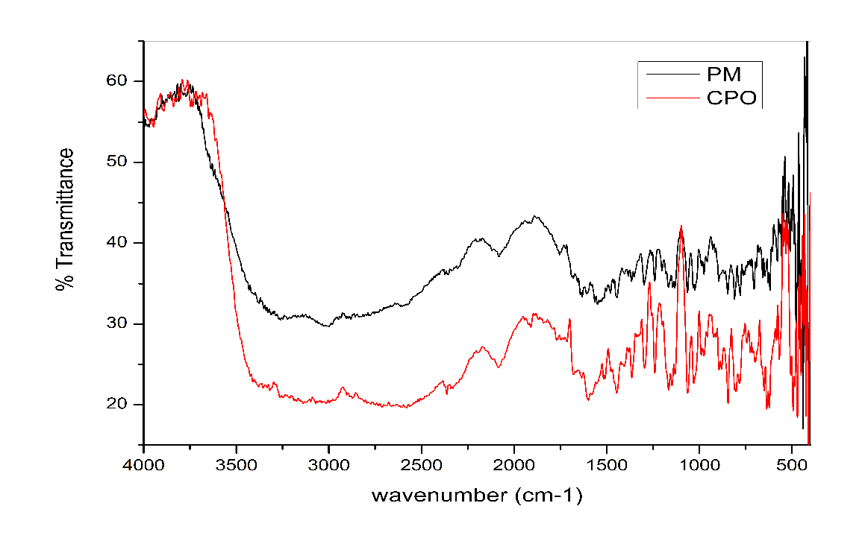

**Figure 1: FTIR spectra of CPO and PM (Physical mixture)**

* 1. DSC

Differential Scanning Calorimetry (DSC 60 SHIMADZU) was utilized to analyze the interaction between Ciclopirox olamine and excipients. The DSC thermograms of CPO, and the physical mixture were recorded and studied. From Figure 2, A1 showed an endothermic peak at 155°C, which confirmed the crystalline nature of Ciclopirox olamine 39,40. A2 had confirmed that there were no interactions between the drug and excipients.

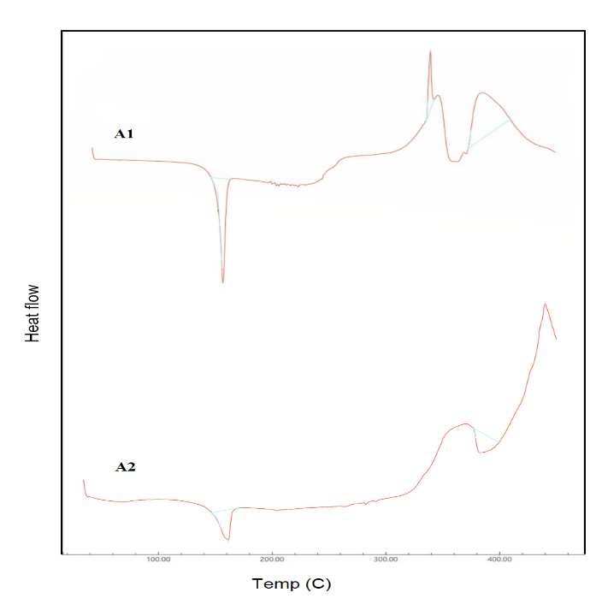

**Figure 2: A1-DSC curve of CPO, A2-DSC curve of PM**

* 1. *In Vitro* Drug Release Study

An *in vitro* drug release study was performed in a Franz diffusion cell using PBS pH 7.4 for 12 hours41. Figure 3 indicates that, among the formulations mentioned above, formulation TR2 showed the highest drug release 83.17% within 12 hours compared to other formulations, which is due to polymer concentration and grade (Table 1).

**Figure 3: *In vitro* drug release studies**

* 1. Drug Release Kinetics

Based on the *in vitro* studies, the TR2 formulation has shown the highest drug release, which is further evaluated for various kinetic models, such as the Zero-order, first-order, Korsmeyer Peppas, Higuchi, and Hixon Crowell models42. Results are presented in Table 4. Among the release kinetic models, the Korsmeyer peppas model with R2 value 0.9913 was the closest match to the 1 with n =0.86, which indicates it follows non-Fickian diffusion with anomalous transport.

**Table 4: Regression coefficient values for Zero-order, First-order, Higuchi, Korsmeyer Peppas, Hixon Crowell release kinetic models**

|  |  |
| --- | --- |
| **Kinetic model** | **Regression coefficient value** |
| Zero order | 0.9804 |
| First order | 0.908 |
| Higuchi | 0.776 |
| Korsmeyer peppas model | 0.9913 |
| Hixon crowell | 0.97 |

* 1. *Ex Vivo* Permeation Studies

*Ex vivo* studies were done using snake shed skin (obtained from the nearby forest region) in a Franz diffusion cell. In the study, TR2 formulation had shown a 1341.046µg/cm2 in 24hr with a flux value of 68.31 µg/cm2 /hr which is 57% higher permeation as compared to the pure drug (TR14 formulation): which had shown 853.318 µg/cm2 in 24hr with a flux value of 45.231 µg/cm2/hr see figure 4. The eutectic mixture facilitated lipid leaching, which enhanced the drug permeation by both intracellular and transcellular drug delivery 43.

**Figure 4: *Ex vivo* permeation studies of formulations TR2 and TR14**

* 1. Antifungal Assay

The antifungal activity of the formulation was tested against Candida albicans, measuring the zone of inhibition (ZOI) in millimeters (mm) 44. In comparison with the pure drug (22mm), the results of the final selected formulation TR2 exhibited a ZOI of 20 mm, as shown in Figure 5. The decrease in the ZOI of TR2 is attributed to controlled release of the drug from the formulation TR2.

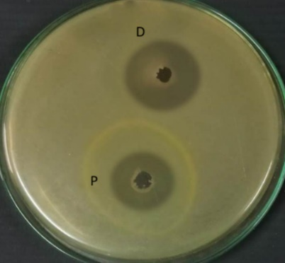

**Figure 5: Antifungal activity of P-Formulation TR2 and D-Pure drug**

* 1. Short-Term Stability Studies

The stability assessment of the selected formulation TR2 was conducted over 30 days. After a month, various evaluations were performed, including viscosity, pH, drug content, film appearance, outward stickiness, and in vitro drug release45, and the values are tabulated in Table 5. These values give us an idea that there are no chemical changes or interactions that occurred during the trial period.

**Table 5: Short-term stability studies**

|  |  |  |
| --- | --- | --- |
| **Test parameter** | **Initial values** | **Values after 30 days** |
| **Viscosity** | 40.26Cps | 39.36Cps |
| **pH** | 5.84 | 5.69 |
| **Drug content** | 94.36 | 92.65 |
| **Film appearance** | Uniform | Uniform |
| **Outward stickiness** | Low | Low |
| **Drying time** | <1 min | <1 min |
| ***In vitro* drug release** | 83.17% | 81.26% |

1. CONCLUSION

CPO loaded polymeric film forming solutions were developed and characterized in this study. The PFFS were developed using various polymers and investigated for physicochemical evaluations. Selected formulations were subjected to drug release studies, where formulation TR2 showed an 83.17 percent controlled release drug profile. Based upon this, the TR2 and TR14 formulations were selected for the permeation studies. TR2 has demonstrated 57 percent higher permeation compared to TR14, with an anomalous transport mechanismand non-Fickian diffusion behavior. Further, it is subjected to antifungal activity, where it has demonstrated a 20±0.9 mm zone of inhibition against Candida albicans compared to the marketed formulation. The activity indicates effective management of antifungal growth. Therefore, it could be useful for transdermal delivery of CPO. Further studies should be conducted to support its efficacy claims by an extended period of pharmacokinetics and pharmacodynamics in animals.

Disclaimer (Artificial intelligence)

Author(s) hereby declare that NO generative AI technologies such as Large Language Models (ChatGPT, COPILOT, etc.) and text-to-image generators have been used during the writing or editing of this manuscript.

1. REFERENCES
2. Jain, S., Patel, N., Shah, M. K., Khatri, P., & Vora, N. (2017). Recent advances in lipid‑based vesicles and particulate carriers for topical and transdermal application. *Journal of Pharmaceutical Sciences, 106*(2), 423–445. <https://doi.org/10.1016/j.xphs.2016.10.001>
3. Mucha, P., Borkowski, B., Erkiert‑Polguj, A., & Budzisz, E. (2024). Ciclopirox and ciclopirox olamine: Antifungal agents in dermatology with expanding therapeutic potential. *Applied Sciences, 14*(24), 11859. <https://doi.org/10.3390/app142411859>
4. Helal, D. A., El‑Rhman, D. A., Abdel‑Halim, S. A., & El‑Nabarawi, M. A. (2012). Formulation and evaluation of fluconazole topical gel. *International Journal of Pharmacy and Pharmaceutical Sciences, 4*(5), 176–183.
5. Ameen, M. (2010). Epidemiology of superficial fungal infections. *Clinics in Dermatology, 28*(2), 197–201.
6. Saudagar, R. B., & Bornare, A. S. (2018). Formulation and development of nanostructured lipid carrier loaded emulgel of ciclopirox olamine. *International Journal of Current Pharmaceutical Review and Research, 9*(6), 82–88.
7. Subissi, A., Monti, D., Togni, G., & Mailland, F. (2010). Ciclopirox: Recent nonclinical and clinical data relevant to its use as a topical antimycotic agent. *Drugs, 70*(16), 2133–2152. <https://doi.org/10.2165/11538110-000000000-00000>
8. Minden, M. D., Hogge, D. E., Weir, S. J., Kasper, J., Webster, D. A., Patton, L., et al. (2013). Oral ciclopirox olamine displays biological activity in a phase I study in patients with advanced hematologic malignancies. *American Journal of Hematology.* <https://doi.org/10.1002/ajh.23640>
9. Arunkumar, S., Shivakumar, H. N., & Murthy, S. N. (2018). Effect of terpenes on transdermal iontophoretic delivery of diclofenac potassium under constant voltage. *Pharmaceutical Development and Technology, 23*(8), 806–814. <https://doi.org/10.1080/10837450.2017.1369110>
10. Kaur, I. P., & Kakkar, S. (2010). Topical delivery of antifungal agents. *Expert Opinion on Drug Delivery, 7*(11), 1303–1327.
11. Tran, T. T. D., & Tran, P. H. L. (2019). Controlled release film forming systems in drug delivery: The potential for efficient drug delivery. *Pharmaceutics, 11*(6), 290. <https://doi.org/10.3390/pharmaceutics11060290>
12. Lind, M., Nielsen, K. T., Schefe, L. H., Nørremark, K., Eriksson, A. H., Norsgaard, H., Pedersen, B. T., & Petersson, K. (2016). Supersaturation of calcipotriene and betamethasone dipropionate in a novel aerosol foam formulation for topical treatment of psoriasis provides enhanced bioavailability of the active ingredients. *Dermatology and Therapy, 6*(3), 413–425. <https://doi.org/10.1007/s13555-016-0125-6>
13. McAuley, W. J., & Caserta, F. (2015). Film‑forming and heated systems. In R. F. Donnelly & T. R. R. Singh (Eds.), *Novel delivery systems for transdermal and intradermal drug delivery* (Vol. 15, pp. 97–124). John Wiley and Sons.
14. Milinković, S., & Đekić, L. (2025). Film‑forming solutions for cutaneous application: Current challenges and future directions in formulation design and characterization framework. *Journal of Drug Delivery Science and Technology*. Article 106863.
15. Ranade, S., Bajaj, A., Londhe, V., et al. (2017). Fabrication of topical metered dose film forming sprays for pain management. *European Journal of Pharmaceutical Sciences, 100*, 132–141. <https://doi.org/10.1016/j.ejps.2017.01.004>
16. Kathe, K., & Kathpalia, H. (2017). Film forming systems for topical and transdermal drug delivery. *Asian Journal of Pharmaceutical Sciences, 12*(6), 487–497. <https://doi.org/10.1016/j.ajps.2017.07.004>
17. Frederiksen, K., Guy, R. H., & Petersson, K. (2015). Formulation considerations in the design of topical, polymeric film‑forming systems for sustained drug delivery to the skin. *European Journal of Pharmaceutics and Biopharmaceutics, 91*, 9–15. <https://doi.org/10.1016/j.ejpb.2015.01.002>
18. Kittaneh, M., Qurt, M., Malkieh, N., Naseef, H., & Muqedi, R. (2023). Preparation and Evaluation of Vitamin D3 Supplementation as Transdermal Film-Forming Solution. Pharmaceutics, 15(1), 39. <https://doi.org/10.3390/pharmaceutics15010039>
19. Singh, G., Ghosh, B., Kaushalkumar, D., & Somsekhar, V. (2008). Screening of venlafaxine hydrochloride for transdermal delivery: Passive diffusion and iontophoresis. *AAPS PharmSciTech, 9*, 1–7.
20. Flynn, G. L., & Stewart, B. (1988). Percutaneous drug penetration: Choosing candidates for transdermal development. *Drug Development Research, 13*, 169–185.
21. Tundisi, L. L., Mostaço, G. B., Carricondo, P. C., & Petri, D. F. (2021). Hydroxypropyl methylcellulose: Physicochemical properties and ocular drug delivery formulations. *European Journal of Pharmaceutical Sciences, 159*, 105736.
22. Alayadan, P., Kumar, A., Prakash, S. S., Bashir, B., Bhagya, V., Murthy, S. N., & Shivakumar, H. N. (2024). Development, in vitro and in vivo evaluation of film forming solutions for transdermal drug delivery of zaltoprofen. *Journal of Biomaterials Science, Polymer Edition*, 1–24. <https://doi.org/10.1080/09205063.2024.2443332>
23. Rajab, N. A. (2013). Preparation and evaluation of ketoprofen as dermal spray film. *Karbala Journal of Pharmaceutical Sciences, 4*(6), 1–8.
24. Cheng, W., Chen, J., Liu, D., Ye, X., & Ke, F. (2010). Impact of ultrasonic treatment on properties of starch film‑forming dispersion and the resulting films. *Carbohydrate Polymers, 81*(3), 707–711.
25. Harak, P. D., Zalte, A. G., & Gulecha, V. S. (2023). Formulation and evaluation of film forming solution of tavaborole for treatment of skin infections. *Research Journal of Pharmacy and Technology, 16*(3), 1342–1346.
26. Muzaffar, K., Nayik, G. A., & Kumar, P. (2015). Stickiness problem associated with spray drying of sugar and acid rich foods: A mini review. *Journal of Nutrition & Food Sciences, 1*(Suppl. 12), 1.
27. Saudagar, R. B., & Gangurde, P. A. (2017). Formulation, development and evaluation of film‑forming gel for prolonged dermal delivery of miconaole nitrate. *Research Journal of Topical and Cosmetic Sciences, 8*(1), 19–29.
28. Mundada, A., Satturwar, P., Fulzele, S., Joshi, S., & Dorle, A. (2011). Characterization and evaluation of novel film forming polymer for drug delivery. *Iranian Journal of Pharmaceutical Research, 10*(1), 35–42.
29. Song, Y., Cong, Y., Wang, B., et al. (2020). Applications of Fourier transform infrared spectroscopy to pharmaceutical preparations. *Expert Opinion on Drug Delivery, 17*(4), 551–571. <https://doi.org/10.1080/17425247.2020.1737671>
30. Niranjan, P., Reddy, V., Reddy, G., & Panda, K. (2015). Effect of different grades of HPMC and Eudragit on drug release profile of doxofylline sustained release matrix tablets and IVIVC studies. *International Research Journal of Pharmacy, 6*, 493–504.
31. Baby, A., Shivakumar, H. N., & Alayadan, P. (2022). Formulation and evaluation of film forming solution of diphenhydramine hydrochloride for transdermal delivery. *Indian Journal of Pharmaceutical Education and Research, 56*(1), 43–49.
32. El‑Say, K. M., Ahmed, O. A., Aljaeid, B. M., & Zidan, A. S. (2017). Matrix‑type transdermal films to enhance simvastatin ex vivo skin permeability. *Pharmaceutical Development and Technology, 22*(4), 492–499.
33. Srinivasan, D., Nathan, S., Suresh, T., & Perumalsamy, P. L. (2001). Antimicrobial activity of certain Indian medicinal plants used in folkloric medicine. *Journal of Ethnopharmacology, 74*(3), 217–220.
34. Dhimmar, B., Pokale, R., Rahamathulla, M., Hani, U., Alshahrani, M. Y., Alshehri, S., Shakeel, F., Alam, P., Osmani, R. A. M., & Patil, A. B. (2023). Newfangled topical film‑forming solution for facilitated antifungal therapy: Design, development, characterization, and in vitro evaluation. *Polymers, 15*(4), 1003. <https://doi.org/10.3390/polym15041003>
35. Kittaneh, M., Qurt, M., Malkieh, N., Naseef, H., & Muqedi, R. (2022). Preparation and evaluation of vitamin D3 supplementation as transdermal film‑forming solution. *Pharmaceutics, 15*(1), 39.
36. Kienzler, J. L., Queille‑Roussel, C., Mugglestone, C., Ortonne, J. P., & Larnier, C. (2007). Stratum corneum pharmacokinetics of the anti‑fungal drug, terbinafine, in a novel topical formulation for single‑dose application in dermatophytoses. *Current Medical Research and Opinion, 23*(6), 1293–1302.
37. Sonthalia, S., Agrawal, M., & Sehgal, V. N. (2019). Topical ciclopirox olamine 1%: Revisiting a unique antifungal. *Indian Dermatology Online Journal, 10*(4), 481.
38. Cebrian, R. A., Dalmagro, M., Pinc, M. M., Donadel, G., Engel, L. A., Bariccatti, R. A., de Almeida, R. M., de Aguiar, K. M., Lourenço, E. L., & Hoscheid, J. (2024). Development and characterization of film‑forming solution loaded with *Syzygium cumini* (L.) Skeels for topical application in post‑surgical therapies. *Pharmaceutics, 16*(10), 1294.
39. Dudhipala, N., & Gorre, T. (2020). Neuroprotective effect of ropinirole lipid nanoparticles enriched hydrogel for Parkinson’s disease: In vitro, ex vivo, pharmacokinetic and pharmacodynamic evaluation. *Pharmaceutics, 12*(5), 448.
40. The Society of Japanese Pharmacopeia. (2016). *The Japanese Pharmacopeia* (17th ed., p. 1780). Society of Japanese Pharmacopeia.
41. Joshi, M., Sharma, V., & Pathak, K. (2015). Matrix based system of isotretinoin as nail lacquer to enhance transungal delivery across human nail plate. *International Journal of Pharmaceutics, 478*(1), 268–277.
42. Kittaneh, M., Qurt, M., Malkieh, N., Naseef, H., & Muqedi, R. (2022). Preparation and evaluation of vitamin D3 supplementation as transdermal film‑forming solution. *Pharmaceutics, 15*(1), 39.  
    *Note: This is a duplicate of reference 34.*
43. Mori, N. M., Patel, P., Sheth, N. R., Rathod, L. V., & Ashara, K. C. (2017). Fabrication and characterization of film‑forming voriconazole transdermal spray for the treatment of fungal infection. *Bulletin of Faculty of Pharmacy, Cairo University, 55*(1), 41–51.
44. NN, V., & Saudagar, R. B. (2014). Formulation, development and evaluation of film-forming gel for prolonged dermal delivery of terbinafine hydrochloride.
45. Harak, P. D., Zalte, A. G., & Gulecha, V. S. (2023). Formulation and evaluation of film forming solution of tavaborole for treatment of skin infections. *Research Journal of Pharmacy and Technology, 16*(3), 1342–1346. <https://doi.org/10.52711/0974-360X.2023.00220>
46. Bakshi, A., Bajaj, A., Malhotra, G., Madan, M., & Amrutiya, N. (2008). A novel metered dose transdermal spray formulation for oxybutynin. *Indian Journal of Pharmaceutical Sciences, 70*(6), 733.