**Review Article**

**Unleashing the potential of Spanlastics as drug delivery carrier**

**ABSTRACT:**

Spanlastics, a novel class of vesicular drug delivery systems, have garnered significant attention for their potential to overcome the limitations of traditional drug administration. Comprising non-ionic surfactants and edge activators, spanlastics exhibit unique characteristics such as enhanced deformability, improved stability, and the ability to efficiently encapsulate a wide range of therapeutic compounds. This review provides a comprehensive analysis of spanlastics, highlighting their structure, composition, and key advantages in drug delivery. The distinct mechanism of penetration of spanlastics through biological membranes, along with a comparative analysis against other nanocarriers like liposomes and niosomes, brings out their superior efficacy. Various preparation methods, characterization parameters, and formulation factors influencing their physicochemical properties are discussed. The applications of spanlastics in oral, transdermal, intranasal, and ophthalmic drug delivery systems, along with future development perspectives, are thoroughly examined, emphasizing their potential to revolutionize targeted drug delivery.

*GRAPHICAL ABSTRACT:*

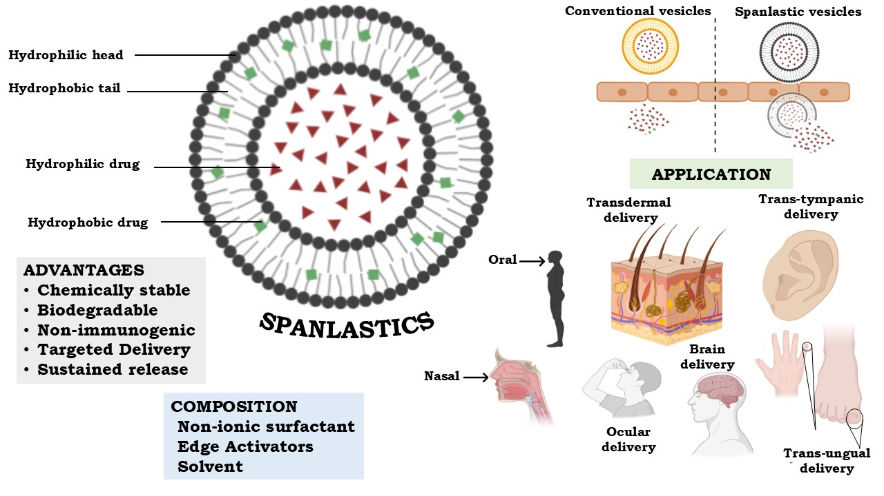

*This image was created using BioRender (BioRender.com)*

*Keywords: Spanlastics, Vesicles, Non-ionic surfactants, Edge activators, Deformability, Permeability.*

1. **INTRODUCTION**
   1. **Novel Drug Delivery System**

A next-generation drug delivery system i.e. a novel drug delivery system refers to an advanced pharmaceutical approach that integrates innovative formulation strategies, emerging technologies, and modern delivery methodologies to ensure the safe and effective passage of therapeutic agents throughout the body, ultimately achieving targeted pharmacological action. In addition to enhancing drug potency, these systems are made to modulate drug release guaranteeing long-lasting therapeutic effects. They may also include site-specific delivery systems, which allow medications to be precisely delivered to the right places [1].

Novel drug delivery systems represent a new area of pharmacy research and innovation, spurred by the pharmaceutical industry's growing need for improved therapeutic efficacy and fewer side effects. The shortcomings of traditional drug administration, including short half-lives, poor targeting, limited solubility, and bioavailability, are intended to be addressed by these systems [2]. A novel drug delivery system is designed to release the therapeutic agent at a rate designed to the body's needs throughout the treatment duration, while directing the therapeutic agent to its target site. Several novel drug formulations have been developed across different routes of administration to accomplish targeted and controlled drug delivery. Among these, encapsulating drugs within vesicular structures is a promising approach, as it can potentially prolong the drug's presence in systemic circulation and minimize toxicity through selective uptake [3].

* 1. **Vesicular Drug Delivery System**

This type of delivery system fills the gap between the ideal and practicality of new drug delivery systems by protecting active ingredients within a vesicular structure. Due to their customizable nature, vesicular systems have been extensively investigated over the years as versatile and promising platforms for drug delivery.

Vesicular drug delivery systems are gaining popularity due to their ability to precisely target medications to specific sites, minimizing toxicity and undesirable effects while offering numerous therapeutic advantages. These systems have been utilized to enhance the solubility, therapeutic index, and stability of drug molecules while also improving bioavailability, reducing the required dose, and increasing the therapeutic efficacy of the medication [4].

Various vesicular drug delivery systems, including aquasomes, colloidosomes, electrosomes, herbosomes, liposomes, niosomes, pharmacosomes, proniosomes, sphingosomes, transferosomes, and ufasomes, have been developed and explored for pharmaceutical applications. However, many of these systems suffer from drawbacks such as low stability, limited drug loading capacity, rapid drug leakage, and high production costs [5]. This review includes a discussion about one such newly developed vesicular system, i.e., spanlastics, which overcomes these limitations. Spanlastics are potential drug delivery vehicles, which are elastic in nature capable of transporting a variety of drug molecules while offering enhanced deformability, improved stability, and better penetration across biological membranes. Numerous studies have demonstrated that spanlastics greatly increase therapeutic efficacy, improve drug bioavailability, and lower drug toxicity [6].

This review aims to provide a comprehensive analysis of spanlastics as a novel nanocarrier system, highlighting their structure, composition, and advantages. Additionally, it emphasizes their distinct deformability mechanism and critically compares spanlastics with other established nanocarriers, such as liposomes, niosomes, ethosomes and nanoparticles to emphasize their distinctiveness and potential for improved drug delivery. It also describes their various methods of preparation, characterization parameters and investigates important formulation factors that affect physicochemical properties of spanlastics and thoroughly examines their uses in oral, transdermal, intranasal, and ophthalmic drug delivery systems as well as future development perspectives.

1. **SPANLASTICS**

In 2011, Kakkar and Kaur first presented spanlastics, a novel therapeutic nano vesicular carrier based on non-ionic surfactants. Spanlastics (SPs) are a novel vesicular drug delivery system composed of non-ionic surfactants (Spans) and edge activators (Tweens), which contribute to their high elasticity and nanoscale structure. These vesicles efficiently encapsulate drugs within a bilayer structure surrounding a core cavity, enabling the effective transport of a wide range of therapeutic compounds. They are characterized by their nanoscale dimensions, typically ranging from 10 to 300 nm, depending on the formulation method and composition. Due to their deformability and stability, spanlastics serve as promising drug delivery vehicles for enhancing bioavailability and targeted drug release [7].

* 1. **Structure**

They are spheroid structures consisting of amphiphilic molecules acting as suitable matrices for bio encapsulation. Based on the size of the SPs, their concentric bilayers can be either unilamellar or multilamellar [8].

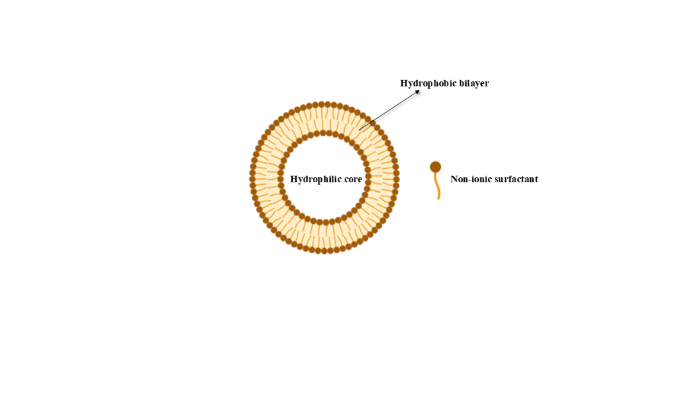

**Fig. 1: Structure of Spanlastic vesicle**

*This image was created using BioRender (BioRender.com)*

* 1. **Composition**

Two crucial ingredients that make up SPs are a non-ionic surfactant, specifically a Span, and an edge activator. These vesicles are termed "Spanlastics" because their primary constituent is a Span surfactant, which forms the structural bilayer [9].

* + 1. **Non-ionic surfactants:**

They play a crucial role in the formation and stability of spanlastics.In contrast to ionic surfactants, these surface-active agents do not carry a net charge, which makes them less toxic and more biocompatible for use in pharmaceutical applications. Non-ionic surfactants are especially well-suited for ocular, nasal, and transdermal delivery because of their superior chemical stability, relative insensitivity to pH changes, and decreased risk of irritation [10]. Non-ionic surfactants, especially Spans, are the main agents that form bilayers in spanlastic formulations. They self-assemble into concentric bilayers, creating the vesicular structure capable of encapsulating both hydrophilic drugs (within the aqueous core) and lipophilic drugs (within the bilayer itself)[8]. The non-ionic surfactants that are used in the preparation of spanlastics are given in the Table 1. Span 60 (sorbitan monostearate) is the most widely used surfactant among the different Spans because of its high lipid content, low hydrophilic-lipophilic balance (HLB) value (4.7), and capacity to form rigid and stable bilayers, which improves drug entrapment efficiency and extends the stability of the vesicles. Vesicle size, entrapment efficiency, deformability, and drug release profile are all influenced by the choice of Span; vesicles with shorter alkyl chains (such as Span 20) typically form less stable vesicles, whereas vesicles with longer saturated chains (such as Span 60) form more stable and compact vesicles [11].

* + 1. **Edge activators (EAs):**

EAs are single-chain surfactant molecules that disrupt the tight packing of surfactant molecules in the vesicle membrane. The high HLB value of these surfactants indicates that they have the unique property of being highly hydrophilic. They improve the permeability and flexibility of SPs, that allow for enhanced drug delivery [15]. The edge activators that are used in the preparation of spanlastics are listed in the Table 2.

**Table 1** Lists the different non-ionic surfactants used to create SPs [12,13,14]

|  |  |  |  |  |
| --- | --- | --- | --- | --- |
| **S.No.** | **Non-ionic surfactant** | **Chemical name** | **HLB Value** | **Key characteristics** |
| 1 | Span 20 | Sorbitan monolaurate | 8.6 | Forms larger vesicles, lower rigidity |
| 2 | Span 40 | Sorbitan monopalmitate | 6.7 | Moderate stability, semi-flexible bilayers |
| 3 | Span 60 | Sorbitan monostearate | 4.7 | Highly stable bilayers, high drug entrapment |
| 5 | Span 80 | Sorbitan monooleate | 4.3 | Flexible vesicles, suitable for deformable carriers |

**Table 2** Lists the different edge activators used to create SPs [16,17,18,19,20,21,22]

|  |  |  |  |
| --- | --- | --- | --- |
| **S.No.** | **Edge activator** | **Category** | **HLB Value** |
| 1 | Sodium cholate | Anionic | 18 |
| 3 | Cremophor RH 40 | Non-ionic surfactant | 15.65 |
| 4 | Poly Vinyl Alcohol | 18 |
| 5 | Tween 20 | 16.7 |
| 6 | Brij 97 | 12.4 |
| 7 | Tween 60 | 14.9 |
| 8 | Tween 80 | 14.5 |
| 9 | Brij 35 | 16.9 |

* + 1. **Ethanol:**

Ethanol is added to these nano vesicular carriers to improve their characteristics. It is beneficial due to its capacity to condense membranes. It makes it easier for the drug to partition and entrap inside the vesicles. An increase in the spanlastic system's ability to entrap drugs is the consequence of the vesicular membrane's decreased thickness [23].

* 1. **Classification of Spanlastics [24]**

The classification is determined by the number of layers that make up the spanlastics, as shown in the following illustration. The figure 2 depicts the type of SPs.

* + 1. **Multi Lamellar Vesicles (MLVs):** MLVs, or multilayer vesicles, are structures made up of multiple surfactant bilayers. Their diameter usually falls between half and one micron. Because they are easy to manufacture and maintain their stability over extended storage times, MLVs are used extensively.
    2. **Large Unilamellar Vesicles (LUVs):** The size range of LUVs is 100nm to 1µ. They can constitute high amount of drug in their core because of their high aqueous to lipid component ratio.
    3. **Small Unilamellar Vesicles (SUVs):** MLVs undergo a sonication process to form SUVs. They are smaller, usually falling between 20 to 50 nm in size.

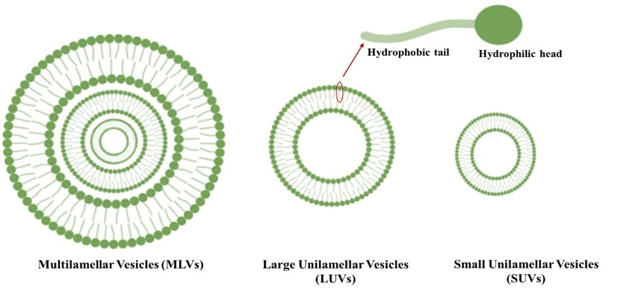

**Fig. 2: Classification of Spanlastics** *This image was created using BioRender (BioRender.com)*

* 1. **Advantages and Disadvantages of Spanlastics**
     1. **Advantages [2]**
* Spanlastic vesicles enhance the permeability of both hydrophilic and lipophilic drugs across biological barriers, including challenging tissues such as the cornea
* SPs are naturally biodegradable and do not elicit an immunological reaction
* Because SPs provide protective support, the drug can reach the intended region without being torn off, increasing its bioavailability compared to conventional material
* SPs enhance drug stability by encapsulating them within a bilayer structure, providing protection against the harsh conditions of the biological environment
* SPs offer versatile drug delivery options, allowing administration through oral, parenteral, and topical routes, thereby facilitating localized or systemic delivery based on therapeutic needs
* Since SPs contain non-ionic surfactant and edge activators, they are more flexible than other colloidal delivery methods
* The use of non-ionic surfactants in the preparation of SPs instead of phospholipids enables lower production costs and chemical stability as compared to liposomes
  + 1. **Disadvantages [6]**
* Surfactants used in the preparation of SPs are not very soluble in water
* SPs are not stable in acidic environment as the membrane disrupts easily
* The two most widely used techniques for making MLVs are extrusion and sonication where both the methods require specialized equipment and are time-consuming
  1. **Mechanism of penetration of spanlastic vesicles [25, 26]**

The penetration of spanlastic vesicles through biological membranes occurs via two primary mechanisms, enabling efficient drug transport to deep tissue layers and enhancing bioavailability. These mechanisms involve vesicular deformation and penetration-enhancing interactions, both of which facilitate drug delivery through intercellular spaces and lipid bilayers.

* + 1. **Vesicular Deformation and Squeezing Through Intercellular Gaps**

Spanlastics, owing to their high deformability, can squeeze through narrow intercellular gaps under the influence of a hydration gradient. The presence of edge activators (EAs) within the vesicular bilayer destabilizes lipid packing, enhancing membrane flexibility. This allows intact vesicles to navigate through the epidermal layers, corneal epithelium, nasal mucosa, and other biological barriers, carrying the entrapped drug to deeper tissues.

* + 1. **Penetration Enhancement via Membrane Interaction and Lipid Disruption**

In addition to their ability to deform and traverse small pores, spanlastics also act as penetration enhancers. Upon interaction with the epithelial cell membrane, the surfactant components of spanlastics disrupt intercellular lipid lamellae, increasing membrane permeability. This disruption facilitates drug diffusion across tight junctions and deeper tissue layers, improving absorption and localized drug release.

**Key Factors Contributing to Vesicle Penetration**

Several physicochemical factors influence the efficiency of spanlastic penetration:

* **Elasticity of Vesicle Bilayers** – The presence of edge activators lowers membrane rigidity, allowing vesicles to undergo stress-induced deformation, essential for passage through biological barriers.
* **Osmotic Gradient-Driven Transport** – The hydration-driven movement of water through membranes helps vesicles squeeze through intercellular spaces.
* **Surfactant-Induced Membrane Pore Formation** – At higher concentrations, surfactants within spanlastics can create temporary pores in lipid bilayers, further aiding drug transport.

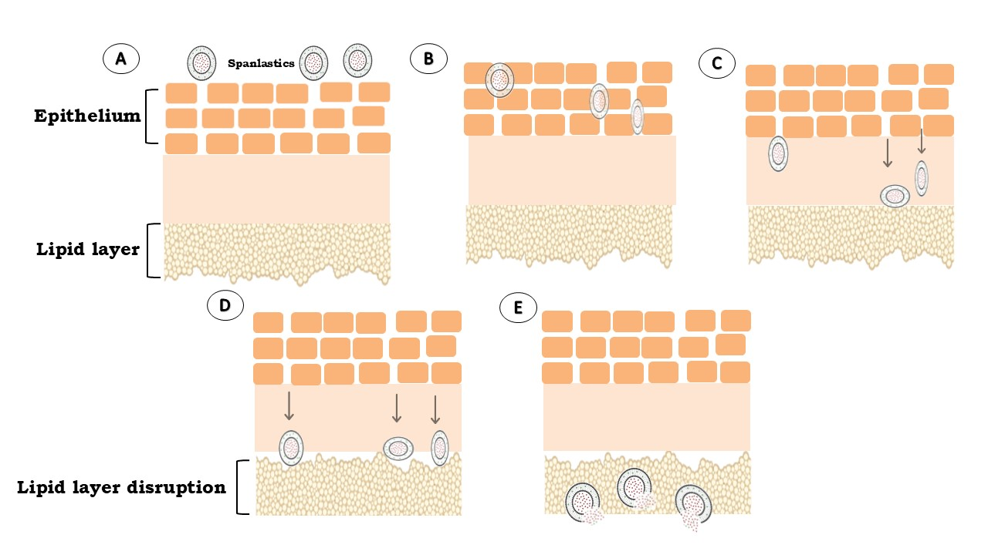

**Fig. 3: Mechanism of penetration of Spanlastics** *This image was created using BioRender (BioRender.com)*

In the fig. 3,

* **A** depicts spanlastic and the layers of the organs
* **B** depicts the permeation of the vesicles through the intercellular spaces by membrane deformation
* **C** depicts the interaction of the vesicles with the lipid layer
* **D** represents the disruption of the lipid layer
* **E** represents the drug delivery to the targeted sites from vesicles

1. **COMPARATIVE ANALYSIS OF SPANLASTICS WITH OTHER NANOCARRIERS**

Nanocarrier systems play a vital role in drug delivery by enhancing solubility, stability, and bioavailability. Among these, spanlastics, liposomes, niosomes, ethosomes, and solid lipid nanoparticles (SLNs) have emerged as prominent vesicular systems with unique advantages and limitations. A comparative analysis of these carriers is essential to understand their applicability in various drug delivery contexts.

**Table 3** Comparison of SPs with other nanocarriers

|  |  |  |  |  |  |
| --- | --- | --- | --- | --- | --- |
| **Parameters** | **Spanlastics** | **Liposomes** | **Niosomes** | **Ethosomes** | **Nanoparticles** |
| **Type** | Non-ionic surfactant based | Lipid-based | Surfactant-based | Lipid-based | Lipid-based & Polymer-based |
| **Composition** | Non-ionic surfactants, edge activators | Phospholipids, cholesterol | Non-ionic surfactants, cholesterol | Phospholipids, ethanol,  cholesterol | Lipids, surfactants, polymers |
| **Elasticity & penetration efficiency** | High, due to the deformable nature | Moderate | Moderate | High, due to ethanol content | Low |
| **Drug encapsulation** | High drug encapsulation efficiency with retention | High drug encapsulation | High drug encapsulation | High drug encapsulation | Face burst issues |
| **Stability** | Improves stability | Depending on the composition | Depending on the surfactant type | Ethanol can induce instabil ity over time | Good physical stability(lipid-based); Depending on the polymer type(polymer-based) |
| **Application** | Highly suitable for localized drug delivery, including transdermal, intranasal, and ocular applications | Drug delivery, gene therapy, vaccines | Drug delivery, vaccines | Topical drug delivery, trans dermal | Targeted and controlled drug delivery |
| **Advantages** | High deformability, skin permeation, stable and cost-effective | Biocompatible, versatile | Stable, cost effective | Enhanced skin permeation, good for trans dermal delivery | Protect drugs from degradation, allow controlled release, and excellent targeting capabilities |
| **Disadvantages** | Stability concerns with long-term storage | May have stability issues | Limited drug loading, potential instability | Ethanol can cause irritation and instability over time | Risk of drug expulsion during storage, and complex formulation techniques |
| **References** | [27] | [28] | [29] | [30] | [31] |

1. **LIMITATIONS AND CHALLENGES OF SPANLASTICS [32,33]**
   1. **Potential toxicity**

* As the SPs are composed of non-ionic surfactants, the concentration of the edge activator may cause membrane irritation or cytotoxic effects at higher doses.
* *In vivo* studies are needed to fully assess their safety for long-term use.
  1. **Scalability Issues**
* The production of spanlastics requires precise control over formulation parameters (e.g., surfactant ratio, hydration conditions).
* Scaling up from lab-scale to industrial production remains a challenge due to batch-to-batch variability.
  1. **Long-Term Stability Concerns**
* Spanlastics may be prone to vesicle aggregation, drug leakage, or surfactant crystallization over time.
* Storage conditions, including temperature and humidity, need optimization to ensure stability in pharmaceutical formulations.
  1. **Regulatory and Clinical Approval Barriers**
* As a relatively new drug delivery system, spanlastics lack extensive clinical data compared to liposomes and other FDA-approved nanocarriers.
* Regulatory pathways need further exploration to ensure their acceptance in pharmaceutical markets.

**Table 4** Challenges and Potential Solutions for Spanlastics

|  |  |
| --- | --- |
| **Challenges** | **Potential solutions** |
| EAs may cause cytotoxicity at higher concentrations | Optimize surfactant concentration to reduce toxicity |
| Long-term safety is not fully assessed | Conduct comprehensive *in vivo* and *in vitro* toxicity studies |
| Prone to vesicle aggregation, drug leakage, or surfactant crystallization over time | Incorporate stabilizers or cryoprotectants to improve stability |
| Limited clinical data compared to FDA-approved nanocarriers like liposomes | Conduct extensive preclinical and clinical studies |

1. **METHODS OF PREPARATION OF SPANLASTICS**

There are various ways to formulate spanlastics. They are represented in the figure 4.

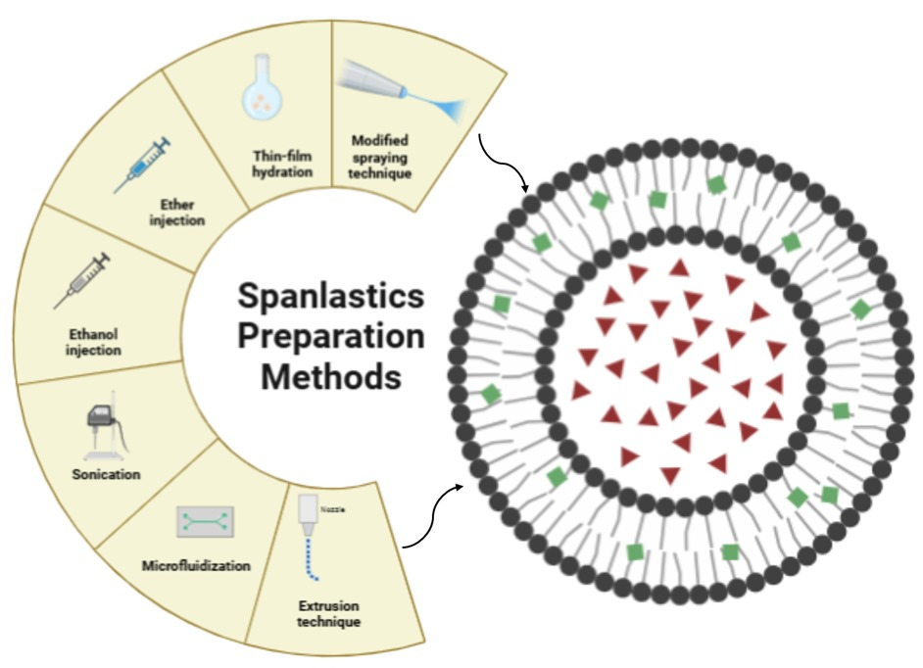

**Fig. 4: Methods of preparation of Spanlastics** *This image was created using BioRender (BioRender.com)*

* 1. **Ethanol injection method [34]**

With a specific ratio of non-ionic surfactant to EA, SPs can be produced using this method. A precise amount of EA is dissolved in distilled water and heated to 80°C, serving as the aqueous phase. Separately, span 60 and the drug are dissolved in ethanol, and this organic phase is maintained at 70°C. The organic phase is then slowly injected into the pre-heated aqueous phase at 80°C, under continuous stirring using a magnetic stirrer. Stirring is continued for 1 hour to facilitate the complete evaporation of ethanol. The formulation volume is then adjusted to the desired final volume using distilled water. The resulting dispersion is stirred at 1000 rpm for 45 minutes to ensure uniform mixing and further evaporation of residual organic solvent. Finally, the formulation undergoes ultrasonication for about 5 mins to further reduce vesicle size and ensure uniformity.

* 1. **Thin film hydration technique [35]**

The first step is to dissolve the non-ionic surfactant in an organic solvent, like ether or chloroform. Following that, the solvent is vaporized in a vacuum evaporator fitted with a round-bottom flask while the pressure is progressively decreased. A thin film is deposited along the flask's inner walls after the organic solvent is vacuum-evaporated. Aqueous solution containing the drug and an EA is then used to hydrate the layer, at a temperature higher than the surfactant's transition temperature (Tc) with continuous agitation. The flask is reattached to the rotary evaporator after the aqueous phase is added, and it is rotated for 30 minutes at 60°C under normal pressure at 90 rpm to ensure full hydration and the film's separation from the flask walls. Because of this phenomenon, the surfactant layer becomes thicker. The swelling of amphiphilic molecules will eventually cause them to fold, creating spanlastic vesicles. Hydrophilic drugs are usually added to the aqueous phase during hydration, lipophilic drugs can be added straight into the organic phase during film formation. After two hours of standing at room temperature to ensure full hydration, the resultant vesicular dispersion is kept at 4°C overnight to stabilize the formulation.

* 1. **Microfluidization method [36]**

This technique entails the ultra-high velocity interaction of two fluidized streams—one carrying a drug and the other a non-ionic surfactant—within predetermined microchannels in an interaction chamber. To guarantee that it stays within the range needed for spanlastic compositions, the energy supplied to the system is meticulously regulated. The submerged jet principle is the term used to describe this occurrence. As a result, the formulation has improved reproducibility, decreased dimensions, and improved uniformity.

* 1. **Sonication method [37]**

In a glass vial with a 10-milliliter capacity, an aliquot of the drug is prepared in the proper buffer and added to the surfactant mixture. Sonication of the mixture is done with the titanium probe.

* 1. **Ether injection method [38]**

The non-ionic surfactant and drug are dissolved in diethyl ether, and the mixture is then injected into an aqueous solution containing EA at a temperature of 60 to 65 °C. Solvent evaporation is made possible by the temperature differences between the organic and aqueous phases. The formation of a bilayer is made feasible by the slow evaporation of ether. One of this method's drawbacks is that there may be a trace amount of ether in the vesicle's suspension, which can be challenging to eliminate. Because lipophilic drugs are more soluble in ether, this approach works well for them. The safety profile of residual ether for pharmaceutical applications can be improved by employing evaporation at lower pressures.

* 1. **Extrusion technique [39]**

This approach makes it possible to regulate the spanlastics' size. After dissolving diacetyl phosphate and non-ionic surfactant in an organic solvent (such as chloroform), the solvent is removed by rotary evaporation to create a thin film, which is then hydrated using a drug-containing aqueous solution. The spanlastics are obtained by extruding the suspension through polycarbonate membranes. Significant benefits include better vesicle size control and the consequent decrease in polydispersity. But there are drawbacks as well, like higher product loss and longer formulation times.

* 1. **Modified spraying technique [40]**

In this method, the non-ionic surfactants are dissolved in ethanol, to form the organic phase, which is transferred to a spray device. The 9% w/v sucrose solution is prepared using double-distilled water and heated to 60 °C in a closed system, regarded as aqueous phase. The organic phase is sprayed over the aqueous medium while being swirled at 1500 rpm and 60 °C. The resulting spanlastics were subjected to four consecutive freeze-thaw cycles at -8 °C for eight hours and 25 °C for one hour to enhance the drug’s entrapment inside the vesicle.

1. **CHARACTERIZATION OF SPANLASTICS**
   1. **Vesicle size [18]**

By using the dynamic light scattering (DLS) technique, the size of the vesicles can be ascertained. The equipment that employs this technique is Zetasizer. Variations in light scattering caused by the particles' Brownian motion are examined using the DLS technique to provide the estimated vesicle size.

* 1. **Poly Dispersity Index (PDI) [34]**

To show the level of particle size homogeneity, the PDI is employed. The PDI is measured using Zetasizer that employs DLS technique.

* 1. **Morphology examination [41]**

To conduct morphological analysis, a transmission electron microscope is employed. This makes it possible to determine the spanlastics' lamellarity, size, shape, and physical stability characteristics. To speed up the process, a suspension is made and the proper amount of phosphotungstic acid is added at a concentration of 1%. After the extra liquid has been drained off, the mixture is put on a carbon-covered grid and left to dry completely. After that, the grid is examined at the appropriate magnification while being captured on camera using a Philips TEM.

* 1. **Zeta potential [42]**

By using a device known as a Zetasizer, the zeta potential of the spanlastic formulation is assessed. The electrophoretic mobility principle in an electric field is the basis for Zetasizer's operation. It is useful for figuring out what caused the sample to aggregate, flocculate, or disperse.

* 1. **Elasticity measurement [43]**

Elasticity is measured by the deformability index, or "DI," as it is sometimes referred to. This method involves extruding vesicles under continuous pressure using a polycarbonate filter with pores that are 50 nm wide. A 200 ml barrel and a stainless-steel pressure holder with a 25 mm filter were used in the procedure. The time intervals before and after the extrusion process had an impact on the vesicular size of the extruded suspension. The formulation's flexibility demonstrates SP's capacity to squeeze itself and penetrate the mucus barrier, which is an interesting requirement for this kind of vesicle.

The following formula is used to determine deformability:

Deformability index (DI) = J[rv/rp]

where,

J – sample’s weight in grams after it has been compressed for 10 mins and run through a polycarbonate filtration membrane

rv – size of spanlastic vesicles following extrusion

rp – pore size of the polycarbonate membrane filter

* 1. **Evaluation of stability [9]**

This study assesses the amount of drug that leaks from vesicles during storage. The spanlastic formulation was kept in a glass vial at 4 0C and 25±2 0C for three months to test its stability. Samples are taken out of the system at 30, 60 and 90 days of storage and they are measured for %EE, vesicle size and drug release.

* 1. **Drug content [44]**

To break up the spanlastic vesicles and liberate the drug that was trapped, isopropyl alcohol was chosen as an appropriate solvent. To guarantee total disruption of the vesicular structure, a measured volume of the spanlastic dispersion (1mL) was combined with the proper amount of isopropyl alcohol. The drug content of the resultant solution was then ascertained by UV-visible spectrophotometry analysis.

* 1. **% Entrapment efficiency (%EE) [12]**

A centrifugation technique is used to extract any drug that the spanlastics have not been able to capture to calculate the entrapment efficiency. After the remaining solution has been separated, the supernatant is gathered. After being collected, the liquid is diluted to a specific concentration and tested using the proper procedure specified in the relevant drug monograph. The yield and efficacy of spanlastics' entrapment are usually influenced by the non-ionic surfactants used and the manufacturing process employed.

%EE can be calculated using the formula below,

% EE = Amount of entrapped drug/Total amount added×100

* 1. ***In vitro* drug release [45]**

Franz diffusion cells were used for the experimental setup in *in vitro* drug release research. The donor and the receptor compartments are separated by a semi permeable membrane, and the temperature is maintained at 370C by magnetically swirling the solution at a rate of 500 revolutions per minute. The receptor compartment is loaded with phosphate buffer, and the weighed amount of spanlastic formulation is placed on one side of the semi permeable membrane. The samples contained within the receptor chamber are removed at predetermined intervals and immediately replaced with an equivalent volume of buffer. After the proper dilution, the sample is subjected to spectrophotometric analysis at maximum concentration.

1. **KEY FACTORS INFLUENCING THE PHYSICOCHEMICAL PROPERTIES OF SPANLASTICS**
   1. **Drug characteristics [46]**

Numerous factors, such as the drug's chemical structure, molecular weight, hydrophilicity, and lipophilicity, can affect its entrapment efficiency. The vesicle's size may increase because of the drugs being trapped and the repulsion that is created between the surfactant bilayers.

* 1. **Hydration temperature [34]**

The size and shape of the vesicle is influenced by the temperature at which it is hydrated. The process of vesicle assembly is affected by the temperature differential across the system. Additionally, temperature changes can cause changes in the morphology of vesicles. The spherical vesicles eventually form a cluster of much smaller, after being cooled.

* 1. **Surfactant type [13]**

The vesicle size and entrapment efficiency are affected by the surfactant type. The mean size of spanlastic vesicles increases with the HLB value of the surfactants, i.e., from Span 85 (HLB 1.8) to Span 20 (HLB 8.6). This could be due to the fact that the surface free energy decreases as the hydrophilicity of the surfactant increases. Furthermore, the phase transition is the reason for the impact. A spanlastic vesicle’s entrapment efficiency is influenced by its HLB value; for instance, spanlastics have a high entrapment efficiency at an HLB value of 8.6, but their formulation is not optimal at an HLB value of 14 to 17.

* 1. **Sonication time [41]**

The sonication time affects the particle size of the vesicle which in turn affects the %EE. Increase in the sonication time decreases the % EE which is due to the decreased vesicle size of the SPs.

* 1. **Type of Edge activator [47]**

The entrapment efficiency and particle size of SPs are significantly influenced by the type of edge activator. As surface-active chemicals, edge activators modify interfacial tension, packing qualities, and bilayer flexibility, all of which have an impact on the vesicles' ultimate physicochemical characteristics.

Higher HLB edge activators, such as Tween 80 (HLB 14.5), typically result in smaller vesicles in terms of particle size. This is because of their exceptional capacity to lower surface tension, which enables the formation of densely packed vesicles by the surfactant bilayers. Smaller, more deformable particles are formed because of the controlled rupture of the bilayer structure caused by these activators. In contrast, because of their limited capacity to decrease surface tension and enhance bilayer fluidity, edge activators with lower HLB values—like Span 85 (HLB 1.8)—promote the production of bigger vesicles.

This also affects the %EE. Higher drug entrapment results from moderately hydrophilic edge activators (HLB between 14 and 16), which achieve the ideal balance between flexibility and vesicle stability. Over time, medication leakage may occur due to vesicle destabilization caused by highly hydrophilic edge activators (extremely high HLB). On the other hand, stiff vesicles with inadequate drug encapsulation are produced by lesser HLB edge activators.

1. **APPLICATIONS OF SPANLASTICS IN SITE-SPECIFIC DELIVERY**

* **Ocular delivery [9,48,49]**

The ocular drug delivery system encounters several challenges that restrict ocular bioavailability because of the multiple pre-corneal and corneal barriers. SPs serve as specific drug delivery vehicles for the anterior segment of the eye, which includes the aqueous fluid and corneal barrier, and the posterior segment, which includes the vitreous chamber, choroid, and retinal epithelium. Using SPs, drugs that are hydrophilic or lipophilic can be delivered to the tissues of the eyes. In contrast to conventional eye drops, spanlastic formulations have effectively integrated drugs like anti-glaucoma, antifungal, immunosuppressants, antihistamines, antibiotics, and anti-inflammatory ingredients, resulting in extended ocular retention and enhanced therapeutic efficacy.

Kakkar et al. developed ketoconazole-loaded spanlastics using Span 60 and Tween 80, resulting in nanosized, elastic vesicles. These spanlastics demonstrated twice the corneal permeation compared to niosomes. Safety assessments confirmed their non-toxic nature, and fluorescent labelling showed penetration into rabbit vitreous humor within 2 hours, indicating potential for posterior eye delivery.

* **Oral delivery [47,50,51]**

The oral administration of drug is the most common method, yet it faces challenges with bioavailability due to several factors, such as poor solubility, potential drug interactions, erratic absorption rates and first-pass metabolism. SPs are useful in addressing these challenges. Tayel et al. formulated pravastatin sodium-loaded spanlastic dispersions using Span 60 with Tween 60 or Tween 80 as edge activators. The optimized formulation exhibited nanosized vesicles (~647.60 nm) with an entrapment efficiency of 63.22%. Enteric surface coating with Eudragit L100-55 provided duodenum-triggered release, enhancing oral bioavailability and sustaining drug release.

* **Transdermal delivery [17,21,52]**

Spanlastic technology promotes transdermal drug delivery, particularly for hydrophilic medications that have trouble entering the lipophilic stratum corneum. The elasticity and surfactant properties of spanlastics allow for the effective delivery of drugs like vitamins, NSAIDs, antifungal agents and local anaesthetics through the skin, providing longer-lasting effects and improved patient compliance.

Badria et al. developed sodium valproate-loaded nanospanlastics for transdermal delivery, achieving high entrapment efficiency and controlled release. This formulation enhanced skin permeability, suggesting potential for improved treatment of epilepsy and androgenic alopecia via transdermal delivery.

* **Intranasal delivery [22,53,54]**

SPs are ideal candidates for intranasal drug delivery, particularly for drugs targeting the central nervous system. Drugs such as antiemetics and neurotherapeutics (e.g., anti-Parkinson’s agents) can be incorporated into spanlastic formulations for nasal delivery, to improve bioavailability and provide faster onset of action. Antihypertensives used to treat pulmonary hypertension can be given intranasally. The nasal mucosa, being highly vascularized, allows spanlastics to bypass the hepatic first-pass metabolism and directly transport drugs to the brain via the olfactory pathway.

Gupta et al. developed Piperine-loaded spanlastics for nose-to-brain delivery, showing enhanced bioavailability and therapeutic efficacy in managing epilepsy. The optimized formulation demonstrated improved permeability and brain targeting, making spanlastics a promising approach for nose-to-brain delivery of the drug.

1. **DRUGS INVESTIGATED AS POTENTIAL SPANLASTIC DELIVERY SYSTEMS**

**Table 5** lists the drugs investigated as potential Spanlastic delivery systems

|  |  |  |  |
| --- | --- | --- | --- |
| **Application** | **Drug** | **Purpose** | **References** |
| Ocular delivery | Ketoconazole | To increase the corneal permeability of the drug | [9] |
| Transdermal delivery | Simvastatin | To improve permeability | [11] |
| Ocular delivery | Clotrimazole | To improve bioavailability of the drug | [12] |
| Intranasal delivery | Lercanidipine HCl | To improve bioavailability and diffusion of the drug | [13] |
| Transdermal delivery | Fluvastatin sodium | To improve oral bioavailability | [14] |
| Mucoadhesive buccal  drug delivery | Carvedilol | To avoid first-pass metabolism, enhancing the pharmacological effect and drug absorption | [16] |
| Topical delivery | Retinoic acid | To enhance permeation | [17] |
| Topical delivery | L-Ascorbic acid | To provide maximum stability and efficacy | [18] |
| Transnasal brain drug targeting | Risperidone | To increase bioavailability of the drug | [19] |
| Non-invasive *trans*-tympanic delivery | Ciprofloxacin | To provide means for ototopical treatment for acute otitis | [20] |
| Transdermal delivery | Sodium valproate | To increase permeability | [21] |
| Nose-To-Brain Delivery | Piperine | To improve the drug’s solubility, bioavailability, and permeation through nasal mucosa | [22] |
| Buccal delivery | Lacidipine | To override first-pass metabolism of the drug and enhance its bioavailability | [23] |
| Transdermal delivery | Haloperidol | To provide enhanced permeation | [34] |
| Ocular delivery | Levofloxacin | To improve the corneal permeability | [35] |
| Transdermal delivery | Thymoquinone | To increase solubility and stability of the drug | [40] |
| Nose-to-brain delivery | Flibanserin | To avoid first-pass metabolism | [41] |
| Transdermal delivery | Fenoprofen calcium | To eliminate oral gastrointestinal adverse effects of the drug | [43] |
| Transdermal delivery | Dapagliflozin | To enhance drug stability and permeability | [44] |
| Nose-to-brain delivery | Rasagiline mesylate | To improve bioavailability | [45] |
| Topical delivery | Benzalkonium chloride | To enhance drug penetration | [27] |
| Oral delivery | Epigallocatechin Gallate | To improve oral bioavailability | [47] |
| Ocular delivery | Itraconazole | To improve the corneal permeability | [48] |
| Ocular delivery | Cyclosporine A | To improve the drug’s solubility | [49] |
| Oral delivery (liver targeted drug delivery system) | Ledipasvir | To enhance ledipasvir liver bioavailability | [50] |
| Topical delivery | Luliconazole | To improve transdermal penetration of the drug | [52] |
| Nose-to-brain delivery | Zolmitriptan | To enhance the bioavailability and avoid first-pass effect of the drug | [53] |
| Intranasal delivery | Cefdinir | To enhance the drug's solubility and bioavailability | [54] |
| Transungual delivery | Efinaconazole | To improve the permeability | [55] |
| Transdermal delivery | Raloxifene | To improve bioavailability | [56] |
| Ocular delivery | Fluconazole | To achieve a prolonged and better effect | [57] |
| Transdermal delivery | Letrozole & Quercetin | To improve therapeutic efficacy, increase drug bioavailability, and reduce toxicity | [58] |
| Transdermal delivery | Tacrolimus | To improve the transdermal permeation | [59] |
| Buccal delivery | Felodipine | To enhance drug bioavailability | [60] |
| Ocular delivery | Ketotifen fumarate | To increase the bioavailability | [61] |

1. **PATENT INFORMATION [62]**

Patent title - Cationic hyaluronic acid coated spanlastics and preparation and application thereof

Inventors - Li Gan, Yang Liu, Hua Zhang, Yanan Wang, Jinlong Yang

Patent application number - US20220192980A1

Summary of the patent claims

Designed for ocular drug delivery, a cationic hyaluronic acid-coated spanlastic consists of a drug-loaded vesicle with a vesicle membrane made of non-ionic surfactants (Span or Poloxamer) and edge activators (polyoxyethylene derivatives, Tween, or sodium cholate). The coating of cationic hyaluronic acid to the surface improves mucoadhesion, stability, and bioavailability. A zeta potential of -10 to -30 mV, a viscosity of 1–12 mPa·s, and a particle size of 200–310 nm are all characteristics of the vesicles. By injecting ethanol and then coating with cationic hyaluronic acid, the patented technique can be used to treat eye conditions.

1. **FUTURE SCOPE**

Spanlastics are a flexible vesicular drug delivery technology that may find use in a variety of therapeutic domains. Their complete potential has not yet been realized, though. Future studies should concentrate on surface modification by active targeting using ligands, antibodies, or peptides to improve site-specific delivery. More research is necessary to enhance encapsulation efficiency, stability, and cellular uptake for their use in gene therapy and nucleic acid delivery. Furthermore, improving mucoadhesion qualities might help drugs stay at mucosal locations longer, which is advantageous for distribution through the eyes, nose, and mouth. Finally, adding spanlastics to smart medication delivery devices like 3D-printed customized formulations and microneedle patches may greatly enhance patient adherence and treatment results. With these developments, spanlastics may develop into therapeutically feasible carriers that can solve important issues in contemporary medication administration.

1. **CONCLUSION**

Spanlastics have emerged as a promising nanocarrier system with enhanced deformability, allowing efficient drug penetration through biological barriers. Their unique structure, composed of non-ionic surfactants and edge activators, enables the encapsulation of both hydrophilic and hydrophobic drugs, improving solubility, bioavailability, and therapeutic efficacy. Spanlastics have been widely explored for transdermal, ocular, and intranasal drug delivery, demonstrating superior permeability and stability compared to conventional nanocarriers.

However, challenges such as potential cytotoxicity, formulation scalability, and long-term stability require further investigation. Optimizing surfactant composition, storage conditions, and large-scale production techniques could enhance their viability for clinical use. Additionally, regulatory approval pathways need to be established to facilitate their pharmaceutical applications.

Despite these limitations, spanlastics have shown potential in improving drug delivery efficiency, prolonging drug retention, and minimizing systemic side effects. Future research should focus on refining formulations, exploring novel modifications to enhance stability, and expanding their applicability to other drug delivery routes. With continued advancements, spanlastics could play a vital role in next-generation drug delivery systems.

Disclaimer (Artificial intelligence)

Option 1:

Author(s) hereby declare that NO generative AI technologies such as Large Language Models (ChatGPT, COPILOT, etc.) and text-to-image generators have been used during the writing or editing of this manuscript.

Option 2:

Author(s) hereby declare that generative AI technologies such as Large Language Models, etc. have been used during the writing or editing of manuscripts. This explanation will include the name, version, model, and source of the generative AI technology and as well as all input prompts provided to the generative AI technology

Details of the AI usage are given below:

1.

2.

3.

**REFERENCES:**

1. Chen, Q., Yang, Z., Liu, H., Man, J., Oladejo, A. O., Ibrahim, S., Wang, S., & Hao, B. (2024). Novel Drug Delivery Systems: An Important Direction for Drug Innovation Research and Development. *Pharmaceutics*, *16*(5), 674.
2. Alhammid, S. N. A., Kassab, H. J., Hussein, L. S., & Haiss, M. A. (2023). Spanlastics nanovesicles: An emerging and innovative approach for drug delivery. *Maaen Journal for Medical Sciences*, *2*(2), 9.
3. Myneni, G. S., Radha, G., & Soujanya, G. V. R. L. (2021). Novel vesicular drug delivery systems: A review. *J Pharm Res*, *11*(04), 1650-1664.
4. Shinde, N. G., Aloorkar, N. H., & Kulkarni, A. S. (2014). Recent advances in vesicular drug delivery system. *Research journal of pharmaceutical dosage forms and technology*, *6*(2), 110-120.
5. Gill, B., Singh, J., Sharma, V., & Kumar, S. H. (2012). Emulsomes: An emerging vesicular drug delivery system. *Asian Journal of Pharmaceutics (AJP)*, *6*(2).
6. Ansari, M. D., Saifi, Z., Pandit, J., Khan, I., Solanki, P., Sultana, Y., & Aqil, M. (2022). Spanlastics a novel nanovesicular carrier: Its potential application and emerging trends in therapeutic delivery. *AAPS PharmSciTech*, *23*(4), 112.
7. Karati, D., Mukherjee, S., & Prajapati, B. G. (2025). Unveiling Spanlastics as a Novel Carrier for Drug Delivery: A Review. *Pharmaceutical Nanotechnology*, *13*(1), 133-142.
8. Saini, H., Rapolu, Y., Razdan, K., Nirmala, & Sinha, V. R. (2023). Spanlastics: a novel elastic drug delivery system with potential applications via multifarious routes of administration. *Journal of Drug Targeting*, *31*(10), 999-1012.
9. Kakkar, S., & Kaur, I. P. (2011). Spanlastics—A novel nanovesicular carrier system for ocular delivery. *International journal of pharmaceutics*, *413*(1-2), 202-210.
10. Ge, X., Wei, M., He, S., & Yuan, W. E. (2019). Advances of non-ionic surfactant vesicles (niosomes) and their application in drug delivery. *Pharmaceutics*, *11*(2), 55.
11. Badr-Eldin, S. M., Aldawsari, H. M., Alhakamy, N. A., Fahmy, U. A., Ahmed, O. A., Neamatallah, Tima, S., Almaghrabi, R.H., Alkudsi, F.M., Alamoudi, A. A., Alzahrani, A. A., Kotta, S., & Al-hejaili, O. D. (2022). Merging experimental design and nanotechnology for the development of optimized simvastatin spanlastics: a promising combined strategy for augmenting the suppression of various human cancer cells. *Pharmaceutics*, *14*(5), 1024.
12. Abdelbari, M. A., El-Mancy, S. S., Elshafeey, A. H., & Abdelbary, A. A. (2021). Implementing spanlastics for improving the ocular delivery of clotrimazole: in vitro characterization, ex vivo permeability, microbiological assessment and in vivo safety study. *International Journal of Nanomedicine*, 6249-6261.
13. Bukhary, H. A., Hosny, K. M., Rizg, W. Y., Alahmadi, A. A., Murshid, S. S., Alalmaie, A., Alamoudi, A.J., Badr, M.Y., & Khallaf, R. A. (2024). Development, optimization, in-vitro, and in-vivo evaluation of chitosan-inlayed nano-spanlastics encompassing lercanidipine HCl for enhancement of bioavailability. *Journal of Drug Delivery Science and Technology*, *96*, 105677.
14. El Menshawe, S. F., Nafady, M. M., Aboud, H. M., Kharshoum, R. M., Elkelawy, A. M. M. H., & Hamad, D. S. (2019). Transdermal delivery of fluvastatin sodium via tailored spanlastic nanovesicles: mitigated Freund's adjuvant-induced rheumatoid arthritis in rats through suppressing p38 MAPK signaling pathway. *Drug delivery*, *26*(1), 1140-1154.
15. El Zaafarany, G. M., Awad, G. A., Holayel, S. M., & Mortada, N. D. (2010). Role of edge activators and surface charge in developing ultradeformable vesicles with enhanced skin delivery. *International journal of pharmaceutics*, *397*(1-2), 164-172.
16. Sallam, N. M., Sanad, R. A. B., Ahmed, M. M., Khafagy, E. S., Ghorab, M., & Gad, S. (2021). Impact of the mucoadhesive lyophilized wafer loaded with novel carvedilol nano-spanlastics on biochemical markers in the heart of spontaneously hypertensive rat models. *Drug Delivery and Translational Research*, *11*, 1009-1036.
17. Shamma, R. N., Sayed, S., Sabry, N. A., & El-Samanoudy, S. I. (2019). Enhanced skin targeting of retinoic acid spanlastics: in vitro characterization and clinical evaluation in acne patients. *Journal of liposome research*, *29*(3), 283-290.
18. Elhabak, M., Ibrahim, S., & Abouelatta, S. M. (2021). Topical delivery of l-ascorbic acid spanlastics for stability enhancement and treatment of UVB induced damaged skin. *Drug delivery*, *28*(1), 445-453.
19. Abdelrahman, F. E., Elsayed, I., Gad, M. K., Elshafeey, A. H., & Mohamed, M. I. (2017). Response surface optimization, ex vivo and in vivo investigation of nasal spanlastics for bioavailability enhancement and brain targeting of risperidone. *International Journal of Pharmaceutics*, *530*(1-2), 1-11.
20. Al-Mahallawi, A. M., Khowessah, O. M., & Shoukri, R. A. (2017). Enhanced non invasive trans-tympanic delivery of ciprofloxacin through encapsulation into nano-spanlastic vesicles: Fabrication, in-vitro characterization, and comparative ex-vivo permeation studies. *International journal of pharmaceutics*, *522*(1-2), 157-164.
21. Badria, F. A., Fayed, H. A., Ibraheem, A. K., State, A. F., & Mazyed, E. A. (2020). Formulation of sodium valproate nanospanlastics as a promising approach for drug repurposing in the treatment of androgenic alopecia. *Pharmaceutics*, *12*(9), 866.
22. Gupta, I., Adin, S. N., Rashid, M. A., Alhamhoom, Y., Aqil, M., & Mujeeb, M. (2023). Spanlastics as a potential approach for enhancing the nose-to-brain delivery of piperine: In vitro prospect and in vivo therapeutic efficacy for the management of epilepsy. *Pharmaceutics*, *15*(2), 641.
23. Mary DCruz, C. E., Bhide, P. J., Kumar, L., & Shirodkar, R. K. (2021). *Novel nano spanlastic carrier system for buccal delivery of lacidipine. J Drug Deliv Sci Technol 2022; 68: 103061*.
24. Sharma, A., Pahwa, S., Bhati, S., & Kudeshia, P. (2020). Spanlastics: A modern approach for nanovesicular drug delivery system. *Int J Pharm Sci Res*, *11*(3), 1057-65.
25. Nadim, N., Khan, A. A., Khan, S., Parveen, R., & Ali, J. (2024). A narrative review on potential applications of spanlastics for nose-to-brain delivery of therapeutically active agents. *Advances in Colloid and Interface Science*, 103341.
26. Chauhan, M. K., & Verma, A. (2017). Spanlastics-future of drug delivery and targeting. *World J Pharm Res*, *6*(12), 429-46.
27. Wagdi, M. A., Salama, A., El-Liethy, M. A., & Shalaby, E. S. (2023). Comparative study of niosomes and spanlastics as a promising approach for enhancing benzalkonium chloride topical wound healing: In-vitro and in-vivo studies. *Journal of Drug Delivery Science and Technology*, *84*, 104456.
28. Andra, V. V. S. N. L., Pammi, S. V. N., Bhatraju, L. V. K. P., & Ruddaraju, L. K. (2022). A comprehensive review on novel liposomal methodologies, commercial formulations, clinical trials and patents. *Bionanoscience*, *12*(1), 274-291.
29. Bhardwaj, P., Tripathi, P., Gupta, R., & Pandey, S. (2020). Niosomes: A review on niosomal research in the last decade. *Journal of Drug Delivery Science and Technology*, *56*, 101581.
30. Emanet, M., & Ciofani, G. (2023). Ethosomes as promising transdermal delivery systems of natural‐derived active compounds. *Advanced NanoBiomed Research*, *3*(10), 2300020.
31. Al-Thani, A. N., Jan, A. G., Abbas, M., Geetha, M., & Sadasivuni, K. K. (2024). Nanoparticles in cancer theragnostic and drug delivery: A comprehensive review. *Life sciences*, 122899.
32. Paliwal R, Babu RJ, Palakurthi S. Nanomedicine scale-up technologies: feasibilities and challenges. *AAPS PharmSciTech*. 2014;15(6):1527-1534. doi:10.1208/s12249-014-0177-9
33. Patel, A., & Patel, R. (2024). Nano formulations for peptide drug delivery: Overcoming bioavailability and stability challenges. *World Journal of Advanced Research and Reviews*, *22*(1), 2032-2044.
34. Fahmy, A. M., El-Setouhy, D. A., Ibrahim, A. B., Habib, B. A., Tayel, S. A., & Bayoumi, N. A. (2018). Penetration enhancer-containing spanlastics (PECSs) for transdermal delivery of haloperidol: in vitro characterization, ex vivo permeation and in vivo biodistribution studies. *Drug delivery*, *25*(1), 12-22.
35. Agha, O. A., Girgis, G. N., El-Sokkary, M. M., & Soliman, O. A. E. A. (2023). Spanlastic-laden in situ gel as a promising approach for ocular delivery of Levofloxacin: In-vitro characterization, microbiological assessment, corneal permeability and in-vivo study. *International Journal of Pharmaceutics: X*, *6*, 100201.
36. Ag Seleci, D., Maurer, V., Stahl, F., Scheper, T., & Garnweitner, G. (2019). Rapid microfluidic preparation of niosomes for targeted drug delivery. *International journal of molecular sciences*, *20*(19), 4696.
37. Khan, D. H., Bashir, S., Figueiredo, P., Santos, H. A., Khan, M. I., & Peltonen, L. (2019). Process optimization of ecological probe sonication technique for production of rifampicin loaded niosomes. *Journal of Drug Delivery Science and Technology*, *50*, 27-33.
38. Mawazi, S. M., Ge, Y., & Widodo, R. T. (2025). Niosome Preparation Techniques and Structure—An Illustrated Review. *Pharmaceutics*, *17*(1), 67.
39. Liga, S., Paul, C., Moacă, E. A., & Péter, F. (2024). Niosomes: Composition, formulation techniques, and recent progress as delivery systems in cancer therapy. *Pharmaceutics*, *16*(2), 223.
40. Alaaeldin, E., Mostafa, M., Mansour, H. F., & Soliman, G. M. (2021). Spanlastics as an efficient delivery system for the enhancement of thymoquinone anticancer efficacy: Fabrication and cytotoxic studies against breast cancer cell lines. *Journal of Drug Delivery Science and Technology*, *65*, 102725.
41. Alharbi, W. S., Hareeri, R. H., Bazuhair, M., Alfaleh, M. A., Alhakamy, N. A., Fahmy, U. A., Alamoudi, A.A., Badr-Eldin, S.M., Ahmed, O.A., AlGhamdi, S.A., & Naguib, M. J. (2022). Spanlastics as a potential platform for enhancing the brain delivery of flibanserin: In vitro response-surface optimization and in vivo pharmacokinetics assessment. *Pharmaceutics*, *14*(12), 2627.
42. Seary, H., Barakat, E. H., Raslan, M. A., & Samy, A. M. (2024). DEVELOPMENT, CHARACTERIZATION, AND OPTIMIZATION OF REPAGLINIDE LOADED SPANLASTICS ALONG WITH INVESTIGATION OF DRUG SOLUBILITY IN VARIOUS MEDIA. *Universal Journal of Pharmaceutical Research*.
43. Farghaly, D. A., Aboelwafa, A. A., Hamza, M. Y., & Mohamed, M. I. (2017). Topical delivery of fenoprofen calcium via elastic nano-vesicular spanlastics: Optimization using experimental design and in vivo evaluation. *AAPS PharmSciTech*, *18*, 2898-2909.
44. Barakat, E. H., Kassem, A. M., Ibrahim, M. F., Elsayad, M. K., Abdelgawad, W. Y., Salama, A., Alruwaili, N.K., Alsaidan, O.A., & Elmowafy, M. (2024). Fabrication of prostructured spanlastics gel for improving transdermal effect of dapagliflozin: In vitro characterization studies and in vivo antidiabetic activity. *Journal of drug delivery science and technology*, *97*, 105804.
45. Ali, M. M., Shoukri, R. A., & Yousry, C. (2023). Thin film hydration versus modified spraying technique to fabricate intranasal spanlastic nanovesicles for rasagiline mesylate brain delivery: Characterization, statistical optimization, and in vivo pharmacokinetic evaluation. *Drug Delivery and Translational Research*, *13*(4), 1153-1168.
46. Kumar, L., Rana, R., Kukreti, G., Aggarwal, V., Chaurasia, H., Sharma, P., & Jyothiraditya, V. (2024). Overview of Spanlastics: A Groundbreaking Elastic Medication Delivery Device with Versatile Prospects for Administration via Various Routes. *Current Pharmaceutical Design*, *30*(28), 2206-2221.
47. Mazyed, E. A., Helal, D. A., Elkhoudary, M. M., Abd Elhameed, A. G., & Yasser, M. (2021). Formulation and optimization of nanospanlastics for improving the bioavailability of green tea epigallocatechin gallate. *Pharmaceuticals*, *14*(1), 68.
48. ElMeshad, A. N., & Mohsen, A. M. (2016). Enhanced corneal permeation and antimycotic activity of itraconazole against Candida albicans via a novel nanosystem vesicle. *Drug delivery*, *23*(7), 2115-2123.
49. Liu, Y., Wang, Y., Yang, J., Zhang, H., & Gan, L. (2019). Cationized hyaluronic acid coated spanlastics for cyclosporine A ocular delivery: Prolonged ocular retention, enhanced corneal permeation and improved tear production. *International Journal of Pharmaceutics*, *565*, 133-142.
50. Fatouh, A. M., Elshafeey, A. H., & Abdelbary, A. (2022). Liver targeting of ledipasvir via galactosylated chitosan–coated spanlastics: chemical synthesis, statistical optimization, in vitro, and pharmacokinetic evaluation. *Drug Delivery and Translational Research*, *12*(5), 1161-1174.
51. Tayel, S. A., El-Nabarawi, M. A., Tadros, M. I., & Abd-Elsalam, W. H. (2015). Duodenum-triggered delivery of pravastatin sodium via enteric surface-coated nanovesicular spanlastic dispersions: development, characterization and pharmacokinetic assessments. *International journal of pharmaceutics*, *483*(1-2), 77-88.
52. Marques, S. M., Chavan, D. U., Bhide, P. J., Joshi, M., Kumar, L., & Shirodkar, R. K. (2023). Novel luliconazole spanlastic nanocarriers: development and characterisation. *Current Drug Delivery*, *20*(6), 792-806.
53. Saleh, A., Khalifa, M., Shawky, S., Bani-Ali, A., & Eassa, H. (2021). Zolmitriptan intranasal spanlastics for enhanced migraine treatment; formulation parameters optimized via quality by design approach. *Scientia pharmaceutica*, *89*(2), 24.
54. Chettupalli, A. K., Ajmera, S., Kuchukuntla, M., Palanivel, V., & Katta, S. (2024). Design Formulation of Nanospanlastic Novel Carriers as a Promising Approach to Enhanced Bioavailability in Intranasal Drug Delivery for Sinusitis: Statistical Optimization and In vitro and In vivo Characterization. *Current Nanomedicine (Formerly: Recent Patents on Nanomedicine)*, *14*(3), 266-288.
55. Almuqbil, R. M., Sreeharsha, N., & Nair, A. B. (2022). Formulation-by-design of efinaconazole spanlastic nanovesicles for transungual delivery using statistical risk management and multivariate analytical techniques. *Pharmaceutics*, *14*(7), 1419.
56. Ansari, M. D., Solanki, P., Pandit, J., Jahan, R. N., Aqil, M., & Sultana, Y. (2022). Fabrication and optimization of raloxifene loaded spanlastics vesicle for transdermal delivery. *Journal of Drug Delivery Science and Technology*, *68*, 103102.
57. Kaur, I. P., Rana, C., Singh, M., Bhushan, S., Singh, H., & Kakkar, S. (2012). Development and evaluation of novel surfactant-based elastic vesicular system for ocular delivery of fluconazole. *Journal of ocular pharmacology and therapeutics*, *28*(5), 484-496.
58. Mekkawy, A. I., Eleraky, N. E., Soliman, G. M., Elnaggar, M. G., & Elnaggar, M. G. (2022). Combinatorial therapy of letrozole-and quercetin-loaded spanlastics for enhanced cytotoxicity against MCF-7 breast cancer cells. *Pharmaceutics*, *14*(8), 1727.
59. Zaki, R. M., Ibrahim, M. A., Alshora, D. H., & El Ela, A. E. S. A. (2022). Formulation and evaluation of transdermal gel containing tacrolimus-loaded spanlastics: In vitro, ex vivo and in vivo studies. *Polymers*, *14*(8), 1528.
60. Natekar, R. M., DCruz, C. E. M., Kumar, L., Bhide, P. J., & Shirodkar, R. K. (2023). Felodipine-loaded Spanlastics: superior nanocarriers for transdermal delivery. *Tenside Surfactants Detergents*, *60*(4), 296-311.
61. Elhabal, S. F., El-Nabarawi, M., Elrefai, M. F. M., Teaima, M. H., Shoela, M. S., Khamis, G. M., Faheem, A. M., & Sanad, M. T. (2025). Nano-spanlastics-loaded dissolving microneedle patches for ketotifen fumarate: advanced strategies for allergic conjunctivitis treatment and molecular insights. *Drug Delivery and Translational Research*, 1-24.
62. Li Gan, Yang Liu, Hua Zhang, Yanan Wang, Jinlong Yang. Cationic hyaluronic acid coated spanlastics and preparation and application thereof. United States of America; 2022. [US20220192980A1 - Cationic hyaluronic acid coated spanlastics and preparation and application thereof - Google Patents](https://patents.google.com/patent/US20220192980A1/en)