**Review Article**

**ORAL WAFER TECHNOLOGY: REVOLUTIONIZING DRUG DELIVERY FOR ENHANCED PATIENT COMPLIANCE AND BIOAVAIALABILITY OF SPECIFIC LOW DOSE DRUG CATEGORIES**

**ABSTRACT**

Oral wafer technology has emerged as a significant innovation in pharmaceutical drug delivery, offering enhanced therapeutic efficacy, patient compliance, and ease of administration compared to conventional dosage forms. These thin, rapidly dissolving films eliminate the need for water, making them particularly advantageous for pediatric, geriatric, and dysphagic populations. The formulation of oral wafers is primarily based on hydrophilic polymers, facilitating rapid disintegration, improved bioavailability, and controlled drug release.

Recent advancements have expanded their applications beyond fast-dissolving oral wafers to include mucoadhesive and melt-away formulations, enabling prolonged drug release and targeted therapeutic effects. The integration of nanotechnology, including drug-loaded nanoparticles and liposomal systems, has significantly enhanced solubility, precision targeting, and bioavailability. Additionally, state-of-the-art manufacturing techniques such as solvent casting, hot-melt extrusion, electrospinning, and 3D printing have improved scalability, formulation consistency, and mechanical stability. These wafers are now being explored for a wide range of therapeutic applications, including pain management, neurological disorders, cardiovascular treatments, and pediatric drug delivery, demonstrating their versatility and clinical relevance.

This review aims to provide a comprehensive analysis of the advancements in oral wafer technology, with a focus on formulation strategies, material selection, and their impact on drug release kinetics. Furthermore, it highlights recent applications, in vivo study outcomes, and emerging trends in personalized medicine to illustrate their clinical significance.

Despite these advancements, challenges related to stability, moisture sensitivity, and dose uniformity persist. Ongoing research focuses on optimizing biodegradable polymers, smart drug delivery systems, and AI-driven formulation strategies to enhance therapeutic precision and patient adherence. The integration of personalized medicine through 3D-printed wafers is anticipated to revolutionize drug administration by enabling tailored treatments. By addressing these limitations and leveraging emerging technologies, oral wafer technology is set to transform pharmaceutical therapeutics, establishing itself as a highly promising alternative to traditional oral drug delivery systems.

***Keywords:*** *Oral wafer, Lyophilization (freeze-drying), Applications, drug delivery.*

*GRAPHICAL ABSTRACT*

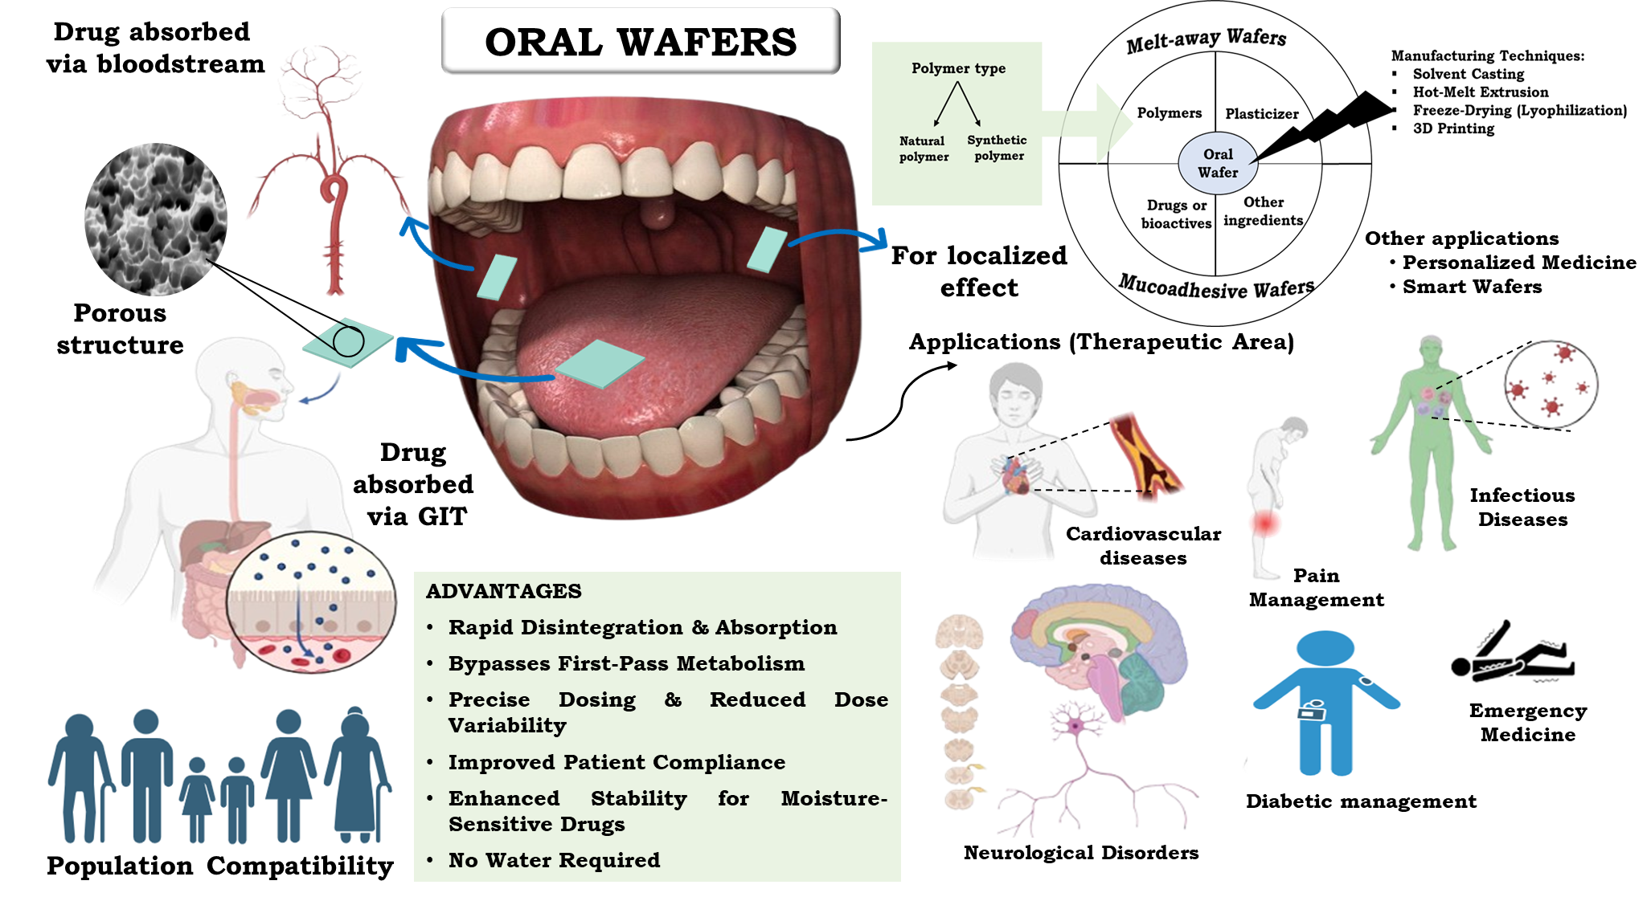

1. INTRODUCTION

Over the years, drug delivery system has significantly evolved, transitioning from conventional solid dosage forms to more patient-centric alternatives [1]. Amongst such novel alternatives, oral wafer technology is an emerging innovation and a next-generation drug delivery system, designed to enhance therapeutic efficacy by utilizing rapidly dissolving films that promote quick absorption, leading to improved bioavailability and better therapeutic outcomes.

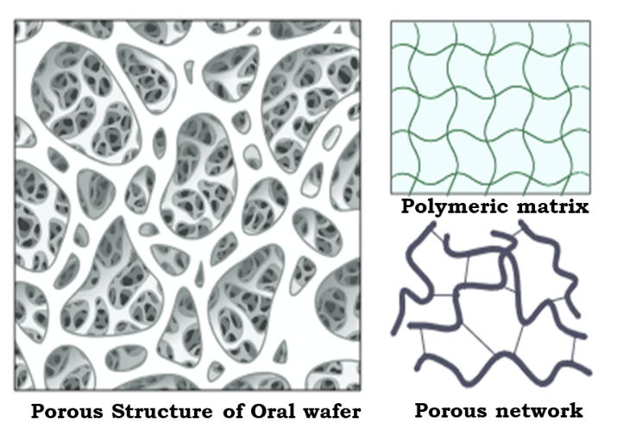Oral wafers are thin, flexible and rapidly disintegrating formulations for oral delivery of active pharmaceutical ingredients (APIs). Formulated from hydrophilic polymers, they disintegrate promptly in saliva without the need for water, ensuring effective drug absorption by oral mucosa. Additionally, these wafers provide for simple administration making them extremely desirable for pediatric, geriatric and dysphagic patients with impaired ability to swallow conventional solid dosage forms [2]. Structurally, Oral wafers are characterised by their porous nature, (as depicted in Figure 1) that has a marked effect on drug delivery properties. Micro-scale and nano-scale pores enhance disintegration by providing more surface area to act with saliva. The wafer matrix, often composed of polymers such as hydroxypropyl methylcellulose (HPMC), polyvinyl alcohol (PVA), or sodium alginate, provides strength and facilitates rapid dissolution of formulation in saliva. And the porous network in the matrix facilitates salivary penetration, providing faster hydration and eventually drug release. Besides, the drug may be uniformly distributed in the wafer or encapsulated within nanoparticles or lipid carriers dispersed within the porous matrix to modify the release profile. The porous nature also allows for a quick onset of action thereby enhanced bioavailability and enhanced patient compliance, and hence oral wafers become a viable choice in comparison to traditional solid dosage forms [3].

**Figure 1: Porous polymeric matrix structure. The left section illustrates a 3D porous network, while the right section depicts schematic representations of the polymeric matrix organization**

Clinical surveys have shown that about 8% of patients miss doses and 4% abandon therapy due to challenges to swallow solid dosage forms. Moreover, patient distaste for injectable drugs further restricts compliance [2]. In addition, oral wafers provide an innovative solution by enabling drug delivery through the oral mucosa, which helps in bypassing first-pass metabolism and preventing gastric degradation of the drug [4]. Thereby, allowing these formulations to offer rapid onset of action and improved drug absorption. However, drug absorption via oral wafers depends on multiple physicochemical factors, including molecular size, enzymatic stability, hydrophobicity and the specific site of drug delivery within the oral cavity [5][6]. FDA suggests, any type of orodispersible films must be weigh up to 500 mg and breakdown within 30 seconds. Among them, wafers are highly porous solid matrix, obtained with the help of freeze-drying of polymer gels or suspensions, usually between 3 mm in thickness and 9×12 mm in dimension [2][6].

Another advantage of oral wafers lies in their precise dosing capability, ensuring consistent drug delivery with minimal risk of dose variation. Unlike liquid formulations, which may require careful measurement of dose, wafers provide a pre-measured dose that eliminates dosing errors, further enhancing treatment efficacy. Their thin, flexible, and lightweight nature also makes them highly convenient to store and transport, reducing the risk of breakage associated with conventional solid dosage forms [5][7]. Furthermore, they offer superior stability for moisture-sensitive drugs, particularly lyophilized wafers, which contain lower moisture content compared to oral films and are less susceptible to microbial contamination.

The porous structure of oral wafers allows for enhanced drug loading, which is particularly beneficial for poorly water-soluble drugs that require improved dissolution properties. Additionally, by incorporating taste-masking agents, flavour enhancers, and mucoadhesive polymers, wafers can be formulated to improve patient acceptance, ensuring better adherence to prescribed therapy. Their potential for customized drug release profiles—ranging from immediate to sustained release—further adds to their versatility across various therapeutic applications [8].

Despite these advantages, oral wafers do present some challenges. Their formulation requires careful optimization to balance mechanical strength with rapid disintegration, as an excessively brittle or flexible structure may affect handling and packaging. The cost of manufacturing, particularly for lyophilized wafers, is relatively higher than traditional tablet compression methods, potentially limiting widespread commercial adoption. Furthermore, some drugs may have poor permeability through the oral mucosa, reducing their effectiveness when delivered via this route. Stability concerns related to environmental factors such as humidity and temperature also require specialized packaging solutions to maintain product integrity.[9][10]

Overall, the numerous advantages of oral wafers, ranging from improved patient compliance and bioavailability to enhanced stability and precise dosing make them a valuable alternative to traditional oral drug delivery systems. While certain formulation and manufacturing challenges exist, continued advancements in pharmaceutical technology are likely to further optimize this dosage form, expanding its potential across a wide range of therapeutic areas. Given their numerous benefits and the limited availability of comprehensive reviews on wafer-based drug delivery systems, this paper aims to explore their formulation strategies, production methods and critical evaluation parameters, highlighting their potential to revolutionize modern pharmaceutical therapeutics.

* 1. **Historical Evolution of Fast-Dissolving Drug Delivery Systems**

The history of fast-dissolving drug delivery systems goes back to the early 20th century, with initial breakthroughs in the forms of sublingual and buccal tablets that provide drugs for quick absorption. Nonetheless, major breakthroughs in polymer science and production technologies during the late 20th and early 21st centuries resulted in the development of oral wafers as a separate and improved option. The initial commercial oral wafers appeared in the early 2000s based on the requirement for non-invasive, patient-compliant drug delivery. From then on, the technology developed with advances in formulation, integrity of the film, and techniques for incorporating drugs, resulting in extensive applications in diverse therapeutic areas [11]. Figure 2, represents the flow of the major breakthroughs leading to technological advancement in formulation development.

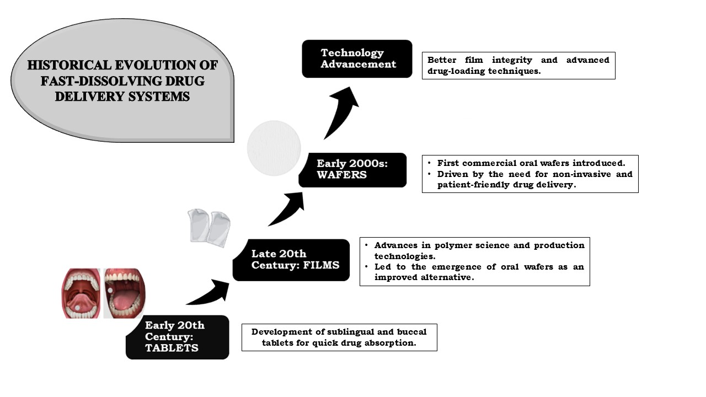

**Figure 2: Historical Evolution of Fast-Dissolving Drug Delivery Systems. The diagram illustrates the transition from sublingual and buccal tablets to films and wafers, highlighting technological advancements in drug delivery.**

* 1. **Mechanism of Drug Release from Oral Wafers**

Release of drugs from oral wafers is a multifaceted process, which involves hydration, swelling and disintegration upon exposure to saliva, represented in Figure 3. Hydrophilic polymers take in water, swell, and dissolve, promoting the drug for quick dissolution. Based on formulation, the drug release might be through diffusion from the polymer matrix, film erosion, or through ion-exchange processes. Mucoadhesive polymers enable extended retention of drugs and controlled delivery through the buccal mucosa without first-pass metabolism. In certain instances, enzymatic erosion of bioerodible polymers controls drug release. A few important parameters like type and concentration of polymer, drug solubility, pH of saliva, film thickness, and inclusion of plasticizers or permeation enhancers control the release pattern. The drug is then absorbed via sublingual, buccal, or gastrointestinal pathways to either provide a quick onset or a prolonged effect, depending on the design of the formulation [12][13].

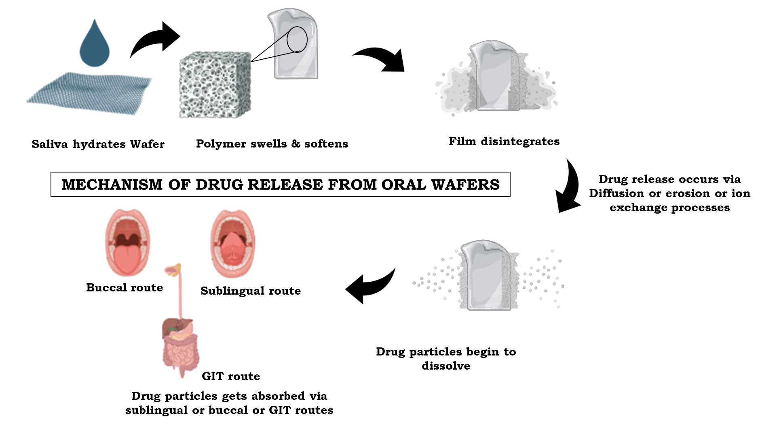

**Figure 3: Mechanism of Drug Release from Fast-Dissolving Films. The schematic illustrates the hydration, disintegration, and drug release process, along with the possible routes of drug absorption through buccal, sublingual, and gastrointestinal pathways.**

* 1. **Clinical Relevance and Market Potential**

Oral wafers have obtained regulatory acceptance for a number of different therapeutic uses, such as antiemetics, painkillers, and central nervous system drugs. Owing to the increasing need for patient-friendly formulations, the oral wafers market is poised to grow substantially in the future.[6]

1. TYPES OF ORAL WAFERS

Oral wafers are a flexible and cutting-edge drug delivery solution, with several different release profiles for a variety of therapeutic applications. Oral wafers, depending on their mechanism of action and formulation, fall into distinct categories, each formulated to maximize drug effectiveness, increase patient compliance and treat various medical conditions [14][15]. The major categories of oral wafers are differentiated in Table 1.

* 1. **Fast-Dissolving Oral Wafers (FDOWs) or Flash release Oral wafers**

Fast-dissolving oral wafers or Flash release oral wafers are formulated to rapidly disintegrate when in contact with saliva, enabling swift release and absorption of the drug. The wafers are well suited for dysphagic, geriatric and pediatric populations that face challenges in swallowing standard tablets or capsules. The rapid dissolution property avoids the requirement of water, rendering FDOWs a quick administration option when needed on-the-go. FDOWs are usually made up of water-soluble polymers like hydroxypropyl methylcellulose (HPMC), Pullulan, polyvinyl alcohol (PVA) or maltodextrins, which allow for rapid disintegration and drug dispersion. Super disintegrants like crospovidone, sodium starch glycolate, and croscarmellose sodium are also incorporated to further enhance the dissolution rate. Porosity of the wafer matrix is also responsible for improving dissolution so that the active pharmaceutical ingredient (API) is released effectively for local or systemic absorption. These wafers are commonly used for conditions requiring immediate therapeutic action, such as pain management (e.g., analgesics), allergy relief (e.g., antihistamines), and nausea treatment (e.g., antiemetics). The ability of FDOWs to deliver medication rapidly makes them ideal for emergency use or situations where quick onset of action is critical.

**Advantages**

* Provides a rapid onset of action, which is beneficial for drugs requiring immediate therapeutic effects.
* Eliminates the need for water, making it suitable for patients with dysphagia or restricted water intake.
* Improves bioavailability by bypassing hepatic first-pass metabolism.
* Convenient and easy to administer, especially for pediatric and geriatric populations [16].
  1. **Mucoadhesive Oral Wafers**

Mucoadhesive oral wafers are formulated to stick to the oral mucosa, maintaining extended drug retention in the site of administration. Mucoadhesive wafers take advantage of bio adhesion processes, in which polymeric excipients establish physical and chemical bonds with mucosal surfaces. Adhering to the buccal or sublingual mucosa, these wafers release the drug in a sustained manner and enhance bioavailability, avoiding first-pass metabolism by the liver. Mucoadhesive wafers are prepared using bioadhesive polymers like chitosan, carbopol, and sodium alginate, which provide increased adhesion. Slow release of the drug provides extended therapeutic action, and these wafers are ideal for chronic diseases where there is a need for sustained levels of medication, e.g., hormone therapy, cardiovascular agents, and anti-inflammatory drugs. The advantages of mucoadhesive wafers are decreased dosing frequency, localized action of the drug, and decreased side effects at the systemic level. Mucoadhesive wafers are particularly useful for managing oral and systemic infections, relief from pain, and mucosal diseases, in which direct contact with the involved area for extended periods is helpful [17].

**Advantages**

* Provides prolonged drug release, reducing dosing frequency and improving patient adherence.
* Ensures controlled absorption with minimal drug fluctuations in the bloodstream.
* Can be used for both systemic and localized drug delivery.
* Bypasses first-pass metabolism, leading to better drug bioavailability [18].
  1. **Mucoadhesive Melt-Away Wafers**

Mucoadhesive melt-away wafers are designed to adhere to the oral mucosa for a short period before dissolving completely. Unlike flash-release films, these wafers remain in place long enough to ensure localized drug absorption, enhancing bioavailability while avoiding gastrointestinal degradation.

These wafers work by forming a bioadhesive interaction between the polymer and mucosal tissue, allowing sustained drug absorption before they dissolve completely. These wafers typically contain mucoadhesive polymers, such as:

* Sodium carboxymethylcellulose (NaCMC)
* Polyacrylic acid
* Chitosan
* Hydroxypropyl cellulose (HPC)

Plasticizers like glycerine or polyethylene glycol (PEG) are added to improve film flexibility, while penetration enhancers like bile salts may be incorporated to increase drug absorption through the mucosal tissue. Taste-masking agents and flavour enhancers are also typically used to enhance palatability and provide a smoother experience for the patient [19].

**Advantages**

* Ensures effective drug absorption through the oral mucosa, reducing drug loss in the gastrointestinal tract.
* Bypasses first-pass metabolism, leading to higher systemic drug availability.
* Provides prolonged retention in the oral cavity, making it suitable for drugs requiring enhanced absorption.
* Can be formulated for local action, such as in treating oral infections or inflammation.

**Table 1. Overview of types of oral wafer Based on Composition and Application** [20]

|  |  |  |  |
| --- | --- | --- | --- |
| **PARAMETER** | **TYPES OF ORAL WAFER** | | |
| **Flash release wafer** | **Mucoadhesive melt-away wafer** | **Mucoadhesive release wafer** |
| **Area** | 2 – 8 cm² | 2 – 7 cm² | 2 – 4 cm² |
| **Thickness** | 20–70 µm | 50 – 500 µm | 50 – 250 µm |
| **Cross-sectional structure** | Single layer thin film | Single or multi-layer film | Multi-layer film |
| **Type of polymer** | Water soluble polymers | Water soluble polymers | Mucoadhesive polymers |
| **Application** | Placed on tongue in oral cavity | Buccal or gingival cavity | Buccal or gingival cavity |
| **Disintegration time** | <60secs | 1-2 minutes | ~8 to 10 hours |

1. FORMULATION INGREDIENTS AND ITS FUNCTIONS

Oral wafer formulations need a careful balance of excipients to achieve optimal drug delivery, mechanical integrity, and patient compliance [21]. Each ingredient plays an important role in setting the wafer's disintegration rate, drug release profile, and effectiveness. This section discusses the major formulation ingredients and their contributions to oral wafer technology.

Table 2. Compositional requirements of Oral wafers [22]

|  |  |  |
| --- | --- | --- |
| **Sl.NO** | **INGREDIENTS** | **AMOUNT (w/w)** |
| 1 | Active Agent (API) | 5-30% |
| 2 | Hydrophilic Polymer(s) | 45%-50% |
| 3 | Plasticizer | 5-20% |
| 4 | Saliva Stimulating Agent | 2-6% |
| 5 | Surfactant | If needed |
| 6 | Sweetening Agent | 3-6% |
| 7 | Flavors, Colours, Fillers | If needed |

* 1. **Polymers for Film Formation**

Polymers are the structural backbone of oral wafers, determining their mechanical properties, dissolution characteristics, and mucoadhesive potential. The selection of polymer determines the disintegration time, drug-loading capacity, and stability of the wafer.

**Natural Polymers:** Natural polymers are biocompatible, biodegradable, and frequently obtained from plant or animal origins. They exhibit superior film-forming properties and improve the safety profile of oral wafers [23].

* **Sodium Alginate:** From brown seaweed, sodium alginate produces gel films with satisfactory mucoadhesive characteristics, which is appropriate for sustained-release wafers.
* **Gelatin:** A protein polymer that produces smooth, flexible wafers with fast-dissolving characteristics.
* **Pullulan:** A polysaccharide that produces transparent, flexible films with satisfactory oxygen barrier characteristics, maintaining drug stability.
* **Pectin:** Pectin is derived from fruit peels and contributes to mucoadhesive and controlled-release preparations [24].

**Synthetic Polymers:** Synthetic polymers provide improved mechanical strength, targeted drug release, and greater reproducibility over natural counterparts.

* **Hydroxypropyl Methylcellulose (HPMC):** One of the most commonly used cellulose derivatives with superior film-forming and targeted drug release characteristics.
* **Polyvinyl Alcohol (PVA):** With its mechanical strength and water solubility, PVA increases oral wafers' flexibility.
* **Sodium Carboxymethylcellulose (NaCMC):** Water-soluble polymer that enhances mucoadhesion and targeted drug release. [24][25]
  1. **Plasticizers**

Plasticizers are critical excipients that enhance the elasticity, flexibility, and mechanical strength of oral wafers. Without plasticizers, wafers would be brittle and crackable, minimizing their usability in pharmaceutical applications. Role of plasticizer in film formation decrease intermolecular forces among polymer chains, increasing film flexibility and decreasing fragility. They enhance the mechanical strength of the wafers to maintain their integrity during handling and administration. By adjusting the glass transition temperature (Tg) of the polymer, plasticizers control disintegration and drug release rates.

**Typical Plasticizers**

**Glycerol:** Moisturizes but can add to the water content.

**Polyethylene Glycol (PEG):** Varies in molecular weight, PEG has a combination of flexibility and stability.

**Propylene Glycol:** Softens the film and improves mechanical strength without holding too much moisture.[26][27]

* 1. **Drug Incorporation Strategies**

Effective drug loading in the wafer matrix provides even distribution, stability, and bioavailability. The selection of the drug-loading method is based on the drug's physicochemical characteristics.

1. **Direct Drug Dispersion in Polymer Matrix (Solid dispersion):** The most uncomplicated approach is the direct dissolution or dispersion of the drug in the polymer solution prior to casting or lyophilization. Appropriate for water-soluble drugs that don't need sophisticated solubilization methods.[28]
2. **Application of Drug-Loaded Nanoparticles/Liposomes:** Nanoparticles and liposomes enhance solubility and bioavailability of drugs with low water solubility. Such carriers shield vulnerable APIs from decomposition and increase mucosal penetration. Liposomes imitate biologic membranes to improve absorption across the oral mucosa. [29][30][31]
   1. **Flavouring Agents and Sweeteners**

Flavour is very important to patient acceptance, especially in children and the elderly. Sweetening agents and flavouring agents suppress bitterness of active compounds and promote patient satisfaction overall.

**Natural vs. Artificial Sweeteners**

**Natural Sweeteners:** They include sucrose, fructose, and stevia. These are used owing to their safety profile and lesser aftertaste.

**Artificial Sweeteners:** Aspartame, sucralose, and saccharin are examples. These offer a high-intensity sweet taste with less caloric effect but are liable to create an aftertaste. [32]

**Role in Patient Acceptability and Compliance**

* Increases the palatability, thus improving the acceptability of the wafer.
* Lowers bitterness, hence improving the patient compliance as well as with the therapy.
* Enables formulation personalization according to patient preference and therapeutic requirements. [33]
  1. **Surfactants and Penetration Enhancers**

Surfactants and penetration enhancers are important in enhancing the solubility, absorption, and bioavailability of drugs, especially poorly soluble drugs.

**Function in Drug Dissolution and Absorption:** Surfactants decrease surface tension to improve drug dispersion and solubility in saliva.

Penetration enhancers ease the passage of drugs through mucosal membranes through the modification of lipid bilayer permeability or the disruption of tight junctions. [34]

**Examples of Surfactants and Penetration Enhancers**

**Poloxamers:** Amphiphilic copolymers with enhanced drug solubilization and mucosal permeability enhancement.

**Tween 80 (Polysorbate 80):** A non-ionic surfactant that enhances dispersion and wettability of the drug.

**Bile Salts:** Natural surfactants, which enhance the absorption of a drug by emulsifying the lipophilic drug and causing disruption of the mucosal barriers. [34][35]

* 1. **Colouring Agents**

Colouring agents are employed to improve the oral aesthetic value and distinguish between products. The most widely used colorants are:

* Pigments: Give intense, stable colour. Example: Titanium dioxide, a general-purpose white pigment.
* FD&C Approved Colorants: They are synthetic dyes approved by the FDA for food, pharmaceuticals, and cosmetics. They provide safety and consistency to colouring.
* Natural Colorants: Plant, mineral, or animal-derived. Beetroot extract (red), turmeric (yellow), and spirulina (blue-green) are examples.
* Custom Pantone-Matched Colours: Employed to preserve brand-specific or proprietary colour shades for enhanced product identity.

**Advantages**

* Improves the aesthetic value of wafers, enhancing patient acceptance.
* Facilitates brand identification and differentiation.
* Can signal the presence of active ingredients (e.g., iron supplements tend to be red).
* Natural colorants can have additional health benefits. [36]
  1. **Saliva Stimulating Agents**

Saliva stimulating agents are employed for the improvement of saliva production, to assist in the speedy breakdown of oral wafers. They are normally incorporated at a strength of 2-6% (w/w).

**Types of Saliva Stimulating Agents:**

**Sweeteners:** Fructose, Xylose, Maltose.

**Flavouring Agents:** Peppermint & Cinnamon, Nutmeg & Vanilla, Cocoa & Coffee, Apple & Cherry. [37]

* 1. **Thickening Agents**

Thickening agents enhance the viscosity and consistency of the solution prior to casting of oral wafers, allowing uniform distribution of active ingredients. They are generally applied at 5% (w/w) concentration.

**Common Thickening Agents:**

**Gums:** Xanthan gum, Guar gum, Locust bean gum, Carrageenan

**Cellulosic Derivatives:** Hydroxypropyl Methylcellulose (HPMC), Carboxymethyl Cellulose (CMC), Methylcellulose. [38]

1. ORAL WAFERS MANUFACTURING TECHNOLOGIES

Oral wafers represent a novel drug delivery system that facilitates quick release and absorption of drugs. Multiple manufacturing methods have been explored to make oral wafers with the desired uniform distribution of drugs, mechanical strength, and release profiles. This section discusses the major manufacturing technologies employed in oral wafers, their benefits, limitations, and comparison.[39][40]

* 1. **Solvent Casting Method**

The solvent casting technique is one of the most common methods of preparing oral wafers because it is easy and can be employed for heat-sensitive drugs. It is a technique where the film-forming polymer is dissolved in an appropriate solvent, and the drug and other additives are added to it, which is then cast onto a flat surface and dried.[39][41][42]

**Methodology**

The method starts with the dissolution of a polymer like hydroxypropyl methylcellulose (HPMC), polyvinyl alcohol (PVA), or sodium carboxymethyl cellulose (NaCMC) in a solvent like water or ethanol. Plasticizers like glycerol or polyethylene glycol (PEG) are incorporated to enhance film pliability and avoid brittleness. The active pharmaceutical ingredient (API) is dissolved or homogeneously dispersed into the polymer solution. The homogeneous solution is cast onto an un-stick surface such as a Teflon plate or Petri dish. Under controlled temperature conditions, the solvent is evaporated to create a thin film, which is removed by peeling off, cut to the desired shape, and packaged in moisture-resistant containers. Figure 4, represents the methodology of solvent casting process.[43]

**Process Parameters that Affect the Quality of the Film**

* **Polymer Concentration:** Increased polymer concentration thickens the film and increases tensile strength but can retard disintegration.
* **Solvent Type and Evaporation Rate:** Solvent selection influences film homogeneity and drug distribution. High evaporation rates can lead to film brittleness and non-uniformity.
* **Drying Temperature and Time:** Elevated drying temperatures can lead to shrinkage and impact drug stability, while insufficient drying can result in residual solvent in the film.
* **Plasticizer Concentration:** Insufficient plasticizer results in brittle films, while too much plasticizer can result in excessive film softness and tackiness

**Advantages**

* Easy and inexpensive method.
* Ideal for heat-labile drugs.
* 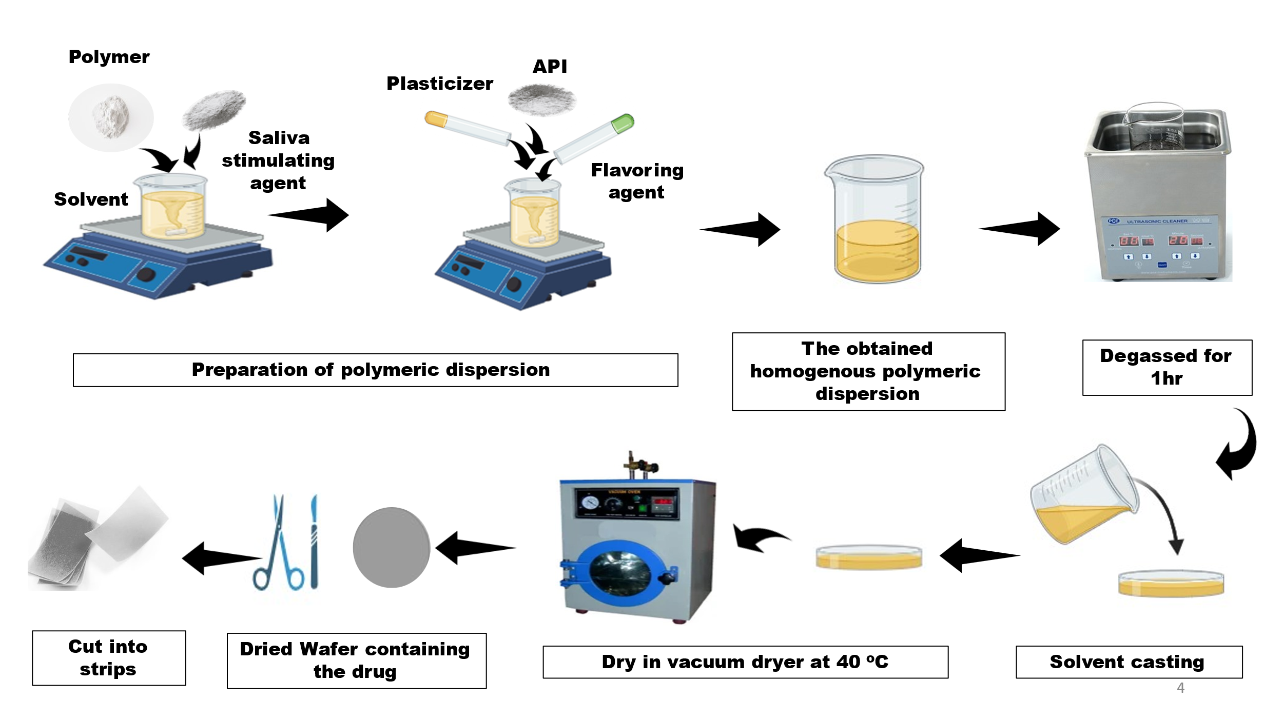Facilitates homogeneous distribution of drug within the film. [41]

**Figure 4: Oral Wafer Preparation by solvent Casting Method**

* 1. **Hot Melt Extrusion (HME) Process**

Hot melt extrusion (HME) is a solventless, continuous process that has found widespread application in pharmaceuticals. It enhances drug solubility and offers greater mechanical strength to the films than solvent casting. It demands exact temperature control to avoid drug degradation, though. During this process, the active pharmaceutical ingredient (API) is mixed with film-forming polymers like polyvinyl alcohol (PVA) or hydroxypropyl cellulose (HPC) in powder form. The blend is processed in a twin-screw extruder, where it is heated and mechanically sheared to create a molten mass. This molten mass is then extruded through a flat die to create a thin film. The extruded film is quenched quickly to solidify it prior to being cut to the desired size and stored under controlled conditions [44][45][46]. Figure 5, represents the methodology of HME process.

**Process Parameters Affecting Film Quality**

* **Extrusion Temperature:** Should be optimized to avoid drug degradation while ensuring good polymer melting.
* **Screw Speed and Shear Rate:** Increased speeds enhance mixing but may lead to excessive heat generation.
* **Polymer Type and Molecular Weight:** Controls the viscosity and mechanical properties of the film.
* **Plasticizer and Drug Loading:** High drug loading may influence film integrity, whereas improper plasticizer levels can result in stickiness or brittleness.

**Advantages**

* Does not require solvents, thus is eco-friendly.
* Offers enhanced mechanical strength and stability.
* 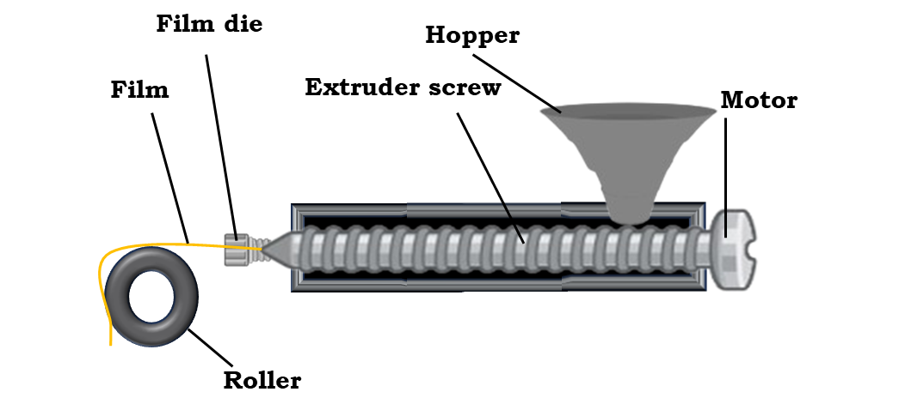Ideal for enhancing drug solubility and bioavailability. [47]

**Figure 5: Oral Wafer Preparation by Hot Melt Extrusion (HME) Method**

* 1. **Rolling Method**

The rolling process is a cost-effective and scalable method for mass production of oral wafers. It is a process of spreading a drug-polymer blend between mechanical rollers to create a uniform thin film.

**Methodology**

A uniform mixture of film-forming polymers, API, plasticizers, and other excipients is formed. This mixture is passed between two rollers, which spread it continuously into a thin film of uniform thickness. The film is then dried under controlled conditions to evaporate any residual solvents. The film is then peeled off, cut to the required shape, and packed. Figure 6, represents the methodology of rolling technique.[43]

**Process Parameters Affecting Film Quality**

* **Roller Speed and Pressure:** Need to be regulated in order to maintain uniform thickness and avoid film rupture.
* **Polymer Viscosity:** Impacts spreading ease and film integrity.
* **Drying Conditions:** Need to be optimized in order to avoid solvent entrapment while retaining film flexibility.
* **Film Thickness Control:** Impacts disintegration time and drug release profile.

**Advantages**

* Compatible with mass production.
* Yields films of uniform thickness and drug content.
* 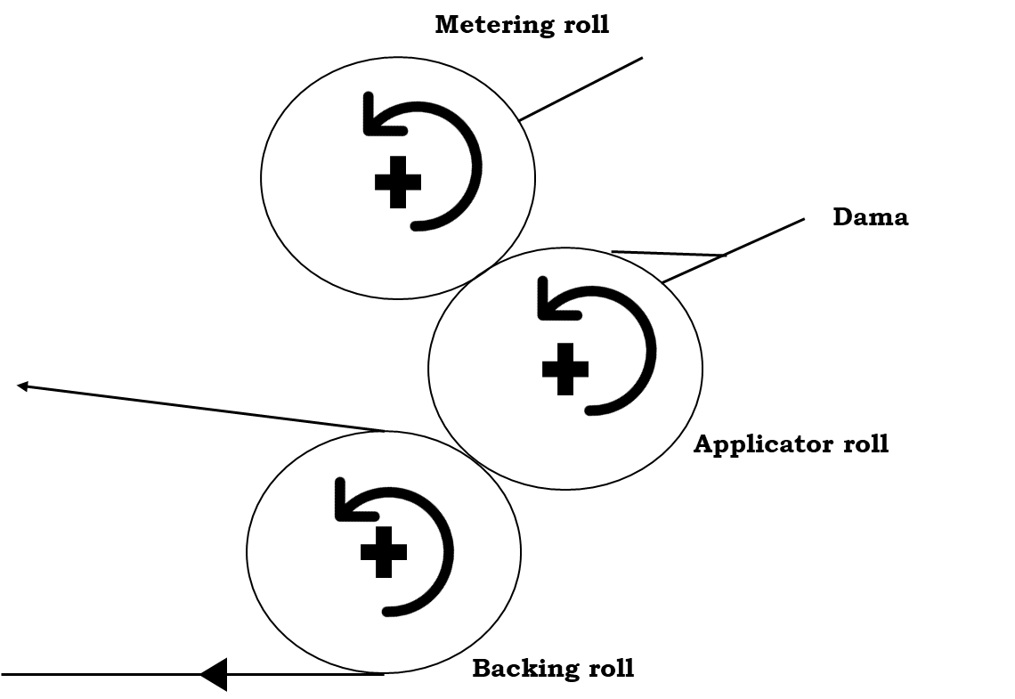Fewer solvent-related problems than solvent casting.[48]

**Figure 6: Oral Wafer Preparation by Rolling Method**

* 1. **Freeze-Drying (Lyophilization) Method**

Freeze drying is a specific method for the preparation of highly porous, rapidly dissolving wafers. It finds application in the case of heat-sensitive drugs which need to disintegrate fast in the mouth.

**Methodology**

The solution of active pharmaceutical ingredient, film-forming polymers (gelatin or polyvinylpyrrolidone), and other excipients is filled into moulds. These moulds are immediately frozen at very low temperatures (-40°C or lower) to solidify the liquid. The frozen substance is subjected to a vacuum chamber where sublimation is done, removing water content without going through the liquid state. Porous wafers resulting from the above process are cut and packed in a way that protects them from moisture. Figure 7, represents the methodology of lyophilization process.[43]

**Process Parameters Affecting Film Quality**

* **Rate of Freezing:** Higher freezing rate results in finer ice crystals and improved film porosity.
* **Vacuum Pressure:** Controls the rate of sublimation efficiency and the total drying time.
* **Primary and Secondary Drying Temperature:** Need to be properly controlled to avoid folding up of the film structure.
* **Moisture Content:** Can impact drug stability and shelf life.

**Advantages**

* Creates highly porous and fast-dissolving wafers.
* Improves drug stability by eliminating moisture.
* Ideal for thermally sensitive drugs.[49]

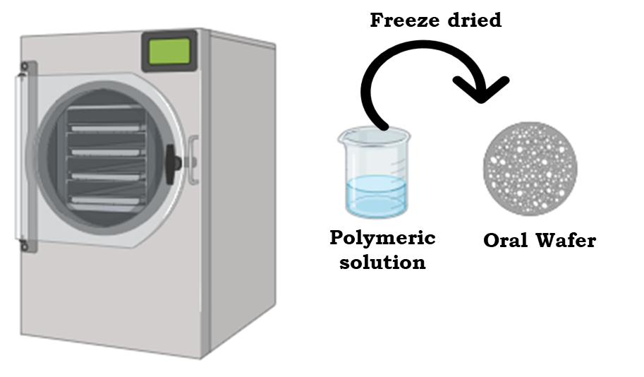

**Figure 7: Oral Wafer Preparation by Freeze-Drying (Lyophilization) Method**

* 1. **Comparative Analysis of Techniques**

All of the above manufacturing methods have their own advantages and disadvantages, making them appropriate for various applications in oral wafer manufacture and a comparative analysis of the techniques is given in the Table 3.

Table 3. Comparative analysis of oral preparation methods [50]

|  |  |  |  |  |
| --- | --- | --- | --- | --- |
| **METHOD** | **SOLVENT CASTING** | **HOT MELT EXTRUSION** | **ROLLING METHOD** | **FREEZE DRYING** |
| **Solvent requirement** | Requires solvent | Solvent-free | Minimal solvent | Water-based solution |
| **Drug distribution** | Uniform | Requires optimization | Uniform | Uniform |
| **Temperature sensitivity** | Suitable for heat-sensitive drugs | Not suitable for heat-sensitive drugs | Suitable | Best for heat-sensitive drugs |
| **Mechanical strength** | Moderate | High | High | Low |
| **Scalability** | Moderate | High | High | Low |
| **Disintegration speed** | Moderate to fast | Moderate | Moderate | Very fast |

1. QUALITY CONTROL AND EVALUATION PARAMETERS OF ORAL WAFERS

The quality and performance of oral wafers need to be evaluated by strict testing under different physicochemical, mechanical, drug release, and stability studies. The parameters decide the efficacy, safety, and stability of the product.[51]

* 1. **Physicochemical Characterization**
* **Thickness:** Regular thickness is crucial for homogenous drug content and mechanical durability. The thickness of the wafer is measured at various locations by a digital micrometre or Vernier calliper.
* **Weight Uniformity:** Random samples of wafers are taken from a batch, individually weighed, and compared against the average weight. This will confirm homogeneity of drug loading.
* **Surface pH:** The surface pH must be near the physiological pH of saliva (6.5–7.5) to avoid irritation. The wafer is immersed in distilled water, and the pH is determined by a pH meter to confirm patient compliance and preclude mucosal irritation.
* **Moisture Content:** Defines the flexibility and stability of the wafer. High moisture content can influence mechanical properties and microbial stability. Moisture content is measured by Karl Fischer titration or thermogravimetric analysis.
* **Hygroscopicity:** Quantifies the capacity of the wafer to take up moisture from the surroundings, which can impact disintegration and drug stability. The wafer is subjected to controlled humidity conditions, and weight gain is measured.[52][53][54]
  1. **Mechanical Properties**
* **Tensile Strength:** Quantifies the wafer's resistance to stress without fracture. A texture analyzer or universal testing machine is employed to exert a force until the wafer fractures. Good tensile strength guarantees durability on handling and administration.
* **Folding Endurance**: Quantifies flexibility and resistance to fracture on repeated folding. A wafer is folded repeatedly at one point until it fractures; the greater the number of folds, the better the mechanical strength.
* **Influence of Polymer Type on Mechanical Characteristics:** Polymer selection has a strong impact on mechanical characteristics. Hydrophilic polymers (e.g., HPMC, NaCMC, PVA) increase flexibility and fast dissolution, whereas hydrophobic polymers (e.g., ethyl cellulose) can exhibit sustained release but decrease mechanical strength. Plasticizers such as glycerol or PEG enhance flexibility through weakening intermolecular forces within the polymer matrix.[53][54]
  1. **Drug Release Studies**

***In-vitro* Disintegration and Dissolution Testing**

* **Disintegration Time:** Tests the rate at which the wafer disintegrates in the oral cavity. The film is submerged in simulated saliva or phosphate buffer, and the time to total disintegration is measured.
* **Dissolution Testing:** Tests the rate and extent of release of the drug. The dissolution apparatus (USP Type I or II) with simulated saliva or buffer solution is used, and samples are assayed spectrophotometrically to determine drug release.[55][56]

1. **Stability Studies**

* **Short-Term and Long-Term Stability:** Wafers are placed under different conditions (e.g., 25°C/60% RH and 40°C/75% RH) for different times to determine drug content, physical appearance, and moisture absorption.
* **Photostability Testing:** Guarantees wafers retain their potency upon exposure to light in order to avoid degradation of light-sensitive drugs.
* **Packaging Considerations:** Wafers are generally packaged in moisture-resistant packaging (aluminium foil pouches) to avoid degradation as a result of exposure to the environment.[57]

1. **In Vivo Studies**

**Importance of In Vivo Studies**

Preclinical in vivo studies are essential to understanding the pharmacokinetics (PK) and pharmacodynamics (PD) of drug formulations before clinical trials. Oral wafer formulations undergo rigorous animal testing to assess drug release, absorption, bioavailability, and systemic circulation. These studies provide critical insights into the effectiveness of the formulation, ensuring that the active pharmaceutical ingredient (API) is efficiently delivered, absorbed, and metabolized before progressing to human trials.

Animal models, including rats, rabbits, and dogs, are commonly used to evaluate the disintegration time, drug release profile, and systemic absorption of oral wafers. Key parameters measured in these studies include:

* Disintegration time: Evaluates the rapid breakdown of wafers in the oral cavity.
* Dissolution and absorption profile: Determines the rate at which the drug is released and enters the bloodstream.
* Mucosal adhesion and retention time: Assesses how well mucoadhesive wafers adhere to oral tissues, ensuring sustained drug release.
* Bioavailability studies: Compare systemic drug absorption in oral wafers versus traditional dosage forms.[58]

Recent preclinical studies have demonstrated the efficacy of oral wafers in improving drug bioavailability and patient compliance. For instance:

* **Case study 1:** Fentanyl, a potent opioid analgesic, was formulated as a sublingual wafer using a freeze-drying technique to enhance bioavailability and ensure rapid pain relief. The formulation, containing sodium carboxymethylcellulose and amylogum as matrix formers, was evaluated for uniformity, dissolution rate, and structural properties using SEM and XRD. In vitro studies showed that 90% of the drug dissolved within a minute, while in vivo pharmacokinetic analysis in 11 opioid-naïve female patients revealed detectable plasma levels within 3.5 minutes, with peak concentration occurring between 61.5 and 67 minutes. The wafer demonstrated a median absolute bioavailability of 53%, highlighting its potential as a fast-acting sublingual pain management option. [59]
* **Case study 2**: Another study focused on the development of an ultra-fast disintegrating wafer (U-D-WAF) loaded with diphenhydramine hydrochloride (DPH) for rapid Oro-mucosal drug delivery. A blend of hydroxypropyl cellulose, poly(acrylic) acid, sodium starch glycolate, and beta-cyclodextrin was optimized using a Box-Behnken experimental design. The formulation achieved a mean drug entrapment efficiency of 72.96%, with disintegration occurring in 29.33 seconds and 86.32% of the drug being released within 60 seconds. Ex vivo permeation studies confirmed rapid drug absorption through buccal tissue, and in vivo evaluation in the Large White Pig model showed a Cmax of 59 mg/L within 300 seconds, confirming the wafer's suitability for immediate symptom relief through Oro-mucosal absorption. [60]
* **Case study 3:** Berberine-loaded wafers were designed for the treatment of chemotherapy-induced oral mucositis using lyophilized hydrogels containing chitosan/sodium alginate (CS-SA) and chitosan/hydroxypropyl methylcellulose (CS-HPMC). These formulations exhibited sustained drug release, excellent mucoadhesion, and a porous structure as confirmed by SEM analysis. XRD and FTIR studies indicated that berberine was incorporated in an amorphous form, improving solubility and bioavailability. In vivo evaluation in a 5-Fluorouracil-induced oral mucositis rat model demonstrated that the optimized wafers significantly reduced mucositis severity and inflammatory marker expression (TNF-α and IL-1β). The findings suggest that berberine-loaded wafers could provide an effective localized treatment for chemotherapy-related oral mucositis, enhancing therapeutic outcomes while minimizing systemic side effects. [61]

These case studies illustrate the advancements in oral wafer formulations, demonstrating their potential in achieving rapid drug delivery, improved patient compliance, and enhanced therapeutic efficacy across various medical applications.

1. RECENT PROGRESS IN ORAL WAFER TECHNOLOGY

Recent advancements in oral wafer technology have focused on enhancing drug solubility, prolonging retention at the absorption site, optimizing formulations. These innovations collectively aim to improve therapeutic outcomes and patient compliance.

There has been notable progress in oral wafer technology in the last few years, especially in drug delivery systems. The innovations have improved the solubility of drugs, increased patient compliance, and facilitated personalized medication strategies. This section discusses some of the most important developments in the field.

**Nanotechnology-Integrated Oral Wafers**

Nanotechnology has transformed oral wafer technology through enhanced drug solubility and bioavailability. A majority of drugs have poor aqueous solubility, which results in poor absorption and under optimal therapeutic effects. The use of drug nanoparticles in oral wafers solves this problem.[62] [63] [64]

**Application of Drug Nanoparticles for Enhanced Solubility**

* Nanoparticles enhance the surface area of the drug, thereby increasing its dissolution rate.
* They enable easier penetration of the drug through biological membranes.

**Examples-** The anti-hypertensive drug Carvedilol-loaded nano-spanlastic-based wafers are a potential solution for improving trans-buccal drug delivery effectiveness. [65]

**Mucoadhesive and Smart Polymers**

Mucoadhesive and smart polymers are highly effective in drug retention enhancement and targeted release in the oral cavity or gastrointestinal tract.

**Smart polymers for targeted release**

* Smart polymers react to stimuli in their environment like pH, temperature, or enzymes, etc.
* pH-responsive polymers release the drug in a selective manner in the stomach (acidic environment) or intestines (neutral/basic environment).
* Thermo-responsive polymers (e.g., poly(N-isopropylacrylamide)) vary drug release as a function of changing body temperatures.
* Enzyme-sensitive polymers break down according to targeted enzymes, enabling controlled release in targeted areas.[66]

Example- An example of localized drug delivery is the use of mono- and bilayer mucoadhesive films and wafers for the treatment of oral mucosal infections, ensuring prolonged retention and effective therapeutic action.[67]

**Mucoadhesive polymers for extended retention**

* Mucoadhesive wafers stick to mucosal tissues, maintaining extended drug retention and absorption.
* Examples of mucoadhesive polymers include chitosan, carbopol, and hydroxypropyl methylcellulose (HPMC).

Examples-

* Microemulsion-based mucoadhesive buccal wafers, focusing on their formulation, in vitro drug release, and ex vivo evaluation.[68]
* Berberine-loaded blended mucoadhesive wafers, designed for the treatment of chemotherapy-induced oral mucositis, with in vitro and in vivo characterization.[61]
* Mucoadhesive wafers with binary polymer blends, developed for sublingual delivery and stabilization of protein-based vaccines.[69]
* Clay-functionalized wafers and films, evaluated for their potential in nicotine replacement therapy via buccal mucosa.[70]
* An example of macromolecule delivery via oral wafers is the development of composite sodium alginate and chitosan-based buccal wafers, designed for enhanced mucoadhesion and controlled release.[71]
* An example of protein drug delivery using oral wafers is the development of lyophilized chitosan-based wafers, designed for buccal mucosal administration with optimized physico-mechanical properties.[72]

**Personalized Medicine and 3D Printing**

The development of 3D printing technology has allowed for oral wafer customization according to specific patient requirements. 3D printing provides exact control of drug dosage, release patterns, and wafer content. This follows the increasing focus on personalized medicine.

**Example of 3D-Printed Oral Wafers-**

An example of advanced oral wafer technology is the development of 3D-printed mouth-dissolving wafers using fused deposition modelling (FDM), incorporating nanostructured lipid carriers (NLCs) for controlled in vitro drug release**.**[73]

1. APPLICATIONS OF ORAL WAFERS IN VARIOUS THERAPEUTIC FIELDS

Oral wafers applications extend across several therapeutic categories, such as neurological disorders, pain relief, cardiovascular disease and antimicrobial therapy.

**Neurological Disorders:**

Neurological and psychiatric conditions tend to need long-term medication compliance, which may be difficult because of dysphagia or lack of compliance. Oral wafers provide a convenient solution by ensuring quick and consistent drug delivery with minimal effort on the part of the patient.

Example- An example of oral wafer application in neurology is the use of dissolving oral clonazepam wafers for the acute treatment of prolonged seizures, providing a rapid onset of action and ease of administration, particularly in pediatric patients. [74]

**Pain management: Opioids and NSAIDs**

Management of pain frequently requires instant relief, for which oral wafers are a perfect drug delivery platform.

Example-

* Opioids can be included in oral wafers to deliver quick analgesia for chronic pain, breakthrough cancer pain, and post-operative pain. Sublingual absorption is facilitated by these wafers, avoiding first-pass metabolism and providing greater bioavailability.
* An example of tramadol hydrochloride delivery via oral wafers is the **design, development, and characterization of Oro mucosal wafers**, formulated for rapid drug release and enhanced pain management. [67]

**Cardiovascular Drugs**

Cardiac emergencies like hypertensive emergencies, angina pectoris, and heart failure demand instant care. Oral wafers yield quick and rapid drug delivery to manage these emergent conditions.

Example-

* Antihypertensives: Various antihypertensives have been encapsulated in the form of rapid-dissolving films to accelerate blood pressure decline. These medicines are especially valuable in patients suffering from dysphagia and emergency situations needing immediate drug effects.
* An example of buccal wafer technology for cardiovascular treatment is the development and evaluation of Bucco adhesive wafers of nimodipine, designed for hypertension management with enhanced mucoadhesion and controlled drug release. [75]

**Antibiotics: Infection-Specific Formulations**

Prompt and effective drug delivery is important in the treatment of bacterial and viral infections. Oral wafers enable quick drug absorption, which leads to swift therapeutic action and prevents the development of disease.

Antibiotics loaded into wafers taken orally to make it easier for patients to stick to their medicine and have faster action. It is especially helpful in the management of pediatric and geriatric patients who have difficulties swallowing capsules or syrups.

Example- An example of antibacterial wafer technology for wound healing is the development of ciprofloxacin-loaded calcium alginate wafers, formulated using the freeze-drying technique for the potential treatment of chronic diabetic foot ulcers by providing sustained drug release and enhanced wound healing.[76]

**Antidiabetic drugs**

An antidiabetic oral wafer is a fast-dissolving film or wafer designed for the rapid and convenient delivery of antidiabetic drugs. It dissolves in the mouth without the need for water, making it ideal for patients with swallowing difficulties or those needing a quick onset of action.

Example- An example of antidiabetic oral wafer formulation is the development and evaluation of fast-dissolving oral wafers of linagliptin, designed for enhanced bioavailability and rapid onset of action, improving patient compliance in diabetes management.[77]

1. **PATENT LANDSCAPE**

The patent landscape for oral wafer drug delivery systems is evolving, with several key patents protecting formulation compositions, manufacturing methods, and novel applications.

**Key Patents:**

1. **EP2821066-** High-content fast dissolving film with masking of bitter taste comprising sildenafil as active ingredient

**Inventor:** Jeong *et al* (2015) [78]

1. **EP2883540-** Fast-dissolving oral film preparation comprising aripiprazole

**Inventor:** Kim *et al* (2015) [79]

1. **US8906277-** Process for manufacturing a resulting pharmaceutical film

**Inventor:** Yang *et al* (2014) [80]

1. **EP2509631-** pH sensitive compounds in taste masking within oral thin film strips

**Inventor:** Schobel *et al* (2014) [81]

1. **US20100215774-** Film comprising nitro-glycerine

**Inventor:** Todd Maibach (2010) [82]

1. **US7727466-** Disintegrable films for diagnostic devices

**Inventor:** Meathrelet *et al* (2010) [83]

1. **US7241411-** Thin film strip

**Inventor:** Berry *et al* (2007) [84]

1. **US8623401B2-** Wafer formulation

**Inventor:** Pankaj Modi (2008) [85]

1. **US20070292479A1-** Film-shaped drug form for oral administration (wafer)

**Inventor:** Podhaisky *et al* (2007) [86]

The global market for oral wafer formulations is experiencing significant growth due to increasing demand for patient-friendly drug delivery solutions.

**Some of Commercialized Products:**

**Table 4. List of commercially available oral disintegrating formulations**

|  |  |  |  |  |  |
| --- | --- | --- | --- | --- | --- |
| **PRODUCT NAME** | **ACTIVE**  **AGENT** | **INDICATION** | **DOSAGE FORM** | **MANUFACTURER** | **STATUS** |
| Zuplenz | Ondansetron | Nausea and vomiting | Oral Soluble Film | Midatech Pharma | FDA Approved |
| Suboxone Sublingual Film | Buprenorphine + Naloxone | Opioid dependence | Sublingual Film | Indivior | FDA Approved |
| Rizafilm | Rizatriptan benzoate | Migraine | Oral Thin Film | IntelGenx Corp. | Approved |
| Simpazan | Clobazam | Lennox-Gastaut syndrome (epilepsy) | Oral Soluble Film | Aquestive Therapeutics | FDA Approved |
| Exservan | Riluzole | Amyotrophic lateral sclerosis (ALS) | Oral Soluble Film | Mitsubishi Tanabe Pharma America | FDA Approved |

1. **CHALLENGES AND FUTURE PERSPECTIVES**

Despite their advantages, oral wafer formulations face several challenges

**Stability and Scalability Issues:**

* Susceptibility to moisture and humidity leads to stability concerns, necessitating specialized packaging.
* Maintaining uniform thickness and consistency during large-scale production remains challenging.
* Maintaining dose uniformity across the wafer surface can also be challenging, particularly during large-scale production. Ensuring adequate drug loading while maintaining wafer integrity and flexibility requires careful consideration of formulation parameters.
* Ensuring long shelf life without compromising drug efficacy requires advanced formulation techniques.

**Drug Loading and Dose Uniformity:**

* Achieving high drug loading while maintaining rapid disintegration can be difficult.
* Ensuring dose uniformity in thin films is challenging, requiring precise manufacturing controls.
* Compatibility issues between APIs and excipients may impact the bioavailability of drugs.[87]

The future of Oral Wafer Technology lies in advancements in drug release mechanisms, utilization biodegradable materials, personalized medicine and integration with digital health technologies. With continuous research and technological innovations, wafers are set to transform the pharmaceutical landscape, addressing unmet medical needs and improving patient compliance.

**Next-Generation Drug Delivery Strategies**

**Controlled and Targeted Drug Release**

* Future Oral wafer formulations will not only disintegrate quickly but will also provide controlled drug release to sustain optimal therapeutic concentrations in the blood for prolonged periods.
* Sophisticated formulations like matrix-based systems, reservoir-based carriers and bio responsive materials will enable targeted drug release kinetics.
* Targeted drug delivery systems in the oral cavity are being investigated to maximize drug effectiveness for the treatment of localized diseases while reducing systemic side effects.

**Combination Therapies for Better Treatment**

* The use of multiple drugs in a single wafer is expected to make complicated treatment regimens easier to manage, decrease pill burden and increase compliance.
* Optimization of various drug release profiles, pharmacokinetics and bioavailability is being researched to produce synergistic therapeutic effects.
* This methodology is especially advantageous for chronic diseases, psychiatric conditions, and regimens of drugs for infectious disease.

**Biodegradable and Eco-Friendly Innovations**

The Role of Biodegradable Polymers-

* Pharmaceuticals are turning to biodegradable and biocompatible polymers for ODW applications in order to minimize environmental impact while maintaining patient safety.
* The following are major biodegradable polymers under investigation:
* Chitosan – mucoadhesive in nature, enabling extended retention of drugs.
* Pullulan – water-soluble polysaccharide that increases the strength and stability of films.
* Hydroxypropyl Methylcellulose (HPMC) – extensively employed polymer with a high level of film-forming and drug-loading ability.

Research is concentrating on new biopolymers that improve mechanical strength, flexibility, and disintegration time, maximizing the functionality of the wafer.

**Green Packaging and Environmentally Friendly Formulations**

The future of ODW packaging is moving towards recyclable, compostable, or biodegradable materials to minimize pharmaceutical waste. Advances in bio-based films and coatings ensure that packaging integrity is preserved while being environmentally friendly.

**Advances in Taste Masking Technologies**

* Many active pharmaceutical ingredients (APIs) have an inherently bitter or unpleasant taste, making patient acceptance a challenge.
* Microencapsulation, advanced flavour-masking agents, and polymer coatings are being developed to completely mask the bitterness of drugs while preserving the wafer’s rapid disintegration properties.
* These taste-masking strategies are particularly beneficial for pediatric and geriatric patients who may struggle with swallowing traditional tablets or capsules.

**Integration of Emerging Technologies in Orodispersible Wafers**

**Smart Wafers with Digital Health Integration**

* Future wafers may incorporate embedded sensors and microelectronics to monitor- drug release profiles, patient adherence, disintegration time within the oral cavity
* Such smart technology can be integrated with mobile health apps to provide rea l-time data, ensuring better treatment monitoring and adherence.

**Nanotechnology-Driven Innovations**

* Nanocarriers such as nanoparticles, nano capsules and liposomes can significantly enhance drug solubility, stability, and bioavailability.
* These advancements will be particularly useful for:
  + Poorly water-soluble drugs, where nanotechnology can increase absorption and therapeutic effectiveness.
  + Targeted drug delivery, ensuring higher drug concentrations at the site of action while reducing systemic side effects.

**3D Printing for Personalized Medicine**

* 3D printing technology allows for precise control over drug loading, release kinetics, and wafer design, making it ideal for customized formulations.
* Potential applications include:
  + Patient-specific wafers tailored to genetic makeup, lifestyle, and disease condition.
  + Multi-layered wafers capable of delivering multiple drugs in a sequential release manner.

**Mucoadhesive Wafers for Prolonged Retention**

* Development of mucoadhesive wafers for prolonged drug retention in the oral cavity could improve therapeutic efficacy., improving efficacy for:
  + Pain management (e.g., opioid-based wafers for breakthrough cancer pain).
  + Oral infections (e.g., antifungal or antibiotic wafers for treating oral candidiasis).
  + Hormone therapies, ensuring controlled hormone release over a prolonged period.

**Personalized Medicine and the Future of Orodispersible Wafers**

* Advances in genetic research and pharmacogenomics are paving the way for customized drug formulations.
* Digital health technologies will allow precise tailoring of dosage forms, drug concentrations, and release patterns based on individual patient needs.
* Future research will integrate AI-driven pharmaceutical formulation techniques to create wafers that are optimized for specific patient populations such as:
  + Pediatric patients – optimized for taste and rapid disintegration.
  + Elderly patients– designed for easier administration and enhanced bioavailability.
  + Patients with rare diseases – allowing customized treatments for conditions with limited drug options.

The future of oral wafer drug delivery systems appears promising, with ongoing research focusing on overcoming current limitations and expanding therapeutic applications. With advancements in material science, regulatory support, and technological innovations, oral wafer formulations are poised to revolutionize drug administration for diverse medical conditions, offering a versatile, patient-friendly, and highly effective alternative to traditional dosage forms.

1. **CONCLUSION**

Oral wafer technology has emerged as a next-generation drug delivery system, offering significant advantages in terms of rapid drug release, patient compliance, and enhanced bioavailability. With continued advancements in formulation strategies, manufacturing techniques, and regulatory frameworks, these innovative dosage forms are set to revolutionize pharmaceutical therapeutics. Overcoming challenges related to stability, scalability, and drug loading will be key to maximizing their potential. Future research integrating nanotechnology, personalized medicine, and AI-driven optimization will further enhance the efficacy and versatility of oral wafers, ensuring their place as a transformative approach in modern drug delivery

COMPETING INTERESTS DISCLAIMER:

Authors have declared that they have no known competing financial interests OR non-financial interests OR personal relationships that could have appeared to influence the work reported in this paper.

Disclaimer (Artificial intelligence)

Option 1:

Author(s) hereby declare that NO generative AI technologies such as Large Language Models (ChatGPT, COPILOT, etc.) and text-to-image generators have been used during the writing or editing of this manuscript.

Option 2:

Author(s) hereby declare that generative AI technologies such as Large Language Models, etc. have been used during the writing or editing of manuscripts. This explanation will include the name, version, model, and source of the generative AI technology and as well as all input prompts provided to the generative AI technology

Details of the AI usage are given below:

1.

2.

3.

**REFERENCES**

1. Kirsch, K., Hanke, U., & Weitschies, W. (2017). An overview of intestinal wafers for oral drug delivery. *European Journal of Pharmaceutics and Biopharmaceutics, 114*, 135–144. <https://doi.org/10.1016/j.ejpb.2017.01.003>
2. Costa, J. S. R., De Oliveira Cruvinel, K., & Oliveira-Nascimento, L. (2019). A mini-review on drug delivery through wafer technology: Formulation and manufacturing of buccal and oral lyophilizates. *Journal of Advanced Research, 20*, 33–41. <https://doi.org/10.1016/j.jare.2019.04.010>
3. Mehravaran, M., Haeri, A., Rabbani, S., Mortazavi, S. A., & Torshabi, M. (2022). Preparation and characterization of benzydamine hydrochloride-loaded lyophilized mucoadhesive wafers for the treatment of oral mucositis. *Journal of Drug Delivery Science and Technology, 78*, 103944. <https://doi.org/10.1016/j.jddst.2022.103944>
4. Liu, J., Sun, J., Hu, J., Xue, H., Lei, L., & Pan, X. (2025). Biomaterial-based drug delivery strategies for oral mucosa. *Colloids and Surfaces B: Biointerfaces, 251*, 114604. <https://doi.org/10.1016/j.colsurfb.2025.114604>
5. Liu, Y., Guo, H., Xu, R., & Chen, W. (2022). Smart intraoral systems for advanced drug delivery. *Medcomm – Biomaterials and Applications, 1*. <https://doi.org/10.1002/mba2.19>
6. Cilurzo, F., Musazzi, U. M., Franzé, S., Selmin, F., & Minghetti, P. (2017). Orodispersible dosage forms: Biopharmaceutical improvements and regulatory requirements. *Drug Discovery Today, 23*, 251–259. <https://doi.org/10.1016/j.drudis.2017.10.003>
7. Kumar, A., Naik, P. K., Pradhan, D., Ghosh, G., & Rath, G. (2020). Mucoadhesive formulations: Innovations, merits, drawbacks, and future outlook. *Pharmaceutical Development and Technology, 25*(7), 797-814. https://doi.org/10.1080/10837450.2020.1753771
8. He, M., Zhu, L., Yang, N., Li, H., & Yang, Q. (2021). Recent advances of oral film as platform for drug delivery. *International Journal of Pharmaceutics, 604*, 120759. <https://doi.org/10.1016/j.ijpharm.2021.120759>
9. Saxena, A., & Singh, T. (2022). Oral dissolving films: A comprehensive review on recent perspectives and current approach to effective drug delivery. *Journal of Drug Delivery and Therapeutics, 12*, 139–147. <https://doi.org/10.22270/jddt.v12i2.5244>
10. Jacob, S., Boddu, S. H. S., Bhandare, R., A, S. S., & Nair, A. B. (2023). Orodispersible films: Current innovations and emerging trends. *Pharmaceutics, 15*, 2753. <https://doi.org/10.3390/pharmaceutics15122753>
11. Park, H., Otte, A., & Park, K. (2021). Evolution of drug delivery systems: From 1950 to 2020 and beyond. *Journal of Controlled Release, 342*, 53–65. <https://doi.org/10.1016/j.jconrel.2021.12.030>
12. Adrover, A., Varani, G., Paolicelli, P., Petralito, S., Di Muzio, L., Casadei, M. A., et al. (2018). Experimental and modeling study of drug release from HPMC-based erodible oral thin films. *Pharmaceutics, 10*, 222. <https://doi.org/10.3390/pharmaceutics10040222>
13. Madhav, N. V., Shakya, A. K., Shakya, P., & Singh, K. (2009). Orotransmucosal drug delivery systems: A review. *Journal of Controlled Release, 140*(1), 2–11. <https://doi.org/10.1016/j.jconrel.2009.07.016>
14. Bala, R., Khanna, S., Pawar, P., & Arora, S. (2013). Orally dissolving strips: A new approach to oral drug delivery system. *International Journal of Pharmaceutical Investigation, 3*, 67. <https://doi.org/10.4103/2230-973x.114897>
15. Özakar, R. S., & Özakar, E. (2020). Current overview of oral thin films. *Turkish Journal of Pharmaceutical Sciences, 18*, 111–121. <https://doi.org/10.4274/tjps.galenos.2020.76390>
16. Payghan, S., Desai, S., Lade, M., & Kate, V. (2022). Design and development of polymer-based fast disintegrating wafers of selective antihypertensive agent. *International Journal of Pharmaceutical Sciences Review and Research*, 33–39. <https://doi.org/10.47583/ijpsrr.2022.v76i01.007>
17. De Souza Ferreira, S. B., Fukase, G. O., Gomes, R. G., & Bruschi, M. L. (2020). Mucoadhesive wafers for buccal delivery of probiotic bacteria: Mechanical properties and enumeration. *Journal of Drug Delivery Science and Technology, 61*, 102201. <https://doi.org/10.1016/j.jddst.2020.102201>
18. Hanson, S. M., Singh, S., Tabet, A., Sastry, K. J., Barry, M., & Wang, C. (2020). Mucoadhesive wafers composed of binary polymer blends for sublingual delivery and preservation of protein vaccines. *Journal of Controlled Release, 330*, 427–437. <https://doi.org/10.1016/j.jconrel.2020.12.029>
19. Sonte, S., Sedimbi, R. P., Mohan Krishna, L., & Srinavasa Murthy, M. (2014). Formulation and evaluation of mucoadhesive fast melt-away wafers using selected polymers. *Research Journal of Pharmacy and Technology, 7*(2), 176–180.
20. Hariharn, M., & Bogue, A. (2009). Orally dissolving film strips (ODFS): The final evolution of orally dissolving dosage forms. *Drug Delivery Technology, 9*, 24–29.
21. Dixit, R. P., & Puthli, S. P. (2009). Oral strip technology: Overview and future potential. *Journal of Controlled Release, 139*, 94–107. <https://doi.org/10.1016/j.jconrel.2009.06.014>
22. Deshmane, S. V., Joshi, U. M., Channwar, M. A., Biyani, K. R., & Chandewar, A. V. (2010). Design and characterization of carbopol-HPMC-ethyl cellulose based buccal compact containing propranolol HCl. *Indian Journal of Pharmaceutical Education and Research, 44*, 67–78.
23. B, D. A., M, S. S., & B, S. R. (2017). Formulation and evaluation of orally fast dissolving wafer by using natural gum: Review article. *International Journal of Current Pharmaceutical Review and Research, 8*. <https://doi.org/10.25258/ijcprr.v8i03.9214>
24. Gupta, R. K., Guha, P., & Srivastav, P. P. (2022). Natural polymers in bio-degradable/edible film: A review on environmental concerns, cold plasma technology and nanotechnology application on food packaging—A recent trend. *Food Chemistry Advances, 1*, 100135. <https://doi.org/10.1016/j.focha.2022.100135>
25. Reddy, M. S. B., Ponnamma, D., Choudhary, R., & Sadasivuni, K. K. (2021). A comparative review of natural and synthetic biopolymer composite scaffolds. *Polymers, 13*(7), 1105. <https://doi.org/10.3390/polym13071105>
26. Vieira, M. G. A., Da Silva, M. A., Santos, L. O. D., & Beppu, M. M. (2010). Natural-based plasticizers and biopolymer films: A review. *European Polymer Journal, 47*, 254–263. <https://doi.org/10.1016/j.eurpolymj.2010.12.011>
27. Suderman, N., Isa, M. I. N., & Sarbon, N. M. (2018). The effect of plasticizers on the functional properties of biodegradable gelatin-based film: A review. *Food Bioscience, 24*, 111–119. <https://doi.org/10.1016/j.fbio.2018.06.006>
28. Huang, Y., & Dai, W.-G. (2013). Fundamental aspects of solid dispersion technology for poorly soluble drugs. *Acta Pharmaceutica Sinica B, 4*, 18–25. <https://doi.org/10.1016/j.apsb.2013.11.001>
29. Pande, S. (2023). Liposomes for drug delivery: Review of vesicular composition, factors affecting drug release, and drug loading in liposomes. *Artificial Cells, Nanomedicine, and Biotechnology, 51*, 428–440. <https://doi.org/10.1080/21691401.2023.2247036>
30. Patra, J. K., Das, G., Fraceto, L. F., Campos, E. V. R., Del Pilar Rodriguez-Torres, M., Acosta-Torres, L. S., et al. (2018). Nano-based drug delivery systems: Recent developments and future prospects. *Journal of Nanobiotechnology, 16*. <https://doi.org/10.1186/s12951-018-0392-8>
31. Daraee, H., Etemadi, A., Kouhi, M., Alimirzalu, S., & Akbarzadeh, A. (2014). Application of liposomes in medicine and drug delivery. *Artificial Cells, Nanomedicine, and Biotechnology, 44*(1), 381–391. <https://doi.org/10.3109/21691401.2014.953633>
32. Abou-Taleb, H. A., Mustafa, W. W., Makram, T. S., Abdelaty, L. N., Salem, H., & Abdelkader, H. (2022). Vardenafil oral dispersible films (ODFs) with advanced dissolution, palatability, and bioavailability. *Pharmaceutics, 14*, 517. <https://doi.org/10.3390/pharmaceutics14030517>
33. Sevinç Özakar, R., & Özakar, E. (2021). Current overview of oral thin films. *Turkish Journal of Pharmaceutical Sciences, 18*(1), 111–121. <https://doi.org/10.4274/tjps.galenos.2020.76390>
34. He, M., Zhu, L., Yang, N., Li, H., & Yang, Q. (2021). Recent advances of oral film as platform for drug delivery. *International Journal of Pharmaceutics, 604*, 120759. <https://doi.org/10.1016/j.ijpharm.2021.120759>
35. Maher, S., Casettari, L., & Illum, L. (2019). Transmucosal absorption enhancers in the drug delivery field. *Pharmaceutics, 11*, 339. <https://doi.org/10.3390/pharmaceutics11070339>
36. Tao, D., Wang, T., Wang, T., & Qu, X. (2017). Influence of drug colour on perceived drug effects and efficacy. *Ergonomics, 61*, 284–294. <https://doi.org/10.1080/00140139.2017.1349935>
37. Da Mata, A., Da Silva Marques, D., Silveira, J., Marques, J., De Melo Campos Felino, E., & Guilherme, N. (2009). Effects of gustatory stimulants of salivary secretion on salivary pH and flow: A randomized controlled trial. *Oral Diseases, 15*, 220–228. <https://doi.org/10.1111/j.1601-0825.2009.01513.x>
38. Ruiz-Picazo, A., Colón-Useche, S., Gonzalez-Alvarez, M., Gonzalez-Alvarez, I., Bermejo, M., & Langguth, P. (2020). Effect of thickener on disintegration, dissolution, and permeability of common drug products for elderly patients. *European Journal of Pharmaceutics and Biopharmaceutics, 153*, 168–176. <https://doi.org/10.1016/j.ejpb.2020.06.005>
39. Takeuchi, H., Yamakawa, R., Nishimatsu, T., Takeuchi, Y., Hayakawa, K., & Maruyama, N. (2013). Design of rapidly disintegrating drug delivery films for oral doses with hydroxypropyl methylcellulose. *Journal of Drug Delivery Science and Technology, 23*, 471–475. <https://doi.org/10.1016/s1773-2247(13)50068-2>
40. Mishra, R., & Amin, A. (2011). Manufacturing techniques of orally dissolving films. *Pharmaceutical Technology, 35*(1), 70–73.
41. Schruben, D. L., & Gonzalez, P. (2000). Dispersity improvement in solvent casting particle/polymer composite. *Polymer Engineering and Science, 40*, 139–142. <https://doi.org/10.1002/pen.11147>
42. Verma, S. (2018). A review on conventional and modern techniques to develop orodispersible films. *Asian Journal of Pharmaceutics, 12*, S433–S438.
43. Zaman, M., Hassan, R., Razzaq, S., Mahmood, A., Amjad, M. W., Raja, M. A. G., et al. (2020). Fabrication of polyvinyl alcohol-based fast dissolving oral strips of sumatriptan succinate and metoclopramide HCl. *Science Progress, 103*. <https://doi.org/10.1177/0036850420964302>
44. Maniruzzaman, M., Boateng, J. S., Snowden, M. J., & Douroumis, D. (2012). A review of hot-melt extrusion: Process technology to pharmaceutical products. *ISRN Pharmaceutics, 2012*, 1–9. <https://doi.org/10.5402/2012/436763>
45. Palem, C. R., Kumar Battu, S., Maddineni, S., Gannu, R., Repka, M. A., & Yamsani, M. R. (2013). Oral transmucosal delivery of domperidone from immediate-release films produced via hot-melt extrusion technology. *Pharmaceutical Development and Technology, 18*(1), 186–195. <https://doi.org/10.3109/10837450.2012.693505>
46. Patil, H., Tiwari, R. V., & Repka, M. A. (2015). Hot-melt extrusion: From theory to application in pharmaceutical formulation. *AAPS PharmSciTech, 17*, 20–42. <https://doi.org/10.1208/s12249-015-0360-7>
47. Simões, M. F., Pinto, R. M. A., & Simões, S. (2019). Hot-melt extrusion in the pharmaceutical industry: Toward filing a new drug application. *Drug Discovery Today, 24*, 1749–1768. <https://doi.org/10.1016/j.drudis.2019.05.013>
48. Özakar, R. S., & Özakar, E. (2020). Current overview of oral thin films. *Turkish Journal of Pharmaceutical Sciences, 18*, 111–121. <https://doi.org/10.4274/tjps.galenos.2020.76390>
49. Siow, C. R. S., Heng, P. W. S., & Chan, L. W. (2016). Application of freeze-drying in the development of oral drug delivery systems. *Expert Opinion on Drug Delivery, 13*, 1595–1608. <https://doi.org/10.1080/17425247.2016.1198767>
50. Salawi, A. (2022). An insight into preparatory methods and characterization of orodispersible film—A review. *Pharmaceuticals, 15*, 844. <https://doi.org/10.3390/ph15070844>
51. Pham, M. N., Van Vo, T., Tran, V.-T., Tran, P. H.-L., & Tran, T. T.-D. (2017). Microemulsion-based mucoadhesive buccal wafers: Wafer formation, in vitro release, and ex vivo evaluation. *AAPS PharmSciTech, 18*, 2727–2736. <https://doi.org/10.1208/s12249-017-0754-9>
52. Farias, S., & Boateng, J. S. (2020). In vitro, ex vivo, and in vivo evaluation of taste-masked low-dose acetylsalicylic acid-loaded composite wafers as platforms for buccal administration in geriatric patients with dysphagia. *International Journal of Pharmaceutics, 589*, 119807. <https://doi.org/10.1016/j.ijpharm.2020.119807>
53. Hassan, N., Ali, M., & Ali, J. (2010). Development and evaluation of novel buccoadhesive wafers of nimodipine for treatment of hypertension. *Drug Delivery, 17*, 59–67. <https://doi.org/10.3109/10717540903508987>
54. Hassan, N., Ali, M., & Ali, J. (2010). Development and evaluation of novel buccoadhesive wafers of nimodipine for treatment of hypertension. *Drug Delivery, 17*, 59–67. <https://doi.org/10.3109/10717540903508987>
55. Nair, A. B., Kumria, R., Harsha, S., Attimarad, M., Al-Dhubiab, B. E., & Alhaider, I. A. (2012). In vitro techniques to evaluate buccal films. *Journal of Controlled Release, 166*, 10–21. <https://doi.org/10.1016/j.jconrel.2012.11.019>
56. Speer, I., Preis, M., & Breitkreutz, J. (2019). Dissolution testing of oral film preparations: Experimental comparison of compendial and non-compendial methods. *International Journal of Pharmaceutics, 561*, 124–134. <https://doi.org/10.1016/j.ijpharm.2019.02.042>
57. Payghan, S., Desai, S., Lade, M., & Kate, V. (2022). Design and development of polymer-based fast disintegrating wafers of selective antihypertensive agent. *International Journal of Pharmaceutical Sciences Review and Research*, 33–39. <https://doi.org/10.47583/ijpsrr.2022.v76i01.007>
58. Saeidnia, S., Manayi, A., & Abdollahi, M. (2015). From in vitro experiments to in vivo and clinical studies; pros and cons. *Current drug discovery technologies*, *12*(4), 218-224.
59. Lim, S. C., Paech, M. J., Sunderland, B., & Liu, Y. (2013). In vitro and in vivo evaluation of a sublingual fentanyl wafer formulation. *Drug Design, Development and Therapy*, 317-324.
60. Reddy, D., Choonara, Y. E., Kumar, P., Govender, M., Indermun, S., du Toit, L. C., ... & Pillay, V. (2017). In vivo evaluation of an Ultra-fast Disintegrating Wafer matrix: A molecular simulation approach to the ora-mucoadhesivity. *Journal of Drug Delivery Science and Technology*, *37*, 123-133.
61. Vaezi, H., Rabbani, S., Mortazavi, S. A., Kamalinejad, M., & Haeri, A. (2022). Fabrication, in vitro, and in vivo characterization of mucoadhesive berberine-loaded blended wafers for treatment of chemotherapy-induced oral mucositis. AAPS PharmSciTech, 24(1), 19.
62. Ahadian, S., Finbloom, J. A., Mofidfar, M., Diltemiz, S. E., Nasrollahi, F., Davoodi, E., Hosseini, V., Mylonaki, I., Sangabathuni, S., Montazerian, H., Fetah, K., Nasiri, R., Dokmeci, M. R., Stevens, M. M., Desai, T. A., & Khademhosseini, A. (2020). Micro and nanoscale technologies in oral drug delivery. *Advanced Drug Delivery Reviews, 157*, 37–62. <https://doi.org/10.1016/j.addr.2020.07.012>
63. Tran, P. H. L., Duan, W., & Tran, T. T. D. (2019). Recent developments of nanoparticle-delivered dosage forms for buccal delivery. *International Journal of Pharmaceutics, 571*, 118697. <https://doi.org/10.1016/j.ijpharm.2019.118697>
64. Nair, V. V., Cabrera, P., Ramírez-Lecaros, C., Jara, M. O., Brayden, D. J., & Morales, J. O. (2023). Buccal delivery of small molecules and biologics: Of mucoadhesive polymers, films, and nanoparticles – An update. *International Journal of Pharmaceutics, 636*, 122789. <https://doi.org/10.1016/j.ijpharm.2023.122789>
65. Sallam, N. M., Sanad, R. A. B., Ahmed, M. M., Khafagy, E. S., Ghorab, M., & Gad, S. (2021). Impact of the mucoadhesive lyophilized wafer loaded with novel carvedilol nano-spanlastics on biochemical markers in the heart of spontaneously hypertensive rat models. *Drug Delivery and Translational Research, 11*, 1009–1036.
66. Targhotra, M., & Chauhan, M. K. (2020). An overview on various approaches and recent patents on buccal drug delivery systems. *Current Pharmaceutical Design, 26*, 5030–5039. <https://doi.org/10.2174/1381612826666200614182013>
67. Timur, S. S., Yüksel, S., Akca, G., & Şenel, S. (2019). Localized drug delivery with mono and bilayered mucoadhesive films and wafers for oral mucosal infections. *International Journal of Pharmaceutics, 559*, 102–112. <https://doi.org/10.1016/j.ijpharm.2019.01.029>
68. Pham, M. N., Van Vo, T., Tran, V. T., Tran, P. H. L., & Tran, T. T. D. (2017). Microemulsion-based mucoadhesive buccal wafers: Wafer formation, in vitro release, and ex vivo evaluation. *AAPS PharmSciTech, 18*, 2727–2736.
69. Hanson, S. M., Singh, S., Tabet, A., Sastry, K. J., Barry, M., & Wang, C. (2021). Mucoadhesive wafers composed of binary polymer blends for sublingual delivery and preservation of protein vaccines. *Journal of Controlled Release, 330*, 427–437.
70. Boateng, J., & Okeke, O. (2019). Evaluation of clay-functionalized wafers and films for nicotine replacement therapy via buccal mucosa. *Pharmaceutics, 11*(3), 104.
71. Boateng, J. S., & Areago, D. (2014). Composite sodium alginate and chitosan-based wafers for buccal delivery of macromolecules. *Austin Journal of Analytical and Pharmaceutical Chemistry, 1*(5), 1–7.
72. Ayensu, I., Mitchell, J. C., & Boateng, J. S. (2012). Development and physico-mechanical characterization of lyophilized chitosan wafers as potential protein drug delivery systems via the buccal mucosa. *Colloids and Surfaces B: Biointerfaces, 91*, 258–265.
73. Chaudhari, V. S., Malakar, T. K., Murty, U. S., & Banerjee, S. (2021). Fused deposition modeling (FDM)-mediated 3D-printed mouth-dissolving wafers loaded with nanostructured lipid carriers (NLCs) for in vitro release. *Journal of Materials Research, 36*, 3963–3973.
74. Troester, M. M., Hastriter, E. V., & Ng, Y.-T. (2010). Dissolving oral clonazepam wafers in the acute treatment of prolonged seizures. *Journal of Child Neurology, 25*, 1468–1472. <https://doi.org/10.1177/0883073810368312>
75. Hassan, N., Ali, M., & Ali, J. (2010). Development and evaluation of novel buccoadhesive wafers of nimodipine for treatment of hypertension. *Drug Delivery, 17*(2), 59–67. <https://doi.org/10.3109/10717540903508987>
76. Ahmed, A., Getti, G., & Boateng, J. (2018). Ciprofloxacin-loaded calcium alginate wafers prepared by freeze-drying technique for potential healing of chronic diabetic foot ulcers. *Drug Delivery and Translational Research, 8*, 1751–1768.
77. Dhone, P. G., Pravin, Z., Madhusmita, S., Nilesh, G., & Lalan, M. S. (2022). Formulation and evaluation of fast dissolving oral wafers of linagliptin. *International Journal of Health Sciences, 6*, 3630–3640. <https://doi.org/10.53730/ijhs.v6ns5.9567>
78. Jeong, S., Lee, S., & Kim, H. (2015). High-content fast dissolving film with masking of bitter taste comprising sildenafil as active ingredient. *European Patent No. EP2821066A2*. Available from: <https://patents.google.com/patent/EP2821066A2/en>
79. Kim, H., Lee, S., & Jeong, S. (2015). Fast-dissolving oral film preparation comprising aripiprazole. *European Patent No. EP2883540*. Available from: <https://patents.google.com/patent/EP2883540/en>
80. Yang, W., Yu, L., & Liu, X. (2014). Process for manufacturing a resulting pharmaceutical film. *US Patent No. US8906277*. Available from: <https://patents.google.com/patent/US8906277/en>
81. Schobel, U., Fischer, R., & Dietz, F. (2014). pH-sensitive compounds in taste masking within oral thin film strips. *European Patent No. EP2509631*. Available from: <https://patents.google.com/patent/EP2509631/en>
82. Maibach, T. (2010). Film comprising nitroglycerin. *US Patent No. US20100215774*. Available from: <https://patents.google.com/patent/US20100215774/en>
83. Meathrelet, R., Desai, K., & Gao, P. (2010). Disintegrable films for diagnostic devices. *US Patent No. US7727466*. Available from: <https://patents.google.com/patent/US7727466/en>
84. Berry, T., Holland, N., & Davidson, J. (2007). Thin film strip. *US Patent No. US7241411*. Available from: <https://patents.google.com/patent/US7241411/en>
85. Modi, P. (2008). Wafer formulation. *US Patent No. US8623401B2*. Available from: <https://patents.google.com/patent/US8623401B2/en>
86. Podhaisky, H. (2007). Film-shaped drug form for oral administration (wafer). *US Patent No. US20070292479A1*. Available from: <https://patents.google.com/patent/US20070292479A1/en>
87. Dey, P., & Ghosh, A. (2016). Wafers: An innovative advancement of orodispersible films. *International Journal of Applied Pharmaceutics, 8*(2), 16–22.