Original Research Article

THE PHYTOCHEMICAL PROFILE OF SANSEVIERIA ROXBURGHIANA: A KEY TO UNLOCKING ITS THERAPEUTIC APPLICATIONS

Abstract:
Aim: This study examines the potential of plant analgesics as an analgesic measure concerning their safety, efficacy and affordability over conventional synthetic analgesics.
Study design: This is a review article addressing the classification of pain, the action of analgesic mechanisms, and the use of medicinal plants in pain relief.
Place and duration of study: This study was conducted over an interval to be ascertained in a study population, possibly involving the collection of data from pharmacological studies and clinical trials.
Methodology:
Classification of pain into acute and chronic pain based on onset and duration of time. Investigating the neurological process of pain perception, both central and peripheral nervous system. Research into plant-derived analgesics which have been traditionally employed with minimal side effects. Isolation of bioactive phytoconstituents of plant species implicated in analgesic activity. Discussion of the potential to develop cost-effective plant-based medicines that are effective. The Phyto chemical studies have been performed by using the tests to determine the alkaloids, flavonoids, saponins, and carbohydrates.
Results:
Pain relief is contingent on several factors including the cause and nature of pain. Medicinal plants are the source of bioactive compounds that have shown the presence of alkaloids, saponins, Tannins and steroids. They may be used as alternatives to synthetic analgesics. Long-term usage of plant analgesics causes fewer side effects than man-made drugs. There is vast potential for low-cost drug development through medicinal plants.
Conclusion:
There is a need to research and discover new plant-based analgesics to provide more effective and safer pain relief. Studies would include isolating, testing and determining plant components for analgesic activity. Affordable and eco-friendly production of medicines from plants can transform pain management in the healthcare region. As we conclude further studies this research of phytoconstituents on sansevieria roxburghiana to evaluate the analgesic activity in-vivo studies. Phytoconstituents are responsible for evaluating the analgesic activity.
Keywords: Analgesics, Peripheral, Acute Pain, Chronic Pain, Phytoconstituents.
Introduction:
The International Association for the Study of Pain (IASP) defines pain as “an uncomfortable emotional and sensation linked to current or impending tissue injury”. Aspirin, as well as morphine, have been popular pain relievers in recent decades. Typically, opioids and nonsteroidal anti-inflammatory medications (NSAIDs) can only alleviate 50 percent of pain in around 30 percent of individuals. In addition, several of these medications have substantial negative effects. Research indicates opiates can lead to physical dependence, tolerance, and addiction.[1]. Analgesics are medications used to treat pain, which is a well-known indicator of illness. The primary issue with these medications is still their adverse effects. Natural herbs and safer substitutes [2]. Each of these medications has the potential to be harmful. According to one study, acute usage of NSAIDs, such as regular-dose ketorolac, and naproxen, was substantially linked to an increased risk of gastrointestinal bleeding. The most often prescribed medications for treating postoperative pain are opioids [3]. The hunt for a novel, safe analgesia and anti-inflammatory therapy is continuous due to the prevalence of pharmaceuticals used in contemporary medicine to decrease discomfort and swelling, which include corticosteroid drugs. Just offer temporary relief from symptoms, and prolonged usage of these drugs is associated with serious negative side effects [4]. About 8 percent of people worldwide suffer from chronic pain, which is a serious health issue. Those who suffer from this illness have worse physical and mental health, which lowers their quality of life. Moderate to severe acute and chronic pain cannot be effectively managed with current pharmaceutical therapies. Some of the main medications prescribed for pain management are opioids, paracetamol, nonsteroidal anti-inflammatory drugs, muscle relaxants, anticonvulsants, COX2 inhibitors Unwanted side effects include constipation, and drowsiness, renal toxicity and exhaustion [5]. Since tissue damage produces several chemical mediators, including prostaglandins, bradykinins and substance P, which work on the nociceptors to produce this feeling, it is the direct source of pain. Small myelinated thin C-fibres carry the nociceptive stimulus to the central nervous system. It is frequently divided into acute and chronic categories. Acute pain can be defined as having a rapid onset and a brief duration, sometimes lasting hours. Conversely, chronic pain is frequently linked to ongoing discomfort over an extended length of time [6]. Numerous contemporary pharmaceutical drugs have been identified through their natural origins. For thousands of years, nature has been the source of the concept for a new medicinal substance of natural origins, some of which are used in traditional medicines currently in use and have their origins in plants that are utilized by indigenous people. Approximately 60 percent of the population still believes in ancient treatment and uses medicinal plants in their treatment [7]. The medical community still requires strong, safe analgesic medications to address a variety of painful illnesses, particularly chronic pain, even with the recent advancements in pain therapy. According to studies, NSAIDs often result in gastrointestinal problems, whereas drugs create tolerance, addiction, and physical reliance. Finding different ways to relieve pain is essential for that. Herbal therapy may be a viable therapeutic option for drug withdrawal and dependency [8].
Pain, developed by the neurological system, is a daily occurrence for people worldwide. Pain can be acute (due to damage) or chronic (e.g., from rheumatoid arthritis, gout, or cancer). Prolonged or excessive consumption of (OTC) medication might result in stomach ulcers and liver impairment [9]. Over the past 30 years, many pain-relieving drugs have had significant physiological adverse effects. Several plants in traditional medicine have analgesic properties, and researchers have examined crude extracts for these properties [10].
2. MATERIALS AND METHODS:
2.1 Study area
The research was undertaken at the Department of Pharmacology, Pulla Reddy Institute of Pharmacy, Annaram, Hyderabad.
2.2 Plant material
Sansevieria roxburghiana belongs to the family Dracaenaceae, commonly referred to as bowstring hemp, piles root, and Jang matai in Tamil (vernacular) [11]. Sansevieria species are among the most common garden plants; they are also suitable as indoor plants with long rhizomes and fibrous roots that can flourish under low sunlight conditions and require minimal care. Leaves of Sansevieria roxburghiana were collected from the garden of Pulla Reddy Institute of Pharmacy in Annaram, Hyderabad, Telangana.

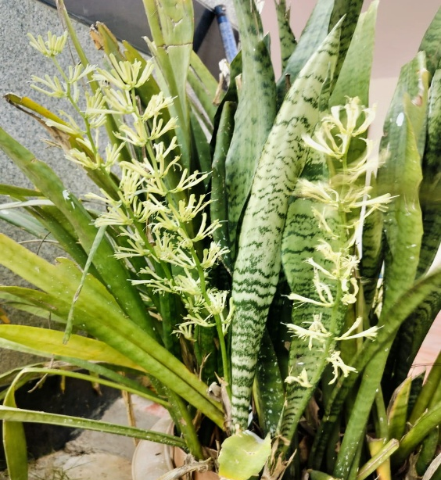
Fig 1. Sansevieria Roxburghiana
2.3 Preparation of extract
Collection and extraction of ethanolic, methanolic and water extract from plants.
Leaves of Sansevieria roxburghiana were collected and cut, properly cleaned and desiccated beneath the shade. After drying, the parts of the plant were chopped and then ground to a fine powder. Dry leaf powder (100g) was weighed for the soxhlation method and extracted with methanol, ethanol and distilled water with a weight of 20gm of plant powder was subjected to extraction in a Soxhlet extractor of three with the solvents with measurements of 150ml each of methanol, ethanol and distilled water. The three extracts were concentrated by rotary vacuum evaporator and evaporated to dryness. The crude sample of Sansevieria roxburghiana is subjected to tests of phytochemical analysis.
3. PHYTOCHEMICAL ANALYSIS
Phytochemical screening for major bioactive constituents like alkaloids, tannins, flavonoids, carbohydrates, saponins, glycosides, starch, and protein was undertaken using the standard phytochemical methods for the methanolic, ethanolic and distilled water extract of sansevieria roxburghiana
Test for alkaloids:
- Dragendroff’s Test:
Three millilitres of the sample were taken and combined with a few drops of Dragendroff’s reagent. Test results that are reddish-brown precipitate.
- Wagner’s Test:
A crude extract of 2 millilitres was mixed with 2-3 drops of Wagner’s reagent brown colour of the resulting was taken as the evidence of presence of alkaloids.
Test for Flavonoids:
- Ferric chloride Test:
Plant extract was taken and combined with the ferric chloride solution and results in the green colour will be considered as the presence of flavonoids.
- Alkaline Reagent Test:
The crude plant sample was mixed with 2 ml of 2% sodium hydroxide solution. An intense yellow colour was formed which turned colourless with the addition of a few drops of diluted Hydrochloric acid which indicated the presence of flavonoids.
Test for Carbohydrates:
- Molisch’s Test:
The plant sample was mixed with 2-3 drops of molisch’s reagent which resulted formation of a violet ring or purple colour confirming the carbohydrates.
- Benedict’s Test:
The crude extract is combined with 2 drops of Benedict’s reagent by boiling the sample for 2-3mins which shows the orange or red colour precipitate this result is considered for carbohydrates.
Test for Proteins:
- Ninhydrin Test:
The extract is added to the ninhydrin reagent which results in a purple colour showing the presence of proteins.
- Biuret Test:
The crude extract is mixed with a biuret reagent and shows a violet colour for the presence of proteins.
Test for Saponins:
- Foam Test:
Crude extract was mixed with 5 ml of distilled water in a test tube and it was shaken vigorously. The formation of stable foam was taken as an indication of the presence of saponins [12].
Test for glycosides:
- Keller -Kiliani Test:
The plant extract was mixed with 2-3 ml of glacial acetic acid containing 1-2 drops of Ferric chloride solution. The mixture was then added to another test tube that contained 2 ml of concentrated sulphuric acid. A brown ring indicated the presence of glycosides.
Test for Tannins:
- Lead acetate Test:
The crude extract was combined with lead acetate solution which resulted in forms a pale yellow ppt showing the existence of tannins.
Test for starch:
- Iodine Test:
The unprocessed extract was varied with iodine solution then continued to shake vigorously and show blue-black as starch.
Test for steroids:
- Salkowski Test:
The initial extract was combined with 2 millilitres of chloroform and shaken subsequently add the conc. sulphuric acid from the walls of test tube walls and shows greenish yellow as the appearance of steroids.
- Wagner’s Test:
The sample was assorted with 2 -3 drops of the reagent which indicated red-brown as test results in the presence of steroids.
4. RESULTS:
The result of the phytochemical screening of the plant showed that the leaves of Sansevieria roxburghiana are rich in various active components as it always helps in the resourcefulness of plant extracts such as methanolic, ethanolic and distilled water by the soxhlation method. It revealed the presence of phytoconstituents that the plant is rich in alkaloids, flavonoids, carbohydrates, saponins and steroids.
The phytochemical analysis shows that alkaloids are present in methanol, ethanol and water extracts. Flavonoids, carbohydrates, saponins, tannins, and steroids are also detected in all three extracts, which shows their general solubility. Proteins are found in methanol and water extracts but not in ethanol. Glycosides are found in water extracts only, and starch is found in methanol and ethanol extracts but not in water. This means that different solvents possess varying abilities to extract specific bioactive compounds. (Table 1)

S.no | Tests | Methanol | Ethanol | Water
1 | Alkaloids | + | + | +
2 | Flavonoids | + | + | +
3 | Carbohydrates | + | + | +
4 | Proteins | + | - | +
5 | Saponins | + | + | +
6 | Glycosides | - | - | +
7 | Tannins | + | + | +
8 | Starch | + | + | -
9 | Steroids | + | + | +

Table 1: Results of phytochemical tests of sansevieria roxburghiana extracts of methanol , ethanol and water. Presence is presented as (+) and absence is represented as (-).
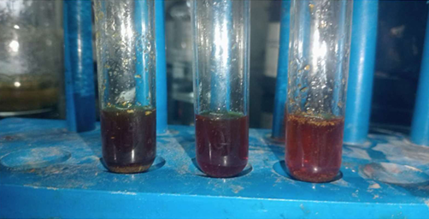
Fig 2. Dragendroff’s test result had showed the presence of alkaloids and colour indicated reddish-brown . fist test tube methanol second ethanol and third is distilled water extracts of sansevieria roxburghiana leaves.
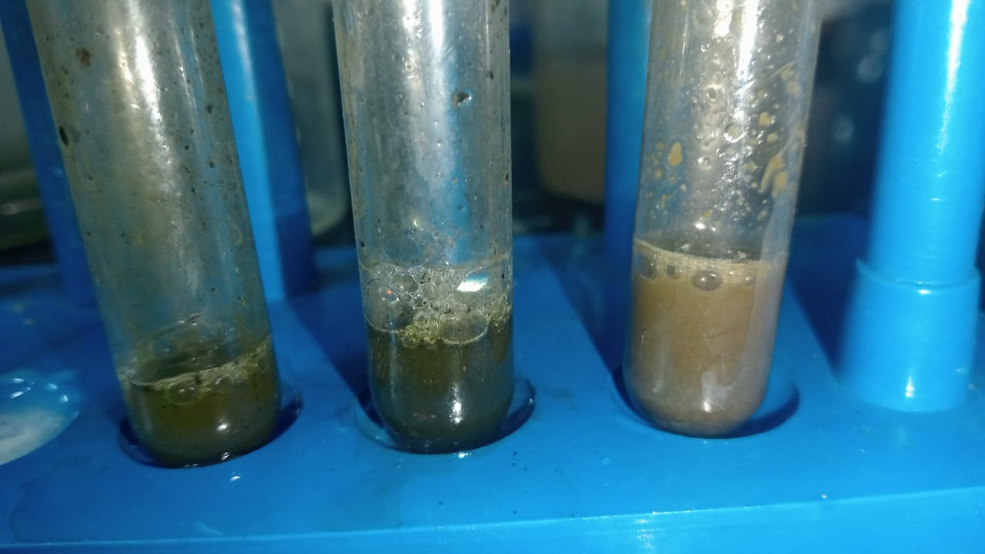
Fig 3. Form test result shows the presence of saponins as the three extracts of methanol, ethanol and water extracts of sansevieria roxburghiana leave extracts.

DISCUSSION:
This main study is conducted to determine and evaluate the phytoconstituents in the plant of Sansevieria roxburghiana. This relates to the family of Dracaenaceae. It is widely recognized as a snake plant, bowstring hemp. Sansevieria roxburghiana can live at minimal light and is also used for air purification. The plant material was collected in November from the garden of Pulla Reddy Institute of Pharmacy located in Annaram, Hyderabad. This plant has been authenticated by the Botanical Survey of India which is located in Koti, Hyderabad -500001.
Plant material was subjected to initial processing at the time of collection, where it was chopped into small pieces to allow easy drying and extraction. Chopped material was washed with water thoroughly to remove any dirt, dust or unwanted residues that can hamper the extraction process. After washing, the plant material was stored for shade drying for about two weeks. Shade drying is an important step as it avoids the degradation of heat-sensitive phytoconstituents that otherwise would be lost due to direct sunlight. The drying process allows the plant material to lose its moisture content slowly, which is essential for effective grinding and extraction. After drying completely, the plant material was powdered finely using an electric grinder to enhance the surface area for extraction. Powdered material was stored at room temperature in airtight containers to avoid contamination and degradation due to environmental conditions like humidity and microbial growth. Powdered plant material was then subjected to an extraction process using the Soxhlet apparatus, a conventional method of extraction of bioactive compounds from plant material. Soxhlet extraction, also referred to as soxhlation is an effective technique that allows continuous extraction of compounds using solvents of varying polarities. The process allows complete extraction of maximum phytoconstituents, resulting in a more detailed phytochemical profile of the plant. Soxhlet apparatus was filled with the finely powdered plant material and solvents like methanol, ethanol and water were used sequentially to extract different phytoconstituents. These solvents were selected because of their capacity to dissolve various classes of phytochemicals and thus recover a vast array of compounds. Methanol and ethanol are commonly employed in phytochemical extractions since they can dissolve both polar and non-polar compounds, while water is an effective solvent in the extraction of highly polar compounds like tannins and flavonoids. Each of the solvent extraction operations was performed for five full cycles to ensure the maximum recovery of the bioactive constituents. During the soxhlation process, the solvent percolates continuously through the plant material dissolves the phytochemicals and carries them to the extraction chamber. This process is used to select the extraction of compounds based on the solubility of the compounds in the respective solvents. Once the extraction process was complete, the obtained extracts were cautiously taken and preserved in vials for further use. The preserved extracts were then subjected to phytochemical screening to confirm the presence of various bioactive compounds, which are accountable for the pharmacological action of the plant. The tests for phytochemical screening were performed according to standard protocols to confirm the presence of alkaloids, flavonoids, carbohydrates, saponins, tannins and steroids in the extracts.
CONCLUSION:
Exploring herbal plants as natural remedies alternative to synthetic drugs to avoid the side effects by concluding had chosen sansevieria roxburghiana. As herbal plants are more safe, effective with fewer side effects compared to synthetic drugs. The soxhlation of the method is employed in the study that found that it is effective in the extraction of bioactive compounds from the Sansevieria roxburghiana. The extract obtained by soxhlation was found to be rich in phytochemicals. The evaluation of sansevieria roxburghiana revealed a total existence with various phytochemicals such as alkaloids, saponins, and carbohydrates. Further studies should be conducted on in-vivo studies.

Disclaimer (Artificial intelligence)
Option 1:
Author(s) hereby declare that NO generative AI technologies such as Large Language Models (ChatGPT, COPILOT, etc.) and text-to-image generators have been used during the writing or editing of this manuscript.
Option 2:
Author(s) hereby declare that generative AI technologies such as Large Language Models, etc. have been used during the writing or editing of manuscripts. This explanation will include the name, version, model, and source of the generative AI technology and as well as all input prompts provided to the generative AI technology
Details of the AI usage are given below:
1.
2.
3.
I AUTHOR OF THIS ARTICLE THERE IS ‘’NO’’ AI GENERATIVE PHOTOS THESE ARE THE NORMAL CAMERA PHOTOS OF THE RESULTS OF THE EXTRACTS AND THE PLANT PHOTO IS TAKEN FROM THE GARDEN OF PULLA REDDY INSTITUTE OF PHARMACY.
REFERENCES:
- Sook-Ha Fan,Noraisah Akbar Ali and Dayang Fredalina Basri.Evaluation of analgesic activity of the , methanolic extract from the Galls of Quercus infectoria (Olivier) in rats. Hindawi publishing corporation, Evidence -based complementary and alternative medicine, volume 2014,article ID 976764.
DOI: https://dx.doi.org/10.1155/2014/976764
- Bhomik Goel, Nishant Pathak, Dwividendra Kumar Nim ,Sanjay Kumar Singh, Rakesh Kumar Dixit , Rakesh Chaurasia.Clinical Evaluation of Analgesic Activity of Guduchi (Tinospora Cordifolia) Using Animal Model. Journal Of Clinical and Diagnostic Research. 2014 Aug,Vol-8(8).
DOI: https://dx.doi.org/10.7860/JCDR/2014/9207.4671
- Amberkar Mohan Babu Vittal Rao, Tara Shanbhag ,Meena Kumari K , K.L. Bairy and Smita Shenoy. Evaluation of anti-inflammatory and analgesic activities of alcoholic extract of Kaempferia Galanga in rats. Indian J Physiol Pharmacol 2011; 55(1) : 13-24

- Swapnil R.Jaiswal, Smita D. Sontakke. Experimental evaluation of analgesic and anti-inflammatory activity of simvastatin and atorvastatin. Indian Journal of Pharmacology. August 2012,Vol44.
DOI: https://dx.doi.org/10.4103/0253-7613.99311
- Adnan A. Bekhit , Sherry N. Nasrana , Eman J. El-Agroudy , Nahla Hamouda, Ahmed Abd El-Fattah. Investigation of the anti-inflammatory and analgesic activities of promising pyrazole derivative. European journal of pharmaceutical sciences 168 (2022) 106080
DOI: https://doi.org/10.1016/j.ejps.2021.106080
- Saswata Banerjee, Antara Mukherjee, Tapan Kumar Chatterjee. Evaluation of analgesic activities of methanolic extract of medicinal plant Juniperus communis linn . International journal of pharmacy and pharmaceutical sciences vol 4, Suppl 5,547-550
- B.K Das , M.M. Al-Amin , S.M Russel, S.Kabir , Bhattacherjee and J.M.A Hannan. Phytochemical screening and evaluation of analgesic activity of oroxylum indicum. Indian journal of pharmaceutical sciences Nov-Dec 2014.
- Mohamad Ali Hijazi , Ahmed El-Mallah , Maha Aboul-Ela ,Abdalla Ellakany. Evaluation of analgesic activity of paper libanoticum extract in mice: involvement of opioids receptors. Hindawi Evidence-based complementary and alternative medicine volume 2017.
DOI: https://doi.org/10.1155/2017/8935085
- Ahamed Ismail Hossain , Mohammad Faisal , Shahnaz Rahman , Rownak Jahan , Mohammed Rahmatullah. A preliminary evaluation of antihyperglycemic and analgesic activity of Alternanthera sessilis aerial parts .BMC Complementary and medicine 2014,14:169.
DOI: http://www.biomedcentral.com/1472-6882/14/169
- Ram kumar Kumawat ,Suresh kumar , Sunil Sharma. Evaluation of analgesic activity of various extracts of Sida tiagii Bhandari. Acta Poloniae Pharmaceutica-Drug Research, Vol.69 No 6 pp.1103-1109,2012 . ISSN 0001-6837

- Deepa Philip , P.K Kaleena , K. valivittan and C. P Girish kumar . Phytochemical screening and anti-microbial activity of sansevieria roxburghiana Schult .and Schult F Middle- east journal of scientific research. ISSN: 1990-9233
DOI: http://doi.org/10(4):512-518

- Pillalamarri Madhavi , Kothmiri Swathika , Kunta Akhil , Palladi Naresh Kumar , Jamagani Anusri , Faruque Ahmed , Rahul Sarkar. Evaluation of anti-inflammatory activity plants brassica oleracea var.capita , brassica oleracea var Italica. World journal of pharmaceutical research. World journal of pharmaceutical research, volume 12, Issue 9, ISSN:2277-7105.
DOI: http://doi,org/10.20959/wjpr20239-28252

