***In-silico* investigation and potential therapeutic approaches of *Acanthus montanus* for COVID-19: Computer-aided drug design perspective**

Abstract

The severe acute respiratory syndrome coronavirus 2 (SARS-CoV-2) has resulted in a significant number of fatalities globally, establishing it as a critical and urgent public health concern. Phytochemicals may serve as a valuable source of effective and safer therapeutic agents against SARS-CoV-2. The lack of sanctioned treatments or vaccinations remains a significant concern, necessitating the development of novel pharmaceuticals. Computer-aided drug design has significantly accelerated the drug research and development process by reducing both costs and time. Natural compounds derivatives demonstrate significant effects on viral replication and support future research in the development of novel therapeutics. *Acanthus montanus* (Nees) T. Anderson (Acanthaceae) is notable shrubby herb, which is commonly used for culinary and medicinal purposes. This study seeks to assess and evaluate the bioactive compounds present in Acanthaceae leaves that may be utilized in drug design for the treatment of COVID-19. The crystal structure of the SARS-CoV-2 main protease was obtained from a protein sequence database, specifically the Protein Data Bank. The bioactive compounds in Acanthaceae were identified through Gas Chromatography-Mass Spectrometry (GC-MS) analysis and High-Performance Liquid Chromatography (HPLC) analysis. The main protease of SARS-CoV-2 plays a critical role in the synthesis of polyproteins, which encompasses viral maturation and the assembly of nonstructural proteins, thereby positioning it as a promising target for antiviral intervention. Additionally, the bioactive compounds within the Acanthaceae family were evaluated in accordance with Lipinski’s rule of five to assess their drug-like molecular characteristics. Furthermore, molecular docking analysis was performed utilizing the PyRx (version 0.8) software, and a comprehensive examination of the interactions between SARS-CoV-2 and the bioactive compounds in Acanthaceae was carried out using the computational software. Among the 19 bioactive compounds that were successfully docked, Naringin, Kaempferol, Progesterol, Quercetin, Stigmasterol, and Rutin trihydrate exhibited the lowest binding energy against SARS-CoV-2, according to the virtual screening results. These compounds demonstrate significant potential as viral inhibitors of SARS-CoV-2 when compared to the standard drug Nirmatrelvir. Additional in vivo and in vitro investigations are recommended to validate the findings of this study and to furnish more robust evidence.

Keyword: SARS-CoV-2, Gas Chromatography-Mass Spectrometry (GC-MS) analysis, High-Performance Liquid Chromatography (HPLC) analysis, Acanthaceae, Nirmatrelvir , Rutin trihydrate , Quercetin

1.0 INTRODUCTION

The outbreak of coronavirus-2, responsible for severe acute respiratory syndrome associated with COVID-19, has been officially designated as a global pandemic and a public health emergency, garnering significant international attention from 2019 to 2022. The COVID-19 disease presents a spectrum of symptoms, which can vary from mild manifestations to severe respiratory distress, potentially leading to sepsis, multi-organ dysfunction, and mortality (Kandeel et al., 2022). As of 31 May 2023, the World Health Organization (WHO) has reported a total of 766 million confirmed cases of COVID-19 globally, with 6.9 million fatalities recorded. On 11 May 2023, the World Health Organization officially declared the conclusion of Covid-19 as a global health emergency. The Covid-19 virus persists in its spread, evolving continuously and maintaining its status as a global health concern, albeit to a diminished degree (Rahman et al., 2023). Consequently, it remains imperative to persist in the exploration of novel pharmaceuticals or medicinal compounds with antiviral properties that may offer immunization against this coronavirus-2 (Rauf et al., 2020).

The coronavirus-2 particle consists of a positive single strand of ribonucleic acid (+RNA) encased within a membrane protein (M) and an envelope protein (E). The spike envelope (S) protein exhibits the ability to interact with the Angiotensin-Converting Enzyme-related carboxypeptidase (ACE2) receptor present on host cells. The spike protein consists of two subunits, S1 and S2, with the S1 subunit specifically engaging with the host cell membrane protein ACE2. This interaction will alter the conformation of the host cell membrane and facilitate the entry of coronavirus-2 particles into the cytoplasm (M. Drobysh et al; R. García et al; Gao et al). A number of studies have been conducted to elucidate the virulence mechanism of coronavirus-2. Research indicates that coronavirus-2 demonstrates a greater efficiency in recognizing human ACE2 compared to its predecessor, coronavirus-1, thereby enhancing the potential for human-to-human transmission (Harrison et al., 2020), (Hu et al., 2019). Consequently, the efforts to prevent the spread of coronavirus-2 necessitated the exploration of novel pharmaceutical formulations, derived from diverse classes of chemicals and natural substances, with an emphasis on their pharmacologically active constituents as ACE2 inhibitors.  
Approximately one-third of marketed pharmaceutical products are sourced from natural ingredients, either directly or indirectly (Newman et al., 2019). Natural products derived from secondary metabolites demonstrate promising potential for antiviral treatment and immunotherapy, as evidenced by in silico docking genomic studies (Al-Harrasi et al., 2022).

*Acanthus montanus* (Nees) T. Anderson (Acanthaceae), commonly referred to as "Bear's breeches," "Mountain thistle," or "Alligator plant," is a notable small shrub characterized by its sparse branching and soft stem structure. *A. montanus* is widely recognized in southern Nigeria, where it is referred to by various names including "Elele-nyijuo," "Agamsoso," and "Agameru," and is utilized in traditional medicinal practices (Igoli et al., 2004). The roots are utilized in bathing practices to alleviate discomfort and pain (Ibe AE and Nwufo MI, 2005). Documented evidence of pharmacological activities indicates that the leaves of the plant exhibit spasmolytic (Adeyemi et al., 1999), analgesic (Adeyemi et al., 2004), anti-inflammatory, and antipyretic (Asongalem et al., 2004) properties. The isolation of constituents, including saponins (Anam EM , 1997) and gammaceranes such as acanthusol and its 3-O-β-D-glucopyranoside [Anam EM, 1997), from the plant has been documented.

In this research we present new insights into the role of natural products in the treatment and prevention of COVID-19. Natural products also play a significant role in the development of novel drug discovery, thus adopting a preventive approach utilizing these products is both practical and promising (Janeway J. C. A. 2001 ; Ho et al., 2007). Ultimately, this integrated analysis will provide compelling evidence regarding the efficacy of natural products in the treatment and prevention of COVID-19 [Nassiri-Asl M., Hosseinzadeh H. (2009); Choi et al., 2017; Laurent et al., 2017; Omrani et al., 2020). The aim of this work is to use GC-MS and molecular docking to uncover possible SARS-CoV-2 inhibitors in *A. montanus* leave.

**2.0 MATERIAL AND METHODS *(Acanthus montanus)***

2.1. Collection of plant materials

*Acanthus montanus* was collected from Bolorunduro town Ondo East Local Government Area, Ondo State, Nigeria. Bolorunduro town is in the southwestern region of Nigeria, characterised by a tropical savanna climate favourable for the growth of *A. montanus*. The plant was harvested during its flowering season to ensure maximum phytochemical content. Details of the collection site, including geographical coordinates (latitude and longitude), were documented to allow reproducibility and traceability. The collected plant samples were examined for their distinguishing morphological features, such as leaves, fruits, and flowers, to ensure accurate species identification. The initial identification was carried out by local experts familiar with the region's flora and was confirmed by a taxonomist at the Department of Plant Biology and Biotechnology, University of Benin, Nigeria. A representative specimen of *A. montanus* was prepared and preserved following standard herbarium protocols. This involves: Pressing and drying the plant material between blotting or newspaper sheets and mounting it on herbarium sheets with detailed labels, including the plant's local name, collection site, date, and collector’s information. The voucher specimen will be deposited at the Herbarium unit of the department for future reference under an assigned accession number.

**2.2. Preparation of the extract**

Fresh leaves of *Acanthus montanus* were collected, rinsed with distilled water to remove dirt and debris, and air-dried in a well-ventilated, shaded area to preserve bioactive compounds. The dried plant material was ground into a fine powder using a mechanical grinder to increase the surface area for extraction. A pre-determined quantity of the powdered plant material (e.g., 500 g) was weighed using an analytical balance and an aqueous solvent was used for the extraction. The powdered material was soaked in distilled water at a ratio of 1:10 (w/v; 500 g in 5 L of distilled water) in an airtight container to prevent evaporation and the mixture was intermittently stirred to enhance the dissolution of phytochemicals in water. This soaking process was carried out for 48–72 hours at room temperature (Sasidharan et al., 2011). After the extraction period, the mixture was filtered using a muslin cloth or Whatman No. 1 filter paper to separate the aqueous extract from plant debris. The process was repeated for better yield by re-soaking the residue for another 24 hours. The filtered aqueous extract was concentrated under reduced pressure using a rotary evaporator at 40–50°C to remove the solvent, leaving behind a semi-solid or dry crude extract. The crude extract was further dried in a vacuum oven or desiccator to eliminate residual solvent. The dried aqueous extract was then weighed, stored in an airtight container, and kept at 4°C in a refrigerator until further analysis and a small portion of the extract was analyzed for preliminary phytochemical screening to confirm the presence of target bioactive compounds (Sasidharan et al., 2011).

*2.3. Gas chromatography-mass spectrometry (GC-MS) analysis*

The leaves of *Acanthus montanus* were analyzed using Gas Chromatography-Mass Spectrometry. A GC-MS (Modal; Agilent tech nologies 7890A) equipped with a VF - 5 ms fused silica capillary column of 30 m length, 0.25 mm diameter, and 0.25 mm film thickness was used. An electron ionization system with an ionization energy of 70eV was used for GC-MS detection. At a constant flow rate of 1 ml/min, helium gas (99.99%) was used as a carrier gas. The injection and mass transfer lines were set to 200 and 240 ◦C, respectively. The oven’s temperature range was set to hold between 80 ◦C for 2 min at 10 ◦C/min and 240 ◦C for 6 min. Manually inserting 2 ml of water solution from the samples in split-less mode with a split ratio of 1:40 and a mass scan of 50–600amu. The GC-MS ran for 35 min in total. Peak area normalization was used to express each extract constituent’s relative percentage as a percentage. The National Institute of Standard and Technology (NIST) library’s database, which contains more than 62,000 spectral patterns, was used to interpret the mass spectra of the plant extracts. The compounds’ spectra and those of the National Institute of Standards and Technology were compared (Fig. 1).

2.4. *High-performance liquid chromatography (HPLC) analysis*

The phytochemical analysis of *Acanthus montanus* extract was carried out using a High-performance liquid chromatography ( HPLC) . HPLC analysis of the extract was performed using an Agilent 1260 Infinity II series equipped with DAD WR G71115A (DEAC606992), Column Oven of G7130 (DEAEQ22974), Quat Pump VL G711A (DEAEY01907). Auto Sampler G7129A (DEAEQ22974) produced in the USA; and with a poroshell column 120 EC-C 18 4µm (250mm x 4.0 mm), PN 693970-902 (T), SN USHKB12136, LN B18447. During the HPLC experiment, a high-pressure pump takes the mobile phase from a reservoir through an injector. It then travels through a reverse-phase C18-packed column for component separation. Finally, the mobile phase moves into a detector cell, where the absorbance is measured at 250 nm, and ends in a waste bottle. The amount of time it takes for a component to travel from the injector port to the detector is called the retention time. In this analysis, samples were injected into the HPLC system and eluted isocratically at a flow rate was 2 ml/min. The column dimensions are 250mm x 4.0 mm. Detection is by absorption spectroscopy at a wavelength of 280 nm. The resulting chromatogram has a peak for every component in the sample. For this experiment, the mobile phase is primarily 20% acetonitrile and 80% purified deionized (DI) water. A small amount of acetic acid is added to lower the pH of the mobile phase, which keeps the silanol in the stationary packing phase in an undissociated state. This reduces the adsorption peak from tailing, giving narrower peaks. Then, the pH is adjusted with 40% sodium hydroxide to raise the pH and help decrease the retention times of the components.

2.5 Protein Optimization

The crystal structure of SARS coronavirus was obtained from RCSB using PDB ID 2AJF and a resolution of 2.90 Å. located at (https://www.rcsb.org/structure/2AJF). The homology modeling was done using the Swiss Model Server (https://swissmodel.expasy.org/interactive/K84PtA/). The 3D structure of alpha-glucosidase was modeled using the coordinate file of a template from the protein data bank (PDB ID: 2AJF). Water and ligand coordinates were removed prior to molecular docking. In this experiment, Discovery Studio 2024 was used to remove the native ligand so the tested compounds could access the target protein’s active sites later in the docking procedure. Subsequently, we determined the coordinates (X = −10.729204, Y = 12.417653, and Z = 68.816122) of the active site, and ultimately, we integrated the polar hydrogen into this structure.

2.6 Starting coordinates: *Acanthus montanus* secondary metabolites

From the GC-MS and HPLC analysis, nineteen bioactive compounds where gotten. The three-dimensional (3D) structures of these ligands were acquired in simple data format (SDF) from the PubChem server through Open Babel in PyRx (version 0.8). This procedure energetically optimized the ligands into their most stable conformations using the Merck Molecular Force Field 94 (MMFF94).

2.7*Molecular docking*

A flexible docking approach, as outlined by Trott and Olson (Trott O, Olson AJ. AutoDock Vina, 2010), was utilized to perform the molecular docking with minor modifications. The molecular docking analysis of the chosen ligands with the target protein was performed with PyRx (version 0.8), which integrates Auto Dock Vina. The PDBQT files for the proteins were generated utilizing their previously established PDB files as inputs. The receptor was made stiff by allowing all the ligand's linkages to rotate freely and adjusting the grid box to align with the protein molecule's active sites. Text files with score results were prepared to enable manual comparative analysis following completion of the molecular docking investigations, with ten configurations established for each protein-ligand interaction across all phytocompounds. Minimum binding energy (BE, kcal/mol).

2.8. *Pharmacokinetic screening*

The highest-scoring compounds underwent structure-based pharmacokinetic screening to forecast their absorption, distribution, metabolism, excretion, and toxicity (ADMET) characteristics and drug likeness. Online servers ADMETlab 2.0 (ADMETlab 2.0 <https://admetmesh.scbdd.com/>) was utilized to predict the key physicochemical properties that influence drug-likeness. The predicted properties include lipophilicity, water solubility, blood-brain barrier permeation, gastrointestinal absorption, and cytochrome P450 inhibition, among others.

2.9. *Phytochemical Screening (Qualitative)*

Preliminary phytochemical screening of crude ethanolic extracts obtained was used as per standard procedure described by (J. B. Harborne et al., 1973) and (Ejikeme et al., 2014), for various phytochemicals such as alkaloid, steroids, terpenoids, tannins, phenolic compounds, flavanoids, carbohydrates and amino acids as shown in table 7.

2.9.1Test for Alkaloid (Mayer Test)

10 ml of a mixture of ethanol and hydrochloric acid (50:50) was added to 1 ml of the ethanolic extract in a test-tube. The mixture was allowed to boil in a water bath for 10 minutes and thereafter filter. The filtrate was then treated with Mayer’s reagent (mixture of mercuric chloride (1.36 g) and of Potassium iodide (5.00 g) in 100 ml distilled water), and formation of a buff-white yellow precipitate indicates the presence of alkaloids.

2.9.2 Test for Saponin (Frothing Test)

10 ml of the ethanolic extract was diluted with 10 ml of water in a graduated measuring cylinder; it was shake vigorously and allowed to stand for 15 minutes. The formation of foam indicates the presence of Saponin, and the height of foam is measured: H2-H1.

Foam Height = H2-H1

Where H2 = Final foam height, H1 = Initial foam height

2.9.3 Test for Tannins

0.30 g of the powder was weighed into a beaker; 30 ml of water was added and brought to a boil for 10 minutes in a water bath. The mixture was then filtered. To the filtrate, 5 ml of 1% ferric chloride solution was added, and a formation of brownish-green or a blue-black coloration showed a positive test for Tannins.

2.9.4 Test for Steroids / Terpenoids

To 5 mg (0.005 g) of the powder sample was dissolved in 10 ml of hot water, 3 ml of chloroform/ diethyl ether was then added to it into test-tube. The test tube was then tited with the addition of 2 ml of concentrated sulphuric acid, slowly through the side of the test-tube; the presence of a brown-reddish color at the chloroform phase indicates the presence of steroid / terpenoid.

2.9.5 Test for Phenol

1 ml of the extract was mixed with 2 ml of1 % FeCl3, the presence of blue-black (violet) or blue green coloration indicates the presence of phenol

2.9.6 Test for Phlobatannin

0.30 g of powder sample was weighed into a beaker and 30 ml of distilled water was added. After 24 hours, 10 ml of the aqueous extract was boiled with 5 ml of 1% aqueous hydrochloric acid. The formation of deposit of red precipitate on the wall of the test-tube indicates presence of Phlobatannin.

2.9.7 Test for Flavonoids

0.30 g of powder sample was weighed into a beaker containing 30 ml of distilled water, and allowed to stand for 2 hours.10 ml of the filtrate was mixed with 5 ml of 1.0 M dilute ammonia solution followed by the addition of 5 ml of concentrated tetraoxosulphate (VI) acid. A yellow color which disappeared on standing shows the presence of flavonoids.

2.9.8 Test for Reducing Sugars

To 2 ml of aqueous extract,1 ml of Fehling solution A and B are added to it in a test tube and boil for 10 min. Formation of a brick red precipitate indicates the presence of reducing sugar.

2.9.9 Test for Glycosides

2.00 g of the powder sample was added to 20 ml of water, it was then heated for 5 minutes on a water bath and filtered through filter paper (12.5 cm).15 ml of 1.0 M sulphuric acid was added to 2 ml of the aqueous extract and boil for 10 minutes, formation of red precipitate indicates the presence of glycosides.

*2.10 Phytochemical Screening (Quantitative)*

2.10.1 Test for Alkaloids

200 ml of 10% acetic acid in ethanol was added to each sample (2.50 g) in a 250 ml beaker and allowed to stand for 4 hours. The extract was then concentrated on a water bath to one-quarter of its original volume followed by addition of 15 drops of concentrated ammonium hydroxide dropwise to the extract until the precipitation was complete immediately after filtration. After 3 hours of mixture sedimentation, the supernatant was discarded and the precipitates were washed with 20 ml of 0.1 M of ammonium hydroxide and then filtered. The residue was dried in an oven and the percentage of alkaloid

% Alkaloid = Weight of alkaloid X 100

Weight of sample

2.10.2 Test for Saponin

100 ml of 20% aqueous ethanol was added to 5 grams of each powder sample in a 250 mlconical flask. The mixture was heated over a hot water bath for 4 hours with continuous stirring at a temperature of 550C. The residue of the mixture was re- extracted with another 100 ml of 20% aqueous ethanol after filtration and heated for 4 hours at a constant temperature of 55∘ C with constant stirring. The combined extract was evaporated to 40 ml over water bath at 90∘ C. 20 cm3 of diethyl ether was added to the concentrate in a 250 separating funnel and vigorously agitated from which the aqueous layer was recovered while the ether layer was discarded. This purification process was repeated twice. 60 ml of n-butanol was added and extracted twice with 10 ml of 5 % sodium chloride. After discarding the sodium chloride layer, the remaining solution was heated in a water bath for 30 minutes, after which the solution was transferred into a crucible and was dried in an oven to a constant weight.

% Saponin = Weight of Saponin X 100

Weight of sample

2.10.3 Test for Tannins

50 g of sodium tungstate (Na2WO4) was dissolved in 37 ml of distilled water, Folin-Denis reagent was made. To the reagent prepared above, 10 g of phosphomolybdic acid (H3PMo12O40) and 25 ml of orthophosphoric acid (H3PO4) were added. This was reflux for 2 hours, cooled, and diluted to 500 ml with distilled water. One gram of each (sample) in a conical flask was added to 100 ml of distilled water. This was boiled gently for 1 hour on an electric hot plate and filtered using 125 mm §Whatman filter paper in a 100 ml volumetric flask. Addition of 5.0 ml Folin-Denis reagent and 10 ml of saturated Na2CO3 solution into 50 ml of distilled water and 10 ml of diluted extract (aliquot volume) was carried out after being pipetted into a 100 ml conical flask for color development. The solution was allowed to stand for 30 minutes in a water bath at a temperature of 25∘C after thorough agitation. With the aid of UV/VIS spectrophotometer optical density was measured at 700 nm and compared on a standard tannic acid curve. For preparation of tannic acid for UV/VIS absorbance, 0.20 g of tannic acid was dissolved in distilled water and dilution to 250 ml standard flask (1 mg/ ml) were used to obtain tannic standard curve. Varying concentrations (0.2–1.0 mg / ml) of the standard tannic acid solution were pipetted into five different test tubes to which Folin-Denis reagent (5 ml) and saturated Na2CO3 (10 ml) solution were added and made up to the 100 cm3 mark with distilled water. The solution was left to stand for 30 minutes in a water bath at 250C. Optical density was ascertained at 700 nm with the aid of UV/VIS spectrophotometer. Optical density (absorbance) versus tannic acid concentration was plotted.

Tannic acid (mg /100 g) = 𝐶 × extract volume × 100

Aliquot volume × weight of sample

where 𝐶 is concentration of tannic acid.

2.10.4 Test for Phenols

2 g powder sample was carried out for 2 hours in 100 ml of diethyl ether using a soxhlet apparatus. The defatted sample (0.50 g) was boiled for 15 minutes with 50 ml of ether for the extraction of the phenolic components. Exactly 10 ml of distilled water, with 2 ml of 0.1 N ammonium hydroxide solution, and 5 ml of concentrated amyl alcohol were also added to 5 ml of the extract and left to react for 30 minutes for color development. The optical density was measured at 505 nm. 0.20 g of tannic acid was dissolving in distilled water and diluted to 250 ml mark (1 mg / ml) in preparation for phenol standard curve. Varying concentrations (0.2–1.0 mg/ml) of the standard tannic acid solution were pipetted into five different test tubes to which 2 cm3 of NH3OH, 5 ml of amyl alcohol, and 10 ml of water were added. The solution was made up to 100 ml volume and left to react for 30 minutes for color development. The optical density was determined at 505 nm with UV/VIS TG 50 spectrophotometer.

Phenolic acid (mg /100 g) = 𝐶 × extract volume × 100

Aliquot volume × weight of sample

where 𝐶 is concentration of tannic acid.

2.10.5 Test for Flavonoid

50 ml of 80 % aqueous methanol added was added to 2.50 g of sample in a 250 ml beaker, covered, and allowed to stand for 24 hours at room temperature. After discarding the supernatant, the residue was re-extracted (three times) with the same volume of ethanol. The solution was then filter and transferred into a crucible and then evaporated to dryness over a water bath. The content in the crucible was cooled in a desiccator and weighed until constant weight was obtained.

% Flavonoid = Weight of Saponin X 100

Weight of sample

2.10.7 Reducing Sugar

The reducing sugar content (RSC) can be determined using the 3,5-dinitrosalicylic acid (DNSA) method. The measurement was performed according to the procedure of Krivorotova and Sereikaite 2014. 1 g of DNSA and 30 g of sodium-potassium tartaric acid were dissolved in 80 mL of 0.5 N NaOH at 45°C. After dissolution, the solution was allowed to cool to room temperature and diluted to 100 mL with distilled water. 2 mL of DNSA reagent was then pipetted into a test tube containing 1 mL of plant extract (1 mg/mL) and kept at 95°C for 5 min. After cooling, 7 mL of distilled water was added to the solution and the absorbance of the resulting solution was measured at 540 nm using a UV-VIS spectrophotometer (Shimadzu UV-1800). The reducing sugar content was calculated from the calibration curve of standard D-glucose (200-1000 mg/L), and the results were expressed as mg D-glucose equivalent (GE) per gram dry extract weight.

Reducing Sugar (mg /100 g) = 𝐶 × extract volume × 100

Aliquot volume × weight of sample

**3.0 RESULT**

*3.1 Molecular docking*

From a total of nineteen natural compounds (Table 1), six compounds were selected based on their superior binding affinity to alpha-glucosidase: Naringin(ID:442428), Kaempferol(ID: 5280863), Progesterol (ID:5994),Quercetin (ID:5280343), Stigmasterol(ID:5280794), and Rutin trihydrate (ID: 5280805). Naringin and Rutin trihydrate exhibited the highest docking score (−9.2kcal/mol). The subsequent four compounds were Stigmasterol, Progesterone, Quercetin and Kaempferol with docking scores of −8.5, −7.4, −7.6 and -7.6 Kcal/mol respectively. The Standard drug Nirmatrelvir as approved by Food and Drug Administration (FDA) was also docked with the receptor as a control and gave dockimg score of -7.3 Kal/mol. The lead compounds exhibited robust interactions with the target. Figure 2 illustrates the 2D interaction profile of crystal structure of SARS coronavirus with the lead compounds. In the interaction with the amino acid residues in the ligand-binding domain of crystal structure of SARS coronavirus, Naringin formed connections via hydrogen bonds with ASN 397, GLU 398, GLY 395, ASN 394, HIS 378 and ALA 348. Also, Rutin hydrate established hydrogen bond interactions with ARG 514, GLU 402, TYR 515, HIS 401, ASN 397, GLY 395, ARG 393 and ASP 350. Stigmasterol also established hydrogen bond interactions with ARG 393, PHE 40, LEU 73, LEU100. Furthermore, Progesterol formed connections via hydrogen bonds with LEU 73. Quercetin interacted with adjacent amino acids by hydrogen bonds with ASP 382, PHE 390, ASN 394, ARG 393. Kaempherol formed connections via hydrogen bonds with LYS 562, ASP 206, GLY 205, TYR 202. These as shown in figure 3.

*3.2 ADME-T results*

The outcomes of the in silico ADME-T analysis of phytoconstituents in *Acanthus montanus* are presented in Tables 2-6. The findings from the human intestinal absorption (HIA) test demonstrated that all selected compound exhibited high permeation across the membrane except Rutin Hydrate and Naringin. (Table 3). In the in vitro Caco-2 cell permeability test, Kaempferol, Stigmasterol and Progesterone demonstrated good permeation except for Quercetin, Nairingin and Rutin triydrate. All compounds are anticipated to be soluble in water. All compounds exhibit distinct subcellular localization. All compounds demonstrated no inhibition of P-glycoprotein (P-gp) except Stigmasterol and Progesterone, and All compounds were identified as P-gp substrates except Naringin, Rutin Hydrate and Stigmasterol. All compounds demonstrated a positive permeable to the blood-brain barrier (BBB. Kaempferol, Quercetin and Stigmasterol are found to be non-inhibitors for CYP450 1A2 (Table 5). Kaempferol acted as inhibitors for CYP450 2C9. All compounds demonstrated a lack of hepatotoxicity (Table 6). Rutin triydrate exhibit mutagenic properties, as indicated by the AMES toxicity test. A few compounds were found to be non-carcinogenic. This analysis demonstrates that Kaempferol exhibit superior pharmacokinetic and toxicity profiles compared to other compounds.

*3.3 Phytochemical Screening*

The qualitative and quantitative test for phytochemicals presents in *Acanthus montanus* extract reveal the presence of Alkaloid, Tannin, Phlobatannin, Saponnin, Terpenoid, Cardic, Glycosides, Steroid, Reducing sugar, Flavonoid and Phenol. Alkaloid and reveled to be more present in the extract are shown in table 2.

**4.0 Discussion**

Currently, computational tools have been considered the most popular tools for designing and discovering new therapeutic compounds (Ou et al., 2012; Sliwoski et al., 2014). COVID-19 is a severe health disease. Bioactive compounds have been used numerous times to check infections against viral disease and boost the immunological feedback of the host. Valuable natural goods are shown in prior COVID-19 illnesses, including SARS and MERS; therefore, natural ingredients may be suitable and hopeful in this recent outbreak. Naringin, Kaempferol,Progesterol, Quercetin Stigmasterol and Rutin trihydrate are shown to be more potent compare to the standard drug Nirmatrelvir. A lower docking score signifies enhanced binding affinity and energy.

The main obstacle for medications to be efficiently dispersed throughout the body is their ability to be absorbed in the gastrointestinal system. HIA functions as a metric for forecasting the absorption of a pharmacological molecule in the human intestine post-oral delivery, evaluated via the concentrations of excretion in urine, bile, and feces. The chemical exhibits efficient absorption when at least 90% is assimilated into the human bloodstream (Borad et al., 2020). The Caco-2 permeability parameter presents a considerable obstacle for oral drugs, since it entails translocation over the barrier formed by intestinal epithelium generated from human colonic adenocarcinomas, which possess various transport channels (Pham The et al., 2011). Drugs that have undergone absorption are then disseminated throughout the body. The plasma membrane ATP-binding cassette transporter, P-glycoprotein (P-gp), is crucial in drug transport mechanisms. The activation of P-glycoprotein results in the efflux of the medication from cells, hence hindering the attainment of the therapeutic effect (Ojo et al., 2021). A crucial element of the distribution process is the drug's ability to traverse the blood-brain barrier (BBB) (Borad et al., 2020). The administered medicine is subsequently metabolized. CYP450 participates in the metabolism of pharmaceuticals and xenobiotics in the liver and intestines. When a molecule is recognized as a substrate for at least one CYP450 enzyme, it is anticipated that the compound will be efficiently metabolized by the associated CYP450 enzyme (Baba Tomiwa et al., 2020). Drug interactions occur due to the suppression of a particular isoform of the enzyme, resulting in hepatotoxicity (May and Schindler, 2016). The human liver is the primary site for metabolism, affecting the impact of hazardous substances and many medications. Hepatotoxicity criteria indicate several types of liver damage that may cause organ failure or perhaps result in deadly consequences. Consequently, it is essential to evaluate hepatotoxicity at the development and drug discovery stages for oral delivery (Ojo et al., 2021). This study illustrated that multiple compounds in the *Acanthus montanus* may function synergistically in treating Covid-19, owing to their varied mechanisms of action on SARS-CoV-2 and their potential to compete with conventional pharmaceuticals. Moreover, Kaempferol meet the criteria for drug similarity and have a favorable ADME-T profile which can aid in the development of Covid-19 pharmaceuticals produced from *Acanthus montanus*.

**5.0 Conclusion**

The study has identified six compounds that could function as potential Covid-19 drugs. Further investigations, encompassing the extraction of these chemicals for in vitro testing, are necessary to validate these findings.

COMPETING INTERESTS DISCLAIMER:

Authors have declared that they have no known competing financial interests OR non-financial interests OR personal relationships that could have appeared to influence the work reported in this paper.

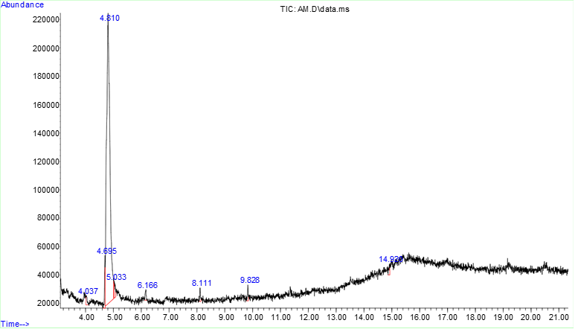

***Figure 1:*** *Graph showing the various peaks from the GC-MS analysis of Acanthus montanus* *leave*

Table 1: Summary of molecular docking result *Acanthus montanus* *leave.*

|  |  |  |  |  |
| --- | --- | --- | --- | --- |
| ***No.*** | ***Compound name*** | ***Molecular formulae*** | ***Mass*** | ***Docking Score***  ***Kcal/mol*** |
| 1. | 2-Chloromethyl-6-methyl-4-phenyl-quinazoline 3-oxide | C16H13ClN2O | 284.74 g/mol | -7.1 |
| 2. | 3-Ethyl-3-methyldiaziridine | C4H10N2 | 86.14 g/mol | -4.1 |
| 3. | Methyl benzoate | C8H8O2 | 136.15 g/mol | -4.8 |
| 4. | Benzohydrazide | C7H8N2O | 136.15 g/mol | -5.8 |
| 5. | 1-benzothiophen-3-yl-(2-methylphenyl)methanone | C16H12OS | 252.3 g/mol | -6.8 |
| 6. | N-Methyl-1-adamantaneacetamide | C13H21NO | 207.31 g/mol | -5.6 |
| 7. | Caffeic Acid | C9H8O4 | 180.16 g/mol | -6.5 |
| 8. | Ferulic acid | C10H10O4 | 194.18 g/mol | -5.9 |
| 9. | Maleic Acid | C4H4O4 | 116.07 g/mol | -4.6 |
| 10. | Salicylic Acid | C7H6O3 | 138.12 g/mol | -6.5 |
| 11. | Gallic Acid | C7H6O5 | 170.12 g/mol | -5.6 |
| 12. | Curcumin | C21H20O6 | 368.4 g/mol | -7.0 |
| 13. | Rutin trihydrate | C27H36O19 | 664.6 g/mol | -9.2 |
| 14. | Kaempferol | C15H10O6 | 286.24 g/mol | -7.6 |
| 15. | Naringin | C27H32O14 | 580.5 g/mol | -9.2 |
| 16. | Quercetin | C15H10O7 | 302.23 g/mol | -7.6 |
| 17. | Progesterone | C21H30O2 | 314.5 g/mol | -7.4 |
| 18. | Stigmasterol | C29H48O | 412.7 g/mol | -8.5 |
| 19. | p-Coumaric acid | C9H8O3 | 164.16 g/mol | -6.6 |
|  | **Standard Drug** |  |  |  |
| 20. | Nirmatrelvir | C23H32F3N5O4 | 499.5 g/mol | -7.3 |

Table 2: Lipinski’s rule of Six for the phytoconstituents in *Acanthus montanus*

|  |  |  |  |  |  |  |  |
| --- | --- | --- | --- | --- | --- | --- | --- |
| **No.** | **Compound** | **MW**  **≤500 Dalton** | **nHA**  **≤10** | **nHD**  **≤5** | **logP**  **≤5** | **No. of rule violations**  **≤ 2 violations** | **Drug- Likeness** |
| 1. | Naringin | 580.18 | 14.0 | 8.0 | 0.475 | 3 | No |
| 2. | Kaempferol | 322.12 | 4.0 | 1.0 | 4.475 | 0 | No |
| 3. | Rutin triydrate | 610.15 | 16.0 | 10.0 | 0.986 | 3 | No |
| 4. | Progesterone | 314.22 | 2.0 | 0.0 | 3.957 | 0 | Yes |
| 5. | Quercetin | 302.04 | 7.0 | 5.0 | 2.155 | 0 | Yes |
| 6. | Stigmasterol | 412.37 | 1.0 | 1.0 | 7.5 | 1 | Yes |

Table 3. Absorption prediction output

|  |  |  |  |  |  |  |  |
| --- | --- | --- | --- | --- | --- | --- | --- |
| **No.** | **Compound** | **Caco-2 Permeability** | **HIA** | **logS** | **Pgp-inhibitor** | **Pgp-substrate** | **Conclusion** |
| 1. | Naringin | 580.18 | 14.0 | 8.0 | 0.475 | 3 | Yes |
| 2. | Kaempferol | -4.974 | 0.008 | -3.624 | 0.004 | 0.011 | Yes |
| 3. | Rutin triydrate | 610.15 | 16.0 | 10.0 | 0.986 | 3 | Yes |
| 4. | Progesterone | -4.734 | 0.003 | -4.539 | 0.995 | 0.007 | No |
| 5. | Quercetin | -5.204 | 0.014 | -3.671 | 0.004 | 0.005 | Yes |
| 6. | Stigmasterol | -4.576 | 0.009 | -6.736 | 0.951 | 0.936 | No |

Table 4. Distribution prediction output

|  |  |  |  |  |
| --- | --- | --- | --- | --- |
| **No.** | **Compound** | **BBB** | **BCRP inhibitor** | **MRP1 inhibitor** |
| 1. | Naringin | 0.151 | 14.0 | 8.0 |
| 2. | Kaempferol | 0.009 | 4.0 | 1.0 |
| 3. | Rutin triydrate | 0.041 | 16.0 | 10.0 |
| 4. | Progesterone | 0.18 | 12.0 | 10.0 |
| 5. | Quercetin | 0.008 | 0.099 | 0.008 |
| 6. | Stigmasterol | 0.009 | 6.0 | 8.0 |

Table 5. Metabolism prediction output

|  |  |  |  |  |  |  |  |
| --- | --- | --- | --- | --- | --- | --- | --- |
| **No.** | **Compound** | **CYP450**  **1A2**  **inhibitor** | **CYP450**  **2C9**  **inhibitor** | **CYP450**  **2D6**  **inhibitor** | **CYP450**  **2C19**  **inhibitor** | **CYP450**  **3A4**  **inhibitor** | **Conclusion** |
| 1. | Naringin | 0.0 | 0.087 | 0.0 | 0.0 | 0.0 | Yes |
| 2. | Kaempferol | 0.972 | 0.653 | 0.722 | 0.181 | 0.697 | No |
| 3. | Rutin triydrate | 0.0 | 0.0 | 0.0 | 0.0 | 0.0 | Yes |
| 4. | Progesterone | 0.349 | 0.233 | 0.032 | 0.498 | 0.569 | No |
| 5. | Quercetin | 0.943 | 0.598 | 0.411 | 0.053 | 0.348 |  |
| 6. | Stigmasterol | 0.093 | 0.346 | 0.295 | 0.17 | 0.832 |  |

Table 6. Toxicity prediction output

|  |  |  |  |  |  |
| --- | --- | --- | --- | --- | --- |
| **No.** | **Compound** | **hERG Blockers** | **AMES Mutagenicity** | **Human Hepatotoxicity** | **Carcinogenicity** |
| 1. | Naringin | 0.023 | 0.939 | 0.895 | 0.053 |
| 2. | Kaempferol | 0.07 | 0.672 | 0.098 | 0.097 |
| 3. | Rutin triydrate | 0.216 | 0.698 | 0.828 | 0.367 |
| 4. | Progesterone | 0.16 | 0.009 | 0.42 | 0.844 |
| 5. | Quercetin | 0.099 | 0.657 | 0.1 | 0.05 |
| 6. | Stigmasterol | 0.31 | 0.005 | 0.188 | 0.1 |

Table 7: (A.) Qualitative analysis report of *Acanthus montanus* (B.) Quantitative analysis report of *Acanthus montanus*

1. **QUALITATIVE**

|  |  |  |  |  |  |  |  |  |  |  |
| --- | --- | --- | --- | --- | --- | --- | --- | --- | --- | --- |
| Code | Alkaloid | Tannin | Phlobatannin | Saponnin | Terpenoid | Cardic Glycosides | Steroid | Reducing Sugar | Flavonoid | Phenol |
| **AM** | **++** | **+** | **+** | **+** | **+** | **+** | **+** | **+** | **+** | **+** |

**+ = Present, ++ = Much in abundance, - = Absent**

**B. QUANTITATIVE**

|  |  |  |  |  |  |  |  |  |  |  |
| --- | --- | --- | --- | --- | --- | --- | --- | --- | --- | --- |
| Code | Alkaloid mg/100g | Tannin mg/100g | Phlobatannin mg/100g | Saponnin mg/100g | Terpenoid mg/100g | Cardic Glycosides  mg/100g | Steroid mg/100g | Reducing Sugar  mg/100g | Flavonoid mg/100g | Phenol mg/100g |
| **AM** | 50.50  50.60  50.55 | 30.06  30.90  30.62 | 25.06  25.50  25.35 | 22.52  22.33  22.60 | 40.22  41.09  40.20 | 20.50  20.55  20.52 | 20.15  20.10  20.18 | 25.40  25.45  25.45 | 15.10  15.20  15.25 | 40.28  40.20  46.35 |

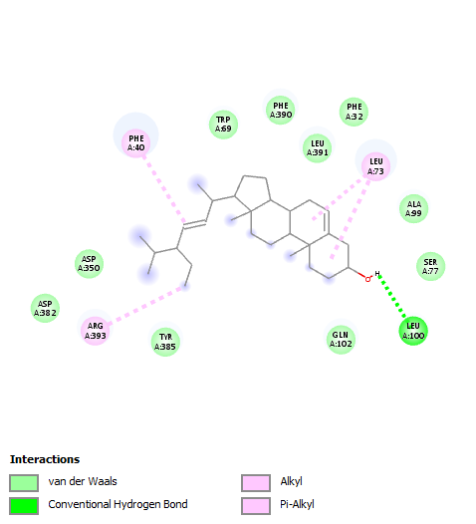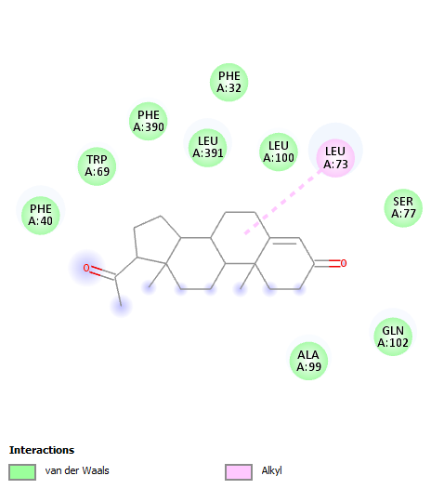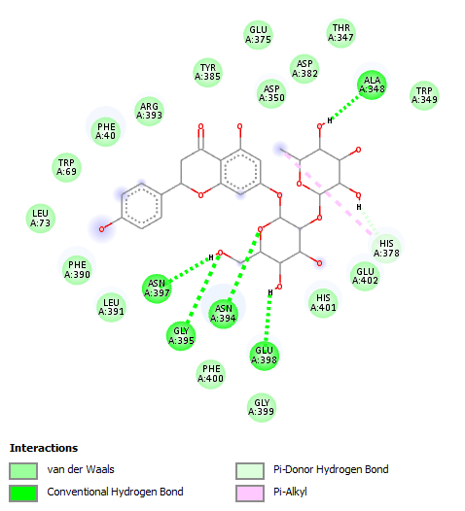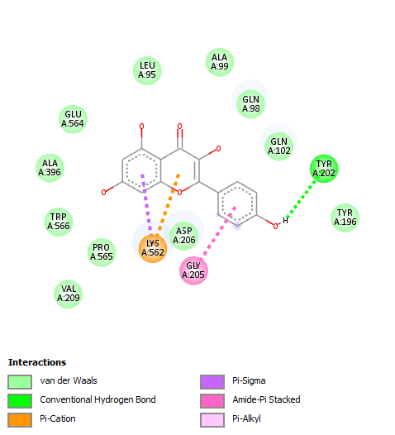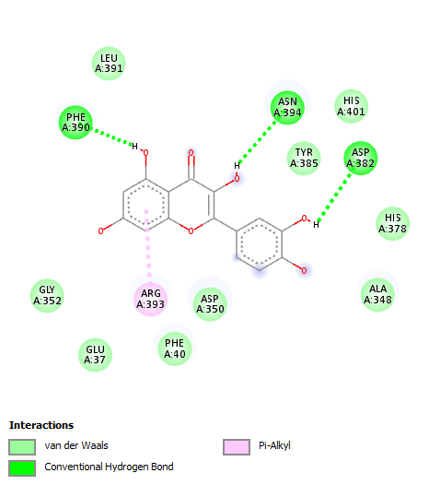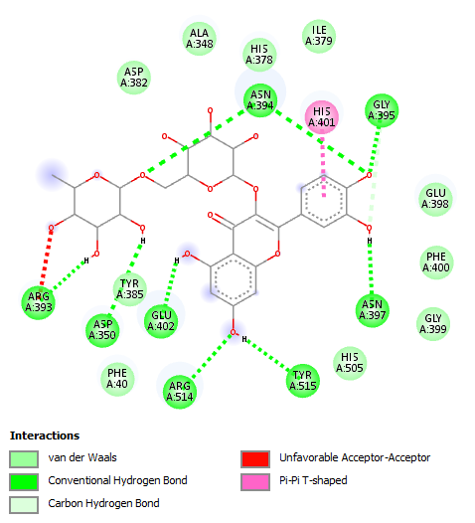

**d.**

**c.**

**d.**

**c.**

**b.**

**a.**

Figure 2:2D view of the molecular interaction of the six compounds: (a.) Naringin (b.) Kaempferol (c.) Rutin triydrate (d.) Progesterone (e.) Quercetin, (f.) Stigmasterol.

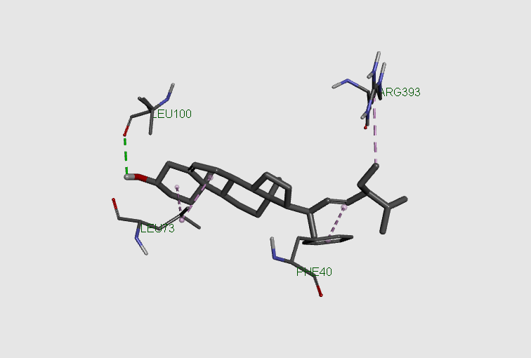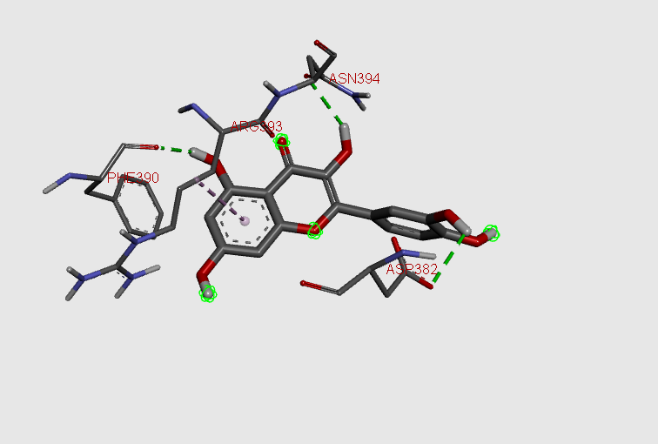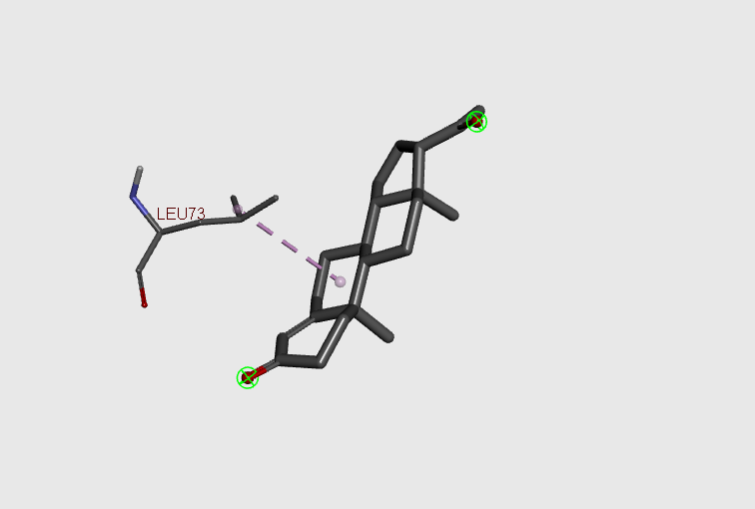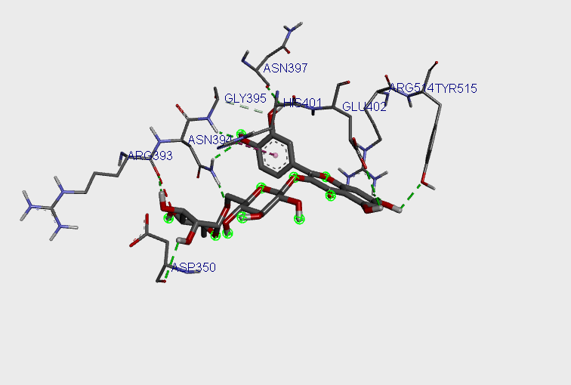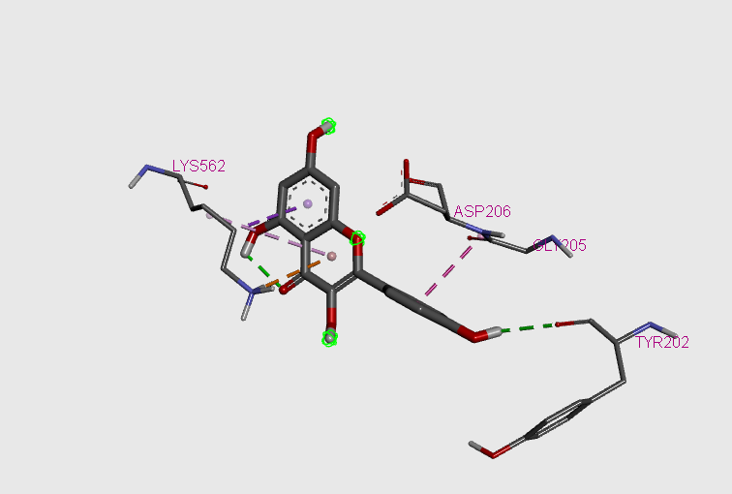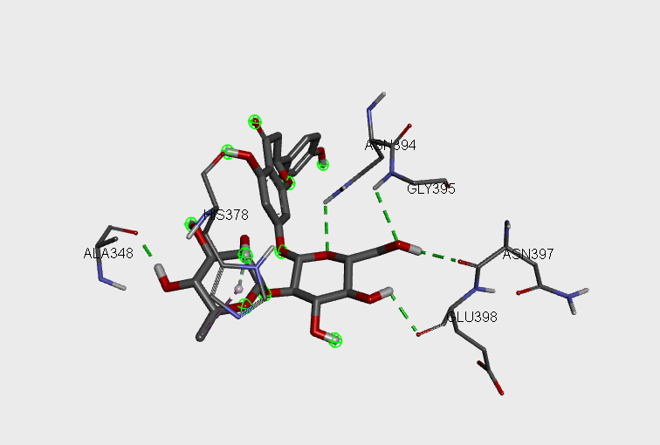

Figure 3: The 3D view of the molecular interaction and amino acid residue of the top six compounds: (a.) Naringin (b.) Kaempferol (c.) Rutin triydrate (d.) Progesterone (e.) Quercetin, (f.) Stigmasterol.

**g.**

**f.**

**e.**

**d.**

**b.**

**a.**

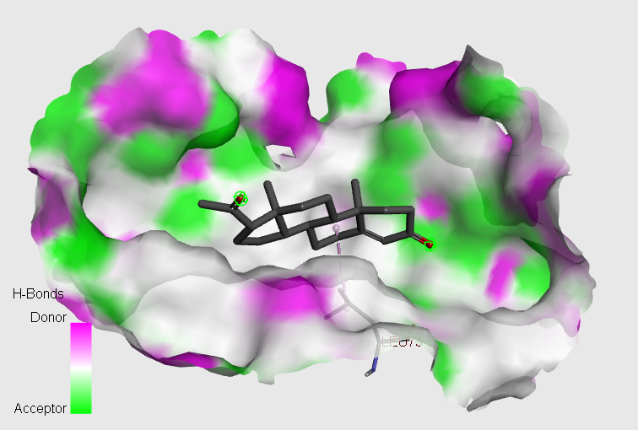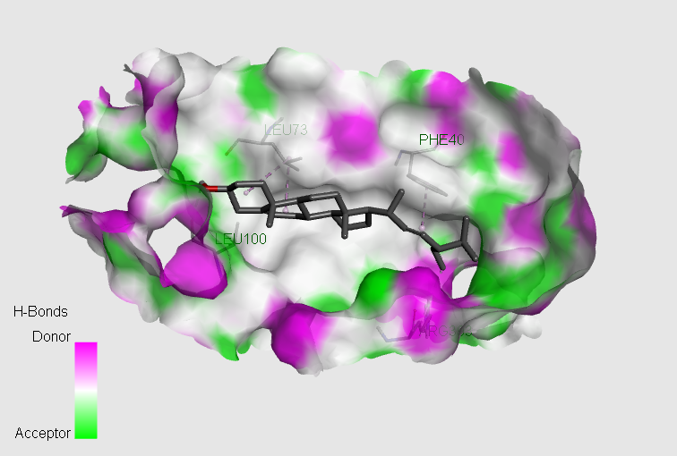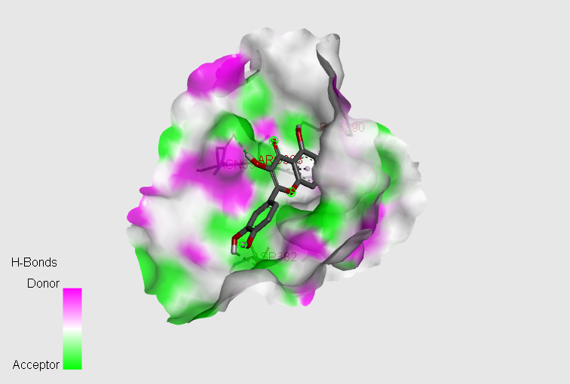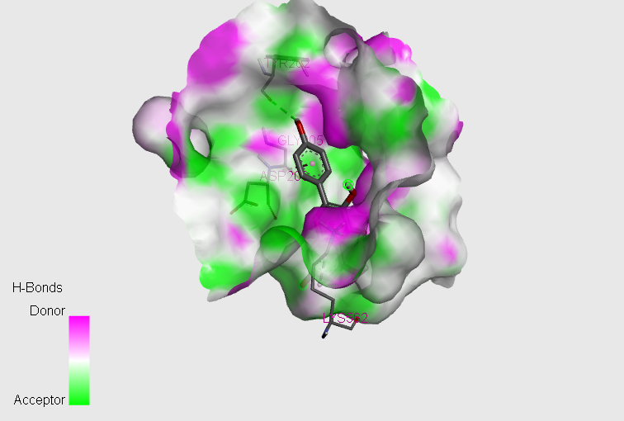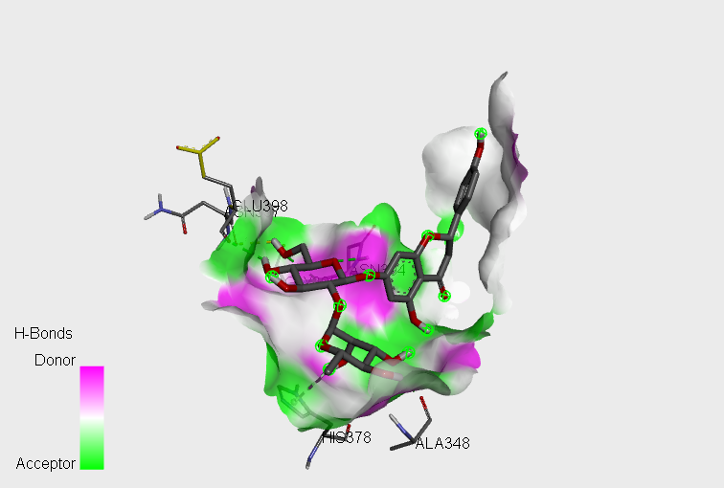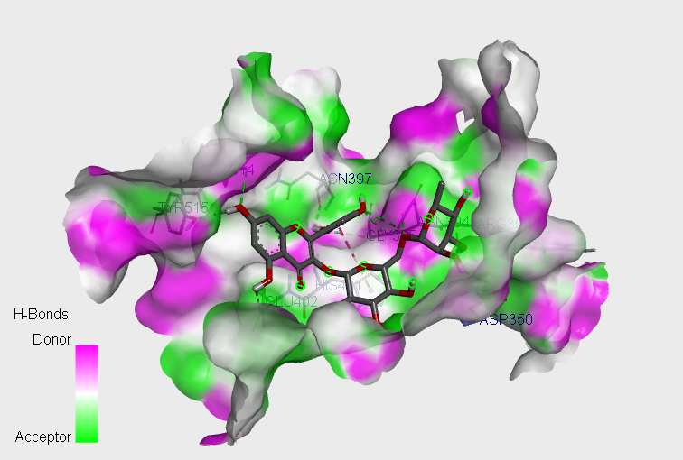

**f.**

**e.**

**d.**

**c.**

**b.**

**a.**

Figure 4: The 3D pose of Hydrogen bond interaction of the top six compounds: (a.) Naringin (b.) Kaempferol (c.) Rutin triydrate (d.) Progesterone (e.) Quercetin, (f.) Stigmasterol.

Disclaimer (Artificial intelligence)

Option 1:

Author(s) hereby declare that NO generative AI technologies such as Large Language Models (ChatGPT, COPILOT, etc.) and text-to-image generators have been used during the writing or editing of this manuscript.

Option 2:

Author(s) hereby declare that generative AI technologies such as Large Language Models, etc. have been used during the writing or editing of manuscripts. This explanation will include the name, version, model, and source of the generative AI technology and as well as all input prompts provided to the generative AI technology

Details of the AI usage are given below:

1.

2.

3.

**Reference**

1. M. Kandeel, J. Kim, M. Fayez, Y. Kitade, and H. Kwon, "Antiviral drug discovery by targeting the SARS-CoV-2 polyprotein processing by inhibition of the main protease," PeerJ, vol. 10, no. e12929, pp. 1–20, 2022. doi: 10.7717/peerj.12929.2085
2. M. A. Rahman, S. Cronmiller, Y. Shanjana, and M. Bhuiyam, "The WHO announced COVID-19 is no longer a global public health emergency amid the spreading of Arcturus variant: A correspondence evaluating this decision," Int. J. Surg., vol. 25, no. 37222689, pp. 1–7,2023. doi: 10.1097/JS9.0000000000000522.
3. A. Rauf, U. Rashid, A. A. Khalil, S. A. Khan, and S. Anwar, "Docking-based virtual screening and identification of potential COVID-19 main protease inhibitors from brown algae ," South African J. Bot., vol. 143,pp. 428–434, 2020. doi: 10.1016/j.sajb.2021.06.033.
4. M. Drobysh et al., "Biosensors for the determination of SARS-CoV-2 virus and diagnosis of COVID-19 infection," Int. J. Mol. Sci., vol. 23, no. 666, pp. 1–25, 2022. doi: 10.3390/ijms23020666.
5. R. García et al., "Identification of potential antiviral compounds against SARS-CoV-2 structural and non structural protein targets: A pharmacoinformatics study of the CAS COVID-19 dataset," Comput.Biol. Med., vol. 133, no. 104364, pp. 1–12, 2021.doi: 10.1016/j.compbiomed.2021.104364.
6. S. Gao, T. Huang, L. Song, and S. Xu, "Medicinal chemistry strategies towards the development of effective SARS-CoV-2 inhibitors," Acta Pharm. Sin. B, vol. 12, no. 2, pp. 581–599, 2022.doi: 10.1016/j.apsb.2021.08.027.
7. A. G. Harrison, T. Lin, and P. Wang, "Mechanisms of SARS-CoV-2 transmission and pathogenesis," Trends Immunol., vol. 41, no. 12, pp. 1100–1115, 2020. doi: 10.1016/j.it.2020.10.004.
8. B. Hu, H. Guo, P. Zhou, and Z.-L. Shi, "Characteristics of SARS-CoV-2 and COVID-19," Nat. Rev. Microbiol., vol. 19, pp. 141–154, 2019. doi: 10.1038/s41579-020-00459-7.
9. D. J. Newman and G. M. Cragg, "Natural products as sources of new drugs over the nearly four decades from 01/1981 to 09/2019," J. Nat. Prod., vol. 83, pp. 770–803, 2020. doi: 10.1021/acs.jnatprod.9b01285.
10. A. Al-Harrasi, T. Behl, T. Upadhyay, S. Chigurupati, and S. Bhatt, "Targeting natural products against SARS-CoV-2," Environ. Sci. Pollut. Res., vol. 29, pp. 42404–42432, 2022. doi: 10.1007/s11356-022-19770-2.
11. Igoli JO, Tor-Anyiin TA, Usman SS, Oluma HOA, Igoli PN: Folk medicines of the lower Benue valley in Nigeria. Recent Progress in Medicinal Plants. Ethnomedicine and Pharmacognosy II. Edited by: Singh VK, Govil SH, Singh S. 2004, USA: Science Tech Publishers, 7: 327-338.
12. Ibe AE, Nwufo MI: Identification, collection and domestication of medicinal plants in southern Nigeria. African Dev. 2005, 30: 66-77.
13. Noiarsa, P.; Ruchirawat, S.; Kanchanapoom, T. Acanmontanoside, a New Phenylethanoid Diglycoside from Acanthus montanus. Molecules 2010, 15, 8967-8972. https://doi.org/10.3390/molecules15128967.
14. Adeyemi OO, Okpo SO, Okpaka O: The analgesic effect of the methanolic extract of *Acanthus montanus*. J Ethnopharmacol. 2004, 90: 45-48. 10.1016/j.jep.2003.09.021.
15. Asongalem EA, Foyet HS, Ekobo S, Dimo T, Kamtchouing P: Anti-inflammatory, lack of central analgesia and antipyretic properties of *Acanthus montanus* (Ness) T. Anderson. J Ethnopharmacol. 2004, 95: 63-68. 10.1016/j.jep.2004.06.014.
16. ANAM, E.. (2010). ChemInform Abstract: Novel Triterpenoid Glycosides and Triterpenoid Acid from the Root Extract of Acanthus montanus (Acanthaceae). Cheminform. 29. 10.1002/chin.199815223.
17. ANAM, E.. (2010). ChemInform Abstract: Pentacyclic Triterpenoids from Acanthus montanus (Acanthaceae). Cheminform. 28. 10.1002/chin.199740224.
18. Janeway J. C. A. (2001). How the immune system protects the host from infection. Microbes infection 3, 1167–1171. doi: 10.1016/S1286-4579(01)01477-0.
19. Ho T.-Y., Wu S.-L., Chen J.-C., Li C.-C., Hsiang C.-Y. (2007). Emodin blocks the SARS coronavirus spike protein and angiotensin-converting enzyme 2 interaction. Antiviral Res. 74, 92–101. doi: 10.1016/j.antiviral.2006.04.014.
20. Nassiri-Asl M., Hosseinzadeh H. (2009). Review of the pharmacological effects of vitis vinifera (Grape) and its bioactive compounds. Phytother Research: Int. J. Devoted to Pharmacol. Toxicol Eval. Natural Product Derivatives 23, 1197–1204. doi:  10.1002/ptr.2761.
21. Choi J.-G., Jin Y.-H., Lee H., Oh T. W., Yim N.-H., Cho W.-K., et al. (2017)Protective effect of panax notoginseng root water extract against influenza a virus infection by enhancing antiviral interferon-mediated immune responses and natural killer cell activity (Accessed 2017).
22. Laurent P., Jolivel V., Manicki P., Chiu L., Contin-Bordes C., Truchetet M.-E., et al. (2017). Immune-mediated repair: A matter of plasticity. Front. Immunol. 8. doi: 10.3389/fimmu.2017.00454.
23. Omrani M., Keshavarz M., Nejad Ebrahimi S., Mehrabi M., Mcgaw L. J., Ali Abdalla M., et al. (2020). Potential natural products against respiratory viruses: a perspective to develop anti-COVID-19 medicines. Front. Pharmacol. 11 2115. doi:  10.3389/fphar.2020.586993.
24. Sasidharan, Sreenivasan, et al. "Extraction, isolation and characterization of bioactive compounds from plants’ extracts." *African journal of traditional, complementary, and alternative medicines* 8.1 (2011).
25. Trott O, Olson AJ. AutoDock Vina: improving the speed and accuracy of docking with a new scoring function, efficient optimization, and multithreading. J Comput Chem 2010 Jan 30;31(2):455–61. https://doi.org/10.1002/jcc.21334. PMID: 19499576; PMCID: PMC3041641.
26. ADMETlab 2.0 (<https://admetmesh.scbdd.com/>).
27. J. B. Harborne, Phytochemical Methods: A Guide to Modern Techniques of Plant Analysis, Chapman and Hall, London, UK, 1973.
28. C. M. Ejikeme, C. S. Ezeonu, and A. N. Eboatu, “Determination of physical and phytochemical constituents of some tropical timbers indigenous to Niger Delta Area of Nigeria,” European Scientific Journal, vol. 10, no. 18, pp. 247–270, 2014.
29. Ou-Yang S.-S., Lu J.-Y., Kong X.-Q., Liang Z.-J., Luo C., Jiang H. (2012). Computational drug discovery. Acta Pharm. Sin 33, 1131–1140. doi: 10.1038/aps.2012.109.
30. Sliwoski G., Kothiwale S., Meiler J., Lowe E. W. J. R. (2014). Computational methods in drug discovery. Pharmacol. Rev 66, 334–395. doi: 10.1124/pr.112.007336.