Digital Microvascular Occlusion in Essential Thrombocythemia: A Case Report and Review of Management Strategies

Abstract

Aim:
This case report aims to address the apparent lack of documented instances of digital microvascular occlusion secondary to essential thrombocythemia (ET) in the southwestern region of Nigeria, while also providing a review of management strategies.

Presentation of Case:
This report describes the case of a 75-year-old patient exhibiting signs of erythromelalgia, characterized by dusky, congested, and hyerpigmented foot. The patient experienced vascular complications due to a delayed presentation at Redeemers Health Village, a multi-specialty tertiary academic hospital in western Nigeria.
The patient was diagnosed with JAK2 negative ET based on a Doppler ultrasound that revealed atherosclerotic arterial stenosis. His diagnosis met four criteria outlined in the WHO guidelines, including a sustained platelet count greater than 450,000/µL.
Given his background history of a thrombotic stroke, the ultimate goal of treatment was to reduce the risk of thrombosis or hemorrhage. The patient underwent cytoreduction therapy, which successfully reduced his initial platelet count from 809,000/µL at presentation to 198,000/µL. Following this treatment, he underwent a below-the-knee amputation. Postoperative management included rehabilitation, ambulation, and the use of a below-the-knee prosthesis.

Discussion:
Essential thrombocythemia (ET) is often asymptomatic and is therefore frequently detected incidentally, particularly in facilities equipped to recognize it. The limited availability of specialized care in many community and general hospitals may contribute to the perceived rarity of ET. As illustrated in this case report, if left untreated for extended periods, ET can lead to increased morbidity and mortality due to conditions that predispose patients to microvascular disease. These risks can be minimized by implementing measures to reduce the time to treatment.

Conclusion:
Essential thrombocythemia may not be as uncommon as previously suggested. Patients with this condition are often asymptomatic and may remain unaware of their diagnosis until they experience a sudden thrombotic event. Identifying this condition through routine laboratory tests requires the expertise of a haematologist.The case points towards the significance of early intervention and intensive treatment since delay in presentation leads to critical complications needing significant surgery.

Keywords: thrombocythemia, digital ischemia, gangrene, anti-platelet agents, cytoreduction, surgical intervention

- Introduction

Essential thrombocythemia (ET) is a type of myeloproliferative neoplasm (MPN) characterized by significant thrombocytosis and megakaryocytic hyperplasia. This category of BCR-ABL negative myeloproliferative neoplasm also includes polycythemia vera (PV) and primary myelofibrosis (PMF). [1,2]
ET is a rare chronic disorder with annual incidence rate of 1.2 to 3cases per 100,000 people. It affects twice as many females as males, [3,4] and typically impacts patients between ages of 60 and 80 years. Approximately 20% of all cases involve patients aged 40 and younger, while it is rare in children. [5,6]
Essential thrombocythemia develops due to genetic mutations, primarily in the Janus associated kinase 2 (JAK2 V617F) gene, which occurs in about 55% of cases, Calreticulin gene mutations (CALR located at 19p13.2) are present in approximately 25% of cases, and mutations in the Myeloproliferative leukemia virus (MPL) oncogene (thrombopoietin receptor gene. located at 1p34) occur in 4% to 5% of cases. The JAK2 gene mutation, particularly the JAK2 V617F variant, leads to a gain of function, resulting in uncontrolled activation of JAK2 kinase and downstream signaling through the STAT pathway. The activated JAK2-STAT signaling promotes the proliferation and maturation of megakaryocytes, ultimately resulting in increased platelets production. The dysregulation of the JAK2-STAT pathway and the consequent elevated platelet count may predispose patients to thrombosis. [7,8]
The diagnosis of ET is established when there is a sustained platelet count exceeding 450 x 10⁹/µL, inaddition to meeting other outlined World Health Organization criteria . [4,9,10, 11, 16] Primary thrombocythemia can manifest in various ways, ranging from asymptomatic to symptomatic presentations. When symptoms do occur, they may include: thrombotic events (both arterial or venous), hemorrhagic complications, erythromelalgia, neurological consequences from microvascular disturbances, transient ischemic attack, ocular disturbances, and an increased risk of first-trimester miscarriages. Microvascular symptoms account for the highest rate of morbidity and mortality in cases of ET. [2,6] According to Papadonikolakis et al., the major risk factors for thrombosis in essential thrombocythemia are age greater than 60 years and a history of previous thrombotic episodes.
The significant morbidity and mortality associated with ET can be alleviated through early diagnosis, prompt treatment, and regular patient monitoring.
This publication is inspired by a case involving a preventable gangrenous foot, which ultimately resulted in a below-the-knee amputation. There is a notable gap in the literature regarding digital microvascular occlusion secondary to essential thrombocythemia, particularly in Nigeria and, more specifically, the Southwest region. This documented case report aims to address this deficiency while also providing a review of management strategies.

- Case Presentation

The patient is a 75 year old male who was generally well until approximately one year before his presentation. He sustained an injury to his left foot, resulting in mild excoriation that progressively enlarged. Other developing symptoms included pain, induration, foul-smelling purulent discharge, and weight loss. Notably, he did not experience fever, drenching night sweats, bleeding diathesis, cough, polyuria or polydipsia.
The patient has a past medical history of a right hemispheric ishemic stroke with left hemiparesis, which occurred about two years prior to his presentation. He was previously managed at a general hospital in Nigeria , but his symptoms did not resolve before he sought further care at the Redeemers Health Village (RHV). He is a known hypertensive and has not been diagnosed with diabetes mellitus. He is married and has four children.
On examination, the patient is an elderly man with adequate vital signs and no significant findings during the general and physical examination,except for the musculoskeletal system. The dorsal surfaces of both feet appeared dusky, congested, and hyerpigmented, with more pronounced features on the left foot. The hyperpigmentation extended from the big toe to the fourth toe. The left foot displayed an ulcer with an irregular outline, sloping edges, and necrotic tissue in the first dorsal interosseous. The plantar surface of the left foot exhibited cyanotic features, with bluish discoloration mixed with areas of necrotic tissue. [Figure 1 and 2]
The diagnosis of essential thrombocythemia complicated by vascular disease and foot gangrene was made based on the clinical features, including the previous ischemic stroke, and the revised WHO criteria, which include four crieria: a sustained platelet count of ≥ 450,000/µL, megakaryocyte hyperplasia, the absence of neutrophils granulopoiesis or erythropoiesis, no evidence of chronic myeloid leukemia, polycythemia vera or primary myelofibrosis and was the absence of a reactive cause.[9,11,16]
Preliminary investigation results revealed the following: White Blood Cell (WBC): 17.7 × 10⁹/L, Red Blood Cell (RBC): 2.8× 10⁹/L, Hemoglobin (Hb): 7.3g/dL, Hematocrit (PCV): 22.9%, Platelets: 809,000/µL.[Figure 4] Additionally, a bilateral lower limb Doppler ultrasound (both arterial & venous) showed features of atherosclerotic arterial stenosis. Other laboratory findings included: JAK2 V617F: Negative, D-Dimer: 1.5mg/dL (reference range: 0-0.5mg/dL), and Glycosylated Hemoglobin (HBA1C): 5.3% (reference range: 4.0 - 6.5%).
Based on the clinical presentation, diagnosis, and elevated platelet count, the patient was \scheduled for a below- the- knee amputation (BKA) of the left foot. However, this surgical intervention was postponed until the target platelet count of less than 450,000µL was achieved.
The Patient was treated with a direct thrombin inhibitor, Dabigatran at a dosage of 150mg daily, and an anti-platelet agent, Clopidogrel at 75mg daily. For cytoreduction, Hydroxyurea was administered at a daily dose of 1g.[12, 22] The patient’s platelet count was monitored regularly as shown in figure 4, with the lowest recorded value being 198,000µL after approximately 12 weeks of antiplatelet and cytoreduction therapy.
The Patient underwent a successful below-the-knee amputation and was discharged home after a satisfactory postoperative recovery and stable performance status. Currently, he is being followed up in both the hematology and orthopedic clinics.

Fig1:Left Foot dorsal surface with Dusky
congested Digital interosseous necrosis Fig.2: Left Foot plantar surface with digital ischaemia necrosis
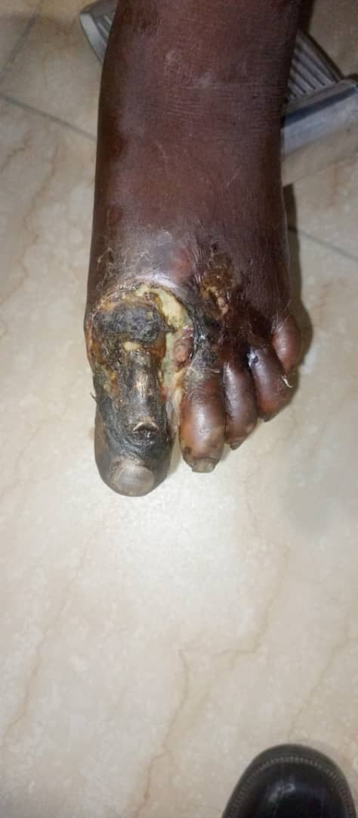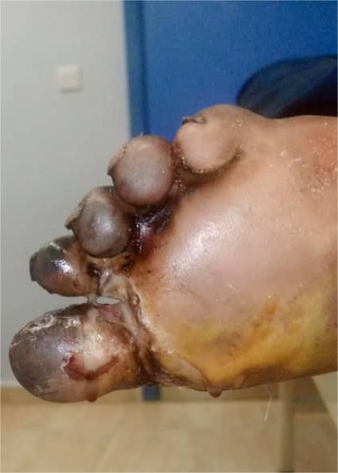

Fig 3: Below the left knee amputation
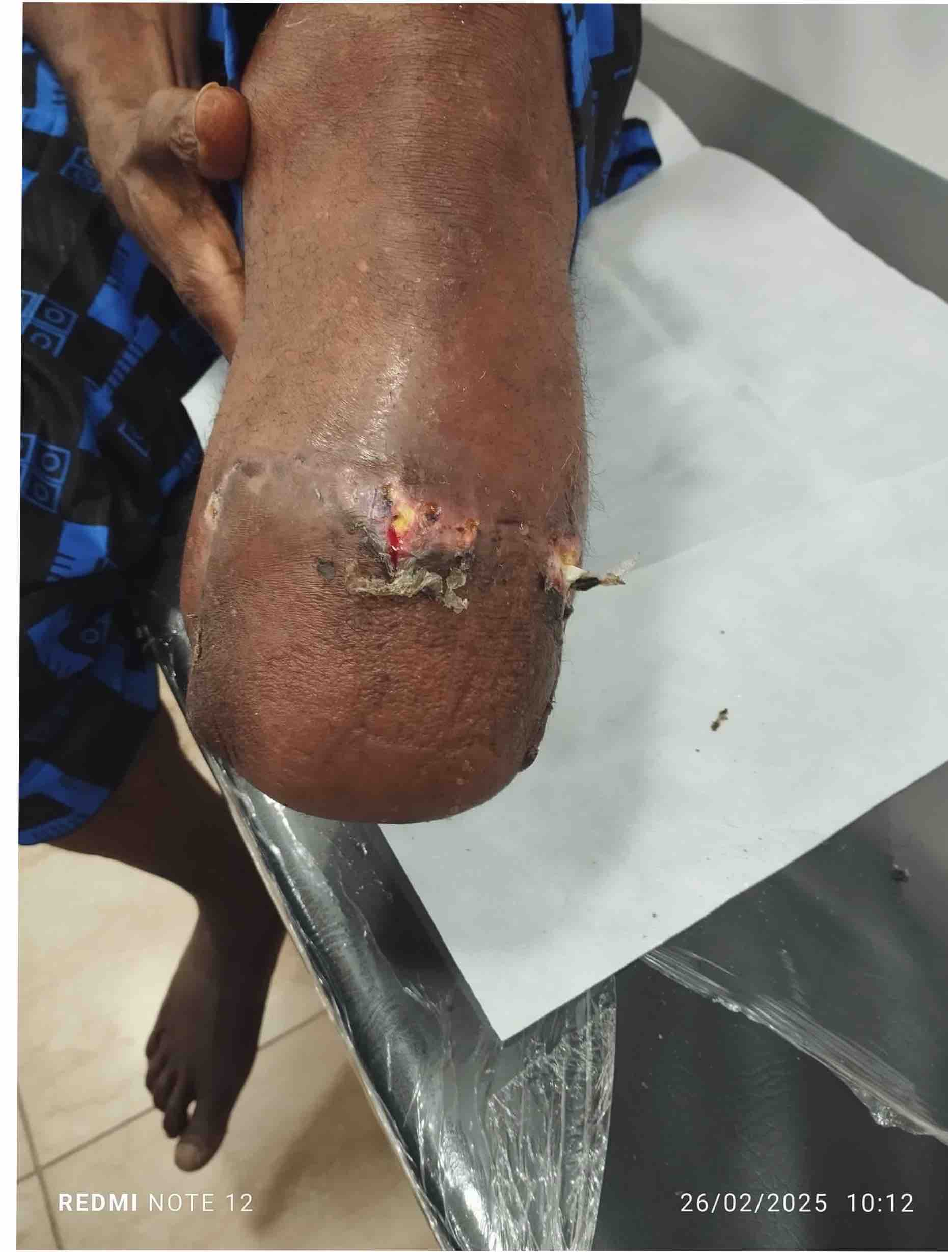

SHAPE \* MERGEFORMAT

Fig 4:Line graph showing pattern of platelet count
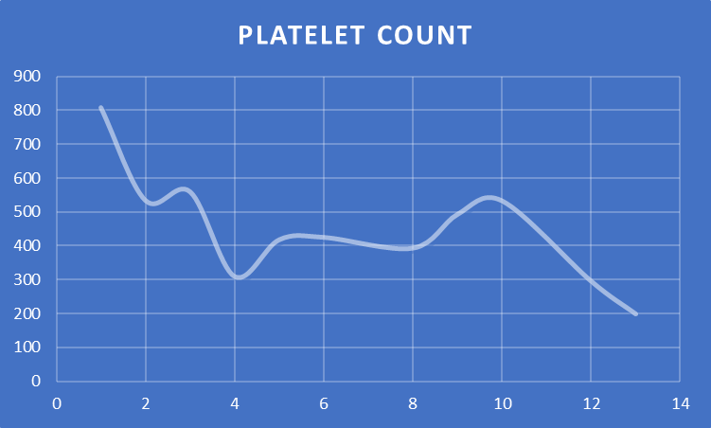
Platelet count
Weeks on antiplatelets and cytoreduction therapy

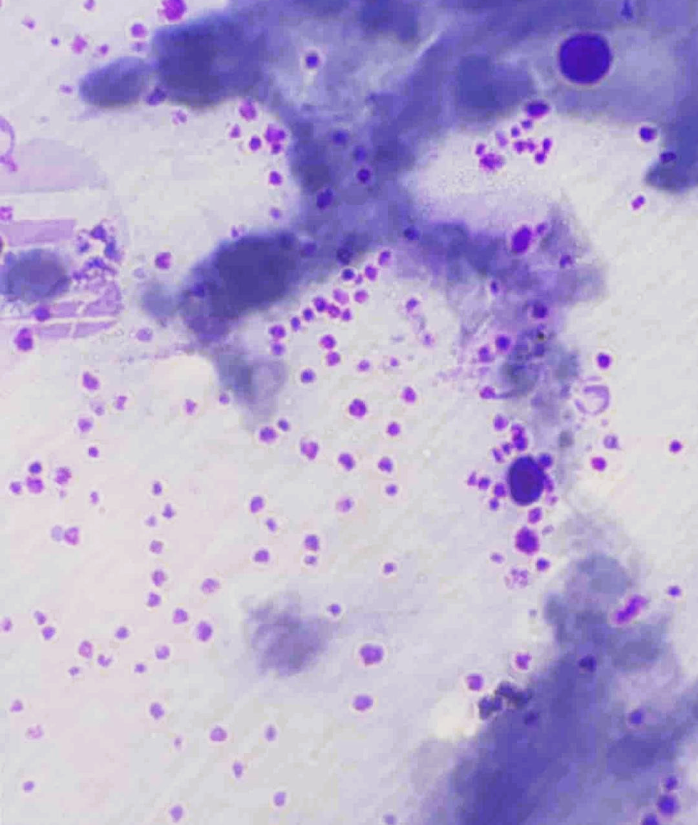
Fig 5: Peripheral Blood film

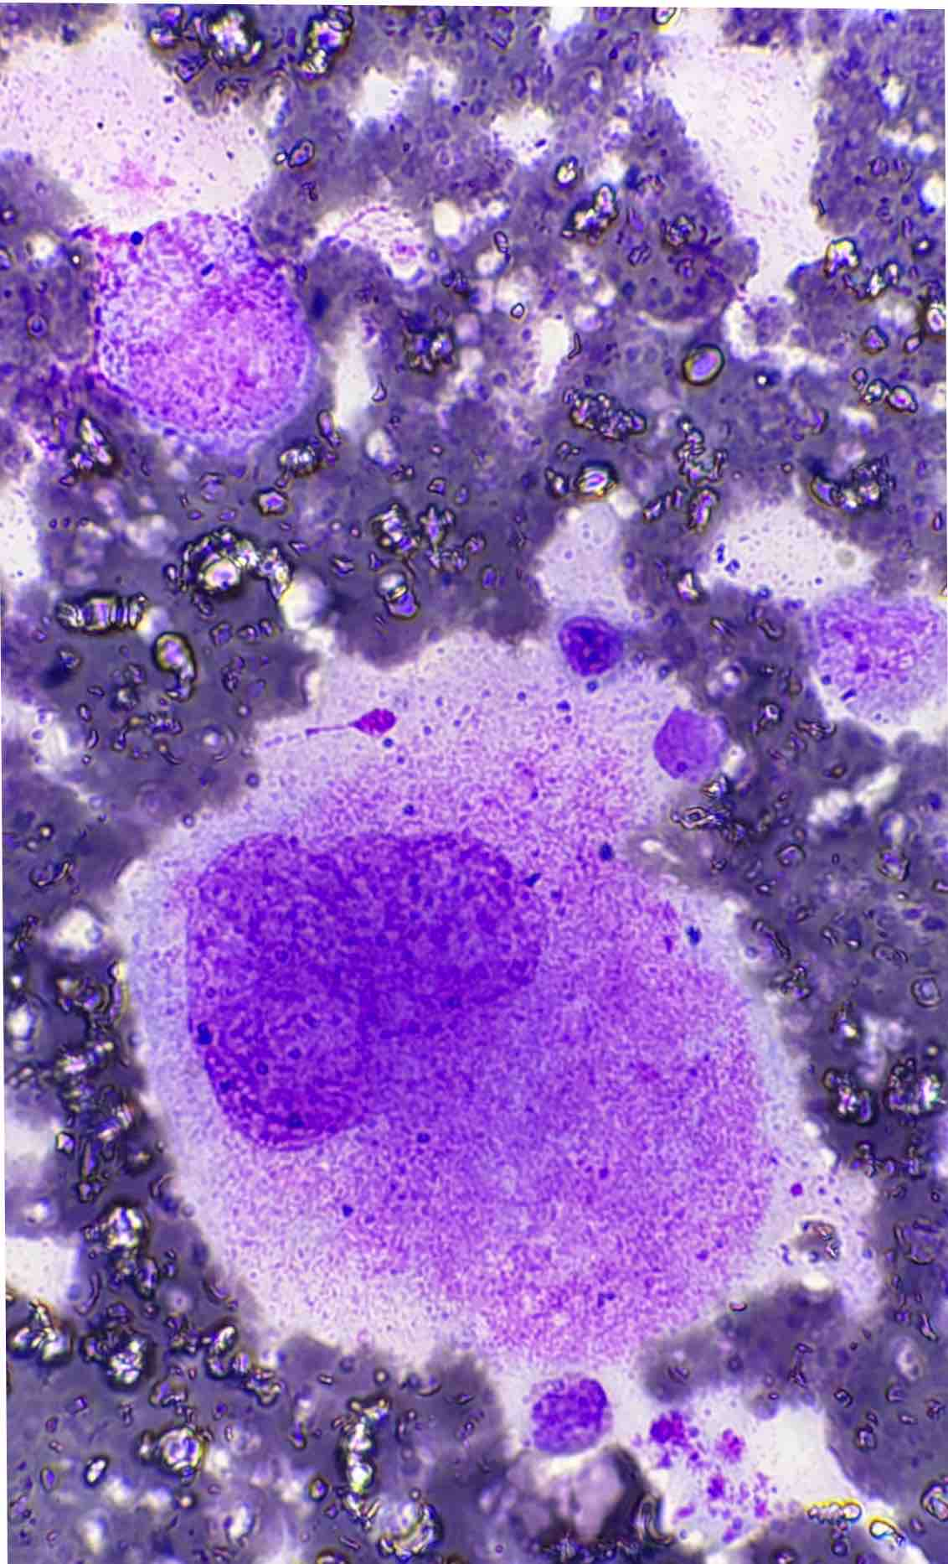

Fig 6: Bone Marrow Aspiration displaying clusters of megakaryocytes

- Discussion
Microvascular thrombosis occurs when small blood vessels (microvasculature), become blocked by blood clots (thrombi). This blockage is primarily results from a complex interplay of endothelial cell dysfunction, platelet activation, and the coagulation cascade. These events can lead to tissue ischemia and potential damage to various tissues or organs. [4, 11]
Essential thrombocythemia (ET) is often asymptomatic, meaning it frequently goes undetected until diagnosed incidentally, particularly in health facilities equipped to recognize it. The limited access to specialized care in many community and general hospitals may contribute to the misconception that ET is rare. [11] As demonstrated in this case report, if ET is left untreated for an extended periods, it can lead to increased morbidity and mortality. Patients may become predisposed to thromboembolic strokes, ischemic heart disease, and microvascular disease.[25] The risks associated with this condition can be minimized by implementing measures to reduce the time before treatment begins. [4, 13, 14]
Several factors can adversely affect outcomes for patients being managed for ET or other chronic debilitating conditions. Key issues include a poor referral system, late presentation, and a lack of specialized expertise needed to interpret routine hematological investigations, establish a diagnosis, and initiate prompt treatment.
In the case report, the patient presented to the hospital approximately twelve months after the onset of symptoms. A timely referral could have greatly benefited this patient if the primary medical condition had been identified earlier. The diagnosis was made based on the patient's clinical history, which included a previous medical history of hemispheric ischemic stroke, the absence of reactive throbocytosis, and findings from a complete blood count showing a sustained platelet count ≥ 450,000/µL, along with results from a peripheral blood film, and bone marrow aspiration. [9,16,] Although the Janus Kinase 2 (JAK2) mutation was not detected in this patient, studies suggest that this mutation is present in about 55% of ET cases. Alternative markers for JAK2 negative ET include Calreticulin gene mutations (CALR located at 19p13.2) which are found in about 25% of cases, and mutations in the Myeloproliferative leukaemia virus (MPL) oncogene (which is the thrombopoietin receptor gene. located at 1p34) occurring in about 4% to 5% of cases.[17] It is noted that approximately 10% to 15% of patients with ET do not express any of the three driver mutations markers. [18]
Supportive laboratory findings for this case included elevated platelet counts of 809,000/µL,which exceeds the 450,000µL threshold set by the WHO criteria. Additionally, there was evidence of megakaryocyte hyperplasia, absence of causes for secondary thrombocytosis, and the exclusion of features consistent with chronic myeloid leukemia. Furthermore, a bilateral Doppler ultrasound revealed evidence of arterial stenosis, resulting from platelet aggregation or thrombus formation.
The patient’s thrombocytosis, along with an abnormal D-Dimer of 1.5 mg/L, places him at high risk for arterial / venous thrombosis including acute ischemic stoke. [14, 25]
D-Dimer is a soluble fibrin degradation product generated during the breakdown of cross-linked fibrin, often indicating coagulation activation and secondary fibrinolysis. [19]
The manifestation of occlusive vascular disease in this patient is consistent with findings from a study by Hussani et al., which reported that out of ten patients analyzed, six presented with symptoms indicative of incipient gangrene of the toes, and several developed occlusions in the tibia and larger arteries while under observation. [20] At the time of presentation, this patient exhibited signs of long-standing ET, including a dusky congested foot, numbness, erythromelalgia, cyanotic toes, and gangrene. The management plan put forward for this patient involved a multidisciplinary approach, incorporating an orthopedic surgeon, an internal medicine physician, and a hematologist. After considering all clinical factors, including the ascending pathology, a below-the-knee amputation was deemed the appropriate surgical intervention. However, this surgical intervention was delayed due to the high risk of thrombosis, bleeding, and the elevated platelet count of 809,000/µL. The treatment plan involved administering an anti-platelet agent, specifically clopidogrel at a dosage of 75 mg daily, along with cytoreduction therapy using hydroxyurea at 1g daily.[12] Antiplatelet agents and Hydroxyurea are the first line treatment for JAK 2 negative ET and their combination have been found to be superior to anagrelide paired with low dose aspirin.[21, 22] The second-line alternatives are anagrelide, peginterferon alfa (Pegasys), ropeginerferon alfa, bulsulfan. Cytoreduction agents can be combined in patients whose platelet levels are difficult to control with a single agent. Regardless of JAK2 status, targeted therapy such as ruxolitinib (a JAK1/JAK2 inhibitor ) and fedratinib (a selective JAK2 inhibitor) are to some extent beneficial in high-risk ET patients who are intolerant or resistant to hydroxyurea.[27]
Elevated platelet counts, particularly those exceeding one million per microlitre, can lead to conditions such as pseudo-Von Willebrand disease (pseudo-VWD), which can result in uncontrollable hemorrhage, especially during surgery. [23, 24, 25] In such cases, therapeutic plateletpheresis is recommended as an emergency measure to reduce platelet counts, however, this procedure was not indicated in this particular patient.[4]
The patient successfully underwent a below-the-knee amputation after extensive counselling, obtaining informed consent, and achieving satisfactory platelet reduction.
Notably, there was significant improvement in the reperfusion and overall health of the patient's right foot. The stump is being manged on an outpatient basis while discussions regarding rehabilitation and restoration of lost function are ongoing. To ensure comfortable ambulation, the patient is being guided on the option of obtaining a below-the-knee prosthesis.

- Conclusion:
Essential thrombocythemia (ET) may not be as uncommon as previously suggested. [26] Patients with this condition often do not exhibit symptoms and may remain unaware of their diagnosis until they experience a sudden thrombotic event. Identifying this condition through routine laboratory tests requires the expertise of a hematologist, which is unfortunately lacking in many general hospitals in Nigeria. Early diagnosis is crucial for preventing complications associated with ET.

Consent
As per international standards or university standards, patient(s) written consent has been collected and preserved by the author(s).

COMPETING INTERESTS DISCLAIMER:
Authors have declared that they have no known competing financial interests OR non-financial interests OR personal relationships that could have appeared to influence the work reported in this paper.

AI DISCLAIMER:
Authors hereby declare that NO generated AI technologies such as large language Models (ChatGPT, COPILOT, etc) and text-to-image generator have been used during the writing or editing of this manuscript.

Reference
- Titilola Stella Akingbola, Olateni Asake Adeoye, Oluwafemi Akinyinka Akinwunmi. Management of Essential Thrombocythemia in a Resource-limited Country: A Nigerian Case Study. Annals of Tropical Pathology Journal / Annals of Tropical Pathology. 2018; 9: 2
- Rodrick B, Lucia M, Srdan V. A review of Essential Thrombocythaemia and its complications. Clinical Advances in Haematology & Oncology. 2023;23:2
- Essential Thrombocythemia - Blood Disorders - MSD Manual Consumer Version. Available at https://www.msdmanuals.com/home/blood-disorders/myeloproliferative-disorders/essential-thrombocythemia.
- Papadonikolakis A, Chloros G. D., Smith B. P. & Koman L. A.Digital Ischaemia Due to Essential Thrombocythemia. A case Report. The Journal of Hand Surgery. 2007; 32A.
- Cleveland Clinic. Available at https://my.clevelandclinic.org/health/diseases/24031-essential-thrombocythemia.
- Akingbola TS' and Aworanti OW. Essential Thrombocythaemia: A Phenotypic Spectrum with Polycythaemia Vera. Nigerian Medical Practitioner. 2018;74 (3-4):51-55
- Kelly J.M and Gilliland. A role for JAK2 mutations in myeloprolferative disease. Annu Rev Med. 2008. Available at http://pubmed.ncbi.nlm.nih.ng
- Marchetti A., Vignoli A., Balducci D.,Russo L., Guerini V., Barbui T. V617F JAK2 mutation in patients with essential thrombocythemia: related to platelet, granulocyte, and plasma hemostatic and inflammatory molecules. Experimental Hematology. 2007;35(1):1476.e1-147.e11.
- Ashorobi D, Gohari P. Essential thrombocytosis. Statpearls publishings; 2023. Available at https://www.ncbi.nlm.nih.gov/bppks/NBK539709/#
- Patrick Olanrewaju Osho1, Maltida Adesuwa Ojo1, Evelyn Salewa Osho2. Profile of Polycythaemia Vera in South Western Nigeria. Nigerian Journal of Medicine. 2022; 31:4.
- Justyna K. Essential Thrombocytosis.Medscape. Ed: Emmanuel C.B.September 30, 2024. Available at https://emedicine.medscape.com
- Elisa Rumi, Mario Cazzola. How I treat essential thrombocythemia.
Blood. 2016; 128 (20): 2403–2414.
Available at https://doi.org/10.1182/blood-2016-05-643346

- Falanga A, Marchetti M, Vignoli A, Balducci D, Russo L, Guerini V, and Barbui T. V617F JAK-2 mutation in patients with essential thrombocythemia: relation to platelet, granulocyte, and plasma hemostatic and inflammatory molecules. Experimental Hematology. 2007;35:702-711
- Franchini M. Thromboembolic risk in hematological malignancies. Clin Chem Med 2015;53(8):1139-1147
- Liu Y, Li F, Sun H, Sun Y, Sun H, Zhai Y, Yang F, Wang J, Feng A, Zhao J, Tang Y. Combined prognostic significance of D-dimer level and platelet count in acute ischaemic stroke.Thrombosis Research. 2020;194:142-149
- Tefferi A, Vannucchi MA, Barbui T. Essential thrombocythemia: 2024 update on diagnosis, risk stratification, and management. American Journal of Hematology.2024;99(4):697-718. https://doi.org/10.1002/ajh.27216

- Kashif WA, Aggarwal S, Verma T, Gupta MR. JAK2 V617F negative essential thrombocythemia. Med J Armed Forces India. 2012; 69(3):294-296
- Liesveld J, James P. Essential Thrombocythaemia. MSD Manual, Professional version. Available at www.msdmanual.com
- Margaret C. Mudge. Hemostasis, Surgical Bleeding, and Transfusion. Chapter 4, 2012,Equine Surgery (Fourth Edition)
- Hussain S, Schwartz MJ, Friedman AS, and Chua NS. Arterial thrombosis in essential thrombocythemia. American Heart Journal. 1978;96(1):31-36
- Kacarow J, Dourado DMC. Essential Thrombocytosis. Medscape. Available at www.medscape,com
- Harrison NC, Campbell JP, Buck G, Wheatley K, East LC Bareford D, Wilkins SB. Hydroxyurea Compared with Anagrelide in High-Risk Essential Thrombocythemia. N Engl J Med 2005;353(1):33-45. doi:10.1056/NEJMoa043800
- Russell DS & Roth JG. Pseudo-von Willebrand Disease:A Mutation in the Platelet Glycoprotein 1bα Gene Associated With a Hyperactive Surface Receptor. Blood. 1993;81(7):1787-1791
- Weiss JH, Meyer D, Rabinowitz R, Pietu G, Girma PJ, Vicic JW and Rogers J. Pseudo-von Willebrand’s Disease- An Intrinsic Platelet Defect with Aggregation by Unmodified Human Factor VIII/von Willebrand Factor and Enhanced Adsorption of its High-Molecular-Weight Multimers. N Eng J Med 1982;306:326-333
- Elliott MA, Tefferi A. Thrombosis and haemorrhage in polycythaemia vera and essential thrombocythaemia. Br J Haematol. 2005;128(3):275-90. doi:10.1111/j.1365-2141.2004.05277.x.
- Johnson M, Gernsheimer T, Johansen K. Essential thrombocytosis: Underemphasized cause of large-vessel thrombosis. Journal of vascular surgery. 1995;22(4):443-449
- Gunawan A, Harrington P, Garcia-Curto N, McLornan DRadia D, Harrison C. Ruxolitinib for the Treatment of Essential Thrombocythemia. HemaSphere. 2018;2:4

