Original Research Article
Antidiarrheal of Ethanolic Extract of Cherry Tree (Muntingia calabura L.) Leaf Against Bacillus cereus FNCC-0057 and Escherichia coli FNCC-0091
ABSTRACT

Aims: The cherry tree (Muntingia calabura L.) is a widely available wild plant containing metabolite compounds that can counter various diseases, including diarrhea. Cherry tree leaves contain flavonoids, tannins, and saponins, which can inhibit bacteria responsible for diarrhea. This research aimed to determine the phytochemical composition and antidiarrheal activity of cherry tree leaf extract against Bacillus cereus and Escherichia coli.
Study design: This study applied a completely randomized design with a positive control using cotrimoxazole antibiotic, a negative control with 10% DMSO, and varying cherry tree leaf extract concentrations of 15%, 25%, and 35%.
Place and Duration of Study: Technobio-Industry Laboratory and Bioprospecting Laboratory, Faculty of Biotechnology, Universitas Atma Jaya Yogyakarta, Indonesia, between June 2024 and February 2025.
Methodology: The stages of this study included sample selection and sorting, standardization of simplicia, extraction using the maceration method with 96% ethanol, measurement of the zone of inhibition diameter (ZID), and determination of the minimum inhibitory concentration (MIC). Data were analyzed using SPSS One-Way ANOVA.
Results: Ethanol extract of cherry tree leaves had a yield of 28.93%, total flavonoid content (TFC) of 78.18 ± 0.8 mg QE/g extract, total tannin content (TTC) of 18.39 ± 0.8 mg TAE/g extract, and total saponin content (TSC) of 15.09 ± 0.05 g SE/g extract. The 35% cherry tree leaf extract concentration showed the largest ZIDs in B. cereus at 7.02 ± 0.02 mm and in E. coli at 5.31 ± 0.04 mm. The MIC for both B. cereus and E. coli was determined to be 15%.
Conclusion: The TFC of cherry tree leaves was determined to be 78.11 mg QE/g extract, the TTC was 18.20 mg TAE/g extract, and the TSC was 15.01 mg SE/g extract. The ZID of the cherry leaf extract tested in the study showed the highest antimicrobial activity against both B. cereus and E. coli at a concentration of 35%. The MIC of the ethanol extract of cherry tree leaves against both B. cereus and E. coli was 1.5%.

Keywords: antidiarrhea, cherry tree (Muntingia calabura), Bacillus cereus, Escherichia coli

1. INTRODUCTION

Diarrheal disease is an infectious condition characterized by an abnormal frequency of defecation more than three times in 24 hours, often accompanied by a change in stool consistency to a more liquid form. Diarrhea is caused by various microbes, including bacteria, viruses, and protozoa, present in contaminated food or drinks (Asda & Sekarwati, 2020). Poor hygiene practices, an unhygienic environment, and the lack of handwashing before meals contribute to microbial infections in the digestive system. If untreated, diarrhea can lead to fever, loss of appetite, dehydration, and severe health complications, including death (Melvani et al., 2019).
Diarrhea affects individuals of all age groups, from toddlers to adults, and remains a significant health issue in developing countries. According to the World Health Organization (2017), diarrhea is the second leading cause of death in children under five, responsible for approximately 525,000 deaths annually. The 2018 Indonesian Health Survey reported an incidence of 301 cases per 1,000 people, while the 2020 Indonesian Health Profile stated that healthcare professionals diagnosed 9.8% of diarrhea cases. Infectious diarrhea is a major contributor to mortality in children aged 29 days to 11 months, accounting for 14.5% of deaths (Ministry of Health of the Republic of Indonesia, 2020).
Common bacteria responsible for diarrhea in Indonesia are B. cereus and E. coli. According to Mutiara et al. (2022), food poisoning in Indonesia is often associated with B. cereus (26.67%) and E. coli (16.67%). Food poisoning can result from chemical contamination, microbial infection, improper cleaning of food ingredients, and poor food processing practices. Given the varying characteristics of different microbes, preventive measures are essential to reducing mortality rates associated with diarrhea (Mutiara et al., 2022).
The standard treatment for diarrhea includes antibiotics, which are prescribed to fight bacterial infections (Emelda et al., 2023). However, the inappropriate use of antibiotics, coupled with a lack of public awareness regarding their proper administration, can lead to side effects such as bacterial resistance, toxicity, and persistent infections that are difficult to cure (Neal, 2006). Consequently, natural treatments utilizing plant-based compounds are highly recommended to mitigate antibiotic side effects.
The cherry tree (Muntingia calabura) is a tropical, perennial plant that can grow up to 10 meters tall. It contains bioactive compounds, including flavonoids, tannins, terpenoids, saponins, and polyphenols, all of which exhibit antibacterial properties (Linder, 2006). This study is novel in that it employs 96% ethanol as a solvent and tests against B. cereus. Additionally, both qualitative and quantitative phytochemical analyses of the plant extract were conducted. This research aimed to determine the phytochemical composition and antidiarrheal activity of cherry tree leaf extract against B. cereus and E. coli.

2. methodOLOGY

2.1. Sample preparations
The cherry tree leaves used were obtained from Sleman district, Yogyakarta Special Province, Indonesia. Determination and identification of the cherry tree were carried out at the Technobio-Industry Laboratory of Universitas Atma Jaya Yogyakarta. Cherry tree samples were collected in the Laboratory (Klau and Hesturini, 2021).
The cherry tree leaves that have been picked and collected are then washed with running water. The washed leaves are air-dried for 1 hour. The cherry tree leaves are put into an oven at a temperature of 50 ºC for 24 hours. The dried cherry tree leaves are then blended and ground into a fine powder. The fine powder is put into a powder container. The powder is sieved using a mesh sieve number 60 and stored in a powder container in the laboratory locker (Anisa and Najib, 2022).
The simplicia was weighed as much as 145 grams using an analytical scale and put into an Erlenmeyer flask and mixed with 725 mL of 96% ethanol solvent so that the ratio of simplicia and solvent was 1:5. The Erlenmeyer was put in a shaker incubator for 3 days (3 x 24 hours) at a speed of 120 rpm and a temperature of 30 ºC. The extract that has been macerated for 3 days is filtered to obtain a filtrate and collected in an Erlenmeyer flask. Re-maceration is carried out for 2 days (2 x 24 hours) with the same method (Korompis et al., 2020). All filtrates obtained are then concentrated with a rotary evaporator at a temperature of 50 ºC with ethanol solvent, a thick extract is obtained. According to the Ministry of Health of the Republic of Indonesia (2008), the weight of the extract yield obtained and calculated using the formula:
$$Yield= \frac{We (g)}{Ws (g)} x 100\%$$

where:
W_{e}: weight of extract (gram)
W_{s}: weight of simplicia (gram)

2.2. Phytochemistry Analyses
2.2.1. Qualitative flavonoids
One mL of cherry tree leaf extract was put into a test tube, and then 5 drops of methanol were added. The solution was filtered using filter paper, and the filtrate was dripped with 2 drops of H₂SO₄. If a red, orange, or yellow color is formed, it indicates the presence of flavonoid compounds. The results of the flavonoid test reaction were recorded and documented (Ita et al., 2024).
2.2.1.1. Tannins
Cherry tree leaf extract was taken as much as 1 mL and then put into a test tube. The extract was added with 9 mL of distilled water and waited for 5 minutes. The extract was then filtered and 5 drops of 1% FeCl₃ were added; the formation of a greenish brown or blackish blue color indicates the presence of tannin compounds (Nurjannah et al., 2022).
2.2.1.2. Saponin
Cherry tree leaf extract is put into a test tube as much as 1 mL. The extract was added with 10 mL of aquadest and then shaken. The sample is waited for 5-10 minutes. Samples with foam indicate the presence of saponin content (Ministry of Health of the Republic of Indonesia, 2008).

2.2.2. Quantitative flavonoid
The standard quercetin (QE) solution was prepared by weighing as much as 25 mg, then dissolved in 25 mL of 96% ethanol. The 1000 ppm quercetin standard solution that had been made was then taken as much as 1 mL and dissolved in 10 mL of methanol for 100 ppm, then variations in concentration were made, 6, 8, 10, 12 and 14 ppm, respectively. Each concentration of quercetin standard solution was taken as much as 1 mL then added with 1 mL of 10% AlCl₃, 0.1 mL of 1 M potassium acetate, and added with aquadest up to 10 mL. The standard solution was incubated for 30 minutes at room temperature (28 ºC). Absorbance was measured by UV-Vis spectrophotometry at a wavelength of 435 nm. The result of the standard concentration variation was to make a standard curve of quercetin, and the linear gradient equation was recorded (Hasanah and Novian, 2020).
The determination of the flavonoid content of cherry tree leaf extract was carried out by weighing 15 mg and dissolving it in 10 mL of 96% ethanol to produce a concentration of 1500 ppm. The solution was pipetted as much as 1 mL and added with 1 mL of 10% AlCl₃ and 1 mL of potassium acetate. The solution was incubated for 30 minutes at room temperature (28 ºC). The absorbance value was read at the wavelength of 435 nm (Hasanah and Novian, 2020).
The total flavonoids content (TFC) was calculated using the formula:
$$TFC=\frac{(v.n.c)}{(g extract)}$$
where:
TFC = Total Flavonoids Content (mg QE/g extract)
c = concentration of flavonoid
n = dilution factor
v = volume of solvent used (mL)
g = weight of simplicia used during extraction (g)

2.2.2.1. Tannins
Tannic acid (TA) was weighed and 5 mg of it was put into a measuring flask. Folin ciocalteu was added as much as 0.5 mL and 20% Na₂CO₃ was added as much as 2 mL. The solution was added with sterile aquadest and homogenized using a vortex. The solution was made at concentrations of 6, 12, 18, 24 and 30 ppm, respectively, and then homogenized using a vortex and incubated for 30 minutes. The absorbance was analyzed using a spectrophotometer with a wavelength of 500 nm, a standard curve of tannic acid was made and the linear gradient equation was recorded (Nofita and Dewangga, 2022).
As much as 500 mg of cherry leaf extract was taken and 5 mL of 96% ethanol was added to obtain a concentration of 100,000 ppm. Dilution was carried out to 10,000 ppm with 1 mL of solution taken and 9 mL of distilled water added. The solution was added with 0.5 mL of Folin ciocalteu and 2 mL of 20% sodium carbonate. The solution was homogenized using a vortex and incubated at room temperature (28 ºC) for 30 minutes. The absorbance of the solution was analyzed using a spectrophotometer with a wavelength of 500 nm (Nofita and Dewangga, 2022).
The total tannin content (TTC) was calculated using the formula:
$$TTC=\frac{c}{(\frac{V}{m})}$$
where:
TTC = Total Tannin Content (mg TA/g extract)
c = concentration of total tannin, from standard curve (mg/L)
V = volume of extract used (L)
m = weight of extract (g)

2.2.2.2. Saponin
The preparation of the saponin standard curve begins by weighing 10 mg of saponin (SE) and adding 5 mL of distilled water. The solution is homogenized using a vortex, then 50 μL of anisaldehyde is added and vortexed again. The solution is left for 10 minutes and 2 mL of 50% H₂SO₄ is added. The solution is heated using a water bath for 10 minutes at a temperature of 60 ºC and distilled water is added to a volume of 10 mL. Dilutions are carried out to 100, 125, 150, 175 and 200 ppm. The absorbance value is read at a wavelength of 435 nm. The saponin curve is made and the linear gradient equation is recorded (Handayani et al., 2020).
Weigh 100 mg of sample and add with 2 mL of 25% H₂SO₄. The solution was autoclaved for 20 minutes at a temperature of 121 ºC. The solution was extracted with ether then the filtrate is dried and add with 1 mL of distilled water and homogenize using a vortex. Add with 50 µL of anisaldehyde and then vortex again. The solution is left for 10 minutes then add with 2 mL of 50% H₂SO₄ and heated with a water bath at a temperature of 60 ºC for 10 minutes. Add distilled water to a volume of 10 mL. Transfer the solution to a cuvette and read the absorbance at a wavelength of 435 nm (Handayani et al., 2020).
The total saponin content (TSC) is calculated using the formula:
$$TSC=\frac{c}{(\frac{V}{m})}$$
where:
TSC = Total Saponin Content (mg SE/g extract)
c = concentration of saponin, from standard curve (mg/L)
V = volume of extract (L)
m = weight of extract (g)

2.3. Zone of Inhibition Diameter (ZID)
Zone of inhibition diameter (ZID) test was done utilizing the agar well method. Bacterial starter solution (1x10⁸ CFU/mL) is made by taking 1 loop of bacteria using a previously sterilized loop wire and then suspending it in a test tube containing 7 mL of Nutrient Broth (NB) medium solution. The test tube containing the medium is incubated at 37 ºC for 24 hours.
Bacterial starter solution, solid Nutrient Agar (NA) medium in a petri dish, positive control (cotrimoxazole 0.48%), negative control (DMSO 10%), and variations of extract concentrations of 15%, 25%, and 35% (v/v) are prepared. The amount of 0.1 mL of bacterial starter was put on the NA medium in the petri dish. It is spread using a drigalski that has been sterilized using Bunsen flame. The NA medium is made into wells with perforator number 2 as many treatments are used. The wells are filled with the treatment solutions using a micropipette (Kipimbob et al., 2019).
The petri dish was wrapped and then incubated at 37 ºC for 24 hours. The results were observed by measuring the zone of inhibition diameter (ZID) in each treatment using a caliper. According to Kipimbob et al., (2019) the calculation of the ZID using the formula:
$$ZID=\frac{(\left(Dv-Ds\right)+\left(Dh-Dw\right))}{2}$$
where:
Dv = Diameter vertical (cm)
Dh = Diameter horizontal (cm)
Dw = Diameter of well (cm)

2.4. Minimum Inhibitory Concentration (MIC)
Minimum inhibitory concentration (MIC) determination was carried out by utilizing the agar dilution method by making variations of the ethanol extract of cherry tree leaves, namely concentrations of 3.75%, 7.5%, and 15% (v/v). B. cereus and E. coli cultures were taken 1 loop and inoculated into 9 mL of NB medium and incubated at 37 ºC for 12 hours. Positive control, negative control and variations of plant extract concentrations were taken as much as 1 mL then inoculated into 9 mL of NB medium containing bacteria. The mixture was vortexed and incubated at 37 ºC for 24 hours (Safitri et al., 2024).
As much as 100 µL of each treatment was put on the NA medium in the petri dish using a micropipette. It was then spread using a drigalaski that had been sterilized using Bunsen flame and then wrapped. The petri dishes were incubated at 37 ºC for 24 hours and the results were observed by counting the number of bacterial colonies grown on the medium (Safitri et al., 2024).

2.5. Data analysis
Data analysis was performed using the SPSS program. Data obtained from the research results were analyzed using One Way ANOVA (Analysis of Variance) with a confidence level of 95% (P=.05) in the research design to determine differences between treatments. If the ANOVA results show significantly different results, it is continued with Duncan's Multiple Range Test (DMRT) to determine significant differences between treatments (Muadifah et al., 2019).

3. results and discussion

3.1. The Yield Value
The yield value produced (Table 1) fulfills the standards by the Indonesian Herbal Pharmacopoeia (Ministry of Health of the Republic of Indonesia, 2017), i.e. the yield value of a good extract is more than 10% (Sari et al., 2021).
Table 1. Yield of plant extract
Weight of simplicia (g) | Weight of condensed extract (g) | Yield (%)
145 | 44.95 | 28.93

In the study of Anisa and Najib (2022), the extraction of cherry tree leaves using Soxhlet with 96% ethanol solvent with the leaf powder weight of 250 g, the extract weight of 72.1 g had a yield of 28.84%. These results show that the yields produced by the maceration and soxhletation methods do not show much different results. The factors in extraction greatly affect the results obtained, namely temperature, time of extraction, pH, stirring speed, particle size and shape, type of simplicia, and the ratio between solvent and simplicia used (Anggista et al., 2019).

3.2. Phytochemistry analyses
3.2.1. Qualitative phytochemistry
The qualitative phytochemistry results (Table 2) showed that the extract of cherry tree leaves positively contained flavonoid compounds which were marked by a change in color to dark yellow. The addition of methanol aims to attract compounds such as flavonoids (Thompson, 1985). H₂SO₄ causes a reduction reaction of the benzopyrene core acid in flavonoid compounds so that a flavilum salt is formed which can change color to orange, red, or yellow (Ferdinan and Natasa, 2024).
The qualitative test of cherry tree leaves is positive for saponin compounds (Table 2). Saponin mixed with aquadest indicates that saponin is soluble in water, producing micelles in which the polar group faces outward while the nonpolar group faces inward, making it look like foam (Robinson, 1991).
The qualitative tannins result (Table 2) is caused by the reaction of FeCl₃ which hydrolyzes the tannins group so that it can change the color of the solution (Durri and Walid, 2024). The result showed that the qualitative analysis of the cherry tree leaves was positive for tannin compounds.

Table 2. Qualitative phytochemistry of the plant leaf extract
Test | Reagent | Result | Note | Reference  (Anisa and Najib, 2022)
 |  |  |  | Result | Note
Flavonoids | Methanol + H₂ SO₄ | ++ | Yellow color | ++ | Yellow color
Tannins | FeCl₃ | + | Green-black color | + | Black color
Saponin | Aquadest | + | Foam formed, 3 cm thick | ++ | Foam formed
Notes:
++ = Positive (strong reaction, dark colored)
+ = Positive (reaction present)
- = Negative (no reaction present)

3.2.2. Quantitative phytochemistry
The TFC and TTC results (Table 3, Figure 1a-c) are higher compared to the previous result (Anisa and Najib, 2022) which showed that the TFC of cherry tree leaf of 13.375 mg QE/g extract and TTC of 13.375 mg TA/g extract. This is due to several factors for instance, the plants, growth conditions (temperature, pH, light intensity, altitude), as well as methods and solvents used (Lallo et al., 2019). The extraction method used in this study was maceration, while the study by Anisa and Najib (2022) used the Soxhlet extraction method.

Table 3. Quantitative phytochemistry of the plant’s leaf extract
Compound | Linear regression equation | Correlation value (R) | Total concentrations (mg/g extract) ± SD
Flavonoids | y = 0.0051x – 0.091 | 0.990 | 78.19 ± 0.81
Tannins | y = 0.0086x + 0.0706 | 0.994 | 18.20 ± 0.08
Saponins | y = 0.0051x + 0.091 | 0.990 | 15.09 ± 0.05

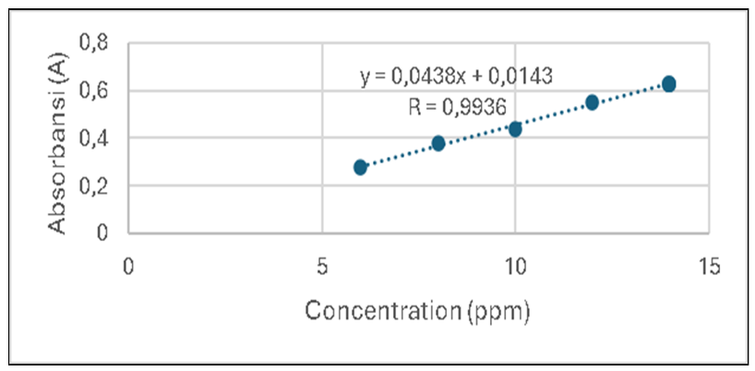
Figure 1a. Standard curve for flavonoids (TFC)

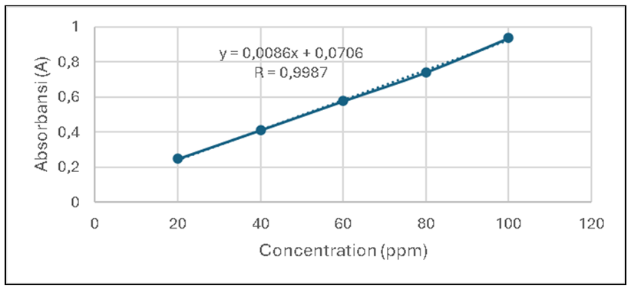
Figure 1b. Standard curve for tannins (TTC)

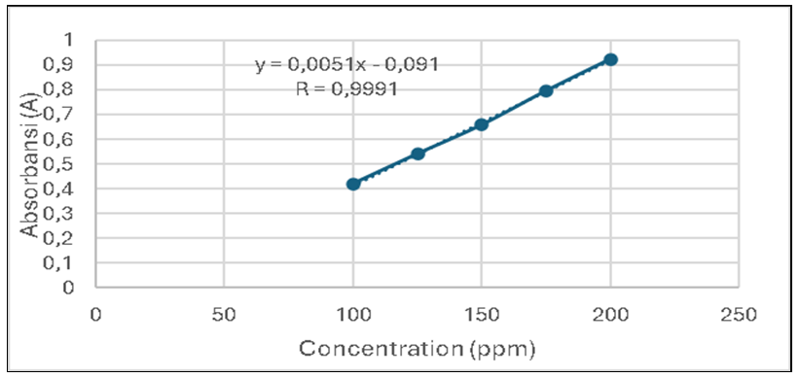
Figure 1c. Standard curve for saponins (TSC)

3.3. Zone of Inhibition Diameter (ZID)
The zone of inhibition diameters (ZIDs) of the ethanolic extract of cherry tree leaves against B. cereus with the treatment of extract concentrations of 15, 25 and 35% respectively had ZIDs of 4.92 ± 0.005 mm, 5.63 ± 0.004 mm, and 7.02 ± 0.02 mm, the positive control had a ZID of 6.182 ± 0.04 mm and the negative control was 0 ± 0 mm. The ethanolic extract of cherry tree leaves against E. coli with the treatment of extract concentration of 15, 25, and 35% respectively showed ZID of 3.55 ± 0.05 mm, 4.19 ± 0.05 mm, and 5.31 ± 0.04 mm, the positive control had a ZID of 7.83 ± 0.18 mm and the negative control ZID was 0 ± 0 mm (Table 4, Figure 2).
Extract concentrations of 15%, 25%, and 35% against B. cereus and E. coli show significant differences in results. The ZID is proportional to the increase of extract concentration. The concentration of 15% extract of cherry tree leaves against B. cereus is considered as “weak” in inhibiting the bacteria, while concentrations of 25% and 35% are considered as “moderate”. The concentration of 15% and 25% of ethanol extract of cherry leaves against E. coli is considered as “weak” in inhibiting the bacteria, while concentration of 35% is considered as “moderate”. This is following the research of Indriani et al., (2020) that the antibacterial ability of a plant sample is assessed based on the ZID which is divided into four categories, namely weak (<5 mm), moderate (5-10 mm), strong (11-20 mm), and very strong (˃20 mm).

Table 4. ZID of the ethanolic extract of the plant leaf against B. cereus and E. coli
Treatments | Diameter (mm)
 | B. cereus | E. coli
K+ (cotrimoxazole 0.48%) | 6.182 ± 0,04^{d} | 7.83 ± 0.18e
K- (DMSO 10%) | 0 ± 0ª | 0 ± 0ª
Leaf extract 15% | 4.92 ± 0.005^{b} | 3.55 ± 0.05^{b}
Leaf extract 25% | 5.63 ± 0.004^{c} | 4.19 ± 0.05^{c}
Leaf extract 35% | 7.02 ± 0.02e | 5.31 ± 0.04^{d}
Note: numbers with the same alphabet showed no significant difference between treatments at the level of confidence of 95% (P = .05) and n = 5.

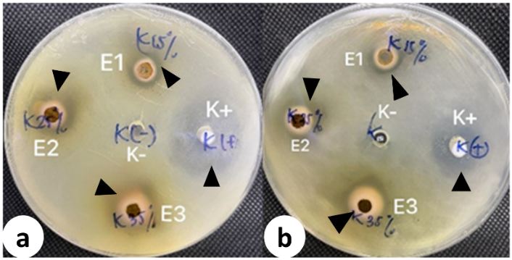
Figure 2. ZID of the cherry tree leaf extracts against (a) B. cereus and (b) E. coli. Arrowheads are the inhibition zones of the treatments against B. cereus and E. coli. K(+): positive control (Cotrimoxazole 0.48%), K(-): negative control (DMSO 10%), E1: Leaf extract 15%, E2: Leaf extract 25%, E3: Leaf extract 35%
The mechanism of action of flavonoids as antibacterials is to damage the cytoplasmic membrane and bacterial cell walls. Flavonoids targeted phospholipids in the bacterial cytoplasmic membrane so that phospholipids cannot maintain the cell membrane which results in cell leakage. Cell leakage in the cytoplasmic membrane causes substances needed by bacteria in metabolism to be wasted so that bacterial death occurs. Flavonoids react with lipids and amino acids which are the components of the bacterial cell wall so that the bacterial cell wall is damaged. Damage to the bacterial cell wall causes flavonoid compounds to enter the bacterial cell and react with DNA so that damage occurs to the DNA lipid structure and then the bacteria lyse (Amanda et al., 2019).
The mechanism of tannins in inhibiting bacterial growth is by inhibiting the reverse transcriptase enzyme and DNA topoisomerase so that bacterial cell formation is not formed. In addition to inactivating microbial cell adhesins and enzymes, tannins can interfere with protein transport in the inner layer of cells. Tannins also attack the peptidoglycan of the bacterial cell wall so that the formation of the cell wall is imperfect. An imperfect cell wall causes lysis due to differences in osmotic and physical pressure so bacteria die (Sarijowan et al., 2022).
The mechanism of saponin is to react with porins (transmembrane proteins) on the outer membrane of the bacterial cell wall, forming strong polymer bonds that result in damage to the porins (Rahmawatiani et al., 2020).

3.4. Minimum Inhibitory Concentration (MIC)
The concentration of 1.5% ethanol extract of cherry tree leaves was able to inhibit the growth of B. cereus (Figure 3) and E. coli (Figure 4) which is indicated by the absence of bacterial colony growth in the medium (Table 5) while the concentration of 0.375% and 0.75% ethanol extract of cherry tree leaves shows bacterial growth on agar media. Based on the research of Weni et al. (2024) the MIC of cherry tree leaves against E. coli is at a concentration of 10% due to flavonoids, tannins, terpenoids, saponins, and polyphenols, and in the research of Rusmayanti (2013), the MIC of cherry tree leaves extract against Salmonella typhi is at 14% due to flavonoids, tannins, and saponins. Based on the results of the MIC, with a concentration of 1.5% ethanol extract of cherry tree leaves, it can inhibit the growth of B. cereus and E. coli which shows that the cherry tree leaves extract in this study has a stronger antibacterial potential than the previous research of Weni et al. (2024) and Rusmayanti (2013).

Table 5. MIC of the plant leaf ethanolic extract against B. cereus and E. coli
Treatments | Number of colonies
 | B. cereus | E. coli
K+ (cotrimoxazole 0.48%) | 0 | 0
K- (DMSO 10%) | >300 | >300
Leaf extract 0.375% | >300 | >300
Leaf extract 0.75% | >300 | >300
Leaf extract 1.5% | 0 | 0
Note: numbers are results from quintuplicates

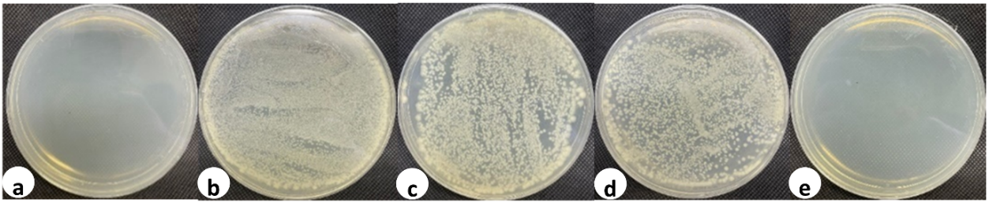
Figure 3. MIC of ethanolic extract of cherry leaves against B. cereus. (a) positive control (Cotrimoxazole 0.48%), (b) negative control (DMSO 10%), (c) leaf extract 0.375%, (d) leaf extract 0.75%, and (e) leaf extract 1.5%

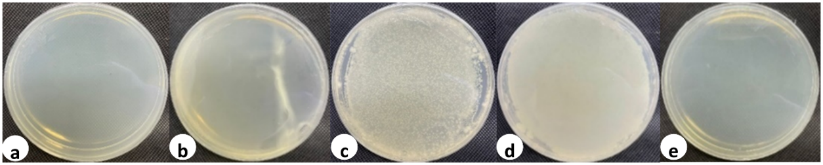
Figure 4. MIC of ethanolic extract of cherry leaves against E. coli. (a) positive control (Cotrimoxazole 0.48%), (b) negative control (DMSO 10%), (c) leaf extract 0.375%, (d) leaf extract 0.75%, and (e) leaf extract 1.5%

4. Conclusion

Cherry tree leaf extract contains flavonoids, tannins, and saponins of 78.11 mg QE/g extract, 18.20 mg TA/g extract, and 15.01 mg SE/g extract, respectively. The ZID of the cherry leaf extract at a concentration of 35% significantly inhibits both B. cereus and E. coli. The MIC of the ethanol extract of cherry tree leaves against both B. cereus and E. coli was 1.5%. Thus, the ethanol extract of cherry tree leaves has the potential to be used as an alternative antidiarrheal agent.
It is recommended that the maceration extraction method be replaced by a hot extraction method, such as reflux or Soxhlet extraction, to reduce extraction time and enhance the yield of flavonoids, tannins, and saponins.

Competing interests

The authors declare no conflict of interest regarding the publication of this research.

Authors’ Contributions

MLK designed the study, performed the laboratory works and statistical analysis, wrote the protocol, and wrote the first draft of the manuscript. PKA and EM did the analyses of the study and wrote the first draft of the manuscript. BRS did the literature review, wrote the manuscript in English. All authors read and approved the final manuscript.

Disclaimer (Artificial intelligence)
Authors hereby declare that NO generative AI technologies such as Large Language Models (ChatGPT, COPILOT, etc.) and text-to-image generators have been used during the writing or editing of this manuscript.

References

Amanda, E. A., Oktiani, B. W., and Panjaitan, F. U. A. (2019). Antibacterial effectiveness of flavonoid extract of Trigona sp (Trigona thorasica) propolis against the growth of Porphyromonas gingivalis bacteria. Journal of Dentistry 3(1): 23-28.
Anggista, G., Pangestu, I. T., Handayani, D., Yulianto, M. E., and Kusuma, S. (2019). Determination of factors influencing the extraction of ginger rhizome using a stirred extractor. Journal of Gema Teknologi 20(3): 80-84.
Anisa, N. and Najib. S. Z. (2022). Phytochemical screening and determination of total phenol flavonoid and tannin levels in cherry leaves (Muntingia calabura L.). Indonesian Journal of Pharmaceutical and Herbal Medicine 1(2): 96-104.
Asda, P. and Sekarwati, N. (2020). Handwashing behavior with soap (CTPS) and the incidence of infectious diseases in families in the Donoharjo village area, Sleman district. Nursing Media: Makassar Health Polytechnic 11(1): 1.
Durri, S. A. and Walid, M. (2024). Identification of tannin compounds and evaluation of Persea americana Mill avocado skin extract as a lotion. Journal of Clinical Pharmacy and Pharmaceutical Science 3(1): 1-9.
Emelda, A., Yuliana, D., Maulana, A., Kurniawati, T., Utamil. W. Y., Marwah, Idawati, and Novianti, L. (2023). Overview of antibiotic use in the community at the Makassar niaga daya market. Indonesian Journal of Community Dedication 5(1):13-18.
Ferdinan, A. and Natasa, E. (2024). Identification of flavonoid compounds in ethanol extract of bajakah roots (Spatholobus lirroralis Hassk.). IKIFA Pharmaceutical Journal 3(1): 54-58.
Handayani, T. W., Yusuf, Y., and Tandi, J. (2020). Qualitative and quantitative analysis of secondary metabolites of moringa seed extract (Moringa olefera Lam.) using the UV-Vis spectrophotometry method. Journal of Chemical Research 6(3): 230–238.
Hasanah, N. and Novian, D. R. (2020). Analysis of Ethanol Extract of Yellow Pumpkin Fruit (Cucurbita moschata D.). Journal of Poltektegal 9(1): 54-59.
Indriani, V., Chiuman, L., Wijaya, L. L., Lister, G., and Grandis, L. (2020). Antibacterial effect of Curcuma zedoaria extract on Bacillus cereus and Staphylococcus epidermidis. Althea Medical Journal 7(1): 6-10.
Ita, I., Saepudin., S., and Ramdhani, H. M. (2024). Identification of Flavonoid Compound Structure from Kesum Leaves (Polygonum minus Huds.) Using Shear Reagent Method. Imelda Scientific Journal of Pharmacy 8(1): 57-68.
Kipimbob, E., Bara, R., Wowor, P. M., and Posangi, J. (2019). Antibacterial effect test of Chromodoris dianae against Escherichia coli and Staphylococcus aureus bacteria. e-Biomedik Journal 7(1):61-65.
Klau, M. H. C. and Hesturini, R. S. (2021). Effect of administration of ethanol extract of dandang gendis leaves (Clinacanthus nutans (Burm F) Lindau) on analgesic power and macroscopic appearance of the stomach of mice. Indonesian Journal of Pharmacy and Science 4(1): 6-12.
Korompis, F. C. C., Yamlean, P. V. Y., dan Lolo, W. A. (2020). Formulasi dan uji efektivitas antibakteri sediaan sabun cair ekstrak etanol daun kersen (Muntingia calabura L.) terhadap Staphylococcus epidermidis. Jurnal Ilmiah Farmasi-UNSRAT 9(1): 30-37.
Lallo, S., Lewerissa, A. C., Rafi’i, A., Usmar, Ismail, and Tayeb, R. (2019). Effect of height of growing place on antioxidant and cytotoxic activity of galangal rhizome extract (Alpinia galanga L.). MFF 23(3): 118-123.
Linder, M. C. (2006). Nutritional Biochemistry and Metabolism. UI-Press, Jakarta, p 98.
Mafruchati, M. (2023). Analysis of Chemical Materials on Embryo Development. Zifatama Jawara, Sidoarjo, p. 31.
Melvani, R. P., Zulkifli, H., and Faizal, M. (2019). Analysis of factors related to the incidence of diarrhea in toddlers in Karyajaya Village, Palembang City. Scientific Journal of Health Research 4(1): 57–68.
Ministry of Health of the Republic of Indonesia, (2008). Indonesian Herbal Pharmacopoeia 1st Edition. Ministry of Health of the Republic of Indonesia, Jakarta.
Ministry of Health of the Republic of Indonesia, (2017). Indonesian Herbal Pharmacopoeia 7th Edition. Ministry of Health of the Republic of Indonesia, Jakarta.
Ministry of Health of the Republic of Indonesia, (2020). Indonesian health profile 2019 Ministry of Health of the Republic of Indonesia. https://pusdatin.kemkes.go.id
Muadifah, A., Putri, A. E., and Latifah, N. (2019). Activity of turmeric rhizome extract gel (Curcuma domestica Val.) Against Staphylococcus aureus bacteria. Jurnal SainHealth 3(1): 45-54.
Mutiara, A., Zuhrotun, A., and Astrini, D. (2022). The main bacteria causing food poisoning outbreaks. Jurnal Pharmasi Klinik Indonesia 11(3): 239-255.
Neal, M. J. (2006). Medical Pharmacology at A Glance, 5th Edition. Willey: Germany, p. 26.
Ningsih, I. S., Chatri, M., Advinda, L., and Violita. (2023). Active flavonoid compounds found in plants. Serambi Biologi 8(2): 126-132.
Nofita, D. and Dewangga, R. (2022). Optimization of the comparison of ethanol-water solvents on tannin content in matoa leaves (Pometia pinnata J.R & G. Forst) by spectrophotometry. Chimica et Natura Acta 9(3): 102-106.
Nurjannah, I., Mustariani, B. A. A., and Suryani, N. (2022). Phytochemical screening and antibacterial test of a combination of kaffir lime leaves (Citrus hystrix) and Moringa leaves (Moringa oleifera L.) as active substances in antibacterial soap. Journal of Chemistry and Education Chemistry 4(1): 23-26.
Rahmawatiani, A., Mayasari, D., and Narsa, A. C. (2020). Antibacterial activity of suruhan herb extract. Unmul Pharmacy Journal 117: 124.
Robinson, T. (1991). The Organic Constituents of Higher Plants. 6th Edition. University of Massachusetts, USA, p. 311.
Rusmayanti, N. L. 2013. Ekstrak Etanol Daun Kersen (Muntingia calabura) sebagai Antimikroba Terhadap bakteri Salmonella Typhi Secara In Vitro. Skripsi, Program Studi Pendidikan Dokter, Fakultas Kedokteran, Universitas Brawijaya, Malang.
Safitri, Y. D., Azizah, Y. D. N., and Nurjanah, M. H. (2024). Minimal Inhibitory Concentration (MIC) and Minimal Bacterial Concentration (MBC) of clove stem decoction (Syzgium aromaticum) against Bacillus cereus Causes Diarrhea. Journal of Pharmaceutical Sciences 5(2): 163-169.
Sari, D. P. and Basyarahil, B. A. (2021). Analysis of inhibition zone of broccoli (Brassica L. var. italica) extract against Staphylococcus aureus bacteria. Indonesian Journal Pharmaceutical amd Herbal Medicine 1(1): 34-38.
Sari, Y., Syahrul, and Iriani, D. (2021). Phytochemical screening and antioxidant activity of kijing (Pilsbryoconcha sp) with different solvents. Indonesian Journal of Agricultural Technology and Industry 13(1): 16-20.
Sarijowan, T. P. D., Bodhi, W., and Lebang, J. S. (2022). Antibacterial activity test of African leaf extract against the growth of Staphylococcus aureus and Pseudomonas aeroginosa bacteria. Pharmacon 11(4): 1678-1685.
Thompson, E. B. (1985). Drug Bioscreening. Graceway Publishing Company, USA, p. 88.
Weni, M., Marfuati, S., Fauzah, S. N., and Affandi, T. T. (2024). Antibacterial activity test of ethanol extract of cherry leaves (Muntingia calabura L.) against Escherichia coli bacteria. Tunas Medika Journal of Medicine & Health 10(3): 1-7.
WHO. 2017. Diarrhoeal disease. World Health Organization. https://www.who.int/newsroom/fact-sheets/detail/diarrhoeal-disease.

