**Evaluation of *Curcuma longa* extract as a natural alternative to Eosin stain forHemoparasite diagnosis**

**Abstract**

*Curcuma longa* L., a medicinal herb from the Zingiberaceae family, is widely known for its antioxidant, anti-inflammatory, hepatoprotective, and antimicrobial properties. This study evaluates the efficacy of *C. longa* extract as an eco-friendly, cost-effective, and sustainable alternative to eosin for staining blood smears, specifically for detecting *Babesia gibsoni*. Ethanolic extraction was performed using 70% ethanol as a solvent to obtain the dye from *C. longa* rhizomes. Blood smears were stained with different concentrations of the extract and counterstained using various methods. The highest diagnostic clarity was achieved using 5% *C. longa* extract for 5 minutes, followed by Field Stain A for 10 minutes. This combination produced well-differentiated red blood cells (RBCs), white blood cells (WBCs), and *Babesia gibsoni*, demonstrating its potential as a reliable diagnostic staining protocol. Compared to conventional eosin, curcumin offers distinct advantages due to its natural origin, non-toxicity, and biodegradability, supporting its suitability for routine and resource-limited diagnostic applications.

**Key words**: *C. longa*, stain, Hemoparasite diagnosis, blood smear and ethanol

**Introduction**

Curcuma longa L., commonly known as turmeric, is a rhizomatous herbaceous perennial from the Zingiberaceae family, extensively cultivated in tropical and subtropical regions, especially in India and Southeast Asia. Traditionally revered in Ayurvedic and Chinese medicine, C. longa has long been used for its broad spectrum of bioactive properties, including antioxidant, anti-inflammatory, hepatoprotective, and antimicrobial effects (Kumar et al., 2014). The vibrant yellow pigment derived from its rhizome, primarily curcumin, has found diverse applications, not only as a culinary spice and food colourant but also as a natural dye in the textile and cosmetic industries.

In recent years, interest in the application of C. longa as a biological stain has grown, particularly in the context of sustainable and eco-friendly alternatives to synthetic laboratory reagents. Conventional stains such as eosin, widely used in histology and haematology for cytoplasmic and background staining, are associated with several limitations. These include photobleaching, potential toxicity, high procurement costs, and dependency on importation or commercial supply chains (Fisher et al., 2008; Herculano et al., 2013; Sarode et al., 2022). Moreover, the growing emphasis on green chemistry and low-cost diagnostics has intensified the search for natural, non-toxic alternatives.

Curcumin, the principal curcuminoid of C. longa, exhibits inherent fluorescence and strong affinity for cellular components, making it a promising candidate for use in microscopy. Several studies have demonstrated its effectiveness in staining collagen fibres, erythrocytes, and other cellular elements with reasonable specificity and stability (Bassey et al., 2012; Rubina et al., 2023; Suryawanshi et al., 2017). Furthermore, curcumin's low environmental impact and safety profile support its potential as a substitute for eosin in diagnostic staining (Dey et al., 2025).

Despite these promising findings, limited studies have evaluated the comparative staining efficiency of C. longa extract against synthetic eosin across animal species. This study aims to bridge that gap by systematically assessing the staining efficacy of purified ethanolic C. longa extract on blood smears from different animals. The performance of the natural stain is evaluated in terms of staining intensity, clarity, and cytoplasmic definition, with eosin serving as the standard comparator. The study also highlights the practical benefits of using a locally available, cost-effective, and environmentally sustainable staining agent, particularly in resource-limited settings.

**Materials and Methods**

The experimental study was conducted in the Department of Veterinary Epidemiology and Preventive Medicine, College of Veterinary and Animal Sciences Pookode, Wayanad.

**Method employed for turmeric dye preparation**

The rhizomes of *Curcuma longa* were collected, cut into small pieces, and finely milled into powder. Precisely 2.5 g, 5 g, and 7.5 g of the powdered sample were weighed using an electronic balance and dissolved in 50 mL of 70% ethanol. The mixture was homogenized using a magnetic stirrer for 1 hour, followed by centrifugation at 3000 rpm for 5 minutes. The supernatant was carefully collected and filtered through Whatman No.1 filter paper. The resulting staining solutions are presented in Figures 1, 2, and 3.

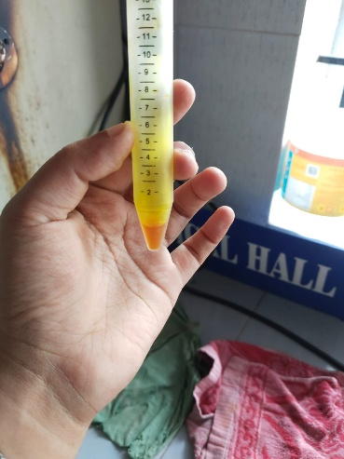 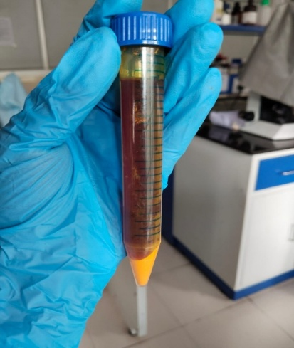 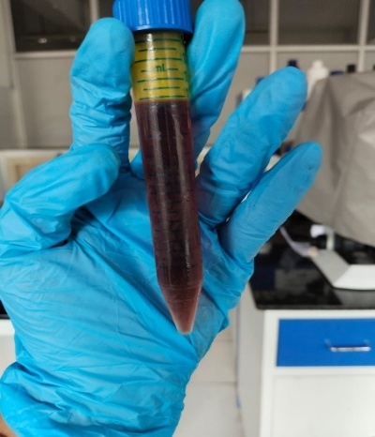

**Fig.1:** 5% curcumin stain prepared

**Fig.3**: 15% curcumin stain prepared

**Fig.2**: 10% curcumin stain prepared

**Staining Procedure**

Blood smears were obtained from clinically normal animals (n=10) and animals diagnosed with *Babesia gibsoni* infection (n=5) at the Teaching Veterinary Clinical Complex (TVCC), Pookode. The staining protocol was adapted from Avwioro et al. (2007) and Kumar et al. (2014), with minor modifications. The smears were initially fixed with methanol and subsequently stained using varying concentrations of *Curcuma longa* extract and different staining durations, as outlined in Table 1. Following curcumin staining, the smears were counterstained with Field Stain A (methylene blue and azure dissolved in phosphate buffer), Loeffler’s Alkaline Methylene Blue (LAMB), and Methylene Blue Aqueous, as detailed in Table 2. After washing, the smears were air-dried and examined under an oil immersion objective for microscopic evaluation.

**Results**

**Staining Performance of Different Curcumin Extract Concentrations and Counterstains**

The staining quality of blood smears varied depending on the concentration of *Curcuma longa* extract and staining duration (Table 1). At 5% curcumin extract, optimal staining was observed at 5 minutes, whereas shorter durations (2 minutes) resulted in poor staining, and longer durations (10 minutes) led to overstaining. Higher concentrations (10% and 15%) consistently caused overstaining across all time points, suggesting that increased curcumin concentration reduces precision in stain differentiation.

Further evaluation of the 5% curcumin extract in combination with conventional counterstains (Table 2) revealed that Loeffler’s Alkaline Methylene Blue (LAMB) and Methylene Blue Aqueous resulted in poor staining across all time points. In contrast, Field Stain A provided improved staining quality, with a 5-minute duration yielding fair staining, 10 minutes achieving optimal staining, and 15 minutes leading to overstaining. These findings highlight the potential of curcumin as a hematological staining agent while emphasizing the need for precise concentration and duration adjustments to achieve optimal staining quality.

**Table 1.** staining qualities of different concentration of curcumin extract in different time

|  |  |  |  |
| --- | --- | --- | --- |
| **Time** | **5% Curcumin extract** | **10% Curcumin extrac**t | **15% Curcumin extract** |
| 2 min | Poor staining | Over stained | Over stained |
| 5 min | Good staining | Over stained | Over stained |
| 10 min | Over stained | Over stained | Over stained |

**Table 2.** 5% Curcumin extract – Other stain combinations used

|  |  |  |  |
| --- | --- | --- | --- |
| **Stain used** | **5 min** | **10 min** | **15 min** |
| Loeffler’s Alkaline methylene blue (LAMB) | Poorly stained | Poorly stained | Poorly stained |
| Methylene Blue aqueous | Poorly stained | Poorly stained | Poorly stained |
| Field stain A | Fairly stained | Good | Over stained |

**Staining Characteristics of *Curcuma longa* Extract in Hematological Smears**

The staining efficiency of *Curcuma longa* extract varied with concentration, staining duration, and counterstaining method, significantly influencing the differentiation of blood cell components and hemoparasites. Optimal staining was achieved at 5% curcumin extract for 5 minutes. The red blood cells (RBCs) exhibit a greenish tint, indicating the influence of a specialised staining technique that differs from conventional eosin-based methods. *Babesia* organisms appear as distinct blue to purple structures, likely due to selective uptake of a methylene blue-based counterstain, enhancing their contrast against the RBC background. (Fig.12).

**Effect of Concentration and Staining Duration on Staining Efficacy**

Lower concentrations (5%) of *Curcuma longa* extract applied for shorter durations resulted in understaining, reducing the visibility of RBCs, white blood cells (WBCs), and *Babesia gibsoni*. Smears treated with 5% curcumin for 2 minutes followed by Loeffler’s Alkaline Methylene Blue (LAMB) for 5 minutes exhibited weak staining, limiting the differentiation of cellular structures (Figure 4). Similarly, 10% curcumin for 2 minutes followed by Field Stain A for 5 minutes produced lightly stained smears with poor contrast (Figure 11).

Conversely, higher curcumin concentrations (10%,15%) and prolonged staining durations (10 minutes) resulted in overstaining, leading to intense RBC coloration (yellowish-green) and reduced contrast between cellular components. Smears stained with 10% curcumin for 5 minutes and aqueous methylene blue for 10 minutes exhibited excessive RBC staining, whereas WBCs remained unstained (Figure 8). A similar trend was observed in smears treated with 15% curcumin for 10 minutes, where the intensified staining compromised hemoparasite visualization (Fig. 9).

**Evaluation of Counterstains**

The counterstaining method significantly influenced staining contrast and the ability to differentiate *Babesia gibsoni* from RBCs. Among the evaluated counterstains (Table 2), Field Stain A at 10 minutes provided the most distinct staining contrast, where RBCs retained a greenish colour while *Babesia gibsoni* appeared dark bluish (Fig.12). In contrast, smears counterstained with LAMB or aqueous methylene blue exhibited poor contrast, with RBCs appearing faintly stained and hemoparasite morphology remaining indistinct.

**Optimal Staining Protocol for Hemoparasite Visualization**

The highest diagnostic clarity was achieved using 5% *Curcuma longa* extract for 5 minutes, followed by Field Stain A for 10 minutes (Figure 12). This staining combination produced well-differentiated RBCs, WBCs, and *Babesia gibsoni*, demonstrating its suitability as a diagnostic tool. A reference smear stained with Giemsa (Figure 13) exhibited standard staining characteristics, serving as a comparison for the curcumin-based protocol.

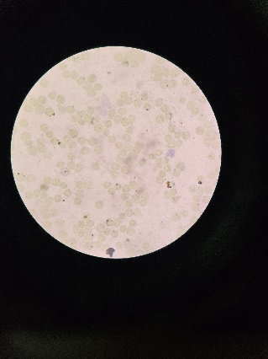 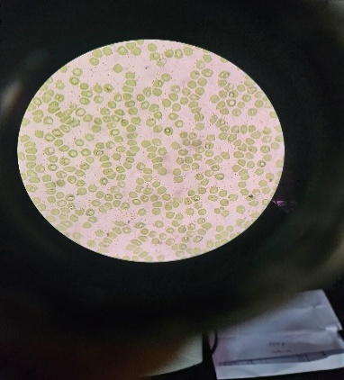 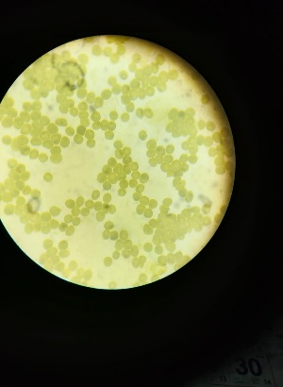

**Fig.4**: 5%curcumin for 2 min, LAMB for 5 min

**Fig.5**: 5% curcumin for 5 minutes and LAMB for 15 minutes

**Fig.6**: 15%curcumin for 10 minutes and LAMB for 10 minutes

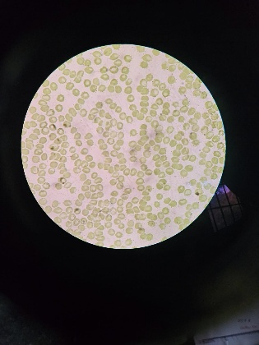 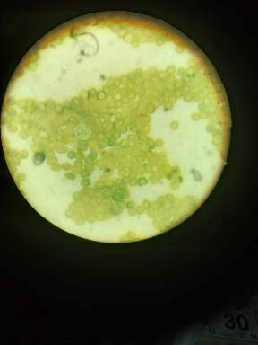 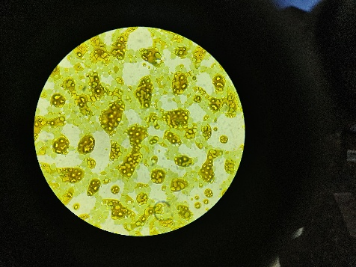

**Fig.8**: 10% curcumin for 5 minutes and aq. methylene blue for 10 minutes

Fig.7:5%curcumin for 15 minutes and aq. Methylene blue for 15 minutes

**Fig. 9**:15% curcumin for 5 minutes and aq. Methylene blue for 10 minutes

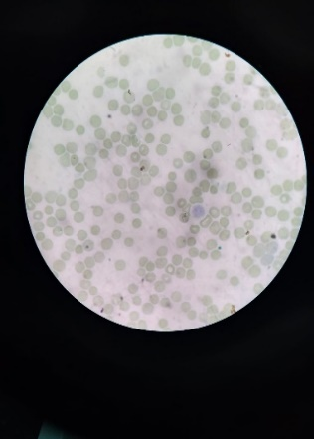 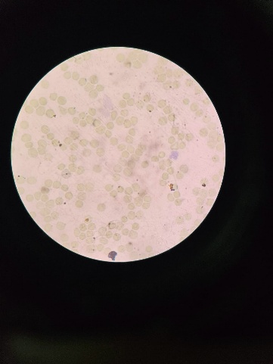

**Fig.10**: 5% curcumin for 2 minutes and field stain A for 5 minutes

**Fig.11**: 10% curcumin for 2 minutes and field stain A for 5 minutes

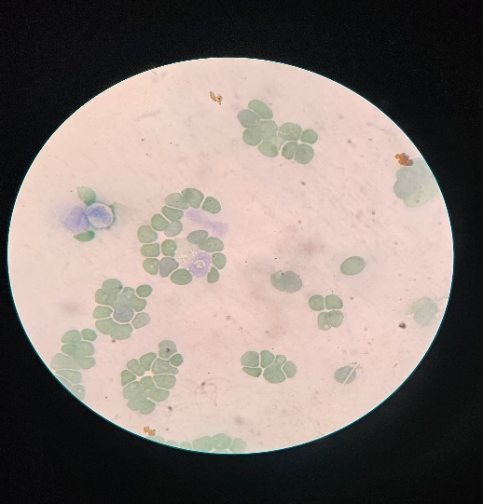 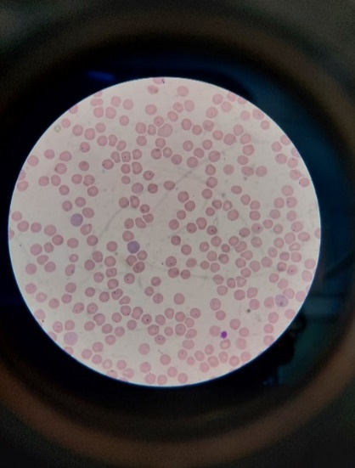

**Fig.12**: 5% curcumin for 5 minutes and field stain A for 10 minutes

**Fig.13**: staining of blood smear with Giemsa staining

**Discussion**

The present study evaluated the staining efficacy of *Curcuma longa* extract as a natural hematological stain for blood smears, particularly for the differentiation of blood cell components and *Babesia gibsoni*. Our findings indicate that a 5% curcumin extract applied for 5 minutes yielded optimal staining quality, balancing clarity and contrast. The observed greenish tint of red blood cells (RBCs) is a unique characteristic of curcumin staining, differing significantly from conventional eosin-based staining methods. This suggests curcumin’s potential applicability in hematological diagnostics, particularly as an alternative to synthetic stains.

**Comparative Analysis with Conventional Staining Methods**

Counterstaining played a crucial role in optimizing contrast and enhancing hemoparasite visualization. Among the tested counterstains, Field Stain A, applied for 10 minutes provided superior contrast, facilitating the distinct visualization of *Babesia gibsoni* as dark bluish structures against a greenish RBC background. In contrast, Loeffler’s Alkaline Methylene Blue (LAMB) and aqueous methylene blue resulted in poor contrast and inadequate hemoparasite differentiation. These findings align with previous studies demonstrating that counterstains significantly influence staining precision in diagnostic hematology (Grosset et al., 2019).

Compared to Giemsa staining, the gold standard for hemoparasite identification, curcumin-based staining showed comparable differentiation when paired with optimal counterstains. Prior research has highlighted the potential of natural stains in diagnostic microscopy, with curcumin exhibiting promising results due to its bioactive properties and selective staining ability (Kumar et al., 2021). However, further validation across a broader range of hemoparasites and hematological disorders is necessary to establish curcumin’s reliability as a routine diagnostic stain.

**Effect of Concentration and Staining Duration**

Our findings indicate that curcumin concentration and staining duration are critical determinants of staining quality. Lower concentrations (5%) with shorter durations (2 minutes) resulted in inadequate staining, leading to poor visualization of RBCs, white blood cells (WBCs), and *Babesia gibsoni*. Conversely, higher concentrations (10%, 15%) and extended durations (10 minutes) led to overstaining, where excessive RBC coloration reduced hemoparasite contrast. These findings are consistent with prior studies demonstrating the concentration-dependent staining properties of plant-derived dyes (Adeyemo et al., 2017;Mulla et al., 2023).

**Mechanism of Staining**

The staining specificity of *C. longa* extract is likely influenced by its acidic properties, as it selectively stains basic cellular structures. The bioactive component, curcumin (diferuloylmethane), exhibits polyphenolic characteristics, allowing effective interaction with cellular proteins (Hope-Roberts and Horobin, 2017). Previous studies have reported that natural phenolic compounds exhibit pH-insensitive staining mechanisms, further supporting curcumin’s potential as a stable alternative to eosin (Avwioro et al., 2007). Unlike eosin-stained smears, which may undergo photobleaching over time, curcumin’s inherent fluorescence confers long-term stability, making it advantageous for prolonged sample storage and analysis (Wittekind, 2003).

Despite the promising results, the study has several limitations. First, staining efficacy was evaluated only for *Babesia gibsoni*; further studies are required to assess its applicability in detecting other hemoparasites and hematological abnormalities. Second, the stability of curcumin-stained smears under varying storage conditions remains unknown and warrants further investigation. Additionally, inter-laboratory validation is necessary to confirm reproducibility across diverse diagnostic settings. Future research should also explore the molecular interactions of curcumin with blood cell components to elucidate the underlying staining mechanisms.

**Conclusion**

This study highlights the potential of *Curcuma longa* extract as a hematological stain, particularly when combined with Field Stain A as a counterstain. The optimized protocol (5% curcumin for 5 minutes, followed by Field Stain A for 10 minutes) demonstrated effective differentiation of *Babesia gibsoni* from RBCs, underscoring its applicability as an alternative diagnostic tool. However, further validation and standardization studies are essential before widespread implementation in clinical and veterinary hematology. The advantages of curcumin staining, including its non-toxic nature, environmental sustainability, and stability, support its potential integration into diagnostic laboratories. Nevertheless, optimization efforts should continue to refine its staining performance to match or surpass conventional eosin-based methods.

**Disclaimer (Artificial intelligence)**

Author(s) hereby declares that NO generative AI technologies such as Large Language Models (ChatGPT, COPILOT, etc.) and text-to-image generators have been used during the writing or editing of this manuscript.

**References**

* Adeyemo, S. M., Akinloye, A. J., & Adenkanmi, G. B. (2017). The use of plant dyes for microbial staining and identification: An eco-friendly and non-toxic alternative method. *Journal of Advances in Biology and Biotechnology*, *16*(4), 1–10.
* Avwioro, O. G., Onwuka, S. K., Moody, J. O., Agbedahunsi, J. M., Oduola, T., Ekpo, O. E., & Oladele, A. A. (2007). *Curcuma longa* extract as a histological dye for collagen fibres and red blood cells. *Journal of Anatomy*, *210*(5), 600–603.
* Bassey, R., Oremosu, A., & Osinubi, A. (2012). *Curcuma longa: Staining effect on histomorphology of the testis*. Macedonian Journal of Medical Sciences, 5(1), 26–29.
* Bondoc. C.C. (2018). Curcuma longa Linn rhizome extract as an alternative stain for histological studies. *Journal of Pharmacognosy and Phytochemistry*, 7(5),3010-3017.
* Dey, P., Dey, P., Hoque, M. B., et al. (2025). Sustainable and eco-friendly natural dyes: A holistic review on sources, extraction, and application prospects. *Textile Research Journal, 0*(0).
* Fisher, H. A., Jacobson, K. A., Rose, J., & others. (2008). Hematoxylin and eosin staining of cell and tissue sections. *Cold Spring Harbor Protocols, 2008*, pdb.prot4986.
* Grosset, A. A., Loayza-Vega, K., Adam-Granger, É., Birlea, M., Gilks, B., Nguyen, B., Soucy, G., Tran-Thanh, D., Albadine, R., & Trudel, D. (2019). Hematoxylin and eosin counterstaining protocol for immunohistochemistry interpretation and diagnosis. *Applied Immunohistochemistry & Molecular Morphology*, *27*(7), 558–563. <https://doi.org/10.1097/PAI.0000000000000626>
* Herculano, L. S., Malacarne, L. C., Zanuto, V. S., Lukasievicz, G. V., Capeloto, O. A., & Astrath, N. G. (2013). Investigation of the photobleaching process of eosin Y in aqueous solution by thermal lens spectroscopy. *The Journal of Physical Chemistry B, 117*(6), 1932–1937.
* Hope-Roberts, M., & Horobin, R. W. (2017). A review of curcumin as a biological stain and as a self-visualizing pharmaceutical agent. *Biotechnic & Histochemistry*, *92*(5), 315–323.
* Kumar, S., Singh, N. N., Singh, A., Singh, N., & Sinha, R. K. (2014). Use of *Curcuma longa* L. extract to stain various tissue samples for histological studies. *AYU: An International Quarterly Journal of Research in Ayurveda*, *35*(4), 447–451.
* Mulla, S. A., Bhattacharjee, M., Shrivastava, S., & Panchmahalkar, A. (2023). Natural staining-aided cytology: A potential ally of pathologists for early diagnosis of pathological lesions in remote and unequipped setups. *Journal of Oral and Maxillofacial Pathology*, *27*(4), 746–747.
* Rubina, M.P., Sukesh, Soumya, V., Safeer, T.K., & Basheer, K.B. (2023). The effect of curcuma longa extract and significance of mordant as an alternative for eosin in H and E: A comparative study. *Indian Journal of Pathology and Microbiology*,66,697-701.
* Sarode, S. A., Pradeep, G. L., Prakash, N., Mahajan, A., & Mangle, N. (2022). Exploring a safer alternative to eosin in soft tissue staining. *Journal of Oral and Maxillofacial Pathology, 26*(4), 603.
* Suryawanshi, H., Naik, R., Kumar, P., & Gupta, R. (2017). *Curcuma longa* extract – Haldi: A safe, eco-friendly natural cytoplasmic stain. *Journal of Oral and Maxillofacial Pathology*, *21*(3), 340–344.
* Wittekind, D. (2003). Traditional staining for routine diagnostic pathology including the role of tannic acid. 1. Value and limitations of the hematoxylin–eosin stain. *Biotechnic & Histochemistry*, *78*(5), 261–270.