**Bio-efficacy of organic and natural products against *Rhizoctonia solani* causing banded leaf and sheath blight of maize (*Zea mays* L.)**

**ABSTRACT**

Banded leaf and sheath blight (BLSB), primarily caused by the necrotrophic soil-borne fungus Rhizoctonia solani, significantly affects the yield and quality of maize (*Zea mays* L.). Managing banded leaf and sheath blight with organic and natural products offers environmental benefits, reduces resistance development, and alignment with consumer demand for pesticide-free produce. It also promotes soil health, biodiversity, and sustainability in farming, offering an eco-friendly alternative to chemical treatments. Six natural/organic products *viz.,* Eupatorium ark, Dashparni, Khatti lassi, Matkakhad, Ghanjeevamrit and Compost tea, procured from Department of Organic Agriculture, COA, CSKHPKV, Palampur were tested at 10, 20, 30, 40 and 50 per cent concentrations against *Rhizoctonia solani* using Poisoned Food Technique. All the products inhibited mycelial growth. Highest mycelial growth inhibition was observed at 50 per cent concentration of each product ranging from 27.78 in compost tea to 100 per cent in Eupatorium ark, Dashparni and Khatti lassi.

**Keywords**: Banded leaf and sheath blight, Organic and natural inputs, *Rhizoctonia solani,* eco-friendly.

1. **INTRODUCTION**

“Maize (*Zea mays* L.), also referred to as corn and commonly known as Makka or Makai in Hindi, is among the most significant cereal crops in the global agricultural economy. Maize is believed to have originated in the tropical regions of south-central or south western Mexico. The crop is known as the "queen of cereals" due to its exceptional yield potential. In India, a significant portion of maize production is utilized for human consumption. It is cultivated extensively around the globe for use as food for humans and feed for animals. The Ministry of Agriculture and Farmers Welfare has released first advance estimates for production of *Kharif* crops for the year 2024-25. The total *Kharif* food grains production is estimated at 1647.05 Lakh Metric Tonnes (LMT), with maize accounting for 245.41 LMT” (Ministry of Agriculture & Farmers Welfare, 2024).

“Among all the diseases which infect maize, banded leaf and sheath blight (BLSB), caused by Rhizoctonia solani f. sp. sasakii Kühn, has emerged as a serious concern in recent years. The severity of losses depends on the level of disease intensity, susceptibility of the host and environmental factors. Grain losses can reach up to 100 per cent when the ear rot phase of BLSB dominates under continuous rainfall conditions” (Lu et al. 2012). “Banded leaf and sheath blight (BLSB) of maize, a soil-borne disease has been reported in multiple maize-growing countries” (Singh and Shahi 2012). “Maize requires a significant number of mineral fertilizers and absorbs more nutrients than other cereal crops during its growth period” (Yadav et al. 2023). “In regions with high yields, where seed maize production surpasses 16 tons per hectare, it can consume 250–300 kg of nitrogen per hectare” (Biswas et al. 2022). “This often compels farmers to excessively apply chemical fertilizers to maximize seed yields. However, the heavy reliance on chemical fertilizers can negatively impact soil health, raise environmental concerns, and diminish economic returns due to the high costs of inputs” (Chen et al. 2022).

“Combining organic compost with chemicals has proven to be an effective strategy for sustainable agricultural production systems in various countries” (Etesami et al. 2023). “The use of soil fumigants and fungicides to control soil borne pathogens is reduced due to awareness of their negative impacts. Since ancient times, organic inputs have played a significant role in crop management. The use of traditional organic inputs is also discussed in the Vedas, Arthashastra, Agnipuran, and Surapalas Vrukshayurveda for the management of a number of soil and seed borne plant diseases. Various organic composts showed antifungal activity against soil-borne and foliar pathogens. Aqueous extracts of vermicompost and organic compost inhibited the mycelial growth of *Botrytis cinerea*, *S. sclerotiorum*, *Sclerotium rolfsii*, *Rhizoctonia solani* and *Fusarium oxysporum* f.sp. *lycopersici* under *in vitro* conditions” (Nakasone et al. 1999).

Karthika et al. (2017) evaluated “the antifungal potential of selected organic preparations, botanicals and non-hazardous chemicals under *in vitro* conditions against *Rhizoctonia solani* causing sheath blight in rice. A total of twenty treatments were tested for their efficacy in inhibiting the mycelial growth of *R. solani*. Among the treatments, six treatments *viz*., garlic extract (10%), fermented weed (*Setaria barbata*) extract (100%), fermented egg- lemon juice extract (10%), potassium silicate (1%), lime solution (12.5%) and panchagavya (5%) showed inhibition against *R. solani* in potato dextrose agar medium. Further, dipping the sclerotia for different time intervals in the most effective six treatments with fermented egg-lemon juice extract (10%), fermented weed extract (100%), lime solution (12.5%) and panchagavya (5%) completely inhibited the mycelial regeneration from sclerotia”.

The organic amendments provide an effective non-chemical, cost friendly method to control the black scurf disease of potatoes. It was observed that Vermi-compost, a soil amendment was able to control disease up to 40.00 and 50.01 per cent at doses of 10 and 20 g/kg soil/pot, respectively, followed by Neem cake (35.01 and 45%) and mustard cake (25 and 30%), whereas spent mushroom compost (10 and 15%) and farmyard manure (15 and 20.01%) recorded the lowest levels of disease control, respectively (Kumar and Kumar 2018). González et al. (2021) confirmed the positive effect of Compost Tea (CT) application on total biomass and pepper fruit production and for its direct implication for the control of pathogen development by causing a reduction of both *P. capsici* and *R. solani* *in vitro* and *in vivo* assays. The rich abundance of microbiota in the CT induced a reduction in the relative growth rate of both *P. capsici* and *R. solani* (31.7% and 38.0%, respectively) *in vitro* assays compared to control. Hence, the present investigation was carried out to evaluate various organic and natural inputs against *Rhizoctonia solani.*

1. **MATERIALS AND METHODS**

**2.1 Isolation and purification of the pathogen**

The pathogen of banded leaf and sheath blight of maize was isolated from diseased plants on potato dextrose agar (PDA) medium. These infected leaf sheaths were washed thoroughly in tap water and separately cut into small pieces having healthy and diseased area with the help of a sterilized blade. Infected tissues were surface sterilized in 0.1 per cent sodium hypochloride solution for half to one minute and rinsed three times in sterilized distilled water. The infected pieces were placed in between two layers of sterilized blotting sheets to remove moisture and then were transferred aseptically on solidified sterilized Potato Dextrose Agar (PDA) plates and incubated at 25±1ºC. The growing mycelium from the margin of apparently distinct colonies was sub-cultured on fresh plates containing Potato Dextrose Agar (PDA) medium. The culture was purified and was maintained in laboratory for the use throughout the investigation.

**2.2 *In vitro* evaluation of organic and natural inputs against *Rhizoctonia solani***

Six natural/organic products *viz.,* Eupatorium ark, Dashparni, Khatti lassi, Matkakhad, Ghanjeevamrit and Compost tea, procured from the Department of Organic Agriculture, COA, CSKHPKV, Palampur were tested at 10, 20, 30, 40 and 50 per cent concentrations against *Rhizoctonia solani* using Poisoned Food Technique. The experiment was conducted in completely randomized design and each treatment was replicated thrice. Seven-day-old mycelial bits of 5 mm of *R. solani* were placed in the center of plates. Each treatment was replicated thrice and incubated at 25±1°C in BOD incubator. The radial growth of the fungal colony in each Petri plate was measured and per cent inhibition was calculated by using the formula given by Vincent (1947):

I = C - T x 100

C

Where, I = Per cent mycelial inhibition of test pathogen,

C = Radial growth of pathogen (mm) in control

T = Radial mycelial growth of pathogen (mm) in treatment

* 1. **Statistical Analysis**

The data of experiments was pooled and subjected towards appropriate statistical analysis. All the data was analysed statistical by two-way ANOVA (Analysis of variance) using OPSTAT software. The significance of treatments was taken at 5 per cent level of significance. CD (Critical difference) is used to compare means of different treatments that have an equal number of replications.

1. **RESULTS AND DISCUSSION**

**3.1 Identification of Pathogen**

Isolation was made from diseased samples of banded leaf and sheath blight of maize collected from nearby vicinity of maize growing areas. Based on morphological, cultural and pathogenic characteristics, the pathogen was identified as *Rhizoctonia solani* causing banded leaf and sheath blight of maize.

**3.2 *In vitro* evaluation of organic and natural inputs**

Six natural/organic products *viz.,* Eupatorium ark, Dashparni, Khatti lassi, Matkakhad, Ghanjeevamrit and Compost tea were tested at 10, 20, 30, 40 and 50 per cent concentrations against *Rhizoctonia solani* using Poisoned Food Technique. All natural and organic products were found to have an antifungal activity against the pathogen.The radial growth was found to decrease significantly with the increase in concentration of different organic and natural products. Highest mycelial growth inhibition was observed at 50 per cent concentration of each product ranging from 27.78 in compost tea to 100 per cent in Eupatorium ark, Dashparni and Khatti lassi. Dashparni was also found to be completely inhibitory to the growth of *R. solani* at 40 per cent concentration.

Radial growth ranged from 48.87 mm (**Eupatorium ark**) to 88.00 mm (**Matkakhad**) was observed at 10 per cent concentration. At this concentration, Eupatorium ark gave maximum mycelial growth inhibition of 45.70 per cent. Matkakhad and Ghanjeevamrit were found least effective at this concentration. At 20 per cent concentration Eupatorium ark gave minimum radial growth of 38.00 mm followed by Dashparni (62.00 mm) and maximum mycelial growth inhibition between 57.77 and 31.11 per cent, respectively. Similar trends were also observed at 30 per cent concentration. At 40 per cent concentration maximum inhibition of 100 per cent was shown by Dashparni followed by Khatti lassi (57.03%). Maximum radial growth of pathogen was reported in Compost tea (69.00 mm) followed by Matkakhad (56.00 mm). At 50 per cent concentration Dashparni and Khatti lassi showed 100 per cent mycelial inhibition whereas Compost tea reported mycelial inhibition of 27.78 per cent which was the least followed by Matkakhad (53.07%).

Liu et al. (2016) investigated the antifungal activity of Eupatorium ark and found that because of its strong antibacterial and antifungal properties, it inhibits the proliferation of pathogen mycelial cells. Vermiwash, Jeevamrit, and Eucalyptus ark were tested *in vitro* against soil borne pathogen by Thakur (2022). The results showed that Eupatorium ark was the most effective, showing complete mycelium inhibition over the control at a concentration of 10 per cent, while Jeevamrit followed closely behind with 88.78 per cent mycelial inhibition over the control at a concentration of 25 per cent.

|  |  |  |  |  |  |  |  |  |  |  |  |
| --- | --- | --- | --- | --- | --- | --- | --- | --- | --- | --- | --- |
| **Treatments** | **Table 1: *In vitro* evaluation of organic and natural inputs against *Rhizoctonia solani*** | | | | | | | | | | **Mean** |
| **10** | | **20** | | **30** | | **40** | | **50** | |
| **Radial Growth (mm)\*** | **Inhibition**  **(%)** | **Radial Growth (mm)\*** | **Inhibition**  **(%)** | **Radial Growth (mm)\*** | **Inhibition**  **(%)** | **Radial Growth (mm)\*** | **Inhibition**  **(%)** | **Radial Growth (mm)\*** | **Inhibition**  **(%)** |
| **Eupatorium ark** | 48.87 | 45.70 | 38.00 | 57.77 | 28.8 | 68.00 | 25.00 | 72.22 | 19.33 | 78.51 | 32.00 |
| **Dashparni** | 78.00 | 13.33 | 62.00 | 31.11 | 47.6 | 47.11 | 0.00 | 100.00 | 0.00 | 100.00 | 37.52 |
| **Khatti lassi** | 85.66 | 4.81 | 77.26 | 14.14 | 66.67 | 25.92 | 38.66 | 57.03 | 0.00 | 100.00 | 53.65 |
| **Matkakhad** | 88.00 | 2.22 | 71.66 | 20.37 | 62.33 | 30.74 | 56.00 | 37. 78 | 41.67 | 53.70 | 63.93 |
| **Ghanjeevamrit** | 87.66 | 2.59 | 71.67 | 20.37 | 64.67 | 28.14 | 49.00 | 45. 56 | 40.34 | 54.78 | 62.67 |
| **Compost tea** | 85.33 | 5.18 | 78.00 | 13.33 | 74.00 | 17.78 | 69.00 | 23.33 | 65.00 | 27.78 | 74.27 |
| **Control** | 90.00 | - | 90.00 | - | 90.00 | - | 90.00 | - | 90.00 | - | 90.00 |
| **Mean** | 80.50 | **-** | 69.80 | **-** | 62.01 | - | 46.81 | - | 36.62 | - | 59.15 |
|  | | | **CD (p=0.05)** | **SE(m) +** |  |  |  |  |  |  |  |
| **Organic and natural products (A)** | | | 1.19 | 0.42 |  |  |  |  |  |  |  |
| **Concentrations (B)** | | | 1.01 | 0.36 |  |  |  |  |  |  |  |
| **Factor (A X B)** | | | 2.66 | 0.94 |  |  |  |  |  |  |  |

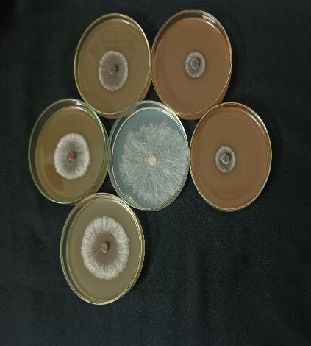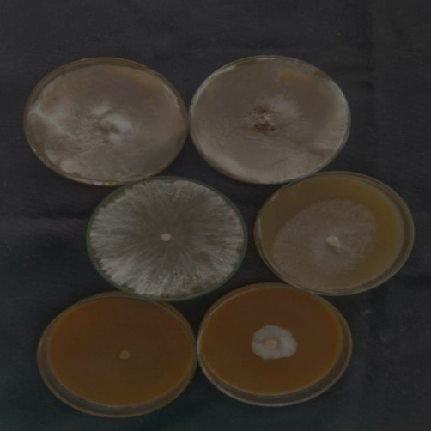

**Eupatorium ark Dashparni Khatti lassi**

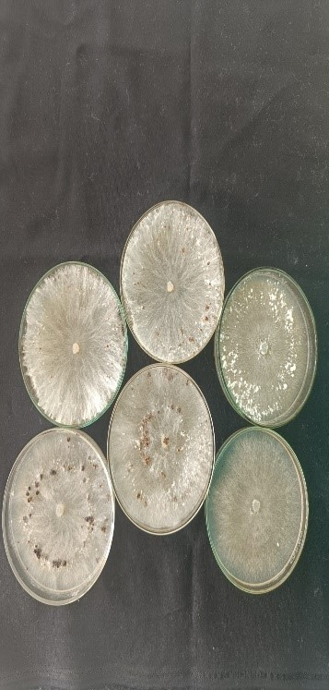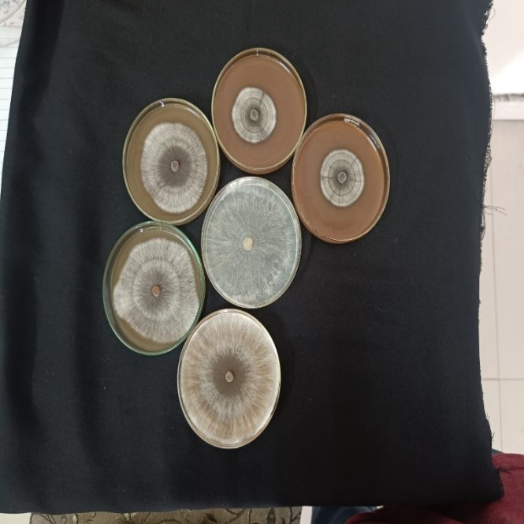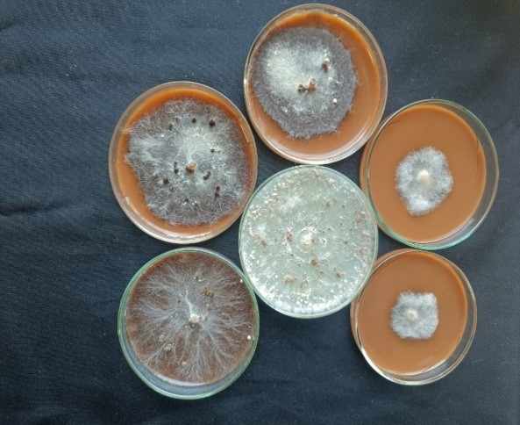

**Compost tea Ghanjeevamrit Matkakhad**

**Fig 1. Mycelial inhibition of *Rhizoctonia solani* with organic and natural inputs**

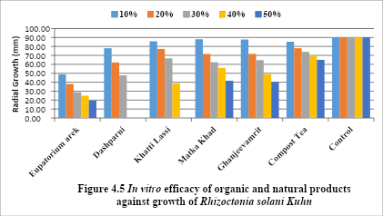

**Fig 2. Outcome of the different treatments at varying concentrations on the growth of *Rhizoctonia solani***

1. **CONCLUSION**

The present investigation highlighted the potentialities of organic and natural products in managing Banded Leaf and Sheath Blight disease of maize. Six organic inputs *viz*., Compost tea, Eupatorium ark, Ghanjeevamrit, Dashparni, Khattilassi, and Matkakhad were evaluated under *in vitro* against *R. solani*Kühnat 10, 20, 30, 40 and 50 per cent concentrations. Dashparni followed by Eupatorium ark was found to be most effective. The management of banded leaf and sheath blight (BLSB) in maize through organic and natural products offers a sustainable and environmentally responsible alternative to conventional chemical control methods. Unlike synthetic fungicides, which may contribute to chemical residues and pathogen resistance, biological control agents, plant-derived extracts, and organic amendments enhance disease suppression while preserving soil health and ecological balance. These natural interventions not only inhibit Rhizoctonia solani f. sp. sasakii but also promote beneficial microbial communities, fostering a resilient agroecosystem. Certain bioactive compounds may also trigger systemic resistance in maize, strengthening its natural defence against infection. Due to limitations of chemical fungicides and the increasing regulatory and consumer-driven demand for sustainable agriculture, the integration of organic approaches presents a viable long-term strategy for effective BLSB management.

**Disclaimer (Artificial intelligence)**

Option 1

Author(s) hereby declares that NO generative AI technologies such as Large Language Models (ChatGPT, COPILOT, etc.) and text-to-image generators have been used during the writing or editing of this manuscript.

**REFERENCES**

Biswas, R., Molla, M. M. U, Faisal-E-Alam, M., Zonayet, M., & Castanho, R. A. (2022). Profitability analysis and input use efficiency of maize cultivation in selected areas of Bangladesh. *Land*, 12(1), 23.

Chen, Y., Fu, X., & Liu, Y. (2022). Effect of farmland scale on farmers’ application behavior with organic fertilizer. *International Journal of Environmental Research and Public Health*, 19(9), 4967. <https://doi.org/10.3390/IJERPH19094967>

Erenstein, O., Jaleta, M., Sonder, K., Mottaleb, K., & Prasanna, B. M. (2022). Global maize production, consumption and trade: Trends and R&D implications. *Food Security*, 14(5), 1295–1319.

Etesami, H., Jeong, B. R., & Glick, B. R. (2023) Potential use of *Bacillus* spp. as an effective biostimulant against abiotic stresses in crops—A review. *Current Research in Biotechnology*, 5, 100128.

Karthika, S. R., Sajeena, A., Girija, V. K., John, J., & Heera, G. (2017). Antifungal activities of organic preparations, botanicals and nonhazardous chemicals against *Rhizoctonia solani* causing sheath blight of rice. *Journal of Tropical Agriculture*, 55, 104-113.

Kumar, M., & Kumar, A. (2018). Evaluation of efficacy of different organic amendments against *Rhizoctonia solani* under screen house conditions. *Journal of Pharmacognosy and Phytochemistry*, 7, 191-194.

Liu, X., Ouyang, C., Wang, Q., Li, Y., Yan, D., Yang, D., Guo, M., & Cao, A. (2016). Evaluation of antibacterial and antifungal properties of 9-oxo-10,11-dehydroageraphorone extracted from *Eupatorium adenophorum*. *Journal of Plant Disease Protection*, 123, 93-99.

Lu, Y. L., Xu, J., Yuan, Z. M., Hao, Z. F., Xie, C. X., Li, X. H., Shah, T., Lan, H., Zhang, S. H., Rong, T. Z., & Xu, Y. B. (2012). Comparative LD mapping using single SNPs and haplotypes identifies QTL for plant height and biomass as secondary traits of drought tolerance in maize. *Molecular Breeding*, 30, 407–418.

McKinney, H. H. (1923). Influence of soil temperature and moisture on infection of wheat seedlings by *Helminthosporium sativum*. *Journal of Agricultural Research*, 26, 195-217.

Singh, A., & Shahi, J. P. (2012). Banded leaf and sheath blight: an emerging disease of maize. *Maydica*, 57, 215–219.

Thakur, A. (2022). Epidemiology and management of *Stemphylium* blight of onion. Ph.D. Thesis, p. 144. *CSK Himachal Pradesh Krishi Vishvavidyalaya, Palampur (H.P.).*

Yadav, M. R., Kumar, S., Lal, M. K., Kumar, D., Kumar, R., Yadav, R. K., Kumar, S., Nanda, G., Singh, J., Udawat, P., Meena, N. K., Jha, P. K., Minkina, T., Glinushkin, A. P., Kalinitchenko, V. P., & Rajput, V. D. (2023). Mechanistic understanding of leakage and consequences and recent technological advances in improving nitrogen use efficiency in cereals. *Agronomy*, 13(2), 527.