**Proposed Use of Limocide 60 ME (An Extract of Sweet Orange Essential Oil) to Control Pathogens of Crown Rot in Dessert Bananas**

Abstract

Background: In Côte d'Ivoire, dessert banana production has been estimated at around 450,000 tonnes in 2019, representing 7% of agricultural Gross Domestic Product (GDP) and 3% of national GDP. However, it has been repeatedly observed that the application of synthetic fungicides for pest control would have numerous harmful consequences for man and his environment. Objective: The main aim of this study is to demonstrate the efficacy of Limocide “a biological fungicide” against crown rot of dessert banana. Methodology: The biological product used for the treatments was Limocide 60 ME, an extract of essential oil from sweet orange. Pure colonies aged 6 to 14 days were identified using the Botton et al. determination key (1990). Limocide 60 ME was only tested at 500 ppm because of its effectiveness. As for PRBB, it was incorporated to obtain concentrations of 250, 500, 750, 1500 and 2500 ppm and 100, 150, 250, 400. These products were compared with citric acid. The effect of the different products was determined from the calculated rate of mycelial growth inhibition. The data collected were analyzed using Statistica version 7.1 software. Results: Three fungal strains were identified: Fusarium oxysporium, Fusarium solani and colletotrichum musae. These were identified as responsible for crown rot disease. Control tests carried out in the laboratory also demonstrated that Limocide 60 ME at 500 ppm and PRBB at 400 ppm have very significant antifungal activity for disease control.

**Key words:** Côte d'Ivoire, Dessert Banana, Limocide 60 ME; Crown rot

Introduction

Banana (Musa) is a genus of perennial monocotyledonous plants in the Musaceae family, whose fruits are bananas. Native to Southeast Asia, it comprises over 1,000 varieties. Over the centuries, it has migrated to India, East Africa, the Pacific islands, the Caribbean and South America, and is generally produced in tropical and subtropical zones (Ewané et al., 2013). In Côte d'Ivoire, dessert banana production has been estimated at around 450,000 tonnes in 2019 and records sales of 145 billion FCFA, or 7% of agricultural Gross Domestic Product (GDP) and 3% of national GDP (FAOstat, 2012). The country is considered Africa's leading supplier of dessert bananas to the European Union market (FAOstat, 2012). Dessert bananas are Côte d'Ivoire's leading fresh fruit export, accounting for around 95% of its production. However, banana production is declining due to numerous constraints caused by fungal diseases (Carlier et al., 2002). In addition, there are recurrent post-harvest diseases such as fruit crown rot. This disease manifests itself as softening of the infected tissue, accompanied by blackening. They are caused by a main fungal complex species Colletotrichum musae, Botryodiplodia theobromae and Fusarium sp. (Ewané et al., 2012; Abd-Alla et al., 2014). These fungal diseases are controlled in packaging plants by the use of fungicides. However, new food quality requirements and international market conditions are increasingly restricting the use of synthetic products. In fact, these products have numerous harmful consequences for mankind and the environment. These products have a carcinogenic effect on humans (Rautiainen and Reynolds, 2002) and are a source of environmental pollution (Madeley, 2002; Sténuit and Van Hammée, 2004). In order to limit the significant losses caused by post-harvest diseases, and with a view to respecting human health and the environment, it is therefore preferable to adopt new control methods that take into account the various criteria mentioned above. The main aim of this study is to demonstrate the efficacy of Limocode, a biological fungicide, against crown rot of dessert bananas. Specifically, the aim was firstly to identify the fungi responsible for the rot, and secondly to compare in vitro doses of the Limocode fungicide with those of equisetum arvense extract on mycelial growth, and to determine effective dosses in cold storage.

**Materials and methods**

**Materials**

**Plant material**

The plant material consisted of dessert bananas of the Cavendish variety.

Fungicide products tested

The biological product used for the treatments was LIMOCIDE, an essential oil-based fungicide from orange. As for PRBB 5SL. PRBB 5SL is an organic product with a fungicidal and bactericidal mode of action based on botanical extracts (Equisetum arvense 5g/L) (Figure 2).

**Methods**

**Isolation and identification of isolates**

Pure colonies aged between 6 and 14 days were identified using the determination key of Botton et al. (1990), based on the morphological characteristics of the different isolates. Observations of the macroscopic and microscopic characteristics of the colonies were also made using the naked eye and light microscope respectively.

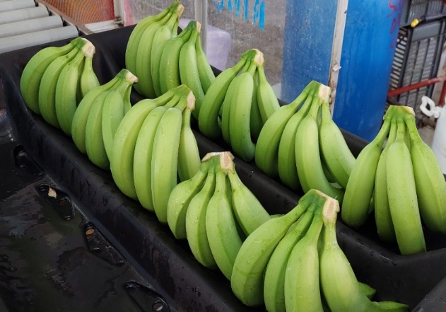

Figure 1: Tray of treated healthy bananas

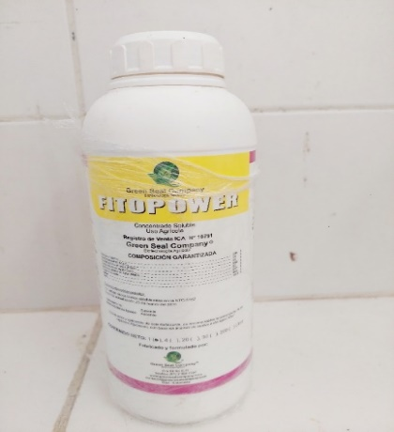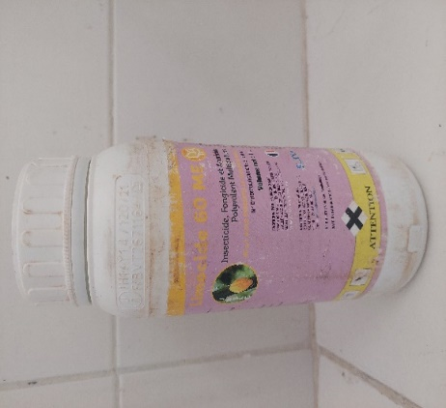

**A**

**B**

Figure 2: Products used for treatments

A: PRBB; B: Limocide

**Description of macroscopic characteristics**

For each fungal isolate, a 7 mm diameter mycelial disk was grown on PDA medium in the center of the Petri dish. Petri dishes were incubated at 27 ± 2°C under photoperiod for 12 h until the mycelial filaments reached the periphery of the dish. Thallus growth was observed daily. Mycelial texture, coloration and growth rate were recorded (Botton et al., 1990).

**Description of microscopic characteristics**

For microscopic observations, a superficial sample was taken from the PDA medium after 14 days of culture, using the platinum loop. This sample, stained with two drops of lactophenol (cotton blue), was observed at different magnifications using a light microscope (Botton et al., 1990). The structure of the mycelium and the shape and size of the spores were recorded for each fungal isolate.

**In vitro antifungal activity of biofungicides and chemicals**

**Preparation of culture media and doses**

An autoclave at 121°C under a pressure of 1 bar for 20 min is using for sterilization the culture medium. The culture medium was then cooled to room temperature. Limocide was tested only at a dose of 500 ppm, as its efficacy is not yet known. As for PRBB, it was incorporated to obtain concentrations of 250, 500, 750, 1500 and 2500 ppm and 100, 150, 250, 400. These products were compared with Citric Acid, a homologous synthetic product for rot management. The media amended with the products were homogenized in 90 mm-diameter Petri dishes at a rate of 18 ml per dish. A control without biofungicide or chemical product was carried out under the same conditions.

**In vitro efficacy tests**

A mycelial disk, approximately 7 mm in diameter, was removed from a 7-day-old culture using a sterilized cork borer, and placed in the center of a Petri dish containing PDA medium amended with biofungicide or chemical. The dishes were incubated at room temperature (27 ± 2°C) under a 12-hour photoperiod. Each treatment was performed in 4 Petri dishes and the experiment was repeated 3 times.

**Evaluation of mycelial growth**

The mycelial growth of colonies was assessed every day until the control dish was filled (7 days after plating). Mycelial growth was measured along two perpendicular axes traced on the reverse side of each Petri dish, intersecting in the middle of the mycelial disk. The effect of the different products was determined from the rate of inhibition of mycelial growth calculated by the modified formula of Hmouni et al. (1996):

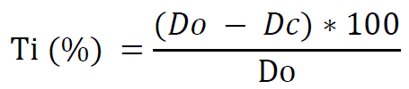

Do: average mycelial growth diameter of the fungus in control dishes; Dc: average mycelial growth diameter of the fungus at concentration (c) of PRBB or chemicals (Citric acid and Limocide).

**Data collection and analysis**

The data collected were recorded using EXCEL 2016 spreadsheet software, then analyzed using Statistica version 7.1 to assess the effect of different biofungicide doses on the growth of the strains obtained. A one-factor (product factor) analysis of variance (ANOVA) was used. The Newman Keuls mean comparison test at the 5% threshold was performed.

**RESULTS**

**Mycelial growth of in vitro strains**

Analysis of the results obtained in the table shows that mycelial length varies significantly from one strain to another. The longest lengths were 2.19, 2.03 and 2.02 cm respectively for strains T34Apex A51, T26PC CA53 and T26PC AA56. Furthermore, lengths ranging from 1.57cm to 1.15cm were observed for strains T15PC A2, T24 DS2, T05 Ped A20, T24 PC 51, T34 PCAA50, T04Apex A78 and T25PC A70. Strains T06 PCA2 and T43 Ped A21 had the shortest mycelium lengths, ranging from 0.57 to 0.91cm. After incubation for 7 days, growth rates varied between strains. Strain T16PCA32 recorded a higher growth rate of 1.82cm/d compared with T06PCA6 (0.55cm/d) (Table 1).

**Macroscopic and microscopic characteristics of fungal strains**

Analysis shows that the frequency of isolation of fungal species depends on the strain isolated from the crown, apex and stalk. In fact, the highest rates of isolation were on the crown 75% were white, 80% pink and 78% black. Then on the apex, 12.5% were white, 7% pink and 12% black. Finally, on the peduncle, 12.5% were white, 13% pink and 10% black (Table 2) Macroscopic examination of the purified isolates revealed morphological variability as shown in figure 3: three morphotypes with a dominance for the rare aspect (pink and black). The macroscopic characteristics of morphotype 1 show a light pink color, sometimes darker depending on the morphotype, for the face and pink for the dream. A spiky, radiating mycelial colony. Microscopically, a rare, branched pink mycelium was observed. Arched, weighted spores of Fusarium Oxysporium were observed. Morphotype 2 was characterized by white-colored mycelium on the face and reverse side of the boxes. The colony's oval-shaped appearance is supported by a whorled mycelium, and the genus was identified as Fusarium solani. The third morphotype has a powdery black-white thallus that turns black with age on the face and white on the uniformly growing dream. Colony texture is sparse and powdery. Macroconidia are fusiform with five or more septa. It has been identified as Fusarium oxysporium (Figure 3).

Table 1. Mycelial growth and in vitro growth rate of different strains

|  |  |  |
| --- | --- | --- |
| Strain | Growth length (cm) | Growth rate (cm/d) |
| T34 APEX A51 | 2,19 ± 0,22a | 1,21 ± 1,21a |
| T04 APEX A78 | 1,44 ± 0,95a | 1,26 ± 1,13a |
| T26 PCA A56 | 2,02 ± 0,38a | 1,24 ± 1,163a |
| T16 PC A32 | 1,30 ± 0,75ab | 1,82 ± 0,22ab |
| T05 PED A20 | 1,48 ± 0,39ab | 1,53 ± 0,33ab |
| T06PC A6 | 0,57 ± 0,32b | 0,55 ± 0,34c |
| T15 PC A2 | 1,57 ± 0,57ab | 1,43 ± 0,72ab |
| T4 PC A72 | 1,21 ± 0,87ab | 1,15 ± 0,94bc |
| T34 PCA A50 | 1,46 ± 0,72ab | 1,30 ± 0,89ab |
| T25 PC A70 | 1,15 ± 0,64ab | 1,90 ± 0,10ab |
| T43 PC A25 | 1,42 ± 0,92a | 1,33 ± 1,02a |
| T04 PC A27 | 1,43 ± 0,70ab | 1,44 ± 0,69ab |
| T14 PC A2 | 1,36 ± 0,83ab | 1,34 ± 0,85ab |
| T04 PED A29 | 1,36 ± 0,77ab | 1,24 ± 0,89ab |
| T06 PC A16 | 1,43 ± 0,98a | 1,21 ± 1,21a |
| T26 APEX A60 | 1,33 ± 0,99a | 1,37 ± 0,96a |
| T16 PC A36 | 1,20 ± 0,74ab | 1,18 ± 0,77ab |
| T26 PC C A53 | 2,03 ± 0,39a | 1,21 ± 1,21a |
| T26 PC A54 | 1,36 ± 0,76ab | 1,32 ± 0,79ab |
| T06 PC A17 | 1,32 ± 0,86ab | 1,60 ± 0,58ab |
| T42 PC A65 | 1,34 ± 0,96a | 1,41 ± 0,88a |
| T15 PC A1 | 1,19 ± 0,75ab | 1,52 ± 0,41ab |
| T43 PED A21 | 0,91 ± 0,46b | 1,13 ± 0,24bc |
| T16 PC A26 | 1,27 ± 0,71ab | 1,54 ± 0,44bc |
| T24 PC S1 | 1,46 ± 0,92a | 1,23 ± 1,15a |
| T24 D S2 | 1,52 ± 0,90a | 1,21 ± 1,21a |
| S3 | 1,40 ± 0,93a | 1,21 ± 1,21a |
| P Value | 0,031539 | 0,000009 |

Table 2: Isolation rates and morphological characteristics of fungal isolates.

|  |  |  |  |  |  |
| --- | --- | --- | --- | --- | --- |
|  | Sampling site | | | Morphological characteristics | Microscopic characteristics |
|  | Crown | Apex | Peduncle |
| Strain 1 (White) | 75 | 12,5 | 12,5 | Cottony | Arched and septate spores |
| Strain 2 (Pink) | 80 | 7 | 13 | Rare | Arched and septate spores |
| Strain 3 (Black) | 78 | 12 | 10 | Rare | Arched and septate spores |

Fig 3: Observation of morphological and microscopic characteristics of isolates.

|  |  |  |
| --- | --- | --- |
| IMG-20220913-WA0028 | IMG-20220913-WA0026 | T34APexA51B1 |
| Revers : Pink b | Face : Pink | Arched and septate spores |
| IMG-20220913-WA0038 | IMG-20220913-WA0040 | G:\TATA\T34APexA51B1.bmp |
| Revers: White | Face : White / Black | Arched and septate spores |
|  | IMG-20220913-WA0033 | T42PCA65 |
| Revers | Face : White | Arched and septate spores |

**III.3 *In vitro* antifungal activity of biofungicides and synthetic products**

**III.3.1 Strain-dependent inhibitory activity of products**

Analysis of the results obtained shows that the two biofungicides (PRBB and Limocide) and the control (Citric Acid) have variable antifungal activity on the different strains obtained from the isolations carried out. Inhibition rates varied according to 3 main factors: product type, concentration and test duration.

For Strain 1, the biofungicide PRBB demonstrated the best mycelial growth reduction activity at concentrations C4 and C5 (1500 and 2500 ppm) (Figure). At concentrations C1, C2 and C3, PRBB exhibited an antifungal activity of around 60%, which gradually decreased with time until it reached zero. From C4 to C5, the inhibitory activity of PRBB on the strain is 100% and remains constant throughout the test (Figure 3). Like PRBB, Limocide shows the best inhibition rates of around 40% at concentrations C4 and C5. From C1 to C3, Limocide's antifungal activity progressively declines over time to almost zero. From C4 to C5, antifungal activity remains constant throughout the experiment, dropping between day 6 and 7 (Figure 3). Citric acid shows a relatively low inhibition rate throughout the test at all concentrations. At C1, the inhibition rate is 40%, decreasing progressively to zero by day 7. From C2 to C5, the rate of citric acid inhibition on strain 1 is 20%, decreasing over time until it reaches zero (Figure 3).

In strain 2, PRBB inhibition rates at concentrations C1 and C3 are virtually identical. The inhibition rate is over 50% at the start of the test and decreases over time, whereas at doses C2 and C4, the inhibition rates are 100% up to day 6, then successively decrease to reach low levels. At C5, PRBB shows a total inhibition rate of 100% throughout the experiment (Figure 4). With regard to Limocid, at doses C1 and C3 the inhibition rate decreases over time. At doses C2, C4 and C5, the inhibition rate is high, estimated at around 70%. It remains relatively constant over 6 days, decreasing slightly until the last day, D7 (Figure 4). For citric acid, the rate is consistently low at all the different concentrations used. From C1 to C5, the rate of citric acid inhibition on strain 2 was around 40-50%, decreasing progressively over time until it reached zero on day 7 (Figure 4). For strain 3, from C1 to C2, PRBB has a low activity of 10 to 30%, which decreases slowly over time. At C3, PRBB inhibition rises to 100% and then suddenly drops to 40% by day 2. From C4 to C5, the inhibitory activity of PRBB on strain 3 is very high, reaching 100% and thus exerting total inhibition for almost the entire duration of the experiment (Figure 5). Limocid shows a very high inhibition rate. From C1 to C2, Limocide activity on strain 3 was close to 60-70%, dropping slightly from day 5 onwards to reach an inhibition rate of around 60%. From C4 to C5, Limocide merges with PRBB and exerts a total inhibitory activity of 100%, declining slightly to 80% (Figure 5). From C1 to C2, the rate of citric acid inhibition is 40% on day 1, dropping slightly on day 2 to become low. At C3, the inhibition rate is constant until day 3, then drops sharply over time to zero by day 7. From C4 to C5, citric acid has a low inhibitory activity and decreases over time (Figure 5).

**III.3.2 Average inhibition rates for the different products studied**

In the case of Strain 1, the average inhibition rate of products differed considerably from strain to strain. The analysis showed a significant difference at all concentrations tested. PRBB showed the highest inhibition rates at all concentrations. At doses C4 and C5, it exerted a total inhibition of 100%. At doses C1, C2 and C3, the activity of PRBB on strain 1 is low, at around 20% (Figure 6). Limocide showed antifungal activity of between 20% and 40%. Limocide activity on strain 1 evolves as a function of concentration, with the best inhibition rates observed at C4 and C5. Citric acid showed the lowest inhibition rates, almost insignificant at all concentrations; the lowest antifungal activity was observed at C5 (Figure 6). As for Strain 2, the highest inhibition rates for the strain were observed with PRBB. At concentrations C3, C4 and C5, the inhibition rate is high, with 80% at C3 and total inhibition at C4 and C5. From C1 to C2, the inhibition rate is low, estimated at 20%. The antifungal activity of limocide on strain 2 is high, and progressively increases as the concentration is raised; it is around 40% at C1 and C2, then rises to almost 80% from C3 onwards. The antifungal activity of citric acid is low throughout the experiment, at all concentrations used. It was around 20% from C1 to C5 (Figure 7). For Strain 3, the average inhibition rate as a function of strain showed a significant difference at all concentrations tested. With PRBB, the highest inhibition rates were obtained with doses C4 (80) and C5 (100). Limocid biopescide activity was 100 at doses C4 and C5. On the other hand, the inhibition rate of citric acid is low, and the results are statically the same for all doses (Figure 8).

Figure 4: Inhibition rates of the different products used on Strain 1 as a function of time

Figure 5: Inhibition rates of the different products used on the strain 2 as a function of time

Figure 6: Inhibition rates of the different products used on Strain 3 as a function of time

Figure 7: Average inhibition rate of products used as a function of concentration

Figure 8: Average inhibition rate of products used as a function of concentration on strain 3

**III.3.3 Biofungicide activity as a function of applied doses**

The rate of inhibition of all strains as a function of the three products and five concentrations. The analysis showed that the doses used were effective, the higher the concentration, the greater the inhibition. At concentration C5, we achieved a 100% inhibition rate with PRBB, followed by a rate of around 90% at concentration C4 and 50% at dose C3. At lower doses, however, inhibition rates are only 20%. With limocide, the highest inhibition rates were obtained at concentrations C4 and C5, i.e. 70%, then doses C1 and C2 gave around 40% inhibition rate (Figure 9). Citric acid, on the other hand, proved ineffective, with very low inhibition rates of around 18% at all concentrations (Figure 9, Figure 11).

**III.3.4. Efficacy of biofungicides on different strains**

Figure 10 shows that inhibition rates are strain-dependent, as results differ from one strain to another. The best results were obtained with the S2 and S3 strains, which are virtually identical and worth almost 50%. Strain S1 showed the lowest inhibition rate of around 30% (Figure 10).

Figure 9: Inhibitory activity of products as a function of concentration

Figure 10: Final inhibition rate by strain

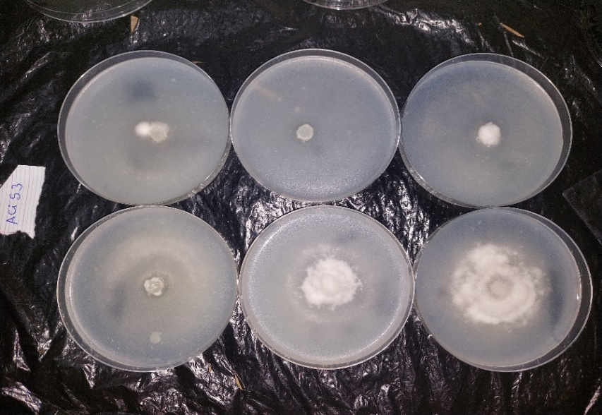

T0

C2

C1

C3

C4

C5

Figure 11: Citric acid activity on strain 3 at all concentrations

**III.4 Discussion**

The aim of this study was to control the pathogen responsible for cassava crown rot using biopesticide. It consisted in describing the symptoms of banana crown rot, identifying the causal agents and also carrying out biological control activities to reduce the infection rate of the pathogens. Morphological character analysis of fungal isolates identified three strain morphotypes. These results show that there are several strains and therefore several pathogens responsible for postharvest diseases of dessert bananas. Our results are similar to those of Alvindia et al. (2012), who isolated 25 fungal genera from organic bananas in the Philippines. These results also demonstrate that export-ready dessert bananas face enormous parasitic constraints. Symptoms were present on several organs of the dessert banana, including the fingers, the apex and, more specifically, the crown. Similar observations were noted by the work of Ewane et al. (2012) and Diedhou et al. (2014), having worked respectively on epicarp necrosis and crown rot, showed that bananas could be infected on both the epicarp and crown. The presence of pathogens on the organs (crown, etc.) is thought to be due to wounds caused during fruit handling. Strain identification showed that the majority of these pathogens are of the Fusarium and colletotrichum genus, and show pink, white and black colorations to the naked eye. Microscopically, they show arched, spectate spores and fusiform macronidia. These characteristics are identical to the Fusarium genus described by Leslie and Summerel (2016). These results prove that bananas destined for the farm are subject to several attacks, so effective control methods need to be initiated. In this respect, evaluation of the antifungal activity of PRBB's fungal Limocide showed highly significant results. Antifungal activity therefore varies according to product composition, concentration and duration of activity. Limocide is the biofungicide that proved most effective in these tests at high concentrations. It has very high in vitro antifungal activity, with total inhibition of mycelial growth. This high level of activity may be due to its orange oil-based active ingredient. Our observations are identical to those made by Kassi et al. (2014). These indicate that Ocimum gratissimum, the active ingredient in the NECO biopesticide, is responsible for its strong antifungal activity against Mycosphaerella fijiensis, the causal agent of black rot. In addition, our results once again corroborate those of Kouakou et al, (2017) in which Azoxystrobin was shown to be effective against the surface development of Fusarium oxysporium and Alternaria tenuissima on pears. Work by Kouamé et al. (2018) and Yao, (2021) showed that biological products based on plant extracts such as NECO, ASTOUN effectively inhibit mycelial growth. The use of LIMOCIDE had similar results to PRBB, achieving high inhibition rates at dose C5. As for PRBB, it is composed of botanical extracts containing metabolites that inhibit the development of fungi and bacteria, thus preventing the start-up of infectious processes. The results also show that inhibition differs from strain to strain. Strains 2 and 3 were more sensitive to biofungicides. Strain 1, on the other hand, was slightly more resistant to the products tested, especially at low concentrations.

**CONCLUSION**

Dessert bananas are subject to attack by multiple post-harvest pathogens. The fungal species Fusarium oxysporium, Fusarium solani and colletotrichum musae have been identified as responsible for crown rot disease. In vitro control treatments considerably reduced the mycelial growth of the strains obtained with the doses tested. Control tests carried out in the laboratory also demonstrated that Limocide and PRBB have very significant antifungal activity for disease control. This product could be effective for biological control of the agent responsible for crown rot of post-harvest dessert bananas in Côte d'Ivoire.

**DISCLAIMER (ARTIFICIAL INTELLIGENCE)**

Author(s) hereby declare that NO generative AI technologies such as Large Language Models (ChatGPT, COPILOT, etc) and text-to-image generators have been used during writing or editing of this manuscript.

**REFERENCES**

**Abd-Alla, M.A., El-Gamal, N.G., El-Mougy, N.S., Abdel-Kader, M.M. (2014).** Post-harvest treatments for controlling crown rot disease of Williams banana fruits (*Musa acuminata* L.) in Egypt. Plant Pathology & Quarantine, 4(1), 1-12. Doi 10.5943/ppq/4/1/1.

**Alvindia DG., Miriam A. (2012).** An integrated approach witb *Trichoderma harzianum* DGAOl and hot water treatment on control of crown rot disease and retention of overall quality in banana. In: Biocontrol Science and Technology, 22(9): 1021-1033.

**Botton, B., Breton, A., Fevra, M., Gauthier, S., Guy, P., Larpent, J.P., Reymond, P., Sanglier, J.J., Vayssier, Y. and Veau, P. (1990)** Moisissures utiles et nuisibles. Importance industrielle. Masson, Paris, 41-220.

**Carlier, J., De Waele, D., Escalant, J.-V., Vézina, A., and Picq, C. (2002**). Global evaluation of musa germplasm for resistance to fusarium wilt, mycosphaerella leaf spot diseases and, nematodes: in-depth evaluation. Technical report, INIBAP Technical Guidelines, 6. 88.

**Diedhiou, P.M., Zakari, A.H., Mbaye, N., Faye, R., & Samb, P.I. (2014).** Control methods for post-harvest diseases of banana (*Musa sinensis*) produced in Senegal. International Journal of Science, Environment and Technology, 3(5) : 1648-1656.

**Ewané C.A., Lepoivre P., de Lapeyre de Bellaire L., & Lassois, L. (2012).** Involvement of phenolic compounds in the susceptibility of bananas to crown rot. A review. Biotechnologie, Agronomie, Société et Environnement 16(3) : 393-404.

**Ewané CA., Lassois L., Brostaux Y., Lepoivre P., De Lapeyre De BL. (2013).** The susceptibility of bananas to crown rot disease is influenced by geographical and seasonal effects. ln: *Canadian Journal of Plant Pathology.* 35(1):27-36.

**Faostat (2012).** Food and Agriculture Organization of th United Nations. Statistiques Agricoles : *Bananes.* https://www.faostat3.fao. (Consulté le 27 novembre 2021).

**Kassi F. M., Badou O. J., Tonzibo Z. F., Salah Z., Amari L., Dadé G. E. & Koné D., (2014). Action of the natural fungicide NECO against black Sigatoka (Mycosphaerella fijiensis Morelet) in plantain banana (AAB) in Côte d’Ivoire. Journal of Applied Biosciences, 75: 6183-6191.**

**Kouakou T. K.; Pohé J., Tienebo E. O., Ohoussou N. I. L. V., (2017). Inventory of post-harvest pathogenic fungi of dessert banana “Cavendish” and evaluation of their sensitivity to Azoxystrobin in Côte d’Ivoire.**

**Kouamé K. D., Nandjui J., Kassi F. J-M., Kouassi K. C., Bringa K. G., Dove J. H. & Seelavarn G., (2018). Study of the population of nematodes associated with sugarcane cultivation in sugar plantations in Côte d’Ivoire. Journal of Animal & Plant Sciences, 37(1): 5985-5996.**

**Leslie J. F. and Summerell B. A., (2016). The Fusarium Laboratory Manual (Ames, Iowa: Wiley Blackwell).**

**Madeley J., (2002) Paraquat: Syngenta’s questionable herbicide. Summary of the report for the Berne Declaration, Swedish Society for the Protection of Nature, Pesticide Action Network United Kingdom (PAN UK), Pesticide Action Network Asia-Pacific (PAN AP), Foro Emaus. www.evb.ch, 3p.**

**Rautiainen,R H , Reynolds S J., (2002). Mortality and Morbidity in Agriculture in the United States. Journal of Agricultural Safety and Health 8 (3): 259−276.**

**Sténuit J., van Hammée M. L. (2004) Overview of the epidemiology of pesticides. 51 p.**

**Yao K. J-E., (2021). Contribution to the study of sugarcane smut disease (saccharum officinarum L.) caused by Sporisorium scitamineum Piep. And control trial using formulations based on extracts of local aromatic plants. PhD thesis in Climate Change and Sustainable Agriculture, Phytopathology Option, UFR Biosciences, Félix HOUPHOUET-BOIGNY University, 168p.**