Synthesis and Antibacterial Activity of Iron-Doped Zinc Oxide Nanoparticles: A Comparative Study

Abstract
Bacterial resistance to commonly administered drugs has necessitated the need for alternative drugs for effective treatment. In this study, the synthesis, characterization, and antibacterial activity of iron-doped zinc oxide nanoparticles (Fe-ZnO Nps) were investigated. The synthesized nanoparticles (Nps) were characterized using Scanning Electron Microscopy (SEM)/Energy Dispersive X-ray Spectroscopy (EDX) and Transmission Electron Microscopy (TEM) methods of analysis. The synthesized Nps were tested against ten Clinical bacteria, which were both Gram-positive and Gram-negative (Micrococcus luteus, Bacillus subtilis, Escherichia coli, Enterobacter agglumerans, Klebsiella pneumoniae, Acinetobacter baumannii, Staphylococcus aureus, Bacillus cereus, Pseudomonas aeruginosa and Corynebacterium bovis) using the agar diffusion method. SEM/EDX images showed the spherical nature and the elemental composition of the nanoparticles, and the TEM showed the morphology and the nanoparticles' size distribution. The presence of all the expected elements was an indication of the successful synthesis of the nanoparticles. Moreover, the SEM image of the synthesized nanoparticles revealed that the nanoparticles were not uniformly distributed and that the nanoparticles were of different sizes. Iron-doped zinc oxide nanoparticles (Fe-ZnO Nps) exhibited excellent and significant antimicrobial activity against all the bacteria (inhibitory zones ranging from 29.00 - 32.00 mm). The obtained result indicated that all the organisms were susceptible to the synthesized Fe-ZnO Nps. The excellent antimicrobial activity of the nanoparticles against all the tested organisms could be attributed fact that the synthesized Fe-ZnO Nps could penetrate the cell wall of the organisms, which could damage the cell wall, thereby causing the death of the organisms. Also, the results from this study revealed that Fe-ZnO Nps exhibited strong antibacterial activity against all the tested clinical isolates with a zone of inhibition (ZOI) ranging from 29.00 mm – 32.00 mm. The obtained result is a clear indication of the potential applications of the Fe-doped ZnO Nps to combat the challenge of bacterial resistance.
Keywords: Antibacterial activity; Fe-ZnO Nps; Bacterial resistance; Gram-positive bacteria; Gram-negative bacteria
Introduction
A high number of antibiotics lost their effectiveness due to the formation of drug resistance within several years after creation. These days, pharmaceutical companies decrease their interest in new antibiotics investigation due to high costs and the duration of the research with unpredictable financial and clinical results (Holubnycha et al., 2024; Ondrašovičová et al., 2025). The emergence of nanoparticles as an alternative to antibiotics has been a major area of focus for researchers. This has made the creation of new therapeutic agents a necessity. The use of nanoparticle-based treatments to manage pathogenic bacteria has become a significant alternative as nanotechnology becomes a leading field in integrated research. Currently, a diverse range of physiochemical methods is being employed for the production of nanoparticles (Arum et al., 2024). Researchers around the world are becoming more interested in using nanomaterials in the biomedical area because of their special ability to interact with cells and tissues at the molecular level with a high degree of specificity and enhanced efficacy to treat infectious diseases (Qamar et al., 2020a).
These materials have a high surface-to-volume ratio, are tiny, and are flexible in their design (Besinis et al., 2012; Karlsson et al., 2009). Numerous studies on various metal oxide nanomaterials have been conducted over the past decade due to the well-established fact that metal oxide at the nanoscale exhibits better characteristics (Besinis et al., 2012; Karlsson et al., 2009). A wide range of nanoparticles has been investigated for their antibacterial potency. These include silica nanoparticles, silica/iron oxide, titanium, copper, aluminum, bifunctional Fe₃O₄-Ag NPs, and those of silver, gold, and zinc (Shimi et al., 2022).
The science of nanotechnology holds great promise for the medical field. Comparable to nature, the integration of biology and nanoscience will not only improve the fight against harmful microbes but may also lead to a shift in the strategy used to treat infectious diseases (Janardhanan et al., 2009). This has led to the use of nanoparticles to treat diseases like rheumatoid arthritis and cancer (Lim et al., 2011; Sanjib Bhattacharyya, Rachel A. Kudgus, Resham Bhattacharya, 2012). Materials are classified as nanoparticles if they are 100 nm or smaller. In contrast to their bulk materials, they display a variety of properties such as optical, electrical, catalytic (Day et al., 2013), magnetic, and biological activity (Lim et al., 2011; Bhattacharyya et al., 2012).
A lot of investigations have been done on metal oxides, such as zinc oxide nanoparticles and nanorods, to investigate their potential uses in several transdisciplinary domains (Grigore et al., 2016; Nasrollahzadeh et al., 2016; Qamar et al., 2020b). Evaluating the antimicrobial susceptibility of nanoparticles made from various metals using various synthetic techniques has allowed researchers to investigate some of the biological characteristics of these particles (Gyawali et al., 2011).
Metal nanoparticles (Ag, Cu, CuO, and Au) have been shown to have a broad range of antibacterial activity against a variety of microorganisms, including fungi and both Gram-positive and Gram-negative bacteria (Jemal et al., 2017). There have been reports of antibacterial activity against Escherichia coli (Chakraborty et al., 2022; Durán et al., 2007; Xie et al., 2011) and a non-resistant type of Gram-positive bacterium (Staphylococcus aureus) (Durán et al., 2007; Jung et al., 2008). The results showed that the addition of the nanoparticles inhibited the organism's growth.
High reactivity and a high surface-to-volume ratio have demonstrated the immense potential of metallic and metal-oxide nanostructures. Metal nanoparticles (Ag, Cu, Au CuO and ZnO) have been shown to have a broad range of antibacterial activity against a variety of microorganisms, including fungi and both Gram-positive and Gram-negative bacteria (Cruz et al., 2020). Zinc oxide (ZnO) has demonstrated a broader range of applications, notably in nanomedicine, where ZnO nanoparticles have demonstrated significant promise in interacting with biological membranes and displaying antibacterial and/or anticancer properties (Emami-karvani and Chehrazi, 2011). Fe-doped ZnONPs show superior antibacterial action against pathogens like E. coli, S. aureus, C. albicans, and K. pneumonia (Zyoud et al., 2024).
Generation of reactive oxygen species (ROS) (Mahdy et al., 2012; Mir and Mallik, 2010; Prabhu et al., 2015) such as hydrogen peroxide (H₂O₂), hydroxyl radicals (OH−), and superoxide (O2) were known to be the primary way whereby ZnO nanostructures primarily inhibited the growth of microorganisms by destroying some essential components of the microbe cells (Yudasari et al., 2020; Sirelkhatim et al., 2015).
This mechanism was, however, constrained by the fact that ZnO's broad band gap energy (≈3.3 eV) makes it respond better to UV light than visible light (Nurfina Yudasari, Suliyanti and Imawan, 2020; Sirelkhatim et al., 2015). This restriction has emerged as the primary driver behind numerous studies in the field of advanced materials in collaboration with microbiology to alter ZnO's band gap energy so that it can be used as a potent antibacterial agent in visible light (Qi et al., 2017).
Doping offers special characteristics to the physical and chemical properties of metal nanoparticles. Metal dopants have been used in several studies to make ZnO an effective antibacterial agent in visible light (Qi et al., 2017). Under exposure to visible light, Guo et al., reported a Ta-doped ZnO nanostructure that was synthesized using a modified Pechini-type approach and shown a clear antibacterial impact on P. aeruginosa, E. coli, and S. aureus (Guo et al., 2015). Using the simple microwave-assisted precipitation approach, Vignesh et al. created Sn and Cu-doped ZnO, which lowers the band gap energy of ZnO to about 2.6 eV (Vignesh and Sundar, 2018).
Significant improvements in the photocatalytic and antibacterial effects demonstrated that the metal dopant treatment was effectively enhancing ZnO function. For ZnO's antibacterial use, other metals as manganese (Mn) (Rekha et al., 2010), silver (Ag) (Ruparelia et al., 2008), (Cu) (Narjis et al., 2020), and (Co) (Nair and Nirmala, 2011) exhibit promise as dopants or hybrid structures.
Several studies have been carried out on the effect of metal dopant treatment on nanoparticles. For instance, Fe-doped copper-oxide nanoparticles (Fe-doped CuO Nps) showed excellent antibacterial activities against bacterial and fungal infection, as reported by Pugazhendhi et al in 2018. Report from the investigation showed that the Fe-doped CuO Nps had significant antimicrobial efficiency than the undoped copper-oxide nanoparticles. (Pugazhendhi et al., 2018). Rekha et al. (2010) reported the antibacterial activity of ZnO nanoparticles, and Mn-doped ZnO nanoparticles were tested against both Gram-negative and Gram-positive organisms. Results from the investigation revealed that the Mn-doped ZnO nanoparticles exhibited better antibacterial activity than the undoped ZnO. Guo et al. (2015) also reported a stronger and higher antibacterial activity of Ta-doped ZnO nanoparticles than the pure ZnO nanoparticles. The study was carried out using a standard microbial method against some test organisms: Gram-positive bacteria (B. subtilis and S. aureus) and Gram-negative bacteria (E. coli and P. aeruginosa).
This present study aimed at investigating the successful synthesis and characterization of Iron-doped zinc oxide nanoparticles (Fe-ZnO Nps). The nanoparticles were characterized using Transmission electron microscopy (TEM), Energy dispersive x-ray spectroscopy (SEM/EDS). The synthesized nanoparticles were further investigated for their antimicrobial activity against some selected Gram-positive and Gram-negative bacteria.

2.0 MATERIAL AND METHOD
Materials:
2.1 CHEMICALS AND REAGENTS
Iron (III) chloride hexahydrate (FeCl₃. 6H₂O), Zinc acetate dihydrate (Zn(CH₃COO)₂(H₂O), Ammonia solution (NH₄OH, 30%), Dimethyl sulfoxide (DMSO) were of analytical grade and purchased from sigma Aldrich. All the reagents were utilized in their original form and were prepared and used according to manufacturer’s instruction.

METHODS:
2.2.1 Preparation of Iron-doped zinc oxide nanoparticles
Iron-doped zinc oxide nanoparticles (Fe-ZnO Nps) were prepared using a method previously reported with slight modifications (Narayanan and Wilson, 2012). This method involved combining an aqueous solution of ferric iron and zinc acetate. Specifically, a mixture consisting of FeCl₃.6H₂O (10g), ammonium hydroxide (30ml), and deionized water (70ml) was prepared. Simultaneously, zinc acetate (2g) was dissolved in 98ml of deionized water. The solution containing zinc acetate and deionized water was placed on a stirrer. Afterwards, the mixture of iron chloride and ammonium hydroxide was slowly added drop by drop to form particles within the mixture. The resulting mixture was then washed three times with deionized water, and the residue was separated by filtration using filter paper. The liquid portion was discarded, and the remaining residue was subjected to calcination in a muffle furnace at a temperature of 300ºC for a duration of 3 hours. Thus, the iron-doped zinc oxide nanoparticles were successfully obtained after this process.
2.2.2 Characterization of Iron-doped zinc oxide nanoparticles
The synthesized iron-doped zinc oxide nanoparticles (Fe-ZnO Nps) were characterized by using some analytical techniques, which include Scanning Electron Microscopy (SEM/EDX) Analysis and Transmission electron microscopy (TEM).
Transmission electron microscopy: The images were acquired using JEOL 2100F equipment and the copper grid coated (using drop-dry) with materials to be investigated.
Energy dispersive X-ray (EDX) analysis spectra were obtained using an X-ray microanalysis system added as a module on the Nova NanoSEM 200.
2.3 BIOLOGICALS
2.3.1 Preparation of media
Nutrient agar powder (28 g) was measured and combined with one liter of distilled water. The mixture was thoroughly mixed by boiling until all the ingredients were completely dissolved. Next, the solution was subjected to autoclaving at a temperature of 121°C for 15 minutes to ensure proper dissolution. Afterward, the mixture was left to cool to approximately 45°C and poured into Petri dishes. These plates were left undisturbed until they solidified before the process of inoculation took place.
2.4 ANTIMICROBIAL SUSCEPTIBILITY TEST
2.4.1 Test Organisms
Ten different clinical were isolates collected from out-patients ward of the Federal medical centre, Owo whose morphological and biochemical characteristics were confirmed according to Bergey’s manual of determinative bacteriology 9th edition. The isolates used were Micrococcus luteus, Bacillus subtilis, Escherichia coli, Enterobacter agglumerans, Klebsiella pneumoniae, Acinetobacter baumannii, Staphylococcus aureus, Bacillus cereus, Pseudomonas aeruginosa, Corynebacterium bovis.
2.4.2 Determination of Antibacterial activity
The bacterial cultures were maintained on nutrient broth. Standardized inoculum (1.5 x 10⁸ cfu/ml of bacterial cells) was used to seed already solidified Petri plates of Mueller-Hinton (MH) agar. The antibacterial activities of the synthesized iron-doped zinc oxide nanoparticles were determined using the agar well diffusion method. A sterile 6 mm cork borer was used to make wells on already solidified agar; each well was filled with the metal complex dissolved in 30% dimethylsulfoxide (DMSO). Ampicillin was used as a positive control. The plates were allowed to stand for about 2 hours to allow absorption of the metal complex and ligands dissolved in 30% DMSO into the medium, after which they were incubated at 37ºC for 24 hours. Macro-broth dilution technique, as modified by Ajibade et al. (2012), was used for minimum inhibitory concentration (MIC) and minimum bactericidal concentration (MBC). Serial dilutions of the metal complex dissolved in 30% DMSO were carried out to give a concentration of 50 mg/ml, 25 mg/ml, 12.5 mg/ml and 6.25 mg. For MIC, a sterile 6 mm cork borer was used to make four wells on already solidified and bacterial-seeded agar plates; each well was filled with a concentration of the diluted metal complex and labeled appropriately. The plates were incubated at 37ºC for 24 hours and observed afterwards. For MBC, 2 ml of each diluted concentration was added to 18 ml of pre-sterilized molten MH medium, mixed properly and allowed to set, after which the standardized inoculum was seeded on each plate. The bacterial plates were incubated at 37ºC for 24 hours. The results were observed and recorded. Those recorded as MBC were the lowest concentration of the tested metal complex that showed no visible growth of the tested bacteria.

2.4.3 Killing Rate Dynamics
A 50% dilution of metal complex was used to determine the killing rate of the antibacterial agent against the test organisms. A 1 ml of the 50% diluted oil was added to 9 ml broth containing 1 ml of the test organism with inoculum size of 1.5 x 10⁸ cfu/ml. The killing rate was measured using UV/Visible spectrophotometer at a wave length of 620 nm for 48 hours.
3.0. RESULTS
3.1 Characterization of iron-doped zinc oxide Nanoparticles (Fe-ZnO Nps)
3.1.1. Energy dispersive X-ray spectroscopy (EDX) spectrum of Fe-ZnO Nps
The EDX spectrum is presented in Fig 1. It is a non-destructive elemental analysis used to characterize the synthesized iron-doped zinc oxide nanoparticles to confirm the presence of the expected elements. The presence of all the expected elements was an indication of the successful synthesis of the nanoparticles. The percentage composition of the elements is shown with the EDX spectrum.
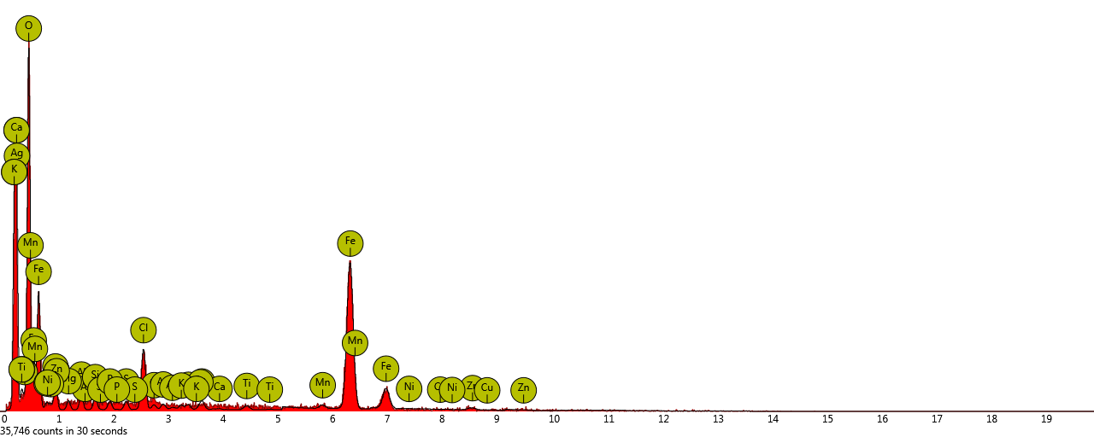
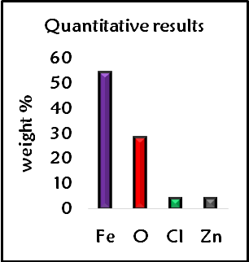

Fig. 1: EDX spectrum of iron-doped zinc oxide nanoparticles

3.1.2. Transmission electron microscopy (TEM) image of Fe-ZnO Nps
The TEM image of the synthesized nanoparticles revealed the morphology of the nanoparticles, particle size distribution, and the shape of the nanoparticles. From the TEM result, the nanoparticles were spherical in shape. The particle size distribution ranges from 2.20 nm – 15.30 nm, with the majority of the nanoparticles between 2.20 – 9.70 nm having the highest distribution. The average particle size was 5.10 ± 2.9 nm.
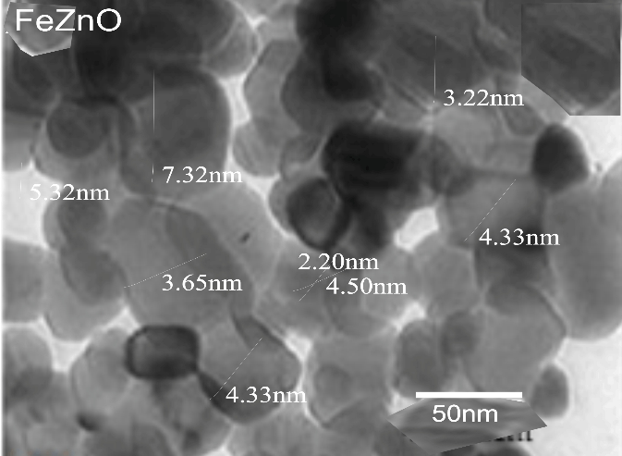
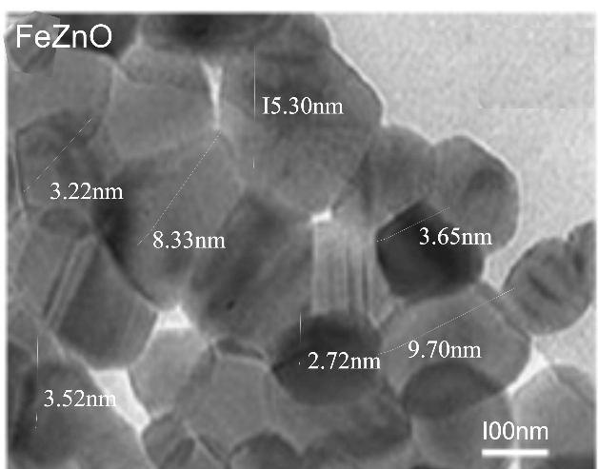

5.10 ± 2.9 nm

5.10 ± 2.9 nm

Fig. 2 TEM image of the Fe-ZnO Nps at different magnifications and the corresponding histogram

3.1.3 SEM image of Fe-ZnO Nps
The SEM image of the synthesized nanoparticles confirmed the surface morphology of the iron-doped zinc oxide nanoparticles. The nanoparticles were not uniformly distributed and the nanoparticles were of different sizes.

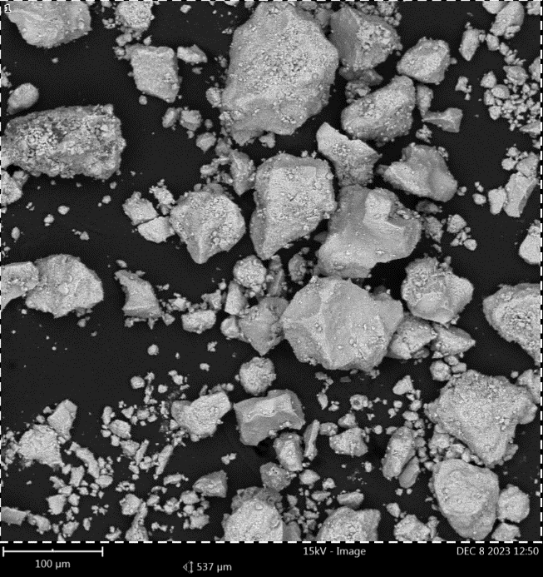

Fig. 3 SEM image of Fe-ZnO Nps

3.2. Antimicrobial susceptibility test (AST)
The results from this study revealed that all the tested organisms (E. agglumerans, C. bovis, P. aeruginosa, A. baumannii, E. coli, M. luteus, K. pneumoniae, B. subtilis, S. aureus and B. cereus) were susceptible to iron-doped zinc oxide nanoparticles (Fe-ZnO Nps) (Table 1). This study indicated MIC values in the range of 50 – 3.125 mg/ml for the synthesized nanoparticles. The MIC results (Tables 2) further showed that synthesized nanoparticles were effective against all the ten tested organisms at concentrations ranging from 50 % - 12.5 %. No activity was observed at a concentration lesser than 12.5 % for all the tested organisms. The MBC results presented in Table 3 also show a similar trend with results obtained for MIC.
Table 1: Antimicrobial zones of inhibition (ZOI) using 100mg/ml of iron-dopedzinc oxide nanoparticles (Fe-ZnO Nps) against bacteria
Test organism | Iron-zinc oxide(mm) | Ampicillin (mm)
Enterobacter agglumerans | 31.50 | 23.50
Corynebacterium bovis | 30.00 | 26.50
Pseudomonas aeruginosa | 29.50 | 38.50
Acinetobacter sp | 29.00 | 16.00
Escherichia coli | 29.50 | 20.00
Micrococcus luteus | 31.50 | 31.50
Klebsiella pneumoniae | 31.50 | 20.50
Bacillus subtilis | 31.00 | 17.00
Staphylococcus aureus | 32.00 | 40.00
Bacillus cereus | 30.00 | 25.00
Key: Sensitive = 25 mm above, Intermediate = 20 – 24 mm, Resistance = 0 – 19 mm
Table 2: Result of Minimum Inhibitory Concentration (MIC) of iron-doped zinc oxide nanoparticles (Fe-ZnO Nps) against bacteria
Test organism | 50% | 25% | 12.5% | 6.25% | 3.125%
Enterobacter agglumerans | + | + | + | _ | _
Corynebacterium bovis | + | + | + | _ | _
Pseudomonas aeruginosa | + | + | + | _ | _
Acinetobacter baumannii | + | + | + | _ | _
Escherichia coli | + | + | + | _ | _
Micrococcus luteus | + | + | + | _ | _
Klebsiella pneumoniae | + | + | + | _ | _
Bacillus subtilis | + | + | + | _ | _
Staphylococcus aureus | + | + | + | _ | _
Bacillus cereus | + | + | + | _ | _
Key: + = Growth inhibition; - = no growth inhibition
Table 3: Result of Minimum Bactericidal Concentration (MBC) of iron-doped zinc oxide nanoparticles (Fe-ZnO Nps) against bacteria
Test organisms | 50% | 25% | 12.5% | 6.25% | 3.125%
Enterobacter agglumerans | + | + | + | _ | _
Corynebacterium bovis | + | + | + | _ | _
Pseudomonas aeruginosa | + | + | + | _ | _
Acinetobacter baumannii | + | + | + | _ | _
Escherichia coli | + | + | + | _ | _
Micrococcus luteus | + | + | + | _ | _
Klebsiella pneumoniae | + | + | + | _ | _
Bacillus subtilis | + | + | + | _ | _
Staphylococcus aureus | + | + | + | _ | _
Bacillus cereus | + | + | + | _ | _
Key: + = Growth; - = no growth
TABLE 4: The killing time of 50% dilutions of iron-doped zinc oxide synthesized against bacterial isolates
Organisms | 0hr | 6hrs |  | 12hrs | 18hrs | 24hrs | 30hrs | 36hrs | 42hrs | 48hrs
Enterobacter agglumerans | 0.226 |  | 0.102 | 0.052 | 0.017 | 0.001 | 0.000 | 0.000 | 0.000 | 0.000
Corynebacterium bovis | 0.227 |  | 0.112 | 0.046 | 0.016 | 0.001 | 0.000 | 0.000 | 0.000 | 0.000
Pseudomonas aeruginosa | 0.225 |  | 0.118 | 0.044 | 0.015 | 0.000 | 0.000 | 0.000 | 0.000 | 0.000
Acinetobacter baumannii | 0.231 |  | 0.152 | 0.051 | 0.010 | 0.001 | 0.000 | 0.000 | 0.000 | 0.000
Escherichia coli | 0.230 |  | 0.099 | 0.049 | 0.009 | 0.002 | 0.000 | 0.000 | 0.000 | 0.000
Micrococcus luteus | 0.230 |  | 0.096 | 0.044 | 0.011 | 0.001 | 0.000 | 0.000 | 0.000 | 0.000
Klebsiella pneumoniae | 0.234 |  | 0.111 | 0.046 | 0.010 | 0.002 | 0.000 | 0.000 | 0.000 | 0.000
Bacillus subtilis | 0.231 |  | 0.122 | 0.047 | 0.009 | 0.002 | 0.000 | 0.000 | 0.000 | 0.000
Staphylococcus aureus | 0.234 |  | 0.101 | 0.057 | 0.008 | 0.001 | 0.000 | 0.000 | 0.000 | 0.000
Bacillus cereus | 0.227 |  | 0.121 | 0.048 | 0.008 | 0.001 | 0.000 | 0.000 | 0.000 | 0.000

4.0. DISCUSSION AND CONCLUSION
4.1 DISCUSSION
Nanomedicine is the application of nanotechnology in the biomedical field. Nanomedicine encompasses a variety of applications, including biological instruments, nanomaterials, nanoelectronic biosensors, and even anticipated future applications of molecular nanotechnologies, including biological devices. Understanding the problems with the toxic nature and environmental risks connected to the use of these nanomaterials is one of the recent challenges facing nanomedicine. In the future, nanomedicine holds great promise as a research tool for developing significant biomedical devices and drug carriers. New biomedical applications in the pharmaceutical manufacturing sector, including sophisticated drug delivery methods, innovative therapies, and in vivo imaging, are anticipated by the National Nanotechnology program (Shahzad et al., 2022).
The investigation of the antibacterial activity of iron-doped zinc oxide nanoparticles (Fe-ZnO Nps) was reported in this study. The presence of an inhibition zone clearly indicated the antibacterial efficacy of Fe-ZnO Nps. The results of the study revealed that iron-doped zinc oxide nanoparticles (Fe-ZnO Nps) exhibited excellent and significant antimicrobial activity against all the bacteria (inhibitory zones ranging from 29.00 - 32.00 mm). A sample exhibiting ≥ 14 mm inhibition zone is considered significant (Mustopa et al., 2016). The synthesized nanoparticles exhibited the strongest antimicrobial effect with the largest zone of inhibition produced against Staphylococcus aureus (32.00 mm). The obtained result indicated that all the organisms were susceptible to the synthesized Fe-ZnO Nps. The excellent antimicrobial activity of the nanoparticles against all the tested organisms could be attributed fact that the synthesized Fe-ZnO Nps could penetrate the cell wall of the organisms, which could damage the cell wall, thereby causing the death of the organisms.
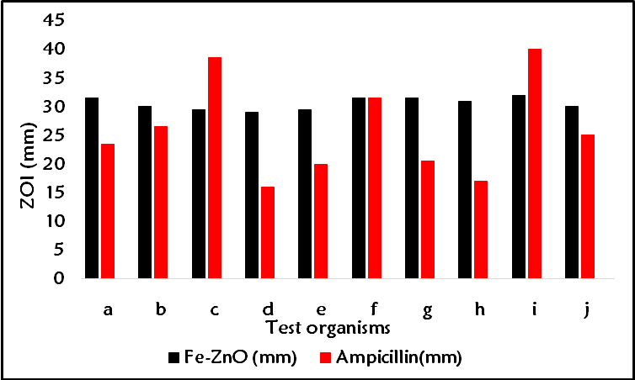

Figure 4: Graphical presentation of antimicrobial activity of Fe-ZnO Nps against some bacteria (a: Enterobacter agglumerans, b: Corynebacterium bovis, c: Pseudomonas aeruginosa, d: Acinetobacter baumannii, e: Escherichia coli, f: Micrococcus luteus g: Klebsiella pneumoniae, h: Bacillus subtilis, i: Staphylococcus aureus, and j: Bacillus cereus
It was revealed from the present study that Fe-ZnO Nps exhibited significant antimicrobial activity against E. agglumeran, C. bovis, P. aeruginosa, A. baumannii, E. coli, M. luteus, K. pneumoniae, B. subtilis, S. aureus, and B. cereus. The MIC results showed that Fe-ZnO Nps was most effective against all the tested organisms. The antimicrobial activity of Fe-ZnO Nps observed in the present study is consistent with the findings of previous studies. For instance, Nurfina Yudasari et al (2020) reported that Fe-ZnO Nps exhibit significant antimicrobial activity against S. aureus (Nurfina Yudasari, Suliyanti and Imawan, 2020). Similarly, Neha et al. (2017) demonstrated that Fe-ZnO Nps exhibited significant antibacterial activity against S. aureus, E. coli, K. pneumoniae, S. typhi, P. aeruginosa, and B. subtilis. The mechanism of the antimicrobial action of Fe-ZnO Nps has been attributed to their ability to disrupt the bacterial cell membrane, leading to cell death (Abdulsada et al., 2022; Webster, 2010). Also, Fe-ZnO Nps can induce oxidative stress by generating ROS that damage bacterial DNA and proteins thereby causing cell death (Behera et al., 2012).
The susceptibility of the tested organisms towards Fe-ZnO Nps could be attributed to the fact that the synthesized nanoparticles have the ability to penetrate the cell wall of the organisms. The action of the Fe-ZnO Nps on bacteria causes a membrane attachment, membrane penetration, and subsequent morphological changes thereby leading to cell death.
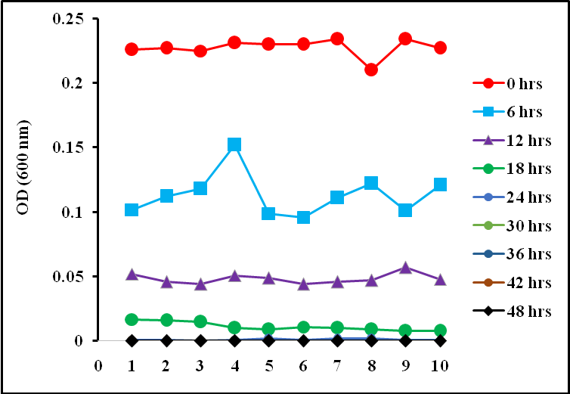

Figure 5: Time-kill plots of 50% dilution of Fe-ZnO Nps synthesized against some bacteria (1: Enterobacter agglumerans, 2: Corynebacterium bovis, 3: Pseudomonas aeruginosa, 4: Acinetobacter baumannii, 5: Escherichia coli, 6: Micrococcus luteus, 7: Klebsiella pneumoniae, 8: Bacillus subtilis, 9: Staphylococcus aureus, and 10: Bacillus cereus
4.2 CONCLUSION
The synthesis, characterization and the antimicrobial activity of iron-doped zinc oxide nanoparticles (Fe-ZnO Nps) were investigated in this study. The results obtained from TEM SEM/EDX indicated the successful synthesis of the Fe-ZnO Nps. It was observed that all the bacteria were susceptible to the synthesized Fe-ZnO Nps; this implies that the iron-doped zinc oxide nanoparticles are promising in biomedical applications. The synthesized nanoparticles also serve as a low-cost material that can inhibit the growth of certain microorganisms and can act as a promising alternative means of overcoming the challenges of multidrug resistance to antibiotics.
Disclaimer (Artificial intelligence)
Option 1:
Author(s) hereby declare that NO generative AI technologies such as Large Language Models (ChatGPT, COPILOT, etc.) and text-to-image generators have been used during the writing or editing of this manuscript.
Option 2:
Author(s) hereby declare that generative AI technologies such as Large Language Models, etc. have been used during the writing or editing of manuscripts. This explanation will include the name, version, model, and source of the generative AI technology and as well as all input prompts provided to the generative AI technology
Details of the AI usage are given below:
1.
2.
3.

References
Abdulsada, F.M., Hussein, N.N., Sulaiman, G.M., Ali, A. Al, 2022. Evaluation of the Antibacterial Properties of Iron Oxide , Polyethylene Glycol , and Gentamicin Conjugated Nanoparticles against Some Multidrug-Resistant Bacteria. J. Funct. Biomater. 13, 1–17.
Behera, S.S., Patra, J.K., Pramanik, K., Panda, N., Thatoi, H., 2012. Characterization and Evaluation of Antibacterial Activities of Chemically Synthesized Iron Oxide Nanoparticles. World J. Nano Sci. Eng. 2, 196–200.
Besinis, A., Peralta, T. De, Handy, R.D., 2012. The antibacterial effects of silver , titanium dioxide and silica dioxide nanoparticles compared to the dental disinfectant chlorhexidine on Streptococcus mutans using a suite of bioassays. Nanotoxicology 8, 1–16. https://doi.org/10.3109/17435390.2012.742935
Chakraborty, N., Banerjee, J., Chakraborty, P., Chanda, S., Ray, K., Acharya, K., Sarkar, J., 2022. Green synthesis of copper / copper oxide nanoparticles and their applications : a review. Green Chem. Lett. Rev. 15, 185–213. https://doi.org/10.1080/17518253.2022.2025916
Cruz, D.M., Mostafavi, E., Vernet-crua, A., Barabadi, H., Shah, V., Jorge, L., 2020. Green nanotechnology-based zinc oxide ( ZnO ) nanomaterials for biomedical applications : a review Green nanotechnology-based zinc oxide ( ZnO ) nanomaterials for biomedical applications : a review. J. Phys. Mater. 3, 1–26.
Day, E.S., Thompson, P.A., West, J.L., 2013. Nanoshell-mediated photothermal therapy improves survival in a murine glioma model. J. Neurooncol. 104, 55–63. https://doi.org/10.1007/s11060-010-0470-8
Durán, N., Marcato, P.D., Souza, G.I.H. De, Alves, O.L., Esposito, E., 2007. Antibacterial Effect of Silver Nanoparticles Produced by Fungal Process on Textile Fabrics and Their Effluent Treatment. J. Biomed. Nanotechnol. 3, 203–207. https://doi.org/10.1166/jbn.2007.022
Emami-karvani, Z., Chehrazi, P., 2011. Antibacterial activity of ZnO nanoparticle on gram- positive and gram-negative bacteria. African J. Microbiol. Res. 5, 1368–1373. https://doi.org/10.5897/AJMR10.159
Grigore, M.E., Biscu, E.R., Holban, A.M., Gestal, M.C., Grumezescu, A.M., 2016. Methods of Synthesis , Properties and Biomedical Applications of CuO Nanoparticles. Pharm. 9, 1–14. https://doi.org/10.3390/ph9040075
Guo, B., Han, P., Guo, L., Cao, Y., Li, A., Kong, J., Zhai, H., Wu, D., 2015. The Antibacterial Activity of Ta-doped ZnO Nanoparticles. Nanoscale Res. Lett. 10, 1–10. https://doi.org/10.1186/s11671-015-1047-4
Gyawali, R., Ibrahim, S.A., Hasfa, S.H.A., Smqadri, S.Q., Haik, Y., 2011. Antimicrobial Activity of Copper Alone and in Combination with Lactic Acid against Escherichia coli O157 : H7 in Laboratory Medium and on the Surface of Lettuce and Tomatoes. J. Pathog. 2011, 650968. https://doi.org/10.4061/2011/650968
Janardhanan, R., Karuppaiah, M., Hebalkar, N., Rao, T.N., 2009. Synthesis and surface chemistry of nano silver particles. Polyhedron 28, 2522–2530. https://doi.org/10.1016/j.poly.2009.05.038
Jemal, K., Sandeep, B. V, Pola, S., 2017. Synthesis , Characterization , and Evaluation of the Antibacterial Activity of Allophylus serratus Leaf and Leaf Derived Callus Extracts Mediated Silver Nanoparticles. J. Nanomater. 2017, 1–11.
Jung, W.K., Koo, H.C., Kim, K.W., Kim, S.H., Park, Y.H., Jung, W.K., Koo, H.C., Kim, K.W., Shin, S., Kim, S.H., Park, Y.H., 2008. Antibacterial Activity and Mechanism of Action of the Silver Ion in Staphylococcus aureus and Escherichia coli Antibacterial Activity and Mechanism of Action of the Silver Ion in Staphylococcus aureus and Escherichia coli ᰔ. Appl. Environ. Microbiol. 74, 2171–2178. https://doi.org/10.1128/AEM.02001-07
Karlsson, H.L., Gustafsson, J., Cronholm, P., Möller, L., 2009. Size-dependent toxicity of metal oxide particles — A comparison between nano- and micrometer size. Toxicol. Lett. 188, 112–118. https://doi.org/10.1016/j.toxlet.2009.03.014
Lim, Z.J., Li, J.J., Ng, C., Yung, L.L., Bay, B., 2011. Gold nanoparticles in cancer therapy. Acta Pharmacol Sin. 32, 983–990. https://doi.org/10.1038/aps.2011.82
Mahdy, S.A., Raheed, Q.J., Kalaichelvan, P.T., 2012. Antimicrobial Activity of zero-valent Iron Nanoparticles. Int. J. Mod. Eng. Res. 2, 578–581.
Mir, A., Mallik, D., 2010. Bactericidal effect of iron oxide nanoparticles on Staphylococcus aureus. Int. J. Nanomedicine 5, 277–283. https://doi.org/10.2147/IJN.S9220.
Mustopa, A.Z., Umami, R.N., Melki, ., 2016. ANTIBACTERIAL ACTIVITY ASSAY OF MANGROVE EXTRACTS AGAINST SALMONELLA TYPHI AND LISTERIA MONOCYTOGENES. J. Ilmu dan Teknol. Kelaut. Trop. https://doi.org/10.29244/jitkt.v7i2.11029
Nair, M.G., Nirmala, M., 2011. Structural , optical , photo catalytic and antibacterial activity of ZnO and Co doped ZnO nanoparticles. Mater. Lett. 65, 1797–1800. https://doi.org/10.1016/j.matlet.2011.03.079
Narayanan, P.M., Wilson, W.S., 2012. Synthesis , Characterization , and Antimicrobial Activity of Zinc Oxide Nanoparticles Against Human Pathogens. Bionanoscience 2, 329–335. https://doi.org/10.1007/s12668-012-0061-6
Narjis, A., Aakib, H. El, Boukendil, M., Hasnaoui, M. El, Nkhaili, L., Aberkouks, A., Outzourhit, A., 2020. Controlling the structural properties of pure and aluminum doped zinc oxide nanoparticles by annealing. J. King Saud Univ. - Sci. 32, 1074–1080. https://doi.org/10.1016/j.jksus.2019.10.004
Nasrollahzadeh, M., Sajadi, S.M., Rostami-vartooni, A., Hussin, S.M., 2016. L . leaves and their catalytic performance for N -arylation of indoles and amines. J. Colloid Interface Sci. 446, 113–119. https://doi.org/10.1016/j.jcis.2015.12.018
Nurfina Yudasari, Suliyanti, M., Imawan, C., 2020. Antibacterial activity of Fe-doped ZnO nanoparticles synthesised via pulsed laser ablation in liquid against Staphylococcus Aureus Antibacterial activity of Fe-doped ZnO nanoparticles synthesised via pulsed laser ablation in liquid against Staphylococcus. Adv. Nat. Sci Nanosci. Nanotechnol. 11, 1–10.
Prabhu, Y.T., Rao, K.V., Kumari, B.S., Sesha, V., Kumar, S., Pavani, T., 2015. Synthesis of Fe 3 O 4 nanoparticles and its antibacterial application. Int. Nano Lett. 5, 85–92. https://doi.org/10.1007/s40089-015-0141-z
Pugazhendhi, A., Kumar, S.S., Manikandan, M., Saravanan, M., 2018. Photocatalytic and antimicrobial efficacy of Fe doped CuO nanoparticles against the pathogenic bacteria and fungi. Microb. Pathog. 84–89. https://doi.org/10.1016/j.micpath.2018.06.016
Qamar, H., Rehman, S., Chauhan, D.K., Tiwari, A.K., Upmanyu, V., 2020a. Green Synthesis , Characterization and Antimicrobial Activity of Copper Oxide Nanomaterial Derived from Momordica charantia. Int. J. Nanom 15, 2541–2553.
Qamar, H., Rehman, S., Chauhan, D.K., Tiwari, A.K., Upmanyu, V., 2020b. Green Synthesis , Characterization and Antimicrobial Activity of Copper Oxide Nanomaterial Derived from Momordica charantia. Int. J. Nanomedicine 15, 2541–2553.
Qi, K., Cheng, B., Yu, J., Ho, W., 2017. A review on TiO 2 ‐ based Z ‐ scheme photocatalysts. Chinese J. Catal. 38, 1936–1955. https://doi.org/10.1016/S1872
Rekha, K., Nirmala, M., Nair, M.G., Anukaliani, A., 2010. Structural , optical , photocatalytic and antibacterial activity of zinc oxide and manganese doped zinc oxide nanoparticles. Phys. B Phys. Condens. Matter 405, 3180–3185. https://doi.org/10.1016/j.physb.2010.04.042
Ruparelia, J.P., Kumar, A., Duttagupta, S.P., 2008. Strain specificity in antimicrobial activity of silver and copper nanoparticles. Acta Biomater. 4, 707–716. https://doi.org/10.1016/j.actbio.2007.11.006
Sanjib Bhattacharyya, Rachel A. Kudgus, Resham Bhattacharya, and P.M., 2012. Inorganic Nanoparticles in Cancer Therapy. Pharm Res 28, 237–259. https://doi.org/10.1007/s11095-010-0318-0.Inorganic
Shahzad, M.A., Khan, H., Mangi, A.A., Ashraf, R., Dar, E., 2022. Synthesis , Characterization , and Antibacterial Activity of Metal Doped Copper Oxide MCM-41 Nanocomposites. J. Hunan Univ. 49, 1–7.
Shimi, A.K., Ahmed, H.M., Wahab, M., Katheria, S., Wabaidur, S.M., Eldesoky, G.E., Islam, A., Rane, K.P., 2022. Synthesis and Applications of Green Synthesized TiO 2 Nanoparticles for Photocatalytic Dye Degradation and Antibacterial Activity. J. Nanomater. 2022, 1–9.
Sirelkhatim, A., Mahmud, S., Seeni, A., 2015. Review on Zinc Oxide Nanoparticles : Antibacterial Activity and Toxicity Mechanism. Nano-Micro Lett. 7, 219–242. https://doi.org/10.1007/s40820-015-0040-x
Vignesh, S., Sundar, J.K., 2018. Investigations of visible light driven Sn and Cu doped ZnO hybrid nanoparticles for photocatalytic performance and antibacterial activity. Appl. Surf. Sci. 449, 617. https://doi.org/10.1016/j.apsusc.2017.11.167
Webster, T.J., 2010. Bactericidal effect of iron oxide nanoparticles on Staphylococcus aureus. Int. J. Nanomedicine 5, 277–283.
Xie, Y., He, Y., Irwin, P.L., Jin, T., Shi, X., 2011. Antibacterial Activity and Mechanism of Action of Zinc Oxide Nanoparticles against Campylobacter jejuni ᰔ. Appl. Environ. Microbiol. 77, 2325–2331. https://doi.org/10.1128/AEM.02149-10
Zyoud, S. H., Abdullah, C. A. C., Ashames, A., Hassan, N., Yahia, I. S., Zyoud, A. H., ... & AlZoubi, T. (2024). Superior photocatalytic degradation of pharmaceuticals and antimicrobial Features of iron-doped zinc oxide sub-microparticles synthesized via laser-assisted chemical bath technique. Results in Engineering, 24, 102875.
Holubnycha, V., Husak, Y., Korniienko, V., Bolshanina, S., Tveresovska, O., Myronov, P., ... & Pogorielov, M. (2024). Antimicrobial activity of two different types of silver nanoparticles against wide range of pathogenic bacteria. Nanomaterials, 14(2), 137.
Arum, C. T., Bbumba, S., Kigozi, M., Karume, I., Ssekatawa, J., & Kiganda, I. (2024). Synthesis of Metallic Nanomaterials Using Green Chemistry Approaches. Asian Journal of Chemical Sciences, 14(5), 114–131.
Ondrašovičová, S., Zigo, F., Farkašová, Z., Lacková, Z., Velgosova, O., Mačák, L., ... & Rehan, I. F. (2025). Green synthesis of silver nanoparticles and their inhibitory effects on resistant udder pathogens. Journal of Applied Animal Research, 53(1), 2462578.

