Studies on the extraction of DNA from human: Resourceful material for the identification

ABSTRACT
The extraction of DNA from human samples is a pivotal process in forensic science, medicine, and genetics, serving as a resourceful tool for identification purposes. This study explores various methods and techniques employed in DNA extraction from human tissues, focusing on their efficiency, reliability, and applicability in different contexts. Additionally, the impact of sample quality, degradation, and contamination on DNA yield and integrity is discussed. We compared 5 different methods to isolate DNA from human saliva and cigarette butts and result have been incorporated in form of gel images and UV-Spectrophotometer absorbance readings. Findings are represented in graphs for same sample with different methods.
Keywords: DNA, genetics, DNA extraction, forensic science, identification
- INTRODUCTION
The extraction of DNA from human samples is a critical process in forensic science, medicine, and genetic research, as it provides a unique resource for human identification ^{1,2}. DNA, as the genetic material of an individual, carries unique markers that can be used for a wide range of applications, including criminal investigations, paternity testing, and genetic diagnostics ³. The importance of accurate DNA extraction techniques cannot be overstated, as they form the foundation for subsequent analyses such as polymerase chain reaction (PCR) and sequencing, which are essential for human identification ⁴.
Various methods have been developed for the isolation of DNA from human tissues, with protocols continually evolving to improve yield, purity, and reliability ^{4,5}. Traditional methods, such as organic solvent-based extractions, have been widely used due to their simplicity and cost-effectiveness. However, these methods can sometimes result in low yields or contamination, especially in challenging samples like degraded or ancient forensic evidence ⁶. To address these challenges, newer techniques, such as silica-based column extraction and magnetic bead-based methods, have been introduced, offering higher efficiency and reducing the likelihood of contamination ^{7,8}.
Despite the advances, challenges persist, particularly in forensic applications where evidence may be degraded, contaminated, or available in small quantities ^{1,9}. The condition of the sample plays a crucial role in the success of DNA extraction, with factors such as DNA degradation, contamination from environmental sources, and inhibitor presence all affecting the quality and yield of extracted DNA ¹⁰. Thus, the optimization of extraction methods, especially for compromised samples, remains a key area of research ¹¹.
This paper explores the various DNA extraction methods from human samples, focusing on their relevance and effectiveness in human identification. This research aims to contribute to the development of more efficient and reliable protocols for human identification. The paper also examines emerging trends in DNA extraction technology and its implications for the future of forensic investigations and genetic testing.
- MATERIAL AND METHOD

2.1 Sample Collection
For forensic DNA related issues, the procedure consists of three major steps: extraction of DNA from the samples, PCR amplification of the target DNA sequences and lastly fragment analysis of PCR products using Gel electrophoresis ¹². However, when the substrate for DNA profiling comprises fixed specimens, the isolation of DNA remained the most time consuming and tedious step of the analysis process. The first crucial step in DNA extraction starts with the collection of the sample followed by its appropriate storage. as shown in Fig.1. human saliva ^{13,14} and cigarette butts ¹⁵ of 7 persons were used as resource materials for the criminal identification in the current study.
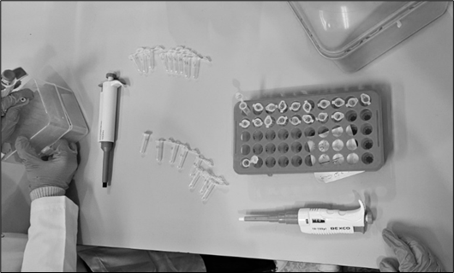
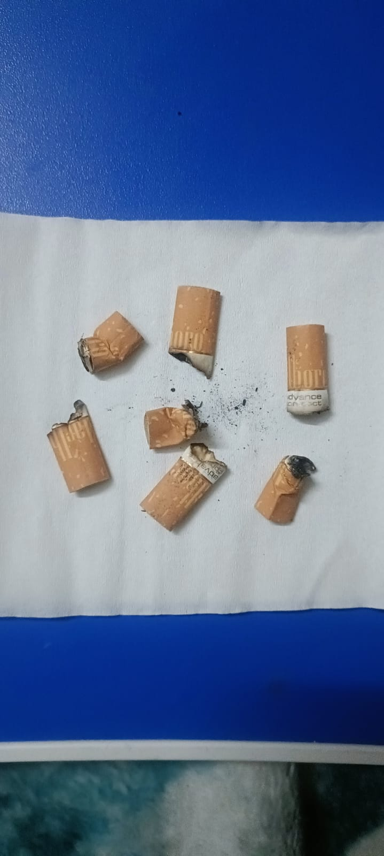
Fig.1. Pre-processing for DNA sample collection.
Initially the washed samples were divided into 3 equal parts in order to subject them to 4 independent extraction protocols which include:
1. Cetyl trimethyl ammonium bromide (CTAB) extraction ¹⁶, 2. Phenol Chloroform extraction¹⁷ (I), 3. Phenol Chloroform extraction (II), 4. Phenol Chloroform extraction (III), 5. Salting out extraction
However, one protocol (CTAB) was abandoned due to the repeated failure in extracting any DNA from the tissues as no DNA was noticed on the gel material following gel electrophoresis. Excluding CTAB extraction protocol, other 3 extractions protocols were standardized for the liberation of DNA. Pertinently the standardized protocols that were followed during initial attempts/trials failed to give any positive results of DNA retrieval. While there has been a significant variation in the DNA recovery protocols of different laboratories, it is emphasized that one should optimize the protocols within the means of the individual laboratory ¹⁸. Accordingly, a protocol was chosen after deciding the final conditions of proteinase K concentration, incubation temperature, incubation period and complete homogenization of the tissue ¹⁹. However, when standardized phenol chloroform extraction failed to give satisfactory results particularly for aged specimens, the technique was further modified for the liberation of DNA in all the circumstances irrespective of the duration of fixation ²⁰. Accordingly, three versions of standardized phenol chloroform method of extraction were attempted and developed thereby making a total of five extraction methods ²¹. While the tissues were divided into equal parts, variations due to cellularity among some of the tissue sections cannot be excluded. Hence in all the later attempts, tissues were divided into 5 equal parts. Each tissue part was thereafter subjected to an independent extraction protocol after complete homogenization using different various set of reagents/chemicals ^{22,23}.
  - Materials required
Chloroform (99.8%), iso-Propyl Alcohol (99.8%), Ammonium Acetate (98%), Acetone (99.8%), Dithiothreitol (DTT) (99%), Sodium Chloride (99.5%), Glycine (99.5%), Phenol (99.5%), Ethylene Diamine Tetra Acetic Acid (99.5%), Hydrochloric Acid (36.5%) were bought from Loba Chemie; Proteinase K, Sodium Acetate, Sodium Chloride, Tris, Sodium Dodecyl Sulphate, Phenol Chloroform isoamyl alcohol mixture, Isoamyl alcohol, Sodium hydroxide pellets, Potassium Chloride, Ammonium Acetate, Monopotassium phosphate, Sodium phosphate dibasic were procured from Hi Media; Ethanol was taken from Merck Germany; Sodium Lauryl Sulphate “Ultra Pure” was purchased from Otto; QIAamp® was acquired from Qiagen (Germany).

2.3 Protocols used for DNA extraction
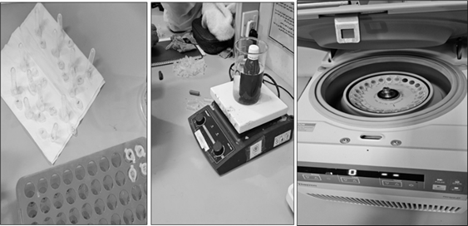
Fig.2. Tissue sections prepared for DNA extraction.
Each tissue section prepared at step is shown in Fig.2. was subjected to an independent DNA extraction protocol using various reagents. The DNA extraction methods employed in this investigation along with the usual steps followed in independent extraction protocols are as follows.

2.3.1 Method I-CTAB DNA isolation method
Collected sample in 1.5ml vial and lysis buffer and incubated for 30 minutes at 60 degree centigrade. After incubated added 0.5ml separation buffer (Chloroform: Isoamyl alcohol), mixed properly by many times inverting, centrifuged for 10 minutes at 10,000 rpm. Collected supernatant (top layer) in new eppendorff tube and added 0.5 ml 70% isopropanol, mixed properly and again centrifuged like last step. This time decant supernatant and save pellet, dry vial for 15 minutes and after that add 100ul 1X TE buffer or water for further use

2.3.2 Phenol chloroform extraction protocol
A single validated protocol for Phenol-Chloroform extraction was developed by modifying existing methods. The process involved adding TNE buffer to washed tissue, mincing it finely, and homogenizing it. Proteinase K was then added, followed by a 72-hour incubation at 60°C. After incubation, samples were vortexed, centrifuged, and processed for DNA extraction. When this method failed for aged specimens, three modified versions were developed.
The steps of Phenol chloroform method of DNA extraction in its three versions are:
2.3.2.1 Method II - Phenol chloroform extraction (Version-I) protocol
The DNA extraction process involved adding a phenol/chloroform/isoamyl alcohol mixture to the sample, followed by vortexing and centrifugation. The supernatant was transferred to a new tube while discarding protein debris. This step was repeated with another round of phenol/chloroform/isoamyl alcohol, followed by chloroform/isoamyl treatment twice. The final supernatant was collected for DNA precipitation using sodium acetate or sodium chloride along with cold ethanol, incubated at -80°C for 5 hours or -20°C overnight. After ethanol washes and drying, the DNA pellet was resuspended in TE buffer, incubated at 55°C, and analyzed using gel electrophoresis and spectrophotometry.
2.3.2.2 Method III -Phenol-chloroform extraction (Version-II) protocol
This modified DNA extraction method used only a phenol/chloroform mix (1:1) initially instead of phenol/chloroform/isoamyl alcohol. After vortexing and centrifugation, the supernatant was transferred to fresh tubes through multiple rounds of phenol/chloroform and phenol/chloroform/isoamyl treatments, followed by additional chloroform/isoamyl washes. DNA precipitation was carried out using 0.1M NaCl (1:5) or isopropanol, along with cold ethanol. After incubation at -80°C for 5 hours or -20°C overnight, ethanol washes were performed, and the DNA pellet was dried at room temperature. The DNA was resuspended in TE buffer, incubated at 55°C, and analyzed using gel electrophoresis and spectrophotometry.
2.3.2.3 Method IV -Phenol chloroform extraction (Version-III) protocol
When formalin-preserved specimens were processed using the previous Phenol/Chloroform extraction methods, DNA recovery significantly declined or failed. To minimize DNA loss, instead of discarding the leftover bottom material (protein debris), it was collected in a fresh tube at each stage. After completing the standard extraction steps, 1000 µl of chloroform/isoamyl alcohol (1:1) was added, followed by vortexing and centrifugation. The supernatant was then transferred and treated again with 500 µl of chloroform/isoamyl alcohol. DNA was precipitated using isopropanol instead of NaCl. After centrifugation, the pellet was washed twice with 70% ethanol, air-dried, and resuspended in TE buffer. The DNA solution was incubated at 56°C for 15 minutes before storage at -20°C. The extracted DNA was analyzed using gel electrophoresis and spectrophotometry.
2.3.3. Method V-Salting out DNA extraction protocol
For salting out extraction method, the protocol of Rivero et al., 2006 and Funabashi et al., 2012 was followed but with some modifications ^{24,25}. The steps followed were:
Prior to any addition, a tissue was finely chopped using a clean sterilized surgical blade. 2. Following this 1000µl of digestion buffer (10mM Tris-HCl, 1.0mM EDTA and 0.5% Tween 20 at a pH=8.0,) was added to this chopped tissue and was additionally subjected to homogenization using a tissue homogenizer. The homogenized tissue was transferred to a sterilized falcon tube and followed by adding 20mg/ml proteinase K to it. The tubes were then left for overnight incubation (up to 36 hours in some cases) at 56ºC. After the completion of this period, incubation temperature was extended to 95ºC for 10 -25 minutes (usually 15 minutes) for inactivating the proteinase K activity. 400 µl of Ammonium acetate was added to the tube and was again incubated for 10 minutes at 20ºC. Following this, step, tubes were briefly vortexed and centrifuged for 12 minutes at maximum speed. The supernatant was then transferred to a new tube and 600 µl of isopropanol was added to this tube. Following this addition, the tube was briefly vortexed and centrifuged at maximum speed for 35 minutes. After the completion of centrifugation, the supernatant was discarded and 250 µl of 70% ethanol was added to the tube containing the pellet. The pellet was washed twice with 70% ethanol. The ethanol was discarded after being used for the washing of the pellet and consequently the pellet was left for air drying. Once the ethanol was completely evaporated, 80 µl of TE solution was added to the pellet and was briefly vortexed. The tube was again incubated at 56ºC for 15 minutes with a view to dissolve the DNA in the TE solution and was thereafter stored in -20ºC. A part of this diluted DNA was subjected to gel electrophoresis and spectrophotometric analysis.

2.4 Pre-processing of paraffin embedded tissues for DNA extraction

For paraffin-embedded specimens, a tissue portion was excised with a sterile blade and placed on a cleaned microscope slide. The slide was heated on a hot plate to melt the paraffin, after which the tissue was carefully separated and transferred to a new slide. Further heating helped remove residual paraffin. The tissue was then washed in 70% alcohol, followed by 95% alcohol. Due to the small tissue size, only two DNA extraction methods were used: the Salting Out method and a commercial kit, following previously discussed protocols.

2.5 DNA integrity
Agarose gel electrophoresis: A 1% agarose gel was prepared by dissolving agarose in 1X TAE buffer, heating, and adding Ethidium Bromide (EtBr) before setting at room temperature. Once set, the gel was placed in a running tank with 1X TAE buffer. Extracted DNA was mixed with loading dye and loaded into wells, though DNA ladders were later omitted. Electrophoresis was run at 100V for 30-50 minutes. The DNA, bound to EtBr, fluoresced under UV light and was imaged. Only DNA verified through visualization was stored at -20°C for spectrophotometric analysis, while non-authenticated samples were discarded.

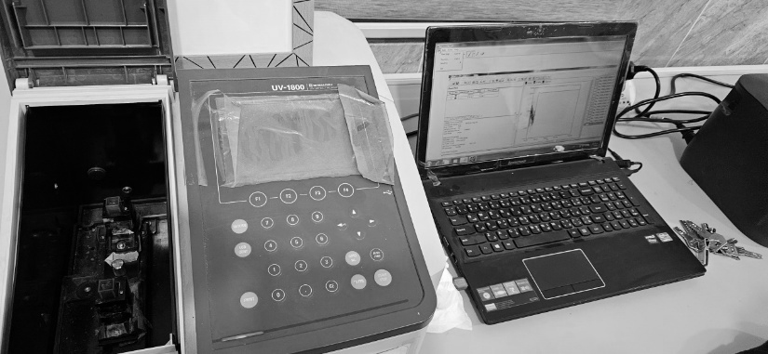
2.6 Quality control assessment using UV spectrophotometer
Fig.3. UV Spectrophotometer.
Ultraviolet spectrophotometry (UV) (Fig. 3) was used for DNA quantification using the Evolution 60S Thermo Fisher Scientific spectrophotometer. DNA samples were placed in a quartz cuvette, and absorbance was measured at 260 nm (A260) for nucleic acid concentration and 280 nm (A280) for protein contamination. The DNA purity was determined by the A260/A280 ratio, with values ≥1.8 considered relatively pure. DNA concentration was calculated using the formula: Concentration (µg/ml) = A260 × dilution factor × 50 µg/ml.
While UV spectrophotometry is simple and requires minimal purified DNA, it has limitations, especially for low-yield samples from formalin-fixed tissues, where dilution is impractical due to degradation. Only DNA samples with an A260/A280 ratio between 1.8-2.0 were selected for PCR analysis.

2.7 PCR Amplification

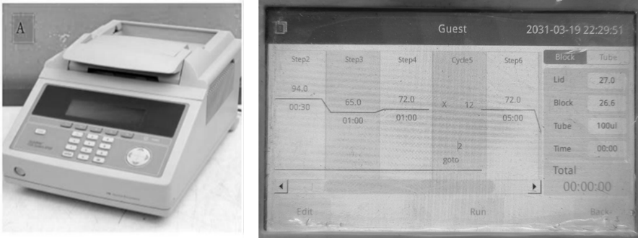
Fig.4. PCR thermal cycler and PCR programming.

Samples with an absorbance (A₂₆₀/A₂₈₀) ratio in between 1.2 - 1.8 were selected for the PCR amplifications. GlobalFiler® PCR Amplification Kit (Life Technologies) was used for the amplification of DNA extracted from fixed specimens. All PCR assays were conducted using 5 µl of DNA, 7.5 µl of Primer mix, 2.5 µl of Master Mix. The amplifications were performed as per the standardized protocol on a 9700 thermal cycler (Fig. 4) specific for degraded samples using up-to 40 PCR cycles (Life Technologies).

- RESULT AND DISCUSSION:
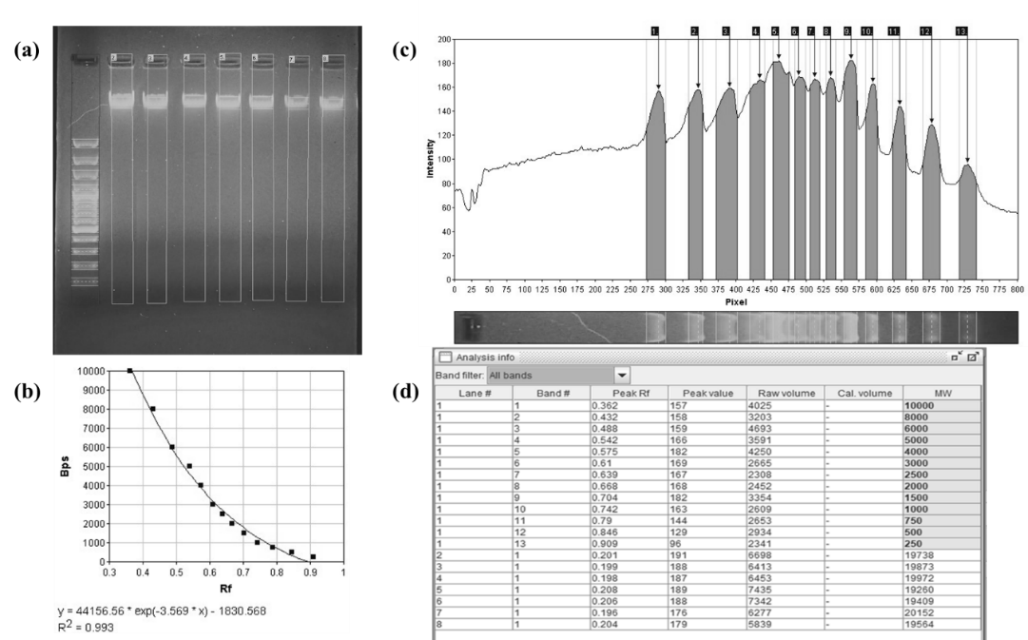
Fig.5. Gel analysis of DNA obtained from Human saliva samples from method 1.
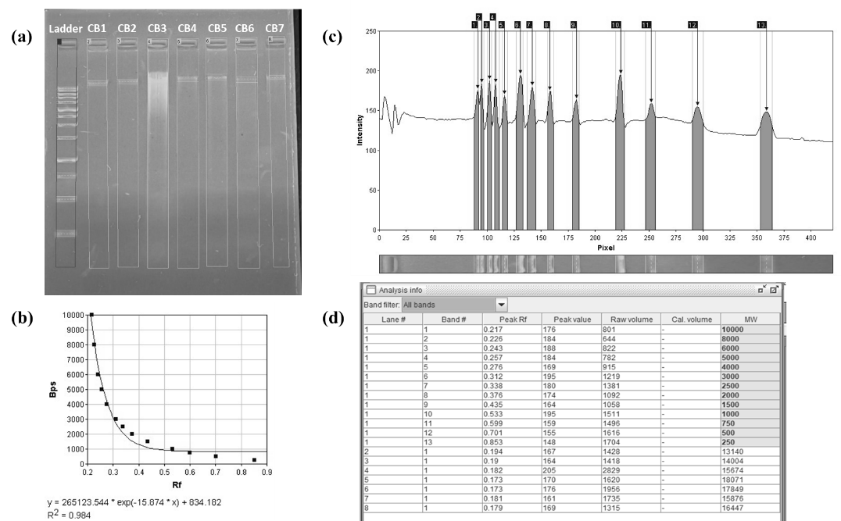
Fig.6. Gel analysis of DNA obtained from Cigarette bud samples from method 1.
Human Saliva | Absorbance at 260nm | Absorbance at 280nm | Absorbance 260nm/280nm Purity (O.D.) | Concentration of DNA (µg/µl) | Cigarette Butts | Absorbance at 260nm | Absorbance at 280nm | Absorbance 260nm/280nmPurity (O.D.) | Concentration of DNA (µg/µl)
HS1 | 1.57 | 1.28 | 1.22 | 7.85 | CB1 | 1.84 | 1.11 | 1.65 | 9.2
HS2 | 1.89 | 1.08 | 1.75 | 9.45 | CB2 | 1.93 | 1.09 | 1.77 | 9.65
HS3 | 1.97 | 1.02 | 1.93 | 9.85 | CB3 | 1.99 | 1.11 | 1.79 | 9.95
HS4 | 1.76 | 1.18 | 1.49 | 8.8 | CB4 | 1.95 | 1.17 | 1.66 | 9.75
HS5 | 1.3 | 1.15 | 1.13 | 6.5 | CB5 | 1.87 | 1.13 | 1.65 | 9.35
HS6 | 1.85 | 1.08 | 1.71 | 9.25 | CB6 | 1.51 | 1.32 | 1.14 | 7.55
HS7 | 1.75 | 1.15 | 1.52 | 8.75 | CB7 | 1.97 | 1.11 | 1.77 | 9.85
Table.1. Absorbance and concentration of DNA obtained from Human saliva and Cigarette butts through method 1.
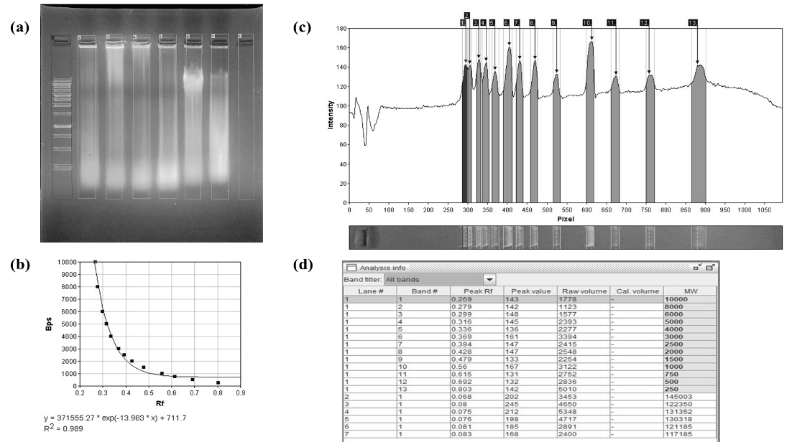
Fig.7. Gel analysis of DNA obtained from Human saliva samples from method 2.
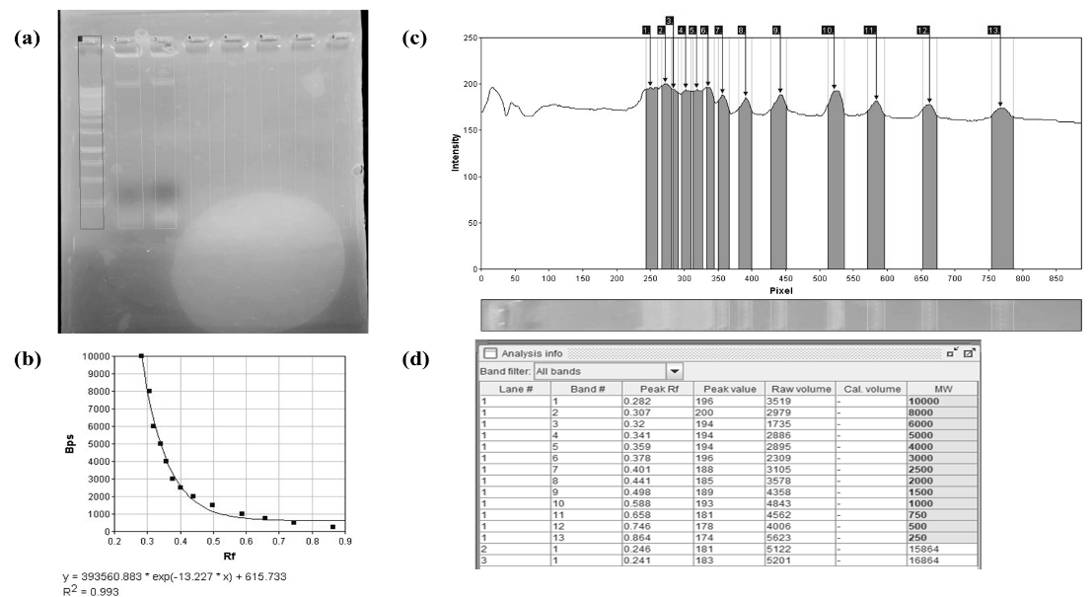
Fig.8. Gel analysis of DNA obtained from Cigarette bud samples from method 2.
Human Saliva | Absorbance at 260nm | Absorbance at 280nm | Absorbance 260nm/280nm Purity (O.D.) | Concentration of DNA (µg/µl) | Cigarette Butts | Absorbance at 260nm | Absorbance at 280nm | Absorbance 260nm/280nm Purity (O.D.) | Concentration of DNA (µg/µl)
HS1 | 1.91 | 1.38 | 1.38 | 9.55 | CB1 | 1.68 | 1.25 | 1.34 | 8.4
HS2 | 1.79 | 1.27 | 1.41 | 8.95 | CB2 | 1.82 | 1.19 | 1.52 | 9.1
HS3 | 1.85 | 1.15 | 1.61 | 9.25 | CB3 | - | - | - | -
HS4 | 1.79 | 1.21 | 1.47 | 8.95 | CB4 | - | - | - | -
HS5 | 1.91 | 1.58 | 1.21 | 9.55 | CB5 | - | - | - | -
HS6 | 1.79 | 1.48 | 1.21 | 8.95 | CB6 | - | - | - | -
HS7 | 1.88 | 1.13 | 1.66 | 9.4 | CB7 | - | - | - | -
Table.2. Absorbance and concentration of DNA obtained from Human saliva and Cigarette butts through method 2.
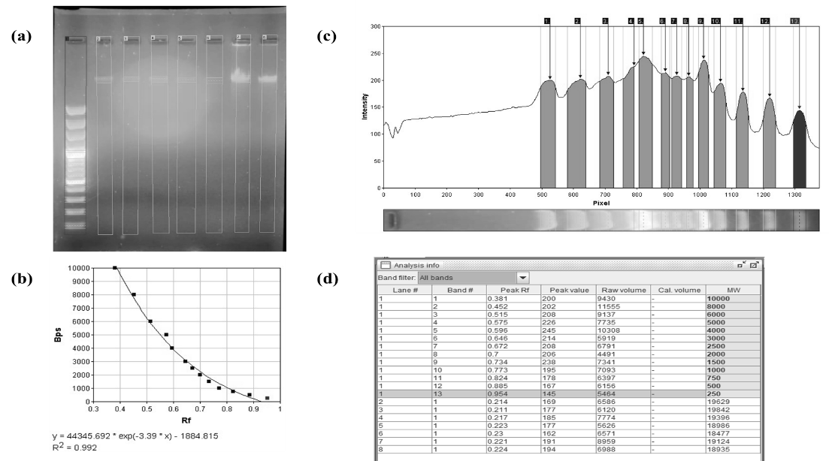
Fig.9. Gel analysis of DNA obtained from Human saliva samples from method 3.
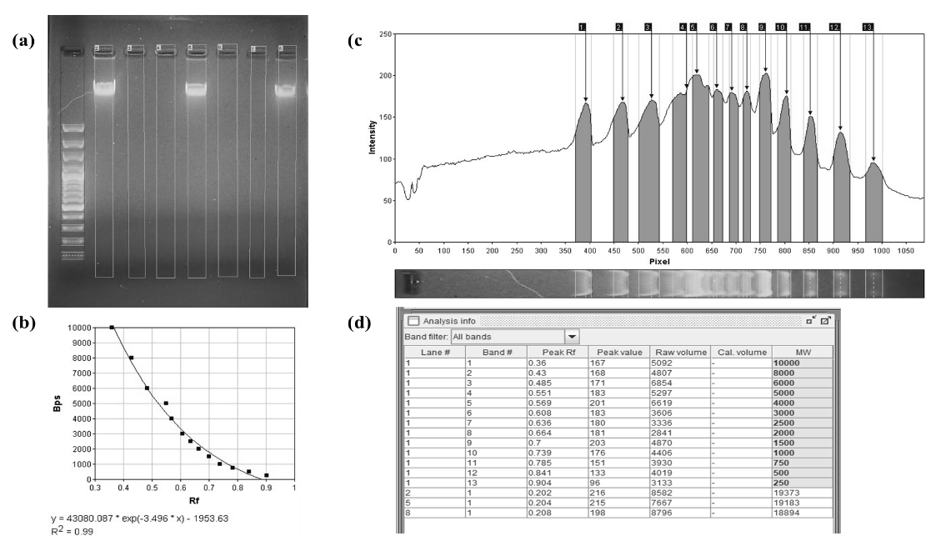
Fig.10. Gel analysis of DNA obtained from Cigarette bud samples from method 3.
Table of method 3
Human Saliva | Absorbance at 260nm | Absorbance at 280nm | Absorbance 260nm/280nm Purity (O.D.) | Concentration of DNA (µg/µl) | Cigarette Butts | Absorbance at 260nm | Absorbance at 280nm | Absorbance 260nm/280nm Purity (O.D.) | Concentration of DNA (µg/µl)
HS1 | 1.88 | 1.41 | 1.33 | 9.4 | CB1 | 1.68 | 1.25 | 1.34 | 8.4
HS2 | 1.91 | 1.32 | 1.44 | 9.55 | CB2 | - | - | - | -
HS3 | 1.79 | 1.18 | 1.51 | 8.95 | CB3 | - | - | - | -
HS4 | 1.85 | 1.23 | 1.5 | 9.25 | CB4 | 1.79 | 1.27 | 1.4 | 8.95
HS5 | 1.94 | 1.61 | 1.2 | 9.7 | CB5 | - | - | - | -
HS6 | 1.77 | 1.51 | 1.17 | 8.85 | CB6 | - | - | - | -
HS7 | 1.89 | 1.23 | 1.53 | 9.45 | CB7 | 1.82 | 1.19 | 1.52 | 9.1
Table.3. Absorbance and concentration of DNA obtained from Human saliva and Cigarette butts through method 3
.
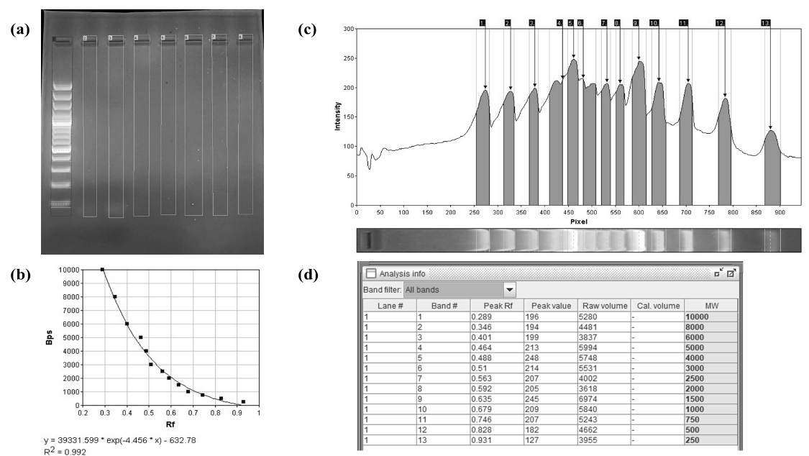
Fig.11. Gel analysis of DNA obtained from Human saliva samples from method 4.
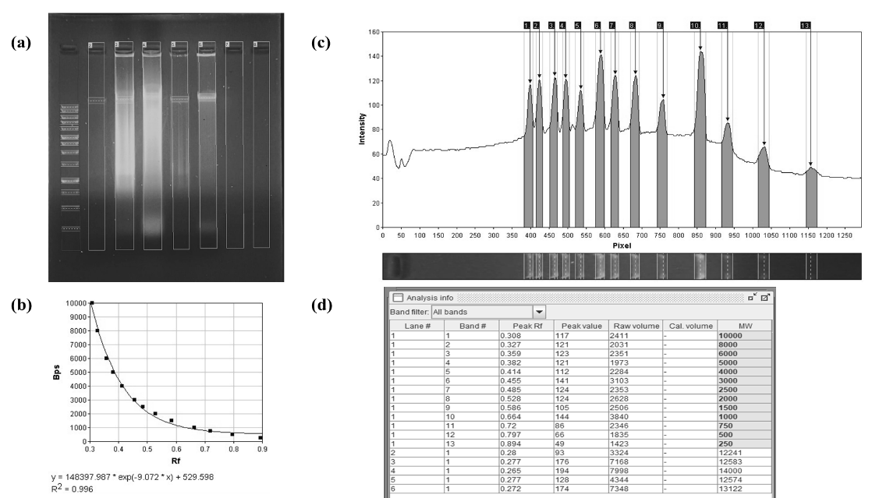
Fig.12. Gel analysis of DNA obtained from Cigarette bud samples from method 4.
Human Saliva | Absorbance at 260nm | Absorbance at 280nm | Absorbance 260nm/280nm Purity (O.D.) | Concentration of DNA (µg/µl) | Cigarette Butts | Absorbance at 260nm | Absorbance at 280nm | Absorbance 260nm/280nmPurity (O.D.) | Concentration of DNA (µg/µl)
HS1 | - | - | - | - | CB1 | 1.78 | 1.25 | 1.42 | 8.9
HS2 | - | - | - | - | CB2 | 1.82 | 1.19 | 1.52 | 9.1
HS3 | - | - | - | - | CB3 | 1.94 | 1.61 | 1.2 | 9.7
HS4 | - | - | - | - | CB4 | 1.79 | 1.27 | 1.4 | 8.95
HS5 | - | - | - | - | CB5 | 1.69 | 1.25 | 1.35 | 8.45
HS6 | - | - | - | - | CB6 | - | - | - | -
HS7 | - | - | - | - | CB7 | - | - | - | -
Table.4. Absorbance and concentration of DNA obtained from Human saliva and Cigarette butts through method 4.

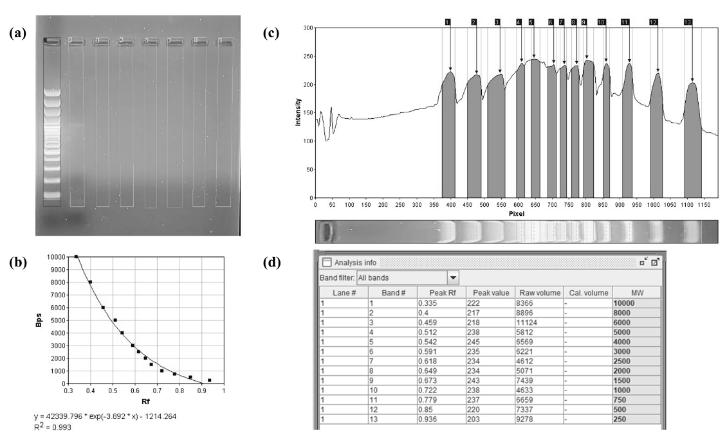
Fig.13. Gel analysis of DNA obtained from Human saliva samples from method 5.
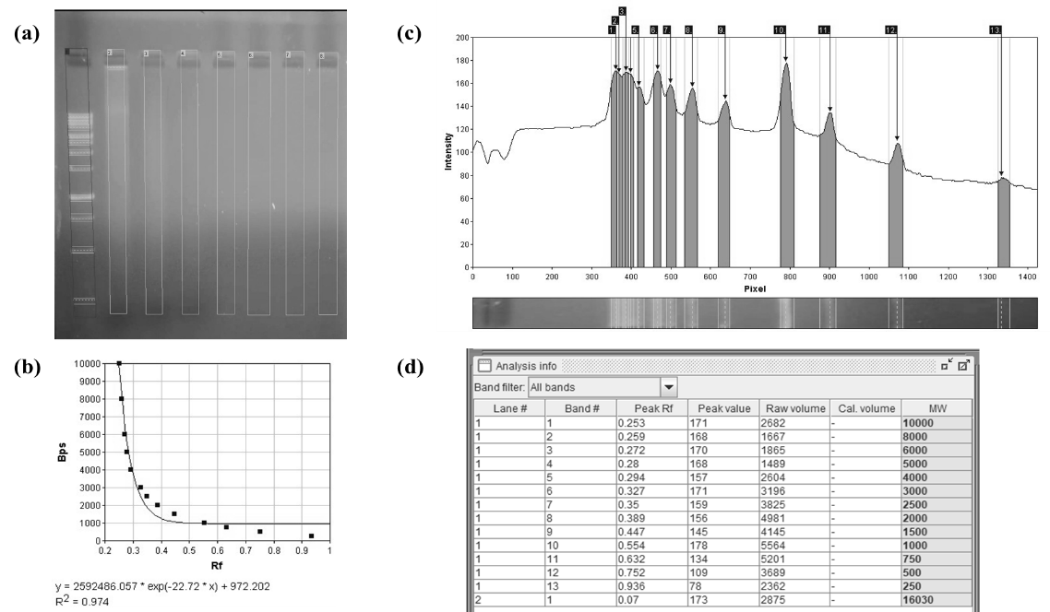
Fig.14. Gel analysis of DNA obtained from Cigarette bud samples from method 5.
Fig.5 to 14. which is of human genomic DNA agarose gel analysis. Through the images it is concluded that the DNA bands visible are of more than 10kbps which is an ideal result for genomic DNA bands. Smearing pattern seen through few of the lane can be caused by improper storage, enzymatic degradation, or excessive shearing during extraction. DNA bands appears cloudy or trapped in the well can have the possibility of protein or salt contamination (e.g., phenol-chloroform extraction, ethanol precipitation).
Human Saliva | Absorbance at 260nm | Absorbance at 280nm | Absorbance 260nm/280nm Purity (O.D.) | Concentration of DNA (µg/µl) | Cigarette Butts | Absorbance at 260nm | Absorbance at 280nm | Absorbance 260nm/280nmPurity (O.D.) | Concentration of DNA (µg/µl)
HS1 | - | - | - | - | CB1 | 1.89 | 1.2 | 1.57 | 9.45
HS2 | - | - | - | - | CB2 | - | - | - | -
HS3 | - | - | - | - | CB3 | - | - | - | -
HS4 | - | - | - | - | CB4 | - | - | - | -
HS5 | - | - | - | - | CB5 | - | - | - | -
HS6 | - | - | - | - | CB6 | - | - | - | -
HS7 | - | - | - | - | CB7 | - | - | - | -

Table.5. Absorbance and concentration of DNA obtained from Human saliva and Cigarette butts through method 5.
From Table. 1,2,3,4 and 5. It can be interpreted that the absorbance 260nm/280nm purity (O.D.) is between the range of 1.2 to 1.99. The ideal range falls between 1.8–2.0 for pure DNA. If the range is <1.8 there can be a possibility of protein or phenol contamination, which may interfere with downstream applications. Or if the range is >2.0 possibility of RNA contamination is there which requires additional purification.

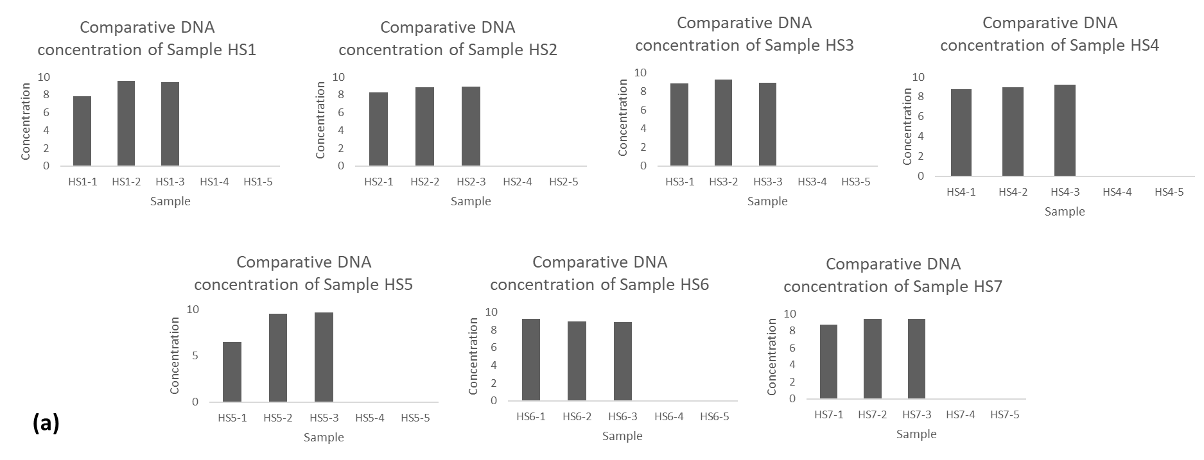
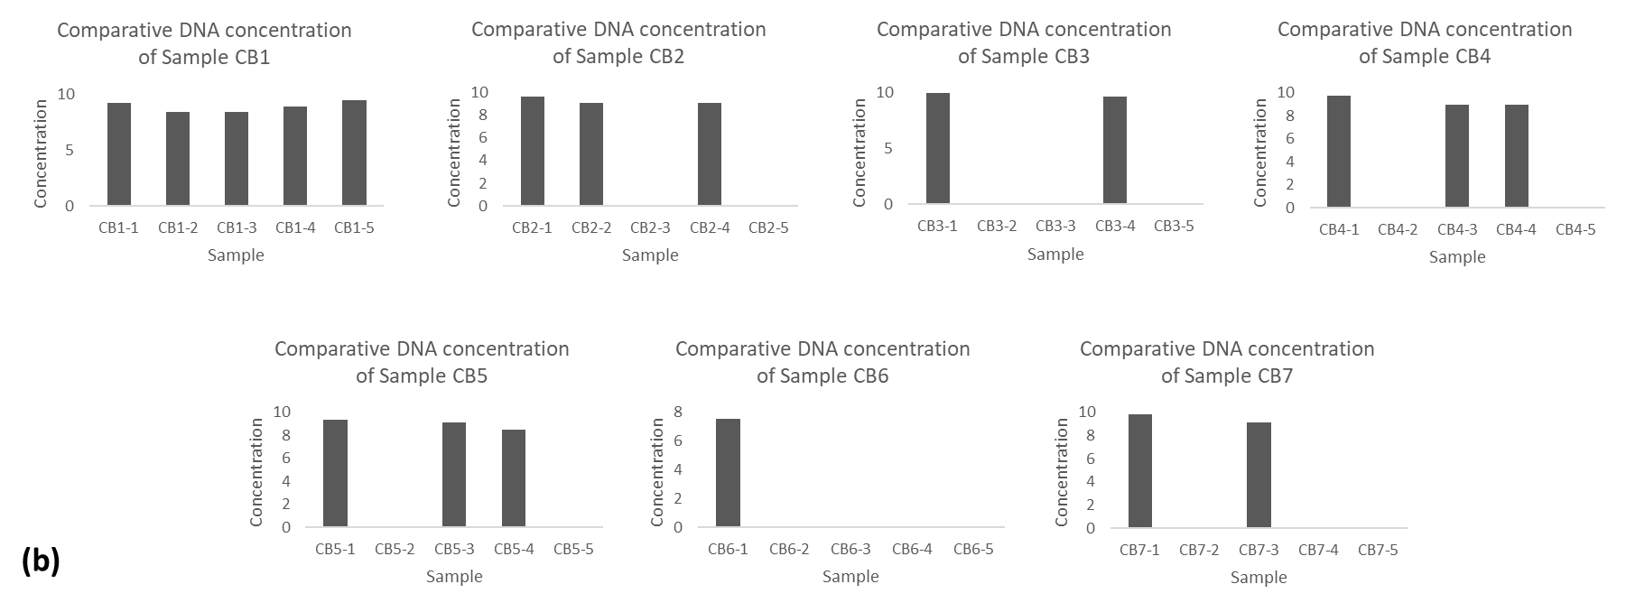
Fig.15. Comparative DNA concentration of sample (a) Human saliva (HS1-HS7) and (b) Cigarette butts (CB1-CB7).

- CONCLUSION:
In this project, five different methods were used to isolate DNA. With few methods, we even did not get light band as it can be seen in Electrophoresis images. Reasons are not only method it may be method employed to collect samples as well or how initial steps have been applied like removal of salt present with saliva, as salt is major concern which is part of saliva samples. However, Cigarette butts samples were collected many times to get saliva specimen from its surface and it was tough though, therefore, proper kit to collect saliva from cigarette butts is already available and that is recommended to buy, manual process is time consuming and looks non scientific.
CTAB DNA isolation method is robust method what is being concluded from this project which is not using comparative toxic chemicals to handle but chloroform should be used carefully although while making solution. Results obtained finds CTAB DNA isolation is one of the best, but human error while making chemicals and following protocol for isolation can be denied while using other methods.
DNA extraction remains fundamental in forensic science, genetics, and medical diagnostics, playing a crucial role in human identification. While advancements have improved DNA yield and purity, challenges persist, particularly with degraded or contaminated samples.
Future innovations, such as automated extraction systems and molecular biology advancements, will enhance forensic investigations, especially for challenging samples. As DNA-based identification grows in demand, continued research into improved methods is essential. Ultimately, refining DNA extraction techniques will strengthen forensic science, healthcare, and personal identification.
Disclaimer (Artificial intelligence)
Option 2:
Author(s) hereby declare that generative AI technologies such as Large Language Models, etc. have been used during the writing or editing of manuscripts. This explanation will include the name, version, model, and source of the generative AI technology and as well as all input prompts provided to the generative AI technology
Details of the AI usage are given below:
1.ChatGPT version 1.2025.077

REFERENCES:
1. Bhoyar, L., Mehar, P. & Chavali, K. An overview of DNA degradation and its implications in forensic caseworks. Egypt J Forensic Sci 14, 15 (2024).
2. M. Carpi, F., Di Pietro, F., Vincenzetti, S., Mignini, F. & Napolioni, V. Human DNA Extraction Methods: Patents and Applications. DNAG 5, 1–7 (2011).
3. School of Health Sciences, Universiti Sains Malaysia, Kelantan, Malaysia, Panneerchelvam, S., Mohd Nor, N., School of Health Sciences, Universiti Sains Malaysia, Kelantan, Malaysia, & Malaysia Genome and Vaccine Institute, National Institutes of Biotechnology Malaysia, Selangor, Malaysia. DNA Profiling in Human Identification: From Past to Present. MJMS 30, 5–21 (2023).
4. Gupta, N. DNA extraction and polymerase chain reaction. J Cytol 36, 116 (2019).
5. J Shetty, P. The Evolution of DNA Extraction Methods. AJBSR 8, 39–45 (2020).
6. Zhang, Q.-W., Lin, L.-G. & Ye, W.-C. Techniques for extraction and isolation of natural products: a comprehensive review. Chin Med 13, 20 (2018).
7. Haarkötter, C. et al. A comparison of five DNA extraction methods from degraded human skeletal remains. Forensic Science International 348, 111730 (2023).
8. Witt, S., Neumann, J., Zierdt, H., Gébel, G. & Röscheisen, C. Establishing a novel automated magnetic bead-based method for the extraction of DNA from a variety of forensic samples. Forensic Science International: Genetics 6, 539–547 (2012).
9. Barbaro, A. Challenges in DNA Extraction from Forensic Samples. in Handbook of DNA Profiling (eds. Dash, H. R., Shrivastava, P. & Lorente, J. A.) 1–20 (Springer Singapore, Singapore, 2021). doi:10.1007/978-981-15-9364-2_36-1.
10. Tan, S. C. & Yiap, B. C. DNA, RNA, and Protein Extraction: The Past and The Present. BioMed Research International 2009, 574398 (2009).
11. Bitwell, C., Indra, S. S., Luke, C. & Kakoma, M. K. A review of modern and conventional extraction techniques and their applications for extracting phytochemicals from plants. Scientific African 19, e01585 (2023).
12. McDonald, C., Taylor, D. & Linacre, A. PCR in Forensic Science: A Critical Review. Genes 15, 438 (2024).
13. Goode, M. R., Cheong, S. Y., Li, N., Ray, W. C. & Bartlett, C. W. Collection and Extraction of Saliva DNA for Next Generation Sequencing. JoVE 51697 (2014) doi:10.3791/51697.
14. Nunes, A. P. et al. Quality of DNA extracted from saliva samples collected with the OrageneTM DNA self-collection kit. BMC Med Res Methodol 12, 65 (2012).
15. Hochmeister, M. N. et al. PCR-based typing of DNA extracted from cigarette butts. Int J Leg Med 104, 229–233 (1991).
16. Schenk, J. J., Becklund, L. E., Carey, S. J. & Fabre, P. P. What is the “modified” CTAB protocol? Characterizing modifications to the CTAB DNA extraction protocol. Appl Plant Sci 11, e11517 (2023).
17. J. Barnes, S., Christner, B. & Thrash, C. Modified Phenol Chloroform Genomic DNA Extraction Protocol from the Christner Lab (University of Florida) v1. Preprint at https://doi.org/10.17504/protocols.io.b5beq2je (2022).
18. Hedman, J. et al. Enhanced forensic DNA recovery with appropriate swabs and optimized swabbing technique. Forensic Science International: Genetics 53, 102491 (2021).
19. Meizarini, A., Puteri, A., Yasan, Y. D. R. & Hussaini, H. M. Optimization of proteinase K incubation protocol duration during DNA extraction from oral squamous cell carcinoma FFPE samples. Dent. J. 56, 233–237 (2023).
20. Liu, A. W., Villar-Briones, A., Luscombe, N. M. & Plessy, C. Automated phenol-chloroform extraction of high molecular weight genomic DNA for use in long-read single-molecule sequencing. F1000Res 11, 240 (2022).
21. Shin, J. H. Nucleic Acid Extraction Techniques. in Advanced Techniques in Diagnostic Microbiology (eds. Tang, Y.-W. & Stratton, C. W.) 209–225 (Springer US, Boston, MA, 2013). doi:10.1007/978-1-4614-3970-7_11.
22. Elkins, K. M. Forensic DNA Biology: A Laboratory Manual. (Academic Press, Oxford, UK ; Waltham, MA, 2013).
23. Green, M. R. & Sambrook, J. Isolation of High-Molecular-Weight DNA Using Organic Solvents. Cold Spring Harb Protoc 2017, pdb.prot093450 (2017).
24. Nasiri, H., Forouzandeh, M., Rasaee, M. J. & Rahbarizadeh, F. Modified salting-out method: high-yield, high-quality genomic DNA extraction from whole blood using laundry detergent. J. Clin. Lab. Anal. 19, 229–232 (2005).
25. Rivero, E. R. C., Neves, A. C., Silva-Valenzuela, M. G., Sousa, S. O. M. & Nunes, F. D. Simple salting-out method for DNA extraction from formalin-fixed, paraffin-embedded tissues. Pathology - Research and Practice 202, 523–529 (2006).

