**Endophytic microbiota of diverse apple cultivars reveals cultivar-specific microbial associations**

.

ABSTRACT

|  |
| --- |
| Endophytic fungi are key components of plant microbiomes, contributing to host health, stress tolerance, and ecological adaptability. In apple (*Malus domestica*), the diversity and distribution of endophytic communities may be influenced by host genotype, yet comprehensive assessments across cultivars remain limited. This study investigates the culturable fungal endophytic communities associated with diverse apple cultivars to evaluate patterns of microbial diversity, community structure, and potential cultivar-specific associations. Culturable fungi were isolated, identified, and analyzed using a combination of morphological characterization and multivariate statistical tools. Community diversity metrics, relative abundance profiling, and ordination analyses were employed to explore fungal composition and interspecies relationships. The findings provide insights into the influence of host cultivar on the assembly of endophytic fungal communities and contribute to a broader understanding of plant–microbe interactions. This work lays the foundation for future microbiome-informed strategies aimed at enhancing sustainable apple cultivation. |

*Keywords: Apple Endophytes, Diversity Indices, Microbiome, Host genotype interaction*

1. INTRODUCTION

Apple (*Malus domestica*, Borkh), member of the Rosaceae family, which includes over 100 genera and 3,000 species distributed globally, especially in temperate zones (Velasco et al., 2010). Apples are mainly grown in temperate and subtropical regions worldwide, with limited production in the mountainous areas of tropical countries. Apple is considered one of the most important fruit crops in the world, with an annual production exceeding 80 million tons (http://faostat.fao.org). They are cultivated in all temperate and subtropical countries, with small-scale production occurring at high altitudes in tropical regions. Based on recent data from Jammu and Kashmir’s Department of Horticulture, apple cultivation in the region spans about 163,000 hectares, which represents nearly 75% of India’s total apple production area, and annual production reached 2,054.828 ton in 2024. Like many perennial plants, apple trees harbor diverse microbial communities that reside within their tissues without causing disease. These endophytic microorganisms comprising bacteria, fungi, and other microbes play critical roles in host health, including nutrient acquisition, stress tolerance, disease suppression, and growth promotion (Eid et al., 2019). Recent advances in plant microbiome research have highlighted the importance of host genotype in shaping microbial community structure. (Dastogeer et al., 2020). The interaction between rootstock and scion genotypes in apple trees plays a crucial role in shaping both rhizospheric and endophytic microbial communities, highlighting the significant impact of plant genetics on microbial diversity and distribution (Liu et al., 2018). Despite this, the individual influence of specific apple cultivars on the structure and diversity of their endophyte populations remains insufficiently studied, especially under uniform environmental conditions (Olivieri et al., 2021). In our research, endophytic fungal isolates obtained from various apple cultivars were primarily classified under Ascomycota (98.04%), with a minor proportion belonging to Basidiomycota (1.96%). This is consistent with earlier reports by Liu et al. (2018), who also identified Ascomycota as the dominant fungal group in U.S. apple samples, followed by Mucoromycota and Basidiomycota. Similar trends have been observed in other regions; for instance, Alijani et al. (2016)) found a prevalence of Ascomycota genera like Aspergillus, Alternaria, Chaetomium, and Trichoderma in Iranian apple orchards. These findings collectively highlight the widespread dominance of Ascomycota in apple-associated endophytic communities worldwide and emphasize the combined influence of cultivar genetics, local environment, and cultivation methods on fungal community dynamics.

The aim of this study was to assess the influence of apple cultivar genotype on the diversity and composition of endophytic microbiota. By isolating and characterizing endophytes from multiple cultivars, we seek to understand the extent to which cultivar genotype influences the endophytic microbiota. The findings may contribute to a deeper understanding of plant-microbe interactions in apple and support future efforts to harness endophytes for sustainable crop improvement and protection.

2. material and methods

Stem cuttings of various resistant and susceptible varieties of apple were collected from SKUAST Kashmir Shalimar (34 ̊8'42" and 34 ̊9'3"N latitudes and 74 ̊39'5" and 74 ̊53'5.6"E longitude). The samples were placed in paper bags and stored at 4°C. Furthermore, the plant materials were disinfected, and endophytes were isolated using a method adapted from Ebrahimi et al. (2021) and Strobel (2002). The plant stem sections were washed thoroughly under running tap water. Segments measuring six millimetres were then cut from each stem to isolate fungal endophytes in pure culture. These segments were surface-sterilized using 0.2% mercuric chloride for one minute, followed by three rinses with sterile deionized water. After drying with blotting paper, the segments were aseptically transferred onto PDA plates under sterile conditions and incubated at 25°C. The plates were observed regularly, and any emerging mycelium was immediately sub-cultured. The resulting cultures were further purified using either spore isolation or hyphal tip techniques and maintained through routine subculturing.

To assess the diversity of culturable fungal endophytes isolated from different apple cultivars, standard ecological diversity indices like Shannon Diversity Index (H’) (Shannon 1948), Simpson Diversity Index (D) (Simpson 1949), and Inverse Simpson Index (1/D) (Hill 1973) were calculated using the obtained species abundance data. The relative abundance of culturable fungal endophytes was analyzed to determine the proportional representation of each species within the community. Relative abundance data were processed and visualized based on the total isolate count per species. To explore differences in community composition among the fungal endophytes isolated from various apple cultivars, Principal Coordinates Analysis (PCoA) was performed using a Bray–Curtis dissimilarity matrix (Bray and Curtis 1957). This multivariate analysis was used to visualize beta diversity, i.e., the dissimilarity in fungal community structure samples. All the statistical analysis was done by using R studio (packages: vegan, tidyverse, ade4, cluster).

3. results

**3.1 Identification of endophytes isolated from different apple cultivars**

Using morphological characteristics, nine fungal genera were identified from the purified fungal isolates. Among these, 26 species were determined through an analysis that combined morphological features (Figure 1, Table 1). The findings revealed that 98.04% of the identified isolates were classified under Ascomycota and (1.96%) under Basidiomycota. Morphological characteristics of fungal endophytes isolated from different apple cultivars were depicted in (Figure 2, Table 2). It was found that Golden Delicious consistently harboured more endophytic fungi compared to other apple varieties.

Table 1 Distribution of fungal endophytes isolated from different sources apple cultivars.

|  |  |  |
| --- | --- | --- |
|  | **Source** | **No of endophytes** |
| 1 | Golden delicious | 14 |
| 2 | Maharaji | 11 |
| 3 | Ambri | 9 |
| 4 | Shalimar Apple | 7 |
| 5 | Red delicious | 6 |
| 6 | Shireen | 1 |
| 7 | Redchef | 1 |
| 8 | Superchef | 2 |

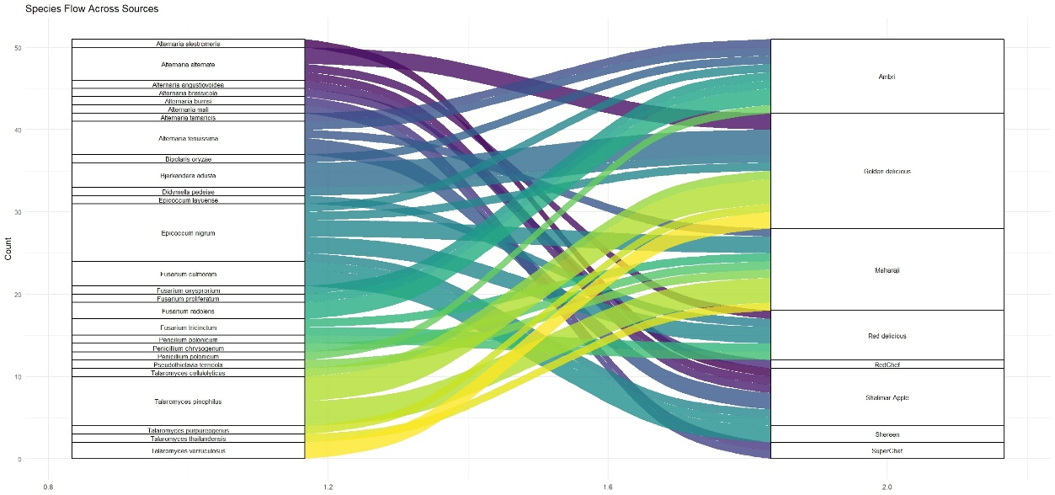Figure 1. Sankey diagram illustrating species flow across sources.

Table 2: Colony description of endophytes isolated from different apple cultivars.

|  |  |  |  |  |  |
| --- | --- | --- | --- | --- | --- |
| **S.NO** | **Endophyte Code** | **Isolate Name** | **Colony colour** | **Conidia** | |
| **Shape** | **Size(µm)** |
| 1 | E1 | Epicoccum *nigrum* | dark brown to dark orange | Spherical | 19 $×$ 25 |
| 2 | E2 | *Fusarium trunciticum* | Initially, white turning light pink at agar base | cylindrical | 30 $×$ 5 |
| 3 | E3 | *Fusarium oxysporum* | White and Yellow coloured at agar base | Sickle shaped | 30x4 |
| 4 | E4 | *Fusarium proliferatum* | White colored at agar base | Sickle shaped | 35x7 |
| 5 | E5 | *Fusarium redolens* | White and pale-yellow coloured at agar base | Elongated apical cell | 30×5 |
| 6 | E6 | *Alternaria angustiovoidea* | Dark olive-brown to greyish black | Obclavate | 18×12 |
| 7 | E7 | *Alternaria.alternata* | light to dark brown | irregular ellipsoid to obclavate | 21 ×17 |
| 8 | E8 | *Alternaria alestromeria* | Greyish to black, fluffy or cotton | Club shaped | 20 × 12 |
| 9 | E9 | *Penicillium polonicum* | Darker green to bluish green | Round | 3.7 - 3 |
| 10 | E10 | *Alternaria mali* | Dark olivaceous green | Elongated to cylindrical | 20×10 |
| 11 | E11 | *Fusarium oxysporum* | White and Yellow coloured at agar base | Sickle shaped | 30x4 |
| 12 | E12 | *Alternaria brassicola* | Iron grey | Obpyriform | 21×12 |
| 13 | E13 | *Fusarium culmorum* | Pale pink or reddish coloured at agar base | Sickle shaped | 25x4 µm |
| 14 | E14 | *Alternaria.tenussima* | light to dark brown | Obpyriform | 18×11 |
| 15 | E15 | *Penicillium chrysogenum* | Darker green to bluish green | Round | 3.7 – 3 |
| 16 | E16 | *Bipolaris oryzae* | Greyish | Fusiform to cylinder | 56 x 12 |
| 17 | E17 | *A. Tamaricis* | Brownish black or Greyish black | irregular ellipsoid to obclavate | 15×9 |

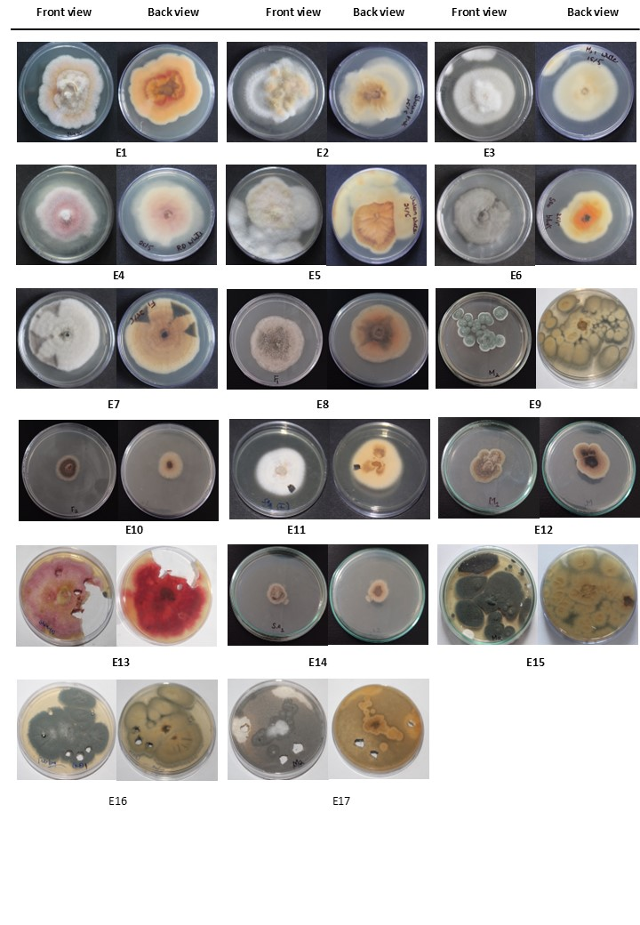

Figure 2: Colony morphology of fungal endophytes on PDA.

**3.2 Diversity Indices**

The calculated diversity indices offered valuable insights into the structure of the fungal endophytic community. The Shannon Diversity Index was determined to be 3.0, reflecting a moderate level of species diversity within the sampled population. A Simpson Diversity Index value of 0.9 indicated a degree of dominance by certain taxa, although a considerable level of diversity remained. Additionally, the Inverse Simpson Index, calculated at 1.2, further corroborated the presence of moderate diversity, suggesting a relatively balanced community structure with a few dominant species. Fig 3

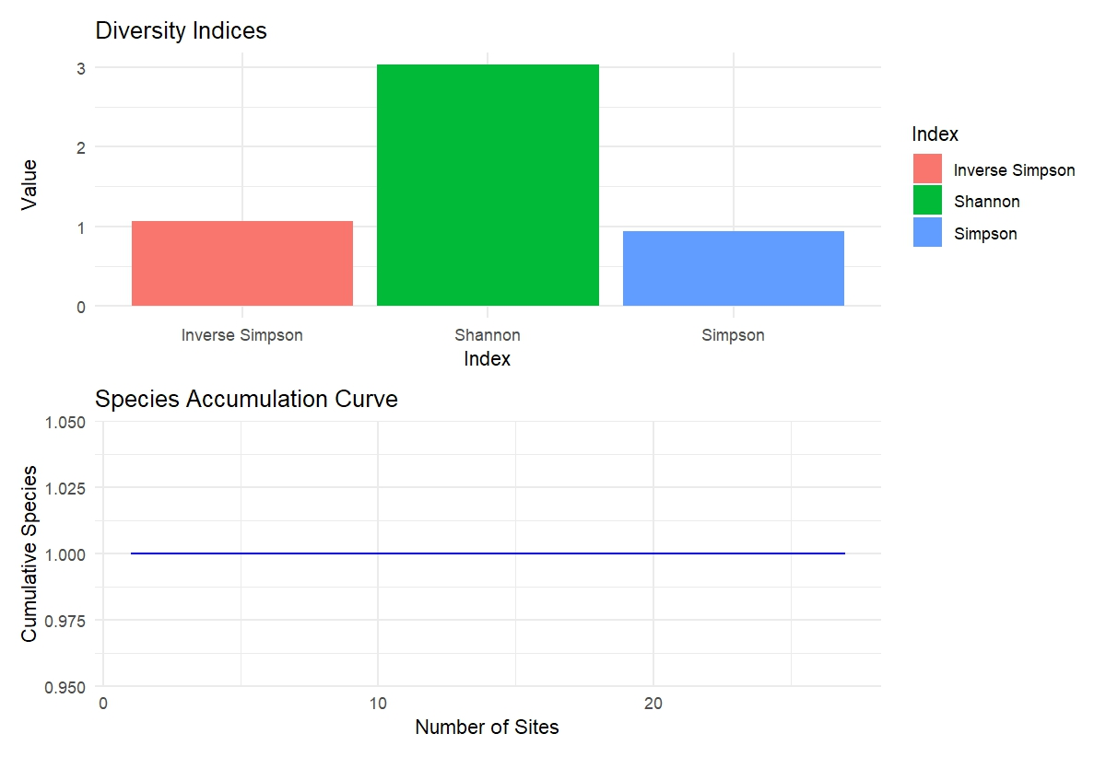

Figure 3: Diversity indices representing the structure of the culturable fungal endophytic community isolated from apple cultivars

**3.3 Relative Abundance:**

The relative abundance analysis provided a comprehensive overview of the fungal community composition across the sampled apple cultivars (Figure 1). Among the identified taxa, *Epicoccum nigrum* exhibited the highest relative abundance, accounting for over 10% of the total sequence reads. This indicates its potential role as a dominant member of the endophytic community. Following *E. nigrum*, *Talaromyces pinophilus* and *Alternaria alternata* also represented relatively abundant taxa, suggesting their widespread presence and possible ecological significance within the plant tissues. In contrast, the majority of the remaining species were characterized by low relative abundances, each contributing marginally to the overall community structure. Fig 4

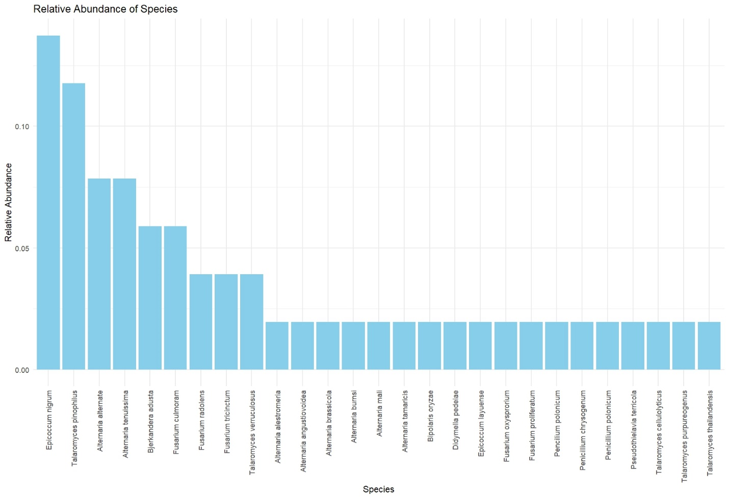

Figure 4: Relative abundance of culturable endophytic fungal species isolated from apple cultivars

**3.4 Principal Coordinates Analysis (PCoA)**

Principal Coordinates Analysis (PCoA) explained a cumulative 49.9% of the total variation, with PCoA1 accounting for 28.5% and PCoA2 for 21.4% of the variance. This suggests a moderate resolution in separating the community structures across different fungal taxa. (Figure 5). The plot revealed a clear differentiation among species clusters, indicating distinct community patterns and associations among certain fungal taxa. Notably, species such as *Talaromyces pinophilus* and *Alternaria alternata* (cyan cluster) were positioned at the periphery of the ordination space, suggesting distinct community composition and lower similarity with other taxa. Similarly, *Fusarium radicicola*, *Bipolaris oryzae*, and *Alternaria tamaricis* (red cluster) also showed clear segregation, indicating a unique compositional profile potentially associated with specific environmental conditions or host interactions. Conversely, a central cluster comprising *Epicoccum nigrum*, *Alternaria angustiovoidea*, *Alternaria brassicicola*, and *Fusarium culmorum* (green cluster) was observed, suggesting a shared ecological niche or overlapping distribution among these species. This central positioning indicates greater similarity in community composition, possibly representing core members of the endophytic microbiota in apple cultivars Fig 5.

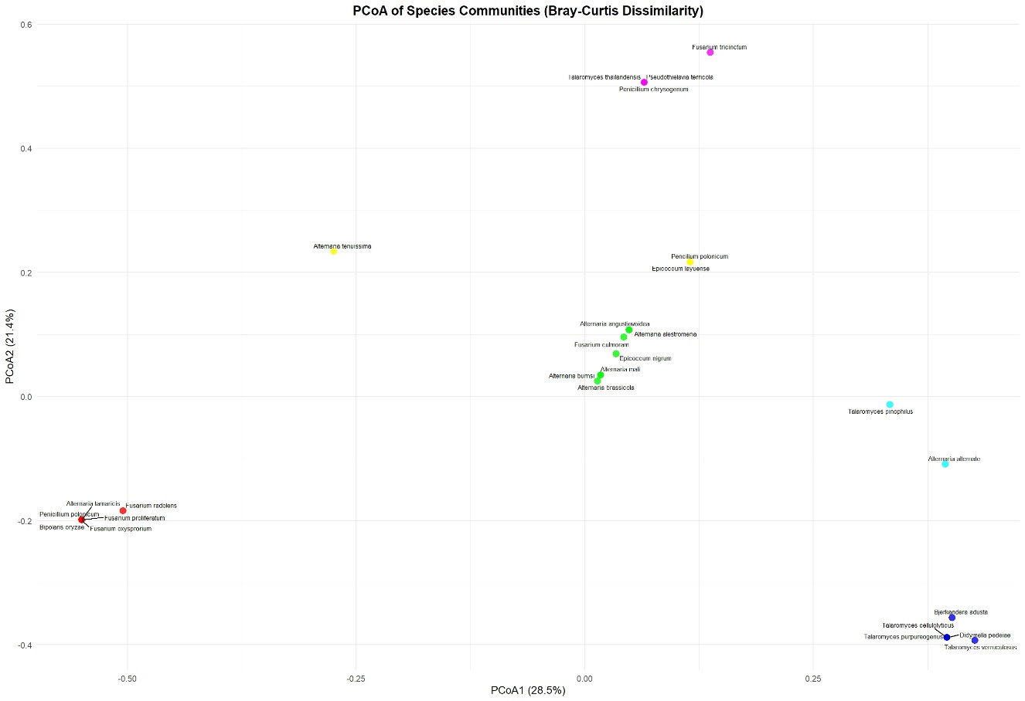

Figure 5: Principal Coordinates Analysis (PCoA) of endophytic fungal species based on Bray–Curtis dissimilarity, showing community composition across apple cultivars.

**4**. **Discussion**

This study underscores the spatial variability and host specificity of endophytic fungal communities, in line with previous findings that plant type, habitat, and cultivation practices influence microbial composition (Rivera-Orduña et al., 2011). Among the apple cultivars analyzed, Golden Delicious consistently exhibited the highest number of endophytes, particularly *Talaromyces pinophilus* and *Bjerkandera adusta*, while Maharaji was also rich in fungal diversity, notably harboring *Epicoccum nigrum*. A novel observation was the identification of *Bjerkandera adusta* as an apple endophyte. Known for its ability to degrade xenobiotics via Mn-peroxidases, its presence suggests potential for natural bioremediation within orchard ecosystems. The overall fungal community was dominated by Ascomycota (98.04%), with a minor representation of Basidiomycota (1.96%), consistent with previous studies from various regions (Liu et al., 2018, Alijani et al., 2016, Muresan, 2017). Genotype-specific traits, along with rootstock–scion combinations and orchard conditions, appear to shape fungal diversity (Olivieri et al., 2021). Notably, disease-resistant cultivars were associated with distinct endophytic profiles, potentially contributing to pathogen suppression. External factors such as fungicide use leaf age, and management practices (Arrigoni et al., 2020; Afandhi et al., 2017) further influenced community structure. Collectively, these results reinforce the role of host genotype and environmental interactions in shaping the apple endophytic microbiota and point to their potential applications in plant health and sustainable agriculture.

The analysis of diversity indices and relative abundance patterns reveals that the fungal endophytic community associated with the examined apple cultivars is moderately diverse, characterized by both species richness and a degree of dominance by certain taxa. The Shannon Diversity Index (H') value of 3.0 reflects a balanced community with considerable species variation, while the Inverse Simpson Index (1/D) value of 1.2 supports this observation, indicating the presence of diversity but with uneven species distribution (Magurran and McGill, 2010). These indices suggest that while a number of species coexist, a few exert a greater influence on the community structure. Notably, *Epicoccum nigrum*, *Talaromyces pinophilus*, and *Alternaria alternata* emerged as dominant species, collectively contributing a substantial proportion of the total community composition. These taxa have been frequently reported as common endophytes in various plant hosts and are known for their potential roles in plant health and ecological function. For instance, some of the endophytes have been widely documented for its antagonistic activity against phytopathogens and their ability to produce secondary metabolites with biocontrol properties (Singh et al., 2022) (Mousa and Raizada, 2013). Similarly, *T. pinophilus* is known for its enzymatic capabilities and potential involvement in nutrient cycling, while *A. alternata*, despite being associated with both pathogenic and endophytic lifestyles, may function as a facultative endophyte under certain environmental or host conditions (DeMers, 2022).The predominance of these species suggests that they may play critical ecological roles within the apple endosphere, potentially influencing host physiology, microbial community stability, and plant resilience. Their dominance could be driven by several factors, including host genotype preference, niche adaptability, or microbial competition dynamics. Further functional studies would be valuable to elucidate their specific contributions to host-microbe interactions and their potential utility in sustainable apple cultivation systems. When compared with similar studies on plant-associated fungal communities, the diversity indices observed in this study align with previous findings that describe fungal endophyte assemblages as moderately diverse and often dominated by a limited number of taxa. For instance, (Roy and Banerjee, 2018) reported that tropical and temperate endophytic fungal communities commonly exhibit a community structure where a few species dominate, while the majority occur at low frequencies. This trend has been attributed to factors such as competitive exclusion, niche partitioning, and host selective pressures, all of which shape microbial community assembly and stability (Lee et al., 2019). Such a structure suggests a core set of functionally important taxa that may contribute significantly to host fitness, while less abundant species may represent transient or conditionally active members of the microbiome. As such, future studies should aim to explore the ecological roles, functional traits, and interactions of the dominant species within the endophytic habitat. This could provide valuable insights into how microbial community dynamics influence host health and resilience, particularly in the context of genotype-specific plant-microbe interactions.

5. Conclusion

This study highlights the diversity and structure of culturable endophytic fungal communities associated with different apple cultivars, demonstrating clear cultivar-specific microbial associations. The predominance of Ascomycetous fungi and the repeated occurrence of certain dominant species suggest the existence of a core endophytic microbiota potentially shaped by host genotype. It was found that Golden Delicious consistently harboured more endophytic fungi compared to other apple varieties, Diversity indices and multivariate analyses further support the notion that apple cultivars harbor distinct endophytic communities, likely influenced by genetic and environmental factors. These findings underscore the role of host plant identity in shaping endophytic fungal communities and emphasize the potential of cultivar-targeted microbiome management in sustainable apple production. Future studies integrating culture-independent methods and functional assays will be crucial to fully understand the ecological roles of these endophytes and their potential applications in plant health and crop improvement.

Disclaimer (Artificial intelligence)

Author(s) hereby declares that NO generative AI technologies such as Large Language Models (ChatGPT, COPILOT, etc.) and text-to-image generators have been used during the writing or editing of this manuscript.

References

Afandhi, A., Choliq, F. A., Ws, H. A. & Tarno, H. (2017). Distribution Of the Endophytic Fungi In Apple Leaves. *Agrivita Journal of Agricultural Science,* 40**,** 91-100.

Alijani, N., Ghosta, Y. & Rezaiie-Danesh, Y. Biodiversity of Endophytic Fungi from Apple Trees in West Azerbaijan Province. Proceeding Of 22nd Iranian Plant Protection Congress, 2016. 27-30.

Arrigoni, E., Albanese, D., Longa, C. M. O., Angeli, D., Donati, C., Ioriatti, C., Pertot, I. & Perazzolli, M. (2020). Tissue Age, Orchard Location And Disease Management Influence The Composition Of Fungal and Bacterial Communities Present On The Bark Of Apple Trees. *Environmental Microbiology,* 22**,** 2080-2093.

Bray RJ, Curtis JT (1957) An ordination of the upland forest communities of southern Wisconsin. Ecol Monogr 27:325–349

Dastogeer, K. M., Tumpa, F. H., Sultana, A., Akter, M. A. & Chakraborty, A. (2020). Plant Microbiome–An Account of The Factors That Shape Community Composition And Diversity. *Current Plant Biology,* 23**,** 100161.

Demers, M. (2022). Alternaria Alternata As Endophyte And Pathogen. *Microbiology,* 168**,** 001153.

Ebrahimi, L., Hatami Rad, S., Ayenekar, T., Agh-Atabay, M., Moghimi, H. & Etebarian, H. (2021). New Records Of Apple Endophytic Fungi For The Funga Of Iran. *Mycologia Iranica,* 8**,** 31-39.

Eid, A. M., Salim, S. S., Hassan, S. E.-D., Ismail, M. A. & Fouda, A. (2019). Role of Endophytes In Plant Health And Abiotic Stress Management. *Microbiome In Plant Health And Disease: Challenges and Opportunities***,** 119-144.

Hill, M. O. (1973). Diversity and evenness: a unifying notation and its consequences. Ecology, 54(2), 427-432.

Lee, M. R., Powell, J. R., Oberle, B., Cornwell, W. K., Lyons, M., Rigg, J. L. & Zanne, A. E. (2019). Good Neighbors Aplenty: Fungal Endophytes Rarely Exhibit Competitive Exclusion Patterns Across A Span of Woody Habitats. *Ecology,* 100**,** E02790.

Liu, J., Abdelfattah, A., Norelli, J., Burchard, E., Schena, L., Droby, S. & Wisniewski, M. (2018). Apple Endophytic Microbiota of Different Rootstock/Scion Combinations Suggests A Genotype-Specific Influence. *Microbiome,* 6**,** 1-11.

Magurran, A. E. & Mcgill, B. J. (2010). *Biological Diversity: Frontiers In Measurement And Assessment*, Oup Oxford.

Mousa, W. K. & Raizada, M. N (2013). The Diversity of Anti-Microbial Secondary Metabolites Produced By Fungal Endophytes: An Interdisciplinary Perspective. *Frontiers In Microbiology,* 4**,** 65.

Muresan, L. E. (2017). *Cultivable Bacterial and Fungal Endophytes From Apple Tissues And Their Potential For Biological Control Of Venturia Inaequalis.* University Of Guelph.

Olivieri, L., Saville, R. J., Gange, A. C. & Xu, X. (2021). Apple Endophyte Community In Relation To Location, Scion and Rootstock Genotypes and Susceptibility to European Canker. *Fems Microbiology Ecology,* 97**,** Fiab131.

Rivera-Orduña, F. N., Suarez-Sanchez, R. A., Flores-Bustamante, Z. R., Gracida-Rodriguez, J. N. & Flores-Cotera, L. B. (2011). Diversity of Endophytic Fungi of Taxus Globosa (Mexican Yew). *Fungal Diversity,* 47**,** 65-74.

Roy, S. & Banerjee, D. (2018). Diversity Of Endophytes In Tropical Forests. *Endophytes of Forest Trees: Biology And Applications***,** 43-62.

Singh, D., Thapa, S., Mahawar, H., Kumar, D., Geat, N. & Singh, S. (2022). Prospecting Potential of Endophytes For Modulation Of Biosynthesis Of Therapeutic Bioactive Secondary Metabolites and Plant Growth Promotion Of Medicinal And Aromatic Plants. *Antonie Van Leeuwenhoek,* 115**,** 699-730.

Shannon, C. E. (1948). A mathematical theory of communication. The Bell system technical journal, 27(3), 379-423.

Simpson, E. H. (1949). Measurement of diversity. nature, 163(4148), 688-688.

Strobel, G. A. (2002). Rainforest Endophytes And Bioactive Products. *Critical Reviews In Biotechnology,* 22**,** 315-333.

Velasco, R., Zharkikh, A., Affourtit, J., Dhingra, A., Cestaro, A., Kalyanaraman, A., Fontana, P., Bhatnagar, S. K., Troggio, M. & Pruss, D. (2010). The Genome of The Domesticated Apple (Malus× Domestica Borkh.). *Nature Genetics,* 42**,** 833-839.